Module Title: Contemporary Themes in the Hotel and Hospitality Sector
Module code: BMIH6001

Option Four: Staff Shortages and Labour Challenges

Student Name: Sorin Chelm
Student ID: 2125245
Table of Contents
Introduction 4
Literature review 5
Workforce shortages in the hospitality industry 5
Impact of workforce shortage 6
Strategies to overcome the labour shortages 7
Theme impact Analysis 8
PEST Analysis 8
Industry responses and critical reflection 10
Recommendations 11
Conclusion 12
References 13

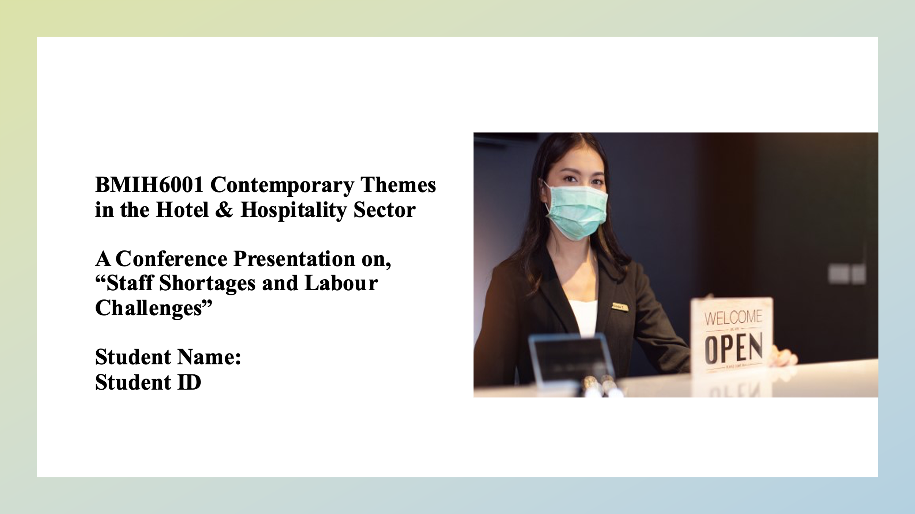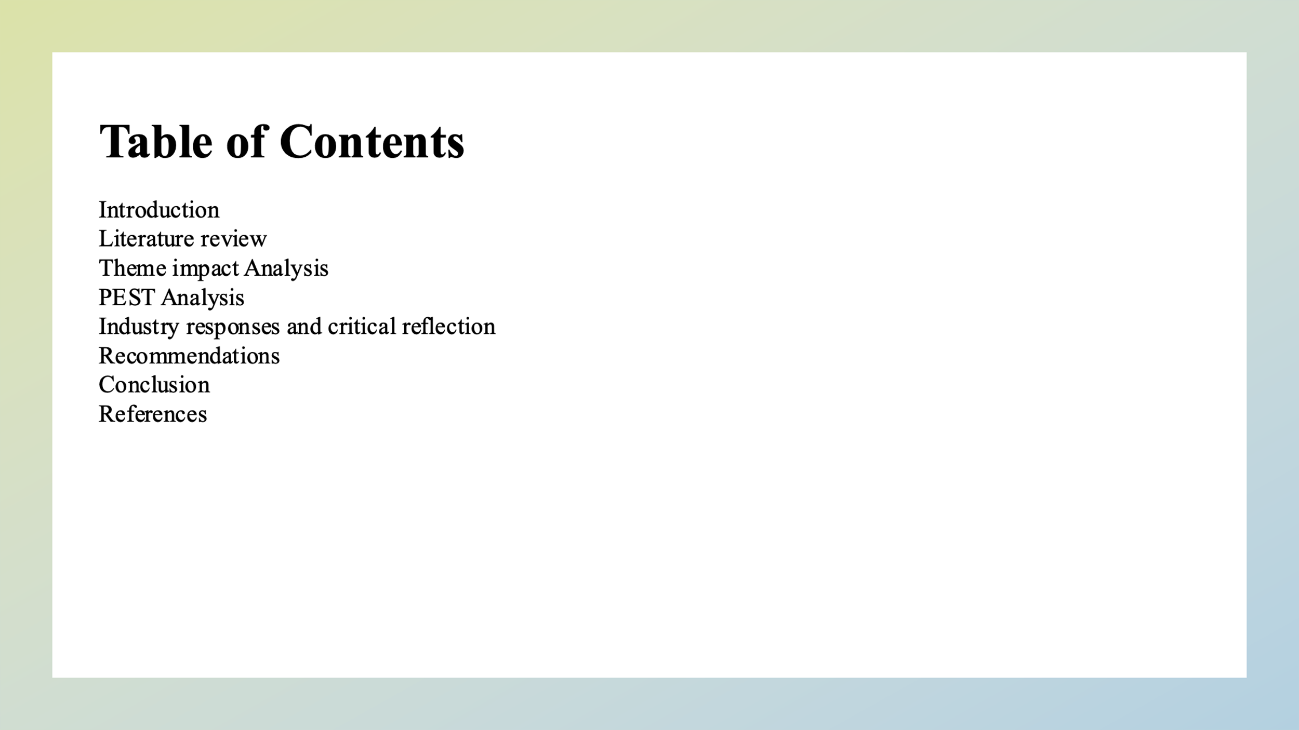

Introduction
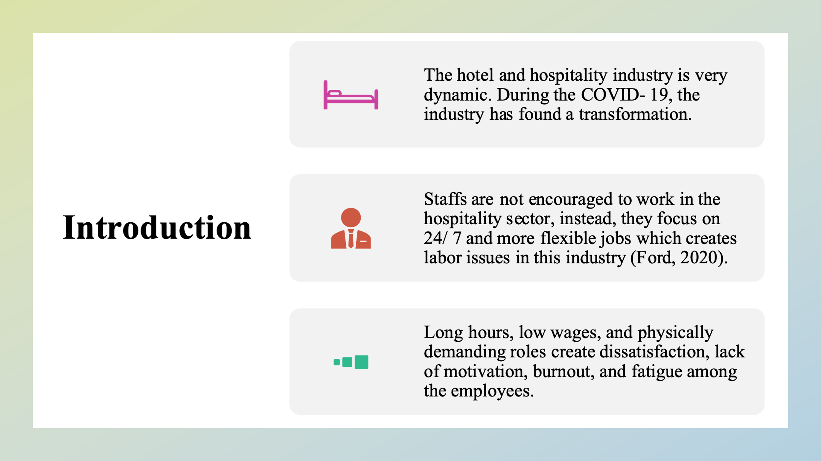
The hotel and hospitality industry are very dynamic. During the COVID-19, the industry has found a transformation. The hotel industry encompasses a wide range of services like accommodation, food and beverage tourism, and others in which an adequate workforce is required. However, the industry is facing workforce challenges due to staff shortages and a lack of motivation. Staff are not encouraged to work in the hospitality sector, instead, they focus on 24/ 7 and more flexible jobs which creates labor issues in this industry (Ford, 2020). The seasonal fluctuations in demand, job insecurity, and lack of career progression are the reasons for the labor shortage within this industry. After COVID-19 due to widespread job loss, that industry has lost its reputation for employment. Besides that, long hours, low wages, and physically demanding roles create dissatisfaction, lack of motivation, burnout, and fatigue among the employees.

Literature review

Workforce shortages in the hospitality industry
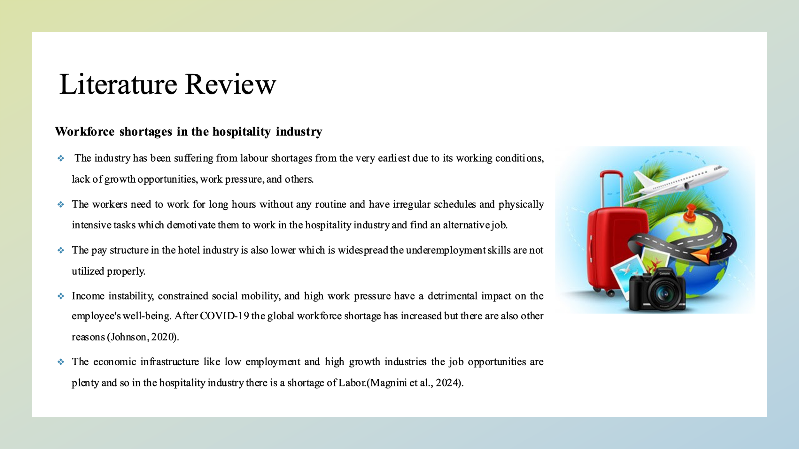According to Birdir and Sahilli Birdir (2024), the industry has been suffering from labour shortages from the very earliest due to its working conditions, lack of growth opportunities, work pressure, and others. The workers need to work for long hours without any routine and have irregular schedules and physically intensive tasks which demotivate them to work in the hospitality industry and find an alternative job. The pay structure in the hotel industry is also lower which is widespread the underemployment. skills are not utilized properly as most of the work is repetitive and there are fewer career opportunities or ways of contributing within the organization. Income instability, constrained social mobility, and high work pressure have a detrimental impact on the employee's well-being. After COVID-19 the global workforce shortage has increased but there are also other reasons (Johnson, 2020). Most of the hotel staff are the baby boomers who are starting to retire and the current generation or the millennials or Gen Z don't feel attracted to work as labourers, waitresses or bartenders within the hospitality industry. The younger generation is not interested in developing their career in the hospitality industry; rather they want employment in the more flexible organizations that will pay more and be socially respected. The job sector in the hospitality industry has a higher risk for which reason due to the COVID-19 effect many jobs in this industry have been dismissed (Morosan and Bowen, 2022). The economic infrastructure like low employment and high growth industries the job opportunities are plenty and so in the hospitality industry there is a shortage of Labor. For these reasons, the hospitality industry needs to make higher costs in talent retention and recruitment continuously. The workplace and work conditions are also not in the favor of the employees. Unfavorable working conditions, internal politics of the organization, and lack of collaboration among the department increase the turnover rate among the employees within the industry (Magnini et al., 2024).

Impact of workforce shortage
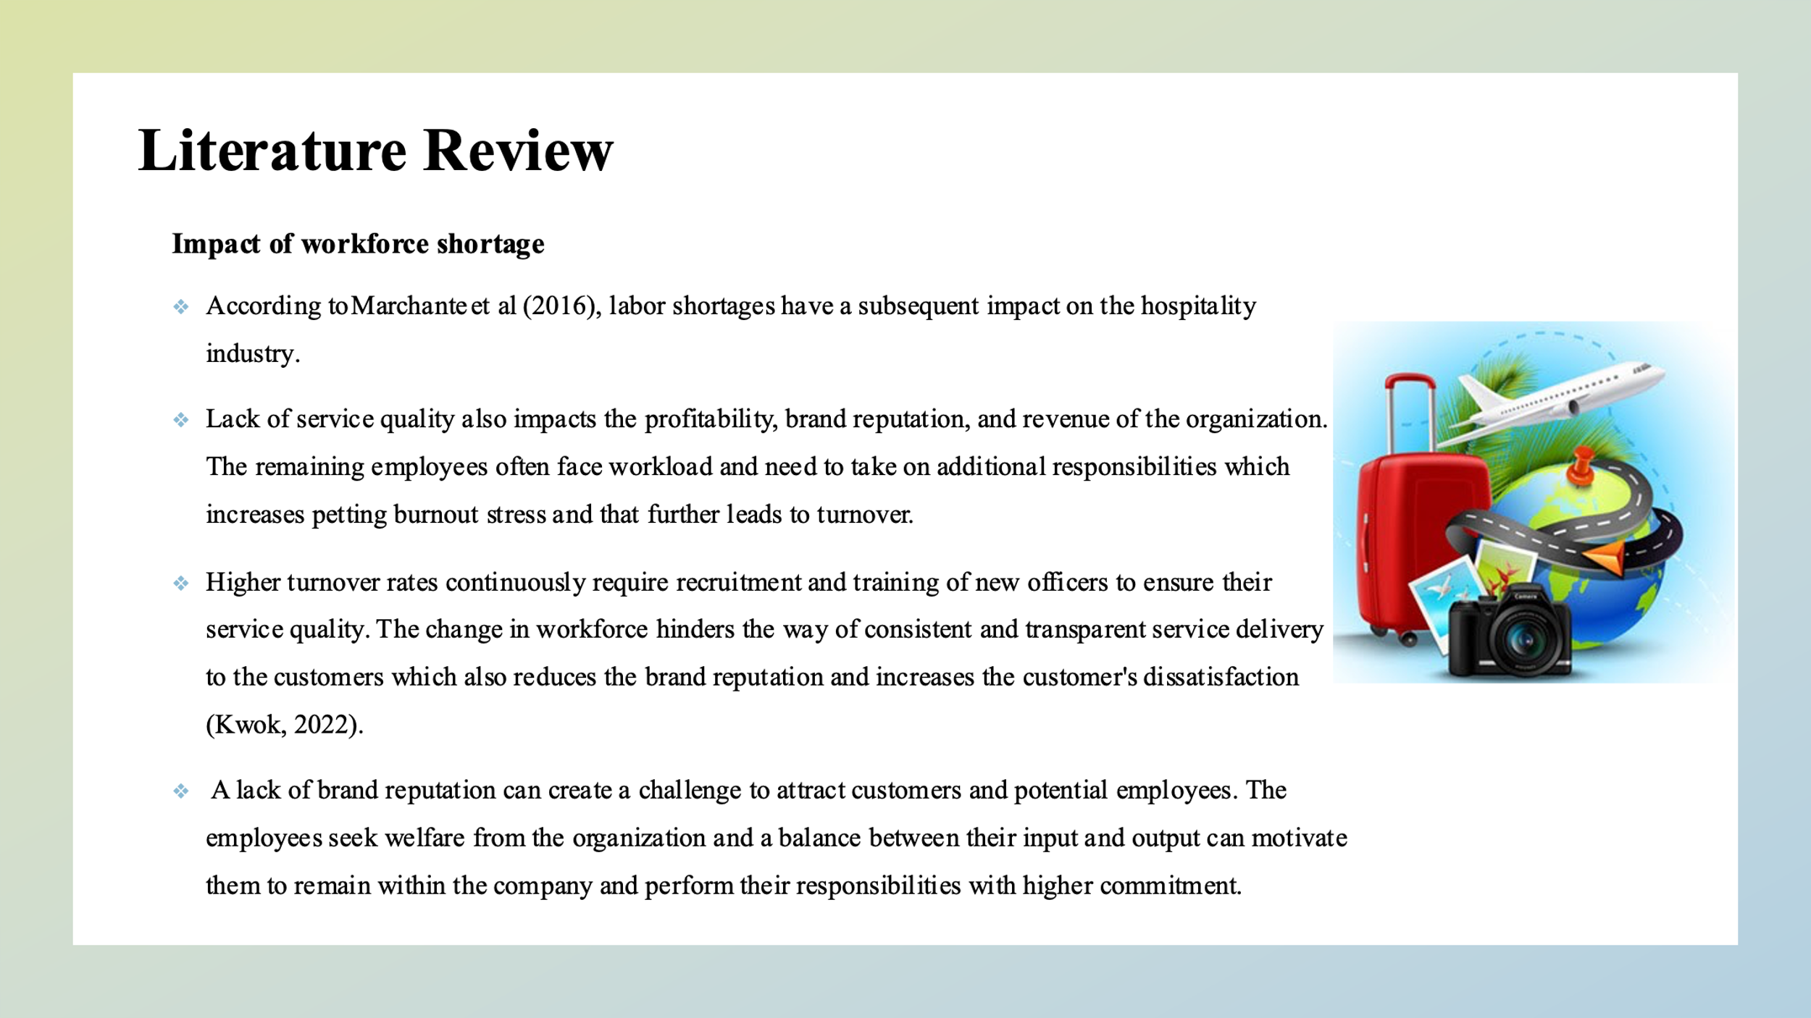According to Marchante et al (2016), labor shortages have a subsequent impact on the hospitality industry. With fewer staff members, the quality of services cannot be provided equally to all customers which creates dissatisfaction. lack of service quality also impacts the profitability, brand reputation, and revenue of the organization. The remaining employees often face workload and need to take on additional responsibilities which increases petting burnout stress and that further leads to turnover. Higher turnover rates continuously require recruitment and training of new officers to ensure their service quality. The change in workforce hinders the way of consistent and transparent service delivery to the customers which also reduces the brand reputation and increases the customer's dissatisfaction (Kwok, 2022). A lack of brand reputation can create a challenge to attract customers and potential employees.

Strategies to overcome the labour shortages
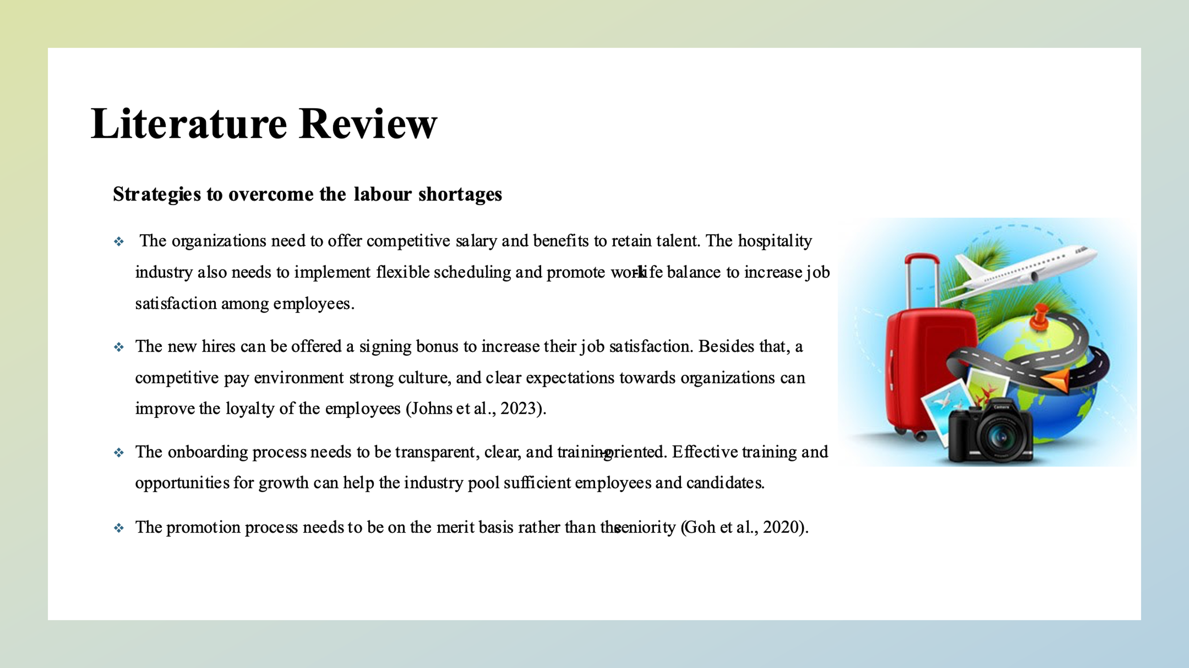
The labor shortage in the hospitality industry requires extensive strategies. A multifaceted approach can help to improve the working conditions and retain the employees. the organizations need to offer competitive salary and benefits to retain talent. The hospitality industry also needs to implement flexible scheduling and promote work-life balance to increase job satisfaction among employees. The new hires can be offered a signing bonus to increase their job satisfaction. Besides that, a competitive pay environment strong culture, and clear expectations towards organizations can improve the loyalty of the employees (Johns et al., 2023). The onboarding process needs to be transparent, clear, and training-oriented. Effective training and opportunities for growth can help the industry pool sufficient employees and candidates. The working hours need to be definite and, in this case, the roster system can be applied to ensure 24/7 Services for the customers. A clear career progression path can motivate employees for which succession planning leadership innovation creativity promotion and other opportunities are necessary.

Theme impact Analysis

PEST Analysis
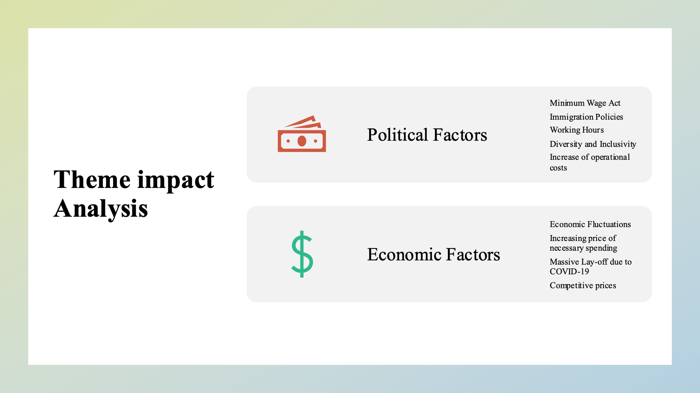
Political factors
The political factor has a crucial role in shaping the hospitality industry. In the UK there is a minimum wage act which you need to follow by the hotels to save the compensation of the employees. Restriction on immigration law can reduce the labor sufficiency within the organizations and keep a higher impact on the service quality (Beesley et al., 2013).
Economic factors
The economic factor also has a profound impact on hospitality services. Due to the economic downturn and an increase in the necessary spending, hotels, and restaurants need to cut their cost which leads to cutting the head cost within the organisation. The organizations need to face competitiveness struggling to attract and retain their Staff. COVID-19 has caused a massive layoff and employees are not encouraged to start their jobs in the hospitality industry.
Social factors
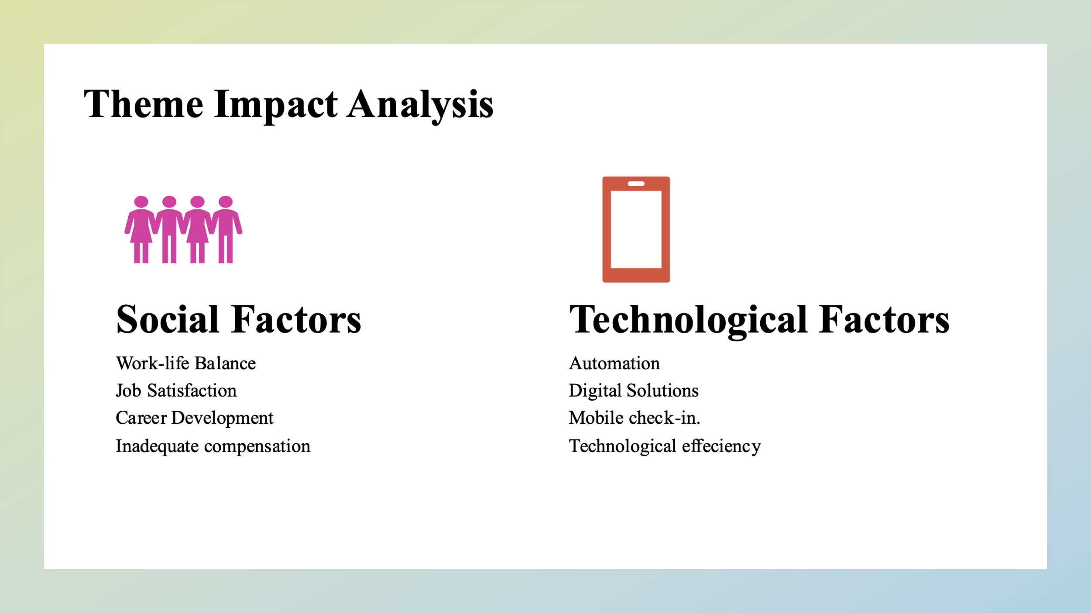
There are different social factors like work-life balance, job satisfaction, career development opportunities, etc. impact a lot and influence the labor supply within the hospitality industry.
Technological factors
The advancement of technology presents challenges and opportunities for the organization. Automation and digital solutions before expert staff. The staffing issues have been mitigated by streamlining operations like self-service kiosks, mobile check-ins, and others but adoption of this technology requires significant investment and expertise employment (Thompson, 2024).

Industry responses and critical reflection
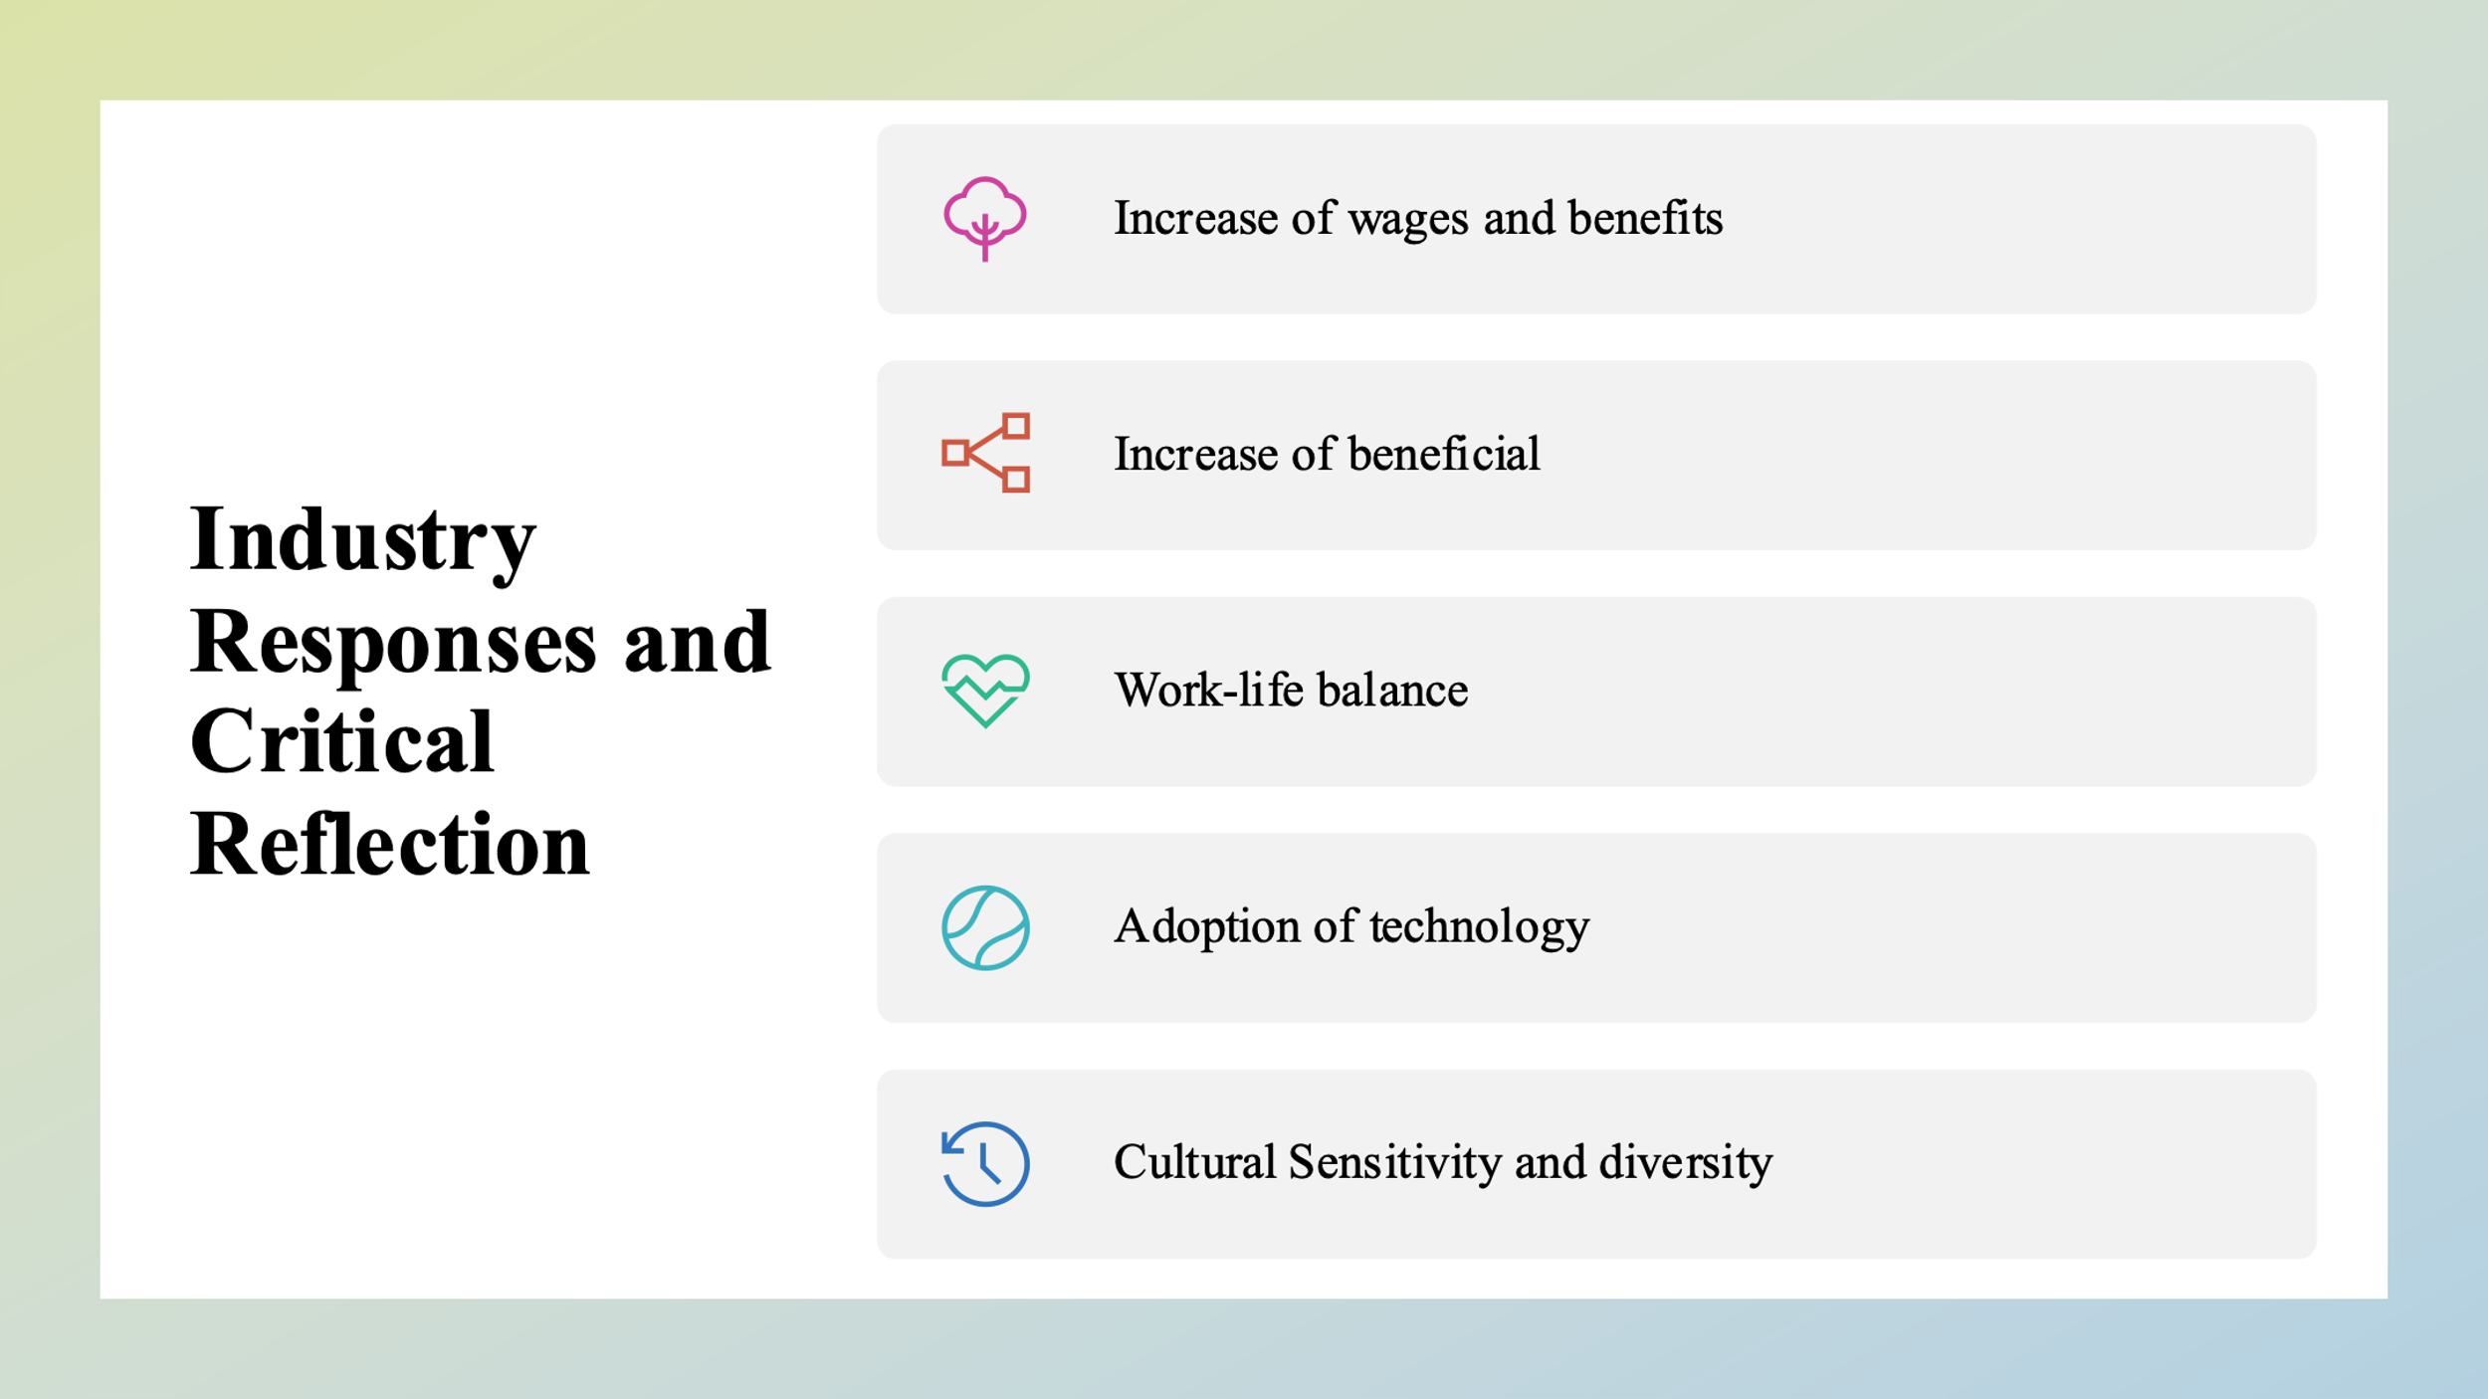
The labor shortages in the hospital industry have implemented different strategies to solve the problem and increase efficiency. The organisation has increased its wages and benefits to attract employees. 75% of hotels have increased their wages and 64% of them are offering flexibility in workplaces to improve satisfaction and retention through reducing operational costs and streamlining operations. They are also offering flexible working schedules through the roster system and improve the work-life balance (Cooper and Hall, 2019). The employees are becoming more attracted to this flexibility. They are also employing part-time workers during peak hours to divide the work pressure and ensure the overall well-being of the employees. The Staff are equipped with effective training and career development progression paths to stay in the industry and seek advancement opportunities. Though it requires time and financial investment, the benefits are visible nowadays. The adoption of technology has also impacted highly. The repetitive boring and monotonous routine tasks have been created which is elevating the labor pressures and also reducing the need for front desk Staff (Tribe, 2019).

Recommendations
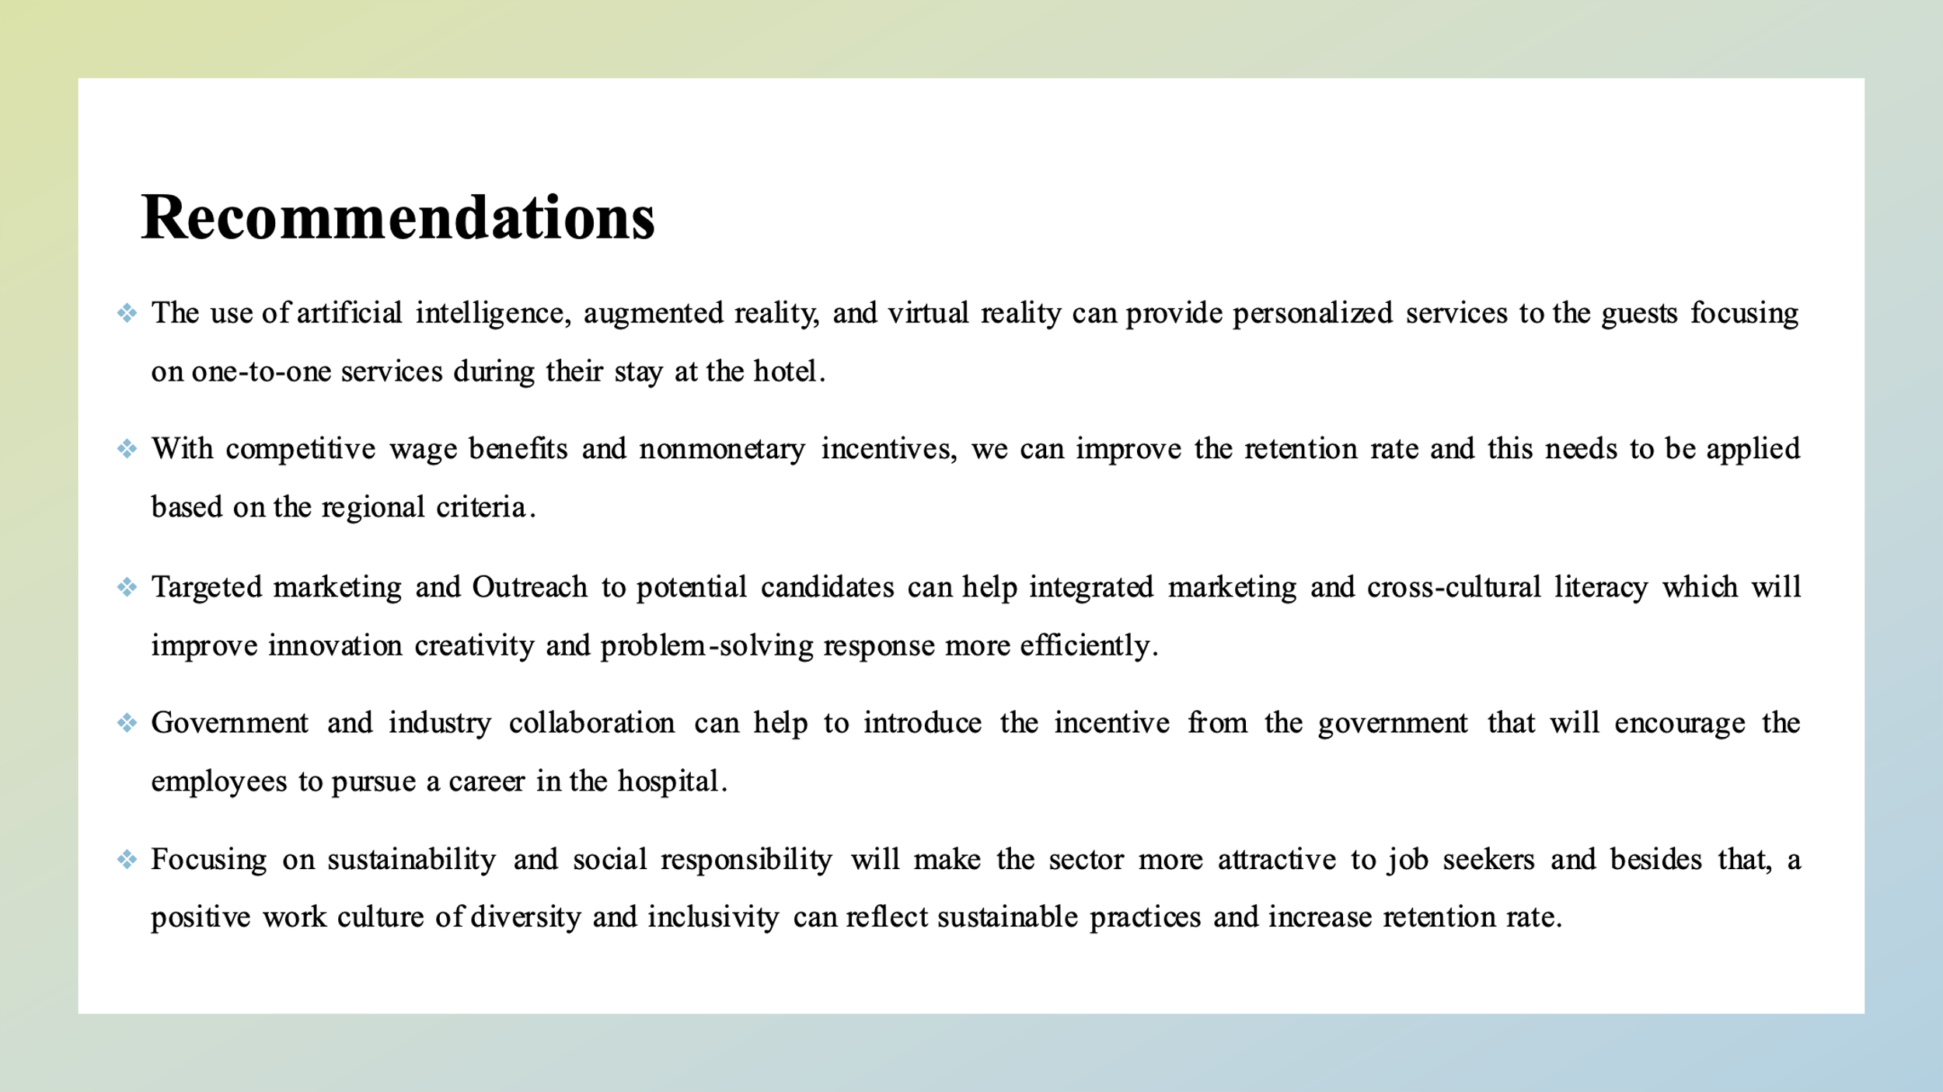
- The organization can invest in the well-being of the employees and their career development. They should prioritise ensuring our work-life balance for the employees so that they can give time to their families and the highest performance to the organization.
- Continuous training programs developed their skills of customer handling which gives the feeling of meaningfulness that helped to reduce the turnover and improve the job satisfaction.
- The use of artificial intelligence, augmented reality, and virtual reality can provide personalized services to the guests focusing on one-to-one services during their stay at the hotel.
- The recruitment and retention strategies need to be varied from different socioeconomic backgrounds.
- Targeted marketing and Outreach to potential candidates can help integrated marketing and cross-cultural literacy which will improve innovation creativity and problem-solving response more efficiently.
- Government and industry collaboration can help to introduce the incentive from the government that will encourage the employees to pursue a career in the hospital.
- Focusing on sustainability and social responsibility will make the sector more attractive to job seekers and besides that, a positive work culture of diversity and inclusivity can reflect sustainable practices and increase retention rate.

Conclusion
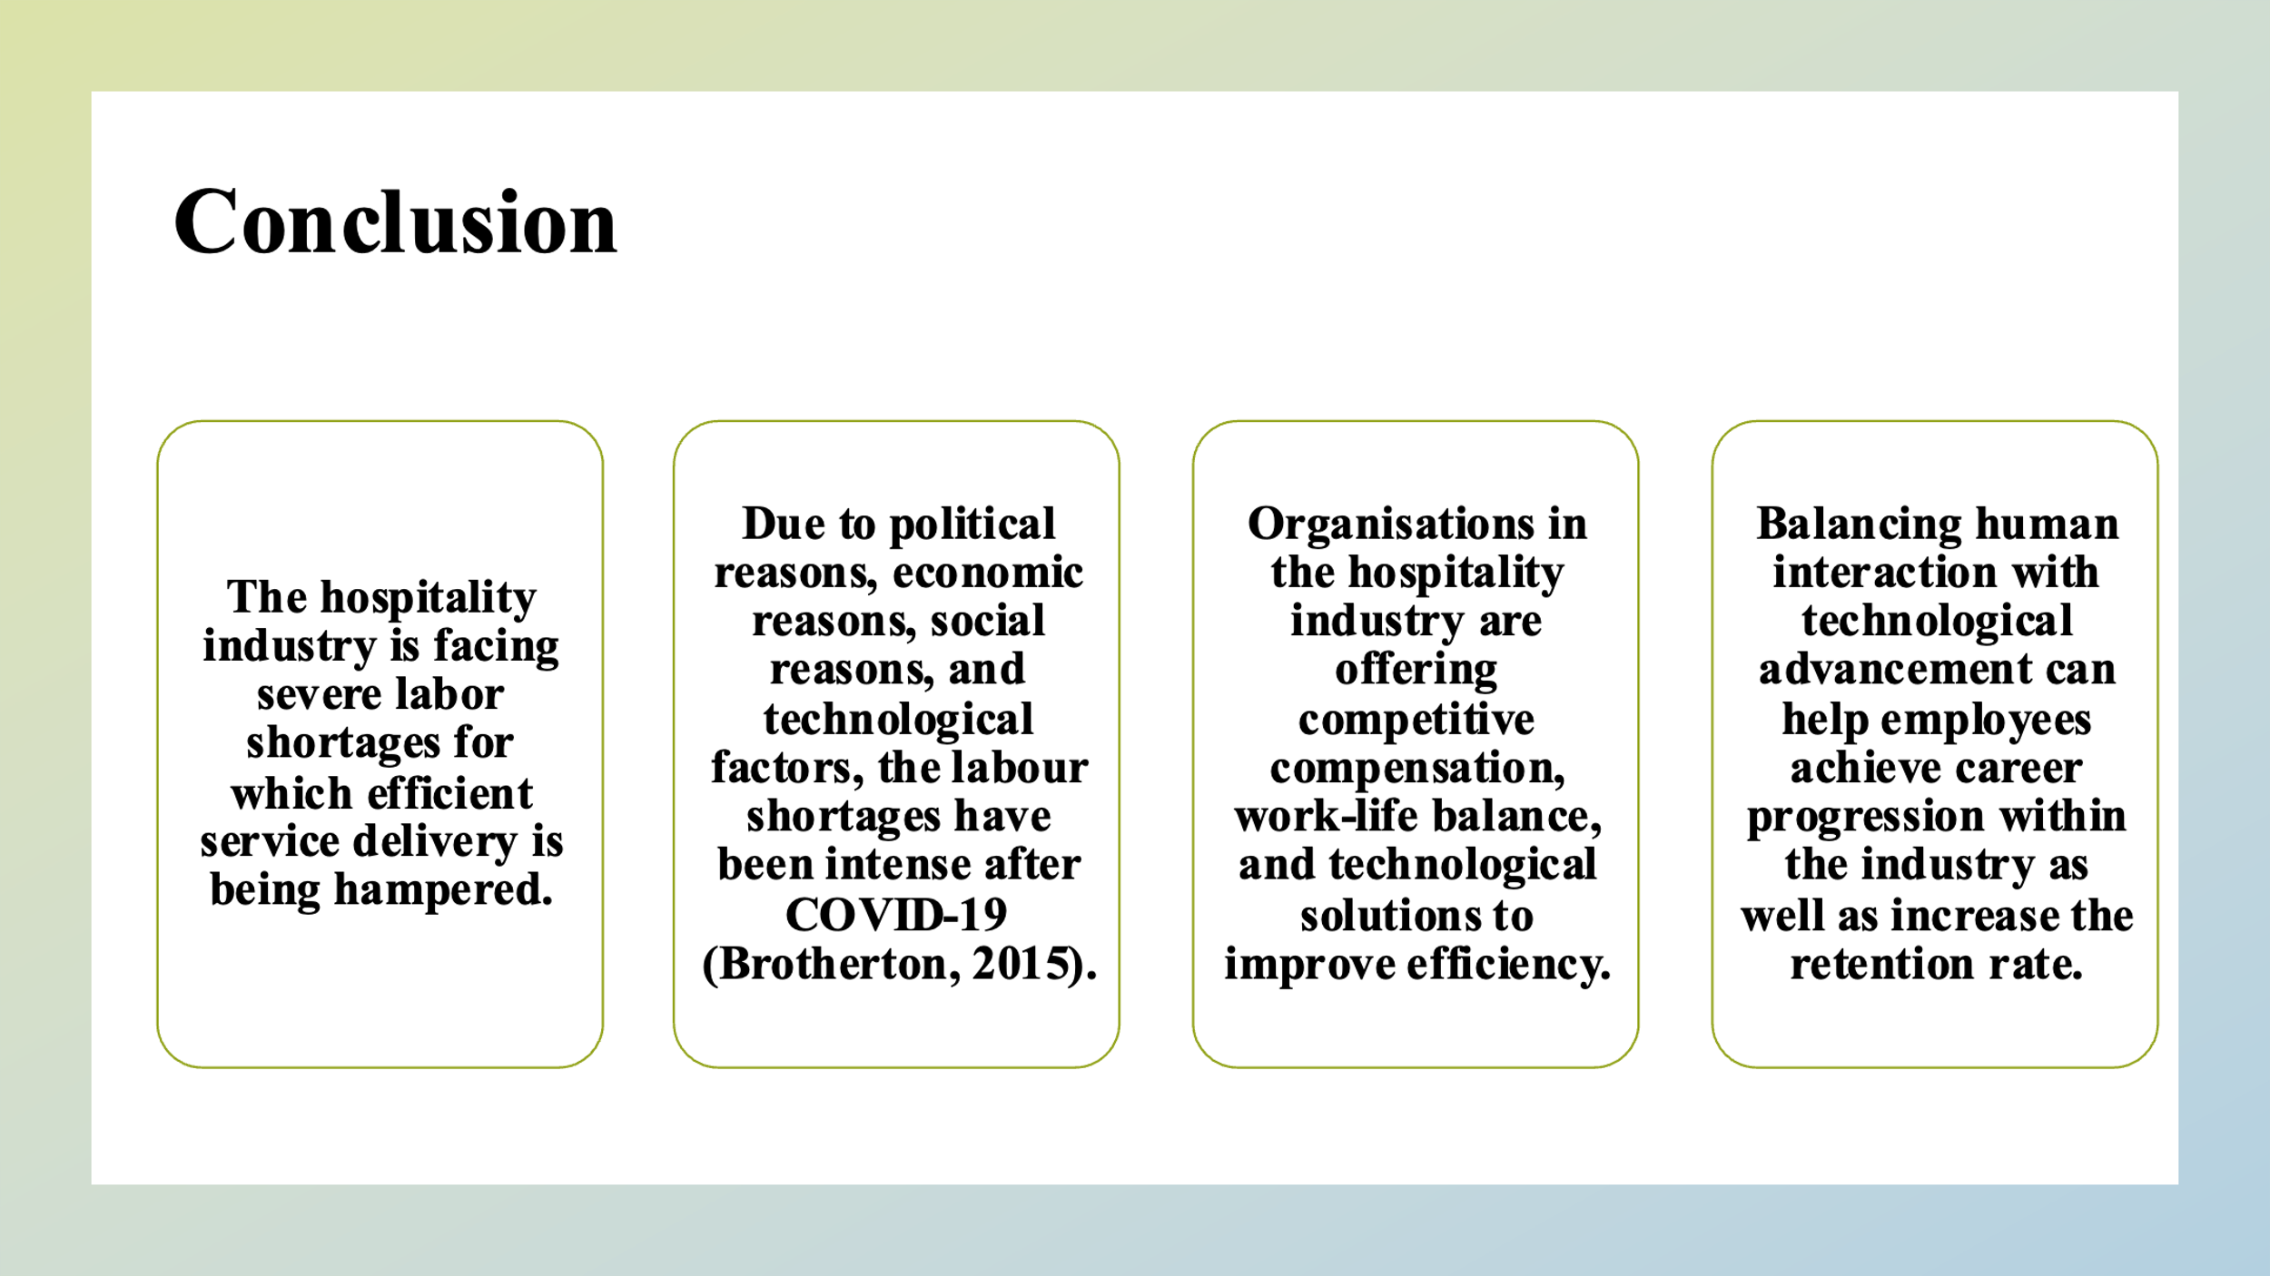
The hospitality industry is facing severe labor shortages for which efficient service delivery is being hampered. Due to political reasons, economic reasons, social reasons, and technological factors, the labour shortages have been intense after COVID-19 (Brotherton, 2015). Responding to the reasons for Labor shortages, organisations in the hospitality industry are offering competitive compensation, work-life balance, and technological solutions to improve efficiency. Balancing human interaction with technological advancement can help employees achieve career progression within the industry as well as increase the retention rate.

References


