Strategic Management for SMEs
Fame Fashions (UK) Ltd
Student: Mariana Grigorita (2014974)
Lecturer: Bente Fatema

Table of Contents
Introduction 2
Current strategic decision 2
Environmental analysis 3
PESTLE 3
SWOT 8
Competitive analysis/ Porter’s Five Forces 10
Stakeholder analysis 11
Strategic growth choices 14
Recommendations 15
Challenges 16
Conclusion 18
References 19

Introduction
One of the best examples of a small and medium-sized business (SME) in the Leicester’s vibrant retail industry is Fame Fashions store. This store was founded in 2014(find-and-update.company-information.service.gov.uk, n.d.) and has gained recognition for its unique approach to sustainable and cheap retailing. With a strong emphasis on sustainability, Fame Fashion has emerged as a leader in moral business practices in the thriving Leicester market town where it is based. The goal of this SME's founding was to provide eco-friendliness, ethical sourcing, and community involvement in addition to fashionable clothes. The boutique has become into a beloved shopping destination over time. High-quality, ethically sourced, locally manufactured products for families is the specialty of Fame Fashion store. They sell unique goods from regional craftsmen, handcrafted accessories, and fashion items.

Current strategic decision
The current strategic orientation of Fame Fashion store is defined by its unshakable dedication to community involvement, ethical retail practices, and sustainability (Dvorský et al., 2020). Although these principles are in line with the expanding global trend of eco-conscious purchasing, a critical evaluation of their strategic approach reveals both advantages and disadvantages. A primary advantage is their unwavering commitment to sustainability. In the current day, Fame Fashion has established itself as a conscientious participant in the retail industry (Toke and Kalpande, 2020). Their focus on providing locally produced, organic, and recycled fashion items appeal to a certain kind of customers who are becoming more aware of their environmental impact. This emphasis not only sets the boutique apart, but it also supports international initiatives aimed at lessening the environmental impact of the fashion industry. In addition, their encouragement of regional artists and craftspeople is a calculated action that strengthens ties within the community (Červinka, 2023). They support the local economy and capitalize on the growing "shop local" movement by exhibiting and selling handcrafted goods made in the area, particularly during the pandemic.
However, there are challenges that need to be carefully considered. Although their efforts towards sustainability are commendable, companies need to stay up with the quick changes in market trends and consumer preferences. Sustainability is gaining momentum in the retail industry, and to stay ahead of the competition in this space, innovation must never stop (de Araújo et al., 2020). The COVID-19 pandemic's effects exposed the weaknesses of numerous SMEs, notably Fame Fashion. Given the trend in consumer behaviour towards online buying, it is vital that they maintain their e-commerce acceptance and diversification of sales channels. Although their individualized in-store service is what sets them apart, their long-term viability depends on extending these principles to an internet platform.
In summary, Fame Fashion has a great foundation owing to its strategic direction, which places a strong emphasis on sustainability and local participation (Chaithanapat and Rakthin, 2021). They must continue to be flexible in responding to shifting consumer preferences and allocate the required funds toward e-commerce infrastructure to maintain and grow this. The key to moving forward is striking a balance between their basic beliefs and the requirement to embrace digital transformation to prosper in the rapidly changing retail environment.

Environmental analysis

PESTLE
The acronym PESTLE stands for political, economic, social, technological, legal, and environmental issues. Examining these elements can assist determine how the external business environment affects SMEs, including the concerned company.
Factors | Impacts
Political | - Trade Impact: The UK officially left the EU on January 31, 2020. Post-Brexit, the UK's fashion industry faced trade barriers and customs checks with the EU. It was estimated that these changes could result in billions of pounds in additional administrative costs for UK businesses.  - Supply Chain Disruptions: A significant number of fashion retail SMEs sourced materials and products from EU countries. Delays and disruptions in supply chains were reported due to new customs and regulatory requirements.  - Supply chain disruption might cause complications in production capacity of the organisation which will ultimately reduce their capacity to satisfy the customer requirement. Supply chain disruption due to the unstable political condition results in reduced financial profit generation which is a significantly negative sign for the growth.  - Establishment of international relationships with emerging political powers including Asian countries can improve the trade regulation of Fame Fashion. Yet among these emerging political powers in the international market, the continuous turmoil of the current international environment results in complicated inflation. International politics and changing policies ultimately create complications in business resulting in increasing the distance between the product and the consumer (Philbeck and Davis, 2018).
Economic | - Reduced Sales: During the early months of the pandemic in 2020, fashion retailers experienced a sharp decline in sales. The British Retail Consortium (BRC) reported that clothing and footwear sales fell by nearly 35% year-on-year in March 2020.  - Store Closures: Many physical stores were temporarily closed during lockdowns. According to BRC, nearly 70% of non-food sales came from physical stores before the pandemic.  - Shift to E-commerce: Sales in e-commerce have increased. According to the Office for National Statistics (ONS), online sales as a percentage of total retailing reached a record high of 22.3% in March 2020, signalling a major change in consumer behaviour.  - International economic terminal resulting in increased inflation in multiple countries as well as the active participation of powerful nations in the war-torn environment ultimately results in creating complications for business activities.  - Customer preferences towards online purchasing behaviour increases uncertainty for organisations such as Fame Fashion operate mostly in offline environments. The diverse range of products available in front of the customer as well as the option to return the product from the doorstep has permanently shifted their purchasing behaviour which is a negative sign for offline stores.
Social | - Sustainability: Consumer interest in sustainable fashion was on the rise. According to a McKinsey analysis, 45% of consumers polled in 2020 indicated that they were more likely to purchase clothing that was marked as environmentally friendly.  - Localism: Supporting small companies in the community was becoming more popular. In a survey conducted in the UK in 2020, 59% of consumers stated they were more likely to patronise a local company during the pandemic.  - Fame Fashion has committed towards the improvement of society and technique social challenges. This commitment of the organisation towards betterment of the customers lifestyle and help them make greener choices has positive implications in increasing their brand awareness and repetition.
Technological | - E-commerce Adoption: To access a larger client base, many SMEs in the retail industry are adopting e-commerce platforms. This trend was expedited by the COVID-19 epidemic, which led to a sharp rise in online commerce.  - Social Media Marketing: Social media sites are frequently used for advertising and client interaction. These platforms are used by SMEs to promote their goods, engage with customers, and increase sales. Statistics on the use of social media by SMEs can differ by area and industry.  - AI and Data Analytics: Larger retailers have embraced AI and data analytics to better customer shopping experiences, optimise pricing tactics, and improve inventory management. Statistics on how these technologies are being adopted by SMEs vary, depending on the industry.
Legal | - Protection of Consumer Data: Data privacy laws, like the GDPR in the EU, have an impact on how companies handle customer data. Legal repercussions and substantial fines may follow non-compliance.  - Labour Laws: It is important to abide by all applicable labour laws and regulations. Violations can result in legal action, penalties, and reputational harm to a business.
Environmental | - Sustainability Practices: Environmental concerns have led to increased consumer interest in sustainable products. SMEs that adopt eco-friendly practices have the potential to attract a more environmentally conscious customer base.  - Supply Chain Disruptions: Climate change-related events (e.g., extreme weather, natural disasters) can disrupt supply chains, impacting the availability of products and increasing costs. These events can vary greatly by location.  - Regulatory Compliance: Environmental regulations, such as restrictions on plastic use or emissions, may affect manufacturing, packaging, and transportation. Compliance with these regulations can be a legal requirement and impact production costs.
Table 1: PESTLE analysis

SWOT
SWOT analysis helps to understand the aspects of internal business environment of a business:
Strengths  - Commitment to Sustainability: Fame Fashion has established a strong reputation for its ethical and sustainable fashion, appealing to eco-conscious consumers.  - Local Artisan Engagement: The boutique's support for local artisans and creators strengthens community ties and resonates with the trend of supporting local businesses.  - Unique Product Offering: The boutique offers a curated collection of high-quality, locally made, and ethically sourced clothing, differentiating it from mass-produced fashion chains.  - Personalized Service: The boutique provides personalized shopping experiences, fostering customer loyalty and a loyal customer base. | Weaknesses  - Limited Geographic Presence: The company's boutique is in a single location, limiting its physical reach to a specific local market.  - Dependence on Suppliers: Relying on local and sustainable suppliers can lead to supply chain limitations and potential cost fluctuations.  - Limited Online Presence: While there is a growing demand for e-commerce, Fame Fashion may have a limited online presence and may not fully leverage the digital marketplace. Fame Fashion needs to improve their base operations by expanding their territory in nationally markets and emerging economies.  - Relatively Small Market Share: Being an SME, Fame Fashion may struggle to compete with larger retailers with extensive resources and market reach.
Opportunities  - E-commerce Expansion: Leveraging the growing trend of online shopping can extend the boutique's reach beyond its physical location. Utilisation of technology in the progress of business activities is one of the most effective opportunities of Fame Fashion.  - Sustainable Fashion Trend: The increasing demand for sustainable and eco-friendly fashion aligns with Jones & Co.'s core values, providing growth opportunities.  - Digital Marketing: Enhanced online marketing and social media strategies can help the boutique tap into a broader customer base.  - Community Engagement: Further engaging with the local community and hosting events can strengthen the boutique's position as a community-centric business. | Threats  - Competition from Larger Chains: Larger fashion chains may pose a challenge due to their extensive resources and marketing power. The current violence in the international political market might cause increasing inflation at the international level under which procurement of raw material from the external market can be expensive. This might result in reducing the number of customers due to the higher price of the product (World Bank, 2020).  - Economic Downturn: Economic fluctuations and consumer spending limitations can impact the demand for higher-priced sustainable fashion.  - Supply Chain Disruptions: Climate change and other environmental factors can disrupt sustainable material sourcing.  - Regulatory Changes: Changes in labour or environmental regulations can impact operations and add compliance costs.

Table 2: SWOT analysis

Figure 1: Advanced SWOT analysis

Competitive analysis/ Porter’s Five Forces

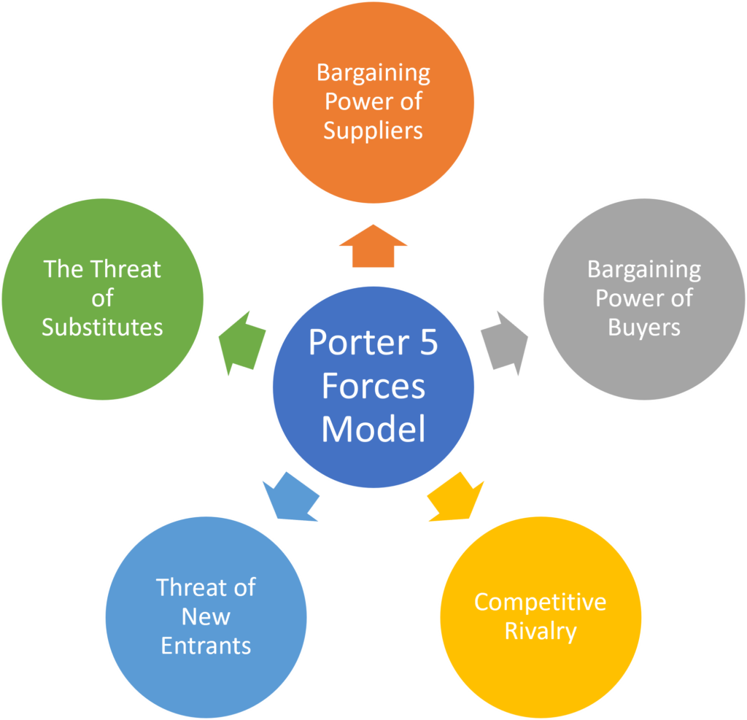

The Porter analysis model was developed in 1979 by Professor Michael E. Porter. Porter's Five Forces is a valuable tool for understanding the competitive structure of a particular industry or company. It is based on the observation that since all businesses develop in a competitive environment, differentiation is essential if companies are to attract and retain customers and avoid losing market share. Through Porter's competition analysis model, the following aspects are considered: in the first three identified forces, the external competition environment is analysed, and in the rest two forces, competition elements from the company's internal plan are analysed.
The 5 forces in Porter's analysis model are as follows:
- The threat of new entrants to the market- this factor refers to new companies entering the textile industry market of which Fame Fashion is a part. What is very important to remember is that, although it is an ever-changing market, every company must be very careful to maintain its place. Because it is a market where it is difficult to enter, but very easy to exit. For Fame fashion, a threat of new entrants to the market does not only refer to large and large-scale companies like Tu, George, Zara H&M, Next etc., even local firms can affect the success of the fame fashion store. If these smaller companies manage to attract customers and keep them loyal then the Fame Fashion store may suffer.
- Direct competitors - they are the second highest external factor to which any company must relate. Direct competitors to the Fame fashion store are other local stores in the neighbourhood, also H&M, Primark etc., which means that the offer on the market is also diversified. Thus, the Fame Fashion store must be always innovative and in trend with the wishes of the customers.
- The threat of substitute products - is the third factor from the external environment, to which the company must be very attentive. As in any industry there are products that can replace what the company already commercialise. These are similar products from a qualitative point of view and that meet the same needs, but at a more advantageous price for the consumer. Thus, one of the elements that the company should analyse is the behaviour of the consumer. The consumers of this store are mainly women in a proportion of 70-80 percent, the remaining 30-20% are men.
- The bargaining power of customers- refers to the number of existing customers in the market for the goods that the company sells. Thus, the greater the number of customers, the more they can influence the offer that Fame Fashion offers, because the company must align with the needs and requirements of the customers.
- The bargaining power of suppliers- this factor is part of the internal ones, because within this the density of alternative suppliers must be analysed, but Fame Fashion is at a disadvantage because, compared to other companies in the fashion industry, they do not produce their own production.

Stakeholder analysis
The following analysis would help to understand the perspectives of stakeholder and impact of them on business decisions:
Stakeholder | Expectations | Relative Power | Stakeholder Classification
Customers | - High-quality, sustainable fashion  - Personalized service  - Ethical sourcing | Medium | Manage Closely
Local Artisans | - Consistent business support  - Platform to showcase products  - Fair compensation | Low-Medium | Keep informed
Suppliers/  Distributors | - Consistent orders  - Timely payments  - Commitment to sustainability | Low-Medium | Manage closely
Competitors | - Market competition  - Ethical competition  - Compliance with industry norms | Low | Monitor
Local Community | - Community engagement  - Support for local economy  - Hosting local events | Medium | Keep informed
Regulatory Bodies | - Compliance with labour and environmental regulations | High | Keep Satisfied
Environmental Groups | - Sustainable practices  - Reduction of environmental footprint | High | Keep Informed
Table 3: Stakeholder analysis

High power/Low interest  Regulatory bodies | High power/High interest  Employees  Customers  Suppliers /Distributors  Management
Low power/ Low interest  Media | Low power/ High interest  Local artisans  Local community  Environmental Groups  Competitors

Table 4: Power – Interest Matrix
Customer Expectations and Relative Power: Consumers anticipate individualized attention and premium, eco-friendly clothing. Since they provide revenue and can quickly switch to competitors if expectations are not fulfilled, they have a moderate relative power. To keep this stakeholder group loyal, Fame Fashion needs exercise tight management.
Local Artisans' Expectations and Relative Power: Regional craftspeople anticipate steady business assistance and just recompense (Garzella et al., 2021). They have a moderate amount of relative strength because their goods add to the distinctiveness of the boutique. It is critical to keep an eye on their pleasure to guarantee a long-term collaboration.
Supplier Expectations and Relative Power: Suppliers anticipate reliable orders, prompt payments, and a dedication to sustainability. They play a role in the supply chain, which gives them a moderate relative influence. To make sure that the supply chain is ethical and sustainable, supplier connections must be managed closely.
Competitors' Expectations and Relative Power: Rivals anticipate honest business dealings and competitive market conditions. Even though they don't have much direct impact, they can nonetheless affect market norms. It is critical to keep an eye on industry dynamics and practices.
Local Community Expectations and Relative Power: The host community wants local events to be hosted, the local economy to be supported, and community engagement (Crovini et al., 2021). Because of their part in the boutique's success, they hold a moderate amount of relative authority. Keep informed this stakeholder group is necessary for good community relations.
Regulatory Bodies' Expectations and Relative Power: Regulatory agencies demand adherence to environmental and labour laws. Due to the possibility of legal repercussions for noncompliance, they have a high relative authority. Ensuring regulatory bodies are satisfied is crucial for both operational and legal compliance.
Environmental Groups' Expectations and Relative Power: Environmental organizations anticipate less environmental impact and sustainable practices (Albats et al., 2020). They have a lot of relative influence, particularly in this day and age of growing environmental consciousness. Keeping a positive environmental reputation requires satisfying these stakeholders.
In conclusion, Fame Fashion must comprehend and manage stakeholder expectations. Even if power dynamics differ, it is important to carefully analyse and engage with all stakeholders in order to ensure the sustainability, moral conduct, and long-term success of the organization.

Strategic growth choices
Businesses in cutthroat marketplaces must make a number of strategic growth decisions to ensure their long-term viability. These decisions frequently centre on market expansion, innovation, and diversity (Alvarez et al., 2021). Adopting an omni-channel strategy that blends physical retail and online sales is one viable business plan for a small and medium-sized enterprise (SME), such as Fame Fashion.
This plan needs to build a user-friendly e-commerce platform, increasing the company's online presence, and utilizing digital marketing to attract a larger clientele while keeping their physical boutique (Chege and Wang, 2020). This strategy's capacity to adjust to shifting market trends and consumer behaviour is what gives it long-term benefits.
An omni-channel approach allows the organization to:
- Cater to Shifting Consumer Preferences: In light of the growing popularity of online purchasing, it is imperative to establish an online presence in order to satisfy changing consumer demands.
- Wider Geographic Reach: The digital channel can boost sales beyond the local market and even to foreign markets (Williams et al., 2020).
- Data-Driven Decision-Making: To make better marketing and product selections, e-commerce offers useful data on consumer behaviour, preferences, and purchase trends.
- Resilience Against Disruptions: Having an e-commerce presence guarantees business continuity even if traditional stores are temporarily shuttered in the event of unanticipated disruptions, such as a pandemic.
- Diversified revenue streams are possible with an omni-channel strategy, which lessens dependency on a single channel (Kot et al., 2020).
By adopting this approach, Fame Fashion may set itself up for long-term competitiveness, adaptability in the constantly changing retail environment, and sustainable growth.

Recommendations
- Expand E-commerce: Given the increasing popularity of online purchasing, Fame Fashion ought to keep improving its e-commerce infrastructure (Raymond et al., 2019). This entails making payments gateway investments, streamlining the website for a seamless user experience, and maximizing the online store for mobile access. A successful e-commerce expansion can greatly increase the clientele.
- Digital Marketing: Invest in digital marketing to advertise the online store and reach a larger audience. To interact with customers and create an online community, use email campaigns, content marketing, and social media advertising. Online sales and traffic can both be increased with the use of targeted digital marketing.
- Data Analytics: Use data analytics technologies to learn more about the preferences, behaviour, and purchasing patterns of your customers (Barbosa et al., 2020). Make educated judgments on product offerings, pricing schemes, and marketing efforts by utilizing these insights. This data-driven strategy can enhance the overall shopping experience and optimize resource allocation.
- Omnichannel Integration: Make sure the e-commerce platform and the physical boutique integrate seamlessly. Whether a customer shops online or in-store, they should always get the same brand identity and experience. To improve client convenience, this connection can offer services like online order pickup that can be picked up in-store.
- Sustainability Focus: Maintain your dedication to ethical sourcing and sustainability (Ibidunni et al., 2020). Investigate joint ventures with environmentally conscious companies and vendors to enhance the boutique's standing as a conscientious and morally driven vendor of clothing.
- Community Engagement: Increase the number of regional gatherings, workshops, or partnerships to fortify your connections with the neighbourhood (Iborra et al., 2020). Within the local market, this interaction promotes goodwill and increases client loyalty.
- Merging with local brands: Expansion of business can be done by the option of merging with other business organisations in the operating country. As entering a new market or acquiring new customers require a significant amount of financial investment and a certain amount of uncertainty, It is recommended that Fame Fashion can merge with a local company and launch their combined product. It will provide the organisation with better understanding in the market and also get statistical knowledge about the customer preferences.

Challenges
For a SMEs such as Fame Fashion, putting these tactics into practice could be difficult due to limited resources and knowledge. To overcome these obstacles:
- Resource Allocation: Organize investments based on potential return on investment (AlQershi, 2021). Make sure you provide adequate funds and resources to high-impact projects and that you give growing e-commerce and digital marketing plenty of your focus.
- Staff Training: Equip employees with the necessary training and resources to efficiently oversee the e-commerce platform and digital marketing. It can also be more affordable to outsource certain tasks to professionals, like digital marketing firms.
- Financial Planning: Ensure financial security by keeping an emergency fund on hand to handle unforeseen difficulties or interruptions (D’Angelo and Baroncelli, 2020). Sturdy finances are necessary for sustainable growth.

Conclusion
In conclusion, the strategy recommendations for centre on data analytics, digital marketing, e-commerce growth, and upholding sustainability. While staff knowledge, resource constraints, and financial stability present implementation hurdles for SMEs, these issues can be lessened with careful planning, strategic resource allocation, and employee training. Through the implementation of these strategies and skilful management of implementation challenges, Fame Fashion can secure its long-term future in the fashion retail industry, position itself for sustainable growth, and respond to changing market trends. In the current environment making strategic decisions is mostly dependent upon the capacity of the organisation to make better judgement regarding the external and international business environment along with the factors that affect the environment. The continuous dynamic nature and the ambiguity not only increase the complication for operating in a national environment but also open a significant range of new opportunities for expanding business.

References
Albats, E., Alexander, A., Mahdad, M., Miller, K. and Post, G., (2020). Stakeholder management in SME open innovation: interdependences and strategic actions. Journal of Business Research, 119, pp.291-301.
AlQershi, N., 2021. Strategic thinking, strategic planning, strategic innovation and the performance of SMEs: The mediating role of human capital. Management Science Letters, 11(3), pp.1003-1012.
Alvarez, T., Sensini, L., Bello, C. and Vazquez, M., (2021). Management accounting practices and performance of SMEs in the Hotel industry: Evidence from an emerging economy. International Journal of Business and Social Science, 12(2), pp.24-35.
Barbosa, M., Castañeda-Ayarza, J.A. and Ferreira, D.H.L., (2020). Sustainable strategic management (GES): Sustainability in small business. Journal of cleaner production, 258, p.120880.
Červinka, T., (2023). Digital Transformation of Strategic Management of SMEs in the Czech Republic. European Journal of Interdisciplinary Studies, (01).
Chaithanapat, P. and Rakthin, S., (2021). Customer knowledge management in SMEs: Review and research agenda. Knowledge and Process Management, 28(1), pp.71-89.
Chege, S.M. and Wang, D., 2020. Information technology innovation and its impact on job creation by SMEs in developing countries: an analysis of the literature review. Technology Analysis & Strategic Management, 32(3), pp.256-271.
Crovini, C., Ossola, G. and Britzelmaier, B., (2021). How to reconsider risk management in SMEs? An advanced, reasoned, and organised literature review. European Management Journal, 39(1), pp.118-134.
D’Angelo, A. and Baroncelli, A., 2020. An investigation over inbound open innovation in SMEs: Insights from an Italian manufacturing sample. Technology Analysis & Strategic Management, 32(5), pp.542-560.
de Araújo Lima, P.F., Crema, M. and Verbano, C., (2020). Risk management in SMEs: A systematic literature review and future directions. European Management Journal, 38(1), pp.78-94.
Dvorský, J., Petráková, Z., Khan, K.A., Formánek, I. and Mikoláš, Z., (2020). Selected aspects of strategic management in the service sector. Journal of Tourism and Services.
Find-and-update.company-information.service.gov.uk. (n.d.). FAME FASHIONS (UK) LTD overview - Find and update company information - GOV.UK. [online] Available at: https://find-and-update.company-information.service.gov.uk/company/09146560 [Accessed 1 Nov. 2023].
Garzella, S., Fiorentino, R., Caputo, A. and Lardo, A., (2021). Business model innovation in SMEs: The role of boundaries in the digital era. Technology Analysis & Strategic Management, 33(1), pp.31-43.
Ibidunni, A.S., Kolawole, A.I., Olokundun, M.A. and Ogbari, M.E., (2020). Knowledge transfer and innovation performance of small and medium enterprises (SMEs): An informal economy analysis. Heliyon, 6(8).
Iborra, M., Safón, V. and Dolz, C., 2020. What explains the resilience of SMEs? Ambidexterity capability and strategic consistency. Long Range Planning, 53(6), p.101947.
Kot, S., Haque, A.U. and Baloch, A., 2020. Supply chain management in SMEs: Global perspective. Montenegrin Journal of Economics, 16(1), pp.87-104.
Philbeck, T. and Davis, N., (2018). The fourth industrial revolution. Journal of International Affairs, 72(1), pp.17-22.
Raymond, L., Bergeron, F., Croteau, A.M. and Uwizeyemungu, S., (2019). Determinants and outcomes of IT governance in manufacturing SMEs: A strategic IT management perspective. International Journal of Accounting Information Systems, 35, p.100422.
Toke, L.K. and Kalpande, S.D., 2020. Total quality management in small and medium enterprises: An overview in Indian context. Quality Management Journal, 27(3), pp.159-175.
Williams Jr, R.I., Smith, A., R Aaron, J., C Manley, S. and C McDowell, W., (2020). Small business strategic management practices and performance: A configurational approach. Economic research-Ekonomskaistraživanja, 33(1), pp.2378-2396.
World Bank, (2020). Global economic prospects, June 2020. The World Bank.

