Student name: Benonia Ngwala
Student name: 1813797
M4X01915- Hospitality and Guest Service Management
Assignment title: Services provided and Quality Management at the Hotel
Lecturer’s name: Olubukola Adegbite (Ade)
Date 17/07/2020

Table of contents

Introduction.......................................................................................................................... 3
Discussion/Evaluation and Critical Analysis........................................................................ 3
Evaluate how the hotel adapts to changing consumer preference……………………………5

Consumer preferences impacts guest service management …………………………………7
Conclusion............................................................................................................................8
References...........................................................................................................................9
Appendix……………………………………………………………………………………………10

Introduction

The purpose of this report is to determine the value of the DoubleTree by Hilton Hotel London – Chelsea and on this report I will be discussing about the service provided, the quality management, the way the hotel adapts to the changing preferences guests and visitors by changing their preference and how this impact the guest service management.
According to Collins (2020), Guest Services are the services, amenities and help that the hotel provides for its guests. Some of the guest services include free morning breakfast, breakfast buffet, bar/lounge, newspaper delivery, concierge, room service, free WIFI, on site restaurant, high chairs available for infants, taxi service, laundry, answering any questions guests may have. Conference room with WIFI availability, function/parties and wedding room as well café bar, Complimentary instant coffee, Fax / photocopying, there is also availability of bureau de change, dry cleaning service and the hotel offers ongoing front desk, check in and out service.

Discussion/Evaluation and Critical Analysis
Quality management
Quality Management refers to as a cycle of activities in which product design is successively refined in the light of consumer feedback (Johns 1993). Hilton Hotels and Resorts is one of the hotels with best quality service in the hospitality and continue to provide excellent services to the consumers and its guests.
DoubleTree by Hilton Hotel London is a 4star hotel with 172 rooms with a no smoking rooms policy. Located in the Imperial Wharf area, it is within half a mile of few shops and coffee bar. It is a two-minute walk to Imperial Wharf railway station, providing links to Central London attractions. Very good service from the bar and restaurant, would recommend it to someone want a quick and fast service.
Also, there is nearby attractions such as Gambado, Design centre and Queen’s market and few restaurants.
At arrival, a friendly hotel staff at reception greeted everyone with a smile while maintaining good eye contact and was offered chocolate chip cookie. Everyone luggage was taken to the rooms. At check in, receptionist asked for ID and booking confirmation.
All the rooms are spacious, air conditioned with a beautiful view and have the same features such as beautiful curtains, rooms with a spacious desk, available daily housekeeping, available room service, good size TV, clean combined shower and bath, there is a selection of toiletries, safe, sofa, room telephone, wardrobe with plenty of storage space.(TripAdvisor 2020).

Hilton has a very good effective customer service, always provide guests needs by creating a good customer satisfaction and guests always come back to stay. According to TripAdvisor (2020), DoubleTree by Hilton Hotel London has an excellent 1,977 reviews by its customer stating that it has the hotel is right in a reputable area in Chelsea. Guests have a variety of activities to do. As well as visiting shops, attractions and enjoying a nice coffee or tea in nearby coffee bar around Chelsea.
Hilton has large portfolio due to his high brand image in the hospitality industry and lots of costumers are attracted by the services and products they offer.
According to Hilton Management Service (2020), every Hilton hotel around the world have an ecosystem to be able to provide support to every team members for all those who are already working within the hotel and for those who join Hilton, team members are offered excellent opportunities to progress further to improve their career. Team members also have a program called recognition that appreciate them, therefore give team members the power to perform a better job and do their best to make guests happy. Learning and Leadership Development programs that save team members money for virtual courses also team members have rewards such travel program and discounts on rooms while staying at Hilton Hotel.
According to Sanchez (2019), Hilton hotels provide loyalty program and offers tourists and guests loyalty rewards points and discount prices when booking.
Hilton has the best quality of food and services and that make the hotel and its brand very competitive business to other companies in the hospitality industry.
Guest service experience is important and helps achieve the success of the business and there are various methods to improve it, one of them is to use Servqual methods.
Servqual
Servqual is a tool for rating quality service in any service industry and servqual is divided in 5 dimensions: tangibles, reliability, responsiveness, assurance and empathy. Servqual plays an important role and is very important in the hospitality industry like a big Hotel like Hilton & Resort. Hilton uses Servqual for its success in terms of advantages of competitive, facilities, training of staff, customer satisfaction, services and equipments and Hilton uses Servqual to attract guests, increase & measure the level of customer satisfaction.
Tangibles
Tangibles refer to the general appearance and functionality of the hotel. Hilton’ rooms are clean and perfectly adequate with free toiletries, bathrooms feel a little dated, outfitted with simple shower/tub combos. Most top-level rooms have impressive city views.
Reliability
Reliability is a consistency of performance and dependability. Lack of errors or delays. Some guests at Hilton were not happy the way there was a long wait to be checked in, the hotel manager apologised, promised that there will not anymore delays next time, and offered everyone 15% off for the next booking.

Responsiveness
Responsiveness is a way of willing or be ready for employees to provide service. A complaint was made to the hotel manager if it was possible to be moved to a better room, unfortunately, the hotel only have a limited number of rooms with a removable shower and was told to make our preferences at check in on arrival.

Assurance
Assurance is the prevention of quality problems through planned and systemic activities
Due to COVID-19, Hilton has introduced a new plan for the hotel and other brands to be clean and free of infection so that guest can feels safe while staying there. (See appendix)

Empathy
Empathy is usually when management and its employees care about his guests needs. According to TripAdvisor (2020), a guest’s daughter was sick and who could not spend the day at Disney as planned and hotel staff surprised them with a gift of a stuffed Minnie Mouse & a bowl of snacks. That was a good gesture from the hotel staff.

Evaluate how the hotel adapts to changing consumer preference

Guests are important in the hospitality industry. Most of customers expect a lot more from hotels. The hotel has an obligation to observe the guests needs, study them and their behaviour so that they can provide guests with what they want so that they will have a very good experience and memory to remember.

Lots of hotels have to initiative to offers more to the guests so it is easy for the hotel to adapt to consumers preferences. With the use of new technology, Double tree London hotel make guests’ lives easier during their stay, they leave with a memorable experience and always want to come back and stay for more enjoyable experience. For example, by offering a personalised service and offer guests their expectation and needs so that they are happy and will remember. As a guest oh Hilton hotel, and with the new technology in place, rooms can be personalised by their own choice for example having connected room will give guest the option use their own voice to control their own room and easy access to facilities within the hotel.
According to the world of hospitality (2017), Double tree by Hilton London have an option to give to guests to choose their own room and have the option check in using an application online. Hotel’s staff get in touch with the guests by a system called text-based application anytime using tablets instead of room phones to make it easy for everyone. The new technology and data let the hotel know about guests’ taste, needs and expectations for example staff will know how much drinks to have to stock daily to make sure that everyone is happy and satisfied.
According to Harris customer power hotels (2015), it is very important to listen to guests needs, understand their expectations, treat everyone with respect, dignity so that everyone is happy and will give the hotel a good feedback. Therefore it is vital for managers to conduct training for their stall to ensure that they understand the new digital platform so that using the new digital technology will be easier for them and that would make communications more effectively between staff and guests.
According to Jones (2020), Hilton introduced a new inn brand in October 2018 as a reaction to the converting panorama of the lodge industry. It was only in 2020 that they would begin to see the effects of opening a new brand, Motto with the help and assistance of Hilton. The first Motto to be opened was in Washington D.C in the early months of the year 2020, however there are some plans of opening some in 2021 in locations such as New York City and Indianapolis.
This shows Hiltons preference to captivate customers who are looking to spend less money on resorts and instead use that money in more efficient ways such as spending it on tourist locations and things to enhance the overall experience of their trip. Hilton has shown a tendency of following trends which could be because of its business model. The hotel branch is attempting to persuade and sway the minds of wealthy tourists into indulging in their brands with ‘one of a kind’ experiences. The hotel industry has begun to lean more towards luxury experiences and things based off a journey. In 2019, Hilton was able to present that they are able to change their ways in order to cater to the needs of the customer while also attending the attention of investors. In doing so, Hilton have been placed on a pedestal as a guide for the hotel industry in the upcoming decades.

Double tree by Hilton hotel have the advantage over services like Airbnb because it creates a lovely community space and most customers feel at home and easier for guests to access facilities within the hotel.
Consumer preferences impacts guest service management
According to Hilton newsroom (2019), the new technology will permit each room to be designed so that guests’ needs are updated and met. Wirelessly, guests can control any lightening, TV, doors with a digital key given at check in.
The menu will include a healthy variety of interesting recipes with source of protein and all dinners and rooms service will include a personalise plate. Biometric data for each guest will be introduced for chefs to prepare meals based on expectations and requirements for guests.
By 2030, Hilton hotel has a plan and has set goals so that the environmental footprint will be cut in half and to reduce the amount of carbon emissions used according to Hilton newsroom(2018), and that would make Hilton globally the first hotel business to lower carbon emissions used.
Due to the Coronavirus (COVID-19), hospitality industry is going through a difficult time. Hilton has taken lots of decision to protect the business and support those has been affected by the virus. Lots of services within the hotel have been suspended and reduced. Few hotels are opened and services for guests have been reduced because due to shortage of staff.
Few measures have been taken by Hilton to lower the cost by decreasing spending and protecting cashflow by activating assistance fund for team member that would help team member who have been affected by COVID-19, also extending the Hilton hospitality during this bad period. Everywhere in the world, hotels are helping local communities by giving food to those who mostly needs it.
Hilton is helping the community and national governments to offer accommodations to health staff & emergency worker. Hilton Honours, who are members, convert their points into cash so that they can help various organisations worldwide.
Also, Hilton has created flexibility for their guests, due to COVID-19, have introduced a non-cancellable reservation stays and full refund policy as well as the flexibility for booking and cancellations.

Conclusion
To summarise, Hilton is a 4-star worldwide hotel with an excellent guest services & amenities, located at various areas in the UK and other countries. Hilton hotel has the biggest portfolio of more than 10 world class brand. Quality management is very important t as it plays an important role to the business by providing his best service and quality by using the Servqual framework tool. Hilton has created a lovely community space and most customers feel at home and easier for guests to access facilities within the hotel. By being a member for the Hilton group, members can book and earn point and enjoy all the benefits. With the introduction of the new technology, guests who are members of Hilton Honours will manage several things, controlling temperature, lighting the tv and window coverings. Also, guests have the option to choose easy and quick online check in using the Hilton platform app, this will facilitate to reduce long time in queue. The new digital technology will reduce papers use, will reduce costs, guests and hotels stall will both benefit with the new system in place.

References

Collins, 2020, Definition of 'guest services’, guest services in Hospitality, available at https://www.collinsdictionary.com/dictionary/english/guest-services, [Accessed 16/05/2020]
Harris Customer Power Hotels, (2015), The Relationships That Hotel Customers Want, available at https://harris-interactive.co.uk/wp-content/uploads/sites/7/2016/01/Harris-Customer-Power-Hotels-16.pdf, [Accessed 03/06/2020]
Hilton Management Service, (2020), HR & Training, Available at https://www.managementservices.hilton.com/en/support-services/hr-training/, [Accessed 29/06/2020]
Hilton, (2018), Hilton Commits to Cutting Environmental Footprint in Half and Doubling Social Impact Investment, New Consumer Research Confirms Environmental and Social Efforts Are Central To Hotel Guest Booking Decisions, available at https://newsroom.hilton.com/corporate/news/hilton-commits-to-cutting-environmental-footprint-in-half-and-doubling-social-impact-investment [Accessed 09/07/2020]

Hilton, (2019), Moon-walking Mini-breaks, 3D-printed Room Service and Hyper-personalised Spaces: Welcome to the Hotel of 2119, Hilton releases future-gazing report to mark its 100th anniversary, available at https://newsroom.hilton.com/corporate/news/hyperpersonalised-spaces-welcome-to-the-hotel-of-2119 [Accessed 09/07/2020]
Johns, N. (1992), "Quality Management in the Hospitality Industry: Part 1. Definition and Specification", International Journal of Contemporary Hospitality Management, Vol. 4 No. 3. https://doi.org/10.1108/09596119210014219
Johns, N. (1993), "Quality Management in the Hospitality Industry: Part 3. Recent Developments", International Journal of Contemporary Hospitality Management, Vol. 5 No. 1. https://doi.org/10.1108/09596119310026242

Jones, S., (2020), The Motley Fool, How Hilton Is Adapting to the Changing Traveler, available at https://www.fool.com/investing/2020/03/17/why-hotel-stocks-plunged-double-digits-on-monday.aspx , [Accessed 03/06/2020]

Sanchez, L., (2019), The Motley Fool, How Hilton's Growth Strategy Is Delivering Strong Results,
available at https://www.fool.com/investing/2019/11/29/how-hiltons-growth-strategy-deliver-strong-results.aspx [Accessed 29/06/2020]

The world of hospitality, (2017), Four ways independent hotels will adapt to changing consumer demand, available at https://www.theworldofhospitality.com/four-ways-independent-hotels-will-adapt-changing-consumer-demand/, [Accessed 01/06/2020]
Tripadvisor,(2020), DoubleTree by Hilton Hotel London – Chelsea, available at https://www.tripadvisor.co.uk/Hotel_Review-g186338-d305742-Reviews-DoubleTree_by_Hilton_Hotel_London_Chelsea-London_England.html, [Accessed 16/05/2020]

Appendix

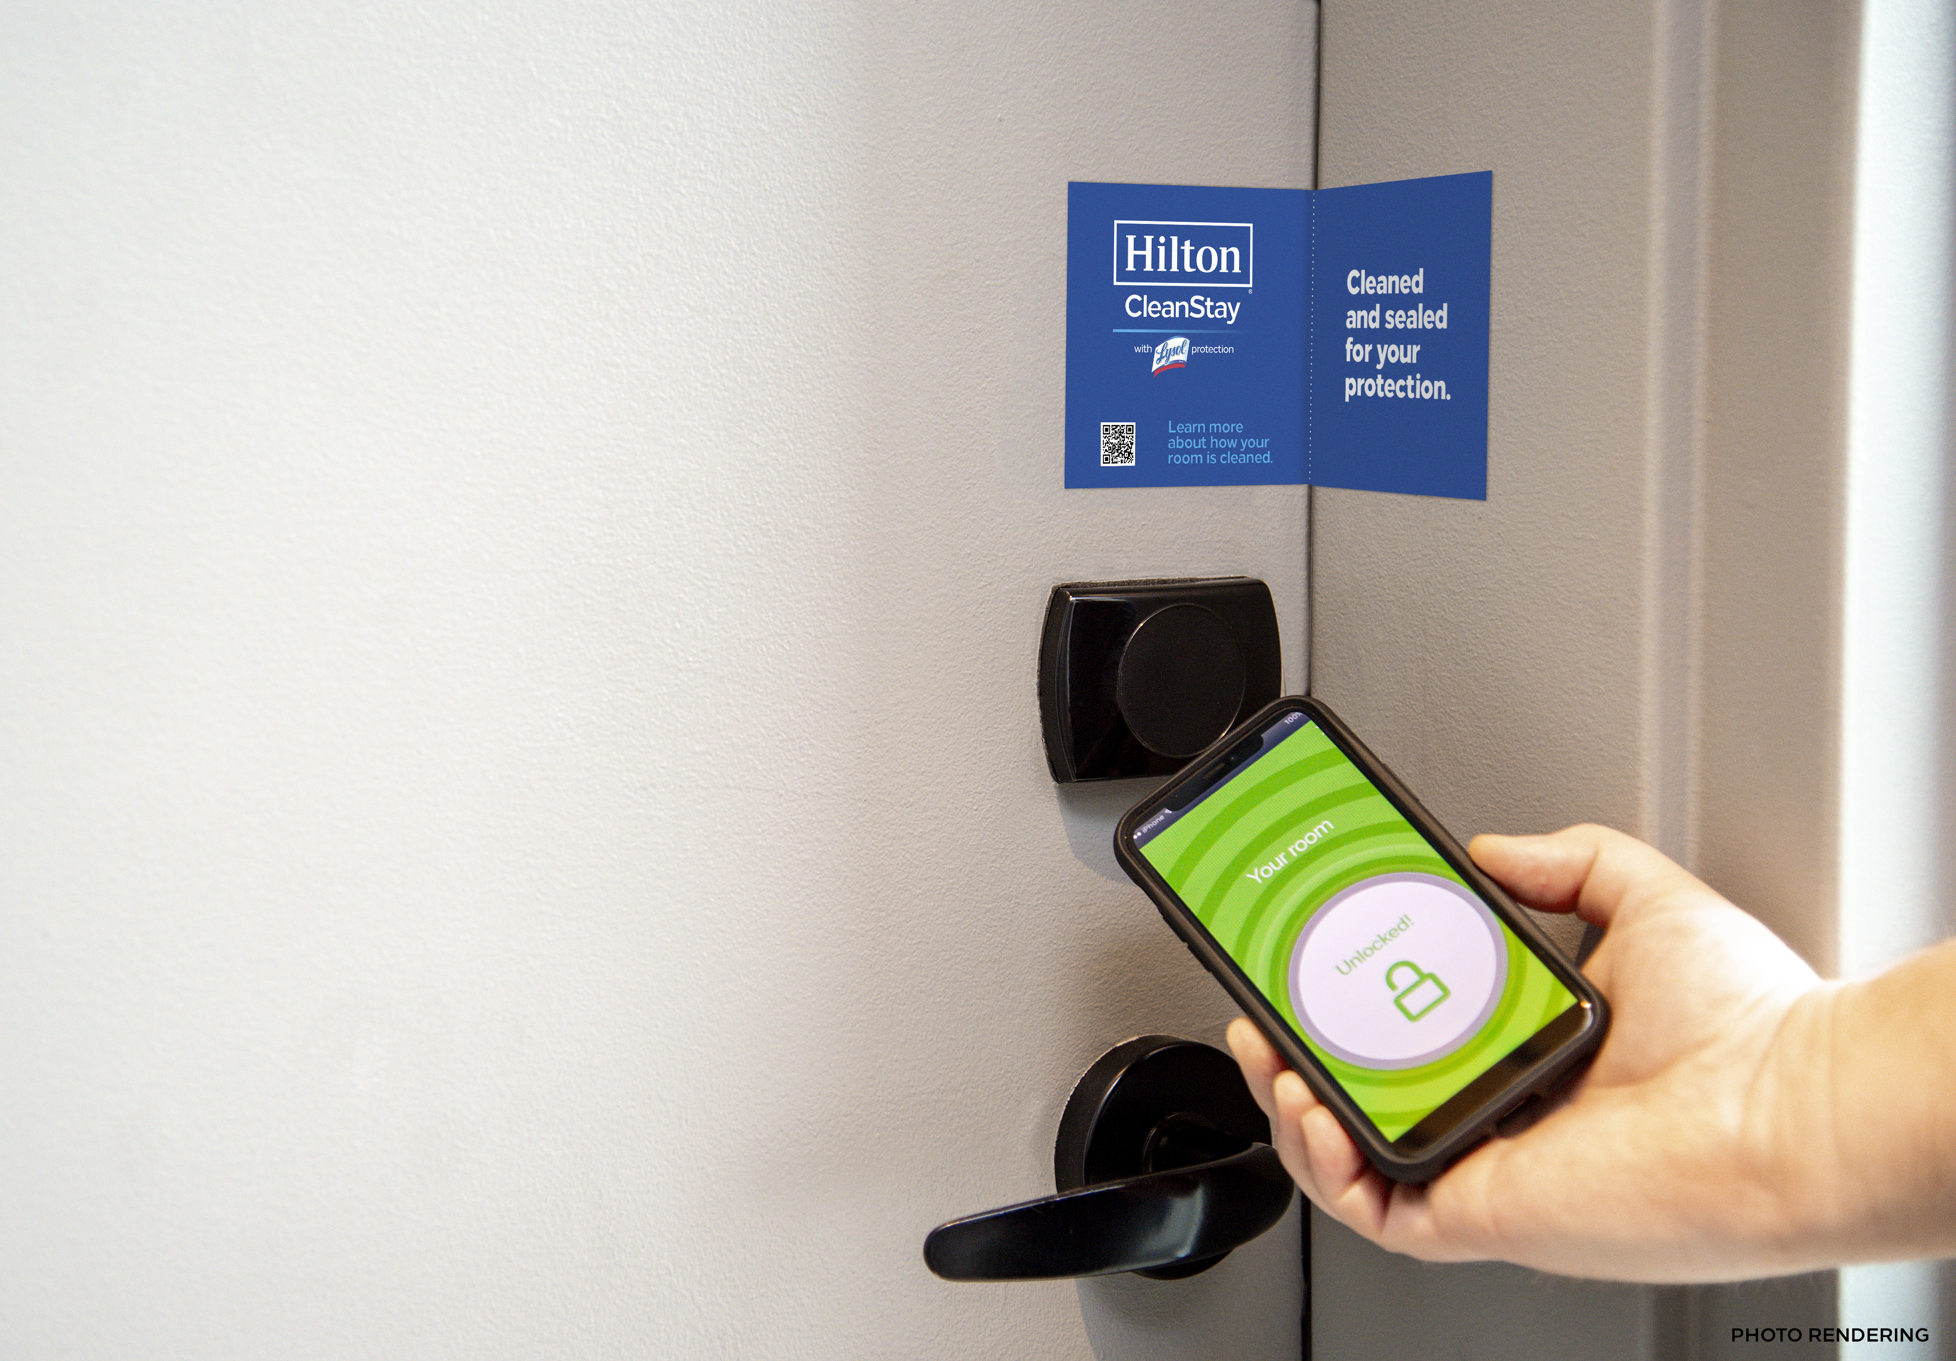

Source : https://newsroom.hilton.com/corporate/news/hilton-defining-new-standard-of-cleanliness

