1805378

EAEE5002
Reflections

Table of contents

Element 1 – Presentation References……………………………………………………………2
Element 2 – Reflective Log……………………………………………………………………..3-4
Element 3 – Briefing Paper……………………………………………………………………..5-6
References………………………………………………………………………….7
Element 4 – Personal Development Plan………………………………………………………..8-9

EAEE5007 1805378

References-Presentation
All Assignment help (2017) Your essential guide to Gibbs Reflective Cycle. Available at: https://www.allassignmenthelp.co.uk/blog/your-essential-guide-to-gibbs-reflective-cycle/ Accessed on 6th June 2019
Brodie (2010) Early years tips & ideas. Reflective practice and EYP. Available at: https://www.kathybrodie.com/viewpoint/reflective-practice-and-the-eyp/ Accessed 6th June 2019
Felstead, (2017) Gov.UK. Better Workplaces means better Learning. Available at: https://foresightprojects.blog.gov.uk/2017/06/13/better-workplaces-mean-better-learning/ Accessed: 5th June 2019
Gavett (2017) Harvard business reviews. The power of reflection at work. Available at: https://hbr.org/2014/05/the-power-of-reflection-at-work Accessed: 6th June 2019
Kelly (2015) Early years careers. Reflective practice. Available at: http://www.earlyyearscareers.com/eyc/latest-news/reflective-practice/ Accessed: 6th June 2019
Kelly, M (2018) ThoughtCo. The Importance of Teacher Reflection. Available at: https://www.thoughtco.com/importance-of-teacher-reflection-8322 Accessed: 5th June 2019
Liebenguth (2018) HR zone. Time to Reflect. Available at: https://www.hrzone.com/perform/people/time-to-reflect-why-does-it-matter-in-the-workplace Accessed: 6th June 2019
Mcleod, S (2018) Simply Psychology. Kolb’s Learning Cycle Available at: https://www.simplypsychology.org/learning-kolb.html Accessed 5th June 2019
Mind Tools (no date) Gibbs Reflective Cycle. Available at: https://www.mindtools.com/pages/article/reflective-cycle.htm Accessed: 6th June 2019
Skills you Need, (no date) Reflective Practice. Available at: https://www.skillsyouneed.com/ps/reflective-practice.html Accessed: 6th June 2019

Element 2 Reflective log EAEE5007 1805378
Disgrifiad byr o’r gweithgaredd (dim mwy na 50 o eiriau
Brief description of the activity (no more than 50 words)
The children are to create a collage from things collected from outdoors (pine cones, leaves, twigs etc…) to create an animal that would live in the Welsh countryside, the children will have collected the equipment the previous day and are now ready to sit and create their art work.

Nod/Amcan y gweithgaredd Aim/Objective of the activity
To create their own unique art work from their own collection of raw materials, to encourage children to think about what animals live on our doorstep. To develop their imagination and creative skills. To stimulate and encourage the children’s confidence in art. Early year’s art can have a positive impact on behaviour and emotional development, it can also have a positive effect on social and cultural prejudices (Blatchford 2002)

Eich rôl chi Your role
To capture their imagination and encourage them to use other sources to create their collage. To monitor and record the children’s experiences, take photos of their learning, and listen to their thoughts about the exercise. I will encourage and ask questions, such as, Why are you using that? The children are creating a countryside animal, so I will be asking them, where do these animals live, what foods do these animals like to eat. To ensure safety throughout the task, as scissors and glue will be being used.
Agweddau cadarnhaol – pam? Positive aspects – why?
Recycling outdoor materials, to demonstrate the use of other materials instead of pens and paint to create an art piece. Art has many positive effects on children, to their creative and physically wellbeing. This exercise will give the children chance to freely think of what choices to make, deciding which animal they want to create, what material they want to use, thus growing their confidence and encouraging decision making skills. Being outdoors during the collection of materials allowed the children to be physically active, walking, running and carrying their supplies. Being outdoors means the children have a positive appreciation of nature and the environment, it gave them an understanding of their surroundings. The activity gave the children chance to be independent, and allowed some element of risk, the children had to make their own decisions.

Agweddau heriol – pam? Challenging aspects – why?
Some children may find being able to create an animal using these materials challenging, so I will provide finished pieces as examples. Whilst some children can express themselves easily, others may find it tough to go it alone, I will offer gentle encouragement and guidance throughout the exercise. The age of the children, older children may find the task easier than smaller children, older children may find making a model instead of a image stuck down on card more interesting. Children with additional needs may find the fine motor skills tricky, they may struggle to get finished in the allocated time.
Pa wybodaeth arddangoswyd? What knowledge was demonstrated?
The children had great knowledge of what animals would be found in the Welsh countryside, they were able to demonstrate how to use pinecones as bodies and twigs as legs. Their understanding of the world, they were given the opportunity to go into the physical world and gather materials, the shapes and textures they collected went towards their mathematical knowledge. The children spoke about their creations and throughout the activity to myself and to their peers, their language and communications skills were enriched with new vocabulary.

Pa sgiliau arddangoswyd? What skills were demonstrated?
The ability to use glue, and to make a 3D image, their mathematical skills were being exercised as well as their listening skills (to instructions). The children’s creative skills, their ability to think and make their own decisions. Cutting skills, using scissors, their fine motor skills.

Pa werthoedd arddangoswyd? Which values were demonstrated?
The children learned to be patient and respect that other children were creating their own piece of work, the children learnt to share and to encourage each other whilst the task was being carried out. When each piece was finished, the children were encouraged to say what they liked about their own piece and others, this shows empathy and kindness. The children demonstrated an appreciation to the wildlife, and we spoke about looking after our woodland’s and outdoor space, so as to encourage the wildlife here in Wales.


An Early Year’s Practitioners Guide to show why reflective practice is important within the Early Year’s setting.
EAEE5002 1805378
Maintaining Quality Services to Children
The EYFS states that “Children develop quickly in the early years, and early years practitioners aim to do all they can to help children have the best possible start in life” To support children, practitioners analyse and observe, recording information and adjusting work accordingly, to enable the child to learn and thrive (EDC, 2019). As practitioners it is the reasonability of the individual to ensure that every child’s needs are met, In order for our settings to meet these needs, it is important for practices to reflect and learn new ways of developing and moving forward (Pacey, 2016).
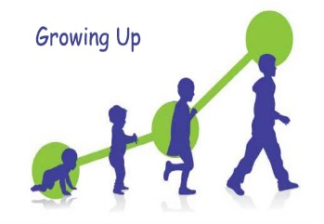
Children attend early years settings for a variety of reasons, however once they are a part of the setting it is the role of the practitioner to promote and support the skills children need to reach (Kelly, 2016)
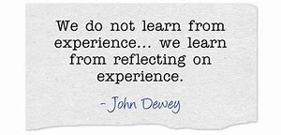
What could I do next time?
As childcare professional it is important to be open-minded, responsible and be Wholehearted about what we are teaching and learning children, these characteristics are what Dewey (1933, cited

in Lindon, 2012) states makes for reflective thinkers.
‘Reflection is an important human activity in which people recapture their experience, think about it, mull over & evaluate it. It is this working with experience that is important in learning’. Boud, D., Keogh, R. & Walker, D.

What is reflective practice?
As a professional in childcare and early years the aim is to provide the best care possible for the children within the setting. Reflective practice is an excellent way to maintain and continually improve the quality of the practice (Pacey, 2016)
To think about and reflect on what practitioners are doing, learn from experience and decide what to do next time differently (Skills you need, no date). Mint (2017) writes “Reflective practice helps you to strengthen your day to day practice”.
Reflection in the Early Years.
To enable practitioners to become a ‘Change agent’ reflective practice can be used for professionals to fulfil their role (Brodie, 2010). There are different methods for carrying out reflections, such as reflective logs and self-evaluation forms, and these can be done as individuals or as a group. Spalding and Wilson (2002, quoted in Ajguesdon, no date) argue that ‘reflective thinking is essential to identifying, analysing, and solving the complex problems that characterize classroom thinking’.
Did that go well?

Would it work better a different way?

To enable the practitioner to get the most from reflective practice, they will need to develop skills, skills which are used daily in every day life, but that need adapting for use in the professional environment – such as Audit skills (QCS, 2016) Looking at the way in which things are done in the setting and making comparisons about doing them differently next time.
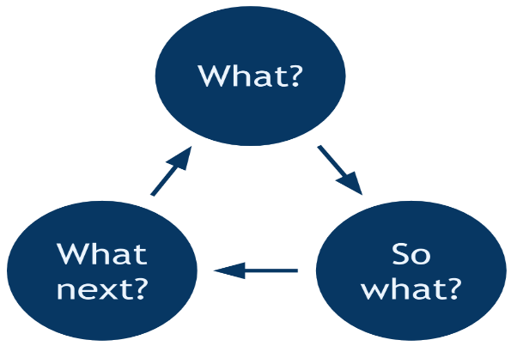

Pacey, 2016 states through reflection and continual improvement practitioners will achieve better outcomes for children. The benefits to children are:
- Increased self esteem
- Individual needs met
- Suitable resources
- Opportunities
- Interactive and appropriate environment
Benefits to the staff and parents will also be achieved through seeing changes and feeling confident about the care and high quality within the setting.
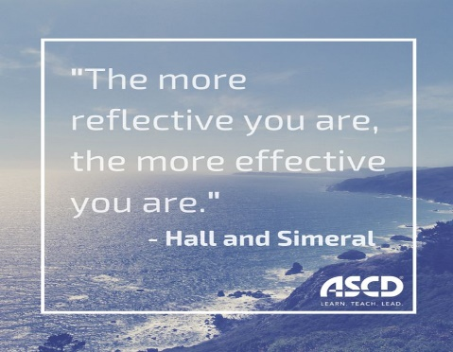
Whichever theory is chosen to use to help aid a child through their development, make sure the child is at the heart of whatever is planned (Kelly, 2016)

How to become more reflective?
According to Thum (2008) by following these 5 steps will allow for better reflection:

- Get into the right state and environment.
- Ask the right questions.
- Be 100% truthful.
- Attain clarity: Analyze the situation by writing and coming to a solution.
- Make a decision and commit to it

Realising your strengths and weaknesses is vital for reflection, working within a team, knowing someone else could be doing the same job better or a different way and it being more effective for the whole setting.
A learner can become more reflective by going over work he/she doesn't feel confident about (Kpodar, 2012)

Use A Reflective model to help…
Gibbs
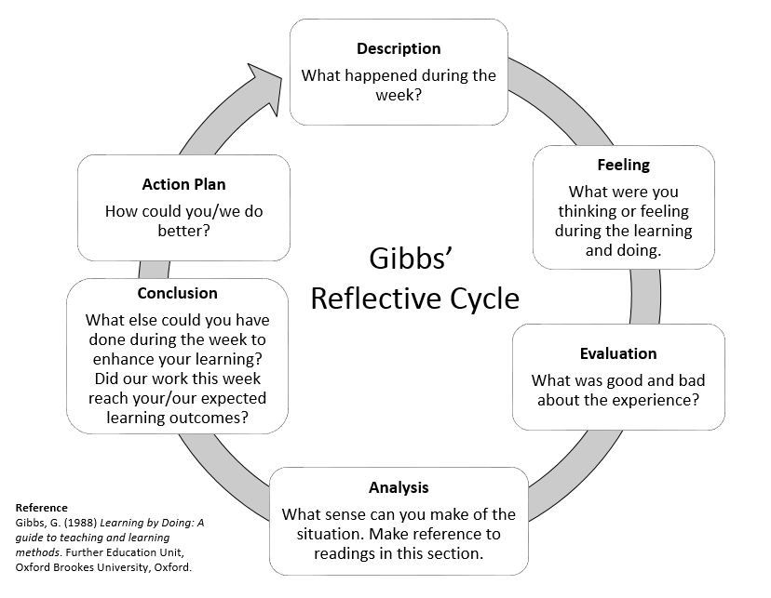
Career Experts (2016) states “If you have professional goals, are hungry for success or simply looking to be the best you can be at what you do, it’s time to take a long, hard look at yourself – you may be surprised at what you learn”!

EAEE5002 1805378
References

Ajguesdon, no date. John Dewey: How we think: Reflective Pratice, Journals and Logs. Available at: https://ajguesdon.wordpress.com/john-dewy-how-we-think-reflective-practice-journals-and-learning-logs/ Accessed: 10th June 2019
Boud D, Keogh R & Walker D (1985) Reflection: turning experience into learning. London: Kogan Page
Brodie K, 2010. Reflective Practice and the EYP. Available at: https://www.kathybrodie.com/viewpoint/reflective-practice-and-the-eyp/ Accessed: 10th June 2019.
Career experts, 2016. The importance of self-reflection. Available at: http://www.careerexperts.co.uk/career-progression/importance-of-self-reflection Accessed: 16th June 2019.
EDC, 2019. All Children Learn and Thrive. Available at: https://first10.org/ Accessed: 12th June 2019
Kelly, 2016. Early Years Careers. How early years practitioners can help develop children’s skills. Available at: http://www.earlyyearscareers.com/eyc/learning-and-development/how-early-years-practitioners-can-help-develop-childrens-skills/ Accessed: 12th June 2019
Kpodar, S. 2012. Quora. How does a learner become more effective. Available at: https://www.quora.com/How-does-a-learner-become-more-reflective Accessed: 13th June 2019.
Lindon, J. (2012) Reflective practice and early years professionalism. (2nd ed) Great Brittain: Hodder Education
Mint (2017). Benefits of being a reflective practitioner and how to reflect, Available at: https://www.mintpractice.co.uk/2017/01/benefits-of-being-a-reflective-practitioner-and-how-to-reflect/ Accessed: 10th June 2019
Pacey, 2016. Developing Self Reflective Practice. Available at: https://www.pacey.org.uk/Pacey/media/Website-files/PACEY%20member%20practice%20guides%20(PDFs)/PG04-self-reflective-practice.pdf Accessed: 12th June 2019
QCS, 2016. What is reflective practice and why is important? Available at: https://www.qcs.co.uk/reflective-practice-important/ Accessed: 10th June 2019
Skills you need, no date. Reflective practice. Available at: https://www.skillsyouneed.com/ps/reflective-practice.html Accessed: 10th June 2019
Thum, M. 2008. Self Reflection: How to do it right. Available at: https://www.myrkothum.com/self-reflection-how-to-do-it-right/ Accessed. 13th June 2019

Element 4 Personal Development Plan EAEE5007 1805378

Area for further development (provide further details) | Why? | How? | Who/Where? | When?
- Knowledge | Safeguarding children course, as my last one is coming to the end of the suggested 3 years requirements. | Complete an online course. | I can complete this course free on PACEY as a registered member online at home. | Within the next month, and then every 3 years
- Knowledge | Learning Welsh, to fully diverse with children and parents in my setting. | Start an online or group course. | Join CLWB CWTSH, an eight week beginners course. | Next course begins July.
- Skills | Creativity skills, I could learn to become more creative with the children, trying to capture their creativity. | Follow creative sites, such as Pinterest for ideas with children. | PACEY have special workshops and sites to use. | Straight away.
- Skills | My ability to work under pressure, planning activities and meeting deadlines. | Focus on time management, allow myself space to plan activities and adapt a better working environment for preparation. | Myself, at home in my setting, create an office space purely for me to work and prepare activities away from other distractions. | Within the next month.
- Values | Democracy, allowing children to make more of their own choices. | Give the children more free play, and allow them to decide what activities we do during the week, listen to their ideas and plan it into the weekly timetable. | Myself, plan their choices of activities into my planner. | In next week’s plan.
- Values | House Rules (Rules of law) following these at all times. So as to learn right from wrong, with clear boundaries. | Write the rules down and laminate them and put them where everyone can see. Talk through the rules, every time a new child enters the setting and recap daily. Reinforce rules when a child displays wrong behaviour and reward when a child is correctly using them. | Myself, place rules in a space easily viewed by all. | Within the month.
- Other | Become more confident within my self and give my self more credit for what I have achieved so far, be less negative and strive for more. | Take praise and not put myself down, look more positively. | Myself, complete a monthly self-evaluation questionnaire and use a reflective log to note my achievements. | Next month.

