
Wirecard AG
Assignment

CORPORATE GOVERNANCE

Submitted By:
Antar Podder
Student ID: 2505892
University Of Wales Trinity Saint David
MSc in Financial Management
Submitted to:
Badir Miftah
Lecturer in Finance
Institute of Management & Health (UWTSD)

Executive Summary

The assignment is all about corporate governance failure and earnings management issues. In this case, the author has chosen Wirecard AG, a fintech company based in Germany. Wirecard AG is a fintech company whose main task is to process debit and credit card payments. Wirecard was established in the year of 1999 and become a most successful financial service providing companies.
However, thing become changed in 2020 when their financial fraud came to light. The company has reported that 1.9 billion euro has been missing. In 2015 company joined the German stock exchange and become public limited company, and in 2018, it joined the DAX30 (Jörn Poltz, 2018).
Companies' top management manipulates financial statements to make the company look more profitable. They have said that their 1.9 billion euro which is missing its kept in the bank in the Philippines. But when reporters started questioning about the finances, their external auditor Ernst & Young did some investigation and concluded that this money was never deposited in the bank on Philippines, and this money became a missing amount ( Dan Byrne , 2020).
In the Wirecard AG company, there were presence of weak board oversight, which means the board does not monitor the senior management's activities properly. Also. They did not have a good internal control system by which they could verify every money transaction. Because of these reasons, Wirecard AG collapsed and filed for insolvency in the year of 2020 (Reuters, 2022).
Another thing is that companies’ top management failed to protect shareholders and stakeholders’ interests, they have acted to protect only their interest, according to the corporate governance code, they should have acted in a way to protect stakeholders and shareholders' interests rather than their own.
Lastly, this situation will not happen if the board successfully monitors some issues, such as senior or top management's activities, every transaction, and proper internal and external audit practices. Because of Wirecard AG's lack in these areas, they have collapsed and need to filed insolvency in the same year.

Contents
Executive Summary 2
Abbreviations & Meaning 5
Overview of the Company 6
Introduction 7
Begging to End the Flowchart 8
About the scandal 9
Why does Wirecard AG reported false information? 10
Who are the executives? 11
Analysis of the Earnings Management Issue 12
Key Factors That Contributed to the Problem 13
Weak Board Oversight 13
Financial Reporting Practices 13
Internal Control System 13
Regulatory Compliance 14
Ethical Evaluation Using Stakeholder Theory 15
Impact on Stakeholders and the Market 15
Employees 15
Customers 15
Suppliers 16
Providers of finance 16
Impact on Reputation 16
Impact on Share Price 17
Impact on Long-Term Performance 18
Agency theory at Wirecard AG 18
TYPE 1 Agency Problem: 19
TYPE 2 Agency Problem: 19
Corporate Governance Failure at Wirecard AG 19
Weak board oversight 20
Transparency 20
Internal Control and Risk Management 20
Failure of External Auditing 21
Lack of Accountability 21
Findings 21
Recommendations 22
Management Honesty & Transparency: 22
External Auditing: 23
Strong Internal Control Systems: 23
Poor Board Oversight: 23
Strong Corporate Governance: 23
Conclusion 24
Bibliography 25

Abbreviations & Meaning

DAX: DAX means Deutscher Aktienindex. It is the main stock market index in Germany.
CEO: Chief Executive Officer
COO: Chief Operating Officer
OECD: Organization for Economic Co-operation and Development
PLC: Public Limited Company
BOD: Board of Directors

Overview of the Company

Wirecard AG is a financial company, whose main task to provides digital payment and financial services around the world. The company was founded in 1999 and was headquartered in Aschheim near Munich, Germany. Its main business was helping companies accept and process electronic payments such as credit cards, mobile payments, and online transactions. (Forbes, 2020).
Wirecard AG worked in the financial technology and financial services industry. The company combined banking services with digital payment technology, and it offered different services such as processing online payments, issuing payment cards, mobile payment solutions, fraud detection, and risk management. These services helped businesses accept payments from customers both online and in physical shops. (Forbes, 2020).
The continuous growth in digital payment has pushed this company a lot, and for this reason company has grown quickly. In 2005, they merged with InfoGenie Europe AG, and in 2015, they were listed on Germany stock exchange. (Emil Persson, 2025). In 2018, they joined the DAX 30, which includes some of the biggest companies listed on the German stock market. (Stefan Zeranski & Ibrahim E. Sancak, 2020).
Even though, rapid growth company was later involved in the biggest fraud in Europe, in 2020, external auditors discovered that €1.9 billion of money reported in the company’s accounts did not exist. This thing led the company to collapse, and the company had to declare bankruptcy in 2020.
Before the scandal, Wirecard had more than 5,000 employees and operated in many countries as a large digital payment company. When the accounting fraud was discovered, investors lost trust in the company. This led to investigations by authorities and criminal charges against several senior executives. (Dustin Voss, 2020).
In the past, Wirecard was one of the most successful fintech company in the Europe. But when the company collapsed in 2020, it became one of the biggest financial frauds in German history. The case also showed serious problems in corporate governance, auditing, and financial regulation.

Introduction

Wirecard AG is company is financial service company, which was founded in 1999 and its headquarters are located in Aschheim near Munich, Germany. (Wirecard AG, 2026). Its main task is to process credit or debit card payments for the companies. Generally, big companies do not process payments, they hire companies like Wirecard AG to process their credit or debit card payments for them.
Wirecard AG played a crucial role in the fast-growing digital payments industry, by providing payment process service this companies helps businesses to take payments via debit or credit cards online. Because of their better service, they expand their businesses internationally and become a global business service provider that operates in many countries. (Stock analysis, 2026).
Wirecard AG becomes one of the most successful fintech companies in Europe because of massive growth in its financial performance. Because of their growth, they joined the DAX, which includes some of the biggest companies listed on the German stock market in 2018. During this periods company had a lot of employees and provided services globally (Oxford Business Law Blog, 2026).
However, this massive success of Wirecard became controversial in June 2020, when the company declared that €1.9 billion in their financial statements could not be found in its bank accounts. Later on, this issue led them to a massive financial fraud and raised serious concerns about financial reporting and corporate governance, also creates concerning things for investors. (Reuters, 2022).
After the controversy came out about the missing money, the company collapsed very quickly, and in June 2020 company filed for insolvency and become a biggest financial scandal and corporate governance failure in Europe’s financial history. (Hoje Jo, 2021). This issue damaged trust in the fintech industry, and this company becomes the real-life business and corporate governance failure example for financial studies.

Begging to End the Flowchart
1999: Founded

2005: Merger with InfoGenie Europe AG

2015: Listed on Frankfurt Stock Exchange

2018: Joined DAX 30

2020: Fraud Discovered (€1.9 billion missing)

2020: Company collapsed

2020: Company declares insolvency

Flow Chart: Journey of the Wirecard AG

NOTE: This Flow Chart is Created by the Author

About the scandal
In direct words, the fraud is mainly reporting money that did not even exist. Wirecard is a digital fintech company who processed digital payments for many companies globally, and it reported very strong growth and shows its profits are growing day by day. Because of their positive reports, they attract many investors; for this reason, a lot of investors invests on their company.
However, the main issues are that the missing money, a huge amount of money that does not actual exists, was reported in their financial report; the amount of money is €1.9 billion. They mentioned that this amount of money is kept in the bank in the Philippines. In the year 2020, one of the biggest accounting firms, Ernst & Young have doubts about this company while reviewing their financial statements, and they tried to verify this money.
The auditors contacted the banks in the Philippines, and the banks confirmed that this money did not exist. That represents that Wirecard AG’s published financial statements are not correct, and they have manipulated them. (Hoje Jo, 2021).
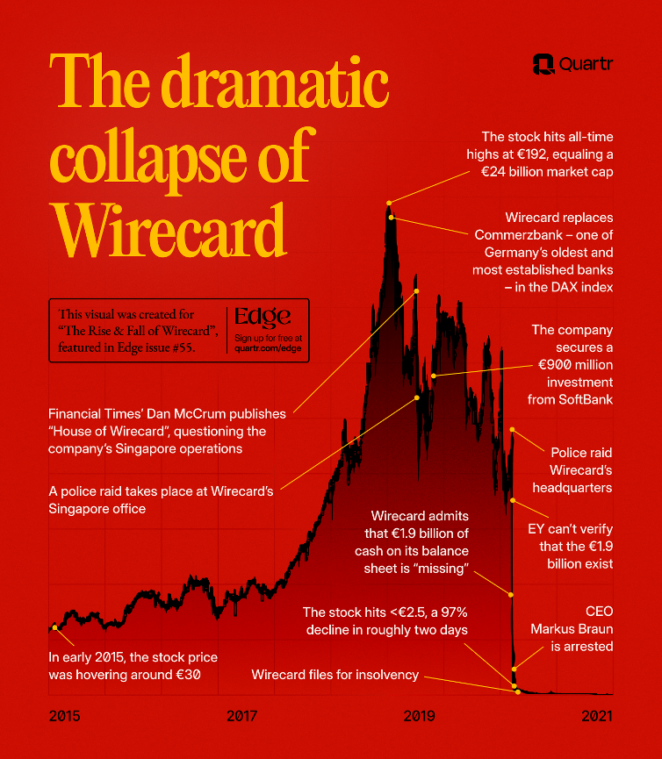
Infographic: Dramatic Collapse of Wirecard AG (Emil Persson, 2025).
Later investigations suggested that the company had been manipulating its accounts and creating fake transactions to make its profits appear higher than they actually were. By doing this, Wirecard created the impression that the company was performing well and continuing to grow, which helped maintain investor confidence. In the end, when the truth about the missing money came to light, the investors and general people lost trust in this company in 2020, that results a drastic decline, and the company collapsed. (Möllers, 2021).

Why does Wirecard AG reported false information?
Wirecard AG reported false financial information in its accounts. The company said that it had €1.9 billion in bank accounts, but later it was discovered that this money did not actually exist. Wirecard also showed higher profits in its financial reports, which were not real. Because of this, the company looked very successful and financially strong. The main reason for this fraud was to attract investors and increase the company’s share price. When investors saw high profits and strong financial reports, many of them trusted the company and invested in it. This helped Wirecard’s shares grow in the DAX stock market index (Reuters, 2022).

Who are the executives?
Markus Braun: Markus Braun was the CEO of Wirecard. Authorities say he played an important role in showing false financial information to investors. The company reported money and profits that were not real. In 2020, after the €1.9 billion fraud was discovered, Braun was arrested by German authorities (Financial Times, 2022). He was known as the new Steve Jobs of Germany.
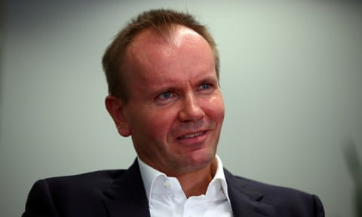
Infographic: Markus Braun, former CEO of Wirecard AG (Michael Dalder/Reuters, 2020).
Jan Marsalek – Jan Marsalek was the COO of the company. He managed many of Wirecard’s business operations, especially in Asia, where many of the suspicious and fake transactions were reported. When the scandal became public, Marsalek disappeared and has been missing since then. Authorities are still searching for him (Mark Jolley, 2024).
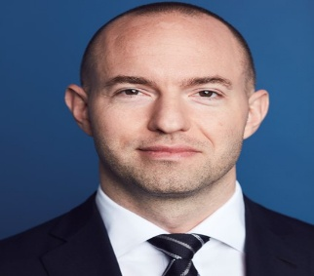
Infographic: Jan Marsalek, former COO of Wirecard AG (Leopold Fiala Photography, 2019).
Oliver Bellenhaus: Oliver Bellenhaus worked as the head of Wirecard’s subsidiary office in Dubai. He was accused of helping to create fake business deals and transactions. These false activities were used to make the company appear more profitable than it really was (Mark Jolley, 2024).

Infographic: Oliver Bellenhau, former head of Wirecard’s subsidiary office in Dubai (The Business Times , 2022).
Stephan von Erffa: Stephan von Erffa was the company’s accounting chief. He was responsible for the financial reporting of the company. Investigators later examined his role because the financial statements contained false information about the company’s money and profits (Mark Jolley, 2024).
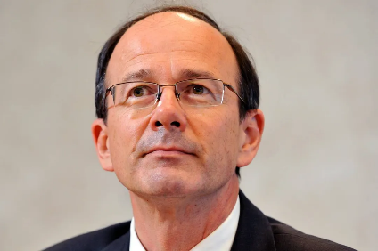
Infographic: Stephan von Erffa, former accounting chief of Wirecard AG (dpa, 2020).

Analysis of the Earnings Management Issue
Wirecard AG is a successful fintech company that was growing day by day. No one assumes that it will be involved in fraud. After the huge success of the company, the company listed on the Frankfurt Stock Exchange in 2015, and their continuous success pushed them, and they joined the DAX 30 index in 2018 (Reuters, 2022). Reports starts questing about their finances and financial statements from June 2019, and in 2020, an external audit revealed that the company claimed 1.9 euros they kept on bank in the Philippines, but the external audit called them they replied that 1.9 euros was never deposited and that became missing money. It is an earnings management problem, and because of this earnings management issue company collapsed and declared insolvency in 2020 (Emil Persson, 2025).

Key Factors That Contributed to the Problem
There are several factors that are contributed this problem, such as board oversight, financial reporting practices, internal controls, or regulatory compliance.

Weak Board Oversight
The main reason for the fraud was weak monitoring by the board of directors. From 2018, reporters have been starts questioning about company’s financial reports. At that time, the board did not start questioning the management, and it did not properly investigate. Because of this lack of supervision, management was able to control financial statements without proper checks, and in the end, for these reasons company collapsed (Martyn Fiddler, 2022).

Financial Reporting Practices
Wirecard AG used complex accounting methods, and it relied on third-party payment partners to process many of its transactions, especially in the international market, and more accurately in the Asian market. Because of this, these transactions were very difficult to verify, and for this reason, it became very easy for management to manipulate financial statements and show higher profits to attract investors and raise the share price (Xiaotong Li, 2025).

Internal Control System
Another thing is that this fraud issue clearly represents a weak internal control system in Wirecard AG. To maintain a good internal control system, companies should have proper procedures to verify cash and business transactions, which are missing here. In a strong company, transactions have to be verified and checked to confirm, which is not done here, and these things generated some opportunities for top management to manipulate financial data and create some fake documents (ABDELRAHIM AQQAD, M.Sc., CIA, CISA, CRISC, CGMA, ACCA DipIFR, PMI-RMP, CSSGB, 2024).

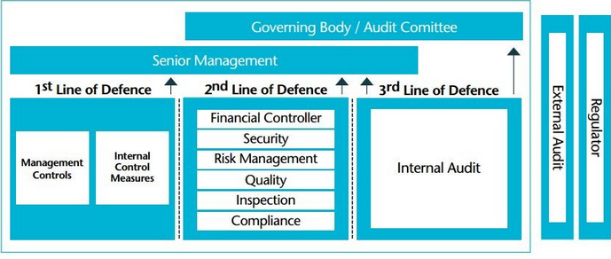
Infographic: Three lines of defense (ABDELRAHIM AQQAD, M.Sc., CIA, CISA, CRISC, CGMA, ACCA DipIFR, PMI-RMP, CSSGB, 2024).

Regulatory Compliance
Regulatory compliance also failed in this case. Ernst & Young approved Wirecard AG's financial statements for many years and did not detect the fraud. They were criticized for not investigating the allegations properly when these concerns were raised, and because of these things this fraud continued for a long run before it was finally revealed (Dr. T. P. Ghosh, 2021).

Infographic: Revenue and Total Assets of Wirecard 2005-18 (Source: Annual report of Wirecard)

Ethical Evaluation Using Stakeholder Theory
Stakeholder theory refers, companies have to consider the interests of all people who are related to the business, and companies can not only focus on making profits. Employees, customers, suppliers, and providers of finance are called stakeholders. This stakeholder theory suggests that businesses should act ethically and responsibly so that their decisions do not harm any of these groups. (Fares, 2021).
According to R. Edward Freeman, stakeholders can be affected by companies’ activities, so companies should behave in appropriate manners so that they cannot harm the interests of stakeholders.
In the case of Wirecard AG, the company clearly failed to follow Stakeholder Theory. The company reported false financial information and claimed it had around €1.9 billion in bank accounts, but the money did not actually exist. Later investigations showed that this amount was missing from the company’s accounts, which revealed a major financial fraud. (Shannon Moyer, 2020).
This fraud mainly benefited the top management of the company, also benefited the company in the short run, because in this process, they were able to show a good profit in the financial statement, and they can attract investors, but in the long run, the company will collapse. The problem became very serious mainly because of poor ethical decisions by the company’s leaders. Instead of correcting the financial reports and telling the truth, the executives kept hiding the fraud for many years. This dishonest behavior misled investors and other stakeholders.

Impact on Stakeholders and the Market

Employees
Wirecard AG became a huge company, and when it collapsed. In 2020, when the fraud was revealed, employees lost their jobs. As they were heavily dependent on their jobs as an internal stakeholder, they were negatively affected by the company’s fraud.

Customers
Customers are stakeholders because they depend on the company’s products and services. Wirecard AG provided digital payment services to many businesses around the world. When the fraud became public, many businesses that used Wirecard’s payment system faced problems and confusion with their financial transactions. Because of this, trust in the company dropped, and some businesses experienced difficulties in their daily operations. (Oxford Business Law Blog, 2026).

Suppliers
Suppliers and business partners are also stakeholders because they work with the company through contracts and cooperation. Wirecard AG had partnerships with many banks and payment service providers in different countries. When the fraud became public, many of these partners faced damage to their reputation and financial risk because they were connected with the company.

Providers of finance
Providers of finance include shareholders, banks, and other investors who give money to support the company. In the Wirecard scandal, investors were among the stakeholders most seriously affected. When it was discovered that €1.9 billion reported in the company’s accounts did not actually exist, the company’s share price dropped sharply, and it later went bankrupt. As a result, investors lost billions of euros, making it one of the largest corporate fraud cases in Europe. (Dan McCrum in London, Olaf Storbeck in Frankfurt, Stefania Palma in Singapore and John Reed in Bangkok, 2020).
If the company had followed ethical principles and considered its responsibilities to stakeholders, the scandal might have been avoided. The leaders of Wirecard AG should have ensured clear and transparent financial reporting, strong internal controls, and honest communication with investors and regulators. Independent auditors and board members should also have acted more carefully to protect the interests of stakeholders. Overall, the Wirecard scandal shows that ignoring stakeholder responsibility and ethical behavior can lead to serious corporate failure and cause major harm to many stakeholders.

Impact on Reputation
Wirecard AG’s accounting fraud badly hurt its reputation. Before the scandal, many people saw Wirecard as one of the top fintech companies in Europe. It was growing fast and was trusted by investors, banks, and business partners. Because it was part of the DAX, many people believed it was a strong and successful company.
But everything changed in 2020 when €1.9 billion in cash did not exist. After that, people quickly lost trust in Wirecard AG. Investors no longer believed in the Wirecard’s financial statements, and customers and partners are also becoming worried about dealing with the company (Reuters, 2022).
The scandal not only damaged Wirecard’s name. It also created serious doubts about Germany’s financial regulation, corporate governance, and auditing system. Many people started to ask how such a big fraud could go unnoticed for so long.

Impact on Share Price
The discovery of the fraud had an immediate impact on Wirecard’s share price. When the company announced in June 2020 that €1.9 billion in cash could not be found, investor confidence collapsed. Within a few days, the company’s share price fell by more than 90%, destroying billions of euros in market value (Kalyeena Makortoff, 2020).
Before the scandal, Wirecard’s market value had reached around €24 billion, but after the fraud was revealed, the value dropped sharply. This caused major financial losses for shareholders and institutional investors who had relied on the company’s financial statements when making investment decisions (Kalyeena Makortoff, 2020).
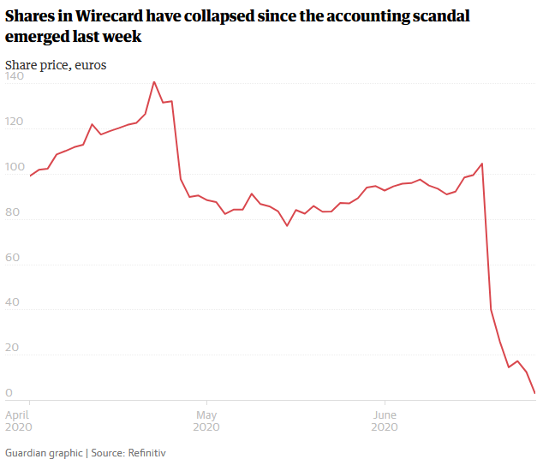
Infographic: Wirecard AG’s share Price dropped after the Fraud (Kalyeena Makortoff, 2020).

Impact on Long-Term Performance
The scandal destroyed Wirecard’s long-term performance. After it was confirmed that €1.9 billion reported in the company’s accounts was missing, banks and financial institutions quickly lost confidence in the company. Many business partners also ended their relationships with Wirecard. Without the trust of investors and financial institutions, the company was not able to continue normal operations. (Kalyeena Makortoff, 2020).
In June 2020, Wirecard filed for insolvency. It became the first company in the history of the DAX to collapse because of a major accounting fraud. As the company shut down, its business activities stopped, and thousands of employees lost their jobs (Emil Persson, 2025).
Today, the Wirecard scandal is often used as a major example of corporate governance failure and financial reporting fraud. The case shows how unethical leadership, weak internal controls, and poor oversight can destroy even a large public company.

Agency theory at Wirecard AG

Agency theory explains the relationship between shareholders and managers. Shareholders are the owners of shares of a company because they purchased the share and managers are the individuals who are responsible to run the business and protecting shareholders’ interests. Sometime manager act in their own interest rather than protecting shareholder interest, and this conflict is known as the agency problem (ACCA GLOBAL, 2025).
In the case of Wirecard AG’s accounting fraud can be clearly explained by agency theory. According to the agency theory manager should act in a way to protect shareholders interest but in the Wirecard AG company it was clearly visible that top management including CEO Markus Braun they are not honest and instead of being honest and protecting shareholders interest, they were involved in manipulating financial statement to look more profitable company and increasing share price, and hiding the actual financial condition of the company (Wienclaw, Ruth A., 2021).
Wirecard’s management reported profits that were not real and claimed that €1.9 billion was held in bank accounts, even though the money did not actually exist. By doing this, they made the company look financially strong and successful. This false picture helped keep investors confident and pushed the company’s share price higher. In the short term, these actions mainly helped the top executives. Their reputation improved, the company’s market value increased, and they benefited from bonuses and other rewards linked to the company’s performance.
However, when the fraud was finally discovered, the situation changed completely. Investors lost huge amounts of money, the company collapsed, and many other stakeholders were negatively affected.
There are 2 types of agency problems in the agency theory. Application of the agency theory to Wirecard AG below.

TYPE 1 Agency Problem:
Type 1 agency problem is when managers act in their own interest instead of shareholder interest. In the case of Wirecard AG, it was clearly visible that its top management acted in its own interest rather than in the shareholders' interest. According to this theory, management should be honest, and they are not allowed to change or manipulate any data in the financial statement, but they have done so to show Wirecard AG as more profitable and increase the share price. This clearly shows a conflict of interest between management and shareholders, which is the main characteristic of a Type 1 agency problem (Vince Ratnawati, Mohamad Ali Abdul-Hamid, Oluwatoyin Muse Johnson Popoola, 2016).

TYPE 2 Agency Problem:
Type 2 agency problem usually happens when the majority shareholders control the company and use their power to benefit themselves while harming minority shareholders. In this situation, the controlling owners may influence company decisions or move company resources for their own advantage. In the situation at Wirecard AG was different. In the Wirecard scandal, the main problem was caused by top managers, especially Markus Braun and Jan Marsalek. They manipulated the company’s financial reports and claimed that €1.9 billion existed in bank accounts when the money was actually missing. This made the company look financially strong and helped increase the share price. So, the conflict was between managers and shareholders, not between majority and minority shareholders. (Vince Ratnawati, Mohamad Ali Abdul-Hamid, Oluwatoyin Muse Johnson Popoola, 2016).

Corporate Governance Failure at Wirecard AG
The scandal of Wirecard AG is considered a major example of corporate governance failure. Corporate governance refers to the system of rules and structures that are used to guide and supervise how a company is managed. It includes the roles of the BOD, management, auditors, and regulators in ensuring that the company operates responsibly, transparently, and in the best interests of shareholders and other stakeholders. Strong corporate governance helps prevent fraud, improve accountability, and ensure that financial information is reported honestly.

Weak board oversight
In the case of Wirecard AG is an example of weak board oversight. The supervisory board is responsible for monitoring the actions of senior executives, but in the case of Wirecard AG, it was clearly visible that they did not effectively monitor the actions of senior or top management. Despite receiving continuous doubt about financial statements from the journalist, the board never investigated the actions of top management, which creates more opportunity for careless behavior for top management to continue their scandal and, as a result, to look more profitable. Top management manipulated financial data for a long time, and in the end, the company collapsed, and the company needed to filed insolvency (THE CFO, 2020).

Transparency
Transparency is an important part of strong corporate governance because it ensures that stakeholders receive clear and accurate information about a company’s activities. When companies share reliable information, investors, regulators, and other stakeholders can make better decisions. When transparency is weak, trust in the company can quickly decline, and corporate governance can fail (THE CFO, 2020).
One of the key causes of poor transparency is the failure to share important and accurate information about the company's finances. In this case, Wirecard AG, it is visible. Wirecard AG shares information that they want to share, but these are not actual information; these are generative financial data that are manipulated by the top management
When important information is not properly disclosed, stakeholders cannot clearly understand the company’s real performance and risks. This lack of openness can damage the company’s reputation, create legal problems, and reduce the confidence that investors and other stakeholders have in the organization.

Internal Control and Risk Management
There were also serious failures in internal controls and risk management. In an effective corporate governance requires strong internal systems to monitor financial activities and detect issues. In the case of Wirecard AG internal control system is absent or not strong; if its presence or strength were strong, this thing would not have prevented this from happening (THE CFO, 2020).

Failure of External Auditing
Another thing is that Ernst & Young approved Wirecard AG’s financial auditor for many years, and they have failed to detect these issues in the beginning to stop this thing. Because of these governance failures, the company’s management was able to manipulate financial statements and mislead investors for many years. When the missing €1.9 billion was finally discovered in 2020, the company quickly lost investor confidence and filed for insolvency (Emil Persson, 2025).

Lack of Accountability
In the case of Wirecard AG, accountability was very weak. Senior executives had significant control over the company’s financial reporting, but there was not enough effective oversight from the board and other monitoring bodies. Because of this lack of strong accountability, top managers were able to manipulate financial information for several years (THE CFO, 2020).

Findings

Based on the above case, the author has found out some of the key findings such as financial statement manipulation, weak corporate governance, poor internal control system, agency problem and etc (Emil Persson, 2025). Each them mentioned below:

Financial Statement Manipulation: Wirecard AG’s top management manipulated financial statements data to show more profit and hide the actual financial condition.

Weak Corporate Governance: The company’s board did not monitor the actions of senior management. Because of this reason, top management get chance to manipulate financial data to make the company look more profitable.

Poor Internal Control System: The Wirecard AG case showed a major problem in the company's internal control system. Companies internal control system should be careful and check each money transaction.

Failure of External Auditing: The external auditor, Ernst & Young, signed the company’s financial statements for many years and failed to detecting that €1.9 billion was missing. This indicates major weaknesses in the audit process and poor verification of the company’s financial information.

Presence of Type 1 Agency Problem: The case shows a Type 1 agency problem, where managers acted to protect their own interests rather than protect shareholder and stakeholder interests.

Severe Impact on Stakeholders: Because of the scandal, stakeholders were seriously harmed. Investors lost billions of euros, many employees lost their jobs after the company collapsed, and the case reduced trust in financial markets and corporate governance systems.

Recommendations

Management Honesty & Transparency:
Honesty is the key factor that will help to protect shareholders' and stakeholders' interests. If a company's top managements are honest, they will never manipulate data to hide anything from the shareholder & stakeholders.
In the case of Wirecard AG, it is seen that managements are not honest and they manipulate financial statements to look more profitable in the short term, which is not an ethical thing in a public limited company. Because of this thing, in the end company has collapsed and needs to filed insolvency (Reuters, 2022).

External Auditing:
In a public limited company, there are two types of auditors, one is internal auditor and one is an external auditor. An internal auditor has management pressure, but an external auditor doesn’t. So, external auditors need to be more careful when they sign the financial statement of any company.
In Wirecard AG, it is clearly noted that the auditing company who have signed their financial report for several years has not played a careful role here. Ernst & Young, which has been the auditor for the last several years at Wirecard AG, they had been careful from the beginning, then the company may not have collapsed, and they could have identified the issue in the beginning ( Dr. Wolf H. von Bernuth,Dr. Philipp F. Hardung ,Falk Emmerich, 2023).

Strong Internal Control Systems:
A stronger internal control system can help to prevent financial manipulation in a public limited company. Companies should implement an internal verification system for every money transaction, and regular internal audits should be conducted for internal verification.
In the case of Wirecard it is visible that they have a bad internal control. And there is a presence of an internal auditor, but they may have faced too much management pressure, and because of this reason they were not able to perform their duties properly (Emil Persson, 2025).

Poor Board Oversight:
In a public limited company, Companies board has to monitor the activities of top management, if it fails to perform its duties, it may create opportunities for manipulation by the senior or top management in the company.
In the case of Wirecard AG, it is clearly visible that the board does not carefully monitor the senior management's activities and that have makes managements easier to manipulate financial statements (THE CFO, 2020).

Strong Corporate Governance:
Corporate Governance simply means rules and regulations. Corporate Governance refers to how the company’s senior management will make decisions by protecting shareholders' and stakeholders' interests (OECD, 2026).
In the case of Wirecard AG, the supervisory board failed to perform its duties, they needed to monitor and questioned to the top management's activities. If they have done that in the past, then later the company will not collapse.

Conclusion

Wirecard AG, one of the most successful fintech company become a company which is collapsed and needs to file for insolvency because of corporate governance failure. Once this company joined DAX 30, they have now collapsed. The Wirecard AG scandal is considered one of the major fraud cases in European financial history.
The Wirecard AG case highlights some important key factors, such as failure in internal control, weak board oversight, management pressure on internal audit, and failure of external auditing. Wirecard AG’s top management manipulated financial data to make the company look more profitable, and this thing at the results €1.9 billion loss (Emil Persson, 2025).
In Wirecard AG, it is clearly visible that there is a presence of a type 1 agency problem. Wirecard’s top management manipulates financial data to protect their own interest but they should act to protect shareholders' and stakeholders' interests (Vince Ratnawati, Mohamad Ali Abdul-Hamid, Oluwatoyin Muse Johnson Popoola, 2016).
The Wirecard AG’s case tells how weak corporate governance. A poor monitoring system can lead to serious financial fraud. The scandal shows that when managers are not monitored, they can manipulate financial data to protect their interests and personal benefit. SO, to prevent these problems strong corporate governance system, transparency in financial statement and an effective monitoring system should be implemented in the public limited company (JOHN C. COFFEE, JR, 2005).

Bibliography
Dan Byrne , 2020. The Corporate Governance Institute.. [Online]
Available at: https://www.thecorporategovernanceinstitute.com/insights/news-analysis/audit-scandal-wirecards-finance-chief-admits-forging-documents/
[Accessed 14 3 2026].
Dr. Wolf H. von Bernuth,Dr. Philipp F. Hardung ,Falk Emmerich, 2023. The Hausfeld. [Online]
Available at: https://www.hausfeld.com/en-gb/news/wirecard-scandal-hausfeld-claims-damages-on-behalf-of-institutional-investors
[Accessed 13 3 2026].
ABDELRAHIM AQQAD, M.Sc., CIA, CISA, CRISC, CGMA, ACCA DipIFR, PMI-RMP, CSSGB, 2024. LinkedIn. [Online]
Available at: https://www.linkedin.com/pulse/internal-control-over-financial-reporting-icfr-a-czc5e/
[Accessed 10 3 2026].
ACCA GLOBAL, 2025. ACCA GLOBAL. [Online]
Available at: https://www.accaglobal.com/uk/en/student/exam-support-resources/professional-exams-study-resources/strategic-business-leader/technical-articles/corporate-governance-inside-out.html#Agency-theory
[Accessed 11 3 2026].
Dan McCrum in London, Olaf Storbeck in Frankfurt, Stefania Palma in Singapore and John Reed in Bangkok, 2020. Financial Times. [Online]
Available at: https://www.ft.com/content/ac949729-6167-4b6c-ac3f-f0aa71aca193
[Accessed 7 3 2026].
dpa, 2020. FinanzBusiness. [Online]
Available at: https://finanzbusiness.de/nachrichten/banken/article12413733.ece
[Accessed 9 3 2026].
Dr. T. P. Ghosh, 2021. Wirecard collapse, Ernst & Young audit failure and investigative journalism of Dan McCrum: A case of misplaced auditor’s professional skepticism. Wirecard collapse, Ernst & Young audit failure and investigative journalism of Dan McCrum: A case of misplaced auditor’s professional skepticism, Issue Wirecard collapse, Ernst & Young audit failure and investigative journalism of Dan McCrum: A case of misplaced auditor’s professional skepticism.
Dustin Voss, 2020. The London School of Economics & Political Science (LSE). [Online]
Available at: https://blogs.lse.ac.uk/europpblog/2020/11/19/what-the-wirecard-scandal-reveals-about-the-state-of-german-financial-supervision/
[Accessed 9 3 2026].
Emil Persson, 2025. Quartr. [Online]
Available at: https://quartr.com/insights/edge/the-rise-and-fall-of-wirecard
[Accessed 9 3 2026].
Fares, J. C. K. a. A. A. (., 2021. National Library. Stakeholder theory and management.
Financial Times, 2022. Financial Times. [Online]
Available at: https://www.ft.com/wirecard
[Accessed 6 3 2026].
Forbes, 2020. Forbes. [Online]
Available at: https://www.forbes.com/companies/wirecard/
[Accessed 9 3 2026].
Hoje Jo, A. H. R. L.-P. a. J. V.-V., 2021. European Journal of Business and Management Research. Corporate Governance and Financial Fraud of Wirecard, Issue Corporate Governance and Financial Fraud of Wirecard.
JOHN C. COFFEE, JR, 2005. OXFORD REVIEW OF ECONOMIC POLICY. A THEORY OF CORPORATE.
Jörn Poltz, 2018. Reuters. [Online]
Available at: https://www.reuters.com/article/business/dax-newcomer-wirecard-sees-plenty-more-room-for-growth-idUSKCN1LM1P7/
[Accessed 14 3 2026].
Kalyeena Makortoff, 2020. The Guardian. [Online]
Available at: https://www.theguardian.com/business/2020/jun/25/wirecard-files-for-insolvency-amid-german-accounting-scandal
[Accessed 11 3 2026].
Leopold Fiala Photography, 2019. BKA. [Online]
Available at: https://www.bka.de/DE/IhreSicherheit/Fahndungen/Personen/BekanntePersonen/Jan_Marsalek_wirecard/Sachverhalt.html
[Accessed 10 3 2026].
Mark Jolley, 2024. Transparently. [Online]
Available at: https://www.transparently.ai/blog/how-the-wirecard-scandal-happened
[Accessed 6 3 2026].
Martyn Fiddler, 2022. Martyn Fiddler. [Online]
Available at: https://www.martynfiddler.com/assets/case-studies-in-bad-governance-boeing-and-wirecard/
[Accessed 10 3 2026].
Michael Dalder/Reuters, 2020. The Guardian. [Online]
Available at: https://www.theguardian.com/business/2020/jun/23/former-wirecard-ceo-markus-braun-arrested-in-germany
[Accessed 10 3 2026].
Möllers, T. M. J., 2021. The Wirecard Accounting Scandal in Germany, and How the Financial Industry Failed to Spot It. The Wirecard Accounting Scandal in Germany, Issue The Wirecard Accounting Scandal in Germany, and.
OECD, 2026. OECD. [Online]
Available at: https://www.oecd.org/en/topics/corporate-governance.html
[Accessed 13 3 2026].
Oxford Business Law Blog, 2026. Oxford Business Law Blog. [Online]
Available at: https://blogs.law.ox.ac.uk/business-law-blog/blog/2020/10/wirecard-scandal-high-speed-rise-and-fall-fintech-company-and-its
[Accessed 6 3 2026].
Reuters, 2022. Reuters. [Online]
Available at: https://www.reuters.com/business/finance/rise-fall-wirecard-2022-12-06/
[Accessed 6 3 2026].
Reuters, 2022. Reuters. [Online]
Available at: https://www.reuters.com/business/finance/rise-fall-wirecard-2022-12-06/
[Accessed 6 3 2026].
Shannon Moyer, 2020. Accountancy Age. [Online]
Available at: https://accountancyage.com/2020/06/22/eys-wirecard-audit-exposes-potential-fraud/
[Accessed 6 3 2026].
Stefan Zeranski & Ibrahim E. Sancak, 2020. Oxford Business Law Blog. [Online]
Available at: https://blogs.law.ox.ac.uk/business-law-blog/blog/2020/10/wirecard-scandal-high-speed-rise-and-fall-fintech-company-and-its#:~:text=Founded%20in%20Germany%20in%201999%2C%20Wirecard%20AG,around%20%E2%82%AC%2024%20billion%20in%20September%202018.
[Accessed 9 3 2026].
Stock analysis, 2026. Stock Analysis. [Online]
Available at: https://stockanalysis.com/quote/otc/WRCDF/company/
[Accessed 6 3 2026].
The Business Times , 2022. The Business Times. [Online]
Available at: https://www.businesstimes.com.sg/international/former-wirecard-exec-admits-guilt-pins-fraud-blame-ex-ceo
[Accessed 9 3 2026].
THE CFO, 2020. THE CFO. [Online]
Available at: https://the-cfo.io/2020/02/23/most-common-reasons-for-corporate-governance-failure/
[Accessed 12 3 2026].
Vince Ratnawati, Mohamad Ali Abdul-Hamid, Oluwatoyin Muse Johnson Popoola, 2016. International Journal of Economics and Financial Issues. International Journal of Economics and Financial Issues.
Wienclaw, Ruth A., 2021. EBSCO. [Online]
Available at: https://www.ebsco.com/research-starters/economics/agency-theory-and-corporate-governance
[Accessed 11 3 2026].
Wirecard AG, 2026. Wirecard AG. [Online]
Available at: https://www.wirecard.co.uk/
[Accessed 6 3 2026].
Xiaotong Li, 2025. Financial Fraud, Audit Failure, and Regulatory Oversight Breakdown: An Empirical Analysis of the Wirecard Scandal. Financial Fraud, Audit Failure, and Regulatory Oversight Breakdown: An Empirical Analysis of the Wirecard Scandal, Issue Financial Fraud, Audit Failure, and Regulatory Oversight Breakdown: An Empirical Analysis of the Wirecard Scandal.

