PROJECT MANAGEMENT

Student Name: Sana Arif

Student Number: 2116663

Lecture Name: Aderemi Ojebode (Dr)

Module Code: BMSW5104

Date: September 2023

Executive Summary –
Joyful Nursery is a premium childcare facility located in a prime residential area, catering to the needs of parents seeking a safe and nurturing environment for their children. With a mission to provide excellent early childhood education and care, our nursery is committed to fostering the holistic development of each child in our care. Our nursery offers a range of programs tailored to different age groups, including infants, toddlers, and preschoolers. We prioritize creating a joyful and stimulating environment through play-based learning, structured activities, and age-appropriate curriculum delivery.

TABLE OF CONTENTS
Executive summary………………………………………………………………………………………3

Introduction 3
The description of the project 3
Project scope 4
Work breakdown structure 6
Quad chart 8
Gantt Chart 12
Stakeholder investment 13
Allocation of resources 14
Risk analysis 15
Conclusion 18
Reference list 19

TASK 2

Introduction

The market for childcare assistance has especially advanced in Birmingham because of the city’s work-from-home procedures being released. The problem that working parents have in misrepresenting their experienced responsibilities with childcare has increased the need for easily available and trustworthy daycare resolution. As business proprietors, it can be comprehended that the growing need for childcare is not possible to go away given the continuous issue of growing childcare expenditures and the absence of parent-friendly daycare opportunities. Various acknowledge that beginning a conservatory enterprise would be a great way to meet this increasing demand.

The description of the project

The task concerns starting a nursery called ‘Joyful Nursery’ enterprise as a reaction to the growing need for services across the UK because of the country's decision to stop presenting work-from-home possibilities. Joyful Nursery has a sharp focus on cost control, operational effectiveness, client satisfaction, and communication gaps, aims to create a competitive and sustainable enterprise in addition to meeting working parents' urgent childcare requirements. A thorough approach to market research will pinpoint needs and preferences, making it possible to create a strong plan for branding and advertising. Setting a strong focus on differentiated services will set the joyful nursery apart in a competitive market. Financial resilience will require effective cost management strategies, such as thorough budgeting and resource optimisation. To cut costs, the study will also investigate environmentally friendly methods. Strict safety regulations, reduced procedures for administration, and employee training will all contribute to efficiency in operations.
A child-centered strategy will guarantee that the joyful nursery offers a caring, secure, and engaging environment, and additional amenities with adaptable timetable choices will meet the various demands of working parents. Building confidence and fulfilment with parenting will need ongoing interaction through feedback channels (Shirley, 2020). To put it briefly, the goal of this project is to create an early childhood center that not only adheres to but also exceeds the childcare needs of parents with careers in the UK by taking advantage of the continuing need for parenting, filling in gaps in marketplaces, controlling costs effectively, maintaining superior operational performance, and placing a high priority on pleasing clients.

Project scope

Objectives:
- Create a nursery company (Joyful Nursery) to meet the growing need for childcare services in Birmingham United Kingdom.
- Offer working parents early childhood education and childcare services of the highest caliber.
- Close market gaps and satisfy customers to build a lucrative and sustainable business.
Constraints:
- Budgetary restrictions, with a £500,000 maximum investment cap, are among the constraints.
- Adherence to UK safety and childcare regulations.
- Project execution has a 12-month time limit from planning to facility opening.
Deliverables:
- A childcare facility with a minimum capacity of 50 children that is fully licensed and operating.
- A thorough marketing strategy that includes a powerful internet presence, advertising materials, and a brand identity.
- Trained and qualified nursery employees, such as support workers and teachers.
- Efficient software tools and administrative procedures for scheduling, admissions, and parent communication (Collett et al., 2020).
- Strict safety procedures, such as hygienic and health requirements.
- Curriculum and resources for early childhood education.
- Ecofriendly substitutes and sustainable methods for improved operational effectiveness.

The project's scope includes setting up a nursery with specific goals to meet the demand for childcare, adhere to financial and legal requirements, and provide several necessary elements, such as a fully functional facility, marketing plans, skilled employees, effective procedures, safety measures, instructional materials, and environmentally friendly practices.

Work breakdown structure

Phase 1: Scheduling and Getting Ready

Analysis and Research on the Market:
- Determine market segments based on geography and demographics.
- Evaluate the competitive environment.
- Examine the preferences and needs of working parents for childcare.
- Financial Planning: Create a budget that accounts for both startup and ongoing expenses.
- Obtain capital or sources of investment.

Legal and Regulation Compliance:
- Examine and follow UK childcare laws.
- Obtain the required authorizations and licenses (Donald et al., 2019).

Phase 2: Establishing Infrastructure and Resources

Location Selection:
- Find and acquire an appropriate building or location for Joyful nursery.
- Verify compliance with safety and accessibility reg ulations.

Renovating and setting up the facility:
- Create a nursery area with kid-friendly furnishings and security measures.
- Invest in and install the required classroom supplies, furniture, and equipment.

Hiring and Training Staff:
- Find competent educators and support personnel.
- Offer instruction on childcare and safety procedures.

Phase 3: Branding and Marketing

Brand Development:
- Construct a memorable and appealing brand identity.
- Create a website, a logo, and marketing collateral.
- Marketing strategies include creating a website and using social media to have an online presence.
- Form alliances for reciprocal marketing with nearby companies.
- Outreach and Advertising: Execute focused advertising efforts.
- Take part in networking and community outreach.

Phase 4: Customer Engagement and Operations

- Everyday Operations: Put in place administrative procedures for scheduling, admissions, and parent correspondence.
- Assure excellent care and safety procedures.

Educational Programs
- Create and implement a well-organized curriculum for early childhood education. Offer children an engaging learning environment.
- Customer relations: Establish avenues for feedback and keep lines of contact open with parents.
- Respond to complaints and keep making service improvements.

With a heavy emphasis on consumer interaction and education, the Work Breakdown Structure (WBS) breaks down the project into four separate phases: initial planning and preparations, infrastructure setup, marketing and branding, and daily operations. Every phase consists of certain duties and subtasks that are necessary for the nursery business to be established successfully.

Quad chart

Project Management Plan for Opening a Nursery

Objective
To launch a prosperous nursery business in reaction to the improved market for childcare services due to the removal of government work-from-home advice.

Benefits
- Perform a vital societal need.
- Create a profitable and sustainable venture (Takako et al., 2020).
- Support working parents and children.

Challenges
- Initial investment limitations.
- Regulatory compliance complexities.
- Competitive childcare industry.
- Rapid project execution.

Planning and Market Analysis (Phase 1)

Objectives
- Identify market gaps
- Develop a budget
- Ensure legal compliance

Key activities:
- Market research and competitor analysis.
- Budget planning and funding acquisition.
- Regulatory research and license acquisition.
Milestones:
- Completion of market analysis.
- Budget approval.
- Acquiring necessary licenses.

Risks:
- Inaccurate market research.
- Budget overrun.
- Regulatory hurdles.

Table 2: Quad chart of Planning and Market Analysis (Phase 1)
(Source: self-created)

Setup of infrastructure (phase 2)

Objectives
- Secure a suitable location.
- Set up child-friendly facilities.
- Recruit and train staff.

Key Activities
- Property selection and renovation.
- Furniture and equipment purchase (Kemp et al., 2021).
- Staff recruitment and training.

Milestones
- Secured property.
- Fully equipped nursery.
- Trained staff.
Risks
- Delays in property acquisition.
- Renovation issues.
- Staff shortages.

Table 2: Quad chart Setup of infrastructure (phase 2)

(Source: self-created)
Branding and marketing (phase 3)
Objectives
- Develop a strong brand.
- Create effective marketing strategies – Use Social Media
- Reach the target audience.
Key Activities
- Brand identity creation.
- Website and social media development.
- Marketing campaigns and local partnerships.
Milestones
- Established brand identity.
- Online presence.
- Effective marketing campaigns.

Risks
- Weak brand recognition.
- Ineffective marketing.
- Limited outreach.

Table 3: Quad chart of Branding and marketing (phase 3)
(Source: self-created)

Customer Engagement and Operations (Phase 4)

Objectives
- Efficient daily operations
- High-quality education and care
- Continuous customer satisfaction.
Key Activities

- Administrative processes setup
- Educational curriculum development (Park & Pierce, 2020).
- Customer feedback channels.

Milestones
- Smooth daily operations.
- Well-implemented curriculum.
- Positive customer feedback.
Risks
- Operational inefficiencies.
- Quality concerns.
- Poor customer relations.

Table 4: Quad chart of Customer Engagement and Operations (Phase 4)
(Source: self-created)

Gantt chart

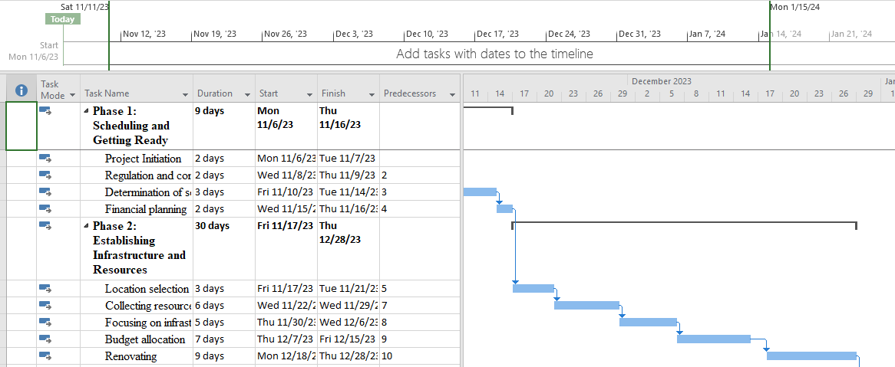
Figure 1: Phase 1 & 2
(Source: self-created)

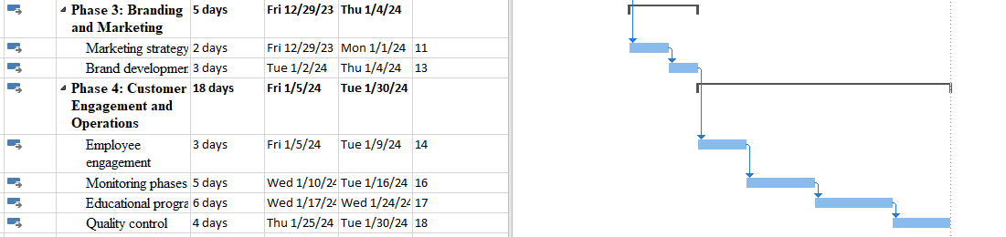
Figure 2: Phase 3 & 4
(Source: self-created)

Stakeholder investment

Investors

Investors play a vital role in the success of Joyful Nursery by providing the necessary financial support and guidance. Their investment enables the nursery and ongoing operation of the nursery, ensuring it meets the needs of its target market being parents and their children. Also, investors may contribute industry expertise e.g. knowing the correct way to market for children, valuable connections e.g. vendors and suppliers, and mentorship to the nursery's management team e.g. putting the staff on accredited courses that are specific for teachers. Maintaining a strong relationship with these investors is crucial for transparency, trust-building, and potentially attracting more investments as the nursery expands.

Parents/ Guardians

Parents and guardians play a pivotal role in the success and sustainability of Joyful Nursery. Not only do they provide a continuous stream of revenue through tuition fees if they are not paying fees and the government is providing grants for those families, but they also actively participate in their child's education and contribute valuable feedback and insights this will mean they are constantly getting feedback on how to improve. Their engagement and collaboration ensure that the nursery consistently improves and meets the needs of the children and their families. By fostering open communication and transparency, the nursery can cultivate a strong partnership with parents, creating a sense of ownership and pride within the community while providing a high-quality education and care for their children.

Nursery staff

The staff at Joyful Nursery play an indispensable role in the nursery's operation and success. They invest their time, expertise, and dedication to provide a safe, nurturing, and educational environment for the children. Through continuous training and professional development, they stay updated on the best practices in child development and safety. They invest in building strong relationships with the children, their families, and the community, fostering open communication and trust. The staff's commitment and passion for early childhood education contribute greatly to the nursery's overall quality and the growth and development of the children in their care.

Regulatory authority

The local authority plays a crucial role in the operations and success of Joyful Nursery. They invest in ensuring that the nursery meets all necessary licensing e.g. license to cater to children and regulatory requirements e.g. making sure all staffs DBS checks are completed before employment, ensuring the health, safety, and well-being of the children this will mean the children as well as staff are being protected. The authority also provides guidance and support for the nursery staff in terms of policies, procedures, and best practices. They may invest in inspections and assessments to monitor the quality of care provided and offer recommendations for improvement.

Allocation of resources

Allocating resources wisely is a crucial component of every project, and when it comes to starting a nursery, it's especially important to ensure its success. The £100,000 project funding will be distributed with the priority of paying staff salary for the first three months, together with the essential components of equipment and premises.

- Buildings and Equipment (70% Allotted):

Allocation of Budget: £70,000
Goal: Most of the funds will go toward finding an appropriate location, making sure it's furnished, and taking care of the necessities for nursery supplies, food service, and décor.
Distribution: - £68,000 will be used to pay for the lease of the buildings, which includes rent and other related expenses.
The remaining £2,000 will be used to buy materials and equipment that both classrooms require, dividing them equally. This covers toys, safety gear, furnishings, and educational supplies.
Stock Maintenance: To guarantee prompt replacement in the event of damage or wear and tear, a minimum of 100% of the equipment stock will be kept in storage. As a result, nursery activities are protected.

2. Staff Wages (30% of First Three Months Budget):

Allocation of Budget: £30,000
Goal: To assist in paying and employing Joyful nursery workers for the first three months of their employment.
Distribution: - This budget will cover employee pay, benefits, and training costs for the first three months (Wu et al., 2019).
The price of hiring will also cover hiring-related expenses like posting job openings and doing interviews.
This kind of financial resource allocation guarantees the equipment and facilities are attractive, safe, and well-equipped. To attract competent and committed employees who will deliver top-notch childcare and education, it also gives worker compensation priority. Joyful nursery minimizes operational disruptions by keeping a 100% stock of equipment in storage, enabling it to swiftly resolve any equipment concerns. This approach to resource allocation supports the objective of starting a profitable nursery while effectively allocating the available funds.

Risk analysis

Risk Assessment before Starting a Nursery:

1. Fire

Danger: A nursery's fire danger seriously jeopardizes the security of the facility, the employees, and the children.
Remedy: Install smoke detectors and do routine maintenance on them, prepare a fire escape strategy, and make sure that fire safety gear is always on hand.

2. Slippery flooring:

Danger: Children and employees may be injured in incidents caused by slippery flooring.
Remedy: Install wet floor warning systems, keep dry floors clean, and install anti-slip flooring.

3. Outsiders:

Risk: The safety of the children may be jeopardized if unauthorized people gain entrance to the nursery.
Require visitors and employees to wear identity badges and keep a sign-in book for extra security (Mackay, 2020).

4. Injured Children:

Risk: Children's health is at risk due to the possibility of injuries sustained during activities.
Remedy: Designate a first aider, keep well-stocked first aid supplies on hand, and carry out frequent safety exercises.

5. Workers:

Risk: The fitness and competency of the workers may influence the general joyful nursery operations and child safety.
Remedy: Perform Disclosure and Barring Service (DBS) investigations to confirm the qualifications and background of personnel.

6. Children Never Insert Their Fingers Into Plugs:

Risk: Curious young minds could try sticking things into electrical outlets.
Solution: To avoid mishaps, install childproofing measures like socket covers.

7. Unsafe Building:

Risk: Children's and employees' safety may be jeopardized by several risks that arise from an unsafe building.
Solution: Ensure that the building's infrastructure complies with safety standards and laws by conducting routine inspections and maintenance.

Risk Management and Mitigation:

Joyful nursery project ought to incorporate the subsequent procedures in order to handle these risks:
- Frequent maintenance and safety inspections to handle problems like building safety and slick flooring.
- Provide first aid, fire safety measures, and safety protocol training to the personnel.
- Define precise, widely disseminated rules and processes for dealing with outsiders and illegal access.
- Ensure that all required safety supplies and equipment, such as socket covers and first aid kits, are easily accessible (Stanley et al., 2022).
- Review and update safety rules on a regular basis to consider newly identified hazards and regulatory changes.
- For the long-term survival of the nursery as well as the safety and wellbeing of the children and staff, a strong risk management strategy is essential. Effective risk identification and mitigation will be aided by routine evaluations and preventative actions.

Conclusion

It can be concluded that the project management strategy for starting a Joyful nursery in response to the growing need for childcare is a well-considered undertaking. Through the consideration of critical elements including stakeholder participation, resource allocation, market analysis, and risk management, the plan offers a thorough framework that will enable the nursery to be established and run successfully. The distribution of resources, with a large amount going toward the space and furnishings, guarantees that the nursery is aesthetically pleasing, secure, and well-equipped. To minimize interruptions, the plan also keeps 100% of the equipment stocked to handle any faults quickly. Stakeholder investment illustrates the varied network of backing and contributions essential to the project's success, ranging from parents and businesses to regulatory bodies and educational specialists. The project management plan is prepared to address the rising demand for childcare facilities while maintaining the nursery's viability and the happiness of all stakeholders by integrating these components. It emphasizes the dedication to providing kids across the UK with a secure, caring, and excellent environment.

Reference list
Journals
Collett, M.J., Fraser, C. and Thompson, S.C., 2020. Developing the future rural nursing workforce: report on a nursing roundtable. Collegian, 27(4), pp.370-374.
Collier, D.A., De Marco, A., Ferreira, I.A., Meng, B., Datir, R.P., Walls, A.C., Kemp, S.A., Bassi, J., Pinto, D., Silacci-Fregni, C. and Bianchi, S., 2021. Sensitivity of SARS-CoV-2 B. 1.1. 7 to mRNA vaccine-elicited antibodies. Nature, 593(7857), pp.136-141.
Collier, D.A., De Marco, A., Ferreira, I.A., Meng, B., Datir, R.P., Walls, A.C., Kemp, S.A., Bassi, J., Pinto, D., Silacci-Fregni, C. and Bianchi, S., 2021. Sensitivity of SARS-CoV-2 B. 1.1. 7 to mRNA vaccine-elicited antibodies. Nature, 593(7857), pp.136-141.
Donald, K.A., Wedderburn, C.J., Barnett, W., Nhapi, R.T., Rehman, A.M., Stadler, J.A., Hoffman, N., Koen, N., Zar, H.J. and Stein, D.J., 2019. Risk and protective factors for child development: An observational South African birth cohort. PLoS medicine, 16(9), p.e1002920.
Dugstad, J., Eide, T., Nilsen, E.R. and Eide, H., 2019. Towards successful digital transformation through co-creation: a longitudinal study of a four-year implementation of digital monitoring technology in residential care for persons with dementia. BMC health services research, 19, pp.1-17.
Fonsén, E. and Soukainen, U., 2020. Sustainable pedagogical leadership in Finnish early childhood education (ECE): An evaluation by ECE professionals. Early childhood education journal, 48(2), pp.213-222.
Kemp, S.A., Collier, D.A., Datir, R.P., Ferreira, I.A., Gayed, S., Jahun, A., Hosmillo, M., Rees-Spear, C., Mlcochova, P., Lumb, I.U. and Roberts, D.J., 2021. SARS-CoV-2 evolution during treatment of chronic infection. Nature, 592(7853), pp.277-282.
Mackay, L., 2020. Nursing: Will the idea of vocation survive?. In The sociology of the caring professions (pp. 54-72). Routledge.
Park, T. and Pierce, B., 2020. Impacts of transformational leadership on turnover intention of child welfare workers. Children and Youth Services Review, 108, p.104624.
Perry, S.E., Hockenberry, M.J., Cashion, K., Alden, K.R., Olshansky, E. and Lowdermilk, D.L., 2022. Maternal child nursing care-E-Book. Elsevier Health Sciences.
Shirley, D., 2020. Project management for healthcare. CRC Press.
Stanley, D., Bennett, C.L. and James, A.H. eds., 2022. Clinical leadership in nursing and healthcare. John Wiley & Sons.
Takako, H., Mizue, M., Izumi, H., Chie, O., Harue, T., Uchida, M. and Spatz, D.L., 2020. Improving human milk and breastfeeding rates in a perinatal hospital in Japan: a quality improvement project. Breastfeeding Medicine, 15(8), pp.538-545.
Wu, G., Hu, Z. and Zheng, J., 2019. Role stress, job burnout, and job performance in construction project managers: the moderating role of career calling. International journal of environmental research and public health, 16(13), p.2394.
Zhao, X., Hwang, B.G. and Lim, J., 2020. Job satisfaction of project managers in green construction projects: Constituents, barriers, and improvement strategies. Journal of Cleaner Production, 246, p.118968.





