Ellis Jones (1708692)
Work Based Project (ACBA5009)
Reflective Journal (Final)

Table of Contents

Submission 1 – Background Information 1

Work Based Project Learning Contract – Interim Submission No.1 5

Work Based Project Learning Contract – Interim Submission No.2 6

Work Based Project Learning Contract – Interim Submission No.3 10

Work Based Project Learning Contract – Interim Submission No.4 15

Final Reflection 16

Submission 1 – Background Information
Company description and overview, including a summary of the range of activities for the project that you are involved in.
I am currently employed by WRW Construction Ltd. WRW are based in Llanelli and have offices in Cardiff and Bristol. WRW have a wide variety of jobs on their portfolio, ranging from Museums & Schools to Housing & Hotels.
My current project is the new Sands of Speed Museum in Pendine Sands where I operate as a Design Coordinator.
The project consists of a Passivhaus “Eco-Hostel” and a Museum that is to be built to Passivhaus principles. Both buildings are timber frame with the Museum also including large components of steel. We are also completing infrastructure works such as driveways, a road in to site, a new car park and also a sports area for volleyball and various other beach activities.
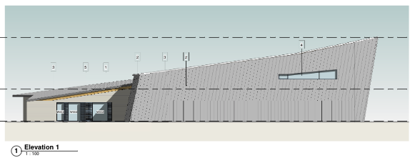
(Pendine Museum)
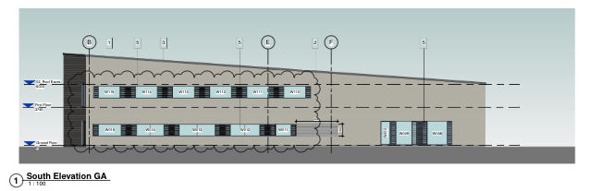
(Pendine Hostel)
The Health & Safety implications that affect the company and the project you are involved in
The company are externally audited by BSG (Building Safety Group) who carry out site inspections and offer guidance to ensure the business is compliant with industry regulations.
Internally, the company employs SHEQ (Safety, Health, Environmental & Quality) Coordinators to ensure that all relevant Health & Safety documents are in place and are correct.
Site operatives must present risk assessments & method statements before commencing work on site. They must also provide their CCS cards and be inducted by Site Management prior to starting works.
As the site is a popular area for tourists and is located on a popular beach, it is essential that site is fenced off from the public to ensure their safety and welfare. It is also vital that traffic management plans are in place to ensure there are no accidents on site due to any vehicles or plant.
All management and site operatives are required to wear personal protective equipment when on site, such as hi-vis vests, steel toe boots and hard hats.

Which parts of the company are involved within the project? Including management and wider structure, as peripheral as necessary
There are a number of staff members in various different roles that make up the site team, consisting of a Construction Manager, Site Manager, Quantity Surveyor, Site Engineer and a Design Coordinator (myself). We also have a appointed specialist to aid us in the process of compiling all documentation required for Passivhaus. This consultant also advises us on best practice and workmanship advice.
By means of Sub-Contractors, there are a large variety of tradesmen, including Timber Frame specialists, Groundworkers, Carpenters, Steel Erectors, Dryliners and Bricklayers.
By means of Consultants and the Design Team in general, there is a Architect, Structural Engineer, Mechanical & Electrical Engineer, Landscape Architect, Timber Frame Designer, Scaffold Designer, Ecologist and as previously mentioned, a Passivhaus consultant.
Each member of the Design Team provides various pieces of information for the site team to build to, such as drawings, schedules and specifications
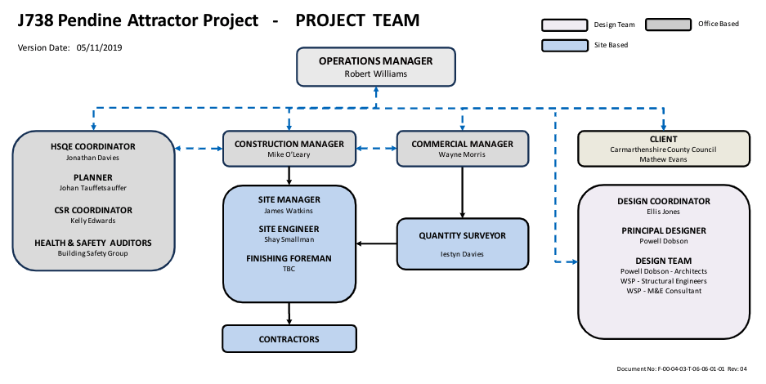

Marketing, communication and presentation – how your project links to wider communication, marketing and outside presence within the company e.g. events
The project itself is marketed and displayed across a number of platforms, including social media websites such as Linked in and has featured in newspaper articles such as Wales Online and also on the BBC.
The community have been involved in the job in a number of ways - most notably a number of local schools have visited site to get an experience of construction.
The client, Carmarthenshire Council, have updated the local community on works through the use of drone video footage displaying the progression of works on site.
What software and hardware will be involved in your project?
The Project is fully BIM integrated with Revit as the main piece of software being used by all key consultants. All models provided by each consultant have been integrated and full clash detection reports have been produced as a result. Box Cloud System is used to share various information such as drawings, schedules, drawing registers and specifications with various consultants, sub-contractors and other team members. The Client utilise a system known as Viewpoint to receive and approve drawings from ourselves via our various consultants.
By means of hardware, all site management utilise laptops, phones and tablets to communicate, annotate drawings, record photographs, document snags and carry out various task.
A television is used in the site office to present reports during meetings to the client and to study and discuss various drawings
What materials and processes are involved in your project (relating to the nature of the organisation and outputs)
There are a large variety of materials being used in this project, such as plasterboard, vinyl flooring, blockwork to the lift shaft, steel columns, mineral wool insulation, timber cladding and zinc cladding, cellulose insulation and also specialist tape to ensure all penetrations are sealed in order to maintain the air tightness required for Passivhaus. Plant such as scissor lifts, bulldozers, concrete pumps, drills, generators, floodlights and heaters have been and will be used to aid the construction process.
Processes such as weekly site diaries, internal project reviews, design team meetings, client project reviews and monthly reports to Directors ensure that communication is maintained between all parties and any issues are addressed.

How many hours will be worked on this project by you?

I spend roughly three days a week on this project and this time is split between the office and on site. My working days consist of 8 hour days and the project will be ongoing until the end of this summer and so I am projected to spend around 550 hours working on this job, on top of the 550 I have already spent on the job since I started in early September.

This project is benefitting myself and my career in many ways. I am gaining invaluable experience in many areas such as Passivhaus buildings, BREEAM, Design Coordination, teamwork, workmanship, health & safety, planning conditions, ecological requirements in construction, building regulations and also the design and construction process in general.

Work Based Project Learning Contract – Interim Submission No.1
What new skills did you learn in the period?

Since starting this project, I have learnt a lot about techniques that are used in the industry such as BIM, BREEAM and Passivhaus. In my previous job I was working on new build developments for housing associations – straight forward builds with less complicated construction details.
As the job is to be built to Passivhaus standards, the construction details are a lot more complex than I have previously worked with and so I have had to learn and familiarise myself with these various details and requirements. Typically, these details are more complex due to the importance of airtightness and to avoid any potential thermal bridging.
I was also fortunate enough to attend a Passivhaus course where we were given some guidance on potential issues and key design requirements to look out for to help avoid any problems on site such as the requirement for louvre grills to the outside of windows to allow them to be fully openable and still achieve Secure by Design.

How have you been able to adapt / use the new skills learnt within the work environment?

I have now become more familiar with the requirements for BIM and as such, I have started to familiarise myself with software such as Revit for modelling, Navisworks for viewing integrated models easily & Viewpoint to submit drawings to the client for approval. By learning how to use Revit and navigate through a Revit model, I have been able to get a better understanding of the design of the building.
I am able to manage my time through various documents the company has in place, such as a Design Control Action Plan, a Design Release Schedule, an RFI Schedule and various other documents. By utilising these documents, I can ensure I am meeting deadlines, managing my workload efficiently and making sure no queries are being lost in my emails.

What was the highlight and why?

The highlight of the project so far has been the experience gained from working on a larger scale job than what I have been used to previously and as a result, being able to gain experience of BIM and Passivhaus.

What part of the task / activity were most challenging and least challenging?

One of the most challenging aspects so far has been understanding the steel frame construction and how it interlinks with the timber frame cassettes. As I have only worked on traditional build and timber frame construction previously, this area was one of which I had little experience. Interacting with knowledgeable consultants has been quite a challenge but I have made sure to make notes during any meetings and to then research anything I have been unsure of post-meeting. One example of something I was previously unsure of and so required research in my own time was the function of a MVHR unit. I have since studied the system to gain a general understanding of how it works and how it is important in a Passivhaus scheme.

Work Based Project Learning Contract – Interim Submission No.2
What new skills did you learn in the period?

I have further developed my knowledge of BREEAM and the various credits that can be achieved on a project. I met with an appointed BREEAM consultant as I will now be taking on the responsibility of collating information for BREEAM on site and ensuring we achieve BREEAM “Very Good”. During this meeting, the BREEAM consultant explained which credits we were aiming to achieve on this particular scheme and what information he needed from us to achieve these credits. In order to mitigate a rush to collate all evidence at the end of the project, I will be storing information as I go along on our cloud system shown below.

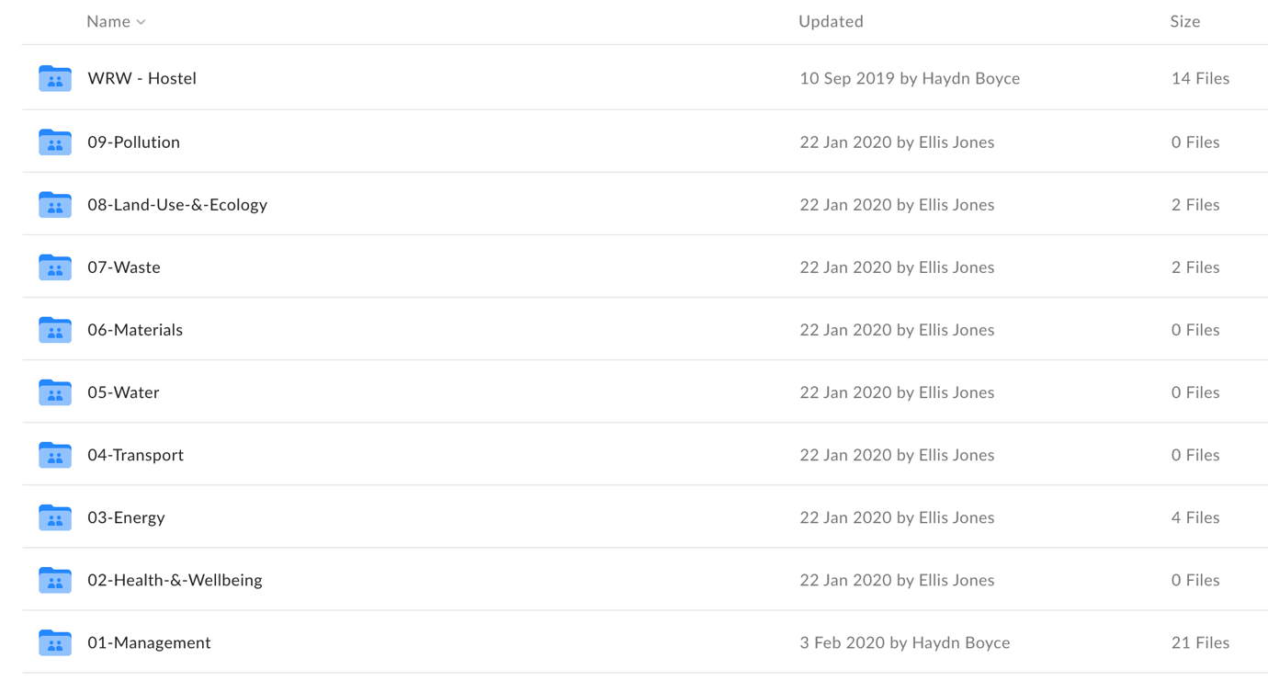

(Box Online Cloud System)

How have you been able to adapt / use the new skills learnt within the work environment?

Through practice, I have developed my knowledge of Navisworks. This has proved beneficial during design meetings with our client where we have been discussing potential late changes to the layout of bathrooms. Through utilising the Navisworks model, we were able to visualise the various layout options available and receive a decision from the client on how they want the bathroom layout to look before then instructing the architect to make the necessary amendments.
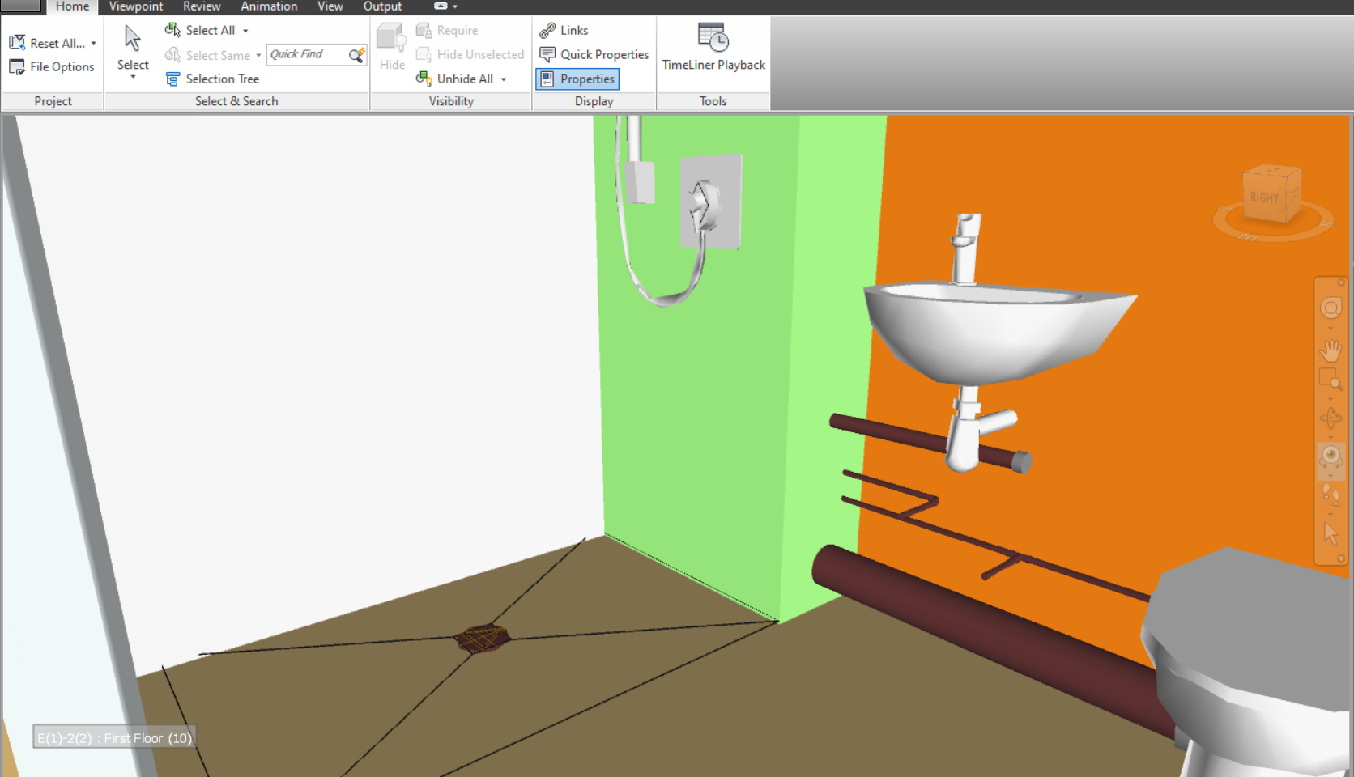

(Navisworks Screenshot)

What was the highlight and why?
By learning how to navigate the model, I have given myself a better understanding of how the building layout will look on completion. This has given me a better understanding of the building and as a result, I am more confident in carrying out my day to day job. Also, since meeting with the BREEAM consultant and taking on responsibility for providing information, I feel I am also developing my knowledge in the various requirements for BREEAM.

What part of the task / activity were most challenging and least challenging?
One challenging task was having to notify a sub-contractor that they had not adopted the correct workmanship required for Passivhaus. This soon proved to be less challenging however, as we have adopted a blame-free culture on site to ensure we are all working together so nobody feels they should cover up any mistakes or errors.

How are you progressing according to your objectives (learning contract)?
During this time period, I believe I have progressed in developing my knowledge on a different objective to my previous submission - the correct workmanship required. An example of this can be seen in the photo below, where poor workmanship has been identified on site.

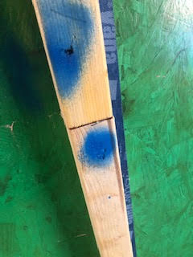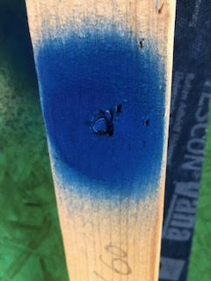

(Nailed battens to be removed and re-fixed with screws)

The site manager and I identified areas where the carpenters had nailed battens to the pro passive OSB boards as opposed to using screws. From attending a Passivhaus course, and referring to the training booklet I received, I had learnt that this is poor practice as this can create potential for air leakage, as shown in the below diagram. We sprayed these areas to highlight where we may need to remove these battens and potentially use screws instead (as shown above).

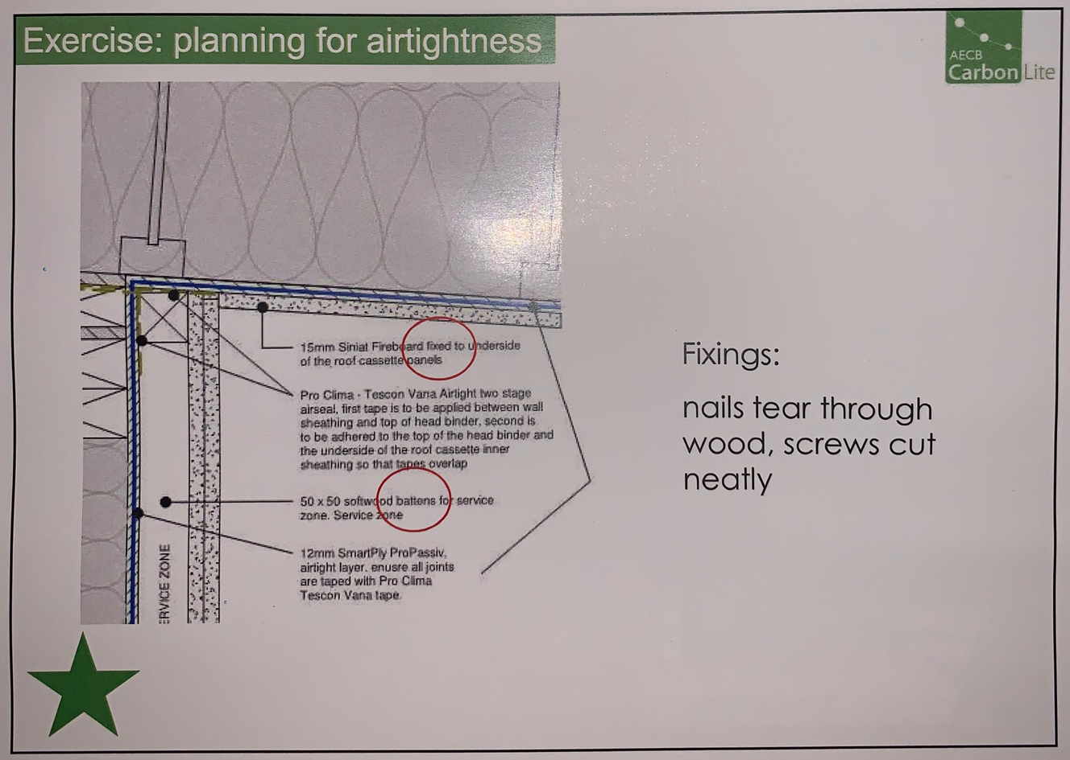

(“Passivhaus for Contractors” Training Booklet, WARM, 2019)

Work Based Project Learning Contract – Interim Submission No.3

What New Skills did you learn in the period?
Throughout my time on site, I have continued to learn new skills. I have enhanced my knowledge of “4 P’s”, the system our Client use to review and approve all drawings and specifications received from Designers/Consultants. I have also learnt that

What was the highlight and why?
A highlight during this period was further experiencing new forms of construction. One example of this can be seen below - the Warmcell insulation within the wall cassettes. This is the first time I have worked on a scheme using cellulose fibre and so this was a good experience for myself. As I mainly have experience of house building, I find it beneficial and interesting to experience non-conventional construction methods such as this as I am then further developing my knowledge.
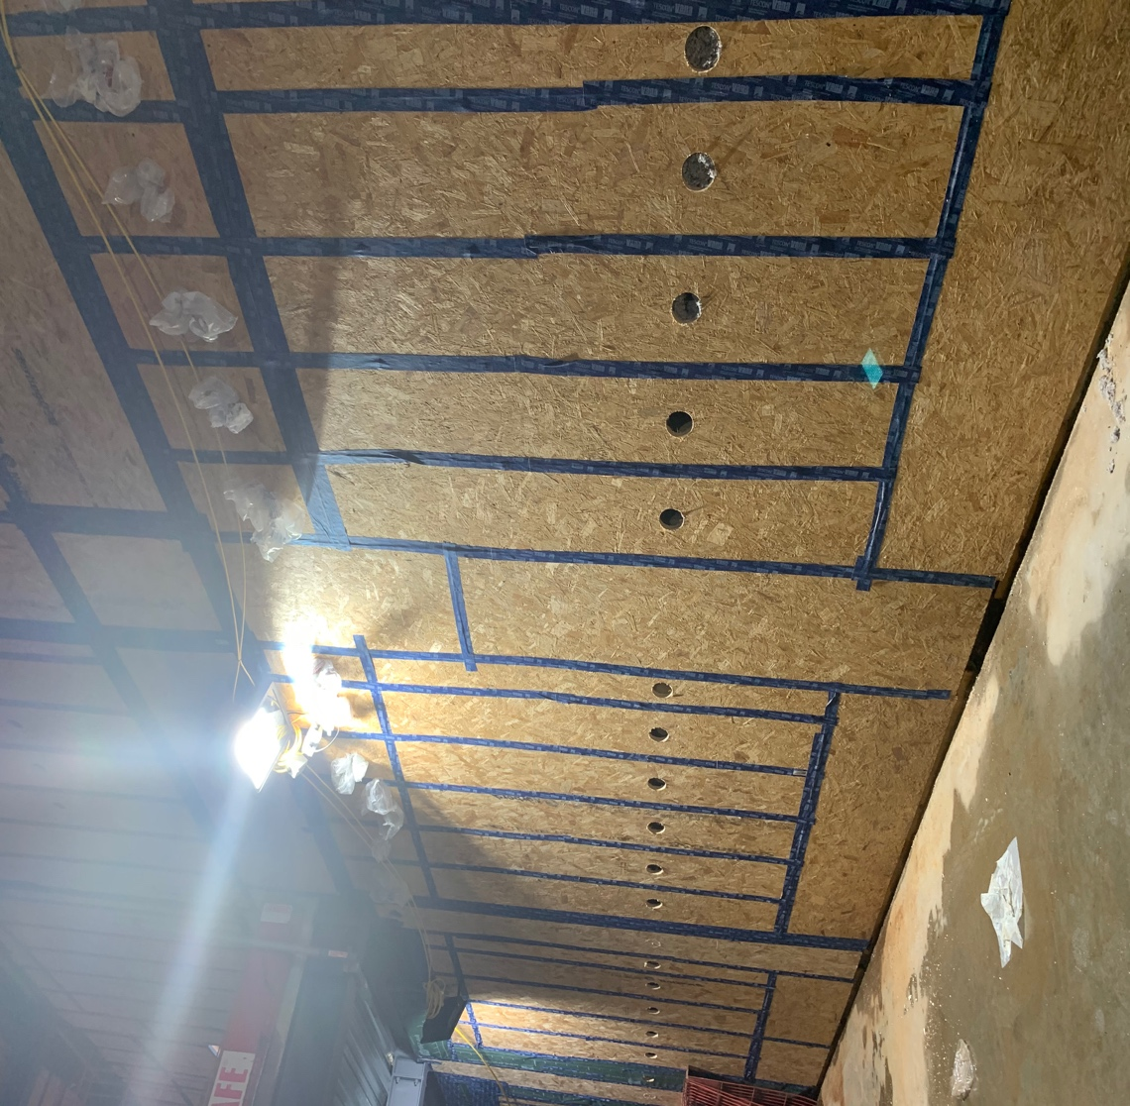

(Warmcell Insulation within the Museum Wall Cassettes)
It is also my first experience of a timber cladding system. After spending a large number of months studying drawings, it has been interesting to see the construction taking shape on site, as seen below –
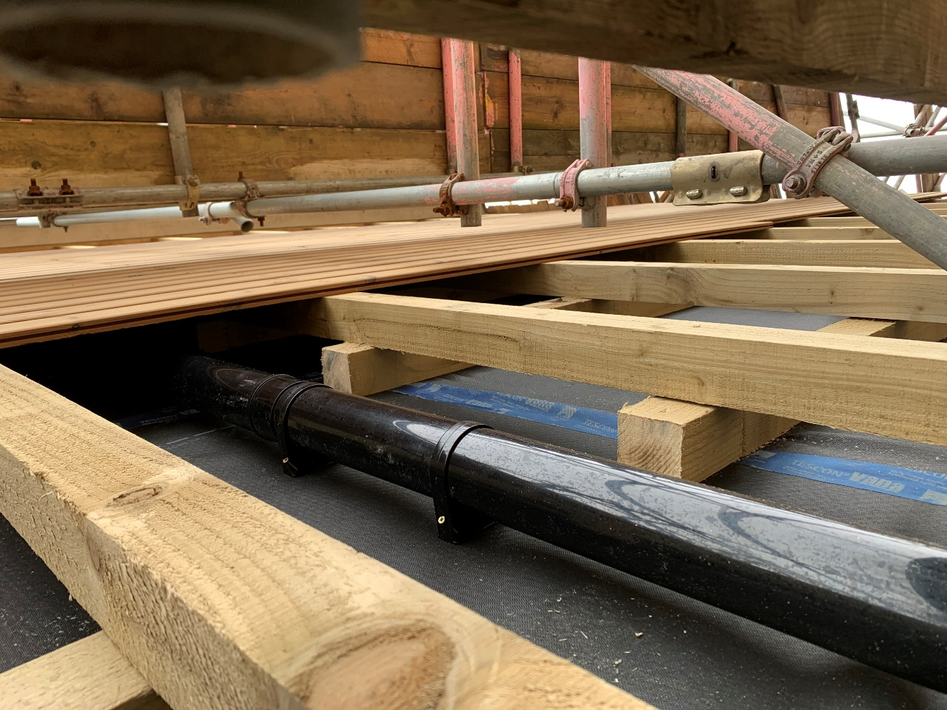
“Tyvek” breather membrane
Timber battens
Rainwater downpipe
Timber Cladding
Pro-Clima Air Tight Tape

(Rainwater pipe concealed within Timber Cladding

What parts of the task/activity were most challenging and least challenging?

One challenge encountered on site during this period has been the weather. Due to storm damage, the roofing works which were previously close to completion have been delayed. As this event led to quite a large amount of water ingress in the Museum, this further delayed the insulation pumping process as the cassettes had to be completely dry. This has had a negative effect on the contract programme, resulting in a potential 2 week delay to practical completion.

How are you progressing according to your objectives? (learning contract)

As per the goals set out in my learning contract, I have spent this period familiarising myself with the various pieces of evidencing required to achieve a Passivhaus certified building. On completion, the Passivhaus certifier will require a completed checklist, which I have now received from our Passivhaus consultant (below).

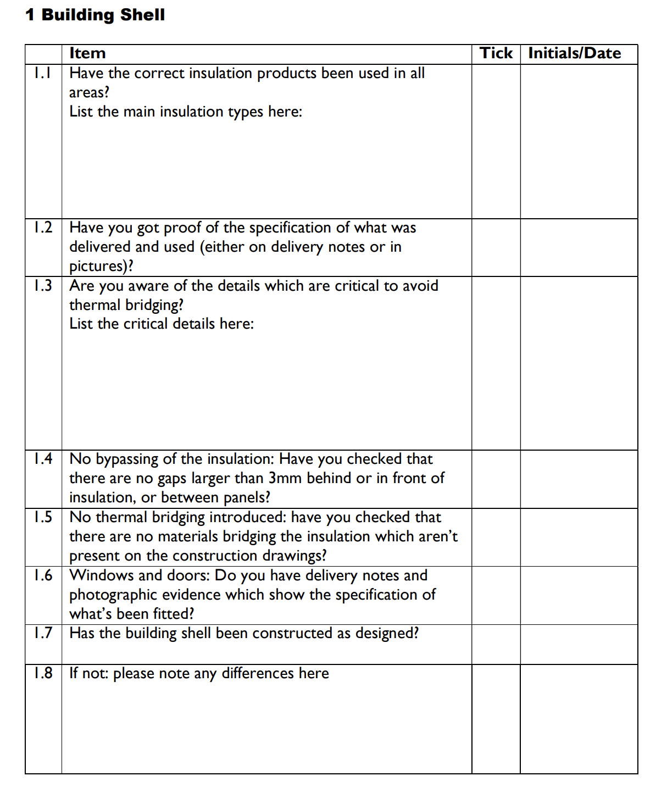
(Section from “WARM” Passivhaus Certifiers Site Checklist (2017)

This checklist has proved very useful on site as it has given the site team and I some good guidance on key items to look out for. An example of what is required for item 1.2 can be seen below where I have evidenced the use of Warmcell insulation with photographic evidence and delivery notes.

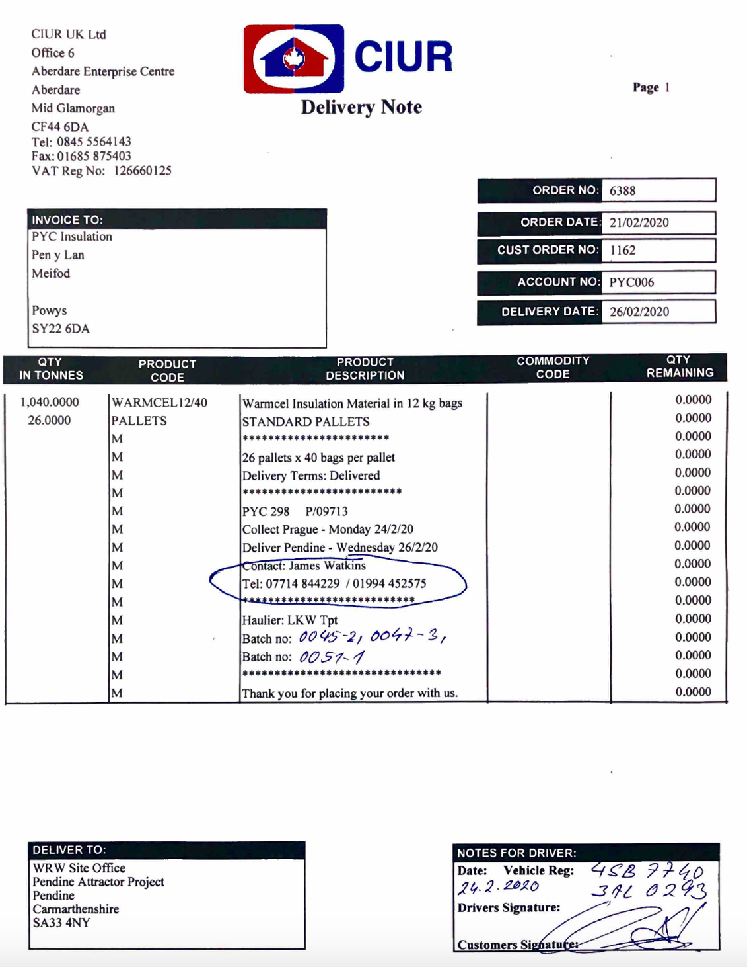

(Delivery note - evidence of product used to insulate the external walls)

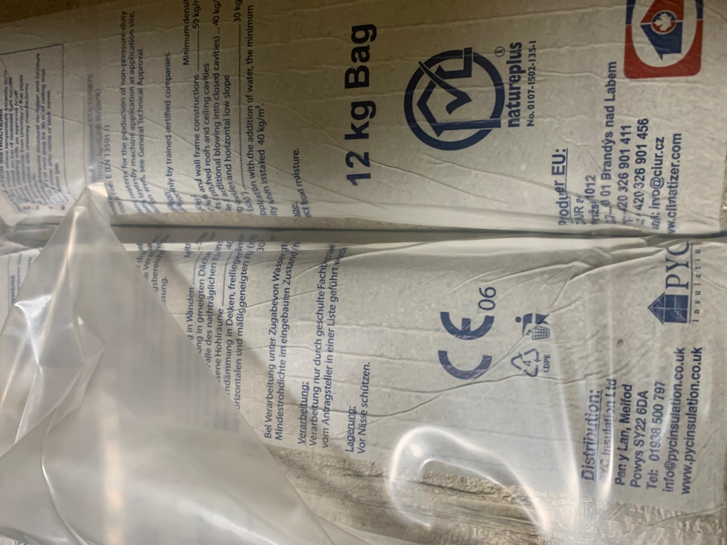
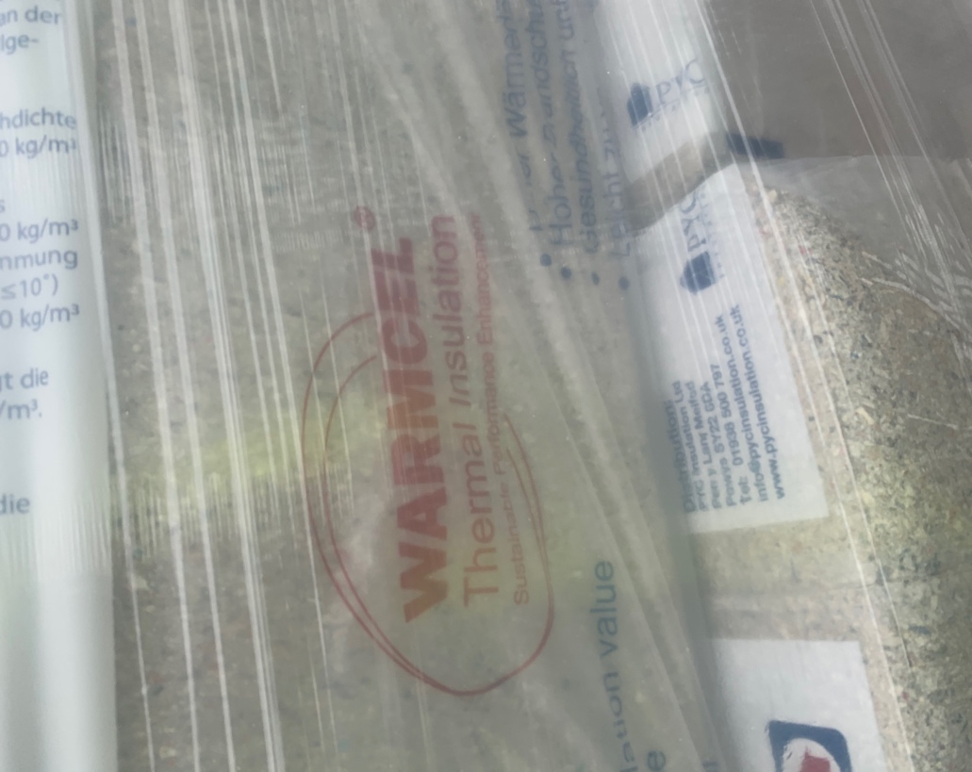
(Photographic evidence of product used to insulate the external walls)

As per the goals set out in my learning contract, I have also been studying the benefits of energy efficient buildings. I have been reading books such as “The Passivhaus Designer’s Manual: A technical guide to low and zero energy”. This has given me not only a good idea on the design and workmanship required, but also the benefits of Passivhaus buildings.

“Over 50,000 Passivhaus buildings have been constructed to date, in almost every climatic zone. Documented scientific evidence from dozens of studies has shown that deep savings in energy consumption coupled with high levels of thermal comfort have been achieved by the vast majority of these projects”
(Hopfe and McLeod, 2015)

Work Based Project Learning Contract – Interim Submission No.4

Upon reflection of my time spent working on this project, there have been a number of positive experiences and challenges which I feel have benefited me greatly and will prove beneficial throughout my career.

One of my initial objectives from my learning contract was to become familiar with the principles of Passivhaus construction. Through being involved in both the development and the implementation of the design process, I believe I have improved my technical knowledge significantly across all aspects of Passivhaus design from sub-structure through to finishes.

In this respect, I feel I have achieved this objective - although there is still an exponential amount to learn about Passivhaus. Whilst I have become familiar with the requirements to achieve Passivhaus in a large timber-frame commercial building such as this one, the details and requirements will vary significantly across different types of buildings such as a traditional masonry build house or, whilst it is not often a preferred method of Passivhaus construction due to its potential for a high amount of thermal bridges, a steel frame school building.

My second objective was to become familiar with any specialist materials used and any unique design factors. I believe I have achieved this objective mainly through regularly reviewing drawings and specifications, but also from seeing the materials being used on site, such as the Warmcell installers applying the air tight tape in areas missed by the timber frame contractors. The contractor installing the insulation has a lot of experience in Passivhaus requirements and so being able to walk around site as they snagged the timber frame was very good experience for myself.
My third main objective was to strongly familiarise myself with the various pieces of evidencing and certification required to achieve a Passivhaus certified building. This is one objective I feel I haven’t been able to fully achieve due to a number of issues such as poor weather and an inability to place orders with certain contractors due to the COVID-19 pandemic. Most notably, we have not been able to carry out any air-testing on site which is a key element to achieving Passivhaus certification. Ideally, we would have carried out these tests and submitted the evidence to our Passivhaus certifier, however this has not been possible.

Aside from these initial learning objectives, I have also improved my knowledge on a number of other items, such as the planning process and submitting non-material amendments, an improved understanding of BREEAM, understanding of the NEC contract as previously I had only worked on JCT, an increased understanding of BIM and also the RIBA work stages, as previous projects I have been involved in did not follow the RIBA stages of works.

In regard to anything I will do differently in the future, it will be to keep a stricter schedule in terms of journaling. As I have been involved with other projects, this has not always been possible, however as I move into site management, I will be more focused on one site, meaning more opportunity to journal and document issues/things to look out for in future.

Final Reflection

What has this exercise taught you about yourself (personally and professionally) and what will you change going forward?

I feel that this project has enabled me to further better myself both personally and professionally. From a professional aspect, I feel it is easy for my role to become quite monotonous given that my tasks and deadlines are quite structured, meaning that it is easy to switch off and not pay thought to the actual process. An example of this which stands out would be my role in updating drawing registers and keeping a log of all design information. Previously, I may have found myself opening the drawing and simply updating the register in line with the revision number in the corner. Due to the increased emphasis on the importance of correct design for Passivhaus, as outlined in my learning contract, I have found myself further studying the drawing (e.g. what has been updated in this revision and how will it have an effect on our aim of achieving a Passivhaus building?). This process of studying the drawings further meant that I had improved my knowledge on the design requirements of the project, resulting in me being able to have more input in meetings with the client and more constructive discussions in meetings with our design consultants.
From a personal aspect, the increased knowledge and the opportunity to give my input in meetings has led to improved confidence and higher self-esteem as I now feel that I am able to contribute to the team. I have found my job easier due to my further understanding of the project as a whole. Through my interim submissions, I have given more thought to progress on site. This has inspired me to journal regularly in the future to give myself the opportunity of reflection and to ensure I stay focused on the progress of my projects. These submissions will also benefit me on future projects, for example if I am to work on another Passivhaus project, I will be able to reflect on my interim submissions to ensure any previous mistakes aren’t repeated, such as the incorrect fixings used.

What was the journey to your goals, including successes and failures; how were issues resolved?

I feel that there were a large number of successes and failures. In regard to successes, I feel that all design issues encountered were tabled to the rest of the site team where we then worked together collectively to overcome the issue.
One example of this was the specialist window louvres which are fitted externally as a safety protocol, as fully openable windows are a requirement for Passivhaus.
These were not specified on every elevation of the building and so there was a potential issue with the window supplier not allowing for the correct quantity. Help from our quantity surveyor enabled us to locate the order documents that were issued to the supplier, showing these louvres on all windows which meant that they then amended their order to include the correct quantity. Some discrepancies of setting out also occurred between certain parties of the design team which threatened to prove costly on site but thankfully, due to an attentive and cooperative design team, we were able to resolve these issues before work took place on site.
One large failure in achieving my project goals was the inability to carry out any air testing. It was highlighted at the start of my project that the air tests would be pivotal to my project as they are a key indicator of how well the building is performing in relation to its air tightness and Passivhaus suitability.
Due to many issues mentioned previously, the program slipped significantly, meaning that key items of work were not completed in time for the air testing to take place.

Given what you now know, would you do anything differently (if you were to do the project again)?

Whilst the overall experience of the project has been positive and relatively successful, there are still a number of items I would have done differently and will bear in mind on future projects. Due to my late involvement with the project, I was not involved at pre-construction. One issue with this was that I did not have any relevant trackers in place such as a BREEAM tracker to check what evidence we had collated and what was still outstanding. Trackers such as these are hard to collate retrospectively and so I will ensure on future projects that items such as these are in place before we have commenced on site. This also applies to planning conditions trackers and also building regulations trackers. By having these trackers in place at the start of the job, it will be possible to collect information as I go along, rather than spending long periods of time retrospectively collecting information from consultants and sub-contractors.

Has what you have done changed your ambition or strengthened it?

I believe this project has strengthened and changed my ambition. I feel I have become more ambitious in terms of project size and my own capabilities. I previously found the idea of working on a project with a contract value as large as this one very daunting.
I now feel I am able to work on considerable size projects and have a lot to offer to the site team. The frequent journaling through interim submissions has certainly contributed to this as it has helped me develop a better understanding of the project.
My ambitions have also changed in regard to what I see as the most suitable job role for myself. Whilst my role has been as a design coordinator, this has not necessarily reflected the correct role for myself in terms of my ultimate goal. I feel a site manager role would be more suitable in achieving my ultimate goal of becoming a project manager as the experience of running site day-to-day would prove extremely valuable in being a successful project manager. It is for this reason that I am moving into site management where I hope I will be able to develop myself further as a professional in the construction industry.

Bibliography

- Hopfe, C. and McLeod, R., 2015. The Passivhaus Designer's Manual. Routledge, pp.1-2.

- Warm, P., 2019. Passivhaus For Contractors Training Booklet.

- Warm, P., 2017. Passivhaus Certifiers Site Checklist.

