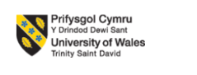
Module code: LCBB6006
Module title: Project Management
Student Name: Mirabela Laura Dobre
Student ID: 2315966
Lecturer: Dr. Said Usman

Project Plan: Development of a University Digital Learning Platform (DLP)

Table of Contents
Introduction 3
Aim, Objectives and Scope of the Project 4
Project Aim 4
Project Objectives 4
Project Scope 4
Project Outputs (Deliverables and Other Direct Results) 5
Deliverables 5
Other Direct Results 6
Activities Required to Deliver Outputs 7
Work Breakdown Structure (WBS) 9
Tasks, Deliverables and Milestones 10
Resource Considerations 12
Conclusion 13
Reference list 14

Introduction
This task is based on a project plan like development of a digital learning platform for a university. The main purpose of this task is to increase digital engagement in the university by integrating communication tools, assessments and analytics as well as learning materials into a digital environment for the well-being of the students. The need for technological solutions has been created by increasing demand for flexible learning which assist both learning and teaching activities. A structured system will be provided by the digital learning platform for online course management that enables users to access course content, submit necessary documents including assignment and receive-feedback properly. However, current trends are aligned with this project in higher education where digital transformation is required mostly to the institutions. According to contemporary research in project management, clear planning, robust risk management and high stakeholder engagement are required by technological projects. These principles are followed by development of the digital learning platform through integrating projects tools and methodologies. Basically, a structured approach is presented by this project plan through including outputs, work breakdown structure, milestones, timeliness and resources. Critical evaluation of the sustainability of techniques are included by this plan. Moreover, several supporting tools are used such work breakdown structure, Gantt scheduling and stakeholder analysis for project execution successfully.

Aim, Objectives and Scope of the Project

Project Aim
The aim of this project is to design, develop, test and implement a better operational digital learning platform for a university to enhance accessibility, teaching efficiency and learning experiences in the field of activity.

Project Objectives
To achieve this aim, the project will follow several objectives which are:
- To improve a functional, user-friendly online learning platform within five-month timeframe (Rusconi, 2024).
- To incorporate course management tools, assessment submission features and communication channels.
- To ensure system compatibility across devices and operating systems.
- To offer secure data storage by encrypted and compliant solutions.
- To arrange training programs for academic and administrative staff.
- To operate pilot testing with 100 users before full establishment.

Project Scope
Planning, designing, developing, testing and implementing are covered by the scope of this project for the digital learning platform. Requirement analysis, platform interface design, database development, integration of teaching tools and user training are involved in this project. Additionally, polit testing is included to evaluate performance and functionality (Williams, 2023). However, content creation is excluded by this project for academic modules, long-term system maintenance and hardware purchases. It is essential to limit project feasibility and focus on improvement task only. According to literature on project management, project delays, cost escalation and misunderstanding can be occurred because of inadequate scope definition. Therefore, a structured scope boundary is adopted by this project to make sure work remains achievable.

Project Outputs (Deliverables and Other Direct Results)
The measurable and tangible results are represented by this project outputs that will be supported during the development of the digital learning platform. PMBOK and PRINCE2 are recognised as strong definition of deliverables where the basis for milestone completion and quality assessment are provided by the outputs (Matos and Lopes, 2020). Misalignment of expectations, resources wastage and schedule delays are occurred due to failure to specify outputs properly. For instance, formal deliverables and other direct results are set by this section of the project.

Deliverables
- Requirement Specification Report: All functional, non-functional and technical requirements will be described by this report for the platform. Findings will be summarised through it from stakeholder consultations and existing systems.
- Platform Design Prototype: Wireframes, sample dashboards, user interface design and system architecture schematics are included by this deliverable (Lee, 2022). Visual design and structural elements are ensured by this protype which will increase efficiency.
- Fully Developed Digital Learning Platform: The competence software system can be the core deliverable of the project that includes several features such as dashboard features, video integration, grading features, login authentication, messaging functions, analytics etc.
- Piton Testing Report: Results are summarised from existing information such as unit testing, integration testing and user acceptance testing. System defects, performance issues, user feedback and recommended improvements will be highlighted by it.
- User Training Materials: Staff training sessions, video tutorials, manuals and step-by-step guides are involved by this deliverable (FURUTA and KUSAMA, 2024). Smooth adoption is ensured through training that support to minimise resistance from users.
- Final Implementation Package: Deployment files, hosting configuration, security settings, backup procedures and user account creation are involved in this deliverable. The platform can be run by the university securely and smoothly after completion of the projects.

Other Direct Results
In addition to main deliverables, several direct results will be generated by this project such as improving digital learning environment, enhancing communication channels, strengthening data security measures, increasing operational efficiency and organisatoinal readiness for future digital transformation. User satisfaction and better learning outcomes are enhanced by supporting of this report. University gets better services after implementing a modern system.

Activities Required to Deliver Outputs
A series of structured activities are required to complete all the deliverables in the field of activity. Project management principles are followed by each activity which are recognised as essential project management principles that reflects best practices from implemented methodologies. The way of a real software development project is applied by theoretical concepts which are demonstrated in these activities. These activities are explained below:
Requirement Gathering: It becomes the first major activity that involves meeting with stakeholders to know existing challenges and potential benefits of the digital learning platform. However, functional requirement, technical requirement and user needs will be collected through survey, interview and document analysis by the project team (Ballardini, 2019). This activity is necessary that reduces timelines and system failure. Therefore, a solid foundation is established through the requirements gathering stage for all later activities in the project.
System Design: System Design is another activity of this project which includes converting requirement into clear technical blueprint. In addition, creating wireframes, user interface prototypes, database structures and workflow diagrams are included in this activity which will be reviewed by stakeholders to make sure alignment with their expectations. User-friendly system reduces rework through a well-developed design. Therefore, this activity works as a bridge between technical development and user needs.
System Development: Coding for the platform’s user interface and backend functions are included through the development activity. Different third-party tools are involved by this department like video conferencing systems, messaging functions and assessment modules (Jackson, 2021). However, close collaboration is required by the system development stage to make sure consistency and quality. Main deliverable is produced by this stage such as digital learning platform. Therefore, continuous improvement can be occurred by following this stage.

Testing Phase: Performance and reliability are checked by this phase of the system. Several testing systems are included here such as unit testing for checking each module, integration testing for ensuring modules work together and user acceptance testing for assessing real-world usability. Additionally, defects, performance issues and feedback will be recorded by the testing team. Therefore, strict testing standard will be applied by the project to make sure system quality before establishment.
Implementation: Deploying the Digital Learning Platform (DLP) is involved by the implementation activity on university servers. However, configuration, data migration, user account creation and installation of security protocols are included by this step effectively. lecturers and staff are supported by taking enough training. Therefore, a controlled rollout is used by this project to make sure smooth transition to the new system.
Evaluation: It is the final activity of this project. Multiple actions are included in this stage such as feedback from users, system performance and project outcomes against the actual objectives. Prominently, strengths, weaknesses and recommendations will be documented through an evaluation for future developments. The project lifecycle is closed by evaluation that is highlighted through academic research (Wilson, 2022). For instance, learning, accountability and sustainability are ensured through the evaluation.

Work Breakdown Structure (WBS)
A clear breakdown is provided by the work breakdown structure of all project activities into manageable sections in the field of activity. The work is divided into several phases, tasks, and sub-tasks in an organised way that makes easier to understand and control the project scope. In WBS, the overall project is started as level 1 including Digital Learning Platform Project then divides into several phases such as initiation, requirements, design, development, testing, implementation and evaluation (Webster, 2021). Each phase is divided into specific tasks and sub-tasks including requirement collection, interface design, coding activities, configuration, pitot testing, deployment and performance review. This breakdown helps the project team to bring better outcomes based on the full scope of the work. Effective monitoring is possible for this breakdown. Therefore, communication n is also enhanced among stakeholders by the WBS which increases controlling and visibility of overall projects.
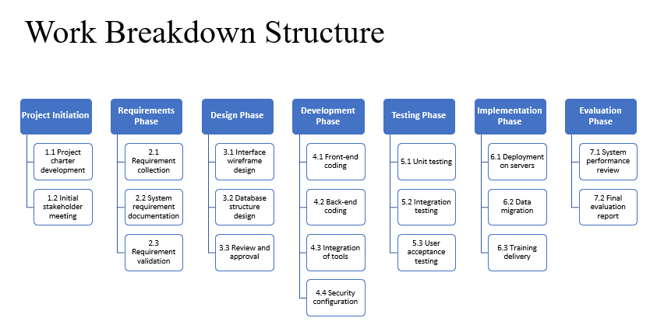
Figure 1: WBS
Source: Author

Tasks, Deliverables and Milestones

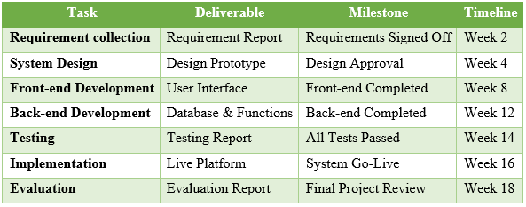
Source: Author
Tasks, deliverables and milestones are needed to complete the project like Digital Learning Platform (DLP) within a specific timeframe. A major phase of work is represented by each task including requirement collection and go through system design, development, testing, implementing and final evaluation of the project. These tasks are linked with deliverables including the requirement report, design prototype, finished platform, testing report, package of implementation and evaluation report. However, control is provided milestones where improvement is measured by including requirement signed off, design approval, frond-end completed, back-end completed, successful testing, system go-live and final project review. For example, spring checkpoints are used by software companies to monitor improvement. However, first milestone will be achieved within 2 weeks, 2nd one within 4 weeks, 3rd one within 8 weeks, 4th one within 12 weeks, 5th one within 14 weeks, 6th one within 16 weeks and final one within 18 weeks (Clark, 2019). A structured timeframe (Gantt Chart) is attached in below:
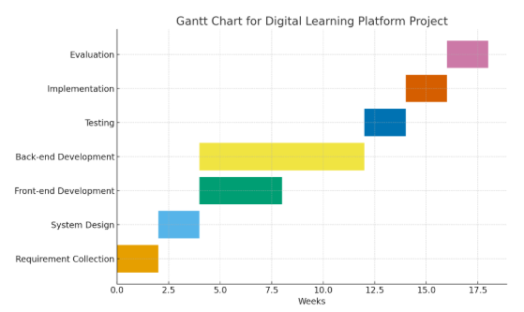
Figure 2: Gantt Chart
Source: Author

Resource Considerations
- Personnel Resources: All individuals are included as personnel resources which are necessary to implement the project tasks. A project manager, software developers, a UI/UX designer, a database administrator, quality assurance tester, IT support Staff and trainers will be required to operate and complete the project within due period (adminprl, 2023). Productive is affected because of skill levels. For this reason, it is very crucial to select better personnel resources.
- Material Resources: Physical and digital tools are involved by material resources that support to improve work properly. For instance, computers and development tools, server infrastructure, cloud services and software are included as material resources of the project. These resources must be distributed based on technical requirements. Proper distribution of material resources may ensure smooth project execution.
- Financial Resources: The overall budget is included as the financial resources which are essential to complete the project. Without adequate budget, project will not be executed properly. Staff salaries, software licenses, cloud hosting fees, training activities and contingency funds will be covered by the budget (adminprl, 2023). However, unexpected changes can be handled by using contingency funds.
- Time Resources: It is very essential to complete the tasks effectively. Whole tasks will be covered based on allocation. This project timeline is approximately 18 weeks where starting with requirement collection and ending with the final evaluation. However, the major cause of project delays is unrealistic scheduling. Therefore, it should be careful to ensure priority.
- Risk Consideration: Identifying and managing potential risks are included as risks considerations which will influence project execution and success. These can be system malfunction, resistance from staff and risk of data breach. Therefore, these can be mitigated by testing, training and encryption.

Conclusion
In conclusion, a structured approach is outlined by this project to improve a Digital Learning Platform for a university. Different sections are involved in this project such as project aim, objectives, scope, deliverables, activities, milestones, breakdown structure and resource allocation. Principles of project management methodologies are followed by each section. Besides, theoretical concepts and practical implications are included here. A structured Gantt Chart is attached here as the scheduling on 18 weeks. However, the Digital Learning Platform project support the university to improve teaching and learning quality and increase educational facilities as well as results. Therefore, disciplined implementation and continuous monitoring will support to execute the project effectively.

Reference list
adminprl (2023). Personnel Resources Ltd. [online] Personnel Resources Limited. Available at: https://prlmalta.com/ [Accessed 16 Nov. 2025].
Ballardini, R.M. (2019). Software patents in Europe: the technical requirement dilemma. Journal of Intellectual Property Law & Practice, 3(9), pp.563–575. doi:https://doi.org/10.1093/jiplp/jpn121.
Clark, W. (2019). The Gantt chart : a working tool of management. Miami, Fl: Hardpress Publishing, Hardpress Publishing.
FURUTA, E. and KUSAMA, K. (2024). Teaching materials for radiation training and user guides. Radiation Safety Management, 13(1), pp.1–8. doi:https://doi.org/10.12950/rsm.13.1.
Jackson, M.A. (2021). System development. Englewood Cliffs, N.J.: Prentice-Hall.
Lee, H.N. (2022). A Study on Prototype Design to Improve Usability of Web Platform. JOURNAL OF THE KOREAN SOCIETY DESIGN CULTURE, 27(2), pp.385–393. doi:https://doi.org/10.18208/ksdc.2021.27.2.385.
Matos, S. and Lopes, E. (2020). Prince2 or PMBOK – A Question of Choice. Procedia Technology, 9(9), pp.787–794. doi:https://doi.org/10.1016/j.protcy.2013.12.087.
Rusconi, G. (2024). 10 Best Digital Learning Platforms in 2024 | Features & Pricing. [online] Cloud Assess. Available at: https://cloudassess.com/blog/digital-learning-platforms/ [Accessed 16 Nov. 2025].
Webster, F.M. (2021). Work Breakdown Structure (WBS) - Basic Principles. [online] www.pmi.org. Available at: https://www.pmi.org/learning/library/work-breakdown-structure-basic-principles-4883 [Accessed 16 Nov. 2025].
Williams, T. (2023). What is Pilot Testing? Explanation, Examples & FAQs. [online] dovetail.com. Available at: https://dovetail.com/research/pilot-testing/ [Accessed 16 Nov. 2025].
Wilson, R. (2022). A comprehensive guide to project management schedule and cost control : methods and models for managing the project lifecycle. Upper Saddle River, New Jersey: Pearson.

