Programme: BSc Health and Social Care
Module: Community Care and Development
Module code: BMHP6022
Lecturer: Chizoba Esio-Bassey

Assessment Component 2 - Written Assignment (Report)

London Borough of Hounslow

Introduction
This report aims to develop an understanding of how communities can be developed in the health care, children and young people sectors now and in the future. Community care and development is a vital aspect that must be looked into critically to foster development. To accomplish this purpose, this report will explain how important and key in developing a community using various sectors in the community. Some factors must be induced into an existing system in other encourage development and this report is aim at identifying such factors. Furthermore, this report will examine the health, education and wellbeing initiatives that have helped to foster community development. The report will also investigate and evaluate innovative digital technologies that could be used to develop communities now and in the future. Additionally, it will be revealing how community development would reduce the youth crime rate and child poverty in the community.
A community are people living together in the same environment or having a major character in common. Community is the act and condition of sharing certain attributes and major interests in common. It conveys a sense of positivity and togetherness among people. Community varies concerning differences in ethnicity, race, languages, beliefs, social class, age and culture. Individuals may belong to a specific community base on individual characteristics. (Hayden and Parkin, 2020).
According to (Crowther and Van den Hoogen, 2020), the level of community development affects the people of the community. The level of health care, education, and digital innovation would determine the opportunity and the influence that would be open to such a community. Accessibility to various health care facility motivate the citizens of the community to function effectively and productively in the community. (Hayden and Parkin, 2020).
(Hayden and Parkin, 2020), explicitly defines Community Development as a social intervention that involves specialist community development workers, existing National Health Services (NHS) staff can be trained by active participation in community development schemes in a variety of ways. Community development helps people in identifying aspirations and share needs; correct imbalances in power; bring about changes in inclusions, equality and social justice, positively influencing the agencies whose decisions affect their lives. (Michelet, 2020).
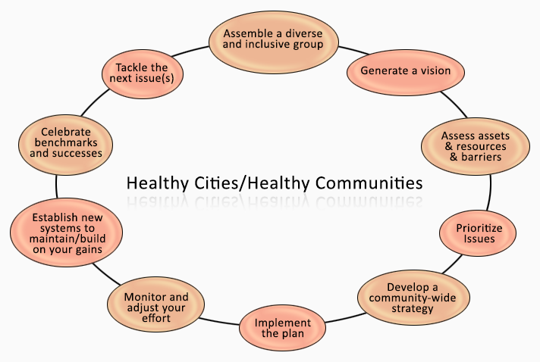
As earlier said, (Adeleke, 2021) states that health is one of the pivots which enhance the London borough of Hounslow community development. A healthy city fosters quick development. (Adeleke, 2021) .*
(Jonathan Taylow et al., 2021) study reveals that Healthy Cities and Healthy Communities are the structure for a participative process that enhances citizens to create a strong healthy community for themselves. Jonathan Taylor et al., 2021).
Diversity And Demographic Study Of London Borough Of Hounslow
(Rachel Aldred, Joseph croft, 2019) reveals that 53.3% of the London Borough of Hounslow population is White, 6.6% is Black, and 34.4% is Asian. South Asian populations in Borough abode in Hounslow, Cranford and Heston and others have a sizeable Eastern European population. Also, the larger part of the White British population is dwelling in the western and eastern parts of the borough of Hounslow East. (Rachel Aldred, Joseph croft, 2019).
In terms of religion, 14% are identified as Muslim, 42% as Christian, 9% as Sikh, 1.4% as Buddhist, 10.3% as Hindu and 0.3% are Jewish, while 18% of the population does not belong to any religious group. (Rachel Aldred, Joseph croft, 2019).

Name | Status | Population  Census  2001-04-29 | Population  Census  2011-03-27 | Population  Estimate  2020-06-30
Hounslow | Borough | 212,341 | 253,957 | 271,767
Bedfont | Ward | 10,106 | 12,701 | 13,545
Brentford | Ward | 10,746 | 14,353 | 16,104
Chiswick Homefields | Ward | 10,290 | 11,346 | 11,232
Chiswick Riverside | Ward | 10,935 | 11,543 | 11,261
Cranford | Ward | 10,936 | 12,330 | 13,767
Feltham North | Ward | 9,570 | 11,563 | 12,392
Feltham West | Ward | 11,530 | 15,541 | 16,180
Hanworth | Ward | 10,995 | 12,155 | 12,891
Hanworth Park | Ward | 10,396 | 11,408 | 12,415
Heston Central | Ward | 10,998 | 12,288 | 13,117
Heston East | Ward | 10,781 | 12,319 | 12,758
Heston West | Ward | 11,332 | 12,438 | 12,968
Hounslow Central | Ward | 10,790 | 15,169 | 19,091
Hounslow Heath | Ward | 11,116 | 14,727 | 15,811
Hounslow South | Ward | 10,369 | 11,408 | 11,212
Hounslow West | Ward | 10,355 | 12,658 | 15,007
Isleworth | Ward | 10,745 | 11,977 | 12,508
Osterley and Spring Grove | Ward | 10,452 | 13,031 | 13,311
Syon | Ward | 9,714 | 13,554 | 14,257
Turnham Green | Ward | 10,184 | 11,448 | 11,940
London | Region

(Rachel Aldred, Joseph croft, 2019).

Issued faced within London borough of Hounslow community
The study (Hounslow, 2018) explains various issues facing the Hounslow community. This includes:
- Young white people are now becoming disentangled and unprotected from far-right influences, and hate crimes against Black and minority ethnic communities have risen. Monitoring evidence shows that children from Somali and Kosovan Albanian communities are currently the most unsafe groups for bullying and racial harassment. They suffer from disorientation, social exclusion, depression and other mental health problems. (Hounslow, 2018)
- The high and growing rate of sexually transmitted and HIV infections in the community. (Hounslow, 2018).

(Campbell, Army T, et al, 2020), Postulated that change can be achieved using the following concept;
- The council must develop a good strategy for redressing inequality in key wards in the borough of Hounslow. (Campbell, Army T, et al, 2020),
- Council developing an effective approach that would reflect community needs, and concerns and make adequate use of collective resources and assets, and involve partner organisations in tackling various health problems in the community. (Campbell, Army T, et al, 2020),
- To investigate Equal Opportunities and Human Rights Policy, Delivery equality Plan reflecting the tasks, counsel of the Task Group and to bring out a fitting monitoring structure to track progress against these actions. (Campbell, Army T, et al, 2020),

Policies used by the borough in tackling issues and application theories; (Rupa Petel. et al, 2021)
- To help tackle the homelessness issues, the Camargue worked alongside and closely with senior council officers to understand and identify various challenges facing the Hounslow community generating an early prevention scheme. The use of social media has been a great instrument in exposing those troubled with homelessness situations.
to prevent or reduce air pollution problems, The City Air guide for building engineers and facilities managers states the following: (Rupa Petel. et al, 2021)
- Always ensure air filters are regularly maintained
- Air conditioning and filtration
- Ensure Installation of low energy two-stage particle and gas filters to enjoy maximum effect and cost savings. (malvina Bondy, Sefi Roth, 2020).
Social Media as a means of tackling issues in the Borough of Hounslow
The advancement of technology, especially social media according to (Burcea, 2020), has been a great help in echoing the voice of the masses to the hearing of the council which helps the council in knowing the challenges people are facing about health, inequalities problem, air pollution and others. Though social media has its shortfalls i.e., cybercrime and so on, we can’t deny the fact of its advantages for the development of the community by giving adequate information to the council which helps them in carrying out their functions effectively. (Burcea, 2020)

Child Poverty
As a review by (Hounslow, Wanda June, et al, 2018). As of 2015-16 4.1 million children live in poverty in the UK That’s about 30% of children. Projection reveals that under the current policies there is a tendency to increase to 5.2 million in 2021‐2022. Different regions face differing child poverty rates, cost of housing and differences in labour markets. (Hounslow, Wanda June, et al, 2018).
It becomes so difficult for many families to provide everything needed by their children to be successful in life. London School of Economics research indicates a link between small income and poor child results. Poverty destroys and damages children’s life chances, and when there is a rise in family incomes, children tend to better and excellent. (Hounslow, Wanda June, et al, 2018).

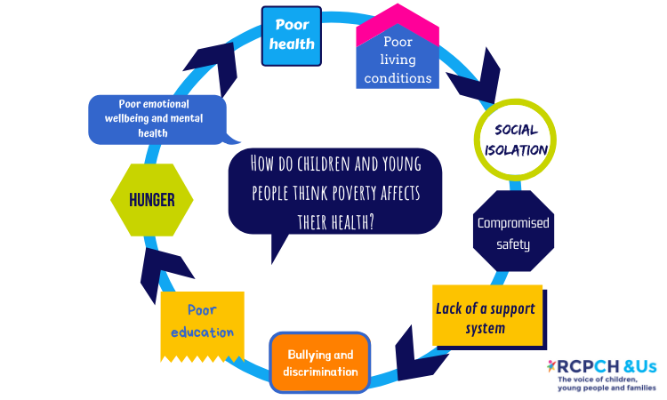
The diagram below describes more on child Poverty and Possible outcome

Education as a factor of community development
Education is a very vital instrument in enhancing community development. According to (Wessel, 2018). Education is defined as the operation which alleviates learning, or acquisition of knowledge, habits, values, skills, and personal development. Education originated as a means of transmitting cultural heritage and values from one generation to the next.
According to (Katerina Tsarava, korbinian Moeller, 2022), Education aims at deliberately influencing and assisting younger ones to improve in knowledge, various skills, physical and morals which will eventually help the child to live happily and engaged in what will be beneficial to him and the society at large. The goal of education is to produce citizens of good morals and inculcate positive values and lifestyles to enjoy peace in the community. (Katerina Tsarava, korbinian Moeller, 2022).
London Borough of Hounslow council exercise its community role in Education by:
- championing educational excellence; Acting locally to create the conditions for children and young people to succeed academically, continuing to act as a strong and effective provider of schools where headteachers and governing bodies wish to remain as a local-authority-maintained schools. (Adeleke, 2021)
- Being the champion of vulnerable children; this would be achieved by ensuring all schools and educational centres in the community area fulfil their duty to play an active part in local safeguarding policies, practices and procedures as agreed by the Local Safeguarding Children Board, giving additional needs to support children and families who need additional needs. (Sean Hayes et al., 2018)
- Being the champion of parents, carers and families. The council would achieve this by supporting families in their child’s early education and schooling, also through the transition to further education, employment or training and by providing support for parenting and family life. (Adeleke, 2021)

Digital Innovation
According to (Florian Wiesböck, 2020). Digital innovation is explained as the act of applying digital technology to existing business difficulties. The initiation of Digital Technology includes Adopting and implementing new software and developing a new technology plan for an existing business. (Florian Wiesböck, 2020).
According to (Emerald, 2016), The introduction of Digital technologies and innovations has transformed the global economy. A lot of Communities are yet to apprehend the whole developmental benefits of digital technology innovations, this includes, inclusive and sustainable growth, and improved community governance. Though digital innovation has a great number of benefits nevertheless it also has its downsides. (Emerald, 2016)
Since the advent of technology, the community has experienced a great and positive turnaround. The introduction and advancement of digital technology have been a great weapon for community development and this also affects London borough positively in so many areas. Florian Wiesböck, 2020)
According to (Malik, 2021), Complete digitisation came as a surprise to a lot of companies and organisations in different communities at the outbreak of the COVID-19 pandemic, as many businesses realised, they lacked digital maturity. However, digital innovation became of necessity for business continuity and expansion. (Malik, 2021),
(Emerald, 2016) establish that, as the result of digital technologies implementation, an organisation can improve its financial strength and progress towards its business goals by 22%. Research has revealed the level at which digital innovation has helped in the community development in the London borough of Hounslow.
(Nepelski, 2019) explicate Digital innovation technologies has a tool in making our world fairer, peaceful and juster. It supports and accelerates the great achievement of each 17 Sustainable Development Goals from bringing extreme poverty to an end to reducing maternal and infant mortality in the community including the Hounslow community, promoting sustainable farming and decent work and also to achieve universal literacy. (Nepelski, 2019)


Digital Innovation and Youth crime
According to (Bughin, 2017), The level of youth crime in several communities and the London borough of Hounslow is very outrageous. The advent of digital technology has led to an unlimited number of terrorism and cybercrime. Digital Innovation technology has a mass number of advantages, it is also important we take note of its adverse effect on communities. While digital technologies give a lot of unique opportunities, it as well gives an increase in online risk and challenges such as exposure to content which are harmful to youth in the communities or infringement of privacy. (Harvell, 2019),

Conclusion
In conclusion, this report explained what a community is, the needs and the importance of community care and development. Explaining how imperative it is for a community to experience development through a mechanism that would gear development. This research has delineated the various sectors which can engineer community care and development, this includes health sector, education, and digital innovation.
When it comes to decision making, residents are usually out of the loop and not aware that they influence these decisions or at least be notified why and when they are taken. Local authorities every so often only involve residents once a decision has been finalised.
Local authorities should allow local people to be inclusive in local decision making. Not only will this allow the residents to be active in their community, but it will also help Hounslow to develop cohesiveness among local communities in the borough, the council and the voluntary sector.

References
Adeleke, Y., 2021. Hospital admissions for strokes and bleeding in Hounslow. Open Heart, Volume 1, p. 8.
Bughin, j., 2017. Digital innovation. The best response to digital disruption, p. 5.
CAMPBELL, Army T, et al, 2020. Addressing community Trauma. community trauma, Volume 4, p. 23.
Crowther and Van den Hoogen, 2020. Science journal. The global soil community and its influence on biogeochemistry, p. 4.
Emerald, 2016. Digital Innovation. Mastering Digital Transformation.
Florian Wiesböck, T. H., 2020. Digital Innovation. Digital Innovation Embedded in an Organisation, p. 6.
Harvell, W. a. S., 2019. Digital innovation. Promoting a new direction for youth justice.
Hayden and Parkin, 2020. Irish Journal of psychological medicine. The challenges of covid 19 for community pharmacists and opportunities for the future, p. 3.
Hounslow, Wanda June, et al, 2018. Genocide and the maintenance of power. Genocide and the maintenance of power, Volume 2, p. 13.
Hounslow, W. J., 2018. Genocide and the Maintenance of Power. Genocide and the Maintenance of Powe, p. 64.
Jarvis, P., 2018. Education. Professional Education, p. 34.
Jonathan Taylow et al., 2021. Shaping a Healthy and Equitable London in a Warming Climate. Urban Climate Science For Planning Healthy Cities, Volume 7, p. 98.
Katerina Tsarava, korbinian Moeller, 2022. education. A cognitive definition of computational thinking in primary education.
Malik, P., 2021. 89N3PDyZzakoH7W6n8ZrjGDDktjh8iWFG6eKRvi3kvpQ. [Online]
Available at: What Is Digital Innovation? Corporate Benefits & Examples (2021
[Accessed 5 April 2022].
Michelet, M., 2020. Development of best practice recommendations to enhance access to and use of formal community care services for people with dementia in Europe: a Delphi process conducted by the Actifcare project, p. 5.
Nepelski, D., 2019. Digital innovation. How to Facilitate Digital Innovation in Europe.
Nepelski, D., 2019. Digital Innovation. How to Facilitate Digital Innovation in Europe.
Norris, T., 2002. https://ctb.ku.edu/en/table-of-contents/overview/models-for-community-health-and-development/healthy-cities-healthy-communities/main. [Online]
Available at: https://ctb.ku.edu/en/table-of-contents/overview/models-for-community-health-and-development/healthy-cities-healthy-communities/main
[Accessed 5th of April April 2016]
Rachel Aldred, Joseph croft, 2019. Evaluating active travel and health economic impacts of small streetscape schemes. Journal of transport & health, Volume 12, p. 9.
Sean Hayes et al., 2018. London Review on Education. What have the changes made to the primary and secondary assessment framework, Volume 3, p. 16.
Wessel, E., 2018. Education. Issues in reporting requirements and benefit of definition and education requirement.

