

TAIWAN CULTURE REPORT

Foreign Languages and Cultural Awareness
BMIH5003

Lavinia Lenuta Siminiuc
2208461
Heidi Prosser
Word count:923

Executive Summary:
The successful expansion of Diversity Hotel & Spa in Taiwan requires a deep understanding of the local culture. This report examines the cultural and behavioural aspects of Taiwan, providing valuable insights that will guide the training sessions for hotel staff.
This report begins by introducing the purpose and significance of the topic, followed by a comprehensive overview of Taiwan's culture. This section highlights the significant impact of the primary language, customs, values, and prevailing religious beliefs on daily interactions and business etiquette within the country.
The GLOBE Project's analysis of Taiwan provides a systematic understanding of the cultural practises and values of the nation. The country demonstrates a strong adherence to power distance and hierarchies, a commendable level of uncertainty avoidance, a prominent dedication to collectivism, a strong focus on performance, and a significant emphasis on ethical principles. Furthermore, by applying Hofstede's model, we emphasise Taiwan's long-term orientation, which highlights the country's focus on persistence and hierarchical relationships.
Simply understanding these cultural aspects is insufficient in the hospitality industry. Cultural intelligence and sensitivity are highlighted for their significance in enhancing communication, fostering trust, promoting employee satisfaction, and improving customer experience.
The report shows the successful integration of traditional and modern elements in Taiwanese culture. By acknowledging and incorporating these elements, Diversity Hotel & Spa has the potential to attain substantial success in its business in Taiwan.
The report suggests a set of measures that can be taken. Key considerations for organisations operating in diverse cultural contexts include staff cultural training, hiring local cultural experts, operational flexibility, open communication channels, participation in local events for community integration, and continuous feedback collection for improvement.

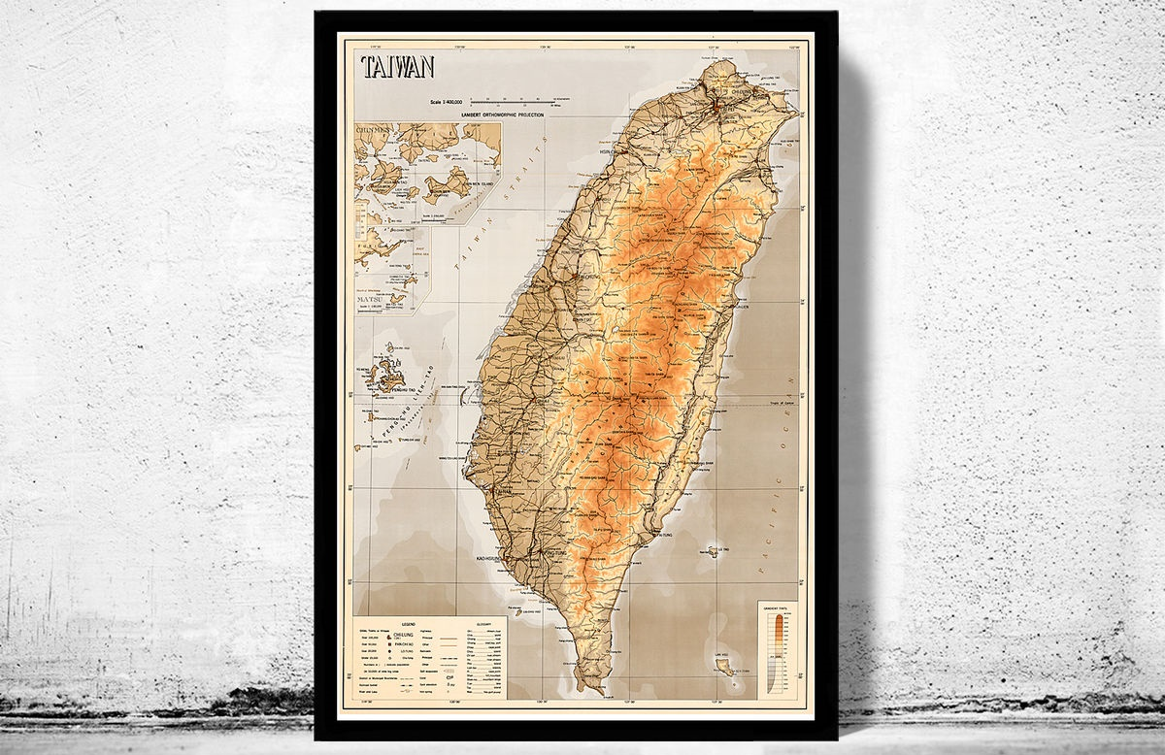Content Table
Introduction
3
Taiwan Culture Review
3
GLOBE Project/Country Analysis
5
Importance of Cultural Intelligence and Sensitivity
6
Conclusion
7
Recommendations
8
References
9

Introduction
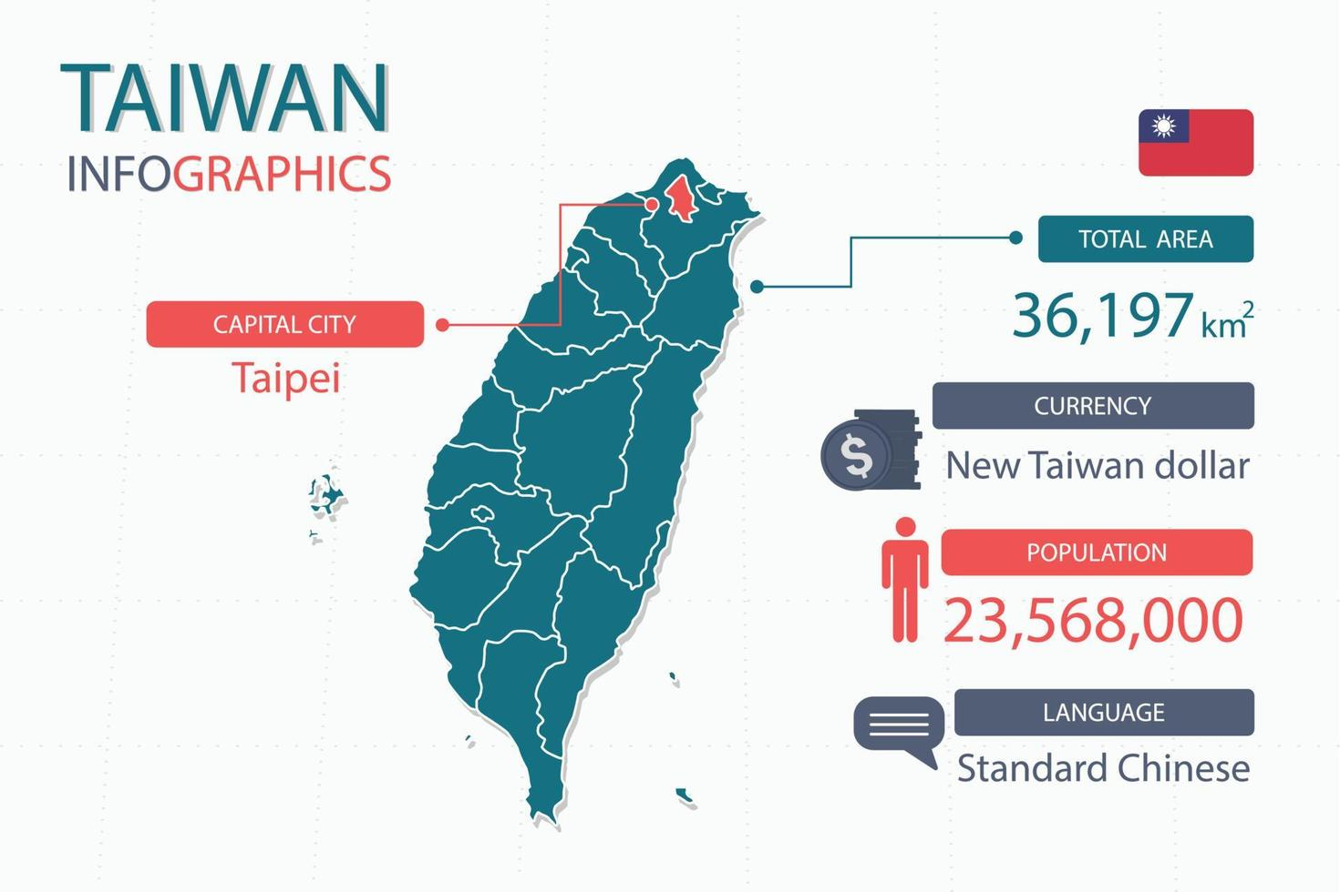
The hospitality industry benefits from absorbing and adapting into various cultural environments. Understanding the cultural, social, and business specifics of Taiwan is crucial for Diversity Hotel & Spa as it expands its operations in the country. This report is carefully prepared to guide the General Manager and the wider team (Heppner, Wang, Heppner and Wang, 2012). This study will examine Taiwan's cultural foundations and analyse them using the GLOBE Project. The focus will be on the impact of these cultural factors on hotel operations. This document seeks to provide actionable insights into the hotel's leadership in Taiwan, focusing on the importance of cultural intelligence and sensitivity for a harmonious and prosperous development.


Taiwan’s Culture Review
Cultural intelligence and sensitivity are essential for the General Manager to operate effectively in Taiwan. According to Heppner, Wang, Heppner, and Wang (2012), cross-cultural competence encompasses self-awareness of one's cultural worldview, familiarity with the culture of the host country, and the ability to adjust one's behaviour to fit within different cultural contexts. The General Manager must possess effective and respectful communication skills to facilitate smooth operations and promote respect among individuals from diverse cultural backgrounds within the hotel.
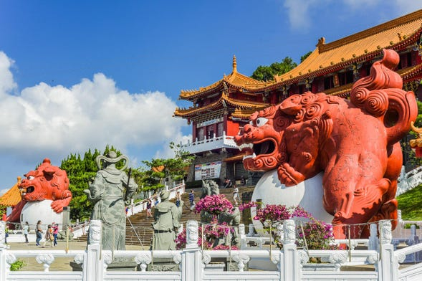
Taiwan, an East Asian Island nation, has a diverse culture influenced by its history and contemporary ambitions. The Mandarin language is central to its communication. Mandarin, as the official language, facilitates conversations and influences the complicated nature of business and social interactions (Cheng, Wang and Tötösy de Zepetnek, 2009).
Taiwan's customs are a fusion of traditional Chinese practises, indigenous habits, and some Japanese influences due to its historical background. Greeting customs often involve a nod or a slight bow, which is seen as a respectful gesture. The depth of the bow can indicate the level of respect being shown (Cheng, Wang and Tötösy de Zepetnek, 2009). According to Way (2023), in the business domain, the act of exchanging business cards is a customary ritual. The gesture of presenting with both hands signifies mutual respect and acknowledgement.
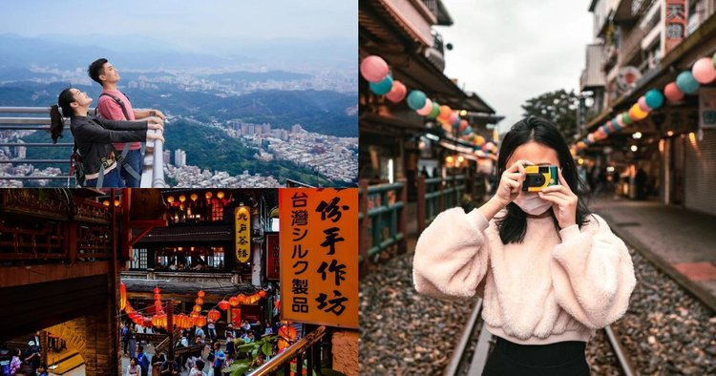
Also, Way (2023) explains that Taiwanese society is deeply rooted in core values such as respect for elders, harmony, and collectivism. These values are evident in personal and professional contexts, highlighting the significance of group unity and respect for hierarchy. The religious context, mainly influenced by Buddhism, Taoism, and Confucianism, strengthens these values by teaching humility, reverence, and community solidarity.

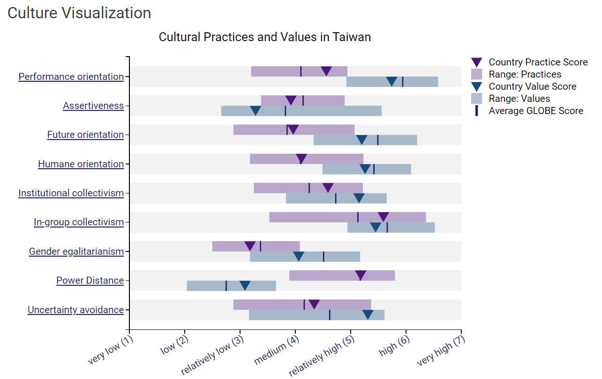
GLOBE Project/Country Analysis
The GLOBE Project's research on cross-cultural leadership examines key aspects of Taiwanese culture that businesses need to understand and navigate.
Power Distance: Taiwan shows a high-power distance, indicating a cultural inclination towards respect for authority and hierarchical systems. Organisational decisions typically exhibit centralization, where subordinates rely on superiors for guidance. Respecting hierarchy requires clear leadership roles and decision-making processes (Tung and Verbeke, 2010).
Uncertainty Avoidance: According to Schlessinger (2022) Taiwanese businesses demonstrate a moderate level of uncertainty avoidance, as they prefer structured environments while also displaying adaptability. In hotel operations, the significance of well-defined procedures and adaptability to unexpected challenges cannot be overstated.
Collectivism: Taiwanese culture places a high value on collectivism, prioritising group harmony over individual achievements. Collaboration, consensus-building, and teamwork are essential in the professional environment (Schlessinger, 2022).
Performance Orientation: Huang (2012) states that Taiwan exhibits a performance-oriented culture that values and encourages accomplishments, hard work, and ongoing enhancement. Establishing specific benchmarks and acknowledging achievements will have a positive impact in the hotel industry.
Humane Orientation: Taiwanese society prioritises caring, kindness, and community well-being. The compassionate mindset that companies have signifies a focus on prioritising employee well-being and fostering a supportive work environment (Schlessinger, 2022).

Importance of Cultural Intelligence and Sensitivity

Cultural intelligence and sensitivity are crucial for success in the globalised hospitality industry. The Diversity Hotel & Spa in Taiwan acknowledges the significance of recognising the multifaceted landscape for several reasons:
Effective Communication: Language, non-verbal cues, and local customs are significant factors in Taiwan. Recognising and valuing these factors can prevent misunderstandings and disputes, promoting effective communication among hotel employees, administration, and visitors (Liao, Wu, Dao and Luu, 2021).
Building Trust: Liao, Wu, Dao, and Luu (2021) state that cultural sensitivity can help hotels build trust with local staff and customers. Acknowledging and valuing indigenous customs and traditions fosters trust, a crucial element for establishing enduring business connections.
Employee Satisfaction: Also, Liao, Wu, Dao and Luu (2021) conclude that the workforce surrounded by understanding and respect is more inclined to exhibit engagement and commitment. By adopting cultural intelligence, the hotel prioritises the appreciation of its staff, resulting in increased job satisfaction and improved service quality.
Customer Satisfaction: Customer satisfaction is enhanced when guests, regardless of their origin, are provided with a culturally sensitive atmosphere. Being acknowledged and valued enhances individuals' experience, fostering a sense of recognition and respect (Cui, 2021).
Cultural intelligence involves not only grasping the 'what' and 'how' of Taiwanese culture, but also understanding the underlying reasons behind it. The profound comprehension will serve as the foundation for the success of Diversity Hotel & Spa in Taiwan (Cui, 2021).

Conclusion
Taiwan's diverse culture, reflected in its traditions, values, and societal norms, poses opportunities and challenges for businesses such as Diversity Hotel & Spa. The GLOBE Project analysis highlights the importance of comprehending power dynamics, collective values, and societal expectations. Cultural intelligence and sensitivity are essential for closing the gap between awareness and integration. The hotel's success in Taiwan's competitive hospitality market depends on more than just operational excellence. It also relies on genuinely embracing and celebrating the local cultural philosophy. Adopting these insights will undoubtedly lead to a prosperous and harmonious existence in Taiwan (Way, 2023).

Recommendations
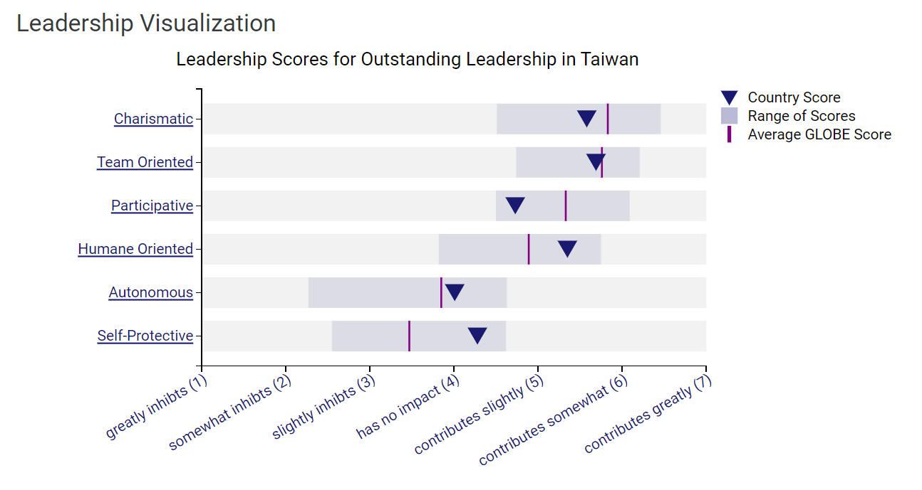To prevent cultural misunderstanding and gain acceptance as a new leader, the General Manager should consider the following specific recommendations:
- Greetings and Physical Contact: In Taiwan, greetings typically involve a nod or bow rather than a handshake, particularly during initial encounters. The General Manager should refrain from initiating handshakes unless they are extended by the Taiwanese counterpart. This is especially significant when interacting with individuals of the opposite gender, as some individuals may prefer avoiding physical contact (Martin and Chaney, 2012).
- Business Card Etiquette: It is customary to use both hands when receiving or offering a business card, and it is recommended to take a moment to carefully examine the card. This demonstrates respect for the individual. Neglecting to acknowledge a business card by casually placing it in a pocket or disposing of it can be perceived as disrespectful or dismissive (Martin and Chaney, 2012).
- Public Behavior: The General Manager should exhibit appropriate behaviour in public settings. In Taiwanese culture, loudness and exuberant behaviour are generally discouraged due to their potential to disrupt harmony and group cohesion, which are highly esteemed (Samovar, Porter, McDaniel, Roy, 2017).

Reference
- Cheng, C-C., Whang, I-C., Zeptenek, S.T., 2014. Cultural Discourse in Taiwan. Online Available at: https://docs.lib.purdue.edu/cgi/viewcontent.cgi?article=1085&context=clcweblibrary
- Cui, Y., 2021. The role of emotional intelligence in workplace transparency and open communication. Aggression and Violent Behavior, p.101602.
- Heppner, P. P., Wang, K. T., Heppner, M. J., & Wang, L.-F. (2012). From cultural encapsulation to cultural competence: The cross-national cultural competence model. In N. A. Fouad, J. A. Carter, & L. M. Subich (Eds.), APA handbook of counseling psychology, Vol. 2. Practice, interventions, and applications (pp. 433–471). American Psychological Association. https://doi.org/10.1037/13755-018
- Huang, J.C., 2012. The relationship between conflict and team performance in Taiwan: The moderating effect of goal orientation. The international journal of human resource management, 23(10), pp.2126-2143.
- Liao, Y.K., Wu, W.-Y., Dao, T.C., 2023. The Influence of Emotional Intelligence and Cultural Adaptability on Cross-Cultural Adjustment and Performance with the Mediating Effect of Cross-Cultural Competence: A Study of Expatriates in Taiwan. Online Available At: https://doi.org/10.3390/su13063374
- Martin, J.S. and Chaney, L.H., 2012. Global business etiquette: A guide to international communication and customs. Bloomsbury Publishing USA.
- Samovar, L.A., Porter, R.E, McDaniel, E.R., Roy, C.S., 2017. Comunication Between Cultures. 9Th Edition. Online Available At: https://lib-pasca.unpak.ac.id/index.php?p=fstream-pdf&fid=3505&bid=15474
- Schlessinger, T., 2022. Weathering Storms: Resilience in the Age of Covid (Doctoral dissertation, Pepperdine University).
- Tung, R.L., Verbeke, A., 2010. Beyond Hofstede and GLOBE: Improving the quality of cross-cultural research. Online Available at: https://link.springer.com/article/10.1057/jibs.2010.41
- Way, J.F., 2023. The Role Of Confucianism In Shaping Taiwanese Values. Online Available at: https://discoveringtw.com/the-role-of-confucianism-in-shaping-taiwanese-values/

