15:55 03/11/20 ACAH3000 Joshua Todd 2005986 Page 1 Of 6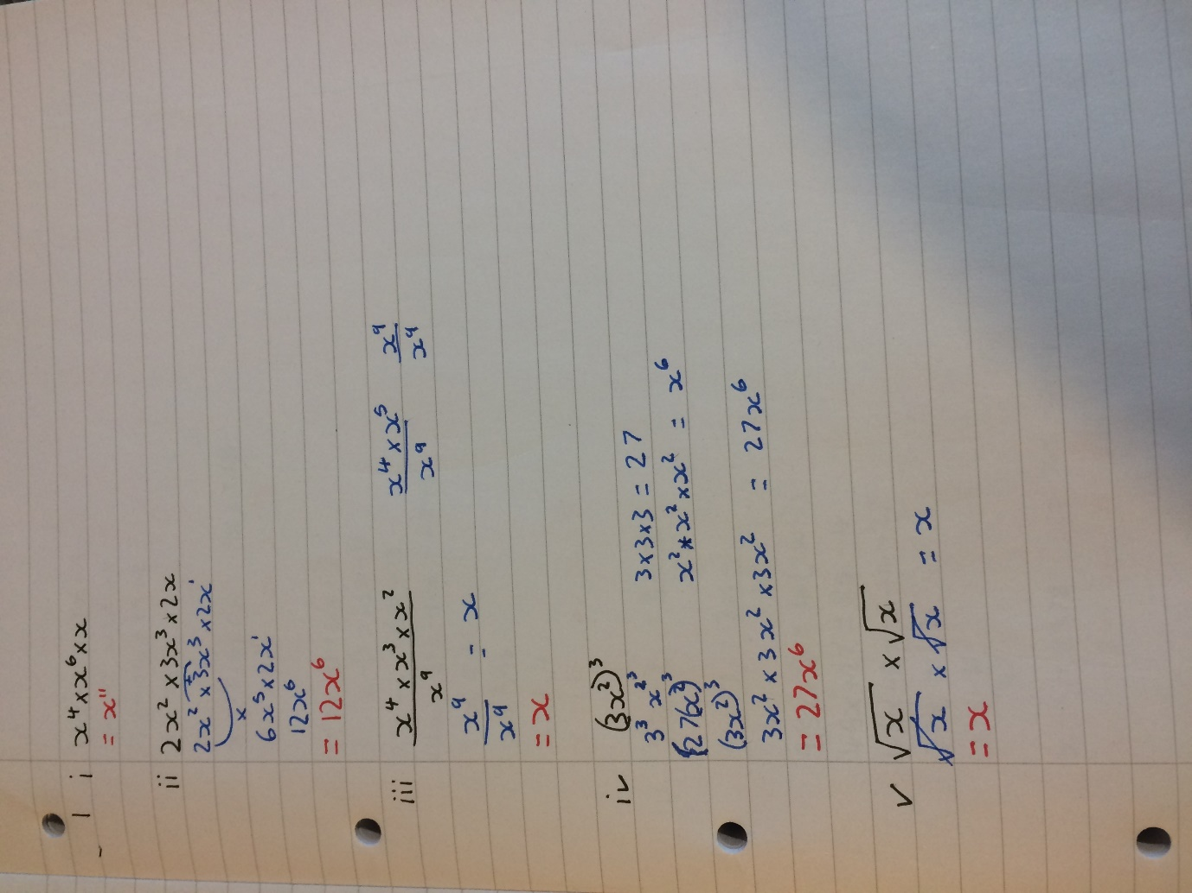

15:55 03/11/20 ACAH3000 Joshua Todd 2005986 Page 2 Of 6
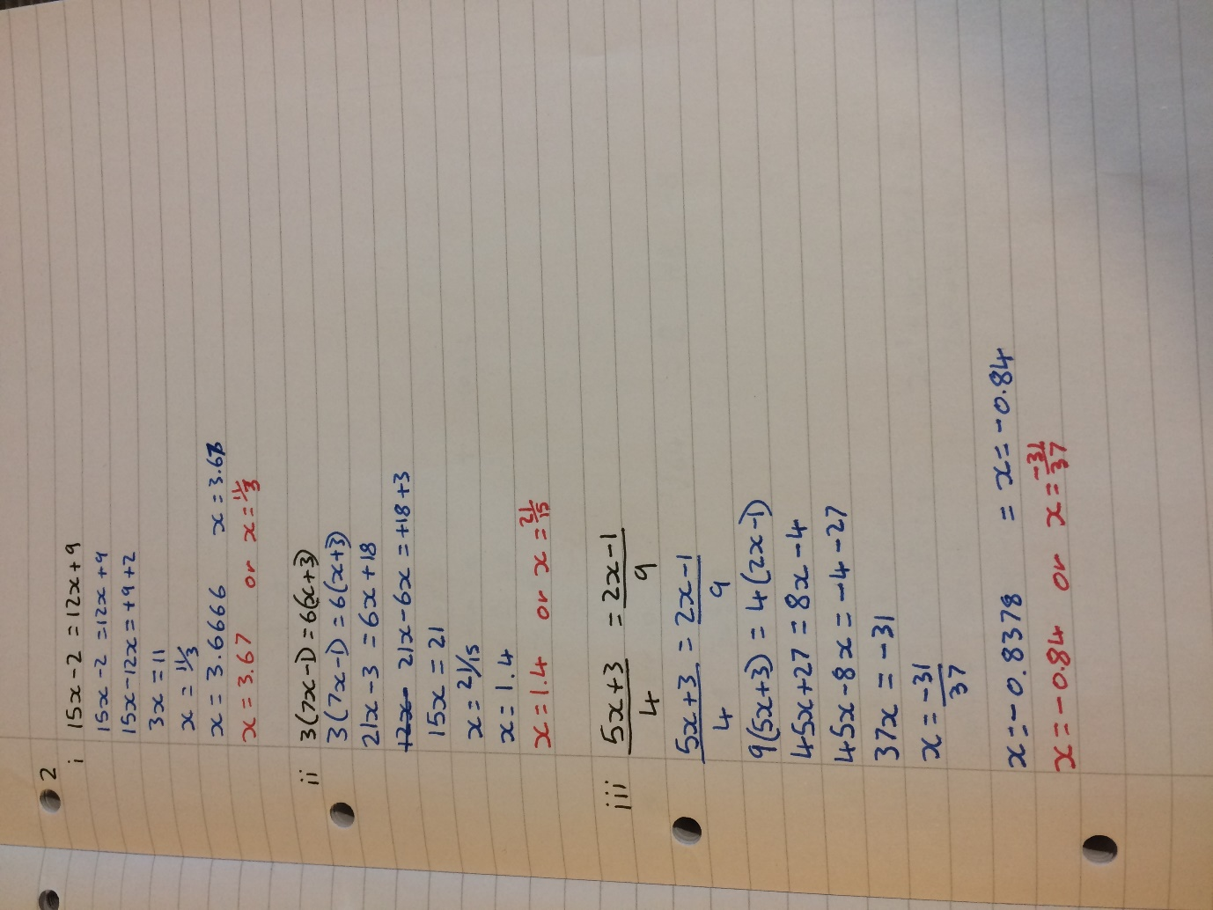

15:55 03/11/20 ACAH3000 Joshua Todd 2005986 Page 3 Of 6
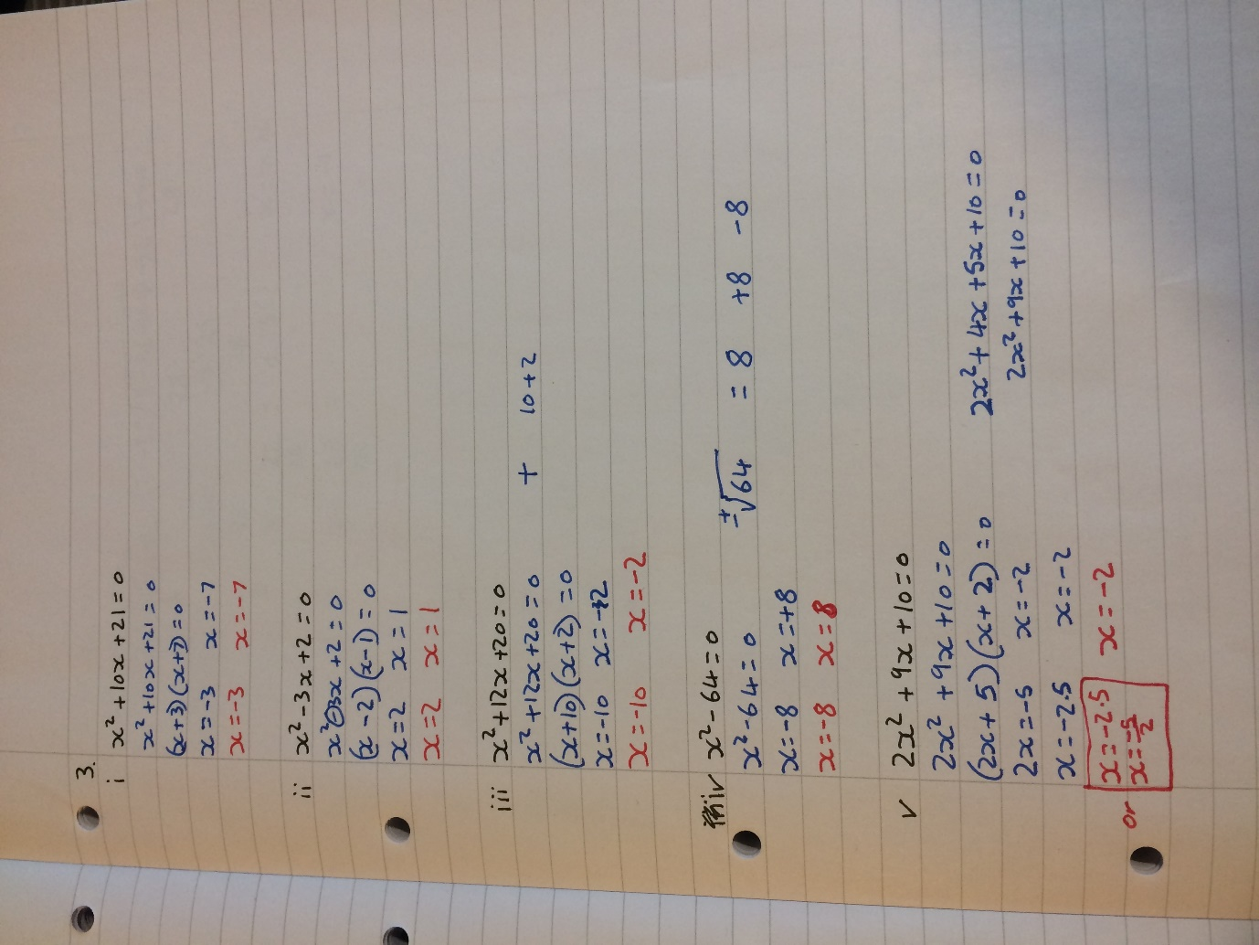

15:55 03/11/20 ACAH3000 Joshua Todd 2005986 Page 4 Of 6
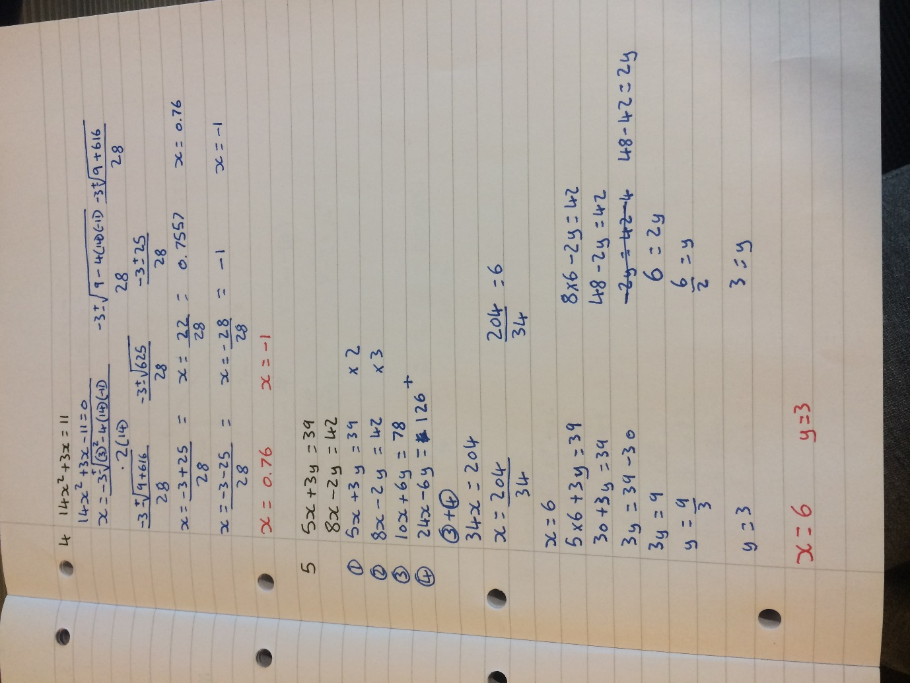

15:55 03/11/20 ACAH3000 Joshua Todd 2005986 Page 5 Of 6
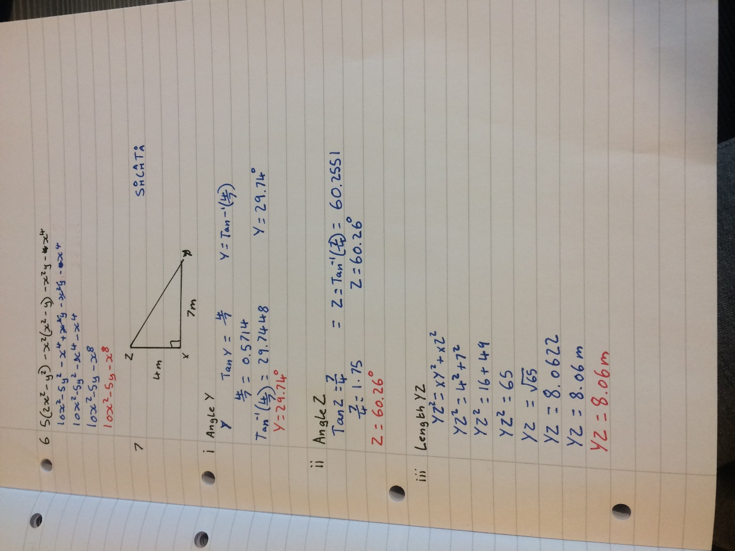

15:55 03/11/20 ACAH3000 Joshua Todd 2005986 Page 6 Of 6


