

Postgraduate/Distance Learning
Assignment coversheet & feedback form

THIS SHEET MUST BE THE FIRST PAGE OF THE ASSIGNMENT YOU ARE SUBMITTING (DO NOT SEND AS A SEPARATE FILE)

For completion by the student:
Student Name: Steve McDonald

Student University Email: 2325822@student.uwtsd.ac.uk
Module code: HPCA7014  Module title: Sacred Geography | Student ID number:  2325822 |  |  | Educational support needs:  No
Assignment title: Is sacred space a human construct or a natural phenomenon?

Assignment due date: 5 January 2026
This assignment is for the 1st 2nd 3rd 4th 5th 6th module of the degree
I confirm that this is my original work and that I have adhered to the University policy on plagiarism.
Signed ……………………………………………………………
Email submission:if you are submitting this form via email, please tick this box
(as a substitute for your signature) to confirm that you agree to the above declaration.
Assignment Mark
1st Marker’s Provisional mark
2nd Marker’s/Moderator’s provisional mark
External Examiner’s mark (if relevant)
Final Mark

NB. All marks are provisional until confirmed by the Final Examination Board.

For completion by Marker 1 :
Comments:

Marker’s signature: |  |  | Date:
For completion by Marker 2/Moderator:

Comments:

Marker’s Signature: |  | Date:
External Examiner’s comments (if relevant)

External Examiner’s Signature: |  | Date:

Is sacred space a human construct or a natural phenomenon?
A phenomenological study of Llanilid in South Wales.

INTRODUCTION

The aim of this essay is to explore whether sacred space is a human construct or a natural phenomenon through a study of Llanilid, in the old county of Glamorganshire in South Wales, and the church dedicated to Ss Ilid and Curig that is situated within it. The question will be investigated through an examination of the stories associated with the site and their role in creating and maintaining the sacred nature of the space. This will be complemented by drawing on my own phenomenological experience of visiting the site and noting my thoughts and feelings while within it. The stories and my experiences will be discussed in the context of theorists such as Emile Durkheim, Mircea Eliade and Belden Lane to understand how they inform ideas of how sacred space comes to be.

LITERATURE REVIEW

‘Sacred place is storied place.’

Belden Lane writes that ‘sacred place is storied place’ and there are many stories attached to Llanilid. I first became aware of the site through a Welsh news article with the headline ‘Christian icon Joseph of Arimathea could be buried in Cardiff, claims author.’ Having a Christian background, the notion that such a prominent Christian figure could be buried only a few miles from my home caught my attention. The article refers to a book by Michael A Clark and centres on the idea that, in South Wales, Joseph of Arimathea was known as St Ilid. It also draws attention to the church dedicated to St Ilid located near the town of Bridgend, only a short drive away. (Fig. 1)

I first visited Llanilid in late 2023, finding what Stewart Williams labels a scattered hamlet in which a 1961 census recorded only 95 people living. Though not far from the M4 motorway, the church is approached via a single-track road making it feel remote. The building perches on what RCAHMW describe as a low glacial eminence which it shares with an ancient ringwork (Fig. 2) thought to be a Norman motte or defensive structure presumably dating to the 12th century. In establishing its age Williams states that ‘the only genuine clue as to the antiquity of the church lies in the ancient foundations at the foot of the north side of the nave’, and also refers to it being mentioned in a 13th century document. I have been unable to locate records of any archaeological excavations at the site that would give a more accurate date for the church or of human activity at the site in general. The church enclosure contains a graveyard and two yew trees, which according to The Ancient Yew Group have diameters of 5.5m and 7m+ classing them both as ancient, with the larger of the two potentially being approximately 2,000 years old. (Fig. 2) Ronald Hutton writes that though a connection between yew trees and ancient paganism cannot be proven, their association with sacred sites and their age (potentially predating the introduction of Christianity to Britain), lead many to believe that such sites have been a focus for religious activity for thousands of years. Additionally, though the ringwork is generally considered of Norman origin, a pamphlet produced by the church on its history refers to the possibility that the ringwork was built on an earlier druid mound. So while the evidence dates the site to the medieval period, there are suggestions that it may have been considered sacred for much longer. The church pamphlet also mentions other interesting features of Llanilid, one being a natural spring called Ffynon Ceri a few hundred metres east of the church which and reputed to be a holy well. Another is the coffin stile built into the boundary wall of the church enclosure. The church’s isolation meant that funeral processions and wedding parties would have had to cross fields to reach it, the stile provided a place for pallbearers to stop and rest, hence its name.

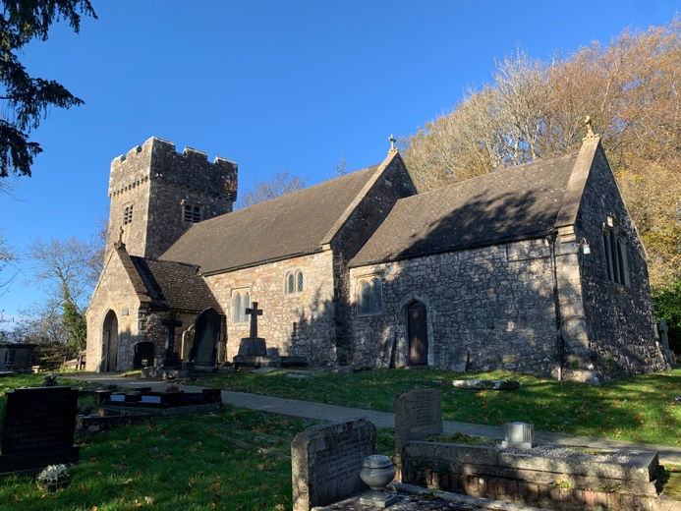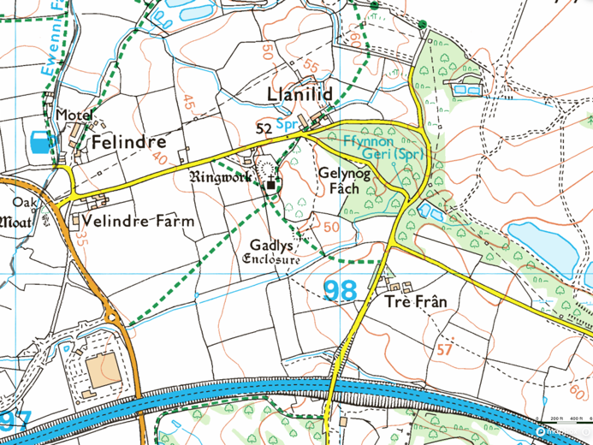
Figure 1: Picture of Ss Ilid & Curig Church in Llanilid and Map of Llanilid in relation to motorway.
Images: Steve McDonald (left) and OS Maps (right)

On my second visit to the church, I was fortunate to find it open and was able to explore inside. The church interior was simple and peaceful, with whitewashed walls, an impressive Norman font with trefoil design, (Fig. 2) and wooden pews facing the altar beneath the stained-glass window depicting the crucifixion of Christ at the eastern end. Hanging on a wall was a clipping from a 1975 edition of a local newspaper with the headline ‘Britain’s oldest church? Ancient Triads say Paul visited the Vale before AD67.’ The potential link between the site and another prominent figure in Christianity again drew my attention. This article refers to a book written in 1910 by a Rev. David Davies who happens to be from my hometown of Penarth. I located a copy in an online book shop, which on arrival I found to contain the author’s signature, and further investigation revealing that he was the minister of a church I attended as a child. In the book Davies mentions a tradition that St Paul met Caractacus, a Welsh Prince, while both were imprisoned in Rome in 58-59 AD. Davies goes on to write that ‘in harmony with a certain interpretation of a phrase used by Clemens Romanus, namely, “the utmost bounds of the west,” Paul was said to have visited the Vale of Glamorgan, and spent some time with Caractacus in his Welsh home.’ The tradition also tells of Bran, the father of Caractacus who was likewise imprisoned in Rome, and who on his release in 67 AD returned to Glamorgan with ‘Ilid and other missionaries, whose ministry was so successful as to result in the building of Llanilid Church’ and with it the entry of Christianity to the British Isles. In addition to tales of Joseph of Arimathea and St Paul, there is also the suggestion of a link to Shakespeare’s King Lear. According to Iolo Morganwg, Llanilid ‘appears to have been a retirement home for Silurian Princes,’ the Silures being the tribe that inhabited Southeast Wales approximately 2,000 years ago. Bran and Caractacus are mentioned as two such princes, with Bran’s father Llyr (Lear) speculated to have been the inspiration for the title character of Shakespeare’s play.

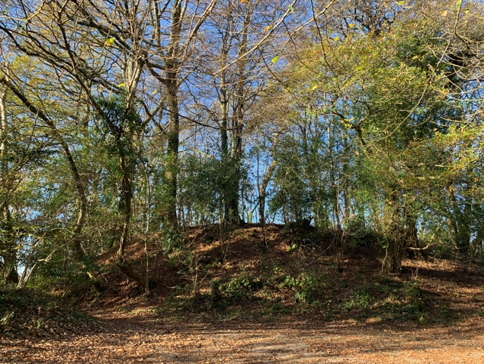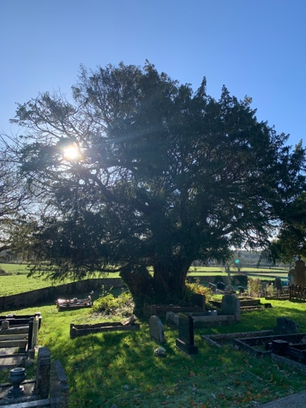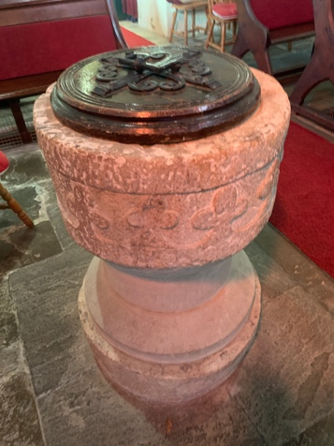
Figure 2: The ringwork (left), the larger of the yew trees (middle), and the font (right).
Images: Steve McDonald.

After recounting the tale of Caractacus and St Paul, Davies writes that ‘the tradition is so romantic and alluring as to make one earnestly wish that it could be substantiated by something like contemporaneous history.’ Hutton however points out that there is ‘no reliable data’ as to how Christianity entered the British Isles, but recognises that it must have been early as he considers it have been ‘well-established and widespread’ by 314 AD when three British bishops were sent to the Council of Arles. In addition, some of the detail of these stories, such as the link between St Ilid and Joseph of Arimathea, comes from Iolo Morganwg, who Hutton states, is known to have contaminated ‘the resources of Welsh historical tradition with bogus texts.’ Clifford Geertz defines culture as ‘an historically transmitted pattern of meanings embodied in symbols.’ The transmission of stories including prominent Christian symbols and Welsh places likely contributes to what Hutton acknowledges was the huge impact that Morganwg had on stimulating Welsh culture. In addition Lane writes that ‘places become valued in proportion to the number and power of stories that are attached to them’, and Emile Durkheim that stories ‘express the nature of sacred things’. In attempting to understand the nature of sacred space Lane identifies four axioms which can act as a guide. The first axiom is that ‘sacred space is not chosen, it chooses’, the second is that ‘sacred place is ordinary place, ritually made extraordinary’, the third that ‘sacred space can be tread upon without being entered,’ and the fourth that ‘the impulse of sacred place is both centripetal and centrifugal.’ The purpose of this essay is not to assess the historical veracity of the stories associated with Llanilid, but rather to examine how they contribute to the sense of sacredness at the site and, guided by Lane’s axioms, to understand the nature of that sacredness.

What’s in a name?

Christopher Tilley argues that ‘place names are of such vital significance’ because through the act of naming ‘places become invested with meaning.’ What meaning then might be contained in the name Llanilid? Durkheim defines the sacred as that which is ‘set apart’ from all else which he terms the profane. In the context of this essay the thing set apart as sacred is space. Often paired with the name of a saint, llan is a common element in Welsh place names which Richard Morgan translates as ‘consecrated ground’. The name Llanilid may therefore be taken to mean ground or space that has been consecrated, or set apart and dedicated, to St Ilid. Therefore Llanilid, or any Welsh place name that includes llan, can be understood to incorporate space sacred in Welsh culture.

There are several interpretations of Ilid. Some suggest that it refers to the name of an early Welsh saint, possibly even Joseph of Arimathea, as previously discussed. Morgan, however, identifies an early association between Ilid and Julitta, a Christian martyr from Tarsus, noting that her fellow martyr, Ciricus, was similarly linked with Curig. Morgan also points out that others reject the idea that Ilid refers to a person at all, and that the term instead denotes a geographical feature. Consultation of a Welsh dictionary shows that il is translated as ‘that is in motion’ or ‘ferment’, implying change or transformation, while id denotes a point. Taken together, Ilid may therefore be understood as signifying a point of transformation.

How sacredness comes to be

Having defined sacred as that which is set apart, there are differing theories as to how a space comes to be so. Durkheim understands sacredness as a nonphysical reality originating in the mind which ‘must be added to… again and again… by collective human doing,’ and that this action ‘transfigures the real world and makes it a shared world’ existing in what he terms a ‘conscience collective.’ Applied to Llanilid this concept suggests that a community first chose the site and constructed the church, then through repeated ritual such as collective worship, the observance of religious festivals, baptisms, marriages, and funerals, created a shared sense of sacredness in the communal imagination. As such, in Durkheim’s view, sacred space is fundamentally a human construct.

In contrast to Durkheim, Mircea Eliade argues that ‘some parts of space are qualitatively different from others,’ and these spaces allow for what he terms an hierophany or manifestation of numinous. This concept of the numinous is drawn from the work of Rudolph Otto, who uses it to express the inexpressible or ‘wholly other,’ that exists within all religions, and which, in a Christian context, may be understood as God. Otto describes the responses that characterise an hierophany through his notion of ‘mysterium tremendum,’ meaning profound mystery provoking feelings of awe, terror, silence, and fascination. For Eliade then, space becomes set apart not through human construction but because people, often through an hierophany, recognise that its quality differs from that of ordinary space; he therefore understands sacred space as a natural phenomenon. This view of sacred space aligns with the notion of ‘thin places’ or locations where the ‘veil is thin’. Rosemary Power explains that the term derives from Biblical texts describing the veil of the Temple, which symbolises the boundary between this world and the next. The implication is that in places where the veil is thin, the quality of the space is such that it may more readily allow for an hierophany. Power further suggests that this concept carries particular resonance within Celtic traditions, meaning that it might therefore be applicable to Llanilid.

From space to place

The final term within the essay question to be explored is space, a consideration of which will lead towards a methodological approach by which the nature of sacredness at Llanilid might be investigated. Christopher Tilley points out that space is generally considered to be ‘quite literally a nothingness, a simple surface for action, lacking depth.’ He explains that while this view of space is useful in a quantitative study of human behaviour it becomes ‘decentred from agency and meaning’. Edward Casey draws on Aristotle’s idea of Topos or a ‘place as container’ shaping or acting on that which it contains; and puts forward an argument that when general space becomes a defined place, it becomes ‘a unique and nonreducible feature of the physical world, something with its own inherent powers’. The general consideration of sacred space therefore gives way to sacred place when considering a specific location such as that at Llanilid, and questions can be asked such as: what inherent power does this place hold and how does it act on those who enter it?

It is an understanding of place which incorporates meaning that leads Tilley to a phenomenological approach which he describes as involving the ‘understanding and description of things as they are experienced by a subject’. Tilley draws on Merleau-Ponty’s argument that ‘the human body provides the fundamental mediation point between thought and the world’, and Lucien Levi-Bruhl puts forward the idea that to exist in the world is to participate with it, and that this participation is often felt before it is thought. By therefore putting my own body into the sacred space at Llanilid and participating with it, I can ask what I feel in this place and how does it act on me. Furthermore, Aristotle’s notion that things move to their own proper place and that in that place they find rest, can be used to ask of this place what here feels like it is in its proper place? Is there anything here that feels as though it is out of place? The result of exploring the implications of a consideration of a specific place rather than of general space, is that it opens an avenue through which the nature of the place can be explored through the phenomenological experience of a subject, which in this case is myself.

In outlining his phenomenological approach Tilley writes that:

A centred and meaningful space involves specific sets of linkages between the physical space of the non-humanly created world, somatic states of the body, the mental space of cognition and representation and the space of movement, encounter and interaction between persons and between persons and the human and non-human environment.

This description of linkages seems akin to rhizome theory put forward by Gilles Deleuze and Félix Guattari in which connections are ceaselessly established between all things both tangible and intangible. In this theory things or places through which these linkages or threads are woven together are known as an assemblage, which Deleuze and Guattari define as a multiplicity that ‘changes in nature as it expands its connections’. In Tim Ingold’s exploration of lines he writes that ‘after all, what is a thing, or indeed a person, if not a tying together of the lines - the paths of growth and movement’. The phenomenological approach can therefore be expanded by considering both Llanilid and myself as assemblages, asking what threads have connected us, and how our respective natures may have been changed through that connection.

METHODOLOGY AND REFLEXIVITY

The researcher as the subject

This study will take a phenomenological approach and guided by Lane’s axioms attempt to understand the nature of sacredness at Llanilid. These findings will be assessed against Durkheim and Eliade’s theories on how sacred space comes to be to answer the question of whether it is a human construct or natural phenomenon. A phenomenological approach is qualitative rather than quantitative and inherently subjective; and as Judith Bell notes, its findings ‘cannot be generalised to whole populations’. The benefit is that it provides what Geertz would describe as a ‘thick description’ of a personal experience of the site. In addition, Tilley points out that a phenomenological approach requires a ‘continuous dialectic between ideas and empirical data,’ that is, between the qualitative and quantitative. It is therefore hoped that adding this small piece of qualitative data to this interaction will contribute to a broader understanding of sacred space.

To investigate the nature of sacredness at Llanilid I visited the site on three occasions additional to those already described. The first visit took in the outside of the church, the graveyard, and the ringwork. For the second visit, I attended a Sunday morning service, allowing me to take part in collective worship with the parishioners and, since the church is typically locked, to experience the inside of the building. The third visit took in the landscape around the church, the fields, the woodland, and the natural spring that it contains. Guided by Edmund Husserl’s notion of the lifeworld as ‘straightforward intersubjective experience’ primarily perceived through the body’s senses, I documented my observations after each visit, noting what I saw, heard, and felt. These notes are contained in appendix 1 for reference.

Tuhiwai Smith argues that researchers will always bring their own cultural orientation and set of values to a study, it is therefore important to understand my own reflexive position in relation to this site. I was born in Glamorganshire to a Christian family and have lived there for most of my life. Although I have Irish heritage, I consider myself Welsh and value the celebration of Welsh culture. A Christian background and passion for Welsh culture likely influenced my decision to investigate these stories; however, it also means that like Davies I find the tradition ‘romantic and alluring.’

FINDINGS

A still place

Leaving the motorway for the first of my planned visits and approaching Llanilid down the single-track road there was very much the sense of crossing a threshold, going from the rush of modern life to somewhere much calmer. It was a sunny day with clear blue skies, I parked my car, walked up the driveway, noticing the birdsong as I passed the ringwork, and as I continued into the churchyard I was immediately struck by the sense of stillness and peace in this place. I took my time to walk slowly amongst the gravestones, stopping to read a few, I sat under the yew trees, touched their bark, and walked in a clockwise direction around the church. I returned to the ringwork, entering through a small path in the southern side into what could be described as a raised dell. The beech trees towering over me made me feel small and gave me the impression that they were observing me rather than the other way around. Everything in the immediate vicinity of the church felt as though it was, as Aristotle might put it, in its proper place, it all felt still, peaceful and calm.

In addition to the stillness, I noticed from this visit that there was a sense of mystery, as recorded in my notes:

‘I feel as though there is an energy or quality here… something that feels deep, vast, mysterious, and unknowable. Perhaps the same feeling one might have if they were adrift in the middle of the ocean, contemplating the unfathomable depths of the water beneath.’

This description of a sense of mystery appears akin to Otto’s concept of the ‘mysterium tremendum’ and again does not seem out of place. Questions surrounding how long the site has been regarded as sacred – whether the ringwork is a druid mound, the stories stirring the imagination and the possibility that figures such as Joseph of Arimathea or St Paul may have visited – all contribute to a sense of mystery.

The one thing that did feel out of place was the motorway, which though not in Llanilid can be seen and heard from the church. I initially found this jarring but on further reflection, in a strange way, it seemed to add to my sense of peace. I noted that by:

‘Seeing and hearing the chaos of the speeding traffic, I was more aware of my separation from it, it made the feeling that I wasn’t in that place more acute and that this place of calm and stillness was one that was very different.’

In his consideration of sacred space Eliade writes that for traditional societies, their known world is the space in which the sacred has already manifested, and that they considered the unknown world to be a chaos. His view is that the society would move out into this chaotic world from their known sacred world, and bring about a manifestation of the sacred there through ritual which would allow them to occupy it. For people today there does not seem to be much of the physical world that is unknown, but the statement above suggests that there is still an element of chaos. In line Eliade’s view and Lane’s fourth axiom that ‘the impulse of sacred place is both centripetal and centrifugal’, it could be that a sacred place still fulfils a similar function. Being in Llanilid and considering the motorway and what it represents, I felt that one purpose of this place was to pull me in, to give me rest and a sense of calm, before pushing me out again into what I hope will be a successful navigation of the chaos of modern life.

A thin place

During my second planned visit I attended a service within the church. The parishioners were all very welcoming and interested in my purpose of visiting. The service itself seemed in accord with the feeling of the place, that is calm, peaceful and with a sense of beauty in its simplicity. During the service something unusual happened as recorded in my notes:

‘I had a strange experience during the service, which is difficult to describe but I’ll try. My vision went a little off, the edges of everything seemed to blur, and I could see something like auras around objects, then the hall started very slowly (like treacle) moving in a circle, the foreground in the opposite direction the background. The experience lasted 1-2 minutes. I have little things like this occasionally when meditating, but it's never come on so quickly or been quite as intense, and I didn't feel I was in a particularly meditative state.’

This experience could be understood in terms of Eliade’s hierophany, but as Lane explains, an encounter with God is often expected to be accompanied by a burst of blazing light, or for cloven tongues of fire to descend. Lane does however go on to describe a simple meeting he had with a deer in a forest clearing after a day searching for and failing to find an ‘encounter with the Other’, and in that meeting realising that his ‘quest for the holy… (was) finally fulfilled in accepting the ordinary.’ My experience here is not ordinary, but neither does it constitute what might be expected from a full hierophany. What the experience does seem to suggest, is that Llanilid can perhaps be considered a thin place that might more easily allow an encounter with the ‘wholly other.’

A place as an assemblage

On my third visit to the site, I took some time to wander the graveyard again and came across a gravestone that included a carving of a trumpet and a few bars of music. (Fig. 3) I noted that this reference to music:

‘Got me thinking about principles of harmony and of how the different melodies knit together to create song. I wondered what metaphorical song I was singing, and if I was keeping in tune with the song of the universe? What tune was this place playing?’

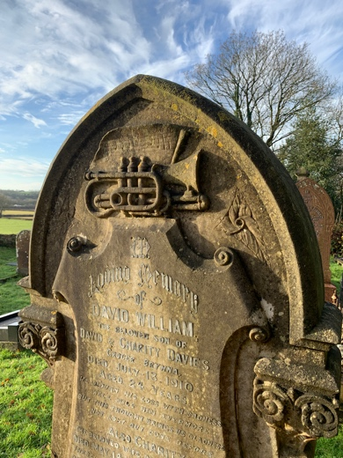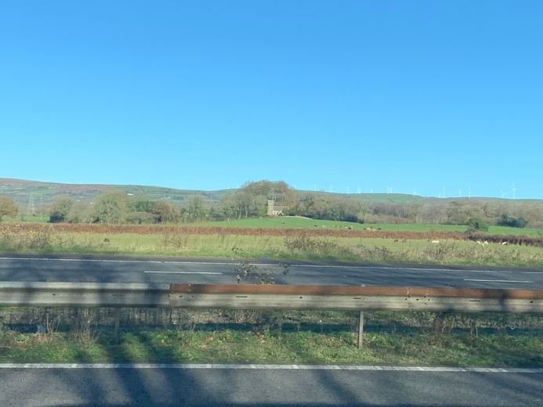
Figure 3: The grave with musical engraving (left), and the church as viewed from the motorway.
Images: Steve McDonald.

Ingold uses the example of musical notes as points that become lines as they are connected, which in turn are woven together into song or what Deleuze and Guattari would term an ‘assemblage.’ When Llanilid is considered as an assemblage that ‘changes in nature as it expands its connections’, the interwoven threads of the church, graveyard and yew trees collectively contribute to the site’s peaceful nature, while the associated stories and ringwork deepen a sense of mystery. Considering myself as an assemblage, numerous threads emerge that connect me to Llanilid. There is a connection between myself and the author David Davies, who recounts the story of St Paul’s visit to Llanilid, as well as a connection formed through the book I purchased – which may once have belonged to him – and through the church that we both attended at different times. Then there are the stories themselves which interconnect, and which first brought me into contact with the site. Understanding these stories as threads acknowledges their power to expand Llanilid’s connections. I regularly travel the stretch of motorway that passes within view of the site, (Fig. 3) but it was only through encountering these stories that I engaged with it. Without a clear reference point as to Llanilid’s prior nature, it is difficult to determine how the site may have changed in nature through my engagement; instead, it is easier to consider how it has altered my own. My engagement with the site has, first, changed how I understand place, leading me to feel what Casey describes as its ‘inherent power.’ Second, it has shown me that rest and stillness can be found within place, and third, it has allowed me to experience a thin place where the ‘wholly other’ feels closer. The power of these stories lies in the way they have connected me to the land and, through that connection, transformed my perception of place, leading me to understand it as having agency and an influence on my being.

DISCUSSION

Human construct or natural phenomenon

Returning to the original question of whether sacred space is a human construct or natural phenomenon, the experiences described in these findings seem to lean more towards the latter. The sense of peace, stillness, and mystery I encountered at Llanilid indicating a difference of quality in alignment with Eliade’s view that ‘space is not homogeneous.’ The unusual experience described during the church service, while perhaps not a full manifestation of the numinous that Eliade considers as being indicative of sacred space, is suggestive of a thin place with the potential for an hierophany to be experienced. Furthermore, in line with Lane’s fourth axiom, the centripetal power of the stories drew me towards the place, allowing me opportunity to rest, before the centripetal power of the place gave me the impetus to move out into the day. This agency to draw people in and send them out seems to indicate a difference of spatial quality. It is not possible to say with any certainty when this place was first considered sacred, or to say what motivated the people who first considered sacred to do so, but these elements would seem to align with Lane’s first axiom, that ‘sacred space is not chosen, it chooses.’ This position is further supported by the unusual location of the site, if sacred space was chosen it might be expected that a more convenient location could be found rather than one that required parishioners to carry coffins or walk in wedding outfits through fields and over stiles.

I am aware that these experiences are subjective, that Durkheim would consider them as ‘non-physical attributes’ which ‘can exist only in the mind,’ and that another person entering this space may not experience it the same way. The consideration of the role played by the mind of the individual in experiencing a space as sacred can be understood in terms of Lane’s third axiom, that ‘sacred space can be tread upon without being entered.’ This axiom seems to suggest that different people experience space in different ways, or even that the same person entering the same space may experience it differently at a different time. For me, each time I entered Llanilid I always felt a sense of peace and stillness, indicating a difference of quality that allowed me to understand the place as sacred. I do however need to consider the possibility that I experienced the place in this way because I was expecting to do so, acknowledging the role that my own mind plays in my experience of place.

These findings demonstrate that rather than understanding sacred space as either a human construct or a natural phenomenon, that there may be an element of both. The feelings of peace, stillness, and mystery, together with an experience that might allow Llanilid to be classed as a thin place, all lead to an understanding that this site has a difference of quality aligning with Eliade’s view of sacred space as being a natural phenomenon. However, the recognition of the subjectivity of these experiences acknowledges the role of the mind in how a place is perceived, aligns with a view that is akin to that of Durkheim. These findings could therefore be summarised by Lane’s third axiom, that ‘sacred space can be tread upon without being entered’; that is, Llanilid possesses a distinct quality that allows it to be understood as sacred, while the mind plays a role in how that sacredness is experienced.

CONCLUSION

This essay has set out to explore whether sacred space is a human construct or a natural phenomenon through a study of Llanilid, in the old county of Glamorganshire in South Wales, and the church dedicated to Ss Ilid and Curig that is situated within it. Firstly, stories associating Joseph of Arimathea and St Paul with the church were explored, not in terms of their veracity, but rather in understanding the power they have in being able to connect people to place. The ideas of theorists in relation to sacred space were then examined, with Durkheim understanding it as a human construct existing solely in the mind, and Eliade viewing it as a natural phenomenon identified through its qualitative difference from the surrounding space. The difference between space and place was investigated drawing on Casey’s idea that when unlimited space becomes a defined place it can be understood to have ‘inherent power’ to act on that which it contains. The acknowledgement of the power of place leads to Tilley’s phenomenological approach in attempting to understand the nature of that power. Guided by Husserl’s notion of the lifeworld as ‘straightforward intersubjective experience’ primarily perceived through the body’s senses, I have used myself as the subject of this phenomenological enquiry; asking what it is that I perceive about the nature and power of Llanilid through my own body’s senses. Tilley’s approach also considers the many linkages or threads woven together through place into what Deleuze and Guattari would describe as an ‘assemblage’ that ‘changes in nature as it expands its connections.’ The threads in this case were identified as including the church, the graveyard, the ringwork, the yew trees, the stories, articles, and books about Llanilid, as well as the people who engage with the site. It is the stories that provide one way by which Llanilid expands its connections, but it is difficult to know how its nature might have changed by my becoming connected with it without the reference point of its previous nature; instead, the question can be reframed, asking how my nature has changed by my engagement with the site. Feelings of peace, stillness, and mystery are all identified, as well as an experience that might allow Llanilid to be classed as a thin place; these have led to a change in my perception of place, understanding it to have agency to act on my being. These experiences also lead to an understanding that this place has a difference of quality aligning with Eliade’s view of sacred space as being a natural phenomenon. However, the subjective nature of these experiences is acknowledged, recognising that not everyone will perceive the place in the same way and, like Durkheim, that the mind plays a role in experiencing a space as sacred. The findings of this study may therefore be best summarised by Lane’s third axiom, that ‘sacred space can be tread upon without being entered’; that is, Llanilid possesses a distinct quality that allows it to be understood as sacred, while the mind plays a role in how that sacredness is experienced.

BIBLIOGRAPHY

Aristotle, Physics, tr. by Philip H. Wicksteed and Francis M. Cornford, (Cambridge: Harvard University Press, 1957)

Bell, Judith, Doing Your Research Project, (Maidenhead: Open University Press, 2024)

Casey, Edward S., The Fate Of Place: A Philosophical History, (Berkeley: University of California Press, 1997)

Clark, Michael A, Maelgwn Of Llandaff And Joseph Of Arimathea, (Durham: The Covenant Publishing Company Ltd, 2013)

Davies, Rev. David The Ancient Celtic Church Of Wales, (London: Simpkin, Marshall, Hamilton, Kent & Co, Ltd, 1910)

Deleuze, Gilles and Guattari, Félix, A Thousand Plateaus, (London: Bloomsbury, 1999 [1988])

Durkheim, Emile, The Elementary Forms Of Religious Life, tr. by Karen E. Fields, (New York: The Free Press, 1995)

Eliade, Mircea, The Sacred And The Profane: The Nature Of Religion, tr. by Willard R. Trask, (New York: Harcourt Inc, 1987)

Fields, Karen E., ‘Religion As An Eminently Social Thing’, in The Elementary Forms Of Religious Life, by Emile Durkheim, (New York: The Free Press, 1995), pp. xvii-lxxiii

Gaskell, Simon, ‘Christian Icon Joseph Of Arimathea Could Be Buried In Cardiff, Claims Author’, WalesOnline (2013) <https://www.walesonline.co.uk/news/wales-news/christian-icon-joseph-arimathea-could-5164183> [accessed 9 December 2025]

Geertz, Clifford, ‘Religion As A Cultural System’, in Anthropological Approaches To The Study Of Religion, ed. by Michael P. Banton (London: Tavistock and New York: Frederick A. Praeger Press, 1966)

Geertz, Clifford, The Interpretation of Cultures, (New York: Basic Books, 1973)

Hills, Tim, ‘Llanilid’, The Ancient Yew Group (2006) <https://www.ancient-yew.org/yew_tree_database/llanilid/?pl=1> [accessed 9 December 2025]

Hindson, Toby, ‘Finding Ages for Large Specimens Of Taxus Baccata’, The Ancient Yew Group (2019) <https://www.ancient-yew.org/wp-content/uploads/2023/01/Yew-ageing-paper-explanatory-article-Toby-Hindson.pdf> [accessed 9 December 2025]

Husserl, Edmund, The Crisis of European Sciences And Transcendental Phenomenology; An Introduction To Phenomenological Philosophy, (Evanston: Northwestern University Press, 1970),

Hutton, Ronald, Blood And Mistletoe: The History Of The Druids In Britain, (London: Yale University Press, 2009)

Hutton, Ronald, Pagan Britain, (London: Yale University Press, 2013)

Ingold, Tim, Lines: A Brief History, (London: Routledge, 2007)

Lane, Belden C., Landscapes Of The Sacred: Geography And Narrative In American Spirituality, (Baltimore: The John Hopkins University Press, 2002)

Levy-Bruhl, Lucien, The Notebooks On Primitive Mentality, tr. by Peter Riviere, (Oxford: Basil Blackwell, 1975)

Llanilid, Glamorganshire, (Pamphlet Self Published by Ss Ilid & Curig Church)

McDonald, Steve, Field Notes, Appendix 1

McSmith, Andy and Wroe, Martin, ‘Smith Is Laid To Rest Among Scottish Kings’, The Observer, 22 May 1994

Merleau-Ponty, Maurice, Phenomenology Of Perception, (London: Routledge, 1962)

Morgan, Elizabeth, ‘Britain’s oldest church? Ancient Triads say Paul visited the Vale before AD67’, Glamorgan Gazette, 21 March 1975

Morgan, Richard, Place-Names Of Glamorgan, (Cardiff: Welsh Academic Press, 2018)

Morien, ‘King Lear In Glamorganshire’, The Red Dragon, 7.2 (1885)

Otto, Rudolph, The Idea Of The Holy, tr. by John W. Harvey, (London: Oxford University Press, 1950)

Power, Rosemary, ‘A Place Of Community: "Celtic" Iona And Institutional Religion’, Folklore, 117. 1 (2006), 33-53

Richards, William, A Pocket Dictionary; Welsh-English, (London: Simpkin, Marshall and Co, 1861)

Smith, Tuhiwai, Decolonising Methodologies, (London: Zed Books, 2012),

The Royal Commission On Ancient And Historical Monuments In Wales, The Early Castles From The Norman Conquest To 1217, (London: HMSO, 1991)

Tilley, Christopher, A Phenomenology Of Landscape, (Oxford: Berg Publishers, 1994)

Williams, Stewart, Glamorgan Historian Vol. 7, (Cowbridge: D. Brown and Sons Ltd, 1971)

Williams, Taliesin, Iolo Manuscripts: A Selection Of Ancient Welsh Manuscripts, (Liverpool: I. Foulkes, 1848)

APPENDIX 1
Notes from site visits

Visit 1 – 20 November 2025

The church is accessed down a single track road only 5 minutes from the motorway junction. In fact, you double back on yourself so when you arrive at the site you can see across a few fields back to the motorway. It was a beautiful day, the sun hanging in a clear blue sky. The place was deserted so felt very calm and still, and I could listen to the birds singing in the trees all around. I was aware of the sound of the cars speeding down the motorway, but it didn’t seem to detract from the sense of peace in this place. In fact, in a strange way it seemed to add to it, almost like seeing and hearing the chaos of the speeding traffic, I was more aware of my separation from it, it made the feeling that I wasn’t in that place more acute and that this place of calm and stillness was one that was very different.

I feel as though there is an energy or quality here, that I hesitate to describe as dark as that might imply an evil, and it is not that. It is something that feels deep, vast, mysterious, and unknowable. Perhaps the same feeling one might have if they were adrift in the middle of the ocean, contemplating the unfathomable depths of the water beneath.

I took my time to wander the site, reading the gravestones, being aware of all the memory from generations of people who had experienced major life events there. I found one grave with the same surname as mine, who also had Irish heritage, which made me feel connected to them. I observed the two yew trees, feeling their bark and wondering how long they had stood there and what they might have witnessed. It did cross my mind that it would make this essay a lot easier if they could talk, but then I had the thought that maybe it’s me that needs to learn to listen to them!

I walked up into the ringwork, it didn’t feel like a defensive structure. I wouldn’t be able to prove it but there is a definite sense that there is more to the place. I feel a sense of peace or stillness, perhaps in line with Aristotle’s ideas of stillness when something is in it’s right place. There are no walls or anything obviously man made, which does make it feel that it is more connected to a natural sacredness, which somehow seems more pure, but at the same time maybe a little more dangerous.

Visit 2 – 30 November 2025

Today I visited the church to attend a Sunday morning service. Everyone at the church was very friendly, and very interested in why I was visiting, I was made to feel very welcome. Many of the church services I have attended in the past were less traditional than this, but I found the place, it’s ambience and the simplicity of the service humbling, which I think helped me to feel calm, and peaceful, more open to the ‘more-than-human’.

I had a strange experience during the service, which is difficult to describe but I’ll try. My vision went a little off, the edges of everything seemed to blur, and could see something like auras around objects, then the hall started very slowly (like treacle) moving in a circle, the foreground in the opposite direction the background. The experience lasted 1-2 minutes. I have little things like this occasionally when meditating, but it's never come on so quickly or been quite as intense, and I didn't feel I was in a particularly meditative state.
I was also able to partake in the breaking of bread, where members of the congregation took it in turns to go up the altar and kneel to receive the bread and wine. I took a moment practise gratitude for life in general and for finding what I feel to be a special place.

Visit 3 – 16 December 2025

I managed to visit on another day with clear blue sky. While walking up the driveway towards the church I felt like I was visiting a friend, perhaps indicating a realisation in myself of the place as an actor. I took a little time to wander the graveyard again, and found a headstone with a trumpet and musical notes on it which got me thinking about principles of harmony and of how the different melodies knit together to create song. I wondered what metaphorical song I was singing, and if I was keeping in tune with the song of the universe? What tune was this place singing? I also came across a grave that said dad with some fresh flowers on, it made me think of my own mortality and I had a picture of my own children visiting my grave at some point in the future. This picture made me upset.

I wandered out of the graveyard and towards an ancient enclosure, I’m not sure that anyone really knows what it once was, perhaps a roman camp or a homestead? I passed a wooded area that hid a large pond with trees growing out of it, like a mangrove, this place felt very still. After passing the enclosure I crossed another stream then through a field and out onto a lane which I knew would take me back towards the church, but which also passed the natural spring. This spring was hidden in a dense wooded area, and it took some finding. It felt as though the wood was trying to keep it hidden and secret in order to keep it safe. Again this place felt special, like the gentle eruption of the water wasn’t just a source of a stream, but was a source of life, there was a natural life giving energy there.

I passed some fly tipping while walking along the lane back to the church which is such a shame. What struck me on this visit was the amount of water around the site, there’s the spring and the pond already mentioned, but I noticed a number of other pools of water and there were streams and babbling brooks crossing all over the place. I wondered about the association of sacred sites with water which seems common and contemplated what it meant for this place.

While driving home the first song that came on was called ‘I’m sending you away’, I felt that after being drawn to the site, after my thirds visit it was telling me I had what I needed and that it was sending me away to complete the essay! It made me think of Lane’s fourth axiom.

Belden Lane, Landscapes Of The Sacred: Geography And Narrative in American Spirituality, (London: The John Hopkins University Press, 2002) p.15.
Simon Gaskell, ‘Christian Icon Joseph Of Arimathea Could Be Buried In Cardiff, Claims Author’, WalesOnline (2013) <https://www.walesonline.co.uk/news/wales-news/christian-icon-joseph-arimathea-could-5164183> [accessed 9 December 2025]
Michael A Clark, Maelgwn Of Llandaff And Joseph Of Arimathea, (Durham: The Covenant Publishing Company Ltd, 2013), p. 25.
Stewart Williams, Glamorgan Historian Vol. 7, (Cowbridge: D. Brown and Sons Ltd, 1971), p. 208-211.
The Royal Commission On Ancient And Historical Monuments In Wales, The Early Castles From The Norman Conquest To 1217, (London: HMSO, 1991), pp. 107-110.
Williams, Glamorgan Historian Vol. 7, p. 209.
Tim Hills, ‘Llanilid’, The Ancient Yew Group (2006) <https://www.ancient-yew.org/yew_tree_database/llanilid/?pl=1> [accessed 9 December 2025]
Toby Hindson, ‘Finding Ages for Large Specimens Of Taxus Baccata’, The Ancient Yew Group (2019) <https://www.ancient-yew.org/wp-content/uploads/2023/01/Yew-ageing-paper-explanatory-article-Toby-Hindson.pdf> [accessed 9 December 2025]
Ronald Hutton, Pagan Britain, (London: Yale University Press, 2013), p. 358.
Llanilid, Glamorganshire, (Pamphlet Self Published by Ss Ilid & Curig Church), p. 1.
Llanilid, Glamorganshire, (Pamphlet Self Published by Ss Ilid & Curig Church), p. 1.
Llanilid, Glamorganshire, (Pamphlet Self Published by Ss Ilid & Curig Church), p. 4.
Elizabeth Morgan, ‘Britain’s oldest church? Ancient Triads say Paul visited the Vale before AD67’, Glamorgan Gazette, 21 March 1975, p. 10.
Rev. David Davies, The Ancient Celtic Church Of Wales, (London: Simpkin, Marshall, Hamilton, Kent & Co, Ltd, 2910), p. 12.
Davies, The Ancient Celtic Church Of Wales, p. 12.
Taliesin Williams, Iolo Manuscripts: A Selection Of Ancient Welsh Manuscripts, (Liverpool: I. Foulkes, 1848), p. 349.
Williams, Iolo Manuscripts, p. 346.
Morien, ‘King Lear In Glamorganshire’, The Red Dragon, 7.2 (1885), p. 184.
Davies, The Ancient Celtic Church Of Wales, p. 12.
Hutton, Pagan Britain, p. 276.
Hutton, Pagan Britain, p. 277.
Williams, Iolo Manuscripts, p. 343.
Ronald Hutton, Blood And Mistletoe: The History Of The Druids In Britain, (London: Yale University Press, 2009) p. 182.
Clifford Geertz, ‘Religion As A Cultural System’, in Anthropological Approaches To The Study Of Religion, ed. by Michael P. Banton (London: Tavistock and New York: Frederick A. Praeger Press, 1966) p. 3.
Hutton, Blood And Mistletoe, p. 182.
Lane, Landscapes Of The Sacred, p.15.
Emile Durkheim, The Elementary Forms Of Religious Life, tr. by Karen E. Fields, (New York: The Free Press, 1995), p. 34.
Lane, Landscapes Of The Sacred, p.19.
Lane, Landscapes Of The Sacred, p.19.
Lane, Landscapes Of The Sacred, p.19.
Lane, Landscapes Of The Sacred, p.19.
Christopher Tilley, A Phenomenology Of Landscape, (Oxford: Berg Publishers, 1994), p. 18.
Tilley, A Phenomenology Of Landscape, p. 18.
Durkheim, The Elementary Forms Of Religious Life, p. 44.
Durkheim, The Elementary Forms Of Religious Life, p. 34.
Richard Morgan, Place-Names Of Glamorgan, (Cardiff: Welsh Academic Press, 2018), p. xli.
Morgan, Place-Names Of Glamorgan, p. 125.
Morgan, Place-Names Of Glamorgan, p. 125.
William Richards, A Pocket Dictionary; Welsh-English, (London: Simpkin, Marshall and Co, 1861), p. 205.
Richards, A Pocket Dictionary; Welsh-English, p. 205.
Karen E. Fields, ‘Religion As An Eminently Social Thing’, in The Elementary Forms Of Religious Life, by Emile Durkheim, (New York: The Free Press, 1995), p. xliv.
Fields, ‘Religion As An Eminently Social Thing’, p. xlvii.
Fields, ‘Religion As An Eminently Social Thing’, p. xlvii.
Mircea Eliade, The Sacred And The Profane: The Nature Of Religion, tr. by Willard R. Trask, (New York: Harcourt Inc, 1987), p. 20.
Eliade, The Sacred And The Profane, p. 11.
Rudolph Otto, The Idea Of The Holy, tr. by John W. Harvey, (London: Oxford University Press, 1950) p. 17.
Otto, The Idea Of The Holy, p. 26.
Otto, The Idea Of The Holy, p. 6.
Otto, The Idea Of The Holy, pp. 12-17.
Rosemary Power, ‘A Place Of Community: "Celtic" Iona And Institutional Religion’, Folklore, 117. 1 (2006), 33-53 (p. 45)
Power, ‘A Place Of Community’, p. 45.
Power, ‘A Place Of Community’, p. 45.
Tilley, A Phenomenology Of Landscape, p. 9.
Tilley, A Phenomenology Of Landscape, p. 9.
Edward S. Casey, The Fate Of Place: A Philosophical History, (Berkeley: University of California Press, 1997), p. 51.
Casey, The Fate Of Place, p. 70.
Tilley, A Phenomenology Of Landscape, p. 12.
Maurice Merleau-Ponty, Phenomenology Of Perception, (London: Routledge, 1962), pp. 303-304.
Tilley, A Phenomenology Of Landscape, p. 14.
Lucien Levy-Bruhl, The Notebooks On Primitive Mentality, tr. by Peter Riviere, (Oxford: Basil Blackwell, 1975), p. 3.
Aristotle, Physics, tr. by Philip H. Wicksteed and Francis M. Cornford, (Cambridge: Harvard University Press, 1957), 212b
Tilley, A Phenomenology Of Landscape, p. 10.
Gilles Deleuze and Félix Guattari, A Thousand Plateaus, (London: Bloomsbury, 1999 [1988]), p. 6.
Deleuze and Guattari, A Thousand Plateaus, p. 7.
Tim Ingold, Lines: A Brief History, (London: Routledge, 2007), p. 5.
Judith Bell, Doing Your Research Project, (Maidenhead: Open University Press, 2024), p. 36.
Clifford Geertz, The Interpretation of Cultures, (New York: Basic Books, 1973), p. 10.
Tilley, A Phenomenology Of Landscape, p. 11.
Edmund Husserl, The Crisis of European Sciences And Transcendental Phenomenology; An Introduction To Phenomenological Philosophy, (Evanston: Northwestern University Press, 1970), p.133.
Husserl, The Crisis of European Sciences And Transcendental Phenomenology, p.108.
Tuhiwai Smith, Decolonising Methodologies, (London: Zed Books, 2012), p. 44.
Davies, The Ancient Celtic Church Of Wales, p. 12.
Aristotle, Physics, 212b
Steve McDonald, Field Notes, (20 November 2025), Appendix 1
Otto, The Idea Of The Holy, pp. 12.
McDonald, Field Notes, (20 November 2025), Appendix 1
Eliade, The Sacred And The Profane, p. 29.
Eliade, The Sacred And The Profane, p. 31.
Lane, Landscapes Of The Sacred, p.19.
McDonald, Field Notes, (30 November 2025), Appendix 1
Eliade, The Sacred And The Profane, p. 11.
Lane, Landscapes Of The Sacred, p.16.
Lane, Landscapes Of The Sacred, p.18.
Otto, The Idea Of The Holy, p. 26.
McDonald, Field Notes, (16 December 2025), Appendix 1
Ingold, Lines: A Brief History, p. 6.
Deleuze and Guattari, A Thousand Plateaus, p. 7.
Deleuze and Guattari, A Thousand Plateaus, p. 7.
Casey, The Fate Of Place, p. 70.
Otto, The Idea Of The Holy, p. 26.
Eliade, The Sacred And The Profane, p. 20.
Eliade, The Sacred And The Profane, p. 11.
Lane, Landscapes Of The Sacred, p.19.
Lane, Landscapes Of The Sacred, p.19.
Fields, ‘Religion As An Eminently Social Thing’, p. xliv.
Lane, Landscapes Of The Sacred, p.19.
Lane, Landscapes Of The Sacred, p.19.
Karen E. Fields, ‘Religion As An Eminently Social Thing’, in The Elementary Forms Of Religious Life, by Emile Durkheim, (New York: The Free Press, 1995), p. xliv.
Mircea Eliade, The Sacred And The Profane: The Nature Of Religion, tr. by Willard R. Trask, (New York: Harcourt Inc, 1987), p. 20.
Casey, The Fate Of Place, p. 70.
Tilley, A Phenomenology Of Landscape, p. 12.
Husserl, The Crisis of European Sciences And Transcendental Phenomenology, p.133.
Husserl, The Crisis of European Sciences And Transcendental Phenomenology, p.108.
Deleuze and Guattari, A Thousand Plateaus, p. 7.
Lane, Landscapes Of The Sacred, p.19.

