Work Based Project

Reflective Journal

Module code: ACBA5009



Student: Max James

Student Number: 1900822

Lecturer: Deborah Hughes

Word count:
Table of Contents
CHAPTER 1 3
1.0 Abstract / Introduction 3
1.1 Proposed Research Title 3
1.2 Introduction 3
1.3 Objectives 3
CHAPTER 2 4
2.0 Literature Review 4
2.1 Change in Hierarchy / Structure 4
2.11 Office Structure within the Infrastructure Department 5
2.2 Current Projects 6
2.3 COVID 19 – Emergency Projects 6
2.4 Conclusion of Known Information 7
CHAPTER 3 8
3.0 Research Methodology 8
3.1 Design Fees 8
3.11 Rationale Behind the Qualitative Data 8
3.2 Quantitative Data 10
3.3 Hourly Rates Comparison 11
3.4 Hourly Rates Comparison – Working Week (PCC Internal Team) 12
3.5 Hourly Rates Comparison – Working Week (External Multi-Disciplinary Team) 13
3.6 Analytical Review of Hourly Rates 14
3.7 Hypothetical Project Example 14
3.71 RIBA Plan of Works 15
3.8 Hypothetical Project Example - £2M Scheme Completed In House 16

CHAPTER 1

1.0 Abstract / Introduction

1.1 Proposed Research Title
‘’Is going out to consultants for multi-disciplinary services more cost effective as a pose to undertaking those duties in house’’.

1.2 Introduction
Going out to consultants for multi-disciplinary services has become the common theme within Pembrokeshire County Council. Undertaking projects in house have recently become diminished and the way in which projects are executed now begins by commissioning a team of multi-disciplinary consultants to undertake duties which were previously all done in house. The rationale behind this change was instigated by resource issues, with employees within the infrastructure department reaching full capacity. The commissioning of external consultants was initially minimalistic, where it was foreseen as the last resort when employees had reached capacity. An augmenting workload combined with members of staff leaving, led onto the way in which the office runs currently, where multi-disciplinary services are undertaken by consultants. This dissertation will examine whether commissioning consultants for multi-disciplinary services is more cost effective as a pose to the previous traditional way of running a project, where duties would be completed fully in house.

1.3 Objectives
Within this dissertation, the main aim is to conclude which way is more cost effective in terms of the multi-disciplinary duties required within a project, whether that’s undertake the duties in house or commission external consultants. The assumption will be made that the multi-disciplinary team compromises of the following disciplines:
- Architects
- Engineers
- Quantity Surveyors
- Planners.
Recent projects such as educational schemes have shown an increase in fees regarding the multi-disciplinary duties as mentioned above.
Based on this the hypothesis is that “Fees will continue increased across the 21st century schemes due to multi-disciplinary services being commissioned externally”.
The objectives will be the following:
- To use data to determine the cost variances between in house services as a pose to external consultant appointments.
- Prove any variances / increases in 21st century project fees are down to multi-disciplinary services being undertaken by external consultants.

CHAPTER 2

2.0 Literature Review

2.1 Change in Hierarchy / Structure
Focusing on a three yearly timeframe, the hierarchy and overall structure of the Infrastructure Department within Pembrokeshire County Council has changed drastically. The departments hierarchy used consist of 2 managers in which they reported to the Director of Infrastructure, below the two managers was a multi-disciplinary team consisting of Architects, Architectural Technicians, Quantity Surveyors, Project Managers, Structural Engineers, Mechanical & Electrical Engineers, and an Energy Manager. Although the team still holds a range of those disciplines, the team is built up predominantly by Project Managers who manage the consultants, and a business case is being put forward to employ more Project Managers again. The current hierarchy has been listed below, demonstrating the current layout within the office:

As the hierarchy lists below, there are currently 5 Project Managers who sit under the ‘Construction Team Leaders’. The ‘Construction Team Leaders’ are also Project Managers by trade and are experienced within the discipline. The supervisors below the build-up of Project Managers are NEC Supervisors who act as a clerk of works once projects are on site.
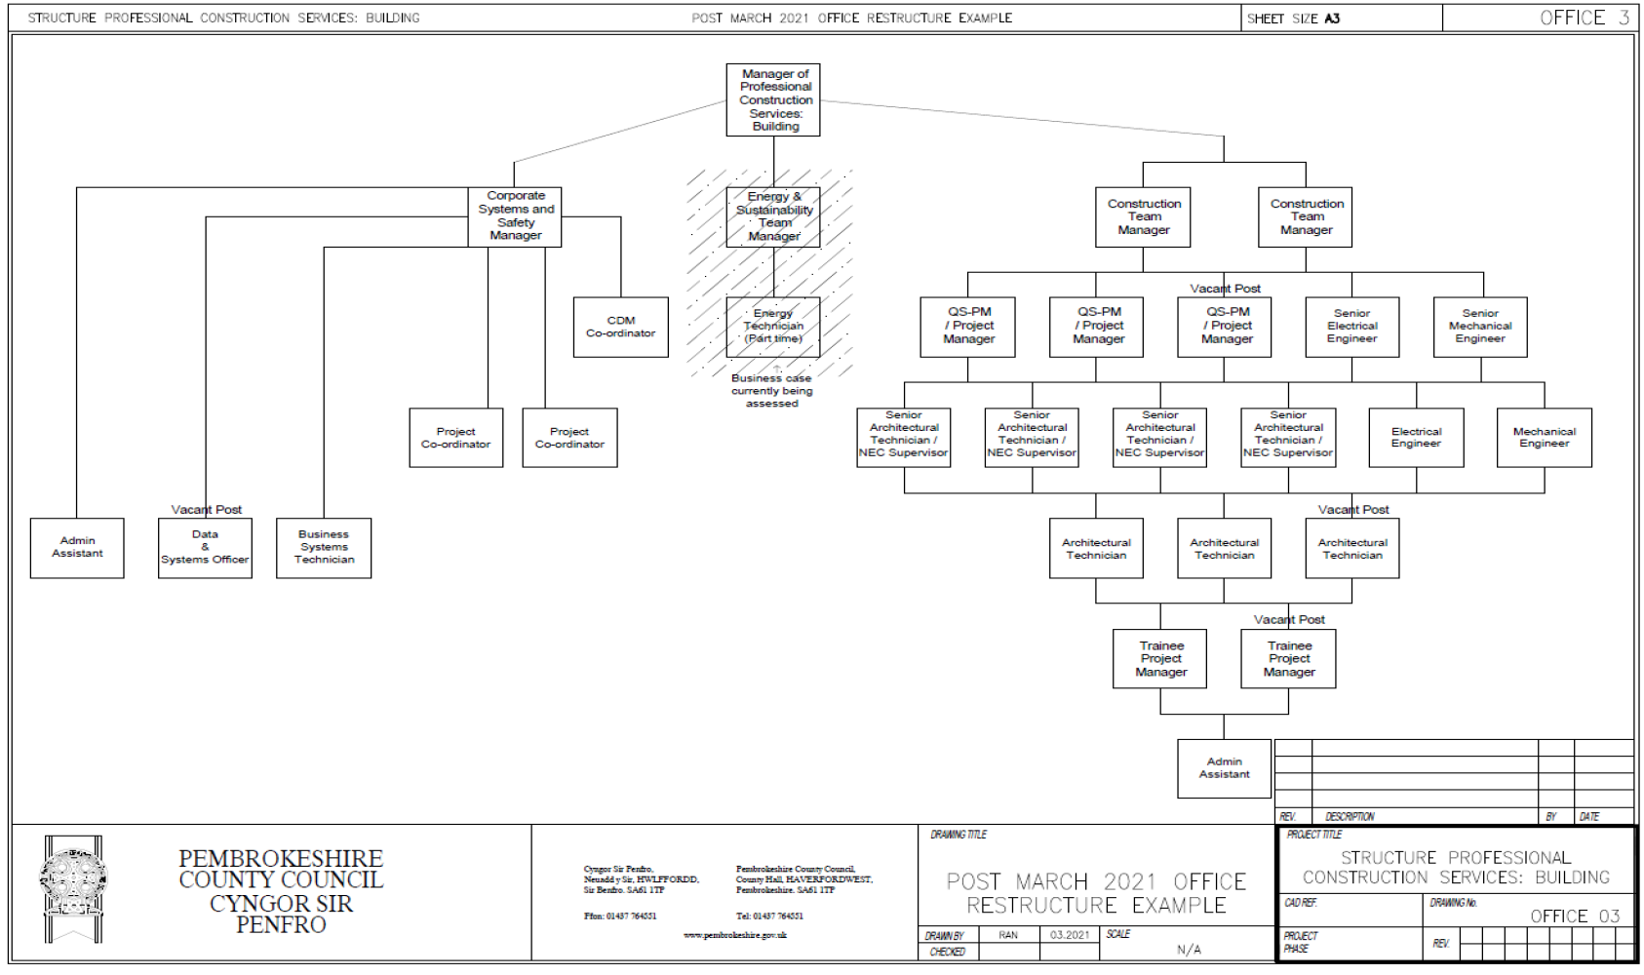

2.11 Office Structure within the Infrastructure Department

2.2 Current Projects
Within the Infrastructure department the projects are segregated into three main categories:
- Education
- Regeneration
- Housing
The regeneration portfolio of work is a recent addition to the department which compromises of listed buildings being retrofitted to various extents. Solitary, the Housing and Education portfolios have increased in size over the last 3 years therefore with the change in structure along with the new addition of Regeneration projects employees’ capacities have reached 100%. The recent addition of the Regeneration portfolio contributes to the conspicuous change the department has reverted to.

2.3 COVID 19 – Emergency Projects
The increasing portfolio of work is the main driver behind the change and in addition to this, COIVD-19 played a factor. COVID-19 has affected the Construction Industry as a whole, with supply chain management being the forefront. Contractors were unable to procure basic materials which has foreseen to play a factor in the uplift on material prices (Marsh, 2022). Aside from the common theme of the uplift in material prices, an additional emergency project was required which compromised of retrofitting an existing building into a temporary field hospital to deal primarily with COVID-19 patients as the hospitals were reaching full capacity in the peak of the pandemic. This project coming into the realm resulted in required resource from our department which the below table demonstrates:
Discipline | Number Required | Input | Capacity %
Project Manager | 1 | Project Manage the scheme on a day-day basis. | 100%
Quantity Surveyor | 1 | Undertake QS duties including interim valuations | 100%
Architectural Technicians | 2 | Produce drawings for Contractor to undertake fitout. | 60%
Quantity Surveyor | 1 | Undertake preliminary costs, procure items of work and complete interim valuations | 60%
Assistant Quantity Surveyor | 1 | Assisting the senior QS on day-to-day duties. | 60%

The above table is an indicative overview of the capacities of members within the office required to undertake this piece of work. This work was reactive and was of course not anticipated or planned therefore it resulted in more strain upon the department.

2.4 Conclusion of Known Information
As can be seen from the above, there are various contributary factors which have resulted in the change within the Infrastructure department. This dissertation aims to evaluate whether going out to consultants for multi-disciplinary services is more cost effective as a pose to undertaking those duties in house. The dissertation will cover the aims listed within 2.0 of the report, using the evaluation factors listed.

CHAPTER 3

3.0 Research Methodology
Within this section of the dissertation, the primary research will be discussed within the form of qualitative data. The qualitative data is secondary data which comprises of hourly rates of the multi-disciplinary team within the authority, and the hourly rates of the external consultants’ multi-disciplinary team. These hourly rates have been inputted into a spreadsheet, in which the variance between the two has been listed. As well as the hourly rates, a standard ‘working week’ table has been formulated, in which the hourly rates for both internal and external have been x by 37 hours which is the contracted hours within the authority. Although the external consultants may have a dissimilar working week in regard to hours worked, in order to get an accurate representation of the variance between the fees a figure was required.

3.1 Design Fees
Design fees vary dependent upon the way in which the multi-disciplinary services are undertaken. The common theme which has been visualised within the authority is undertaking these duties in house used to equate a design fee of around 14% of the overall construction value. Commissioning external consultants to undertake these duties has foreseen the design fee percentage increasing to 20% of the over-all construction value. This factor in itself is a contributory factor to this service being commissioned externally being less cost effective as a pose to undertake these duties in house.

3.11 Rationale Behind the Qualitative Data
The second part of the exercise, a hypothetical project budget has been formed (£2m) to undertake a comparison exercise, in which £200,000 has been allocated as the multi-disciplinary budget. This notional figure of £200,000 is calculated by taking 10% of the overall project budget, which is a rough indication of the design fees within most projects.

The core disciplines that form a multi-disciplinary team have been listed within the exercise, in which the list shows below what these compromises of:
Architect / Manager
Energy & Sustainability Manager
Corporate Systems and Safety Manager
Project Manager
Quantity Surveyor
Senior Mechanical Engineer
Senior Electrical Engineer
Mechanical Engineer
Electrical Engineer
NEC Supervisor
Architectural Technologist
Project Co-Ordinator
Trainee Quantity Surveyor
Trainee Electrical Engineer

Within more complex projects, the team may be far greater and consist of more disciplines however, this list is not exhaustive and has been created purely for the comparative exercise to be undertaken. Each discipline has then had a percentage put against it; this determines the involvement of that specific discipline within the hypothetical project. Each discipline within a multi-disciplinary team has different percentage of involvement, therefore the rationale behind the percentages has been taken from the typical involvement of that discipline within a project. The percentages add up to 100%, in which this forms the £200,000 multi-disciplinary budget. This budget has then been populated into a cashflow, with different figures being allocated at each month dependent upon what their involvement would be at each stage of the project.
The logic behind this being for example an architect is going to draw more fee at RIBA Stages 0-4 (design stages) as a pose to when the project is on site getting constructed. This methodology has been followed throughout each discipline within the document. The last part of the excel document was the allocated figure of each discipline which was divided by the hourly rate, to attain how many hours could be worked for that specific budget. This has been done over two documents, the first document being purely based on the internal hourly rates and involvement. The second has been done based on the external consultants’ hourly rates.
On the second document (external), there has also been a table formulated with 8 core disciplines. These disciplines compromise of:
Architect / Manager
Corporate Systems and Safety Manager
Project Manager
Quantity Surveyor
Senior Mechanical Engineer
Senior Electrical Engineer
Trainee Quantity Surveyor
Trainee Electrical Engineer

A small percentage has been allocated against each of these, despite the fact the tab specifies the multi-disciplinary project duties being undertaken externally, the reasoning behind this is although when the authority commission external consultants to undertake these duties, there is still an aspect of management of these consultants. Aside to management, being the client on all projects also requires input from various disciplines. This contributes to the high fee percentages on projects which has been seen since these duties have not been undertaken fully in house, in which this exercise is set to explore in further detail and identify whether the commissioning the external consultants is a contributory factor to this rise in fees.

3.2 Quantitative Data
The first aspect of quantitative data which has been collected is the hourly rates which are charged against the multi-disciplinary team. The hourly rate varies dependent upon the role and discipline, but a table has been created in which the hourly rates from the authorities’ internal team will be inputted into, as well as the hourly rates that are charged by the external consultants, A variance table has been formulated from this data, highlighting the increases in each area.

3.3 Hourly Rates Comparison

3.4 Hourly Rates Comparison – Working Week (PCC Internal Team)

3.5 Hourly Rates Comparison – Working Week (External Multi-Disciplinary Team)

3.6 Analytical Review of Hourly Rates
As can be identified from the qualitative data above which compromises of a comparison of hourly rates and feeding that information into a working week, external consultants undertaking multi-disciplinary services results in a significant increase in costs. Firstly, the hourly rate comparison table listed within 3.3 shows a variation column between the hourly rates of the internal team as a pose to external consultants. The external consultants’ hourly rates are higher within every discipline. The disciplines are listed within a typical hierarchy, to which this shows the top end of the table shows the hourly rates of external consultants are significantly more.
The hourly rates being significantly more leads onto an impact on the working week tables listed within 3.4 (PCC Internal Multi-Disciplinary Team) and 3.5 (External Multi-Disciplinary Team) of the report. The working week has been set up as 37 hours which is a typical working week, to which a formula has been inserted to multiply the hourly rate by the notional figure of 37 hours for each discipline. Within the first discipline which is an Architect / Manager role, the external consultants working week is over two times higher in regards to cost than the same discipline internally. The costs of external consultants undertaking these duties are substantially higher as the external consultants’ hourly rates are higher; This results in a positive association to the external consultants working week, with the figures being considerably higher.

3.7 Hypothetical Project Example
In addition to the hourly rates and the working week being comparable data, a hypothetical project example has been created in which the data has been utilized and fed into the example. The hypothetical example that has been created has been done to demonstrate the costs a project incurs through multi-disciplinary services within two scenarios:
- Multi-disciplinary services undertaken in house
- Multi-disciplinary services undertaken by external consultants
The hypothetical project compromises of a £2M overall project budget, in which 10% of the overall value has been set aside to form the multi-disciplinary budget (£200k). Within the authority dependant on the complexity of a project, multi-disciplinary budgets are often set between 8-15% of the overall project budget. This rule of thumb was used and 10% was the notional figure used to form the budget. Each discipline has been listed with a ‘percentage of involvement’ being put against each discipline, utilizing the common involvement of each discipline which has been based on previous projects. The percentage of involvement for each discipline has been formulated to total 100%. The key information that is to be analysed from this formulated spreadsheet is number of hours that each discipline would have to spend on the project in regards to their budget, which is attained by dividing it by the hourly rate from the information gathered within the tables listed within 3.3 of the report. Each disciplines budget has been split into each month, essentially replicating a cashflow which forecasts a financial year. This has been set up incorporating RIBA stages as each discipline’s involvement would be different at different stages of a project. For example, an architect’s involvement would be significantly more at RIBA stages 0-4 (Design Stages), as a pose to RIBA 5 which is the construction period. The RIBA plan of works is an industry standard document which is listed below, portraying each stage of works:

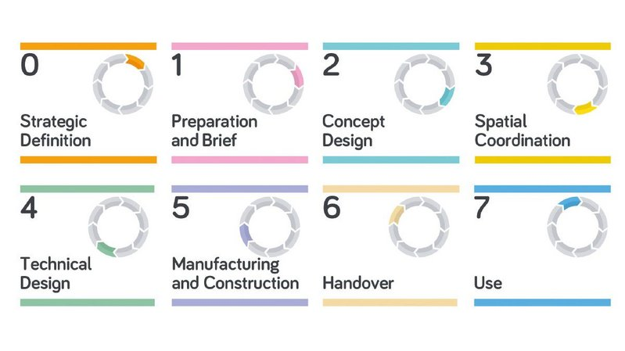
3.71 RIBA Plan of Works
Reference: (RIBA, 2020).
Below lists the hypothetical project example, with an overall project budget of £2M and a formulated multi-disciplinary budget (10% of overall project budget) for the project to be completed by the authorities’ internal multi-disciplinary team:

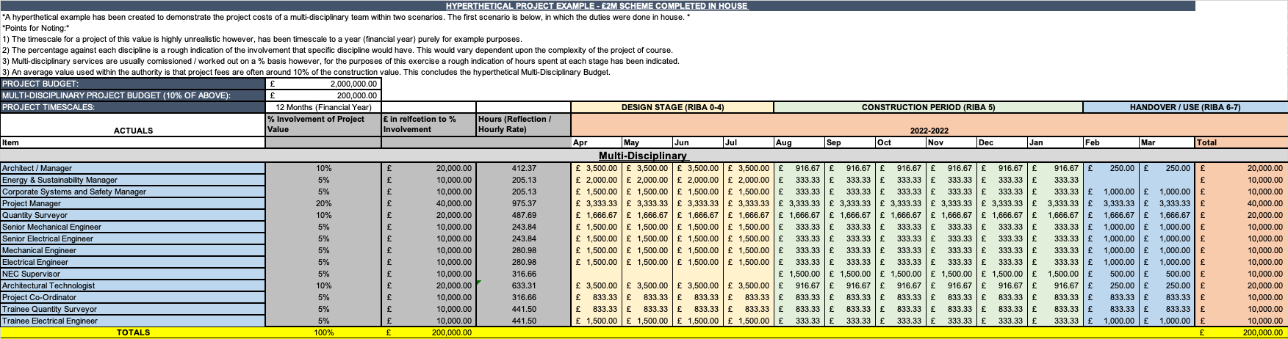
3.8 Hypothetical Project Example - £2M Scheme Completed In House

3.9 Hypothetical Project Example (Internal) – Overview
As an overview of the exercise undertaken above, the hours / reflection column shows each discipline would get a substantial amount of hours on the project in relation to the overall budget and the hourly rate. The same exercise has been undertaken for the multi-disciplinary services being undertaken by external consultants. The information within both exercises remains the same however, within the next exercise the external consultants’ hourly rates have been used:

3.10 Hypothetical Project Example - £2M Scheme by External Multi-Disciplinary Team

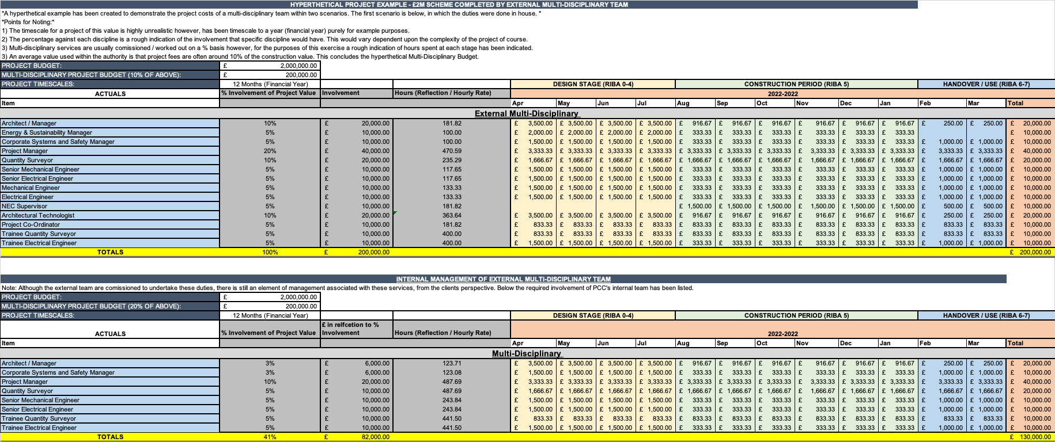

3.11 Hypothetical Project Example (External) – Overview
Within the example above of the multi-disciplinary services being undertaken externally, there is also an element of internal fees which the internal project team would incur. The reason for this is although the external team are commissioned to undertake these duties, there is still an element of management associated with these services from the client’s perspective (PCC). This effectively creates additional fee on top of the external consultant’s fees but is a factor which the authority have recently seen when commissioning external consultants, that there is still a heavy involvement with the authority’s team required. As an analytical overview, the hours / reflection column shows each discipline would get a substantially less amount of hours on the project in relation to the overall budget ad hourly rate compared to the internal team undertaking these duties as listed within the first table (3.8).
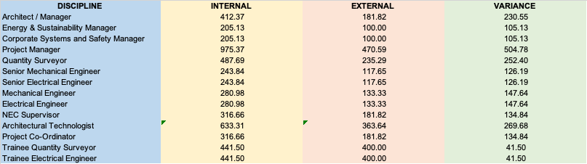
A comparison of hours has been listed below in which the amount of hours each discipline within the internal team would get has been put up against the external team, with a variance column being listed:

As can be identified from the table above, the internal team would get substantially more hours on a project compared to an external multi-disciplinary team. This could be an influential factor to the quality of a project. The internal team in each discipline would be able to spend almost double the number of hours on a project in some disciplines, which could be a detrimental effect when it comes to the quality of the design and construction of a project.

650 1 Qualitative - COMPLETE
650 2 Review of Info / 1st Excel Spreadsheet Inserted – COMPLETE
650 3 Second Spreadsheet // Analysis of Info
Last Submission – Reflective

