Resources used in the microteach 18th Nov 2019
Box for each student
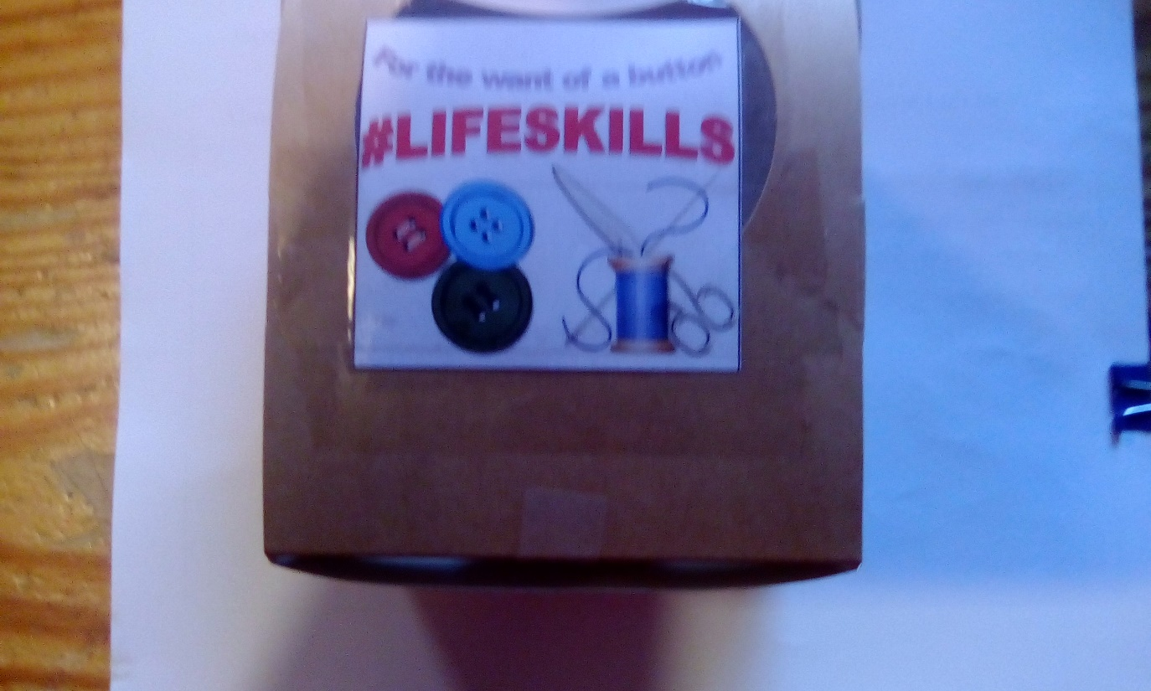
Contents of the box
Sewing needle with point covered, buttons, needle threader and fabric with two buttonholes. Thread supplied on spools on the tables


