Module Name: Workplace Culture and its impact on Organizational Efficiency (BMSW5105)
Individual Written Report
Lecturer: Mr Olusoyi Ashaye
By: Javad Khorramipour Khoshdaregi
Date: 19.08.2023

Table of Contents
Introduction 3
Briefly Introduce Easy Jet airline 3
Critically assess the relationship of organizational culture and structure of Easy jet and this impact on financial and non-financial performance. 4
Organizational Culture 4
Organizational Structure 5
Reaching financial as well as non-monetary results depends significantly on how Easy Jet’s organizational values and framework are aligned. 7
Financial Results 7
Non-Financial Results 7
Evaluate the broader environment of Easy Jet Plc by using appropriate environmental and organizational analytical techniques/tools 8
A PESTEL analysis 8
Porter’s Five Forces Model 10
Identify the key drivers for the change in working practices/ approaches at EasyJet Plc 12
Explains Ethical approaches as a part of Easy Jet Plc organizational culture and benefits 13
Easy Jet employs the following ethical standards 14
Benefits of Easy Jet’s ethical approaches 15
Recommendations to EasyJet Plc to improve its performances and justify suggested actions 15
Conclusion 17
References 18

Introduction
Easy Jet, a well-known low-cost carrier in Europe, has won praise for its cutting-edge methods for improving organizational performance, staff productivity, and agile management techniques. The organizational culture of the corporation strongly supports decentralized making decisions while placing an immense value on operational effectiveness and productivity. This strategy also applies to online work settings, where efficiency is rigorously scrutinized and flexibility in responding to shifting business needs is regarded favorably. Easy Jet’s efforts to revamp its organizational structure demonstrate its dedication to promoting a culture of ongoing improvement. The air carrier believes that providing motivation and encouragement to its staff is a key factor in achieving profitability. In its handling of its supply chain, Easy Jet attaches a great deal of significance to carefully choosing its important suppliers.

Briefly Introduce Easy Jet airline
Leading European low-cost carrier Easy Jet Plc is praised for its cutting-edge approaches to employee efficiency, organizational effectiveness, and agile management techniques. The organizational culture of the corporation places a strong emphasis on operational performance and efficiency simultaneously supporting decentralized decisions. This strategy also applies to online workplaces, where productivity is closely scrutinized and adaptability to changing working procedures is appreciated. The airline's attempts to restructure its organizational structure in order to improve its overall results demonstrate its dedication to promoting a culture of ongoing growth. For the success of the airline, Easy Jet, placed a high value on motivating and encouraging its employees to work hard. Easy Jet meticulously chooses important suppliers through a thorough screening procedure when it comes to supply chain administration (Timóteo,2021). An efficient supply chain is a result of the company's emphasis on developing solid, long-term business connections. In order to preserve running smoothly, Easy Jet also places a high priority on forming strategic alliances with crucial companies and organizations around the world .Easy Jet is committed to reorganizing its outreach avenues and techniques in response to shifting interaction dynamics (Easyjet, 2022). The organization maintains its dedication to operational efficiency by imposing standards of achievement even in online environments. The organizational climate of Easy Jet Plc is distinguished by creativity and safety, responsiveness, and a commitment to improving productivity (Nanni, 2022). For sustained success in the cutthroat aviation sector, the airline practices include decentralized choices, promoting inspiration, collaborative strategies, and adjusting to new interaction paradigms.
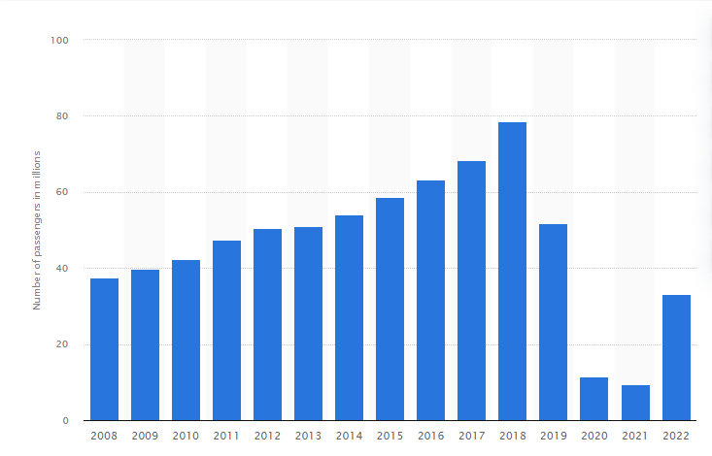
Figure 1: Employee in Easy Jet airline
(Source: Statista, 2022)

Critically assess the relationship of organizational culture and structure of Easy jet and this impact on financial and non-financial performance.
Easy Jet’s processes, achievement, and general achievement are strongly influenced by the interaction between corporate culture and structure.

Organizational Culture
Easy Jet’s culture is ingrained with a concentration on innovations and security for passengers. This is demonstrated by the airline's dedication to coming up with innovative ways to improve procedures while maintaining a high standard of security for travelers. The decentralized culture fits with the airline's commitment to being flexible and adaptable. This promotes rapid judgment and reactivity, both of which are crucial in the hectic aviation sector (Olk, 2021). The airline's initiatives to rethink its organizational structure are consistent with its philosophy of perpetual growth. People are encouraged by this atmosphere to look for chances to advance their skills and increase productivity.
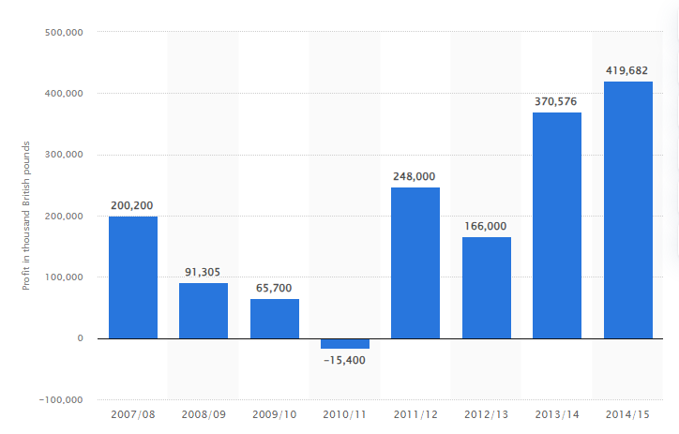
Figure 2: EasyJet Airline Company profit
(Source: Statista, 2022)

Organizational Structure
Easy Jet’s decentralized organizational layout gives regional personnel the freedom to decide on their own, enabling quick answers to business difficulties and consumer demands. This bolsters the airline's agile culture. Even in remote employment situations, the structure of the organization supports the tracking of results. This is consistent with the focus on upholding high expectations as adjusting to evolving work procedures. Strategic alliances and the development of solid supplier connections are supported by the framework. This is essential for preserving a smooth supply system and making sure that operations are reliable in numerous locations (Falconi, 2022).
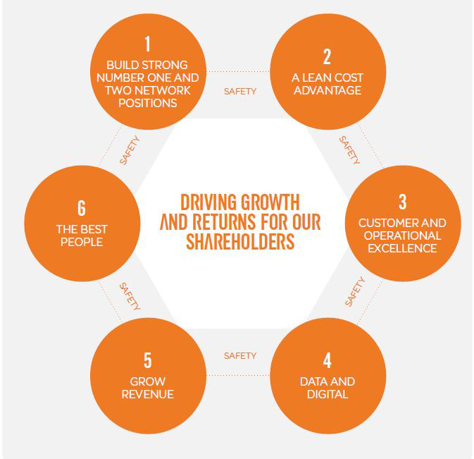
Figure 3: easy jet strategic structure
(Source: Togudygege, 2022)
The similar principles and objectives show how Easy Jet’s organizational culture and structure are in harmony. The culture's dedication to creativity, security, adaptability, and inspiration works in tandem with the decentralized, agile organization. The airline's initiatives to reconfigure its organizational structure for better efficiency are mirrored by the emphasis on ongoing enhancement. The decentralized choices system, which gives teams in local areas the authority to order security protocols, is consistent with the culture's priority on safety. The capacity for change and flexibility built into the framework enhance the emphasis on employee performance and motivation. Structure and culture interact in a way that benefits both. The decentralized and adaptable organizational structure of Easy Jet supports employee engagement, reactivity, and choices, all of which are influenced by the company's environment. Easy Jet can overcome obstacles, adjust to changes, and continually offer passengers reliable, secure transportation thanks to this partnership (Stingel, 2022).

Reaching financial as well as non-monetary results depends significantly on how Easy Jet’s organizational values and framework are aligned.

Financial Results
EasyJet can locate and apply economical alternatives thanks to its decentralized structure, reputation for inventiveness, and commitment to continual development. This results in activities that are more efficient, less waste, and ultimately better financial results. An organized strategy for operating results from an environment that values security and flexibility. This reduces interruptions, boosts timely delivery, and improves customer happiness; all of this can result in more repeat clientele and higher earnings. The importance that Easy Jet places on forging solid bonds with its vendor partners is directly related to how well it performs financially (Kassem et al., 2022). A strong supply chain guarantees on-time and economical purchases, which enhances the bottom line of the business.

Non-Financial Results
Engagement and fulfillment among staff members are increased by Easy Jet’s inspirational and motivating culture. Increased other aspects. Performance measures, greater quality of service, and lower staff turnover are all results of this good work atmosphere. Focusing on a security culture is essential for the airline's reputation as well as for economic reasons. Respect across customers, consumers, and regulators are fostered by a robust security environment, which supports profitable growth and other aspects. Performance metrics like client retention (McCarthy et al., 2022). The innovation-driven mentality encourages imaginative thinking, which improves customer service and has extra advantages like brand loyalty, consumer happiness, and effective referral advertising.
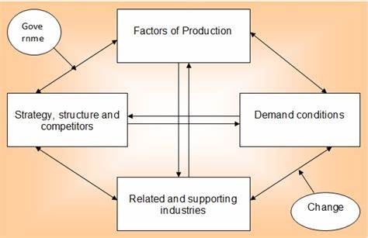
Figure 4: Company strategic management
(Source: Ivypanda, 2020)

Evaluate the broader environment of Easy Jet Plc by using appropriate environmental and organizational analytical techniques/tools

A PESTEL analysis
Political factor
The airline sector is highly influenced by political considerations. EasyJet's operations, route extension, and market access are impacted by governmental rules, aviation legislation, and global pacts. The need for travel and operating costs may be impacted by changes in the levy, visa restrictions, and security regulations (Falconi, 2022). Brexit, for example, has affected the airline's flights in the UK as well as the EU by introducing uncertainty relating to laws and regulations and market access.
Economical factor
The health of the economy has a big impact on airline profit. Travel demand is influenced by economic expansion, exchange rates, price increases, and spending by customers. Economic recessions can result in fewer travel expenses, which has an impact on the popularity of tickets. Fuel expenditures, a significant operational expense for aircraft like EasyJet, are impacted by changing oil costs (Stingel, 2022). Brexit-related currency swings and other aspects of the global economy also affect the airline's business results.
Social and cultural factors
Developments in air travel are influenced by shifting societal values, demography, and tastes. Easy Jet’s emphasis on frugal travelers fits with the expanding need for inexpensive options for travelling. Airlines are being pushed to embrace more environmentally friendly innovations and practices as a result of social developments towards healthier lifestyles and environmental awareness. In addition, an ongoing epidemic has raised questions about health and safety, changing travel habits, and consumer behavior (Marintseva et al., 2022).
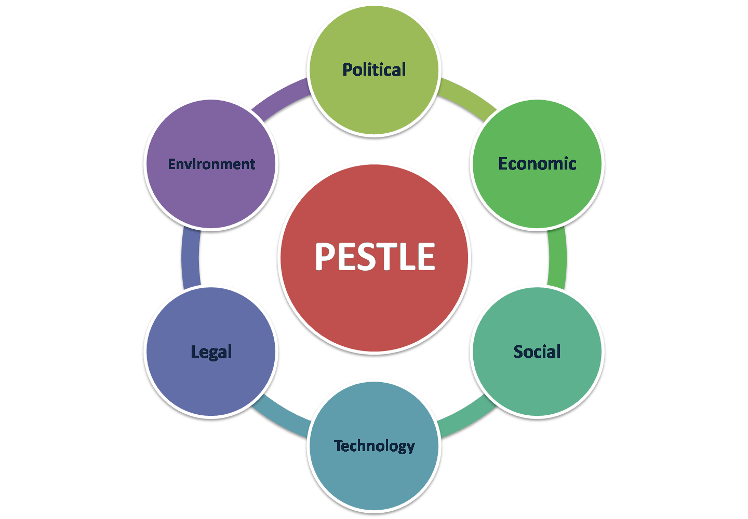
Figure 5: PESTEL analysis
(Source: Advergize, 2020)
Technical factor
The airline business has been transformed by technology. Operations now include digitization, e-ticketing, checking in online, including digital marketing initiatives. EasyJet's technological investments enable improved customer service, effective company procedures, and decisions based on data. The development of artificial intelligence and data analysis has the potential to increase operational effectiveness and personalization.
Environmental factor
Environmental factors are becoming more crucial in the air transport sector. Airlines like Easy Jet are investing in more energy-efficient planes and adopting eco-friendly practices as a result of strict pollution laws as well as sustainability concerns (Stingel,2022). In order to reduce the carrier's environmental effect, carbon offsetting programs and the incorporation of environmentally conscious practices into business are crucial.
Legal factor
A variety of rules and legislation that affect the airline business are considered legal factors. Easy Jet’s business is impacted by laws governing concurrence, labor, security, and protecting consumers. For the goodwill of the business and the reliability of its operations, complying with flight legislation, security policies, and safety criteria is essential.

Porter’s Five Forces Model
The competitive atmosphere of a business or sector is analysed using Porter's Five Forces Model, a framework for strategic analysis. It looks at five main factors that affect how businesses compete and how profitable they can be in the long run.
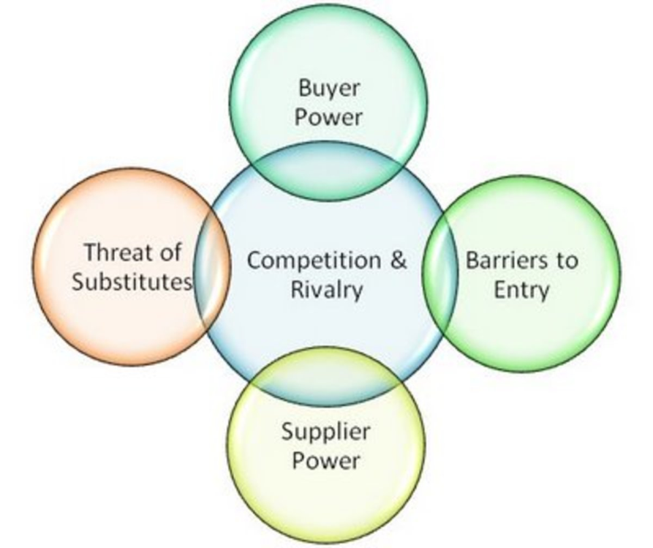
Figure 6: Porter’s Five Forces Model
(Source: Discover, 2020)
New Entrant Threat:
EasyJet works in the airline sector and has somewhat tough entrance requirements because of high capital needs, regulatory restrictions, and reputable businesses. Newcomers would have to spend money on facilities, aircraft, and navigating complicated restrictions. Although the expansion of inexpensive airlines like EasyJet has helped to lessen obstacles to entry a little bit, it continues to be a difficult sector for new entrants (WALCZAK, 2022).
Purchasing Influence of Suppliers:
Airlines' main suppliers are manufacturers of aeroplanes. Airways and Boeing are the two key companies in this sector. Given that aircraft like EasyJet typically have long-term agreements with these makers, competitors' market strength is low. However, any delays or limitations in supplies from manufacturers could affect the company's operations and plans for fleet development.
Buyers' Bargaining Power
In the travel sector, customers' (passengers') negotiating leverage is comparatively high. Customers may quickly research expenses as well as amenities across a large selection of airlines. This has the option to change planes based on things like price, ease, and treatment level (Rüger and Maertens, 2022). Companies such as EasyJet are under pressure because of this to keep their pricing low and enhance the whole travelling experience.
Threat of Replacement Goods or Services:
There are several alternatives to flying, including shorter-distance travel by rail, bus, or automobile, as well as video calls to conduct company conferences. Air travel, however, is still the most cost-effective method for travelling internationally and across large distances. The accessible nature of alternatives can nevertheless affect demand, particularly for short-distance routes when other forms of travel are practical.
Competitive rivalry intensity:
Airlines frequently participate in price fighting to entice clients because of the intense pricing pressure. The industry is also very susceptible to changes in the costs of energy sources, politics, and the economy, which increases rivalry in the market. Easy Jet works in a hard and cutthroat market. Even though it has an established image and is a popular low-cost carrier, it continually has to contend with external influences including the danger of other means of transportation, negotiating leverage with consumers, and stiff rivalry (Pandey and Purohit, 2022). In order to keep the company's market advantage and revenues, the airline needs to keep prioritizing efficiency in costs, client satisfaction, and tactical distinctiveness.

Identify the key drivers for the change in working practices/ approaches at EasyJet Plc
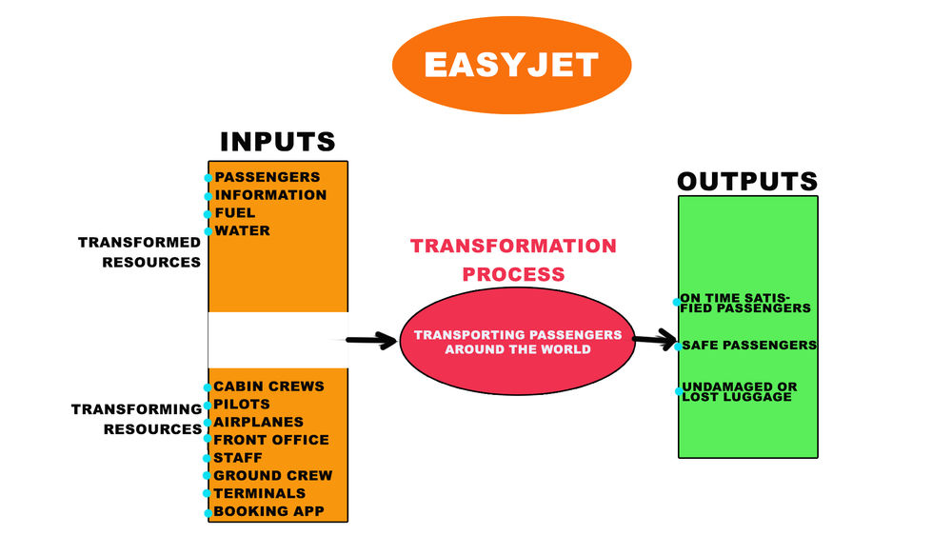
Figure 7: Working practices of EasyJet Plc
(Source: Bilalsaddik, 2022)
Technological progress: The management of tasks, customer relations, and internal systems at EasyJet may alter as a result of the quick improvements in science and technology, including online tools, statistical analysis of data, and robots. Employing novel innovations can streamline different elements of a company, increase efficacy, and enhance client experiences.
Customer Expectations: EasyJet may need to change its operational procedures in response to shifting customer tastes and demands in the airline sector. Customers want individualized care, frictionless online relationships, and practical goods or services, thus the airline has to modify its business practices and customer support strategies to meet these demands (Kumar and Thapliyal, 2022).
Cost Control and Effectiveness: Airlines including EasyJet must always look for methods to save costs yet preserve high standards in an increasingly competitive marketplace. The organization can improve cost control by changes to workplace practices like smaller processes, improved personnel organisation, and effective repair processes.
Pandemic of COVID-19: The aviation sector has been severely hit by the worldwide pandemic. Travel habits, safety, and health regulations, and consumer standards have all changed as a result. EasyJet alongside various airlines must have altered the operational procedures to handle decreasing demand, assure the security of passengers, and deal with travel limitations (Dimitrelou et al., 2022).
Environment-Related Issues: The airline sector is seeing an increase in requests for sustainable and environmentally friendly practices as a result of rising environmental consciousness. In order to implement more sustainable tasks, which might include utilising less fuel-intensive planes and establishing methods for reducing waste, EasyJet might have to remake its working methodologies.
Regulatory Adjustments: Changes in working practices may be required as a result of regulatory changes in the aviation sector as well as the wider economic climate. The way EasyJet does business may be impacted by changes in regulations relating to health and safety requirements, security procedures, safeguarding information, and labour practices (Newbery et al., 2023).
Adoption of technology and remote work: Modifications in EasyJet personnel collaborate, share information, and interact may result from the pandemic-accelerated rise of virtual job postings and digital collaboration technologies. Virtual cooperation and schedules that are flexible might become more commonplace.
Dynamics of the Market and Competition: EasyJet may need to modify its business practices in order to be competitive due to modifications to the market environment, notably rival airlines' and new competitor tactics. This could involve improvements in service delivery, client interaction, or operational efficacy.
Employee Engagement and Well-Being: Businesses like EasyJet are realising the value of worker involvement and well-being. Higher enthusiasm and more performance can result from alterations in working procedures that prioritise life outside of work, learning new skills, and appreciation for staff members.

Explains Ethical approaches as a part of Easy Jet Plc organizational culture and benefits
A well-known low-cost travel company, Easy Jet Plc, has been integrating ethical practices into its organizational culture. The moral business practices support the organization’s ideals while also enhancing its standing with clients and ensuring its long-term viability.
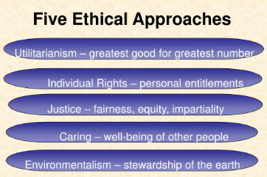
Figure 8: Ethical approaches
(Source: Slideserve, 2020)

Easy Jet employs the following ethical standards
Environmental Sustainability, taking steps to lessen its carbon impact, EasyJet has demonstrated a dedication for ecological sustainability. The airline has made investments in fuel-efficient airliners, incorporated environmentally friendly procedures into its everyday operations, and launched programmers to lessen waste and encourage recovery (Nanni, 2022). This moral stance appeals to clients who care about the natural world and establishes EasyJet being a good corporate citizen.
Fair Labour Standards, Easy Jet prioritizes employment practices, making sure that its staff members are treated fairly and have a secure workspace. The business follows labour regulations, promotes inclusiveness and diversity, and provides its staff with chances for training and professional growth. Workers efficiency and satisfaction with their work are increased when they are treated ethically, which helps to create a positive organizational culture.
Customer Openness, By making its pricing, fees, travel conditions of sale plain to customers, the airline has adopted a customer-focused transparent policy. This moral behavior prevents hidden fees and fosters client respect. Easy Jet fosters a sense of dependability as well as responsibility by being upfront in how it handles flight disruptions, delays, and customer care issues (Masuch et al., 2021).
Community Engagement, Easy Jet participates in the areas it serves by lending assistance to regional causes and nonprofit organizations. The airline's charitable initiatives show a dedication to giving to the community as well as fostering a great corporate image, whether they are focused on humanitarian, medical, or educational reasons.
Safety and security, Easy Jet places a high focus on ensuring passenger safety. The airline engages in thorough instruction for its employees and workers and follows strict safety procedures as well as industry requirements. EasyJet respects its ethical duties to its consumers and partners by keeping a sharp emphasis on security and confidentiality (Smith et al., 2019).

Benefits of Easy Jet’s ethical approaches
Ethical behaviour helps EasyJet maintain a good reputation. A corporation that exhibits a dedication to responsibility for society and the environment will likely be chosen by customers more often. Ethical behavior Improved the popularity of the brand and loyal clients may result from this. Strong emotional connections with clients are established through ethical business practices. Consumers are more inclined to stay loyal and spread the word about a business when they believe it shares their beliefs. The moral stance of EasyJet may encourage repeat business and referrals from others. EasyJet stands itself from rivals with its ethical business practices. A dedication to sustainability, justice, and openness can draw clients looking for environmentally conscious solutions in a crowded market, offering the airline an obvious competitive edge. A good working environment is facilitated by ethical practices, which promote staff involvement and contentment. Employees are more inclined to be inspired, productive, and dedicated to the business's success if it appreciates ethics and treats workers well.EasyJet reduces the risk of bad press, legal issues, and regulatory infringement by upholding moral standards (Reddy, 2021). This proactive strategy guards against future financial and legal implications while safeguarding the company's brand. Sustainability over the long term is consistent with moral practices. EasyJet supports a better tomorrow by emphasizing the environment and ethical business practices, that connect with consumers and others who are growing more mindful about these concerns.

Recommendations to EasyJet Plc to improve its performances and justify suggested actions
Easy Jet putting into practice strategic initiatives that tackle problems while adhering to its company's principles, Easy Jet Plc can improve its standing in terms of ethics and ecological sustainability. The airline may enhance its reputation and make a beneficial impact on the planet and society by aggressively resolving these problems.
Invest in Responsible Technologies: In order to reduce carbon dioxide emissions, Easy Jet should spend money on more recent, economical in-fuel planes. These aircraft are by the airline's dedication to ecological sustainability because they use fewer gallons of gas and emit less carbon dioxide. Long-term operational expenses would decrease as a result of this measure, which would also show how committed the travel company is to minimising the negative environmental effects.
Programs for Offsetting Carbon: Easy Jet should enable travellers to choose to participate in initiatives that reduce their travel-related carbon footprints by implementing a rigorous emissions reduction program. The airline's dedication to fiscal duty is demonstrated by this project, which also gives passengers a chance to help reduce their carbon footprint (Kaselow Salas and Raghavan, 2020). Reforestation, solar power, or environmentally friendly transport initiatives might be supported by such programs.
Reporting on Sustainability with Transparency: EasyJet regularly releases sustainability evaluations that describe its environmental effect, emission-reduction efforts, and ethical practices. EasyJet should increase openness. Open documentation shows transparency and makes it possible for consumers to monitor the airline's progress. Clients, buyers, thereby and regulations are all strengthened by this practice.
Training on ethics and compliance: In order to guarantee that every staff member are apprised of the company's moral principles and practices, make ethics training obligatory. This can assist in preventing unethical behavior and misbehavior in the company. EasyJet may reduce potential brand harm and legal liabilities by promoting an ethical culture (Jiang, et al., 2023).
Supplier Conduct Guidelines: Easy Jet may create a thorough code of conduct for suppliers that sets moral requirements for all partners and suppliers. Fair labor practices, respect for human rights, and sustainable development should all be emphasized in this standard. EasyJet's dedication to conscientious supply chain oversight may have a contagious impact, inspiring others to follow suit.
Customer experience innovation: Easy Jet utilizes tech to improve passenger service and encourage environmental awareness. Easy Jet creates tools that enable users to keep on top of their carbon emissions, select eco-friendly transport options, and get green-travel advice. This not only sets Easy Jet apart but also gives customers the power to decide for themselves.
Collaborations for Social Impact: Form alliances with regional groups to support programs that adhere to Easy Jet’s moral principles. This could comprise municipal development efforts, skill-building initiatives, or courses of study. The airline may positively impact society by making investments in the communities it serves (Rotondo et al., 2019).
Corporate Commitment: Easy Jet can establish a clear executive belief in economic and moral objectives. By incorporating those principles into choices and allocating funds for sustainability programs, upper management should serve as a guide to others. This demonstrable dedication conveys to everybody involved and the staff the significance of these challenges.

Conclusion
In conclusion, the organizational and culture of Easy Jet support performance in both the financial and non-financial Benefits have resulted from the culture's emphasis on inventiveness, security, flexibility, and encouragement and the organizational structure's decentralized and fluid nature. By enabling the airline to find and execute economical options, improve operational effectiveness, and offer improved client experiences, this integration has a favorable impact on financial performance. Additionally, Easy Jet’s organizational culture's emphasis on ethics provides many advantages for the organization, notably improved customer loyalty, involvement among employees, and longevity.

References
Advergize, 2020, pestle-analysis Available at: https://www.advergize.com/insights/pestle-analysis-examples-to-unlock-business-growth/ [Accessed on 14.08.2023]
Available at: https://www.slideserve.com/toyah/chapter-6-values-and-workplace-ethics [Accessed on 14.08.2023]
Available at: /https://www.bilalsaddik.com/post/the-importance-of-operation-management-at-easyjet-s-airlines [Accessed on 14.08.2023]
Bilalsaddik, 2022, the-importance-of-operation-management-at-easyjet-s-airlines
Dimitrelou, S., Oikonomidis, T., Dionysiou, G. and Fouskas, K., THE EFFECTS OF COVID-19 IN THE EUROPEAN AIRLINE INDUSTRY. RESULTS FROM PEST ANALYSIS.
Discover, 2020, Porters-Five-Forces-Model-For-Competitive-Analysis Available at: https://discover.hubpages.com/business/Porters-Five-Forces-Model-For-Competitive-Analysis [Accessed on 14.08.2023]
Easyjet, 2022, about Available at: https://www.easyjet.com/en/about [Accessed on 14.08.2023]
Faiyetole, A.A., 2023. Accident propensity assessment of Boeing 737 Aircraft variants using the Gompertz distribution model. Aerospace Systems, pp.1-25.
Falconi, P., 2022. Arguments for choosing cross border M&A as a growth strategy in the European airline industry exemplified by the Air France and KLM holding and the EasyJet/Wizz Air case study.
Falconi, P., 2022. Arguments for choosing cross border M&A as a growth strategy in the European airline industry exemplified by the Air France and KLM holding and the EasyJet/Wizz Air case study.
Ivypanda, 2020, easyjet-company-strategic-management-and-business-policy Available at: https://ivypanda.com/essays/easyjet-company-strategic-management-and-business-policy [Accessed on 14.08.2023]
Jiang, Y., Tran, T.H. and Williams, L., 2023. Machine learning and mixed reality for smart aviation: Applications and challenges. Journal of Air Transport Management, 111, p.102437.
Kaselow Salas, M.G. and Raghavan, S., 2020. Sustainability Issues and Challenges in Aviation.
Kassem, R., Salama, A. and Ganepola, C.N., 2022. CSR, credibility, employees' rights and legitimacy during a crisis: a critical analysis of British Airways, WizAir and EasyJet cases. Employee Relations: The International Journal, 45(1), pp.1-20.
Kassem, R., Salama, A. and Ganepola, C.N., 2022. CSR, credibility, employees' rights and legitimacy during a crisis: a critical analysis of British Airways, WizAir and EasyJet cases. Employee Relations: The International Journal, 45(1), pp.1-20.
Kumar, S. and Thapliyal, A., 2022. In which areas can easy Jet further improve its use of management information systems?. Central European Management Journal, 30(3), pp.382-386.
Marintseva, K., Mahanecs, A., Pandey, M. and Wilson, N., 2022. Factors influencing low female representation in pilot training recruitment. Transport Policy, 115, pp.141-151.
Masuch, K., Diesterhöft, T.O., Greve, M., Massanneck, S., Nguyen, D.K., Trang, S. and Kolbe, L.M., 2021. Openness Always Pays off-Investigation of Diverse Actions in response Strategies to Data Breaches. In ECIS.
McCarthy, F., Budd, L. and Ison, S., 2022. Negotiating Personal and Professional Identities in the Workplace: The Case of Women Ab Initio Airline Pilots. In Women, Work and Transport (pp. 157-168). Emerald Publishing Limited.
Nanni, A., 2022. Sustainability transition challenges for low-cost airline from E-aviation technologies and solutions.
Nanni, A., 2022. Sustainability transition challenges for low-cost airline from E-aviation technologies and solutions.
Newbery, R., Roderick, S., Sauer, J., Gorton, M. and Robbins, K., 2023. Exploring EO strategic performance measures: value-added versus efficiency outcomes. International Journal of Entrepreneurial Behavior & Research, 29(4), pp.1027-1049.
Olk, S., 2021. The effect of self-congruence on perceived green claims’ authenticity and perceived greenwashing: the case of EasyJet’s CO2 promise. Journal of Nonprofit & Public Sector Marketing, 33(2), pp.114-131.
Pandey, D.C. and Purohit, P., 2022. Is easyJet’s use of management information systems its key advantage over other low-cost competitors in the market?. Central European Management Journal, 30(3), pp.377-381.
Reddy, R., 2021. Reasons for changes of passenger perceptions of low cost carriers identified on social media-a case study on Jetstar Airways-A literature review. Technium Soc. Sci. J., 19, p.520.
Rotondo, F., Corsi, K. and Giovanelli, L., 2019. The social side of sustainable business models: An explorative analysis of the low-cost airline industry. Journal of Cleaner Production, 225, pp.806-819.
Rüger, M. and Maertens, S.U., 2022. The Content Scope of Airline Sustainability Reporting According to the GRI Standards—An Assessment for Europe’s Five Largest Airline Groups. Administrative Sciences, 13(1), p.10.
Slideserve, 2020, values-and-workplace-ethics
Smith, M., Strohmeier, M., Harman, J., Lenders, V. and Martinovic, I., 2019. Safety vs. security: Attacking avionic systems with humans in the loop. arXiv preprint arXiv:1905.08039.
Statista, 2022, easyjets-uk-passenger-numbers/ Available at: https://www.statista.com/statistics/309452/easyjets-uk-passenger-numbers/ [Accessed on 14.08.2023]
Statista, 2022, easyjet-s-uk-profit-before-tax Available at: https://www.statista.com/statistics/308915/easyjet-s-uk-profit-before-tax/ [Accessed on 14.08.2023]
Stingel, H., 2022. European airline consolidation-acquisition strategy for a potential takeover of JET2 by Easyjet (Doctoral dissertation).
Stingel, H., 2022. European airline consolidation-acquisition strategy for a potential takeover of JET2 by Easyjet (Doctoral dissertation).
Stingel, H., 2022. European airline consolidation-acquisition strategy for a potential takeover of JET2 by Easyjet (Doctoral dissertation).
Timóteo, R.F.D.S., 2021. Equity research-EasyJet Airline Company LTD (Doctoral dissertation, Instituto Superior de Economia e Gestão).
Togudygege, 2022, strategic-clock-on-easyjet Available at: https://togudygege.allianceimmobilier39.com/strategic-clock-on-easyjet-16224sd.html [Accessed on 14.08.2023]
WALCZAK, W., 2022. MARKETING INSTRUMENT OF COMPETITION IN LOW-COST AIRLINES. Ekonomia i międzynarodowe stosunki gospodarcze 2021 [DEBIUTY STUDENCKIE], p.40.

