Name: Nagina Kosar
Student number: 2013924
Module: personnel resourcing and development BMIH5005
Tutor: Emily Williams
THE TOWER HOTEL MENTAL HEALTH WELLBEING REPORT
Introduction
This report is based on the Tower hotel located in London. The Tower hotel has 801 guestrooms minutes away from the tower bridge and many other tourist attractions. The hotel has 2 restaurants with international cuisine and breathtaking views of the river Thames. ( Guoman Hotel, 2021)

The purpose of this report is to identify the current situation of employees' health and wellbeing. The increase on mental health and wellbeing has gone quite far up since covid 53% of people have said covid has impacted their mental health and has affected many people around the world as everyone is now moving forward from the pandemic it is most important to look at the wellbeing of employees to build a better workforce. Employers and HR at the Tower hotel have a critical role in supporting employees emotionally through any concerns or fears and taking steps to build a healthier and more resilient workforce. Mental health absences are the most common cause of long-term sickness and if not recognized within the workforce it could affect the business in many ways, the employers at the Tower hotel need to put a strategy in to help the employees through any difficulties they are experiencing weather in work or out of work. (CIPD, 2021)
As employees have returned to their workplaces since lockdown it is more important for employers to focus on their wellbeing, many have gone through bereavement, loss of income and personal problems coming back to changes can be difficult. The importance of mental health may have been underrated in the past, but it cannot be overlooked in the present time, the mental health charity found adults at 60% have reported to say their mental health worsened in lockdown with the majority working from home now and having to adapt to all the changes that have taken place (CIPD, 2021). This report will conclude the importance of employee engagement and how the tower hotel can implement the latest ideas and strategies for their employees' health and well-being. Moving forward can be hard for every business in these unprecedented times, employers need to invest in their employers so their businesses can keep striving and giving the best performance possible. This report will offer the Tower hotel suggestions for the wellbeing of their employees and how it will benefit them overall.

Employee engagement survey
An employee engagement survey is a tool that allows businesses to gather information from their employees so they can measure employee performance and engagement. The tower hotel needs to set up a questionnaire with questions that relate to the employees and the hotel environment. Using open-ended questions will give the employee more time to speak about feelings or emotions surrounding work or home and this will give the Tower hotel the information they need to help employees get back on track and give better performance.
Feedback analysis
The finding from a survey can really help the tower hotel it will give you an insight into where the company really needs to focus on surveys can give you all the information you need to move forward to build an engaged workforce. From all the information the tower hotel now can go and input this information into action and help their employees (Mind,2021). Employees work hard when they feel valued and heard, capturing feedback can tell the Tower hotel where they stand with their employees.

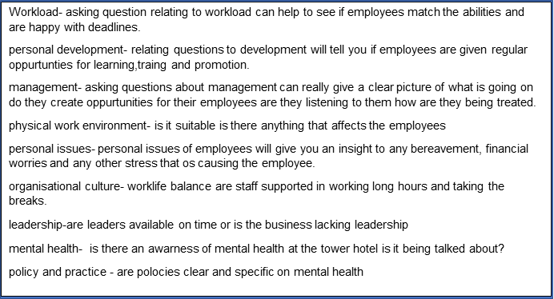

Supporting mental health
- The Tower hotel can make their employees aware of the mental health resources available and advise them to use them
- Remove any sort of stress found from feedback
- Keep employees involved and informed of what is happening at the hotel
- Train managers to help employees suffering mental health
- Encourage mental health programme
- Encourage employees to use their holidays
- Talk more about mental health in meetings
- Giving employees control over their work/lack of autonomy can lead to stress (Havergill, 2021).
- Talk more to employees (Kava et al., 2020).
- Free or subsidized mental wellbeing coaches (Waters, 2021).
Recent findings show that more than two in five HR managers feel mental health is not prioritised like it should be in their organisations (credidio, 2021). The Tower hotel needs to support their employees more now than ever before, having a healthy workforce and environment that is good for business and employees can lead to remarkable success moving forward. There is a risk assessment process which helps employees manage their workforce's wellbeing which involves six key areas, demands,control,support,relationships,role and change if not managed correctly it can lead to poor performance from employees. It is vital for the Tower hotel to implement the HSE standards throughout their business as it will help keep employees engaged and fully aware their management is supporting them (kinman, 2021).86% of employees reported improved work performance and low-rate absenteeism after receiving support for mental health at their workplace's (hilgers, 2021).
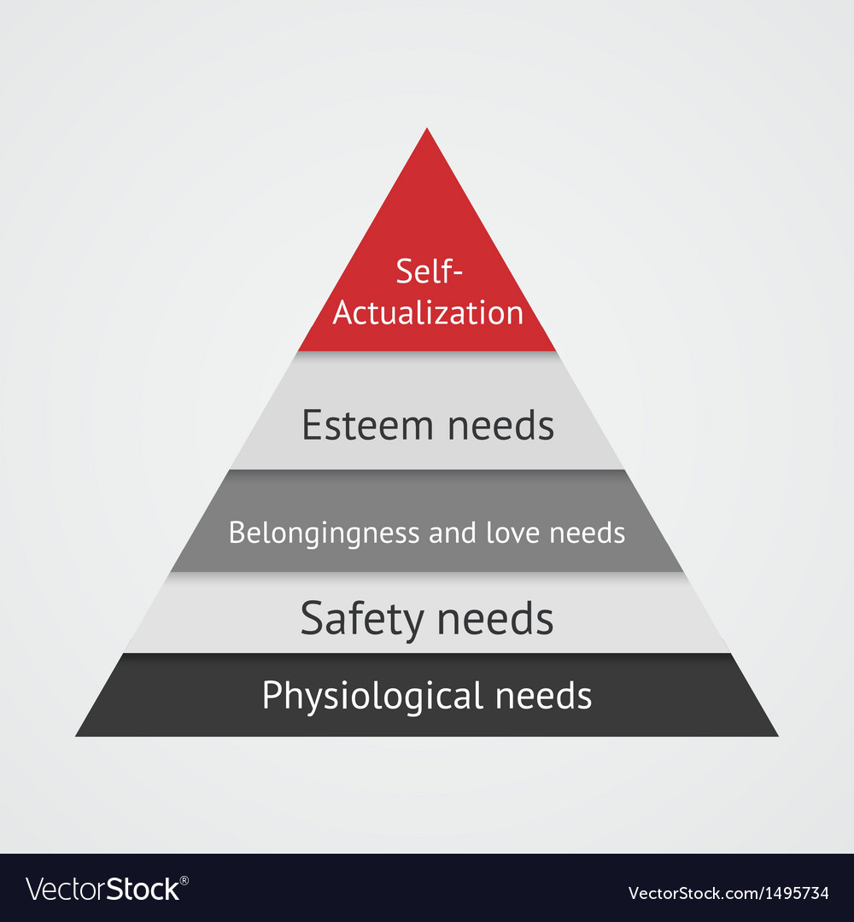(vectorstock, 2021)

The HR management at the Tower hotel should apply the Maslow theory at their workplace. This will help determine if the needs of the employees are met which are phsycological,safety,social needs, self-esteem and self acualisation.
Physiological needs
Employees need access to restrooms, a place to get drinking water, breaks to eat meal, comfortable working environment and steady income which supports the employees living. (indeed editorial team, 2021).
Safety needs
Health and safety should be emphasized in the working environment, employees want a safe place and a sense of feeling comfortable.
Belonging and love
Keeping employees in the loop of what is happening with the business, keeping employees updated, encouraging team building and communicating will give them a sense of being acknowledged and valued.
Self esteem
Esteem is knowing you are contributing to a higher goal; it is important for employees to really grow and flourish to give the best performance and customer experience. Offering regular recognition and appreciation will help the employees' self-esteem and the business can benefit by satisfying these needs.
Self acualisation
Regular meetings, career meetings with employees and offering programmes available can fulfill self acualisation for employees. Enhance the flow of self actualisation by providing online tools for remote workers (Pre and Post Covid 19), 2021)

Benefits of employee engagement
Studies by Wyatt Whatson found that companies that have highly engaged employees produce 26% higher revenue per employee (Burke, 2021).
Better team performance: engaged employees perform at a higher level than a disengaged employee, individual engagements lead to team engagements.
Increased employee productivity: Highly engaged employees produce more efficient high-quality work and give the best service and performance possible (deBara and st-aubin, 2021).
Higher employee satisfaction: employees are happy and have an increased desire and commitment to give their best performance. Employees behave accordingly to business values and respect them.
Many organisations today are striving due to having highly engaged employees, it is impossible to run a successful business without them as they are what forms the backbone of the business.
The importance of employee engagement
A healthy workforce can be where workers and managers contribute to the organisation by protecting the safety and wellbeing of employees (Mental health, 2021). To have a high performing workforce the Tower hotel y must understand how to sustain high levels of employee engagement within its organisation.highly engaged employees hold favorable opinions of their workplaces, connect with other teams, and influence other employees to the best they can (Ryba, 2021). The Tower hotel should ensure all employees are spoken to and support is given to employees who are in need, to have a high engaged workforce behind you it can give you better performance, an increase in revenue, low healthcare costs and recognition of the organisation. The importance of employee engagement is that it is based on trust, integrity, and commitment, which is a two-way commitment if approached properly the tower hotel increases the chances of business success. Disengaged employees will have poor performance, no connection to surroundings and no motivation that can affect areas of the workplace, or all the workplace members and managers should be able to recognised a distressed employee (mizne, 2021). The Tower hotel needs to let their employees know they understand the need to priortise mental health and encourage employees to talk more about their mental health, the Tower hotel needs to put a support system in place that are easily accessible. The importance and wellbeing of employees should be priority, they can implement team training days and personal one to ones so they can keep reminding them of the opportunities available for them to discuss their wellbeing confidentially either in a support group or counselling hotline (Thomson, 2021).
Measure engagement frequently
Frequently measuring the wellbeing of employees can benefit the Tower hotel, by sending out anonymous engagement surveys to their employees will give them an insight into what is happening within the company and employees (Employee Engagement, 2021). It is important to measure frequently to discover current trends, understanding changes from one period to net is necessary and can lead to great success for the company and its employees (Abdi, 2021).
Diversity and inclusion: measuring diversity and inclusion within the Tower hotel is a key KPI which helps create a welcoming company culture that retains employees and attracts talent.
Frequent employee engagement survey: using employee engagement surveys will provide HR at the Tower hotel to ask real life questions relating to employees. The HR at the Tower hotel should use combinations of open and closed questions to get quantitative and qualitative feedback, it is vital something is done with results in order to improve engagement.
Employee net provider score (NPS): these questions are asked 0-10 this can give you the general information when looking at what the employee looks for in their job role ordinary questions on some occasions evaluate the reason behind low employee NPS score.
Employee absenteeism and turnover rates: market research shows employers should aim for an annual employee turnover rate of 10% or less. Absenteeism and turnover rates within the team will determine whether certain departments need attention (Dewar, 2021).
Positive workplace relationships matter now more than ever before. By promoting a happier and sustainable environment the tower hotel will be strengthening employee engagement and will be able to boost company profits.
Evaluation
One of the most important indicators of job satisfaction is employee engagement. In today's competitive business world, effective employee engagement and participation are required more than ever before. This proposed method to the Tower hotel shall help them analyze their employee performance and engagement, we have found that having an engaged workforce can benefit businesses overall. If the Tower hotel fails to engage employees it will result in undesirable outcomes that must be avoided at all costs, such as lower retention rates, lower productivity, poor communication, and negative workplace culture. By providing the employees with the support and resources they need, they will feel happier and more satisfied with their jobs which leads to higher revenue and profits and high quality of service from employees. A high level of employee engagement is essential to any business with an elevated level of engagement the employees will become more productive and it also helps improve their morale. The Tower hotel will need to implement these methods to check the wellbeing of their employees' poor mental health, which is now the number one reason for long-term absences and can have a big impact on the running of the business. It is vital that Tower hotel invest in the right support for their employees, having an empathetic leadership will really help the Tower hotel, the covid 19 pandemic caused a lot of havoc worldwide and left many struggling with mental health and emotions, employees are less engaged when suffering from some sort of anxiety or depression it is vital for the Tower hotel to recognise if any employee needs support as the current pandemic is not going anywhere anytime soon it is vital for the Tower hotel to implement the survey methods to their employees as this can help in the long run or in case of another pandemic the company will know what to do when they feel there is no engagement or productivity in the workplace. This report concludes that supporting and encouraging the health of your employees shows that you recognise that they are your most valuable assets if you value their health, they will be greater value to your organisations.Employee wellness and mental health should be added to the policy of the Tower hotel so new and present employees no what support the Tower hotel offers and how serious they are about the health and wellbeing of their employees.

References
1. Guoman The Tower Hotel. 2021. Tower Hotel London | Hotel Near London Bridge | Guoman Hotel. [online] Available at: <https://www.guoman.com/the-tower> [Accessed 21 November 2021].

2. CIPD. 2021. Coronavirus (COVID-19): Mental health support for employees | CIPD. [online] Available at: <https://www.cipd.co.uk/knowledge/culture/well-being/supporting-mental-health-workplace- return#gref> [Accessed 21 November 2021].

3. CIPD. 2021. Coronavirus (COVID-19): Mental health support for employees | CIPD. [online] Available at: <https://www.cipd.co.uk/knowledge/culture/well-being/supporting-mental-health-workplace- return#gref> [Accessed 21 November 2021].

4. Mind.org.uk. 2021. [online] Available at: <https://www.mind.org.uk/media- a/4664/resource_2_take_stock_of_mh_in_your_workplace_final.pdf> [Accessed 23 November 2021].

5. Havergill, S., 2021. Why line managers are key in managing and supporting mental health at work - Healthy Performance. [online] Healthy Performance. Available at: <https://www.healthyperformance.co.uk/why-line-managers-are-key-in-managing-and-supporting-mental-health-at-work/> [Accessed 26 November 2021].

6. Kava, C., Passey, D., Harris, J., Chan, K. and Hannon, P., 2020. The Workplace Support for Health Scale: Reliability and Validity of a Brief Scale to Measure Employee Perceptions of Wellness. American Journal of Health Promotion, 35(2), pp.179-185.

7. Waters, S., 2021. Mental health in the workplace: Why is support so important?. [online] Betterup.com. Available at: <https://www.betterup.com/blog/mental-health-in-the-workplace> [Accessed 26 November 2021].

8. credidio, r., 2021. Why it’s important to embed mental health support across entire organisations. [online] People Management. Available at: <https://www.peoplemanagement.co.uk/voices/comment/why- important-embed-mental-health-support-across-entire-organisations> [Accessed 25 November 2021].
9. kinman, d., 2021. [online] Som.org.uk. Available at: <https://www.som.org.uk/Supporting_workplace_mental_health_and_wellbeing_in_COVID- 19_and_beyond.pdf> [Accessed 25 November 2021].
10. hilgers, l., 2021. The Key Mental Health Benefits Employees — and Candidates — Are Looking For Today. [online] Linkedin.com. Available at: <https://www.linkedin.com/business/talent/blog/talent-engagement/key-mental-health-benefits-employees-and-candidates-are-looking-for-today> [Accessed 25 November 2021].
11. Nurture an Engaged and Satisfied Workforce | Vantage Circle HR Blog. 2021. Maslow's Hierarchy of Needs in Employee Engagement (Pre and Post Covid 19). [online] Available at: <https://blog.vantagecircle.com/maslows-hierarchy-of-needs-in-employee-engagement/> [Accessed 25 November 2021].
12. Burke, M., 2021. Six Proven Benefits of Engaged Employees & Why This Matters. [online] The 6Q Blog. Available at: <https://inside.6q.io/benefits-of-engaged-employees/> [Accessed 25 November 2021].
13. deBara, D. and st-aubin, n., 2021. 7 benefits of employee engagement and why its so important. [online] officevibe. Available at: <https://officevibe.com/blog/employee-engagement-benefits#:~:text=7%20Benefits%20of%20employee%20engagement%201%20Better%20team,not%20been%20successfully%20managed%2C%E2%80%9D%20is%20one%20of%20> [Accessed 25 November 2021].
14. Who.int. 2021. Mental health in the workplace. [online] Available at: <https://www.who.int/teams/mental-health-and-substance-use/promotion-prevention/mental-health-in-the-workplace> [Accessed 26 November 2021].
15. mizne, d., 2021. 5 Surprising Signs Of A Disengaged Employee (Infographic). [online] 15Five. Available at: <https://www.15five.com/blog/5-surprising-signs-of-disengaged-employee/> [Accessed 25 November 2021].
16. Thomson, I., 2021. Is There a Link Between Employee Engagement and Mental Health?. [online] Sodexoengage.com. Available at: <https://www.sodexoengage.com/blog/is-there-a-link-between-employee-engagement-and-mental-health> [Accessed 25 November 2021].
17. Abdi, N., 2021. How to Measure Employee Engagement in 2021 (w/ Drivers & Metrics). [online] Sparkbay. Available at: <https://sparkbay.com/en/culture-blog/measure-employee-engagement-8> [Accessed 25 November 2021].
18. Havergill, S., 2021. Why line managers are key in managing and supporting mental health at work - Healthy Performance. [online] Healthy Performance. Available at: <https://www.healthyperformance.co.uk/why-line-managers-are-key-in-managing-and-supporting-mental-health-at-work/> [Accessed 26 November 2021].
19. Waters, S., 2021. Mental health in the workplace: Why is support so important?. [online] Betterup.com. Available at: <https://www.betterup.com/blog/mental-health-in-the-workplace> [Accessed 26 November 2021].
20. hilgers, l., 2021. The Key Mental Health Benefits Employees — and Candidates — Are Looking For Today. [online] Linkedin.com. Available at: <https://www.linkedin.com/business/talent/blog/talent-engagement/key-mental-health-benefits-employees-and-candidates-are-looking-for-today> [Accessed 25 November 2021].

