
Online Vs In Store And The Future Of Fashion Retail

Level 6 BA Business and Management

BMSP6081

Word count: 8,000

Declaration

This work has not been previously accepted in substance for any degree and is not being concurrently submitted in candidature for any degree.

This dissertation is being submitted in partial fulfilment of the requirements for the degree Business and Management.

This dissertation is the result of my own independent work and investigation, except where otherwise stated.

Other sources are acknowledged by footnotes giving explicit references. A bibliography is appended.

I hereby give consent for my dissertation, if accepted, to be available for photocopying and for interlibrary loan, and for the title and summary to be made available to outside organisations.

Acknowledgments

I wish to acknowledge and thank all the people involved both directly and indirectly in the development of this investigation.

I would like to thank my supervisor Navdeep Randhawa for her guidance and support, and Jessica Shore for her additional support in finalising this project.

I would like to thank the 159 participants who took the time to complete the questionnaires that have formed the primary research for this project.

Finally, I would like to express my thanks to my friends, family, peers and especially my partner Brad for the continued support, motivation, and encouragement.

Abstract
The growing prevalence of online social media trends, fast fashion marketing and mass consumerism fuelled by online influencers, has caused significant shifts in consumer behaviours. The future of the fashion industry depends on how consumers behaviour evolves and how manufacturers and designers influence and adapt with the changes. Already we have witnessed Highstreet brands taking new approaches to reach online audiences, appealing to users of Tik Tok, Instagram and Facebook through reels and online promotions.
The aim of this research was to evaluate the effect of online trends, social campaigns, and growing environmental awareness has on the future of marketing within the fashion and textile industry. Specifically, the psychology of why we are so easily influenced by people we will never know. Has human psychology always been inclined to behave this way, or is this the outcome of our current culture and environment, and why? Answering these questions has been achieved through conducting secondary research to understand how the market was functioning in previous years, and how the market is currently adapting to global trends. This before conducting a qualitative and qualitative survey to gain primary research to see if the data aligns with other studies findings.

Contents

Chapter 1: Introduction…………………………………………………………………………………….9
1.1 Purpose of Research 9
1.2 Research Questions 9
1.3 An Overview of the Dissertation Structure 9

Chapter 2: Literature Review 12
2.1 Does age widely impact shopping habits and preferences? 11
2.2 What makes a successful marketing campaign in the fashion industry? 12
2.3 What is it about social media influencers that has such a hold on us as consumers? 13
2.4 Why do we continue to feed into trends while simultaneously claiming to hate them? 14
2.5 Are humans predisposed to these impulsive behaviours or have we gradually changed with exposure and our culture? 15-16

Chapter 3: Methodology 19
3.1 Philosophies 19
3.2 Approaches 19
3.3 Strategies 19
3.4 Choices 20
3.5 Time Horizons 20
3.6 Techniques and Procedures 20
3.7 Ethical Considerations 26
3.8 Limitations 27

Chapter 4: Findings and Analysis ……………………………………………………………………27
4.1 Finding’s Overview 27-37

Chapter 5: Further Analysis and Discussion……………………………………………………..37
5.1 Research Questions 37-38

Chapter 6: Conclusion………………………………………………………………………………..38
6.1 Recommendations – Adapting arificial intellignece 38-39
6.2 Further Research 40

Chapter 8: Bibliography…………………………………………………………………………………..41

List of Figures
Figures | Name and reference | Page number
Figure 1 | Saunders Research Onion  (Saunders,2012) | 18
Figure 2 | Questions for questionnaire | 21-25
Figure 3 | Respondent age | 27
Figure 4 | Respondent gender identity | 28
Figure 5 | Most purchased product category | 29
Figure 6 | Respondent online shopping product preference | 30
Figure 7 | Where respondent most sees online shopping adverts | 31
Figure 8 | How much participants are influenced by online shopping trends | 33
Figure 9 | Fig 9: Priorities when purchasing | 34
Figure 10 | Fig 10: Would respondent pay more for quicker delivery? | 34
Figure 11 | Fig 11: Would respondent pay more for branded generic product? | 36

Chapter 1: Introduction
In previous generations, ‘online’ didn’t exist. Google was a futuristic concept, in fact, google wasn’t founded until 1998, by Sergey Brin and Larry Page (Britannica Money, 2024). Your retail options were your local high street, or shops within travelable distance. Clothing brands would release seasonal collections 3 or 4 times a year, and quality was made to last. Buyers would be selective and make conscious decisions because their wardrobe was an investment and often considered special purchases. Since the introduction and widespread adoption of the internet, the world has opened, and online businesses have emerged and flourished. Businesses can now capitalise on a worldwide audience, and with the use of social media, trends, and cultural shifts they have heavily influenced our buying habits. Businesses are now competing in a rapidly expanding, capitalist global market where prices are getting lower and lower as we produce more and more due to supply and demand. The impression viewers get from social media trends, is that today’s consumers often priorities low cost over quality because trends come and go so fast, they will just buy the next big thing once it comes out. Fast fashion is rapidly produced and, due to cutting corners, rapidly diminishes in quality. It is this over accessibility of cheap clothing that pushes disposable fashion trends. The fabrics are inadequately ‘stress tested’ before sales and cheap synthetic fibres are used to keep costs low. (Crumbie, 2024) Unfortunately, these clothes of blended fibres are non-recyclable and much of it will end up in landfill after only being worn a handful of times. However, for people on low incomes, spending £5 a month on a replacement ‘trendy’ shirt is unfortunately more immediately affordable than a lump cost of £30 on a shirt that may last years but go ‘out of style’.

  - Purpose of Research
The purpose of the research is to examine the trends of online and in store sales channels in the fashion industry and identify and analysis the main contributors to these trends. Studies already exist to show that we as a global market are transitioning to online sales channels. We also know social media drives this, but this research will be looking further into why that is. What makes influences so effective, and how does this set the stage for the future of promotion, marketing schemes and the publics perceptions of brands and consumerism?

  - Research Questions
To learn more about this topic, this research project is centred around the following key questions.
- Does age and generation widely impact shopping habits and preferences?

- What makes a successful marketing campaign in the fashion industry?

- What is it about social media influencers that has such a hold on us as consumers?
- Why do we continue to feed into trends while simultaneously claiming to hate them?
- Are humans predisposed to these impulsive behaviours or have we gradually changed with exposure and our culture?
And finally,
- how does our knowledge of these things effect the outlook on the future of the fashion industry?

  - An Overview of the Dissertation Structure
A literature review will be conducted to understand the existing research and gain comprehensive understanding of the research questions. The literature review will look at the existing studies on online sales trends, analysing brands marketing strategies and how they have adapted to cultural changes. Also, seeking to understand the motive behind buyers’ preferences and what about our human psychology makes us susceptible to influencer marketing strategies.
In our society where we have continuous bids for our attention from a global marketplace, this research aims to understand the motivation behind consumer purchasing decisions, why some brands flourish and some brands fail in this highly competitive, fast paced marketplace.
The motivating factors identified will be further analysed alongside primary data collected in two, qualitative and quantitative online surveys. This will show how we differ from our previous market environment to the current modern-day global marketplace and provide insight to the future of fashion retail.
The methodology chapter will outline the evidence gathered in primary research, stating the questions asked, their reasoning and the connection to the existing studies used in the literature review.
The findings, analysis and discussion chapters will evaluate the current habits, motivations, and perceptions of brand marketing with primary data from global consumers, which will be performed through use of statistical analysis of the findings. These will then be related back to the existing research used in the literature review

The following research objectives all provide a structure for this investigation:
- To investigate the environmental impact of unsustainable mass production
- To analyse the impact of influencer marketing strategies
- To identify the disconnect we have between understanding the environmental/ social impact of the fashion industry, and buying into influencer culture of overconsumption
- To evaluate the psychology of effective marketing strategies and how this shapes the future of marketing

Chapter 2: Literature Review
The following chapter looks at the main existing influences for this research, specifically the environmental and social costs of mass production, influencer culture, and the disconnect we as a global culture have between the two. The research methods include using key supporting studies and articles. Each is categorised into relevant subsections that will cover each of the research questions. This section will cover objectives 1-3 and answer key research questions 1-5.

2.1 Does age and generation widely impact shopping habits and preferences?
Each generation comes from different values and experienced. “Baby boomers”, born between 1946 to 1964 are ages 60-78 (Brunjes, 2024). This generations grew up with brick-and-mortar shops and are used to buying quality over quantity, while Gen Z (ages 12-24) are more tech savvy ‘digital natives’ having grown up with technology rapidly advancing (Sawant, n.d.). In fact, in a U.S survey, they found "33% of Gen Z have bought a product based on an influencer’s recommendation in the past three months, and 28% have bought through an in-app shop" (Iskiev, 2023)
An influencer is defined as someone who has amassed a large following of people who believe them to be inspirational, motivational and or credible source of information based on their knowledge or expertise in a particular area. Influencers hold power to affect the purchasing decisions of their viewers because of their relationship with their audience. Often operating within a niche, such as fashion vlogging, the size of their following depends on their niche and relevance (Geyser, 2024)
Millennials born 1981 – 1996 (ages 28 – 43) have an interesting perspective having grown up when technology was really catching on but still being introduced. This generation is less technologically fluent having grown up with it emerging, however are young enough to be fully emersed in the current evolution of technology. Despite this, the same survey in the U.S found "28% of Millennials have bought a product through an in-app shop in the past three months and 26% have bought based on an influencer's recommendation" (Iskiev, 2023). This suggests only a minor difference in online shopping habits among Gen Z and millennials. The main difference identified is the social media apps used. While Gen Z prefer TikTok, Instagram and YouTube (notably all video content apps), Millennials are more likely to use Facebook, YouTube, and Instagram. A subtle difference, but suggests each generation is getting used to faster and more video-based content as each generation passes. YouTube, while a video platform, isn’t delivered in (almost) entirely short 10 second video formats, Instagram, while having ‘reels’ is also used for photo sharing.
Most influencer content is video format, posted on Instagram and TikTok with 66% of brands preferring TikTok for influencer content, and 47% on Instagram according to The State of Influencer Marketing 2024: Benchmark Report. (Digital Marketing Institute, 2024)
Gen Z (ages 12-24) reportedly make up 32% of global Instagram users while in the same study, 30.6% of Instagram users were aged between 25 and 34 years. Overall, 16% of users belonged to the 35-to-44-year age group.” (Statista, 2024)
In the year ending December 2023, 88.1% of 16- to 24-year-olds In the UK had made a purchase online and 39.78% of these had bought clothing online in this time. (MacNaught, 2024)
In the same year 91.61% of 25-to 34-year-olds in the UK has bought online, with 42.55% buying clothing online. (MacNaught, 2024)
88.92% of 35- to 44-year-olds also made online purchases in the same year, with 50.63% buying clothing online (MacNaught, 2024)

2.2 What makes a successful marketing campaign in the fashion industry?
The ways of advertising have become more subtle in recent years. Brands are no longer just selling a product, they are selling a story, an experience, wrapped up in the product. (Rosweide, 2021) We see an increase of ‘aesthetics’ such as ‘cottagecore’ ‘gothcore’, ‘clean girl aesthetic’, All of these are style identities that people use to express their interests and fit with likeminded people. Each style has key themes and accessories. In a society that spends more and more time online and less time interreacting with people face to face, this is a way to feel that sense of community we are lacking. Cottagecore is associated with calm and cozy sustainable living, knitwear, ‘grandma style’ décor, floral prints etc. When the world stopped for a while during covid lockdown and we were forced to work from home and change from typical routines, cottage core was adopted more to reconnect with simpler living. (Male, 2021) Brands are looking to engage more with these style trends in their advertising to reach core audiences. “Gen-z’s dedication to actively labelling themselves is also a marketers dream” (Graham, 2023) It allows perfectly catered adverts to reach and form a relationship with the ideal demographic.
These are visual examples of different ‘core’ aesthetics
Gymcore // cottagecore // Gothcore
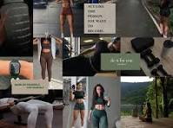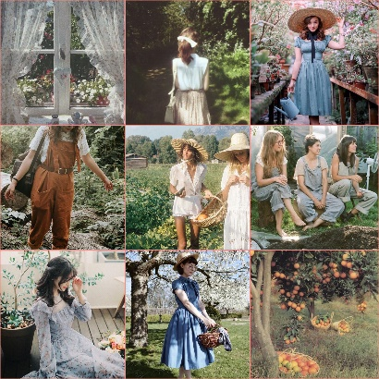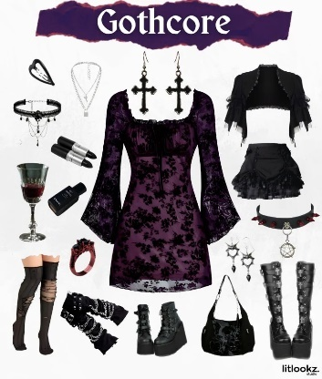
(Image 1: Kivette. n.d) (Image 2: Afterschoolcult, n.d.) (Image 3: Gul, 2024)
Exposure is very important for sales, content must be relevant and engaging, and seen enough times to gain the attention of the target audience. Consumers will be reluctant to buy from a company they’ve never heard of. Using trusted popular influencers can fast-track this process to gaining trust. This strategy is employed by fast fashion giants such as Shein who do collaboration ‘Shein hauls’ where influencers unpack their huge orders on camera to show viewers how each garment looks ‘in real life’ (Feldt, 2024)

2.3 What is it about social media influencers that has such a hold on us as consumers?
Influencers have access to a large reach of people who are more susceptible to being influenced than if they’d seen an advert directly from the brand. Influencers may be given free gifts or commission from a brand to promote to their large audience who appreciate the personal delivery of the advertisement, seeing it as a more trusted review, even if it’s labelled as a paid partnership. Viewers can develop a parasocial relationship with their favourite influencers and are subconsciously (or consciously) swayed by their opinions, likes and dislikes. Findapsychologist.org (2020) defines parasocial relationships as “one sided relationship where one person extends emotional energy, interest and time, and the other party, the persona, is completely unaware of the other’s existence”. This captures the essence of influencers. If an influencer reviews a brand positively, this will be received as more reliable by fans than the brand advertising directly, because viewers feel a connection with the influencer.

2.4 Why do we continue to feed into trends while simultaneously claiming to hate them?
One common contradiction seen online is the perceived awareness of global damage from overconsumption and unsustainable production, paired with the obsession with buying into new trends or buying unsustainable products and overconsumption. The term ‘fast fashion’ comes from the speed at which retailers can push new clothing from catwalk to sales, attempting to match the ever-increasing emergence of new trends (Bick et al., 2018). While the price tag may be low, the environmental and social cost are skyrocketing. The planet cannot sustain the rates of textile pollution and demand for materials and resources. Fast fashion is only one effect to emerge from the global economy. Labour and material sourcing can now be outsourced to areas with cheaper production costs. Prices overseas may be lower due to accessibility of materials, manufacturing equipment or low wage workers/ unregulated slave labour practices (Johansson, 2024)
Fast fashion is credited for “democratization” of fashion (Bick et al., 2018) as it makes trendy, fashionable clothes accessible to everyone. Amongst the most well-known are Shein, Boohoo, Zara and Primark
Primark was the first of these to be founded in 1969 in Dublin, originally under the name Penney’s. (Primark- About us) In 2023, Primark had an estimated net worth of 2.15 billion dollars (Statista, 2023)
Zara was the next of these, founded in Spain in 1975 by Amancio Ortega. In 2023 Zara was valued at approximately 11 billion U.S. dollars (Statista,2023)
Boohoo, which started as a family market stall, was founded in 2006 in Manchester by Mahmud Kamani and Carol Kane (boohooplc.com, n.d.) in 2023 the family business was valued at 1,769.7 million GBP (Statista, 2024), approximately 2179.74 million USD (Exchangerates.org, n.d)
Shein was founded in 2008, in China by Chris Xu and valued at $68 billion ahead of the late 2023 IPO. (Samanta, 2024)
Cotton is one of the most used materials, along with polyester plastics, in the fast fashion industry. Cotton production gives low yields of cotton for water it demands. The crop uses approximately 10,000 litres of water for every 1kg of cotton. (The World Counts, n.d.)
The cost to harvest cotton, process it into thread and weave it into fabric has become industrialised and mass scaled so it is now much cheaper. (Siegle, 2020) Buying bulk often come with discounts. Businesses may for example produce 3000 cotton blend school uniform shirts for £6000 making each unit cost £2 selling them for £5 instead of producing half and charging double, because they must be sold affordably. Suppliers know there is a guaranteed demand (school uniform policies requiring specific shirts). This keeps manufacturers in a constant ‘price war’ where cost of materials increases but we are trapped in a low-price expectancy. This leads to worker exploitation to keep the costs as low as possible. Large scale companies can afford to ‘absorb the cost’ (Siegle, 2020) of loss leader products, such as annual demands for school uniforms, but this undercuts smaller companies who charge reasonable prices to cover their costs. This is the key issue of mass production. It creates an expectancy of low prices because those companies who can afford to cut corners, absorb cost, or sell loss leader products, set the price standard for customers’ expectations. The benefits are affordable clothing for all, but this comes at cost of exploitation of workers, unstable harvesting of materials and draining resources (water to grow cotton, stripping soil of nutrients with repeated crops of cotton)

2.5 Are humans predisposed to these impulsive behaviours or have we gradually changed with exposure and our culture?
Humans have and always will be a tribal species at its roots. Though we have largely evolved past living in tribes in the literal sense, we still seek ‘our people’ through other means to fit in and find our identity in the world. Group loyalty was a way to improve the chances of survival and so we are engrained through years of evolution to be with others who share our values (Clark et al., 2019)
As we have had resources more readily available to us, we have consumed more to guarantee our survival. More food meant more energy, more clothes meant more warmth etc. But we are no longer in a life-or-death situation, and we have accumulated a lot of unnecessary waste. Marketers have successfully convinced us that we ‘need’ this new product they’re offering to feel complete. This style of marketing arose in the 1960’s known as ‘the golden age of marketing’. (Kathrync, 2023) TV advertising was taking off after the 1950s where TVs had become more widespread. The strategy was to make people feel like they had to fill a manufactured void to be happy. The best car, the biggest house, the most attractive partner, these goals were all sold to consumers as ‘the right way’ and this has completely reshaped marketing by playing on our biggest instincts: to survive, to be accepted, and to thrive. This is still evident in today’s marketing. We still hear the lines ‘you need this’ and ‘this will change your life’ but we are more accustomed to it so it’s less impactful than it would have been in the 1960s following WW2.
When we look through history, we can still see how fashion has been used to shape communities and class systems and how we have made impulsive buying decisions to fit in. Fashion across the ages has been use as status symbols to distinguish classes and social standing. Aristocrats would be the best dressed to differentiate themselves from those of lower social class The word aristocrat “comes from the Greek word aristokratia, which itself comes from the root words aristos, meaning "best," and Kratos, meaning "rule."” (vocabulary.com n.d) Thus ‘aristocrats’ were the ‘ruling class’. Whatever the top style at the time was, everyone with the means to participate would, as a display of how involved they were with their social groups.
Victorian Aristocratic style was ostentatious and bold, adorned with expensive jewels and made with expensive fabrics of the time. “Upper class women, who did not need to work, most commonly wore a tightly laced corset over a bodice or chemisette, and paired them with a skirt adorned with numerous embroideries and trims, over layers of petticoats” (What Is Victorian Fashion? 2018). Working class women would wear far simpler more practical dresses, with less expensive decoration. The difference would display to others who did and didn’t need to work, and thus who had more money and spare time.
Be it of wealth, family name, culture or class, trends run through to identify like with like. If you were a rich aristocrat, your clothing would signal your status to others, gaining you entry to exclusive events, a level of authority over peers and you would be able to clearly identify others like minded to meet with.
In modern times, fashion is more related to personal style, comfort, and self-expression, and the message you send is curated by you. The complete accessibility of clothing now and the non-fixture of cultural normative styles is why we have evolved so many subcategories such as ‘cottage core’ and ‘clean girl aesthetic’ so we can ‘find our tribe’ in different ways. Impulsive spending has always been a luxury, but it is very normalised in wealthier countries where not all impulsive purchases are expensive upfront, and seem ‘worth it’ to fit in.

2.8 Legislation
As of 2008, it’s a legal requirement for all sponsored posts, collaborations, and paid promotions to be clearly expressed as such. “The Consumer Protection from Unfair Trading Regulations 2008 (CPRs) This is to prevent unfair practices being used by traders and businesses (including influencers/content creators) when dealing with consumers.” (Ralston, 2022) If someone is paid to promote a product, viewers must be made aware it’s a biased review, possibly leading to commissions for the influencer. Failure to do so can lead to an investigation by the Competition and Markets Authority (CMA) “They have the power to take legal action where necessary.” (Loccisano, 2024)

Chapter 3: Methodology
The literature review has provided necessary context for existing research and has supported each of the research questions that form the foundation of this study
The following research looks to identify key themes and trends among consumers, reflecting on past generational patterns, and predict the outlook of online and in store retail and marketing
The framework of Saunders (2012) research onion will be used to structure this section of the report. The structure provided comprehensive walkthrough of each of the 6 sections that are expressed as subheadings.
This chapter will aim to meet objective 4:
- To evaluate the psychology of effective marketing strategies and how this shapes the future of marketing.
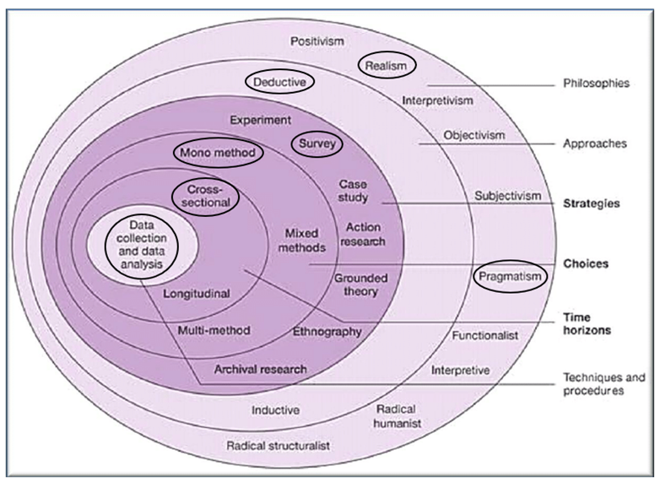
Figure 1 : Saunders Research Onion (Saunders,2012)

3.1 Philosophies
The research consists of understanding consumer preferences and observing trends in behaviour and motivations, and so a pragmatic approach will be used to underpin the philosophies of the research. Pragmatic approach uses a combination of nuance, opinions, and experience to understand the context (interpretivism). While also using numerical data (positivism) in support, to identify commonalities between opinions and statistical evidence. )Jansen, 2023)
3.2 Approaches
Deductive research uses a top-down approach, beginning with analysing existing research and theories to gain further depth of understanding. Followed by primary research to prove or disprove a theory or hypothesis. (Collaborators, 2023)
Deductive research has been selected for this research project as there are clear research questions, and there is existing research that will be compared to the findings of the surveys with quantitative and qualitative analysis.

3.3 Strategies
A critical assessment of existing research relating to the research questions must be conducted to better understand the existing context and identified trends in consumer behaviour. This will be achieved through reviewing various websites, journals and articles covering existing literature, and vintage fashion marketing records. (Bryman, et al 2015).
Empirical research will be used to compare modern primary research findings against existing research to see how closely the correlation lies and analyse what this implies for the future of fashion retail.
This research project will use a questionnaire to collect new data on consumer behaviour and perceptions of online shopping trends. Questionnaires are a form of qualitative and quantitative research that in this context, gather information from a broad sample of participants to gain a wider perspective on the social, cultural, and economic influences. Questionnaires provided a structured consistency when reviewing the data for quantifiable results, while allowing open ended questions for qualitative findings. (Survey Vs Questionnaire - Difference and Definitions - SmartSurvey, n.d.)
3.4 Choices
A multi method approach has been selected as this uses both qualitative and quantitative methods of gathering data. This will be further analysed with thematic analysis to identify key themes that run through the data and can provide future insight. (Jansen, 2024)

3.5 Time Horizons
Due to time constrains, longitudinal study was unavailable as a research method, and so cross-sectional research methods have been chosen as the most suitable method for this study. This allows responses from a wide range of participants in a short time frame. This data will describe the population opinion at this current time, eliminating the risk of sudden change in attitudes impacting results. The study looks to see how the public currently perceive brand marketing, helping predict future marketing trends, based on past patterns in history. (Setia, 2016)

3.6 Techniques and Procedures
The questionnaire is designed and delivered using the Google forms platform. This platform was chosen because it is accessible and allows for different styles of questions such as tick box, scale, multiple choice, or short text answers. Google forms can also be set to collet results anonymously protecting participants identity and data. This method integrates qualitative and quantitative date collection effectively. Questions were limited to 13 to prevent respondents from getting fatigued or giving rushed answers to finish the questions. Participation was clearly expressed as voluntary.

Survey Design

Questions | Type of question | Relation to Literature Review Headings
Please select your age range  - 16-25  - 26-35  - 36-45  - 46-55  - 56-65  - 66+ | Closed | 2.1 Does age and demographic widely impact shopping habits and preferences?  It is important to know which generations are following into which trends from a marketing perspective when predicting future changes.
Please select the gender that you feel most applies to you.  - Male  - Female  - Non-binary  - Other | Open | Gender is also a factor in marketing, although the lines are increasingly blurred and gender-neutral clothing is catching on.
What products are you most likely to purchase online?  - Clothing and fashion accessories  - Shoes  - Toys  - Technology (phones, laptops, headphones etc)  - Food (e.g. uber eats)  - Supermarket delivery  - Other | Open | 2.2 What makes a successful marketing campaign in the fashion industry?  Knowing what makes a successful marketing campaign means knowing what is selling best online and who is buying into each category.
Why do you shop online?  - I don’t shop online  - Cheaper  - Convenience  - I can’t get what I want locally  - Impulse purchases  - Better range of sizing online than in stores  - More choice  - I can’t get to the shops  - other | Open | 2.4 Why do we continue to feed into trends while simultaneously claiming to hate them?  This question shows the motive behind the purchase, what the key drivers are.  2.5 Are humans predisposed to these impulsive behaviours or have we gradually changed with exposure and our culture?  Comparing to historical fashion trends, this question can reflect on if our motivations remain the same or if we have changed to be more impulsive, less involved shoppers.
Where do you see the most ads for online shopping?  - TikTok  - Facebook  - Instagram  - YouTube  - Tv adverts  - Other | Open | 2.2 What makes a successful marketing campaign in the fashion industry?  Understanding the platforms most used and by whom is important information for future marketing predictions.
How much do you consider yourself to be influenced by online buying trends?  - Scale of 1-5 (1=not at all, 5=highly influenced) | Closed | 2.3 What is it about social media influencers that has such a hold on us as consumers?  It is important to understand the level of influence felt by consumers
What do you prioritise more when making a purchase?  - Supports local economy  - Lowest price | Closed | 2.4 Why do we continue to feed into trends while simultaneously claiming to hate them?  Understanding key motivators and how they override our sense of climate and social justice
Would you pay more for something if it arrives quicker? (such as premium shipping)  - Yes  - No  - Depends | Closed | 2.5 Are humans predisposed to these impulsive behaviours or have we gradually changed with exposure and our culture?  To determine the level of impulsivity and impatience to receive a product quickly.
If you selected ‘depends’ please provide an example of a condition (such as last-minute gift purchase) | Open
Are there any products you wouldn't buy online? Why? | Open | 2.2 What makes a successful marketing campaign in the fashion industry?  Understanding what poor performers for online sales are and why
Do you have any favourite online clothes retailor? Why? (e.g. website appearance, reputation, design, colour choice, sizing, price) | Open
Would you pay more for a generic product if it was branded? (e.g. water bottle, cap/hat, mug, candle)  - Yes  - No  - Depends | Closed | 2.3 What is it about social media influencers that has such a hold on us as consumers?  Using the example of ‘a generic product’ will demonstrate the value consumers place on brands and brand identities when the products competitors are widely available from elsewhere at lower prices
Please explain why you would/wouldn't/sometimes would below | Open | For further clarification
Figure 2: Questions for Questionnaire
Data collection
The questionnaire was uploaded to the current leading social media platforms that allow survey sharing Facebook and Instagram (Statista 2024). Online surveys can be shared remotely among peers and gain responses from those who may have otherwise been unreachable, preventing answer from disproportionately being people in the immediate area. i.e. Carmarthen.
Sampling
Random sampling means selecting respondents at random that are recognised from the population as meeting the criteria of a study (Emerson,2015). For this study, this means users of social media who are above the ages of 16, up to 66+. Random sampling requires identifying a demographic and how to reach a broad enough sample. Knowing from previous research that social media platforms Facebook and Instagram are most used within the age ranges starting at 16 up to 66+, this was the chosen method to gain a random sample. (Iskiev, 2023)
Reliability and validity
Validity of research refers to the quality research methods and evaluation of empirical data collected. Reliability refers to the quality of representation and of data collected, and its relevance to the study (Biggam, 2008). Qualitative research is based on several external factors such as opinions and perceptions and so a sample size of 100 is a strong sample size to adequately analyse all the data gathered while gaining enough insight of patterns to extract numerical quantitative data. (Vasileiou et al., 2018)
Analysis
Data will be converted into charts to display key findings and then further analysed on an individual response basis to identify key themes. A Google sheets spreadsheet will be used to compare columns of data gathered. Looking at how many times keywords are mentioned across the qualitative data and converting this into percentages. These will be compared with the separate age brackets to determine any links between ages and brand preferences, ages, and online vs in store shopping preferences etc. This will provide an in depth understanding of each bracketed age group that can be related back to the literature review.

3.7 Ethical Considerations
All participants at the beginning of the survey were informed their responses are and will remain entirely anonymous. Participants were also information that leaving the questionnaire without submitting would prevent any answers being logged, should they choose to leave the research. The questionnaire was delivered through Google forms through a secure shared link for participants to access the questionnaire. Data collected was further analysed using Google sheets, using my university account which is protected by a secure password and not accessible from any shared devices. No data will be stored following the completion of this research to be used for other purposes.
3.8 Limitations
Bias
Social desirability bias may lead participants to give answers that make them appear more ethical consumers. This may mean not mentioning fast fashion retailers as favourite places to shop or claiming to shop more locally. With the survey being anonymous and most of the question being non-emotive, the questionnaire aims to avoid these emotive biases.
Facebook and Instagram
This questionnaire was originally posted to Facebook and Instagram on public settings allowing it to be shared to gain reach. This was chosen as the most accessible and affordable means to reach a large audience of online social media users. While Facebook and Instagram represent a large range of users, the use of random sampling can lead to uneven results in age and gender, and this may cause an over representation of certain demographics.

Chapter 4: Findings and Analysis
The following section presents the findings from the primary research. A total of 100 responses were obtained from the questionnaire distribution.

Question 1
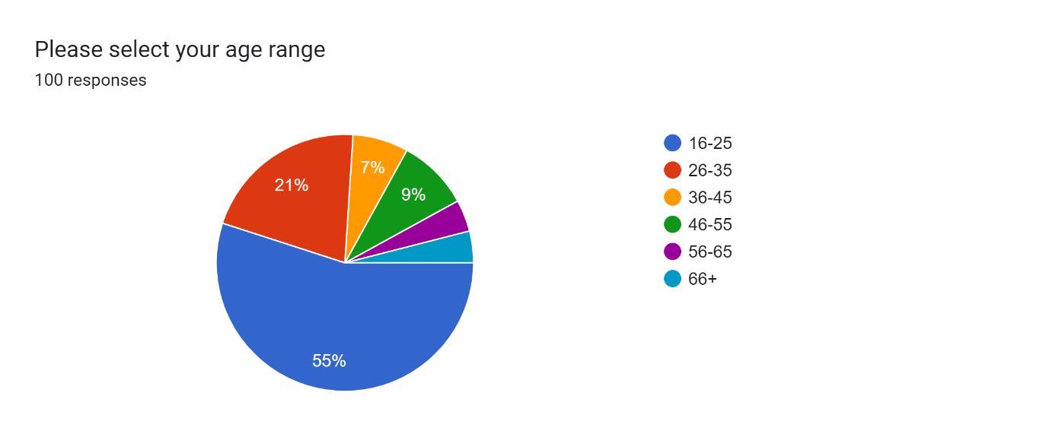
Figure 3: Respondent age
Figure 3 shows that Participants in the questionnaire were predominantly of the ages 16-25, making up 55% of responses. 21% of responses were from the age group 26-25. This is consistent with research that found current users of social media Facebook and Instagram are typically within this bracket, with Instagram popular with both, and Facebook more commonly used by millennials and older generations. The purpose of the research is to understand the impact of social media influencer marketing. If the main users of this social media are 16-25 and 26-35 years old this is important information for social media marketers when deciding target market.

Question 2
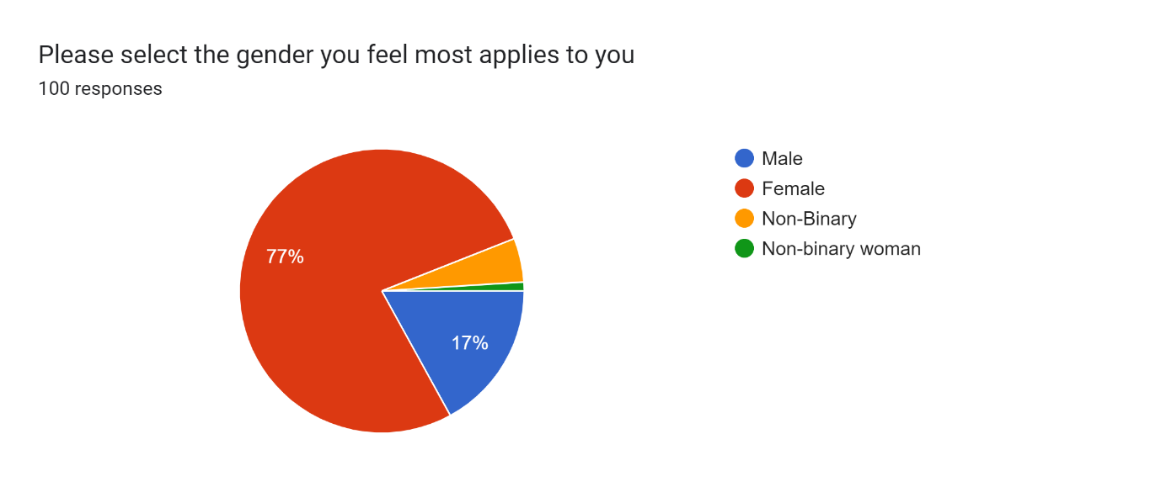
Figure 4 : Respondent gender identity
A limitation of this research is the responses were mainly from women. As random cross-sectional sampling was used this was difficult to avoid. The aim was to gain responses organically from whomever came across the survey once published, in a similar way to how advertisements would be published publicly. A 2024 Statista report shows equal usage of social media across genders. This is likely due to sharing amongst friends and friends-of-friends that there has become an imbalance.

Question 3
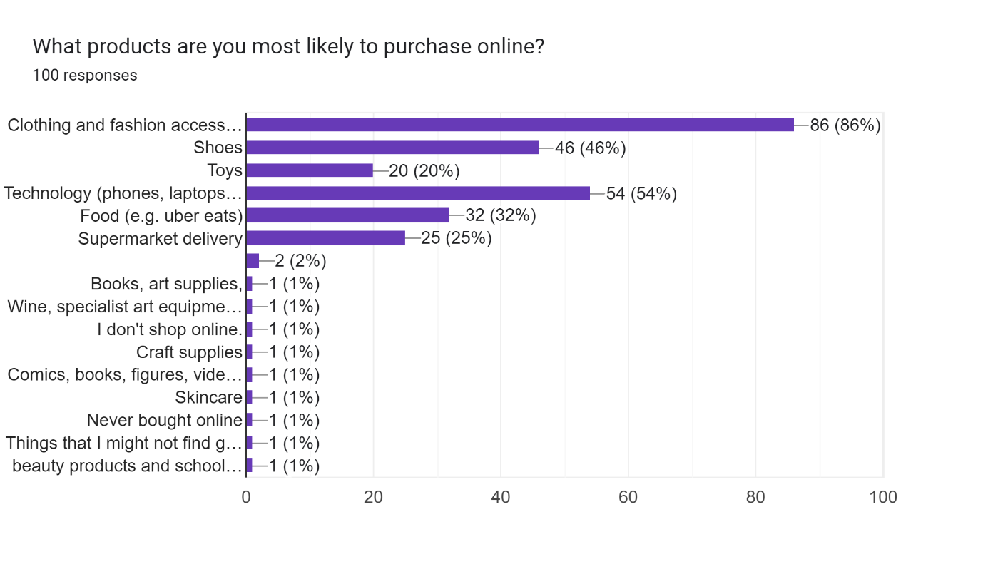
Figure 5 : Most purchased product category
Figure 5 shows the most popular product category
- clothing and fashion accessories, selected by 88%of participants, with the second most popular being technology (54%), followed by shoes (46%)
This was a multiple-choice question so participants could select multiple categories. Some examples of ‘other’ submitted by participants were:
- Books, art supplies and craft supplies
- Wine and specialist art equipment
- Comics and video games
- Skincare
These all have a 1% although there is some overlap with art and craft supplies.

Question 4
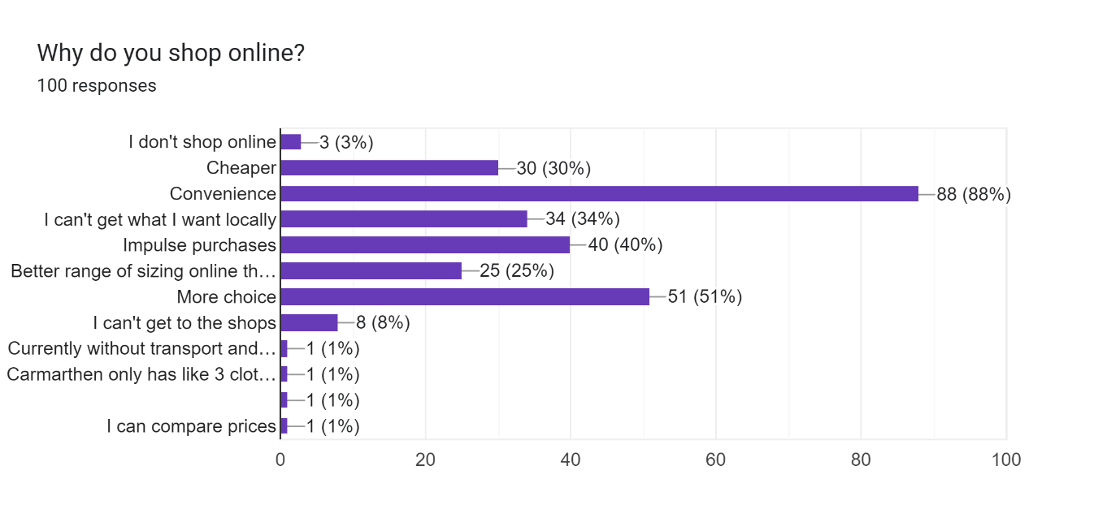
Figure 6 : Respondent online shopping product preference
When asked for reasons for shopping online the top 3 reasons were;
- Convenience (88%)
- More choice (51%)
- Impulse purchases (40%)
The bottom 3 reasons (put by participants who selected ‘other’) were
- That they are currently without transport and can’t get to shops
- That Carmarthen (their local town) has a limited range of shops
- That it’s easier to compare prices online
Surprisingly, ‘cheaper’ prices weren’t ranked that highly at only 30%. 34% voted they shop online because they can’t get what they want locally, so this was ranked a higher priority.

Question 5
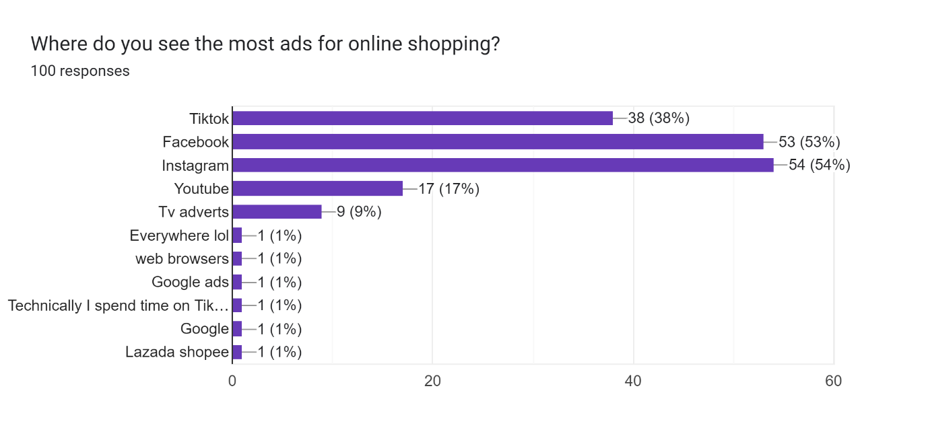Fig 7: Where respondent most sees online shopping adverts
This question was to understand where the most adverts are shown for online shopping. Participants could select multiple. Looking further into individual answers given on the data sheet, findings showed more interesting patterns
- 53% said Facebook. Of these 21 people (21% overall) only put Facebook. Only 7 of these were under the age of 46. The most common age bracket to mention only Facebook was 46-55 (8 people)

- 54% said Instagram of these 14 people (14% overall) put only Instagram. Only one participant in the 36-45 bracket only put Instagram, the rest who only mentioned Instagram with 16-25 (7 people) and 26-36 (6 people)

- 38% of participants who mentioned Instagram as one or more of their answers were aged 16-25, the second largest category was ages 26-35 with 12%

- 38% said TikTok. 38 % represents 38 people, of these 30 were 16-25, 5 were 26-35, 2 were 46-55 and one was 56-65.
- 17% saw online shopping ads on YouTube the most common age bracket for this was 16-25 There was one participant in the ages 26-35, the rest were all ages 16-25

- Only 9% said Tv adverts, of these participants, one selected only Tv adverts and they were in the age range 26-35

Of the others, these were the combinations selected
- Facebook, Instagram, YouTube, Tv adverts (16-25)
- Instagram, Tv adverts (16-25)
- Instagram, Tv adverts (36-45)
- Facebook, Tv adverts (66+)
- TikTok, Facebook, Tv adverts (56-65)
- TikTok, YouTube, Tv adverts (16-25)
- TikTok, Facebook, Instagram, Tv adverts (16-25)
- TikTok, Facebook, Instagram, YouTube, Tv adverts, everywhere lol (16-25)
All participants who are 16-25 have one or more of TikTok, Instagram and Facebook

Question 6
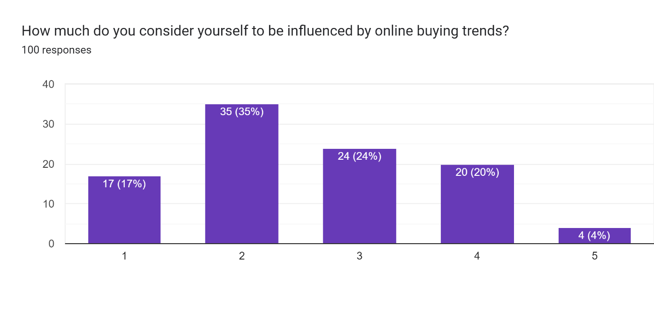
Fig 8: How much participants are influenced by online shopping trends
Fig 8 shows a scale of 1-5 with 1 being not at all influenced and 5 being highly influenced
- 17% of participants identified themselves as not at all influenced
Of these 7 were 16-25, 4 were 26-35 and the rest were 46+
- 2 was the most popular placement on the scale, with 16 from 16-25, 7 from 26-25 , 4 from 36-45 and the rest 46+
- Number 4 on the scale was most popular with 16-25 and 26-35. The exception is one participant aged 56-65.
- 32% of participants (all aged 16-25) placed themselves at 4 or 5
- The only people to select 5 (highly influenced), were female and ages 16-25.
As we go up the scale of influence there’s a definite trend where younger generation are rating themselves as more highly influenced. Although only 9% of the responses were from ages 46-55, all of them rated themselves 1 or 2 on the scale.
Question 7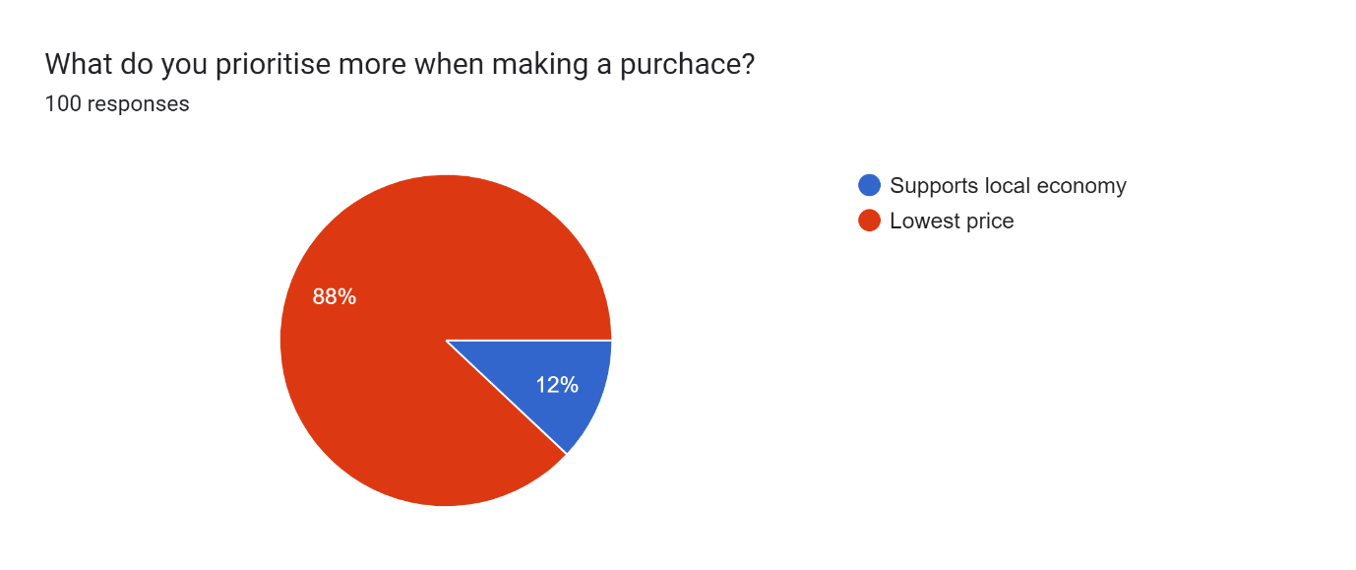
Fig 9: Priorities when purchasing
- 88% value low price over supporting local businesses
- Of the 12% (12 participants overall) who prefer local businesses, only 3 / 12 were aged 16-25, the most common age range to select supports local economy was 26-25 with 4 participants
Question 8
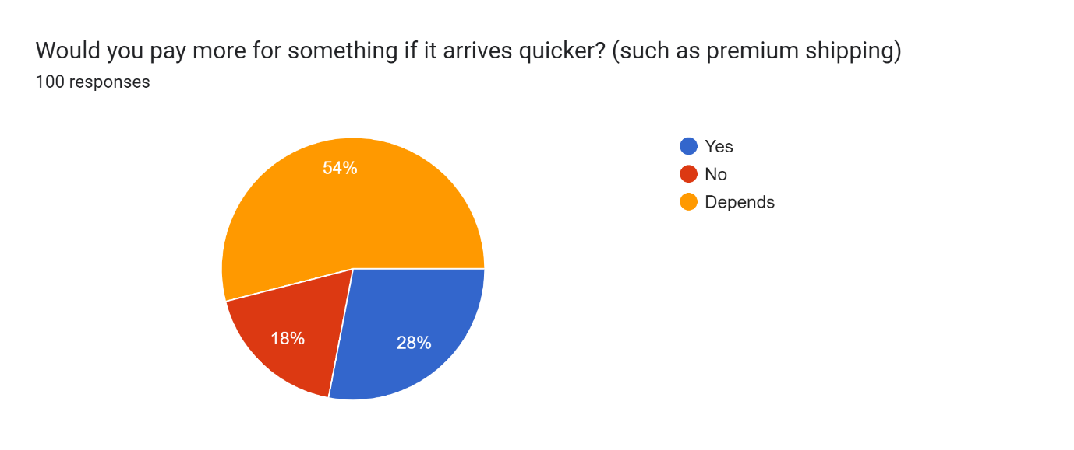
Fig 10: Would respondent pay more for quicker delivery?

Interestingly, while the majority said they prioritise low price, 82% would or would occasionally pay more for faster delivery, such as prime shipping next day delivery etc.
Question 9
“If you selected 'depends' please provide an example of a condition (such as last minute gift purchase)”
The top reasons were
- If it’s a gift that’s needed by a guaranteed date
- If it’s a last-minute purchase
- If it’s needed urgently for any other reasons
Question 10
Question 10 was “Are there any products you wouldn't buy online? Why?”
This was an optional question and received 75 responses
Top answers were
- 22/75 (29.3%) said no to food items – including groceries delivery because they prefer to pick out their own for quality assurance.
- Shoes because you cannot try them on, and they prefer to know the wearability before committing to new shoes
- Underwear because they want to know the quality and durability, as well as comfort.
Question 11
“Do you have any favourite online clothes retailor? Why? (e.g. website appearance, reputation, design, colour choice, sizing, price) This was also an optional question and received 81 responses
- The two most mentioned brands were ASOS and Shein
- ASOS was mentioned 13 different times, most popular with ages 16-24 due to the cheap range and student discounts
- Shein was mentioned 8 different times. Reasons given were affordability and quality for price

Question 12 and 13
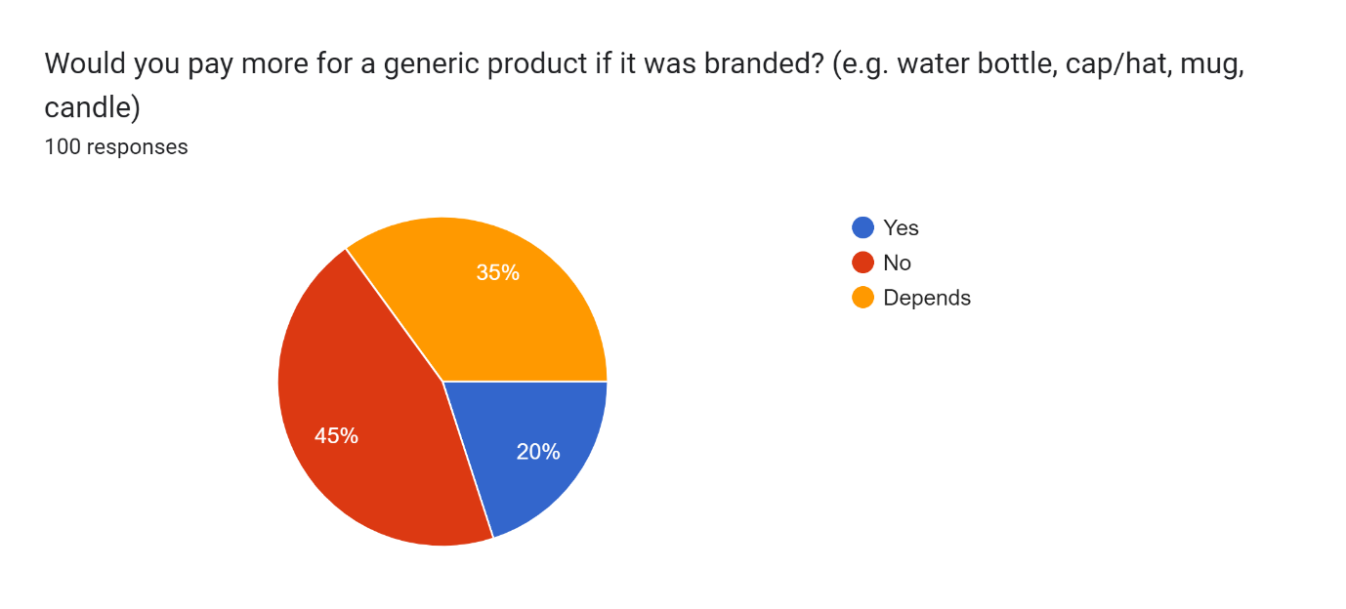
Fig 11: Would respondent pay more for branded generic product?
Question 12 was to understand the level of brand influence on generic products where there are a lot of cheaper alternatives, such as bottles and caps. Question 13 was clarification on why.
- 45% said they wouldn’t with top reasons given being
  - Its generic so they don’t care about branding
  - They don’t like wearing and endorsing a brand logo on generic products
  - It’s an unnecessary added cost
- 20% said they would, resend given were
  - A belief that it means better quality or better durability materials
  - If the brand its trendy at the time
  - If they like the brand
  - ‘Buy cheap by twice’
- The other 35% said it depended on the brand and the reputation
1. They may pay more if it’s higher quality
2. If it’s a gift for someone else

Chapter 5: Further Analysis and Discussion
Each of the questions in the questionnaire is linked to one of the key questions of this research. This chapter will conduct a thematic analysis to observe key themes and trends and relate it back to the corresponding literature review
1.Does age and generation widely impact shopping habits and preferences?
Findings from the questionnaire show that those most likely to buy into trends and be influenced by online influencers are aged 16-25, followed by 26-35. (Question 6) 32% of participants (all aged 16-25) placed themselves at 4 or 5 on the scale, 5 being ‘highly influenced’ by online buying trends. The only people to select 5 (highly influenced), were female and ages 16-25.
This is in keeping with research by Iskiev, (2023) who conducted a study in the US that showed 33% of Gen X, (ages 12-25) had bought online having been influenced by influencer content. This also follows the (Ofcom 2024) report of adult online social media usage.
Age also influences the social media most used, In the questionnaire, Q5 asked participants where they see the most ads for online shopping, 30% (all 16-25) mentioned TikTok and 6% (ages 26-35) mentioned exclusively TikTok.
2-3. What makes a successful marketing campaign in the fashion industry and What is it about social media influencers that has such a hold on us as consumers?
These questions both came to similar conclusions. Successful marketing, especially when using influencers, now means selling a story and connecting with customers in a personal way. Brands must observe trends and popularized aesthetics to sell the relevant story to each consumer. Artificial Intelligence or AI marketing could be the future for fun engagement with customers who can ‘try on’ clothes virtually. (Sinelnikov, 2024)
4. Why do we continue to feed into trends while simultaneously claiming to hate them?
The findings from the literature review and the questionnaire both show that the main motivations for following trends are to fit in with those around us and find a sense of identity. The more affordable options such as fast fashion seem most popular with younger generations (age 16-25) who may have less disposable income. Brand such as Shein and ASOS who offer discounts and student delas were most mentioned among this group (Question11) Marketers can use the self-labelling that younger generations have adopted to reach core audiences and reduce spending on wasted marketing tools. (Graham.2023)
5. Are humans predisposed to these impulsive behaviours or have we gradually changed with exposure and our culture?
Humans naturally seek validation and acceptance from peers as means of survival, (Clark et al., 2019) marketing has historically been pushy and implying life is incomplete without their product. Now we move past this into a word of excess. Where everyone is selling in the same category (I.e. fashion) it becomes less about the clothes and more about the message that is sold with it. (Rosweide, 2021) Artificial Intelligence (AI) will be the next evolution of marketing that follows this storytelling narrative. For online shopping Etsy has already launched ‘Etsy virtual house’ which immerses shoppers in “a virtual home adorned with holiday decorations and gifts available for purchase on the platform.” (Impact, 2024) (Doyle, 2021)

Chapter 6: Conclusion
This chapter will cover the final research question for this study:
How does our knowledge of these things effect the outlook on the future of the fashion industry?
The way the market has changed over generations has been subtle, then suddenly boomed with the internet. As we look towards 2024, the future of marketing will engage with more AI marketing to connect customers to their brand’s immersive virtual world through storytelling and personal engagement. (Impact, 2024). AI encourages user experience, online engagement and connection between businesses and consumers in a collaborative way. In store retail is becoming too expensive to maintain with such high-level competition undercutting sales. AI is also used by some amazon sellers (Perez, 2020) to show customers how the product will look in their space. Selling in a virtual shop could make ‘in store’ shopping globally accessible to all.
TikTok was found by the questionnaire to be the most popular platform among 16–25-year-olds, followed by Instagram. Using AI integrations on these already popularised channels could gain recognition and reputation for brands. AI integrations already exist on snapchat with snapchat filters, a similar system could be used to try on accessories or view products in their homes that are sold online. Specsavers (2024) currently offer a ‘virtual try on’ feature for its online store, where you can scan your face, and AI shows you how you would look in each style of glasses. From an accessibility perspective, this means people who cannot get to the shop, perhaps they’re unable to drive due to an eye condition, can still get the full shopping experience of trying on the full range to fit the perfect fit for them. It is also a time saver if visiting in store if you know ahead what you are looking for. AI can create an innovative new shopping experience for those who are unable to access local shops, or who don’t have a good range of local businesses that cater to these needs. Thes were both cited reasons for shoppers looking online in the questionnaire (Q4) Convenience was rated the top priority in the questionnaire (Q4) selected by 88% of respondents as their reason for shopping online. The second most common was ‘more choice’ which was chosen by 51% of respondents. This innovative solution tackles both of these main motivations to shop online.
Recommendation
New businesses will need to adopt a multichannel approach to reaching new customers. Appearing in a physical shop gives reputation for the quality and authenticity of your claims. If customers can tangibly engage with product before they see them online, they will be more trusting of the brand. Where this is not possible, is where AI can be integrated. Allowing virtual shopping experiences can replace this or be used alongside. Online retail is competitive and so customers must feel connected to a brand in some way to choose them over others. Customer reward schemes, student offers, and free returns are all appealing to customers. These were cited as the reason for ASOS being so popular with ages 16-25 in the questionnaire (Q8).
Further research
For deeper understanding, more exploration into AI and the ways its shaping advertisement. Due to the complexity of this it was unable to be included in-depth in this 8000-word report, though it would be beneficial to businesses to explore these emerging avenues.

Chapter 7: Bibliography

Aristocrat - Definition, Meaning & Synonyms. (n.d.). In Vocabulary.com. https://www.vocabulary.com/dictionary/aristocrat

Afterschoolcult. (n.d.). Soft Gamine Mood board: Cottagecore : r/Kibbe. [image] https://i.redd.it/pizi4pcc7mx41.jpg

Baldwin, R., Evenett,S.J., Martin, F. (2023,December 30). Globalization in 2024: the clouds are clearing - I by IMD. I By IMD. https://www.imd.org/ibyimd/2024-trends/globalization-in-2024-the-clouds-are-clearing/

Banerjee, A. (2024, January 3). Shein Company - Founder | Business model | Funding | Owner. StartupTalky. https://startuptalky.com/shein-success-story/

Behan, A. (2024, April 18). Amancio Ortega: founder of Zara and richest person in Spain. Investopedia. https://www.investopedia.com/terms/a/amancio-ortega.asp

Bick, R., Halsey, E. & Ekenga, C.C. The global environmental injustice of fast fashion. Environ Health 17, 92 (2018). https://doi.org/10.1186/s12940-018-0433-7

Biggam, J. (2008). Succeeding with Your Master’s Dissertation: A Step-by-Step Handbook. Berkshire: Open University Press.

boohooplc.com. (n.d.). Group. https://www.boohooplc.com/group.htm

Britannica money. (2024, May 17). https://www.britannica.com/money/Google-Inc

Brunjes, K. (2024, May 13). Age range by generation - Beresford Research. Beresford Research. https://www.beresfordresearch.com/age-range-by-generation/

Butler, S. (2020, July 11). The billionaire Boohoo family who started with a market stall in Manchester. The Guardian. https://www.theguardian.com/business/2020/jul/10/the-billionaire-boohoo-family-who-started-with-a-market-stall-in-manchester

Clark, C., Liu, B. S., Winegard, B., & Ditto, P. H. (2019). Tribalism is Human Nature. ResearchGate. https://www.researchgate.net/publication/331823894_Tribalism_is_Human_Nature

Collaborators, Q. (2023, August 18). Inductive vs Deductive Research: Difference of Approaches. QuestionPro. https://www.questionpro.com/blog/inductive-vs-deductive-research/

Crumbie, A. (2024, April 9). What is fast fashion and why is it a problem?. Ethical Consumer. https://www.ethicalconsumer.org/fashion-clothing/what-fast-fashion-why-it-problem

Doyle, J. (2021. Sept 27). The Etsy House opens its (Virtual) doors. Etsy News. https://www.etsy.com/news/the-etsy-house-opens-its-virtual-doors/

Exchangerates.org. (n.d). British pound (GBP) to US dollar (USD) exchange rate history for 2023. (n.d.). https://www.exchange-rates.org/exchange-rate-history/gbp-usd-2023

Feldt, S. (2024, March 5). What is a SHEIN haul? Unwrapping the fashion trend. Playbite. https://www.playbite.com/what-is-a-shein-haul/

File:Le bal paré.jpg - Wikimedia Commons. (n.d.). https://commons.wikimedia.org/wiki/File:Le_bal_par%C3%A9.jpg

Findapsychologist.org. (2020, February 18). Parasocial Relationships: The nature of celebrity fascinations - Find a psychologist. Find a Psychologist - Find a licensed psychologist that’s right for you. https://www.findapsychologist.org/parasocial-relationships-the-nature-of-celebrity-fascinations/

Graham. (2023, November 14). How your brand can utilise trending core aesthetics to drive growth. Limely. https://www.limely.co.uk/blog/how-your-brand-can-utilise-trending-core-aesthetics-to-drive-growth

Geyser, W. (2024, February 14). What is an Influencer? – Social Media Influencers Defined [Updated 2024]. Influencer Marketing Hub. https://influencermarketinghub.com/what-is-an-influencer/

Gul, B. (2024, March 14). 33 Types of Aesthetics in 2024: The Ultimate Style Guide w/ Pictures. Litlookz Studio. [Image] https://cdn.shopify.com/s/files/1/0746/5202/5118/files/gothcore-outfit.jpg?v=1698404674

Iskiev ,M. (2023). How Each Generation Shops in 2023 [New Data from Our State of Consumer Trends Report]. https://blog.hubspot.com/marketing/how-each-generation-shops-differently

Ikenson, D. (2022, October 12). The E-Commerce revolution is transforming global trade and benefitting the U.S. economy. Forbes. https://www.forbes.com/sites/danikenson/2022/06/13/the-e-commerce-revolution-is-transforming-global-trade-and-benefitting-the-us-economy/

Jansen, D. (2024, April 23). What (Exactly) is thematic analysis? Grad Coach. https://gradcoach.com/what-is-thematic-analysis/

Jansen, D. (2023, October 26). Saunders’ Research Onion – explained simply (With examples). Grad Coach. https://gradcoach.com/saunders-research-onion/

Johansson, H. (2024, May 16). Overseas Manufacturing In 2024: What Are The Pros & Cons? Gembah. https://gembah.com/blog/overseas-manufacturing/

Kathrync. (2023, October 2). Why the 1960s was the start of the ‘Golden Age of Advertising.’ MBC. https://wearembc.com/why-the-1960s-was-the-start-of-the-golden-age-of-advertising/

Kivette. (n.d) 2023 vision board / pictures wallpaper / gym wallpaper / healthy lifestyle / aesthetic girl. [image] https://i.pinimg.com/736x/a9/df/0c/a9df0c7aa70194a00f48b6337aa9ffc0.jpg

Loccisano, P. (2024, January 21). Legal Considerations for Influencer Marketing | LegalVision UK. LegalVision UK. https://legalvision.co.uk/ecommerce-online-business/legal-considerations-influencer-marketing/

MacNaught, S. (2024, April 22). Ecommerce Statistics 2024 – the numbers. Micro Biz Mag. https://www.microbizmag.co.uk/ecommerce-statistics/

Male, P (2021) The rise of cottagecore. The Boar. https://theboar.org/2021/06/cottage-core/

Ofcom. (2024). Adults’ Media Use and Attitudes report. https://www.ofcom.org.uk/__data/assets/pdf_file/0020/283025/adults-media-use-and-attitudes-report-2024.pdf
Perez, S. (2020, August 25). Amazon rolls out a new AR shopping feature for viewing multiple items at once. TechCrunch. https://techcrunch.com/2020/08/25/amazon-rolls-out-a-new-ar-shopping-feature-for-viewing-multiple-items-at-once/?guccounter=1&guce_referrer=aHR0cHM6Ly93d3cuZ29vZ2xlLmNvbS8&guce_referrer_sig=AQAAAL0fvqST__BETg8bAR8Hv3Vl2cfRzqdklHBC1GhuVp0_ujJ0Bbs785hAQPvGo1QRS-01Q9DjTo_V1iFdhqZLaNmKs6xtzTFjsjJd9FAJ3WqFFQV3dQo-0nSAI1y6dK3coHw2wGSYjx0zhTtaH1ECNGSdgg69legsh8qtEAND5NZs

Ralston, A. (2022, January 28). Influencer Marketing Rules – CMA enforces consumer protection law. Stephens Scown. https://www.stephens-scown.co.uk/intellectual-property-2/influencer-marketing-rules-cma-enforces-consumer-protection-law/

Rosweide, R. (2021, December 13). Sell your story, not your product - Roger Rosweide - Medium. Medium. https://rogerrosweide.medium.com/sell-your-story-not-your-product-157779edeeea

Samanta, O. (2024, January 5). Shein Networth Revenue & usage Statistics 2024. Priori Data. https://prioridata.com/data/shein-revenue-statistics/

Sawant, A. (n.d.). How Demographics Influence Customer behavior & Buying Habits. Edge CRM. https://www.edgecrm.app/articles/how-demographics-influence-customer-behavior-and-buying-habits

Setia, M. S. (2016). Methodology series module 3: Cross-sectional studies. Indian Journal of Dermatology/Indian Journal of Dermatology, 61(3), 261. https://doi.org/10.4103/0019-5154.182410

Siegle, L. (2020, September 23). The cheap cotton crisis. The Guardian. https://www.theguardian.com/environment/2011/aug/14/lucy-siegle-cheap-cotton-clothes

Simon. DMI & by Digital Marketing Institute. (2024, May 1). 20 surprising influencer marketing Statistics. Digital Marketing Institute. https://digitalmarketinginstitute.com/blog/20-influencer-marketing-statistics-that-will-surprise-you

Sinelnikov, D. (2024, February 20). The Future of E-Commerce: Trends to watch in 2024. Forbes. https://www.forbes.com/sites/forbesagencycouncil/2024/01/17/the-future-of-e-commerce-trends-to-watch-in-2024/

Specsavers. (2024). Barbour Men’s glasses BARBOUR 12 | Brown Round Plastic BIO-BASED ACETATE Frame £130 | Specsavers UK. (n.d.). https://www.specsavers.co.uk/glasses/barbour-12?sku=33137094

Statista. (2024, February 19). Revenue of Boohoo.com Plc. group worldwide 2012-2023. https://www.statista.com/statistics/794862/boohoo-plc-group-revenue-worldwide/

Statista. (2023, October 17). Primark brand value 2020-2023. https://www.statista.com/statistics/1313832/primark-brand-value/

Statista. (2023, December 19). Global brand value of Zara from 2016 to 2023. https://www.statista.com/statistics/980126/brand-value-of-zara-worldwide/

Statista. (2024, May 2). Instagram: distribution of global audiences 2024, by age group. https://www.statista.com/statistics/325587/instagram-global-age-group/

Survey vs Questionnaire - Difference and Definitions - SmartSurvey. (n.d.). SmartSurvey. https://www.smartsurvey.co.uk/articles/survey-vs-questionnaire

The World Counts. (n.d.). Environmental issues with cotton - Cotton Environmental Impact. https://www.theworldcounts.com/challenges/consumption/clothing/cotton-farming-water-consumption

What is deductive reasoning? | Definition, Examples & tools. (2024, April 8). ATLAS.ti. https://atlasti.com/guides/qualitative-research-guide-part-2/deductive-reasoning

What is Victorian fashion? (2018, October 3). Victorian Emporium. https://www.thevictorianemporium.com/publications/history/article/what-is-victorian-fashion

Von Moritz, C. (2023, March 29). Can ordinary people join the aristocratic class? Royal Titles - Genuine Titles of Nobility. https://www.royaltitles.net/blog/can-ordinary-people-join-the-aristocratic-class/

Vasileiou, K., Barnett, J., Thorpe, S., & Young, T. (2018). Characterising and justifying sample size sufficiency in interview-based studies: systematic analysis of qualitative health research over a 15-year period. BMC Medical Research Methodology, 18(1). https://doi.org/10.1186/s12874-018-0594-7

