

MODULE NAME: Personnel Resourcing and Development
MODULE CODE: BMIH5005
ASSIGNMENT: Review the analyse of the current challenges facing hotels in managing their employee turnover in the UK
STUDENT NAME: Silviu Alexandru Ciolan
STUDENT ID: 2027368

CONTENTS
INTRODUCTION 3
CRITICALLY ANALYSE OF THE IMPACT OF CURRENT CHALLENGES ON THE LIFECYCLE OF AN EMPLOYEE 4
CONCLUSIONS 8
REFERENCES 9
APPENDICES 11

INTRODUCTION

The present essay has its focus around the challenges that are impacting an employee lifecycle within the hotel industry. In UK, since the pandemic started two years ago, many hotels suffered from a low number of customers, therefore they had to cut the number of their employees as well. Team member turnover has been specified by Price (1977) as the activity of members across the border of an organisation. As Mobley (1982) specified that turnover is the voluntary cessation of membership in an organisation by a person that gets financial repayment for joining that organisation. In addition, there are numerous interpretations in exact same viewpoint from great deals of writers as Van der Merwe and also Miller (1996) mentioned that staff member turnover is a long-lasting withdrawal and also feature of the person-work connection. Lane (2001) specified employee turnover as the outcome of both gives up and also discharges and added states that some turnover is an outcome of tasks in one company being ruined as well as tasks in an extra firm being produced along with hence because of the reallocation of job throughout the economic scenario at work to modifications in product requirement. Staff member turnover can either declare or adverse, nonetheless all have a considerable influence on performance (Boxall as well as Baldwin, 2002). Gomez-Mejia et alia (1997) defined volunteer turnover as a separation that happens when a staff member picks for individual reasons to finish the connection with the employer. Sims (2007) acknowledged that volunteer turn over takes place when an employee starts the discontinuation of their work of their very own free choice.

CRITICALLY ANALYSE OF THE IMPACT OF CURRENT CHALLENGES ON THE LIFECYCLE OF AN EMPLOYEE

The staff member lifecycle is a business strategy utilized to imagine how an employee engages with the business they are part of. The worker lifecycle breaks down the entire of an employee's time with a company right into six stages: attraction, employment, onboarding, growth, retention as well as separation. Comprehending each stage will absolutely increase the worker experience throughout the period of a staff member's time at a firm (Byrne, 2006).
With 70% of hotel employees given up or furloughed due to COVID-19, it is more crucial than ever for hotel owners to maintain their top-performing staff members. When the market recovers, hotel businesses will discover it tough and also expensive to hire the competent talent they need. Therefore, now is the right time for proprietors as well as management to apply a solid retention strategy that sets a structure for the future. The present state of the hospitality market is not quite. COVID-19 has ravaged every element of the sector, including a massive effect on resorts from coastline to coast.
The present situation of the hotel industry lays in the following statements:
- Growth has actually slowed down or quit entirely: Banks are limiting their risks currently, which includes avoiding offering to higher threat courses, such as accommodations.
- Worker lowering: Due to restricted travel as well as cancelled occasions, the market has experienced substantial discharges to save money and pay taken care of price.
- Cross-training of team: High-level placements and also back-office employees are required to service the front lines, consisting of at reservation desks and also in restaurants.
- Trick individuals leaving for more safe and secure industries: The current state of the industry and the unpredictability bordering the next couple of years have actually led to staff members seeking more protected positions somewhere else.
- Workers don't intend to come back: Some resort professionals are not returning as a result of significant unemployment insurance or not feeling safe dealing with the front line.
- Additional expenses and time for individual protection tools: Attempting to keep your hotel staff members secure has led to a heavy burden in terms of prices and also time.
The hospitality industry had a hard time in 2021 to make a comeback after the results from the COVID-19 pandemic. As 2022 and COVID's third year start-- declared by another new variation, omicron -- the screening will certainly proceed. Creative thinking, combined with a sharpened concentrate on danger administration, will be essential for browsing forward. It's not getting any type of much easier. Finding certified people is a struggle at all degrees for resorts as well as restaurants. Tech investment can offset some of the space, however likewise enhances the risk of cyber exposure. Meanwhile, company traveling is still flagging as well as indoor mask required in lots of areas can work as a flash point. The ramifications of it all aren't shed on insurance providers (wttc.com, 2022). It's increasingly usual for underwriters to make on-site evaluations of buildings as well as inspect social networks evaluates for signs of prospective risk. Exactly how dining establishments are taking care of rising alcohol sales is additionally under scrutiny, as is the persistence of hotels in taking COVID precaution.
From a staffing perspective, COVID-19 has included an additional layer to the pre-existing obstacles of searching for and preserving key employees. Every market is encountering its challenges now, however if resort owners do not have a technique when it pertains to recruitment and also retention, they are encountering a much deeper opening to climb up out of than proprietors that are prepared in this critical location. It is essential to comprehend why workers leave, and for this there are numerous devices any business can use to fully grasp why team member are heading elsewhere. The easiest means to obtain this info is with the help of exit interviews conducted by HR, where employees should be encouraged to speak out, their real reasons for the resignation.
Kelly (2001) specified that personnel turn over costs are the concern that a great deal of executives comprehend yet do not identify as a potential loss of profits. A good deal of negative elements that are raised by worker turn over are clearly recognizable in expense advantage analyses. Personnel supervisors understand that staff member turnover is a considerable cost and also substantially impacts an organisation (Irvancewich, 1994). Countless managers decline to face up to these costs, yet they could be needed to do so when thinking about the different components needed to calculate the cost of employee waste (Stewart,1998). According to Mitchell (2001), employee turnover imposes comprehensive expenditure both the individual as well as also the organisation level. At specific degree, it does not matter if the individual leaves voluntarily to one more job or is forced to leave as well as take a personal toll. For organisation degree, the trouble develops when leaving team member take their helpful understanding along with understanding gotten through experience with them. Hassan (2017) verified that staff member turnover is an important price driver for any type of kind of service. The cost of maintaining as well as filling openings, lost efficiency from uninhabited job as well as cost of training new personnel raise operational expenditures. Parts of the expense of work turn over really typically and likewise rely on whether all cost aspects are recognized.
The term "retention" can be specified as a systematic initiative to create and enhance an environment that remains to prompt employees to work while applying plans as well as methods that fit their different needs. Worker retention is the process of protecting employees, or urging them to remain with the business for as long as feasible. Worker retention is "a strategy whereby service keep an effective labour force and meet functional needs" (Eaton, 2014). It is a technique of encouraging workers to stick with the organization, or to stay with the business up till a task is completed (Ming-Chu, 2017). According to Swenson (2018), human resources are a methodical initiative to produce and likewise enhance a setup that motivates employees by advertising plans and likewise methods that satisfy their diverse demands. Retention is a volunteer action by an organization to produce an ideal setting that engages workers for the long term (De Sousa et al., 2018). Staff member retention policies concentrate on recognizing and keeping dedicated staff members. Innovative as well as unification programs with terrific managers can promote team member retention. Magnate' ability to comprehend just how to maintain as well as also influence staff members is necessary to a company's success (Schuler, 2015). Worker retention explains an organization's ability to preserve its workers (Fernandez & Worasuwan, 2017). Some strategies magnate utilizes to maintain employees consist of monitoring chances, payment and incentives, onboarding, employee involvement programs, as well as socializing, training, as well as growth. Resort managers should establish strategies to keep employees. Employee retention attributes are interaction with a positive workplace, favourable functioning connections, inspiring management, training as well as advancement, exceptional commission, organizational policies, as well as management's interest in staff member health (Ruiz & Davis, 2017). Inspired staff members aid organizations to reach their objectives as well as to acquire profits. The success of every hotel market is based upon their staff members because staff members are answerable for delivering quality remedy to clients (Bangwal & Tiwari, 2019). Employers must definitely offer a hallmark experience to their team member to establish a completely committed workforce throughout their expert occupations. The effect of worker turnover in the friendliness market has actually made executives understand the worth of preserving top-notch workers. The proper workers need to be drawn in, produced, and likewise preserved in an organization (Rose & Raja, 2016). Retention elements include training and improvement, occupation chances, supervisor support, task characteristics, work/life balance, as well as compensation. The retention of pleased and additionally committed employees is primary to the success of the business in the friendliness sector (Karatepe & Magaji, 2008). Workers or employees retention is essential due to the fact that it minimizes training as well as growth prices.

CONCLUSIONS

Hotel supervisors come across obstacles in operation effective methods to boost employee retention. Changing methods may aid hotel supervisors enhance employee retention, which might preserve company, thus producing financial growth for area locations. With improved employee retention, hotel supervisors will absolutely pay more service tax obligations, which government, state, as well as city governments may make use of to provide social facilities to the regional people. Additionally, improving employee retention might help resort
managers maintain their companies and also remain to give work possibilities to the citizens. The public may gain from the research analysis for the techniques resort managers utilize to enhance staff member retention. Using Herzberg two-factor theory as a lens for this study including methods resort supervisors use to improve team member retention could load a space in the literature on staff member monitoring.

REFERENCES

Bangwal, D., & Tiwari, P. (2019). Workplace atmosphere, staff member fulfilment and also intent to remain. International Journal of Contemporary Friendliness Management
Byrne, Z. S., Peters, J. M., Weston, J. W. (2016). The deal with employee involvement: Procedures and also construct information using five samples. Journal of Applied Psychology
Chowdhury Abdullah Al Mamun and Md. Nazmul Hasan (2017). Aspects influencing employee turnover as well as sound retention techniques in business organization: a conceptual view. Problems and Point of Views in Monitoring
De Sousa, S. M., Ledimo, O., & Martins, N. (2018). Anticipating personnel retention from staff member motivation as well as work fulfilment. Journal of Psychology in Africa
Fernandez, K., & Worasuwan, K. (2017). Chauffeurs of hotel worker retention: A relative research study. Universal Journal of Management.
Hales, J., James, R.M., Jr., Laura, A. Swenson (2018). A brand-new period of voluntary disclosure? Empirical proof on how worker postings on social media connect to future business disclosures.
Ihuah, P.W.; Kakulu, I.I.; Eaton, D. (2014). An evaluation of Critical Job Monitoring Success Factors (CPMSF) for lasting social real estate in Nigeria. Int. J. Sustain. Built Environ.
John M. Ivancevich (1994). Human Resource Administration: Structures of Employee Management.
Karatepe, O. M., & Magaji, A. B. (2008). Work-Family Problem as well as Facilitation in the Resort Market: A Research in Nigeria. Cornell Friendliness Quarterly.
Ming-Chu, Y. (2017). Exactly How Can Human Resource Monitoring Practices Bring About Increased Corporate Social Performance? Institutional Theory Viewpoint.
Mitchell, T. R., Holtom, B. C., & Lee, T. W. (2001). Just how to keep your finest workers: Creating an efficient retention policy. Academy of Administration Point of Views.
Moen, P., Kelly, E. L., & Hillside, R. (2011). Does enhancing work-time control and versatility decrease turn over? A naturally occurring experiment. Social problems.
Price, J.L (1977). The research of turnover.
Rose, S., & Raja, K. G. (2016). Function of human resource techniques, work satisfaction, and organization dedication in employee retention. CLEAR International Journal of Study in Commerce & Administration
Ruiz, C. A., & Davis, A. (2017). Methods to preserve millennial staff members at full-service restaurants. International Journal of Applied Administration as well as Innovation.
Schuler, R. S. (2015). The 5-C structure for taking care of talent. Business Characteristics.
Team lacks (2022). Readily available at: https://wttc.org/Portals/0/Documents/Reports/2021/WTTC-Staff-Shortages.pdf (Accessed 17 May 2022)
Thomas A Stewart (1998). Intellectual Resources.
Worker Lifecycle (2022). Readily available at: https://thesocialworkplace.com/2017/11/the-employee-lifecycle-is-your-roadmap-to-building-an-engaged-employee-experience/ (Accessed 17 May 2022).

APPENDICES

Appendix 1 Employee Life Cycle
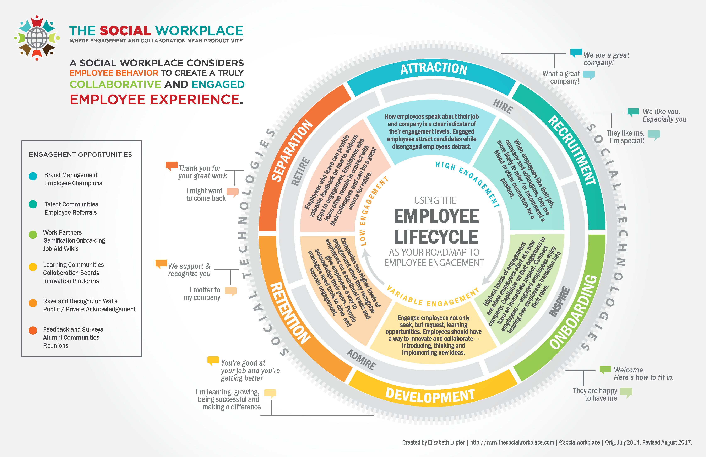
Figure 1: Employee Lifecycle (Source: thesocialworkplace.com, 2022)

