

Student Name: SARVAIYA ANSH RAKESHKUMAR

Student ID: 2544706

Module Name: HUMAN CAPITAL MANAGEMENT

Module Code: LCMB7023

Assignment Title: Designing a Human Capital Architecture for Strategic Renewal: A Strategic Human Capital Report for Helios Urban Mobility
Lecturer's Name: Gladius Kulothungan Eno Maycock

Word Count: 2,742 words (excluding Table of contents, Introduction, Tables, Figures, References)

Term 1
Table of Contents

Introduction 3
Task A: Socialisation, Identity and Business Activism 4
2.1 Traditional Onboarding versus Strategic Organisational Socialisation 4
2.2 The Helios Catalyst Framework: A Strategic Human Capital Architecture 5
2.3 Developing Organisational Identification 6
2.4 Promoting Ethical Professionalism 7
2.5 Developing a Business Activist Mindset 8
Task B: Strategic Job Design 9
3.1 Critical Evaluation of Contemporary Job Design 9
3.2 Strategic Job Design Proposal for Helios 10
3.3 Supporting Innovation and Intrinsic Motivation 11
Task C: Reflective Report 13
4.1 Reflecting on the Responsible Use of AI in Human Resource Decision-Making 13
4.2 Personal Capability Development Plan 14
Conclusion 16
References 17

Introduction
In today’s knowledge economy, sustainable competitive advantage is increasingly a function of people, not just technology. Technological innovation supports organisational growth, but it is employees’ knowledge, creativity, commitment and collaboration that ultimately determine organisational success. Hence, Human Capital Management (HCM) has transitioned from an administrative function to a strategic practice that aligns workforce skills with organisational goals and long-term success (Armstrong and Taylor, 2023).
Helios Urban Mobility (HUM) is a European smart transport start-up with operations across London, Berlin and Singapore, which exemplifies the challenges of rapid organisational growth. The organisation is seeing dwindling engagement (54%), an eight-month onboarding period for employees and increasing graduate attrition despite strong commercial expansion. These challenges imply that current people management practices are not sufficient to enable employee integration, engagement and capability development.
The report adopts the viewpoint of an external Strategic Human Capital Advisor proposing a human capital architecture for the strategic renewal of Helios. It outlines the limitations of traditional onboarding and strategic organizational socialisation, and introduces the Helios Catalyst Framework to build organisational identification, ethical professionalism and business activism. The report then suggests a strategic approach to the design of jobs so as to foster motivation and innovation, before ending with a reflection on the responsible use of Artificial Intelligence (AI) for decision-making in Human Resources and for the development of future professional careers.

Task A: Socialisation, Identity and Business Activism

2.1 Traditional Onboarding versus Strategic Organisational Socialisation
Employee integration is crucial for organisational performance, particularly in knowledge-intensive organisations where collaboration and innovation are key. Traditional onboarding is very much centred on administrative tasks, organisational policies and compliance. Although these activities are useful in preparing employees for operational readiness, they often fail to address the cultural, social and psychological factors needed for long-term commitment (Armstrong and Taylor, 2023).
This means that new employees may know what they are supposed to do, but still struggle to fit into the organizational culture and workplace expectations. This can lead to slower adjustment, lower engagement and greater turnover. “Traditional onboarding is not enough for Helios Urban Mobility, where employees take an average of eight months to reach full productivity and graduate attrition is rising.
A more effective approach is strategic organisational socialisation, which treats the integration of employees as an ongoing process of learning, relationship building and cultural adaptation. This allows employees to build better organisational commitment, while contributing more effectively to business goals (Boxall and Purcell, 2022). Although Van Maanen and Schein’s (1979) framework remains influential, it was developed in relatively stable organisational contexts. Continuous and adaptive socialisation is necessary in Helios and similar modern AI-driven organisations, as employees often move between projects, technologies and international teams. Thus, socialisation should be viewed as a persistent capacity-building process, not as a brief onboarding event.
To sum up, Helios is more appropriate for strategic organisational socialisation than traditional onboarding, because it offers structured learning, cultural integration and psychological support. This approach can reduce ramp-up time, increase engagement and improve employee retention, setting the stage for the proposed Helios Catalyst Framework.

2.2 The Helios Catalyst Framework: A Strategic Human Capital Architecture
Organisational challenges cannot be addressed by traditional onboarding alone. It familiarises staff with organisational processes, but does little to build commitment, cultural integration or long-term engagement. This report proposes the Helios Catalyst Framework, a strategic human capital approach to overcome these limitations, by accelerating employee integration while fostering collaboration, ethical behaviour and sustainable performance.
Unlike traditional onboarding programs that focus on the initial weeks of employment, the Helios Catalyst Framework supports employees throughout their first year. It recognises that commitment to the organisation is developed through ongoing learning, meaningful relationships at work and practical experience, reflecting the Human Capital Management perspective that employees are strategic assets that can create long-term competitive advantage (Armstrong and Taylor, 2023).
The framework consists of four stages: Discover, Connect, Contribute and Catalyst. Discover employees are provided pre-boarding resources and early engagement with their teams so realistic expectations can be set. Connect is about mentoring, cross functional networking and cultural integration. At Contribute, employees work together on projects, receive continuous feedback and develop competencies that are specific to their roles. Finally, Catalyst promotes innovation, ethical decisions and active role in organisational change.
Helios Catalyst Frameworks are structured development journeys that help reduce ramp-up time, increase engagement and improve retention. Ultimately it helps individual development as well as the long-term strategic goals of Helios, enabling employees to grow from new hires to dedicated members of the organisation.
Table 1: Helios Catalyst Framework: A Strategic Human Capital Architecture (Source: Developed by the me).
Stage | Timeline | Strategic Objective | Supporting Theory
Discover | Pre-boarding | Build realistic expectations and strengthen the psychological contract | Psychological Contract Theory
Connect | Day 1–30 | Develop cultural understanding and workplace relationships | Van Maanen & Schein (1979); Schein (2021)
Contribute | Day 31–90 | Build capability, confidence and collaboration | Human Capital Theory; Resource-Based View
Catalyst | Month 4–12 | Encourage innovation, organisational citizenship and business activism | Organisational Identification; Ulrich (2021)

2.3 Developing Organisational Identification
When employees see themselves as part of the organisation and identify with its values and objectives this is known as organisational identification. High levels of organisational identification are associated with higher levels of commitment, collaboration and likelihood of staying with the organisation. Helios Urban Mobility is experiencing a decline in employee engagement and an increase in graduate attrition, making the development of organisational identification vital.
Purpose-led integration is one of the key mechanisms, through which senior leaders communicate Helios’ mission, strategic objectives and contribution to sustainable urban mobility during induction. Grasping how individual roles contribute to organisational success helps employees to develop a stronger sense of purpose and belonging. This approach is supported by the theories of Organisational Identification, Identity Construction and Schein’s Organisational Culture model which emphasise the role of shared values in shaping employee behaviour.
Helios should also encourage cross-functional collaboration through innovation workshops, job shadowing, and team-based problem-solving during employees' first 90 days. These initiatives help newcomers build relationships and understand the wider organisation, supporting knowledge sharing and collaboration in line with Social Capital Theory and the Resource-Based View.
In addition, each newcomer should be assigned an operational buddy and a senior mentor to provide practical support, career guidance, and role clarity. A values-based recognition system should also reward behaviours such as collaboration, innovation, ethical conduct, and customer focus, reinforcing organisational culture and commitment.
Although these initiatives require investment, particularly in mentoring and recognition systems, they are expected to strengthen organisational commitment, reduce graduate attrition, shorten the eight-month ramp-up period, and improve employee engagement, supporting Helios' long-term strategic renewal.

2.4 Promoting Ethical Professionalism
Ethical professionalism extends beyond compliance with organisational policies by encouraging employees to demonstrate integrity, transparency, accountability, and fairness in their daily decisions. This is particularly important for Helios Urban Mobility, where employees work with artificial intelligence, customer data, and smart mobility infrastructure, making ethical decision-making essential for maintaining public trust.
Ethics should be embedded from the outset through ethics-focused induction within the Discover stage of the Helios Catalyst Framework. Training should cover organisational values, the code of conduct, responsible AI practices, data protection, and sustainability commitments. This reflects Schein's Organisational Culture model, which emphasises shared values as the foundation of ethical behaviour.
Ethical professionalism should also be reinforced through ethical leadership, with managers demonstrating integrity, transparency, fairness, and accountability in everyday decision-making. To sustain ethical awareness, Helios should provide regular ethics workshops, AI ethics simulations, and discussion forums that encourage employees to address emerging ethical challenges. Performance management should assess behaviours such as integrity, collaboration, responsible innovation, and stakeholder impact alongside operational performance, signalling that ethical conduct is integral to organisational success.
However, ethics training alone is insufficient. Ethical behaviour must be consistently reinforced through leadership, organisational culture, and fair reward systems. Embedding these practices within the Helios Catalyst Framework will strengthen employee trust, reduce ethical risks, enhance organisational reputation, and support sustainable innovation.

2.5 Developing a Business Activist Mindset
Developing employees as business activists encourages them to think beyond their individual roles and contribute to organisational and societal goals. Ulrich argues that employees and HR professionals should understand external business challenges, stakeholder expectations, and long-term value creation. For Helios Urban Mobility, this means enabling employees to support organisational performance while contributing to sustainable urban mobility and public value.
One approach is to introduce cross-functional innovation challenges involving employees from engineering, AI, analytics, and customer services. Collaborative problem-solving promotes knowledge sharing, creativity, and innovation, reflecting Ulrich's HR Business Partner perspective and the Resource-Based View, which identify employee knowledge as a source of competitive advantage.
Helios should also strengthen stakeholder engagement by involving employees in customer forums, sustainability initiatives, community projects, and partnerships with local authorities. These activities broaden employees' understanding of how their work affects customers and society, encouraging more responsible decision-making.
To encourage continuous improvement, Helios should establish employee voice mechanisms, including innovation platforms, suggestion schemes, and hackathons, allowing employees to contribute ideas and support organisational innovation. Participation in sustainability and ESG initiatives should also be encouraged to reinforce responsible business practices and align employees with the organisation's long-term objectives.
However, developing a business activist mindset requires ongoing leadership support, strategic communication, and employee empowerment. Organisations must also balance innovation with accountability to ensure initiatives contribute to long-term business goals. Collectively, these measures would strengthen organisational citizenship, enhance innovation capability, and create sustainable value for employees, customers, communities, and shareholders.

Task B: Strategic Job Design

3.1 Critical Evaluation of Contemporary Job Design
In knowledge-intensive organisations, job design has evolved beyond task allocation to become a strategic tool for improving employee engagement, innovation and organisational agility. Modern job design supports motivation, collaboration and continuous learning, making it particularly relevant for Helios Urban Mobility, where long onboarding periods, declining engagement and high graduate attrition highlight the need for more effective workforce practices (Armstrong and Taylor, 2023).
The Job Characteristics Model (JCM) by Hackman and Oldham (1976) argues that five job characteristics—skill variety, task identity, task significance, autonomy and feedback—enhance motivation and performance. Employees are more engaged when they find their work meaningful, have autonomy and receive regular feedback. For Helios, increasing autonomy, continuous feedback and opportunities for cross-functional collaboration could reduce the current eight-month ramp-up period while improving knowledge sharing and innovation. However, the JCM assumes managers design jobs and gives limited attention to employees' ability to shape their own roles. In a rapidly changing technology environment such as Helios, this limits flexibility and adaptability (Dessler, 2024).
Job Crafting Theory addresses this limitation by encouraging employees to proactively modify aspects of their work to better match their strengths and interests (Wrzesniewski and Dutton, 2001). Supporting job crafting would enable Helios employees to contribute more creatively across AI-enabled mobility projects. However, excessive autonomy may create role ambiguity and coordination challenges without effective managerial oversight. A skills-based architecture further enhances organisational agility by focusing on employees' transferable skills rather than fixed job descriptions. This enables organisations to deploy talent across projects, support continuous learning and respond quickly to changing business needs (Armstrong and Taylor, 2023). For Helios, this approach would strengthen career development and workforce flexibility, although implementation requires investment in skills mapping and learning systems.
Similarly, internal talent marketplaces use digital platforms to match employees with projects and development opportunities, improving knowledge sharing and retention (CIPD, 2024). While this could help Helios maximise internal talent across its global operations, success depends on accurate skills data, transparent governance and ethical AI practices to maintain employee trust (Stone et al., 2020). Overall, no single job design approach fully addresses Helios' challenges. Combining the Job Characteristics Model, Job Crafting Theory, skills-based architecture and internal talent marketplaces provides a more comprehensive strategy for improving engagement, accelerating capability development and supporting long-term organisational innovation (Boxall and Purcell, 2022).

3.2 Strategic Job Design Proposal for Helios
To address Helios Urban Mobility's challenges of prolonged ramp-up periods, low employee engagement and graduate attrition, this report proposes a strategic job design approach that combines the Job Characteristics Model, Job Crafting Theory, skills-based architecture and internal talent marketplaces. Rather than relying on fixed job descriptions, roles should be designed to promote flexibility, collaboration and continuous learning. Figure 1, presents the proposed Helios TalentFlow Framework, showing how contemporary job design practices combine to develop a more agile, innovative and capability-focused workforce
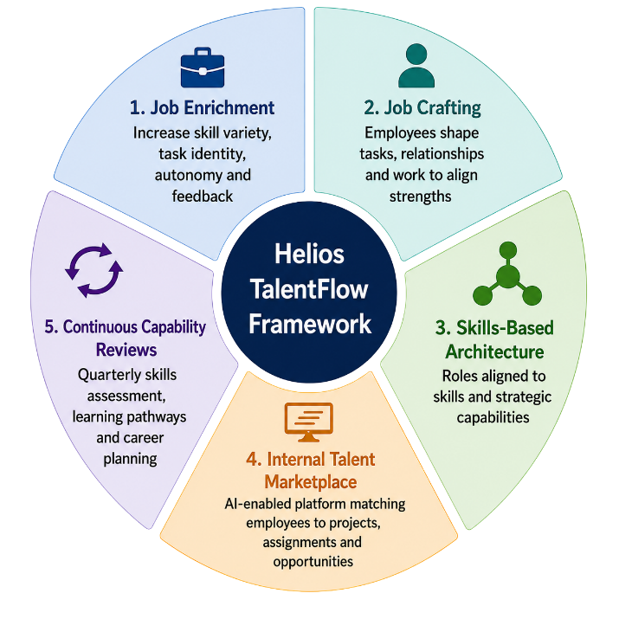
Figure 1: Helios TalentFlow Job Design Framework (Source: Hackman and Oldham (1976), Wrzesniewski and Dutton (2001), Armstrong and Taylor (2023))
Jobs should include greater autonomy, allowing employees to make decisions within defined responsibilities while encouraging ownership and accountability. Regular feedback through coaching sessions and performance check-ins should support faster learning and continuous improvement. Roles should also incorporate skill variety by enabling employees to contribute to cross-functional projects, broadening experience and strengthening organisational knowledge sharing.
Helios should further encourage job crafting, allowing employees to adapt aspects of their roles to match their strengths and career goals while maintaining alignment with organisational objectives. A skills-based approach would enable employees to move across projects based on their capabilities rather than job titles, supported by an internal talent marketplace that provides visibility of development and project opportunities.
However, successful implementation requires clear role expectations, manager support and transparent governance to balance flexibility with accountability. By adopting this integrated approach, Helios can improve employee engagement, reduce the current eight-month ramp-up period and develop a more agile workforce capable of supporting long-term organisational growth.

3.3 Supporting Innovation and Intrinsic Motivation
Innovation depends on employees who are motivated to learn, solve problems and contribute new ideas. Therefore, Helios should design jobs that encourage intrinsic motivation by providing meaningful work, autonomy, continuous learning and opportunities for collaboration.
Employees should participate in innovation projects, multidisciplinary teams and problem-solving workshops that expose them to different perspectives and business challenges. Regular coaching, constructive feedback and recognition of creative contributions can further strengthen motivation and confidence. Providing opportunities for learning and internal career mobility also encourages employees to develop new skills while supporting organisational agility.
These recommendations are supported by the Job Characteristics Model, which highlights the importance of autonomy, feedback and meaningful work in improving motivation (Hackman and Oldham, 1976), and Job Crafting Theory, which recognises employees as active contributors to their own development (Wrzesniewski and Dutton, 2001). The Resource-Based View further suggests that employee knowledge, creativity and collaboration represent valuable sources of sustainable competitive advantage.
Although innovation-focused job design requires investment in leadership support, learning opportunities and collaborative technologies, it can significantly improve engagement, knowledge sharing and organisational performance. For Helios, fostering intrinsic motivation and innovation will help accelerate employee development, strengthen retention and support sustainable competitive advantage.

Task C: Reflective Report

4.1 Reflecting on the Responsible Use of AI in Human Resource Decision-Making
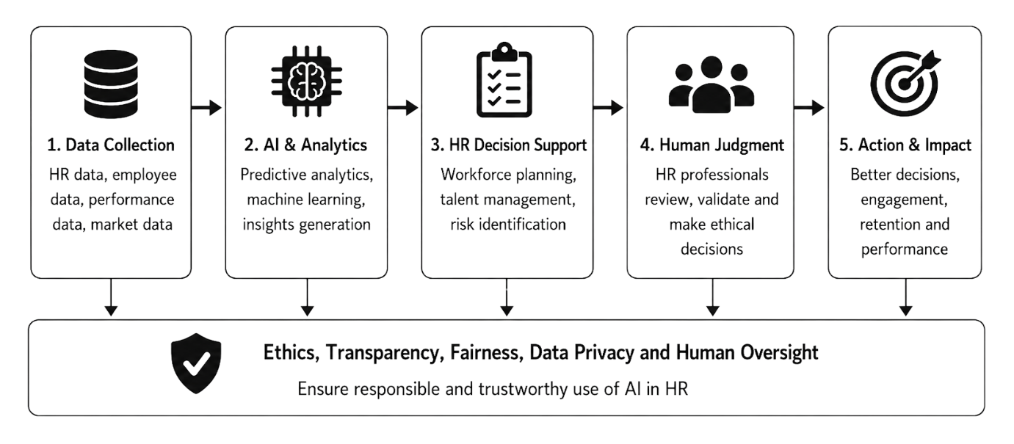
Artificial Intelligence (AI) has revolutionized Human Resource Management, enabling faster and data-driven decision-making. AI can analyze large datasets of employees more efficiently than traditional methods, from recruitment and workforce planning to performance management and talent development. As we have seen in this module, I found AI to be a useful decision support tool as it provides evidence-based insights which help HR professionals to make better decisions (Armstrong and Taylor, 2023). Figure 3 illustrates how Artificial Intelligence can support HR decision making while ensuring ethical judgement, transparency and accountability within human supervision during the decision-making process.
Figure 2 : AI-Supported HR Decision-Making Framework (Source: Created by me (Deloitte (2024) and CIPD (2024)))
When I think about the module I can see how AI can benefit HR. It can cut administrative tasks, enhance workforce planning, forecast employee turnover, detect skills gaps and aid talent management through HR analytics. Discussions on AI recruitment and workforce automation focused on how technology allows HR professionals to shift their focus from routine administration to strategic activities.
But I have also learned that AI has important limitations. AI systems trained on past data may contain bias and lead to unfair recruitment or promotion decisions. They may also fail to consider context, organisational culture and the circumstances of the individual employee. These limitations taught me that the ethical responsibility should always reside with HR professionals, not with technology. Human judgement is required to balance organisational objectives with fairness, transparency and employee wellbeing.
As a future HR professional, I would use AI to support, not replace, decision making. I would assess AI recommendations critically by balancing organizational objectives, employee needs and ethical implications before making decisions. This reflection has confirmed for me that successful HR practice is a blend of technological capability, professional judgment and emotional intelligence.

4.2 Personal Capability Development Plan
This module has also enabled me to recognize four skills that I need to develop in order to have a successful HR career.
First, I want to boost my data literacy by improving my skills of interpreting HR metrics, dashboards and workforce analytics. I would like to complete the HR Analytics training and continue to develop my Excel and Power BI skills using the CIPD learning resources.
Secondly, I will enhance my knowledge of AI in HR by studying AI recruitment, digital HR technologies and ethical AI through online certifications and practical workshops. This will help me to use new technologies responsibly.
Third, I want to develop my strategic influencing skills. Ulrich’s role as Strategic Partner reflects today’s expectations of modern HR professionals to advise senior leaders and contribute to business strategy. I will develop this skill through presentations, stakeholder engagement and consultancy-based projects. Finally, I will enhance my global mobility awareness by studying international HRM, cultural diversity and cross-cultural communication. I will complete international HR courses and analyse global case studies to help me manage diverse workforces effectively.
In general, this module has altered my perception of the future of HR. AI will continue to change HR practice, but technology cannot replace ethical judgement, strategic thinking or human relationships. Continued professional development will enable me to merge digital capability with responsible leadership and make an effective contribution to strategic Human Resource Management.

Conclusion
Helios Urban Mobility faces challenges such as long onboarding times, reduced employee engagement and increasing graduate attrition. This requires a strategic human capital approach and not piecemeal HR interventions. The integration of employee development, organisational culture and job design to develop workforce capability and support long-term organisational performance is involved in solving these problems.
This report recommends the adoption of strategic organizational socialization through the Helios Catalyst Framework which facilitates employees to transition from onboarding to long-term organizational commitment. It also implies a strategic design of jobs that encourages autonomy, collaboration, continuous learning and innovation. The report also points to the responsible use of Artificial Intelligence (AI) in HR as a decision-support tool that reinforces workforce planning and talent management, with ethical judgment at the core of all decisions.
Adoption of these recommendations would reduce Helios’ current eight month ramp-up period, increase employee engagement, improve organisational commitment and increase innovation capability. With smart people management, job design and responsible AI adoption, Helios has the opportunity to create a more agile, engaged and high-performing workforce. Ultimately these initiatives will underpin sustainable competitive advantage and contribute to the organisation’s long-term strategic renewal.

References
Armstrong, M. and Taylor, S. (2023) Armstrong's Handbook of Human Resource Management Practice. 16th edn. London: Kogan Page.
Ashforth, B.E. and Mael, F. (1989) ‘Social Identity Theory and the Organization’, Academy of Management Review, 14(1), pp. 20–39.
Boxall, P. and Purcell, J. (2022) Strategy and Human Resource Management. 5th edn. London: Palgrave Macmillan.
CIPD (2024) People Profession Survey 2024. London: Chartered Institute of Personnel and Development.
Coleman, J.S. (1988) ‘Social Capital in the Creation of Human Capital’, American Journal of Sociology, 94, pp. S95–S120.
Dessler, G. (2024) Human Resource Management. 17th edn. Harlow: Pearson.
Hackman, J.R. and Oldham, G.R. (1976) ‘Motivation through the Design of Work: Test of a Theory’, Organizational Behavior and Human Performance, 16(2), pp. 250–279.
Schein, E.H. (2021) Organizational Culture and Leadership. 6th edn. Hoboken, NJ: John Wiley & Sons.
Stone, D.L., Deadrick, D.L., Lukaszewski, K.M. and Johnson, R. (2020) Human Resource Management and Digitalisation. London: Routledge.
Ulrich, D., Schiemann, W., Sartain, L. and Younger, J. (2021) Reinventing the Organization: How Companies Can Deliver Radically Greater Value in Fast-Changing Markets. New York: McGraw-Hill.
Van Maanen, J. and Schein, E.H. (1979) ‘Toward a Theory of Organizational Socialization’, in Staw, B.M. (ed.) Research in Organizational Behavior. Vol. 1. Greenwich, CT: JAI Press, pp. 209–264.
Wrzesniewski, A. and Dutton, J.E. (2001) ‘Crafting a Job: Revisioning Employees as Active Crafters of Their Work’, Academy of Management Review, 26(2), pp. 179–201.
University of Wales Trinity Saint David (2026) LCMB7023 Human Capital Management: Week 1–4 Module Lecture Slides.
Wilkinson, A., Dundon, T., Donaghey, J. and Freeman, R.B. (2024) Contemporary Human Resource Management. 6th edn. Harlow: Pearson.

