Sheila Malloo - LUX* Belle Mare
ID No: 1715710
Course: DSAW4077
Date of submission: 12 November 2018

WORD COUNT FOR REFLECTIVE ESSAY: 2319
PERSONAL PROFILE

TABLE OF CONTENTS

CONTENTS |  |  |  | PAGE NUMBER
SECTION 1: REFLECTIVE ESSAY
1 | Introduction |  |  | 2
 | 1.1 | How to reach my goals? |  | 2
 | 1.2 | Personal reflective analysis |  | 2
2 | My Goals |  |  | 3
 | 2.1 | Share my knowledge and inspire confidence as a leader |  | 3
 |  | 2.1.1 | Learn the complexity of the Housekeeping team | 3
 |  | 2.1.2 | Ability to define and develop high potentials within the department | 4
 | 2.2 | Self-development to participate in higher level decision making |  | 4
 |  | 2.2.1 | Understanding service measures and metrics in the workplace. | 4
 |  | 2.2.2 | Understanding short term & long term business strategy | 5
 |  | 2.2.3 | Clear understanding of statistics and financial results | 5
3 | Conclusion |  |  | 6
 | References |  |  | 7
SECTION 2: APPENDIX
1 | Curriculum Vitea |  |  | 8
2 | Job Description |  |  | 14
3 | Training Needs Analysis |  |  | 20
4 | Personal Development Plan |  |  | 21
5 | Moments |  |  | 23
6 | Preference Type |  |  | 26
7 | Profile Report |  |  | 27
8 | Learning Style Questionnaire - Honey & Mumford |  |  | 28
9 | The VARK Questionnaire |  |  | 41

SECTION 1 REFLECTIVE ESSAY
1.0 INTRODUCTION
I have been promoted from Front Office Manager to Rooms Division Manager, a role which demands more responsibilities. Now it is crucial to step back and analyse my personal development growth, be productive in leading the team and long term decision making. This reflective thinking has helped me understand and analyse my learning needs. Neil Fleming, Myers Briggs, Honey and Mumford learning style and John Maxwell methods, have been excellent guidance for me to develop my skills, understand my needs and broaden my knowledge. My goals are two fold; (1) learn how to share my knowledge and inspire confidence as a leader and (2) develop myself to be able to participate in higher level decision making.
1.1 HOW TO REACH MY GOALS?
Being flexible and self-directed, my aim is to be able to share my knowledge with my peers and colleagues, so as they are more confident when dealing with challenging situations.
Self-confidence, optimism and positive reaction in the team will lead to genuine, warmth and pleasant working atmosphere throughout. Creating a pleasant working atmosphere with the team leads to a positive mind-set and a trusting work environment, as per Aubé C., Rousseau V., Brunelle E, Marques D., (2018). Empowering the team will allow me to focus on higher level decisions leading to improvement and innovation. While I aim to deepen my understanding of strategic thinking, I slowly need to move away from a purely operational to a mixed mind frame; have a global view of the hotel instead of focusing on one area. For that, I intend to devote time to researching and self-learning as a complement to this course.
1.2 PERSONAL REFLECTIVE ANALYSIS
A personal reflection on my career path is essential. Starting as a Receptionist in 2002, I was the only female who stood out to do night receptionist; this shift was being done by male only. After a year of night shift I was promoted to front office supervisor. I learnt how to deliver training, how to ensure procedures in place are duly respected and how to effectively handle guest’s situations which proved to be beneficial for my career growth. I was promoted to Assistant Guests Relation Manager in 2005.
In 2005 till 2007 my personal life changed drastically; married in 2005, 1st child in 2006 and 2nd child 2007. Within those 3 years, I realized my passion for my work, because there has not been a single day where my work has been an obstacle for my personal life.
I learnt how to deliver exceptional wedding experiences for the guests. This involves a lot of communication with the other departments. I also developed my marketing and financial skills.
In 2008, I was promoted to Guests Relation Manager until 2012. In 2008, I was faced with a personal dilemma which turned me into a more optimistic and positive person. My ability to understand people, read emotions and understand the unsaid has helped me analyze and take strategic decisions for the betterment of the team as well as guests. Refer to appendix 5 Company Moments, which is our company internal newspaper sharing accomplishments of the resort and the team members.
In 2012, I was promoted to Assistant Front Office Manager, and 2014 to Front Office Manager. This involved a new set of skills such as budgeting, empowering, training and decision making. I maintain consistency and stability within my department ensuring the best result is being delivered at all time. I enjoy being a mentor and grow the team, by confidently sharing my knowledge.
In November 2017, I was promoted to Rooms Division Manager, which entails much more responsibility and decision making, where I am also in charge of the Housekeeping department along with the Front Office Department.
2.0 MY GOALS
2.1 SHARE MY KNOWLEDGE AND INSPIRE CONFIDENCE AS A LEADER
Following my personal development plan, the below improvement areas were identified, along with the actions needed to close or reduce the latter.
    - Learn the complexity of the Housekeeping Team
Following the above self-analysis, I have come to the conclusion that I need to empower the Front Office team and expand my knowledge in the Housekeeping department with a better monitoring and planning system.
I have a strong Front Office background, however the same is not applicable for the Housekeeping department. Following my leadership assessment test from John Maxwell titled “Discovering Your Authentic Leadership Style”, according to Maxwell J. (2013), I am an Adaptor and I do recon that I have very strong communication skills, am a good influencer and work very well in group, giving everyone the opportunity to express themselves and helping people around me to feel valued. Refer to Appendix 7.
To guide and lead confidently in my role of Room Division Manager I need to improve communication with the Executive Housekeeper and shadow him. My Executive Housekeeper is a Theorist according to Honey P. & Mumford A. (1982) Learning style. He is methodical and structured.
I scheduled one to one meetings with the Executive Housekeeper on a weekly basis, where I seize the opportunity to assist him and the team, share information in a productive way. I put emphasis on his learning style when communicating. Specific goals and objectives with a time frame are set and reviewed weekly.
This has led to an open-communication and supportive environment. When I am faced with challenges, I can rely on one of my mentors, Raj Reedoy, General Manager of Salt of Palmar. As a previous Rooms Division Manager, Raj provides the guidance needed.
Our Financial Controller has also been of valuable help in providing with relevant financial information on the Rooms Division department which has helped to have a clear picture of where we stand.

    - Ability to define and develop high potentials within the department
To be able to define and give opportunity to grow the team, understand their training needs, provide assistance and learning opportunities, it is important for me to understand how to share my strength of self-motivation and find the right person to help me empowering the team.
My Quality Assurance Manager who following her Honey and Mumford learning style falls in both Reflector and Theorists, is actually the ideal person coaching me, so as I can develop my personal monitoring system.
We started by building up more on my strength, to confidently develop intrinsic motivation with managers and supervisors. I have worked on a presentation which is about positive attitude at work which I share with colleagues in order to develop intrinsic motivation. Refer to the PowerPoint presentation.
The team is motivated and we move forward pursuing common goals. To empower them, I started sharing the yearly and monthly budget, as well as guests’ satisfaction index with the Managers and Supervisors of the Front office team and the Executive Housekeeper as well as Housekeeping supervisors.
We have weekly overview and instead of putting my ideas upfront, I let the team open up and share their opinions which can eventually be put in place to attain our common target. We have open discussions and plans to achieve our objectives.
2.2 SELF-DEVELOPMENT TO PARTICIPATE IN HIGHER LEVEL DECISION MAKING
2.2.1 UNDERSTANDING SERVICE MEASURES AND METRICS IN THE WORKPLACE
To be able to lead confidently cost vs. revenue, guests satisfaction survey, team member survey, achievement of set targets, respect of deadlines.
I started by segregating my long term target into daily actions by involving the Front Office Manager and the Executive Housekeeper in decisions making and SMART actions. Once the ideas been jointly agreed and concluded, the ideas are being actioned daily to my subordinates. We monitor our performance in our weekly meeting, where we discuss about below points: Our achievement so far, challenges encountered and find constructive solutions.
Also planned to catch up once a week with the Maintenance Manager, where we focus on Room Prevention and have a structured rooms planning which is directly related to hotel room occupancy.
Should the team faced difficult situation, instead of jumping in and solving the issues, I ask them first what they think would be the ideal solution, I share my point of view and empower the team to take the appropriate solution.
If I see an area that I want to delegate to the managers and supervisors, I explain the importance of the task, I empower and give them the adequate tools to ensure that they have fully understood. I often inquire and asked open questions, rather than stepping in and doing it myself. For example: The Weekly Newsletter, Weekly report and follow up on daily guest’s requests and incident forms are now being performed by the supervisors and managers and I oversee the work.
To build up confidence within the Housekeeping Team I spend at least 1 hour on the floor in housekeeping, such as the laundry, rooms and guest areas, being curious and asking questions to the team. When I see eventual mistakes, I ask questions as if I am someone new that does not know how it works. Eventually I get the team to recognize and work on those mistakes to attain a desired level of satisfaction. Doing such, I get the team to redo the task, without feeling imposed and happily deliver a good work. I noticed that the team knows exactly their scope of work and often they choose to cut short on a few things. I eventually present to them the impact that this simple error can have on the guests and company.
2.2.2 UNDERSTANDING SHORT TERM & LONG TERM BUSINESS STRATEGY
As a Rooms Division Manager, it is also very important for me to have a deeper understanding of revenue statistics and learn to have long term planning to achieve set goals.
After having done my Myers Briggs personality test as per the Myers B. (1940) theory of psychological types, I acknowledge that I am eventually an “ENFP”, refer to Appendix 6. I am a person that does not like to have many bureaucratic structures and is not necessarily passionate about figures. However, it is very important to understand long term business strategy and to be able to fully grasp the hotel financial objectives and know successfully how to empower my team to achieve the set objectives.
I spent some time with our financial controller, to understand the figures and accounting principles: revenue is all that matters in the head of a financial controller. For me, I needed to find a balance between guest’s satisfactions, team members and ensuring budgets are met.
I have to explore and do research to be able to stimulate ideas for me to move from the ‘implementing’ to the ‘creating’. To be able to find this quality time; planning, delegating and empowering my subordinates is of a sense.
2.2.3 CLEAR UNDERSTANDING OF STATISTICS AND FINANCIAL RESULTS
To be revenue driven, also confidently submit financial budget, to be able to seize revenue opportunities and be fully aware of all operational cost involved in the process. Understand and fully grasp the hotel objectives and know successfully how to empower my team to achieve the objectives.
Expanding my knowledge in the Housekeeping department was my first step. Now I need to confidently propose long term solutions to enhance the budget of the company, with SMART actions and analysis.
I recognize that a business study course would be ideal for my personal growth. However, the next batch for Business Study will be by October 2019. In the meantime, our Financial Controller, Mr. Patrick Juliette who have been in the industry for more than 25 years is keen to be my mentor in helping me reach my goals.
We planned to spend more time together in analyzing our EBITA figures with the aim of putting in place relevant actions to push the EBITA upwards.
During my career path, I have grown through experiences and trials and errors. However, moving forward, I will have to be more cautious as it cannot be too much of trial and error. From my VARK study, according to Fleming & Mills, (1992), being an “AK learner” (Aural and Kinesis Strategies) I understood that my preferred learning is more of listening, talking, questioning and discussing, thus, spending quality time with the Financial Controller will give me a boost of confidence. Understand what has not work in the past, analyze different scenarios and focus on different strategies, contribute creative ideas to new project and build a trusting affiliation.
To start with, I learnt to analyze different revenue driven outlets and study them closely. Organize brainstorming sessions with my key managers and supervisors. Create a synergy between the Housekeeping and the Front office departments as well as the Maintenance team. Find innovative ways to enhance revenue and stimulate the Front Office Manager, Executive Housekeeper, Kids & Teens Club Manager and the team to adhere to the new process implemented.
Learn to assist and monitor the expenses and expenditures of all Rooms division department. Have a monthly review of overall performance and guidance to develop revenue opportunities and minimize costs.
For being a spontaneous person, I tend to have last minute actions, though this is also one of my strength being an “Activist” as per my Honey and Mumford personality test. However, being a bit more structured and creating my own system of monitoring will help me to be more productive.
3.0 CONCLUSION
To conclude, following all the attributions of my personal development plan, I am convinced to enhance my personal growth and be a great leader; contribute in value-added decision making for long and short term with senior management. If I am at this position today it is not solely because of my willpower. The people that surrounds me plays a crucial role; from my General Manager who is constantly pushing my limit to a very supporting team. While I continue to learn and grow, I will ensure that people grow along with me by sharing my knowledge.

REFERENCES
Aubé C., Rousseau V., Brunelle E, Marques D., (2018). Motivation and Emotion. The relevance of being “on the same page” to succeed as a project team: A moderated mediation model, Volume 42, Issue 6, pp 804–815.
Available from:https://link-springer-com.ezproxy.uwtsd.ac.uk/article/10.1007%2Fs11031-018-9706-2

Boud D., Docherty P. and Cressey P. (2006). Productive Reflection at work, Productive Reflection at Work. London: Routledge

Boyatzis R., PhD (2001). Unleashing the Power of Self-Directed Learning, Theory of Self Directed Learning Richard E. Boyatzis

Fleming and Mills, The VARK modalities, (1992)
Available from: http://vark-learn.com/introduction-to-vark/the-vark-modalities

Harvard Business Review Press, (2014). HBR Guide to Getting the Mentoring you need, Havard Business School Publishing Corporation, Boston, Massachusetts

Honey P. & Mumford A. (1982) Honey and Mumford learning style, Manual of Learning Styles London. Available from: https://www2.le.ac.uk/departments/doctoralcollege/training/eresources/teaching/theories/honey-mumford

Maxwell J., John Maxwell Leadership Assessment, (2013)
Available from: http://blog.johnmaxwell.com/blog/assess-yourself-l-by-david-hoyt-vp-of-the-john-maxwell-company

Myers B., Myers-Briggs Type Indicator, The Myers-Briggs Foundation, (accessed in 2017)
Available from: https://www.myersbriggs.org/my-mbti-personality-type/mbti-basics/home.htm?bhcp=1

SECTION 2 APPENDIX

1 CURRICULUM VITEA

PERSONAL DETAILS
SURNAME Malloo
NAME Marie Sheila
ADDRESS Dr. Edward Street, Curepipe
TELEPHONE Mobile: 59191739
Work: 4022000
E-MAIL sheila.malloo@luxbellemare.com
LANGUAGES Fluent in English and French

PROFILE Have an extensive experience of 20 years in the Hotel Industry. I have developed strong leadership capabilities and excellent organizational and time management skills. I am energetic with the ability to encourage the team to provide outstanding customer service and to lead by example. Always maintain a friendly, respectful attitude towards the guests and team members even when dealing with complaints or issues that create a stressful environment.
I have acquired analytical and communication skills, helping me in any complex situations with guests and team. Can easily deal with last minute changes and daily unforeseen situations to ensure smooth running of the operations.

EXPERIENCE
October 2017 Room Divisions Manager
Present LUX* Belle Mare – 5 Star Resort (174 Suites and 12 Villas)
luxresorts.com
Main Responsibilities
- Guest Experience: Timely, efficient & professional guest’s service, from pre- arrival to post – departure. Pursuing genuine high performance in all Guests Satisfaction Forum such as Trip Advisor, Guests Satisfaction Questionnaire and Expedia. Analyze the trend of guest satisfaction for the different departments and implement action plans.
- Oversee Front Office & Housekeeping Operations which comprise of 130 team members: Ensuring all service standards are followed, throughout all sub-departments. Also ensure that there is an excellent communication flow between other departments.
- Having worked closely with the team on daily operations we have achieved our yearly targets for year 2017/2018, which form part of our Key Performance Indicator ‘KPI’.
- Team management: Delegate operational tasks and ensure that the team achieves the desired results, through coaching and mentoring.
- Third party Liaison (entity or individuals delivering their own services within hotel premises), i.e Boat House Team, Diving Centre team, Suppliers, understand our principles and abide to our standards.
- Financial: Ensure budgets are met by putting in place relevant measures while at the same time focus on guest satisfaction.
- We have achieved our financial yearly budget by 96% and for year 2018/2019 I am looking forward to achieve above 100%.

October 2017 Front Office Manager
June 2014 LUX* Belle Mare – 5 Star Resort (174 Suites and 12 Villas)
Main Responsibilities
- Guest Experience: Ensure guests satisfaction during their stay and that guest feedback are followed, as well as all complaints being dealt in a timely manner. Encourage and sustain excellent standards of service.
- Front Office Operations which comprise of 30 team members: Oversee and lead the Front Office team which includes reservation, telephone operators, guest relations, concierge, porters, cashiers, night duty manager and the Front Office assistant. Ensuring that policies and standard are being maintain at all time.
- Team management: Train, Manage and support the Front office team and also involves in the recruitment process.
- Financial: Operate and manage the Front Office budget and ensure monthly budget is met. Controls the Front Office Department costs, including room amenities.
- Has achieved yearly Front Office Budget for 3 consecutive year 2014 - 2016 and also contributed in bringing the hotel to number 1 on Trip Advisor by ensuring that we all deliver excellent service to the guests.

June 2014 Assistant Front Office Manager
September 2012 LUX* Belle Mare – 5 Star Resort (174 Suites and 12 Villas)
Main Responsibilities
- Overview Daily Operations: Maintaining the Operational Standards and coordinating work schedule for the Front Office department.
- Address Guest Concerns and Provide Customer Satisfaction: Tackle guest complaints and concerns in a timely and professional manner.
- Train and Lead team: Provide necessary training to all team members working in front desk operations. Also explain all hotel policies and price of different points of sale to front office team, for example: Room Upsell, Food & Beverage special evenings and spa promotions.
- Recognize as a Course Leader for the hotel by Ron Kaufman, year 2012: Has developed my ability to communicate and deliver better training. Conduct numerous ‘Course 100’ sessions for 300+ team members.
- Recognize as a certified trainer in customer care by MQA (Mauritius Qualification Award).

September 2012 Guest Relations Manager
March 2008 LUX* Belle Mare – 5 Star Resort (174 Suites and 12 Villas)
Main Responsibilities
- Guest Experience: Deliver excellent guest service experience.
- Guests Satisfaction: Front analysis of customer feedback and providing strategic direction to continuously improve overall rating. Also respond to guests’ needs and anticipating their unstated ones.
- Manage the Guest Relation Team and the Front office team in the absence of the Front office Manager: Manage the team (including Receptionists, and Wedding coordinator) to ensure we comply with the hotel set standards and procedures.
- Was congratulated by the CEO for being actively involved in the group rebranding and was also chosen to be a trainer, to share the new concept. I was also chosen to join the leading team in the grand launching of the rebranding which happen in a sister hotel called LUX Le Morne. I assisted in planning the day for the VIP’s (Very important person) in regards to excursions and restaurant booking. Also coordinate flawless massive arrivals for the launching, above 70 rooms on VIP level.
- Has received the best attendance certificate award year 2008 and year 2010. For I have always been hard working and lead by examples.

March 2008 Assistant Guest Relations Manager
February 2005 LUX* Belle Mare – 5 Star Resort (174 Suites and 12 Villas)
Main Responsibilities
- Overview Daily Operation: Maintaining and coordinating work schedule for the Guest Relations and Front Office department.
- Train and Lead team: Assist the Guest Relations Manager in day to day operations and train the Guest Relation Officers.
- Conduct Wedding: Organize wedding in partnership with the Food and Beverage Department ensuring flawless events.
- Has received outstanding service award year 2007, as my name appeared several times on different forum by guests.

February 2005 Front Office Supervisor
February 2004 LUX* Belle Mare – 5 Star Resort (174 Suites and 12 Villas)
Main Responsibilities
- Supervise Front Office Operations: Plan and supervise the work schedule for the team. Prepare operational and financial records for the Manager to review.
- Handling Guests Request: Exceed guest satisfaction by providing excellent service. Also respond to all guests concern, complain, request in a professional and timely manner.
- Train and lead: Train new receptionist and being passionate in explaining the workloads. Has been chosen to follow training courses and been certified as a Skills Trainer by our Training Academy.

February 2004 Receptionist
September 2002 LUX* Belle Mare – 5 Star Resort (174 Suites and 12 Villas)
Main Responsibilities
- Cashiering: Preparing bills, taking payments, exchange foreign currencies and City Ledger completion. Ensure that guests dossier and bills are well kept and handy whenever needed by authorized team.
- Check In and Check Out: Assist guests upon arrivals and departures as per standard and extend a warm approach.
- Has been mentioned few times by guests on guest’s satisfaction survey as one the best employer and also received a certificate for same by our General Manager.
- Has got best attendance certificate award.

June 2002 Supervisor
October 2000 KFC, Kent, Blue Water Shopping Mall, England
Main Responsibilities:
- Taking Order and Cashiering: Responsible of cashiering tills, taking food order and take payment accordingly, respecting the HACCP standard put in place.
- Assign Front Stock: Ensuring that Front team has their stock and do inventory accordingly.
- Being very dedicated and always helping, within 3 months was given the post of supervisor.
- Has won several HACCP (Hazard Analysis Critical Control Points) reward of service from mystery inspections.

September 2000 Receptionist
January 1997 Blue Lagoon Hotel
Main Responsibilities
- Room Allocation: On top of main duties of receptionist, cashiering, check in and check out, was also doing room allocations.
- Night Audit: Work a 24 hours schedule, perform night audit and hand over cash float and balance sheet to account department.
- Was awarded employee of the year 1999 and also in 1999 was retitled senior receptionist.

EDUCATION

2000 - 2001 Advanced Diploma in Hotel Management

Confederation Tourism Hotel Catering Management

West London College, England

2000 – 2001 Food Production – National Vocational Qualification level 2

Thames Valley University, England

May 1996 National Trade Certificate level 3 Front Office & Housekeeping Hotel School of Mauritius

November 1994 School Certificate

Hamilton College, Mauritius

TRAININGS
2018 Living our Values, White & White Associates
2017 Operational Finance for Non-Finance Manager, Open Mind Consulting
2016 First Aid Course, St John Ambulance
2014 John Maxwell Courses, The John Maxwell Company, 2014
2014 Leading your company, leading your workforce by Tom Peters, National Productivity and Competitiveness Council
2013 Focus Recruitment Skills, Alentaris consulting

SKILLS Microsoft Office, Fidelio & Opera

INTERESTS Travel & Cinema

REFEREES 1. Pascal Bertrand
General Manager, Body Holiday, Saint Lucia

2. Ashish Modak

General Manager, LUX* Belle Mare

2 JOB DESCRIPTION

JOB POSITION: Rooms Division Manager
REPORT TO: General Manager
RESPONSIBLE FOR: To plan, implement, organise and coordinate operations in Front Office and Housekeeping Departments; as well as liaising with the Executive Housekeeper to ascertain readiness of rooms for accommodation, and work with all Departments to ensure high standard of service to Guests and focusing on meeting budget set.
KEY RELATIONSHIPS: 1. Central Reservation Office and Head office
2. Front Office & Housekeeping Department
3. Accounting Department
4. Human Resources Department
BASE OF WORK: LUX* Belle Mare Hotel, coastal road Belle Mare Mauritius. Off-site meetings across the island.

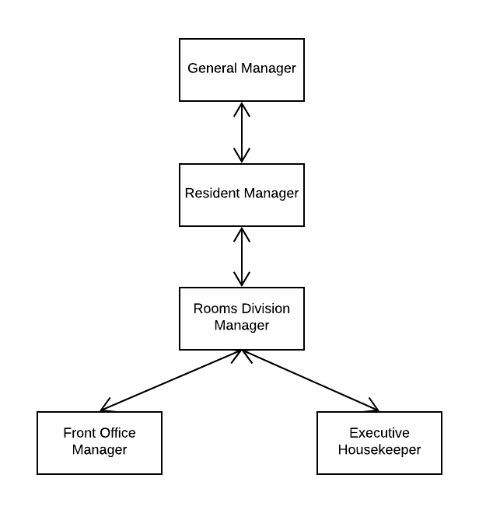

Figure
Figure 1 – Organisational Chart

VISION
We make each moment matter
PURPOSE
Helping people celebrate life
VALUES
- People – Consideration for People
- Passion – Serving with Passion
- Integrity – Insistence on Integrity
- Leadership – Responsibility of Leadership
- Creativity – Entertaining with Creativity

SKILLS REQUIRED
The Room Division Manager should showcase: leadership, integrity, good manners, self-initiative and apt to handle complaints and difficult situations.
RESPONSIBILITIES
- Assist the Front Office Manager, Guest Relations Manager and the Executive Housekeeper in leading the operations.
- Front office team comprises of 35 members including guest relations officers and receptionists, telephone operators, concierge, porter and reservations clerk.
- The Housekeeping department which comprise of approximately 85 team, including Public area attendant and Laundry team.
- Responsible of monitoring room allocation, training and interviewing new members of staff.
- Dealing with customer complaints that have been escalated from more junior team members.
- Close collaboration with the room department to ensure that guests’ expectations are met.
- Assist and lead the Kids Club Manager and team, which comprises of 15 persons. Ensure that standard are being respected by the Kids Club team and the Teens Club team in the day to day operation.
- Chair meetings daily with other departments, to discuss about the arrivals and departures of the following day, ensuring that the guests preferences has been met and that guests are satisfied throughout the stay. Plan for upselling.

GENERIC ACTIVITIES
Customer Service
- Actively anticipate guest’s needs and ensure all customer service touchpoints are fully implemented on the day to day operations.
- Converses with guests, whenever possible, to obtain feedback and suggestions for improvement.
- Dealing with guests’ complaint ensuring that we turn same to a constructive feedback and turn an unhappy guest to a delighted guest.
- Ensure that we have excellent feedback on all social media platforms. Analyse and communicate corrective actions
- Personally replying (within 48hours) effectively to any comments / concerns mentioned on those forums

SOP Compliance and Quality Assurance
- Conduct frequent quality spot-checks within the Front Office and Housekeeping Departments assets, ensuring that standard put in place by the safety regulations and quality department are being duly followed.
- Ensure that high quality standards are maintained, with regards to courtesy and service quality.
- Efficiently implement all SOP(s) and ascertains their professional execution.
- Inspect rooms on a daily basis

Promotion & Direct Up-selling
- Provide relevant information about the hotel, conduct visits and promote the hotel to Educational Tours and visitors by confidently sharing the product knowledge.
- Participate in the negotiations between the Resident Manager and Sales & Marketing Manager
- Create a room upgrading/upselling scheme at the resort level to generate additional revenue and increase average daily rate (ADR)
- Implement up-selling tactics among the Front Office team to enhance hotel and restaurants overall revenue

Team Management
- Conduct interviews and orientation, and advise the General Manager on the selection, induction and recruitment of employees, working closely with the Human Resource Department.
- Conduct regular meetings with Senior Management to brainstorm on solutions.
- On a regular basis sit down with the team for a debrief on their performance; conduct the performance evaluation of subordinates and complete performance appraisal report in accordance with Human Resources Policy and Guidelines.
- Act as Duty Manager whenever schedule by the Human Resource Manager. Oversee the hotel operations, do walk around in back area, as well as front of house. Do some spot check for example; food temperature on buffet / cold room temperature.
- Organise and facilitate on-the-job training and coaching sessions for trainees and team members in order to develop their knowledge and competencies.
- Ensure that all departments are well covered by verifying the duly filled monthly roster of the Front Office Supervisors / Manager and Housekeeping Supervisors / Manager and ensure adequate coverage before approving their roster.

Continuous Improvement
- Create a trusting work environment to encourage creativity and team work by listening to team concern and assist them in difficult situation. Lead by example and have an open door policy. Be open minded when receiving feedback and have an optimistic approach.
- Learn from personal and professional mistakes, to create a path to improvement by taking personal responsibility. Strive to do better on the field that is not flourishing and motivate others to use the same path. Take time to reflect on current situations instead of rushing into hasty decisions.
- Anticipate and adapt service sequence based on guests and team interactions
- Be flexible and open to change
- Be able to accept differences and move on

Administration
- Be Responsible for the Rooms Division Budget achievement
- Analyze and implement actions to achieve set revenue budget. Monitor monthly results compared to target/budget.
- Work closely with Financial Controller and Hotel General Manager to determine the overall financial performance budget
- Assist in any administrative work as requested by the General Manager.
- Prepare monthly and year-end reports for submission requested by the General Manager

Training/Development
- Attend Leadership Meetings and other meetings as required
- Undertake training as required, whether identified by self or others
- Vocational and professional studies are encouraged and individual learning styles are recognised and taken into account

Health and Safety
- Unsure that all procedures put in place are in accordance with health and safety regulations and the standard of procedures of the group.
- Work environment is safe and in compliance with the health and safety regulations.

Equal Opportunities
- Work in transparency with colleagues and team members.
- Create a safe working environment where team members feel valued, recognized and challenged to develop their skill sets and qualifications.
- Have a fair and transparent employment practices within the entire employer-employee relationship.

Internal/External Communication
- Liaise with the Central Reservation Office concerning reservation issues.
- Liaise with the Front Office Manager or Assistant Front Office Manager to ensure all correct payments by guests.
- Represent the Hotel in meetings/seminars or any other events linked to Room Division issues, when required

This is not exhaustive and may change to meet the needs of the group
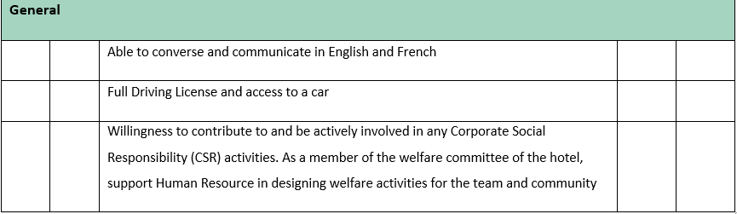
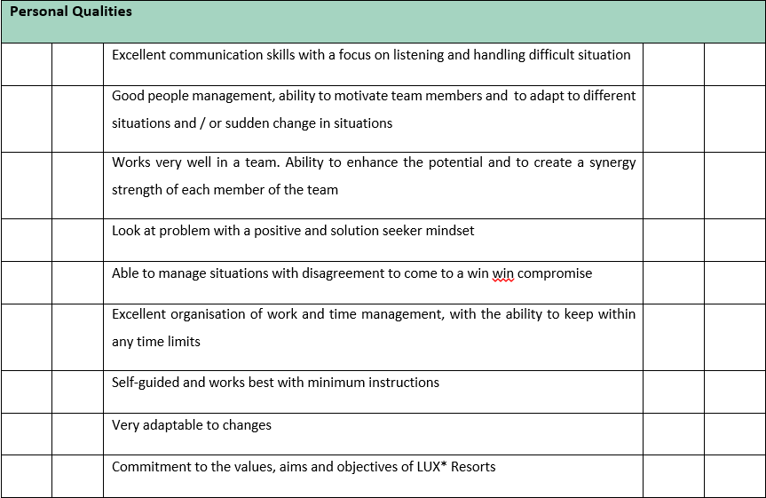
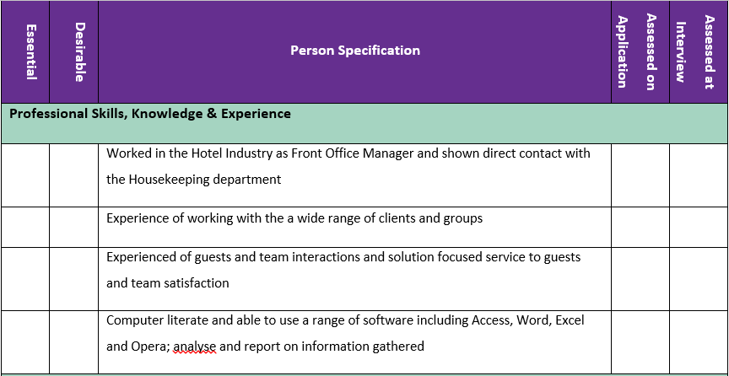

Figure 2: Person Specification Form

3 TRAINING NEEDS ANALYSIS

3 TRAINING NEED ANALYSIS

TRAINING NEEDS ANALYSIS
WHAT AM I GOOD AT? | WHAT DO I NEED TO WORK ON?
Good communication skills - present well and talk well with others. Able to deliver clear message to the team and to the guests | Setting clear boundaries for myself and others - communication with Impact
Flexible and adapt easily in different situation - Evaluate situation and adjust style to work well with others. Quick to devote my skills wherever needed to get job done | Build up more Self-confidence - Tend to underestimate myself - Increase assertiveness
Strong on standards in my day to day work | Strategic Vision - Proactive and establish plan of work. To be able to set SMART objectives for myself and my team
Good empathy - helps me to connect well and understand guest's feelings as well as my team | Being more formal when formality is needed and be naturally organised
Good knowledge of the actual browser use by the company, called Opera system which is an updated version of Fidelio | Be more Innovative
Stress Management - can easily absorb pressure and turn same into productivity | To be more result driven - better understanding of financial results

Good self-discipline - autonomous in my work
WHAT COULD HELP ME ALONG? | WHAT MIGHT STOP ME?
Coaching by a highly structured and formal line Manager | Personal Commitment
Training on strategic Planning & Organisational Skills | Unavailability of Mentors or conflicting schedule
IT Knowledge & skills | Unforeseen situations out of myr control

4 PERSONAL DEVELOPMENT PLAN

DEVELOPMENT NEEDS IDENTIFIED | DEVELOPMENT OBJECTIVES | METHOD | BY WHOM | BY WHEN | REVIEW
Understanding short term & long term business strategy | To be able to fully grasp the hotel objectives and know successfully how to empower my team to achieve the objectives | Coaching by our Financial Controller and our Resident Manager | Patrick Juliette Antoine Chignac | Starting 1st of October for 6 months. | 1st review: 31st October 2018  Monthly reviews  Last review: April 2019
Learn the complexity of the Housekeeping Team | To be able to guide and lead confidently in my current role as Room Division Manager and to be innovative. | Shadowing the Executive Housekeeper and Coaching by my Mentor who has strong Housekeeping back ground | Umesh Seechurn and Raj Reedoy | Starting on the 24th of October and ongoing for 6 month | Beginning of January 2019 with an overview by the General Manager – Final review March 2019
Clear understanding of statistics and financial results. | To be revenue driven and to be able to seize revenue opportunities.  To be fully aware of all operational cost involved in the process  To better decision making process. To be able to submit a yearly financial budget for my department for financial year 2020 | To participate on the next ESSEC Training given by the company. In the meanwhile, been coached on the Job by our Financial Controller in monthly revenue meeting | Smita Modak for ESSEC Course. Patrick Julliette for coaching | Starting 01st October and ending February 2019.  For ESSEC to participate on Batch starting November 2019 | 1st review on 31st October and 2nd review end of February 2019
Understanding Service Measures and Metrics in the workplace | To be able to lead confidently cost vs. revenue, guests satisfaction survey, team member survey, achievement of set targets, respect of deadlines | Shadow and coaching by Quality Assurance Manager and Resident Manager | Tivani Udaiyan and Antoine Chignac | Starting 1st December 2018 for 3 month | 1st review on 1st January and last review End February 2019
Ability to define and develop high potential within the department | To be able to define and give opportunity to grow the team: understand their training needs, provide assistance and learning opportunities.  To assess team on a regular basis and plan for their growth | Shadow and coaching by Quality Assurance Manager | Tivani Udaiyan | Starting on 01st November 2018 for 3 month – then ongoing process | Review end of February 2019 – Ongoing process

5 MOMENTS
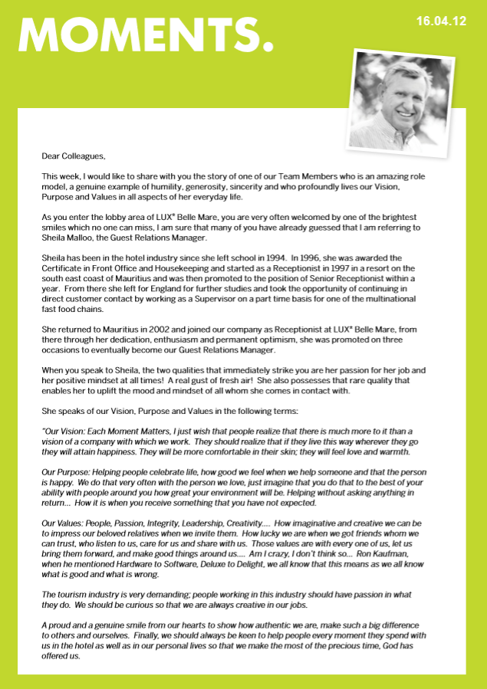

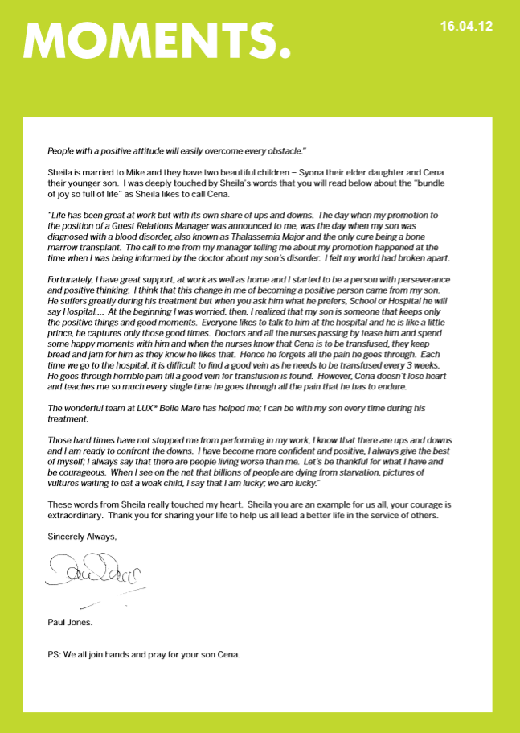

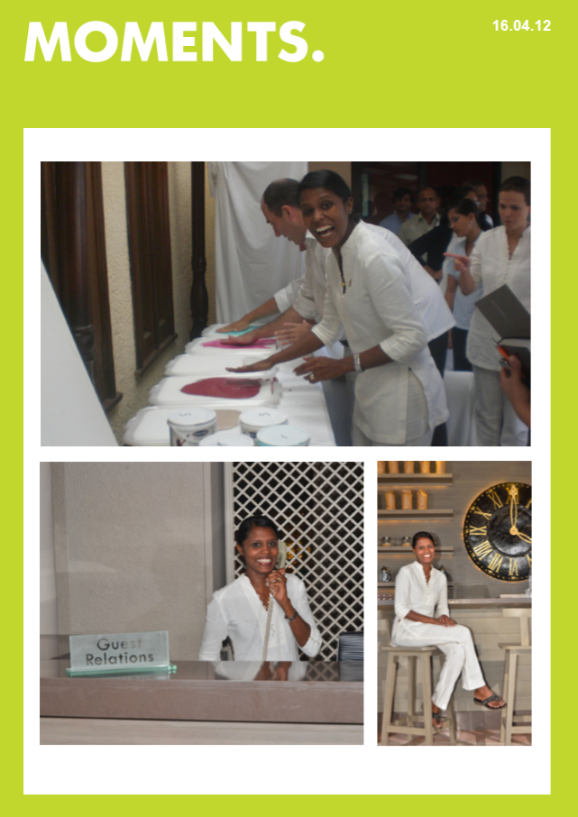

6 PREFERENCE TYPE

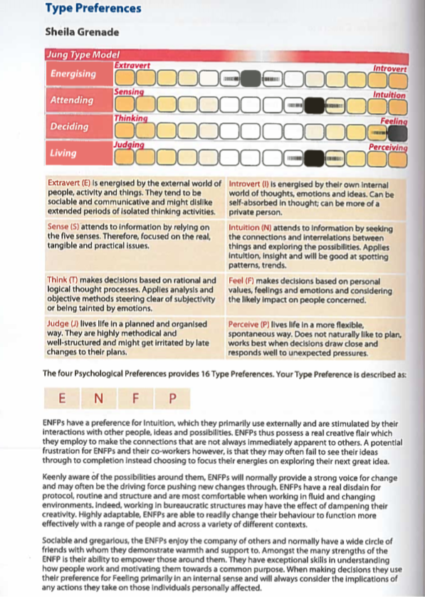

7 PROFILE REPORT
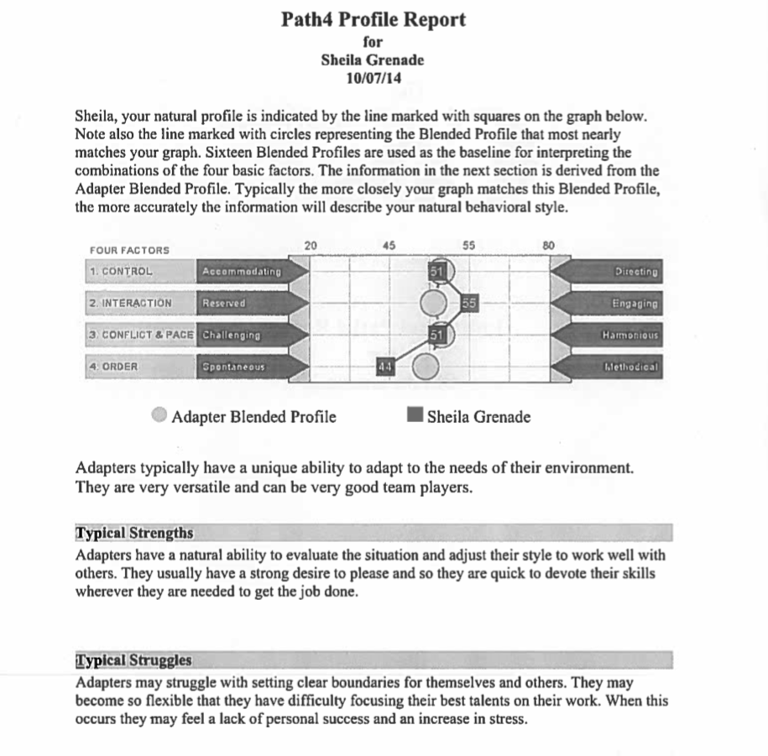

8 LEARNING STYLE QUESTIONNAIRE – HONEY & MUMFORD

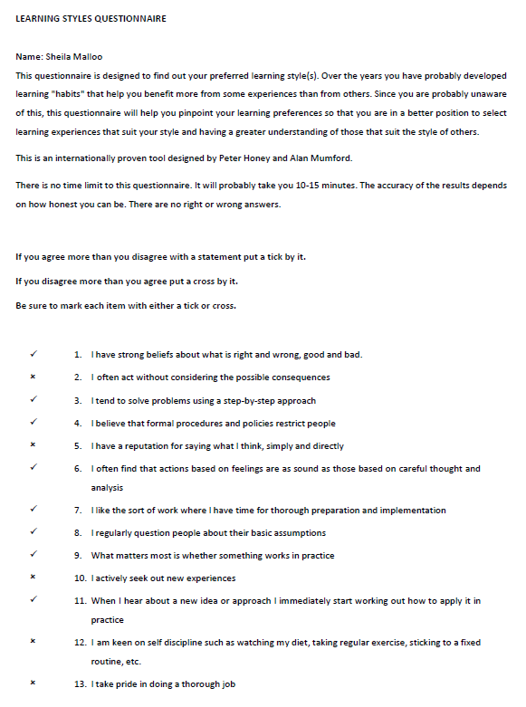

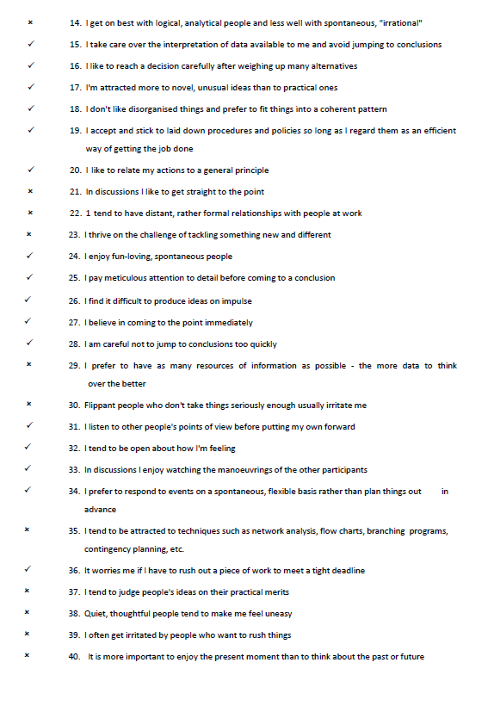
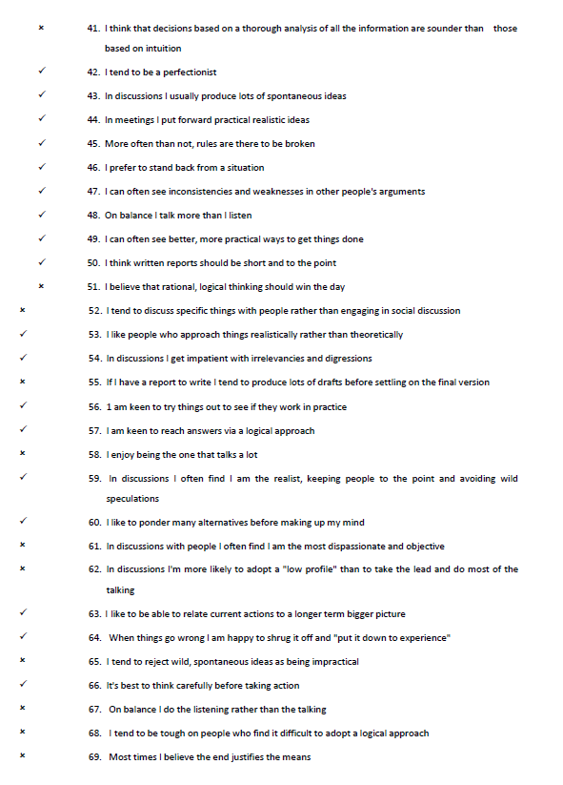

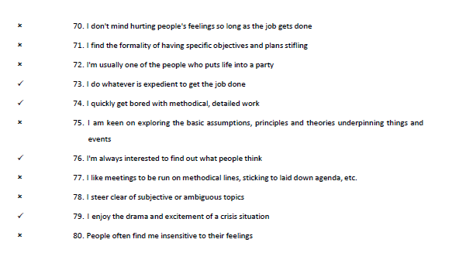

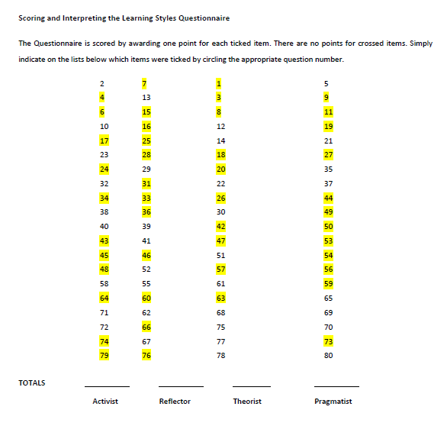

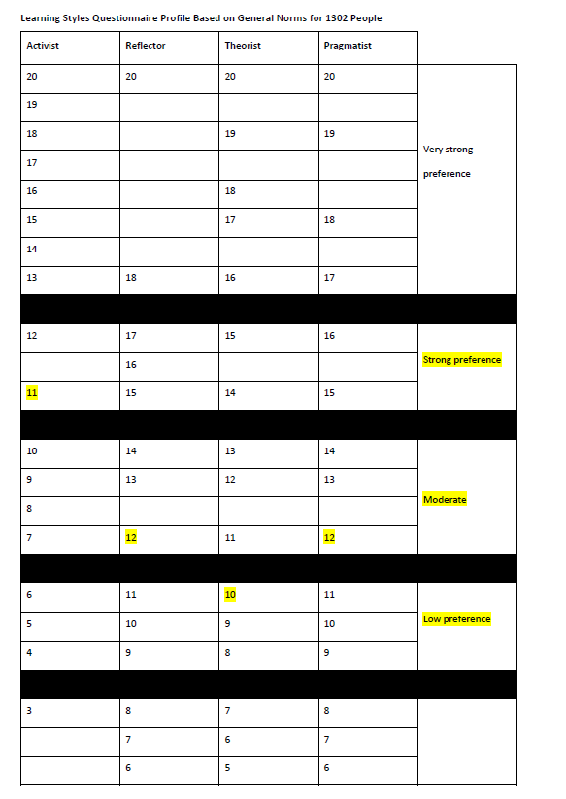
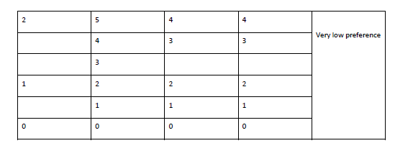
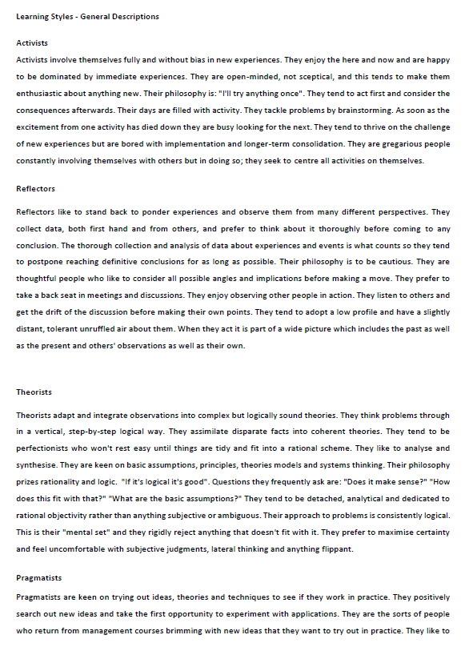
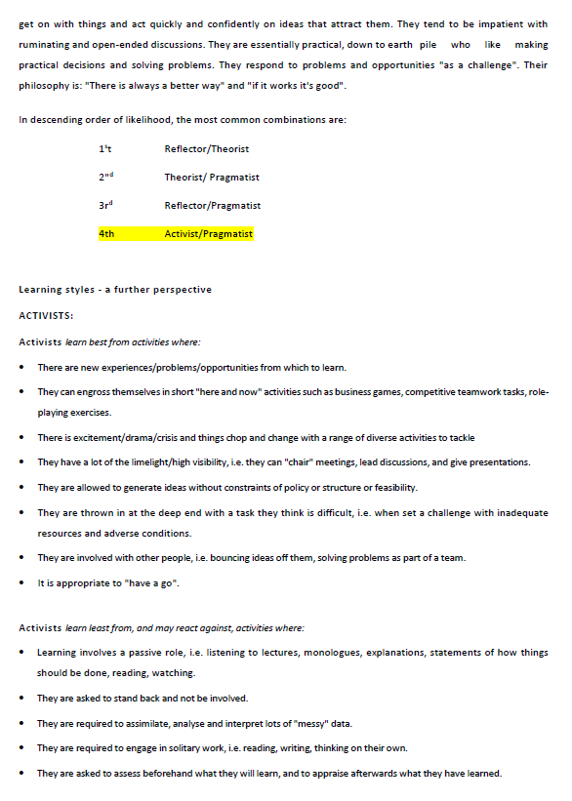
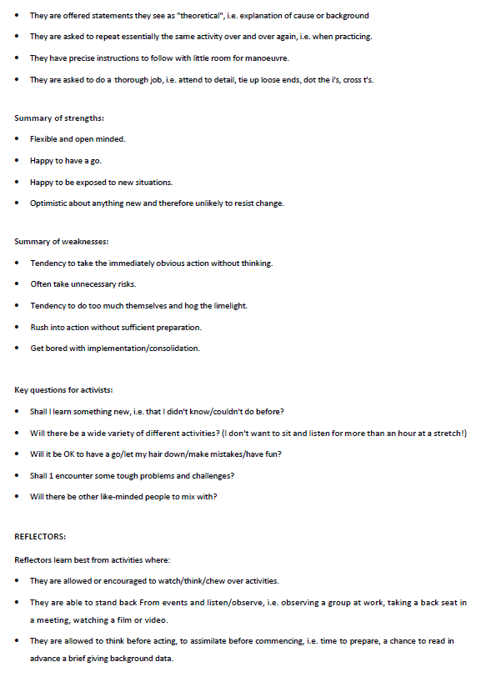
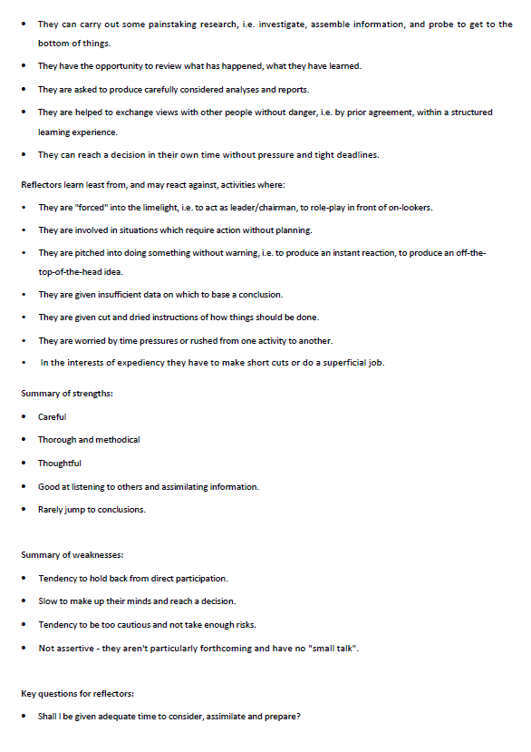
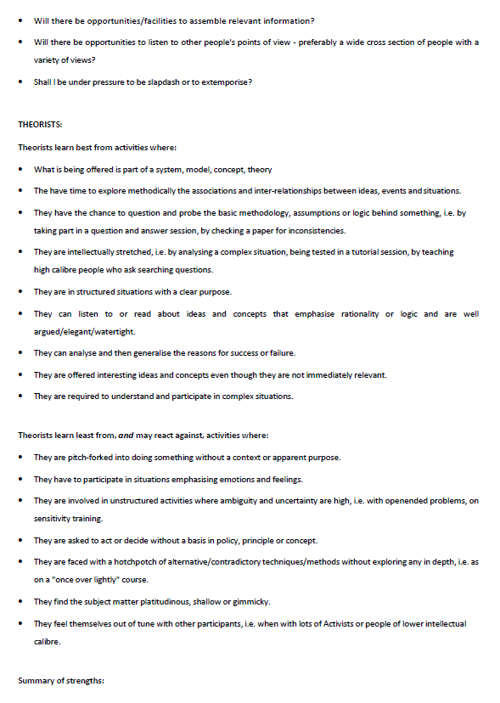
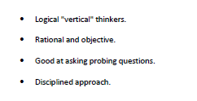
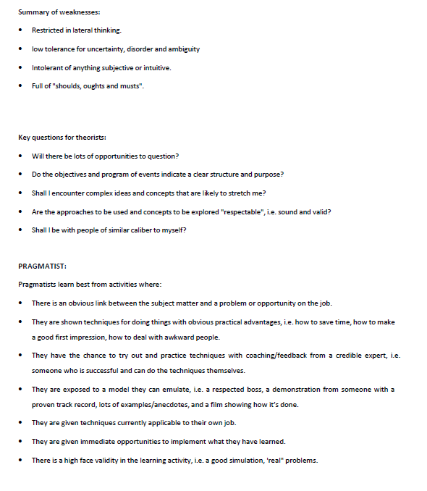
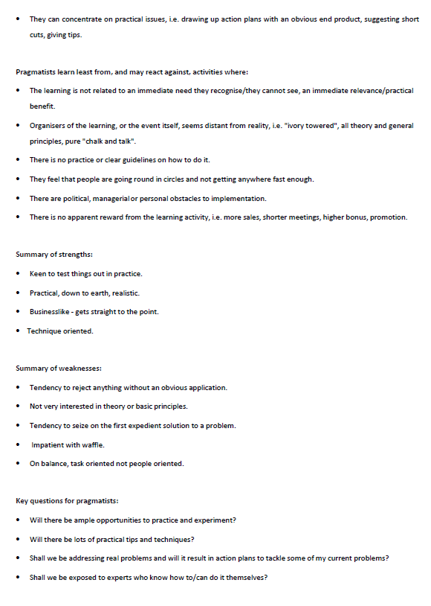

9 THE VARK QUESTIONNAIRE



