

‘’Perceptions of Police Officers and Staff on the Impact of Neighbourhood Policing on Crime Rates"

Steven Waterfield 2031232
UWTSD Swansea
Police Constable Degree Apprenticeship
Due Date: 8th April 2024
Word Count: 7887

Declaration
This work has not previously been accepted in substance for any degree and is not being concurrently submitted in candidature for any degree.
Signed: 
Date: 08/04/2024
Statement 1:
This dissertation is being submitted in partial fulfilment of the requirements for the degree of BA.
Signed:
Date: 08/04/2024
Statement 2:
This dissertation is the result of my own independent work/investigation, except where otherwise stated.
Other sources are acknowledged by footnotes giving explicit references. A bibliography is appended.
Signed:
Date: 08/04/2024
Statement 3:
I hereby give consent for my dissertation, if accepted, to be available for photocopying and for interlibrary loan, and for the title and summary to be made available to outside organisations.
Signed:
Date: 08/04/2024

Statement 4:
I hereby give consent for my dissertation, if accepted, to be available on the university’s IT system to those who have consent to use the system.
Signed:
Date: 08/04/2024

Acknowledgements

I would like to acknowledge the support provided by South Wales Police and the training team throughout my three years of study.

I would particularly like to thank my supervisor Fay Cosgrove for her support and guidance throughout this dissertation process.

Finally, I would like to thank my family and friends for their endless support and patience throughout my three years of academic studies.

Abstract
The aim of this study is to assist in gaining a deeper understanding of Neighbourhood Policing and its impact on crime rates as well as the challenges that the Policing model faces. This will be achieved by gathering information directly from the officers and staff who are intrusted to deliver the Policing method. By gaining the perceptions from officers and staff it is believed that this study will further contribute with recommendations on how Neighbourhood Policing can improve its impact.
This study will discuss the history and foundations of Neighbourhood Policing as well as the supporting theories and policing techniques which are widely used by Neighbourhood Policing teams around the world. To support these theories, select case studies will be detailed as examples of successful Neighbourhood Policing projects. Historic research into the impact of Neighbourhood Policing on crime rates will be discussed to further expand on the impact of Neighbourhood Policing.
The findings in this study will be analysed using a thematic analysis to identify any recurring themes or ideas, which will highlight the perceptions on the impact which Neighbourhood Policing has.
Following its completion, the study will look to detail recommendations on how to Improve Neighbourhood Polcing and discuss the perspectives from participating Officers and Staff members.

Contents

Chapter 1: Introduction Page 10-11
  - Background
1.2 Research Rationale
1.3 Aims and Objectives
1.4 Structure
1.5 Conclusion

Chapter 2: Literature Review Page 12-19
2.1 Introduction
2.2 Foundations of Neighbourhood Policing
2.3 Neighbourhood Policing Strategies and Theories
2.4 Factors Influencing Neighbourhood Policing
2.5 Previous Studies on Neighbourhood Policing
2.6 Conclusion

Chapter 3: Research Methodology Page 20-22
3.1 Introduction
3.2 Research Approach
3.3 Data Collection
3.4 Sampling Strategy
3.5 Data Analysis
3.6 Ethical Considerations
3.7 Research Limitations
3.8 Conclusion
Chapter 4: Results and Data Analysis Page 23-32
4.1 Introduction
4.2 Data Preparation
4.3 Themes Identified from Data
4.3a Crime rates are positively impacted by Neighbourhood Policing and Neighbourhood Policing is seen as a positive tool utilised by Police Services.
4.3b The perceived objectives of Neighbourhood Policing are to reduce crime, increase community engagement, develop intelligence and be a visible presence within a community.
4.3c The perception is that Neighbourhood Policing is effective at reducing Anti-Social Behaviour, Thefts and Drug Related Offences.
4.3d Neighbourhood Policing is servery impacted by a lack of resources.
4.3e Police Community Support Officers can be better utilised and should be supported to expand their role.
4.4 Data produced from the Survey to support Neighbourhood Policing’s impact on crime rates.
4.5 Conclusion

Chapter 5: Conclusion Page 33-34

Chapter 6: Recommendations Page 35-36
6.1a Increase the powers held by Police Community Support Officers
6.1b Investment in Resources
6.1c Increase the number of high visibility patrols
6.2 Conclusion

Chapter 7: References Page 37-43

Chapter 8: Appendices Page 44-80
8.1 Appendix 1: Copy of Survey.
8.2 Appendix 2: Copy of Ethics Form.
8.3 Appendix 3: Copy of Propossal Form.
8.4 Appendix 4: Survey Results / Answers.
8.5 Appendix 5: Responses to Question 4.
8.6 Appendix 6: Responses to Question 6.
8.7 Appendix 7: Responses to Question 7.
8.8 Appendix 8: Responses to Question 8.
8.9 Appendix 9: Responses to Question 9.
8.10 Appendix 10: Responses to Question 10.
8.11 Appendix 11: Responses to Question 11.
8.12 Appendix 12: Responses to Question 12.
8.13 Appendix 13: Responses to Question 13.
8.14 Appendix 14: Responses to Question 17.
8.15 Appendix 15: Responses to Question 18.

List of Figures
Fig 1 Problem Analysis Triangle Page 15
Fig 2 Pie chart showing consent given by survey participants. Page 24
Fig 3 Pie chart showing role of each survey participant Page 24
Fig 4 Pie chart showing length of service from survey participants Page 24
Fig 5 Pie chart detailing perception of effectiveness of Neighbourhood Policing Page 25
Fig 6 Pie chart on Neighbourhood Policing being a good use of resources Page 26
Fig 7 Pie Chart on impact of resources on Neighbourhood Policing Page 30
Fig 8 Pie chart showing results for are PCSO’s underutilised Page 31
Fig 9 Table displaying figures for Op Adriatic Page 32

Chapter 1: Introduction

  - Background
Neighbourhood Policing is a global concept which has garnered a reputation for engaging positively with communities, increasing the feeling of public safety and enhancing trust between Police services and their communities (Mehmi, Blauer and De Gannes, 2021). The Policing world is currently undergoing a shift away from traditional Policing and moving in the direction of a more collaborative, problem-solving approach which looks to get Police services, partnering agencies and members of the public to work together to resolve community problems and reduce crime (Coquilhat, 2008). As a concept Neighbourhood Policing is held in high regard, however, debate is still on going as to whether Neighbourhood Policing has an impact on crime rates with studies showing conflicting results (Usman and Adamu, 2023).

  - Research Rationale
Existing research such as that conducted by Gill et al, 2014 explores the impact of Neighbourhood Policing on crime rates, however, there remains a gap in research on the perspective from frontline Police Officers and staff who are directly involved in the delivery of Neighbourhood Policing (Nalla, Meško and Modic, 2016). By gaining insight from these personnel, this study will look to expand upon available literature and research papers about Neighbourhood Policing and its impact with a view to making recommendations on how the Policing concept can improve.

  - Aims and Objectives
The primary objective of this study is to explore the perceptions of Police Officers and staff on the impact of Neighbourhood Policing on crime rates.
This study seeks to contribute towards a deeper understanding of Neighbourhood Policing and its impact on crime rates by ascertaining responses to a survey which will include a mix of open and closed questions with the objective of gaining first hand experiences and opinions from those directly involved with the implementation of Neighbourhood Policing. A further objective will be to collaborate suggestions on improvements for Neighbourhood Policing and its impact on crime rates.
  - Structure
This study is structured in chapters which will guide the reader through the subject matter. The study will start with an introduction which will discuss the title of this study. This will be followed by a Literature review which will look to detail previous research into Neighbourhood Policing, theories behind Neighbourhood Policing and gain a better understanding of how it has or could impact crime rates. The next chapter is the research methodology which will outline the methods used to gather data for analysis, followed by the data analysis chapter which will present the results and identify any themes for discussion. The final chapters in this study will be the conclusion and recommendations chapters which will summarise all the themes and findings with a view to making recommendations which can be utilised to improve the impact of Neighbourhood Policing on crime rates and contribute towards a deeper understanding of Neighbourhood Policing.

  - Conclusion
Chapter one has introduced the research topic of this study, making clear the objectives along with the rationale for the research which will look to expand upon existing studies into the impact of Neighbourhood Policing on crime rates. Chapter 2 will look to expand upon the theories behind Neighbourhood Policing as well as explore current research.

Chapter 2: Literature Review

2.1 Introduction
This literature review will look to expand upon Neighbourhood Policing whilst looking at its impact on crime rates. The review will look to detail theories and strategies utilised as part of Neighbourhood policing and discuss the foundations and origins of the practise. This review will discuss previous research conducted by Gill et al, 2014 which is a historic research paper studying the impact of Neighbourhood Policing across several areas, the report looks to systematically analyse data to determine whether Neighbourhood Policing can be contributed towards the reduction of a crime in an area.

2.2 Foundations of Neighbourhood Policing
Neighbourhood Policing was introduced to the UK in 2003 as a trial programme dubbed the National Reassurance Programme. This trial was to take place over 16 sites across the United Kingdom with the purpose of reassuring communities that the Police service was theirs and was prioritising their needs (Millie and Herrington, 2004). To achieve this the programme had three objectives, increase high visibility patrols, ensure communities are involved in tackling local problems and ensure Police resources are focusing on signal crimes such as anti-social behaviour (Innes, 2006). A Home Office evaluation in 2006 found that the trial had a positive impact on crime, improved feelings of safety and increased public confidence in the Police (Tuffin et al, 2007). The positive performance of the National Reassurance programme led to the creation of the Neighbourhood Policing Programme in 2005, this saw the creation of the role of a Police Community Support Officer as well as every ward in England and Wales introducing a dedicated Safer Neighbourhood Team, consisting of a Sergeant, Police Constables and Police Community Support Officers with the objectives of increasing public confidence, reducing crime and reassuring the public within their sector (College of Policing, 2019).
Subsequently Neighbourhood Policing has seen numerous reviews and changes. Her Majesty’s Inspectorate of Constabulary undertook a review in 2008 which made suggestions on changes to made to improve Neighbourhood Policing. The most significant of these changes was to ensure that the role and powers of a PCSO are made clear to the public (HMIC, 2008). 2008 saw the publication of the Flanagan Review (Flanagan, 2008), which saw Neighbourhood Policing confirmed as a core fundamental of UK Policing. The report continued to explain that Neighbourhood Policing is not a ‘One size, fits all’ process and that each community has its own needs and should be acted upon accordingly. The Flanagan report identified the importance of Partnership working, having a visible, accessible presence and Safer Neighbourhood teams having to involve themselves within the community. The Flanagan report, in many ways, has shaped Neighbourhood Policing as we know it today (Flanagan, 2008).
Neighbourhood Policing has long been a priority for South Wales Police. The service listed the following as pledges to the area to which it serves:
- ‘’We will work to protect the most vulnerable in our communities, understanding causes and taking prompt positive action as issues arise.’’
- ‘’We will involve and empower our communities, working with partners in local government, health, fire and Welsh Government to deliver services that people need.’’
- ‘’We will reduce and prevent crime and anti-social behaviour to keep people safe and confident in their homes and communities.’’ (South Wales Police, 2021).
South Wales Police took part in the reassurance programme in 2003, which led to the established Neighbourhood Policing programme of today. This saw the introduction of Police Community Support Officers who are a vital component in the delivery of Neighbourhood Policing. PCSO’s and Neighbourhood Police Officers are responsible for ensuring a link between the Police service and the communities in which it serves (South Wales Police, 2021).

2.3 Neighbourhood Policing Strategies and Theories
The most regarded theory which supports Neighbourhood Policing is known as the Broken Window Theory, devised by Kelling and Wilson in 1982. In summary, the theory states that if an area has any signs of being unkept or demonstrates scenes of minor disorder then this will encourage further disorder which will eventually lead to more serious crimes. It is the belief of the theory that if minor disorder is dealt with and ‘broken windows’ are repaired then the crime rate in that area will see a reduction. Managing these minor disorders and unkept streets is the responsibility of Police services and partnering agencies, solving these problems will lead to improving the feeling of safety and a reduction in recorded crime within a community (Rahul, 2022).
In 2008, researchers from the University of Groningan decided to test the Broken Window Theory. The researchers set up several urban areas as test samples. One of these areas was clear of graffiti and litter and presented well, the other area had visible signs of low-level disorder. The researchers found that the area with low levels of disorder had more people littering and more people willing to take an envelope out of a mailbox containing five euros. This research further supported that preventing minor criminal offences and creating a sense of pride within a community will have a positive impact on the reduction of crime in an area, this research concluded by demonstrating support towards the Broken Window Theory (Ferriere et al., 2008).
One of the most widely utilised strategies within Neighbourhood Policing is the use of high visibility foot patrols. Foot patrols were introduced upon the formation of the first organised Police force in the United Kingdom. In 1829 Sir Robert Peel formed the Metropolitan London Police Force, Peel believed that communities would be deterred from committing offences if they saw a Police presence on the streets, Peel believed the public would be “unremitting through visible patrol” (Ratcliffe et al, 2011). The use of foot patrols was found to increase public confidence and the sense of safety within an area, it was found that alone, foot patrols could not be highlighted as a reason for the reduction of crime in an area (Tung, 2019). Researchers confirmed that targeted patrols alongside problem solving, and community engagement have reduced the rate of crime within areas (Quinton and Tuffin, 2007), this targeted patrol strategy is better known as Hot Spot Policing. Hot Spot policing is simply a targeted approach to tackling crime – A hot spot is a small geographical area in which high levels of criminal activity and disorder are identified and expected, a hot spot could be a building, group of buildings, a street or a bus stop (Ratcliffe et al., 2011). Two theories have been created to support the theory of Hot Spot Policing, the first of these is the Deterrence Theory (Beccaria, 1764) which simply states that offenders must feel that the reward for committing an offence is outweighed by the potential punishment and likelihood that they will be caught before being successful. To achieve this the Police and partnering agencies must create this environment by working together (Braga, 2016). The second supporting theory is the Crime Opportunity Theory which is best described with the Problem Analysis Triangle as shown in Fig 1.

Fig 1.

The problem analysis triangle allows for the Police service to easily identify problems within an area. The theory states that if one side of the triangle is removed or appropriately managed then there will not be an opportunity to commit an offence, therefore reducing crime (College of Policing, 2022).
In May 2021, the Denver Police Department US announced the launch of a hot spot programme to identify key areas in which fatal shootings were taking place in the city. Five areas were identified, Denver Police significantly increased foot patrols in these areas and focused on building rapport with locals. A year later, the results of this hot spot approach showed a significant decrease in the number of shootings / murders going from fifty-seven reported in 2020 down to seven in 2022 (Bates, 2022). This supports the original theory set by Sir Robert Peel in 1829, it is believed that by simply seeing Police Officers on the street people were deterred from openly committing gun crime.
South Wales Police have adopted a similar hot spot policing approach, utilising high visibility foot patrols daily. In 2023 several operations have looked to target established hot spot areas, these operations are called Op Adriatic and Op Viscaria with the purpose of reassuring the public, reducing anti-social behaviour and showing a visible presence identified hot spot areas (South Wales Police, 2023). Op Adriatic covered the beach area of Aberavon, Port Talbot whilst Op Viscaria covered urban areas across multiple different areas within the South Wales Police area. This paper will look to gather information relating to these operations, at presents no statistics are available to present.

2.4 Factors Influencing Neighbourhood Policing
For Neighbourhood Policing to have any significant impact on crime rate, Community Engagement is of the upmost importance (Lister and Platts-Fowler, 2014). A successful Neighbourhood Policing team who positively engage with their community will see the development of a mutually beneficial relationship which will allow for the Police to utilise a problem-solving motive to identify and resolve local crime and disorder. Engaging with the community contributes towards the Police service tackling the issues which the community believe should be a priority (Lister et al, 2013). A further positive from Community Engagement is an increase in public trust shown towards the Police service, this can be established in number of ways. South Wales along with other forces run frequent PACT meetings, PACT stands for Police and Communities together, these meetings offer an open forum to Communities to allow their voices to be heard but also give opportunity for the Police service and partnering agencies to provide the community with feedback. PACT meetings alone do not make any significant impact, they simply highlight concerns from a community. PACT meetings may not highlight all concerns from a community as certain demographics may be under representation due to barriers such as language or cultural beliefs (Skogan, W, 2003). To break down these barriers effective engagement could see the utilisation of door knocking, leaflet drops, mass marketing or informal forums in varying locations, all of which will increase the positive public perception for that Police service (Tuffin et al, 2006). Until we have a full spectrum of representation from a community, a PACT meeting will never truly address a community’s issues, this shows the importance of engaging with all sectors of a community.
A further influence on the effectiveness of Neighbourhood Policing are the level of available resources and funding. In South Wales, Police Community Support Officers play a significant role in engaging with their communities, these PCSO’s are then supported by allocated Neighbourhood Police Officers (South Wales Police, 2023). The employment of PCSO’s is funded by the Welsh Government who currently provide the funding for 600 Officers. This funding shows how important the Welsh Government feel about Neighbourhood Policing, cutting crime and the values of community, equality and social justice (Gov.Wales, 2021). Financially, the Welsh Government are in a fragile position (Price, 2024), the impact of COVID 19, Brexit and the current state of the UK economy are all likely to impact funding given to public services (Welsh Gov, 2022). It’s a possibility that these funding cuts will impact the number of PCSO’s employed, which will then see an impact on the number of resources available to deliver an effective form of Neighbourhood Policing. South Wales Police will be under the same financial struggles as the government, it is unlikely that they will be able to cover the financial cost currently funded by the Welsh Government. In short, fewer resources and less financial support will see a significant negative impact on Neighbourhood Policing and its capabilities (Unison, 2015).
Priorities for a Police service can also have an impact on the effectiveness of Neighbourhood Policing, if the Police service deem Response, Criminal Investigation or other such departments as a priority for funding or use of resources, then this will see an impact on the service which Neighbourhood Policing can deliver. Fortunately, all current UK Police services have published Neighbourhood issues as a priority and this is something which has been supported by the Government who, in 2019, pledged to recruit an additional 20,000 Police Officers (Home Office, 2019). Historical cuts in Neighbourhood Policing have been experienced, in 2010 there were 16377 PCSO’s, in 2022 there were 8750, the impact of this can be seen by the research that shows the proportion of public who report never seeing a Police Officer on the street between 2015 and 2020 rose from 25% to 48% (Chappell, 2022).

2.5 Previous Studies on Neighbourhood Policing
The 2014 the research paper ‘Community-oriented policing to reduce crime, disorder and fear and increase satisfaction and legitimacy among citizens: a systematic review’ by Gill et al, 2014 looked to systematically review the impact of community orientated policing on crime rates, levels of fear and public satisfaction. The report collects data from twenty-five reports containing sixty-five tests whereby community policing has been implemented. The report shows that there is no significant evidence to prove that community-based policing reduces crime. The report states that there is evidence to suggest that between 5 and 10% of crime reduction can be contributed towards the impact of community orientated policing but not solely down to this practice. The paper concludes that a problem-solving approach cannot be confirmed or denied as a successful strategy in crime reduction. In direct conflict with this information, Weisburd et al, 2010 states that a problem orientated approach is effective in the prevention of crime. This report utilised data from 5,500 articles across the world. This shows how research is still in conflict over the effectiveness of Community Orientated Policing / Neighbourhood Policing.
The detailed research paper by Gil et all, 2014, predominately focuses in on the impact of Community Based Policing (Neighbourhood Policing) in the United States. The strategies and theories implemented are the same as UK practice, however, communities and crimes are very different. The United States has a serious issue with gun crime resulting in homicides. In 2021 there were 48,830 confirmed deaths by gun crime, this equated to 85.7% of all homicides in the United States (Gramlich, 2023). Community Based Policing was highlighted as a technique to be used to build rapport with gangs in the hope of reducing this damning statistic (National Institute of Justice, 2023). In the same year, gun crime equated to 4% of all murders / homicides in the UK showing the landscape of criminality in the UK is very different to that of the United States (Statista, 2023). It is fair to say that comparing impacts of Neighbourhood Policing in the United States to that of the UK is not beneficial or reflective of the practice. The biggest differential being the priorities for the practice, in the UK Neighbourhood Policing looks to reduce Anti-Social Behaviour, theft, hate crime and minor crimes (Michael, 2021). The research paper suggests that the United States is utilizing Community Orientated Policing to tackle crimes such as homicide and gun violence which is deemed criminality of a more severe nature (National Institute of Justice, 2023).

2.6 Conclusion
In conclusion, the research to date which looks to quantify the effectiveness of Neighbourhood Policing on Crime rates is not conclusive. Neighbourhood Policing utilises the same theories and same foundations around the world, however, its implementation and priorities vary, meaning that where the practice shows positive results in one area, the same cannot be said for others. This shows that Neighbourhood Policing is not a one size fits all practice but can, if used correctly, with appropriate and realistic targets be effective on reducing crime. Gil et al, 2014 suggests that a crime reduction of between 5-10% could be the result of effective Neighbourhood Policing, but the report is unable to put the practice as the sole reason for these results. The effectiveness of its impact is reliant on two notions – What are the priorities and targets of Neighbourhood Policing? And what data can be used to identify and confirm its effectiveness?
Previous research such as Myhill et al, 2008 and Cummings, 2019 agree that Neighbourhood Policing increases the positive perception that the public have of their Police service as well as increasing the feeling of safety. To date the conflict in research is whether the practise reduces the rate of crime in an area, this question remains and thus the notion of how effective Neighbourhood Policing is remains unanswered.
The gaps in research and data are evident – much of the research used does look at what Neighbourhood Policing is responsible for but fails to address impacts on individual crimes. This report will utilise data which will come directly from operational staff to come to a more decisive conclusion by analysing data to present results on the perceived impact of Neighbourhood Policing on crime rates.
Chapter 2 has successfully identified historic research into the impact of Neighbourhood Policing on crime rates, identifying gaps in research. The chapter has investigated the history of Neighbourhood Policing and highlighted the fundamentals which support this approach in Policing. Chapter 3 will go into detail regarding the Research Methodology.

Chapter 3: Research Methodology

3.1 Introduction
This chapter will provide an overview of the approach used to gather opinions and information on the perceived impact of Neighbourhood Policing on crime rates from Police Officers and staff with the objective of making recommendations to improve the impact of Neighbourhood Policing. The chapter will look to describe the research methods used, data collection techniques chosen, sampling strategy and data analysis used, whilst addressing any forthcoming limitations and any ethical considerations associated with this research.

3.2 Research Approach
This study will use a survey which is tool designed to gather and record information through the means of selected questions (Gillham, 2008). This survey which will allow for a mixed quantitative and qualitative approach, focusing on gathering and analysing the opinions and perspectives of Police Officers and staff on the impact of Neighbourhood Policing on Crime Rates (Jones et el al, 2013). The data will be collected directly from Police Officers and staff who are involved with the implementation of Neighbourhood Policing, ensuring a high level of insight into the subject matter. The research will seek to gather data relating to Community engagement, impact on crime rates, the overall effectiveness of Neighbourhood Policing and what can be done to improve Neighbourhood Policing. This research approach enables participants to express their opinions, share experiences and insights, in a structured, open-ended format whilst also allowing for statistics to be generated to draw conclusions.

3.3 Data Collection
The main method to gather data will be the utilisation of a survey which will incorporate both closed and open questions to gather as much information as possible on the perceived impact of Neighbourhood Policing on crime rates. The advantages of having both open and closed questions will allow for unbiased answers as well as keeping the survey simple to ensure engagement from participants (Kuhun, 2020). This survey will be created and shared with the tools available on Google Forms to allow easy access for invited participants and ensure all information received is recorded on a secure online portal. The link to this questionnaire will be sent directly to all officers and staff members involved with Neighbourhood Policing. All participants will be made aware of the informed consent and confidentiality procedures. Google Forms will allow for the results to be displayed in a simplistic manner, making the results clear and precise. Any anomalies or failed participation will be presented within the results section of this study.

3.4 Sampling Strategy
The target sample for this study is twenty-five who will be selected via convenience sampling. Convenience sampling is taking advantage of people who are available and wish to participate in the study. There is a risk of volunteer bias, as volunteers’ responses are likely to be different of those who don’t wish to volunteer, however, due to the time restraints posed on this study, convenience sampling is the only viable option (Shantikumar and Barratt, 2018).
Participants will all be active Police Officers and staff who are directly involved with the implementation of Neighbourhood Policing. A broad range of participants will be sought to gauge opinion from those of differing ages, lengths of service and involvement within Neighbourhood Policing. To ensure diversity, questions in the questionnaire will relate to length of service and current position within the Police service, these responses will be available in the presentation of the responses.
No volunteers will be omitted, the survey will be closed following the receipt of 25 responses to prevent any attempts to alter the results.

3.5 Data Analysis
To analyse the data, this paper will look to utilise thematic analysis which seeks to identify any patterns, ideas or common themes from the responses of participants (Brough, 2018). Furthermore, this paper will use descriptive analysis to quantify any data provided within the questionnaire, this will allow for me to take the provided statistics and present them in a manner that is easily understandable and support the conclusion of this research paper.

3.6 Ethical Considerations
Ethical consideration must be taken to ensure that this study is appropriate to be undertaken. It is also important to acknowledge that no study would seek to cause offence, nor should any questions asked cause unnecessary stress or be intrusive in nature (Saunders et al, 2009).
Consent will be gartered from all participants before completion of the questionnaire ensuring confidentiality and anonymity, no names or data will be recorded which may be used to identify the participants. Participants are informed on how the research will be used, the purpose of the research, where the data will be published and how the data will be handled in compliance with ethical guidelines.

3.7 Research Limitations
Limitations of this research include the potential for bias from participants who may see this as an opportunity to justify their own position as opposed to responding in an honest manner (Šimundić, 2013). The limitation of responses to twenty-five may cause issues with representation such as all officers having limited experience. Counter to this there may well not be enough willing participants to gather suitable data, consideration for expansion will need to be given in this instance which may then dilute the validity of the data. It also possible that a lack of responses will cause a non-response bias causing the reliability of the data to be questioned. In this instance the questionnaire will be shared further afield to gather the required level of data. The deadline for this research paper restricts the amount of time given to gather data, more time would provide more substantial results and offer further support to the study’s outcome. These limitations are acknowledged and discussed in order to provide transparency and context for the interpretation of the data.

3.8 Conclusion
Chapter 3 has successfully covered the research approach, method for collecting data, sampling strategy, how the data will be analysed, ethical considerations and the limitations that this study will may face.
Chapter 4 will now present the results from the survey and implement the data analysis.

Chapter 4 Results and Data Analysis

4.1 Introduction
The data analysis chapter will look to collate the results of the survey which was issued to Police Officers and Staff with the objective of gathering their insights into the impact of Neighbourhood Policing on crime rates. Participants were able to share their opinions and experiences to support the primary objective of this study which is to collate data on the perceived impact of Neighbourhood Policing on crime rates. Analysing the results of this survey will allow for discussion on what Neighbourhood Policing does well, what is executed poorly and what can be improved upon.

4.2 Data Preparation
This study has opted to utilise a Thematic analysis approach which allows for analysis of the qualitative data provided from the survey. Thematic analysis aims to identify themes or search for codes which can be identified as a pattern (Braun and Clarke, 2012). Thematic analysis has been criticised for leading inconsistencies when developing themes (Holloway and Todres, 2003). For this study, Thematic analysis is the most appropriate and offers the flexibility needed for the large array of responses to be analysed.
Full responses to the survey have been detailed below for transparency. Responses which do not directly relate to the question being asked have not been included but can be found as part of the full responses at the end of this study. The survey was distributed electronically utilising Google Forms and suitable efforts were made to ensure no fraudulent responses.
To assess the quality of responses all applicants were asked to read the conditions of the survey and consent to the results being shared, this can be seen as part of Fig 2 below. To further qualify applicants each were asked to confirm their role within the Police service and length of time. This was to ensure that this study remains as transparent as possible with regards to the demographic of participants, this data has been presented in the form of two pie charts Fig 3 and Fig 4 which can be found below.

Fig 2.
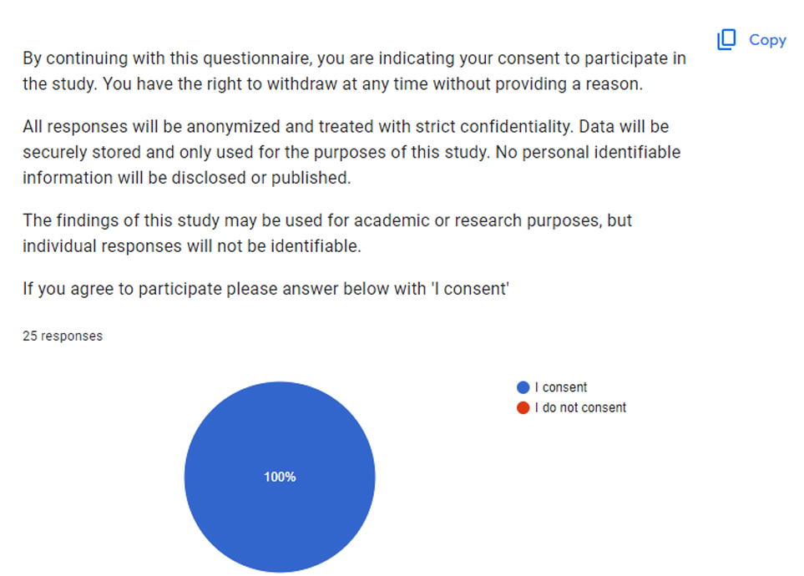
Fig 3. Fig 4.
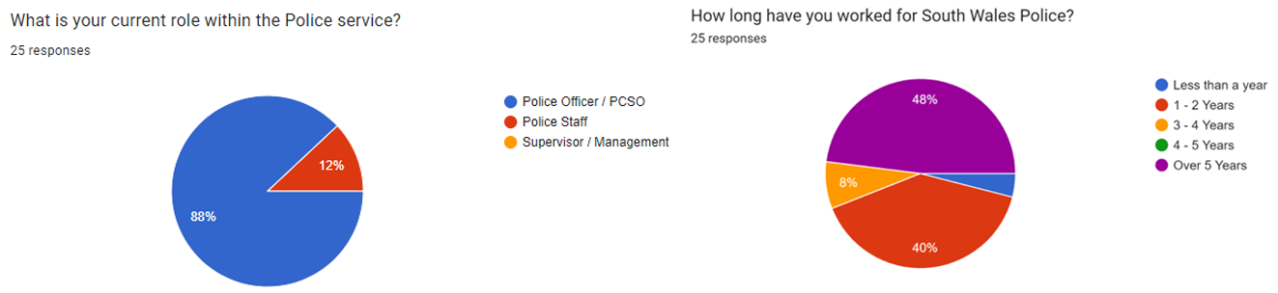

4.3 Themes Identified from Data

4.3a Crime rates are positively impacted by Neighbourhood Policing and Neighbourhood Policing is seen as a positive tool utilised by Police Services.
Upon being asked the question
‘’Based on your experiences, how effective do you believe Neighbourhood Policing is in reducing the rate of crime? (Scale 1-10, 1 being the least effective)’’
The responses show an overwhelming positive opinion on the impact of Neighbourhood Policing on crime rates. 16% scored 10, 36% scored 9, 16% scored 8 and 12% scored 7. Based on this scale it is fair to say any score of 5 and above can be perceived as a positive opinion for the impact on crime rates by Neighbourhood Policing.
Overall, 80% of all participants have provided a positive response suggesting that the agreed perception is that Neighbourhood Policing has a positive impact on crime rates. The other 20% have scored 5 and under, suggesting they do not see a value in Neighbourhood Policing.
Fig 5 presents all response in the form of pie chart.
Fig 5.
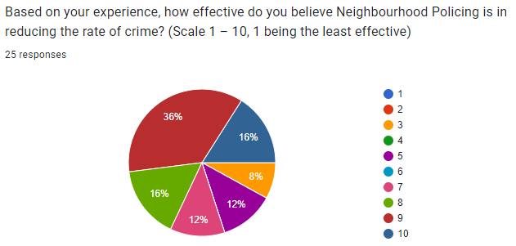
To expand on this topic, the following question was put to all participants:
‘’Do you believe Neighbourhood Policing is a worth wild / appropriate use of Police service resources?’’
The response to this was positive with 91.7% replying yes and 8.1% replying no. 24 out of the 25 participants responded to this question. No reason for the missing response was given, it is understood that a response was not given in error. Fig 6 presents all responses in the form of a pie chart.

Fig 6.
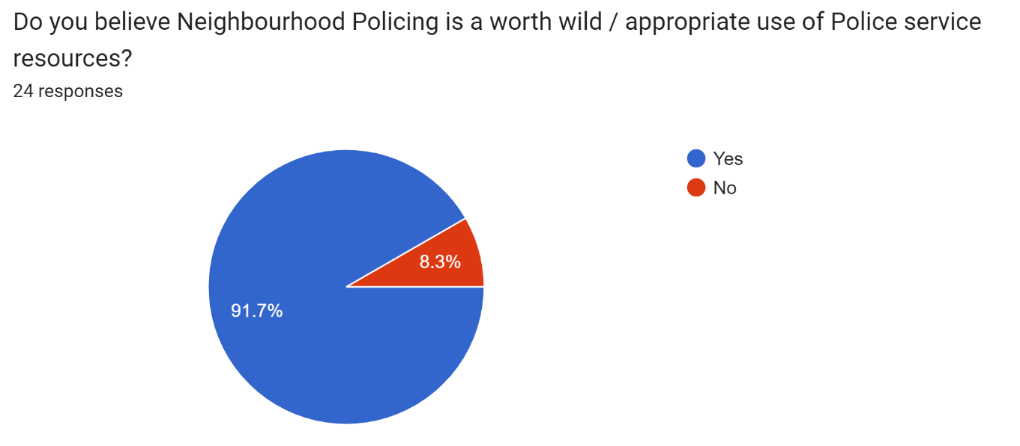

The above results signify strong support from officers and staff towards Neighbourhood Policing. This support underpins the fundamentals of Neighbourhood Policing such as community engagement, reducing crime, Problem orientated Policing and partnership building (Seagrave and Ratcliffe, 2004). This level of support and belief from officers and staff highlights the need for senior management to consider further investment into Neighbourhood Policing teams whether that be by expanding the training given to current staff or by increasing the allocation of resources into the Policing method. It is widely regarded that Neighbourhood Policing teams need expansion, high volume crime such as theft, anti-social behaviour and drug related offences have been highlighted as the biggest concerns from members of the public (Home Office, 2023). The solution to reducing and preventing these crimes are high visibility, trusted Neighbourhood Policing (Hawksbee, 2024). The positive internal perception of Neighbourhood Policing can be used by senior management to further build trust with communities and support the notion that Police services are prioritising the needs and wants of their communities. Neighbourhood Policing is the link between the public and the Police service, therefore the internal positive motions towards Neighbourhood Policing should be reflected and supported by those outside of Neighbourhood Policing (Longstaff et al., 2015).
This data indicates strong support internally, but it needs to be noted that further research will need to be conducted with persons outside of the organisation such as members of the public and partnering agencies before the impact of Neighbourhood Policing can be fully endorsed. It is fair to say that internally Neighbourhood Policing is regarded as highly effective.

4.3b The perceived objectives of Neighbourhood Policing are to reduce crime, increase community engagement, develop intelligence and be a visible presence within a community.
The following question was presented to all participants:
‘’In your opinion, what are the main objectives of Neighbourhood Policing?’’
Several of the responses followed a similar trend with 16 out of the 24 responses mentioning ‘reduce crime’ as an objective. Within the responses anti-social behaviour was specifically mentioned eight times as a targeted crime for reduction.
Responses such as ‘patrol the community’ ‘be seen’ ‘be an ever present’ ‘be seen in the community’ ‘engage with the community’ ‘talk to the community’ ‘build trust with communities’ ‘engage with young people’ all align with the objective of increasing community engagement and being a visible presence within a community.
The responses clearly emphasise the fundamental goal of reducing crime and improving the feeling of safety for members of the public as the key objective for staff and officers. This internal response is emulated from the needs and wishes of the communities in which they serve. Statistics suggest that crime is down around two thirds since the 1990’s (Farrell, Tilley and Tseloni, 2014), however, members of the public do not feel any safer due to a lack of reassurance, which is created by visible, trusted Policing within their local communities (Newton & Hawksbee, 2024). This study shows that internally the belief is that objectives are being achieved, this internal belief does not seem to be reflected by the communities in which they serve.
Officers and staff have highlighted the need to develop intelligence, developing intelligence is widely regarded as a vital component for a targeted reduction in crime (Peterson, 2005). A case study in San Diego determined that significant improvements in the way they gathered intelligence led to the identification of gang members who were responsible for 47% of gang related violence and crime. The San Diego Police Department was able to significantly reduce this by using intelligence to target certain people, property and locations. This would not have been possible if it wasn’t for Neighbourhood teams developing intelligence (Bureau of Justice Assistance, 2012). Participants in the survey have recognised the need for intelligence led Policing to target crime and deploy resources appropriately.
Participants agree, with regards to the importance of being a visible presence and increasing community engagement. These elements are fundamentals of Neighbourhood Policing encouraging the feeling of trust, deterring crime and creating a positive perception of Police Officers within a community (College of Policing, 2021). It is widely agreed between participants that building trust is vital for successful partnership working, which has been highlighted as a vital component for successful crime prevention and reduction (Manresa, 2023).
Overall, the data shows correlation between what Officers and staff know and the expectations of Neighbourhood Policing as set by the national guideline detailed in (College of Policing, 2021). This shows Officers and staff have a good understanding of their role and expectations of them. By aligning with these objectives, Officers and staff can work towards the enhancement of community trust, promotion of public safety and empowering communities to assist Police services with the reduction of crime.

4.3c The perception is that Neighbourhood Policing is effective at reducing Anti-Social Behaviour, Thefts and Drug Related Offences.
Out of 24 responses, 19 mention anti-social behaviour as a specific crime which Neighbourhood Policing reduces. A further 7 responses specify theft in the form of ‘shop lifting’ and ‘theft from cars’ and 11 responses detail drug related offences. It is evident that these three crimes are highlighted throughout responses as those in which Neighbourhood Policing has the biggest impact.
The results from this question reveal the multifaceted impact of Neighbourhood Policing by identifying three crimes which officers and staff believe are being positively impacted. It is fair to say that the perception is that Neighbourhood Policing has the biggest impact on Anti-Social Behaviour. This perception supports the shared belief between Police services and their communities that reducing anti-social behaviour is a priority (Cleverley, J & Sunak, R, 2024). The responses to the survey prove that officers and staff have been adequately trained and understand their roles and the expectations on them. It is fair to say that these Officers and staff are displaying satisfaction towards their roles by expressing positive results towards these crimes.

4.3d Neighbourhood Policing is servery impacted by a lack of resources.
When asked ‘’Do you believe a lack of resourcing hinders Neighbourhood Policing and its impact on crime rates?’’, 96% of responses stated yes. Only one response equating to 4% of the responses stated No. This supports the notion that the perception on the impact of Neighbourhood Policing is positive, although its impact is hindered by a lack of resources and support. The response here shows that participants believe that with more resources, Neighbourhood Policing will be able to have a more significant impact on crime rates.
To further support this notion, the following question was asked:
‘’ How effectively do you think the resources allocated to Neighbourhood Policing are being utilised?’’
10 of the responses to this question make comment about how more resources are needed. 15 of the responses answer this question in a positive manner, showing that the consensus is that available resources are used well for Neighbourhood Policing. The remaining 8 responses are mixed in opinion with little constructive feedback that can be utilised for this study.
The notion of being under resourced had been further supported in the answers to the following question.
‘’In your opinion, what improvements or changes could be made to enhance the effectiveness of Neighbourhood Policing in reducing crime rates?’’
In response to this, 17 answers all state they would like to see an increase in staff and resources, the consensus from participants is that an increase in resources is the main improvement they would like to see for Neighbourhood Policing. This response suggests that participants agree that Neighbourhood Policing is effective in its approach to reducing crime but is capable of far more if provided with more resources.

Fig 7 shows shows responses in the form of a pie chart.

Fig 7.
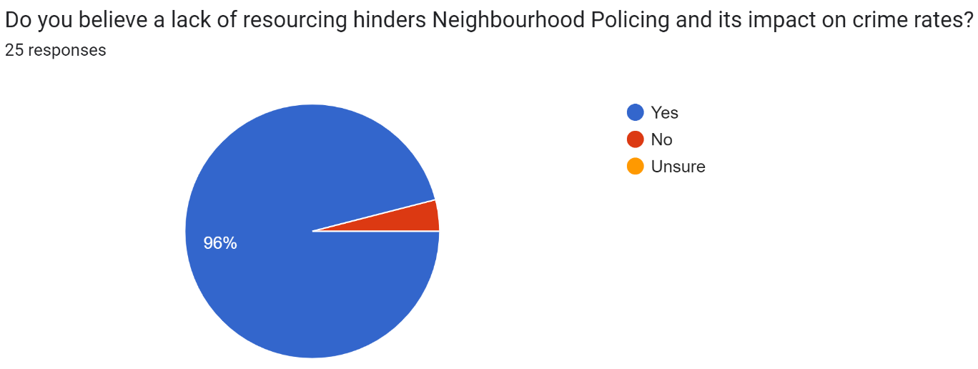

The results of this survey highlight the importance of adequate funding and staff for Neighbourhood Policing with mention of operational challenges and staff limitations hindering the full capabilities of Neighbourhood Policing teams. A lack of resources may impact the response capabilities of a Neighbourhood Policing teams which can inadvertently impact the confidence levels which the public have in the Police service, furthermore, a lack of resources will mean that Police services are not able to provide high visibility patrols in hot spot areas which is regarded as a successful action for crime prevention, nor will Police services be able to progress investigations in a timely manner (Webster, 2018).
Further to this a lack of resources may create a feeling of neglect and seclusion from a community towards its Police service which would go directly against the objectives of Neighbourhood Policing – it would subjectively break down any possibility of collaboratively working in partnership and somewhat undermine the purpose of Neighbourhood Policing in the first place (Tudor, 2023).

4.3e Police Community Support Officers can be better utilised and should be supported to expand their role.
Participants were asked to answer the following question:
‘’In your opinion, are PCSOs (Police Community Support Officers), underutilised?’’
Out of the 25 responses, 20 replied with yes. 3 said no and 2 replied with unsure. This suggests that Police Community Support Officers can do more. Contrary to this, the role of a Police Community Support Officer is limited by powers and safety equipment. If senior management and decision makers are not willing to support the role of a PCSO then it is not fair to expect more from these officers. Fig 8 shows the full set of responses in the form of a pie chart.
Fig 8.
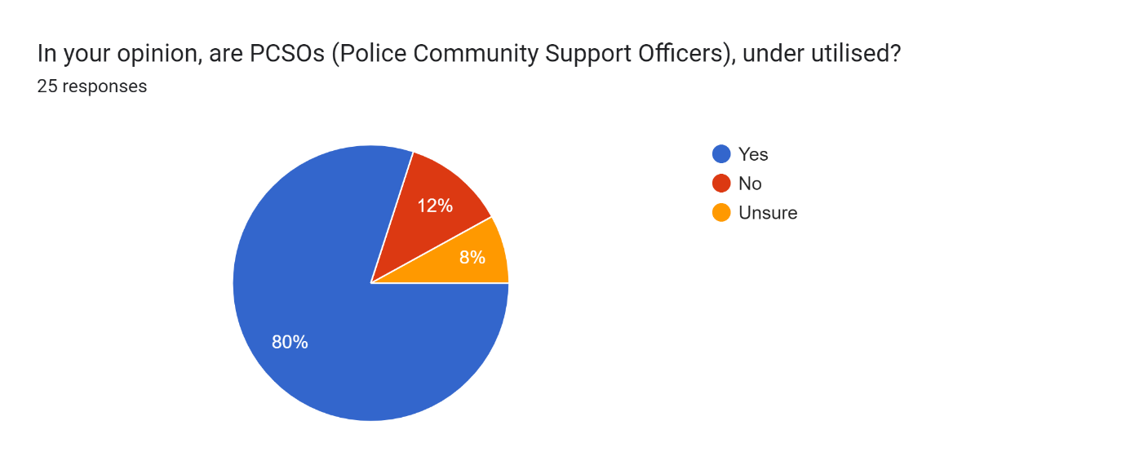

To support this notion, the final question asked on the survey was:
‘’Are there any additional comments or suggestions you would like to provide regarding the effectiveness of Neighbourhood Policing on crime rates in this area?’’
In response to this, comments were provided as follows:
‘’PCSO’s can be better utilised, give them more responsibilities and powers to tackle crime’’.
‘’Give PCSO’s the same powers as warranted Officers’’.
‘’Increase involvement of PCSO’s’’.
‘’PCSO’s should have more powers, such as the power to arrest and be equipped with handcuffs’’.
‘’PCSO’s should have more powers and equipment’’.
This suggests that the wider opinion is that PCSO’S are capable doing more and officers and staff are in support of this. This solution would certainly address the earlier concerns regarding lack of resources. These responses present an opportunity for further research, specifically looking at Police Community Support Officers, their role and utilisation and whether that can be improved.

4.4 Data produced from the Survey to support Neighbourhood Policing’s impact on crime rates.
The following question was posed to all participants of the survey.
‘’What specific Neighbourhood Policing strategies / Operations are you aware of?’’
Four of the responses mentioned Op Adriatic which is a beach front patrol operation with the objective of reducing anti-social behaviour. One of these responses included the below statistics which I have displayed as Fig 9.
Fig 9.
Year | Number of reported ASB incidents
2021 | 1629
2022 | 1072
2023 | 694

The figures above show a reduction in the number of anti-social behaviour incidents. This data comes from a localised area but is certainly a good example of a successful implementation of Neighbourhood Policing, showing a clear reduction on the crime rate, which can be accounted to the good work of Neighbourhood Policing. This small amount of data is not sufficient to claim a certainty but does add to the conversation on the impact of Neighbourhood Policing on crime rates.

4.5 Conclusion
Chapter 4 has successfully presented data from the survey as well as offering some analysis on these results. The analysis has revealed several challenges that are present within Neighbourhood Policing as well as recommendations for how the Policing practise can be improved. Chapter 5 will look to conclude this study.

Chapter 5: Conclusion
The study into the perceptions of Officers and staff on the effectiveness of Neighbourhood Policing on crime rates has brought to light the potential impact of Neighbourhood Policing as opposed to being able to directly answer the question as to whether the Policing strategy does reduce crime rates. It is evident that the Officers and staff are motivated and have a positive opinion on Neighbourhood Policing, however, several challenges have been identified and can be touted as reasons as to why Neighbourhood Policing isn’t as impactful as many believe it can be.
Despite the challenges, several positive stories of crime reduction were shared, as well as the importance of community engagement, partnership working and the building of trust between Police services and the communities to which they serve. Furthermore, the study highlights that Police Officers and staff value Neighbourhood Policing as an effective method of Policing and see its utilisation as a vital component for helping to prevent and reduce crime. This conclusion is further supported by the Gil et al, 2014 study which stated that it was possible Neighbourhood Policing was responsible for between a 5-10% reduction in crime rates, however it was not possible to confirm that Neighbourhood Policing was solely responsible for this reduction, the result of this study further supports the conclusion found by Gil et al, 2014.
This study highlights the significance of investing in Neighbourhood Policing resources. Adequate funding and staff are both vital for allowing Neighbourhood Policing teams to engage with their communities, adequately resource high visibility patrols in crime hotspots, support crime prevention programmes and help to improve the feeling of safety felt by their communities (Team, 2023). The results from this study reveal that staff and officers truly believe that with more resources they will be capable of doing more to reduce and prevent crime. This perception is further supported by the Machin & Marie study, 2006 which demonstrates how increased resources can result in significant improvements, more about this can be found in the recommendations chapter of this study.
Alongside the need for increased resources, one of the key improvements recommended by staff and officers is the need to increase the powers held by Police Community Support Officers to enhance the capabilities and effectiveness of Neighbourhood Policing. Increasing the powers held by PCSO’s will allow for them to deal with more low-level crime, support Police Officers and be present and influential in areas deemed higher risk. In turn this should then enhance the good work already conducted by PCSO’s in that a higher level of involvement will likely enhance the trust which the public have, open opportunities for community engagement and give more opportunity to gather intelligence (College of Policing, 2019). This advancement in PCSO’s powers is supported by those who work within Neighbourhood Policing as shown by the results of this study.
To summarise, this study outlines several recommendations to improve the impact that Neighbourhood Policing has on crime rates. By investing in resources, empowering PCSO’s and increasing high visibility patrols, Neighbourhood Policing can improve on its recorded impact on crime rates, help to create a feeling of safety in a community and further encourage partnership working to prevent and reduce crime.

Chapter 6: Recommendations
With regards to the results of this study, several recommendations can be made with a view of enhancing the impact of Neighbourhood Policing on crime rates based on the perceptions provided by Officers and Staff.

6.1a Increase the powers held by Police Community Support Officers
By increasing the powers held by Police Community Support Officers you also increase the operational capabilities of Neighbourhood Policing. This will allow for PCSO’s to be more effective with managing low level crime and give those in the role a more meaningful sense of purpose (Higgins, 2018). The above is being trialled in Kent but further consideration should be given across all Neighbourhood Policing teams.

6.1b Investment in resources
Increasing the investment into resources is vital in increasing the effectiveness of Neighbourhood Policing. More resources will allow for further community events to be operated, an increase in crime prevention operations and an increase in high visibility patrols. All of this will look to increase community engagement, build trust and improve the perception of the Police service for the public which in turn will aid in crime prevention and reduction. The study from (Machin & Marie, 2006) demonstrates perfectly the significant impact that increased resources can have on crime rates, showing that a hot spot for robbery in a controlled area, with increased resources saw a 17.1% decrease in one year. Investment in resources should be made a priority to improve Neighbourhood Policing.

6.1c Increase the number of high visibility patrols
Studies have shown that increased high visibility patrols in hotspot areas increase the feeling of safety felt by the public (College of Policing, 2021). High visibility patrols have also been proven to increase the feeling of safety amongst a community by offering assurance and engagement (Quinton and Tuffin, 2007). This further supported by the results shown in Fig 8 which show a significant decrease in reported ASB incidents when a regular high visibility patrol is arranged for hot spots. This evidence strongly supports a recommendation to increase this activity to benefit the impact of Neighbourhood Policing on crime rates.

6.2 Conclusion
The recommendations aim to offer guidance to senior management who make the key decisions relating to the implementation of Neighbourhood Policing. By increasing the powers of PCSO’s, increasing and investing in resources and increasing high visibility patrol strategy then it is expected that Neighbourhood Policing will be able to have a bigger impact on the reduction of crime. These recommendations come from the results relating to the perceived impact from Officers and staff who work directly withing Neighbourhood Policing.

Chapter 7: References
Bates, J (2022). Police Are Turning to an Old Tactic to Fight the Surge in Violence. [online] Time. Available at: https://time.com/6227552/hotspot-policing-crime-effectiveness/.

Beccaria, B (1764) The Online Library of Liberty Cesare Bonesana di Beccaria, An Essay on Crimes and Punishments. Available at: http://files.libertyfund.org/files/2193/Beccaria_1476_EBk_v6.0.pdf.
Braga AA (2016). Hot Spot Policing: Theoretical Perspectives, Scientific Evidence, and proper Implementation. In: Teasdale A and Bradley MS, eds ‘Preventing Crime and Violence’. Switzerland: Springer. PP269-279.
Braun, V, & Clarke, V (2012). Thematic analysis. In H. Cooper, P. M. Camic, D. L. Long, A T Panter, D Rindskopf, & K. J Sher (Eds.), APA handbook of research methods in psychology, Vol. 2. Research designs: Quantitative, qualitative, neuropsychological, and biological (pp. 57–71). American Psychological Association. https://doi.org/10.1037/13620-004

Brough, P (2018). Advanced Research Methods for Applied Psychology: Design, Analysis and Reporting (1st ed.). Routledge. https://doi.org/10.4324/9781315517971

Bureau of Justice Assistance (2012). Reducing Crime Through Intelligence-Led Policing | Office of Justice Programs. [online] Available at: https://www.ojp.gov/ncjrs/virtual-library/abstracts/reducing-crime-through-intelligence-led-policing.

Chappell, E (2022). 10,000 neighbourhood police officers cut since 2010, Labour analysis finds. [online] LabourList. Available at: https://labourlist.org/2022/07/10000-neighbourhood-police-officers-cut-since-2010-labour-analysis-finds/.

Cleverley, J & Sunak, R (2024). Plan proven to slash anti-social behaviour rolled out nationwide. [online] Available at: https://www.gov.uk/government/news/plan-proven-to-slash-anti-social-behaviour-rolled-out-nationwide#:~:text=Deputy%20Chief%20Constable%20Andy%20Prophet [Accessed 31 Mar. 2024].

College of Policing (2019). Role and purpose. [online] College of Policing. Available at: https://www.college.police.uk/career-learning/joining-police/joining-pcso/handbook/role-and-purpose.

College of Policing (2021). Neighbourhood policing. [online] College of Policing. Available at: https://www.college.police.uk/guidance/neighbourhood-policing [Accessed 31/03/2024].

College of Policing (2021). The effectiveness of visible police patrol. [online] College of Policing. Available at: https://www.college.police.uk/research/what-works-policing-reduce-crime/visible-police-patrol [Accessed 31/03/2024].

College of Policing (2022). Hot spots policing. [online] Available at: https://www.college.police.uk/guidance/hot-spots-policing#crime-opportunity-theory.

Cummings, M (2019). Study finds community-oriented policing improves attitudes toward police. [online] YaleNews. Available at: https://news.yale.edu/2019/09/16/study-finds-community-oriented-policing-improves-attitudes-toward-police.

Farrell, G., Tilley, N. and Tseloni, A (2014). Available at: https://eprints.whiterose.ac.uk/97466/1/Farrell%20Tilley%20Tseloni%202014%20Why%20the%20Crime%20Drop%20%28C%26J%20vol43%29.pdf.

Ferriere, L, Koeberl, C, Ivanov, B.A and Reimold, W.U (2008) Shock Metamorphism of Bosumtwi Impact Crater Rocks, Shock Attenuation, and Uplift Formation. Science, [online] 322(5908), pp.1678–1681. doi:https://doi.org/10.1126/science.1166283

Flanagan, R (2008) Policing Final Report The Review. [online] Available at: https://assets-hmicfrs.justiceinspectorates.gov.uk/uploads/flanagan-review-of-policing-20080201.pdf

Gill, C., Weisburd, D., Telep, C.W., Vitter, Z. and Bennett, T (2014) Community-oriented policing to reduce crime, disorder and fear and increase satisfaction and legitimacy among citizens: a systematic review. Journal of Experimental Criminology, [online] 10(4), pp.399–428. doi:https://doi.org/10.1007/s11292-014-9210-y

Gillham, B. (2008) Developing a Questionnaire: Real World Research. 2nd edn. London: Bloomsbury Publishing.

Gov. Wales (2021). 100 new PCSOs funded by the Welsh Government | GOV.WALES. [online] Available at: https://www.gov.wales/100-new-pcsos-funded-by-the-welsh-government#:~:text=The%20additional%20100%20PCSOs%20brings [Accessed 2 Nov. 2023].

Gramlich, J (2023). What the data says about gun deaths in the U.S. [online] Pew Research Center. Available at: https://www.pewresearch.org/short-reads/2023/04/26/what-the-data-says-about-gun-deaths-in-the-u-s/.

Hawksbee, A (2024). Why we need more neighbourhood policing. [online] New Statesman. Available at: https://www.newstatesman.com/spotlight/2024/02/neighbourhood-policing-high-streets-local-economies.

Higgins, A. (2018). THE FUTURE OF NEIGHBOURHOOD POLICING. [online] Available at: https://www.police-foundation.org.uk/wp-content/uploads/2010/10/TPFJ6112-Neighbourhood-Policing-Report-WEB_2.pdf.

HMIC (2008) Her Majesty’s Inspectorate of Constabulary - get smart: planning to protect. Available at: https://assets-hmicfrs.justiceinspectorates.gov.uk/uploads/get-smart-planning-to-protect-20080530.pdf

Holloway, I and Todres, L (2003). The Status of Method: Flexibility, Consistency and Coherence. Qualitative Research, 3(3), pp.345–357. doi:https://doi.org/10.1177/1468794103033004.

Home Office (2019). Home Office announces first wave of 20,000 police officer uplift. [online] GOV.UK. Available at: https://www.gov.uk/government/news/home-office-announces-first-wave-of-20000-police-officer-uplift.

Home Office (2023). Anti-social behaviour: impacts on individuals and local communities. [online] GOV.UK. Available at: https://www.gov.uk/government/publications/impacts-of-anti-social-behaviour-on-individuals-and-communities/anti-social-behaviour-impacts-on-individuals-and-local-communities.

Innes, M (2006) The Public Face of Policing Available at: https://www.crimeandjustice.org.uk/sites/crimeandjustice.org.uk/files/09627250608553108.pdf

Kelling, G.L. and Wilson, J.Q (1982) Broken Windows: The police and neighbourhood safety. [online] The Atlantic. Available at: https://www.theatlantic.com/magazine/archive/1982/03/broken-windows/304465/

Kuhn, G (2020). The Pros and Cons of Open-Ended Questions and Closed-Ended Questions. [online] www.driveresearch.com. Available at: https://www.driveresearch.com/market-research-company-blog/the-pros-and-cons-of-open-ended-questions-and-closed-ended-questions/ [Accessed 29 Mar 2024].

Lister, S and Platts-Fowler, D (2014). N8 Policing Research Partnership Community Engagement: Evidence Review. [online] Available at: https://documents.manchester.ac.uk/display.aspx?DocID=56499#:~:text=Community%20engagement%20can%20foster%20collaboration.

Lister, S, Adams, B and Phillips, S (2015). ‘Evaluation of Police-Community Engagement Practices’ Available at: https://essl.leeds.ac.uk/dir/research-projects?query=&categoryID=5&searchDirCategoryID=-1

Longstaff, A., Willer, J., Chapman, J., Czarnomski, S. and Graham, J (2015). Neighbourhood policing: Past, present and future A review of the literature. [online] Available at: https://www.police-foundation.org.uk/wp-content/uploads/2017/06/neighbourhood_policing_past_present_future.pdf

Machin, S and Marie, O (2006). Can more police resources reduce crime? [online] Available at: https://cep.lse.ac.uk/pubs/download/cp190.pdf [Accessed 2 Apr. 2024].

Manresa, G (2023). 5 Reasons Why Community Policing is Effective. [online] The Lesniak Institute for American Leadership. Available at: https://www.lesniakinstitute.org/5-reasons-why-community-policing-is-effective/.

Mehmi, S, Blauer, R and De Gannes, K (2021). Building trust in modern day policing: A neighbourhood community officer evaluation. Journal of Community Safety and Well-Being, 6(1), pp.6–10. doi:https://doi.org/10.35502/jcswb.186.

Michael, A (2021) Everything is Connected to Everything Else. Available at: https://commissioner.south-wales.police.uk/media/2330/2022-03-04-police-crime-plan-2226-final-eng.pdf.

Millie, A and Herrington, V (2004). Reassurance Policing in Practice: Views from the Shop Floor. [online] Available at: https://www.britsoccrim.org/volume7/002.pdf.

Myhill, A. and Beak, K. (2008). Public Confidence in the Police. [online] Available at: https://library.college.police.uk/docs/npia/public-confidence-in-the-police.pdf.
‌Nalla, M K, Meško, G and Modic, M (2016). Assessing police–community relationships: is there a gap in perceptions between police officers and residents? Policing and Society, 28(3), pp.271–290. doi:https://doi.org/10.1080/10439463.2016.1147564.
National Institute of Justice (2023). Police Use Science and Community Partnerships to Reduce Gun Violence. [online] Available at: https://nij.ojp.gov/topics/articles/police-use-science-and-community-partnerships-reduce-gun-violence.

Newton, C & Hawksbee, A (2024). Back to Basics. [online] Available at: https://www.ukonward.com/reports/back-to-basics/ [Accessed 31/03/2024]

Peterson, M (2005). N E W R E A L I T I E S Law Enforcement in the Post9 11 Era. [online] Available at: https://www.ojp.gov/pdffiles1/bja/210681.pdf.

Price, E (2024). Concern over community policing cuts. [online] Nation.Cymru. Available at: https://nation.cymru/news/concern-over-community-policing-cuts/.

Quinton, P. and Tuffin, R. (2007). Neighbourhood Change: the Impact of the National Reassurance Policing Programme. Policing, [online] 1(2), pp.149–160. doi:https://doi.org/10.1093/police/pam024

Rahul, C (2022). Broken Windows Theory of Polciing (Wilson and Kelling). [online] Available at: https://www.simplypsychology.org/broken-windows-theory.html#What-Is-the-Broken-Windows-Theory

Ratcliffe, J.H, Taniguchi, T, Groff, E.R and Wood, J.D (2011). The Philadelphia Foot Patrol Experiment: A randomized controlled trial of Police Patrol effectiveness in violent crime hotspots. Criminology, 49(3), pp.795–831. doi:https://doi.org/10.1111/j.1745-9125.2011.00240.x.

Saunders, M., Lewis, P. and Thornhill, A. (2009) Research methods for business students. England: Pearson Education Limited.

Segrave, Marie and Ratcliffe, Jerry (2004). Community policing: a descriptive overview | Australian Institute of Criminology. [online] Aic.gov.au. Available at: https://www.aic.gov.au/publications/archive/archive-168.

Shantikumar, S and Barratt, H (2018). Methods of Sampling from a Population. [online] Health Knowledge. Available at: https://www.healthknowledge.org.uk/public-health-textbook/research-methods/1a-epidemiology/methods-of-sampling-population.

Skogan, W (2003) Representing the community in community Policing. In Skogan, W. (eds) Community Policing: Can it work? Belmont, CA: Wadsworth Publishing.

South Wales Police (2021). Performance and priorities. [online] Available at: https://www.south-wales.police.uk/police-forces/south-wales-police/areas/about-us/about-us/performance-priorities/

South Wales Police (2023). Additional high-visibility patrol team for Swansea City Centre. [online] Available at: https://www.south-wales.police.uk/news/south-wales/news/2023/tac-nov/additional-high-visibility-patrol-team-for-swansea-city-centre/ [Accessed 7 Apr. 2024].

South Wales Police (2023). Ely Your Area. [online] Available at: https://www.south-wales.police.uk/area/your-area/south-wales/cardiff-the-vale/ely/on-the-team/our-priorities [Accessed 2 Nov. 2023].

Statista (2023). Gun crime in London 2022. [online] Available at: https://www.statista.com/statistics/865565/gun-crime-in-london/#:~:text=The%20United%20Kingdom%20has%20some.

Team, S (2023). Community Policing: The Foundations of a Safe Society. [online] SaferWatch. Available at: https://www.saferwatchapp.com/blog/community-policing-the-foundations-of-a-safe-society/.

Tudor, S (2023). Police standards and culture: Restoring public trust. [online] Available at: https://lordslibrary.parliament.uk/police-standards-and-culture-restoring-public-trust/ [Accessed 2 Apr. 2024].

‌Tung, L (2019). The police experiment that changed what we know about foot patrol. [online] Available at: https://whyy.org/segments/the-police-experiment-that-changed-what-we-know-about-foot-patrol/#:~:text=Foot%20patrol%20had%20no%20effect.

Unison (2015). Trouble in the Neighbourhood Government cuts to Neighbourhood Policing take their toll (2014). Available at: https://www.unison.org.uk/content/uploads/2015/08/Trouble-in-the-Neighbourhood-Report.pdf

Usman, H and Adamu, M (2023). IMPACT OF COMMUNITY POLICING ON CRIME REDUCTION IN KADUNA CENTRAL SENATORIAL DISTRICT, NIGERIA. EPRA International Journal of Economics, Business and Management Studies (EBMS), [online] 10(2), pp.1–1. Available at: https://eprajournals.com/IJHS/article/10060 [Accessed 29 Mar. 2024].

Webster, R (2018). Dire consequences of under-funding the police - Russell Webster. [online] Available at: https://www.russellwebster.com/hascpolice18/.

Welsh Gov (2022). Welsh Government Draft Budget 2023-24 A Budget in Hard Times. Available at: https://www.gov.wales/sites/default/files/publications/2023-10/2023-2024-draft-budget-narrative.pdf [Accessed 2 Nov. 2023].

Chapter 8: Appendices

8.1 Appendix 1: Copy of Survey.
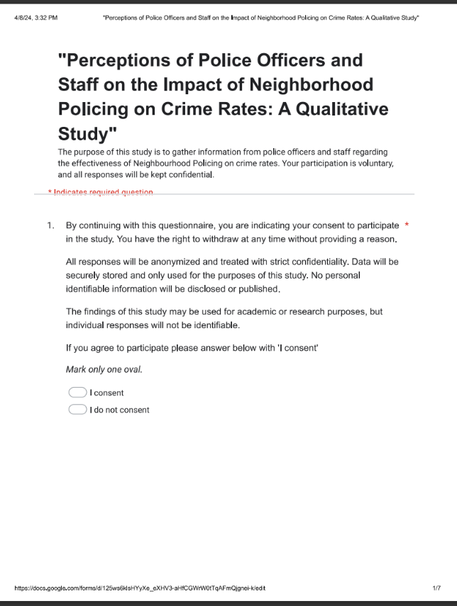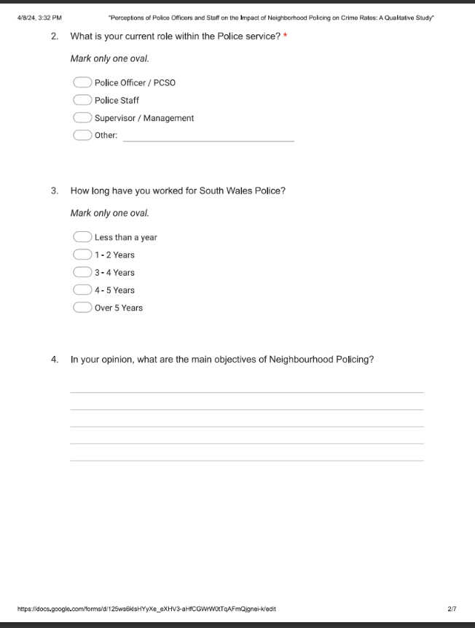

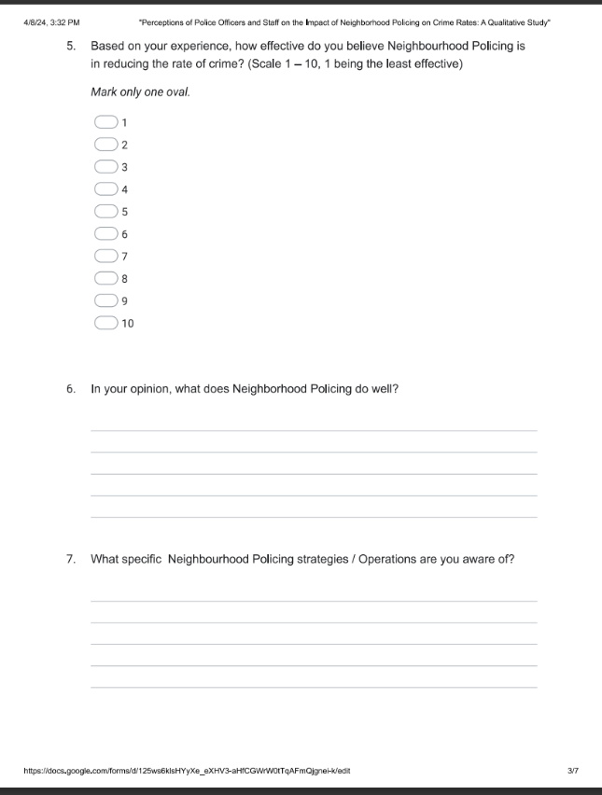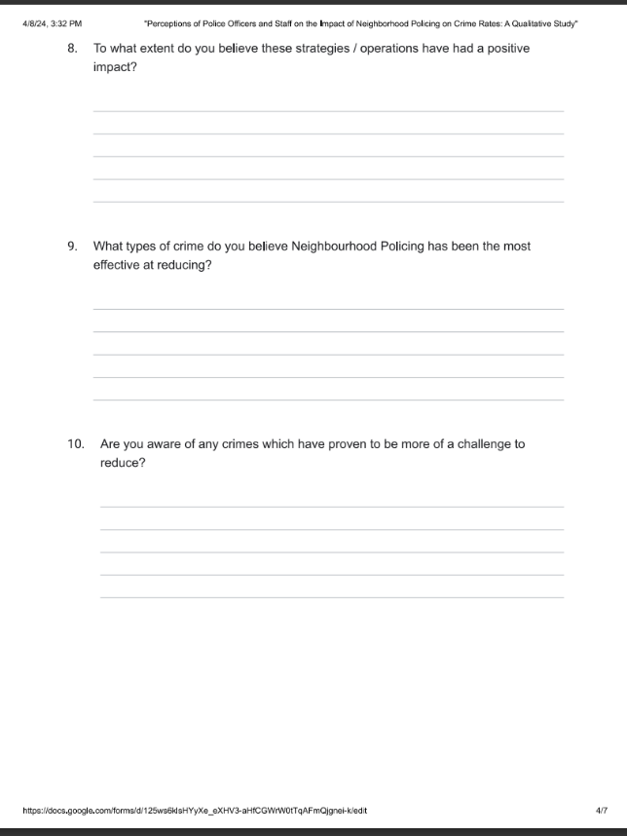

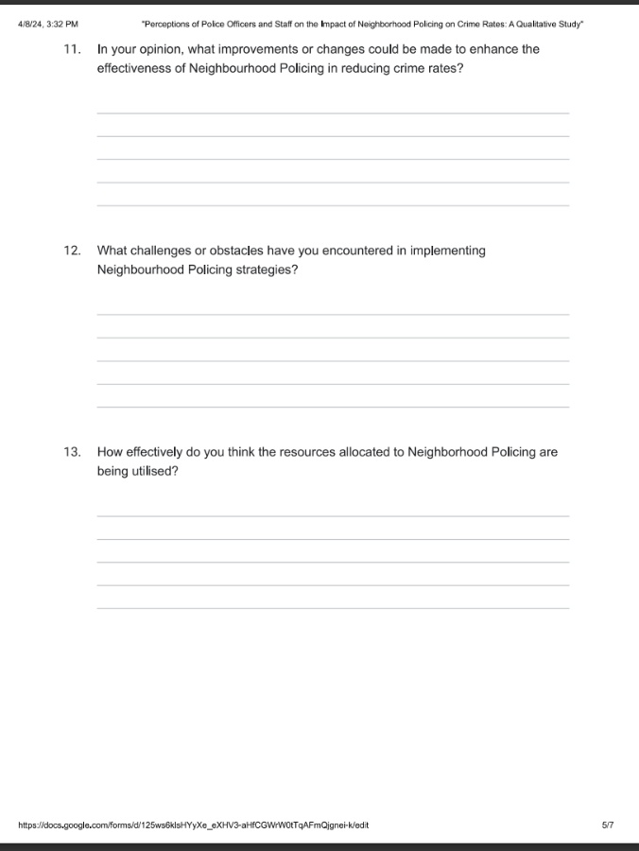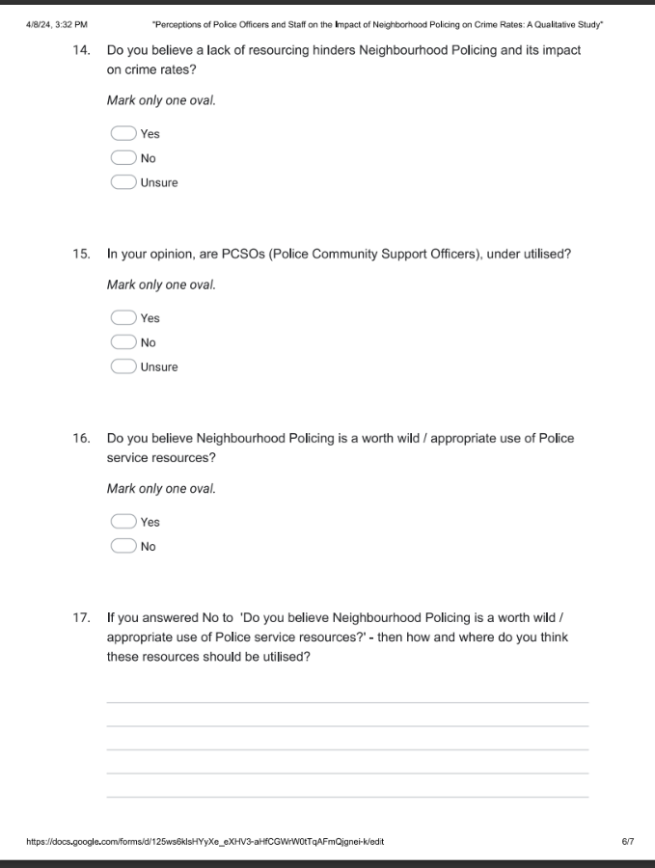

8.2 Appendix 2: Copy of Ethics Form.
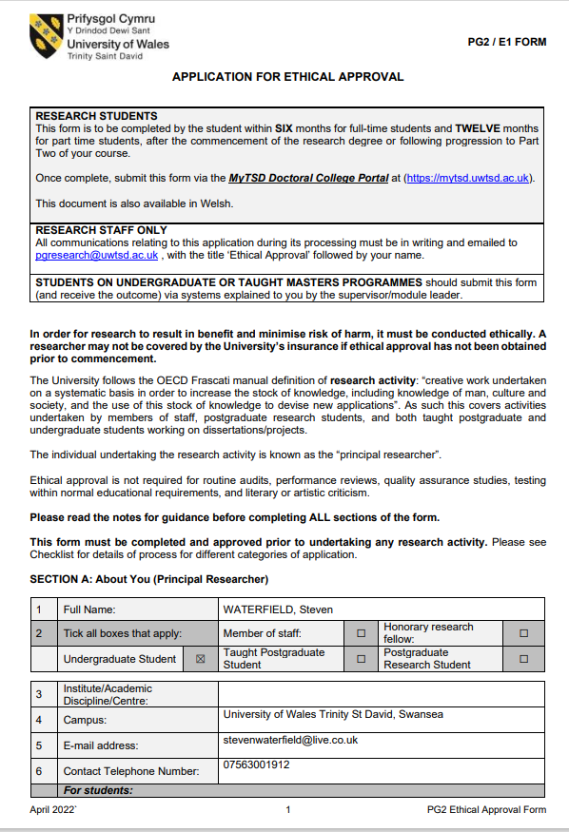
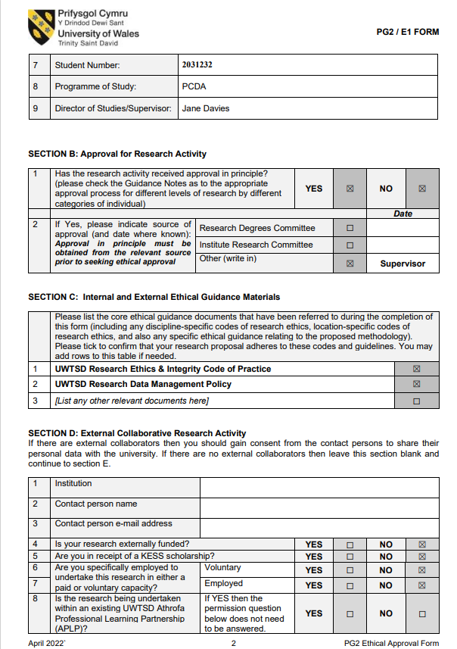

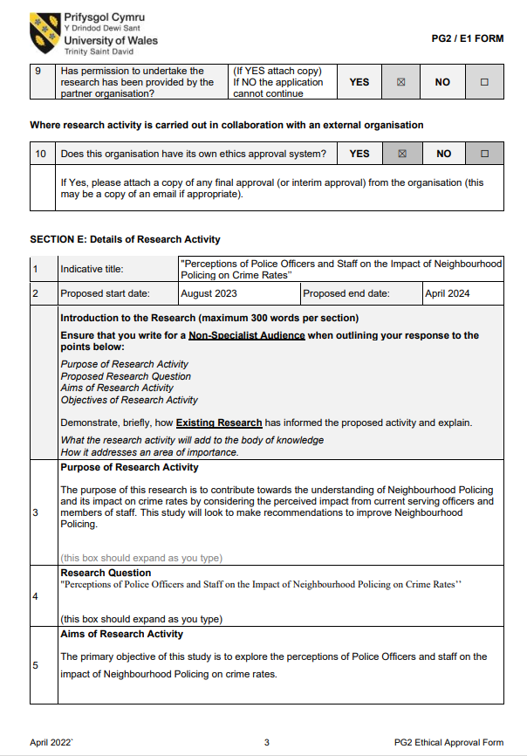
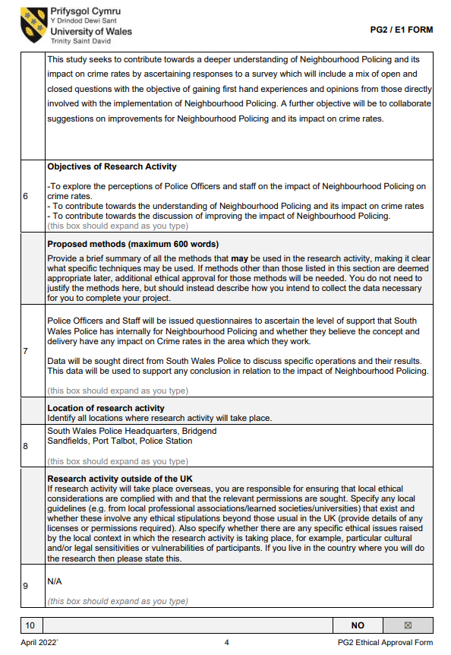
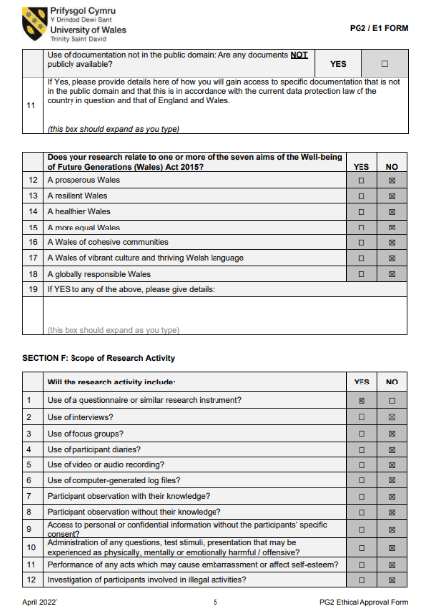
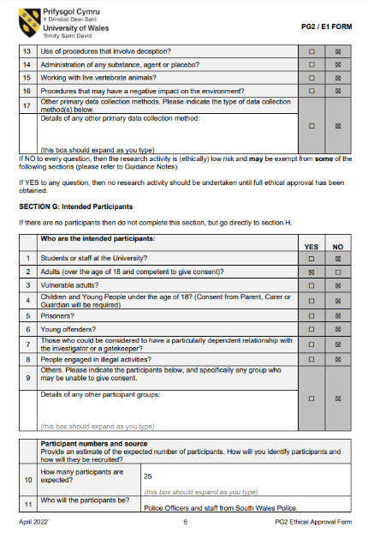
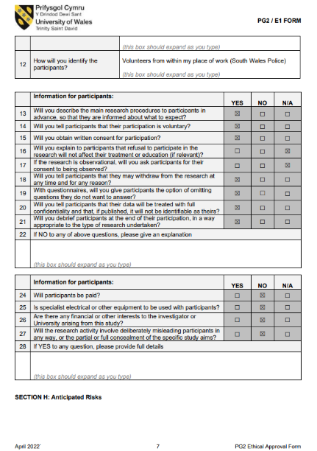
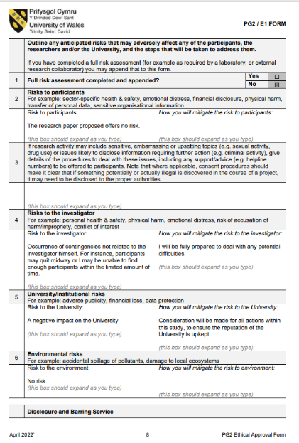
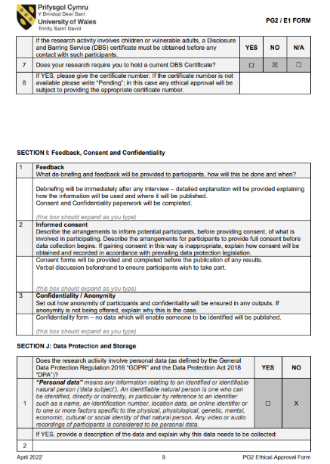
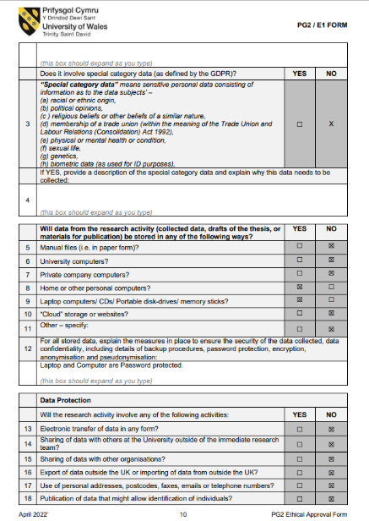
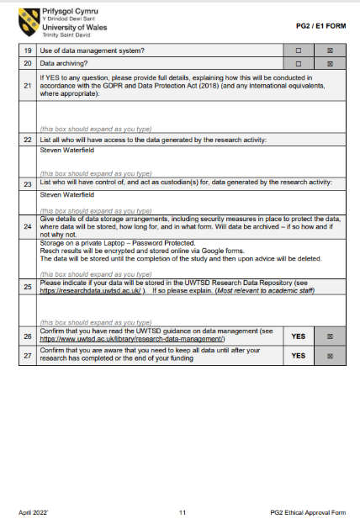
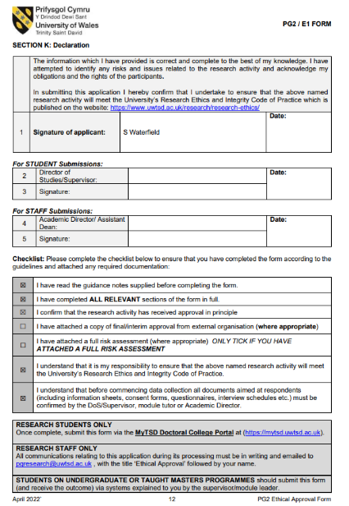

8.3 Appendix 3: Copy of Propossal Form.



UNDERGRADUATE DISSERTATION
RESEARCH PROPOSAL FORM

Please complete the following research proposal and submit it to Turnitin.

Which project option are you taking? Please tick:

8,000 word project

NAME: WATERFIELD, Steven | STUDENT ID No 2031232
DRAFT RESEARCH TITLE QUESTION:

"Perceptions of Police Officers and Staff on the Impact of Neighbourhood Policing on Crime Rates’’

INTRODUCTION:

Neighbourhood Policing was introduced in 2005 with the objective to increase public confidence in the police, reduce crime and reassure the public (Longstaff et al., 2015).

Reports such as, Kuipers 2018, state that Neighbourhood Policing does not directly impact crime rates, however, it does increase the confidence levels shown in the Police service and brings a safer feeling to communities.

A fundamental strategy used by Neighbourhood Policing is high visibility patrols. In 2018, The Police Foundation stated that that high visible foot patrols do not reduce crime rates, but that they can improve community relations and reduce fear of crime (College of Policing 2021).

In direct comparison to this, a research study by Vandegrift, 2020 suggests that Neighbourhood Policing has shown itself to be successful in reducing the rate of crime in areas. This shows a conflict in whether Neighbourhood Policing does or does not impact the rate of crime in a positive way, showing a need for further research.

This report will specifically look at South Wales Police and gather the perspective from Officers and staff on whether Neighbourhood Policing has had any impact on crime rates in South Wales. Neighbourhood Policing is at the forefront of South Wales Polices working strategy, time has moved away from traditional methods of Policing with Police services under scrutiny more than ever. Neighbourhood Policing is seen as a practise which incorporates problem solving, partnership working and opens an avenue allowing for communities to voice their concerns, their priorities. This also gives opportunity for the Police service to provide feedback, prioritise issues which the public wish them to address and deliver on those expectations. It is the flagship Policing method in modern times, making this research relevant and worthwhile (Longstaff et al, 2015).

Numerous research papers and reports have already been published detailing the perceived impact of Neighbourhood Policing. There are notable conflicts and gaps in the research that this report will look to fill. Appropriate research and analysis within this report will look to further expand on factors which impact Neighbourhood Policing within South Wales. This report will look to assist in improving future operations in Neighbourhood Policing and look to contribute towards Police action in reducing crime rates. Neighbourhood Policing directly impacts local people and their communities, this report can directly contribute knowledge towards improving the relationship between the Police service and its communities as well as improving quality of life and community safety.
SUMMARY OF RESEARCH OBJECTIVES:

-To explore the perceptions of Police Officers and staff on the impact of Neighbourhood Policing on crime rates.
- To contribute towards the understanding of Neighbourhood Policing and its impact on crime rates
- To contribute towards the discussion of improving the impact of Neighbourhood Policing.

LITERATURE REVIEW:

Key literature that will support this research paper is -

Neighbourhood Policing: The Rise and Fall of a Policing Model (2020)
Martin Innes, Colin Roberts,Trudy Lowe,Helen Innes. The book goes into detail about the origins of Neighbourhood Policing as a concept and highlights its use within sub-urban areas of the United States.

Gill, C., Weisburd, D., Telep, C.W., Vitter, Z. and Bennett, T (2014) Community-oriented policing to reduce crime, disorder and fear and increase satisfaction and legitimacy among citizens: a systematic review.

This research paper systematically reviews 65 different Neighbourhood Policing Operations and uses data to quantify whether Neighbourhood Policing is successful at reducing the crime rate in an area. The research paper includes in depth analysis which leads to a conclusion which states there is not sufficient evidence to show that Neighbourhood Poling has the desired impact.

Both mentioned Literatures discuss Community Orientated Policing which takes place in the United States. The gap for research remains for the UK, crime and communities are very different in the United States compared to the UK. Gil et al, 2014 states that Community Orientated Policing has been used to reduce gun violence, In the UK Neighbourhood Policing focuses on low level criminality. Research is required to see whether Neighbourhood Policing can have an impact on the low-level criminality it is tasked to deal with in the UK (Stephens, 2022). Previous research confirms that Neighbourhood Policing does have a positive impact such as improving public perception and creating a feeling of safety (Rahul, 2022). To date the research cannot conclude whether Neighbourhood Policing reduces the rate of crime in an area. It is this gap which this paper will look to fill, by analysing data from Neighbourhood Policing operations to determine if the practice does have the desired positive impact.

SUMMARY OF RESEARCH –SURVEY METHOD:

Police Officers and Staff will be issued questionnaires to ascertain the level of support that South Wales Police has internally for Neighbourhood Policing and whether they believe the concept and delivery have any impact on Crime rates in the area which they work.

SUMMARY OF SAMPLING FRAMEWORK:

Questionnaire: Police Officers and Staff (25-30 Volunteers)
Operation Adriatic: Neighbourhood Policing Project - Data

ETHICAL ISSUES:

This report will ensure that consent is gained from all willing participants, include authorisation from organisations to use statistics as well as consent from all Police Officers / Staff who participate in the questionnaire. The report will ensure participants are kept confidential, removing any data which may allow for a participant to be identified. Participants will have the opportunity to remove themselves from the research at any given point. I will ensure all participants are fully aware of their rights and where this research paper will be published.

This report will remain transparent, highlighting that participants are involved with Neighbourhood Policing and may seek to use this study as an opportunity to falsify positively to protect jobs, any conflict of interest with participants will be addressed. Participants will be kept anonymous to prevent any from being identified.

This report will follow the Ethical standards expected by The University of Wales Trinity St David.
TIME SCALE:

Questionnaire: Police Officers and Staff (25 Volunteers) – To be completed by January 2024
Operation Adriatic: Neighbourhood Policing Project – Data – Completion November 2023

Final Draft Submission: April 2024

REFERENCE LIST:
College of Policing (2021). The effectiveness of visible police patrol. [online] College of Policing. Available at: https://www.college.police.uk/research/what-works-policing-reduce-crime/visible-police-patrol

Gill, C., Weisburd, D., Telep, C.W., Vitter, Z. and Bennett, T (2014) Community-oriented policing to reduce crime, disorder and fear and increase satisfaction and legitimacy among citizens: a systematic review. Journal of Experimental Criminology, [online] 10(4), pp.399–428. doi:https://doi.org/10.1007/s11292-014-9210-y

Kuipers (2018). The Effects of Community Policing on Trust in Police and Crime – EGAP [Online] Available at: https://egap.org/resource/brief-the-effects-of-community-policing-on-trust-in-police-and-crime/

Longstaff, A, Willer, J, Chapman, J, Czarnomski, S. and Graham, J (2015). Neighbourhood policing: Past, present and future A review of the literature. [online] Available at: https://www.police-foundation.org.uk/wp-content/uploads/2017/06/neighbourhood_policing_past_present_future.pdf

Publications Parliament UK (2018). Policing for the future - Home Affairs Committee - House of Commons. [online] Available at: https://publications.parliament.uk/pa/cm201719/cmselect/cmhaff/515/51506.html

Rahul, C (2022). Broken Windows Theory of Polciing (Wilson and Kelling). [online] Available at: https://www.simplypsychology.org/broken-windows-theory.html#What-Is-the-Broken-Windows-Theory

Stephens, G (2022). Neighbourhood Policing. [online] College of Policing. Available at: https://www.college.police.uk/guidance/neighbourhood-policing/foreword

8.4 Appendix 4: Survey Results / Answers.
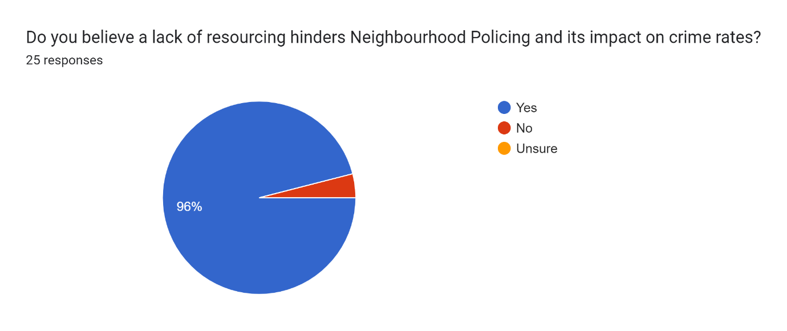

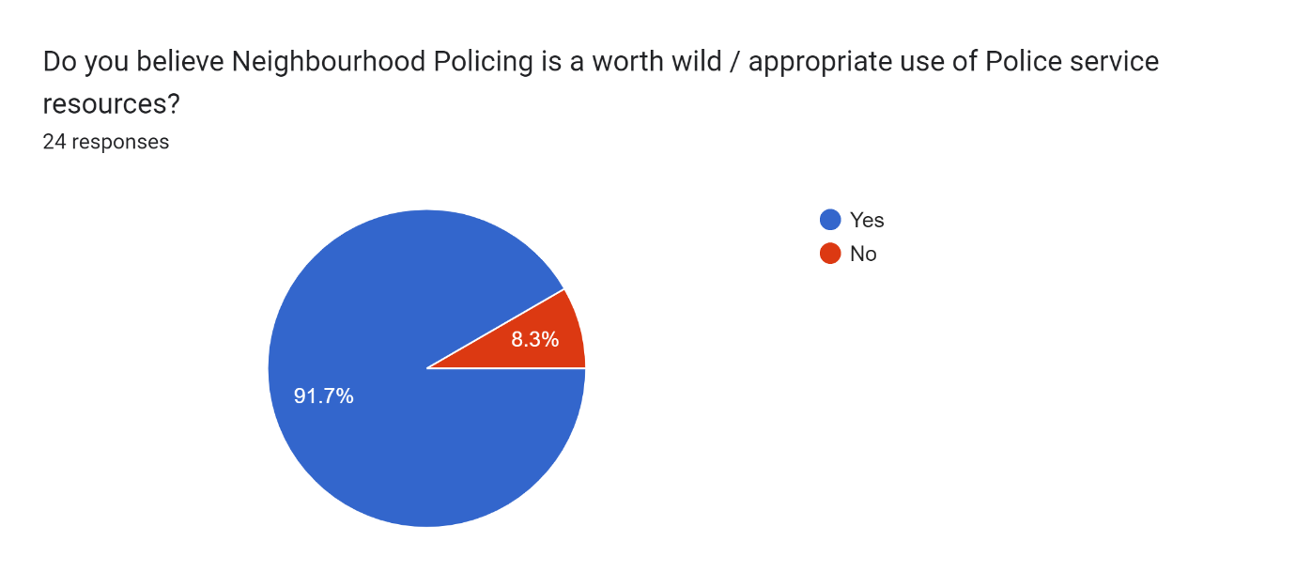

8.5 Appendix 5: Responses to Question 4.
To reduce crime
To engage with communities
Partnership Working
Build confidence and trust with the Public
Problem Solving approach
Be seen
Be the link between the public and Police service
To build relationships with the local community in order to provide effective policing
To interact with the community, gain intelligence and deal with high profile investigation.
To Foster community engagement with the police and help in terms of neighbourhood wellbeing and quality.
Building a bond between community and police, public reassurance
public reassurance/visible presence and an actual face to talk to
Community Engagement and reducing crime
Engage with the community of all ages and ethnicity. Gather and submit local intel. Reduce ASB. Stop Neighbour disputes. Carry out operations and assist Police officers with investigations.
Supporting vulnerable members of the community, victims of crime. Neighbourhood Policing teams also provide support for sector priorities
Working within the community, actively patrolling and having a presence in the community, dealing with low level crime, engaging with the public and partner agencies
Trying to improve the community they serve
Reassuring communities, building relationships with partner agencies, getting to know key persons in areas and developing intelligence.
To make policing more visible, to interact with communities/public and to tackle areas of concern such as ASB.
Developing intelligence and forming a working relationship with the communities
- Reduce Crime
- Build trust with communities
- Deal with with high volume crime (ASB - Thefts - Assaults)
- Become a figurehead of the communities in which they work
Being out and seen in the community
People who live here should know the names of Community Police Officers.
Engage with young people to prevent crime.
Prevent and investigate crime.
Assist with investigations being dealt with by Response / Detectives
REDUCE CRIME, BE SEEN ON THE STREETS, MAKE COMMUNITIES FEEL SAFE
Talk to the community, reduce crime, prevent / reduce ASB
- BE SEEN - REDUCE ASB - ASSIST IN INVESTIGATING CRIME - REDUCE CRIME IN THE LOCAL COMMUNITY
TO engage with the community in order to prevent and reduce crime.
Help to reduce crime - Patrol the community
STOP ASB/ REDUCE CRIME
BE SEEN IN THE COMMUNITY
Reduce ASB / minor crime such as shop lifts / car thefts
Be an ever present in a community

8.6 Appendix 6: Responses to Question 6.
Reduce ASB
Engage with the community
Be seen
Building relationships with the community
Dependant on the officers involved. In the local area NPT is useful at interacting with the community and attending events.
Engaging with the community to develop relations with members of their local community.
talking/communicating with the community
drug warrants, building bridges within certain parts of community, visible patrols
Build community trust and rapport.
Reduces ASB
All of the above. Although this does vary from one local team to another on how well and how engaging the teams are towards the community.
Prevent and detect crime, such as drug related offences. Also developing a positive community cohesion
Engaging with communities
They knowledge and intelligence is the best
Develop intelligence.
I think that they do well in policing ASB in certain areas and build up a good knowledge of the area/community
Speak with local communities
- Reduce ASB
- Being a visible presence
- Reduce crime - although the prevention of a crime cannot be presented as a tangible statistic
- Talking to people and showing understanding of a communities needs
Educating young people and preventing ASB.
Being seen in the community
Pro active patrols to prevent crime
Making people feel safe
MAKE PEOPLE FEEL SAFE
REDUCE LOW LEVEL CRIME SUCH AS ASB
removing weapons from the street - Reduce ASB - Creating and supporting community events - patrols
Engaging with people - Prevent crime / ASB by being seen - making people feel safe - additional resources to response.
Creates a feeling of safety in a community
Dealing with ASB and shop lifts.
Speaking to people
Arranging and supporting community events
Be seen out and about in a community
Prevent crime (althought this cannot be recorded)
Develop officers - Many pcsos move on to PC
Engage with their community
Reduce ASB
Deter drug dealing and show a visible deterrent in the community.
Prevent and discourage ASB
Assist in the reduction of crime
ENGAGE WITH PEOPLE
RELIEVE THE PRESSURE ON RESPONSE
UNDERSTAND THE NEEDS OF A COMMUNITY
BE KNOWN AND SEEN BY A COMMUNITY
REDUCE CRIME / PREVENT CRIME
I believe NPT play a major role in crime reduction and making people feel safe.
Much of the work that NPT do cannot be recorded as a statistic, without NPT I truly believe crime rates would increase significantly, especially that which involves young people.

8.7 Appendix 7: Responses to Question 7.
None
Op Sceptre - reduce Knife Crime
Patrol Strategies - reduce asb
Op sentinel - policing ASB hotspots
Op Sentinal - ASB patrols on aberavon beach

Patrol strategy around Mosque in port talbot
Patrol strategy around tata steel
I am aware of patrol strategies in place to monitor areas of concern and neighbourhood policing monitoring emerging gangs I'm the area.
Op Adriatic is a beach patrol strategy for the area I work - it has proven successful since its introduction in 2022.
Reported ASB incidents
2021 - 1629
2022 - 1072
2023 – 694
The above shows a significant reduction in ASB year on year - factors that could impact this are increased sizes of teams allowing for a more pro active approach to dealing with ASB.
Local Vaping operations, alongside trading standards. Trading standard op - for heavy overloaded scrap collector vehicles. Drugs ops, ASB ops/patrols. Multiple warrants in relation cannabis factories. Dealing with prolific Shoplifters. Attending local events.
OP Sentinel patrols for areas of anti socail behavouir
ASB in the area, commercial burglaries, targetting prolific shoplifters
Forgot the name- each start month they smash out warrants and clear up scum
Warrants, Op sentinel, monthly meetings
None
Visible patrols
Anti ASB operations - pro active patrols in hotspot ASB areas
Off Road Bike Ops - Proactive patrols in off road bike hot spots with a view to reducing the nuisance which these cause to local people.
I am not aware of any specific operations
BEACH FRONT PATROLS TO REDUCE ASB
CITY CENTRE PATROLS TARGETTING SHOPLIFTING
OP ADRIATIC - BEACH ASB PATROLS - I have been on this team for two months
Adriatic is an op designed to reduce ASB on the beach front.
Op Sentinel is an op designed to reduce crime in city centers and other high traffic hot spots.
Op Adriatic - Op designed to recue ASB on the beach front - this has run for a number of years and has proven successful.
N/A
OFF ROAD BIKE OPS TO REDUCE ASB IN RURAL AREAS
Beach Patrol for ASB
Patrols for Off Road Bikes
Plain Clothed Ops for Drug Dealing

8.8 Appendix 8: Responses to Question 8.
N/A
I believe they have
I believe that these have been effective however due to funding, these could be withdrawn at any time which would immediately lose the desired effect
Op sentinal is positive as officers are seen
These are prevention measures to stop crime occurring and relieve possible future crime. I believe these strategies and operations work to a degree.
The above Op has significantly reduced ASB in my area as shown in the above stats.
10 out of 10.
The micro beats that are conducted allow officers to focus on main areas where anti social behaviour is likely to occur. It also aids in developing a visible police presence
Shoplifting reduced, number of ASB call reduced
Yeah the crime reduces quickly for a period of time
Warrants are positive for getting results
I am currently not aware of any strategies/operations
Not much
I believe these ops have had a positive impact on the community - both of these are deemed as priorities in my area. It shows that we are taking note of the communities concerns and delivering recordable results.
I am not aware of any specific operations
SHOPLIFTING OP HAS RESTORED FAITH IN THE POLICE FROM BUSINESSES.
IT SHOWS WE CARE - WE ARE SEEN ON THE STREETS ACTIVELY DEALING WITH CRIME.
I believe DRIATIC has significantly reduced ASB on the beach fronts
Very well - they have been running for a number of years and I believe they achieve their purpose.
Beach patrols have been effective
Very much so - ASB has been reduced year on year.
VERY WELL - GATES PUTS UP IN PARTNERSHIP WITH CHARITIES TO PROTECT WALKING ROUTES
All have positive results - prevention cannot be recorded as a stat imo.

8.9 Appendix 9: Responses to Question 9.
ASB
ASB
Hate Crime
Public Order
Challenges
Hate Crime
ASB, drug dealing, neighbour issues
Drug related offences
The distribution of drugs and anti social behaviour.
ASB
Shop Lifting
Its never ending, but everything within their remit as mentioned above.
ASB and Criminal Damage
ASB along the beach front
Drug dealing
Drugs
I think reducing ASB is the most effective for neighbourhood policing at the moment and tacking gang cultures
ASB
Hate Crime
ASB
Public order
Young people involved in crime
Crimes which take place in schools
SHOP LIFTS
ASB
HARRASMENT
ASB - THEFTS - DRUG DEALING
ASB - DRUG DEALING / MANUFACTURING
ASB - Drug dealing - Shop Lifts
Theft from cars
ASB
Drug related crime
ASB - youth related
Drug dealing
Drug possession
ASB
ASB
THEFT / SHOP LIFT
SPEEDING
ASB
Drug Dealing
Shop Lifts

8.10 Appendix 10: Responses to Question 10.
No
Bikers without helmets or licences plates.
Evening/Night time crimes, when NPT arent working
night times and evenings when NPT don't work
Don't know. Unable to get on top of drugs, ASB, weapons.
Hate related offences
Drug dealing , it’s a never ending battle
Hate Crime - this is a deep social issue which needs education - beyond that which is possible of a neighbourhood Policing team - Partner agencies need to assist.
School Crime - anything involving children seems to be a challenge - punishment is too soft.
ONLINE CRIME - SCHOOL BASED CRIME INVOLVIING SOCIAL MEDIA HAS PROVEN TO BE DIFFICULT.
Drug Dealing - it is never ending and there will never be enough resources to manage the issue.
DRUG MANUFACTURINJG - IT SEEMS ENDLESS - WE ARE DEALING WITH A MERE DROP IN THE OCEAN DUE TO LOW RESOUCES.
Drugs
Drug related crime
Drug related crime - it seems endless with the amount of resources available.
Drug Dealing - NPT is hugely under resourced
NO
Drug Dealing - we don't have enough officers to deal with the level of intel received.

8.11 Appendix 11: Responses to Question 11.
Increased number of police officers
Take on more investigations such as shoplifts which has a direct effect on the community
I feel like I am not in a position to recommend changes as my knowledge of neighbourhood policing isn't the most in depth.
patrols/duties based on areas/times of specific offences
patrols based on stats/facts of when and where crimes are happening
More funding / More staff
More officers. More powers given to the PCSO'S.
Further communications and rapport build up with members of the community
More powers to PCSOs
Apply more NBM and give PCSO’s more Powers to assist. For example arrest powers
Allow them more powers to assist PC’s including power to arrest.
Possibly expanding the neighbourhood policing team for each sector
More resources and more proactive officers
- MORE STAFF
- MORE VEHICLES
- A LARGER BUDGET
- MORE SUPPORT FROM PARTNERING AGENCIES SUCH AS COUNCILS / SOCIAL SERVICES / YOUTH CLUBS / SPORTS CLUBS
More staff / officers
MORE OFFICERS
SMALLER AREA TO COVER
BETTER PARTNERSHIP WORKING WITH OTHER POLICE DEPARTMENTS SUCH AS RESPONSE OR CID.
More money and Officers
BRING IN MORE OFFICERS - GIVE PCSOS MORE POWERS AND EQUIPMENT
More officers / staff
Increase resources
Smaller areas to cover in order to have a high level of focus.
More resources
MORE RESOURCES
WE NEED MORE OFFICERS
Increase resources
Change the work rota - NPT work a different pattern to all other departments - this does not make sense to me.

8.12 Appendix 12: Responses to Question 12.
N/A
None
Funding
Staff Levels
No issues come to mind
I haven’t implemented a strategy
Due to the period of time I have had with south wales police. I haven't had any negative encounters with neighbourhood policing strategies.
lack of officer numbers, being used for scenes/other duties
numbers, NPT being taken for scene guard or other tasks (not NPT related)
Staff turnover - relationships with the community are important to build trust - when staff get moved and new people introduced this causes trust to be diminished and makes the implementation of new Ops / Strategies difficult.
Unknown.
I personally have not experienced this
Having to carry out surveys and being judged by how many have been completed
Limit of PCSOs powers
Not enough resources
None
- NONE THAT I CAN RECALL
A lack of staff and vehicles - this seems to be common across all sectors of policing. We can and could always do more...
LACK OF RESPECT FROM OUNG PEOPLE - QUESIONS ABOUT THE ROLE OF A PCSO AND HOW THEY ARE 'NOT REAL COPPERS'
Courts - all to often drug dealers are allowed to return to the streets with little top no punishment - they are repeat offenders and are poorly managed.
Lack of respect shown to PCSO's - they are poorly advertised - people think of them as fake police officers and often ask to speak to a real one.
A LACK OF RESPECT IS OFTEN SHOWN TOWARDS PCSOS DUE TO THEIR REPUTATION OF NOT BEING REAL POLICE OFFICERS - I BELIEVE THIS IS UNFAIR AND SOMETHING WHICH NEEDS WORKING ON BY SENIOR MANAGEMENT.

8.13 Appendix 13: Responses to Question 13.
Not well more resources are needed.
They make the best of the limited resources that they have due to poor funding
Not very effectively
I believe they are being utilised fairly well but mainly due to how senior leadership is more in support of neighbourhood policing and pcso's than response officers.
Priorities constantly changing - a focus is needed - Resources constantly stretched and expected to do other jobs.
Very well.
I believe resources are allocated well, there is a strong police presence in the area that I work in.
PCSOs could be used far more by being given more powers
Cannot comment not aware enough
I am unaware how the resources are allocated
I think at times they could be utilised be bring more present in the community
Poorly
- LIMITED RESOURCES ARE BEING USED AS BEST AS CAN BE EXPECTED IMO
Very effectively - resources are low - I believe they are being stretched thin.
I BELIEVE THEY ARE USED WELL - I BELIEVE NEIGHBOURHOOD POLICING COULD DO MORE SUCH AS CCTV H2H TO CREATE A ONE TEAM MENTALITY.
As well as can be 9/10
As well as they can be - resources are low
Very well - we just need more.
As well as they can be
Low numbers - I cant see how resources could be better use.
LOW REOURCES - MORE CAN BE DONE
AS WELL AS THEY CAN BE - WE NEED MORE RESOURCES
Available resources are utilized well

8.14 Appendix 14: Responses to Question 17.
N/A
More people on response to deal with the demand from the public
-
I believe a focus should be on response Policing - A larger response department will be bale to deliver the same service as that which is provided by Neighbourhood.

8.15 Appendix 15: Responses to Question 18.
No
No
PCSOS should have more powers - such as power to arrest and be equipped with cuffs.
I believe being an effective NPT officer is dependant on the person, if you are proactive then you will be good and wanted.
If you are not proactive then you won’t be spoken to about it as it seems management doesn’t wish to acknowledge the lack of proactiveness
PCSO's can be better utilised - more responsibilities and powers to tackle crime.
None
I believe PCSOS can do more - they are protected but have similar training to response officers. They should be investigating and responding to more calls.
Give them handcuffs and ensure they have the right equipment to protect themselves.
NO FURTHER COMMENTS
GIVE PCSOS THE SAME POWERS AS WARANTED OFFCIERS - JUST ENSURE THEY HAVE OBJECTIVES AND ARE NOT USED IN TEH SAME WAY AS RESPONSE OFFICERS.
N/A
PCSOS should have more powers and equipment - they can be involved with response officers more and further help with crime prevention.
NO
PCSOS TO INVESTIGATE MORE CRIME
PCSOS TO RESPOND TO MORE CALLS
Align NPT with other departments in terms of operational hours.
Increase involvement of PCSO's
Increase the numbers of Officers and PCSO's

