Learning in Digital Era
ACCA4025

Assignment 1

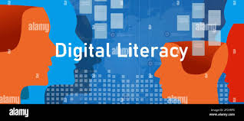

Lecturer Created By
Dr Abida Perveen Zainab Naweed
(2221255)

Task1(a):
Essential Skills for Study & Employment:
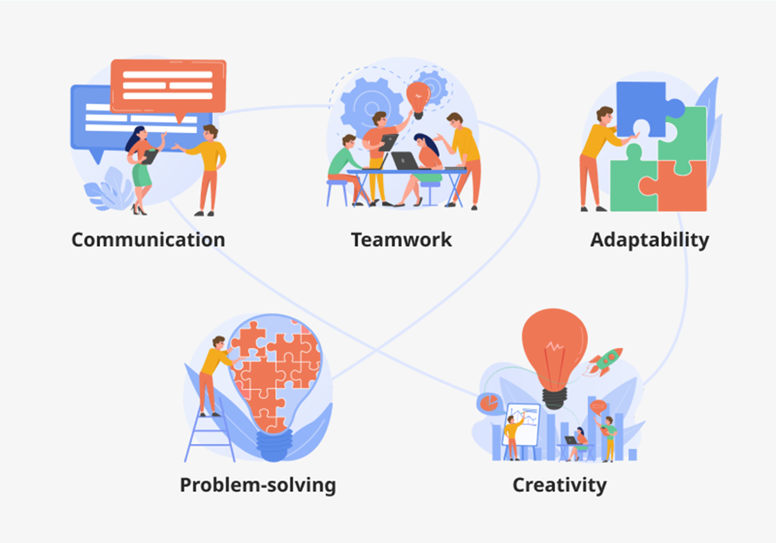
[1]
To thrive as a citizen in the 21st century we must be equipped with communication, critical thinking, and problem-solving skills. [2] As a student here at UWTSD I will be acquiring and mastering essential digital literacy skills which are required in almost every workplace.
The first and utmost important skill is Time management in the workplace and at home. Grasping the time management technique means I can organize and plan tasks in a better way which means working smarter, not harder, and it will increase my productivity and task accomplishment before deadlines and to the required levels at work which can be noticed by employers and can improve my career growth. [3]
By arming ourselves with critical thinking skills, we can connect ideas, spot errors, and instability, and identify possible solutions to make the best decisions, and it’s a great way to resolve conflicts.
In today's knowledge economy, most of our occupations require us to connect with people who aren't even in our own profession. Any firm needs effective teamwork to succeed. We collaborated as a team, and we will continue to develop this ability in later modules. Having the capacity to operate in a team will help me stand out while applying for jobs and being a team player.[4]
Written communication skills are vital in many industries, just like verbal communication skills. Each module's tasks, essays, and report writing are aiding in the development of these abilities. I will not only become a better associate but also a better leader if I keep improving my communication skills. The three ‘V’s (verbal, visual, vocal) play a significant role in making your communication effective to your recipient. (2009, pp.23) [5]
Task 1(b):

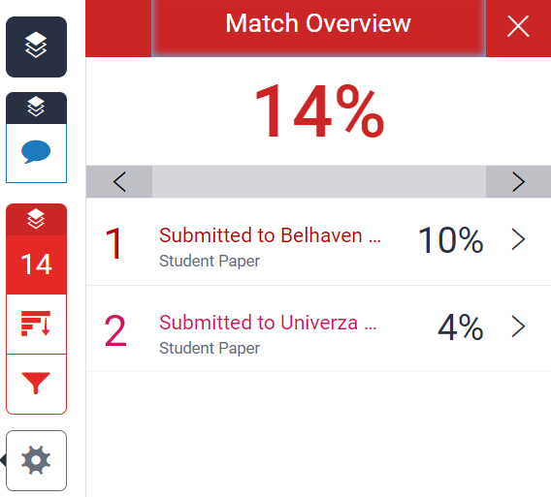

Similarity Score: 14%
One can have up to 30% similarity and mine being 14% is quite good, I still need more focus on how to work out the sentence in fewer words but in a more effective way. My similarity to the sentence I used has been published in a student paper that was submitted to Belhaven University. I will work on the sentence and paraphrase it to reduce the similarity.

Score: 65%
The reason for 65% is I believe I have done fair amount of reading and understood the concepts and tried my level best to answer the question in expected way. This is just the start, and I will be working harder to achieve more higher results in future.

Task 2:
Create an e-Portfolio:

I have created my e-portfolio in Microsoft Sway, there are other options as well you can choose from.

All the assignment tasks are in e-portfolio.
I have given the e-portfolio a heading of Learning in Digital Era, and then task 1 to 4 can be sited in further subheadings.
The link for my Sway e-portfolio is below:

https://sway.office.com/EpE0poRU0zy4HZAA?ref=Link

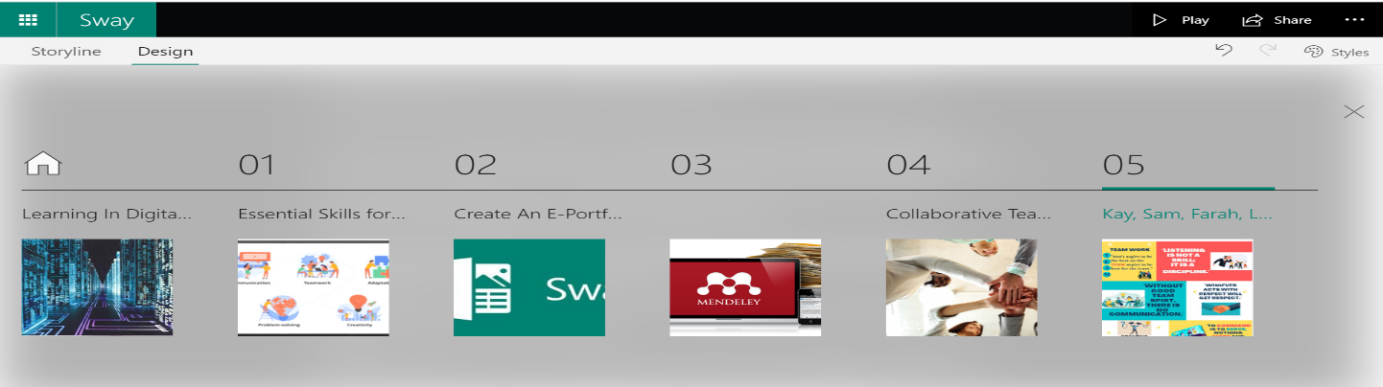

Task 3:
Automatic Referencing Tool:
For this task, I have selected Mendeley Reference Manager

Mendeley Beginner’s Guide:

Download and install the Mendeley Desktop. Create a Mendeley account.
Click the link below to download


https://www.mendeley.com/search [6]

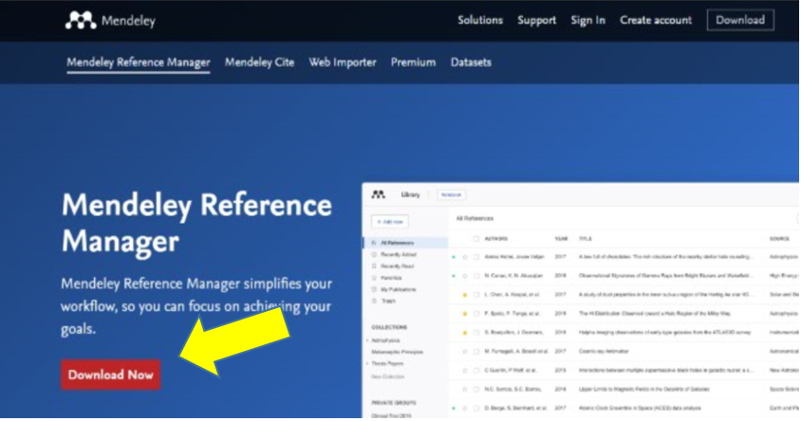

- Go to Mendeley website and create an account.
- After registering your account, click on the arrow beside your name in the upper right-hand corner.
- Click "Download" from the drop-down menu.
- Download Mendeley Desktop for Windows.
- Install using the Mendeley Desktop Installation Wizard.

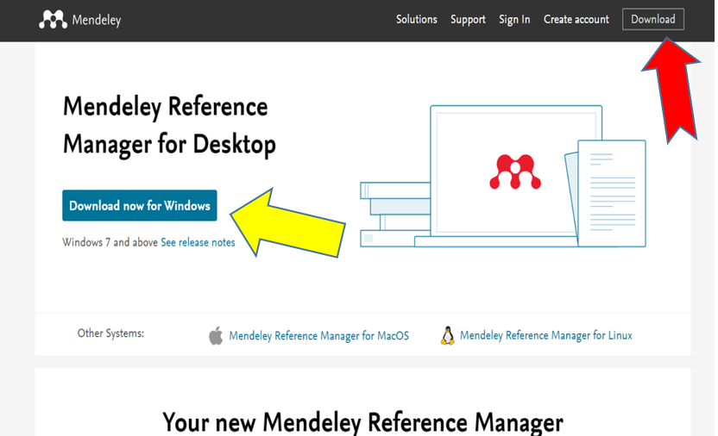

Create a Mendeley Account:

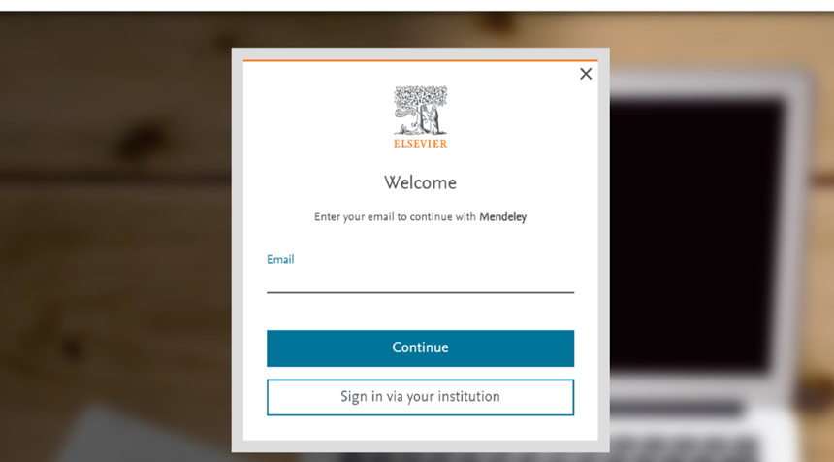

- Go to Mendeley's website to set up your free account.
- Click on Create Account (in the top, right-hand corner) and follow the steps.

You now have a Mendeley account

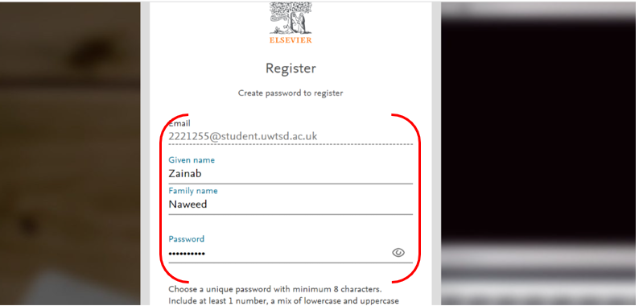

Upload PDF file in Mendeley:
There are various methods to upload files in Mendeley:
1st Method
Click Add new on left hand side of Mendeley

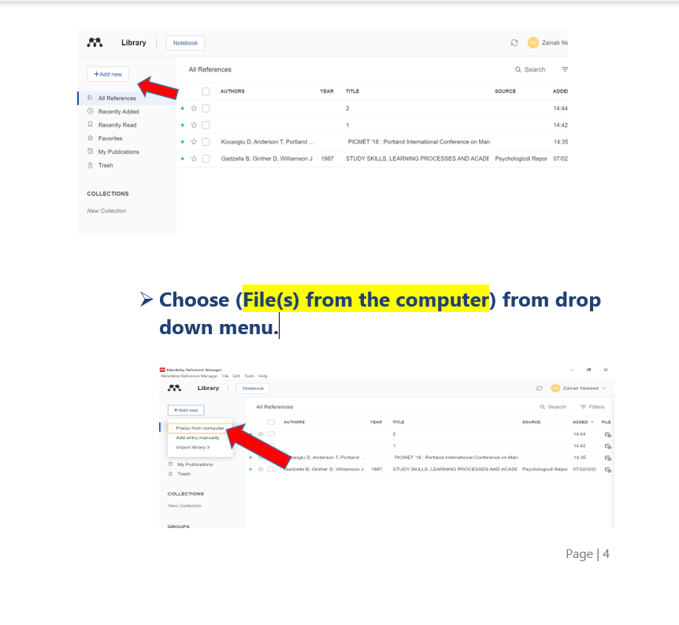

- Select file and click the Open tab.

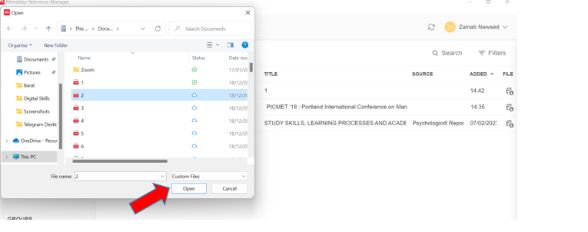

- Selected File has been uploaded in Mendeley.

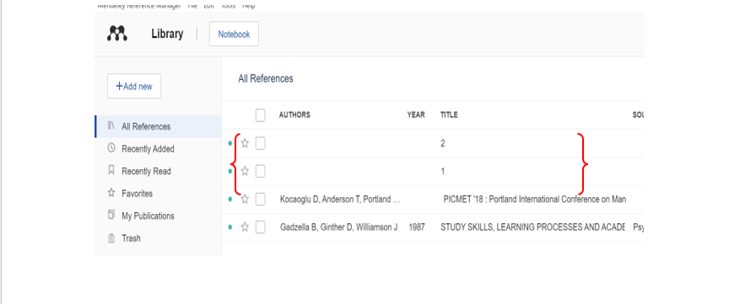

2nd Method
- Select PDF file from a website.

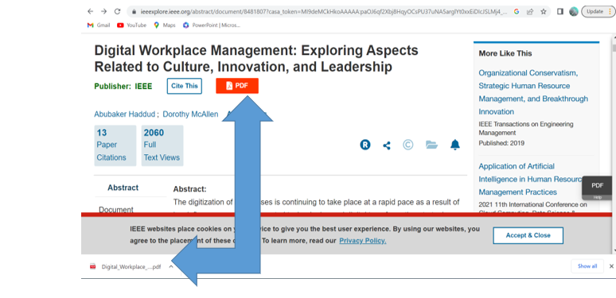

- Download and Save the PDF File.

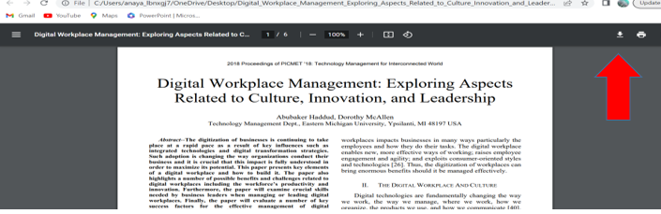

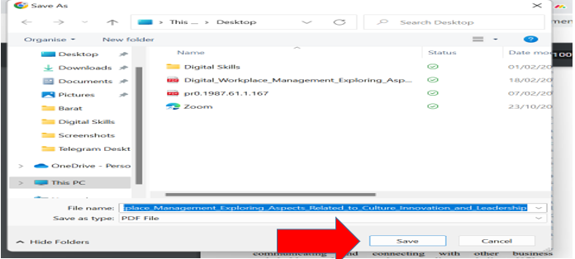
- Drag the Pdf File and drop in the Mendeley.

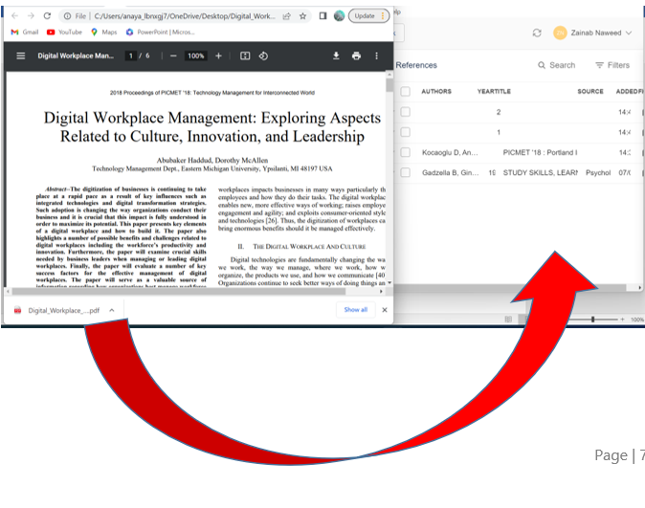

Installing Mendeley in Microsoft:
Download Mendeley Cite
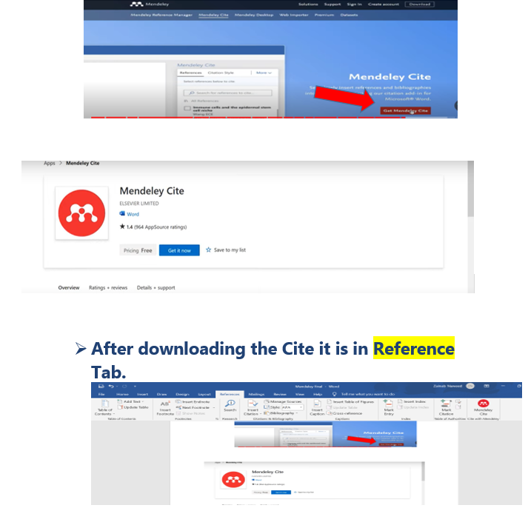
- Finally, we have Mendeley in Microsoft.
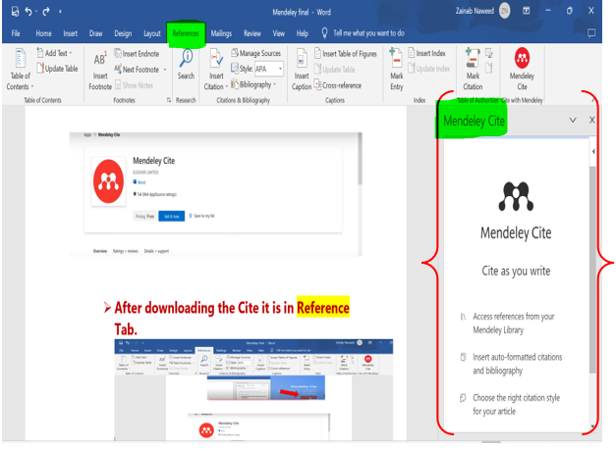

Task 4:
Collaborative Teamwork and Professional Academic poster
“LIFE IS A TEAM SPORT’’
Link for the poster:
https://www.canva.com/design/DAFdTeS0lTI/mdwnR1TSGapbcuvp747q6w/edit?utm_content=DAFdTeS0lTI&utm_campaign=designshare&utm_medium=link2&utm_source=sharebutton
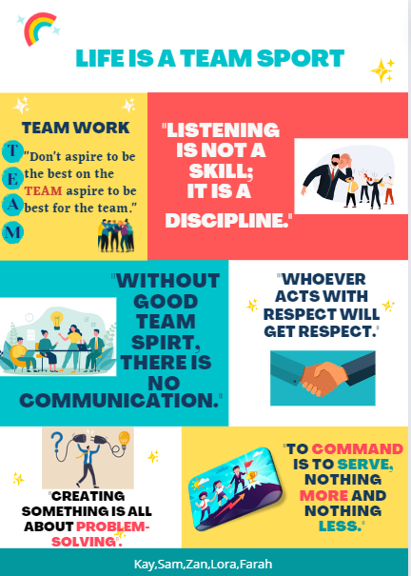
[1] Good listening [2] Communication [3] Respect [4] Problem Solving
[5] Leadership
Quotes for Poster:
‘’To command is to serve, nothing more and nothing less’’ —Andre Malraux (2022) [7]

“Whoever acts with respect will get respect.” – Rumi (2020) [8]
“Creating something is all about problem-solving.” — Philip Seymour Hoffman (2013) [9]
“Creating something is all about problem-solving.” — Philip Seymour Hoffman [10]

In this task we were 5 team members to create a poster. We had team meetings to collaborate and work as a team. My task was to collect all the information from my team and design the Poster, we communicated well and were in touch via WhatsApp for any editing in the poster. We all had to choose a key words or quote and an image for our related topic. We all participated well and shared the ideas and most relevant ideas and points were taken and approved by all members of the team. I really enjoyed working with my team. I used Canva to design the poster. [20]

Team members Name and their topics
Kulsom (Communication)
Sanam (Good Listening)
Tahmeena (Problem Solving)
Loraine (Respect)
Zainab (Leadership)

Leadership:
To be successful, one must have a strong team and a great leader.
The team leader's objective is to continue to keep the team focused by offering support and inspiration.
Northouse (2013) defined leadership as “a process whereby an individual influences a group of individuals to achieve a common goal” [18]
A great leader is the one who instead of imposing conclusions, allow members of the team to explore and create their own ideas. Great leaders not just help the team to do their job but also:
- Identify opportunities for advancement so that they can improve their abilities and grow their careers.
- Give your team the resources they need to flourish and go to the next level.
Utilizing your leadership abilities to foster an inclusive environment in which every employee views themselves as an important part of a larger picture may be a powerful motivator of team success.
An excellent leader acts as a glue to hold the team together.
Be a leader then a Boss.

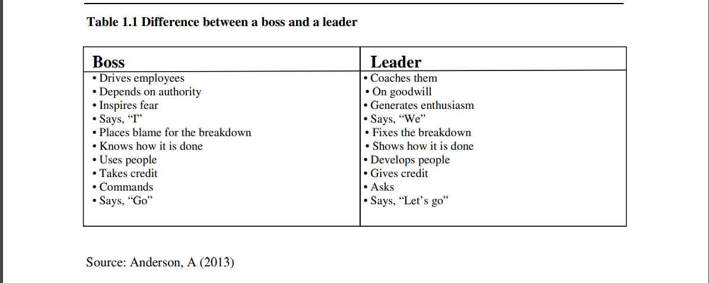[19]
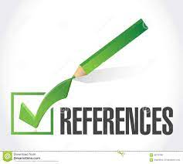

[1] Uganda JobLink (2021) Soft Skills. Available at:https://ugandajoblink.com/soft-skills/ (Accessed: 20 March 2023)
[2] Carlgren, T., 2013. Communication, critical thinking, problem solving: A suggested course for all high school students in the 21st century. Interchange, 44(1-2), pp.63-81.
[3 Eerde, W.V., 2003. Procrastination at work and time management training. The Journal of psychology, 137(5), pp.421-434.

[4] Xiao, Y., Parker, S. H., & Manser, T. (2013). Teamwork and Collaboration. Reviews of Human Factors and Ergonomics, 8(1), 55–102. https://doi.org/10.1177/1557234X13495181
[5] Sen, L., 2007. Communication skills. PHI Learning Pvt. Ltd.
[6] Mendeley (2022) I Discovery. Available at: https://www.mendeley.com/ (Accessed:20 March 2023)
[7] Malraux (2022) (https://www.quotetab.com/quote/by-andre-malraux/to-command-is-to-serve-nothing-more-and-nothing-less)
[8] Rumi (2020) (https://www.quotespad.com/50-inspirational-quotes-about-respect/)
[9] Hoffman (2013)(https://everydaypower.com/problem-solving-quotes/)
[10] Peter Drucker (2012). “Managing the Non-Profit Organization”, p.15, Routledge
[11] Pinterest (2020) Available at:https://www.pinterest.co.uk/pin/392235448789493842/ (Accessed:20 March 2023)
[12] Eficode (2022) Available at:https://www.eficode.com/blog/how-to-build-an-unbeatable-team-spirit (Accessed: 20 March 2023)
[13] Leadership https://www.freepik.com/free-photos-vectors/leadership-cartoon
[14] Career news (2022) Available at: https://synnexfpt.com/en/listening-skills-and-examples-of-effective-listening-in-the-workplace/ (Accessed: 20 March 2023)
[15] Insperity (2020) Available at:https://www.insperity.com/blog/trust-and-respect-in-the-workplace/ (Accessed: 20 March 2023)
[16] Tariq Chohan (2021) Available at: https://www.entrepreneur.com/en-ae/growth-strategies/effective-communication-in-business-needs-much-more-than/399455 (Accessed: 20 March 2023)
[17] Fred Wilson (2022) Available at: https://everydaypower.com/problem-solving-quotes/ (Accessed: 20 March 2023)
[18] Mikkelson, A.C., York, J.A. and Arritola, J., 2015. Communication competence, leadership behaviors, and employee outcomes in supervisor-employee relationships. Business and Professional Communication Quarterly, 78(3), pp.336-354.
[19] Muteswa, R., 2016. Qualities of a good leader and the benefits of good leadership to an organization: A conceptual study. European journal of business and management, 8(24), pp.135-140
[20] Canva (2023) Canva. Available at: https://www.canva.com/templates/ (Accessed: 15 March 2023)

