

Operating Systems:
CLI commands and Basic Scripts

Module Name: Computer Architecture and Operating Systems
Module Code: ACCA4022
Student Name: Beniamin Markiewicz
Student ID: 2513687
Lecturer Name: Md Shantanu Islam

Submission date: 26/03/2026

Contents
Introduction 4
Key functions of general Operating Systems 4
Task Management: 5
Application/Program Management: 6
File/Directory Management: 7
Device Management: 8
Security Management: 9
Use of Windows OS CLI commands 10
Example 1: dir 10
Example 2: cd 11
Example 3: mkdir 12
Example 4: date 13
Example 5: echo 13
Example 6: tasklist 14
Example 7: systeminfo 15
Example 8: ipconfig /all 16
Example 9: ping 17
Example 10: tracert 18
Use of Linux OS CLI commands 19
Example 1: su 19
19
Example 2: pwd 20
Example 3: ls 20
Example 4: cd 21
Example 5: mkdir 21
Example 6: rmdir 22
Example 7: touch 22
Example 8: echo, cat 23
Example 9: ifconfig 24
Example 10: date, whoami 25
Use of Windows OS scripts 26
Example Script 1: 26
28
Example 2: 30
Use of Linux OS scripts 33
Example 1: 33
Example 2: 34
Conclusion 36
References 37
Appendices 39
1.1 39
1.2 40

Introduction
This paper contains information about common operating systems such as Linux and Windows and explain how they differ from each other in functionality and programming languages that can be used within them.
It will also cover CLI (Command Line Interfaces), for example, “mkdir”, “cd”, “touch” etc. It will provide instructions on how to use given commands and explain their usage. Programming languages that will be covered are BASH for Linux and BATCH for Windows. In addition to that there will be explanation for scripts for both Linux and Windows and their implementation with accompanying screenshots for clarity.

Key functions of general Operating Systems
The first full Windows operating system was released in 1995 called “Windows95” by Microsoft [1], it featured an improved GUI (graphical user interface) that differed that from Windows 1.0. It had functions like a taskbar, file manager and shortcuts that were placed on the desktop where users could find other programs that were installed [2].

Task Management:
Task manager in Windows lets users see which processes are currently running. As seen in the screenshot below task manager splits processes in different categories such as applications and background processes which lets users distinguish between them. From there users can choose to stop processes, open file directories from where the process is running or, for example, switch them to efficiency mode [3].
In addition to that users can see how much CPU (Central processing unit) power, memory, disk and network a given process is using at this time.

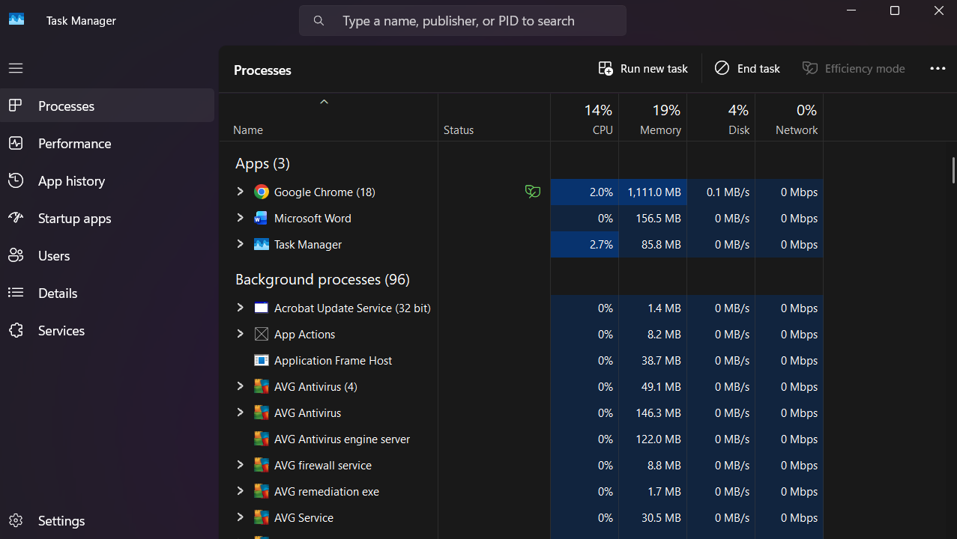
Figure 1: Task Manager Window

Application/Program Management:
In Windows users can view their installed applications in “Installed Apps” tab, additionally this tab will let users uninstall applications and view where the application is installed [4]. “Installed Apps” tab also lets users know the version of different applications, when the application was installed and its size. It does this by creating a list of said applications and putting them in alphabetical order.

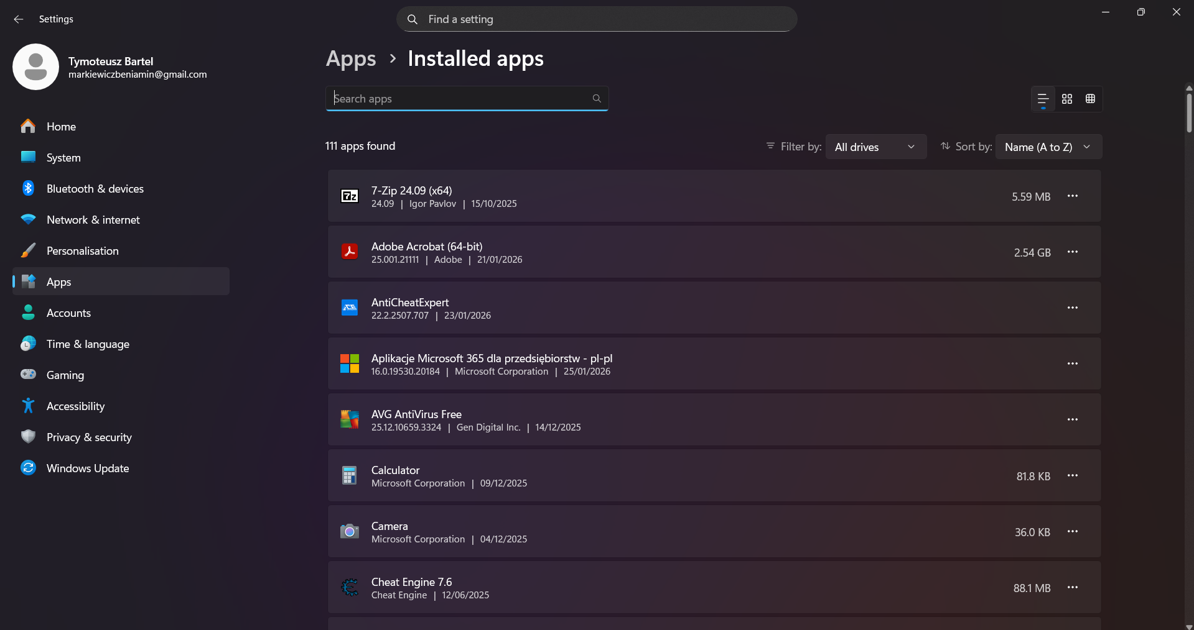
Figure 2: Application Management

File/Directory Management:
File/Directory management in Windows is called “File Explorer” in which users can browse, select, delete and copy files. They can also select and run different programs or scripts; it lets users quickly traverse between different directories. In the screenshot below it is shown that on the left-hand side users can see a list of directories, in this case folders, to choose from. This tab contains most used directories and automatically highlights them for the user. In the centre of the window, we can see “Devices and Drives” which lets users see what drives and devices are connected to their computer, users then can move between directories by double clicking on them [5].

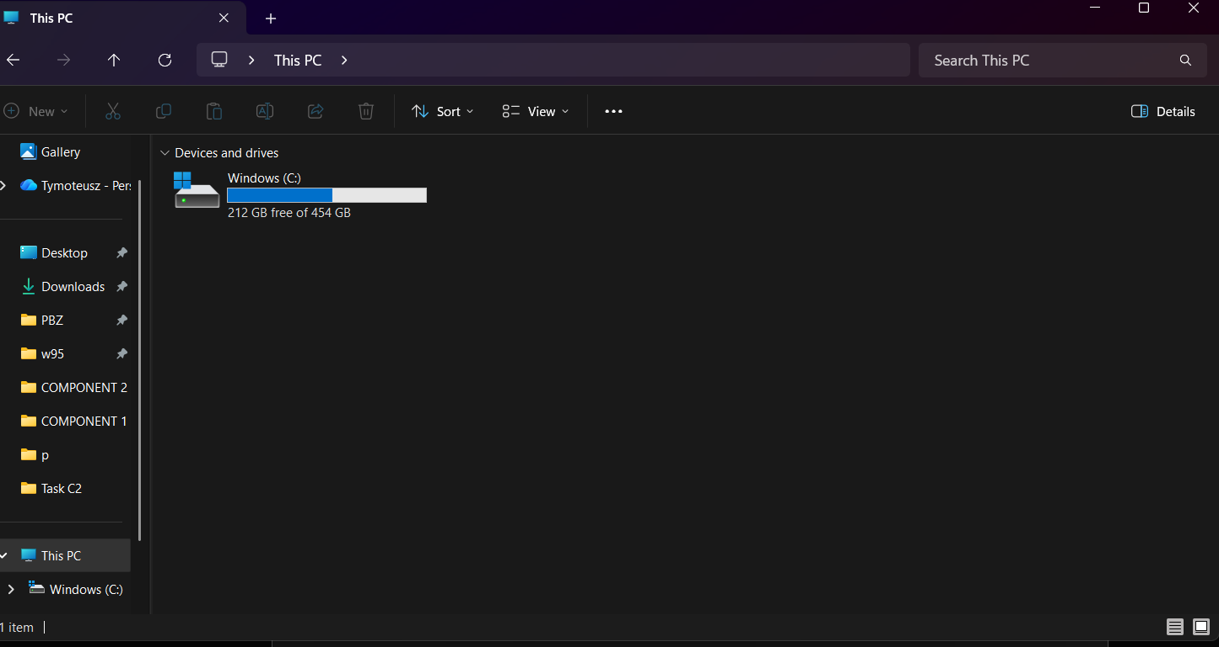
Figure 3: File Explorer

Device Management:
Device Manager in Windows lets users view what devices are connected to the computer, there are many categories of devices that the computer distinguishes, for example, keyboards, mice, monitors, disk drives and audio inputs and outputs [6].
From there users can choose to check drivers of the connected device, uninstall the device or disable it. In addition to that it lets users check properties of different devices such as, device type and manufacturer. It is especially useful for managing multiple devices from the same window.

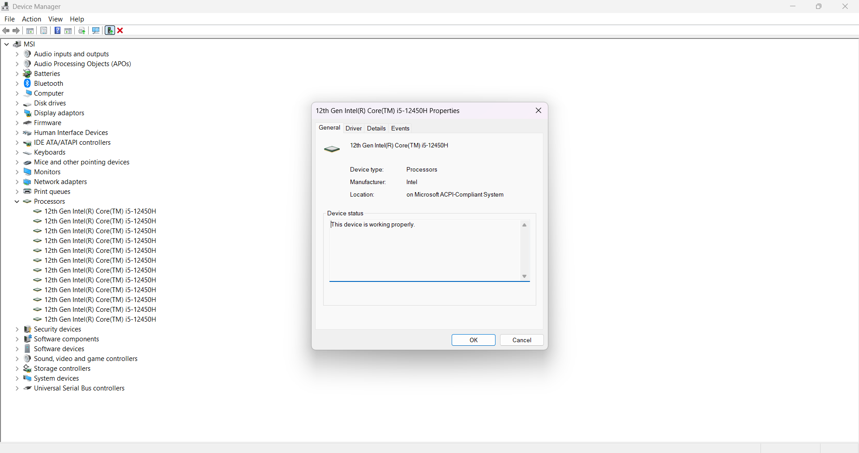
Figure 4: Device Manager

Security Management:
Windows Security lets users view current security measures that come with Windows but also security programs that are installed by the user. It allows users to view and configure settings for security, disable, or update them [7].
From there users can choose which category they would like to view, for example, “Account protection” or “Virus & threat protection”. The current state of protection is shown by either a green checkmark a red cross, or a yellow warning sign indicating that the system has either insufficient or sufficient protection as shown in the screenshot below:

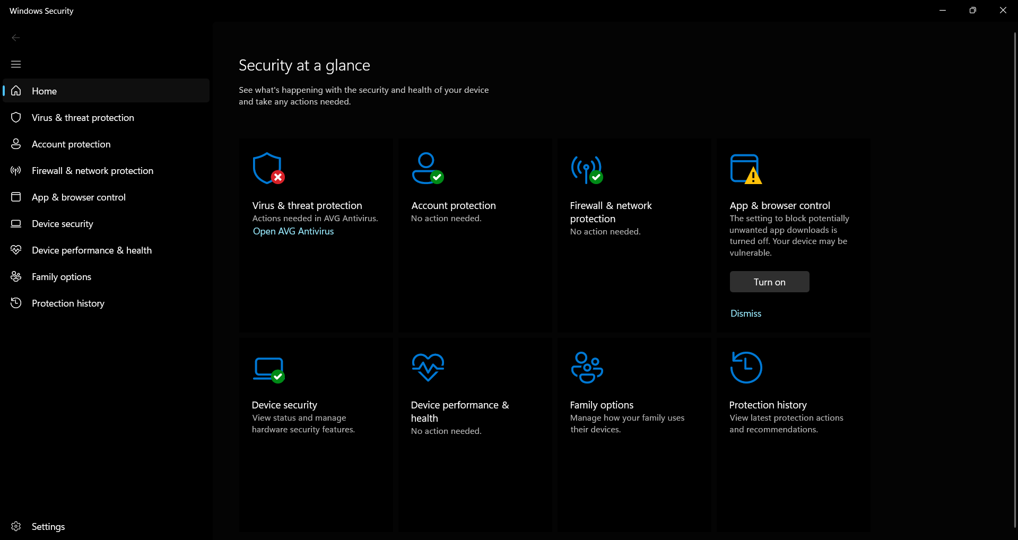
Figure 5: Security in Windows

Use of Windows OS CLI commands
Command line interface in Windows lets users communicate with their computer or different applications installed on the computer [8]. It also has potential to automate various tasks through scripts. There are many useful commands that let users interact with the operating system and create scripts [9].

Example 1: dir
The “dir” command lets users see the content of the directory they are currently I, along with the name of the other directories, files and programs that exist within that space. It also shows users the date at which the directory/file was modified.
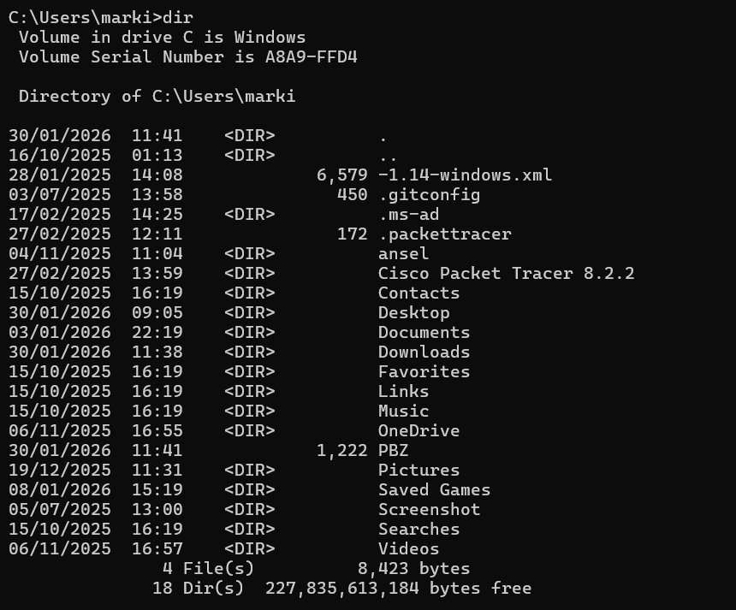
Figure 6: dir

Example 2: cd
This command lets users go from one directory to another, for example, in the figure below the “cd” command is entered followed by the name of the directory the user would like to access. In the figure below the user is seen accessing directory called “Documents” and then entering “. .” which is a command to quickly access the previous directory.
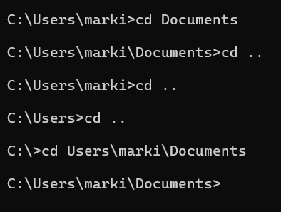
Figure 7: cd

Example 3: mkdir
This command lets users create directories, in the figure below it is shown that “mkdir” command is typed in followed by the name of the directory that is being created. After that users can check if their directory was created with the “dir” command. In the figure below directory named “goal” was created followed by the creation of the directory named “goal goal”.

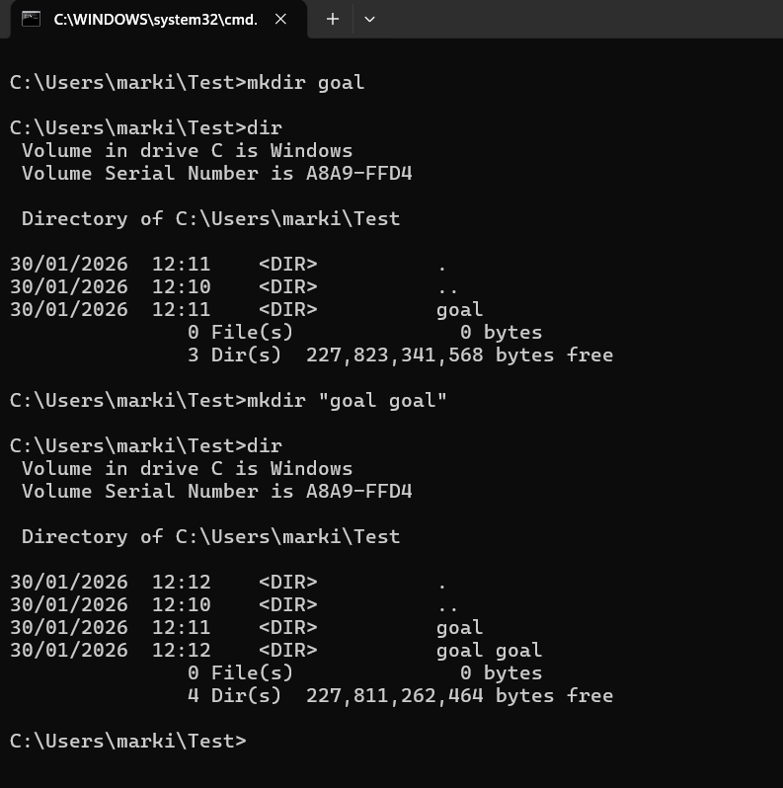
Figure 8: mkdir

Example 4: date
This command lets user check the current date that is set on their computer. In addition, users can also set a new date that will be used by the computer, as seen in the figure below:

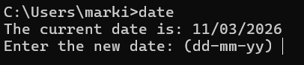
Figure 9: date

Example 5: echo
This command lets users display messages, for example, typing in “echo alien” will display “alien” as the message. In addition to that users can create text files that will display their message. As shown in the figure below, the user created a text file and indicated that it will display “wafala alien” in the file.

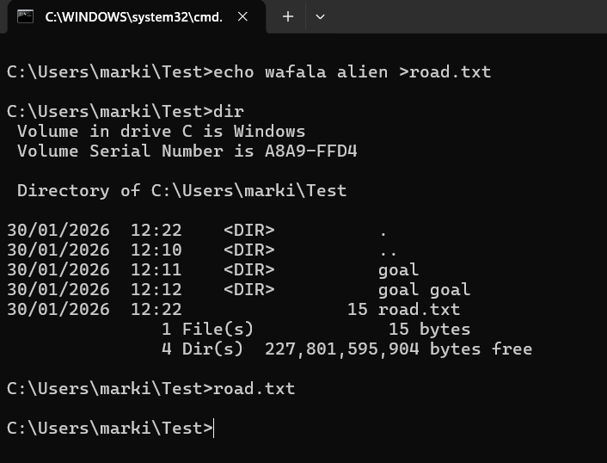
Figure 10: echo

Example 6: tasklist
This command lets users see what processes are running on their computer, along with their name, type, ID and memory usage, as shown in the figure below:

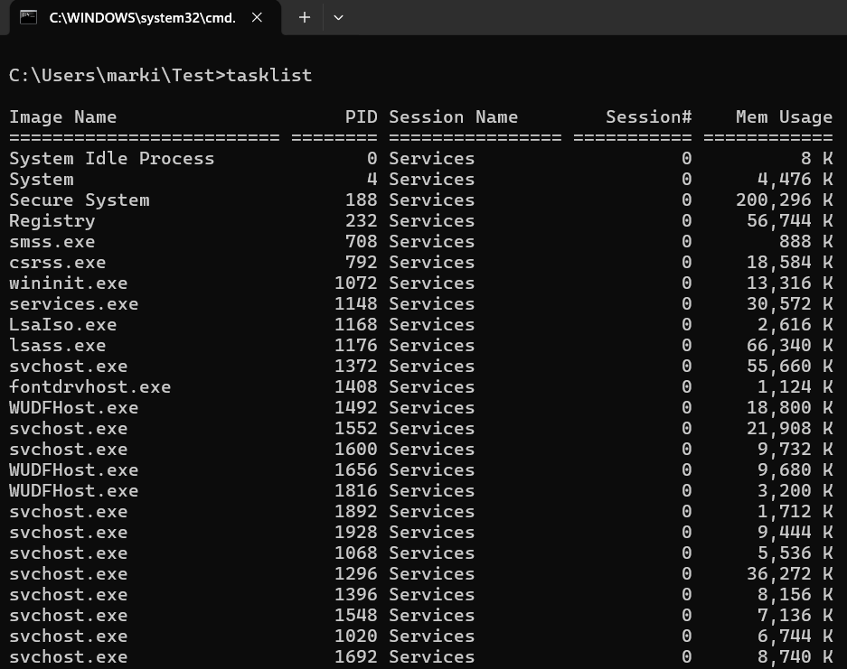
Figure 11: tasklist

Example 7: systeminfo
This command lets users see information about their machine and operating system, for example, OS name, version and manufacturer, the owner of the machine, ID of the machine and system type as shown in the figure below:

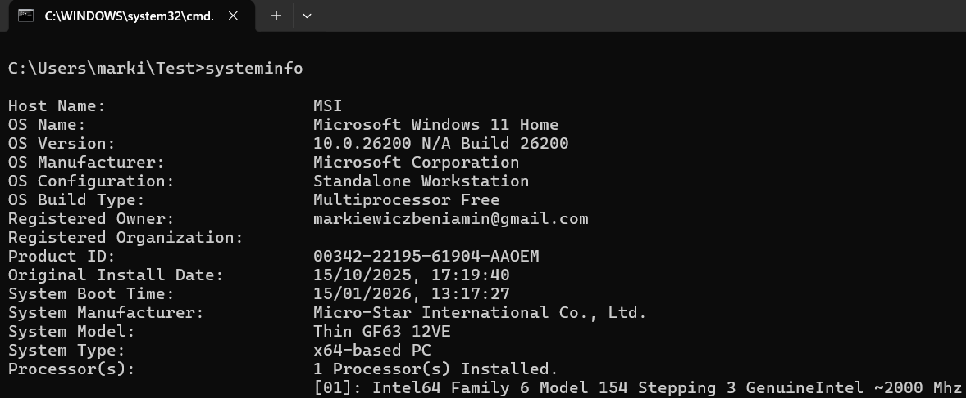
Figure 12: systeminfo

Example 8: ipconfig /all
This command lets users see their network connection, host name, their IPv4 and IPv6 addresses along with their physical address and their subnet mask, as seen in the figure below.

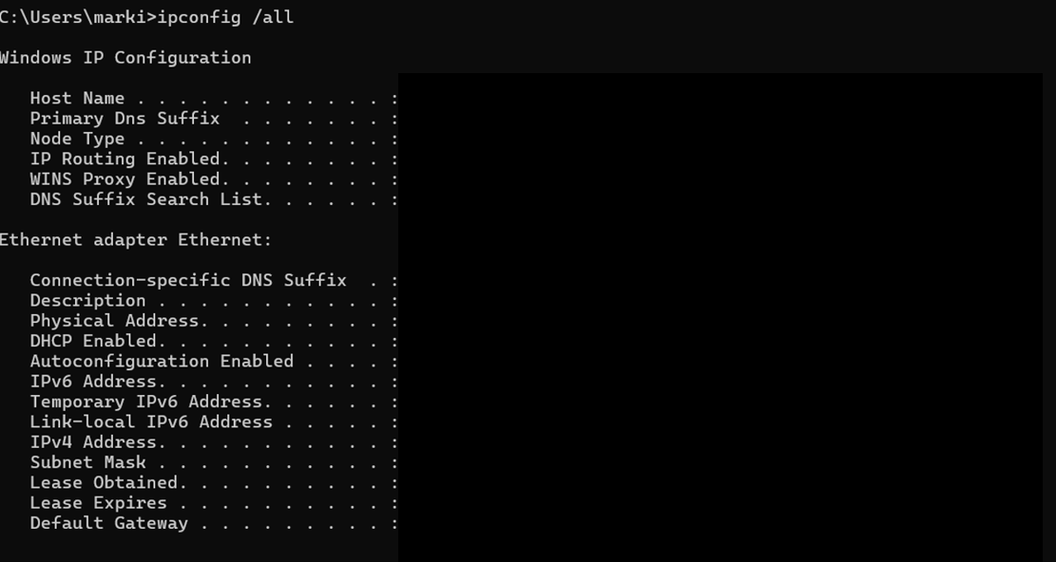
Figure 13: ipconfig /all

Example 9: ping
This command lets users send packets to another user or server to check the internet connection or to see if the server is responding. As shown in the figure below the user is sending packets to the address named “www.google.com” and the server is replying to the user. Other information that is shown below includes how many packets were sent, in this case it is four, and long it took for server to respond in milliseconds.

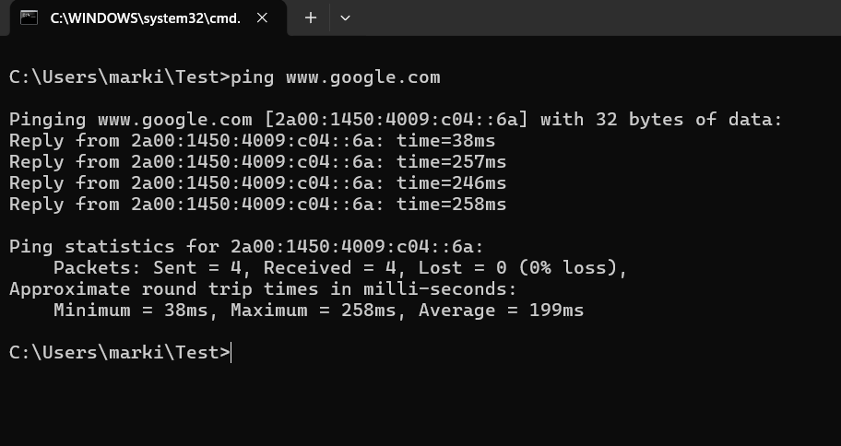
Figure 14: ping

Example 10: tracert
This command lets users track the path that an IP packet takes when connecting with an online address, in the figure below it is shown that it takes one packet seventeen hops of travel to arrive at its destination.

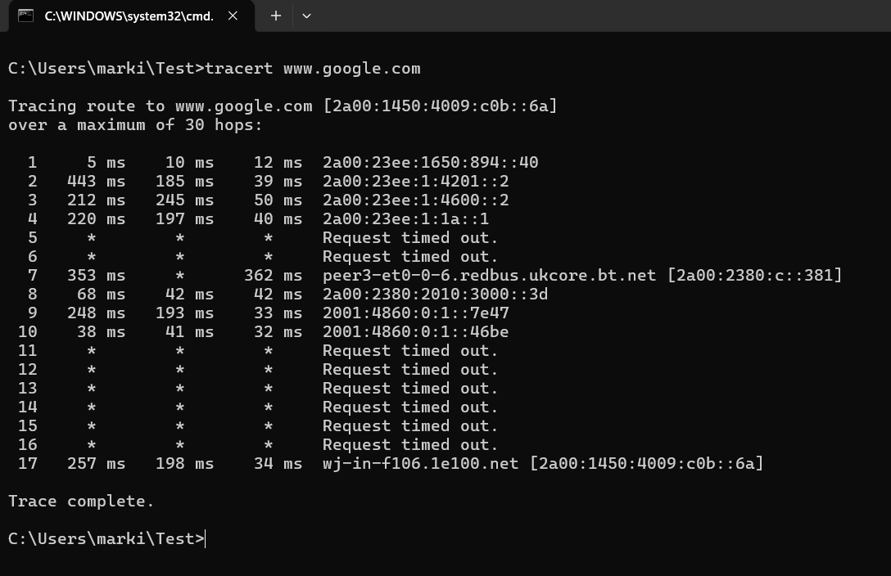
Figure 15: tracert

Use of Linux OS CLI commands
Linux provides users with multiple different shells to use from, one of them being BASH (Bourne Again Shell) which lets users automate tasks and do multiple actions quickly [10].
Just like in Windows, Linux provides many commands that are useful for automation or remote access.[11] (This paper will focus on providing information about BASH applications as shown in the figures below.)

Example 1: su
This command lets users log in to a different user account and use privileges from that account. As shown in the figure below a user logs in to a root account which lets them access any user account remotely without a password.

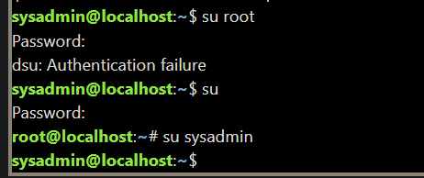

Figure 16: su

Example 2: pwd
This command lets users check which directory they are currently in. As shown in the figure below the user inputs the command and receives an output in a form of his current position in the directory.

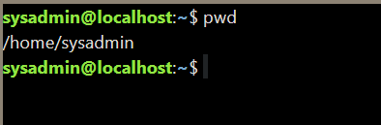
Figure 17: pwd

Example 3: ls
As shown in the figure below, this command is very similar to the one in the Windows CLI as it lets users list files/directories that can be accessed from the current directory. Additionally, if the “-l” operator is inputted along with the “ls” command, the output will be in a longer form, and users will receive more information about the files/directories they are viewing.
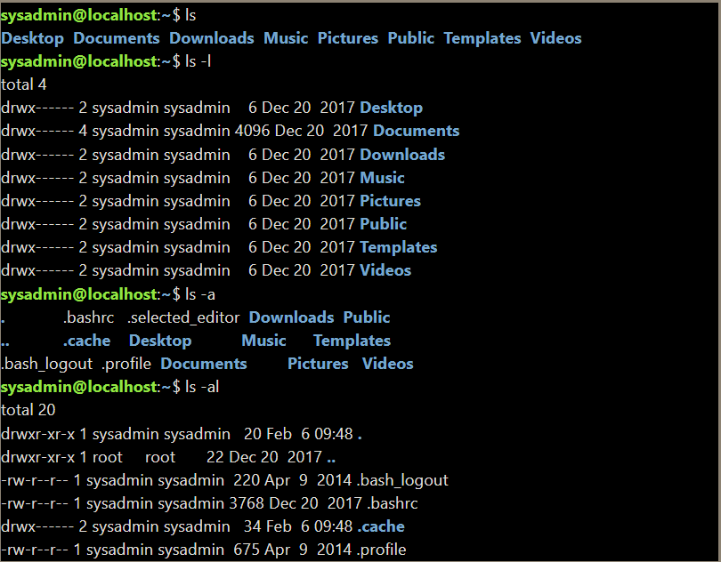
Figure 18: ls

Example 4: cd
This command lets users access the directory they wish to interact with. In the figure below the user inputs the command “cd Desktop/” and is moved to that directory.


Figure 19: cd

Example 5: mkdir
Similarly to Windows CLI, this command is used to create directories with a specific name. in the figure below the user inputs the command “mkdir goal” and then using the command “ls” can check that the directory named “goal” was indeed created.

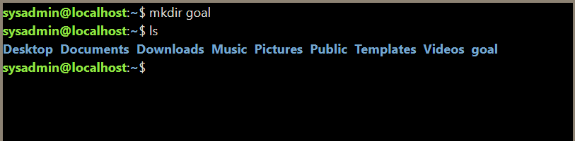
Figure 20: mkdir

Example 6: rmdir
This command is used to remove a specified directory, in the figure below the user removes a directory named “goal” that was previously created.

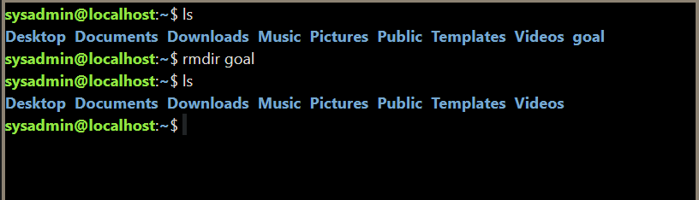
Figure 21: rmdir

Example 7: touch
This command lets users create text files with a given name, in the figure below the user creates a file named “goal” by inputting “touch goal.txt”. Note that the user also specifies the file extension by adding “.txt” at the end of the name.

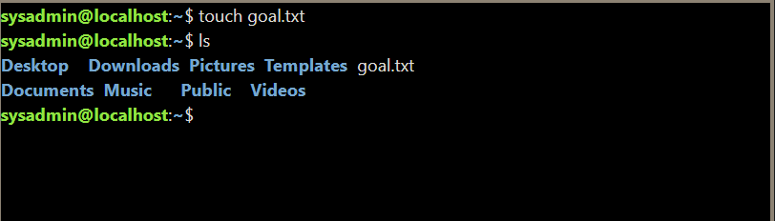
Figure 22: touch

Example 8: echo, cat
The “echo” command is used to create a text file with a printed message inside it. In the figure below the user creates a text file named “goal” with the message “goal alien” inside it. Then the user uses the “cat” command to read the text file he just created without opening it on the desktop.

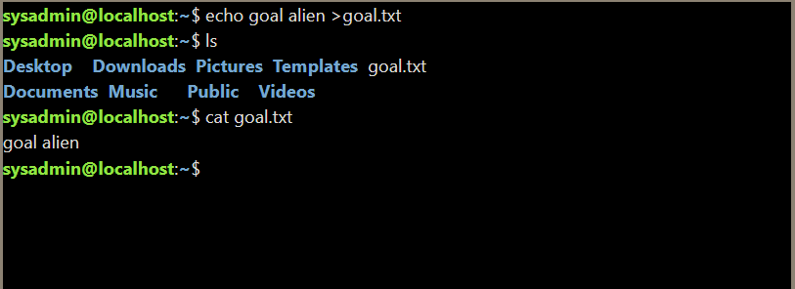
Figure 23: echo, cat

Example 9: ifconfig
This command is very similar to the “ipconfig” command in Windows CLI, it shows the information about users’ network like their IP address or their hardware address. In the example in the figure below that the user inputs the command and the output provides information about the network.

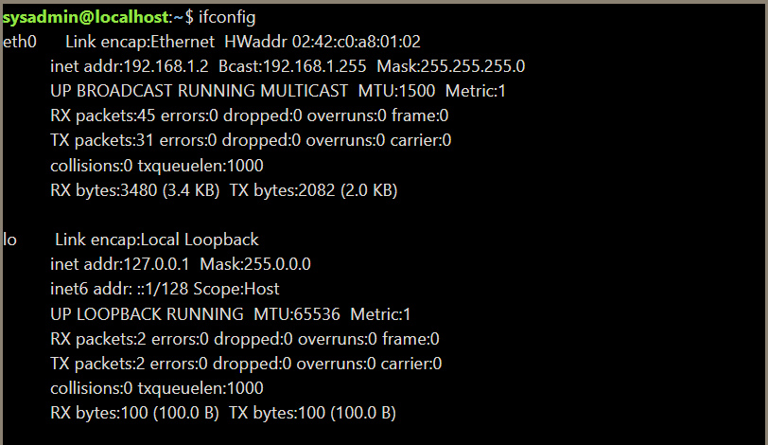
Figure 24: ifconfig

Example 10: date, whoami
The “date” command allows users to check the current date and time that the system is set to. The “whoamI” command lets users which account they are currently logged in on, as illustrated in the figure below:

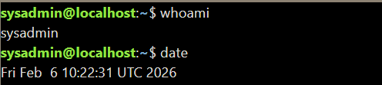
Figure 25: date, whoami

Use of Windows OS scripts
Windows scripts can provide automation to many tasks that a user might find tedious, as well as improving the overall efficiency of their work [12]. Many of those scripts are designed for IT tasks and problems but it is still viable to use scripts in Windows to automate tasks outside of the IT sectors, for example, to skip entering the same data into a form in an office position [13]. Note that this paper will focus on scripts written in BASH for Linux and BATCH for Windows as shown in the examples below:

Example Script 1:
This example script is written in BATCH, the figure below shows the first part of the script for a simple calculator that includes addition, subtraction, multiplication, and division. This is done by using the “echo” command which display the message typed after it. The user will be presented with those four options and will have to input the corresponding letter from A to D.
The variable “X” is to be set by the user indicated by the “/p” operator which means that depending on the letter the user inputs it will transfer them to that section. In addition to that the user will also have to set both variables named “alpha” and “beta” for the calculator to output the answer.

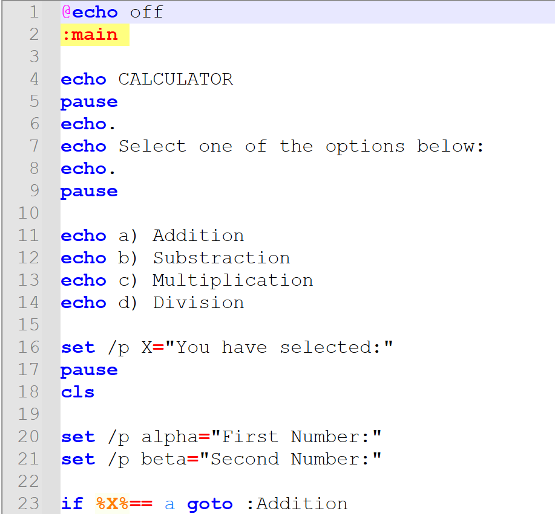
Figure 26: Example Script 1
There are five sections included in the code:
- Main
- Addition
- Subtraction
- Multiplication
- Division
Depending on the letter that the user chose the script will transfer the user to that section. This is done by the command “if %X%== goto :Addition”. Depending on the options that was chosen the equation will change, the figure below gives us an example of this. Line sixty-five indicated that a new variable has been set, but in this case, it is a variable that is calculated by the script instead of the user indicated by the “/a” operator.
After the user inputs the first and second numbers the script then calculates the total variable named “total”, after that the output of the equation is displayed for the user with the “echo %total%” command, after which the script will automatically return to the “Main” section of the script and can again choose a different type of equation.

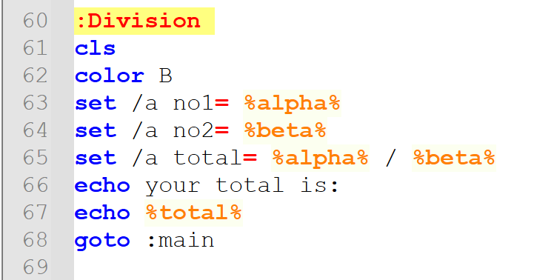
Figure 27: Example Script 1- Division Section

It is also important to add that at the start of every section there is a “cls” command that clears the entire screen, which helps to keep the screen clear and clutter-free.

The output of the code written is illustrated in the figures below:

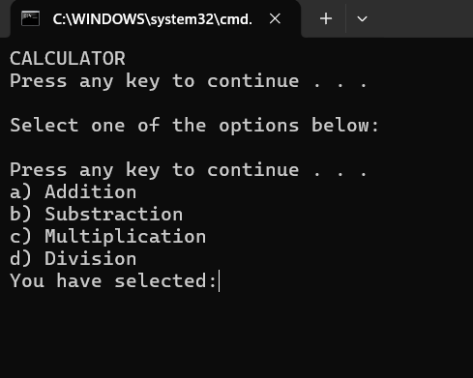
Figure 28: Example 1 Output

The user is prompted to input the first and second number:

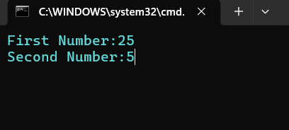
Figure 29: Example 1 Output Continued

The user is then given an answer, and the script goes back to the “Main” section:

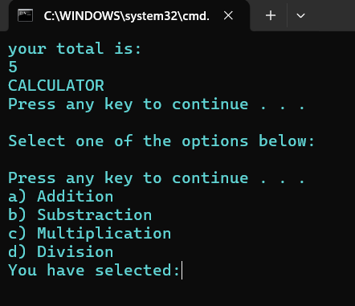
Figure 30: Example 1 Output Final

Example 2:
This example script calculates the money that is owed to a contractor for their hours worked.
The variables that are set by the user are named “HoursWorked” and “Pay”, which indicates the user to input how many hours they have worked and how much do they earn. After the input the script automatically calculates the pay that is owed by doing an equation- “%Pay% * %HoursWorked%” (“*” stands for multiplication) and provides the variable “Total” which is the answer and is set before the equation by the command “set /a Total= %Pay% * %HoursWorked%”.

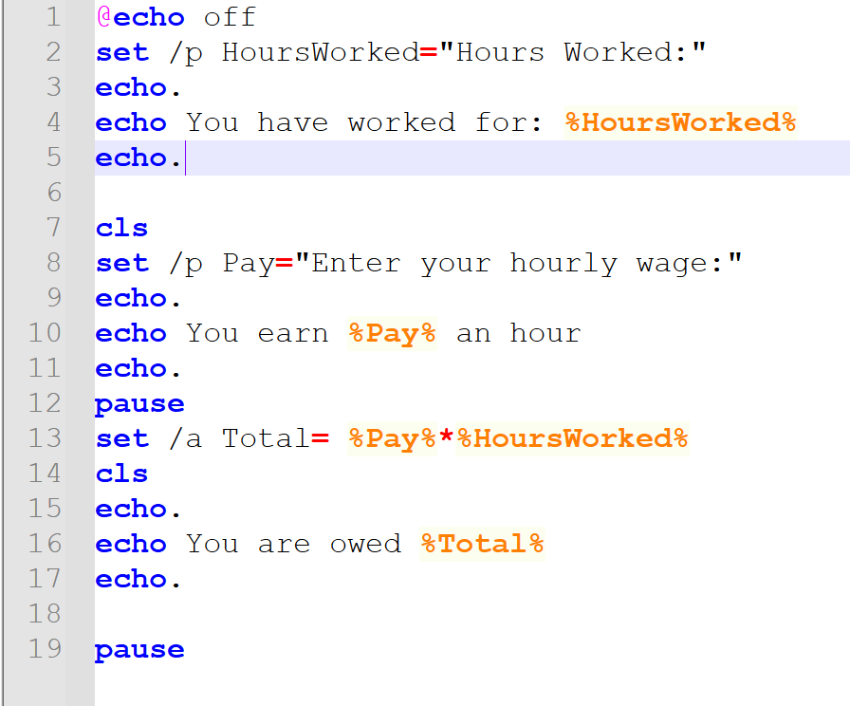
Figure 31: Example 2 Code

In the output of the code seen above, in the first step the user is prompted to input how many hours have they worked:

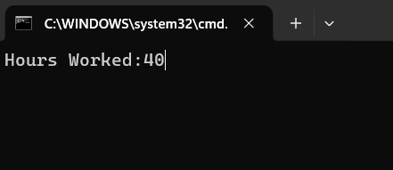
Figure 32: Example 2 Output

After this step the user is prompted to input their hourly wage:

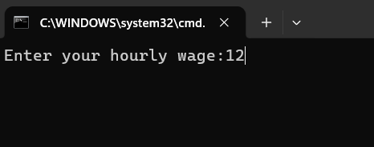
Figure 33: Example 2 Output Continued

Then the script automatically calculates how much money the contractor is owed:

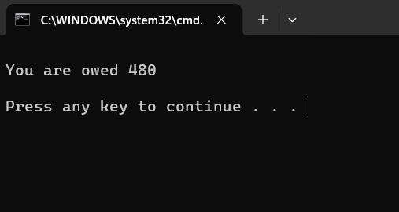
Figure 34: Example 2 Output Final

It is important to note that BATCH is unfortunately unable to process floating point numbers (e.g. 1.2, 35.6 etc.) Therefore, to do this it would be necessary to use external programs or a different command line such as PowerShell.

Use of Linux OS scripts
Just like Windows scripting, BASH also can be used to automate processes, it is also used to this day, unlike BATCH which is considered a legacy technology [14]. BASH also contains many useful commands and shortcuts to help users automate processes [15].

Example 1:
This script is a simple calculator that calculates multiplication of only two numbers. First the command “echo” is used to display a message to the user prompting them to input the first value and setting the variable named “num1” using the command “read” for the number that must be typed in by the user. After that a variable named “total” is set by using the command “total=$((num1*num2))” which means that the system will automatically calculate this number when the user inputs all the values. Finally, an “echo” command is used again to display the calculated number. The final product looks like this:

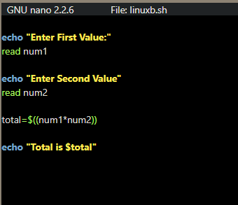
Figure 35: Example 1 Linux - Code

The output of the code will first prompt the user to input the first value and then the second one, the system will then calculate the answer and display it for the user. What the user would see is demonstrated in the figure below:

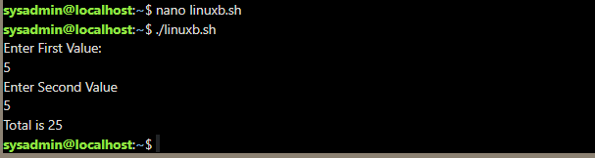
Figure 36: Example 1 Linux- Output

Example 2:
This script demonstrates how loops can be used in scripts to avoid inputting the same information again, instead the user will receive more answers but inputting the same number of values. First “echo” is used to display and prompt the user to input the fist number then “read” is used to set a variable “num”. For the loop to be created “for” command is used, after the command parameters are set inside the double bracket. “k” is set as a variable in this case that the loop starts at number 1, second parameter means that the loop should stop at the number 20 which is indicated by the “k<=20” command, finally the third parameter is set to increase by 1 every loop indicated by the “k + +”.

After that command “result=$((num / k ))” is used to set what kind of calculation the system is going to perform, in this case it is dividing “num” (set by the user) by “k” (set by the system). Finally, the result is displayed by the use of the “echo” command:
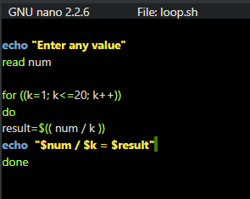
Figure 37: Example 2 Linux- Code

When the script is started it prompts the user to enter any value, after that the system calculates the answer and divides, in this case 20, by every number through 1 to 20:

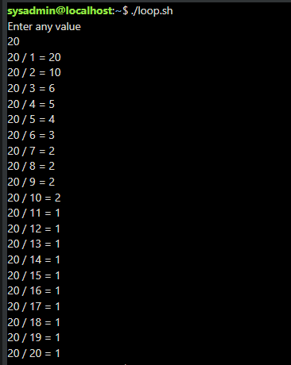
Figure 38: Example 2 Linux- Output
Just like BATCH, BASH cannot calculate floating point numbers, so the remainder is unfortunately lost during the division because the system automatically rounds it up.

Conclusion
In conclusion there are many similarities between both Linux and Windows operating systems, but both can be equally used to enhance the user’s experience from simply opening files to writing complex scripts that will help them automate some aspects of their work. Both BASH and BATCH have many applications when automating tasks and contain hundreds of commands that will be useful to many users even if they are not in an IT environment.

References
[1] A. Moumina, "History of operating systems," 2001
[2] Microsoft. "Operating systems (OS) explained." www.microsoft.com. Accessed: 18/03 2026. [Online]. Available: https://www.microsoft.com/en-us/windows/learning-center/operating-systems-os-explained
[3] Microsoft. "Task Manager- Inside Show." learn.microsoft.com. Accessed: 18/03 2026. [Online]. Available: https://learn.microsoft.com/en-us/shows/inside/task-manager
[4] Microsoft. "Uninstall or remove apps and programs in Windows." support.microsoft.com. [Online]. Available: https://support.microsoft.com/en-us/windows/uninstall-or-remove-apps-and-programs-in-windows-4b55f974-2cc6-2d2b-d092-5905080eaf98
[5] Microsoft. "File Explorer in Windows." support.microsoft.com. Accessed: 18/03 2026. [Online]. Available: https://support.microsoft.com/en-gb/windows/file-explorer-in-windows-ef370130-1cca-9dc5-e0df-2f7416fe1cb1
[6] Lenovo Group Limited. "What is a device manager?" www.lenovo.com. Accessed: 18.03 2026. [Online]. Available: https://www.lenovo.com/gb/en/glossary/device-manager/
[7] IAS (Institute for Advanced Study). "Getting Started with Windows Security and Windows Defender." www.ias.edu. Accessed: 18.03 2026. [Online]. Available: https://www.ias.edu/security/getting-started-with-windows-security-windows-defender
[8] Dell Technologies. "Windows Command Prompt Information and How to Use Its Commands List." www.dell.com. Accessed: 18/03 2026. [Online]. Available: https://www.dell.com/support/kbdoc/en-uk/000130703/the-command-prompt-what-it-is-and-how-to-use-it-on-a-dell-system
[9] Microsoft. "Windows Commands." learn.microsoft.com. [Online]. Available: https://learn.microsoft.com/en-us/windows-server/administration/windows-commands/windows-commands
[10] V. Baranwal. "Bash Explained: How the Most Popular Linux Shell Works." www.digitalocean.com. Accessed: 18.03 2026. [Online]. Available: https://www.digitalocean.com/community/tutorials/what-is-bash
[11] Canonical Ltd. "The Linux command line for beginners." ubuntu.com. Accessed: 18.03 2026. [Online]. Available: https://ubuntu.com/tutorials/command-line-for-beginners#4-creating-folders-and-files
[12] Mossé Cyber Security Institute. "Native Scripting Tools in Windows: Should You Use Powershell?" library.mosse-institute.com. Accessed: 18.03 2026. [Online]. Available: https://library.mosse-institute.com/articles/2022/05/native-scripting-tools-in-windows-should-you-use-powershell/native-scripting-tools-in-windows-should-you-use-powershell.html#:~:text=All%20commands%20accessible%20at%20the,and%20automate%20actions%20more%20effectively.
[13] Coursera Staff. "What Are Scripting Languages? (And Why Should I Learn One?)." www.coursera.org. Accessed: 18.03 2026. [Online]. Available: https://www.coursera.org/articles/scripting-language
[14] Z. Hira. "Shell Scripting for Beginners – How to Write Bash Scripts in Linux." www.freecodecamp.org. Accessed: 18.03 2026. [Online]. Available: https://www.freecodecamp.org/news/shell-scripting-crash-course-how-to-write-bash-scripts-in-linux/
[15] J. Hall. "How I use Bash to automate tasks on Linux." opensource.com. Accessed: 18.03 2026. [Online]. Available: https://opensource.com/article/22/7/use-bash-automate-tasks-linux

Appendices

1.1
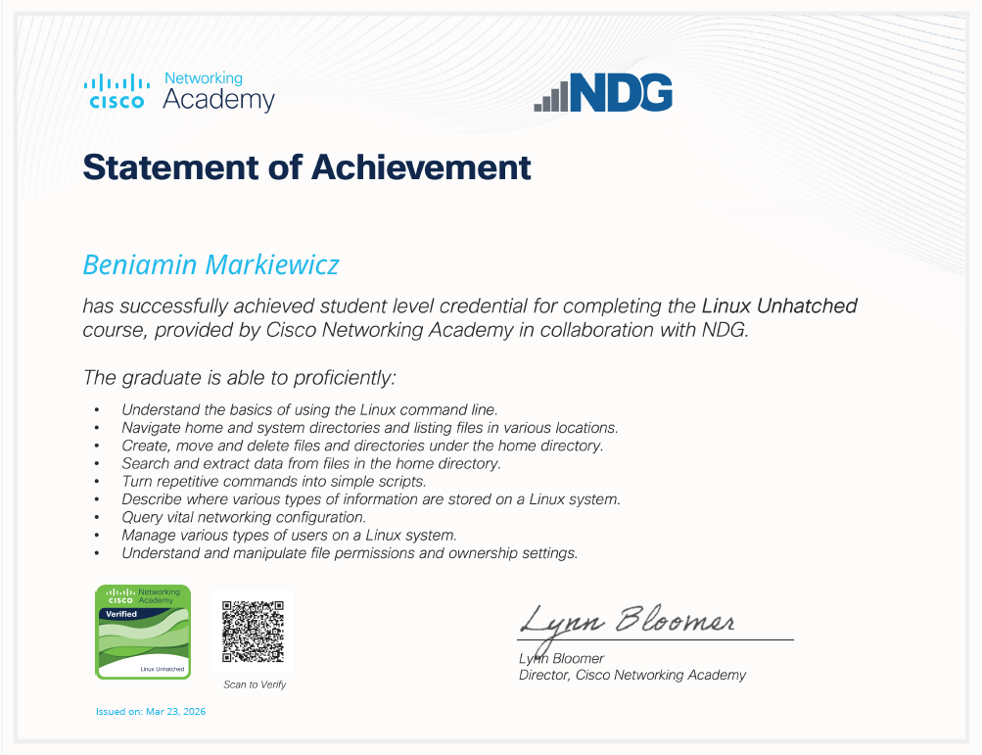
Figure 39: Linux Unhatched Certificate

1.2

Figure 40: Close-up of the verification code

