

MANAGING MARKETING CHANGE
BMMB7026
Future Developments in Marketing Strategy at AstraZeneca PLC
Student Name:Md Masud Rana
Student ID:2507015
Executive Summary
The report is a critical analysis of the marketing technique of AstraZeneca PLC in an evolving global pharmaceutical and digital environment. Basing it on the digitalisation, artificial intelligence and the changing behaviour of healthcare professionals and patients, the analysis evaluates the strategic position of marketing, environmental pressures, segmentation, channel selection and performance control. It has been found that there is an excellent scientific position, and the expansion of digital capability, although it has deficits in data integration, omnichannel coordination and adaptive control mechanisms. Based onthe SOSTAC framework, the report suggests evidence-based recommendations that are feasible to improve integration, responsiveness, and value communication. In general, the report has shown how well-disciplined marketing change can help in enhancing competitiveness, stakeholder involvement and performance in the long term.

TABLE OF CONTENTS
1. Introduction 4
2. Critical Evaluation of AstraZeneca’s Marketing Activity 4
2.1 Concept and Strategic Importance of Marketing 4
2.2 Macro and Micro Marketing Environment 6
2.2.1 Macro Environment 7
2.2.2 Micro Environment 8
2.3 Target Markets, Segmentation, Targeting and Positioning 9
2.4 Marketing Mix and Value Delivery 9
2.5 Selection of Media and Communication Channels 11
2.6 Measuring Marketing Effectiveness and Control 11
3. Conclusions: Shortcomings in Marketing Strategy 12
4. Recommendations for Future Marketing Developments 13
References 16

1. Introduction
The report critically conducts an assessment of the strategic efforts in marketing activities of AstraZeneca PLC, and it maps out how marketing change should be managed in a UK/EU-led scenario, although it is aware of its global operations. The discussion will focus on two related motifs, namely, accelerated digitalisation, including AI-driven analytics and individualisation, and the transformation of the behaviour of healthcare professionals (HCPs) and patients in mixed channels. The development of the digital health ecosystem in Europe increases these pressures. As an example, Europe was raising approximately $4.8bn in digital health funding in 2024, which signals a rapid cycle of innovation that affects the demands of access, support and evidence (HSBC, 2024). Corporate reporting is digital and data-focused within the context of AstraZeneca to enhance patient-centricity and decision-making, which means that marketing should correspond to broader changes throughout the organisation (AstraZeneca, 2024). Under the influence of marketing concept and systems perspective, the report assesses the influences of the environmental forces as well as the relationship of stakeholders and organisational capabilities in segmentation, positioning, marketing mix, selection of channels and performance measurement. It subsequently identifies the notable gaps that arise out of this assessment and offers plausible and evidence-based guidelines to enhance further marketing planning in the face of digital disruption amidst shifting customer demands. As per Mordor Intelligence (2025), reports are inferred based on the industry reports and peer-reviewed research on the trends of digital health and engagement.

2. Critical Evaluation of AstraZeneca’s Marketing Activity

2.1 Concept and Strategic Importance of Marketing
Marketing at AstraZeneca is an enterprise capability that is used to transform science to patient value by encapsulating stakeholder needs such as HCPs, payers, regulators and patients onto access, evidence and differentiated brand experience across markets. In line with the marketing concept, marketing has the role of knowing what customers need and integrating the delivery of value throughout the customer journey. This is assisted through internal organisational marketing to align cross-functional teams, commercial, medical, market access, digital and compliance around a common customer insight, consistent messaging and executing it together (AstraZeneca, 2024).
The selling, overall, and administrative (SG&A) expense of AstraZeneca, where a great deal of organisational and commercial activity takes place, is indicative of the resource investment. In this instance, SG & A was 19,977 million in FY2024 compared to 19,216 million in FY2023 [see Figure 1]. AstraZeneca claims that in order to launch a new brand and support the brands' continued development, the SG&A movements were primarily impacted by market development movements. In Q4 2024, SG&A totalled 5,410 million (AstraZeneca, 2025). These announcements indicate a sustained commitment in lifecycle development, customer-facing capacity establishment, and the start of excellence in the primary regions.
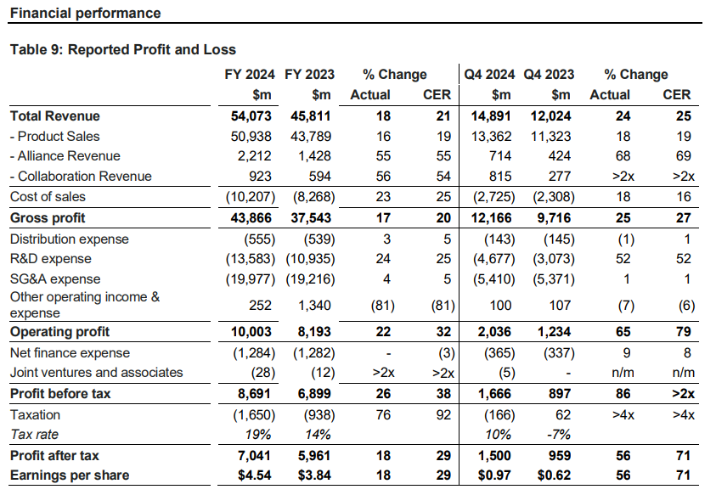
Figure 1: AstraZeneca Financial Performance
(Source: AstraZeneca, 2025)
Marketing strategically transforms therapy-area strategy into segmentation, channel design and evidence-based communications that portray shifting behaviours of HCPs and patients in hybrid care, but is scalable globally. According to EMEA analysis reports by IQVIA, HCP channel preferences transform, and there is a need to align the engagement with the favoured mixes of channels, which supports the idea of organised omnichannel planning. Empirical data presented by peer-reviewed studies reveal that AI applications in CRM have the potential to enhance customer insight and personalisation in combination with governance, data quality and organisational adoption, which will support AstraZeneca to regard marketing change as an organisational-wide potential, as opposed to a functional one. According to Ledro et al. (2025), Medical-legal consultations, data flows with proof, and compliance are more important in the UK and EU due to promotion and data privacy regulations. The models of omnichannel maturity in healthcare emphasise the development of the capabilities, integration, and measurement required to maintain performance.
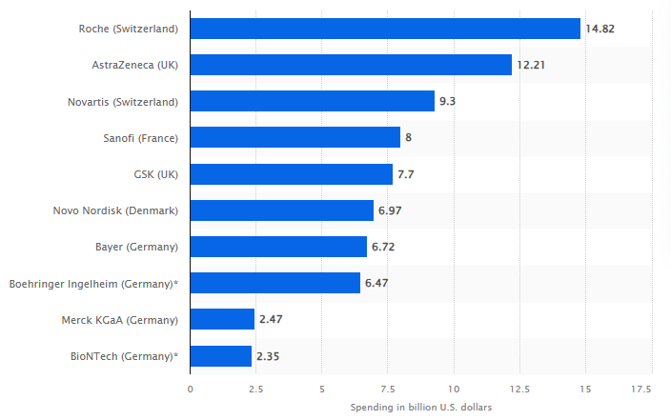
Figure 2: European pharmaceutical companies by spending on R&D in 2024
(Source: Statista, 2024)

2.2 Macro and Micro Marketing Environment
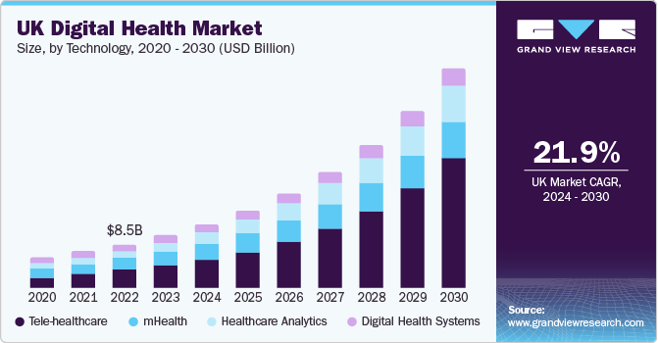
Figure 3: Growth of the European Digital Health Ecosystem (2020-2030)
(Source: Grand View Research, 2025)

2.2.1 Macro Environment
Porter force | Description | Impact
Rivalry | Large multinationals compete in oncology, CVRM and respiratory, using head-to-head clinical data, real-world evidence and omnichannel engagement to defend formulary positions and influence HCP preference. | High
Threat of new entrants | Entry is deterred by capital-intensive R&D, robust IP portfolios, complex manufacturing, lengthy EMA/MHRA authorisation, and pharmacovigilance obligations that dissuade new players. | Low
Bargaining power of buyers | UK/EU national payers and HTA bodies enforce tendering, price negotiation, cost containment and outcomes evidence, pressuring net prices and access terms. | High
Bargaining power of suppliers | Dependence on specialised biologics inputs, contract manufacturers and cloud/AI platform vendors raises switching costs, but AstraZeneca’s scale, partnerships and dual sourcing mitigate risks. | Medium
Threat of substitutes | Post-exclusivity generics, biosimilars and alternative modalities accelerate share erosion and price compression in key classes as competitive landscapes evolve. | High
Table 1: Porter Five Forces Analysis
(Sources: Self-Developed)
Analysis
It seems that AstraZeneca's marketing needs to concentrate on distinction in the fiercely competitive and buyer-power environment, based on the Porter Five Forces research. Because payers and HTA have more negotiating power in the UK/EU markets, there is a greater incentive to make sure that value communication incorporates adequate clinical and economic evidence. Due to lapsed exclusivities, biosimilars and generics are raising the threat of alternatives, which is stressing the margins, and entry barriers remain high. The influence of medium suppliers necessitates prudent management of partners. Conversely, value articulation, omnichannel engagements, and data analytics as a component of marketing competency are all effective tactics for long-term growth and competitive positioning.

2.2.2 Micro Environment
Strengths | Weaknesses
FY2024 total revenue $54.1bn supports sustained launch investment and global omnichannel capability; established medical, regulatory and pharmacovigilance infrastructure enhances HCP trust and compliant engagement; measurable analytics coordinate field and digital touchpoints. | Commercial intensity is indicated by the high SG&A cost base of $19.977 billion (AstraZeneca, 2025). Complex governance slows content/channel experimentation; fragmented EU reimbursement rules challenge campaign consistency and speed of personalisation.
Opportunities | Threats
Growth of the EU digital health ecosystem and AI-enabled segmentation; co-created patient support services. Real-world evidence and outcomes-based contracts to enhance HTA value narratives. Virtual decision-support tools for HCPs. | Patent expiries accelerate generic/biosimilar competition; payer cost containment, tendering and reference pricing compress net prices. Stricter data privacy and promotion rules. Rapid competitor digital innovation raises engagement stakes.
Table 2: SWOT Analysis
(Source: Self-Developed)
Analysis
The SWOT identifies the market size and cross-channel infrastructure as the marketing strengths of AstraZeneca and allows investment sustainability and evidence-based interaction. However, agility is limited by a solid cost base and the complexity of governance. The activities and prospects emerge because of the growing EU digital health ecosystem and AI-driven segmentation, which provides a chance to improve individual contact and evidence creation. Generics, biosimilars, and payer cost threats are driving forces of the necessity to develop compelling value stories and proper positioning of HTA. It will be essential to be strategic in data utilisation and agile processes of content.

2.3 Target Markets, Segmentation, Targeting and Positioning
In this section, the report assesses the use of segmentation, targeting, and positioning (STP) by AstraZeneca PLC as it tries to adapt to the evolving healthcare professional (HCP) and patient behaviours in the growing digital healthcare world. The evaluation aims at determining target audiences and how the existing STP decisions are contributing to marketing change.
Segmentation
The segmentation of AstraZeneca is reflective of the nature of pharmaceutical markets, which integrates the professional, behavioural and contextual criteria. The HCPs are classified according to speciality prescription power, access to and preference to digital channels, and patient segmentation is based more on disease stage, adherence behaviour and digital literacy. According to Schwarz, Almeida and Lingenfelder (2025), the involvement of European HCPs has moved toward hybridised and digital touchpoints, with the share of interactions established based on the channel in 2024 in support of the importance of channel-based and behavioural segmentation. As per Mosuri Muniratnam, Reddy and Yashaswini Aavula (2024), data-based segmentation to relevance is enhanced with the requirements of regulation and ethics in healthcare marketing.
Targeting
Focusing on specialist HCPs, key opinion leaders, and multidisciplinary care teams within the therapy area, including oncology and rare diseases, Targeting is enabled by patient support programmes to improve adherence and outcome. The adoption of digital health in Europe has experienced consistent growth in Europe, which justifies AstraZeneca choosing digitally receptive audiences (AstraZeneca, 2024a). The targeted strategy makes effective use of marketing resources and can be easily scaled to marketing markets all over the world.
Positioning
It places its brands around evidence-based patient-centric value, scientific leadership and above all. As per Ladds et al. (2023), epistemology and clinical evidence, as well as service support, are the essential positioning messages that HCPs ought to implement in the digital space. In general, the STP strategy of AstraZeneca proves useful in aligning the digital interaction with the changing customer demands, but it still needs further optimisation to manage the growing pressure of competition and payer questioning.

2.4 Marketing Mix and Value Delivery
Introduction
The marketing mix at AstraZeneca operationalises marketing segmentation, targeting and positioning choices by incorporating the customer insight within the compliant value delivery of healthcare professionals (HCPs) and patients in hybrid care pathways (Alsharif et al., 2023). This segment is used to assess the fit between product, price, place and promotion factors and STP to differentiate value generation in the regulated global markets, such as the case of the UK/EU, where the latter can be applied as well.
Product
The product strategy of AstraZeneca goes beyond pharmaceuticals and consists of evidence, services, and patient-centric digital support. Growth is highlighted as an aspect of its 2024 Annual Report, where it aims at achieving differentiated clinical outcomes and expansion in indication using integrated commercial capabilities (AstraZeneca, 2025). The external benchmarking evidence shows the increased significance of patient digital experience, and the best approach to brand performance is the presence of top-quality digital experience, implying the role of marketing in the experience design.
Price
Pricing demonstrates value-based evaluation and bargaining where UK/EU health technology assessment (HTA) authorities emphasise cost-effectiveness and outcome evidence. As per Berkowitz (2021), marketing helps in the translation of clinical and economic value into payer and prescriber stories to facilitate access, reimbursement and adoption choices in various payment settings.
Place
Distribution involves the integration of controlled channels (hospitals, pharmacies, wholesalers) with Internet routes connecting HCPs and patients, referring them to verified information and services. The effort to invest in digital infrastructure is backed by estimates that the ICT spend of AstraZeneca had reached about 1.2 billion in 2024, which enabled data-enabled interaction between markets (Globaldata, 2024).
Promotion
Advertising can be limited by the regulatory and privacy standards, thus making it more dependent on the omnichannel interaction, which is and has to be compliant. In reference to the 2024 whitepaper, EMEA references the challenge of pinpointing and tailoring effectiveness in HCP engagement, requiring field-supplied digital orchestration coordination in accordance with the channel preferences. On the whole, the marketing mix proposed by AstraZeneca is aligned with STP; it is characterised by evidence-based differentiation, access-oriented communication and digitally empowered, compliant interaction. Thereby contributing to value delivery and aiding in maintaining the competitive position over the long-term.

2.5 Selection of Media and Communication Channels
The choice of the media and communication channels at AstraZeneca is indicative of the disruptive digital marketing landscape and the necessity to react to changing trends in healthcare professionals (HCP) and patient behaviour, whilst staying within regulatory boundaries. As per Sarkis et al. (2021), HCP accessibility in the global biopharma has shown a decreasing trend, with less than half of HCPs being available in traditional field interaction and the importance of integrated channel strategies. In the case of HCP engagement, AstraZeneca uses a blend of in-field force detailing, peer-to-peer scientific interactions, medical congress interaction and online communication, incurred items like approved email communication, twin webinars and customer relationship programmes. The integration of field and digital communication is of special concern: alignment of digital advertising with field communication has been determined to work out marketing performance by about 23 per cent, and it has been proven that either timing or volume cannot work independently to create the effect.
Europe, which severely limits direct-to-consumer pharmaceutical advertising of prescription drugs, puts more emphasis on medically controlled channels and acceptable content presentation. According to Hoeve et al. (2021), the European communication in pharmaceuticals emphasises the legal requirement to disseminate objective information that lacks promotion to the HCPs and patients, and this influences the selection of channel and message format under the confines of advertising. The hybrid omnichannel strategies have also increased contact points like compliant chat, closed-loop marketing applications, and approved portals. According to Veeva Pulse data, the opportunity of total engagements via compliant digital channels does not shrink face-to-face interactions, and multi-modal responsiveness creates a higher number of situations of relevance and fulfilment in HCPs across markets. In general, as per Iglesias et al. (2024), the choice of channel employed by AstraZeneca is both suitable and efficient in meeting the HCP preferences as well as the regulatory landscape through the balancing of traditional forms of scientific interaction. And digital-based interaction through an omnichannel approach and informed by the needs of real-world evidence and disruptive digital marketing demands.

2.6 Measuring Marketing Effectiveness and Control
The control and marketing effectiveness of AstraZeneca are increasingly relying on digital indicators, constructing a connection between omnichannel activity and the outcomes of the stakeholders, which allows adjusting to the fluctuation of HCP and patient behaviour quickly. In the channel level, secondary indicators of performance include reach, depth of involvement and mix of channels in field, email, virtual events and approved digital assets Southernized in CRM and analytics dashboard. At the organisational level, annual reporting at AstraZeneca also connects commercial execution to financial controls with SG and A following and narrative reporting on launch and growth priorities with accountability to its resources being deployed.
Shared goals within the medical and commercial teams are also needed in control mechanisms to limit unequal customer experiences. According to the Q2 report by Veeva, having field medical education before launch is related to the increased adoption of treatments by 50 per cent, which suggests that measurement needs to encompass educational touchpoints and cross-functional support and not merely promotional outputs (Veeva, 2023). As per Hemanth Kumar et al. (2025), reporting and visualisation are the keys to making strategic decisions and also to gauge customer needs and conversion, which underlies a control approach that is based on cadence. Conformant data quality and content control are the foundations of trustworthy interpretation. Altogether, the AstraZeneca monitoring is suitable for a controlled, data-heavy environment, though it requires that governance transforms measures into action by closed-loop test-and-improve loops. S. Subha et al. (2024) state that pharmaceutical digital transformation reveals that organisational and stakeholder aspects determine the value capture of digital initiatives, condone restrained experimentation inside the realms of privacy and compliance.

3. Conclusions: Shortcomings in Marketing Strategy
This analysis shows that the marketing approach used by AstraZeneca has a high level of congruence with the scientific differentiation, digital enablement and stakeholder engagement, but some areas of strategic gaps limit its success in a fast-changing environment. Throughout the sections 2.1-2.6, marketing is described as an enterprise capability, but its implementation is uneven because of the complexity of the organisation as well as external forces.
To begin with, both segmentation and targeting are becoming more data-driven, but data integration between regions and functions is fragmented, thereby limiting their efficacy. This limits the quality of the omnichannel delivery and decreases the pace at which insights can be altered into differentiated engagement, specifically in markets with non-homogenous reimbursement and regulatory environments. Therefore, the positioning becomes diluted in cases where the worldwide strategy is not adequately joined with regional modifications.
Second, the marketing mix exists in theory but is not as responsive in reality. There is a good product and evidence strategy, but price and access communications are significantly influenced by payer negotiation and HTA processes, making marketing less influential in creating a perception of value. As per Chaffey and Smith (2022), there are compliant distribution and promotional decisions, but governance activities hinder experimentation and optimisation based on digital channels.
Third, as much as media and channel choice indicate hybrid forms of engagement preference, as per Shatakshi Bourai, Arora and Yadav (2024), the competition limits its effect due to decreased HCP access and increased competition. Field and digital interaction presence is correct, but cross-platform integration is not as seamless as it could be, which restricts overall effectiveness in the customer experience.
Lastly, measurement and control mechanisms are strong at the operational level but ineffective in motivating adaptive learning. As per Cosa and Torelli (2024), activities and engagement are captured by metrics, and feedback loops transforming data on performance to timely strategic changes have not developed yet. Comprehensively, these weaknesses indicate that AstraZeneca's marketing strategy needs greater integration, prompt responsiveness and increased connection between the insight, implementation and control to maintain both competitiveness in the face of a digital disruption and the dynamic expectations of its stakeholders.

4. Recommendations for Future Marketing Developments
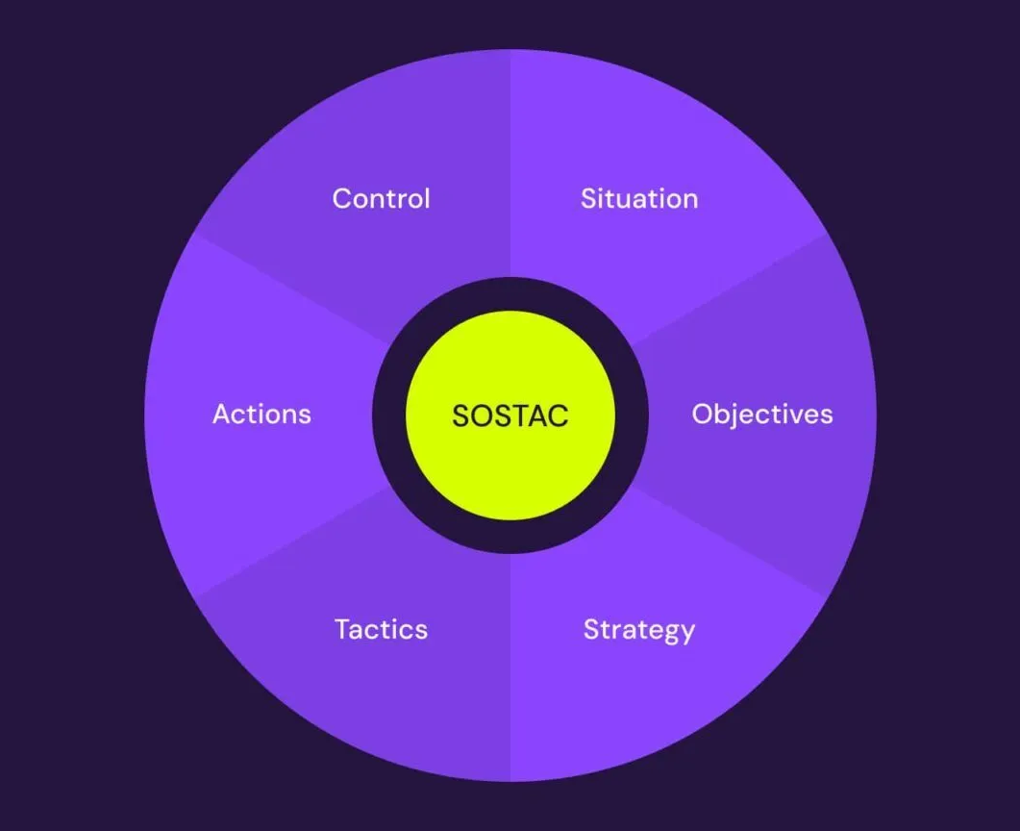
Figure 4: Application of the SOSTAC to Future Marketing Development
(Source: Granite5, 2024)
To overcome the strategic weaknesses that were found in Section 3, the future marketing development at AstraZeneca PLC must be organised based on the SOSTAC framework [refer to figure 4]. This framework offers a rigorous but accommodating logic of planning that synchronises marketing decisions with change within an organisational setting and leadership and stakeholder interaction, but is also practicable in a highly regulated pharmaceutical context.
Situation: AstraZeneca enjoys the advantage of a firm scientific reputation, size and diversifying digital capability internationally, but marketing performance is limited by fragmented customer information, complicated modes of control and disjointed omnichannel implementation. As per NHS England (2023), reduction of access to healthcare professionals, increased competition for attention and heterogeneous UK and EU access necessities further increases the troubling on value communication. These reasons prove that marketing change should be oriented to integration, coordination and quicker translation of insight into action instead of channel expansion in a gradual manner.
Objectives: The future marketing goals will need to be aligned with outcome-oriented measurements that indicate value creation as opposed to mostly activity-based indicators. As per Rahman et al. (2025), answering with better engagement quality across channels and enhancing consistency of customer experience, and the turnaround time between the generation of insight and the ensuing tactical response should be given higher priorities. By clearly connecting marketing goals with the overall organisational key performance indicators, responsibility will be enhanced and the strategic contribution of marketing within that organisation reinforced.
Strategy: To be strategic, AstraZeneca needs to implement an omnichannel model that is locally dynamic and globally scalable. As per Luigi P.L. Cavaliere et al. (2024), data standards and customer insight, and the core platforms should be centralised to facilitate the coherent segmentation, targeting and positioning, as well as allowing the controlled localisation to meet the regulatory and reimbursement needs. In the lens of change management, it would be reasonable to have an integrated planned and emergent strategy, where global orientation ensures permanence and authenticity, and local experimentation is structured to ensure responsiveness to market inputs. Leadership commitment that can be seen is necessary to break siloed working and entrench customer-centric decision-making.
Tactics: Tactically, the marketing practice should focus more on a closer connection of field, digital, and medical channels via joint customer journey planning and coordinated content delivery. According to Gupta et al. (2021), other areas that AI and investment in analytics should be directed to are decision support, including next best action and channel mix optimisation, and not technology adoption. The internal marketing efforts by organisations should support mutual goals, assign duties both within commercial, medical and digital departments, and minimise overlays and delays in performance.
Action: The implementation would need proper governance, assigned roles and long-term ability building. These teams need to be formally required to have cross-functional omnichannel teams, and this ought to be aided by top-level sponsorship, as these teams tend to get all the resistance scaled back and also in a bid to identify similar incentives. The focus of the training should be on data literacy and agile working practices, with compliant experimentation that would help the teams to interpret the insights with confidence and operate within the limits of regulation.
Control: Emphasis should be paid to control mechanisms that focus on learning and accountability. As per Haag et al. (2025), the engagement and access measures must be connected to the periodic strategic review in a closed-loop feedback system so that the strategies and resource distributions can be adjusted accordingly. The integration of SOSTAC into the marketing planning and change processes will improve integration, responsiveness and value delivery, specifically to counter the existing weaknesses and improve the competitiveness of AstraZeneca in a digitally disrupted healthcare setting. Moreover, stakeholder involvement must also be institutionalised under the change process in such a way that new marketing practices will be adopted in the long term. As per Furtner et al. (2023), the planned communication with the internal stakeholders, such as medical affairs, compliance and regional leadership, will decrease misalignment and facilitate the regular execution. Besides this, interaction with the HCPs, groups and payers should be integrated into planning processes to prove assumptions and offer value propositions. This increases legitimacy, lessens resistance and boosts trust, which is important in introducing digitally enabled marketing change in complicated health systems. It will facilitate long-term organisational learning and sustainable performance enhancement.

References
Alsharif, A.H. et al. (2023) ‘Neuromarketing Tools Used in the Marketing Mix: A Systematic Literature and Future Research Agenda’, SAGE Open, 13(1), p. 215824402311565. Available at: https://doi.org/10.1177/21582440231156563.
AstraZeneca (2024a) Digital health: Transforming how we develop medicines, Astrazeneca.com. Available at: https://www.astrazeneca.com/content/astraz/r-d/digital-health-revolutionising-healthcare-for-patients.html (Accessed: 21 December 2025).
AstraZeneca (2024b) What science can do. Available at: https://www.astrazeneca.com/content/dam/az/Investor_Relations/annual-report-2024/pdf/AstraZeneca_AR_2024.pdf (Accessed: 20 December 2025).
AstraZeneca (2025) AstraZeneca 6 February 2025 Full Year and Q4 2024 results Strong momentum in FY 2024 with Total Revenue and Core EPS up 21% and 19% respectively Revenue and EPS summary FY 2024 % Change Q4 2024 % Change $m Actual CER 1. Available at: https://www.astrazeneca.com/content/dam/az/PDF/2024/fy/Full-year-and-Q4-2024-results-announcement.pdf (Accessed: 20 December 2025).
Berkowitz, E.N. (2021) Essentials of Health Care Marketing, Google Books. Available at: https://books.google.com/books?hl=en&lr=&id=2_EfEAAAQBAJ&oi=fnd&pg=PP1&dq=Marketing+helps+in+the+media+of+the+translation+of+clinical+and+economic+value+into+payer+and+prescriber+stories+to+facilitate+access (Accessed: 21 December 2025).
Chaffey, D. and Smith, P. (2022) ‘Digital Marketing Excellence: Planning, Optimizing and Integrating Online Marketing’, Digital Marketing Excellence Planning, Optimizing and Integrating Online Marketing, 6(6). Available at: https://www.taylorfrancis.com/books/mono/10.4324/9781003009498/digital-marketing-excellence-dave-chaffey-pr-smith (Accessed: 21 December 2025).
Cosa, M. and Torelli, R. (2024) ‘Digital Transformation and Flexible Performance Management: a Systematic Literature Review of the Evolution of Performance Measurement Systems’, Global Journal of Flexible Systems Management, 25(3), pp. 445–466. Available at: https://doi.org/10.1007/s40171-024-00409-9.
Furtner, D. et al. (2023) ‘Journey from an Enabler to a Strategic Leader: Integration of the Medical Affairs Function in ESG Initiatives and Values’, Pharmaceutical medicine [Preprint]. Available at: https://doi.org/10.1007/s40290-023-00485-9.
Globaldata (2024) ShieldSquare Captcha, www.globaldata.com. Available at: https://www.globaldata.com/store/report/astrazeneca-plc-enterprise-tech-analysis/ (Accessed: 21 December 2025).
Grand View Research (2025) Europe Digital Health Market Size & Share Report, 2030, www.grandviewresearch.com. Available at: https://www.grandviewresearch.com/industry-analysis/europe-digital-health-market-report (Accessed: 21 December 2025).
Granite5 (2024) Mastering Marketing Strategy with SOSTAC: A Step-by-Step Guide for Success, Granite 5. Available at: https://www.granite5.com/insight/marketing/mastering-marketing-strategy-with-sostac-a-step-by-step-guide-for-success/ (Accessed: 21 December 2025).
Gupta, S. et al. (2021) ‘Artificial intelligence for decision support systems in the field of operations research: Review and future scope of research’, Annals of Operations Research, 308(1). Available at: https://doi.org/10.1007/s10479-020-03856-6.
Haag, L. et al. (2025) ‘Ethical gaps in closed-loop neurotechnology: a scoping review’, npj Digital Medicine, 8(1). Available at: https://doi.org/10.1038/s41746-025-01908-4.
Hemanth Kumar, S. et al. (2025) ‘Harnessing Strategic Analytics for Start-Up Success: Innovations, Insights, and Impact’, Information Systems Engineering and Management, pp. 129–154. Available at: https://doi.org/10.1007/978-3-031-82369-5_8.
Hoeve, C.E. et al. (2021) ‘Dissemination of Direct Healthcare Professional Communications on Medication Errors for Medicinal Products in the EU: An Explorative Study on Relevant Factors’, Drug Safety, 44(1), pp. 73–82. Available at: https://doi.org/10.1007/s40264-020-00995-4.
HSBC (2024) HSBC Holdings Plc Annual Report and Accounts 2024 Contents. Available at: https://www.hsbc.com/-/files/hsbc/investors/hsbc-results/2024/annual/pdfs/hsbc-holdings-plc/250219-annual-report-and-accounts-2024.pdf (Accessed: 20 December 2025).
Iglesias, I. et al. (2024) ‘Understanding the National Healthcare Ecosystem to Position Medical Affairs as a Strategic Element: Lessons Learned from AstraZeneca Spain’, Pharmaceutical Medicine [Preprint]. Available at: https://doi.org/10.1007/s40290-024-00542-x.
Ladds, E. et al. (2023) ‘A contemporary ontology of continuity in general practice: Capturing its multiple essences in a digital age’, Social Science & Medicine, 332, p. 116112. Available at: https://doi.org/10.1016/j.socscimed.2023.116112.
Ledro, C. et al. (2025) ‘Artificial intelligence in customer relationship management: A systematic framework for a successful integration’, Journal of Business Research, 199(1), p. 115531. Available at: https://doi.org/10.1016/j.jbusres.2025.115531.
Luigi P.L. Cavaliere et al. (2024) ‘Leveraging Distributed Systems for Improved Market Intelligence and Customer Segmentation’, Leveraging Distributed Systems for Improved Market Intelligence and Customer Segmentation, pp. 305–319. Available at: https://doi.org/10.1002/9781394188093.ch18.
Mordor Intelligence (2025) Europe Digital Health Market - Share, Size & Industry Analysis, Mordorintelligence.com. Available at: https://www.mordorintelligence.com/industry-reports/europe-digital-health-market (Accessed: 20 December 2025).
Mosuri Muniratnam, Reddy, M. and Yashaswini Aavula (2024) ‘Privacy and Ethical Considerations in Data-Driven Marketing’, Chapman and Hall/CRC eBooks, pp. 165–182. Available at: https://doi.org/10.1201/9781003472544-15.
NHS England (2023) What Are Healthcare Inequalities?, NHS England. Available at: https://www.england.nhs.uk/about/equality/equality-hub/national-healthcare-inequalities-improvement-programme/what-are-healthcare-inequalities/ (Accessed: 21 December 2025).
Rahman, S.M. et al. (2025) ‘Share of time in omnichannel retailing: Definition and measurement’, Journal of Retailing, 101(2). Available at: https://doi.org/10.1016/j.jretai.2025.04.001.
S. Subha et al. (2024) ‘Digital Transformation in the Pharmaceutical and Biotech Industry: Challenges and Research Directions’, Digital Transformation in the Pharmaceutical and Biotech Industry: Challenges and Research Directions, pp. 297–324. Available at: https://doi.org/10.1002/9781394195336.ch13.
Sarkis, M. et al. (2021) ‘Emerging Challenges and Opportunities in Pharmaceutical Manufacturing and Distribution’, Processes, 9(3), p. 457. Available at: https://doi.org/10.3390/pr9030457.
Schwarz, R., Almeida, R. and Lingenfelder, M. (2025) ‘Gaining insights into omnichannel usage behaviour of corporate customers in the German pharmacy supplies market: a cluster analysis approach’, Journal of Business & Industrial Marketing, 40(10), pp. 1971–1989. Available at: https://doi.org/10.1108/jbim-12-2024-0950.
Shatakshi Bourai, Arora, R. and Yadav, N. (2024) ‘Structure-conduct-performance (SCP) paradigm in digital platform competition: a conceptual framework’, Journal of strategy and management, 17(2). Available at: https://doi.org/10.1108/jsma-07-2023-0184.
Statista (2024) European pharmaceutical companies: R&D spend 2024| Statista, Statista. Available at: https://www.statista.com/statistics/857628/leading-european-pharmaceutical-companies-by-randd-spending/?srsltid=AfmBOor-vKojyM0TYylxhv8ug4QQ4_cv0Aisny_HrNR9dT5v-9s91twC (Accessed: 21 December 2025).
Veeva (2023) Pre-Launch Field Medical Education Leads to 1.5x Increase in Treatment Adoption 70% of KOLs engage with only one biopharma, as traditional planning misses most experts 1. Available at: https://www.veeva.com/wp-content/uploads/2023/07/2023_Pulse-Field-Trends_Report.pdf (Accessed: 21 December 2025).

