Toyota - Assessment 1 - Environmental Analysis of Automobile Industry
Programme: BA Business Management  Module: The Global Business Environment  Student Name: Valeria Peeva | Module code: LCCB4005  Module Coordinator: Nadeem Mirza

Table of Contents
INTRODUCTION 3
GLOBAL BUSINESS ENVIRONMENT 3
SWOT ANALYSIS ………………………….………………………………..……………………………...... 4
PESTEL analysis ………………………….………………………………..……………………………........... 5
PORTERS DIAMOND MODEL ……….………………………………..……………………………............ 5
The Value Network ……………………….………………………………..……………………………......... 6
The Five Forces ………………………….………………………………..……………………………............ 7
International Trade ………………………….………………………………..…………………………….... 8
Market Structures………………………….………………………………..……………………………........ 8
Conclusion ………………………….………………………………..…………………………….......……….. 9
REFERENCES ………………………….………………………………..……………………………............. 10

INTRODUCTION

Technological advancement in the transport and communication industries has dramatically impacted the operation of various businesses. Nowadays all business can show the customers how to find and buy the goods they need without physically to have to see them or go to a store. Toyota is known for its outstanding production and supply chain hence why it is worldwide label of automobiles. The trust was built in the customers on an exceptional degree. Toyota is established in Japan and the value chain is achieved on an amazing level. This report will focus on the forces making the global business environment and it will use the business models like Porter’s Diamond, Value Network, and Five Forces. It will also show why businesses need to go international and it will concentrate on the market structures and strategies.
 | GLOBAL BUSINESS ENVIRONMENT
 | The global business environment can be described as the environment in various territories, changing decision making on supply use and resources. It can be categorized into the external and the internal environment. The external involves the social, cultural, economic, legal, political, regulatory, tax, and technological environments. To operate successfully and effectively, firms running worldwide must realize the social environment of the host country they are operating in. Businesses should also consider the rising use of mobile phones and social marketing networks while developing social marketing strategies.  The rising environmental pollution coupled with technological advancement has forced various businesses to embrace various practices related to innovative recycling and waste management. Many countries across the globe have put regulations on effective waste management to protect both human and animal health. | Political factors are among the forces shaping global businesses. When the economy grows, businesses experience various opportunities that facilitate their growth and development. Understanding the demographic features is critical for international companies in identifying the profitable market segment with good growth potential. Additionally, technological factors play a notable role in shaping global businesses. As businesses have no control over the external environment, their accomplishment depends upon how well they adjust to the external environment. A company's capability to create and adapt its internal variables to take benefit of prospects presented by the external environment, and its capability to control threats caused by the same environment, define its achievement.

 | SWOT ANALYSIS  The SWOT analysis refers to the analysis of factors that can impact the business operations of company.  Strength  The Toyota Way: they stick to the rules of constant improvement and admiration for individuals.  Fuel Cell Patents: Toyota maintains about 5,680 international patents linked to hydrogen fuel cells.  Opportunity  Toyota’s opportunities are mostly established on technological and economic styles. They can increase interest in advanced electronics in cars. | In this Toyota SWOT analysis, you will understand about the successes and battles of Toyota, one of the top 10 biggest companies in the globe. SWOT analysis pushes you to see all elements and directs to better judgements.  Weakness  Recalls: Toyota withdrew 700,000 cars as there was a defective fuel pump which devalued the public's belief in the label.  Strikes: Strike due to labor struggles weaken the firm's skill to meet market needs.  Threat  Toyota have competition with low-cost vehicles from Korean, Chinese and Indian firms, which is the main treat to the business.
 | 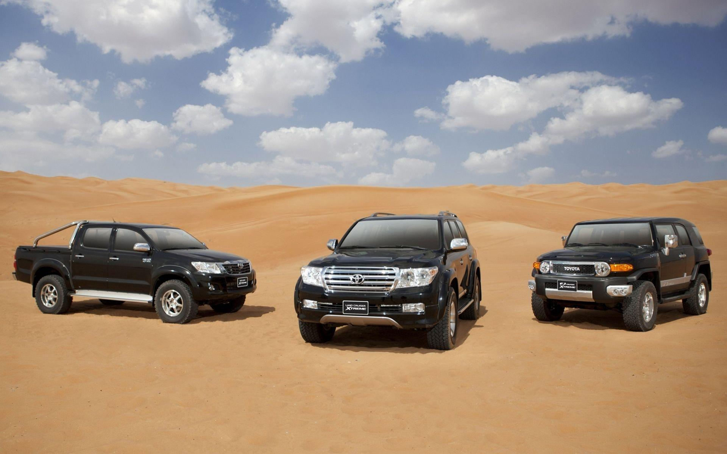

PESTEL analysis
Managers of given firm uses such analysis as a filtration which assists into identifies extrinsic scenarios. Toyota is a top player in the international automotive trade.

Political - The government is financing for ecofriendly goods which is a prospect for the company to be able to improve its goods and services considering the environmental expectations.

Economic - Due to pandemic numerous
businesses have faced the problem of financial crises as well as they found the problems in their personal incomes.

Social – The interest of the clients in hybrid and electric cars is growing which is an advantage for Toyota being specialized in those types of cars. The middle class is the main income supply of Toyota.

Technology – More and more customers prefer to use mobile apps these days which needs to be considered by Toyota.

Legal – laws need to be followed in terms of environment and all requirements that need to be considered for the automobile business.

Environmental – Because Toyota has electric cars or cars with higher fuel efficiency, the company can boost its sustainability operation easily.

PORTERS DIAMOND MODEL
Michael Porter’s Diamond Model, widely recognized as the Theory of National Competitive Advantage of Industries is a tactical instrument utilized by firms for establishing and creating the base of viable benefit. It is relevant for global business environmental analysis because it gives clear insights on the conditions and elements that facilitate the growth of businesses growth with continuous innovations and developments. In a business environment, strategy, structure, and rivalry involve the strategic focus of the business and the managerial and organizational structures. These structures are critical to the business because they determine the international expansion of the business. It is shaped like a diamond and the elements are Firm Strategy, Structure and Rivalry; Factor Conditions; Demand Conditions; and Related and Supporting Industries. For Toyota, the components have been especially beneficial in assisting the company to increase its development worldwide with constant improvement and up-gradation.

The Value Network
A value network involves interaction where individuals develop plans or sell beneficial commodities to the business. Two types of actions exist in the value chain network which are primary and support activities.
Primary activities
Inbound logistics – means the relationship with suppliers and include all the warehousing and inventory control.
Operations – means the process of transforming raw materials into a ready produce for use or service and it includes labels, branding or packaging of all goods. Toyota is a universal brand with its functions scattered throughout the globe.
Outbound logistics – this means all distribution cost of a final product that occur, and it covers delivery of the goods. Toyota maintains components and logistics facilities globally and transport and purchases every day.

Marketing and sales – these are the strategies to target the right audiences including pricing, advertising, and promotion. This all helps the clients to be attracted to the products better. The level of competition in the trade is extremely great. To make sure Toyota continue to have so many customers, the business has invested great amounts in marketing and promoting such as own website, social media, and motor shows.
Services – this means all activities like customer service, refund, exchange, and maintenance making sure the customer experience is on level.

Support/secondary activities
Firms can extend the primary activities by using the secondary activities by supporting them.
Infrastructure – this contains the business’s support system and maintaining such as accounting, administration, and legal functions.
Technology development – this is applied during investigation and improvement and involves designing, equipment, software, hardware, technical knowledge, and procedures. Toyota is a key car label well-known globally for its outstanding manufacturing and equipment. Separately from fantastic manufacture expertise, the label has boosted its financing in technological improvement for expansion.
Human Resource Management – this means the effective hiring of employees and keeping everyone happy while fulfilling the business strategy by helping with the design, market, and the selling of the goods.

The Five Forces
Porter's Five forces indicate factors that affect the competitiveness of a country and its businesses. These forces include the consumers' and suppliers' bargaining power, threats from new competitors, substitutes, and rivalry. From the analysis of the tool, managers of a corporate firm can derive better competitive advantages when engaging their operations in competitive business environment with presence of competitors.

Competition in the industry/Competitive Rivalry
This looks at the numbers and strength of the competition, how many, who are they and what is the quality of the goods and services they provide and when comparing them to ours. Usually if the competition is bigger than most businesses cut prices and add sales deals by trying to draw more customers to their industries.
Power of suppliers/Supplier Power
This depends on the number of suppliers you use as if you have only one than it will be very difficult on the business but if there are many suppliers available, if any of them increase prices you can switch from one supplier to another easily.
Potential of new entrance/Threat of New Entry
If your market is an easy target, then customers can become your competitors easily and weaken your position.
Treat of substitution
This means if the customers can find a better way to do what your company do.
Power of customers/Buyer Power
This works similarly to the supplier power but this time we are focusing on the customers. If your products are targeted only for a specific audience and your customers are not that many than the power will fall into them. On the other hand, if you have loads of customers then the power of the customers will be very low in terms of switching to other companies and of course if the competition is little.

International Trade
Organizations engage in international trade for several reasons. Among the reasons include the need to increase the customer base and reduce dependence on the local market. International markets also increase the business's chances of success. International trade makes available nations to develop their markets and gain access to goods and services that otherwise may not have been offered locally. As an outcome of international commerce, the market is more competitive. This ultimately causes in more competitive pricing and creates a cheaper product to the customer.
Market structures
Market structure is established on the qualities that affect the performance and results of firms operating in a particular market. It means how various activities are distinguished based on competition. What affects the market structures are the number of buyer and sellers and how simple is to enter or exit a particular market. Important factors that help to identify the 4 types of market structures are the industry’s buyer structure, the degree of produce diversity, the figure of players in the market, vertical integration level in the matching trade, the main player’s market part, the turnover of clienteles and the nature of costs of inputs.

Types of Market Structures

1. Perfect Competition
This is when numerous small businesses compete against each other by selling related goods. This market is unrealistic as it faces several major critiques like no motivation for improvement as the profit margin is fixed and retailers cannot raise costs as they risk losing clients. On another note, any firm can start selling the same products which means there are no barriers to entry this market.

2. Monopolistic Competition
This means that vendors’ competition is against them, and they must make their products different considering the brand and the quality. This competition means that sellers consider the fee charged by their rivals.

3. Oligopoly
This is a few businesses that are very enormous selling same products with strategies for competition depending on each other. Companies like this usually make contracts to split the market by limiting manufacture, leading to more profits. This is called monopolies and the collusion is described to as cartels.

4. Monopoly
One company represents the whole production, and it has no competition. The entering of this market is restricted hence the seller remains one and has power of prices and market of all products.

Conclusion
Globalization has portrayed a significant part in linking various markets worldwide and opening methods for companies to flourish beyond boundaries. The study also revealed that the automobile industry is among the businesses that have greatly benefited from globalization. Toyota has branches in Asia, Japan, North and South Americas and Europe which helped in retaining a wide authority all over the world. Presently headed by Akio Toyoda, the label holds an extraordinary occurrence in many of the key markets of the planet.

REFERENCES

Customer Turnover, Available at: https://www.ttec.com/glossary/customer-turnover (Accessed: 04/01/2022)

International Trade, Globalization and Economic Interdependence between European Countries: Implications for Businesses and Marketing Framework, Available at: https://www.sciencedirect.com/science/article/pii/S221256711501374X (Accessed: 05/01/2022)

Market structure, Available at: https://en.wikipedia.org/wiki/Market_structure (Accessed: 05/01/2022)

OUR HISTORY, Available at: https://www.toyota.co.uk/world-of-toyota/careers/tgb-history (Accessed: 02/01/2022)

Porters Diamond Model of Toyota, Available at: https://www.essay48.com/13611-Toyota-Porters-Diamond-Model (Accessed: 01/01/2022)

The Five Forces, Available at: https://www.isc.hbs.edu/strategy/business-strategy/Pages/the-five-forces.aspx (Accessed: 04/01/2022)

The Global Environment: Definition & Importance, Available at: https://study.com/academy/lesson/the-global-environment-definition-importance.html (Accessed: 02/01/2022)

The importance of international trade, Available at: https://www.economicshelp.org/blog/58802/trade/the-importance-of-international-trade/ (Accessed: 02/01/2022)

Toyota PESTEL/PESTLE Analysis & Recommendations, Available at: http://panmore.com/toyota-pestel-pestle-analysis-recommendations (Accessed: 03/01/2022)

Toyota SWOT Analysis 2021: Quick Reference Guide, Available at: https://pestleanalysis.com/toyota-swot-analysis/ (Accessed: 03/01/2022)

Value Chain Analysis of Toyota Motors, Available at: https://notesmatic.com/value-chain-analysis-of-toyota-motors/ (Accessed: 03/01/2022)

