

Evaluating Semtex 10 and Semtex 10SE as Sustainable Booster Alternatives for Initiating Nitromethane Charges

University of Wales Trinity Saint David
Ordnance, Munitions and Explosives (BEng)
Major Project
March 2026

Ewan Simpson
2115523
Supervisor: Gareth Collett

Academic integrity declaration:
I declare that:
- The thesis submitted has been written by me alone.
- The thesis submitted has not been previously submitted to this university or any other.
- That all content, including primary and/or secondary data, is true to the best of my knowledge.
- That all quotations and references have been duly acknowledged according to the requirements of academic research.
I understand that to knowingly submit work in violation of the above statement will be considered by examiners as academic misconduct.

Abstract:
Nitromethane (NM) is widely used within explosives testing and evaluation due to its predictable detonation characteristics and relatively simple handling requirements; however, reliable initiation typically requires high-performance booster explosives such as PE4. Increasing procurement pressures affecting RDX-based explosive supply chains have created a requirement to investigate alternative booster materials that maintain operational reliability while improving availability and sustainability. This project evaluates the technical and operational viability of Semtex 10 (S10) and Semtex 10SE (S10SE) as alternative boosters for the initiation of NM charges.
A multi-disciplinary methodology was adopted, integrating explosives theory, predictive blast modelling, instrumentation engineering, and full-scale experimental testing. Five detonation tests were conducted at DNV Spadeadam using moulded booster charges ranging from 10g to 100g, positioned centrally within partially confined NM contained in modified 25 l plastic drums. Pre-test modelling using PDecay, ConWep, and Kingery-Bulmash methods was used to predict blast parameters and establish safe exclusion zones. Peak overpressure and impulse were measured using pencil pressure gauges positioned at 6 m, 10 m and 15 m stand-off distances, supported by high-speed video analysis at 16,000 fps.
All Semtex-based booster configurations achieved reliable high-order detonation of the NM charge, including the smallest booster mass tested. Measured blast parameters showed strong agreement with modelling predictions, with slightly elevated values attributed to partial confinement and ground reflection effects. The results indicate that PETN-based Semtex boosters provide sufficient initiation energy to function as practical alternatives to PE4 under the tested conditions.
The findings highlight potential operational benefits, including improved material availability and opportunities for reuse of reclaimed energetic materials, supporting more sustainable explosive testing practices. Further work is recommended to determine minimum booster thresholds and to incorporate repeated trials for statistical validations.

Acknowledgements:
I would like to express my sincere gratitude to my supervisor, Gareth Collett, for their continuous guidance, constructive feedback, and encouragement throughout this research project. Their expertise and support were invaluable in shaping both the direction and quality of this dissertation.
I am also grateful to the staff and colleagues at DNV Spadeadam for their technical assistance and providing access to the facilities and resources required to complete this work. Special thanks are extended to Michael Heppell for their professional insight and practical support during the research and testing phases.
I would like to acknowledge the contributions of those who assisted with data collection, peer review, and discussions that helped refine the ideas presented in this study.
Finally, I wish to thank my family and friends for their patience, encouragement, and understanding throughout the duration of my studies. Their support has been fundamental to completing this research.

List of Figures:
Figure 1 - Trial Setup from CCTV 21
Figure 2 - Trial Setup from Go-Pro 21
Figure 3 - Charge and Booster Configurations 22
Figure 4 - Kingery-Bulmash Calculations 26
Figure 5 - Test 1 Measured Overpressure 28
Figure 6 - Test 2 Measured Overpressure 28
Figure 7 - Test 3 Measured Overpressure 29
Figure 8 - Test 4 Measured Overpressure 29

List of Tables:
Table 1 - Comparison of commonly used commercial explosives 9
Table 2 - Comparison of S10 and S10SE against PE4 14
Table 3 - Detonation success 25
Table 4 - Predicted Blast Parameters 26
Table 5 - Blast Overpressure 27
Table 6 - Measured Impulse 27
Table 7 – Percentage Difference Between Predicted and Measured Impulse and Overpressure 28
Table 8 - A table showing the average velocity at the time of reaching the pressure gauges 29

List of Equations:
$PCJ=ρ0∙D2γ+1$Equation 1 - CJ Detonation Pressure 12
$PCJ≈ 14ρ0D2$ Equation 2 - CJ Detonation Pressure Simplified 12
$Z=RW13$ Equation 3 - Scaled Distance 25
$PsPa=8081+Z4.521+Z0.0482×1+Z0.322×1+Z1.352$ Equation 4 - Peak Incident Overpressure 25

List of Abbreviations:
S10SE – Semtex 10SE
S10 – Semtex 10
NM – Nitromethane
TNT – Trinitrotoluene
NEQ – Net Explosive Quantity
DNV – Det Norske Veritas
RDX – Research Department Explosive / Cyclotrimethylene Trinitramine
PETN – Pentaerythritol Tetranitrate
PE4 – Plastic Explosive No.4
UN – United Nations
IATG – International Ammunition Technical Guidelines
NO – Nitrous Oxide
CO – Carbon Monoxide
PPE – Personal Protective Equipment
FTIR – Fourier-Transform Infrared Spectroscopy
HSE – Health and Safety Executive
ANFO – Ammonium Nitrate Fuel Oil
CJ – Chapman-Jouguet
JWL – Jones-Wilkins-Lee
UK – United Kingdom

Contents:
- Academic Integrity Declaration 2
- Abstract 3
- Acknowledgements 4
- List of Figures 5
- List of Tables 5
- List of Equations 5
- List of Abbreviations 6
- Introduction 9
  - Background and Context 9
  - Problem Statement 9
  - Aim 10
  - Objectives 10
  - Scope of the Research 10
  - Structure of the Report 11
  - Summary 11
- Research and Review of Literature 11
  - Introduction 11
  - Detonation Theory and Booster Requirements 12
  - PE4: Properties and Limitations 12
  - Semtex 10 and Semtex 10SE as Potential Alternatives 13
  - Nitromethane Initiation Challenges 13
  - Operational Considerations 13
  - Environmental and Sustainability Context 14
  - Comparative Analysis 14
  - Summary 14
- Research Methodology 15
  - Introduction 15
  - Research Overview 15
  - Research Process 16
  - Research Philosophy 16
  - Research Methodologies 16
  - Data Collection Methods 17
  - Research Design 17
  - Research Deliverables 17
  - Triangulation 18
  - Ethical and Safety Considerations 18
  - Limitations 19
  - Summary 19
- Design and Implementation 19
  - Introduction 19
  - Test Site and Experimental Context 20
  - Experimental Design Rationale 21
  - Charge and Booster Configuration 21
  - Initiation System Design 22
  - Instrumentation and Measurement Layout 22
  - Blast Modelling and Test Planning 22
  - Test Execution 23
  - Post-test Actions and Observations 23
  - Summary 23
- Testing, Results and Evaluation 24
  - Introduction 24
  - Overview of Test Programme 24
  - Predicted Blast Parameters 25
  - Measured Blast Results 26
  - Comparison of Predicted and Measured Results 29
  - Effect of Booster Type and Mass 30
  - Detonation Behaviour and Observations 30
  - Operational Evaluation 30
  - Limitations 31
  - Summary 31
- Conclusions and Recommendations 31
- Reflection 32
  - Introduction 32
  - Critical Evaluation of Technical Decisions 32
    - Modelling and Experimental Design 32
    - Booster Selection and Material Handling 33
  - Risk Management and Safety Culture 33
  - Methodological Limitations and Lessons Learned 33
  - Professional Development and Engineering Practice 34
  - Personal Development and Future Practice 35
- References 35
- Appendices 38
  - Appendix A: Ethical Approval Letter 38
  - Appendix B 49

Introduction:
Background and Context:
Explosive initiation depends on the reliable transfer of detonation energy from a sensitive primary or booster explosive to a comparatively insensitive main charge [1]. Plastic explosives such as PE4 are often used as boosters due to their high detonation velocity, favourable brisance, and well-documented reliability when initiating a wide range of secondary explosives [2] [3]. However, recent global conflicts and increased demand for military-grade energetic materials have disrupted supply chains, significantly increasing procurement lead times and costs for PE4 and similar RDX-based explosives [4].
These constraints present operational challenges for organisations such as DNV, who regularly use plastic explosives, such as Semtex and PE4, for small-scale demolition and testing activities. In parallel, NM is already used by DNV as a bulk explosive for large-scale charges exceeding 100kg NEQ (net explosive quantity). NM is advantageous due to its comparatively low cost, wide availability, and high energy density, as shown in table 1; however, it is classified as relatively insensitive and therefore requires a robust booster to initiate detonation reliably [5].
Explosive | Nitromethane | PE4 | Semtex 10 | ANFO | C4
Cost | Low | High | High | Low | High
Availability | High | Low | Medium | Medium | Low
Density (g/cm³) | 1.1385 [6] | 1.59 [7] | 1.4 [8] | 0.93 [9] | 1.64
Velocity of Detonation (m/s) | 6290 | 8092 [10] | 7200 | 4560 | 8340
Heat of Detonation (MJ/kg) | 6.3-6.4 | 5.1-6.2 | 6.6-7.0 | 3.76 | 6.61
Table 1 - Comparison of commonly used commercial explosives
At the same time, industrial explosive processes such as explosive depth hardening generate significant quantities of surplus or waste energetic material [11]. S10SE, a PETN-based sheet explosive used extensively in such processes, is often discarded following operations, typically through controlled burning. This disposal method represents both an environmental burden and a missed opportunity for material reuse [12]. International guidance, including the UN SaferGuard International Ammunition Technical Guidelines (IATG), increasingly emphasises sustainability, waste reduction, and responsible reuse of energetic materials where safety permits [13].

Problem Statement:
While PE4 remains a highly effective booster, its rising cost, limited availability, and long procurement lead times introduce financial and operational risks. PE4 is also an explosive whose malleability degrades as temperature decreases, thereby causing great difficulty for the user in user-filled applications. Conversely, PETN-based explosives such as S10 and S10SE are more readily available, more malleable, and exhibit detonation velocities and brisance that suggest they may be suitable alternatives for initiating NM charges (see table 2) [14] [15]. Despite this, there is limited published experimental data assessing their effectiveness as boosters for NM, particularly when using reclaimed or surplus Semtex material.
This creates a clear knowledge and operational gap: whether S10 and S10SE can reliably replace PE4 as boosters for NM charges without compromising safety, performance, or regulatory compliance.

Aim:
The aim of this project is to assess whether S10 and S10SE can reliably initiate 15 kg trinitrotoluene (TNT) equivalent NM charges, thereby reducing reliance on PE4 and enabling the reuse of surplus energetic material.

Objectives:
The objectives of this research are to:
- Determine the minimum effective mass of S10 and S10SE required to initiate NM detonation reliably.
- Compare the detonation performance of Semtex-based boosters against PE4 under identical test conditions.
- Evaluate the operational safety and feasibility of using reclaimed S10SE as a booster material.
- Quantify potential cost savings and reductions in explosive waste through the substitution of PE4.

Scope of the Research:
This study focuses on experimental, full-scale detonation trials conducted under controlled conditions at DNV’s licensed explosives testing facility. The scope is limited to the evaluation of S10, S10SE and PE4 as boosters for NM charges of a fixed mass and configuration. The research does not examine alternative primary explosives, long term storage stability of reclaimed materials, or large-scale environmental impact modelling beyond qualitative assessment.

Structure of the Report:
This report is structured as follows:
- Chapter 2 presents a critical review of existing literature on explosive initiation theory, properties of PE4, S10, S10SE, NM initiation requirements, and relevant operational and environmental considerations.
- Chapter 3 outlines the research methodology, including experimental design, data collection methods, and ethical and safety considerations.
- Chapter 4 details the design and implementation of the experimental trials, including charge configuration and instrumentation.
- Chapter 5 presents the test results and evaluates the performance of each booster type relative to literature and operational requirements.
- Chapter 6 draws conclusions from the findings and provides recommendations for operational use and future research.
- Chapter 7 reflects on the project process, learning outcomes, and limitations.

Summary:
This project therefore aims to evaluate whether S10 and S10SE can provide a reliable and operationally viable alternative to PE4 as booster explosives for the initiation of NM charges. To achieve this, this study combines literature analysis, predictive blast modelling, and full-scale experimental testing conducted at DNV Spadeadam. The report is structured to first review relevant explosive theory and operational context, before detailing the experimental methodology, presenting and evaluating measured blast results, and concluding with recommendations for future application within explosive testing and evaluation environments.

Research & Review of Literature
Introduction:
The ongoing scarcity of PE4 due to global conflict and supply chain disruption has necessitated the exploration of alternative booster explosives for initiating insensitive main charges such as NM. This chapter critically reviews existing literature on the properties, performance, and operational considerations of PE4, S10, and S10SE, alongside detonation theory relevant to booster-main charge coupling. It further examines operational supply constraints, environmental sustainability imperatives, and regulatory considerations in the reuse of surplus explosives. The aim is to identify knowledge gaps and contextualise the current research in both technical and practical domains.
Detonation Theory and Booster Requirements:
Effective initiation of an insensitive main charge depends on several interrelated factors: detonation velocity, brisance, detonation pressure, and critical diameter [3] [16]. High detonation velocity ensures rapid energy release, while brisance governs the shock pressure applied to the main charge interface. The concept of critical diameter – the smallest diameter at which a given explosive will sustain a detonation wave – is especially important for NM, which has a relatively high value of approximately 2.5 mm [17]. Coupling efficiency between booster and main charge is another determining factor. A mismatch in density or detonation impedance can lead to partial initiation or failure [5]. The literature indicates that PETN-based boosters, owing to their high detonation pressure and low critical diameter, can initiate NM when adequate confinement is provided.
The Chapman-Jouguet (CJ) theory provides a fundamental framework for estimating detonation pressure and describing the thermodynamic state immediately behind a detonation front. Under the CJ condition, the detonation wave propagates at a velocity such that the reaction products flow away from the reaction zone at sonic velocity relative to the front. Applying the conservation equations of mass and momentum across the detonation discontinuity yields an expression for the CJ pressure of the form:
$P_{CJ}=\frac{ρ_{0∙D^{2}}}{γ+1}$Equation 1 - CJ Detonation Pressure
where $P_{CJ}$ is the detonation pressure, $ρ_{0}$ is the initial density of the unreacted explosive, D is the detonation velocity, and $γ$ is the ratio of specific heats (C_{p}/C_{v}) of the detonation products [18]. For condensed high explosives, $γ$ is typically assumed to lie between 2.5 and 3.5, resulting in the commonly cited engineering approximation
$P_{CJ≈ \frac{1}{4}ρ_{0}D^{2}}$ Equation 2 - CJ Detonation Pressure Simplified
This formulation highlights that detonation pressure scales directly with initial density and with the square of detonation velocity, explaining why relatively small variations in detonation velocity can significantly influence peak shock pressure. Although real detonation products deviate from ideal gas behaviour and are more accurately described using empirical equations of state such as the Jones-Wilkins-Lee (JWL) model [19], the CJ approximation provides a useful first-order comparative tool for assessing booster performance and shock initiation capability in condensed explosives [3] [6].

PE4: Properties and Limitations:
PE4 is an RDX-based plastic explosive (approximately 85 % RDX [20]) with a detonation velocity of 8092 ms⁻¹ [2] [21]. It has a long track record as a reliable booster for insensitive explosives and is valued for its stability under storage and operational conditions. However, its reliance on RDX – subject to restricted production capacity – makes it vulnerable to market and geopolitical pressures. Recent UK Defence and Security Export data shows a 40-60 % increase in procurement lead times for certain munitions-grade explosives, with PE4 prices exceeding £100 /kg [4]. This cost pressure, combined with year-long acquisition delays, creates operational risk for organisations reliant on consistent supply.

Semtex 10 and Semtex 10SE as Potential Alternatives:
Semtex formulations are primarily PETN based, with plasticisers and binders that make them flexible and mouldable. S10 is supplied as solid blocks (2.5 kg), while S10SE is a thin sheet explosive (2 mm thickness) designed for explosive depth hardening and cutting charges [14] [22]. Their detonation velocities are slightly lower than PE4, (minimum 6700 ms⁻¹ for S10SE and 7200 ms⁻¹ for S10) but still within the effective range for NM initiation [15]. From an operational perspective, S10SE is readily available in some defence manufacturing environments as a by-product of industrial processes. At DNV, for example, approximately 8 kg/month is disposed of following depth hardening operations. Currently, this waste is destroyed via burning – an environmentally detrimental and financially unrewarding process.

Nitromethane Initiation Challenges:
NM is an energetic liquid with an energy density of approximately 11.3 MJ/kg [23], yet it is classified as relatively insensitive under UN hazard categorisation [5]. To initiate NM reliably, the booster must deliver high brisance and detonation pressure under conditions of strong confinement. Without these, the shock front attenuates before reaching the NM’s critical energy threshold, resulting in failure to detonate. Literature emphasises that even small variations in booster composition, density, or positioning can impact success rates [24]. PETN-based boosters have demonstrated good initiation capability for NM in both laboratory and field conditions, but there is a lack of published research on the use of reclaimed PETN-based sheet explosives for this purpose.

Operational Considerations:
When evaluating potential PE4 replacements, operational fit is as important as technical performance. S10 and S10SE can be integrated into existing nonelectric initiation systems without significant equipment changes. However, sheet explosives require more precise shaping and positioning than block forms and bulk explosives, and waste Semtex must be assessed for stability and homogeneity before reuse. Handling protocols for reclaimed explosives must comply with UK HSE Explosives Regulations (2014) and site-specific licensing conditions. Storage and shelf-life characteristics also differ. PE4 is known for stability over decades in temperate storage, while PETN-based materials can be more susceptible to ageing and environmental degradation if not properly stored [25]. S10SE only has a shelf-life of 2 years, and S10, 5 years, compared to 10 years for PE4 [14].

Environmental and Sustainability Context:
The UN SaferGuard International Ammunition Technical Guidelines encourages re-use and recycling of explosives where feasible, to reduce hazardous waste and environmental pollution [13]. Reclaiming waste Semtex aligns with these recommendations and could reduce the environmental impact of explosive operations by reducing waste. However, PETN combustion and detonation both produce NO and CO [26], meaning that environmental benefits from waste reuse must be balanced against emissions from testing and operational use [12]. From a sustainability perspective, the most significant advantage is the avoidance of producing new explosives to replace material that would otherwise be disposed of.

Comparative Analysis:
The table below summarises key properties of the three booster options:
Property | PE4 | Semtex 10 | Semtex 10SE
Base Composition | RDX (>85%) | PETN (≤89.5) | PETN (≥86) [27]
Form | Bulk | Block | Sheet
Detonation Velocity (m/s) | ≥8000 | ≥7200 | ≥6700 [28]
Availability | Low | Medium | High
Cost (/kg) | £94 | £85 | £118
Reusable | No | No | Yes
Malleability | Medium | High | High
Table 2 - Comparison of S10 and S10SE against PE4
While PE4 remains technically superior in detonation velocity and historical reliability, S10 and S10SE offer operational advantages in terms of supply availability and cost – particularly when considering the reuse of waste S10SE. The primary technical question, and the focus of this project, is whether these advantages can be realised without compromising initiation reliability for NM charges.

Summary:
The literature establishes the technical feasibility of using PETN-based explosives as boosters for insensitive charges such as NM, but there is a gap in research regarding the use of reclaimed PETN-based sheet explosives for this role. Operationally, S10 and S10SE present opportunities for cost savings and waste reduction, aligning with sustainability guidelines, but their performance must be validated experimentally. This project addresses this gap through controlled trials comparing reclaimed Semtex to PE4 under identical initiation conditions.

Research Methodology:
Introduction:
This chapter outlines the research methodology adopted to investigate the suitability of S10 and S10SE as alternative booster explosives to PE4 for the initiation of NM charges. The methodology has been designed to ensure that the research objectives are addressed through a structured, systematic, and repeatable experimental approach. Given the safety-critical nature of explosive testing, particular emphasis is placed on controlled experimental design, data reliability, and regulatory compliance.
This chapter provides an overview of the research approach and philosophy underpinning the study, before detailing the experimental methods, data collection techniques, and ethical considerations. By clearly justifying the methodological choices made, this chapter demonstrates how the research design supports valid comparison between booster types and enables robust evaluation of their technical and operational performance.

Research Overview:
This research adopts an applied experimental approach to assess the performance of S10 and S10SE as booster explosives for the initiation of NM charges. The study is designed to generate quantitative performance data under controlled conditions, enabling direct comparison with PE4, which is used as the control booster.
Prior to live testing, blast prediction software was used to estimate expected peak overpressure and impulse at defined stand-off distances. This pre-test modelling informed instrumentation placement, exclusion zone sizing, and safety planning, and provided a baseline against which measured results could later be compared.
Due to the high cost, logistical complexity, and regulatory constraints associated with live explosive testing, a single detonation trial was conducted for each booster type/size. While this limits statistical confidence, single-trial testing is consistent with exploratory feasibility studies in explosives engineering where conservative design margins and literature benchmarks are available [3]. The trial is also easily repeatable if further research is required.

Research Process:
A deductive research process was employed, whereby hypotheses derived from published explosive performance data were tested experimentally. Literature indicates that PETN-based explosives exhibit detonation velocities and brisance sufficient to initiate insensitive secondary explosives such as NM, provided adequate confinement and coupling are achieved [24] [17].
PE4 was selected as the control booster, representing current operational practice. The independent variable within the study was the booster material used, along with the booster size, while dependent variables included initiation success, detonation velocity, peak overpressure and impulse. All other parameters – including main charge mass, confinement geometry, detonator type, and instrumentation layout – were held constant to ensure a fair comparison.

Research Philosophy:
The study is grounded in a positivist research philosophy, which assumes that physical detonation phenomena can be objectively observed, measured, and compared. This philosophy is appropriate for explosives research, where outcomes such as pressure, impulse, and detonation velocity are governed by physical laws and can be quantified using calibrated instrumentation [29]. By focusing on empirical measurement rather than subjective interpretation, the research aims to minimise bias and produce results that are repeatable under comparable conditions.

Research Methodologies:
The primary methodology employed is experimental testing, conducted through detonation trials. This is supplemented by :
- Predictive blast modelling, used prior to testing to estimate peak overpressure and impulse values.
- Comparative analysis, in which measured performance of S10 and S10SE boosters is evaluated against PE4 and against published literature values.
Predictive modelling is widely used in explosive operations to support risk assessment and test design; however, it is recognised that such models rely on assumptions regarding charge geometry, TNT equivalence, and atmospheric conditions, and therefore require experimental validation [30] [31].

Data Collection Methods:
Data collection focused on parameters directly related to booster effectiveness and detonation performance:
- High-speed video recording was used to estimate shock front velocity by tracking the progression of the detonation front over a known distance.
- Pressure gauges positioned at predetermined stand-off distances recorded both peak overpressure and impulse, enabling assessment of both peak loading and total energy transfer.
- Blast modelling outputs provided predicted pressure and impulse values for comparison with experimental measurements.
- Visual observation and post-test inspection were used to confirm successful initiation of the NM charge.
- Environmental conditions, including ambient temperature and weather, were recorded to provide contextual information for each trial.
All data were digitally logged and retained in accordance with institutional data management procedures.
Research Design:
The research design prioritised consistency, safety, and operational relevance. Each trial employed an identical charge configuration and instrumentation layout, with the booster material and size being the only variable. This controlled design enables direct comparison between booster types despite the limited number of trials.
The inclusion of predictive blast modelling prior to testing strengthened the design by providing expected pressure ranges, supporting both sensor selection and safe test execution. Post-test comparison between predicted and measured values also contributes to result validation.

Research Deliverables:
The deliverables of this research include:
- Quantitative measurements of detonation velocity, peak overpressure, and impulse for each booster type and size.
- Confirmation of initiation success or failure.
- A comparative assessment of S10 and S10SE relative to PE4.
- Operational recommendations regarding the feasibility of replacing PE4 with Semtex-based boosters.

Triangulation:
Given the limited number of trials, triangulation was critical to improving confidence in the findings. This was achieved through:
- Comparison of shock front velocity measurements with published literature values.
- Use of both peak overpressure and impulse data to characterise blast output.
- Comparison of experimentally measured blast parameters with pre-test blast modelling predictions.
- Correlation of sensor data with visual confirmation of full detonation.
This multi-layered approach reduces reliance on any single method and improves the robustness of the conclusions drawn [29].

Ethical and Safety Considerations:
In addition to standard explosive safety controls, specific measures were implemented to address material compatibility and initiation reliability.
Prior to testing, a non-electric shock tube was immersed in NM for a 24-hour period to assess any visible degradation, softening, or functional compromise. This precautionary test was conducted because, during live trials, the shock tube leading to the detonator was required to pass through the NM charge. No visible deterioration or functional impairment was observed following immersion, and the shock tube was deemed suitable for use.
This compatibility check aligns with best practice in explosives engineering, where prolonged contact between energetic materials and initiation systems can present chemical or mechanical risks if not assessed [24]. The trial was observational in nature and did not include chemical analysis; however, it provided confidence that the initiation system would not be adversely affected during the test window.
The research was conducted under approved ethical clearance from the University of Wales Trinity Saint David and in compliance with all site-specific licensing conditions. All explosive operations adhered to the Explosives Regulations 2014, relevant HSE guidance, and established operational procedures.
Personnel exclusion zones, controlled initiation systems, mandatory PPE, and environmental monitoring were implemented to mitigate risk. Environmental impacts, including noise and gaseous emissions, were managed in accordance with site regulations.

Limitations:
The following limitations are acknowledged:
- Only one trial per booster type was conducted, limiting statistical analysis.
- Blast modelling relies on TNT equivalence assumptions that may not fully capture NM behaviour.
- Environmental variability may influence pressure measurements.
- Reclaimed S10SE was subject only to visual inspection, meaning chemical degradation or compositional variability could not be quantified.
- The shock tube compatibility assessment was observational and did not include laboratory testing.
- Long-term storage behaviour of reclaimed explosives was outside the scope of this study.
These limitations are considered when interpreting results and formulating recommendations.
Summary:
This chapter has outlined the research methodology adopted to evaluate S10 and S10SE as booster explosives for NM initiation. A controlled experimental framework was implemented to isolate booster type and mass as the primary independent variables while maintaining consistent charge geometry, confinement conditions, and instrumentation layout. The integration of predictive blast modelling with full-scale field testing enabled direct comparison between theoretical blast behaviour and measured performance, supporting exclusion zone development and data validation. Although the study was limited to single-trial testing per configuration, the structured design, quantitative data collection, and triangulation with established literature provide a robust methodological foundation for evaluating alternative booster materials within an operational testing context.

Design and Implementation:
Introduction:
This chapter describes the design and implementation of the experimental trials conducted to evaluate the effectiveness of S10 and S10SE as booster explosives for the initiation of NM. The experimental configuration was developed to ensure repeatability, operational relevance, and compliance with safety and regulatory requirements, while enabling direct comparison between booster types and masses.
This chapter details the test environment, charge configuration, initiation system, instrumentation layout, blast modelling inputs, and execution sequence. Together, these elements form a coherent experimental design that supports the methodology outlined in Chapter 3.

Test Site and Experimental Context:
All trials were conducted at DNV Spadeadam, a licensed explosives testing facility in the United Kingdom. The tests were carried out outdoors on an open concrete pad, providing a controlled yet operationally representative environment. The open-air configuration minimised reflective effects while allowing safe deployment of instrumentation at multiple stand-off distances.
The remote nature of the site, combined with established range safety infrastructure, enabled safe execution of live explosive trials while maintaining compliance with the Explosives Regulations 2014 and site-specific operating procedures.
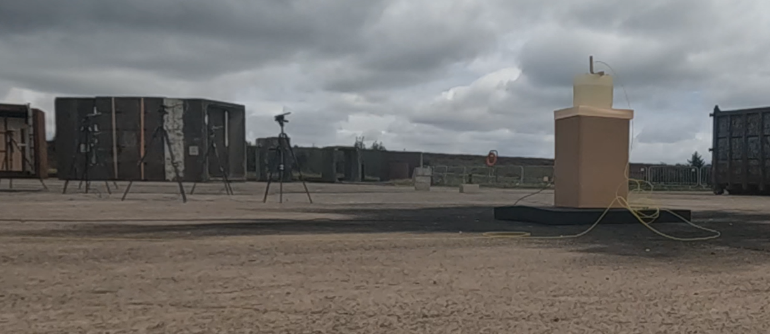
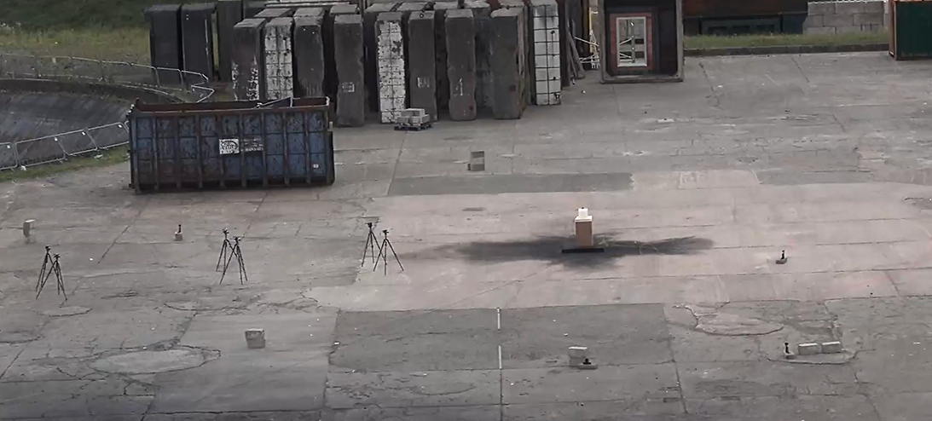
Figure 1 - Trial Setup from CCTV
Figure 2 - Trial Setup from Go-Pro

Experimental Design Rationale:
The experimental design aimed to isolate the influence of the booster type and mass on initiation performance while holding all other variables constant. This approach ensured that differences in detonation behaviour could be attributed primarily to the booster configuration rather than external factors.
Five trials were conducted to explore both material substitution and mass reduction effects:
- Trial 1:100g PE4 (control)
- Trial 2: 100g Semtex 10SE
- Trial 3: 50g Semtex 10SE
- Trial 4: 50g Semtex 10
- Trial 5: 10g Semtex 10SE
This stepped reduction in booster mass enabled assessment of initiation robustness and identification of practical lower bounds for effective initiation, consistent with exploratory feasibility testing in explosives engineering [3].

Charge and Booster Configuration:
In all trials, NM was used in a liquid, unsensitised form. The NM was contained within 25 l plastic drums that had been cut open, resulting in a partially confined charge configuration. This arrangement reflects realistic industrial use while providing a degree of confinement sufficient to support reliable detonation initiation [24].
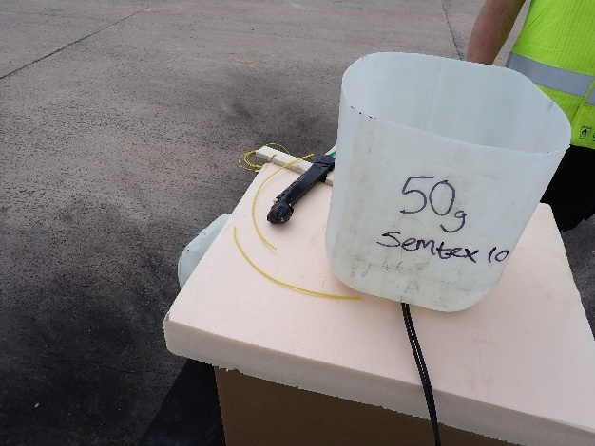
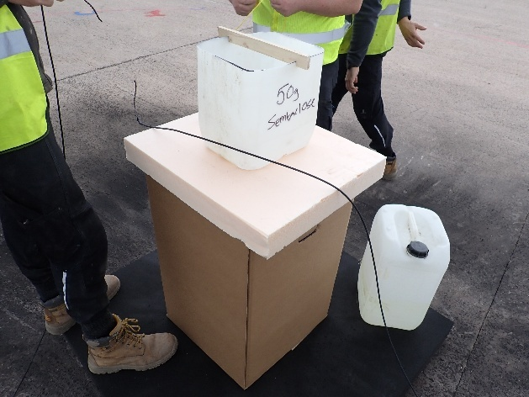
Each booster was moulded into a spherical geometry and attached directly to the detonator. The booster-detonator assembly was placed centrally within the NM charge to maximise symmetry and coupling efficiency. To prevent direct chemical interaction between the NM and solid booster material, the booster was enclosed within a plastic bag, then taped round to ensure it stayed attached. This was intended solely as a protective measure and was not considered to provide significant confinement or affect the booster’s performance.
Figure 3 - Charge and Booster Configurations
Initiation System Design:
All trials used non-electric detonators initiated via shock tube. The detonator was inserted directly into the booster material, with the mechanical integrity of the plastic explosive sufficient to maintain consistent positioning without additional restraint.
The shock tube was routed directly through the NM charge to the detonator. As detailed in Chapter 3, compatibility between the shock tube and NM had been assessed prior to testing through a 24-hour immersion trial, providing confidence that the initiation system would not be adversely affected during the test window.
This initiation arrangement reflects common operational practice and ensured consistent energy transfer from the detonator into the booster and subsequently into the NM charge.

Instrumentation and Measurement Layout:
Blast effects were measured using six pencil-type pressure gauges. The gauges were arranged symmetrically at three stand-off distances:
- Two gauges at 6 m
- Two gauges at 10 m
- Two gauges at 15 m
This layout provided redundancy at each distance and enabled assessment of both spatial consistency and data reliability. The gauges recorded peak overpressure and impulse, allowing evaluation of both instantaneous blast loading and total energy transfer.
In addition, high-speed cameras operating at 16,000 frames per second were deployed to capture detonation phenomena and support estimation of detonation velocity. Camera placement was selected to provide a clear line of sight while remaining within established safety constraints.

Blast Modelling and Test Planning:
Prior to live testing, PDecay and ConWep blast modelling software were used to predict expected blast parameters. A TNT equivalence factor of 1.086 was applied to the NM charge, consistent with published equivalence values for NM under comparable conditions [3] [31].
The modelling outputs served two primary purposes:
- Setting exclusion zones and confirming instrumentation survivability.
- Providing predicted peak overpressure and impulse values for subsequent comparison with measured data.
While it is recognised that empirical blast models rely on simplifying assumptions, their use in test planning is well established and contributes to safe and effective experimental design [30].

Test Execution:
All trials were conducted over a two-day period. Trial 1 (100 g PE4) was carried out the day prior to the remaining trials, during which temporary airport barriers were present on the range as part of an unrelated activity. Trials 2-5 were conducted on the same day under consistent environmental conditions.
Between each shot, the range was fully cleared, inspected, and reset. Instrumentation was checked and repositioned as required to ensure consistency across trials. This reset process ensured that residual effects from previous detonations did not influence subsequent measurements.

Post-Test Actions and Observations:
Following each detonation, a post-blast inspection was conducted. All five trials resulted in complete and successful detonation of the NM charge, with no evidence of low-order behaviour or partial initiation.
No fragmentation was observed in any trial, consistent with the plastic containment and charge configuration used. All pressure gauges were successfully recovered, and no instrumentation failures were recorded. These observations support the validity of the collected data and confirm that the experimental design functioned as intended.

Summary:
This chapter has described the design and implementation of the experimental trials conducted at DNV Spadeadam to evaluate S10 and S10SE as booster explosives for NM initiation. The controlled charge configuration, consistent initiation system, robust instrumentation layout, and integration of blast modelling collectively ensured a reliable framework for performance evaluation.
The results obtained from this experimental design are presented and analysed in the following chapter, where measured blast parameters are compared against predictions and literature values to assess booster suitability.

Testing, Results and Evaluation:
Introduction:
This chapter presents and evaluates the results of the experimental trials conducted to assess the effectiveness of S10 and S10SE as booster explosives for the reliable initiation of NM. The measured blast parameters are compared against pre-test predictions generated using PDecay, ConWep, and the Kingery–Bulmash blast parameter calculator. The results are analysed in terms of initiation success, measured peak overpressure, impulse, and operational performance, with PE4 considered as a qualitative operational reference rather than a direct quantitative blast comparator.
The methodology outlined in Chapter 3, Research Methodology, established a controlled experimental framework intended to isolate the booster type and booster mass as the principal independent variables influencing NM initiation and subsequent blast output. By maintaining consistent environmental conditions, instrumentation layout, and charge configuration across trials, the experimental design aimed to minimise external variability and enable meaningful comparison between booster compositions. The results presented in this chapter are therefore analysed in direct reference to the methodological assumptions, modelling predictions, and measurement techniques previously described, allowing assessment of both experimental validity and the accuracy of pre-trial blast predictions.

Overview of Test Programme:
Five detonation trials were conducted using identical NM charge configurations, with variation only in booster type and mass. Using a TNT equivalence factor of 1.086, each NM charge corresponded to an equivalent mass of approximately 13.81 kg TNT. The two trials employing 100 g boosters therefore had a marginally higher total net explosive quantity; however, this difference was negligible relative to the overall charge mass.
Trial | Booster Type | Booster Mass (g) | Result
1 | PE4 | 100 | Complete Detonation
2 | Semtex 10SE | 100 | Complete Detonation
3 | Semtex 10SE | 50 | Complete Detonation
4 | Semtex 10 | 50 | Complete Detonation
5 | Semtex 10SE | 10 | Complete Detonation
Table 3 - Detonation success
Table 3 summarises detonation success for each trial. All booster configurations resulted in successful initiation of the NM charge, with no evidence of low-order detonation or misfire.
PE4 was incorporated within the experimental programme primarily as an operational reference rather than a direct quantitative blast comparison. The baseline trial was intended to confirm reliable initiation methodology and provide contextual grounding against established RDX-based booster performance, reflecting common practice within defence test and evaluation environments. As a result, full pressure instrumentation was not prioritised for this configuration, and the PE4 trial is therefore discussed qualitatively within this chapter rather than included in detailed statistical analysis alongside the instrumented Semtex trials.

Predicted Blast Parameters:
Using Hopkinson-Cranz cube-root scaling, scaled distances for a 15kg TNT equivalent charge were calculated using the equation:
$Z=\frac{R}{W^{\frac{1}{3}}}$ Equation 3 - Scaled Distance
where Z is equal to the scaled distance, R is equal to stand-off distance, and W is equal to the TNT equivalent mass. Using this equation Z is calculated as 2.43m/kg^{1/3}, 4.05m/kg^{1/3}, and 6.08m/kg^{1/3}, at 6m, 10m, and 15m respectively. These values can then be used to calculate the peak incident overpressure using the equation:
$\frac{P_{s}}{P_{a}}=\frac{808\left(1+{\left(\frac{Z}{4.5}\right)}^{2}\right)}{\sqrt{1+{\left(\frac{Z}{0.048}\right)}^{2}}×\sqrt{1+{\left(\frac{Z}{0.32}\right)}^{2}}×\sqrt{1+{\left(\frac{Z}{1.35}\right)}^{2}}}$ Equation 4 - Peak Incident Overpressure
where Z is scaled distance, P_{s} is the overpressure at scaled distance, and P_{a} is ambient pressure. Using this equation, the overpressure at scaled distance was calculated to be 128.623kPa at 6m, 42.505kPa at 10m, and 20.521kPa at 15m.
Prior to live testing, PDecay and ConWep software were also used to predict peak overpressure as well as impulse values at stand-off distances of 6 m, 10 m, and 15 m. These predictions are presented in Table 4.
Distance (m) | PDecay Predicted Peak Overpressure (kPa) | ConWep Predicted Peak Overpressure (kPa) | ConWep Predicted Impulse (kPa/ms)
6 | 193.98 | 182.16 | 274.76
10 | 71.57 | 63.25 | 175.61
15 | 34.8 | 31.05 | 122.38
Table 4 - Predicted Blast Parameters
The modelling outputs were used to inform pressure gauge placement, establish safe exclusion zones, and determine minimum firing point distances. In accordance with DNV Spadeadam safety procedures, personnel were required to remain outside the distance at which predicted overpressure exceeded 15 mbar. For a 15kg TNT-equivalent charge, PDecay calculated a minimum personnel stand-off distance of 148.09m, which defined the exclusion zone for all trials

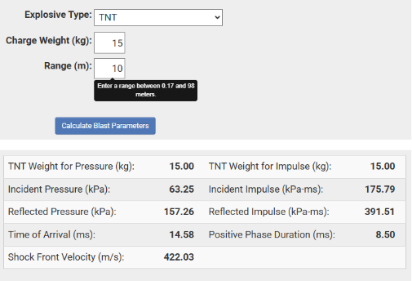
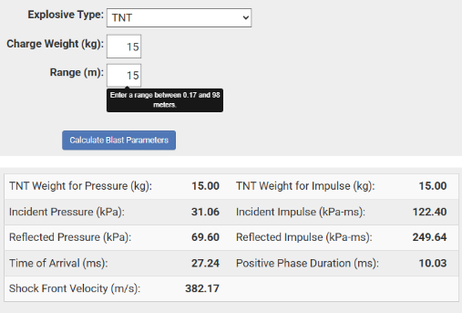
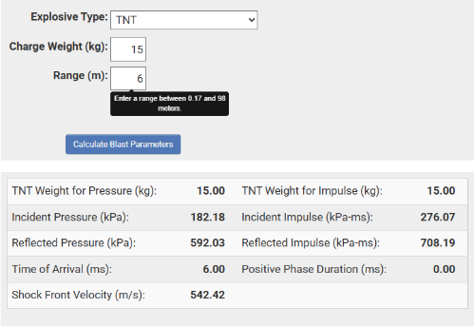
To strengthen the analytical basis of the predictions, the Kingery-Bulmash [32] blast parameter calculator was also used to estimate peak overpressure, impulse, time of arrival, and shock front velocity. The combined use of Kingery-Bulmash, PDecay, and ConWep enabled cross-verification of predicted values and improved confidence in the modelling outputs.
Figure 4 - Kingery-Bulmash Calculations
Using the Kingery–Bulmash blast parameter calculator alongside PDecay and ConWep gives practitioners a far stronger analytical footing than relying on any single tool. Kingery–Bulmash provides a rigorously validated empirical baseline for free‑field blast parameters, helping to anchor predictions in widely accepted experimental data. PDecay then extends this by modelling complex decay behaviours and environmental influences, while ConWep offers a practical, scenario‑driven interface for applied blast assessments. Together, they allow cross‑checking, sensitivity analysis, and a more defensible understanding of blast effects—particularly valuable in technical trials, safety assessments, and evidence‑based reporting.

Measured Blast Results:
Measured blast parameters were recorded using pencil pressure gauges positioned at 6m, 10m and 15m, with two gauges at each distance to provide redundancy. High-speed cameras operating at 16,000fps were also used to observe detonation development.
For the purposes of data analysis:
- Test 1: 100g S10SE
- Test 2: 50g S10
- Test 3: 50g S10SE
- Test 4: 10g S10SE
Pressure data was not recorded for the 100g PE4 trial, as this detonation was conducted as part of a separate test for clients who did not require the instrumentation.

Measured peak overpressure values are presented in table 5, while measured impulse values are presented in table 6.
 | Blast Overpressure (kPa)
Distance (m) | Test 1 | Test 2 | Test 3 | Test 4
6 | 245.92 | 237.29 | 266.33 | 248.65
10 | 81.58 | 73.56 | 76.52 | 81.2
15 | 35.19 | 34.85 | 34.79 | 36.07
Table 5 - Blast Overpressure
 | Measured Impulse (kPa/ms)
Distance (m) | Test 1 | Test 2 | Test 3 | Test 4
6 | 285.64 | 284.06 | 274.03 | 293.2
10 | 202.58 | 160.44 | 202.68 | 207.27
15 | 132.55 | 130.42 | 134.53 | 130.52
Table 6 - Measured Impulse
 | 6m |  | 10m |  | 15m
 | Overpressure | Impulse | Overpressure | Impulse | Overpressure | Impulse
Test 1 | +35% | +3.96% | +28.99% | +15.36% | +13.31% | +8.31%
Test 2 | +30.27% | +3.39% | +16.31% | -8.64% | +12.23% | +6.57%
Test 3 | +46.21% | -0.26% | +21% | +15.41% | +12.02% | +9.93%
Test 4 | +36.5% | +6.71% | +28.38% | +18.03% | +16.15% | +6.65%
Table 7 – Percentage Difference Between Predicted and Measured Impulse and Overpressure

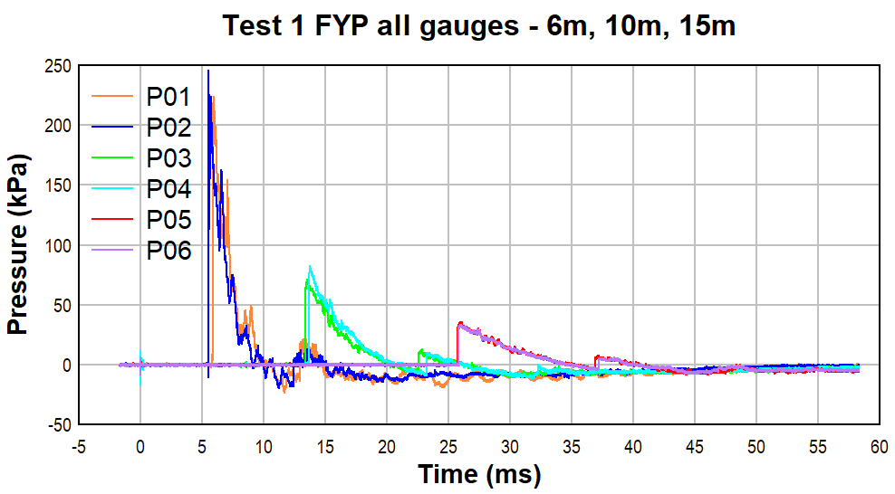

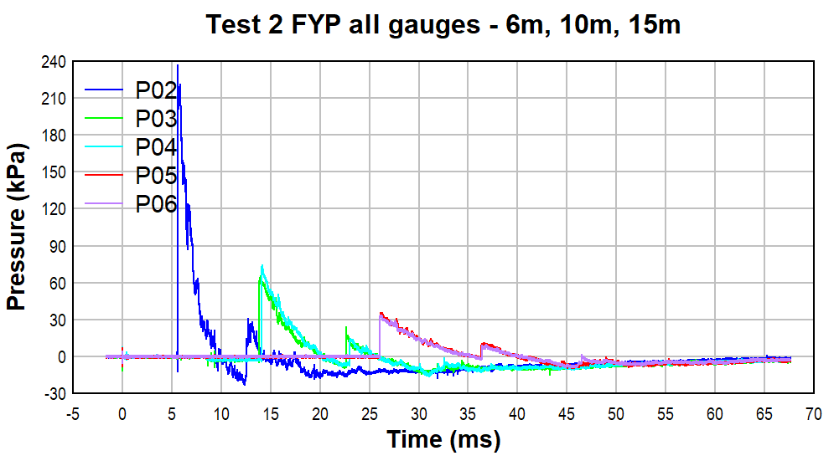
Figure 5 - Test 1 Measured Overpressure

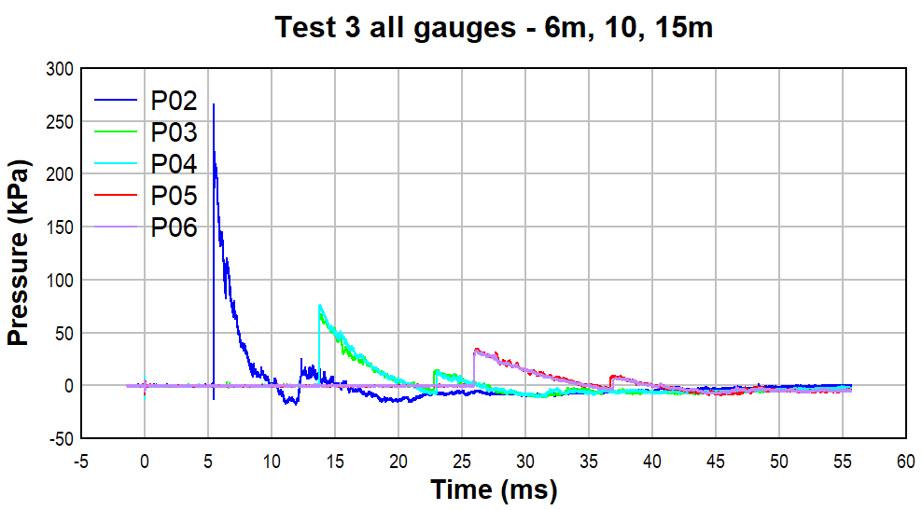
Figure 6 - Test 2 Measured Overpressure

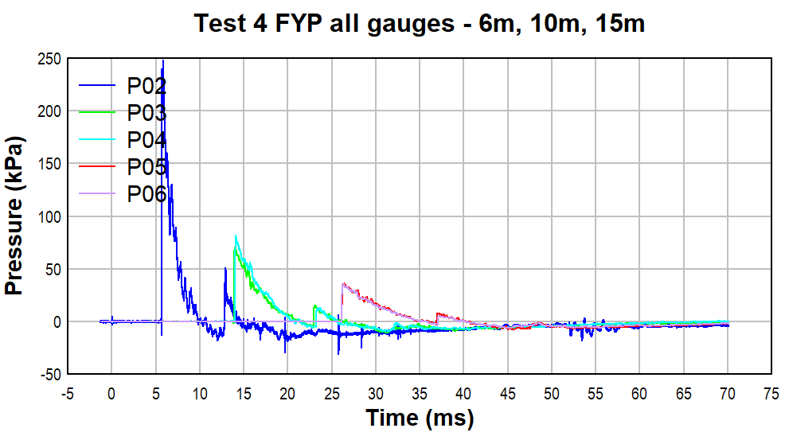
Figure 7 - Test 3 Measured Overpressure

Figure 8 - Test 4 Measured Overpressure

Distance (m) | 0 | 6 | 10 | 15
Time (ms) 1 | 0 | 5.53 | 13.76 | 25.96
Velocity (m/s) 1 | 6290 | 1084.4 | 726.9 | 577.86
Time (ms) 2 | 0 | 5.64 | 14.15 | 26.27
Velocity (m/s) 2 | 6290 | 1064.4 | 706.86 | 571.08
Time (ms) 3 | 0 | 5.46 | 13.8 | 26.16
Velocity (m/s) 3 | 6290 | 1099.1 | 724.48 | 573.46
Time (ms) 4 | 0 | 5.85 | 14.1 | 26.36
Velocity (m/s) 4 | 6290 | 1025.99 | 709.47 | 568.96
Table 8 - A table showing the average velocity at the time of reaching the pressure gauges
Comparison of Predicted and Measured Results:
Comparison between predicted and measured blast parameters show good agreement across all stand-off distances. In general, measured peak overpressure values were slightly higher than those predicted by the modelling tools, although the differences were relatively small. A similar trend was observed for impulse, with measured values consistently exceeding predictions.
This behaviour is consistent with known limitations of empirical and semi-empirical blast models, which typically assume idealised free-field conditions and simplified charge geometries [31]. In this case, partial confinement of the NM within cut-open plastic drums and local ground effects from the concrete pad are likely contributors to the observed increase in measured values relative to predictions [33].
Despite these deviations, the overall correlation between predicted and measured results supports the validity of the modelling approach for exclusion zone determination and test planning.
The blast predictions presented in Table 4 were derived using a TNT equivalence factor of 1.086 for NM. While this value is supported by published literature for comparable confinement conditions, TNT equivalence is inherently empirical and may vary depending on charge geometry, confinement, and the blast parameter considered. To assess the robustness of the modelling approach, a qualitative sensitivity consideration was undertaken.
A ±10 % variation in TNT equivalence would result in an equivalent TNT mass range of approximately 13.5 – 16.5 kg for the tested configuration. Under Hopkinson-Cranz scaling, this would alter scaled distance values by approximately 3 – 3.5 %, leading to predicted peak overpressure to be off by 5 – 10 % depending on stand-off.
Given that measured peak overpressure values exceed model predictions by up to 46 % at 6 m, the discrepancy cannot be attributed solely to reasonable variation in TNT equivalence. This suggests that local confinement effects and ground reflection contributed more significantly to the elevated measured values than uncertainty in equivalence assumptions. The overall conclusions regarding booster effectiveness are therefore considered robust with respect to plausible variation in TNT equivalence.
Effect of Booster Type and Mass:
All booster configurations tested successfully initiated the NM charge, including the smallest booster mass of 10 g of S10SE. This indicated that both S10 and S10SE possess sufficient brisance and detonation velocity to function as effective boosters under the tested conditions.
The results indicate that:
- 50 g S10 and S10SE performed comparably to larger booster masses.
- Reducing booster mass did not result in observable degradation of detonation behaviour.
- Reclaimed S10SE was capable of reliably initiating NM without chemical analysis beyond visual inspection.
These findings align with published literature indicating that NM has relatively low critical initiation thresholds when adequate booster coupling and partial confinement are present [17].

Detonation Behaviour and Observations:
High-speed video footage confirmed rapid, symmetrical detonation development in all trials. No evidence of delayed initiation, asymmetric shock propagation, or anomalous behaviour was observed.
Post-blast inspections confirmed:
- Complete detonation in all trials
- No fragmentation of the NM container
- Successful recovery of all pressure gauges
These qualitative observations support the quantitative blast measurements and confirm reliable energy transfer from booster to main charge.

Operational Evaluation:
From an operational perspective, the results demonstrate several advantages associated with Semtex-based boosters:
- Improved availability compared to PE4
- Ease of shaping and placement
- Reduced reliance on high-demand RDX-based explosives
- Potential reuse of surplus energetic material, reducing waste
No adverse effects were observed from immersion of the non-electric shock tube in NM for 24 hours prior to testing, suggesting compatibility under the tested conditions. The successful use of reclaimed S10SE demonstrates practical feasibility of reuse within controlled testing environments, supporting lifecycle-based approaches to energetic material management.

Limitations:
Several limitations of the test programme should be acknowledged:
- Only one trial was conducted per booster configuration
- No pressure data was recorded for the PE4 trial
- Chemical condition of reclaimed S10SE was not analytically verified
- Environmental conditions were not explicitly measured or controlled
These limitations are considered when interpreting the results and inform recommendations for future work. While single-trial testing limits statistical analysis, the consistency of detonation behaviour across all booster types provides qualitative confidence in initiation reliability.

Chapter Summary:
This chapter has presented the results of four experimental trials investigating the use of S10 and S10SE as boosters for NM initiation. All tested configurations achieved reliable detonation, with measured blast parameters closely aligning with pre-test predictions. The results indicate that Semtex-based boosters represent a viable operational alternative to PE4 for small-scale NM charges, as well as the possibility for larger NM charges.
Overall, the experimental results demonstrate consistent and reliable initiation of NM across all tested Semtex-based booster configurations, with measured blast parameters showing strong agreement with predictive modelling outputs. Despite variations in booster mass and composition, detonation behaviour remained stable under the tested conditions. These results support the hypothesis established in Chapter 1 that PETN-based boosters can provide a technically viable and operationally practical alternative to PE4 for NM initiation within comparable testing environments.

Conclusions and Recommendations:
This project evaluated whether S10 and S10SE could provide a reliable and operationally viable alternative to PE4 as booster explosives for the initiation of NM charges. Across all trials, including booster masses ranging from 10 g to 100 g, complete high-order detonation of the NM charge was achieved. Measured peak overpressure and impulse values showed good agreement with predictive modelling outputs generated using PDecay and related blast calculation methods, with minor deviations attributed to partial confinement and ground reflection effects. The results indicate that PETN-based Semtex boosters provide sufficient initiation energy under the tested conditions and represent a technically viable alternative to PE4 for similar test configurations.
Operationally, the findings indicate potential advantages in material availability and flexibility, particularly where procurement pressures affect RDX-based explosives. The successful use of reclaimed S10SE further suggests opportunities for controlled reuse of energetic materials within test environments. However, the study was limited by single-trial testing per configuration and the absence of instrumented PE4 baseline data to compare with. Future work should therefore include repeated trials to enable statistical validation, determination of minimum effective booster mass, and analytical verification of reclaimed material condition. Overall, the project supports the adoption of Semtex-based boosters for NM initiation in comparable experimental scenarios, subject to further validation under varied operational conditions.

Reflection:
Introduction:
Reflection is a fundamental component of professional engineering practice, enabling practitioners to critically evaluate technical decisions, identify limitations, and improve future performance [34]. This chapter provides a critical evaluation of the major project, considering not only what was achieved but how decisions made during planning, testing, and analysis influenced the overall outcomes. The reflection examines technical learning, safety and risk management, methodological limitations, and professional development within the context of explosives engineering practice.

Critical Evaluation of Technical Decisions:
Modelling and Experimental Design:
The decision to use PDecay, ConWep, and Kingery-Bulmash modelling tools prior to testing proved effective for establishing exclusion zones and instrumentation placement. Measured peak overpressure and impulse values showed good agreement with predicted outputs, validating the modelling approach. However, the observed trend of measured values exceeding predictions highlights a limitation in relying solely on empirical models for partially confined explosive configurations.
In retrospect, incorporating additional modelling methods or sensitivity analysis could have strengthened the predictive framework. Empirical blast models assume idealised free-field conditions and cannot fully account for environmental factors such as ground reflections or partial confinement, which are known to influence blast propagation [31]. This experience reinforced the importance of treating modelling outputs as guidance rather than definitive predictions.

Booster Selection and Material Handling:
This project demonstrated that the S10 and S10SE are technically viable alternatives to PE4 for initiating NM. The successful detonation of NM using booster masses as low as 10 g highlighted the importance of booster-main charge coupling and confinement, consistent with detonation theory described by Cooper [3] and Petel & Higgins [17]. A key decision was the use of reclaimed S10SE based solely on visual inspection. While this proved operationally successful, critical reflection suggests that incorporating analytical verification methods would have strengthened the technical rigour of the project. Engineering best practice emphasises verification of material condition when performance reliability is critical, and future work should integrate analytical techniques to reduce uncertainty.

Risk Management and Safety Culture:
Conducting live explosive trials required careful integration of modelling, procedural compliance, and operational judgement. Establishing exclusion zones based on TNT equivalence and predicted overpressure thresholds demonstrated the direct application of theoretical calculations to real-world risk management.
One of the most valuable learning outcomes was recognising how conservative assumptions contribute to safe testing environments. Although measured blast values were slightly higher than predicted, safety margins ensured that risk remained controlled. This highlights the importance of engineering conservatism within explosive testing, where uncertainty must always be managed proactively.
The pre-test immersion of shock tube in NM represented a small but significant example of hazard anticipation. Rather than assuming compatibility, a preliminary verification step was implemented, reflecting a shift from reactive to proactive risk assessment. Such approaches align with professional engineering competencies related to hazard identification and mitigation.

Methodological Limitations and Lessons Learned:
The most significant limitation of the project was the restriction to a single trial per booster configuration. While this constraint was driven by cost and range availability, it reduced the ability to perform statistical analysis or quantify variability in measured results. A more robust experimental design would include repeated trials to enable calculation of uncertainty and confidence intervals.
Another methodological limitation was the absence of pressure data for the PE4 baseline trial. Although initiation success provided qualitative comparison, the lack of quantitative data restricted direct performance evaluation. Future projects should prioritise consistent instrumentation across all baseline and experimental trials to strengthen comparative analysis.
An additional objective of the project was to determine shock wave velocity using high-speed video analysis. Although high-speed cameras were deployed at 16,000 fps, limitations associated with scene illumination and image saturation during detonation prevented reliable frame-by-frame tracking of the shock front. As a result, shock velocity was instead estimated using the recorded arrival times at the pressure gauge locations. While this approach provided useful approximations, it represents an average propagation velocity between measurement points rather than an instantaneous shock velocity. Given that blast waves decelerate as they expand and interact with the surrounding environment, the calculated values likely overestimate the local shock speed at later time intervals. This limitation highlights the importance of carefully balancing camera exposure, lighting conditions, and optical filtering when attempting quantitative analysis of high-speed detonation phenomena and provides a key lesson for the design of future experimental trials.
Environmental variables such as wind speed and temperature were not formally recorded during testing. While their influence on results is likely limited, incorporating environmental monitoring would improve data completeness and support more detailed analysis of deviations between predicted and measured values.

Professional Development and Engineering Practice:
Beyond technical outcomes, the project contributed significantly to professional development within the explosives testing environment. Managing live trials required coordination with range procedures, adherence to safety documentation, and effective communication with operational personnel. These experiences reflect the multidisciplinary nature of ordnance and munitions engineering, where technical competence must be balanced with procedural compliance and teamwork.
The project also encouraged broader consideration of sustainability within explosives engineering. Evaluating reclaimed explosive material introduced environmental and logistical perspectives that extend beyond purely technical performance. Integrating such considerations aligns with evolving expectations for engineers to consider lifecycle impacts and resource efficiency in design and testing processes.

Personal Development and Future Practice:
From a personal perspective, the project represented a transition from structured academic exercises to independent engineering practice. The requirement to make design decisions, justify methodological choices, and adapt to operational constraints developed increased confidence and critical thinking skills.
Reflecting on the overall process, several areas for future development have been identified:
- Greater use of analytical techniques to verify explosive material condition.
- Expanded statistical analysis skills to support experimental research.
- Increased familiarity with advanced modelling tools to complement empirical blast predictions.
Developing these areas will strengthen future capability in designing and executing experimental programmes involving energetic materials.

References

[1] | S. H. X. C. Lishuang Hu, “Study on the Initiation Capacities of Two Booster Pellets,” Central European Journal of Energetic Materials, 2012.
[2] | M. S. D.Bogosian, “TNT Equivalence of C-4 and PE4: A Review of Traditional Sources and Recent Data,” University of Sheffield Department of Civil & Structural Engineering, Sheffield, 2016.
[3] | P. W. Cooper, Explosives Engineering, Wiley-VCH, 1996.
[4] | Gov.UK, “UK Defence Export Statistics 2023,” 24 February 2025. [Online]. Available: https://www.gov.uk/government/statistics/uk-defence-export-statistics-2023/uk-defence-export-statistics-2023?. [Accessed 27 January 2026].
[5] | M. R.Menikoff, “Modelling Detonation Waves in Nitromethane,” 2011.
[6] | J. K. A. H. Rudolf Meyer, Explosives, 2015.
[7] | e. a. Tamer Elshenawy, “A Modified Penetration Model for Copper-Tungsten Shaped Charge Jets with Non-uniform Density Distribution,” The University of Manchester, Manchester, 2016.
[8] | Explosia, “Semtex 10,” [Online]. Available: https://explosia.cz/wp-content/uploads/2025/10/Navod_SEMTEX-10_2018-10-04.pdf. [Accessed 23 January 2026].
[9] | B. Hamilton, “13.8 What is the Chemical Structure of Common Explosives,” Stason, [Online]. Available: https://stason.org/TULARC/science-engineering/chemistry/13-8-What-is-the-chemical-structure-of-common-explosives.html?. [Accessed 23 January 2026].
[10] | e. a. Farah Nadia, “Investigation of the Effects for Point of Initiation for Military Explosive-PE4 on the Blast Profile,” National Defence University Malaysia, Kuala Lumpur, 2020.
[11] | L. A. Giovanni Begue, “Explosive and Pyrotechnic Wastes Management Practices,” Parc Technologique Alata, Verneuil en Halatte, France.
[12] | Gov.UK, “Policy and Procedures for Munitions Disposal,” [Online]. Available: https://assets.publishing.service.gov.uk/government/uploads/system/uploads/attachment_data/file/491739/20150427_FOI_03698_JSP762_Ch9_Annex-O.pdf. [Accessed 27 January 2026].
[13] | “International Ammunition Technical Guidelines,” UNSaferGuard, 2021. [Online]. Available: https://unsaferguard.org/. [Accessed 27 January 2026].
[14] | Explosia, “Explosives,” [Online]. Available: https://explosia.cz/wp-content/uploads/2025/07/Explosia_kat-Explosives_2025_en.pdf?. [Accessed 12 December 2025].
[15] | e. a. Lichorobiec, “Development of Special Explosive Charges for the Reconstruction of Unstable Damaged Buildings,” Technical University of Ostrava, Faculty of Safety Engineering, Czech Republic, 2014.
[16] | W. P. W. Jonas A. Zukas, Explosive Effects and Applications, Springer, 1998.
[17] | A. H. Oren Petel, “Comparison of Failure Thickness and Critical Diameter of Nitromethane,” AIP Publishing, 2006.
[18] | e. a. Aleksandr Smirnov, “Calculation of Detonation Velocity and Pressure of Individual and Composite Explosives,” State Scientific Research Institute of Mechanical Engineering, Moscow.
[19] | e. a. Ruipeng Liu, “JWL equation of state parameters for ideal detonation: A comparative study of literature reports, theoretical derivation, and artificial neural network prediction”.
[20] | B. Pettersson, Explosives Hazard Data Sheet (PE4), Eurenco, 2013.
[21] | L. L. M.C. Chick, “Determination of Shock Initiation and Detonation Characteristics of PE4 in Proof Test Geometries,” Department of Defence, Melbourne, 1986.
[22] | “Semtex,” Finexplo, [Online]. Available: https://www.finexplo.fi/?page_id=439. [Accessed 27 October 2025].
[23] | “Nitromethane Notes,” PTI-SERT, [Online]. Available: https://pti-sert.com/nitro-note/. [Accessed 21 Jan 2026].
[24] | J. Akhavan, The Chemistry of Explosives, Royal Society of Chemistry, 2011.
[25] | “IATG 10.10,” March 2021. [Online]. Available: https://data.unsaferguard.org/iatg/en/IATG-10.10-Demilitarization-destruction-logistic-disposal-IATG-V.3.pdf. [Accessed 22 January 2026].
[26] | J. J. V. Normand C. Blais, “Real Time Analysis of PETN Detonation Products,” 1985.
[27] | Explosia, “Explosives,” [Online]. Available: https://explosia.cz/wp-content/uploads/2025/07/Explosia_kat-Explosives_2025_en.pdf?. [Accessed 26 January 2026].
[28] | Explosia, “Semtex 10 - SE,” 24 September 2018. [Online]. Available: https://explosia.cz/wp-content/uploads/2025/10/Navod_SEMTEX-10-SE_2018-09-24-1.pdf?_sm_au_=iVVvVHl6RFMkS7MMctQQFK3qWK4TJ. [Accessed 23 January 2026].
[29] | P. L. A. T. Mark Saunders, Research Methods for Business Students, Pearson Education, 2023.
[30] | B. Hopkinson, “A Method of Measuring the Pressure Produced in the Detonation of High Explosives or by the Impact of Bullets,” Philosophical Transactions of the Royal Society of London. Series A, Containing Papers of a Mathematical or Physical Character, vol. 213, pp. 437-456, 1913.
[31] | “Structures to Resist the Effects of Accidental Explosions,” Departments of the Army, the Navy, and the Air Force, 1990.
[32] | “Kingery-Bulmash Blast Parameter Calculator,” UNSaferGuard, [Online]. Available: https://unsaferguard.org/un-saferguard/kingery-bulmash. [Accessed 09 February 2026].
[33] | “A Statistical Approach to Predict the Effect of Confinement on the Detonation Velocity of Commercial Explosives,” Rock Mechanics and Rock Engineering, vol. 37, pp. 317-330, 2004.
[34] | D. A. Schon, The reflective Practitioner, 1991.
[35] | e. a. Carlos Ferreira, “A Circular Economy Approach to Military Munitions: Valorization of Energetic Material from Ammunition DIsposal through Incorporation in Civil Explosives,” University of Surrey, Guildford, 2019.

Appendices:
Appendix A: Ethical Approval Letter

APPLICATION FOR ETHICAL APPROVAL

In order for research to result in benefit and minimise risk of harm, it must be conducted ethically.

The University follows the OECD Frascati manual definition of research activity: “creative work undertaken on a systematic basis in order to increase the stock of knowledge, including knowledge of man, culture and society, and the use of this stock of knowledge to devise new applications”. As such this covers activities undertaken by members of staff, postgraduate research students, and both taught postgraduate and undergraduate students working on dissertations/projects.

The individual undertaking the research activity is known as the “principal researcher”.

This form must be completed and approved prior to undertaking any research activity.

SECTION A: About You (Principal Researcher)
1 | Full Name: | Ewan Simpson
2 | Student Number: | 2115523
3 | Email address: | 2115523@student.uwtsd.ac.uk
4 | Programme of Study: | Beng (HONS) Ordnance, Munitions and Explosives
5 | Director of Studies/Supervisor: | Gareth Collett

SECTION B: Internal and External Ethical Guidance Materials
 | Please list the core ethical guidance documents that have been referred to during the completion of this form (including any discipline-specific codes of research ethics, location-specific dodes of research ethics, and also any specific ethical guidance relating to the proposed methodology). Please tick to confirm that your research proposal adheres to these codes and guidelines. You may add rows to this table if needed.
1 | UWTSD Research Ethics & Integrity Code of Practice | ☒
2 | UWTSD Research Data Management Policy | ☒
3 |  | ☐

SECTION C: Details of Research Activity
1 | Indicative title: | Evaluating Semtex 10 and 10SE as Sustainable Booster Alternatives for Initiating Nitromethane Charges
2 | Proposed start date: | 16/06/2025 | Proposed end date: | 20/03/2026
Introduction to the Research (maximum 300 words in each section)
Ensure that you write for a Non-Specialist Audience when outlining your response to the three points below:
- Purpose of Research Activity
- Proposed Research Question
- Aims of Research Activity
- Objectives of Research Activity
Demonstrate, briefly, how Existing Research has informed the proposed activity and explain
- What the research activity will add to the body of knowledge
- How it addresses an area of importance.
3 | Purpose of Research Activity  By conducting these trials, the aim is to be able to reduce DNV’s use of PE4 on small scall charges, as well as being used as a booster for the Nitromethane charges. PE4 has increased in price substantially to over £100/kg, whereas Nitromethane is less than £10/kg. PE4 is also difficult to acquire with lead times of over a year. Semtex 10SE is used regularly at DNV for explosive depth hardening and produces a lot of waste which could be used for the Nitromethane booster, rather than being disposed of. Semtex 10 is also much more readily available than PE4. By conducting trials to test out Semtex 10 and 10SE, as well as reducing the size of the booster used, it will reduce costs significantly for small scale charges.  (this box should expand as you type)
4 | Research Question  Can Semtex 10 and Semtex 10SE reliably initiate a 15kg TNTe nitromethane charge?  (this box should expand as you type)
5 | Aims of Research Activity  Successfully initiate 15kg TNTe nitromethane charges with Semtex 10 and 10SE, and determine the minimum amount of Semtex required to safely and reliably initiate the charges.  (this box should expand as you type)
6 | Objectives of Research Activity  Determine the minimum effective mass of Semtex 10/10SE for NM initiation.  Compare detonation performance with PE4.  Evaluate safety and feasibility of using reclaimed Semtex.  Quantify cost savings and material waste reductions.  (this box should expand as you type)
Proposed data collection methods (maximum 600 words)
Provide a brief summary of all the methods that may be used in the research activity to collect data, making it clear what specific techniques may be used. If methods other than those listed in this section are deemed appropriate later, additional ethical approval for those methods will be needed. You do not need to justify the methods here, but should instead describe how you intend to collect the data necessary for you to complete your project.
7 | Firstly, video footage will be captured using go-pros. A high-speed camera will also be used which will record footage as well as being used to calculate the detonation velocity. Pressure gauges will then be used for recording the pressure data.  (this box should expand as you type)

SECTION D: Scope of Research Activity
 | Will the research activity include: | YES | NO
1 | Use of a questionnaire or similar research instrument? | ☐ | ☒
2 | Use of interviews? | ☐ | ☒
3 | Use of focus groups? | ☐ | ☒
4 | Use of participant diaries? | ☐ | ☒
5 | Use of video or audio recording? | ☒ | ☐
6 | Use of computer-generated log files? | ☒ | ☐
7 | Participant observation with their knowledge? | ☐ | ☒
8 | Participant observation without their knowledge? | ☐ | ☒
9 | Access to personal or confidential information without the participants’ specific consent? | ☐ | ☒
10 | Administration of any questions, test stimuli, presentation that may be experienced as physically, mentally or emotionally harmful / offensive? | ☐ | ☒
11 | Performance of any acts which may cause embarrassment or affect self-esteem? | ☐ | ☒
12 | Investigation of participants involved in illegal activities? | ☐ | ☒
13 | Use of procedures that involve deception? | ☐ | ☒
14 | Administration of any substance, agent or placebo? | ☐ | ☒
15 | Working with live vertebrate animals? | ☐ | ☒
16 | Procedures that may have a negative impact on the environment? | ☒ | ☐
17 | Other primary data collection methods. Please indicate the type of data collection method(s) below. | ☐ | ☐
 | Details of any other primary data collection method:  Video and audio recordings are of the trial being conducted, primarily of the detonation. Any personnel being recorded is aware and will likely be edited out. Computer-generated log files will be from data loggers, pressure gauges, etc. The trial being conducted will emit carbon and other harmful gases into the environment; however, the purpose of the work is for research, and it can’t be avoided. There will also be noise pollution, but procedures are in place to reduce it to a minimum.  (this box should expand as you type) | ☐ | ☐

If you have ticked NO to every question then the research activity is (ethically) low risk and you may skip section E and continue to section F.

If YES to any question, then no research activity should be undertaken until full ethical approval has been obtained.

SECTION E: Intended Participants
 | Who are the intended participants: | YES | NO
1 | Students or staff at the University? | ☒ | ☐
2 | Adults (over the age of 18 and competent to give consent)? | ☒ | ☐
3 | Vulnerable adults? | ☐ | ☒
4 | Children and Young People under the age of 18? (Consent from Parent, Carer or Guardian will be required) | ☐ | ☒
5 | Prisoners? | ☐ | ☒
6 | Young offenders? | ☐ | ☒
7 | Those who could be considered to have a particularly dependent relationship with the investigator or a gatekeeper? | ☐ | ☒
8 | People engaged in illegal activities? | ☐ | ☒
9 | Others. Please indicate the participants below, and specifically any group who may be unable to give consent. | ☐ | ☒
 | Details of any other participant groups:  Complete this only if your participants cannot give consent. This includes animals  (this box should expand as you type) | ☐ | ☒

Participant numbers and source
Provide an estimate of the expected number of participants. How will you identify participants and how will they be recruited?
10 | How many participants are expected? | Approximately 6  (this box should expand as you type)
11 | Who will the participants be? | Shotfirer, 2 explosive scientists, 2 electricians, Control personnel  (this box should expand as you type)
12 | How will you identify the participants? | Employees at DNV  (this box should expand as you type)

 | Information for participants: | YES | NO | N/A
13 | Will you describe the main research procedures to participants in advance, so that they are informed about what to expect? | ☒ | ☐ | ☐
14 | Will you tell participants that their participation is voluntary? | ☒ | ☐ | ☐
15 | Will you obtain written consent for participation? | ☒ | ☐ | ☐
16 | Will you explain to participants that refusal to participate in the research will not affect their treatment or education (if relevant)? | ☒ | ☐ | ☐
17 | If the research is observational, will you ask participants for their consent to being observed? | ☐ | ☐ | ☒
18 | Will you tell participants that they may withdraw from the research at any time and for any reason? | ☒ | ☐ | ☐
19 | With questionnaires, will you give participants the option of omitting questions they do not want to answer? | ☐ | ☐ | ☒
20 | Will you tell participants that their data will be treated with full confidentiality and that, if published, it will not be identifiable as theirs? | ☒ | ☐ | ☐
21 | Will you debrief participants at the end of their participation, in a way appropriate to the type of research undertaken? | ☒ | ☐ | ☐
22 | If NO to any of above questions, please give an explanation
You should be able to tick YES for all of these questions. If not, then explain why not in this box.

(this box should expand as you type)

 | Information for participants: | YES | NO | N/A
24 | Will participants be paid? | ☒ | ☐ | ☐
25 | Is specialist electrical or other equipment to be used with participants? | ☒ | ☐ | ☐
26 | Are there any financial or other interests to the investigator or University arising from this study? | ☐ | ☒ | ☐
27 | Will the research activity involve deliberately misleading participants in any way, or the partial or full concealment of the specific study aims? | ☐ | ☒ | ☐
28 | If YES to any question, please provide full details
All participants are DNV employees so are getting paid. High-speed cameras and pressure gauges will be used by electricians.

(this box should expand as you type)

SECTION F: Anticipated Risks

 | Outline any anticipated risks that may adversely affect any of the participants, the researchers and/or the University, and the steps that will be taken to address them.
1 | Risks to participants  For example: sector-specific health & safety, emotional distress, financial disclosure, physical harm, transfer of personal data, sensitive organisational information. If you have identified in section D that there are no participants then enter N/A and go skip to question 3.
 | Risk to participants:  Risk of death/severe injury from the blast  Risk of hearing damage  Risk of eye damage from nitromethane  (this box should expand as you type) | How you will mitigate the risk to participants:  Antistatic PPE, limited personnel involved, following appropriate test procedures.  PPE, site alarm to warn people about the test  Eye protection  (this box should expand as you type)
2 | If research activity may include sensitive, embarrassing or upsetting topics (e.g. sexual activity, drug use) or issues likely to disclose information requiring further action (e.g. criminal activity), give details of the procedures to deal with these issues, including any support/advice (e.g. helpline numbers) to be offered to participants. Note that where applicable, consent procedures should make it clear that if something potentially or actually illegal is discovered in the course of a project, it may need to be disclosed to the proper authorities
N/A

(this box should expand as you type)
3 | Risks to the investigator  For example: personal health & safety, physical harm, emotional distress, risk of accusation of harm/impropriety, conflict of interest
 | Risk to the investigator:  Same as the risks to participants  (this box should expand as you type) | How you will mitigate the risk to the investigator:  (this box should expand as you type)
4 | University/institutional risks  For example: adverse publicity, financial loss, data protection
 | Risk to the University:  Reputational damage  (this box should expand as you type) | How you will mitigate the risk to the University:  Testing is done on a secure site and all trials treated as confidential, all data is secure  (this box should expand as you type)
5 | Environmental risks  For example: accidental spillage of pollutants, damage to local ecosystems
 | Risk to the environment:  Harmful gasses emitted  Noise pollution  (this box should expand as you type) | How you will mitigate the risk to environment:  Isn’t possible  Testing when noise forecast is predicted to be low, monitoring number of tests per day  (this box should expand as you type)

SECTION G: Feedback, Consent and Confidentiality

If you have identified in section D that there are no participants then enter skip this section and continue to section H.

1 | Feedback  What de-briefing and feedback will be provided to participants, how will this be done and when?
Lessons learnt de-brief after the trial
(this box should expand as you type)
2 | Informed consent  Describe the arrangements to inform potential participants, before providing consent, of what is involved in participating. Describe the arrangements for participants to provide full consent before data collection begins. If gaining consent in this way is inappropriate, explain how consent will be obtained and recorded in accordance with prevailing data protection legislation.
Kick off meeting

(this box should expand as you type)
3 | Confidentiality / Anonymity  Set out how anonymity of participants and confidentiality will be ensured in any outputs. If anonymity is not being offered, explain why this is the case.
Personnel involved in the tests won’t be included in any video or audio recordings
(this box should expand as you type)

SECTION H: Data Protection and Storage

 | Does the research activity involve personal data (as defined by the General Data Protection Regulation 2016 “GDPR” and the Data Protection Act 2018 “DPA”)? | YES | NO
1 | “Personal data” means any information relating to an identified or identifiable natural person (‘data subject’). An identifiable natural person is one who can be identified, directly or indirectly, in particular by reference to an identifier such as a name, an identification number, location data, an online identifier or to one or more factors specific to the physical, physiological, genetic, mental, economic, cultural or social identity of that natural person. Any video or audio recordings of participants is considered to be personal data. | ☐ | ☐
 | If YES, provide a description of the data and explain why this data needs to be collected:
2 | This includes audio/video data of participants, but can also include IP addresses and usernames. Names, addresses and emails also count, as do consent forms.  (this box should expand as you type)
 | Does it involve special category data (as defined by the GDPR)? | YES | NO
3 | “Special category data” means sensitive personal data consisting of information as to the data subjects’ –  (a) racial or ethnic origin,  (b) political opinions,  (c ) religious beliefs or other beliefs of a similar nature,  (d) membership of a trade union (within the meaning of the Trade Union and Labour Relations (Consolidation) Act 1992),  (e) physical or mental health or condition,  (f) sexual life,  (g) genetics,  (h) biometric data (as used for ID purposes), | ☐ | ☐
 | If YES, provide a description of the special category data and explain why this data needs to be collected:
4 | What counts as ‘sensitive’ will differ between cultures. Any information on behaviour that is not in accordance with cultural norms would count as sensitive personal data.  (this box should expand as you type)

 | Will data from the research activity (collected data, drafts of the thesis, or materials for publication) be stored in any of the following ways? | YES | NO
5 | Manual files (i.e. in paper form)? | ☒ | ☐
6 | University computers? | ☐ | ☒
7 | Private company computers? | ☒ | ☐
8 | Home or other personal computers? | ☐ | ☒
9 | Laptop computers/ CDs/ Portable disk-drives/ memory sticks? | ☐ | ☒
10 | “Cloud” storage or websites? | ☒ | ☐
11 | Other – specify: | ☐ | ☒
12 | For all stored data, explain the measures in place to ensure the security of the data collected, data confidentiality, including details of backup procedures, password protection, encryption, anonymisation and pseudonymisation:
All data will be kept in password protected cloud storage on University Office 365 system or DNV company Office 365 system.

(this box should expand as you type)

 | Data Protection
 | Will the research activity involve any of the following activities: | YES | NO
13 | Electronic transfer of data in any form? | ☒ | ☐
14 | Sharing of data with others at the University outside of the immediate research team? | ☐ | ☒
15 | Sharing of data with other organisations? | ☐ | ☒
16 | Export of data outside the UK or importing of data from outside the UK? | ☐ | ☒
17 | Use of personal addresses, postcodes, faxes, emails or telephone numbers? | ☐ | ☒
18 | Publication of data that might allow identification of individuals? | ☐ | ☒
19 | If YES to any question, please provide full details, explaining how this will be conducted in accordance with the GDPR and Data Protection Act (2018) (and/or any international equivalent):
All data will be encrypted and kept in password protected cloud storage on company Office 365 system which will not be shared outside of DNV.

(this box should expand as you type)
20 | List all who will have access to the data generated by the research activity:
2 explosive scientists, 2 electricians

(this box should expand as you type)
21 | List who will have control of, and act as custodian(s) for, data generated by the research activity:
2 explosive scientists

(this box should expand as you type)
22 | Give details of data storage arrangements, including security measures in place to protect the data, where data will be stored, how long for, and in what form.
All data will be encrypted and kept in password protected cloud storage on company Office 365 system which will not be shared. The data will be deleted upon the projects completion.

(this box should expand as you type)
22 | Confirm that you have read the UWTSD guidance on data management (see https://www.uwtsd.ac.uk/library/research-data-management/) | ☒
23 | Confirm that you are aware that you need to keep all data until after your research has completed or the end of your funding | ☒

SECTION I: Declaration
The information which I have provided is correct and complete to the best of my knowledge. I have attempted to identify any risks and issues related to the research activity and acknowledge my obligations and the rights of the participants.

In submitting this application I hereby confirm that I undertake to ensure that the above named research activity will meet the University’s Research Ethics and Integrity Code of Practice which is published on the website: https://www.uwtsd.ac.uk/research/research-ethics/
 | 1 | Signature of applicant: | E.Simpson | Date: 18/02/26
2 |  | Director of Studies/Supervisor: | Gareth Collett |  | Date:
3 |  | Signature: |  |  | Date:

FOR INTERNAL USE ONLY:
 | Ethical approval given
1 | Signature of assessor: |  | Date:
2 | Name:
3 | Role:

Appendix B:


