Name | Nordia Patrice Baker 1813361
Course reference | BMSK4004
Course | Problem solving and decision making
Tutor | Mr Kumar

Content
- Introduction
- Identifying problems faced by organisation
- Tools and techniques used for problem solving
- Solutions for problem solving and Selecting and implementing solutions for problem solving
- The monitoring and feed back
- Recommendations and conclusions

Introduction
The NHS has been a well-established organisation for over 70, it has looked after millions of people since 1948 to present day. As time has gone on the demand on the service has become bigger and quality of care is becoming harder to maintain. For this assignment I will be looking at Barking, Havering and Redbridge University Trust (BHRT) which covers Queens Hospital which is based in Romford, Queen’s Hospital opened their doors in 2006 after moving from the old site at Old Church, it has over 6500 members of staff and volunteers and covers a diverse community of over 750,000 people. BHRT is also a Teaching Hospital which over sees students from American university of the Caribbean and Bart’s and the London School of medicine and dentistry. The hospital runs a fully functioning A&E service with trauma centre and hyper-acute stroke unit, it is also known for having the largest maternity unit in the country together with Queen’s birth centre a renal dialysis unit and specialist neuroscience centre.
The department I am going to look at is the children outpatient’s department (COPD) based in Queens hospital. On this department there is a structure which consist of the matron, sister in charge, two staff nurses, four phlebotomists, 4-6 health care assistants (HCA) and two receptionists. In contrast to other departments this is a relatively small team. The department sees hundreds of patients a week and operates Monday to Friday for service users, they will occasionally have clinics on the weekend, but this is for consultants who have a long waiting list.
In this essay I will explore the different problems the department face and how they can be managed and what improvements can be made as possible solutions.

Identifying problems faced by organisation
There are many problems that the COPD face’s every year they range from very big to very small. I have identified 6 problems that face the children’s outpatient’s department.
The first problem is the high turnover of staff. The reason for staff to leave has varied over the years for example it can be dues to mental or emotional burnout, the changing in their banding for example they where a band 3 and was downgraded to a band 2 which means they cant use the skills they have and are restricted in what the can do. their goes up and responsibility is more, they are close to retirement age so do not what the stress of the position. They leave for better opportunity, or better hours that fit around their busy lives.
The second problem is communication, unfortunately because we are all individuals the way we interact with one another while at work will vary. Due to other stresses or emotion can break down communication at work. Communication is not isolated unless you have just started and are getting to know your co-workers. According to (Morgan, 2017) communication is how we decode what is being said to us and how we express what we have heard. The biggest break down of communication in the workplace is what we feel is fair treatment or favouritism and this can make it difficult for staff who work hard.
The third problem I will look at is hot clinic waiting times, hot clinics on COPD is an appointment that child is referred to from their general practitioner (GP) they will see a consultant and the issues they are facing is generally urgent and need to be seen right away to be dealt with or put onto the right pathways for treatment. The problem this referral face’s is the of time slots as there is only three slots per day and they have to be agreed by a consultant who is on duty that day, the cancelation of slots by staff who have not had the experience in dealing with this referrals. Also the way GP’s have had to do the referral in the past and present have also caused problems for example previously they would have to fax in the referral and often there was important information missing on the referral or they faxed it to the incorrect department and this can mean delays with children being seen. Other problems with faxing the referrals are simple errors for example not enough toner or paper in the machine, and when this is noticed you could have a few days’ worth of referrals waiting.
The fourth problem is accidents that have happened on the department in the last two years, one of the largest incidents to have happened on the department is a child being kicked in the face by another child with special needs who was much older, this was the first off its kind to have happened on the department. The parents of the child hurt in this incident blamed the hospital solely (Abbasah, March 2017), although there were protocols in place and in hindsight, they could not see something like this happening as the older child who kicked the younger child had been on the department before.
The fifth problem is the implementation of new technology, on the department the use of outlook for email use has been update to NHS mail meaning collecting emails are easier because it is not just limited to work station but can be accessed online anywhere in the world, with such a big up date for all staff across BHRT it can be difficult for example when I returned to work for maternity leave I was locked out of the work system and my manager had to write an email for me to be added back onto the system with this many problems came to the surface which then left me not able to access emails for over a month or so.
The sixth problem is training and although every person is entitled to have training, you can only do what is in your remit. On small departments this can leave them short or missing staff members, if then HCA were able to do the basic training with using some computer systems it would optimise the use of staff.

Tools and techniques used for problem solving
When we talk about problem solving, we need to look at the root cause of the problem and not just the symptoms. The tool is what is used for example a device and the technique is the procedure or strategy used to complete the task.
There are many tools and techniques for problem solving example SWOT analysis, PESTLE, Porters five forces, Fishbone also known as Ishikawa diagram, 80/20 rule which is Pareto principle, force field and brainstorming this is just to name a few, these are all used as aids to try and find a solution or a route to improving a problem or situation in most businesses. I will be applying some of these methods to one of the problems mentioned above.
The techniques I will be using to analysis my problem will be Swot analysis, Fishbone diagram, PESTLE and force field analysis. I will be using these- tool on problem four. The problem is very complex as it need to be looked at in a way where we are not discriminating against a certain group of people and putting their needs first overall.

Force field analysis
This tool was invented by a gentleman called Kurt Lewin in the 1940’s, he used this tool in his work as a social psychologist, but in today business they use it as a tool to see if change is for the best. When using force field, the idea is to keep the balance in a situation the forces for change must be strengthened or the resisting force weakened for change to place or the situation to stay the same.

Forces for change | Proposed change | Forces resisting change
- Parent often feels child does not have a problem or special need  - Parents does not have a diagnosis  - Parent doesn’t know child’s triggers | Introduction of risk assessment for children and young people attending outpatient's department (COPD) who may display aggressive behaviour form. | - Gives a good indication of child’s triggers when attending the department.  - Assess how much restraint is needed for appointment.  - Assess what behaviour may be exhibited

Although there will be resistance from parents in having to fill in the form, the benefits of taking the time to do the form outweighs the risk of the incident happening again.

Swot analysis
Swot analysis is a tool which is used to identify a business strengths, weaknesses, opportunities and threats with the COPD there are many strengths within the team and how they manage difficult situation when they arise. In the table below it will show a swot analysis of the department.
Strengths  - Wide range of skill set  - Excellent manager  - Team works well in a crisis  - Will have a better knowledge of child’s need.  - Time given to each child | Weakness  - More cares need to handle the situation  - Better assessment needs to be done to understand and manage the child’s attendance in clinic
Opportunity  - Could change access point for children with server behavioural needs  - Could do risk assessments for all children with server behavioural needs | Threats  - The accident could happen again  - No security  - Brexit  - No isolation room  - Parent/carer may not want to fill in the assessment form

Fishbone or Ishikawa diagram
The fishbone diagram is used to determine elements could possibly lead to a change in the process of the policy used to deal with problems. It helps to identify problems and put them into an order of where and how to eliminate them. In the diagram below you will see all the factors that can impact a child with behavioural or special need’s when attending an appointment on the COPD.
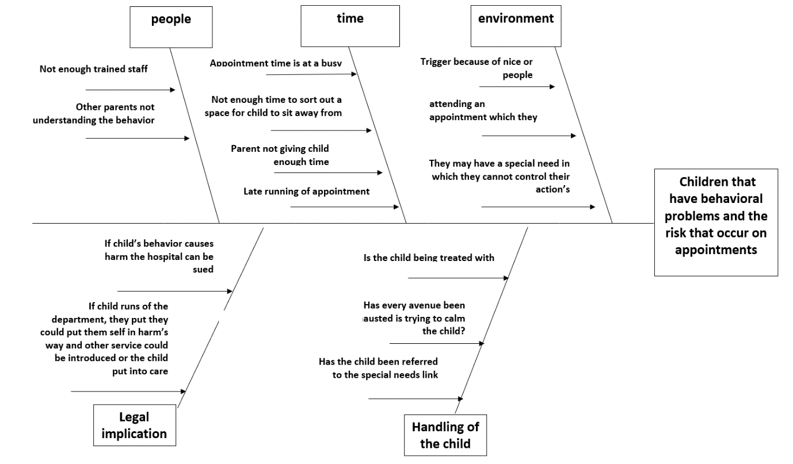
(Template Lab, 2020)

Stakeholders Table
Stakeholder names | Power/  interest | Key interest and issues | Communication vehicle or media | frequency | comment
Directors | Planning in service, decision making. | Making sure budgets are correct and ensuring services are being met. | On and offsite meeting with other agency and reporting | Monthly
Estates | Ensuring building is fit for purpose | Making sure safety checks 24 hrs of the day are complete, ensuring things are fixed and coordinating procurement of these services. | Making sure the service is covered | As needed by email – as you have to book the job
CQC | Insuring standards are met | Visiting, advising and monitoring | Emails, telephone or letters | Yearly or they will set deadlines for improvement | Good for seeing where things need improvement
Managers -Matron | Over see the who department delegating work to sister in charge | That service runs smoothly | Email, telephone | Every week | Supports members of team
Senor sister and Staff nurse | Over see’s rotas are complete, that service is fit to fly.  Update staff on any changes and will delegate some duties to staff nurse | Making sure budget is not gone over, that team works well and any other problems which can occur | Email’s and staff meeting | Emails when need.  Meeting monthly | Supports staff on the ground, willing to help when needed
Staff- HCA, Phlebotomist, consultants, support staff | Teamwork, deliver a safe and smooth service | Making sure training is up to date | Face to face meetings, telephone and email | monthly | Staff are happy with traning given and work effectively as part of a team
Service users | To treat the staff with dignity and respect | Ensuring they get the treatment needed | Through satisfaction surveys community meetings | Surveys when they attend appointments, meetings when needed

PESTLE
PESTLE stands for Political, economic, social, technology, legal and environmental these are all factors that can affect the NHS. The table below shows how they can impact on NHS.
Political | - Brexit - uncertainty of how medical equipment and medicine will be brought by the UK  - EU policies - could mean lengthy process to change contracts.  - Employment - also laws would change on what rights people have working in the UK.
Economical | - Economic downturn – for more than 10 years the NHS has been in financial trouble after the 2008 stock market crash.  - Austerity Measures – because of the stock market crash Pay was capped with no raises for doctor, nurses or heath care assistants it is only this year April 2019 that they were given their first pay rise in years.
Social | - Aging population – Put’s a stain onto the NHS  - High expectations - because patients have a better knowledge of treatment options the NHS has a demand to provide better care and spend a lot more money on the facilities.
Technology | - Improved technology – because technology is being improved, it means big advancement in how some surgeries are performed for example with robots.  - Better education – new technology opens door’s in the way we learn to do things and has its advantages in making thing done quicker.
Legal | - Litigation – more so than ever more people are going to court to settle case for what they feel is unfair treatment when they do not get an outcome they want.
Environment | - Recycling – they have changed the way they get rid of waste by clearly making bins and have certain colours for certain bins  - Disposing of waste – it is now a big deal in the NHS to dispose of clinical waste properly. Over the last few months there was a case of NHS facilities sending their waste to other countries in containers.

Solutions for problem solving and selecting and implementing solutions for problem solving.
To solve the problems of children with behavioural problems or special needs causing accidents like hurting other children the implementation of the risk assessment for children and young people attending outpatient's department (COPD) who may display aggressive behaviour form should be implemented as soon as possible to assess these children’s behaviour when attending appointments on the department. It will help to eliminate risk to staff, potential patients and their guardians. Potential question will be: In the past has child required reasonable adjustments to attend their appointment because they have a learning disability or other disability example behavioural problem? Or in the past has your child displayed violent behaviour? For example, kicking, biting, biting, spiting, or fighting please specify.
The second thing which will need to be implemented is the access to the department. All children who have been deemed high risk should report to the main atrium reception desk and call the department so they can be brought up by a member of staff and placed in a secure room before being seen.
When comparing the Plus, Minus and interesting both solutions were easy to implement, cost effective, with the assign of could be started straight away and less stressful for the child their guardians and clinicians. The only downside to this was the fact that for many patients English was not their first language, or they felt their child di not have any behavioural or special needs.
To implement these solutions, the solution mentioned above will need to be approved by senior management once they have approved the question and signed off the question the forms will be filled in with the parents to asses child’s behaviour when they call to book an appointment

Monitoring and feed back
To monitor how the use of the form is going the team will do an audit to assess whether it is working well or needs adjustment, also by doing observation of staff so they use best practice.
Survey forms can also be given to guardians attending the appointment, the feedback forms given will give us a rough idea how happy the guardians are with the services and changes made. The feedback forms will be very simple to use, they will have 5-6 question and use a scale of one to ten to monitor satisfaction example of this is one is not satisfied 10 is very satisfied.

Recommendations and conclusion
I would recommend that all changes be done or face having this accident again. It is detrimental that we know what the needs of our patients and their cares are, this would help to reduce risk to the child and anyone coming into contact of the child on the department. It would also reduce the risk of the trust being sued in future. We would need to look at the key factors and learn from them.
We must monitor the feelings of our service users so their needs can be met and put them at the centre of their own care while treating them with dignity and respect.

Inconclusion Decision making is only as hard as we make it with all the tools provided and a good team effect we can problem so effectively. But if the team is filled with people who are un caring it can make the decision making process a lot harder.

Reference
Abbasah, A. (2020). Mum blames Romford hospital for son getting kicked in the face. [online] Romford Recorder. Available at: https://www.romfordrecorder.co.uk/news/mum-blames-romford-hospital-for-son-getting-kicked-in-face-1-4912313 (Accessed 4 Jan. 2020)
Bush, T. (2019). PESTLE Analysis of the NHS. [online] PESTLE Analysis. Available at: https://pestleanalysis.com/nhs-pestle-analysis/ [Accessed 9 Jan. 2020].
Hospitals, B. (2020). About us. [online] BHR Hospitals. Available at: https://www.bhrhospitals.nhs.uk/about-us [Accessed 10 Jan. 2020].
Iliffe, S. and Manthorpe, J. (2020). Job dissatisfaction, ‘burnout’ and alienation of labour: undercurrents in England’s NHS - Steve Iliffe, Jill Manthorpe, 2019. [online] SAGE Journals. Available at: https://journals.sagepub.com/doi/abs/10.1177/0141076819855956 [Accessed 7 Jan. 2020].
Morgan, P. (2017). Business student's guide to study and employability. Los Angeles: SAGE, pp.245, 246.
Mindtools.com. (2020). Force Field Analysis: Analysing the Pressures for and Against Change. [online] Available at: https://www.mindtools.com/pages/article/newTED_06.htm [Accessed 7 Jan. 2020].
Mindtools.com. (2020). SWOT Analysis: – How to Develop a Strategy For Success. [online] Available at: https://www.mindtools.com/pages/article/newTMC_05.htm [Accessed 10 Jan. 2020].
Mindtools.com. (2020). What Is Problem Solving?:. [online] Available at: https://www.mindtools.com/pages/article/newTMC_00.htm [Accessed 7 Jan. 2020].
Template Lab. (2020). 43 Great Fishbone Diagram Templates & Examples [Word, Excel]. [online] Available at: http://templatelab.com/fishbone-diagram-templates/ [Accessed 9 Jan. 2020].

