

LEVEL 5

SEMESTER 1 & 2

MODULE CODE: SHSS5084
Expedition Skills

aSSESSMENT TYPE: Project
Assessment/Component: 2
COMPONENT WEIGHTING: 70%
WORD COUNT: 5,000 WORDS
MODULE TUTOR: DENISE LEONARD

Expedition Portfolio

Produce a detailed log of the planning for your expedition. This will include comprehensive risk assessments, route plans, emergency procedures, transport arrangements, medical forms, pre-expedition training/ preparation and any other relevant details. Further information related to this assessment can be found on Moodle under Expedition Portfolio Resources as well as on-going tutorial support.

SUBMISSION DETAILS:

Deadline:
Date: 7th February 2020
Time: 3.00pm
Portal: Turnitin

School of Sport, Health & Outdoor Education

Assessment Feedback Sheet

Student No./Name: 1807553/ Madeleine Barnes-Watson
Module: SHSS5084
Module Code: Expedition Skills

Personal Evaluation – to support your academic progress please complete the section below BEFORE submitting your work.
What do you consider to be the best aspects of this work? |  |  | My research into herons mode of facilitation for leadership styles during the expedition.
Which aspects do you consider could have been improved in this piece of work? |  |  | Possibly organising the entire team members of the expedition to get better profiles of the team and understanding their experiences, qualifications and capabilities.
What have you found most satisfying whilst undertaking this submission? |  |  | Going on reconnaissance trips to Pembrokeshire coast national park.
ASSESSMENT CRITERIA | Learning  Outcomes |  | GRADE
ASSESSMENT CRITERIA |  |  | Poor  0 – 25% | Unsatisfactory  26-39% |  | Satisfactory  40 – 49% | Good  50 – 59% | Very Good  60 – 69% | Excellent  70 – 85% |  | Exceptional  86– 100% | %
Produce a well presented and comprehensive expedition planning log with logical format and clarity of purpose | 1,2,4,6 |  |  |  |  |  |  |  |  |  |  | 80%
Use of appropriate reference material | 6 |  |  |  |  |  |  |  |  |  |  | 20%
It is expected that students will present work that is proof read, correctly referenced and adheres to the Assessment Checklist. Therefore a range of 0 – 10 marks will be deducted for non-completion of any of the points on the checklist below.
TUTOR COMMENTS:

Submission date:  via Turnitin |  | Return date:  (at least within 4 weeks) |  |  | Tutor: Denise Leonard |  |  |  |  | Mark:
Assignment Checklist

- Please complete the Personal Evaluation section of the Assessment Feedback sheet, add your name and details, and paste the whole of this assignment document into the front of your assignment

- Submission is a single word file, clearly labelled with your name and module code
- Font style - Times New Roman, size -12 for text and 14 for headings
- Ink colour – black only
- Line spacing – 1.5 line spacing and 2cm- 2.5cm page margins
- Quotations more than three lines to be indented 1 line spacing
- One line space between paragraphs, paragraphs must be left aligned
- Pagination (your assignment should have page numbers)
- All tables and figures are internally referenced and have a title
- Word count checked and written at end of text (before references and any appendix)
- Assignment is within 10% of the word limit (excluding references and any appendices)
- All references in the text are included in the reference list
- Correct referencing following the Harvard style, as described in the Palgrave study skills book ‘Cite them Right’.
- Correct spelling using UK English
- Correct use of punctuation
- Grammar and syntax correct- double check anything that has a green line under it
- I have read my assignment out loud to myself and it makes sense and is easy to read
- Somebody else has read my work and it makes sense to him or her!
- I have checked and I have not plagiarised
Failure to follow these guidelines will cost you marks!

Expedition Contract
The expedition will run between the 6th and the 8th of May.
I Madeleine Barnes-Watson will at all times, conduct myself as professionally as possible, adhering to the University’s Code of Conduct, and only operate within the agreed parameters of my signed-off expedition, as outlined below.
I will be running my expedition by foot in the Pembrokeshire Coast National Park.
The aims and objectives of my expedition are:
- Developing personal skills.
- To raise awareness of the environment and our effects on the environment.
- Developing a sense of the history of Pembrokeshire Coast.
Expedition Sign-off Matrix
Title | Initial | Date

Expedition Overview

Aim & Objectives

Expedition Leader Profile

Competencies / Qualifications

Expedition Assistant Leader Profile

Expedition Team Profiles

Expedition Support Person

First Aid Provisions

Medical Declaration Forms

Assumption of Risk Forms

Behavioural Expectations

Individual Kit List

Group Kit List Equipment Request Form

Preparatory Training Undertaken

Reconnaissance of Expedition Route

Camp Sites/ Location

Route Cards

Escape Routes

Contingency Planning

Weather Forecast Sources

Contact with Landowners

Generic Risk Assessments

Site Specific Risk Assessment

Roadworthiness of Vehicles

Drivers Licences

Drivers Insurance

Important Contact Details

Accident Emergency Procedures

Expedition Contact Details

Expedition Overview
This is a walking expedition along the Pembrokeshire Coast. On the first day we will begin at Tregwynt farm Woolen Mill, (SM 891 346) and walk 13.9km to Pwllcaerog Farm (SM 912 785) where we will spend the night camping. Day two, the longest day at 14.7km, starts at Pwllcaerog Farm (SM 912 785), we progress further towards the coastline in the direction of St Davids Head. Then the route moves through the city of St Davids, towards Porthclais (SM 872 723) where we are camping overnight at St Davids Bunk Barns- Carn Nwchwn Farm. On the final day, day three, we start at SM 872 71 in Porthclais, where we head towards the coastal path. We remain on the coastal path throughout the day, traveling a total of 13.8 km. The route ends at Newgale Sands (SM 848 221) Duke of Edinburgh Pub. The expedition route is relatively flat making it accessible to most people’s ability and will take place between the dates of 6th and 8th May. The planned expedition has three aims, which will be achieved mainly by using Herons Mode of Facilitation as a guide for leadership styles to be used. This expedition falls under the Lowland leader qualification guidelines. In addition, each day nearly qualifies as a quality mountain day for the Lowland Leader qualification, the only set back is that 4hours of walking is needed and at most for this expedition (Mountain Training, 2014).
Aims and Objectives
The primary aim of the expedition is for the team members to develop their personal skills of team building, improve communication skills and additionally to experience the mental health benefits of being in the outdoors. This is supported by Exeter (2002) who notes that expeditions allow communication to be enhanced, emotions are heightened due to the challenging environment and the potential to leave their comfort zone. Personal development is achieved due to real life risks and consequences. On the second day the primary aim, alongside developing their personal skills is to learn about the history of the Pembrokeshire Coast, especially about St David, the patron saint of wales.
How will you meet your Aims and Objectives?
The aims and objectives of the expedition will be met through gathering information and researching how personal skills are developed during outdoor activities and expeditions. I will use this information to ensure that I use the techniques needed to give the participants the opportunity to develop these skills. Furthermore, I will gather specific information regarding the coastal erosion in the area, geographical information about Pembrokeshire Coast, and how the national park monitor and control the area, to teach the expedition participants about the coastal environment. Additionally, I will gather information about the history of St Davids Cathedral and the town itself.
Keay (2000, p.15) states that ‘Good leaders are distinguished by the quality of their planning and the thoroughness of their preparation’, therefore I shall do use appropriate resource materials to help plan this expedition portfolio for my expedition.
I have decided that participants will be encouraged to bring technology, for example phones, speakers and cameras. This is to allow them to take photographs of the environment, especially any coastal erosion, this will enable the participants to compare and contrast the effects erosion has on the coast in the different bays we will see. By allowing phones and speakers on the expedition, it gives the participants the chance to listen to calm, relaxing music through the expedition of needed. This will create an environment that is suitable for the aims of this expedition, specifically to support the mental health benefits.
During the planned expedition, the expedition leader will use Herons mode of facilitation as the bases of facilitation to achieve the aims, and guiding the expedition members towards developing personal skills, raising awareness towards the environment and developing a sense of history of St Davids.
During the purposed expedition, a more supporting viewpoint and possibly a delegating style of leadership will be taken during the expedition. This will give the group a chance for personal development. The personal development of team-working skills will evolve because by delegating leadership, any problems that might arise will be discussed equally and joint agreement must happen throughout the expedition. From a supportive leadership perspective, the leader has more authority if needed, however communication and listening to the team must occur (Exeter, 2002). By using these two leadership styles, communication and team-work must occur for the expedition to be successful, therefore the teams communication skills, team-working skills, confidence and their technical skills will develop due to everyone having an equal role in the expedition and that all team mates thoughts and feeling must be taken into account. However, during this expedition my leadership style will be very flexible and the styles I could by using could change to suit the environment or the emotions of the group at the time.
Through discussing coastal path erosion on the first day and the final day and discussing the history of St Davids and Wales on the second day, the expedition members communication skills will develop and will be improved. In addition, an awareness of the environment will be achieved and knowledge will be gained from the different points of view from each individual member of the expedition. Also by discussing these issues during the expedition and being involved in nature, the team members of the expedition would be able to view the issues closely and be able to relate easier, therefore getting a different viewpoint to which they would get in the classroom (Allison and Von Wald, 2010).
In appendices 16, 17, and 18 are additional reading to help achieve the aims and objectives.

Expedition Leader Profile, Competencies/Qualifications
According to the Health and Safety Executive there are four ways for leaders to demonstrate their competence, which are: to hold the relevant qualification, to hold an equivalent qualification, to have received appropriate in-house training, to be competent through experience, (Mountain Training, 2014).
I have participated in many expeditions and trips, which have developed my understanding of what is needed to have a successful expedition. Although I do not currently hold any qualifications, such as Lowland leader or Mountain leader, I have gained extensive experience through the UWTSD course and from the Duke of Edinburgh award where I walked and navigated multiple quality mountain days with a small group. These experiences range from different weather conditions and different locations, from the Pembrokeshire Coast National Park, the Brecon Beacons, and Snowdonia National Park.
I have extensive knowledge and experience of camping and staying in a bothy from my previous expeditions. I am also familiar with the necessary behaviour and practice needed when using campsites and respecting the environment and other campers. I am very confident in my planned route as it is one i have walked on multiple occasions. My navigation skills mean that I am very capable and comfortable with this route. Through my Duke of Edinburgh award and my experience working at a Girl Scout Outdoor Adventure camp in Alaska for 4 months leading girls between the ages of 6 to 18 on a daily basis.
Expedition Assistant Leader Profile
Student A has been chosen as my expedition assistant leader because ……
Student A is a student of the UWTSD OAE degree and therefore has experience of….
Student A has the personal experience of….
Student A has the qualifications and competencies of ….
The expedition assistant leader is fully aware of the leadership styles necessary to facilitate a successfully expedition. They are well informed and understand the aims and objectives of the expedition.

Expedition Team Profiles
All expedition team members are students of University of Wales Trinity St Davids Ba Outdoor Adventure Education Degree.
Thanks to being students of UWTSD OAE, all the expedition members hold a Level 3 Outdoor First Aid and should have
Student A = ???
Student B = ???
Student C = ???
Due to the nature of the expedition and that all expedition team members are UWTSD students, parental/guardian consent is not required. Therefore, consent forms are not required, however each team member must fill out a medical declaration form and fill out a assumption of risk form.

Expedition Support Person
I have decided to ask Rosie Davies as my expedition support person. I have asked Rosie Davies because she is very experienced with Pembrokeshire Coast, as she had run many expeditions in many different environments and conditions. Rosie Davies has over 20 years of experience working with children and young adults. She has been involved with the Duke of Edinburgh Awards for over 15 years, she is an assessor for the DofE award scheme, and has been for 12 years. She has led expeditions with students for 5 years, from expeditions in the Brecon Beacons to expeditions in Canada. She also has an updated FAA Level 3 Outdoor First Aid and has earned the Lowland Leader Award.
Rosie Davies is also a Sargent with the Volunteer Police, with over 5 years of experience. Rosie Davies also runs a Scouting group in St Davids.
Rosie Davies has been chosen as the expedition support person, due to the fact that she is an extremely trustworthy individual, who I believe as the expedition leader has the capabilities to support this expedition excellently.

First Aid Provisions
All partaking members in the expedition must carry their own personal first-aid kit with any medication they will/might need for the planned expedition. For the planned expedition, the expedition leader must be fully updated with all expedition group members declaration forms and take special notice of any medical illnesses or physical injuries that might hinder the overall success of the expedition.
Good quality individual first aid kits can be bought in any outdoor shop such as Cotswalds, Millets or Tresspass, also each group member of the must be able to recognize and use any and all items of first aid that they carry with them. If any group member have any allergies, asthma or illnesses, they therefore must carry the appropriate medication themselves for example, epi-pens, inhalers or any prescription tablets.
From Wills (2013) research into outdoor first aid, she found that over half of the 200 participants she questioned, who worked or played in the outdoors, they carried their first aid kits in waterproof bags. Therefore, from this research and my own personal experience in the outdoors, all expedition team members must carry their first aid kit inside either waterproof bags or a container.

Medical Declaration Forms
I will hand out a medical declaration form to all expedition members to complete before they undertake the purposed expedition. My personal medical declaration form is in appendix 10, and all the other group members medical declaration form are in appendices 11,12 and 13. Each individual expedition member must fill out their medical declaration form to the best of their ability with all correct updated medical information.
Medical declaration forms are incredibly important for expeditions because the expedition leader must know if any expedition members have any allergies, medical conditions or physical ailments.

Assumption of Risk Forms
The example assumption of risk for that will be used for the planned expedition is in appendix 4. The expedition leader’s assumption of risk form is in appendix 10, and Student A, Student B and Student Cs assumption of risk forms are in appendices 11, 12, and 13.
Expeditions have assumption of risk forms to inform group members off the potential risks that they might encounter while involved in each expedition. The assumption of risk forms mean that the individuals involved accept any risk or injury that might befall them during the expedition. Also, that it is their responsibility to act without any unnecessary risk to themselves or others. The assumption of risk form informs expedition members that the expedition leader cannot control all outcomes or hazards during the expedition, and that all individuals involved must be accountable for their own actions.

Behavioural Expectations
Behavioural expectations can be defined a "doing your part to make the whole expedition succeed," which includes practicing good self-care and lending a hand when needed. (NOLS, 2016). During the expedition, all expedition members must abide by The Countryside Code throughout the expedition and during the preparatory training. Throughout the expedition, all group members must represent the university in the correct manner, use appropriate respectful language and must wear the appropriate gear (Mortlock, 1994). In addition, all expedition team members must realise they are accountable for their own actions, and that the purposed expedition is for learning, although the expedition aims for all partaking members to have a good time, they must understand that it is an educational expedition. Therefore, during this expedition, all consumption of alcohol and recreational drugs is prohibited. The behavioural expectations of this expedition are in appendix 5.
Individual Kit List
- Walking Boots (sturdy, robust and waterproof)
- 4 pairs of Walking socks
- Jacket/ coat and trousers (waterproof + windproof) *
- 2 fleece mid layers
- Thermal base layers (synthetic fabric, Not cotton)
- Walking trousers
- Underwear
- Nightwear
- Flip flops/ light shoes for campsites
- Warm hat/ sunhat (if appropriate)
- Waterproof Gloves
- Gaiters (optional)
- Water bottle
- Rucksack (minimum 50ltr)
- Waterproof liner bag/ dry bags *
- Sleeping bag
- Sleeping mat (optional)*
- Head torch + spare batteries
- Sunglasses + sunscreen
- Whistle
- Compass (Silva type 4 is perfect) *
- Expedition food (Breakfast, lunch and dinner)
- Cutlery/ plate/ Bowl *
- Bos of matches
- Wash kit/ personal hygiene items
- Towel
- Small quantity of money
- Notebook and pen/pencil (optional)
- Watch
- Sunscreen/block
- First aid kit (inside a waterproof bag/container)
*Available at Cynefin
Above is a copy of the individual kit list I will send out to all expedition group members. I believe that this kit list is sufficient for a three-day expedition along the Pembrokeshire Coast. This kit list is sufficient because I used the UWTSD overnight kit list (UWTSD, 2019) and the Duke of Edinburgh Kit List as references (DofE, 2020). This is a suggested individual kit list for the expedition team members, due to the fact that the expedition leader cannot fully control what each team member brings on expedition. Furthermore, due to the varied experiences and preferences of each team member then they can adapt the kit list to suit their needs if necessary.

Group Kit List
- Route cards
- Group tent*
- Group Shelter*
- Ground sheet (if necessary)*
- 2 maps of Pembrokeshire Coast (1:25 000/1:50 000)
- Compasses*
- 2 Trangiers *
- Butane/ Propane gas (Screw on caps)
- Cooking pans*
- Scourers
- Tin opener
- Tea towels
- Plastic bags for rubbish
- Tick remover
- Survival bag
- Insect repellent (optional)
- Games/ deck of cards
*Available at Cynefin
The group kit list is sufficient for the 3-day expedition. This is because I used the University of Wales Trinity of St Davids Overnight kit list (UWTSD, 2019) and the Duke of Edinburgh Kit List as references (DofE, 2020).

Equipment Request Form
An example of the equipment request form that the expedition members will use for the purposed expedition is in appendix 7.
My equipment request forms that I have filled out for equipment will be needed for the purposed expedition are also in appendix 7. I have filled out equipment request forms for trangiers, a tent, and a group shelter.
Preparatory Training Undertaken
Langmuir (2013) suggests that the enjoyment of the group will be enhanced if there is a general level of fitness. As all group members of the expedition are a part of UWTSD OAE degree, the groups general fitness is very suitable for the level of fitness required for the enjoyment of the purposed expedition. Langmuir also suggests that preparatory training can also help sort out issues with boots and equipment before the planned expedition, such as wearing in the boots.
To improve the expedition members preparedness for the expedition, it would be suggested that the expedition leader and the expedition assistant leader read Mountain Trainings National Guidelines for Climbing and Walking Leaders. This book can be accessed a
To further prepare the expedition leaders and increase understanding of leadership styles, there are several books available at UWTSDs Library and online. To understand Herons Mode of Facilitation and leadership styles, his books= The complete facilitator's handbook (1999) can be found in the library.
As the expedition leaders I must be confident in my knowledge and research to achieve the aims and objectives of the expedition. I will prepare thoroughly by reading relevant/ reliable sources about coastal erosion in Pembrokeshire Coast National Park. Furthermore, the expedition leader will familiarise with control measures and monitoring methods the National Parks Park Rangers put in place. Additionally, the expedition leader must research further into the history of St Davids, so that the expedition leader can confidently convey the information the participants of the planned expedition.
In appendices 15, 16, 17, and 18 are additional reading titles to further develop the expedition leader and the expedition assistant leaders understanding of coastal erosion, personal development skills and the history of St Davids.

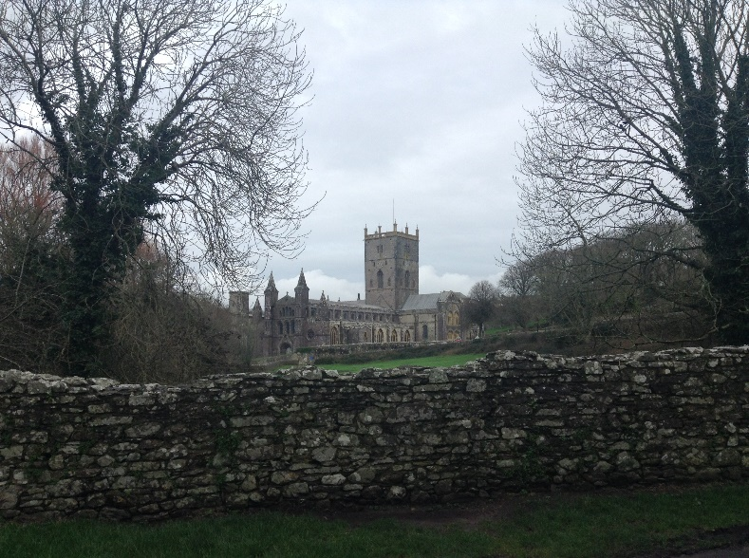
Reconnaissance of Expedition Route
On the 26th of January I undertook a reconnaissance of the 2nd day route along the coast and through St David. I also undertook a reconnaissance of the 3rd finale day route. Focusing especially on the stat of the path along the edge of the cliffs, where erosion has caused the cliffs to crumble and in some places fall. Thankfully, from this reconnaissance, I am confident that my chosen route is currently safe to undertake and suitable for the aims of the purposed expedition without a need for change.
I am also planning on going on a second reconnaissance of the planned route closer to the expeditions planned date, therefore making sure that this planned expedition has an up to date site specific risk assessment.
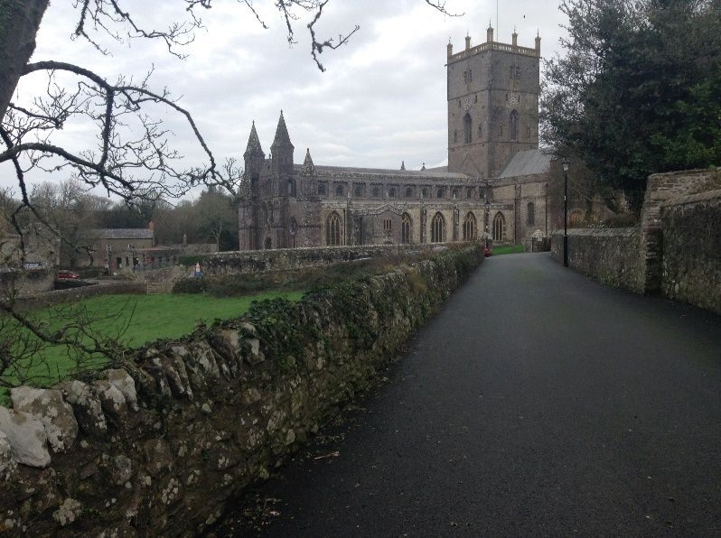
Here is my favourite photos of St Davids Cathedral I took during the reconnaissance of the 2nd day.
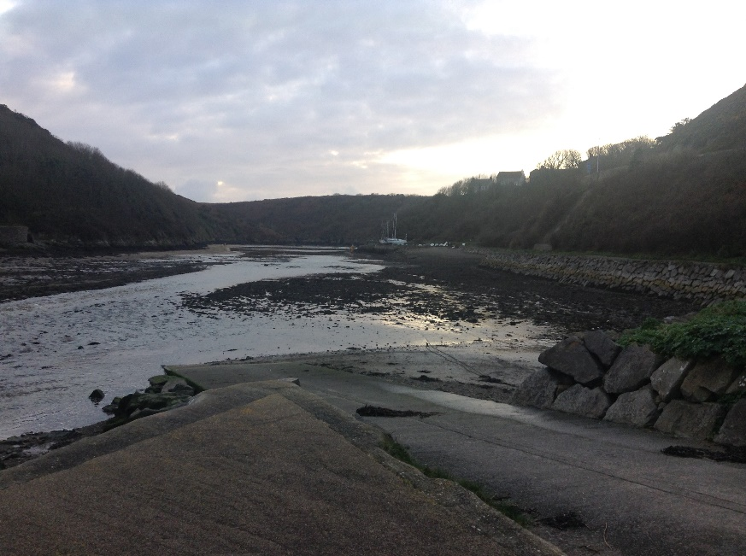
Below are photographs I took on the reconnaissance expedition showing different sections of the route.
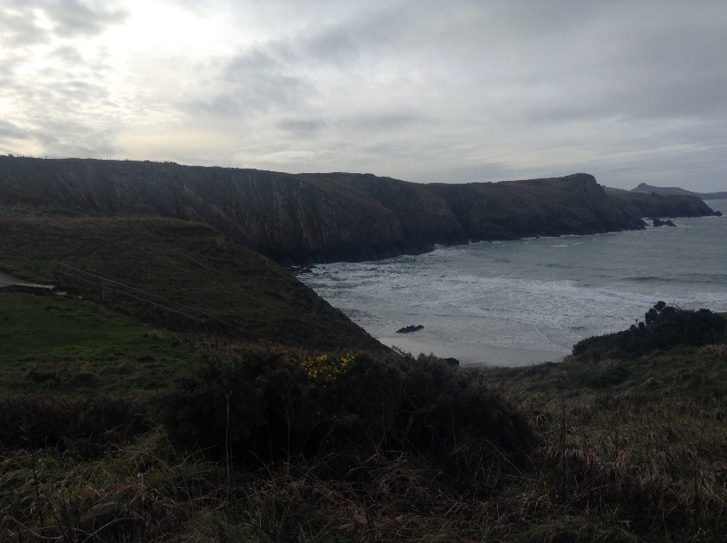
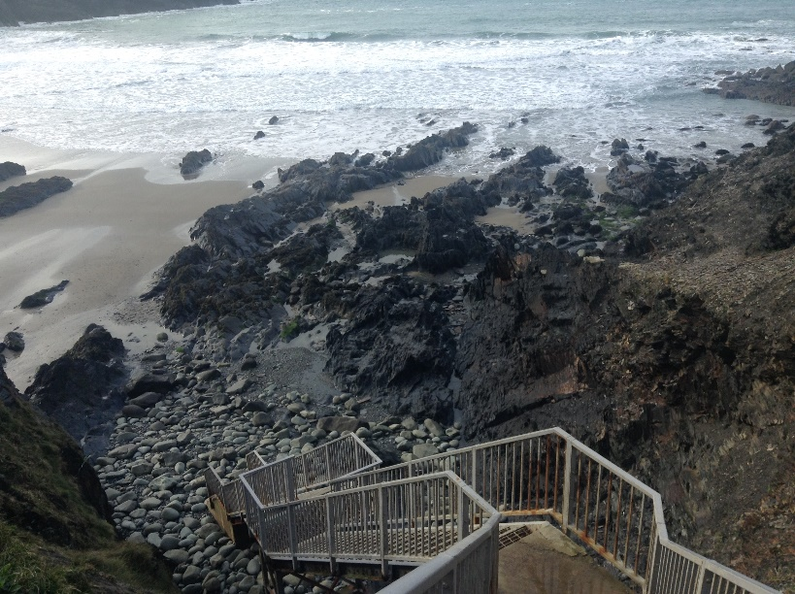
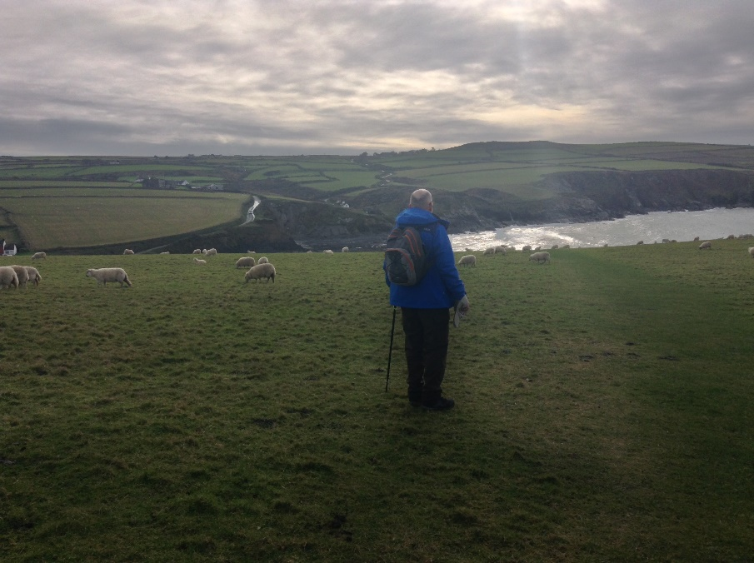
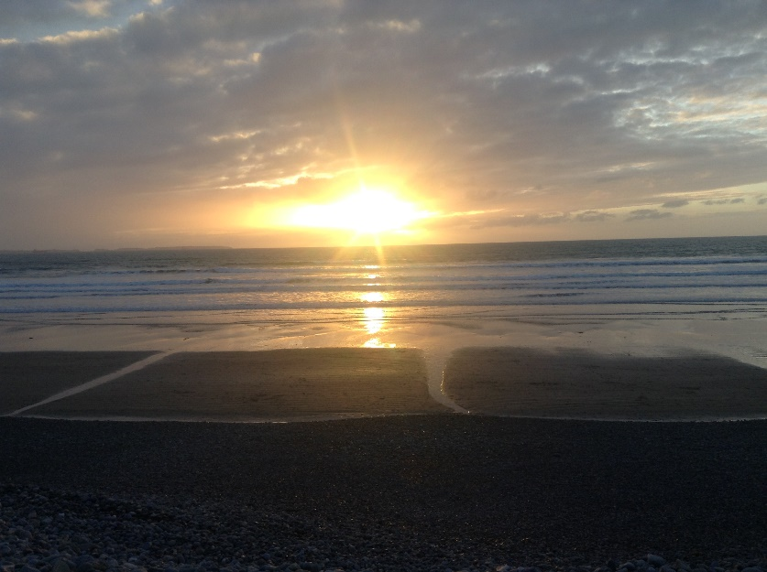
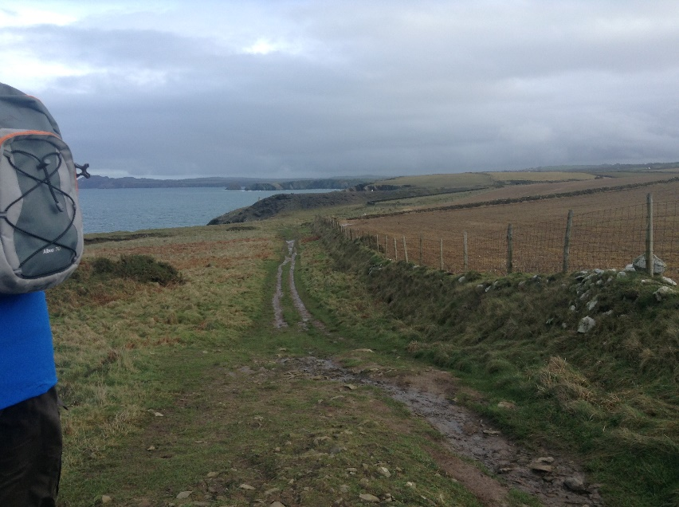
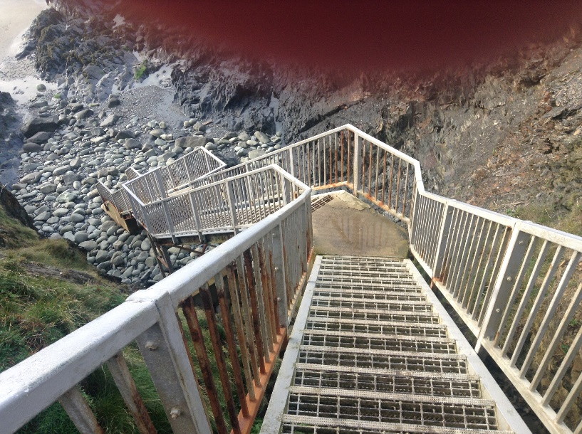
This photograph was taken at the end of the 3rd day expedition outside the Duke of Edinburgh Pub in Newquay. Below is a photograph of a section of the route near Solve Quay where the coastal path is not very clear-the pathis the flatter green on the right side of the photograph, therefore some navigation skills are needed here.

Route Cards
Route planning in advance and writing detailed route cards allows for any problems to be identified early and control measures put in place to minimise the impacts of any problems (Long, 2003, p.118).
All 3 route cards for this proposed expedition along the Pembrokeshire Coast are in appendix 6.
For the purposed expedition, I am using a similar format for my route cards as the route cards the DofE award uses because it is a detailed route card, but it is simple to read and understand.

Escape Routes
On each route card for every day of the expedition, there is a section where the escape routes are if at any point there is an emergency during the expedition or a need to return.
Thanks to the planned route, there isn’t a section of the route that isn’t accessible by either vehicles, helicopter or boat. If there is a need to leave the expedition, and all team members are capable of walking or being helped out- then the best thing to do is walk to the nearest road or track, ring the expedition support person and tell give Rosie the coordinates and any signs and wait for her to meet the team.

Contingency Planning
In case of severe weather, both Celtic Camping campsite and St Davids Bunk Barns have sheltered and indoor sleeping arrangements, however unlikely this contingency is needed it is available if required. Also, the expedition support leader Rosie Davies lives in St Davids just off the main square, and if there is an unforeseen incidents or problems then there ios room in her house to accommodate the expedition group members if necessary.
If there are any issues with the group dynamic, then the expedition leader will receives all the authority, until a time when the issue is sorted within the team or until the expedition ends.

Camp Sites/ Location
Celtic Camping, Pwllcaerog Farm,St Davids Pembrokeshire, SA62 6DG. Celtic camping is the camp site being used for the first night. It is located 4 miles from the smallest UK city, St Davids.
Tel: 01348 837405
St Davids Bunk Barns- Carn-Nwchwn Farm Pembrokeshire
SA62 6QN for the second night
Tel: 01437 720978
Email: info@stdavidsbunkbarns.co.uk
In regards to booking the campsite accommodation for the expedition, neither Celtic Camping or St Davids Bunk Barns have been contacted yet due to the fact that this expedition might not run. Therefore, to contact about booking site accommodation, both campsite have an online webpage which you contat them through:
Celtic Camping: https://www.celtic-camping.co.uk/contact-us/
St Davids Bunk Barns: https://www.stdavidsbunkbarns.co.uk/contact/

Weather Forecast Sources
Weather forecasts can be found from multiple different online websites, with varying degrees of reliability. Sources like the met office and BBC Weather are reliable - https://www.bbc.co.uk/weather, however sources like magic seaweed and any similar website are not reliable or useful sources of weather forecasts for the expedition. Additionally, weather forecast resources can be found on the expedition skills section of UWTSD Moodle page.
The Met Office is the most reliable source for a weather forecast in Britain- https://www.metoffice.gov.uk/. Therefore, the Met Office will be the source that will be used when an accurate weather forecast is needed for each day during the expedition. When looking at weather forecast for the expedition, it will include a general 24hour general picture for each day, and a more localised look to check precipitation, wind speed and direction, air temperature and visibility, especially when the route takes the expedition team members on the coastal path.
According to Mortlock (1994), the leader must know the implications of the weather forecast if it can cause danger during the activities.

Contact with Landowners
The expedition takes part in Pembrokeshire Coast National Park.
There is no need for prior consent at any point on the expeditions route because the expedition is either on the coastal path, roads or public foot paths. However, there are specific areas along the route, where the route takes expedition members through privately owned farmland along the public footpath. Therefore, all expedition members will be respectful, and respect national guidelines for the right to roam = https://www.gov.uk/right-of-way-open-access-land/use-your-right-to-roam

Generic Risk Assessment
The generic risk assessments that will be used for this expedition are in appendix 8 of the appendices. Generic walking risk assessment. Risk assessments are a legal requirement in many circumstances. Generic risk assessments cover hazards that one can expect to encounter on most ventures outside (Beames, Higgins and Nicol, 2012).
The Health and Safety Executive has a five-step risk assessment process which helps organisations write robust risk assessments. The steps include: identifying the hazards, deciding who might be harmed and how, evaluating the risks and deciding on precautions, recording the significant findings and then reviewing the assessments and updating if necessary (Beck, 2016).

Site Specific Risk Assessment
To have a good quality site-specific risk assessment, the expedition leader must now the area very well, in different environments and conditions to fully understand the different hazards and risks that could arise.
The site-specific risk assessments for the planned expedition are in appendix 9. In addition, there are photographs that I took on the reconnaissance expedition to show where the hazards are along the route.

Drivers Licence, Drivers Insurance, Road Worthiness of Vehicle
For this expedition, the UWSTD OAE Lecturers explained that all expeditions taking place within a 4 Hours traveling time, will be able to use the universities minibus with the lecturers driving expedition members to the start of their expedition. Therefore, because the planned expedition is within the 4 hours travel limit, the transport to the start of the expedition and pick up at the end of the expedition is covered by the OAE Lecturers. This means that all drivers licences, insurances and road worthiness of vehicles such as a MOT are always updated and correct because they are covered by the University of Wales Trinity St Davids.

Important Contact Details
Emergency Services: 999
Ask for the most appropriate emergency response: police, fire, ambulance, coast guard, air and sea rescue.
Cynefin; 01267 225122
Tutor: Denise Leonard, denise.leonard@uwtsd.ac.uk
Mob:07979 835785
Tutor: Tom Moore
Mob:07794 445535
Tutor: Graham Harvey
Mob:07896 431200
Sian Davies: s.e.davies@uwtsd.ac.uk

Accident and Emergency Procedures
The accident and emergency procedures example form for this expedition is in appendix 13. The A&E procedures form has the contact numbers for the nearest hospitals in Pembrokeshire to the planned expedition route. If there is a medical emergency then the first thing is to call 999. ‘Incidents in the great outdoors will rapidly escalate if prompt action is not taken. Assertive leadership is required in order to maintain party morale and prevent further incidents’ (Long, 2004, p165).
If there is a need to call 999, due to an emergency then information must be passed on to the rescue/emergency services. According to Wills (2013) you must make note of the following:
- What has happened (in detail), and when.
- Name, sex, and age of casualty
- Nature of the injuries or illness, any medical conditions, are they taking any medication.
- The number in the group, their age and any medical conditions they may have?
- A description of clothing and colour are essential.
- Grid reference of your location
- Weather conditions can be useful, for example strong winds.
The example of the accident report form that will be used for the planned expedition is in appendix 14. I have chosen this format of accident report form for the planned expedition because it is very appropriate for the needs everyone during the expedition, it is also simple to read and understand.

Expedition Team Contact Details
Expedition Leader:
Name: Madeleine Barnes-Watson Number: 07546831570

Expedition Assistant Leader:
Name: Student A Number: ?????

Expedition Support Person:
Name: Mrs Rosie Davies Number:

Expedition Team Member:
Name: Student B Number: ??????

Expedition Team Member:
Name: Student C Number: ??????

Expedition Date: 6th to the 8th of May
Venue: Pembrokeshire Coast National Park

Campsite 1 Date: Celtic Camping 6th of May
Location: Pwllcaerog Ffarm, SA62 6DG St Davids
Tel: 01348 837405

Campsite 2 Date: St Davids Bunk Barnes 7th of May
Location: Carn-Nwchwn Ffarm Pembrokeshire SA62 6QN
Tel: 01437 720978

Expedition Log Sign-Off Form
Name of Expedition Leader: Madeleine Barnes-Watson
Your Expedition Planning Log is not just a series of lists related to routes, dates and equipment etc. but instead, is a detailed account of your planning process that identifies the range of choices you have considered, as well as the rationales that have informed your decision making.
The titles overleaf form a fundamental matrix on which to base your log. In order for your expedition to be signed off, each title needs to be addressed to a satisfactory level, as deemed by a member of module staff.
Failure to address all of the titles overleaf to a satisfactory level will result in the expedition being cancelled, or deferred until the appropriate planning and preparation has been undertaken.
Statement of Expedition Readiness
I agree that all the titles noted overleaf have been completed and that my expedition is ready to proceed. I also agree to undertake my expedition in accordance with any specific safety conditions noted by the module tutor.
Expedition Leader
Signature: Date:
Expedition Approval
To the best of my knowledge all the necessary safety checks noted overleaf have been completed and the expedition is ready to proceed.
Specific safety conditions governing the undertaking of the expedition are noted below:
1. Stick to walking along the inside of the coastal path, unless told otherwise by expedition leader or by signs.
2. Be aware of weather conditions, especially wind direction and speeds above 30mph.
3.
4.
5.
Module Staff
Signature: Date:

Word count: 4872

Appendices
Appendix 1
References
Allison, P. and Von Wald, K. (2009) ‘Choices, Values, and Untidy Processes: Personal, Social, and Healthy Education on Educational Expeditions’, in Beames, S. Understanding Educational Expeditions, Edinburgh: Sense Publishing.
Allison,P. and Von Wald, K. (2010) ‘Exploring values and personal and social development: Learning through expeditions’, Pastoral Care in Education, 28(3), pp219-233. DOI:10.1080/02643944.2010.504222.
Beames, S. (2004) "Critical elements of an expedition experience", Journal of Adventure Education and Outdoor Learning, 4(2), pp. 145-157.
Beames, S. (2009) Understanding Educational Expeditions, Edinburgh: Sense Publishing.
Beames, S. Higgins, P. and Nicol, R. (2012) Learning Outside the Classroom. Theory and Guidelines for Practice. Oxon: Routledge.
Beck, S. (2016) ‘How to ensure school trips are not a risky business’, Prep School, (86), pp. 37-39. Available at: https://search-proquest-com.ezproxy.uwtsd.ac.uk/docview/1790457381?accountid=130472&rfr_id=info%3Axri%2Fsid%3Aprimo (Accessed: 11th February, 2020).
Duke of Edinburgh (2020) Expedition Kit List, Available at: https://www.dofe.org/shopping/wp- content/uploads/2020/01/Expedition_Kit_List-Jan-2020.pdf (Accessed:27th of January 2020).
Exeter, D.J. (2002) Outward Bound: Learning in the Outdoors, UK: The Outward Bound Trust.
Heron, J. (1999) The complete facilitator's handbook. London: Kogan Page.
Keay, W. (2000) Expedition Guide. 4th edn. London: Duke of Edinburgh’s Award.
Langmuir, E. (2013) Mountaincraft and leadership. 4th edn. Conwy: Mountain Training England and Mountain Training Scotland.
Long, S. (2004) Hillwalking, 2nd edn. Nottingham: Mountain Leader Training UK.
Mortlock, C. (1994) The Adventure Alternative, Cumbria: Cicerone Press
Mountain Training (2014) National Guidelines for Climbing and Walking Leaders. 5th edn. Conwy: Mountain Training UK.
Mountain Training (2014) Lowland Leader Award: Candidate Handbook. Available at: https://moodle.uwtsd.ac.uk/pluginfile.php/207697/mod_resource/content/1/LLA%20Handbook.pdf
Natural England (2016) The Countryside Code. Available at: https://assets.publishing.service.gov.uk/government/uploads/system/uploads/attachment_data/file/701188/countryside-code.pdf (Accessed: 7 January 2020).
NOLS. (2016) Behavioural Expectations. Available at: https://www.nols.edu/en/search/?q=Expedition+behaviour (Accessed: 13th February, 2020).
University of Wales Trinity St Davids (2019) Overnight Kit List,
Wattchow, B. and Brown, M. (2011). A Pedagogy of Place: Outdoor Education for a Changing World, Melbourne: Monash University Publishing.
Wills, K. (2013) Outdoor First Aid. Gwynedd: Pesda Press.

Appendix 2
First Aid Kit List
Here is the Millets online shop page for first aid kits: DofE Recommended Kit List
This first aid kit is recommended for camping expeditions by DofE it includes:
- Primary Care Leaflet
- Low-Adherent Dressings
- Zinc Oxide
- Micropore Tape
- Paracetamol
- Antiseptic Wipes
- Duct Tape
- Small-Eyepad Dressing
- Eyewash
- Small Fabric Dressing Strip
- Wound Closure Strips
- Fabric Plasters
- Burn Gel
- Triangular Bandage
- Woven Bandage
- Small Crepe Bandage
- Scissors
- Tweezers
- Safety Pins
- Emergency feminine hygiene products
- Emergency contact numbers in waterproof casing
- Blister plasters
All expedition members may choose their own first aid kit, however it must be suitable to their first aid skill level and suitable for the environment, potential risks, and needs of the individual.
It is also suggested that the expedition leader carry epi-pens and inhalers in case of a medical emergency that requires them.

Appendix 3
Here is an example of the medical declaration form I will hand out to all the participants.
SHSS5084 EXPEDITION LEADERSHIP
MEDICAL DECLARATION FORM
Please complete this form as accurately and truthfully as possible. The information you disclose will be confidential and will only be used to help the expedition leaders respond to an injury or illness.
Name: _____________________________________________ D.O.B.:______________________
Address: ________________________________________________________________________
________________________________________________________________________________
Mobile Number: __________________________________________________________________
Next of Kin/Guardian Name: ________________________________________________________
Next of Kin/Guardian Contact Number: ________________________________________________
If you answer yes to any of the following questions, please give brief details in the space provided.
1. Do you currently suffer from any physical or psychological medical conditions/ailments?
________________________________________________________________________________
2. Are you currently taking any form of medication?
________________________________________________________________________________
3. Do you have any form of allergy?
________________________________________________________________________________
4. Do you currently have any injuries or ailments?
________________________________________________________________________________
5. Do you have history of any physical or psychological medical conditions, injuries or ailments that may affect your participation in any aspect of the programme?
________________________________________________________________________________
If you have answered yes to any of the questions above, please use the space provided on the back of this sheet to give further details, and ensure you discuss this with the expedition leaders.
I declare that the information on this form is as accurate and truthful as possible.
I acknowledge it is my responsibility to keep expedition leaders informed of any information stated here in, or changes to this information, that may affect my participation in the expedition.
Please use the space provided below to expand on any of the information you have given overleaf.

Signature: _________________________ Date: __________________

Appendix 4
Here is the example of the Assumption of risk form I will hand out to all the participants in the expedition.
SHSS5084 EXPEDITION LEADERSHIP
ASSUMPTION OF RISK FORM

(Please read this document carefully)

Expedition’s that are run as part of module SHSS5084 Expedition Leadership inherent in the Outdoor Adventure Education programme at the University of Wales: Trinity Saint David, can take place both at day and night and in different environments, which might be considered remote or hostile, often without easy access to advanced medical or other facilities.

I (full name) ________________________________________ ____________
acknowledge and accept that participation in an expedition of this nature entails both known and unanticipated risks, which could result in damage to my property, physical or emotional injury, paralysis or death. I understand that such risks cannot be eliminated without jeopardising the fundamental qualities of the expedition. By participating in this expedition I accept these risks and take responsibility for my own actions and involvement.

I accept the fact that I have a personal duty and responsibility to learn and to follow safety guidelines and procedures established by the expedition leaders:
Expedition Leader: _____________________________________________________
Assistant Leader: _____________________________________________________

I undertake to inform those named above, at any point during the expedition process, should I not understand what is expected of me or should I not wish to further participate in the expedition. However, due to the venues being used, I understand that it might not always be possible to simply stop or withdraw immediately from the expedition.

I am physically and mentally fit to participate in this expedition. I have completed a medical form that is accurate and true. I agree to notify the expedition leaders of any changes to my health or fitness. If I become ill or injured I give my consent for first aid to be administered and for provision of other medical treatment or rescue services as required.

Signed: ________________________________ Date: _____________________
Appendix 5
Behavioural Expectations
Below is an example of the behavioural expectations for all team members during the expedition.
Prior to the journey, the expedition leader must explain the nature of the expedition and any necessary health and safety procedures. The expedition leader must explain the communication required for a successful expedition.
- Accept responsibility for the safety and the well-being of all expedition members the whole time.
- All expedition members must follow The Countryside Code. https://assets.publishing.service.gov.uk/government/uploads/system/uploads/attachment_data/file/701188/countryside-code.pdf
- Expedition members must follow UWTSD code of conduct for students whilst on the expedition.
- Must be respectful and considerate to other walkers and campers whilst on the expedition.
- All group members must respect the expedition leaders decisions during the expedition, however all decisions are open to discussion.
- All members must be honest and forthright with any ailments or injuries during the expedition.
- No alcohol or recreational drugs are to be consumed during the expedition.
- Be as concerned for others as you are for yourself.
- Treat everyone with dignity and respect.
- Support leadership and growth in everyone.
- Do your share and stay organized.
- Help others, but don’t routinely do their work.
- Model integrity by being honest and accountable.
- Admit and correct your mistakes.
- Respect all opinions

Signature: Date:
Appendix 6
Route Cards of the planned expedition.
Day 1
Leg | Place with grid reference | Distance (km) | Height Climbed  (m) | Details of route to be followed. | Escape to
Start Point | Wollen Mill: SM891 346
1 | Path/Junction:  SM888 342 | 0.5 | 5 | Take path south from Wollen Mill to road opposite Woodlands Farm | Back to the start
2 | Gilfach Farm:  SM 882 330 | 1.4 | 27 | Continue on path southernly, through trees and down into the valley to meet road at sharp bend, then continue. | Road/ path junction to valley.
3 | Mathry Centre:  SM 879 320 | 1.0 | 77 | Take path from centre of Gilfach farm southernly to meet road. Walk to centre of village. | Mathry village centre
4 | Trefin Rd/Path Junction:  SM 843 324 | 3.7 | 0 | Take road west out of village. Continue for 2km to road junction. Track into Rhoslanog Farm and on to Trefin. | Rhoslanog Farm
5 | Porthgain Phone box:  SM 843 324 | 3.4 | 22 | Continue west through Trefin on road. Join Costal Path for 2km into Porthgain village. | Porthgain or back to Trefin.
6 | Abereiddy Rd/Path Junction:  SM 921 794 | 2.6 | 48 | Head south on road through Porthgain and then use path west through Barry Island Farm. Left at path junction to meet road at Abereiddy. | Barry Island Farm or Abereiddy.
7 | Camping@ Pwllcaerog:  SM 912 785 | 1.3 | 50 | Road through Abereiddy and uphill. Head west through Caerhys Farmland to Campsite at Pwllcaerog (Celtic Camping). | Abereiddy or campsite.
Totals |  | 13.9 | 229

Day 2
Leg | Place with grid reference | Distance (Km) | Height climbed (m) | Details of route to be followed | Escape to
Start Point | Pwllcaerog Farm,  SM 912 785
1 | Tretio Campsite: SM911 772 | 1.6 | 15 | Tack track out of Pwllcaerog to road. Turn right and then left along road to Tretio. | Back to start
2 | Coastal Path Junction:  SM 890 774 | 3.0 | 56 | Continue on road to through Tretio. Turn right at track junction. At road junction turn right and find path on left to coastal path. | Tretio
3 | Whitesands Bay:  SM 861 750 | 5.9 | 0 | Continue on Coastal Path west, around St Davids Head to Whitesands. Big carpark will signify arrival. | Head to Whitesands carpark or back to Tretio, whichever is most appropriate.
4 | Ty Ddewi Bishops Palace: SM 879 735 | 2.5 | 56 | Take road east out of carpark to the 2nd junction. Take road to the right heading south. On bend, track to St Davids Cathedral. | Continue to Cathedral/ Bishops Palace.
5 | Warpool Court Hotel: SM 880 729 | 0.7 | 34 | Over bridge at Cathedral. Right to meet road. Go over dogleg junction then left. Then right (signposted St Nons) to hotel. | Hotel or Cathedral
6 | Porthclais Camping: St Davids Bunk Barns:  SM 872 723 | 1.0 | 0 | Take Bridlepath to South West at hotel. Continue onward until at campsite. | Campsite or back to hotel.
Totals |  | 14.7 | 161

Day 3
Leg | Place with grid reference | Distance  (km) | Height climbed (m) | Details of route to be followed | Escape to
Start Point | St Davids Bunk Barns Camp site: SM 872 721
1 | St Nons Chapel: SM 882 723 | 1.2 | 1 | Take Coastal Path east to St Nons ruined chapel, (birthplace of St David). | Retreat to St Davids or head to St Nons.
2 | Caerfai Bay: SM 891 725 | 1.1 | 9 | Continue onwards on Coastal Path to carpark, and Sandy Bay. | Caerfai Bay or back to St Nons.
3 | Bridge at Solva:  SM 806 242 | 5.4 | 44 | Continue on Coastal Path, down into Solva Quay. The bridge is next to pub and café. | Escape to pub.
4 | Dinas Fawr Head:  SM 813 232 | 1.8 | 24 | Continue out of Solva Quay, up through trees. Pass small beach and continue on path. | Solva Quay.
5 | Newgale road/path junction:  SM 848 224 | 4.0 | 53 | Continue on coastal path. | Newgale or up to Pointz Castle of Penycwm.
6 | Duke of Edinburgh Pub: SM 848 221 | 0.3 | 0 | Right at road past the café, Care Needed, fast vehicular traffic. Stop at DofE pub and toilets. | End of expedition.
Totals |  | 13.8 | 131

Appendix 7
Example equipment request form
SHSS5084 EXPEDITION LEADERSHIP
Equipment Request Form

Name:

Dates of Expedition:

Date of collection:

Date of Return:

Filled out equipment request forms.
SHSS5084 EXPEDITION LEADERSHIP
Equipment Request Form

Name: Trangiers

Dates of Expedition: 6th of May to the 8th of May
Date of collection: ???

Date of Return: ???

Item/s | Serviceable check or | Date of Return

Equipment Request Form

Name: Tent

Dates of Expedition: 6th of May to the 8th of May

Date of collection: ????

Date of Return: ????

Item/s | Serviceable check or | Date of Return
Equipment Request Form

Name: Group Shelter

Dates of Expedition: 6th of May to the 8th of May

Date of collection: ????

Date of Return: ???

Item/s | Serviceable check or | Date of Return

Appendix 8
Generic Risk Assessments

Activity: Hill Walking
Hazard | Control Measures | Monitoring
Standard of Instruction | - All staff leading activities shall hold appropriate, current qualifications | - All qualifications and training will be verified and logged in the Staff Training Log
 | - On going CPD | - CPD Files
Hostile Environment | - Students clothing assessed as appropriate before departure | - Students who repeatedly attend inappropriately clothed will not be aloud to attend sessions.
 | - Appropriate resources available at Ystrad
 | - Due consideration to weather forecast
Medical Emergency | - Students’ medical records are checked and relevant precautions taken. | - Student Medical Forms
 | - Staff are trained in first aid and carry appropriate first aid equipment | - Staff Training Log
 | - A complete list of all students and staff and any relevant medical information made available to all staff before departure
Falling Objects | - Correctly fitting rock-climbing helmets to be worn when appropriate | - Staff to ensure correct fitting and monitor and enforce
Falling | - Correctly fitting rock-climbing helmets to be worn when appropriate | - Staff to ensure correct fitting and monitor and enforce
 | - Use of appropriate footwear | - Staff to ensure correct fitting and monitor and enforce
Being Lost | - Staff and students to agree being lost procedure.  - All students to have staff mobile contact numbers | - Staff to ensure correct fitting and monitor and enforce

Above is a copy of the UWTSD OAE generic hill walking risk assessment.

Activity: Camping

Hazard | Control Measures | Monitoring
Standard of Instruction | - All staff leading activities shall hold appropriate, current qualifications | - All qualifications and training will be verified and logged in the Staff Training Log
 | - On going CPD | - CPD Files
Hostile Environment | - Students clothing assessed as appropriate before departure | - Students who repeatedly attend inappropriately clothed will not be aloud to attend sessions.
 | - Appropriate resources available at Ystrad
 | - Due consideration to weather forecast
Medical Emergency | - Students’ medical records are checked and relevant precautions taken. | - Student Medical Forms
 | - Staff are trained in first aid and carry appropriate first aid equipment | - Staff Training Log
 | - A complete list of all students and staff and any relevant medical information made available to all staff before departure
Fire | - Cooking, Barbecuing and Smoking only permitted safe distance from tents
Being Lost | - Staff and students to agree being lost procedure.  - All students to have staff mobile contact numbers | - Staff to ensure correct fitting and monitor and enforce

Above is the UWTSD OAE generic risk assessment used for camping.
Generic risk assessment for this expedition
Hazard | Who’s at risk | Control Measure | Monitoring
Loose cliff face | Participants and other walkers | Stick to the coastal path unless told otherwise. Group members are not to go close to any loose cliff face if they are down on any beaches. | Constantly monitoring foot placement.
Strong Winds | Participants | If wind speed increases above 30mph stay away from cliff edge. | Regularly check weather forecast of the area
Precipitation | Participants | Follow kit list and bring suitable waterproof gear and spare warm clothes
Sun | Participants | Wear sunscreen when appropriate | Regularly check weather forecast of the area
Vehicular Traffic | Participants and drivers | Stay on the path and when the route takes the participants close to the road they are to stay on the pavement.
Medical emergency | Participants | All expedition members are trained in first aid and carry appropriate first aid equipment.  All expedition members carry means to contact emergency services. | Medical declaration forms.  No participants are to take any unnecessary risks during the expedition.
Inappropriate clothing | Participants | Group members should use the kit list for clothes. Check all clothing is suitable for the day. | Group members to use weather forecast and decision making to wear appropriate clothes for each day.
Slips/ trips/ and falls | Participants | Group members to use appropriate footwear throughout the expedition. | Group members to stay on clear path when able, and to watch foot placement
Fire at campsite | Participants and other campers | Adequate separation between tents and from fires. | Any fires or stoves to be monitored by at least one person at all times.
Animals; both livestock and wildlife | Participants, | If livestock in field that the route traveses through, take into account the type of livestock, if its cattle or horses with young calves, advise everyone to stay away to reduce risk of charging.  Group members to walk single file and stay silent. | Use alternative route if necessary.
Allergies/asthma/  Illnesses/hay-fever. | Participants | Medical Declaration Forms must be filled out by every group member to the best of their ability | All group members must monitor their well-being throughout the expedition
Coastal path | Participants, all walkers. | Must walk on the inner side of the coastal path.

Appendix 9
Site-specific risk assessment
Hazard | Who’s at risk | Control Measure | Monitoring
Thunder or lightening | Participants | Must get all group members of the coastal path asap. | Closely monitor local weather forecast. Check wind speed, direction of cloud and colour of cloud. Darker the cloud the worst the storm.
Slips/ trips and falls | Participants | All expedition members to wear appropriate footwear specified in the kit list. | Disallow any members to take part in the expedition if the wear inappropriate footwear and take unnecessary risks during the expedition.
Path too close to cliff edge | Participants | Use alternative route or move slightly further inland if possible but keeping the path in eyesight. | Reconnaissance trips on route to check if there are any areas before expedition.  During expedition the EL is to always look ahead on the route to carefully select the safest route.  All team members to walk on the inside of the coastal path.
Working environments = farmyard. | Participants | Stay on public footpath during route, however, move aside of farm equipment needs to pass. | Monitor route to make sure all expedition members stay on the public footpath.
Fast Vehicular traffic outside DofE pub | Participants | Must stay on pavement or the route. | Group members must be aware of traffic and listening for vehicles before crossing any road.
Slippery stairs going to beach | Participants | Expedition leader will inform the team to take great care when walking up and down stairs, to reduce the risk of slipping. | Weather forecast and if its been raining, decide weather or not the team will go down the stairs to the beach.
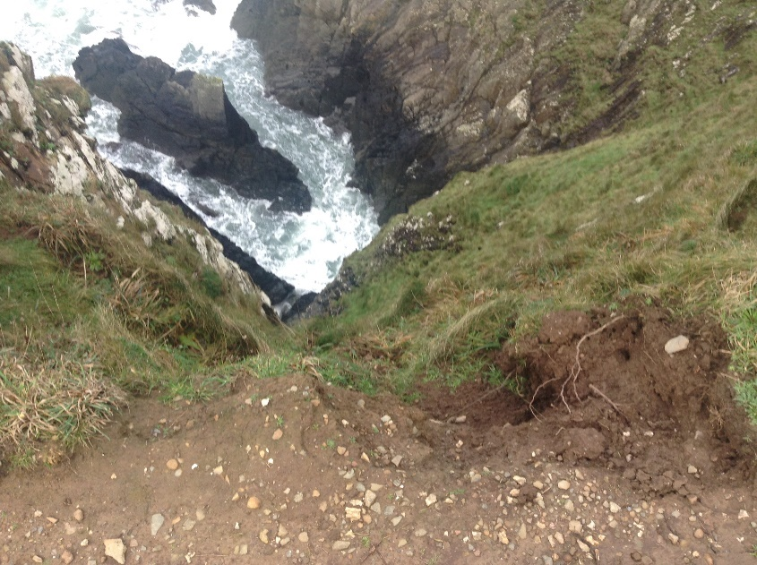
Here is a photograph for the site specific risk assessment where the path that the route takes the expedition on is far to close to the cliff edge, but the path was wide enough that this route is still safe to use as long as the expedition leader makes it clear that all team members are too stay away from cliff edge.
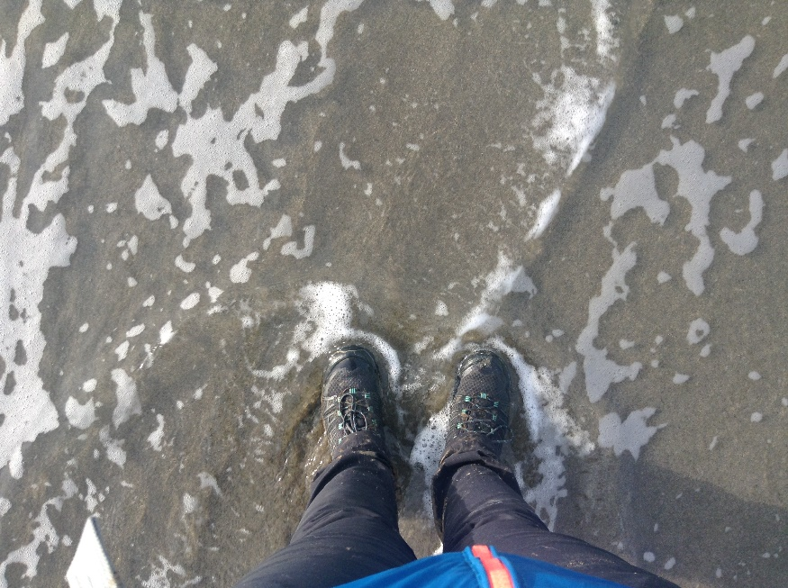
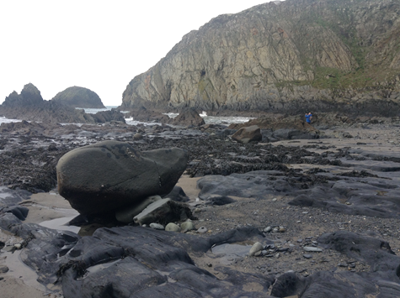
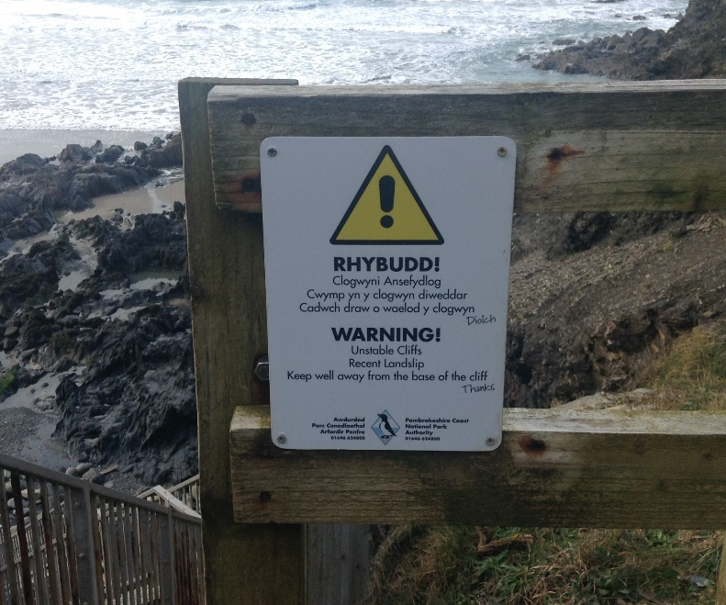
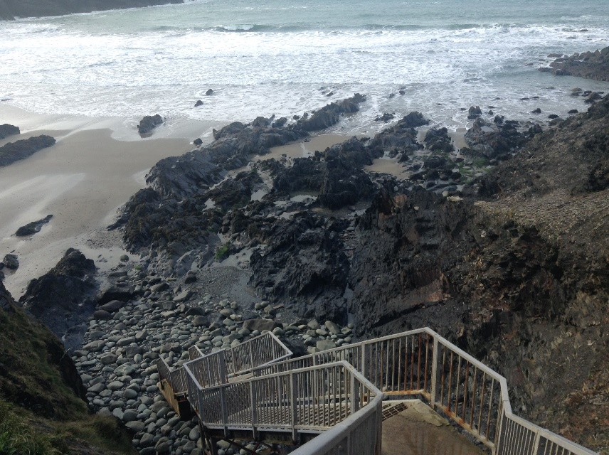
Here is a photograph I have taken of the stairs included in the site specific risk assessment. Also, below is a photograph of the warning sign posted on the staircase, warning people of a dangerous loose hanging cliff face, its warning people that there was a recent landslip and that people must stay away. Below is a photograph of the different types of surface area the expedition members will be walking on during the expedition. This photograph was taken on a misty day therefore the rocks were wet and very slippery, therefore I had to be very careful when placing my foot otherwise I would have fallen.
To the right is a photograph showing the importance of wearing good quality waterproof walking boots. If I wasn’t wearing theses boots when I took this photograph on Abereiddi beach then I would have had very wet feet, which would have made the rest of the reconnaissance expedition very uncomfortable.

Appendix 10
Expedition Leader- Madeleine Barnes-Watson completed paperwork.
SHSS5084 EXPEDITION LEADERSHIP
MEDICAL DECLARATION FORM

Please complete this form as accurately and truthfully as possible. The information you disclose will be confidential and will only be used to help the expedition leaders respond to an injury or illness.
Name: Madeleine Barnes-Watson D.O.B.: 30/10/1999
Address: Bryn-yr-Haul, Mountain Road, Trimsaran, Kidwelly, Carmarthenshire, SA17 4EU
Mobile Number: 07546831570
Next of Kin/Guardian Name: Jeremy Scott Barnes-Watson
Next of Kin/Guardian Contact Number: 07814 382560
If you answer yes to any of the following questions, please give brief details in the space provided.
- Do you currently suffer from any physical or psychological medical conditions/ailments?
No
2. Are you currently taking any form of medication?
No
3. Do you have any form of allergy?
Perfums/ aersols
4. Do you currently have any injuries or ailments?
Yes, Shin Splints in both calves, however mainly in the right calves.
5. Do you have history of any physical or psychological medical conditions, injuries or ailments that may affect your participation in any aspect of the programme?
No
If you have answered yes to any of the questions above, please use the space provided on the back of this sheet to give further details, and ensure you discuss this with the expedition leaders.
I declare that the information on this form is as accurate and truthful as possible.
I acknowledge it is my responsibility to keep expedition leaders informed of any information stated here in, or changes to this information, that may affect my participation in the expedition.
Signature: Madeleine Barnes-Watson Date: 24th of January, 2020

SHSS5084 EXPEDITION LEADERSHIP
ASSUMPTION OF RISK FORM

(Please read this document carefully)

Expedition’s that are run as part of module SHSS5084 Expedition Leadership inherent in the Outdoor Adventure Education programme at the University of Wales: Trinity Saint David, can take place both at day and night and in different environments, which might be considered remote or hostile, often without easy access to advanced medical or other facilities.

I Madeleine Barnes-Watson
acknowledge and accept that participation in an expedition of this nature entails both known and unanticipated risks, which could result in damage to my property, physical or emotional injury, paralysis or death. I understand that such risks cannot be eliminated without jeopardising the fundamental qualities of the expedition. By participating in this expedition, I accept these risks and take responsibility for my own actions and involvement.

I accept the fact that I have a personal duty and responsibility to learn and to follow safety guidelines and procedures established by the expedition leaders:
Expedition Leader: Madeleine Barnes-Watson
Assistant Leader: Student A
I undertake to inform those named above, at any point during the expedition process, should I not understand what is expected of me or should I not wish to further participate in the expedition. However, due to the venues being used, I understand that it might not always be possible to simply stop or withdraw immediately from the expedition.

I am physically and mentally fit to participate in this expedition. I have completed a medical form that is accurate and true. I agree to notify the expedition leaders of any changes to my health or fitness. If I become ill or injured I give my consent for first aid to be administered and for provision of other medical treatment or rescue services as required.

Signed: Madeleine Barnes-Watson Date: 24th of January, 2020

Appendix 11
Here is all the paperwork the assistant Expedition Leader, Student A will complete before the expedition.
SHSS5084 EXPEDITION LEADERSHIP
MEDICAL DECLARATION FORM
Please complete this form as accurately and truthfully as possible. The information you disclose will be confidential and will only be used to help the expedition leaders respond to an injury or illness.
Name: _Student A_____________________________________D.O.B.:_????__________________
Address: ________________________________________________________________________
________________________________________________________________________________
Mobile Number: __________________________________________________________________
Next of Kin/Guardian Name: ________________________________________________________
Next of Kin/Guardian Contact Number: ________________________________________________
If you answer yes to any of the following questions, please give brief details in the space provided.
1. Do you currently suffer from any physical or psychological medical conditions/ailments?
________________________________________________________________________________
2. Are you currently taking any form of medication?
________________________________________________________________________________
3. Do you have any form of allergy?
________________________________________________________________________________
4. Do you currently have any injuries or ailments?
________________________________________________________________________________
5. Do you have history of any physical or psychological medical conditions, injuries or ailments that may affect your participation in any aspect of the programme?
________________________________________________________________________________
If you have answered yes to any of the questions above, please use the space provided on the back of this sheet to give further details, and ensure you discuss this with the expedition leaders.
I declare that the information on this form is as accurate and truthful as possible.
I acknowledge it is my responsibility to keep expedition leaders informed of any information stated here in, or changes to this information, that may affect my participation in the expedition.
Please use the space provided below to expand on any of the information you have given overleaf.

Signature: __Student A_______________________ Date: ____????______________

SHSS5084 EXPEDITION LEADERSHIP
ASSUMPTION OF RISK FORM

(Please read this document carefully)

Expedition’s that are run as part of module SHSS5084 Expedition Leadership inherent in the Outdoor Adventure Education programme at the University of Wales: Trinity Saint David, can take place both at day and night and in different environments, which might be considered remote or hostile, often without easy access to advanced medical or other facilities.

I (full name) __Student A______________________________________ acknowledge and accept that participation in an expedition of this nature entails both known and unanticipated risks, which could result in damage to my property, physical or emotional injury, paralysis or death. I understand that such risks cannot be eliminated without jeopardising the fundamental qualities of the expedition. By participating in this expedition I accept these risks and take responsibility for my own actions and involvement.

I accept the fact that I have a personal duty and responsibility to learn and to follow safety guidelines and procedures established by the expedition leaders:
Expedition Leader: Madeleine Barnes-Watson
Assistant Leader: Student A

I undertake to inform those named above, at any point during the expedition process, should I not understand what is expected of me or should I not wish to further participate in the expedition. However, due to the venues being used, I understand that it might not always be possible to simply stop or withdraw immediately from the expedition.

I am physically and mentally fit to participate in this expedition. I have completed a medical form that is accurate and true. I agree to notify the expedition leaders of any changes to my health or fitness. If I become ill or injured I give my consent for first aid to be administered and for provision of other medical treatment or rescue services as required.

Signed: ___Student A_____________________________ Date: ????

Appendix 12
Here is all the paperwork that Student B will fill out before the expedition.
SHSS5084 EXPEDITION LEADERSHIP
MEDICAL DECLARATION FORM
Please complete this form as accurately and truthfully as possible. The information you disclose will be confidential and will only be used to help the expedition leaders respond to an injury or illness.
Name: ____Student B_____________________________D.O.B.:__?????____________________
Address: ________________________________________________________________________
________________________________________________________________________________
Mobile Number: __________________________________________________________________
Next of Kin/Guardian Name: ________________________________________________________
Next of Kin/Guardian Contact Number: ________________________________________________
If you answer yes to any of the following questions, please give brief details in the space provided.
1. Do you currently suffer from any physical or psychological medical conditions/ailments?
________________________________________________________________________________
2. Are you currently taking any form of medication?
________________________________________________________________________________
3. Do you have any form of allergy?
________________________________________________________________________________
4. Do you currently have any injuries or ailments?
________________________________________________________________________________
5. Do you have history of any physical or psychological medical conditions, injuries or ailments that may affect your participation in any aspect of the programme?
________________________________________________________________________________
If you have answered yes to any of the questions above, please use the space provided on the back of this sheet to give further details, and ensure you discuss this with the expedition leaders.
I declare that the information on this form is as accurate and truthful as possible.
I acknowledge it is my responsibility to keep expedition leaders informed of any information stated here in, or changes to this information, that may affect my participation in the expedition.
Please use the space provided below to expand on any of the information you have given overleaf.

Signature: ___Student B______________________ Date: __?????________________

SHSS5084 EXPEDITION LEADERSHIP
ASSUMPTION OF RISK FORM

(Please read this document carefully)

Expedition’s that are run as part of module SHSS5084 Expedition Leadership inherent in the Outdoor Adventure Education programme at the University of Wales: Trinity Saint David, can take place both at day and night and in different environments, which might be considered remote or hostile, often without easy access to advanced medical or other facilities.

I (full name) ____Student B____________________________________ acknowledge and accept that participation in an expedition of this nature entails both known and unanticipated risks, which could result in damage to my property, physical or emotional injury, paralysis or death. I understand that such risks cannot be eliminated without jeopardising the fundamental qualities of the expedition. By participating in this expedition I accept these risks and take responsibility for my own actions and involvement.

I accept the fact that I have a personal duty and responsibility to learn and to follow safety guidelines and procedures established by the expedition leaders:
Expedition Leader: _Madeleine Barnes-Watson
Assistant Leader: Student A
I undertake to inform those named above, at any point during the expedition process, should I not understand what is expected of me or should I not wish to further participate in the expedition. However, due to the venues being used, I understand that it might not always be possible to simply stop or withdraw immediately from the expedition.

I am physically and mentally fit to participate in this expedition. I have completed a medical form that is accurate and true. I agree to notify the expedition leaders of any changes to my health or fitness. If I become ill or injured I give my consent for first aid to be administered and for provision of other medical treatment or rescue services as required.

Signed: __Student B_______________________ Date: ___??????__________________

Appendix 13
Here is all the paperwork that Student C will fill out before the expedition.
SHSS5084 EXPEDITION LEADERSHIP
MEDICAL DECLARATION FORM
Please complete this form as accurately and truthfully as possible. The information you disclose will be confidential and will only be used to help the expedition leaders respond to an injury or illness.
Name: ___Student C______________________________D.O.B.:_?????_____________________
Address: ________________________________________________________________________
________________________________________________________________________________
Mobile Number: __________________________________________________________________
Next of Kin/Guardian Name: ________________________________________________________
Next of Kin/Guardian Contact Number: ________________________________________________
If you answer yes to any of the following questions, please give brief details in the space provided.
1. Do you currently suffer from any physical or psychological medical conditions/ailments?
________________________________________________________________________________
2. Are you currently taking any form of medication?
________________________________________________________________________________
3. Do you have any form of allergy?
________________________________________________________________________________
4. Do you currently have any injuries or ailments?
________________________________________________________________________________
5. Do you have history of any physical or psychological medical conditions, injuries or ailments that may affect your participation in any aspect of the programme?
________________________________________________________________________________
If you have answered yes to any of the questions above, please use the space provided on the back of this sheet to give further details, and ensure you discuss this with the expedition leaders.
I declare that the information on this form is as accurate and truthful as possible.
I acknowledge it is my responsibility to keep expedition leaders informed of any information stated here in, or changes to this information, that may affect my participation in the expedition.
Please use the space provided below to expand on any of the information you have given overleaf.

Signature: ___Student C______________________ Date: _??????_________________

SHSS5084 EXPEDITION LEADERSHIP
ASSUMPTION OF RISK FORM

(Please read this document carefully)

Expedition’s that are run as part of module SHSS5084 Expedition Leadership inherent in the Outdoor Adventure Education programme at the University of Wales: Trinity Saint David, can take place both at day and night and in different environments, which might be considered remote or hostile, often without easy access to advanced medical or other facilities.

I (full name) __Student C______________________________________
acknowledge and accept that participation in an expedition of this nature entails both known and unanticipated risks, which could result in damage to my property, physical or emotional injury, paralysis or death. I understand that such risks cannot be eliminated without jeopardising the fundamental qualities of the expedition. By participating in this expedition I accept these risks and take responsibility for my own actions and involvement.

I accept the fact that I have a personal duty and responsibility to learn and to follow safety guidelines and procedures established by the expedition leaders:
Expedition Leader: Madeleine Barnes-Watson
Assistant Leader: Student A

I undertake to inform those named above, at any point during the expedition process, should I not understand what is expected of me or should I not wish to further participate in the expedition. However, due to the venues being used, I understand that it might not always be possible to simply stop or withdraw immediately from the expedition.

I am physically and mentally fit to participate in this expedition. I have completed a medical form that is accurate and true. I agree to notify the expedition leaders of any changes to my health or fitness. If I become ill or injured I give my consent for first aid to be administered and for provision of other medical treatment or rescue services as required.

Signed: _Student C_______________________________ Date: ??????__

Appendix 13
SHSS5084 EXPEDITION LEADERSHIP
Accident and Emergency Procedures

Accident and Emergency Procedures relate to the need to deal with any event throughout the duration of your expedition, in which a physical injury occurs to any expedition team member.

You are expected to deal with accidents, to the best of your abilities, and within the recommendations and remit of your first aid qualification. Where recruitment of further assistance (Emergency Services) is essential, you are required to inform a member of module staff, as soon as possible.

If it is necessary to send an expedition member to hospital, you must ensure that at least one other member accompanies the injured party.

To facilitate the processes outlined above, it is essential you complete the following, specific to your expedition:

Emergency Information:

Local Hospital:
Name: Withybush General Hospital
Address: Fishguard Road, Haverfordwest SA61 2PZ
Tel: 01437 764545
A&E: Yes

Local Hospital:
Name: South Pembrokeshire Hospital
Address: Fort Rd, Pembroke Dock SA72 6SX
Tel: 01646 682114
A&E: Yes / No

Local GP Service:
Name: St Davids Surgery
Address: 36 New Street, Haverfordwest SA62 6SS
Tel: 01437 720303

Local Dentist:
Name: Pembrokeshire Dental Hygiene
Address: Corner House Portfield, Haverfordwest SA61 1BW
Tel: 01437 766700

Media Guidance
If at any point during your expedition, the media approaches you, please adopt a “No Comment” response and refer them to a member of module staff.

Appendix 14
Here is an example of the Accident Report Form that will be used if there is an accident or emergency during the planned expedition.
SHSS5084 EXPEDITION LEADERSHIP
Accident Report Form

This form must be completed and sent to the module coordinator as soon as possible after an accident. If operating in a remote area it must be sent within 24 hours of returning to the expeditions operating base.

A verbal notification and a brief account of circumstances of the incident must be phoned through to the module coordinator as soon as possible after the accident.

Expedition Leader:

Second in Charge:

Date of Accident:

Place of Accident:

Name of Casualty
or Casualties:

Circumstances leading up to the accident including details of the route being followed or activity being undertaken, the weather, conditions underfoot, etc:

Description of the accident:

Description of the injuries sustained by the casualty(s):

Details of actions taken to treat the casualty(s):

Details of actions taken to safeguard the rest of the group:

Recommended actions to be taken by Expedition Leader to prevent a similar case recurring:

Details of any witnesses to the accident include on a separate sheet a written statement from the witness if possible:

Name:

Address:

Post Code: Tel:

Name:

Address:

Post Code: Tel:

Name:

Address:

Post Code: Tel:

Details of police officer or other relevant authorities informed:

Name:

Status/authority:

Address:

Post Code: Tel:

Name:

Status/authority:

Address:

Post Code: Tel:

Please return this form to:

Tom Moore
University of Wales Trinity Saint David
School of Sport, Health & Outdoor Education
Carmarthen, UK
SA31 3EP
Tel: 01267 226 616
Mob: 07794 445 535
Email: t.moore@uwtsd.ac.uk

Appendix 15
Additional Reading
Here is a list off books and websites that will help facilitate a successful expedition;
Beames, S. (2009) Understanding Educational Expeditions, Edinburgh: Sense Publishing
Beames, S. Higgins, P. and Nicol, R. (2012) Learning Outside the Classroom. Theory and Guidelines for Practice. Oxon: Routledge.
Heron, J. (1999) The complete facilitator's handbook. London: Kogan Page.
https://moodle.uwtsd.ac.uk/pluginfile.php/119454/mod_resource/content/1/Outdoor%20Leaders%20EI%20Hayashi%20and%20Ewert.pdf
https://moodle.uwtsd.ac.uk/pluginfile.php/121342/mod_resource/content/1/Leave%20no%20Trace%20Implementation.pdf
https://moodle.uwtsd.ac.uk/pluginfile.php/207697/mod_resource/content/1/LLA%20Handbook.pdf
https://moodle.uwtsd.ac.uk/pluginfile.php/51175/mod_resource/content/0/Herons%203%20modes%20of%20facilitation..bmp
https://www.gov.uk/right-of-way-open-access-land/access-private-land
https://www.gov.uk/right-of-way-open-access-land/use-your-right-to-roam
Long, S. (2004) Hillwalking, 2nd edn. Nottingham: Mountain Leader Training UK.
Natural England (2016) The Countryside Code. Available at: https://assets.publishing.service.gov.uk/government/uploads/system/uploads/attachment_data/file/701188/countryside-code.pdf
https://www.mountain-training.org/qualifications/walking/lowland-leader
National Guidelines for Climbers and Walking Leaders, 5th edn. Available at: https://www.mountain-training.org/Content/Uploaded/Downloads/MLT/d0ce4421-70b6-4325-8df2-8525f339802e.pdf
Wills, K. (2013) Outdoor First Aid. Gwynedd: Pesda Press.
Appendix 16
Additional reading regarding coastal erosion

Appendix 17
Additional reading regarding personal development
Beames, S. Scrutton, R.(2015)‘Measuring the Unmeasurable: Upholding Rigor in Quantitative Studies of Personal and Social Development in Outdoor Adventure Education’, Journal of Experiential Education, 38(1),pp 8 –25. Available at: https://web-a-ebscohost-com.ezproxy.uwtsd.ac.uk/ehost/pdfviewer/pdfviewer?vid=2&sid=3f285285-c465-4220-b764-cf06ae61482e%40sessionmgr4007
‘The role of outdoor adventure education in facilitating groupwork in higher education’
Allison,P. and Von Wald, K. (2010) ‘Exploring values and personal and social development: Learning through expeditions’, Pastoral Care in Education, 28(3), pp219-233. DOI:10.1080/02643944.2010.504222.
Appendix 18
Additional reading regarding the history of St Davids
http://www.bbc.co.uk/wales/history/sites/themes/figures/saint_david.shtml
https://www.historic-uk.com/HistoryMagazine/DestinationsUK/St-Davids-Wales/
www.stdavidscathedral.org.uk/
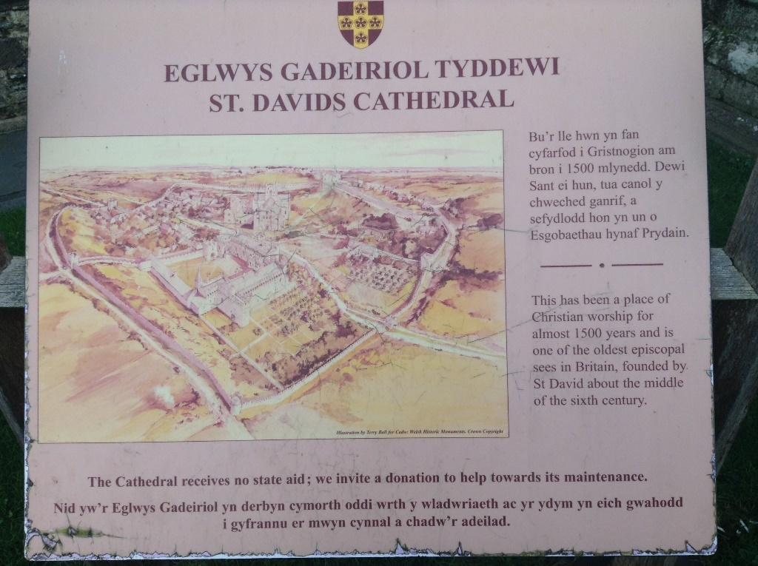
Here is a photograph that I took outside the Cathedral on the reconnaissance of the expedition.

