

Module Name
Changemakers: Creativity and Value Creation
Module Code: BMSW5008_SWAN
Assignment Tittle: E-Portfolio Evidence of Learning
Research Topic: The Impact of Viral Marketing on Consumers Purchasing Behaviour
Lecturer Name: Myfanwy Davies

Student Name | Student ID
NURUL AININ SOFIYA BINTI MOHD IDRIS | 2120995

TABLE OF CONTENT PAGE NUMBER

Table of content….................................................................................................1

Contents of report:
Task 1: Research Question………………………………………………………2-4
Task 2: Research Techniques……………………………………………………5-7
Task 3: Reflection on Elevator Pitch Video………………………………….….8
Task 4: Data analysis & Poster Link……………………………………………..9

References.………………………. ….…………………………………………..10-11

Task 1: Research Question

Research Question
The prominent growth of networking through social media has shifted the trends in the branding industry. Therefore, it has led to a rapidly evolving landscape of digital marketing, where businesses have taken the opportunity of the internet to promote their product and services through the digital platform (Dsouza & Panakaje, 2023). One of method in promoting products and services in the digital platform is to have a viral marketing strategy (Barnhart, n.d.). According to (Hirvijärvi, 2017) viral marketing is an effective marketing tools among various digital marketing implements as it essentially uses a marketing strategy that utilizes pre-existing social networks. However, the issues of influence on consumer purchasing behavior remains a subject of ongoing debate and inquiry. Thus, in this research the question to be addressed is to what extent does viral marketing influence consumers' purchase behavior?
There are times that brand advertisement has spread widely but for the wrong reasons. This is because the company has no control on messages that have been disclosed publicly on social media and that has opened up for readers to have a self-understanding and interpretation of the advertisement (Guyot, 2016). Thus, this may lead to misinterpretation and false information gain which it may affect the company's reputation as well as the perception of consumers towards the company.
Therefore, conducting research on the impacts of viral marketing towards consumers behavior could help company’s managers to have a better understanding on consumers behavior. Also, they will be able to utilize viral marketing appropriately and could strategize the marketing plan properly to market their products or services via the Internet.

Research Approach
There are 3 types of research approaches which are deductive, inductive and abductive. Deductive approach refers to a research that begins with a theoretical framework and previous research that could develop a hypothesis on the area of ​​research topic that will be conducted (Woiceshyn & Daellenbach, 2018). Then with the collection of theories it will be tested out whether the theory can be used and apply in the real world. While for inductive research approach it refers to a research that begins influenced by observation or data on specific issues and that leads to conducting the research to prove whether the observation and facts that have been collected (Woiceshyn & Daellenbach, 2018). Lastly, is the abductive research approach, refers to when a research is being conducted from incomplete observation to be concluded and continue the explanation to the closest possibilities (Gordon, 2022).
In this research, deductive approach was chosen because this research uses theories and analysis from previous research to test out whether the theories can be fully applied in the real world. The best method to apply deductive approach in this research is to gather theories and previous research that has developed an assumption and hypothesis about viral marketing and consumer's purchasing behavior that might give an idea on how it relates to one another.
Moreover, research methods can be divided into 3 categories which are the quantitative, qualitative and mixed methods. Quantitative refers to data collected in a numerical form to test the hypothesis (Sarwono, 2022). While qualitative refers to collecting and analyzing non-numerical data (Sarwono, 2022). As for mixed methods, it involves both qualitative and quantitative methods in collecting and analyzing data (Sarwono, 2022). In this research it will be using the quantitative research method because a survey will be conducted in this research to address the research question and as for that it involves collecting data from respondents and analyzing the results to identify trends, patterns, and correlations.

Data Collection Methods
In data collection it consists of 2 types of method which is the primary and secondary method. Primary research refers to the original source of information that is collected by the investigator for specific purposes and involves no intermediaries (Bouchrika, 2023). Primary data examples include observations, interviews, survey and projective technique. While secondary research is the data collected by someone else for other purposes yet being utilized by investigators for another research (Bouchrika, 2023). This actively demonstrates that secondary research is a compilation from the available resources. For instance, journals, books, and articles.
In this study, primary research was chosen to be used because it is considered more reliable in terms of decision making in view of having directly intact with occurrence of the events. A survey will be conducted through google form in distributing the questionnaire because it is easy and efficient in collecting information and responses.
Sampling size and sample method
Sample size is a research term that is used in defining an amount or numbers of subjects that are used in the research to analyze and have an observation on it (Hickey et al., 2018). According to (Maas & Hox, 2005) a sample size of 30 is sufficient enough to conduct a research that will achieve an accurate result and outcome. Therefore, in this research only 30 samples will be tested in which a questionnaire will be distributed to 30 respondents. The sampling method can be defined as a group of people that will participate in the research (Elfil & Negida, 2017). Therefore, for this study, a convenience sampling method will be used which means that samples that were chosen is based on the convenience of the researcher (Wei, 2014). This is because to reduce the cost and time of collecting data in which the target respondents for this research are the consumers in Malaysia.

Task 2 Research Techniques
Primary Research Techniques
In relation above, the data collection method that will be used in this research is based on the primary research. This is where a survey is conducted through google form and the questionnaire will be distributed to 30 samples of respondents that are based on convenience sampling methods. My primary research can be found in the link attached.
https://docs.google.com/forms/d/1z1WCTSn_NBfSFCEz3NNeSTIH6PQR1wJcHN6lPx4DL_I/viewanalytics
Based on my primary research finding has shown a result that there is a positive significant relationship between viral marketing and consumer’s purchasing behavior. This is because the majority of respondent about 66.7% have answered yes on whether viral marketing influences their purchasing behavior. Another question that can conclude there is significant impact from viral marketing towards purchasing decisions is where most of the respondents 83.3% agree that viral marketing changed their decision on buying a product and services.
Secondary Research
To support my finding 3 different research papers that have been found resulted in similar results with my finding. Therefore, it will be explained below.
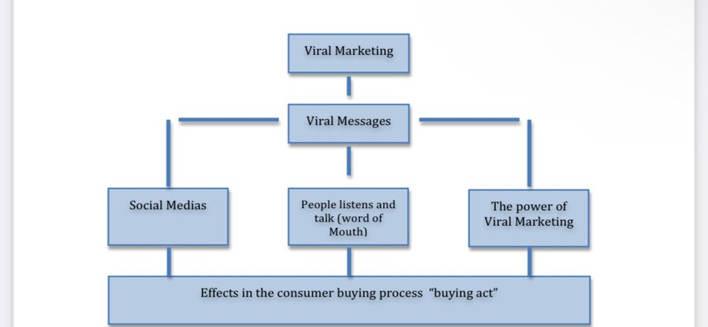
(Figure 1 Jakobsson and Gholamzadeh, 2011).
According to figure 1 (Gholamzadeh & Jakobsson, 2011) developed hypothesis that consumers who are exposed to viral campaigns on social media are influenced to purchase a goods or service. In which there is a positive significant relation between viral marketing and consumer purchasing behavior. This could be interpreted that when companies use more and more viral marketing strategies it has high possibilities to attract consumers to buy the product.
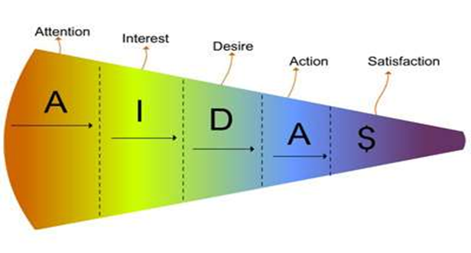
Figure 2: AIDAS Model
Another research (Greeshma & Chandru, 2021) has also stated that viral marketing has influenced on the consumer’s purchasing behavior in which it could be explained that viral marketing that adhere the AIDAS model as presented in figure 2 could be the push factors for the customer in doing the decision making for the buying process and affect the consumer’s decision to purchase the product and services.

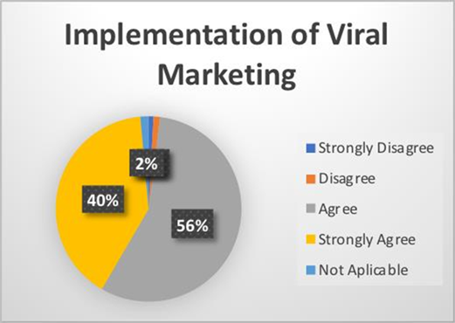
Figure 3
Moreover figure 3 shown a result of an analysis on The Influence of Viral Marketing on Online Purchasing Decisions of Students that are based on (Irwansyah & Devi, 2019) in which has found that the majority of their respondent agrees that purchase decisions made are due to the implementation of viral marketing with 56% of people that agreed and 40% that strongly agree on the statement. This could develop a hypothesis that the impact of viral marketing on consumers behavior in the context of purchasing decision is positively significant in which more viral marketing leads to an increased purchasing behavior of consumers.
Therefore, it can be seen that my findings from primary research and secondary research are correlated to one another as the findings are similar. Therefore, it can be concluded that viral marketing can influence consumer’s purchasing behavior.

Task 3: Reflection on Elevator Pitch Video
In this section I will be explaining about the feedback that I received on my posted elevator pitch video where the video is explaining about my research topic. Based on the feedback, there are a few areas that need to be improved. First of all, the reflection involved the presentation content where I did not mention on value that may contribute to related industry fields or to society from conducting my research. Therefore, I have done some research to understand why it is important to express the value that our research could create is because it helps justify why the study is worth undertaking (Bouchrika, 2023). Moreover, by mentioning the value that could be contributed from my research it could capture the interest of my audience. Thus, based on (Singh, 2021) value that could be contributed to the relevant field is that it could help company’s managers to have a better understanding of consumer behavior. Also, they will be able to utilize viral marketing appropriately and could strategize the marketing plan properly to market their products or services via the Internet.
Besides that, another feedback is relating to my slide presentation where the slides in my video are not at one place so it affects my audience concentration as they need to keep on looking where my slides are going to be placed. As for that, I have done my research on the best position to insert my slide in a video presentation which can be whether to insert it on top, bottom or side. However, it is recommended to position the slide at one place only so that it could make the audience have a better focus on the things that are presented as it can influence how effectively our content is communicated to the audience (Paradi & Paradi's, n.d.).

Task 4: Data analysis & Poster Link

Attached below is the link to the academic poster required for the topic: The Impact of Viral Marketing on Consumers Purchasing Behavior.

Poster Link: Google slide version
https://docs.google.com/presentation/d/10vw4r4A2AH5vx2WUOJlWke7L1xTU0Ep1/edit?usp=sharing&ouid=117978296366627443224&rtpof=true&sd=true

References
- Barnhart, B. (n.d.). What is Viral Marketing? & Does it Work in 2023 [+Examples]. Sprout Social. Retrieved August 25, 2023, from https://sproutsocial.com/insights/viral-marketing/
- Bouchrika, I. (2023, April 4). Research Apr 4, 2023 Primary Research vs Secondary Research: Definitions, Differences, and Examples. Research.com. Retrieved August 25, 2023, from https://research.com/research/primary-research-vs-secondary-research
- Dsouza, A., & Panakaje, D. N. (2023). A Study on the Evolution of Digital Marketing. 7(1). https://www.researchgate.net/publication/368549900_A_Study_on_the_Evolution_of_Digital_Marketing?enrichId=rgreq-619a3a9e5319fc55e2cb987e8a12699c-XXX&enrichSource=Y292ZXJQYWdlOzM2ODU0OTkwMDtBUzoxMTQzMTI4MTEyMDY2MTgzNUAxNjc2NTcyODg5NzI2&el=1_x_2&_esc=publica
- Elfil, M., & Negida, A. (2017). Sampling methods in Clinical Research; an Educational Review. 5(1). https://www.ncbi.nlm.nih.gov/pmc/articles/PMC5325924/
- Gholamzadeh, C., & Jakobsson, K. (2011). A Quantitative Study about how Viral Marketing affects the Consumers Buying act. http://www.diva-portal.org/smash/record.jsf?pid=diva2:439957
- Gordon, J. (2022). Abductive Reasoning - Explained. The Business Professor. Retrieved August 25, 2023, from https://thebusinessprofessor.com/en_US/management-leadership-organizational-behavior/abductive-reasoning-definition
- Greeshma, & Chandru. (2021). IMPACT OF VIRAL MARKETING ON CONSUMERS BUYING BEHAVIOUR TOWARDS COIMBATORE CITY. DOI: 10.36713/epra2016
Guyot, M. (2016). Viral Marketing - How can a campaign succeed in going viral? What are the pros and cons of viral marketing? https://www.theseus.fi/bitstream/handle/10024/125755/Maelle-Guyot-thesis.pdf?sequence=1
- Hickey, G. L., Grant, S. W., Dunning, J., & Siepe, M. (2018, July 1). Statistical primer: sample size and power calculations-why, when and how? PubMed. Retrieved August 25, 2023, from https://pubmed.ncbi.nlm.nih.gov/29757369/
- Hirvijärvi, F. (2017). Viral Marketing and content forwarding on social media Outlining the key elements behind successful viral content creation. https://core.ac.uk/download/pdf/84797993.pdf
- Irwansyah, R., & Devi, S. (2019). The Influence of Viral Marketing on Online Purchasing Decisions of Students. 103. https://www.atlantis-press.com/proceedings/teams-19/125924369
- Maas, C. J.M., & Hox, J. J. (2005). Sufficient sample sizes for multilevel modeling." https://doi.org/10.1027/1614-2241.1.3.86
- Paradi, D., & Paradi's, D. (n.d.). Present with your video beside your PowerPoint slides in Microsoft Teams or Zoom (Windows). Think Outside The Slide. Retrieved August 25, 2023, from https://www.thinkoutsidetheslide.com/present-with-your-video-beside-your-powerpoint-slides-in-microsoft-teams-or-zoom/
- Sarwono, J. (2022). Quantitative, Qualitative and Mixed Method Research Methodology. https://www.researchgate.net/publication/360403377
Singh, A. (2021). Significance of Research Process in Research Work. http://dx.doi.org/10.13140/RG.2.2.32664.93445/1
- Wei, L. S. (2014). The Attitudes of Consumers towards Viral Marketing in Malaysia. http://eprints.utar.edu.my/1297/1/Viral_Marketing_Thesis_(Final).pdf
- Woiceshyin, J., & Daellenbach, U. S. (2018). Evaluating Inductive versus Deductive Research in Management Studies: Implications for Authors, Editors, and Reviewers. 13(12). https://doi.org/10.1108/QROM-06-2017-1538

