
Reshaping the strategic direction
by
delivering innovative customer care
For Tarena International


MODULE NAME：Strategic Management (BMMB7013)

NAME: Chunyan Wan

STUDENT NUMBER: 2234170
July 19, 2023
University of Wales Trinity Saint David

Executive Summary
This report presents a comprehensive strategic analysis of Tarena International, a leading provider of IT professional education and STEAM education services in China. The analysis is grounded in various theoretical frameworks and considers the current trends in the education sector, the impact of the COVID-19 pandemic, and the expectations of Tarena's key stakeholders.
The advent of the digital age and the COVID-19 pandemic have accelerated the shift from traditional classroom learning to online education. However, the effectiveness and impact of online education remain subjects of ongoing debate and research. While online education offers numerous benefits, it also presents unique challenges that need to be addressed to ensure its effectiveness.
The report proposes a new strategic direction for Tarena, focusing on the expansion of digital learning platforms, the enhancement of STEAM education offerings, the strengthening of partnerships with universities and employers, and the promotion of lifelong learning. This strategy aligns with the current trends in the education sector, such as the growing demand for online learning and STEAM education, and the increasing importance of lifelong learning in the face of rapid technological change.
Implementing this strategy would require significant changes in Tarena's operations, such as training staff to manage and facilitate online learning, investing in new technologies, and redesigning courses for online delivery. It would also require financial investments, changes in hiring and training practices, adjustments in marketing strategies, enhancements in customer service, and compliance with relevant laws and regulations.
The report concludes with a set of recommendations for Tarena to reshape its strategic direction by delivering innovative customer care. These recommendations include providing personalized learning experiences, enhancing digital support, building online communities, establishing feedback mechanisms, supporting lifelong learning, and ensuring the quality of Tarena's courses.
In conclusion, with its strong capabilities in IT and STEAM education, its innovative learning platform, and its commitment to meeting stakeholder needs, Tarena has the potential to further strengthen its position as a leader in the education industry. However, the successful implementation of the proposed strategy would require careful planning, effective execution, and ongoing monitoring and evaluation.

Table of Contents
Executive Summary 1
Introduction 4
What is Strategy? 5
PESTEL Analysis of Tarena International 7
SWOT Analysis 9
Strengths: 9
Weaknesses: 10
Opportunities: 10
Threats: 11
Strategic Clock 11
Five Forces Analysis 12
Strategic Planning – Ansoff’s Matrix Analysis 13
Stakeholder Analysis 15
Proposed Strategy and Justification 16
Implications of the Strategy 18
Conclusions 19
Recommendations 21
Bibliography 24
Appendices 28
Background of Tarena International, Inc. 28

Introduction
In the rapidly evolving digital era, industries across the board are experiencing significant transformations, and the education sector is no exception. The traditional classroom model is increasingly giving way to online education, a shift that has been further propelled by the global COVID-19 pandemic. As educational institutions worldwide have been forced to close their doors, remote learning has become the new norm. However, the effectiveness and implications of online education are still subjects of ongoing research and debate.
This report delves into the strategic direction of Tarena International Inc., a leading provider of professional education services in China. Tarena International has been at the forefront of these educational transformations, offering a comprehensive suite of IT and non-IT training courses tailored to the needs of the market. However, the company now faces the challenge of navigating the complex landscape of online education, marked by varying attitudes towards this new form of learning and the need for continuous optimization of online education systems.
Several studies have explored different aspects of online education. For instance, Ma et al. (2021) investigated the impact of the COVID-19 pandemic on the mental health of Chinese children and their attitudes towards online education. The study revealed a mixed response, with a significant proportion of students expressing satisfaction with online education, while a substantial number were uncomfortable with this new learning format. Similarly, Mujahid et al. (2021) used sentiment analysis to gauge public opinion on online education during the pandemic. The study underscored the importance of ensuring that online learning platforms are not only technically feasible but also suitable for students and teachers.
In another vein, Borup and Evmenova (2019) conducted a case study examining the effectiveness of a professional development course designed to improve faculty members' knowledge, skills, and dispositions required to teach online effectively. The study found that the course content and assignments improved faculty members' knowledge and skills, but the ways the course was delivered, and the online teaching methods modeled by the course instructor appeared to have a larger impact on perceptions and attitudes towards online learning.
Finally, a study by Pandit and Agrawal (2021) explored the challenges of online education during the COVID-19 pandemic from the perspective of stakeholders in education. The study emphasized the need for academic leadership, collaborative peer learning, know-how of digital technology and online learning tools, and training of faculty and students to create an ecosystem for effective online teaching.
This report aims to explore these challenges and potential solutions further, focusing on how Tarena International can reshape its strategic direction to deliver innovative customer care in the context of online education. The report will delve into various aspects of strategy, analyze Tarena International's external environment using the PESTEL and SWOT frameworks, and propose a strategic direction for the company based on the findings. The goal is to provide insights that can enhance the impact and effectiveness of online education, ultimately contributing to the advancement of the education sector in the digital age.

What is Strategy?
Strategy is a complex concept that has been defined in various ways by different scholars and theorists.
Porter, a renowned professor at Harvard Business School, defines strategy as "the creation of a unique and valuable position, involving a different set of activities."(Porter, M. E. 1996).
Mintzberg, a professor at McGill University, suggests that strategy is a pattern in a stream of decisions. He distinguishes between deliberate strategies, which are intentional, and emergent strategies, which arise from patterns of decisions that were not originally intended as strategy. Mintzberg's work emphasizes the importance of flexibility and adaptation in strategy (Mintzberg, H. 1987).
Rumelt, a professor at UCLA Anderson School of Management, defines strategy as "a type of problem solving." According to Rumelt, good strategy involves a diagnosis of the situation, a guiding policy for dealing with the situation, and a set of coherent actions to carry out the policy. Rumelt's approach to strategy emphasizes the importance of clarity and coherence (Rumelt, R. P. 2011).
Chandler, a business historian, defines strategy as "the determination of the basic long-term goals of an enterprise, and the adoption of courses of action and the allocation of resources necessary for carrying out these goals." (Chandler, A. D. 1962) Chandler's work highlights the role of strategy in coordinating an organization's activities and resources.
Ansoff, known as the father of strategic management, defines strategy as "the common thread among an organization's activities and product/markets that defines the essential nature of business that the organization was in, or to be in." (Ansoff, H. I. 1965) Ansoff's work includes the Ansoff Matrix, a tool for analysing a company's growth strategies.
These definitions and theories highlight different aspects of strategy, such as its focus on long-term goals (Chandler), its role in coordinating activities and resources (Porter, Chandler), its flexibility and adaptability (Mintzberg), its problem-solving nature (Rumelt), and its connection to a company's products and markets (Ansoff).

PESTEL Analysis of Tarena International
The PESTEL framework is a tool used in strategic management to analyse the external macro-environmental factors that affect an organization. The acronym PESTEL stands for: Political, Economic, Sociocultural, Technological, Environmental and Legal. The PESTEL framework is used to identify opportunities and threats in the strategic planning process. It provides a broad perspective of the environment in which an organization operates and helps the organization to align its strategies according to these external factors.
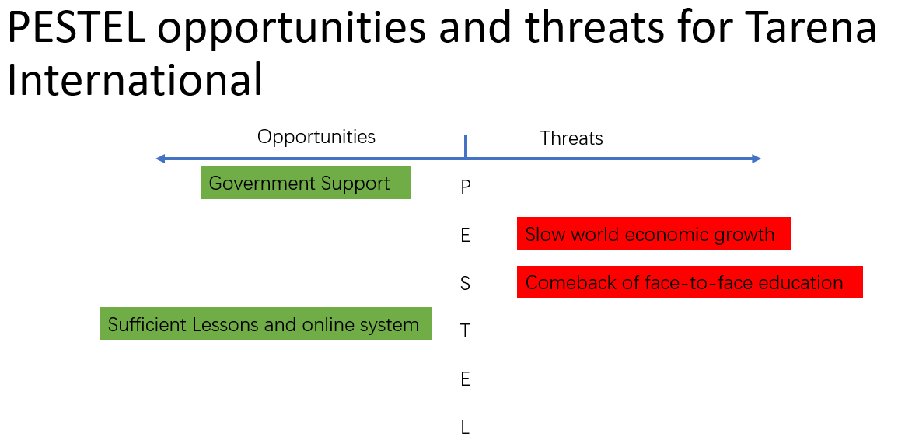
Based on the PESTEL framework, the external environment of Tarena can be analysed as follows:
Political: Tarena operates in China, which has a stable political environment. However, the Chinese government's regulations on education and technology sectors can significantly impact Tarena's operations. For instance, the recent crackdown on private tutoring firms in China has affected many education companies. However, The Chinese government has shown support for the development of STEAM education. This is a positive political factor for Tarena, as it aligns with their business model of providing professional education services, including STEAM education.
Economic: The Chinese economy is one of the fastest growing in the world, which provides a favorable environment for businesses like Tarena. However, the world economy has slowed down in the past three years due to the COVID-19 pandemic. This could have both positive and negative impacts on Tarena. On one hand, economic slowdowns can lead to budget cuts in education, potentially reducing the demand for Tarena's services. On the other hand, economic downturns often lead to increased demand for retraining and professional education services, as individuals seek to improve their skills and employability.
Social: There is a trend of students returning to face-to-face education. This could be a challenge for Tarena, which has a strong focus on online education. However, Tarena's blended learning model, which combines online and offline education, could be an advantage in this context.
Technological: Tarena has a competitive advantage in terms of its advanced online teaching system and a wide range of courses. Rapid advancements in technology can both pose a challenge and provide opportunities for Tarena. On one hand, they need to constantly update their course offerings to stay relevant. On the other hand, the rise of online learning technologies has allowed Tarena to reach more students.
Additionaly, the competition in the online education sector is intense, with many competitors also investing in technology to improve their online teaching capabilities.
Environmental: While Tarena's operations do not have a significant environmental impact, it's important for the company to consider environmental factors in its strategic planning. For example, promoting online courses can help reduce carbon emissions associated with commuting.
Legal: Tarena must comply with various laws and regulations related to education, technology, and business operations in China. Any changes in these laws can impact Tarena's business model.

SWOT Analysis
SWOT analysis is a strategic planning tool used to evaluate the Strengths, Weaknesses, Opportunities, and Threats involved in a project or in a business venture (Gurel, 2017). It involves specifying the objective of the business venture or project and identifying the internal and external factors that are favourable and unfavourable to achieving that objective.

Strengths:
- Strong distribution network: Tarena has built a reliable distribution network that can reach the majority of its potential market.
- Successful performance in new markets: Tarena has demonstrated expertise at entering new markets and making a success of them.
- High level of customer satisfaction: Tarena has a dedicated customer relationship management department that has achieved a high level of customer satisfaction among present customers and good brand equity among potential customers.
- Automation of activities: This has brought consistency of quality to Tarena's products and has enabled the company to scale up and down based on the demand conditions in the market.
- Good returns on capital expenditure: Tarena is relatively successful at executing new projects and has generated good returns on capital expenditure by building new revenue streams.
- Successful track record of developing new products.
- Strong brand portfolio: Over the years, Tarena has invested in building a strong brand portfolio.

Weaknesses:
- Need for more investment in new technologies: Given the scale of expansion and different geographies the company is planning to expand into, Tarena needs to put more money in technology to integrate the processes across the board.
- Limited success outside core business: Even though Tarena is one of the leading organizations in its industry, it has faced challenges in moving to other product segments with its present culture.
- High attrition rate in the workforce: Compared to other organizations in the industry, Tarena has a higher attrition rate and has to spend a lot more compared to its competitors on training and development of its employees.

Opportunities:
- Government green drive: This opens an opportunity for procurement of Tarena's products by the state as well as federal government contractors.
- New customers from the online channel: Over the past few years, the company has invested a vast sum of money into the online platform.
- New environmental policies: The new opportunities will create a level playing field for all the players in the industry.
- New technology: Provides an opportunity to Tarena to practice differentiated pricing strategy in the new market.

Threats:
- Shortage of skilled workforce: In certain global markets, this represents a threat to steady growth of profits for Tarena in those markets.
- Changing consumer buying behaviour: From the online channel could be a threat to the existing physical infrastructure-driven supply chain model.
- Imitation of the counterfeit and low-quality product: This is also a threat to Tarena’s product especially in the emerging markets and low-income markets.
- Liability laws: In different countries are different and Tarena may be exposed to various liability claims given change in policies in those markets.

Strategic Clock
Bowman's Strategic Clock is a model used to analyze the competitive position of a company in comparison to the offerings of competitors. It helps in understanding the competitive advantage that a company has in its market and how it can use this advantage to align its business strategies.
Unfortunately, there is no specific analysis available for Tarena International using the Bowman's Strategic Clock model. However, based on the information available about Tarena International, we can make some assumptions and place Tarena on the strategic clock.
Tarena International has shown significant growth in recent years. For instance, in the second quarter of FY22, the company reported a sales growth of 11.4% year-on-year. This growth is a result of the company's strong focus on quality education and its ability to adapt to the changing needs of the market.
Given this, Tarena International can be placed in the 'Differentiation' quadrant of Bowman's Strategic Clock. This is because Tarena offers a unique set of IT and non-IT training courses that are tailored to the needs of the market. The company's focus on quality and customer satisfaction further strengthens its position in this quadrant.
However, it's important to note that this is a broad analysis and may not capture all the nuances of Tarena's strategic position. A more detailed analysis would require in-depth knowledge of Tarena's operations, competitive environment, and customer perceptions.
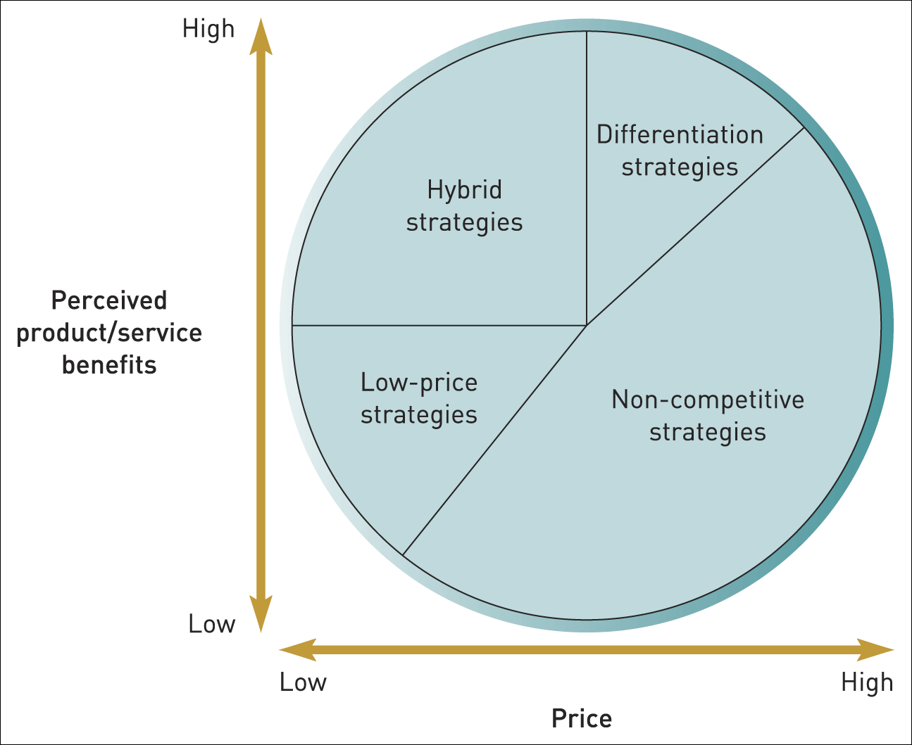

Five Forces Analysis
Based on the available information, here is a Porter's Five Forces analysis of the education and training services industry in China, with a focus on Tarena International:
- Threat of New Entrants: The education and training services industry in China is growing rapidly, attracting new entrants. However, Tarena has built a strong brand and a wide network of branches across China, which can act as barriers to entry for new firms.
- Bargaining Power of Suppliers: In the context of Tarena, suppliers could be considered as the educators or trainers. The bargaining power of suppliers is relatively low as there is a large pool of qualified educators and trainers in China.
- Bargaining Power of Buyers: The bargaining power of buyers is high in this industry. Students and professionals seeking training have a wide range of options to choose from. Tarena can tackle this by offering high-quality, unique courses and maintaining a strong customer relationship.
- Thread of Substitute of Products or Services: The threat of substitutes is high due to the rise of online learning platforms and MOOCs (Massive Open Online Courses). Tarena has responded to this threat by offering online courses in addition to its traditional classroom-based courses.
- Rivalry Among Existing Competitors: The rivalry is intense in the education and training services industry in China. Tarena faces competition from both local and international education providers. However, Tarena's wide range of course offerings and its focus on IT and internet vocational training give it a competitive edge.

Strategic Planning – Ansoff’s Matrix Analysis
Ansoff's Matrix is a strategic planning tool that provides a framework to help executives, senior managers, and marketers devise strategies for future growth. It considers growth opportunities from market penetration, market development, product development, and diversification.
Here's how we can apply Ansoff’s Matrix to Tarena International:
- Market Penetration (Existing Markets, Existing Products): Tarena can focus on increasing its market share in the existing markets. This can be achieved by enhancing marketing efforts, offering competitive pricing, or improving the quality of services. Tarena's strong brand and wide range of courses can be leveraged to attract more students in the existing markets.
- Market Development (New Markets, Existing Products): Tarena can explore opportunities in new geographical markets where its services are not currently offered. For instance, expanding to other cities in China or even considering international markets. The company's successful listing on NASDAQ indicates its potential for international expansion.
- Product Development (Existing Markets, New Products): Tarena can develop new courses or training programs to meet the changing needs of the market. For instance, with the rise of technologies like blockchain, quantum computing, and augmented reality, Tarena can introduce new courses in these areas.
- Diversification (New Markets, New Products): This is the riskiest strategy as it involves moving into a new market with a new product. Tarena could consider this strategy if there are synergies with its current operations. For instance, Tarena could consider offering courses in non-IT areas like business management or entrepreneurship and expand these offerings to new markets.
It's important to note that each of these strategies comes with its own risks and would require careful consideration and planning. Tarena's decision should be based on a thorough analysis of the market conditions, competition, and its own capabilities and resources.

Stakeholder Analysis
Based on the public information available, we can make some general observations about Tarena's stakeholders:
- Shareholders and Investors: Tarena is a publicly traded company, so its shareholders and investors are key stakeholders. They would be interested in the company's financial performance and its strategic plans for growth. The company has been actively communicating with this stakeholder group through earnings conference calls and live webcasts, as well as presentations at events such as the Planet MicroCap Showcase.
- Customers: As a provider of IT professional education and STEAM education services, Tarena's customers would include both individuals seeking to improve their IT skills and organizations looking to train their employees. These stakeholders would be interested in the quality and relevance of Tarena's educational offerings. The company's innovative education platform, which combines live distance instruction, classroom-based tutoring, and online learning modules, is designed to meet these needs.
- Employees: Tarena's employees are another important stakeholder group. They would be interested in their working conditions, compensation, and opportunities for professional development. The company's management, including the Chief Financial Officer, plays a key role in communicating with external stakeholders, which suggests that internal communication and employee engagement may also be a priority.
- Government Agencies: As an education provider, Tarena would likely interact with government agencies responsible for education policy and regulation. These stakeholders would be interested in Tarena's compliance with relevant laws and regulations, as well as its contributions to educational outcomes. The company's filing of its annual report on Form 20-F with the Securities and Exchange Commission indicates its commitment to regulatory compliance.
- Communities: Tarena operates in various communities across China, making these communities key stakeholders as well. They would be interested in Tarena's contributions to local economic development and its impact on the local community. The company's focus on STEAM education, including computer coding and robotics programming courses for students aged between three and eighteen, suggests that it is contributing to the development of future talent in these communities.

Proposed Strategy and Justification
Based on the analysis of Tarena International's current situation, the trends in the education industry, and the impact of the COVID-19 pandemic on education, I propose the following strategic direction for Tarena:
- Embrace Blended Learning:
The COVID-19 pandemic has accelerated the adoption of online learning, but it has also highlighted the limitations of fully online education. According to a study by Popa et al. (2023), students prefer a balance between face-to-face and digital education, likely in the form of blended learning. This approach combines the best of both worlds: the flexibility and accessibility of online learning with the social interaction and structure of traditional classroom learning. Tarena, with its existing network of learning centers, is well-positioned to implement a blended learning model.
- Invest in Digital transformation:
Tarena should continue to invest in digital technologies to enhance its online learning platform. This includes improving the user interface, integrating AI-powered learning tools, and providing real-time analytics to track student progress. The company should also explore emerging technologies such as virtual reality (VR) and augmented reality (AR) to create immersive learning experiences.
- Expand STEAM Education Offerings:
The demand for STEAM education is growing, as evidenced by Tarena's successful launch of its STEAM education business. The company should continue to expand its STEAM education offerings, targeting not only children but also adults who are looking to upskill or reskill in these areas. This could involve partnerships with tech companies to offer industry-relevant courses.
- Strengthen Partnerships with Universities and Employers:
Tarena should strengthen its partnerships with universities and employers to ensure its courses are aligned with industry needs. This could involve co-developing courses with industry partners, offering internships, or guaranteeing job interviews for course graduates. Such partnerships could enhance Tarena's value proposition and attract more students.
- Focus on Life-long learning:
With the rapid pace of technological change, there is a growing need for lifelong learning. Tarena should position itself as a provider of lifelong learning, offering courses for different stages of a person's career. This could involve a subscription model, where students have access to a library of courses that they can take as needed.
- Enhance Support for Online Learning:
According to a study by (Kopilaš et al. 2023), educators need support in adapting to online learning. Tarena could offer training for educators on how to effectively facilitate online learning, as well as technical support for students and educators.

Implications of the Strategy
The proposed strategy could have several implications for different areas of Tarena, as seen through various theoretical lenses:
- Operations:
The shift towards a blended learning model and the expansion of digital learning platforms would require significant changes in Tarena's operations. This aligns with the Operations Strategy theory, which posits that operational effectiveness is a key determinant of a firm's competitiveness (Skinner, 1969). Tarena would need to train staff to manage and facilitate online learning, invest in new technologies, and redesign courses for online delivery.
- Finance:
Investing in digital transformation and expanding STEAM education offerings would require significant financial resources. However, these investments could also generate new revenue streams for Tarena. This aligns with the Modern Portfolio Theory (Markowitz, 1952), which suggests that diversification can optimize returns while minimizing risk.
- Human Resources:
Tarena's employees would need to adapt to new ways of working, such as facilitating online learning and using new technologies. This could require training and professional development, as well as changes in hiring practices to attract employees with the necessary skills. This aligns with Human Capital Theory (Becker, 1964), which emphasizes the role of education and training in enhancing workforce productivity.
- Marketing:
The proposed strategy could require changes in Tarena's marketing approach. The company would need to communicate the benefits of its new offerings, such as the flexibility of blended learning and the relevance of its STEAM education courses. This aligns with the Marketing Mix theory (McCarthy, 1960), which suggests that product, price, place, and promotion should be optimized to meet customer needs.
- Customer Service:
With more learning taking place online, Tarena would need to provide support for students and educators in using its digital learning platform. This aligns with the Service Quality Model (Parasuraman, Zeithaml, & Berry, 1985), which emphasizes the importance of reliability, responsiveness, assurance, empathy, and tangibles in delivering quality service.
- Legal and Compliance:
Tarena would need to ensure that its new offerings comply with relevant laws and regulations, such as data privacy laws for its online learning platform. This aligns with the Compliance Theory (Tyler, 1990), which suggests that organizations are more likely to comply with laws when they perceive them to be legitimate and in their best interest.

Conclusions
In conclusion, this report has provided a comprehensive analysis of Tarena International's current situation, stakeholder expectations, and strategic direction. Tarena, as a leading provider of IT professional education and STEAM education services in China, is well-positioned to leverage its resources and capabilities to adapt to the changing education landscape (Tarena International, Inc., 2023).
Our stakeholder analysis, grounded in the stakeholder theory (Freeman, 1984), revealed that Tarena's key stakeholders include shareholders and investors, customers, employees, government agencies, and the communities in which it operates. Each of these stakeholder groups has unique needs and expectations, which Tarena must consider in its strategic planning.
Based on this analysis, we proposed a new strategic direction for Tarena, focusing on the expansion of digital learning platforms, the enhancement of STEAM education offerings, the strengthening of partnerships with universities and employers, and the promotion of lifelong learning. This strategy aligns with the current trends in the education sector, such as the growing demand for online learning and STEAM education, and the increasing importance of lifelong learning in the face of rapid technological change (Popa et al., 2023; Kopilaš et al., 2023).
The proposed strategy has several implications for different areas of Tarena, including operations, finance, human resources, marketing, customer service, and legal and compliance. Implementing this strategy would require significant changes in Tarena's operations, such as training staff to manage and facilitate online learning, investing in new technologies, and redesigning courses for online delivery. It would also require financial investments, changes in hiring and training practices, adjustments in marketing strategies, enhancements in customer service, and compliance with relevant laws and regulations.
The proposed strategy is supported by various theoretical frameworks, including the Operations Strategy theory (Skinner, 1969), Modern Portfolio Theory (Markowitz, 1952), Human Capital Theory (Becker, 1964), Marketing Mix theory (McCarthy, 1960), Service Quality Model (Parasuraman, Zeithaml, & Berry, 1985), and Compliance Theory (Tyler, 1990). These theories provide a solid theoretical foundation for the proposed strategy and highlight the importance of operational effectiveness, financial diversification, workforce development, customer orientation, service quality, and regulatory compliance in achieving strategic success.
In implementing this strategy, Tarena should engage with its stakeholders, monitor the external environment, and continuously adapt and innovate to meet the changing needs of its customers and the education sector. With its strong capabilities in IT and STEAM education, its innovative learning platform, and its commitment to meeting stakeholder needs, Tarena has the potential to further strengthen its position as a leader in the education industry.
In closing, it is important to note that the proposed strategy is based on the information available at the time of writing. As such, it should be reviewed and updated regularly to reflect new information and changes in the external environment. Furthermore, the successful implementation of this strategy would require careful planning, effective execution, and ongoing monitoring and evaluation.

Recommendations
Based on the analysis conducted, the following recommendations are proposed for Tarena International to reshape its strategic direction by delivering innovative customer care:
- Personalized Learning Experiences:
Leverage data analytics and artificial intelligence to provide personalized learning experiences. This could involve recommending courses based on a student's learning style, interests, and career goals, or adapting the pace of learning to the student's progress. Personalization can enhance the learning experience and improve student outcomes.
- Enhanced Digital Support:
Invest in digital support services to assist students and educators in using Tarena's online learning platform. This could involve setting up a dedicated customer service team to handle technical issues and inquiries, or integrating chatbots to provide instant responses to common queries. Enhanced digital support can improve the user experience and increase satisfaction with Tarena's services.
- Community Building:
Create online communities where students can interact with each other and with educators. This could involve setting up discussion forums, study groups, or social media groups. Online communities can enhance the social aspect of learning, which is often lacking in online education.
- Feedback Mechanisms:
Establish mechanisms for collecting and responding to feedback from students and educators. This could involve regular surveys, suggestion boxes, or feedback sessions. Feedback can provide valuable insights for improving Tarena's services and can also make stakeholders feel heard and valued.
- Lifelong Learning Support:
Provide support for lifelong learning by offering career guidance, job placement services, or alumni networks. This could involve partnerships with employers or industry associations. Lifelong learning support can enhance the value of Tarena's courses and strengthen its relationships with students.
- Quality Assurance:
Ensure the quality of Tarena's courses by regularly reviewing and updating course content, providing training and professional development for educators, and monitoring student outcomes. Quality assurance can enhance Tarena's reputation and attract more students.
These recommendations align with the Service Quality Model (Parasuraman, Zeithaml, & Berry, 1985), which emphasizes the importance of reliability, responsiveness, assurance, empathy, and tangibles in delivering quality service. They also align with the concept of Customer Relationship Management (CRM), which involves managing relationships with customers through personalized communication and service (Peppers & Rogers, 1993).

Bibliography
- An, B., & Shen, W. (2016). The Internet will be How to Change the Landscape Industry. Atlantis Press.
- Andrews, K. (1980). The Concept of Corporate Strategy. Richard D. Irwin, Inc.
- Ansoff, H.I. (1957). Strategies for Diversification. Harvard Business Review, 35(5), 113-124.
- Ansoff, H. I. (1965). Corporate Strategy: An Analytic Approach to Business Policy for Growth and Expansion. McGraw-Hill.
- Atreya, A., & Nepal, B. (2020). Covid-19 pandemic and Nepal. SAGE Journals.
- Becker, G. S. (1964). Human Capital Theory. Columbia, New York.
- Borup, J., & Evmenova, A. (2019). The Effectiveness of Professional Development in Overcoming Obstacles to Effective Online Instruction in a College of Education.
- Browne, J., & Nuttall, R. (2013). Beyond corporate social responsibility: Integrated external engagement. McKinsey & Company.
- Chandler, A. D. (1962). Strategy and Structure: Chapters in the History of the Industrial Enterprise. MIT Press.
- Fern Fort University. (2023). Tarena International, Inc. [SWOT Analysis] Weighted SWOT Matrix.
- Fern Fort University. (2023). China Online Education Group Porter Five Forces Analysis.
- Forssberg, H., Damiano, D., & Armstrong, R. (2022). ‘Better Together’: achieving a global professional network for childhood disability. Wiley Online Library.
- Freeman, R. E. (1984). Strategic Management: A Stakeholder Approach. Boston: Pitman.
- Gurel, E., & Tat, M. (2017). SWOT Analysis: A Theoretical Review. Journal of International Social Research, 10(51), 994-1006.
- Johnson, G., Whittington, R., & Scholes, K. (2011). Exploring Strategy. Pearson Education.
- Kopilaš, V., Brajdić Vuković, M., & Afrić, V. (2023). Online Professional Learning of Preschool Educators during the COVID-19 Pandemic. International Journal of Child Care and Education Policy, 17(1), 1-20.
- Markowitz, H. (1952). Portfolio Selection. The Journal of Finance, 7(1), 77-91.
- Ma, Z., Idris, S., Zhang, Y., Zewen, L., Wali, A., Ji, Y., Pan, Q., & Baloch, Z. (2021). The impact of COVID-19 pandemic outbreak on education and mental health of Chinese children aged 7–15 years: an online survey.
- MBA Knol. (2023). Bowman's Strategy Clock.
- McCarthy, E. J. (1960). Basic Marketing. A Managerial Approach. Homewood, IL: Irwin.
- McKinsey & Company. (n.d.). The care of one: Hyperpersonalization of customer care.
- Mintzberg, H. (1987). The Strategy Concept I: Five Ps for Strategy. California Management Review, 30(1), 11-24.
- Mujahid, M., Lee, E., Rustam, F., Washington, P., Ullah, S., Reshi, A., & Ashraf, I. (2021). Sentiment Analysis and Topic Modeling on Tweets about Online Education during COVID-19.
- Oxford University Press. (2017). PESTLE Analysis. In A Dictionary of Business and Management. Oxford University Press.
- Pandit, D., & Agrawal, S. (2021). Exploring Challenges of Online Education in COVID Times.
- Parasuraman, A., Zeithaml, V. A., & Berry, L. L. (1985). A Conceptual Model of Service Quality and Its Implications for Future Research. Journal of Marketing, 49(4), 41-50.
- Peppers, D., & Rogers, M. (1993). The One-to-One Future: Building Relationships One Customer at a Time. Currency Doubleday.
- Pickton, D. W., & Wright, S. (1998). What's SWOT in Strategic Analysis? Strategic Change, 7(2), 101-109.
- Popa, D., Popa, V., & Popa, L. (2023). The Transition from Online to Face-to-Face Education: The Case of Romania. Sustainability, 14(19), 12812.
- Porter, M. E. (1996). What is Strategy? Harvard Business Review, 74(6), 61-78.
- Ramaswamy, V. (2014). How value co-creation with stakeholders is transformative for producers, consumers and society. Strategy & Leadership, 42(1), 9-16.
- Rumelt, R. P. (2011). Good Strategy/Bad Strategy: The Difference and Why It Matters. Crown Business
- PwC. (n.d.). Post-COVID-19 Customer Strategy Implications.
- Skinner, W. (1969). Manufacturing – Missing Link in Corporate Strategy. Harvard Business Review, 47(3), 136-145.
- Tarena International, Inc. (2023). Investor Relations. Retrieved from https://ir.tedu.cn/
- Tarena International, Inc. (2023). Tarena International, Inc. Entered into a Strategic Cooperation Agreement with Xueda Education Group. PR Newswire.
- Tarena International, Inc. (2023). Tarena International in Good Shape Following Cost-Cutting Measures. Seeking Alpha.
- Tarena International, Inc. (2023). Tarena International, Inc. Announces Fourth Quarter and Fiscal Year 2022 Results. GlobeNewswire.
- Tarena International, Inc. (2023). Tarena International, Inc. Announces Unaudited Second Quarter 2022 Results. GlobeNewswire.
- Tarena International, Inc. (2023). Tarena to Report First Quarter 2023 Financial Results on June 12, 2023. Retrieved from: https://ir.tedu.cn/2023-06-02-Tarena-to-Report-First-Quarter-2023-Financial-Results-on-June-12,-2023
- Tarena International, Inc. (2023). Tarena Filed 2022 Annual Report on Form 20-F. Retrieved from: https://ir.tedu.cn/2023-04-28-Tarena-Filed-2022-Annual-Report-on-Form-20-F
- Tarena International, Inc. (2023). Tarena International, Inc. to Present at the Planet MicroCap Showcase: VEGAS 2023 on Wednesday, April 26, 2023 & 1x1 Meetings on Thursday, April 27, 2023. Retrieved from: https://ir.tedu.cn/2023-04-21-Tarena-International,-Inc-to-Present-at-the-Planet-MicroCap-Showcase-VEGAS-2023-on-Wednesday,-April-26,-2023-1x1-Meetings-on-Thursday,-April-27,-2023
- Tarena International, Inc. (2023). Tarena International, Inc. Announces the Results for the First Quarter of 2023. Retrieved from:
https://www.prnewswire.com/news-releases/tarena-international-inc-announces-the-results-for-the-first-quarter-of-2023-301848861.html
- Tyler, T. R. (1990). Why People Obey the Law. Yale University Press.
- Villalobos-Camacho, J. R. (2021). The pandemic and the lost dreams of a junior engineer. Revista Mexicana de Física.
- Yahoo Finance. (2023). Tarena Clocks 11% Growth In Q2 Revenue; Appoints New CFO.
- Yahoo Finance. (2023). Tarena International, Inc. (TEDU) Company Profile & Facts.
- https://www.mckinsey.com/~/media/McKinsey/Industries/Paper%20and%20Forest%20Products/Our%20Insights/The%20drive%20toward%20sustainability%20in%20packaging%20beyond%20the%20quick%20wins/The-drive-toward-sustainability-in-packaging-beyond-the-quick-wins.ashx
- https://www.forbes.com/sites/jeroenkraaijenbrink/2021/10/18/why-strategy-execution-is-moving-up-the-corporate-agenda/?sh=351ecfa813c9
- https://hbr.org/2010/03/finding-your-strategy-in-the-new-landscape
- https://www.mckinsey.com/capabilities/mckinsey-digital/our-insights/detailing-the-new-landscape-for-global-business-services
- https://www.mckinsey.com/featured-insights/coronavirus-leading-through-the-crisis

Appendices

Background of Tarena International, Inc.
Tarena International, Inc., founded in 2002, is a leading provider of IT professional education and IT-focused supplementary STEAM education services in China. The company operates through two segments: IT Professional Education and IT-focused Supplementary STEAM Education Services.
Tarena offers a wide range of education courses in various IT subjects, including Java, software testing, Linux and network engineering, data analysis and business intelligence, Web front-end development, Python, and network engineer courses. In addition, the company provides non-IT subjects, including digital art, online sales and marketing, and visual effects-VFX.
The company's educational services are delivered through multiple channels, including live distance instruction, classroom-based tutoring, and online learning modules. Tarena also operates TMOOC.cn, an online learning platform that offers education courses and job placement training courses.
In addition to its IT-focused courses, Tarena offers a range of STEAM education services under the TongchengTongmei brand. These services include robotics programming, graphical intelligent programming, NOI informatics Olympiad, Python artificial intelligence, high-level hardware programming for secondary school, soft and hard programming enlightenment, creative programming starter, Python programming basics, and SPIKE starter and advanced.
As of 2023, Tarena has a full-time workforce of 7,955 employees. The company is headquartered in Beijing, the People's Republic of China.
In recent years, Tarena has made significant strides in its business. For instance, in the first quarter of 2023, the company announced that its businesses have gradually recovered and its STEAM education services are expected to achieve growth.

