Exhibiting the Past: Museums, Collections and Heritage
(AHAN7030)
Assignment 1: Part 2a: Proposal for a small exhibition
Moody_1812255_AHAN7030_Ass1_Part2a
Alison Moody

Proposal for an exhibition to mark the opening of the new Museum of Speed at Pendine

The newly re-built Museum of Speed, owned and operated by Carmarthenshire County Council, will be opening in the Spring of 2021 after being closed since the Autumn of 2018. To mark the opening weekend, I propose to bring two iconic cars to Pendine Sands and the Museum of Speed. The two cars, Malcolm Campbell’s Sunbeam 350HP and John Godfrey Parry-Thomas’s Babs competed against each other on Pendine Sands in the 1920’s and both held the land speed record which they set at Pendine. The high point of the opening weekend would be to watch both cars drive on the beach at Pendine before going to display at the museum for a period of eight weeks. The event on the beach at Pendine would include hot rod races which occur regularly at Pendine and are organised by the Vintage Hot Rod Association. The Vintage Hot Rod Association have expressed a willingness to be involved in this event.
During the mid 1920’s Pendine Sands was the place where the land speed records were won and lost. Pendine Sands is a seven mile stretch of sand; the water is incredibly shallow here meaning that at low tide the beach is more than half a kilometre wide. The sand at Pendine Sands is hard and in the 1920’s land speed record attempts moved away from racetracks and onto the beach at Pendine. In September 1924 Campbell set the record at 146.16mph for a measured mile. In July 1925 Campbell beat his own record with a speed of 150.766mph. In April 1926 Parry-Thomas took the record from Campbell, he reached 170.624mph in his car Babs which had a 27 litre Liberty engine. In February 1927 Campbell re-gained the record when his new car, the Napier Campbell Bluebird attained a speed of 174.223mph. On the 3rd March 1927, while trying to set a new record at Pendine Sands, Parry-Thomas was killed when he crashed in Babs, Parry-Thomas was decapitated in the accident and Babs was buried in the dunes at Pendine.
Forty two years later in 1969 Owen Wyn-Owen, an engineering lecturer at Bangor University, dug Babs out of the dunes at Pendine, took her home and restored her. This did not prove popular with some locals at the time, but Babs has been part of the UK racing circuit for the last five decades and now evokes much pride, and tourist revenue, in Pendine. Babs is owned equally by the National Museum of Wales, Pendine Community Council and Owen Wyn-Owen’s son Geraint Owen. The Museum of Speed has an existing agreement with the National Museum of Wales allowing Babs to spend at least eight weeks a year at the Museum of Speed. All the costs associated with insurance of Babs and any car owned by the National Museum of Wales are covered by policies already in place with Carmarthenshire County Council and their legal department. The cost to transport Babs would be around £500. The National Museum of Wales has conditions that must be met by any museum borrowing from its collection. These include requiring the Museum of Speed to ensure the security of any items borrowed and this may include cameras trained on items, security personal in attendance. It does require compliance with government indemnity standards from Arts Council England. There is also a requirement that the museum can meet certain environmental conditions, this is particularly important at the Museum of Speed as it is at the beach and the danger to cars from the salt sea air is significant. Linda Coode the curator of the museum is working to ensure all the environmental and security requirements of Arts Council England are met before the opening of the museum.
Sunbeam 350HP is on display at the National Motor Museum at Beaulieu. The National Motor Museum has a loan agreement in place with the Museum of Speed and Sunbeam 350HP is not unknown in Pendine. Transport costs would be around £500, and the insurance costs would be met by Carmarthenshire County Council as part of their existing agreement. Sunbeam 350HP may be loaned for a shorter period of time than Babs, but I would hope that both cars could be on the beach for the opening weekend and Sunbeam 350HP could spend a short time on display at the Museum of Speed afterwards.
After speaking with Linda my plan for the opening weekend of the Museum of Speed are not dissimilar from her. She has invited me to view the museum when it is closer to completion and I hope I might have the opportunity to work with her in the future.

Appendix 1: Babs
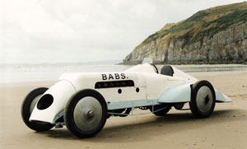

Appendix 2: Sunbeam 350HP
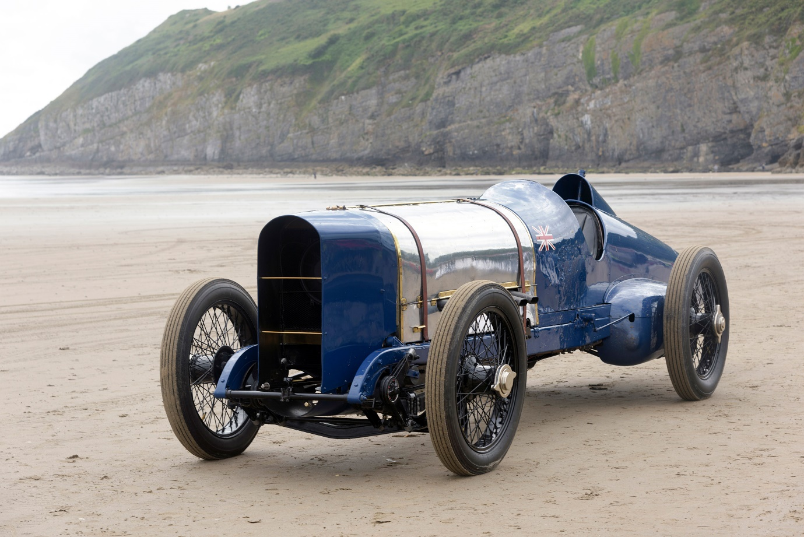

Bibliography

Arts Council England Government Indemnity Scheme https://www.artscouncil.org.uk/protecting-cultural-objects/government-indemnity-scheme
Buried alive: 1926 land speed record holder ‘Babs’ https://www.youtube.com/watch?v=Qlh_P4K_zzU
National Motor Museum, 350HP Sunbeam https://nationalmotormuseum.org.uk/vehicle-collection/sunbeam-350hp/
Pendine Community Council https://www.pendinesands.org/the-world-land-speed/
Vintage Hot Rod Association www.vhra.co.uk/VHRA/Home.html
1968: News: Wreck of Parry Thomas Racing https://www.facebook.com/BBCArchives/videos/565280093845025

I could not have completed this assignment without the advice of Linda Coode, curator, Museum of Speed, Pendine.

Vintage Hot Rod Association www.vhra.co.uk/VHRA/Home.html accessed on 15th April 2020 It’s worth noting that the picture at the top of the Vintage Hot Rod Associations website was taken at Pendine Sands
This is true
Pendine Community Council https://www.pendinesands.org/the-world-land-speed/ accessed on 5th May 2020
ibid
Buried alive: 1926 land speed record holder ‘Babs’ https://www.youtube.com/watch?v=Qlh_P4K_zzU accessed on 8th March 2020
1968: News: Wreck of Parry Thomas Racing https://www.facebook.com/BBCArchives/videos/565280093845025 accessed on 3rd April 2020
I was lucky enough to make contact with Linda Coode who was appointed curator of the new Museum of Speed in the Autumn of 2018 and is currently project managing the build and the re-opening. We spent an hour on the phone discussing my proposed exhibition. She gave me a great deal of advice about the technical aspects and I’ve drawn on that for my proposal.
Information gained from a member of the Vintage Hot Rod Association who moves cars professionally
Arts Council England Government Indemnity Scheme https://www.artscouncil.org.uk/protecting-cultural-objects/government-indemnity-scheme accessed on 5th May 2020
National Motor Museum, 350HP Sunbeam https://nationalmotormuseum.org.uk/vehicle-collection/sunbeam-350hp/ accessed on 31st March 2020
I discovered this in my telephone conversation with Linda Coode, I dropped the Bluebird SN7 which had been part of my original plan because the agreement the Museum of Speed has with the National Motor Museum specifies that the bluebird will only be loaned for special anniversaries.
The picture of Sunbeam on the National Motor Museum website was taken at Pendine Sands

