

Assessment Component 2
Student 1(TL)
Name: Al Arafat Sadin
Student ID: 2428111
Student 2
Name: Imadul Hannan
Student ID: 2422533
Student 3
Name: Abdillahi Abdul Dahag
Student ID: 2531944
Module code: LCBB4012
Module name: Academic Skills
Lecturer: Piyumika K. Gamage
Word Count: 2,227 words

Table of Contents
1. Introduction 3
2. Definition of the Skills 4
3. Importance of Skill 1: Teamwork Skills 5
4. Importance of Skill 2: Academic Writing Skills 7
5. Strategies to Improve Skill 1: Teamwork Skills 8
6. Strategies to Improve Skill 2: Academic Writing Skills 9
7. Conclusion 10
8. References 11

1. Introduction
In higher education, academic performance is not just the knowledge of the subject, but the ability of the subject to be translated into transferable skills that can enable the student to perform efficiently in educational as well as the workplace environment. Universities are putting more pressure on learners to exhibit communication skills, collaboration, critical thinking, time management, and professional behaviour (Hasanah and Malik, 2020). These expectations would be true to contemporary employment markets where organisations are after graduates who are capable of collaborating with others, problem solver, and articulate ideas. Some of the most important of such transferable skills include teamwork skills and academic writing skills. They are both essential to student success and lifelong employability.
The skills of teamwork are particularly significant since the collaborative learning technique is applied in most academic programmes which include group presentations, seminars, business simulations, lab activities, and project-based assessments (Dias-Oliveira et al., 2024). For example, in university team work, teams that debate alternative perspectives tend to generate better work than those that avoid conflict. However, teamwork's effectiveness rests on the successful management of conflict, communication and role definition.
The academic writing skill is also vital since the students use writing as one of the most common means of proving the knowledge, critical thinking, and research skills (Hanim et al., 2020). All of these essays, case studies, reports, reflective journals, and dissertations demand structured, formal presentation of evidence-based arguments by the students. Good writing skills are very crucial in the professional world where one has to write reports, policy, proposal, emails, contracts and strategic documents (Petelin, 2023). Thus, academic writing has not only been restricted to university assessment but also has a strong association with career success.
To support the importance of these skills, Human Capital Theory argues that education and skills development enhances the productivity and employability of individuals (Becker, 2008). In this view, teamwork and academic writing constitute good human capital since they increase the ability of a graduate to make contributions in various settings. Moreover, Constructivist Learning Theory by Vygotsky suggests that knowledge constructions are created as a result of interaction, reflection, and experience (Kumari and Kumar, 2022). This confirms the applicability of teamwork and writing because they entail active participation in ideas as opposed to passive learning.
This report aims to critically review the teamwork skills and academic writing skills by defining both skills, analysing their relevance in academic and professional life and discussing the strategies to improve them through the application of the relevant concepts and theories.

2. Definition of the Skills
Teamwork skills are the skills that people need to have the ability to collaborate with others to accomplish the common goals. These are communication, active listening, conflict resolution skills, leadership, delegation, adaptability, emotional intelligence, trust-building and accountability. According to Mobolade and Akinade (2021), a team is a small group of individuals with complementary skills with the shared purpose, performance objectives, and a sense of accountability to one another. This definition emphasizes that teamwork is not working side by side with people but interdependence and coordinated work.
In context of teamwork skills, the Team Role Theory by Belbin is a crucial perspective in learning about teamwork.
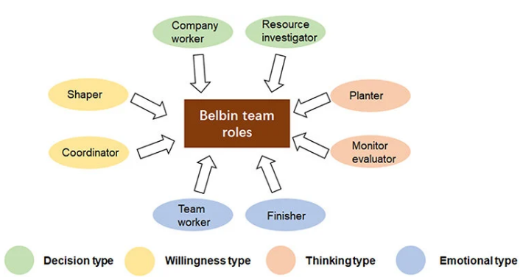
Figure 1: Team Role Theory by Belbin. Source: Han et al., 2023
Belbin posited that successful teams have members who play various roles i.e. coordinator, implementer, plant (creative thinker), monitor evaluator and completer-finisher (Aranzabal Maiztegi et al., 2021). According to this theory, teams are better off when the balance of roles is maintained and diversity of strengths is present. Additionally, Tuckman's group development model also describes teamwork by suggesting that teams pass through stages of forming, storming, norming, and performing and subsequently adjourning (Adam, 2024).
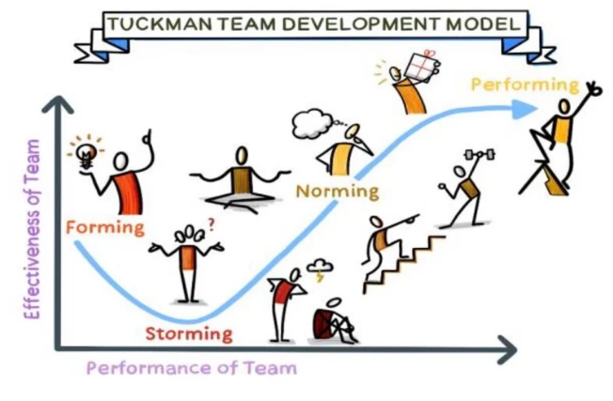
Figure 2: The Tuckman Model. Source: Han et al., 2023
These phases prove that teamwork can be built over time due to relationship-building and conflict management.
Whereas, academic writing skills are skills on how to express ideas in a formal, structured, logical and evidence-based written way that is suitable in higher education. According to Almusaed et al. (2025), academic writing must be clear, objective, critical, referenced, coherent, and utilize scholarly sources. Unlike informal writing, academic writing focuses more on evidence not opinion, and any arguments must be backed up by authoritative literature. The Taxonomy of Bloom can be applied in academic writing since most of the written tasks demand higher levels of cognition like analysing, evaluating and creating (Ybyrayeva et al., 2023). As an example, students might be required to compare theories, criticize research results, or give suggestions. Hence, academic writing skills are pivotal to achieve academic and professional success.

3. Importance of Skill 1: Teamwork Skills
The skills of teamwork are fundamentals of academic success as teamwork learning has become the main characteristic of contemporary higher education. The Social Constructivist Theory is the theory of learning created by Vygotsky (1978) which suggests that learning is the process that takes place in social interaction and dialogue (Syah et al., 2026). This theory can be better understand when students sharing knowledge, testing assumptions, and co-constructing knowledge while working in a diverse team. For instance, in group projects students can pool various strengths including research capability, creativity, technical expertise and presentation confidence. Bećirović et al. (2022) also supported that cooperative learning enhances academic performance, motivation, and interpersonal connections. Such experiences enhance self-efficacy, which refers to the belief of a person in his/her ability to execute tasks successfully.
The group development model of Tuckman is especially applicable in team work in academics (Aggrawal et al., 2024). The forming stage involves familiarizing students and outlining goals. During the storming phase, disagreements can arise on matters concerning leadership or assigning tasks. Examples of leading organizations like Unilever and Tesco explicitly revealed that with efficient management, there is an improvement in trust and cooperation and ultimately teams start performing where productivity is at its peak. In academic context, this model will enable students to cope with difficulties instead of perceiving conflict as a failure.
Teamwork is among the most treasured employability skills in the professional and business world. Systems Theory considers organisations as integrated structures in which departments rely on each other (Sony and Naik, 2020). This theoretical perspective implies that marketing, finance, operations, and human resources are to pull together in order to realize strategic objectives. In the absence of teamwork, there is a decrease in organisational performance because of redundancy, delays, and ineffective communication. Similarly, the theory of Belbin is also applicable in the working environment since effective teams should be comprised of diverse skills. One employee can be creative and generate ideas, another one can be implementation-oriented. Thus, skills diversity contributes to innovation and a balanced decision-making.
The Two-Factor Theory by Herzberg gives robust reason as to why teamwork is important in the workplace.
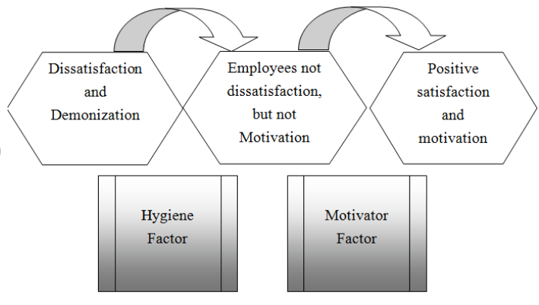
Figure 3: Representation of Herzberg's two-factor theory. Source: Tran, 2019
Good relations with other employees will help in motivation and job satisfaction (Alrawahi et al., 2020). When employees feel supported by their teams, they tend to be more dedicated and productive. Thus, collaboration is not just a good thing to do to accomplish the tasks but also for the organisational culture and wellbeing of the staff.

4. Importance of Skill 2: Academic Writing Skills
Academic writing skills are essential in achieving academic success since writing is the primary way through which universities measure learning outcomes. Students exhibit knowledge, critical thinking and communicative skill through essays, reports, research proposals and dissertations. Thus, writing is a learning process and an assessment tool (Chukwuere, 2024).
The Taxonomy developed by Bloom can be used to understand the academic significance of writing.
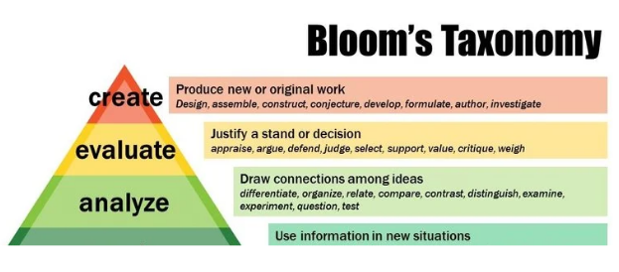
Figure 4: Bloom's Taxonomy pyramid. Source: Kapolo et al., 2017
Most of the assignments demand the students to stop memorising to analysing evidence, evaluating arguments and devising original responses (Shin, 2023). An example is a business report which might entail the assessment of organisational strategy and suggested refinements.
Critical thinking is also closely related to academic writing. According to Raj et al. (2022), critical thinking is the process of reasonable and thoughtful thinking that is aimed at making informed decisions. Students should be able to compare sources, detect bias, evaluate reliability, and synthesise findings into coherent arguments in writing. This process enhances the knowledge of the subject and makes the students ready to make evidence-based decisions.
Another important aspect is academic integrity. Citation of theories like Harvard or APA style is a way of ethical writing as it gives credit to the original authors. This is in line with deontological ethics, which stresses on duty and honesty (Ekene, 2025). Properly referenced work prevents plagiarism and play a responsible role in academic literature.
Academic writing is directly applied to the workplace in terms of communication. Proposals, strategic plans, market analyses, meeting minutes and policy documents are written by business professionals. Managers require succinct reports to make sound decisions whereas consultants should provide compelling reports backed by facts (Guffey et al., 2021). Badly written documents have the potential to cause a misunderstanding, monetary waste or a negative image. On the other hand, concise writing enhances effectiveness and credibility (Holley, 2023). Hence, clear-cut graduates are seen to have more ability and leadership preparedness. Thus, academic writing facilitates organisational performance as well as the progression of the career.

5. Strategies to Improve Skill 1: Teamwork Skills
Development of emotional intelligence is one of the effective methods of enhancing team work skills. Goleman (1998) made the argument that emotional intelligence encompasses self-awareness, self-regulation, empathy, motivation and social skills (Antonopoulou, 2024). Emotionally intelligent people in the team environment can effectively resolve conflicts, listen to others and establish healthy relationships. In this regard, reflection, feedback, and practice of active listening can help students to enhance emotional intelligence.
Role clarification and goal setting is another strategy. The Goal Setting Theory by Locke and Latham, indicates that specific and challenging goals enhance motivation and performance (HUANG, 2023). Early-set objectives, deadlines, and responsibilities tend to make teams successful. As an example, allocation of one member to research, another one to data analysis and the next one to editing, minimizes confusion and duplication. Therefore, role clarification and goal setting is prerequisite to gain success in respective working domains.
Training in communication is also crucial. The teams are to engage in assertive, yet respectful communication, frequent progress reports and problem-solving together. Coordination can be facilitated by digital collaboration tools like Microsoft Teams, Trello, and Zoom, particularly in remote settings (Mammadova and Abdullayeva, 2025). Training of such smart tactics will surely give fruitful results.

6. Strategies to Improve Skill 2: Academic Writing Skills
Extensive reading of academic literature is one of the key methods of developing skills in academic writing. Schema Theory assumes that the learners can perceive new information better when they have the ability to relate it with the existing information (Meylani, 2024).
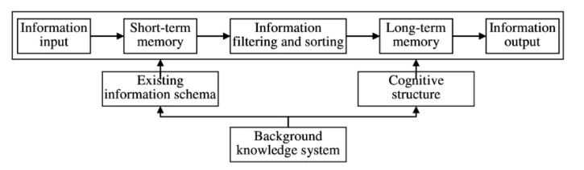
Figure 5: Cognitive process of schema theory. Source: Ma, 2016
Reading journal articles, textbooks, and academic reports, students cultivate knowledge of discipline-specific vocabulary, argument, and evidence-based writing conventions. An example is that, when a business student reads marketing journals, they will come across terminologies like consumer behaviour, segmentation, and brand equity and will find it easier to use such terminologies in the assignments. Alsaleh (2020) supported that reading good sources also enable the students to see how introductions are made, how arguments are presented and how conclusions are made
Structured before drafting is another vital strategy. Process Writing Theory considers writing not to be a one-step process but a series of steps involving planning, drafting, revising, and editing (Sowell, 2020). Students need to analyse the question, locate important command words in it, like, evaluate, compare, etc. and outline them before starting an assignment. As an illustration, when a student is requested to assess leadership styles, he/she can organize areas on transformational leadership, transactional leadership, pros, cons, and suggestions. This stage of planning is essential in order to be more organized and avoid irrelevant content.
Writing is also enhanced by critical thinking techniques. Scholarly writing is not just a description, but an analysis and a judgement. SWOT analysis, PESTLE analysis, and Gibbs Reflective Cycle are some of the models that could help students organize arguments in a logical manner. An example is a management student writing about a company who can use the SWOT to analyse the strengths, weaknesses, opportunities and threats and then give a recommendation. This critical thinking approach makes a report more analytic and clearer.
Lastly, it is important to practice proofreading and referencing. The student is expected to proofread grammar, punctuation, sentence clarity and citation accuracy (Nurhayati, 2022). This can be facilitated by tools like Grammarly, Zotero or Mendeley. To illustrate, reference software can automatically format Harvard citation, which can save time and minimise errors. Regular practice leads to confidence, fluency and competence in academic writing.

7. Conclusion
This report has discussed in a critical manner the teamwork skills and academic writing skills based on the relevant theories and concepts. Skills in teamwork entail cooperation, communication, emotional intelligence, trust and accountability. The Belbins Team Roles, Tuckman stages of a group development, Social Constructivism and Goal Setting theories illustrate why teamwork is a necessity in academic and work-related environments. High teamwork enhances improved learning, innovation, productivity, and employee satisfaction.
Academic writing skills entail systematic, evidence based and critical communication. Theories of Bloom taxonomy, academic literacy, critical thinking, and communication theory demonstrate why writing is the key to success in universities and career domains. Good writing helps one to analyse issues, make convincing cases, and communicate effectively.
The report also identified strategies for development. Emotional intelligence, role clarity, communication training and reflective learning can be used to enhance teamwork. Extensive reading, systematic planning, feedback, proofreading, and practice of referencing can enhance academic writing.

8. References
Adam, M., 2024. Perception and Interpretation of Team Development Phases and Their Changes: Factors Influencing Team Development. The Eurasia Proceedings of Educational and Social Sciences, 37, pp.16-24.
Aggrawal, S., Bosman, L. and Magana, A.J., 2024, June. Exploring teamwork experiences in collaborative undergraduate research (REU) programs through Tuckman's group development theory. In 2024 ASEE Annual Conference & Exposition.
Almusaed, A., Almssad, A. and Yitmen, I., 2025. Academic Writing Style and Rigor. In Practice of Research Methodology in Civil Engineering and Architecture: A Comprehensive Guide (pp. 781-813). Cham: Springer Nature Switzerland.
Alrawahi, S., Sellgren, S.F., Altouby, S., Alwahaibi, N. and Brommels, M., 2020. The application of Herzberg's two-factor theory of motivation to job satisfaction in clinical laboratories in Omani hospitals. Heliyon, 6(9).
Alsaleh, N.J., 2020. Teaching critical thinking skills: Literature review. Turkish Online Journal of Educational Technology-TOJET, 19(1), pp.21-39.
Antonopoulou, H., 2024. The value of emotional intelligence: Self-awareness, self-regulation, motivation, and empathy as key components. Technium Education and Humanities, 8, pp.78-92.
Aranzabal Maiztegi, A., Epelde Bejerano, E. and Artetxe Uria, M., 2021. Team formation on the basis of Belbin’s roles to enhance students’ performance in project based learning. Education for Chemical Engineers, 38.
Bećirović, S., Dubravac, V. and Brdarević-Čeljo, A., 2022. Cooperative learning as a pathway to strengthening motivation and improving achievement in an EFL classroom. Sage Open, 12(1), p.21582440221078016.
Becker, G.S., 2008. Human capital. The concise encyclopedia of economics, pp.248-50.
Chukwuere, J.E., 2024. Critical research thinking: a recipe for academic writing success and publications. In International Conference on Emerging Technology and Interdisciplinary Sciences (pp. 91-96).
Dias-Oliveira, E., Pasion, R., da Cunha, R.V. and Coelho, S.L., 2024. The development of critical thinking, team working, and communication skills in a business school–A project-based learning approach. Thinking Skills and Creativity, 54, p.101680.
Ekene, N.P., 2025. Ethical theories in doctoral students’ discussions of ethical dilemmas in research.
Guffey, M.E., Loewy, D. and Griffin, E., 2021. Business Communication Process and Product, Brief Edition. Cengage Canada.
Han, C., Zhang, L., Liu, J. and Zhang, P., 2023. Mediating role of teamwork in the influence of team role on team performance. Journal of Multidisciplinary Healthcare, pp.1057-1066.
Hanim, N., Aripin, N. and Lin, N.M., 2020. Exploring the connection between critical thinking skills and academic writing. International Journal of Asian Social Science, 10(2), pp.118-128.
Hasanah, H. and Malik, M.N., 2020. Blended learning in improving students’ critical thinking and communication skills at University. Cypriot Journal of Educational Sciences, 15(5), pp.1295-1306.
Holley, R.P., 2023. Effective written communication for successful management. Journal of Library Administration, 63(1), pp.111-118.
HUANG, J., 2023. The impact of goal setting theory on R&D employee performance at Y Medical in China. Procedia of Multidisciplinary Research, 1(10), pp.67-67.
Kapolo, Paulus & Shaimemanya, And & Shihomeka, Sadrag & Nghuumbwa, Malakia. (2017). Effectiveness Of Higher Order Thinking Scaffolding Tool As A Knowledge Transfer Instrument Among University Of Namibia Science Students. Journal for Studies in Humanities and Social Studies. 6.
Kumari, G. and Kumar, N., 2022. Constructivism in learning. Educational Quest: An International Journal of Education and Applied Social Sciences, 13(3), pp.207-213.
Ma, Z., 2016, November. College English Listening Teaching based on Schema Theory. In 2016 3rd International Conference on Management, Education Technology and Sports Science (METSS 2016) (pp. 566-571). Atlantis Press.
Mammadova, F. and Abdullayeva, N., 2025. The role of communication and collaboration in business management.
Meylani, R., 2024. Innovations with schema theory: Modern implications for learning, memory, and academic achievement. International Journal for Multidisciplinary Research, 6(1), pp.2582-2160.
Mobolade, G.O. and Akinade, M.E., 2021. Team building and teamwork in organizations: Implications to managers and employees in work places. International Journal of Management, Social Sciences, Peace and Conflict Studies, 11(4), p.1.
Nurhayati, D.A.W., 2022. The relevance of adopting proofreading tools to maintain academic writing integrity and coherence text. Indonesian Journal of EFL and Linguistics, 7(2), p.373.
Petelin, R., 2023. Professional Writing Guide: Writing well and knowing why. Routledge.
Raj, T., Chauhan, P., Mehrotra, R. and Sharma, M., 2022. Importance of critical thinking in the education. World Journal of English Language, 12(3), pp.126-133.
Shin, S., 2023. Enhancing the Critical Analysis Skills in Writing a Literature Review: An Application of Bloom's Taxonomy for Students in Higher Education. International Journal of TESOL Studies, 5(1).
Sony, M. and Naik, S., 2020. Industry 4.0 integration with socio-technical systems theory: A systematic review and proposed theoretical model. Technology in society, 61, p.101248.
Sowell, J., 2020. The writing process and formative assessment. Crossings: A Journal of English Studies, 11(2), pp.272-286.
Syah, I., Sukmana, O. and Yumitro, G., 2026. Analysis of Vygotsky's Social Constructivism Theory in Collaborative Learning Based on Digital Technology. International Journal of Economics Management and Social Science, 9(1), pp.365-376.
Tran, Thanh-Tuyen. (2019). An investigation about the satisfaction and loyalty of workers in Taiwanese enterprises located in Vietnam. International Journal of ADVANCED AND APPLIED SCIENCES. 6. 1-11. 10.21833/ijaas.2019.03.001.
Ybyrayeva, K., Shyrynbekova, M. and Toltebayeva, F., 2023. Developing students' academic writing skills through the use of Bloom's taxonomy strategies (analysis, synthesis, evaluation). Scientific Collection «InterConf+», (39), pp.155-160.

