Computing (Business Information Systems) Level 4
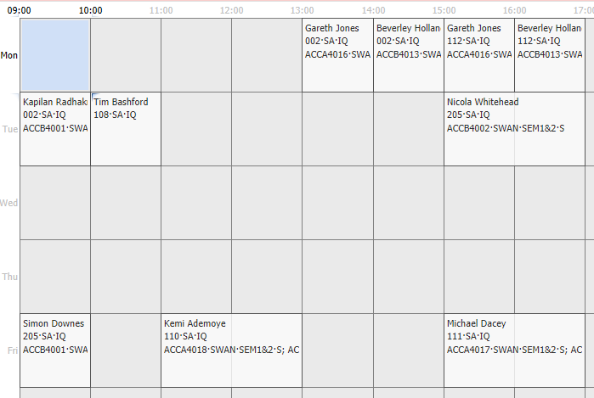

Computing (Data & Information Systems) level 4
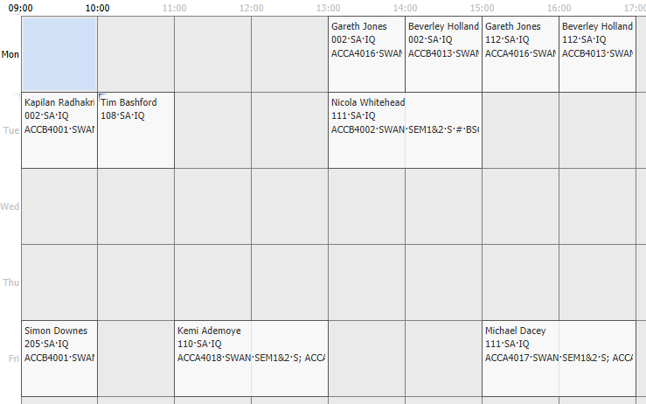
Computing (Computer Networks & Cyber Security) Level 4
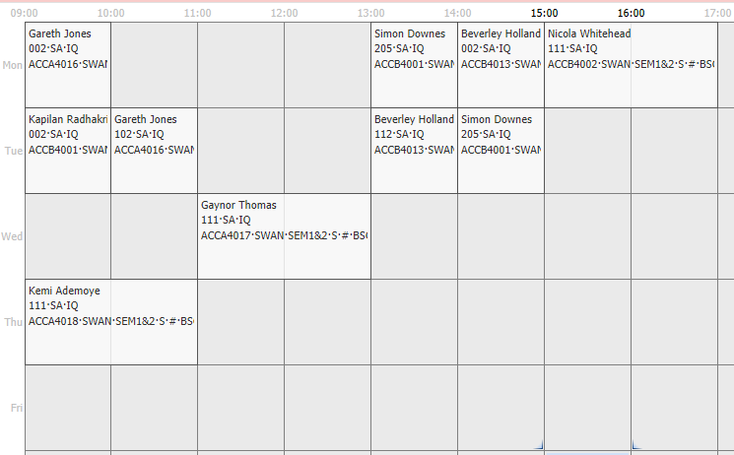

Computing (Web Development) Level 4
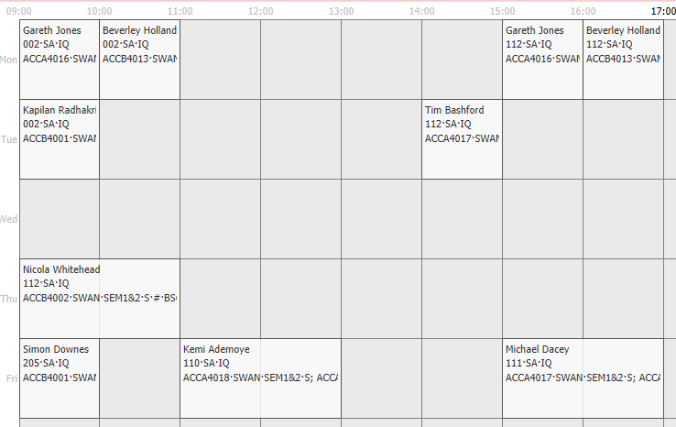
Computing (Games Development) Level 4
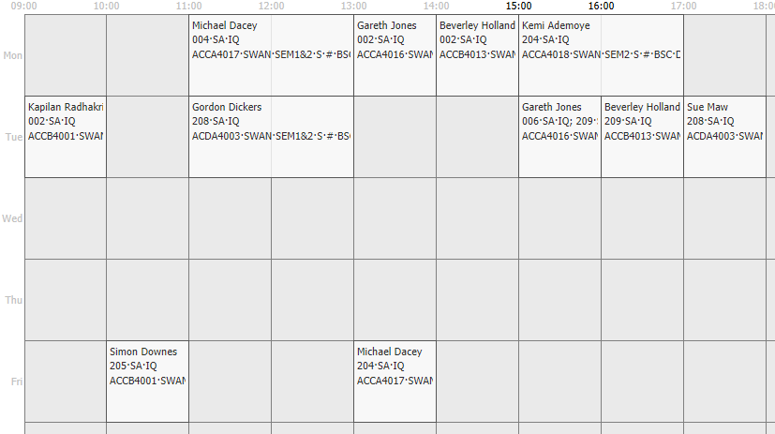

Software Eng Level 4
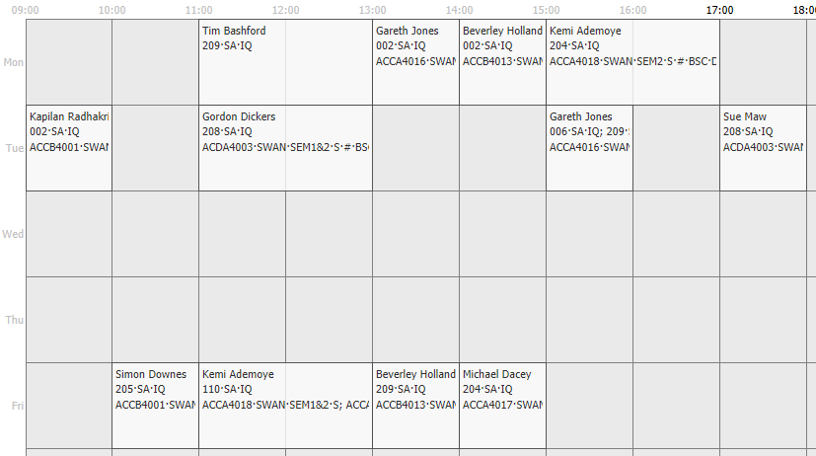

Electronics Level 4


