

Project portfolio
Smart Transport Management System (STMS)
 | MODULE | Project Management – LCLM5003
 | PROGRAMME | Leadership and Management Skills in the Workplace
 | LECTURER | Dr Rexon Nting
 | STUDENT NAME | Huguette Dora Edjangue
 | STUDENT ID NUMBER | 2429780

Part A- Project proposal poster

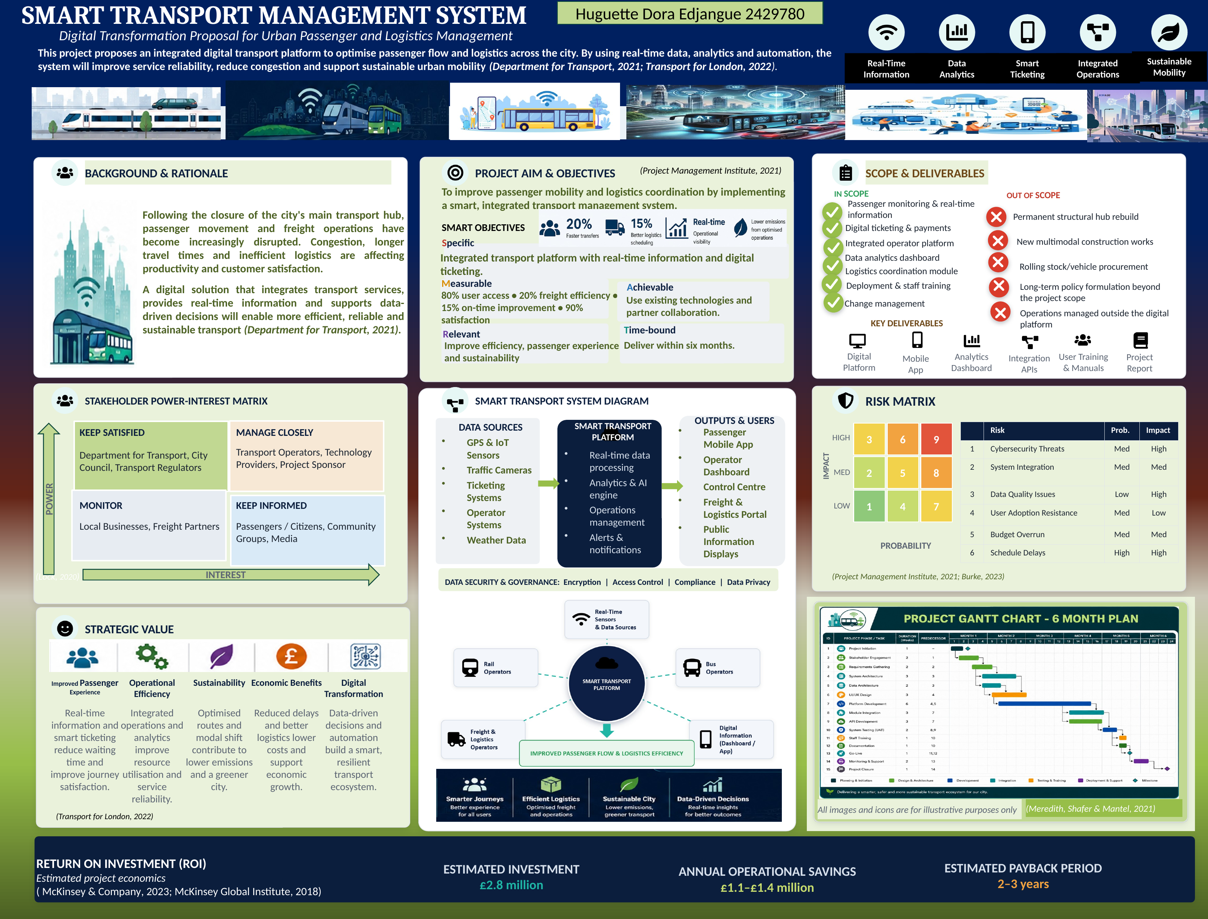

Part B – Reflect critically on the feedback received from tutor and peers

The feedback I received from my lecturer was largely positive and confirmed that my project proposal demonstrated a high standard of presentation, organisation and relevant project management content. The poster was considered well-structured, visually appealing, and informative. However, the feedback also highlighted areas that required further development, particularly the project schedule, SMART objectives, and consistency in formatting and terminology. I used these comments to evaluate my work more critically and consider how my approach could be strengthened. Ghaye (2000) explains that reflective practice involves learning from experience to improve future actions, while Hargreaves and Page (2013) emphasise reflection as an ongoing process of evaluating and adapting practice.
One aspect that particularly encouraged me was the positive feedback on the poster's overall design. Considerable effort had been invested in organising the information and positioning the visual elements. The balance between written content, diagrams and graphics helped communicate the proposal clearly. The poster brought together the project aim and objectives, scope, stakeholder analysis, risk assessment, system architecture and strategic value. This feedback confirmed that visual communication can make complex project information easier to understand. It also increased my confidence in using diagrams and structured layouts when communicating ideas to different audiences.
The most significant area for development was the recommendation to replace the high-level timeline with a detailed Gantt chart. My original timeline presented the main phases of the six-month project, but I recognised from the feedback that it did not adequately show task duration, sequencing or dependencies. This made me reconsider what an effective project schedule should communicate. I subsequently developed a Gantt chart covering initiation, stakeholder engagement, requirements gathering, design, development, integration, testing, training, go-live, monitoring and closure. This provided a clearer representation of how activities would progress and strengthened the planning and monitoring aspects of the project.
I was also advised to make the SMART objectives more accurate. Initially, I concentrated mainly on including measurable targets. However, the feedback helped me recognise that an effective objective must also be realistic, achievable, and within the project's scope of influence. I therefore reviewed the targets against the six-month timeframe and considered the distinction between project outputs and longer-term outcomes. This helped me develop a more realistic understanding of how project objectives should be formulated and assessed.
Another area highlighted was the need for careful proofreading. I reviewed the poster's headings, terminology, spacing, punctuation and references to improve consistency. This process made me realise that attention to detail is not simply a presentation issue; it contributes to the credibility and professionalism of project documentation. Biton (2025) suggests that assessment can help students identify improvements that may not have been recognised independently.
Overall, the feedback had a meaningful impact on both my project and my approach to learning. Developing the Gantt chart, refining the objectives, and carefully checking the presentation enabled me to produce a more coherent and professional plan. More importantly, I learned to view feedback as a source of development rather than simply an assessment of weaknesses. Applying reflective practice has encouraged me to question my initial decisions, consider alternative approaches and seek feedback earlier in future projects. This experience has strengthened my project management skills and reinforced the value of reflection for academic and professional development (Ghaye, 2000).

Part C: Project Management Plan

Contents
1. Introduction 8
2. Project Description 8
3. Scope 9
4. Work Breakdown Structure (WBS) 9
5. Quad Chart 10
6. Gantt Chart 11
7. Stakeholders Analysis 12
8. Allocation of Resources 13
9. Risk Analysis ……15
10. Conclusion 17
References 18

List of Figures
Figure 1: Work breakdown structure for the Smart Transport Management System project (Levels 1-3) 10
Figure 2: Project quad chart summarising objective, schedule, cost and risk 11
Figure 3: Project Gantt chart for the six-month delivery programme 12
Figure 4: Stakeholder power-interest matrix (adapted from Mendelow, 1981) 13
Figure 5: Probability-impact risk matrix for the six registered project risks 16

List of Tables
Table 1: Resource allocation by work package 14
Table 2: Project risk registers 15

- Introduction

Effective project management provides organisations with a structured approach to delivering change by balancing project objectives with constraints relating to time, cost and quality (Project Management Institute, 2021). This report presents a project management plan for the proposed Smart Transport Management System (STMS), a digital transformation initiative designed to improve passenger mobility and freight coordination following the closure of the city's principal transport interchange. The project aims to deliver an integrated platform that combines real-time passenger information, digital ticketing, operator coordination and logistics management within a six-month timeframe and an estimated budget of £2.8 million.

The report applies established project management principles and techniques to demonstrate how the project can be planned, managed and controlled effectively. It includes a defined project scope, a Work Breakdown Structure (WBS), Quad Chart, Gantt Chart, stakeholder analysis, resource allocation plan and an ISO 31000-based risk assessment. Together, these tools provide a structured framework for supporting informed decision-making, effective stakeholder engagement and successful project delivery while maintaining control over project scope, schedule, cost and quality.

2. Project Description
The Smart Transport Management System (STMS) project addresses a well-defined operational problem. Since the closure of the city's principal transport interchange, passenger movement and freight operations have become increasingly disrupted, producing longer travel times, unpredictable freight transfers and declining customer satisfaction (Department for Transport, 2021). Congestion and inefficient logistics coordination are affecting both productivity and the wider local economy, and the absence of a shared digital platform means that transport operators currently plan and communicate largely in isolation from one another.

This project proposes the design, development and deployment of an integrated digital platform that brings together real-time passenger information, digital ticketing, an operator dashboard, and a freight and logistics portal within a single system (Transport for London, 2022). The platform aims to enhance passenger mobility and logistics coordination by enabling real-time information sharing across all participating transport operators. Its objectives follow Doran's (1981) SMART framework. Specifically, the platform will deliver real-time passenger information, digital ticketing and logistics coordination; achieve at least 80 per cent user access to live travel information, a 20 per cent improvement in freight transfer efficiency, a 15 per cent increase in on-time service delivery, and 90 per cent user satisfaction; utilise existing digital technologies, cloud infrastructure and collaborative partnerships; support the city's wider digital transformation and sustainability strategy; and be fully implemented within six months. Evidence from the McKinsey Global Institute (2018) and McKinsey & Company (2023) suggests that comparable smart mobility initiatives can improve quality-of-life indicators by between 10 and 30 per cent, providing strong external support for the project's business case.

3. Scope
As Kerzner (2017) argues, a clearly bounded scope statement is the principal safeguard against uncontrolled change during project execution. The in-scope elements include passenger monitoring and real-time information services, digital ticketing and payments, an integrated operator platform, a data analytics dashboard, a logistics coordination module, and deployment together with staff training and change management support. These elements map directly onto the project's key deliverables: a digital platform, a mobile application, an analytics dashboard, integration application programming interfaces (APIs), user training and manuals, and a project closure report.
Several activities are intentionally excluded from the project scope, including rebuilding the closed transport hub, constructing new multimodal infrastructure, procuring rolling stock and vehicles, developing long-term transport policies, and managing operations outside the digital platform. Excluding these activities keeps the project focused on digital transformation, enabling delivery within the six-month schedule and £2.8 million budget while reducing the risk of scope creep into a much larger infrastructure programme (Lock, 2020). Any proposed changes to the agreed scope will be reviewed through the project's formal change-control process at each project board meeting to ensure that schedule and budget remain under control.
4. Work Breakdown Structure (WBS)
The work breakdown structure (WBS) decomposes the STMS project into progressively smaller, manageable components. This follows Globerson's (1994) observation that the design of a WBS shapes how a project is subsequently organised and managed, often in ways the designer does not fully anticipate. Figure 1 presents the WBS to three levels: Level 0 represents the entire project; Level 1 divides the project into five phases aligned with the six-month delivery timeline: project initiation; system and data design; platform development; testing and training; and deployment and closure; Level 2 then breaks each phase down into discrete work packages, such as stakeholder engagement and requirements gathering under initiation, or module integration and API development under platform development.
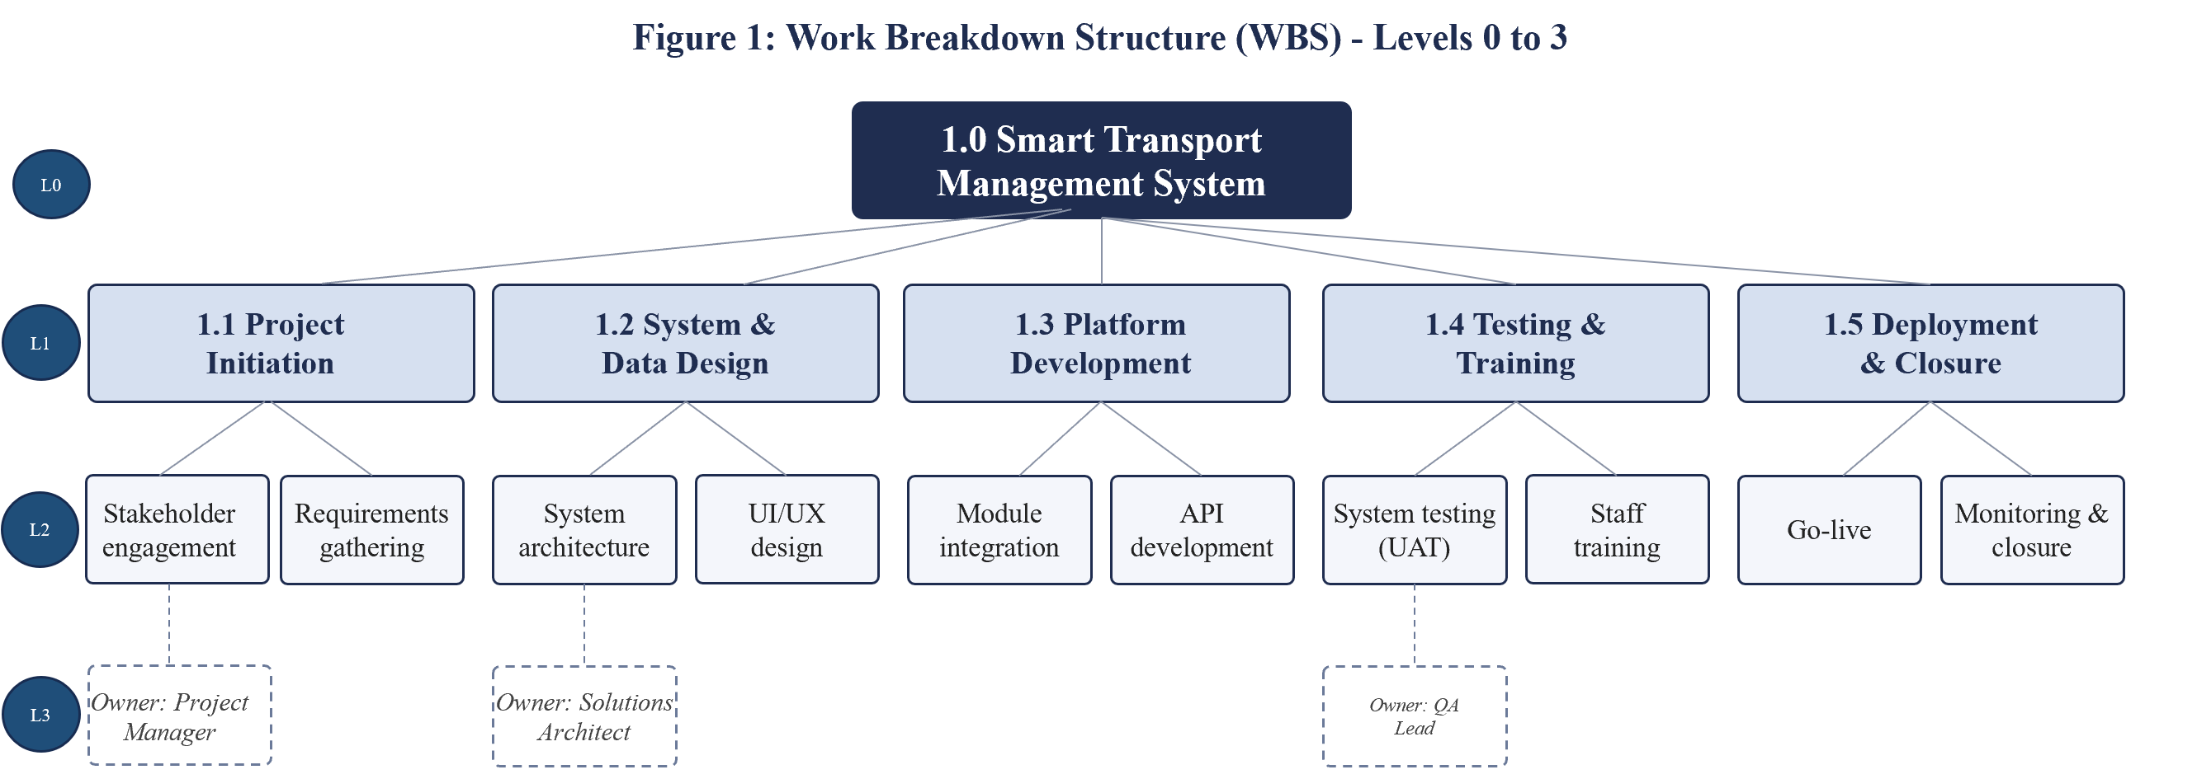
Illustrative Level 3 Owners Only
Kerzner (2017) and Lavold, as cited in Globerson (1994), recommend that a WBS for a project of this scale extend to between four and six levels, with individual work packages sized so that responsibility can rest with a single accountable owner. Level 3 work packages, not shown in full in Figure 1 for clarity, follow this principle: the project manager owns stakeholder engagement, the solutions architect owns system and data architecture, and the quality assurance lead owns user acceptance testing. Each work package carries a defined deliverable, duration and resource assignment, which underpins both the Gantt chart schedule in Section 6 and the resource allocation table in Section 8.
Structuring the WBS around project phases, rather than organisational departments, supports closer collaboration between the technology delivery team and participating transport operators, a priority given the project's dependence on external operator systems for data integration. Additionally, it simplifies reporting to the project board, since each Level 1 branch corresponds directly to a milestone within the overall programme.
5. Quad Chart
Figure 2 presents a quad chart, offering senior stakeholders a single-page overview of the project rather than the full plan. Widely used in government, defence and technology programme management, the format condenses a project into four quadrants covering objective, schedule, cost and risk (Kerzner, 2017). Applied to STMS, the objective quadrant restates the project's core purpose; the schedule quadrant summarises the six-month milestone sequence; the cost quadrant sets out the estimated £2.8 million investment and headline resource requirement; and the risk quadrant highlights the highest-priority risks alongside their principal mitigation.
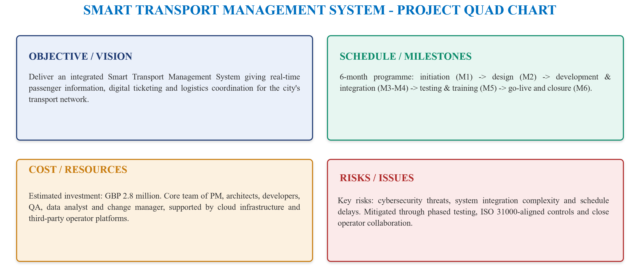
Figure 2: Project quad chart summarising objective, schedule, cost and risk
The quad chart is reviewed at each monthly project board meeting to ensure it remains aligned with the project's schedule, budget and risk register. By presenting these four areas together, it enables stakeholders to identify potential trade-offs more easily. For example, if the schedule slips, the project board can quickly assess whether the delay is likely to affect costs or increase project risks before deciding on corrective action.
6. Gantt Chart
To schedule the STMS project, this plan uses a Gantt chart; a technique first popularised by Henry Gantt in the early twentieth century that remains one of the most widely used project-scheduling tools, valued for communicating timing, duration and overlap in a format that is intuitive and easy to update (Wilson, 2003). Figure 3 sets out the project Gantt chart across the six-month delivery window, from project initiation through to project closure, with activities grouped into the five WBS phases introduced in Section 4.
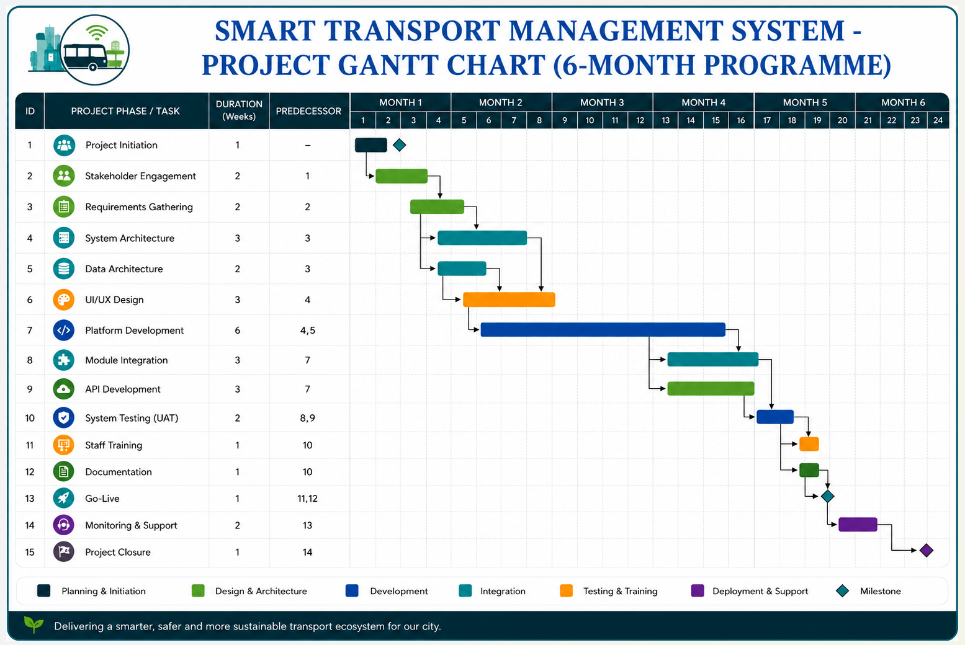
Figure 3: Project Gantt chart for the six-month delivery programme
Project initiation and stakeholder engagement occur in the first month and overlap with requirements gathering, allowing stakeholder feedback to inform the project's early stages. Month two focuses on system and data architecture, together with User Interface/User Experience (UI/UX) design, followed by platform development, module integration, and API development starting in month three. Testing, user acceptance, staff training and documentation are completed during months five and six to ensure any issues are resolved before deployment. The project concludes with system deployment, monitoring and closure by the end of month six, meeting the time-bound SMART objective outlined in Section 2.
Although network-based techniques such as the Critical Path Method provide more detailed dependency and float analysis (Kerzner, 2017), the Gantt chart remains the primary scheduling tool because it presents the project timeline clearly for both technical and non-technical stakeholders. The project team uses a supporting network diagram for detailed planning, while the Gantt chart is shared with stakeholders for progress reporting and communication.
7. Stakeholder Analysis
Stakeholder analysis is planned by using the power-interest matrix originally proposed by Mendelow (1981), which classifies stakeholders according to their relative power to influence the project and their level of interest in its outcomes (Freeman, 1984). Figure 4 maps the principal stakeholder groups for the STMS project onto this matrix.
Smart Transport Management System - Stakeholder Power-Interest Matrix
 | LOW INTEREST | HIGH INTEREST
HIGH POWER | KEEP SATISFIED  Department for Transport, City Council, Transport Regulators | MANAGE CLOSELY  Transport Operators, Technology Providers, Project Sponsor
LOW POWER | MONITOR  Local Businesses, Freight Partners | KEEP INFORMED  Passengers / Citizens, Community Groups, Media  Figure4: Stakeholder power-interest matrix

Stakeholders are managed according to their level of power and interest. Transport operators, technology providers and the project sponsor are managed closely through weekly meetings and by involving them in key design decisions, as their cooperation is essential for integrating ticketing, GPS and scheduling systems. The Department for Transport, City Council and transport regulators are kept satisfied through monthly progress reports and milestone approvals, reflecting their regulatory and funding responsibilities (Department for Transport, 2021). Passengers, community groups and the media are kept informed through regular communications and the phased rollout of passenger services, while local businesses and freight partners are monitored through periodic updates.
This approach reflects Freeman's (1984) view that stakeholder engagement should be tailored to each group's level of influence and interest rather than applying the same communication strategy to everyone. Stakeholder positions are reviewed at each project board meeting to identify any changes in power or interest and adjust engagement strategies where necessary.
8. Allocation of Resources
Resource allocation is based on the work packages defined in the WBS and summarised in Table 1. The project team includes a project manager, solutions architect, data architect, front-end and back-end developers, quality assurance lead, data analyst and change manager, supported during deployment by operator liaison staff. Cloud infrastructure provides the computing, storage and analytics resources required by the platform, supporting the SMART objective of using existing digital technologies outlined in Section 2.
According to Kerzner (2017), resources should be allocated to balance workloads and avoid overloading specialist staff. In this project, the architecture team leads the design phase before moving into an oversight role during development, while additional developers support module integration and API development. Resource requirements are reviewed at each monthly project board meeting to ensure staffing remains aligned with project progress.
The estimated £2.8 million budget covers staffing, cloud infrastructure, third-party software licences and contingency. Based on estimates from McKinsey & Company (2023), the platform is expected to generate annual operational savings of £1.1–£1.4 million, resulting in a payback period of approximately two to three years. This financial profile supports the decision to prioritise cloud-based infrastructure and internal resources over costly new physical assets.
Smart Transport Management System - Resource allocation by work package
Work package | Primary resource(s) | Resource type
Project initiation & stakeholder engagement | Project manager, business analyst | Internal staff
System & data architecture | Solutions architect, data architect | Internal staff
UI/UX design | UX designer, front-end developer | Internal staff
Platform development & module integration | Back-end developers, integration engineers | Internal staff/cloud platform
API development | Integration engineers, operator liaison leads | Internal staff/operator systems
System testing (UAT) | QA lead, QA testers, pilot users | Internal staff/end users
Staff training & documentation | Change manager, training coordinator | Internal staff
Deployment, monitoring & closure | Project manager, operations lead, cloud infrastructure | Internal staff/cloud platform
Table 1: Resource allocation by work package

9. Risk Analysis
Risk analysis follows the ISO 31000:2018 framework, which recommends identifying, assessing, treating and monitoring risks throughout the project lifecycle (International Organisation for Standardisation, 2018). Table 2 summarises the six key risks identified for the STMS project, while Figure 5 presents them on a probability-impact matrix to support risk prioritisation and decision-making (Burke, 2023).
Smart Transport Management System - Project Risk Registry
No. | Risk | Probability | Impact | Mitigation
R1 | Cybersecurity threats | Medium | High | Encryption, access control and independent security review before go-live
R2 | System integration complexity | Medium | Medium | Early, continuous engagement with operator technology providers
R3 | Data quality issues | Low | High | Validation routines built into the data architecture work package
R4 | User adoption resistance | Medium | Low | Change management, phased rollout and user communication
R5 | Budget overrun | Medium | Medium | Monthly budget review at project board, contingency allowance
R6 | Schedule delays | High | High | Phased, overlapping Gantt structure with testing-phase contingency
Table 2: Project risk register
Schedule delays and cybersecurity threats occupy the highest-priority zone of the matrix and receive the most active mitigation. Schedule risk is addressed through the phased, overlapping Gantt structure described in Section 6, which builds contingency into the testing phase before go-live. Cybersecurity risk is addressed through encryption, access control, and compliance measures embedded in the platform's data security and governance layer, which are reviewed independently ahead of deployment. System integration risk, arising from the need to connect multiple third-party operator systems, is mitigated through early and continuous stakeholder engagement with technology providers, consistent with the manage-closely strategy identified in Section 7. Data quality issues, although assessed as low probability, carry high potential impact on the reliability of real-time passenger information and are mitigated through validation routines built into the data architecture work package.
Lower-priority risks, including user adoption resistance and budget overrun, are monitored through routine project board reporting rather than dedicated mitigation plans, reflecting the proportionate, risk-based approach to control recommended by Kerzner (2017). The risk register is reviewed and, where necessary, updated at every project board meeting, so that any risk moving toward the high-probability, high-impact zone of the matrix is identified and escalated before it materially affects the schedule or budget set out earlier in this plan.
Smart Transport Management System - Project Risk Matrix

 |  | Low | Medium | High
Impact | High | 3  R3 | 6 | 9  R6
Impact | Medium | 2 | 5  R2 | 8  R1
Impact | Low | 1 | 4  R4 | 7
Probability
Figure 5: Probability-impact risk matrix (R1 Cybersecurity threats, R2 System integration, R3 Data quality, R4 User adoption, R5 Budget overrun, R6 Schedule delays)

10. Conclusion
This project management plan demonstrates how established project management principles and techniques can be applied to deliver the Smart Transport Management System within the planned six-month schedule and £2.8 million budget. The Work Breakdown Structure, Quad Chart, Gantt Chart, stakeholder analysis, resource allocation and ISO 31000 risk management framework together provide a structured approach to planning, monitoring and controlling project activities. Collectively, these tools support the effective management of the project constraints of time, cost and quality, commonly known as the Iron Triangle (Atkinson, 1999), helping to ensure that the project's objectives are achieved without compromising performance.
However, successful delivery depends not only on effective planning but also on strong leadership, clear communication and collaborative teamwork. Belbin (2010) argues that balanced team roles improve coordination, decision-making and overall project performance, while the stakeholder engagement strategy ensures that communication remains appropriate to each stakeholder group's level of influence and interest (Freeman, 1984). Regular project board meetings, together with ongoing monitoring of project scope, resources and risks, enable informed decision-making and timely corrective action throughout the project lifecycle. By combining recognised project management techniques with effective leadership and stakeholder communication, this plan provides a credible framework for delivering the Smart Transport Management System successfully to scope, within budget, on schedule and to the required quality standards.

References:
Atkinson, R. (1999) ‘Project management: Cost, time and quality, two best guesses and a phenomenon, it's time to accept other success criteria’, International Journal of Project Management, 17(6), pp. 337–342.
Belbin, R.M. (2010) Management Teams: Why They Succeed or Fail. 3rd edn. Oxford: Butterworth-Heinemann.
Biton, Y. (2025) ‘Student reflections on peer assessments: Benefits and challenges in a mathematics class’, Education Process: International Journal, 14(1), e2025003. Available at: https://doi.org/10.22521/edupij.2025.14.3 (Accessed: 20 July 2026).
Burke, R. (2023) Project Management: Planning and Control Techniques. 7th edn. Chichester: Wiley.
Department for Transport (2021) Decarbonising Transport: A Better, Greener Britain. London: Department for Transport.
Doran, G.T. (1981) ‘There's a S.M.A.R.T. way to write management's goals and objectives’, Management Review, 70(11), pp. 35–36.
Freeman, R.E. (1984) Strategic Management: A Stakeholder Approach. Boston: Pitman.
Ghaye, T. (2000) Reflective Practice. Abingdon: Carfax International Publishers.
Globerson, S. (1994) ‘Impact of various work-breakdown structures on project conceptualisation’, International Journal of Project Management, 12(3), pp. 165–171.
Hargreaves, J. and Page, L. (2013) Reflective Practice. 1st edn. Cambridge: Polity Press.
International Organization for Standardization (2018) ISO 31000:2018 Risk Management – Guidelines. Geneva: ISO.
Kerzner, H. (2017) Project Management: A Systems Approach to Planning, Scheduling, and Controlling. 12th edn. Hoboken, NJ: John Wiley & Sons.
Lock, D. (2020) Project Management. 11th edn. London: Routledge.
McKinsey & Company (2023) Infrastructure Technologies: Challenges and Solutions for Smart Mobility in Urban Areas. Available at:
https://www.mckinsey.com/industries/infrastructure/our-insights/infrastructure-technologies-challenges-and-solutions-for-smart-mobility-in-urban-areas (Accessed: 14 July 2026).
McKinsey Global Institute (2018) Smart Cities: Digital Solutions for a More Livable Future. Available at:
https://www.mckinsey.com/capabilities/operations/our-insights/smart-cities-digital-solutions-for-a-more-livable-future (Accessed: 14 July 2026).
Mendelow, A.L. (1981) ‘Environmental scanning: The impact of the stakeholder concept’, in Proceedings of the Second International Conference on Information Systems. Cambridge, MA, pp. 407–418.
Meredith, J.R., Shafer, S.M. and Mantel, S.J. (2021) Project management: a managerial approach. 10th edn. Hoboken: Wiley.
Project Management Institute (2021) A Guide to the Project Management Body of Knowledge (PMBOK® Guide). 7th edn. Newtown Square, PA: Project Management Institute.
Transport for London (2022) Business Plan 2022/23–2025/26. London: Transport for London.
Wilson, J.M. (2003) ‘Gantt charts: A centenary appreciation’, European Journal of Operational Research, 149(2), pp. 430–437.

