

ACCC4004 INFORMATION ENGINEERING

DUMITRU RADU CHIRCA
1818843

Table of Contents
Introduction 3
Task 1 4
Entities 4
Relationship 4
Entities, Attributes, and Data Types 6
Task 2 9
1. Tables 9
2. Forms 16
3. View Queries 20
4. Reports 23
5. Report from Queries 26
6. Relationships 28
7. User Guide 29
Conclusion 30
References 31

Introduction
In this assignment, we need to design a database using software designing tools like StarUML and Microsoft Visio. We need to design a database using the case study given in the assignment. Universal Sports which is a national fitness and sports company having 6 branches and more than 60 staff members. This company provides sports and fitness services to people. But company using a manual paper-based system for managing the staff details. Due to this company facing problems in the management of staff details. This existing system has a very low accuracy rate and other many difficulties. Now the company has decided that they want a new database system which can make management work easier. We need to design a database system for Universal Sports as per their requirement. After completion of the design, we need to create a database system that includes the creation of a table, data insertion into tables, creation of forms, creation of reports, and run queries to test the database system.

Task 1

Entities
1. Staff_Personal_Data
2. Bank_Details
3. Absence_Record
4. Emergency_Contact
5. Staff_Company_Data
6. Branch_Details
7. Training_Courses

Relationship
1. Staff_Personal_Data and Bank_Details have one to one relationship with each other.
2. Emergency_Contact and Staff_Personal_Data have one to many relationships with each other.
3. Staff_Personal_Data and Absence_Record have one to one relationship with each other.
4. Staff_Personal_Data and Staff_Company_Data have one to one relationship with each other.
5. Branch_Details and Staff_Company_Data have one to many relationships with each other.
6. Training_Courses and Staff_Company_Data have one to many relationships with each other.

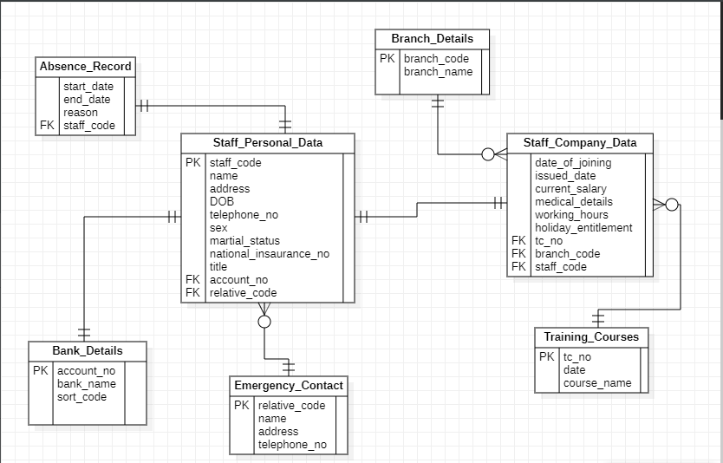

Note: As per the requirement of the assignment, the above attached ERD is designed using StarUML software.

Entities, Attributes, and Data Types
1. Staff_Personal_Datas
Attribute Name | Data Type | Size | Keys
staff_code | Short Text | 3 | Primary Key
staff_name | Short Text | 30
Address | Short Text | 50
DOB | Date/Time | Default
telephone_no | Short Text | 10
Sex | Short Text | 255
martial_status | Short Text | 255
national_insaurance_no | Short Text | 10
Title | Short Text | 50
account_no | Short Text | 10 | Foreign Key
relative_code | Short Text | 3 | Foreign Key

2. Bank_Details
Attribute Name | Data Type | Size | Keys
account_no | Short Text | 10 | Primary Key
bank_name | Short Text | 30
sort_code | Short Text | 10

3. Absence_Record
Attribute Name | Data Type | Size | Keys
start_date | Date/Time | Default
end_date | Date/Time | Default
Reason | Short Text | 50
staff_code | Short Text | 3 | Foreign Key

4. Emergency_Contact
Attribute Name | Data Type | Size | Keys
relative_code | Short Text | 3 | Primary Key
name | Short Text | 30
address | Short Text | 50
telephone_no | Short Text | 10

5. Staff_Company_Data
Attribute Name | Data Type | Size | Keys
date_of_joining | Date/Time | Default
issued_date | Date/Time | Default
current_salary | Short Text | 25
medical_details | Short Text | 25
working_hours | Short Text | 25
holiday_entitlement | Short Text | 250
tc_no | Short Text | 3 | Foreign Key
branch_code | Short Text | 3 | Foreign Key
staff_code | Short Text | 3 | Foreign Key

6. Branch_Details
Attribute Name | Data Type | Size | Keys
branch_code | Short Text | 3 | Primary Key
branch_name | Short Text | 30

7. Training_Courses
Attribute Name | Data Type | Size | Keys
tc_no | Short Text | 3 | Primary Key
completion_date | Date/Time | Default
course_name | Short Text | 30

Task 2

1. Tables
- Staff_Personal_Data
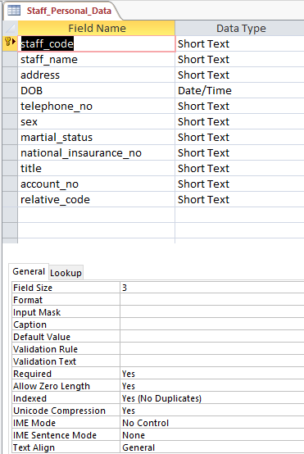

- Bank_Details
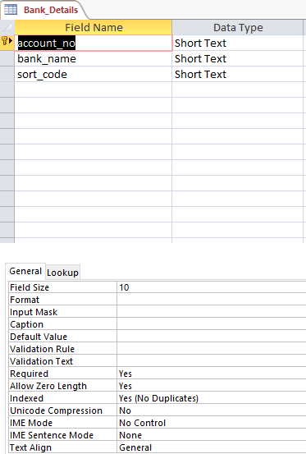

- Absence_Record
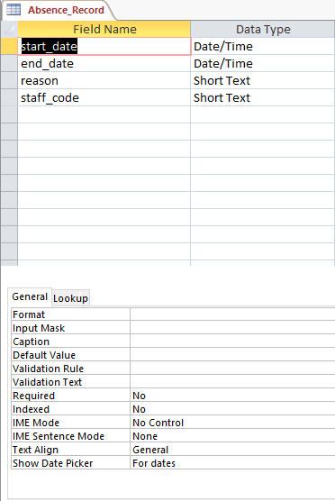
- Emergency_Contact
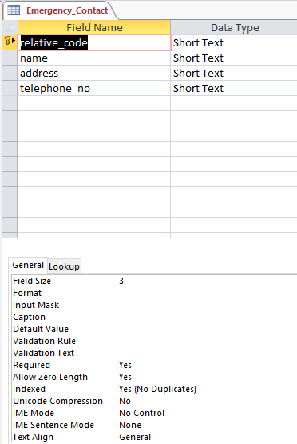
- Staff_Company_Data
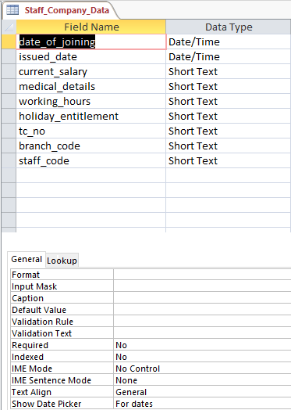
- Branch_Details
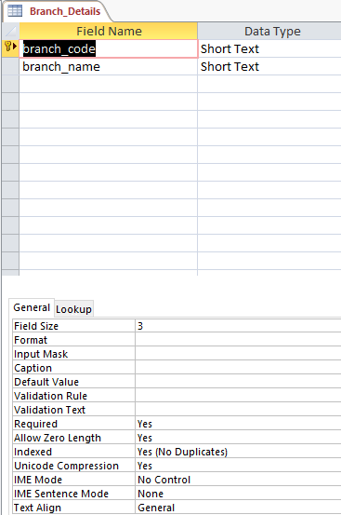

- Training_Courses
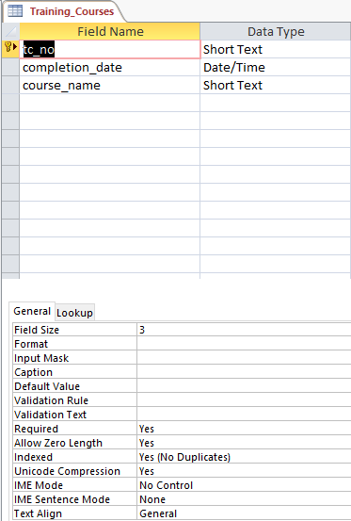

2. Forms
- Bank_Details
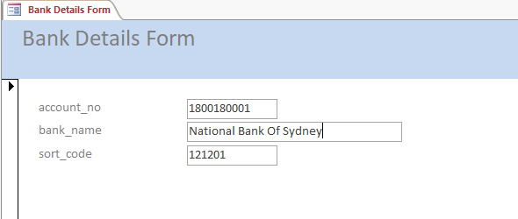

- Emergency_Contact
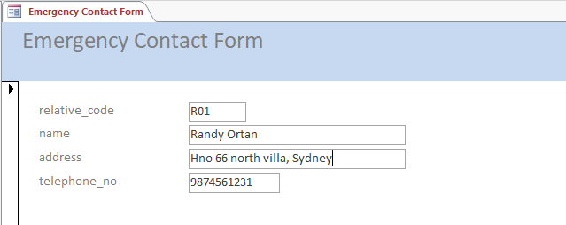

- Staff_Personal_Data
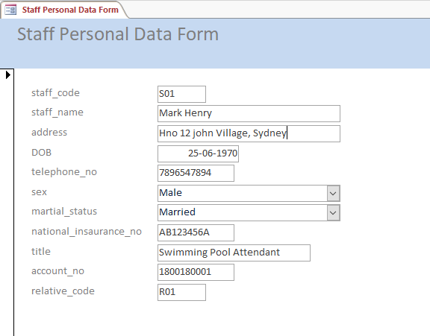
- Absence_Record
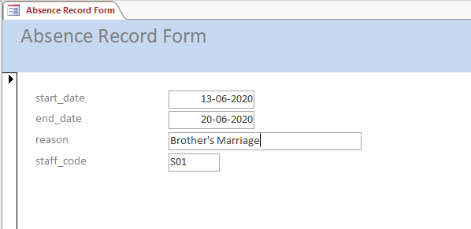

- Branch_Details
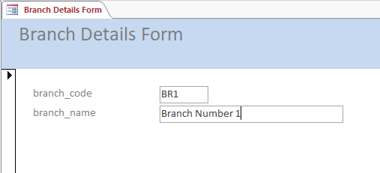
- Training_Courses
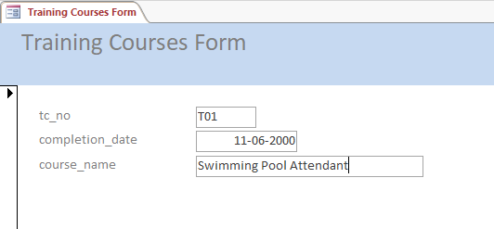

- Staff_Company_Data
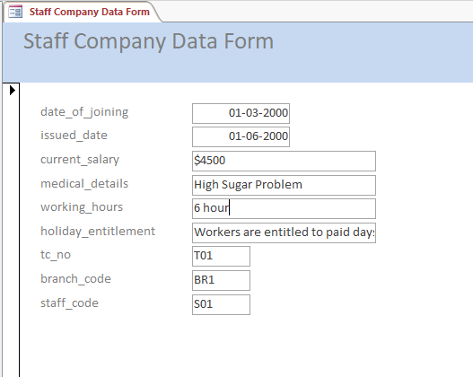

3. View Queries
- Staff_Personal_Data
Query: Select * from Staff_Personal_Data

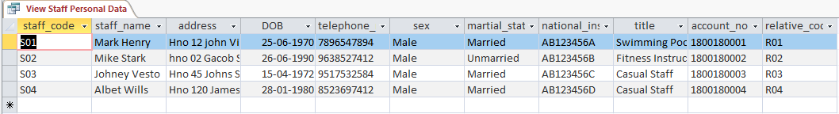

- Bank_Details
Query: Select * from Bank_Details
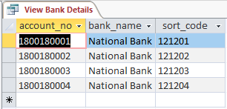

- Absence_Record
Query: Select * from Absence_Record
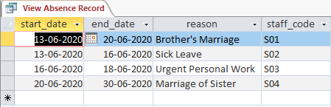

- Emergency_Contact
Query: Select * from Emergency_Contact
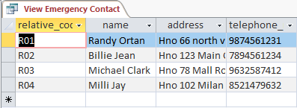

- Staff_Company_Data
Query: Select * from Staff_Company_Data
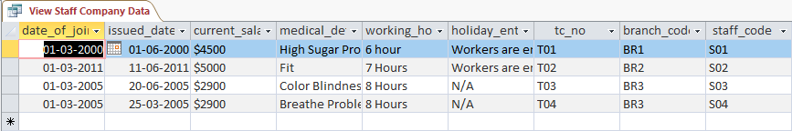

- Branch_Details
Query: Select * from Branch_Details
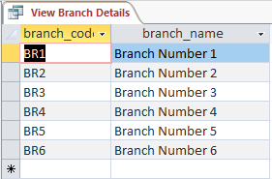

- Training_Courses
Query: Select * from Training_Courses
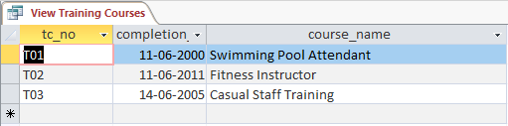

4. Reports
1. Staff_Personal_Data
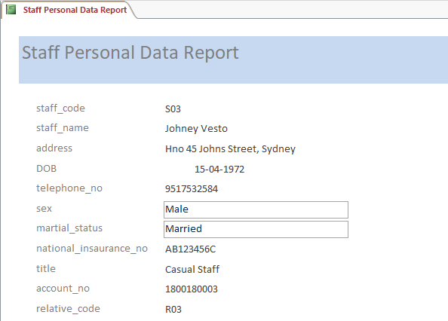

2. Bank_Details
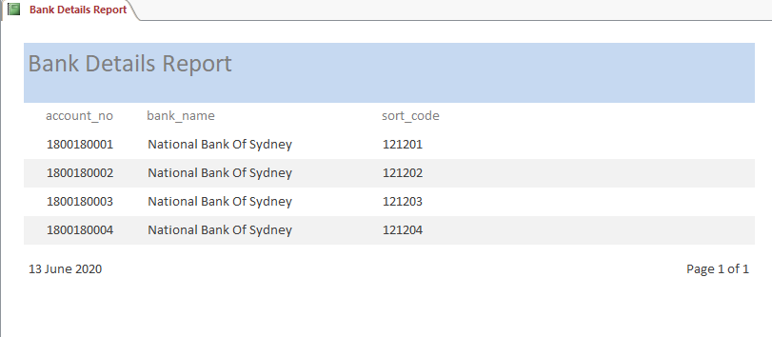
3. Absence_Record
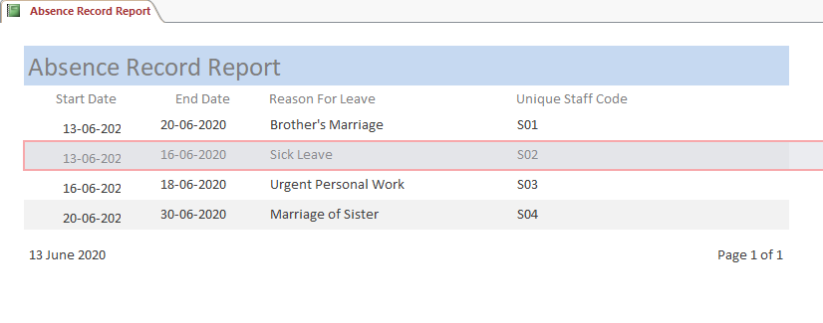
4. Emergency_Contact
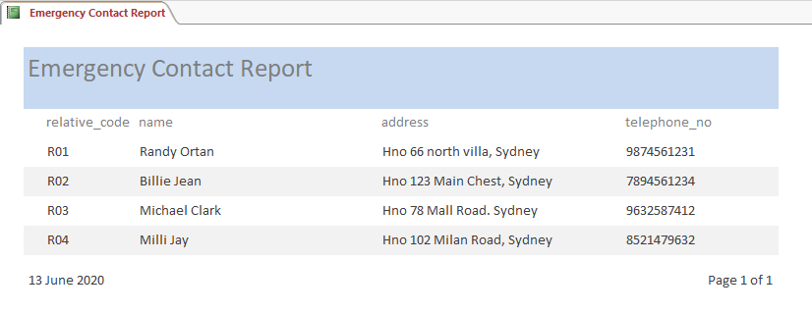
5. Staff_Company_Data
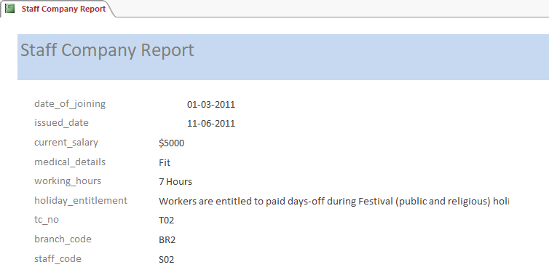

6. Branch_Details
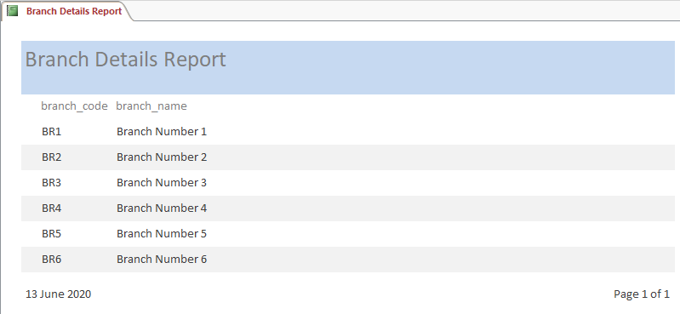

7. Training_Courses
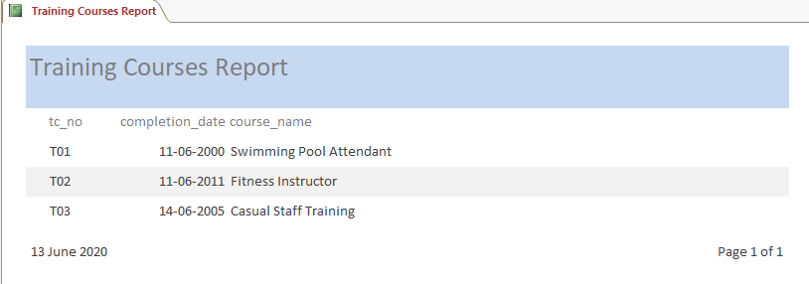

5. Report from Queries
1. SELECT Staff_Personal_Data.staff_name,
Staff_Personal_Data.telephone_no,
Staff_Personal_Data.title,
Emergency_Contact.name as Relative_Name,
Emergency_Contact.address as Relative_Address,
Emergency_Contact.telephone_no as Relative_Contact
FROM Emergency_Contact INNER JOIN Staff_Personal_Data ON Emergency_Contact.relative_code = Staff_Personal_Data.relative_code;
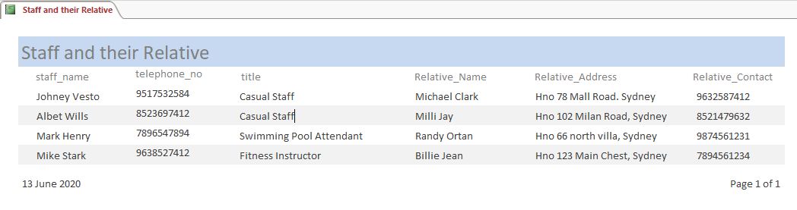
Description: The above query can retrieve the data from the Staff_Personal_Data table and Emergency_Contact table. This query is helpful to identify the staff members and their respective relative’s details together.
2. SELECT Staff_Personal_Data.staff_code, Staff_Personal_Data.staff_name, Staff_Personal_Data.title, Staff_Personal_Data.telephone_no, Absence_Record.start_date, Absence_Record.end_date, Absence_Record.reason
FROM Staff_Personal_Data INNER JOIN Absence_Record ON Staff_Personal_Data.staff_code = Absence_Record.staff_code;
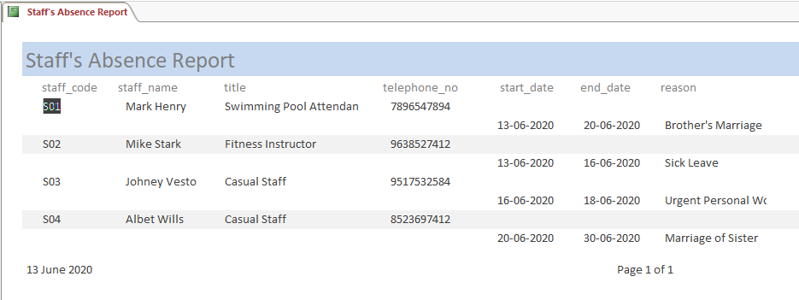
Description: The above query can retrieve the data from the Staff_Personal_Data table and Absence_Record table. This query is helpful to identify the absence record of staff members.

6. Relationships
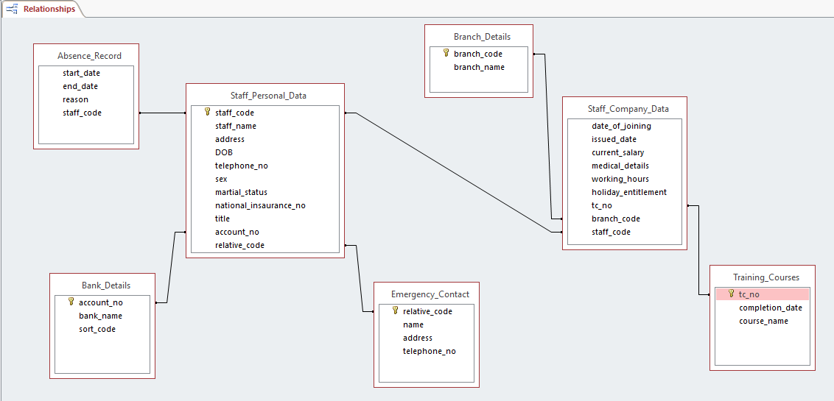

7. User Guide
- The database is designed for employees of Universal Sports. This database can manage the staff’s record, relative’s record, absence record, bank details, branch details, staff’s company details, and training details. Users can retrieve any data from these entities. All the tables are normalized up to the third normal form of normalization.
- This new database system helps Company to easy management of the Staff details and now storing details and retrieving details of staff is very easy using this database system.
- To use the database user need to have Microsoft Access installed into their system.
- After opening MS Access, all the tables, forms, queries, and reports will appear on the left side. Users can open any one of them.

Conclusion
We have successfully designed a database system for Universal Sports. The developed database can manage the Company’s staff details efficiently manner. This database will save time as well as the cost of the company. This system is easy to use and manage. Designed diagrams and developed tables are attached to this document report.

References
Karpisz, D., 2016. Design of manufacturing databases. Czasopismo Techniczne, 2016(Mechanika Zeszyt 3-M (10) 2016), pp.73-77.
Šimović, V. and Varga, M., 2019. APPLYING SQL DATABASE QUERY TO ACCESS SQL SERVER 2019–VISUAL STUDIO 2019. Journal of Agronomy, 6.
Zygiaris, S., 2018. Structured Query Language (SQL): Data Management. In Database Management Systems. Emerald Publishing Limited.

