

Oliver Bowen

P1651498

HND Quantity Surveying (Year2)

Work Based Project

ACBA5009

Learning Contract

Introduction.

A learning contract for a work-based project offers students a chance to explore their chosen field such as Quantity Surveying but also the shows the importance of implementing strategies and goals and how these can play a vital part in the developing the skills necessary for life in the work place. To Benefit from a learning contract, it is important to gain feedback from an instructor such as a line manager or work colleague.

Student name and ID: Oliver Bowen - P1651498
Course: HND Quantity Surveying
Company Name & Address: Morganstone Construction Unit, Llanelli SA14 8LQ
Contact name and number: Stewart Awerys - 01554 779126

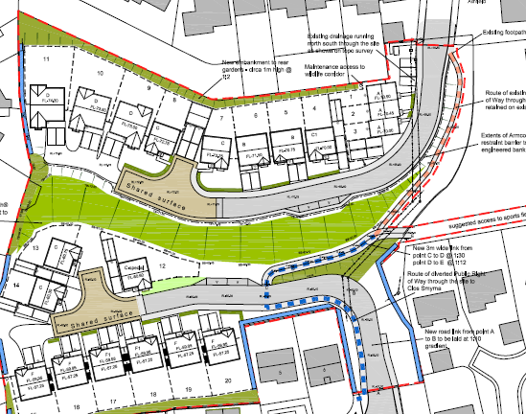
I have been assigned two projects in my work time at MorganStone Construction. The first project I will be working on is called Parc Newydd. This project consists of constructing 31 new properties in Briton Ferry. Working on this project day to day will allow me to oversee all aspects of the construction build from demolition and substructures right through to final finishes. The second project I have been assigned is Pan Y Fai located in Bridgend. This is also a new build project with over 30 houses. There is a large retaining wall that runs through the site splitting it into two sections. Parc Newydd and Pen Y Fair are multimillion-pound projects and from this I will gain valuable experiences that is necessary in order to become a fully qualified Quantity Surveyor.
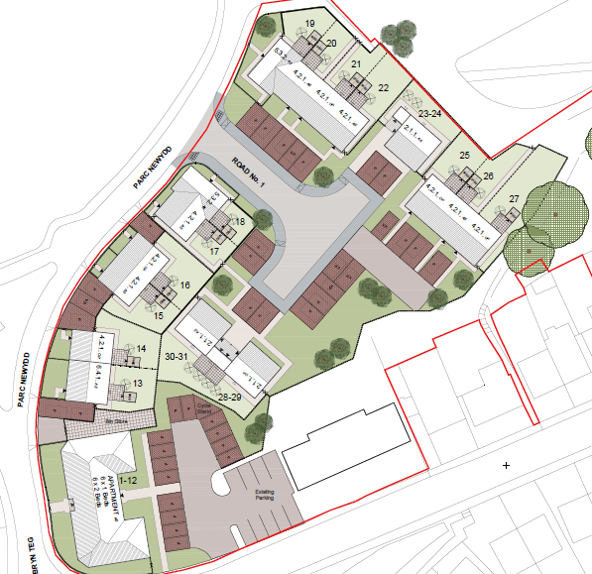

What will be learnt through this project?
(Objectives)
Itemising what is to be done or known once completed

- To increase my understanding of methods and formats used in the use of Cost Reporting.

- To Improve my understanding of the procurement process and how to appoint a subcontractor.

- To increase knowledge of Cash Flow processes and why they are necessary for a Project QS.

How are you going to learn it?
(Resources and strategies)
What has to be done in order to meet each of the defined objectives?
Set Specific Objectives
The more specific you can make your objectives, the simpler it will be to create plans to accomplish them. setting an objective of improving all aspects of being a Quantity Surveyor is too vague. Setting smaller specific objectives will make it easier to learn and improve as a Quantity Surveyor.
Create Individual Plans
For every target that I will set there will be a step by step process on how to accurately complete the task.
Track Results
It is important to track your results as you go. This is important to see if you are on the right path to archive your objectives. Setting benchmarks on your objectives will help you determine if your are going to hit your targets, tracking your results will show if you need to adjust your strategy weekly site meetings and monthly reviews will be a good way of tracking progress.
Day to Day working Environment.
By going to work each day you will automatically learn and pick up important information from colleagues that have gained valuable experience over time. Working on systems such as procurement schedules and cost reports daily will give you a greater understanding of how procedures work.

Target date for completion?
When will each task be completed?

To Improve my understanding of the procurement process and how to appoint a subcontractor.
(19th February 2019)
To increase my understanding of methods and formats used in the use of Cost Reporting.
(9th March 2019)
To increase knowledge of Cash Flow processes and why they are necessary for a Project QS.
(30th March 2019)

How are you going to know that you learned it?
(Evidence)
What is the specific task to complete to demonstrate learning?
By using personal reflection and analysis on events in the work place that are relevant to the overall objectives such as the use of CVR’s, Procurement and Cash Flow, this will help you learn from any situations that have accrued in work. Reflection learning should not necessary focus on what happened rather what weakness were highlighted and what lessons were learned and identify how to improve on the weaknesses. By seeing a demonstration of how the work should be carried out is a good way to learn. By implementing these methods over time, you will find yourself carrying out tasks that were once difficult to complete.
Other examples of providing evidence that demonstrate learning has taken place include feedback and advice from a line manager or senior in the work place, company training days and specific department training and the use of self-assessments reports all these methods can be documented to show demonstrate learning has occurred.
Myself and my mentor will be in agreement of what evidence is required at what stage and how this evidence should be produced so that it is relevant to my objectives. For evidence to be officially assessed it is generally important to set some evaluation criteria.

How are you going to prove that you learned it?
(Verification)
Who will receive the product of your learning and how will they evaluate it?
The Learning contract will be given to my senior line manager and mentor/tutor. The document will then bd evaluated on whether the set objectives have been met. The mentor will analyse the contract on its practicality and whether it is fit for purpose.
The contract shall be investigated for thoroughness and value by the trainer. A reference material schedule should be submitted with the evaluation report. The mentor will offer feedback from the contract he or she will highlight the areas that were done successfully but also the areas that need more work and information to fully complete the objectives. The mentor should also elaborate on methods that can be used to improve the weak areas.

Mentor & Tutor Feedback.
Mentor and Tutor feedback cannot be determined at this stage as not all assignments have been fully issued. Once all assignments have been issued myself and my mentor will have a 1 on 1 meeting to discuss all aspects of the learning contract works. Commenting on its validity and areas of improvement.

