Reflective Essay Assignment
Olubukola R. Adegbite
Student Number:2291368

Table of Contents
Introduction 3
My Self- Awareness Analysis 3
Table 1: My Personal SWOT Analysis 4
My Experiences, Assumptions and Growth Mindset 4
Channels of Support for Self-Directed Learning 7
Figure 1: Formal, Non-formal and Informal Learning Channels 8
My Formal Learning. 8
My Non-Formal Learning 9
My In-Formal Learning 9
My CPD, PDP, Life-long Learning Plan and Strategies to Execute it. 10
Table 2: Gibb’s (1988) Six (6) Stages of the Reflective Model 10
Description 11
Feelings 11
Evaluation 11
Analysis 12
Conclusion 12
Action Plan 12
Wellbeing and Reflective Practice 13
Table 3: My Personal Development Plan 13
Bibliography: 14

Introduction
A key aspect of professional development is reflective practice (Hommel, et al., 2023). This is instructive as professionals virtually in all disciplines are impacted by the changing due to challenges such as emerging technologies, emerging societal and cultural issues and emerging workplace characteristics. Ability to navigate these challenges demands continuous training, knowledge updating and periodic professional development (Messmann et al., 2010).
The term ‘reflective practice’ refers to two types of reflection, namely ‘reflecting-on-action’, - this involves thinking and reviewing an experience in retrospect, while ‘reflecting-in-action’ refers to thinking while in the moment (Schön,1983). Reflective practice is a key cognitive activity and process that professionals embark upon to improve on their self-awareness and further enhance their personal and professional development (The University of Edinburgh 2025).
It involves the continuous assessment of one's thoughts, feelings, and actions through various self-awareness tools, such as personal journal, Johari Window, psychometric test, and other reflective activities (Miller, 2020). Through adoption of personal self-reflection, individual professional can improve on their emotional intelligence, including decision-making skills, and develop a deeper understanding of their values and aspirations, making reflective practice a notable aspect of professional growth in different disciplines (Miller, 2020; The University of Edinburgh 2025).
This assignment presents me the opportunity to critically conduct a self- awareness analysis on my strength, weaknesses, opportunity and threat. In this piece I also present a true reflection on my personal and professional value, ethics and impact of my actions. This essay also covers channels of support for my self-directed learning and future personal development plans.

My Self- Awareness Analysis
Self-awareness in professional career development reflects professionals’ ability to clearly understand who they are, how others see them, and how they fit into their working environment (Callender, et al, 2024). I have watched myself evolved and developed many transferable skills. I have also developed adaptability skills as I have changed jobs and relocated from my home country to the United Kingdom. Initially, I was trained as an Accountant and Auditor. I worked as an Accountant and Auditor in my home country and briefly in the UK. I also worked in Hospitality business for some years in my home country and I did work as a Customer Advisor with Compass Group a major hospitality company in the UK & Republic of Ireland. Over the last twenty (20) years, I have gain self-awareness about my ability and skills to survive in new job role and foreign country.

To further demonstrate my self-awareness, I applied SWOT analysis framework to my skills set, weaknesses, opportunity and threat confronting my skills set and ability.
For example, I intend to use my strength, ability to adapt to a new challenges and environment to overcome the threat of changing workplace and ability to leverage on new technologies for new learning to overcome rising number of online course and fierce competition among HEs for student

Table 1: My Personal SWOT Analysis
Strengths  - I am a subject expert.  - I am a team leader/module leader.  - I mentor young colleagues and learners.  - I like new challenges.  - I have ability to adapt to new challenges/environment.  - I like to help develop others  - I have ability to multitask.  - I have passion for teaching.  - I have very good communication skills.  - I have years of experience in my profession. | Weaknesses  - I struggle with overwhelming workload.  - I have challenge with managing administrative work and other collegial commitments.  - I have challenge with working with lazy colleagues  - I struggle with managing unreliable colleagues.  - I have limited leverage on online and/or education-related technological tools.
Opportunities  - I am able to leverage on new technologies for new learnings.  - I am able to leverage on new technologies for work efficiency.  - I am able to collaborate for research purposes.  - I am able to mentor students and young colleagues.  - I am able to network for career development.  - I am able to improve on my career and learn more through attending training, workshop and other means of career development. | Threat  - Working with laissez faire manager  - Working with biased line manager  - Working with ‘unprofessional’ work colleagues.  - Changing workplace.  - Decrease in funding and budget cut in HE can lead to limited work/career opportunity.  - Technology overload for learners and tutor.  - Rising number of online courses and fierce competition among HEs for students.

My Experiences, Assumptions and Growth Mindset
Over the past twenty (20) years of my work and professional experience, I have discovered that continuous improvement and self-directed learning is highly rewarding. The workplace experiencing constant changes. In some situations, jobs are not guaranteed while career progression are best executed on paper or in theory as there are no or limited opportunities in many organizations for career progressions. My assumptions are horned by my values and belief system. For example, I believe in being dedicated to work and a firm believer in accountability.
In my role as an accountant and auditor, I was dedicated to my roles. My experience in this profession is that colleagues respect me more for my work ethics. They were quick to nominate me for higher responsibilities. This initially seems overwhelming; however, it helps me discover my other strength and managerial skills. I was able to delegate some secondary responsibilities to junior colleagues. In retrospect, I was able to replicate my dedication to work in member of my team. Although, I had a tendency to be seen as being too workaholic which nearly caused friction and misalignment among some team members. However, through open dialogue, we are able to resolve perceived grey areas. This led to the strengthening of the team. My team was often referred to as the pacesetter in good work ethics and meeting deadlines.
As a lecturer in Business Management in one of the UK Universities, I have developed and gained other skills such as collaborative skills, communication skills, interpersonal skills, mentoring skills, organisational and leadership skills. Initially before transitioning to academia, I had my worries. This centres on overcoming stage freights and ability to accommodate other views. I was able to navigate this challenge through my mentor who is a seasoned lecturer. I was also fortunate to have a fantastic line manager who was tender and understanding. Through the mentoring of my mentor and line manager, I was able to settle down on my teachings. Initially, I had to observe a senior colleague’s teaching session. I also attended fortnight module meetings and other organised teaching and learning meetings. All these were opportunities I leveraged on to develop my teaching and learning skills and my confidence.
I was able to settle down quickly on the job, so much so that I was selected by my students as one of the best lecturers within the first three (3) semester of teaching. Upon reflection, I observed that I had studied my class (learners) to understand the class composition and need of my students. I was observed many of my students are matured and from diverse background. This knowledge guides me in using different teaching methods to impact knowledge. I understand that some can learn through the general teaching materials, while some learn through story telling method, some also learn through videos and working in teams. I deployed these methods in my pedagogical approaches which led to over ninety per cent (90%) of the student passing with either distinction or merit at first sitting of the assignment.
I also learned from the feedback provided by students that they learn more in my teaching that cite several real-life examples while explaining complex concepts. They also appreciate my probing method while other would not be bothered to participate in the learning process through active engagement in classroom learning. Furthermore, I also learn that linking previous learning to the new week learning helps them to remember and be able to come to speed with the current lecture.
I took all these insights on board and advice from my mentors whilst revising the teaching materials I inherited from other lecturer in updating my teaching slides. My updated teaching slides have been adopted by lecturers in other campuses of the University* (The University, I work operates on a multi campus structure). I have also received feedback from colleagues’ lecturers which were more of commendation of my ‘creativity’ and the inclusion of different activity to engage adult learners in my teachings. Some of the modules I teach and have improved the teaching materials are LCLM 5001 – Understanding Stakeholder Engagement and LCLM 5005 – Organizational Culture.
Based on my experience in contributing to excellent teaching and learning experience, I was offered the opportunity to lead a module LCLM 4001 – Academic Skills. I was expected to revamp the teaching materials in line with the revised module handbook. I was expected to prepare the assessment brief as well. I leveraged on my previous teaching experience and the experience I gained revising other teaching slides. This guides me in exceeding expectations. Firstly, I understood the course content, key concepts to be taught, the learning aims & objectives including the learning outcomes. I was guided by these key components alongside the key reading materials. In my university, teachings are structured for ten (10) weeks of delivery while students are expected to prepare for and submit any pending assignments. I submitted the prepared assessment briefs, and teaching materials for vetting and internal verification. In preparing the assessment brief, I ensure that the learning aim & objectives, learning outcomes are met. In the teaching slides several examples including case studies were used. Learners are also encouraged to book appointments with the University librarian to help with referencing and sourcing for key readings for the module.
I am determined to keep developing my skills set and in growing my mindset so as to further prepare myself for future opportunities in teachings. According to Dweck and Yeager (2019), people’s motivation and behaviour is guided by how they form their beliefs which in turn shape their experiences. Some beliefs cannot be isolated from ideas; it can be instrumental in aggregating various components together goals, beliefs, and behaviours into a concept called a meaning system. The growth mindset itself is more than putting in positive effort to become better. While effort is key to professional’s achievement, professional with the drive for career development need to try novel strategies and seek input from others through formal, informal and non-formal means. They need this repertoire of approaches—not just sheer effort—to learn and improve.

Channels of Support for Self-Directed Learning
Self-directed learning (SDL) is a pedagogical method that highlights the independence and personal responsibility of the learner in the educational process. The concept was developed by renowned scholars such as Allen Tough, Cyril Houle, and Malcolm Knowles.
SDL is based on how adults learn in independently outside the mortal and brick of the school environments (Miller, 2020). The proponents of SDL argued that individuals are able to own their
educational journeys through identification of their learning needs, goal setting, sourcing relevant materials, executing their learning strategies, and evaluating their learning and development progress (Callender, et al, 2024).
In my effort to adapt to evolving workplace demands, I have taken it upon myself to embrace self-directed learning. According to Morris (2019), self-directed learning is a process through which a learner takes responsibility to control their learning goals and means in order to meet their personal goals or the perceived demands of their individual learner’s context. An important aspect of self-directed learning is that a learner’s learning goals and means are essentially individual; they are differentiated in accordance with their life skills’ needs and peculiarities. This implies each learner as an individual represents a focal and significant characteristic of the learning context.
Several studies (Beckers et al. 2016; Garrison 1997; Sawatsky et al. 2017) confirm that
Self-directed learning has various dimensions. These dimensions include:
(i) the process of learning (i.e., the management of learning activities).
(ii) personality attributes of the learner,
(iii) factors within the learner’s context that impact on the likelihood of learners to assume self-directed learning; and,
(iv) the cognitive aspect of self-directed learning highlight how knowledge is captured during the learning process (e.g. Morris 2019; Garrison 1997).
My self-directed learning has been guided by the dimensions highlighted above. More importantly, my self-directed learning has also taken the form of educational qualification (like enrolling for my DBA), this can also be termed formal learning. I also explore non-formal learning and informal learning channels:

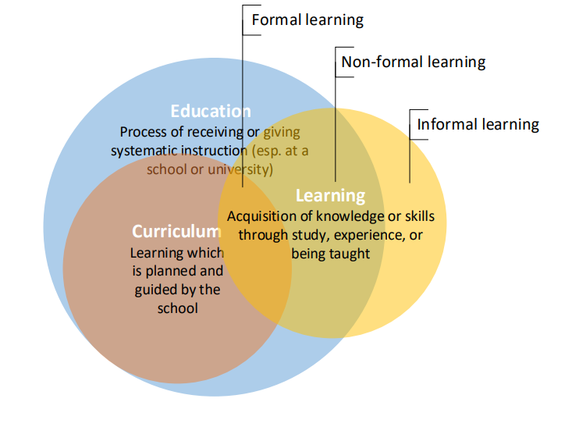

Figure 1: Formal, Non-formal and Informal Learning Channels
(Source: Johnson, and Majewska, 2022).

My Formal Learning.
In 2021, after transiting to academia as a lecturer, I enrolled for a postgraduate certificate in teaching programme (PgCert) which I completed in 2022. It was an eye opening to me as I learnt several concepts about myself as a lecturer, different teaching pedagogical approaches that could help enhance excellent student experience. This course has helped in improving my teaching competencies and in collaborative teaching as well. It has also helped me in improving the sourcing and development of my teaching materials so as to cater for different types of learners.
Presently, I am pursuing a doctoral of Business Administration for Portsmouth University, it has been a fantastic experience learning from different lecturers and studying with other learners and professionals from different backgrounds and disciplines. On this DBA programme, I have covered modules such as Professional Review and Development, Publication and Dissemination, and Advanced Research Techniques.

My Non-Formal Learning
Non-formal learning often refers to learning by a structured knowledge pack, but it is usually not assessed, as it does not lead to certification (Camero, and Harrison, 2012). The non-formal learning could be implicit, reactive and deliberative learning. The reactive learning is almost spontaneous and unplanned, under this circumstance, the learner is aware of the learning experience, but the level of intentionality will differ and often be contentious. It could be challenging to captured in explicit form without making time to reflect on the learning and this makes it become an intentional action (Eraut, 2000). Time of stimulus (i.e., in which the trigger and when the learning takes place), this impact on the sub categorisation as past episode, current experience, and future behaviour with corresponding dimension. The combination of these dimensions namely time of local event and level of intention results in the conceptualisation of a basic typology of non-formal learning as shown below:
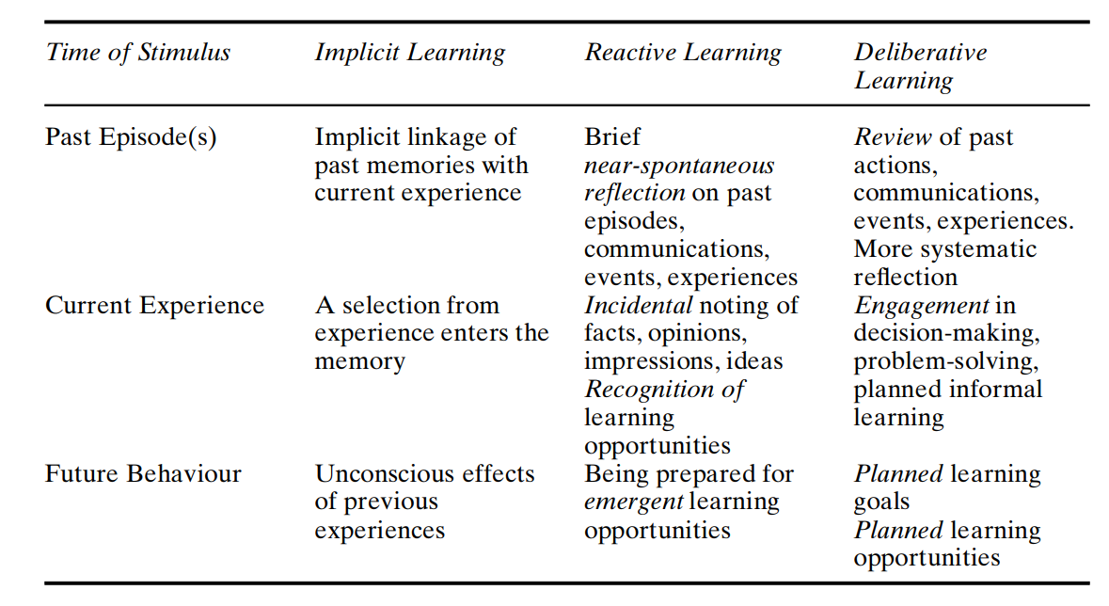Figure 2: A Typology of Non-Formal Learning (Eraut, 2000).

My In-Formal Learning
I have learnt immensely from self-directed readings, educational videos and events. Informal learnings are those learning that do not follow a specific structure or a step-by-step learning that led to certification or any former qualification (Eraut, 2000). Forms of informal learning include attending conferences, reading teaching/research articles, listening to educational programmes on TV or YouTube. Other include attending and learning during visit to educational/book fairs and exhibitions, attending webinars on AI and emerging technologies in higher education (HE) teaching etc.
Others could include oral feedback from colleagues and learners, reading and gaining insights from journals and magazines. The above list is not exhaustive but a pointer that informal learning can take place in any unstructured form, situations, and/or participation in any informal education activities. I have enriched my learning through many of these avenues. I have also learnt in several informal ways from my line manager and also from my mentor. These include their calmness in handling difficult and complex matters between and among colleagues and/or between lecturer and students, teaching and non-teaching staff. Other areas I have learnt include cultural awareness and intelligence while managing a diverse team.

My CPD, PDP, Life-long Learning Plan and Strategies to Execute it.
A key theory of reflective practice is the Gibb’s reflective cycle. This theory guides professionals, students and individuals in reviewing, reflecting past learnings, and experiences with a view to have new set of actions (Gibbs, 1988). I selected Gibb’s reflective cycle as one of the reflective theories in completing my reflective report due to its elaborate way of stepwise and detail narration of reflective stages. These stages are description, feeling, evaluation, analysis, conclusion and action plan. The Gibb’s reflective cycle helps in explaining my continuous professional development plan. The description of each stage of Gibb’s reflective cycle.

Table 2: Gibb’s (1988) Six (6) Stages of the Reflective Model
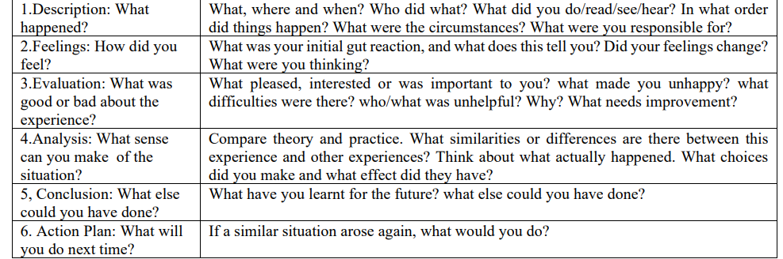

Description
What are my career plan, how has it changed since I graduated from the University over 20 years ago?
My career plan is to bag a doctoral degree in Business Administration in the next five (5) years. I have already enrolled at the University of Portsmouth. I am presently in my first year of study. I have the plan to reach the peak of my career by attaining the highest level of education so as to remain competence in my field and area of expertise.

Feelings
What were my thoughts and feelings towards my career/professional development journey?
My journey back to the classroom has been a mixed feeling for me as it has added more pressure to my time. I am a career mum; I have to juggle my time to be a dedicated worker, caring mum and wife and now I face the pressure of being an excellent student in my forties! The feeling can be overwhelming and daunting considering the many important but conflicting responsibilities. It is a good feeling on one hand that I am back in the classroom as a student; on the other hand, I am feeling somewhat inadequate as I have to divide my time between my work, family and now study.

Evaluation
What were the advantages and disadvantages of Reflecting on my career development?
In my evaluation I think, I am taken the right decision to self-develop myself professionally. More importantly as the workplace is in constant change. It may get to a time that it may be challenging to lecture at the University with a Masters’ degree. Furthermore, considering the uncertainty surrounding many UK universities, many lectureship jobs are becoming unsecured and/or lecturers facing lay off. My choice of doctor in Business Administration, gives me the latitude and flexibility to change to other industry in the near future. Another challenge facing higher education teaching is the use of artificial intelligence (AI) in teaching and learning, while this is still emerging and promising, chances are high that many teaching jobs may be taken over by AI and related technologies. In any case, AI has been regarded as a major disruptor for educators (Lefevre and Shrier, 2023). I think I have been fortunate to have people around me who help me to navigate and transit to academia. As such I do not have major disadvantage in my career development except that I would have loved to have enrolled and completed my DBA earlier. However, I am staying positive while reflecting on gains I have achieved in my career, family life and other areas of lives.

Analysis
What aspects of my career development plan and/or lifestyle that have helped or hindered my intended results/outcomes/progress?
My career development plan has been steady although it could have been more accelerated; however, owing to other factors, lifestyle – being a mother, wife, it could daunting to have career development plan to smoothly as initially planned. Regardless of this seemingly slow and steady progress, it has been advantageous. Reflecting back on how far I have progress/come; it reveals other aspects of me as a resilient lady with ability to multi-task. I am quite happy with developing my adaptability skills is the most intriguing aspect of career development. Either way, the resilience and adaptability I have developed, help me to navigate several hurdles, motivating me to turn my lemons to lemonades.

Conclusion
What did I learn from my self-awareness analysis in specific term? What were the professional goals/plan I need to achieve going forward?
Through my self-awareness analysis I am thrilled to see how I have developed my multi-tasking skills; how I have started as a lecturer with little confidence to have grown and now being able to mentor other young colleagues. I have also discovered other areas of opportunity for career development. Example of this is opportunities to develop my use of emerging technologies for career progression. I am delighted to have started my DBA study; this in itself is a major propeller to keep researching and updating my knowledge in my higher education industry and the application of several technologies. It also help to develop my strength to curb any emerging career threat.

Action Plan
What do future professional need to know about similar opportunities? Based on the first five (5) stages discussed above, what are your action plan as a professional in improving/furthering your career development? This may include your personal development plan (PDP).
I understand that Personal Development Plan (PDP) is a vital first step in the individual’s development process. A PDP enables individuals like me to translate their self-awareness into actionable steps. The most important aspect of the PDP is to have an enabling environment or support system that made needed resources and opportunities available for professionals like me to create and implement their PDPs effectively (Argyris, 1977).
Captured and discussed below in a tabular format is my personal development plan (PDP) which I plan to implement and complete some within three (3) months, six (6) months, annually and some on an ongoing basis.

Wellbeing and Reflective Practice
Professionals’ well-being has an important impact on work output. As an educator low wellbeing has negative impact on both teachers and students. Several effects of low well-being are linked to stress and/or burnout and are leading to resulting from poor health of staff and eventual staff shortages. The issue of wellbeing in reflective practice is important to enhance long-term sustainability of one’s profession and career development (Cherkowski and Walker, 2018; Ferreira, 2022). While it is rewarding to invest in personal professional development, striking a balance is desirable; because job demands are primarily related to the exhaustion component of burnout, whereas (lack of) job resources are primarily related to disengagement (Demerouti, et al., 2001; Carmicheal, et al., 2020). Balancing my studies with family and career has taken a ton on my health. I struggle to meet up with family demand and I tried to get things moving, this has really affected my health and productivity until I attended a workshop organised by my work place, this was a turning point for me I realised that my wellbeing should be prioritise for better perfomance

Table 3: My Personal Development Plan
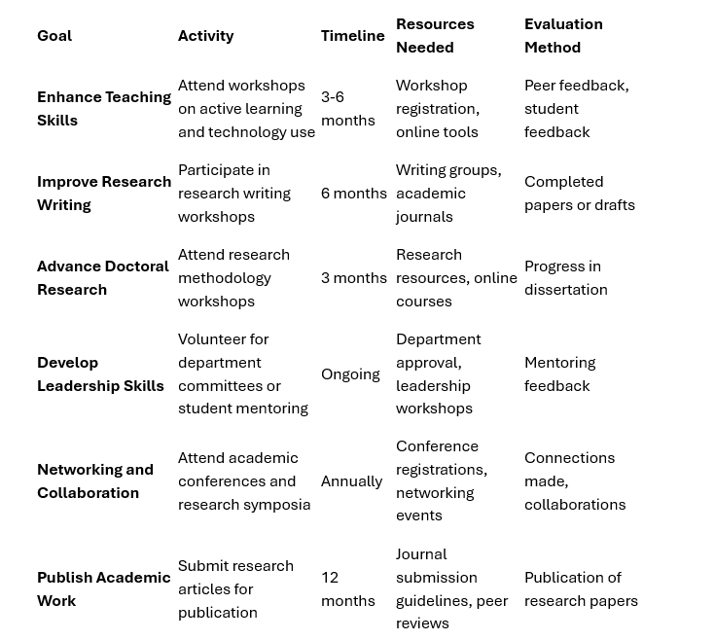

Bibliography:
Argyris, C., (1977). Double Loop Learning in Organizations, available @: https://hbr.org/1977/09/double-loop-learning-in-organizations, (Accessed 23/04/2025).
Beckers, J., Dolmans, D., & van Merriënboer, J. (2016). e-Portfolios Enhancing Students’ Self-Directed Learning: A Systematic Review of Influencing Factors. Australasian Journal of Educational Technology, 32(2), 32–46.
Beckers, J., Dolmans, D. H., Knapen, M. M., & van Merriënboer, J. J. (2018). Walking the Tightrope With An E-Portfolio: Imbalance Between Support and Autonomy Hampers Self-Directed Learning. Journal of Vocational Education & Training, 71(2), 260–288.
Callender, Q., Elklatawy, N., Firdaus, M.I., Remon, A., Al Tarrah, H., Vanishvili, K., (2024). Self-Awareness and Influence: Foundational Approaches to Lead Others in Challenging Healthcare Environments, available @: https://ihf-fih.org/news-insights/self-awareness-and-influence-foundational-approaches-to-lead-others-in-challenging-healthcare-environments-yel-2024/, (Accessed 23/04/2025).
Camero, R., and Harrison, J. L., (2012). The Interrelatedness of Formal, Non-Formal and Informal Learning: Evidence from Labour Market Program Participants, Australian Journal of Adult Learning Volume 52 (2).
Carmichael, K., Rushworth, I., & Fisher, P. (2020). ‘You’re opening yourself up to new and different ideas’: Clinical psychologists’ understandings and experiences of using reflective practice in clinical work: an interpretative phenomenological analysis. Reflective Practice, 21(4), 520–533. https://doi.org/10.1080/14623943.2020.1775569
Cherkowski, S., & Walker, K. (2018). Teacher Wellbeing: Noticing, Nurturing, Sustaining and Flourishing in Schools. Ontario, Canada: Word & Deed Publishing.
Dweck, C. S., & Yeager, D. S. (2019). Mindsets: A View from Two Eras. Perspectives on Psychological Science, 14(3), 481–496. https://doi.org/10 .1177/1745691618804166,
Eraut, M., (2000). Non-Formal Learning and Tacit Knowledge in Professional Work, British Journal of Educational Psychology, 70, 113–136
Ferreira, M. (2022). “Teachers’ Well-Being, Social and Emotional Competences, and Reflective Teaching – A Teacher’s Continuous Training Model For Professional Development and Well-Being,” In International Approaches To Promoting Social and Emotional Learning In Schools – A Framework For Developing Teaching Strategy, eds M. Talvio and K. Lonka (London: Routledge, Taylor & Francis), 109–130. doi: 10.4324/ 9781003093053-9
Garrison, D. R. (1997). Self-directed learning: Toward a comprehensive model. Adult Education Quarterly, 48(1), 18–33.
Greenwood, J., (1998). The Role of Reflection in Single and Double Loop Learning, Journal of Advanced Nursing, 1998, 27, 1048–1053.
Hommel, M., Fürstenau, B., & Mulder, R. H. (2023). Reflection at Work – A Conceptual Model and the Meaning of Its Components in the Domain of VET Teachers. Frontiers in Psychology, 13, 923888. available @: https://doi.org/10.3389/fpsyg.2022.923888, (Accessed on 23/04/2025)
Jasper M, and Rosser M (2013) Work Based Learning and Portfolios. In Jasper, M., Mooney, G., Rosser, M., (eds.) Vital Notes for Nurses: Professional Development, Reflection and Decision Making in Nursing and Health Care, 2nd ed., Chapter 5, pp. 136–167, Chichester: Wiley.
Johnson, M., and Majewska, D. (2022). Formal, non-formal, and informal learning: What are they, What are they, and how can we research them? Cambridge University Press & Assessment Research Report
Lefevre, D., and Shrier, D., (2023). Will AI Replace the Educator? Available @: https://www.imperial.ac.uk/business-school/ib-knowledge/technology/will-ai-replace-the-educator/, (Accessed 23/04/2025).
Messmann, G., Mulder, R. H., and Gruber, H. (2010). Relations between Vocational Teachers’ Characteristics of Professionalism and Their Innovative Work Behaviour. Emp. Res. Vocat. Educ. Train. 2, 21–40. doi: 10.1007/BF03546487
Miller, K., (2020). 9 Best Self-Awareness Activities & Tools, available @: https://positivepsychology.com/building-self-awareness-activities/, (Accessed 23/04/2025).
Morris, T. H. (2019). Self-Directed Learning: A Fundamental Competence in A Rapidly Changing World, International Review of Education, 65(4), 633–653, available @: https://doi.org/10.1007/s11159-019-09793-2, (Accessed 24/04/2025).
Sawatsky, A. P., Ratelle, J. T., Bonnes, S. L., Egginton, J. S., & Beckman, T. J. (2017). A Model of Self-Directed Learning In Internal Medicine Residency: A Qualitative Study Using Grounded Theory. BMC Medical Education, 17, Art. 227.
Schön, D. F. (1983). The Reflective Practitioner. New York: Basic Books.
The University of Edinburgh (2025). Reflecting for Self-Awareness, available @: https://reflection.ed.ac.uk/reflectors-toolkit/self-awareness, (Accessed on 24/04/2025).

