Connor Daniel (1909665)
1909665@student.uwtsd.ac.uk

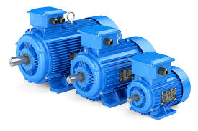
Power Electronics & Drives (ACDA6004)
BEng Electrical and electronic engineering
Table of Contents
Introduction 2
Motor drive systems 3
Motor A 3
Requirements 3
Comparison 3
Conclusion 4
Motor B 5
Requirements 5
Comparison 5
Conclusion 6
Motor C 7
Requirements 7
Comparison 7
Conclusion 8
Motor D 8
Requirements 8
Comparison 8
Conclusion 10
Motor E 10
Requirements 10
Comparison 10
Conclusion 12
Task 1 conclusion 12
Task 2 13
VFD 13
Diode 13
SCR 13
IGBT 13
Harmonics 14
Minimising harmonic noise 14
Harmonics effect on power and power factor. 18
Bibliography 19

Introduction
This report will investigate motor drive systems and variable frequency drives. The report will be set out in two parts looking at both topics. The first half of the report will relate to the motor drive systems aspect of the assignment, gathering information on variable frequency drives to fit the specification of five different induction motors. The report will outline various aspects such as protection, technical data and cost. The second part of this report will investigate variable frequency drives and compare the different components with in them that are used for rectification such as diodes, thyristors and IGBT’s. Research will be completed on harmonics and how they influence power and power factor. This research will then be backed up through simulation results as evidence for the arguments made.

Motor drive systems

Motor A

Requirements
Table 1 - Motor A requirements
 | Motor A
Power | 500 kW
Phases | 3
Voltage | 400
Required to be Reversible? | Yes
Variable speed required? | Yes
Quantity Installed | 5
Example Application | Rolling Mill

Comparison
 | ABB ACS880-07-1480A-3 [13] | OMRON SX series [14] | Schneider Altivar Process ATV600 [15]
Power | 630 kW (Heavy duty) | 630 kW (Heavy duty) | 500 kW (Heavy duty)
Phases | 3 | 3 | 3
Voltage | 380 to 415 V | 400v | 380 to 415 V
Current | 1107 A | 1168 A | 849 A
Frequency | 50 to 60 Hz | 50 to 60 Hz | 50 to 60 Hz
Max output frequency | 0 to 598 Hz | 599 Hz | 0.1 to 500 Hz
Power factor | 0.98
Efficiency | 98% |  | 0.98
Reversible? | Yes | Yes | Unknown
Variable speed | Yes | Yes | Yes
Cooling | Air cooled  Liquid cooling | Air cooling  Liquid Cooling option | Forced convection
Safety function | Safe Torque Off built-in as standard  Optional safety modules for extended safety functions  Encoderless safe speed detection | Motor protection - Motor overheat protection based on output current or PTC by option board  Momentary overcurrent Protection - Drive stops when output current exceeds 200% of peak current  Overload Protection - Drive stops after 1 min at 150% of rated output current (Heavy Duty Rating) Drive stops after 1 min at 120% of rated output current (Normal Duty Rating) (1 min every 10 min)  Overvoltage Protection  -Line Overvoltage-760 VDC during more than 10 s for 400 V class  -Fast Overvoltage: 850 VDC for 400 V class  Under voltage Protection 400 VDC for 400 V class  Momentary power loss Ride-Thru Low - voltage override function  Heatsink Overheat Protection-  Protected by thermistor  Braking Resistance Overheat Protection - Hardware short circuit protection  Stall prevention- Current limit function  Power charge indication- Power LED remains lit until capacitors are charged | Motor: thermal protection  Motor: safe torque off  Motor: motor phase break  Drive: thermal protection  Drive: safe torque off  Drive: overheating  Drive: overcurrent (between output phases and earth) Drive: overload (output)  Drive: short-circuit protection  Drive: motor phase break  Drive: overvoltage (DC bus)  Drive: line supply overvoltage  Drive: line supply under voltage  Drive: line supply phase loss Drive: over speed  Drive: break on the control circuit  Drive: short-circuit protection with semi-conductor fuse (main supply)  Drive: fan monitoring
Communication | Modbus RTU fieldbus  PROFIsafe (functional safety over PROFINET) is also supported | EtherCAT, PROFINET, Modbus, DeviceNet, PROFIBUS, Modbus TCP | Modbus serial EtherNet/IP Modbus TCP
Cost | Price upon request | Price upon request | Price upon request

Conclusion
The VFD that has been chosen for Motor A is the OMRON SX series this is because it fits the ideal specification. When compared to the other two VFD’s it provides more information on the datasheet on safety features and the flexibility of the VFD. The main factors that led to the decision to pick the OMRON SX series over the other VFD’s were its various communication and cooling options. Safety features such as overcurrent and overvoltage protection that provided that figures on the datasheet that the other two VFD’s did not were also a big factor.

Motor B

Requirements
 | Motor B
Power | 80 kW
Phases | 3
Voltage | 400
Required to be Reversible? | Yes
Variable speed required? | Yes
Quantity Installed | 10
Example Application | Gantry Crane

Comparison
 | Siemans sinamaticsPM240-2 [1] | Schneider ATV950C11N4F  [2] | Omron SX-A [3]
Power | 90 kW (Heavy duty) | 90 kW (Heavy duty) | 132 kW (heavy duty)
Phases | 3 | 3 | 3
Voltage | 380 to 480 V | 380 to 440 V | 400 V
Current | 189 A (Heavy duty) | 164 A (Heavy duty) | 240 A (Heavy duty)
Frequency | 47 to 63 Hz | 50 to 60 Hz | 45 to 65 Hz
Max output frequency | Pulse frequency – 2 kHz  Output frequency for V/f control- 0 to 550 Hz  Output frequency for vector control – 0 to 200 Hz | 0.1 to 599 Hz | 0 to 400 Hz
Power factor | 0.95
Efficiency | 0.99
Reversible? | Yes | Yes | Yes
Variable speed | Yes | Yes | Yes
Cooling | Internal air cooling | Forced convection | Air cooling  Liquid Cooling option
Safety function | 1.5 × output current rating (i.e., 150 % overload) for 57 s with a cycle time of 300 s 2 × output current rating (i.e., 200 % overload) for 3 s with a cycle time of 300 s | STO (Safety torque off)  Overload and short circuit protection | Motor protection - Motor overheat protection based on output current or PTC by option board  Momentary overcurrent Protection - Drive stops when output current exceeds 200% of peak current  Overload Protection - Drive stops after 1 min at 150% of rated output current (Heavy Duty Rating) Drive stops after 1 min at 120% of rated output current (Normal Duty Rating) (1 min every 10 min)  Overvoltage Protection  -Line Overvoltage-760 VDC during more than 10 s for 400 V class  -Fast Overvoltage: 850 VDC for 400 V class Undervoltage Protection 400 VDC for 400 V class  Momentary power loss Ride-Thru Low - voltage override function  Heatsink Overheat Protection-  Protected by thermister  Braking Resistance Overheat Protection - Hardware short circuit protection  Stall prevention- Current limit function  Power charge indication- Power LED remains lit until capacitors are charged
Communication |  | Modbus serial EtherNet/IP  Modbus TCP | EtherCAT, PROFINET, Modbus, DeviceNet, PROFIBUS, Modbus TCP
Cost | £9.636.37 | £13,873.36 | £18,520.00

Conclusion
The OMRON SX-A has been chosen for motor B although it is the most expensive it provides the most communication and cooling options. The datasheet also provides the most information on safety features which were the main contributing factor on deciding to choose this VFD. For example, the 150% overload protection, the 200% momentary overcurrent protection and overvoltage protection.

Motor C

Requirements
 | Motor C
Power | 10 kW
Phases | 3
Voltage | 400
Required to be Reversible? | No
Variable speed required? | Yes
Quantity Installed | 23
Example Application | Conveyor

Comparison
 | Danfoss VLT FC51 Series [4] | OMRON Q2A-A4038-AAA [5] | Schneider ATV 630 Series [6]
Power | 18.5 kW | 15 kW (Heavy duty) | 15 kW (Heavy duty)
Phases | 3 | 3 | 3
Voltage | 380 to 480 V | 400 V | 380 to 480 V
Current | 37 A | 31 A (Heavy duty) | 31.7 A (Heavy duty)
Frequency | 50 to 60 HZ | 50 to 60 Hz | 50 to 60 Hz
Max output frequency | 0–200 Hz (VVC+ mode)  0–400 Hz (U/f mode) | AOLV, EZOLV: 120 Hz  CL-V/f, CLV, AOLV/PM, CLV/PM: 400 Hz  V/f, OLV, OLV/PM: 590 Hz | 0.1 to 500 Hz
Power factor | 0.98 | >0.9
Efficiency | 98%
Variable speed | Yes | Yes | Yes
Cooling |  | Cooling fan | Internal fans
Safety function | Earth fault protection - Protects the drive  Over temperature protection - Protects the motor and drive  Short circuit protection - Protects the drive | Embedded STO  Overload tolerance - HD: 150% of the rated output current for 60 seconds | STO  Overload protection up to 150%
Communication | FC Protocol  Modbus RTU | EtherCAT, EtherNet/IP,  PROFINET, POWERLINK | Modbus/TCP, Modbus serial link
Cost | £2,053.05 | £2,798.00 | £2,500.93

Conclusion
For motor C the OMRON Q2A-A4038-AAA has been chosen this is to keep the same supplier as the larger VFD’s. The VFD also meets the specification for the motor and has a good power factor. The OMRON was also selected as the datasheets provides the most information compared to the other two with the factors, they are being compared against each other with. For example, communication, cooling and safety features.

Motor D

Requirements
 | Motor D
Power | 5 kW
Phases | 3
Voltage | 400
Required to be Reversible? | Yes
Variable speed required? | No
Quantity Installed | 17
Example Application | Cutting machine

Comparison
 | ABB ACS580 [7] | Danfoss VLT FC51 Series [8] | OMRON CIMR-AC4A0023FAA [9]
Power | 7.5 Kw (Heavy duty) | 7.5 kW | 7.5 kW (Heavy duty)
Phases | 3 | 3 | 3
Voltage | 400 V | 380 to 480 V | 380 to 480 V
Current | 30.6 A | 15.5 A | 14.8 A
Frequency | 47 to 63 Hz | 50 to 60 Hz | 50 to 60 Hz
Max output frequency | 0 to 500 Hz | 0–200 Hz (VVC+ mode)  0–400 Hz (U/f mode) | 0.01 to 400 Hz
Power factor | 0.98 | 0.98 | >0.9
Efficiency | 98% | 98%
Reversible | Yes | Yes | Yes
Cooling | Air cooled |  | Cooling fan
Safety function | STO  Overvoltage controller  Undervoltage controller  Motor and motor cable earth-leakage monitoring  Motor and motor cable short-circuit protection  Motor overtemperature protection  Output and input switch supervision  Motor overload protection  Phase-loss detection (both motor and supply)  Under load supervision (belt loss detection)  Overload supervision Stall protection Loss of control reference | Earth fault protection - Protects the drive  Over temperature protection - Protects the motor and drive  Short circuit protection - Protects the drive | Motor protection Motor overheat protection based on output current  Momentary overcurrent Protection Drive stops when output current exceeds 200% of Heavy Duty Rating  Overload Protection Drive stops after 60 s at 150% of rated output current (Heavy Duty Rating)*5  Overvoltage Protection 200 V class: Stops when DC bus exceeds approx. 410 V, 400 V class: Stops when DC bus exceeds approx. 820V  Undervoltage Protection 200 V class: Stops when DC bus exceeds approx. 190 V, 400 V class: Stops when DC bus exceeds approx. 380V  Momentary power loss Ride-Thru Immediately stop after 15 ms or longer power loss (default), Continuous operation during power loss than 2 s (standard)*6  Heatsink Overheat Protection Protected by thermistor  Braking Resistance Overheat Protection Overheat sensor for braking resistor (optional)  Stall prevention Stall prevention during acceleration/deceleration and constant speed operation  Ground fault Protected by electronic circuit*7  Power charge indication Charge LED remains lit until DC bus has fallen below approx. 50 V
Communication | Modbus RTU | FC Protocol  Modbus RTU | Modbus, Profibus, CANopen, DeviceNet, ML-II, PROFINET, EtherCAT and EtherNet/IP
Cost | Price on request | £997.09 | £3,116.40

Conclusion
The OMRON CIMR-AC4A0023FAA has been chosen for motor D although being the most expensive the VFD‘s for the larger motors that have been chosen have been from OMRON and keeping the same supplier throughout the factory has major benefits. The data sheet also provides with the most information on safety options, cooling and the OMRON has the most flexibility when it comes to communication options.

Motor E

Requirements
 | Motor E
Power | 1 kW
Phases | 1
Voltage | 230
Required to be Reversible? | No
Variable speed required? | No
Quantity Installed | 127
Example Application | Pumps / Fans

Comparison
 | Schneider LXM32CD18N4 [10] | Allen Bradley 525 powerflex [11] | Omron 3G3MX2 Series  [12]
Power | 3 kW | 2.2 kW | 2.2 kW
Phases | 1 | 1 | 1
Voltage | 220v | 200 to 240 v | 200 to 240 v
Current | 60 A | 8 A | 9.6A
Frequency | 50 to 60 Hz | 47 to 63 Hz | 50 to 60 Hz
Power factor |  | 0.98
Efficiency |  | 97.5% | 90%
Cooling | Natural convection | Cooling fan | Self-cooling
Safety function | STO | STO | Motor overload protection Electronic Thermal overload relay and PTC thermistor input  Instantaneous overcurrent 200% of rated current  Overload Dual rating: Heavy duty (CT): 150% for 1 minute Normal Duty (VT): 120% for 1 minute  Overvoltage 800 V for 400 V type and 400 V for 200 V type  Undervoltage 345 V for 400 V type and 172.5 V for 200 V type  Momentary power loss Following items are selectable: Alarm, decelerates to stop, decelerates to stop with DC bus controlled, restart  Cooling fan overheat Temperature monitor and error detection  Stall prevention level Stall prevention during acceleration/deceleration and constant speed  Ground fault Detection at power-on  Power charge indication On when power is supplied to the control part
Communication | EtherCAT, integrated | Embedded EtherNet/IP™ port  Dual port EtherNet/IP option card  Integral RS485/DSI communications  Optional communication cards such as DeviceNet™, and PROFIBUS DP™  Online EDS file creation with RSNetWorx | Modbus,  DeviceNet  Profibus  CompoNet  EtherCAT  ML-II and EtherNet/IP
Cost | £1,115.40 | £764.01 | £575.50

Conclusion
The Omron 3G3MX2 Series has been chosen for motor E to keep the same supplier as previous VFD’s. The OMRON is also the cheapest option which could help cut back costs on some of the OMRON motors that have been the most expensive of the three options. The OMRON also provides various communication options and safety options while still having a good efficiency rating.

Task 1 conclusion
All the drives selected for the factory have been selected from the same provider OMRON. The reason for this is for the advantages gained by selecting the same provider such as having the same communication options, a common interface, common technical support and one program for all of the drives. These advantages and that the VFD’s meet the required specification provides a solution to replace the drives for the five motors.

Task 2

VFD
A variable frequency drive (VFD) is used to control the speed of an electric motor, it does this by varying the voltage and frequency that is supplied to the motor. A VFD will go through three stages to control the speed of a motor, firstly it will go through a rectifier then a filter and finally an inverter.[16]
During the first stage the 3-phase supply will pass through the rectifier where it will convert the incoming AC to DC. A VFD uses diodes, SCR’s or IGBT’s to complete this rectification stage.
In the next stage the DC supply will go to a DC bus where the DC output will be filtered. The filtering process will use capacitors and/or inductors to create a smoother DC supply from the one that came into the DC bus. This process is completed by releasing electrons in the gap between the ripples providing a smoother and more constant DC output.
The final stage of the process is to pass the smooth DC supply into an inverter, the inverter is made up of electronic switches which turn the DC back in to a sine wave using pulse width modulation. [17]

Diode
Diode rectification is a simple and common way to complete the conversion of AC to DC. A diode will only allow current to flow in one direction, therefore converting the incoming AC to DC. Due to this a three-phase system would use 6 diodes as for each phase of power one diode will allow current on the positive portion and the other will allow current in the negative portion. This is called a 6-pulse rectifier as it draws current from the AC source in six pulses. Diode rectification can also come in 12 pulse and 18 pulses, the more pulses the lower the harmonics. [18]

SCR
A Silicon controlled rectifier (SCR) has three elements to it a cathode, an anode and a gate. An SCR conducts current between the cathode and anode when the correct current is applied to the gate. If the gate is positive with respect to the cathode the SCR will allow current to pass through however, if it is negative, it doesn’t allow current to pass through. [19]
A SCR will provide more control than a diode due to the fact it has a gate, it means the output voltage will be an average DC output. This is because with the use of thyristors a delay can be put in place to where a normal diode would normally switch on. [20]

IGBT
Insulated gate bipolar transistors (IGBT’s) can also be used for rectification, this is known as an active front end. An IGBT uses the properties of MOSFETS (metal oxide semiconductor field-effect transistors) and bipolar transistors. If a three-phase supply is applied to a 6 IGBT rectifier each phase will be connected to two IGBT’s in series with each other. One IGBT will be for the positive side of the phase and the other for the negative side of the phase. When the phase is in its positive cycle and hits the correct voltage the matching IGBT will become forward biased allowing current to flow through, the same will then occur with the IGBT corresponding with the negative portion of the phase becoming forward biased allowing current through. [21]
When comparing IGBT’s to SCR’s the IGBT’s have a lower power consumption and higher power factor, this is due to SCR’s using a linear voltage regulation mechanism. IGBT’s also have a faster response time than the SCR meaning they are more suitable when high precision and quick response times are required. [22]

Harmonics

Minimising harmonic noise

Increased number of pulses
One method of reducing harmonic noise is to increase the number of pulses. For example, using a 12-pulse rectifier instead of a 6-pulse rectifier. The two rectifiers are typically wired up with a transformer each one in star and one in delta. This means they are wired to offset each other therefore reducing the fifth and seventh harmonics. If you were to increase the rectifier to an 18 pulse you would further reduce total harmonic distortion. The 18-pulse rectifier would nearly eliminate the fifth, seventh, eleventh and thirteenth harmonics. [23]

Six pulse diode rectifier
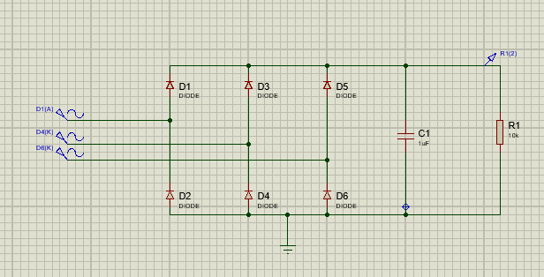
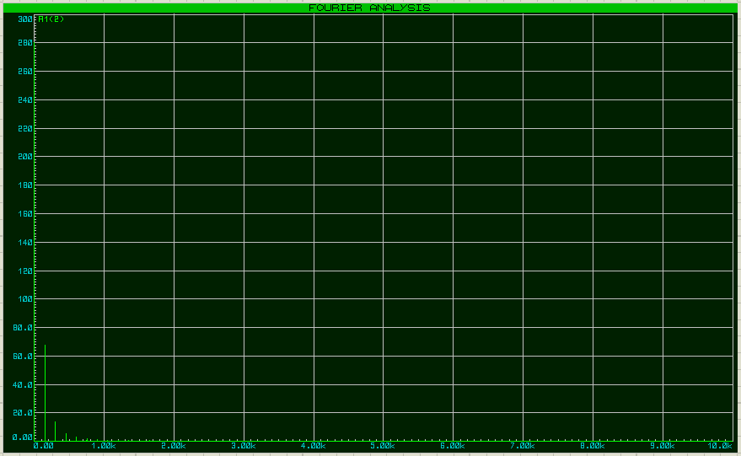
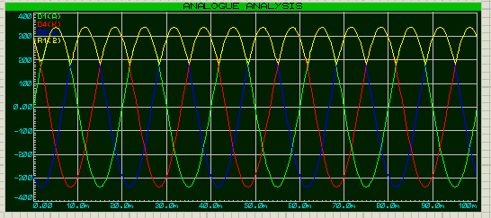

12 pulse diode rectifier
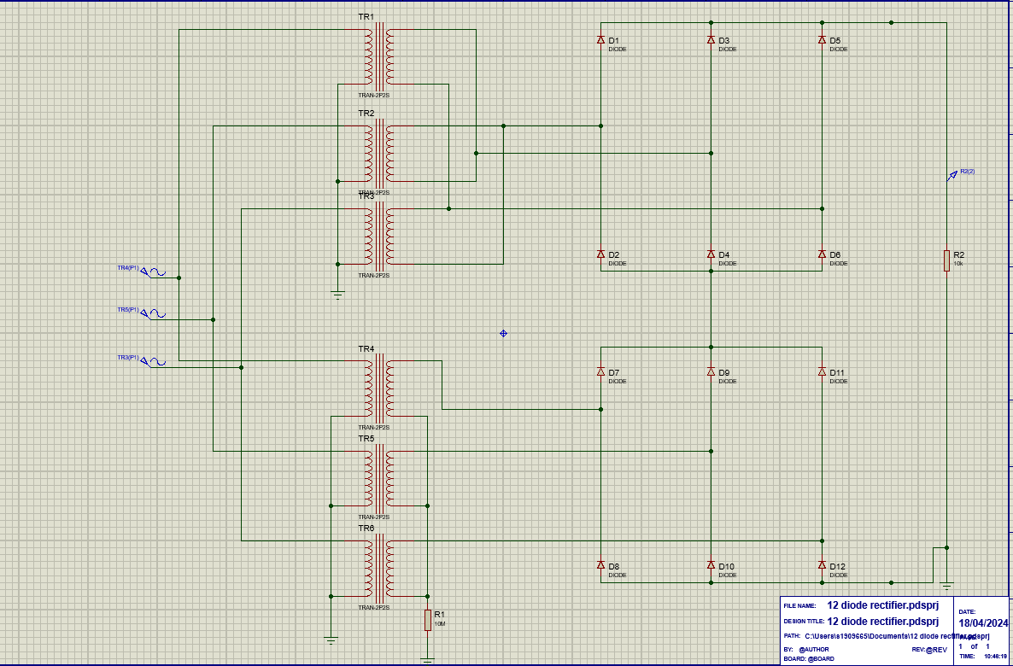
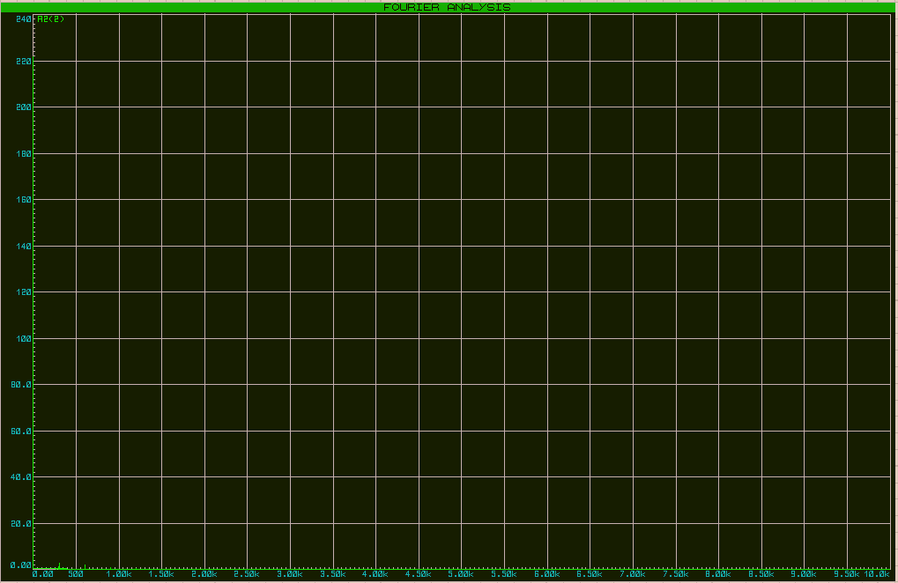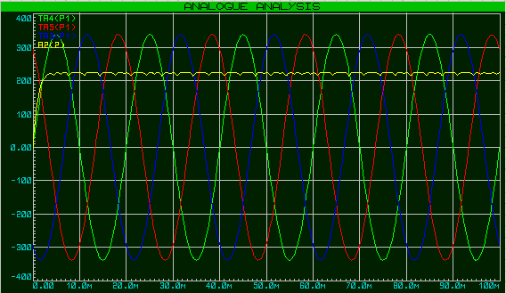
As shown by the simulation results above the 12-pulse diode rectifier when compared to the six-pulse rectifier removes some of the unwanted harmonics and provides a smoother DC output.

Active front end
An active front end is another method to reduce harmonics using IGBT’s. An active front end can account for poor quality power input as it can compensate for any flaws. The IGBT will detect the harmonic and create an equal and opposite waveform to remove the unwanted harmonic. Due to the IGBT’s being bi-directional and regenerative, they remove the need for braking resistors. This also improves the efficiency as it decreases the amount of braking needed.[23]
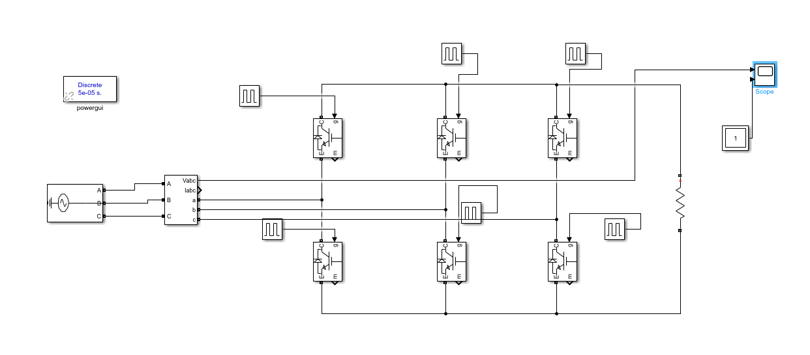
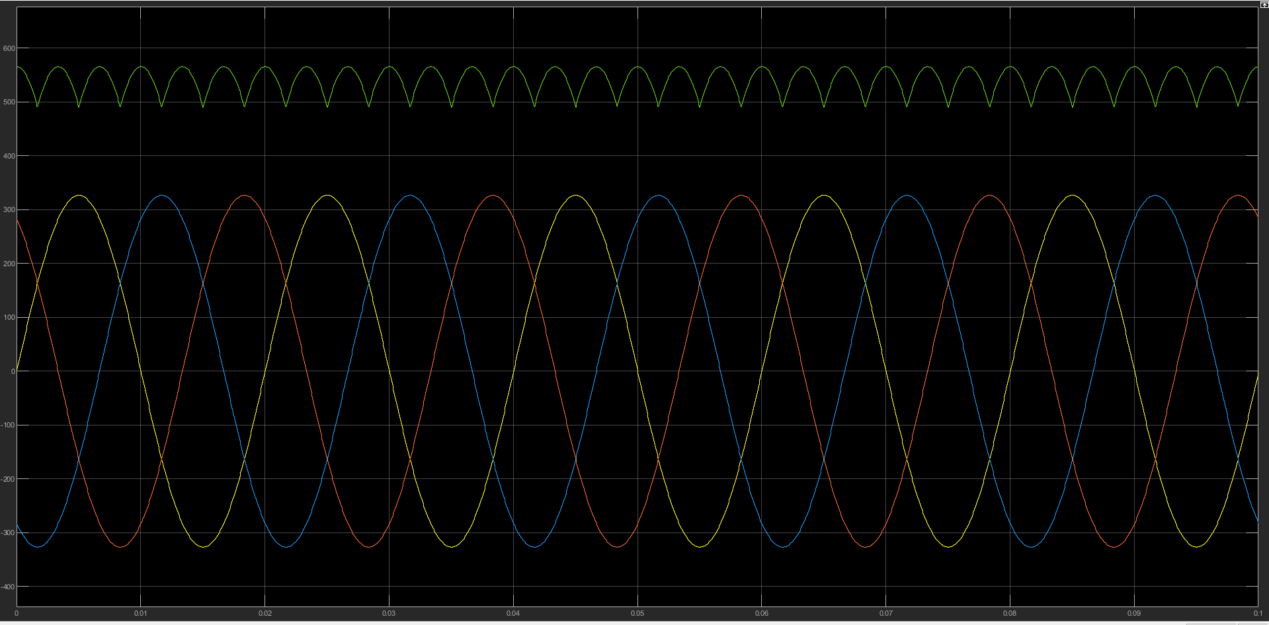

Passive harmonic filters
Harmonic filters are another method that can be used to minimise harmonics, they are usually either active or passive. An active harmonic filter will analyse the harmonics produced and attempt to counter them with the corresponding harmonic, an example of this would be the active front end. Passive harmonic filters however will use capacitors and inductors to block the harmonic or direct it to ground. As the frequency increases so will the impedance of the inductor however, the impedance of the capacitor will decrease. The passive filter is more affordable and easier to install but are less effective under varying loads.[24]

Harmonics effect on power and power factor.
Rectifier circuits are non-linear loads meaning they distort the waveform; this distorted waveform can be broken down into Harmonics. The harmonics that are produced when distorting the waveform provide no use meaning they are naturally reactive. Power factor is the ratio of the real power (kW) to the reactive power (kVa), due to the reactive harmonic component now being a factor this lowers the power factor. [25]

Bibliography
[1] “Siemens Power Module, 110 kW, 3 phase, 380 → 480 V AC, 356 A, sinamics PM240-2 series,” RS, https://uk.rs-online.com/web/p/inverter-drives/2116957?gb=s (accessed Mar. 28, 2024).
[2] “Schneider Electric Inverter Drive, 110 kW, 3 phase, 400 V, 440 V, 164 A, 174 A, 195 A, 207 A, ATV950 series,” RS, https://uk.rs-online.com/web/p/inverter-drives/2483757?gb=s (accessed Mar. 28, 2024).
[3] “Omron Inverter Drive, 160 kW, 3 phase, 400 V AC, 3 A, SX-A Series,” RS, https://uk.rs-online.com/web/p/inverter-drives/2147474?gb=s (accessed Mar. 28, 2024).
[4] “Danfoss inverter drive, 18.5 kW, 3 phase, 400 v AC, 37 A, VLT FC51 series,” RS, https://uk.rs-online.com/web/p/inverter-drives/8918858# (accessed Mar. 28, 2024).
[5] “Q2A-A4038-AAA,” Q2A-A4038-AAA | OMRON, UK, https://industrial.omron.co.uk/en/products/Q2A-A4038-AAA (accessed Apr. 26, 2024).
[6] “Schneider Electric Inverter Drive, 15 kW, 3 phase, 380 → 480 V AC, 23.5 A, 31.7 A, ATV 630 series,” RS, https://uk.rs-online.com/web/p/inverter-drives/8724054 (accessed Mar. 28, 2024).
[7] ACS580 catalog, https://search.abb.com/library/Download.aspx?DocumentID=3AUA0000145061&LanguageCode=en&DocumentPartId=&Action=Launch (accessed Mar. 28, 2024).
[8] “Danfoss Inverter Drive, 7.5 kW, 3 phase, 400 v AC, 15.5 A, VLT FC51 series,” RS, https://uk.rs-online.com/web/p/inverter-drives/8918842 (accessed Mar. 28, 2024).
[9] “CIMR-AC4A0023FAA - AC motor, Speed Controller, 11 kW, three phase, 23 A, 50Hz / 60Hz, IP20, 380 V to 480 V,” Farnell, https://uk.farnell.com/omron/cimr-ac4a0023faa/ac-motor-speed-controllers/dp/3412288?st=omron+11+kw+ac+drive (accessed Apr. 4, 2024).
[10] “Schneider Electric 3 kW servo drive, 100 → 120 V, 200 → 240 V, 1 phase, 12.9 A, encoder feedback function, 240 V,” RS, https://uk.rs-online.com/web/p/motor-controllers/1811394?gb=s (accessed Apr. 4, 2024).
[11] “Allen Bradley Inverter Drive, 2.2 kW, 1 phase, 230 V AC, 11 A, powerflex 525 series,” RS, https://uk.rs-online.com/web/p/inverter-drives/8904310?gb=s (accessed Apr. 4, 2024).
[12] “Omron Inverter Drive, 2.2 kW, 1 phase, 200 V, 9.6 A, 3G3MX2 series,” E, https://uk.rs-online.com/web/p/inverter-drives/2661463 (accessed Apr. 4, 2024).
[13] ACS880 single drives catalog, https://search.abb.com/library/Download.aspx?DocumentID=3AUA0000098111&LanguageCode=en&DocumentPartId=1&Action=Launch (accessed Apr. 4, 2024).
[14] “SX Series,” OMRON, UK, https://industrial.omron.co.uk/en/products/sx-series (accessed Apr. 7, 2024).
[15] “Schneider Electric,” Schneider Electric Global, https://www.se.com/ww/en/product/ATV660C63Q4X1/variable-speed-drive-altivar-process-atv600-compact-system-atv660-630-500-kw-400-v-ip23/ (accessed Apr. 8, 2024).
[16] “Variable frequency drives 101 - all you need to know about vfds,” EDDY Pump, https://eddypump.com/education/variable-frequency-drives-101-all-you-need-to-know-about-vfds#:~:text=The%20VFD%20works%20by%20taking,that%20function%20like%20AC%20current. (accessed Apr. 11, 2024).
[17] P. Evans, “Variable frequency drives explained - VFD basics igbt inverter,” The Engineering Mindset, https://theengineeringmindset.com/variable-frequency-drives-explained/ (accessed Apr. 11, 2024).
[18] D. Collins, “FAQ: What is a pulse rectifier and what kinds are there?,” Motion Control Tips, https://www.motioncontroltips.com/faq-what-is-a-pulse-rectifier-and-what-kinds-are-there/#:~:text=Therefore%2C%20a%203%2Dphase%20system,AC%20source%20in%20six%20pulses. (accessed Apr. 11, 2024).
[19] “Silicon-controlled rectifier,” Silicon-Controlled Rectifier - an overview | ScienceDirect Topics, https://www.sciencedirect.com/topics/engineering/silicon-controlled-rectifier (accessed Apr. 11, 2024).
[20] W. Storr, “Rectification of a three phase supply using diodes,” Basic Electronics Tutorials, https://www.electronics-tutorials.ws/power/three-phase-rectification.html (accessed Apr. 11, 2024).
[21] Nevs. | www.nevsemi.com, “IGBT rectifier: All you want to know,” IGBT Rectifier: All You Want to Know - Nevsemi Electronics, https://www.nevsemi.com/blog/igbt-rectifier (accessed Apr. 13, 2024).
[22] “IGBT switch mode vs. SCR Rectifiers: A comparative analysis for metal finishing applications,” The Advint, https://theadvint.com/short_paper/igbt-switch-mode-vs-scr-rectifiers-a-comparative-analysis-for-metal-finishing-applications.htm#:~:text=However%2C%20SCR%20thyristor%20rectifiers%20exhibit,leads%20to%20significant%20power%20losses. (accessed Apr. 14, 2024).
[23] “SPOC resources: Cancel harmonics using active front end drives,” SPOC Resources | Cancel harmonics using active front end drives, https://spocautomation.com/resources/oil-and-gas/blog/low-harmonic-drives-cancel-harmonics-active-front-end-drive#:~:text=As%20the%20name%20implies%2C%20AFE,waveform%20to%20neutralize%20harmonic%20frequencies (accessed Apr. 26, 2024).
[24] C. Vavra, “Basics of how to minimize harmonics,” Plant Engineering, https://www.plantengineering.com/articles/basics-of-how-to-minimize-harmonics/ (accessed Apr. 26, 2024).
[25] How harmonics have contributed to many power factor ..., http://www.mirusinternational.com/downloads/MIRUS-TP003-A-How Harmonics have Contributed to Many Power Factor Misconceptions.pdf (accessed Apr. 26, 2024).

No table of figures entries found.

