

Alexander Nichols

OME Safety Management & Law
Council Request for Safety Report: Siting an ammunition depot on the SA1 Waterfront

UWTSD
ACDA 6022

BEng
Academic Year: 2025 - 2026

Supervisor: SSO PE Ltd
December 2025

Academic Integrity Declaration
I declare that:
- The thesis submitted has been written by me alone.
- The thesis submitted has not been previously submitted to this university or any other.
- That all content, including primary and/or secondary data, is true to the best of my knowledge.
- That all quotations and references have been duly acknowledged according to the requirements of academic research.
I understand that to knowingly submit work in violation of the above statement will be considered by examiners as academic misconduct.

Abstract
This report provides an independent assessment of a proposal submitted to the City and County of Swansea Council for the construction and operation of a new ammunition storage facility at the SA1 waterfront. The planned site, located between the Prince of Wales and King’s Docks, would comprise five earth-covered explosive storehouses intended to hold up to 7,500 kg of ammunition across and multiple compatibility groups and hazard divisions. As the council does not currently possess any explosive, this review uses the United Nations International Ammunition Technical Guidelines (IATG) to verify the safety distances, storage assumptions, and explosive limits provided by the contractor.
The assessment examines the proposed site location, compatibility group mixing constraints, and quantity-distance requirements, and evaluates potential risks related to surrounding buildings, port operations, transportation, and environmental factors. A safeguarding map and Explosive Limits Licence (ELL) were generated using the UN SaferGuard tools to determine compliance with IATG siting criteria. Using this information a conclusion has then been written on if the council should except this application. Additionally, a risk reduction question list has also been created to support any further applications.

Table of Contents
Contents
Academic Integrity Declaration 2
Abstract 2
1 Introduction 4
1.1 Overview of Report 4
2 Proposed site 5
2.1 Location of Site 5
2.2 Explosive Storehouse (ESH) Construction 6
3 Storage Capacity 8
3.1 Ammunition storage compatibility 8
3.2 Ammunition Distribution 9
3.3 Quantity-Distance Map 11
3.4 Exposed Site Distances 13
3.5 Explosive Limits Licence 14
4 Discussion 16
4.1 Safeguard Distances 16
4.3 Safety Concerns 16
4.5 Storage Concerns 17
5 Conclusion 17
5.1 Summary 17
References 18
Appendix 19
Risk reduction safety questions 19

Figure 1 – Map of Swansea 5
Figure 2 – View of PES 6
Figure 3 – Preliminary Site Plan 6
Figure 4 – ECM Components 7
Figure 5 - Compatibility Group Mixing Table 8
Figure 6 – Compatibility group Descriptions 9
Figure 7 - ESH Signage 10
Figure 8 - Required NEQ Quantity-Distance Calculator 11
Figure 9 – Maximum NEQ Quantity-Distance Calculator 12
Figure 10 – Exposed Site Distances 13
Figure 11 - UN Explosive Limit Licence Tool 14
Figure 12 - Explosive Limit Licence 15

Introduction

Overview of Report

The city and county of Swansea council has received an application involving the construction and operation of an ammunition depot at the SA1 waterfront. This proposed area of this construction is an undeveloped area of land situated between the Prince of Wales and King's Docks. This application has been proposed by ‘BigBang’ Storage Solutions, which has won a contract from the Ministry of Defence (MOD) to build the ammunition facility. This facility is required to store explosives ranging from Hazard Divisions (HD) 1.1 to 1.4, and several different compatibility groups. These explosives are planned to be stored in 5 different Explosive Storehouses (ESH). These magazines will hold all the explosives for the planned site and will be of identical construction and have been stated to be an earth-covered ESH. The council currently lacks suitably qualified and experienced personnel (SQEP) in explosive regulations, munition safety, and ordinance management. Therefore, the stated distance safety distances and capacity figures supplied by the contractor must be independently reviewed to ensure public safety.
To check the figures provided, the International Ammunition Technical Guidelines (IATG) will be used, which are internationally recognised standards developed by the United Nations to support safe storage of ammunition. The IATG states that an ESH should be sited with due regard to the quantity distances calculated to meet the forecast storage requirement [1]. Therefore, to ensure the guidance is followed, this report will investigate the location of the site, investigate safety distances, and generate an Explosive Limits Licence (ELL) for the Potential Explosion Site (PES). This assessment will also include considerations for the operation of the ESH, the transportation of explosives, and the effect on local maritime activity. Additionally, risk reduction measures will also be explored with a list of safety-related questions provided.

Proposed site

Location of Site

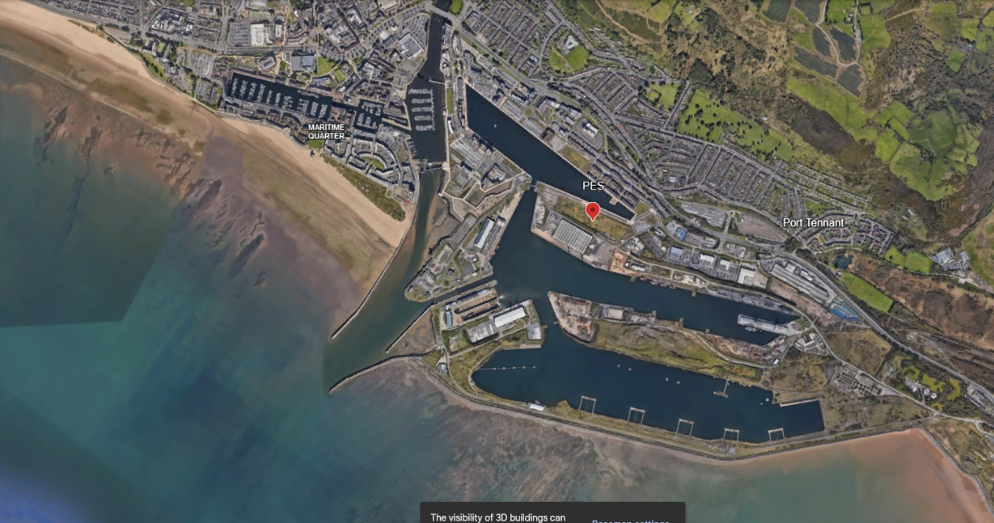
The proposed location of the new ammunition storage facility has been given as the latitude 51.61818 and the Longitude -3.91886. This location can be seen on the map shown in Figure 1, labelled as PES. This site is situated next to the Swansea docks operated by the Associated British Ports (ABP) as part of the ‘Port of Swansea’ [2]. This location is to the southeast of the city centre and is specifically located between the Prince of Wales and King’s Dock. While the Prince of Wales Dock is no longer used, the King's Dock remains an active commercial Port handling 600,000 tonnes of cargo annually. This port regularly hosts cargo and offshore energy vessels, with infrequent visits from cruise ships [2]. While the site itself has been described as wasteland land the surrounding area is relatively developed, as shown in Figure 1. The immediate area features a range of land uses: to the north are substantial residential and commercial properties; to the east, several vehicle dealerships in a commercial development; to the south, the docks and associated warehousing; and to the west, a university campus incorporating student accommodation.
Figure 1 – Map of Swansea

A more detailed view of the immediate area can be seen in Figure 2. Due to the proximity of these buildings to the explosive facility, they are classed as Exposed Sites (ES). An ES is described in the IATG as an inhabited building, assembly place or public traffic route which is exposed to the effects of an explosion or fire from the PES [3]. Several of these buildings may be further classed as vulnerable buildings due to their construction, with the IATG defining them as referring to an exposed site (ES) deemed to be vulnerable by nature of its construction or function [3]. This means that the nearby University, Hospital, and Hotel may require a greater separation distance from explosive activity.

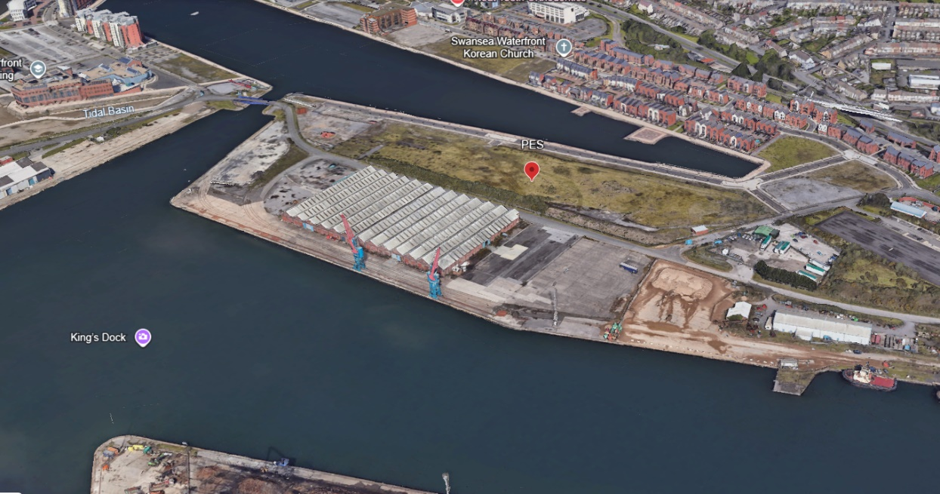
Figure 2 – View of PES

Explosive Storehouse (ESH) Construction

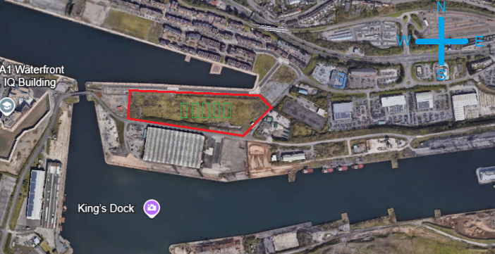
In the contractor's site description, the site is described as requiring no more than 5 ESHs to be built east to west along the wasteland. The site has also been described as having the magazine side perpendicular to the direction of the Exposed Sites (ES). Using this and the provided coordinates, a preliminary site plan has been created, as shown in Figure 3. This shows the site boundary outlined in red with the individual earth-covered storehouse boundaries in green. The site measures approximately 360m by 90m. As all the vulnerable buildings are to the west of the site, the ESHs have been orientated with the doors facing south, providing the most protection to the vulnerable buildings with the earth-covered sides.
Figure 3 – Preliminary Site Plan

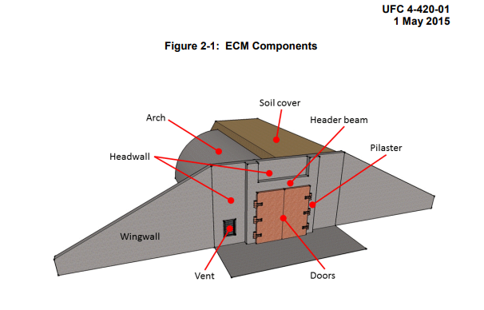
The design of the individual ESHs has not been specified by the contractor; however, for this report, it will be assumed that the construction is that of a typical NATO standard Earth Covered Magazine (ECM). An example of this can be seen in Figure 4, showing the components of an arch NATO standard ECM [4]. Due to the presence of HD 1.1 explosive, it is assumed that Arch-roof ECMs will be used as they are generally superior in terms of blast resilience, debris containment, and safety, making them the preferred option compared to a flat roof design. It is also assumed that this ECM will be built to the Bar-7 standard, meaning it can maintain a degree of structural integrity up to a reflected overpressure of 7-bar [4].
Figure 4 – ECM Components

The key design features of the ECM, shown in Figure 4, include the curved reinforced concrete shell forming the main body of the shelter. This is then covered by a thick layer of soil, providing mass and protection to the structure. This soil is then retained by the wing walls on either side of the blast doors. These doors are held in place by a reinforced concrete frame and are designed to blow off in the event of an internal explosion. The purpose of this design of ECM is not to contain the effects of blast from its own contents but rather to provide a controlled venting of gases, capture fragmentation, and prevent a chain reaction in adjacent magazines. Additionally, the ECM features vents and will typically have a Heating, Ventilation, and Air Conditioning (HVAC) system to control temperature and humidity.

Storage Capacity

Ammunition storage compatibility

As stated in the proposal by the contractor, the 5 ESHs in the ammunition facility can store 1000kg of each hazard division. This would give a theoretical maximum storage capacity of 20,000kg of explosives by Net Explosive Quantity (NEQ) with 4,000kg per ESH, however the requirement is only to hold a combined total of 7500kg of. These explosives are split into 4 different hazard divisions as shown in the table below. These represent a mass explosion hazard, a Projection hazard with no mass explosion, a fire hazard with minor blast, and no significant hazard outside packaging [5].
Hazard Division | NEQ
HD 1.1 | 5000 kg
HD 1.2 | 500 kg
HD 1.3 | 1000 kg
HD 1.4 | 1000 kg

These explosives have then been further split into compatibility groups for each of the hazard divisions. This allows for additional classification to be given to explosives to aid in the safety of the stage. This is because there are thousands of types of ammunition with different manufacturers, purposes, explosive types, and calibres that have different degrees of volatility. These compatibility groups can then be used to determine if these different types of munitions can be in a mixed store. This is controlled by strict mixing rules, which can be seen in the table in Figure 5. This shows which compatibility groups can be stored together in green, which ones cannot be stored together in red, and which ones have caveats to be stored together in orange.
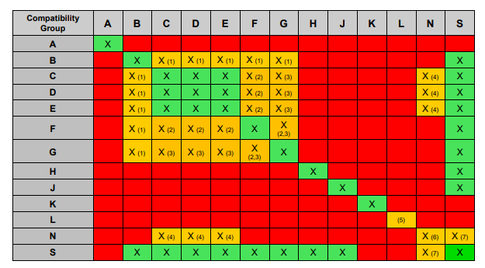
Figure 5 - Compatibility Group Mixing Table

Ammunition Distribution

Using the figures from the proposal in the table below and the compatibility table shown in Figure 6 a preliminary plan for the configuration of ammunition storage can be made. The only compatibility groups that have been requested to store in the ESH are B, D, E, F, C, and S. For these compatibility groups only groups D, E, C and S have no restrictions for mixing so may all be stored together in the same ESH. However, Several restrictions are in place for other items. For the 50kg of HD 1.1D this may only be stored with other items if they are the fuzes with other articles they will be assembled with or with the HD 1.4S. This also applies to the HD 1.1F and HD 1.2F unless effectively segregated to prevent propagation, which is unlikely due to the quantities of explosives
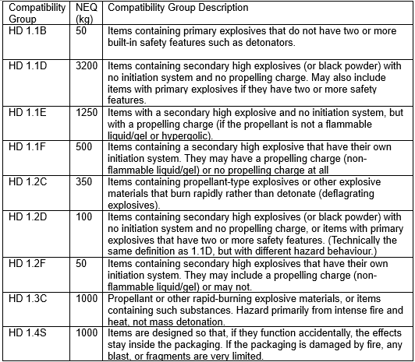
Figure 6 – Compatibility group Descriptions

Using the information from the proposal and the compatibility group mixing table the following distribution plan has been made for the 5 ESHs. This table shows a breakdown of the quantity of each type of hazard division compatibility group and showing the lowest possible NEQ achievable for each ESH. This also meets the requirements in the proposal with no ESH holding more then 1000kg of 1 hazard division whilst also storing the full ammunition quantity required by the facility. Due to the presence of HD 1.1B, an assumption has been made that this represents fuzes being stored with the other HD 1.1 articles to which they will be assembled. Therefore, according to Note 1 of the mixing rules these items may be stored together and treated as compatibility group F allowing HD 1.1F and HD 1.2F to also be stored in ESH-5 [6].

Compatibility Group | Total (kg) | ESH-1 (kg) | ESH-2 (kg) | ESH-3 (kg) | ESH-4 (kg) | ESH-5 (kg)
HD 1.1B | 50 |  |  |  |  | 50
HD 1.1D | 3200 | 1000 | 1000 | 1000 |  | 200
HD 1.1E | 1250 |  |  |  | 1000 | 250
HD 1.1F | 500 |  |  |  |  | 500
HD 1.2C | 350 | 100 | 50 | 100 | 100
HD 1.2D | 100 |  | 100
HD 1.2F | 50 |  |  |  |  | 50
HD 1.3C | 1000 | 250 | 250 | 250 | 250
HD 1.4S | 1000 | 150 | 100 | 150 | 150 | 450
Total | 7500 | 1500 | 1500 | 1500 | 1500 | 1500

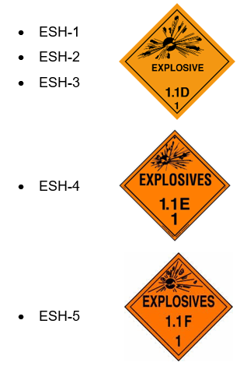
From this storage plan the following warning signs shown in Figure 7 would need to be displayed on the site information board as well as on the individual ESHs themselves.
Figure 7 - ESH Signage

Quantity-Distance Map

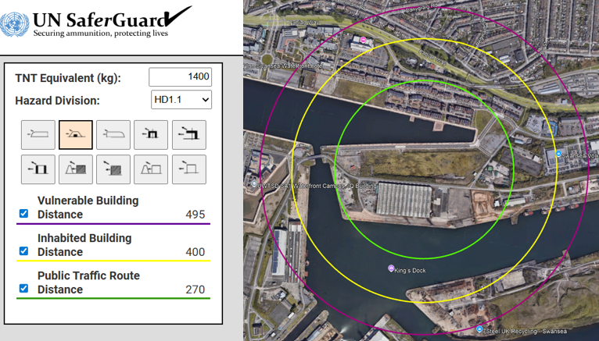
After calculating the quantities being stores in each ESH a quantity distance map could then be created. This was done using the UN SaferGuard risk management tool. As 1.4S does not count to the overall NEQ for a Potential Explosion Site (PES) as stated in the IATG that ammunition and explosives of HD 1.4 are not a function of NEQ. This is because 1.4 separation distances should be based on the fire risks as no significant explosion hazard is present [7]. Therefore, an NEQ of 1400kg TNT equivalence was selected, this was based of ESH-2 representing the largest NEQ from the ESH distribution plan. This was then entered into the quantity distance tool and HD 1.1 was then selected as shown in Figure 6. This was selected as despite some of the explosives being HD 1.2, the quantity distance is based off the highest HD in a PES. The PES type was then selected as an earth covered explosive storehouse and the coordinates entered. Due to a issue with the UN tool this data was then downloaded and imported onto google earth to be displayed, the generated quantity distances can then be seen in Figure 8. This shows the Vulnerable Building Distance (VBD) in purple, The Inhabited Building Distance (VBD) in yellow, and the Public Traffic Route Distance (PTRD) in green.
Figure 8 - Required NEQ Quantity-Distance Calculator

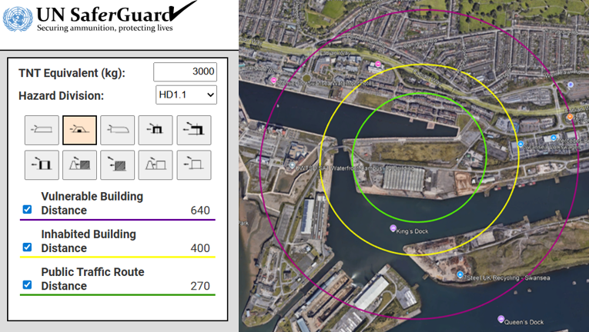
This process was then completed again to calculate the Quantity-Distance for the maximum potential NEQ for an ESH. This was based on the statement from the proposal that each ESH will be able to hold up to 1000kg for each HD. After discounting the HD 1.4 this left a maximum potential of 3000kg of TNT equivalent which was entered into the calculator repeating the same steps as before. The VBD, IBD, and PTRD generated from the calculator for this can be seen in Figure 9.
Figure 9 – Maximum NEQ Quantity-Distance Calculator

Exposed Site Distances

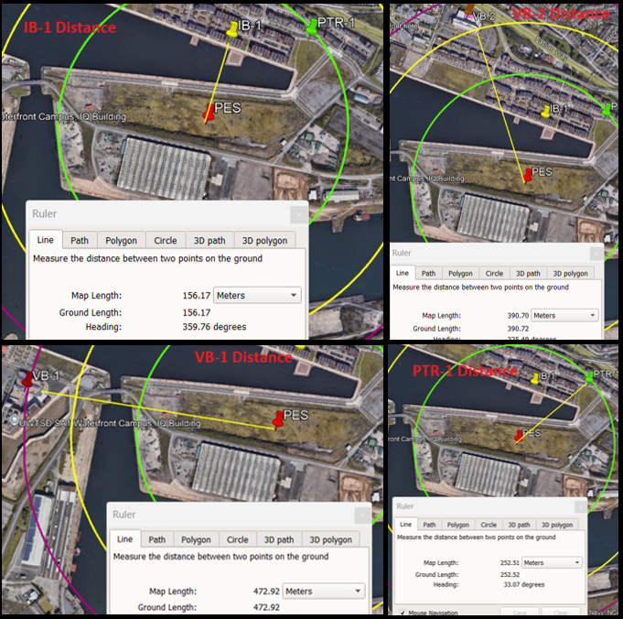
After completing the Safeguard map the distances were then checked from the potential explosion site to each of the nearest types of exposed site. This was done using the distance measuring feature on google earth to allow for an explosive licence to be generated and to check the figures provided in the proposal. These measurements can be seen below in Figure 10 and are based of the buildings identified in the location research. The first measurement shows the distance to the nearest inhabited building marked as IB-1 distance at 156 meters. The Next shows the distance to the nearest vulnerable buildings marked as VB-2 Distance at 390m. The second vulnerable building also within the VBD is marked as VB-1 Distance at 472m. And finally, the nearest public road is marked as PTR-1 at 252m.
Figure 10 – Exposed Site Distances

Explosive Limits Licence

After completing the safeguarding map an Explosive Limits Licence was then generated using the UN SaferGuard Tool [8]. To do this information from the proposal about the site was entered. This included the type of PES and its construction selecting Earth covered explosive storehouse perpendicular to the ES as shown in Figure 11. Using the safeguarding map and the measured distances each exposed site identified was then entered, and an ELL created.
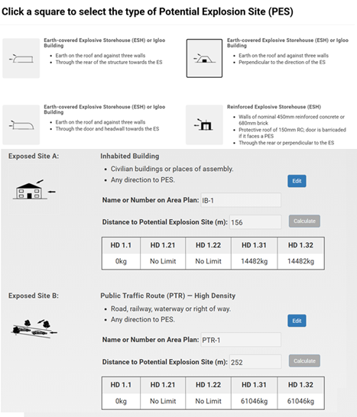
Figure 11 - UN Explosive Limit Licence Tool

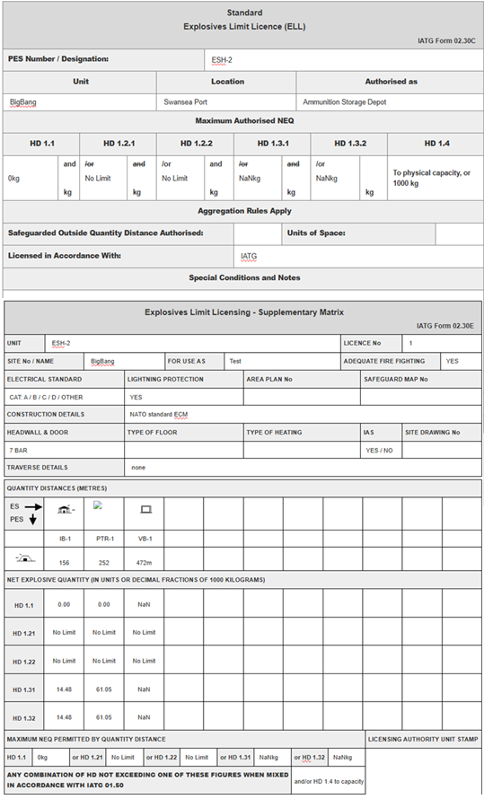
The licence and the supplementary matrix that was created can then be seen in Figure 12. This shows a breakdown of the Maximum authorised NEQ of explosives authorised to be stored in the ESH based on the distances to each exposed site. This shows that no HD 1.1 is authorised to be stored, there is no limit on HD 1.2.1 and HD 1.2.2. Due to issues with the entered figures, it was possible for HD 1.3.1 and HD 1.3.2 to be calculated so No Actual Number (NaN) is displayed. And finally, 1.4 is authorised to physical capacity with the self-imposed limit of 1000kg from the proposal.
Figure 12 - Explosive Limit Licence

Discussion

Safeguard Distances
The information given by ‘BigBang’ in the proposal stated that Vulnerable Building Distance (VBD) was no more than 300m, The Inhabited Building Distance (IBD) was no more then 125m, and the Public Traffic Route Distance (PTRD) was no more than 270m for each ESH. However, after independently completing a Safeguard map for both the required quantity of explosives and maximum for site this distance has been shown to be inaccurate. This can be seen in Figure 8 which shows that based on an NEQ of 1400kg these distances are 495m, 400m and 270m for each respective distance. The maximum storage capacity of 3000kg also increase the VBD increases to 640m. Therefore, the distances provided in the proposal for the IBD and VBD are incorrect and should be larger according to the safeguarding map. As shown in Figure 8 all the sites chosen does not meet any of these distances with a large housing estate being in the IBD, A university and Hotel are also within the VBD due to the glass construction, and a high-density traffic route also running parallel to the site inside the PTRD.
By using the Hopkinson-Cranz rule which allows the scaling of blast data using the cube root law a precise quantity distance can be calculated. Given a coefficient of Z, the equations for this calculation are Range = Z * Weight^{1/3} and Weight = (Range / Z)³ [9]. This allows for a VBD of 496.70m, a IBD of 248.35m, and a 165.57m to be calculated based of an NEQ of 1400kg. This means the distance can be reduced so that the PTRD is met however the IBD and VBD still contain several exposed sites. Using the range calculation for the desired NEQ of explosives 250m would be required for the nearest inhabited building, and 500m distance from the ESH to the nearest vulnerable building which is not met in this site. This means that for a licence to be granted and for the site to contain to desired quantities of explosive further work will need to be completed. This could either be in the form of blast modelling to prove that the design of the ESH will contain / direct the explosion away from the exposed sites or by building traverses. If additional travers were built around the site such as earth or concrete barriers this would provide additional protection to exposed sites and allow for smaller quantity distances.

4.3 Safety Concerns

Several safety concerns have been identified from the requirements set out in the proposal. The first of these concerns are the location of the site, this is because it is situated in the middle of an operational port. This means that visiting vessels would be impacted by the construction of this site and restrictions would need to be put into place and potentially prevent access. Additionally, the presence of vessels and maritime infrastructure also present Hazards of Electromagnetic Radiation to Ordnance (HERO) [10]. This is due to powerful radio frequency that are associated with maritime operations which could affect stored explosives. Additionally, the substantial lumber export yard on the docks also poses an increased risk of fire in the surrounding area, a warehousing facility is also located directly next to the proposed location which could introduce hazards from dangerous goods such as Fuel, chemicals, and combustible cargo.

4.5 Storage Concerns

Several concerns have also been identified from the storage requirements placed on the facility relating to the compatibility groups. This is because it is not possible to store all the required explosives with a limit of 1000kg NEQ for each of the ESHs without mixing compatibility groups. This is only and issue for compatibility group B which can only be stored with the other groups present if they are part of the initiation system of their respective munition as shown in Figure 5. Therefore, to create the storage plan an assumption was made that this was correct however no specific details have been given for what explosive are to be stored. If this assumption is incorrect then the explosive would not be allowed to be stored with the other compatibility group F munitions. This would mean that they would have to be segregated in the ESH as no other storage is available. This could prove not possible to do due to the quantity of category F that has been requested, therefore sufficient space may not be provided by only 5 ESHs.

Conclusion

5.1 Summary

From the investigation carried out as part of this safety report several issues have been identified with the proposal submitted to the council. The first of these issues is the location of the site chosen. This site is located only a short distance away from the centre of a large city. This creates several issues, the first of which would be the transport of explosives, any access to this ammunition facility would require explosive transportation vehicles to drive through densely populated areas. This activity would increase risk to the transportation and would also likely be negatively responded to by residents. Because of this it is likely there would be substantial opposition to the construction and operation of this site. Additionally, the chosen site has a size of 360 by 90 meters, this limits construction space significantly and would limit sufficient separation distances between ESHs and any admin buildings.
Another issue that has been identified with the proposal is the quantities of explosives required to be stored. After independent investigation of the safeguarding distances, it has been determined that the safeguarding distances in relation to VBD and IBD supplied by the contactor are incorrect. Because of this it will not be possible to gain an explosive licence for the facility or operate safely without significant changes to the application. This would either require lowering explosive quantities, building additional traverses, blast modelling, or the relocation of countless buildings. This is due to the presence of both inhabited and vulnerable buildings being inside the calculated VBD and IBD. The location of the site being chosen at an operational port also introduces many issues. This includes HERO, storage of potential hazardous materials, maritime traffic, and increased fire risk. For this to be mitigated exclusion zones and barriers would need to be introduced into the port area significantly effecting operations.
The quantities of explosives requested have also raised issues with compatibility groups as explained previously in the report. This would require either specific explosive types to be listed, quantities to be reduced, or further ESHs included in the plan. Because of these issues mentioned it is the finding of this report that the council should not approve this plan. A recommendation is also being made that any other applications should seek a different location in a less populated area for greater separation distances, more land to build on, and away from operational sites such as ports.

References

[1] | UN, “IATG 05.10 Planning and siting of explosives,” March 2021. [Online]. Available: https://data.unsaferguard.org/iatg/en/V3_IATG-05.10_en.pdf.
[2] | ABP, “Port Inforation Swansea,” [Online]. Available: https://www.southwalesports.co.uk/Port_Information/Swansea/Swansea/. [Accessed 10 12 2025].
[3] | UN, “IATG 01.40 Glossary of terms, definitions and abbreviations,” March 2021. [Online]. Available: https://data.unsaferguard.org/iatg/en/V3_IATG-01.40_en.pdf.
[4] | DOD, “UFC 4-420-01 AMMUNITION AND EXPLOSIVES STORAGE MAGAZINES,” 1 May 2015. [Online]. Available: https://exwc.navfac.navy.mil/Portals/88/Documents/EXWC/DoD_Locks/PDFs/UFC_4-420-01.pdf.
[5] | UN, “Part 2 Classification,” 2009. [Online]. Available: https://unece.org/DAM/trans/danger/publi/unrec/rev16/English/02E_Part2.pdf.
[6] | UN, “IATG 01.50 UN explosive hazard classification system,” March 2021. [Online]. Available: https://data.unsaferguard.org/iatg/en/IATG-01.50-Explosive-hazard-classification-system-IATG-V.3.pdf.
[7] | UN, “02.20 Quantity and separation distances,” March 2021. [Online]. Available: https://data.unsaferguard.org/iatg/en/IATG-02.20-Quantity-separation-distances-IATG-V.3.pdf.
[8] | UN, “Create an Explosives Limit License,” [Online]. Available: https://unsaferguard.org/un-saferguard/explosives-limit-license. [Accessed 8 12 2025].
[9] | UN, “Quantity Distance Calculator,” [Online]. Available: https://unsaferguard.org/un-saferguard/quantity-distance-calculator. [Accessed 10 12 2025].
[10] | M. Lima, “Hazards of Electromagnetic Radiation to Ordnance (HERO),” 27 December 2024. [Online]. Available: https://mikelimadba.substack.com/p/hazards-of-electromagnetic-radiation.

Appendix

Risk reduction safety questions

- Has a formal ammunition management and procurement plan been made?
- Have risk assessments be carried out at the chosen location for the site?
- Has an environment management plan been made to track the location of munitions?
- Does the design of the proposed ESHs meet NATO standards?
- Has a security fence been designed for the site?
- Is there a plan for security cameras to be installed?
- Has a survey been done for the condition of the land for flooding and drainage?
- Has a plan for compatibility group management been created?
- Has an emergency response and firefighting plan been created?
- Have evacuation and alarm plans been created?
- Is there a designed muster point?
- Is there a plan for staff training to ensure that they are suitably qualified and experience?
- Is there a plan to notify the nearby residents in the event of an emergency?
- Have operating procedures been created?
- Has a designated smoking area been created?
- Are there sufficient facilities for staff wellbeing?
- Has a plan been developed for suitable lifting equipment such as cranes and forklifts?
- Does the development include lighting protection systems?
- Is an antistatic regime required?
- Does the site feature sufficient lighting for operations?
- Does the site feature power, sewage, and water utilities?
- Has a maritime interface plan been created?

