

Assessment 1 – Reading Task Template
PART 1: Upload your photo of your A3 in-class notes here:
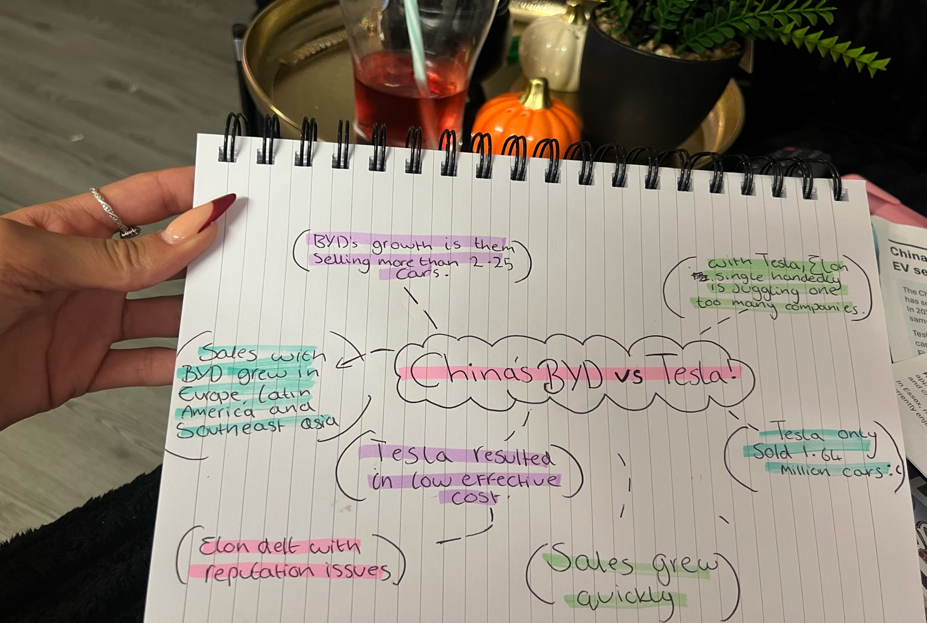

PART 2:
- Answer every question below in 1-3 full sentences.
- Use your own words. Do not use generative AI to answer these questions.
- Include a specific detail from the text when asked.
REMINDER
- The main idea is the overall message of the whole text.
- A key point helps to explain the main idea.
- A specific detail or example from the text shows that the key point is true.

- What is the main idea of the whole text?
The main idea is platforms such as instagram, tik tok and facebook, are able attract and bring in more attention to the public and help smaller businesses grow.

- What is one key point that supports the main idea, and which specific example from the text shows this?

Well, the sandwich shop he opened didn’t do to well reaching the public with him alone just posting his content. Others coming in, trying sharing and uploading food , reached the global audience and was able to gain more customers, thus, better income for the shop.

- What is a different key point that supports the main idea, and which specific example from the text shows this?

A different key point is the media truly can change small business. The example is Lindy loo went to strictly selling online and is able to ship as far as Australia.

- Which part of the text do you think is most important, and why?

Ironically, I personally feel as thought sticking to what it’s about , the media, I think is most important as it goes to show no matter how small a business , there is always a larger community, and with that comes more success!

Reflection:
- What did you find difficult in this task (including in-class components), and why was it difficult?

Difficulty in this task for me was not being able to understand the questions right away and would have to continuously analyse the paper to help understand what was being asked.

- What helped you with this difficulty, and how did it help you?

What helped me was skimming through the paper and reading both paper and questions out loud and not in my head .

