
Student Name: | Ashfaq Mohammad
Student ID Number: | 2504711
Programme: | BSc Health and Social Care
Module Title: | Introduction to Physiology
Module Code: | BMHP5023

Table of Contents
- Introduction ........................................................................................ 3
- Maintenance of Blood Glucose Levels .............................................. 3
- Glucose and Oxygen in Cellular Energy Production ……….………... 6
- Blood Glucose Monitoring and Tracking ............................................ 6
- Evidence-Based Lifestyle Recommendations ................................... 8
- Conclusion ......................................................................................... 9
- Reference List ................................................................................. 10

a) Introduction
More patients are now being diagnosed with diabetes, and there are many benefits they have from understanding their condition as well as what lifestyle activities will impact blood sugar, for them to be involved with their care plans and manage safely and effectively. The report describes blood glucose regulation, cell structure and function of glucose and oxygen, importance of glucose monitoring, and how diet, exercise and smoking affect glucose.
Diabetes is a chronic condition where the blood sugar level is constantly kept elevated due to insufficient supply, or the body's inability to utilize insulin. Type 1 diabetes is caused by an absence of insulin while type 2 diabetes is caused by insulin resistance along with a progressive loss of the pancreatic β-cells which is responsible for half of the diabetes cases in the UK (Ahmad et al., 2022; Diabetes UK, 2025). Diabetes UK (2025) estimates that over 4.7 million people in the UK have a diagnosis, almost 1.3 million may have undiagnosed type 2 diabetes, and over 12 million adults have diabetes or prediabetes. If glucose stays high, blood vessels and nerves to the body get damaged so early detection of glucose and managing it in a proactive way prevent complications (Ahmad et al., 2022).
There are two types of risk: non-modifiable and modifiable. The risk of type 2 diabetes is not influenced by being overweight or obese and age and family ethnicity are uncontrollable (Diabetes UK, 2025). Diabetes UK (2025) states that some ethnic groups have lower weight thresholds for developing type 2 diabetes than white people. The modifiable ones are smoking, which is linked to higher insulin resistance (Blagov et al., 2024; Walicka et al., 2022), physical inactivity, and central obesity, which is directly related to an increase in insulin resistance.
There are implications for my practices with respect to this. Several risk factors are modifiable, so I enquire of every patient in each review about weight, activity, diet and smoking, then I jot these down in exactly the same way every time and I use these to set up patient specific and achievable goals.
b) How the blood glucose level is kept at a safe level
In health, glucose concentrations in the blood stay in an all-too-slim window, despite the ups and downs in food intake, through the regulation of liver glucose production, and tissue uptake, chiefly skeletal muscle (Blagov et al., 2024). After eating, blood glucose levels rise, causing insulin to be secreted by the pancreatic β-cells. The action of insulin is to decrease the production of glucose in the liver while increasing the uptake of glucose in muscle and fat, in the latter of which insulin causes the GLUT4 transporters to translocate to the cell surface (Blagov et al., 2024). Glucose drops which stimulates glucagon (from α-cells) to stimulate glucose release from liver. There is a negative feedback loop which maintains steady level between meals, overnight and active during the day.
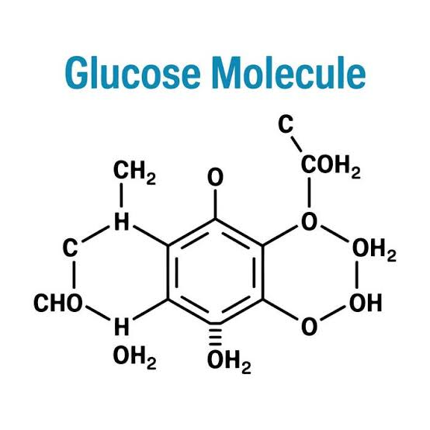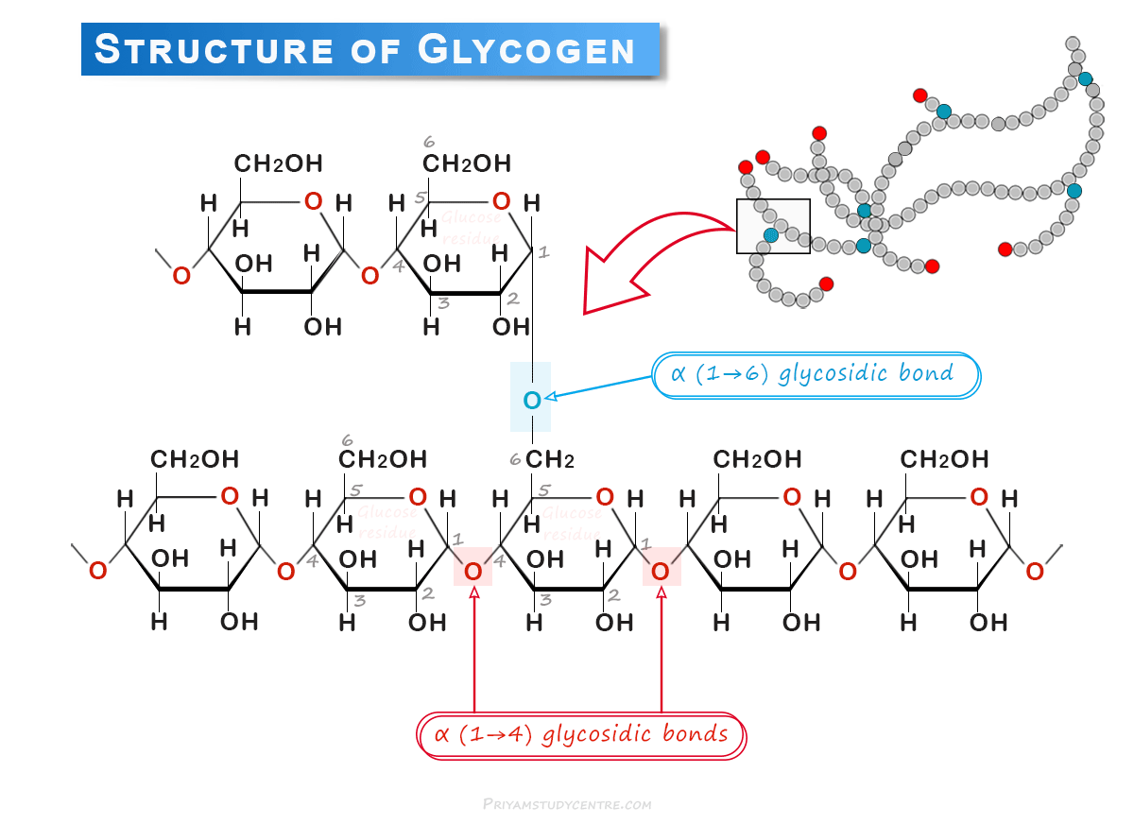
(PSC, 2026)
The loop doesn't work in type 2 diabetes. Body’s muscle, liver and fat start to become less sensitive to insulin, often 10 to 20 years before detection, with the pancreas then coming up with increased insulin production to counteract this (Blagov et al., 2024). Over time, β-cells do not keep up with the glucose requirements and insulin production declines and glucagon levels are not well controlled leading to excess production of glucose by the liver, resulting in elevated glucose in the blood (Blagov et. al., 2024).
Within clinic I explain very simply: insulin is a key which doesn't easily fit in the lock, glucose therefore remains in the blood rather than entering cells. Patients can often see this in the form of thirst, urination and tiredness and, therefore, understand the importance of control.
Safe control also implies not letting the glucose get too low. NICE (2026) suggest discussing an individual target for HbA1c with the adult this should be 48 mmol/mol (6.5%) if using lifestyle or metformin only, and 53 mmol/mol (7.0%) if taking medicines which can cause hypoglycaemia. Every time they are personalized, I tell each patient about their own number at review, and document in the care plan. I also make sure to name side-effects, which they should experience at both sides since hyperglycaemia causes thirst, tiredness and blurred vision, while at the other side, if they do experience a hypoglycaemia, a risk they may have, with sulfonylureas or insulin, then they will get sweating, tiredness and confusion, and require fast-acting carbohydrates and review. It is important for patients taking these medicines to know what to bring with them and when to get help.
Although the latest NICE guidance has more complications driven, the principles of treating hyperglycaemia are basic (Bailey, 2026). If patients grasp the science of regulation, they thus have a practical motivation to check their glucose levels, as well as appropriate medication intake and lifestyle changes.
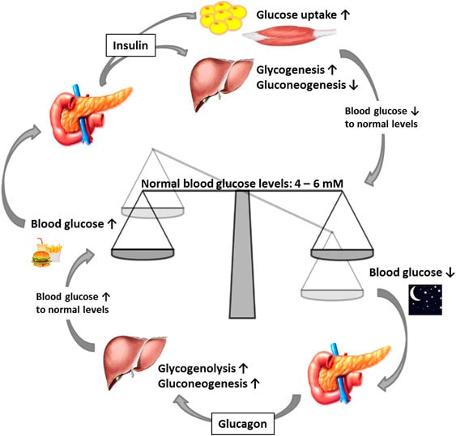
(Liu, 2016)
c) How glucose and oxygen produce energy
The cell must be provided with a constant flow of adenosine triphosphate (ATP) which is the principal raw material provided by glucose and oxygen. Insulin induced GLUT4 mediated uptake: glucose is taken up, then glycolyse in the cytoplasm, yielding a small amount of ATP and pyruvate. In the presence of oxygen, pyruvate is transported into the mitochondria, converted into acetyl-CoA and enters the tricarboxylic acid (Krebs) cycle generating electron carriers, such as NADH and FADH2 (Blagov et al., 2024).
These carry electrons to electron transport chain/inner mitochondrial membrane. Each time the electrons move through protein complex I on to complex IV, protons are pumped into the matrix, creating a gradient which is used by ATP synthase to convert ADP to ATP. In complex IV, Oxygen receive the electrons and gets reduced to water (Blagov, et al., 2024). Therefore oxygen is crucial to the process: if there is an absence of oxygen, the anaerobic glycolysis in the cell is less efficient, and the pyruvate becomes converted to lactate (Blagov et al., 2024).
In diabetes type 2, the activity of insulin signals is disrupted and this prevents GLUT4 from moving, leading to an accumulation of glucose in the blood and cells effectively “starving.” At the same time, elevated levels of glucose result in an increase of ROS (Reactive Oxygen Species) and studies have shown a connection between mitochondrial dysfunction in muscle, liver and β-cells with increased insulin resistance which leads to worsening IR (Insulin Resistance) (Blagov et al, 2024).
That's why a frequent question I hear in my clinic about high sugar and feeling tired is: why is it that when my sugar is high, I feel so tired? Describe that the level of glucose in the blood is high but that the level in the muscle cells is not high enough to be of use. It's also related to lifestyle advice that I give. Regular walking promotes mitochondrial function and glucose oxidation (Blagov et al., 2024), suggesting exercise and calorie restriction benefit cells' use of glucose. I also reference smoking because smoking affects the blood vessel (Walicka et al, 2022) and the oxygen arrives in the blood vessel to reach the cells.
d) Measure of blood sugar and keeping a glucose record
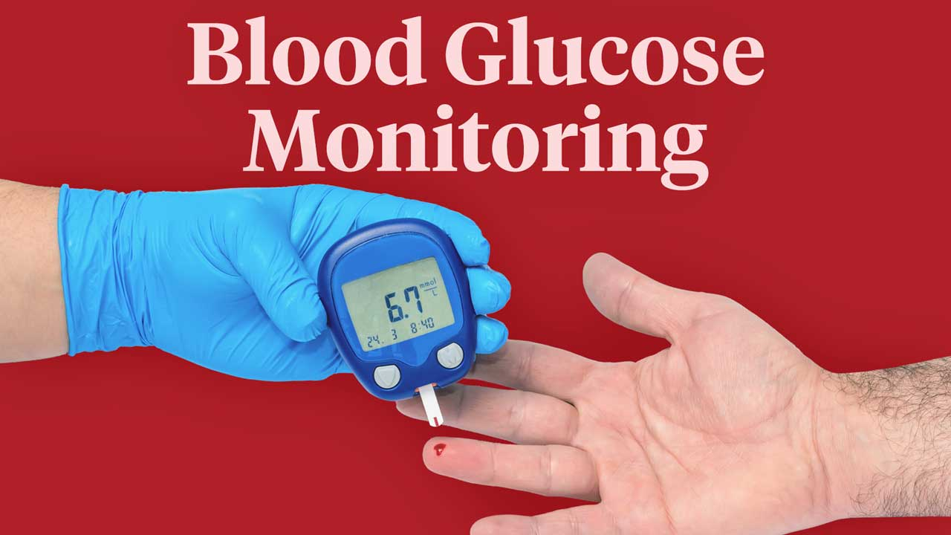
(Mathew et al. 2023)
If I have glucose reading and a patient, they can understand what the objective information actually is that they should adjust that safely and in a proper manner. Two measures matter, HbA1c is considered a guideline measure rather than a direct measure, as it reflects the average blood glucose for approximately three months, Holmes-Truscott et al., 2023 suggest regular monitoring of HbA1c is advised, about every 3-6 months until the HbA1c is stable and then 6 monthly. Real-time snapshot provided with capillary self-monitoring of blood glucose (SMBG).
There has been controversy over the usefulness of SMBG in non-insulin treated type 2 diabetes. Holmes-Truscott et al., (2023) performed a meta-analysis of 23 studies (N = 5,372) and measured the effect of structured self-monitoring on HbA1c and diabetes self-efficacy, which yielded a small, but statistically significant effect for both outcome measures, with reductions in HbA1c of 0.29% and improvements in SE of 0.24%. The finding was that there was cross-study variability, and the effect should be taken with a grain of salt. The word structured is having meaning, readings benefit when they are related to a plan as to what to do with the results.
In real life, I don't have all my patients test every day. If not taking insulin, I think taking a reading before and two hours after the main meal, 3 days a week for 2 weeks and putting this on a diary with what you ate, how active you were, and any symptoms recorded is a good time limited regime if you aren't on insulin. On review we search our ways of rising, for example, after some meals, and correlate them with changes. People who use insulin and people who take drugs that can lead to a low blood sugar should have more frequent tests, I check these when their treatments change. I also keep diaries with the broader GP team to ensure that what's happening is based on trends instead of individual outcomes.
Tracking is also good for safety. I instruct patients to take their readings regularly, take the diary to all review appointments, and make contact with the surgery when readings are regularly high, if they have symptoms of high or low glucose or if they have an acute illness. Given the importance of personalised care in NICE (Bailey, 2026), each plan will be dependent upon the patient's individual routine rather than a generic time schedule. A reduction in reading following the walk also provides immediate feedback, consistent with self-efficacy reported (Holmes-Truscott et al., 2023).
e) Evidence based lifestyle recommendations
Diet and weight
NICE (2026) recommends setting an initial overweight loss goal of 5% to 10% for adults all healthy eating guidelines apply, and abstaining from diabetes specific products should be avoided. In clinics, I make smaller cultural changes, such as eating smaller amounts of foods that I've identified as starchy foods, and less sugary drinks. At each review, I take the patients' weight and waist sizes, so they can provide feedback on how they are feeling and whether they are making progress just a few pounds at a time is better.
Young people learn more in intensive programmes. The UK DiRECT trial revealed a mean 7.6 kg weight loss and remission in 36% of those enrolled in a weight management programme within primary care at the end of 2 years. After five years, extension participants still had lost 6.1 kg (Lean et al., 2024) with 13% (11 of 85) of people in remission and 26% of those in remission at two years remained in remission at five years, the most significant factor being sustained weight loss (Lean et al., 2024). They're not always going to be cured of that, but it is possible to achieve remission and in time, support is required. The study findings may not be generalisable to all patients as the study included people aged 20-65 and with less than six years diabetes duration, a BMI of more than 27, but who were not taking insulin (Lean et al., 2024). Patient consented referral through GP practice for NHS England Diabetes Path to Remission Programme for Total Diet Replacement (TDR) (NHS England, 2023). I review eligible patients to ensure that they are enrolled and discuss the programme with them in a factual manner, along with their medicines being reviewed.
Physical activity
In a 2025 network meta-analysis of trials of 12 or more weeks duration, HbA1c was lowered by 0.61% with HIIT, 0.58% with combined aerobic and resistance training, 0.58% by aerobic training, 0.40% by resistance training and 0.35% for physical activity advice only. The authors suggest giving recommendations on activity to all respondents due to its easy implementation (Garcia et al., 2025). These are mean values obtained from trials and I would encourage patients to select activities in line with their own preference as a successful plan is more useful than a flawless plan that doesn't get followed. For inactive patients, starting with more intense exercise is wrong starting point. Periodic 10 minute strolls after meals, gradually to be progressing to regular brisk walking, twice weekly strength training and possibly a supervised group, cardiovascular risk assessment and footwear. Those on insulin or sulfonylureas are given instructions to have fast-acting carbohydrates readily available.
Smoking
Smoking and diabetes have a more detrimental effect on the development of vascular damage, and smoking also increases insulin resistance (Walicka et al., 2022). While cardiovascular risk is reduced, there is a potentially unpredictable effect on glucose control, with short-term HbA1C worsening seen on the first 6 months after stopping, due in part to weight gain, so there is no need for clinicians to “promise” improved readout and regular monitoring of weight gain is important with (Walicka et al., 2022). I explain to patients that the primary reason to quit is because of the protection of their heart, vessels and kidneys, connect them with NHS, and pay more attention the first few months for weight and HbA1c.
It is impossible to change everything all at once. Establish 2 – 3 SMART goals with each patient, document in care plan, review with patients as part of glucose diary, provide group structured education preferred by NICE (2026). I also take the time to discuss language needs, culture around foods, work life and families support, as all of these things can't be discussed away for practical application.
f) Conclusion
Type 2 Diabetes is a common condition and is increasingly becoming more prevalent, but lifestyle changes can help people control Type 2 Diabetes. My role as a practice nurse is to discuss the action of insulin and glucose and provide clear and proven advice on weight loss, exercise, a healthy diet and on quitting smoking. For patients, structured blood glucose record guides and improves their BGR understanding and decision making. I encourage each of my patients to establish "realistic and achievable goals" and “sites of review” that are expected on regular visits to reinforce the information. Many minor adjustments can help to manage diabetes, make blood glucose healthier and prevent other complications from occurring.
REFERENCES
Ahmad, E., Lim, S., Lamptey, R., Webb, D.R. and Davies, M.J. (2022) 'Type 2 diabetes', The Lancet, 400(10365), pp. 1803–1820. Available at: https://doi.org/10.1016/S0140-6736(22)01655-5
Bailey, C.J. (2026) 'Management of type 2 diabetes in adults: NICE updates guidance', British Journal of Diabetes, 26(1), pp. 16–19. Available at: https://doi.org/10.15277/bjd.2026.508
Blagov, A., Nedosugova, L., Kirichenko, T., Sukhorukov, V., Melnichenko, A. and Orekhov, A. (2024) 'Mitochondrial dysfunction as a factor of energy metabolism disorders in type 2 diabetes mellitus', Frontiers in Bioscience (Scholar Edition), 16(1), article 5. Available at: https://doi.org/10.31083/j.fbs1601005
Diabetes UK (2025) How many people in the UK have diabetes? Available at: https://www.diabetes.org.uk/about-us/about-the-charity/our-strategy/statistics
Garcia, S.P., Cureau, F.V., de Quadros Iorra, F., Bottino, L.G., Monteiro, L.E.R.C., Leivas, G., Umpierre, D. and Schaan, B.D. (2025) 'Effects of exercise training and physical activity advice on HbA1c in people with type 2 diabetes: a network meta-analysis of randomized controlled trials', Diabetes Research and Clinical Practice, 221, article 112027. Available at: https://doi.org/10.1016/j.diabres.2025.112027
Holmes-Truscott, E., Baptista, S., Ling, M., Collins, E., Ekinci, E.I., Furler, J., Hagger, V., Manski-Nankervis, J.-A., Wells, C. and Speight, J. (2023) 'The impact of structured self-monitoring of blood glucose on clinical, behavioral, and psychosocial outcomes among adults with non-insulin-treated type 2 diabetes: a systematic review and meta-analysis', Frontiers in Clinical Diabetes and Healthcare, 4, article 1177030. Available at: https://doi.org/10.3389/fcdhc.2023.1177030
Lean, M.E.J., Leslie, W.S., Barnes, A.C., Brosnahan, N., Thom, G., McCombie, L., Kelly, T., Irvine, K., Peters, C., Zhyzhneuskaya, S., Hollingsworth, K.G., Adamson, A.J., Sniehotta, F.F., Mathers, J.C., McIlvenna, Y., Welsh, P., McConnachie, A., McIntosh, A., Sattar, N. and Taylor, R. (2024) '5-year follow-up of the randomised Diabetes Remission Clinical Trial (DiRECT) of continued support for weight loss maintenance in the UK: an extension study', The Lancet Diabetes & Endocrinology, 12(4), pp. 233–246. Available at: https://doi.org/10.1016/S2213-8587(23)00385-6
National Institute for Health and Care Excellence (2026) Type 2 diabetes in adults: management. NICE guideline NG28. Last updated 18 February 2026. Available at: https://www.nice.org.uk/guidance/ng28
NHS England (2023) NHS Type 2 Diabetes Path to Remission Programme service specification. Available at: https://www.england.nhs.uk/long-read/nhs-type-2-diabetes-path-to-remission-programme-service-specification-2023/
Walicka, M., Russo, C., Baxter, M., John, I., Caci, G. and Polosa, R. (2022) 'Impact of stopping smoking on metabolic parameters in diabetes mellitus: a scoping review', World Journal of Diabetes, 13(6), pp. 422–433. Available at: https://doi.org/10.4239/wjd.v13.i6.422

