Coaching and Mentoring Skills for the Workplace

A Report of
Individual Reflection on Role Play

Student’s Name: Bikash Roy
Student ID: 2010168
Module: BMSW6105_LON
Tarm and Group: T-2 G-1
Lecturer’s Name: Dr Nting Rexon

Healthcare International
  - A Reflective Statement
Contents
1.Introduction 2
2.Description: 3
3.Coaching and Mentoring: 3
4.Learning Outcome from the Module: 4
4a. Gibbs’ Reflective Cycle: 4
4b. Egan’s Skilled Helper Model: 5
4c. GROW Model: 6
5.Summerisetion of the topics: 6
5a. Coaching Session: 7
5b. Graham Philippa vs Robert Lee: 7
5c. Role play and GROW model: 8
5d. Graham Philippa vs John Griffiths: 9
6. Conclusion and Recommendation: 10
7.Refferencesses: 10
Appendix: 10

1.Introduction: We have been provided a case study and to choose any role for role play as coachee, alternatively to act as a Coach “Graham Philippa”. The aim of that role play was to prove our ability to apply strategies and tools and show our learning outcomes to be a Coach or Mentor at appropriate level. We must analyse the goals of coaching and mentoring in the context of an organisation. An effective coach or mentor must be examined in terms of their skills, attitudes, behaviours, convictions, and values. We had to concentrate on examining the skills, attitudes, behaviours, convictions, and values of an effective coach or mentor. In this subject, we learned various methods for setting up coaching or mentoring sessions as well as ways to deal with problems that may arise within an organisation or among individuals. One coaching or mentoring module should be used, as specified.
2.Description: At the 4th week of our lessons, we got opportunity to choose partner of role play. Although I was absent on that day, Mr Alfa chosen me as partner and our teacher accepted it. Mr Alfa later informed it personally. We arranged couple of meeting to make our role play constructive and more effective. We both as coach and coachee wanted to sort out some issues at the aspect of selected role and a soulful method of solution. In this module we introduced ourselves with some of the useful module to organise coaching & mentoring session and in our role play we tried to follow one module for each conversation, however during the role play we tried to apply our learning skills, regardless any formal process.
As it was a role play between two college, known from period, working together in the same company. However, our subject is “Coaching & Mentoring Skills for the Workplace”, we considered us as college, as superior and subordinate, superior to act as coach or mentor, subordinate as coachee. Our main objectives were to show our learning and understanding capacity and utilise the modules in workplace environment. We received feedback from our module teacher Dr Rexon Nting. Although we concentred to follow proper guidelines and format to perform our role play, we understood as a learner still now we have lots of things to consider to be become a proper coach or mentor. However, it is our initiative after starting our journey. We have to do more study and research to apply our skills in the formal workplace environment.
3.Coaching and Mentoring: The mentor serves as a role model and a "how-to-be" guide while the coach provides instruction and demonstration. The mentor waits for anxiety and then gently prods solutions into action while the coach imposes instruction. The alignment of a person's talents and abilities for the best lifetime contribution is the focus of a mentor, whereas progress made by a person towards organisational goals is the focus of a coach. Commonly, the terms "coaching" and "mentoring" are used interchangeably. Coaching involves pushing. Mentoring is described by a pull procedure. They are trustworthy family members.
Coaching is the less formal sibling of teaching, involving both parties' volunteer costs and permitted overhead time. It is the method the boss or other approved advisors use to assist staff members in gaining a competitive edge by helping them become more proficient in the workplace. Here, the word "designated" is crucial. A mentoring relationship might have a coaching component. The fundamental objective of coaching is to accomplish very specific goals within a set amount of time. The primary concerns of coaching are performance and the development of specific skills. It frequently takes place in one-on-one settings with a very specific goal in mind. Since the learning objectives are often preset, it frequently includes a scheduled programme with a substantially shorter duration than mentoring. Mentoring and coaching are complementary pursuits that also serve as "stand-alone" activities.
In the corporate setting, mentoring—as mentor Mentoring - Mentoring is a long-term, relationship-based activity with several narrow yet comprehensive goals. The procedure need not be official. A facilitator, the mentor works with either a person or a group of people for an extended period. The schedule is flexible, and changes as needed over a longer period. Developing wisdom and the ability to use knowledge by applying it to new situations and methods is the aim of mentoring. If the mentor and employee are coworkers and interact frequently, the ned above—may also involve coaching. However, the mentor is not a preselected individual. After carefully considering the connection in the conceptual context that it would have long-term life and meaning for both sides—distilled self-actualization for the employee and career fulfilment for the mentor—the employee picks the mentor. Like a marriage, these relationships don't always last, but there should be an honest desire to stick it out on both sides. (The differences between coaching and mentoring, M Percy, Mar/Apr 2008)
4.Learning Outcome from the Module: We now recognised that coaching and mentoring are development techniques focused on one-on-one interactions and used to enhance a person's skills, knowledge, or productivity at work. To improve and provide the best performance at work, coaching's main objective is. It focuses on skills and goals, but it can also have an impact on personality attributes like confidence or social skills. The coaching process influences employee skills and knowledge as well as employee loyalty and commitment. It is closely linked to individual/team/organizational objectives. There is an impact on cultures in the workplace are evolving and learning to be shared and spread an improved understanding of organisations.
When examining the format of coaching inside organisations, formal and informal coaching are the two main categories present. When formal coaching is used, the coach may be internal or external to the company.
Executives and higher-level management typically use external coaches. This is because of the expense entailed at this level. Utilising outside coaches has benefits such as their experience because they are more knowledgeable and talented in certain fields, the open environment they create, and their expertise. Unaffected by the internal politics or culture of the organisation (Newton & Bristoll, 2013).
As opposed to external coaches, who would incur direct charges, internal coaches are more accessible and less expensive. In situations where the internal coach is also the coach’s direct manager, the coach already is familiar with the coachee and permits can hasten the development of respect and trust amongst people (Newton & Bristoll, 2013). the on-staff mentor the organization's culture will also be known. (Journal of Practical Consulting, Vol 6 Iss 1,2018)
4a. Gibbs’ Reflective Cycle: At the aim to conduct a coaching and mentoring session, Gibbs’ Reflective Cycle will be helpful if
it follows as designed, 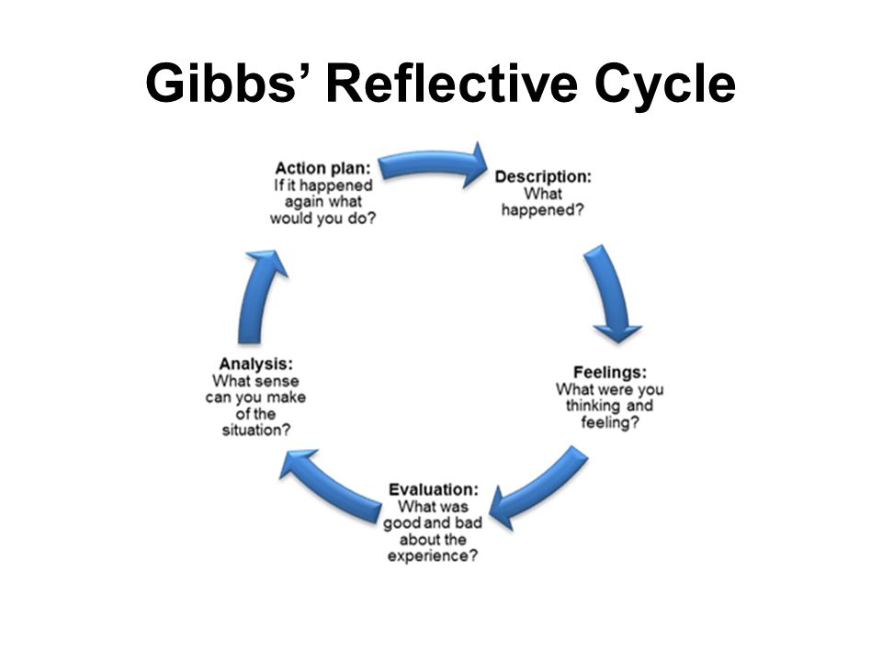
We must identify the issues, feelings and values of empathy related with it, analyse the positive and negative aspect of the issues at workplace environment, take a decision to overcome that unavailable situation and fix a proper time slot to fix it.
4b. Egan’s Skilled Helper Model: This idea is widely used in counselling and coaching contexts where the aim is to effect long-lasting change and provide clients the tools they need to better manage their own challenges and take advantage of untapped opportunities.
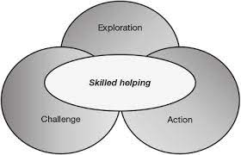

This is a structure that is extremely useful, even though a personal tutor's main duty is to support students with self-help. Following is a summary of the three steps of the model:
Exploration: The situation is what. In place of a challenge, what do I want? I want it, but how can I obtain it?
4c. GROW Model: According to the GROW Model, the coach is assumed to be unfamiliar with the client's situation. This necessitates the coach assuming the function of a facilitator, helping the client arrive at the optimal decisions without offering advice or direction. This may not be the case, though, when team leaders coach or mentor their own team members. In fact, it can be the leader's duty to use their expertise to help their team members reach conclusions that are advantageous to both them and the organisation.
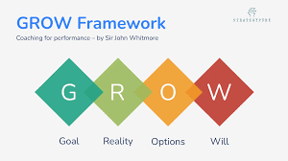
Major Points
With team members, you can plan coaching and mentoring sessions using the GROW Model, a straightforward four-step procedure.
GROW is an abbreviation that means:
Goal.
current time.
Choices (or Challenges).
Will (or the way ahead).
Team members can use the method to help them improve their performance as well as to plan for and realise their longer-term professional goals. ( Mind Tools, 2023)
5.Summerisetion of the topics: Our company's profit level has recently decreased due to pressure from the NHS and foreign national clients to reduce costs by using generic medications rather than branded pharmaceuticals. We currently work for a market leader in both prescribed pharmaceuticals and over-the-counter products. The over-the-counter versions of medications that were previously only available with a prescription need to be heavily promoted. To fulfil the evolving healthcare demands, we must complete the requirement to make significant investments in research and the development of innovative lines.
Some of the mainstream staffs of the company are, Graham Philippa (role is as in charge of quality assurance), Robert Lee, Janice Rowlands, John Griffiths, Maria Cook and Lakshmi Darim.
At the role play, when I was acting as ‘Graham Philippa’ my partner was ‘Robert Lee’ and alternatively when my partner was ‘Graham Philippa’ I was ‘John Griffiths’. We both meet couple of time to discussed with different module of coaching and mentoring. Our main ambition was to make the role play lively and share our understanding of this Moodle.
5a. Coaching Session: At the question and answering session, the role of Graham Philippa considered as,
She has four years of quality assurance leadership. The department has done admirably throughout that time.
1.Prodictivity targets have been met and surpassed.
2.Staff turnover has been low.
3.Moral within the team has been generally high.
4. She established a procedure for team briefings that is now carried out using Microsoft Teams technology.
The role of Robert Lee as follows,
The section's leader, he. His responsibility is to ensure that the work is completed appropriately and within the allotted lead periods. Establish the proper batch priorities and make sure that the necessary resources and personnel are on hand when needed to handle the workload. He has spent 15 years working for the organisation. looking forward to his retirement in three years He has an office in his garden and wanted to work from home.
The role of John Griffiths as follows,
Senior microbiologist describes him. 8 years with the business. Due to his seniority and a history of consistent performance, he was promoted during a recent reorganisation. But dissatisfied with the obligations of his new position. He worries that he will have to devote a lot of his own time to acclimating to his new position. He devotes a large portion of his free time to running a neighbourhood kids club.
5b. Graham Philippa vs Robert Lee: My formal question to Mr Robert Lee was,
1.Do you have any lack of expectation from the company?
Lee: He wants a period of stability, upset with the current upheavals in the department before preparing for his pension.
2. What are the obstacles are you facing currently?
Lee: He is feeling increasingly difficult to work with fewer staff and working schedule, without benefits of doing any overtime.
3. Do you think, you need to develop any of your skills?
Lee: He was worried with the introduction of newly automated machine within the department and needs any opportunity to improve his digital skills.
4. How do you look your future? Any plan?
Lee: He preferred to do his job from home, when upset with the job overwhelming at the time being.
5. How do you feel if I arrange a coaching/mentoring session to fulfil your requirements, as well as companies’ stability?
Lee: He was agreed to join any further session and continue to support the company.
As I received feedback of our role play from our teacher. I realised that we had to prepare more constructively, although we have lots of barriers. However, with my understanding, I wanted to summarise the coaching or mentoring session with the help of GROW Moodle and with that concept I offered further coaching session which should be more effective and profitable for the coachee and for the organisation.
5c. Role play and GROW model: My goal was with the role play to resolve the issues, create a reasonable workplace for Robert Lee, because he is working for this company for the long period, and he deserve a stable position before preparing for his pension.
Reality is the company requires to cut the costs; they took initiative of some changes by,
1.Bringing in automation.
2.Reducing numbers of staff.
3.Incteaasing flexibility in job function.
4.Introducing home working when possible.
My options for Robert Lee were, as he wanted to work from home and my prospective was to leave some staff to work from home if they able to fulfil the requirements. He wanted to do more overtime and my vision also to make flexible everything for the worker when company also will be benefited at the same time. As we are trying to reduce staff, introducing automated and increase profit of company, alternatively staff will benefit by getting chance to receive some extra money from overtime as Robert wanted. Only thing that Robert Lee is not familiar with modern technology, so it was bi difficult to leave him to work from home without further training to improve his digital skills. As he accepted to join any courses to improve his skills and any coaching or mentoring session like this. I can say my introductory coaching or mentoring session was successful.
5d. Graham Philippa vs John Griffiths: At the role play when my partner was Graham Philippa, I was John Griffiths. His question and my answer to me was as follows,
1.What do you want to change the most at your current situation?
John: Actually, after getting promotion in the current position, I am overloaded with my job/tasks. I need flexibility at my workplace.
2.How do you think I can help you to improve this situation?
John: I have not enough time to spend to know about my new role, so it will be helpful for me to have a less responsible role and less pressure with tasks.
3. What obstacles are stopping you?
John: I need more free time out of my job, because I want to work with a group of young people in my free time and them.
4. How are you currently being supported the young people?
John: I am working to improve their sensitivity and patience capacity to be sincere with any situation, Humility (to maintain an interpersonal stance)-Balance-Attitude-Objectivity-Accountability.
5. If I organise a coaching or mentoring session career advancement or skill development for you, do you think it will be helpful?
John: Yes, I will attend the session to know, how can I overcome this unbalanced situation.
As he had listened my problem and promise me that he will be Fosus on my personal development and growth that I was expected and promise me to send me in further skills development courses, arrange further coaching session in future. I think second part of our session also was successful that I appreciated.
6. Conclusion and Recommendation: As we fond our session as the role of coach and coachee applicable. It will be nice if the company introduce such kinds of coaching or mentoring session for everyone alternatively to discuss issues and find a way of solution. It will encourage staffs to concentrated on their tasks, with the light of future brightness and maintain a good rapport with the company to establish the company as employee oriented.

7.Refferencesses:
1. (The differences between coaching and mentoring, M Percy, Mar/Apr 2008)
2. (Journal of Practical Consulting, Vol 6 Iss 1,2018)
3.(Leadership Development: an applied comparison of Gibbs’ reflective cycle and Scharmer’s Theory U, P Cristopher, 2015)
4.(Journal of social work practice, 2016, Sally Riggall)
5.(Mentoring and Coaching in the workplace, W Linda, 2004)
6.(“seven keys to successful Mentoring”, centre for creative leadership, 2009)
7.(is it time to regrow the GROW Model, Anthony M, Grant, Apr 2022)

Appendix:
LOGBOOK of the preparation of the Role Play,


