BA BUSINESS MANAGEMENT
Assignment 1

Module: Marketing Fundamentals
Module code: LCBB4004
Lecturer: Nadeem Mirza
Name: Ancuta Ambrus
Student ID: 2129047
Submitted date: 25/11/2002

Table of Contents
Introduction and Company Overview 3
Marketing Mix of Calvin Klein 4
Product 4
Price 4
Place 5
Promotion 5
Segmentation, Targeting and Positioning of Calvin Klein 6
Target Group in the United Kingdom 7
Marketing Blog – 1 8
Marketing Blog – 2 9
Marketing Blog – 3 10
Marketing Blog – 4 11
Marketing Blog – 5 12
Marketing Blog – 6 13
References 14

Introduction and Company Overview
Getting people interested in your goods and services is what marketing is all about. Marketing comprises researching, advertising, selling, or distributing services or products (Kotler et al., 2015). It outlines the data needed to solve these problems, creates a plan for gathering that data, oversees its collection, processes it, draws conclusions from the data, and shares those conclusions with others.


Calvin Klein Logo (Calvin Klein, 2022).

Calvin Klein is among the world’s global leading fashion lifestyle brands with a heritage of strong, non-conformist principles that inspire all we do. A minimalist and sensuous style guides the approach towards product design and marketing for this New York City-based label, which launched in 1968 and provides a platform for boundless individual expression (Calvin Klein, 2022). The Calvin Klein brands are related by the idea and purpose of elevating daily basics to worldwide legendary status. Each of the brands has a different character and place in the retail environment, giving CK the chance to promote a range of consistently appealing items to local and international customers with a variety of demands (Calvin Klein, 2022). The products are anchored by ethical design, elevated craftsmanship, and the removal of any extraneous features. The goal of Calvin Klein is to create one-of-a-kind, three-dimensional garments that will last a long time and look great no matter the season. By 2021, Calvin Klein had generated over GBP 8 billion in retail sales throughout the world.

Marketing Mix of Calvin Klein

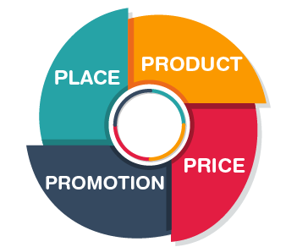
Marketing Mix Elements (Byju's, 2020).

Product
All around the world, people wear and accessorise with Calvin Klein, as it is a top-tier label in the industry. The Calvin Klein product line is extensive. Included in the marketing mix is the following product strategy. Clothing, perfumes, and jewellery are all part of Calvin Klein's vast product range.

Price
Since the brand primarily targets consumers in the upper middle class and upper class, Calvin Klein tends to charge more for its wares. Black Label is a collection of more expensive, high-end garments and accessories that sits above the company's more affordable White Label line. It uses a target pricing approach in which it sets prices just slightly below those of its competitors and adjusts its expenses appropriately to maximise profits (Mondalek, A., 2022). Customers are more likely to remain loyal to a brand when prices are low.

Place
The name Calvin Klein is well-known all over the world. The suburb of Dallas, Texas, was the site of the first shop. Items such as clothing, accessories, perfumes, toiletries, linens, and more were featured. A Manhattan location, on Madison Avenue, serves as its main shop as of now. It operates in 20 other nations outside the United States. It also sells at department shops including Nordstrom, Macy's, and Lord & Taylor, in addition to its own stores. Because of its wide online and offline presence, Calvin Klein must clearly identify its methods of distribution (Avada, 2022). They wanted to make sure their items were always accessible to customers so that they wouldn't have to worry about losing business to other brands.

Promotion
Calvin Klein uses a wide variety of marketing tactics to get the word out about its wares, such as TV commercials, direct mail, social media ads, discounts, gift with purchase, word of mouth, and personal sales (440 Industries, 2022). As the Internet, social media, and other forms of digital advertising have matured, Calvin Klein has begun to actively engage with them in an effort to promote their items and drive massive sales for their brand, hence increasing income.

Segmentation, Targeting and Positioning of Calvin Klein
In order to meet the needs of its flexible consumer base, Calvin Klein uses a fluid segmentation strategy that takes into account the unique characteristics of each product line.
To keep existing customers and attract new ones, it is essential to take advantage of market niches by catering to specific sorts of clients. The segmentation research indicates that the brand's major demographic customers are upper-middle-class young people and high-earning professionals (PVH, 2022). In order to reach its target audience, the company employed psychographics.
The brand's "My Calvins" marketing campaign features celebrities, bloggers, and influencers in an effort to reach the brand's core target of young people. Men as well as women between the ages of 15 and 30, who are single and likely to travel extensively, are the "My Calvins" target group (Mondalek, A., 2022).
The company markets its wares as luxurious yet understated necessities for kids and well-heeled business types who value minimalism in their personal and professional attire. Because numerous celebrities have endorsed the underwear industry, the market for these goods has been given a boost, particularly among younger consumers who place a premium on brand and lifestyle (Avada, 2022).

Target Group in the United Kingdom
Because Calvin Klein is not the most costly brand in the UK, its target market consists of young individuals from 15-30 years old, and single or married people with a moderate income. Their demographic characteristics might include a love of many creative endeavours such as music, art, literature, television, movies, shopping, and photography. They have an expansive perspective and like using social media (Mondalek, 2022). Aspiring and bold customers in the UK. The aspirants in the UK are notoriously materialistic and fixated on their outward appearance, personality, and the latest trends. It's not only the things themselves but the packaging that catches their eye. In addition, their ages differ by only a few years. Adventurers value independence highly. Uniqueness and novelty are highly prized by them. Young people in the United Kingdom tend to be the first to test out new products.

Marketing Blog – 1
‘Elevate Your Pajama Game’
One rule of fashion is to put your own comfort ahead of looking good. When out and about for the entire day, comfort is of the utmost importance. A matching pair, like pyjamas, is a convenient go-to on days like those. You can dress them up or down with ease, making them the ideal component of any comfy-chic look.

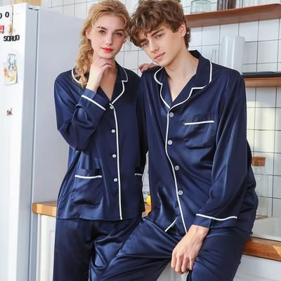
Matching Pajama Set. (Pinterest, 2019)

You need to wear some well-chosen accessories and high-end clothing pieces to alleviate any concerns you may have about your overall appearance. An oversized blazer is a great example of a way to dress up a casual ensemble without sacrificing comfort. Add some flair by accessorising with a pretty necklace and bracelet set; round out your outfit with shoes and a purse. You've got today covered in chic and cosy comfort.

Marketing Blog – 2
‘Match Up Your Workout’
Truth be said, we all experience moments of dread while contemplating an exercise, but there is no denying that sportswear serves as a little encouragement to drive you to that gym class. If you're looking to keep up your fitness routine but find yourself in need of some new workout clothes every now and then, you've come to the correct spot.
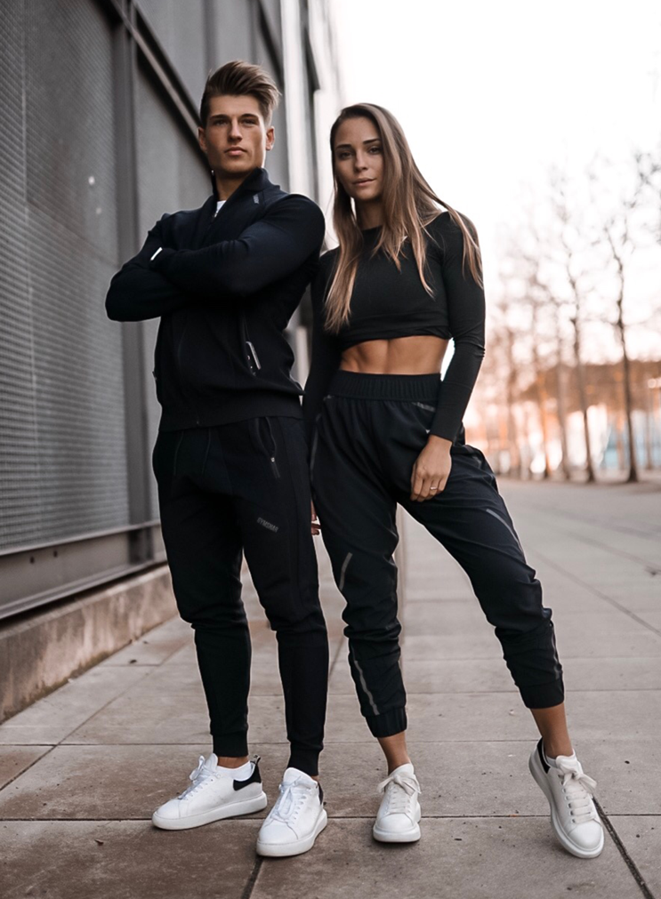
Workout Matches (Tucker, 2016)

Pretty in plum and shade, it comes in a variety of colours and features a distinctive wavy pattern. Each piece is made from a soft, breathable, and moisture-resistant fabric. It is indeed easy to look great during your next gymnastics or fitness class by just donning a pair of sneakers and some accessories.

Marketing Blog – 3
‘Cardigans could be the Click’
Cardigans are as charming and comfy as it gets, which means that you'll certainly adore them throughout every shape and design. It is a wardrobe essential that can elevate even the most laid-back ensembles. They look great thrown over the top of a slip dress or worn as an extra layer over a plain white tee. You may even dress them without anything below, like everyone else is doing here.
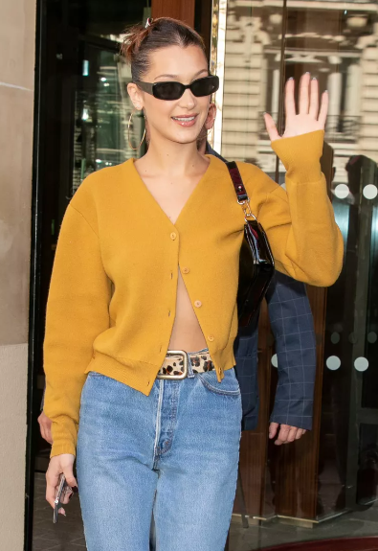
Cardigan Fashion Style (Sutton, 2020)
Cardigans with collar details are great since they provide a sophisticated preppy vibe. Just put on your fave pair of jeans, loafers and your go-to purse for a style that is both casual and sophisticated. You could easily imagine yourself wearing this outfit every day during the fall and winter months; simply add a coat for added warmth.

Marketing Blog – 4
‘Don’t Forget a Cap’
One of the many advantages of wearing a cap is that you may avoid the bother of trying to fix your hair on days when it's not cooperating. But out of all the options, how do you know you're wearing your cap in a way that's not only comfy but also draws positive attention to you?


Solid Caps in Fashion (Flammia, 2022)

Varieties of caps exist, and certain forms go better with particular garments. The brim of this hat, like other hats, is often worn slightly above the eyebrows. Despite their primary use, hats are useful in less sunny conditions. Unlike several other hat styles, the classic baseball cap style really works well regardless of your head shape. Whether you're a young student or well over 40, a cap is always appropriate as it is both a functional and stylish item.

Marketing Blog – 5
‘Where’s Your Backpack?’
Thousands of people will pass you every day, and you will quickly realise that the vast majority of them are carrying backpacks. In fact, most people who possess a majority share the majority's love of backpacks by having many of them. A backpack drastically improves your quality of life. In today's modern world, backpacks are an everyday must.
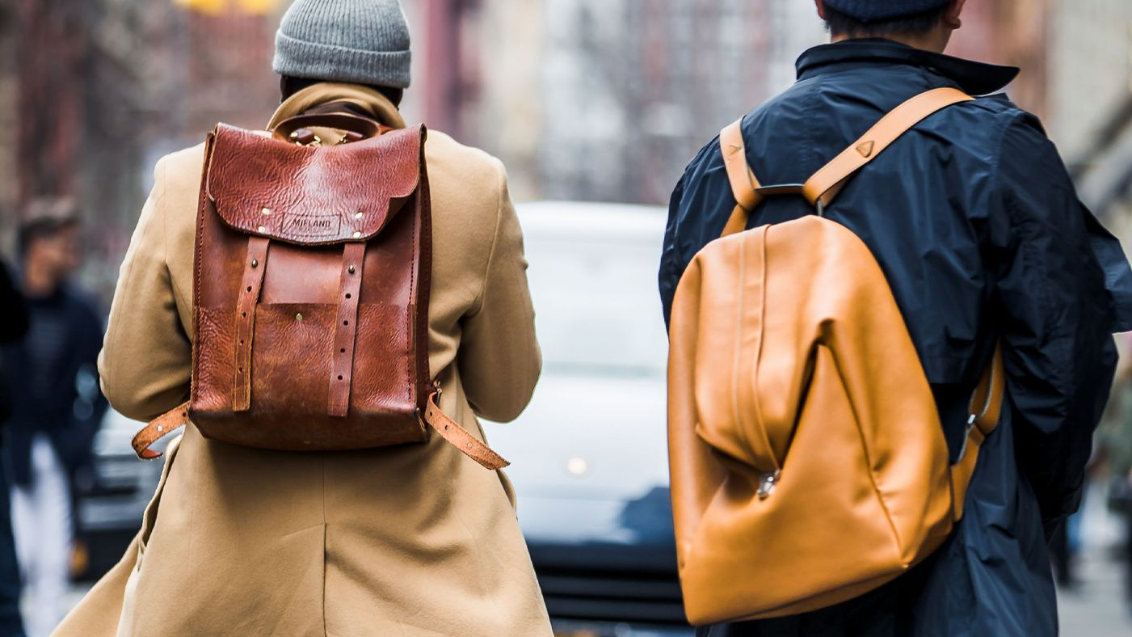
Backpack Styles (Welch, 2020).

Backpacks are designed to make your life simpler, whether you're going to class, the gym, a business meeting, or doing any other activity outside. The true conundrum is figuring out which days to use so that you don't immediately feel out of place in your new social circle. For this, a tiny, lightweight, body-hugging, spill-resistant, water-resistant backpack is ideal. In addition, the straps shouldn't be too long because they might cause problems if they become tangled up with your body while you're on the go. Everyday backpacks are constructed not just in accordance with user requirements but also with the ease of use in mind.

Marketing Blog – 6
‘Put Your Sunglasses ON’
Sunglasses featuring UV protection should always be worn outside, no matter the season, to protect the eyes from sun damage. They'll prevent you from frowning, which ages the skin and is never stylish. However, having a reliable pair of sunglasses on hand may serve a multitude of additional purposes. The effects of a late night might be hidden by wearing large sunglasses. They are perfect for when you ought to be alone, are fatigued, or just don't feel like interacting with others. They are more noticeable and flattering than a scowling face or red eyes and may be used by someone with a variety of different facial structures.

Sunglasses in Trend (Vint &York, 2022)
Buying new sunglasses is a lot less of an ordeal than buying a bikini or a new pair of trousers. The form of your face is the most important factor to consider while entering a trustworthy store. This is crucial since it will direct you toward the most attractive couple.

References
440 Industries, 2022. Calvin Klein brand analysis – competitors, Strategies &amp; More. [online] 440 Industries – Training For Creative. Available at: https://440industries.com/calvin-klein-brand-analysis-competitors-strategies-more/&gt; [Accessed 24 Nov. 2022].
Avada, 2022. Calvin Klein advertising strategy - a symbol of sexiness. [online] AVADA Commerce Blog. Available at: https://blog.avada.io/resources/calvin-klein-advertising.html&gt; [Accessed 24 Nov. 2022].
Byju's, 2020. Marketing mix - definition, 4 P, 7 P of marketing, example, elements. [online] BYJUS. Available at: https://byjus.com/commerce/marketing-mix/&gt; [Accessed 24 Nov. 2022].
Flammia, C., 2022. Dad Hats are the best hats. [online] Esquire. Available at: https://www.esquire.com/style/mens-accessories/g22101302/best-dad-hats/&gt; [Accessed 24 Nov. 2022].
Kotler, P., Burton, S., Deans, K., Brown, L. and Armstrong, G., 2015. Marketing. Pearson Higher Education AU.
Mondalek, A., 2022. Calvin Klein's new strategy: Don't market the dream, market what sells. [online] The Business of Fashion. Available at: https://www.businessoffashion.com/articles/marketing-pr/unpacking-calvin-kleins-hero-product-strategy/&gt; [Accessed 24 Nov. 2022].
Pinterest, 2019. Pajama high quality men women pajama set spring full sleeve long pants 2pcs . [online] Pinterest. Available at: https://www.pinterest.ca/pin/863002347323938776/&gt; [Accessed 24 Nov. 2022].
PVH, 2022. A minimalist canvas for creative exploration. [online] PVH. Available at: https://www.pvh.com/brands/calvin-klein&gt; [Accessed 24 Nov. 2022].
Sutton, S., 2020. Listen, cardigans are sexy now. [online] InStyle. Available at: https://www.instyle.com/fashion/sexy-cardigan-trend&gt; [Accessed 24 Nov. 2022].
Tucker, A., 2016. Here's exactly how to superset at the gym. [online] SELF. Available at: &lt;https://www.self.com/story/how-to-superset-exercises&gt; [Accessed 24 Nov. 2022].
Vint &amp; York, 2022. Hottest sunglasses trends of the season. [online] Vint &amp; York. Available at: &lt;https://www.vintandyork.com/blogs/content/latest-sunglasses-trends&gt; [Accessed 24 Nov. 2022].
Welch, A., 2020. Mr Porter's Ultimate Guide to backpacks. [online] 'S Ultimate Guide To Backpacks | The Journal. Available at: &lt;https://www.mrporter.com/en-us/journal/fashion/ultimate-guide-backpacks-how-to-wear-1355622&gt; [Accessed 24 Nov. 2022].

