Engine Performance Characteristics
Report


(UWTSD, 2017)

University of Wales Trinity Saint David
School of Engineering

Ben MOUNT – 2101011

Automotive and Transport Design

21/12/2021

Abi SUMMERFIELD

VEHICLE TECHNOLOGY - ACHA4004

CONTENTS

Table of Contents
CONTENTS 2
1.0 INTRODUCTION 3
2.0 EXPERIMENTAL PROCEEDURE 4
3.0 RAW DATA RESULTS 5
4.0 EDITED DATA 6
5.0 ANALYSIS 8
6.0 CONCLUSION 10
6.1 CONCLUSION 11
6.2 CONCLUSION 12
7.0 EVALUATION 13
8.0 BIBLIOGRAPHY 14



The aims of this test are to understand the characteristics of an engine and how the load on the engine effect the torque and power the engine produces. In addition to this, the aim of the test to further my personal understanding of how an engine performs and reacts under certain circumstances.

Using the data produced by the Dynamometer we can produce graphical data demonstrating the relationship between the Torque vs Engine Speed as well as the Brake Power vs Engine Speed.

The graphical data can be used to better understand the relationship between these factors and allow us to understand why they are behaving the way they are.

Aswell as the way the engine performs, this test is also an evaluation of how I personally perform within the test environment and how well I understand how the test works and how I interpret the data it produces.

1.0 INTRODUCTION

2.0 EXPERIMENTAL PROCEEDURE
Firstly, we attached the two torque arms and mass to either side of the housing. This allows the system to calculate the torque by referencing the amount of force on the arm at the distance of the arm – in this case 0.815744m. It is important that you apply a torque arm and mass to either side of the housing so that they essentially cancel out. This means that the force that the engine is producing can be calculated using the laws of moments.

When we engaged the engine, we performed both a step test and a sweep test.

Sweep Test – “The sweep or acceleration test accelerates the engine at a constant rate: for example, 100 rpm/second or 300 rpm/second” (McFarland and Jenckes, 2021). This is the test we carried out to get smoother results.
Step Test – Step tests are closer to real life conditions where the engine is held at specific rpm levels for example every 50 rpm.

For finding the force of the engine, the step test was more effective as it gave less data as well as producing data in specific intervals of rpm, which is beneficial when it comes to producing graphical data. Once completed, the test results were transferred to an Excel Document and then transferred to us for analysis.
An Engine Dynamometer is used to “determine the torque or power characteristics of a machine under test” (Lish, 2021). A Dynamometer can be used on any machine that rotates but is most used on engines to evaluate their characteristics. The dyno produces resistance using electromagnets. The amount of resistance and the throttle input of the test can both be controlled wither manually or by running a set test.

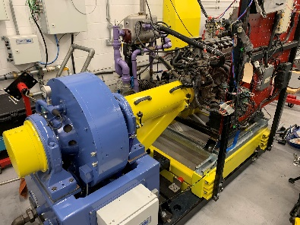
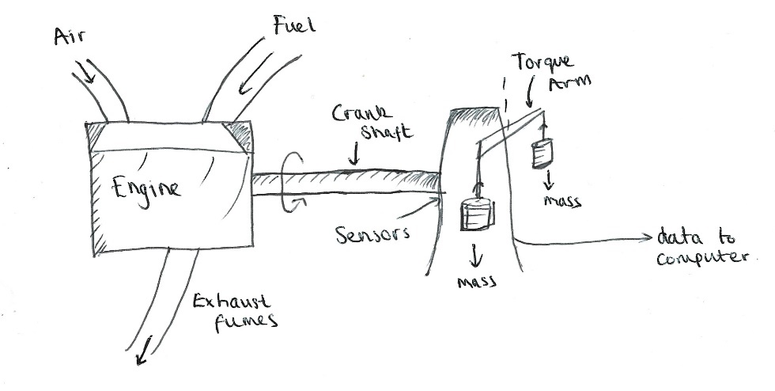

- Basic Diagram I produced of the Dyno setup

3.0 RAW DATA RESULTS
Force (N) | Engine Speed (rpm)
157.267 | 3400
156.714 | 3450
156.031 | 3500
155.394 | 3550
154.841 | 3600
154.283 | 3650
153.895 | 3700
153.537 | 3750
153.207 | 3800
152.982 | 3850
152.81 | 3900
152.686 | 3950
152.585 | 4000
152.443 | 4050
152.235 | 4100
151.91 | 4150
151.399 | 4200
150.827 | 4250
150.068 | 4300
149.154 | 4350
148.116 | 4400
147.008 | 4450
145.914 | 4500
144.832 | 4550
143.855 | 4600
142.954 | 4650
141.876 | 4700
140.982 | 4750
140.028 | 4800
139.039 | 4850
137.983 | 4900
136.865 | 4950
135.733 | 5000
134.623 | 5050
133.253 | 5100
131.742 | 5150
129.994 | 5200
128.245 | 5250
126.542 | 5300
125.13 | 5350
123.554 | 5400
122.083 | 5450
121.004 | 5500

Force (N) | Engine Speed (rpm)
130.037 | 1000
130.61 | 1050
131.485 | 1100
132.641 | 1150
133.729 | 1200
135.143 | 1250
136.396 | 1300
137.723 | 1350
139.186 | 1400
140.496 | 1450
141.522 | 1500
142.271 | 1550
143.07 | 1600
143.631 | 1650
143.895 | 1700
143.984 | 1750
143.769 | 1800
143.411 | 1850
143.045 | 1900
142.816 | 1950
142.873 | 2000
143.19 | 2050
143.772 | 2100
144.551 | 2150
145.344 | 2200
146.106 | 2250
146.954 | 2300
147.835 | 2350
148.72 | 2400
149.675 | 2450
150.825 | 2500
152.138 | 2550
153.556 | 2600
155.005 | 2650
156.482 | 2700
157.786 | 2750
158.838 | 2800
159.646 | 2850
160.156 | 2900
160.53 | 2950
160.755 | 3000
160.772 | 3050
160.64 | 3100
160.269 | 3150
159.847 | 3200
159.295 | 3250
158.657 | 3300

- This is the raw data that was produced from the Dyno test. You can see the result of the step test by viewing the Engine Speed stepping up at 50 rpm at a time.

- In addition, we also received the temperature conditions, the barometric pressure, humidity, and the length of the torque arm.

- Data relevant to the sizes of the engine cylinders was found from the Car Manual (Honda Civic Coupe CXR: Chassis Maintenance and Repair, 2003)

4.0 EDITED DATA

W | N | T | P | Ps | BMEP
Force (N) | Engine Speed (rpm) | Torque (Nm) | Power (W) | Corrected Power (W) | BMEP (Pa)
130.037 | 1000 | 106.0769025 | 11108.34726 | 11250.15405 | 848837.9867
130.61 | 1050 | 106.5443238 | 11715.16028 | 11864.71352 | 852578.34
131.485 | 1100 | 107.2580998 | 12355.24614 | 12512.97059 | 858290.05
132.641 | 1150 | 108.2010999 | 13030.41159 | 13196.75505 | 865836.03
133.729 | 1200 | 109.0886294 | 13708.48147 | 13883.48102 | 872938.13
135.143 | 1250 | 110.2420914 | 14430.65602 | 14614.8747 | 882168.24
136.396 | 1300 | 111.2642186 | 15147.03025 | 15340.39401 | 890347.41
137.723 | 1350 | 112.3467109 | 15882.64207 | 16085.3965 | 899009.62
139.186 | 1400 | 113.5401444 | 16645.85456 | 16858.352 | 908559.59
140.496 | 1450 | 114.608769 | 17402.61323 | 17624.77129 | 917110.84
141.522 | 1500 | 115.4457224 | 18134.17166 | 18365.66864 | 923808.22
142.271 | 1550 | 116.0567146 | 18837.81764 | 19078.29721 | 928697.44
143.07 | 1600 | 116.7084941 | 19554.69587 | 19804.32696 | 933913.05
143.631 | 1650 | 117.1661265 | 20244.85332 | 20503.29481 | 937575.07
143.895 | 1700 | 117.3814829 | 20896.67224 | 21163.43471 | 939298.37
143.984 | 1750 | 117.4540841 | 21524.58512 | 21799.36339 | 939879.33
143.769 | 1800 | 117.2786991 | 22106.51398 | 22388.72103 | 938475.88
143.411 | 1850 | 116.9866628 | 22664.00716 | 22953.33105 | 936138.98
143.045 | 1900 | 116.6881005 | 23217.14368 | 23513.5288 | 933749.85
142.816 | 1950 | 116.5012951 | 23789.97483 | 24093.67259 | 932255.02
142.873 | 2000 | 116.5477925 | 24409.71258 | 24721.32178 | 932627.10
143.19 | 2050 | 116.8063834 | 25075.46852 | 25395.57661 | 934696.37
143.772 | 2100 | 117.2811464 | 25791.47115 | 26120.71958 | 938495.47
144.551 | 2150 | 117.9166109 | 26548.62704 | 26887.54116 | 943580.52
145.344 | 2200 | 118.5634959 | 27315.06857 | 27663.76693 | 948756.96
146.106 | 2250 | 119.1850929 | 28082.32591 | 28440.81891 | 953731.04
146.954 | 2300 | 119.8768438 | 28872.98957 | 29241.57601 | 959266.50
147.835 | 2350 | 120.5955142 | 29677.52189 | 30056.37882 | 965017.37
148.72 | 2400 | 121.3174477 | 30490.40019 | 30879.63415 | 970794.35
149.675 | 2450 | 122.0964832 | 31325.48886 | 31725.38339 | 977028.27
150.825 | 2500 | 123.0345888 | 32210.38003 | 32621.57088 | 984535.09
152.138 | 2550 | 124.1056607 | 33140.60171 | 33563.66758 | 993105.91
153.556 | 2600 | 125.2623857 | 34105.36052 | 34540.74229 | 1002362.14
155.005 | 2650 | 126.4443987 | 35089.25015 | 35537.19205 | 1011820.73
156.482 | 2700 | 127.6492526 | 36091.97588 | 36552.71837 | 1021462.09
157.786 | 2750 | 128.7129828 | 37066.6781 | 37539.86343 | 1029974.17
158.838 | 2800 | 129.5711455 | 37992.24415 | 38477.24505 | 1036841.27
159.646 | 2850 | 130.2302666 | 38867.39265 | 39363.56551 | 1042115.62
160.156 | 2900 | 130.6462961 | 39675.61958 | 40182.1101 | 1045444.73
160.53 | 2950 | 130.9513843 | 40453.93085 | 40970.35712 | 1047886.08
160.755 | 3000 | 131.1349267 | 41197.25224 | 41723.1676 | 1049354.80
160.772 | 3050 | 131.1487944 | 41888.30237 | 42423.03953 | 1049465.77
160.64 | 3100 | 131.0411162 | 42540.04014 | 43083.09725 | 1048604.12
160.269 | 3150 | 130.7384751 | 43126.33847 | 43676.88013 | 1046182.36
159.847 | 3200 | 130.3942312 | 43695.52626 | 44253.33405 | 1043427.68
159.295 | 3250 | 129.9439405 | 44225.01729 | 44789.58445 | 1039824.41
158.657 | 3300 | 129.4234958 | 44725.5494 | 45296.50625 | 1035659.76
158.007 | 3350 | 128.8932622 | 45217.19736 | 45794.43048 | 1031416.78
157.267 | 3400 | 128.2896116 | 45677.15283 | 46260.25765 | 1026586.31
156.714 | 3450 | 127.8385052 | 46185.89852 | 46775.49787 | 1022976.51
156.031 | 3500 | 127.2813521 | 46651.05207 | 47246.58947 | 1018518.11
155.394 | 3550 | 126.7617231 | 47124.32095 | 47725.9 | 1014359.99
154.841 | 3600 | 126.3106167 | 47617.98066 | 48225.86167 | 1010750.19
154.283 | 3650 | 125.8554316 | 48105.3574 | 48719.46016 | 1007107.75
153.895 | 3700 | 125.5389229 | 48641.69947 | 49262.64906 | 1004575.02
153.537 | 3750 | 125.2468865 | 49184.33733 | 49812.21411 | 1002238.12
153.207 | 3800 | 124.977691 | 49733.00615 | 50367.88713 | 1000083.99
152.982 | 3850 | 124.7941486 | 50313.38883 | 50955.67884 | 998615.26
152.81 | 3900 | 124.6538406 | 50909.5067 | 51559.40663 | 997492.50
152.686 | 3950 | 124.5526884 | 51520.35176 | 52178.04961 | 996683.07
152.585 | 4000 | 124.4702982 | 52137.99661 | 52803.57918 | 996023.78
152.443 | 4050 | 124.3544626 | 52740.59393 | 53413.86913 | 995096.85
152.235 | 4100 | 124.1847878 | 53318.86235 | 53999.5196 | 993739.10
151.91 | 4150 | 123.919671 | 53853.87606 | 54541.36319 | 991617.61
151.399 | 4200 | 123.5028259 | 54319.37986 | 55012.8095 | 988281.97
150.827 | 4250 | 123.0362203 | 54758.37215 | 55457.40588 | 984548.14
150.068 | 4300 | 122.4170706 | 55123.78832 | 55827.48687 | 979593.65
149.154 | 4350 | 121.6714806 | 55425.12328 | 56132.66861 | 973627.36
148.116 | 4400 | 120.8247383 | 55672.04283 | 56382.74029 | 966851.64
147.008 | 4450 | 119.920894 | 55883.48559 | 56596.88227 | 959618.99
145.914 | 4500 | 119.02847 | 56090.84505 | 56806.88884 | 952477.73
144.832 | 4550 | 118.145835 | 56293.52324 | 57012.15438 | 945414.79
143.855 | 4600 | 117.3488531 | 56528.21855 | 57249.84576 | 939037.26
142.954 | 4650 | 116.6138678 | 56784.7569 | 57509.65902 | 933155.84
141.876 | 4700 | 115.7344957 | 56962.53385 | 57689.70544 | 926119.01
140.982 | 4750 | 115.0052206 | 57205.76306 | 57936.03966 | 920283.28
140.028 | 4800 | 114.2270008 | 57416.75306 | 58149.72312 | 914055.89
139.039 | 4850 | 113.42023 | 57605.09276 | 58340.46711 | 907600.03
137.983 | 4900 | 112.5588044 | 57756.9391 | 58494.25189 | 900706.81
136.865 | 4950 | 111.6468026 | 57873.54783 | 58612.34923 | 893408.88
135.733 | 5000 | 110.7233804 | 57974.62638 | 58714.71813 | 886019.57
134.623 | 5050 | 109.8179045 | 58075.52554 | 58816.90535 | 878773.86
133.253 | 5100 | 108.7003352 | 58053.66968 | 58794.77048 | 869830.96
131.742 | 5150 | 107.467746 | 57958.07965 | 58697.96017 | 859967.66
129.994 | 5200 | 106.0418255 | 57744.30481 | 58481.45632 | 848557.30
128.245 | 5250 | 104.6150893 | 57515.14929 | 58249.37545 | 837140.41
126.542 | 5300 | 103.2258772 | 57291.87951 | 58023.25546 | 826023.80
125.13 | 5350 | 102.0740467 | 57187.05509 | 57917.09287 | 816806.73
123.554 | 5400 | 100.7884342 | 56994.51679 | 57722.09666 | 806519.13
122.083 | 5450 | 99.58847475 | 56837.39975 | 57562.97391 | 796916.94
121.004 | 5500 | 98.70828698 | 56851.89202 | 57577.65118 | 789873.59

When given the data, the first thing that was necessary was to convert the given information about the dyno test into the correct units:

- Temperature was converted from 26°C to K by adding 273
- The pressure was converted from mBar to Bar by dividing by 1000
- Length of the Torque arm was converted from mm to m by also dividing by 1000
All equations used in this report are sourced from a lesson handbook (Summerfield, n.d.)

Once the units of the relevant information were converted, I started by calculating the Torque produced by the engine at each given rpm:

$$Torque\left(nm\right)=Force\left(N\right)*Distance(m)$$

Now I had the Torque it was possible to calculate the Power:

$$Power\left(W\right)=\frac{2π*Engine Speed\left(rpm\right)*Torque(Nm)}{60}$$
This power wasn’t an exact representation of the power the engine was producing, this was the power without factoring in the conditions in the dyno on that day. As a result, it was necessary to calculate the corrected power:

$$\frac{Corrected Power (W)}{Recorded Power (W)}=\frac{1.01325}{Ambient Pressure(Pa)}*\sqrt{\frac{Ambient Temperature(K)}{293}}$$

To get the corrected power from this equation, it was necessary to make Corrected Power the subject:

$$Corrected Power(W)=(\frac{1.01325}{Ambient Pressure(Pa)}*\sqrt{\frac{Ambient Temperature(K)}{293}})*Recorded Power(W)$$

5.0 ANALYSIS

- Raw data on the cylinder diameters and stroke length of the engine was found from the vehicle’s manual (Honda Civic Coupe CXR: Chassis Maintenance and Repair, 2003)
Temperature | 26 | °C | 299 | K
Barometric Pressure | 1010.67 | mBar | 1.01067 | Bar
Humidity | 42.8 | %
Torque arm | 815.744 | mm | 0.815744 | m

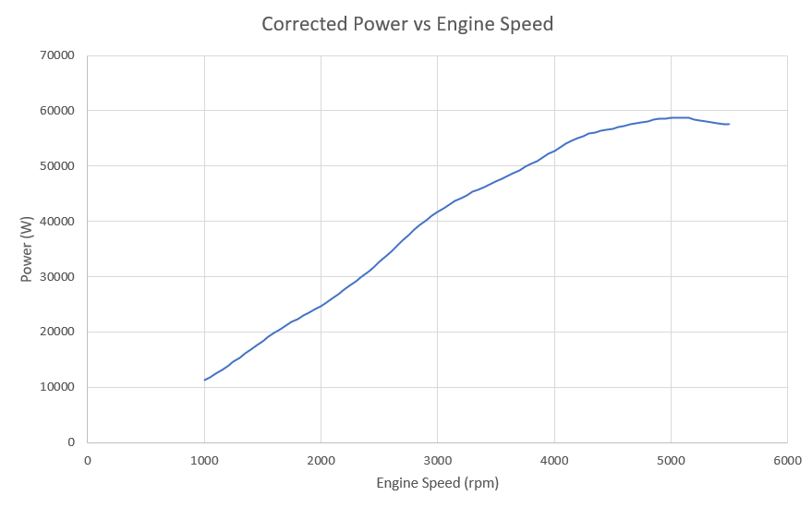
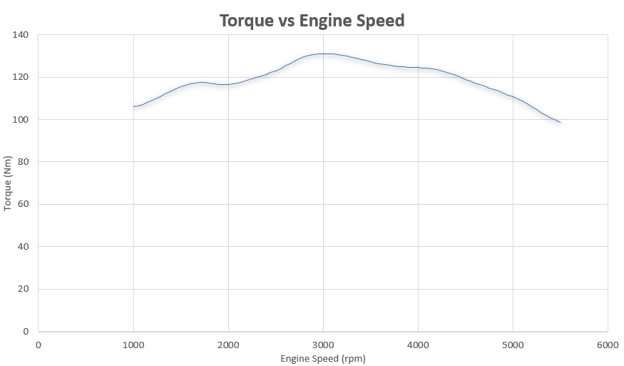

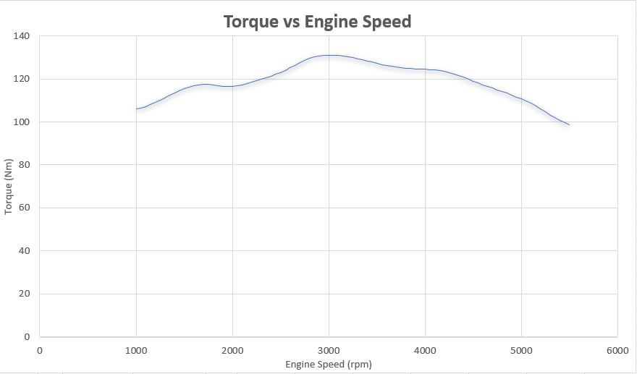
Once I had calculated all the relevant information using Excel, I was able to generate some graphical data from the numerical information:
The final value that needed to be calculated was the Brake Mean Effective Pressure, done using the formula:

$$P=\frac{(BMEP)*l*A*N*n}{60*2}$$

Where P is Power(W), BMEP is Brake Mean Effective Pressure (Pa), l is stroke length (m), A is area of cylinder (m^2), N is Engine Speed(rpm), and n is number of cylinders.

We needed to have BMEP as the subject of the formula, so it rearranges to this:

$$BMEP= \frac{60*2*P}{lANn}$$

6.0 CONCLUSION

The graph for the Torque vs Engine speed shows shallow curve with an almost mirroring at approximately 3000 rpm.

The torque increases pretty much consistently with the rpm, with a minor dip in the middle. This could have been a variety of things; anything from a sensor glitch to an engine misfire. The dip quickly recovers itself and the torque increases again until about 3000rpm. After this point of peak torque, the torque begins to steadily decrease.

This decrease could again be due to multiple things. For example, the torque may begin to decrease due to insufficient amounts of new air and fuel being provided. The faster the engine speed, the faster the CAM shaft turns and therefore the speed of the valves opening and closing. As a result, there is less time for the new fuel and air mix to enter the cylinder chamber before the valve closes again. The result of this is that the explosion is less powerful and therefore less torque produced.

Dynos are conducted in one gear and most commercial engines are designed to have an optimal torque range before the next gear would be selected. Normally when driving a vehicle, you wouldn’t usually get up to 5500 rpm in one gear; manufacturers will factor this in and design the engine to produce the peak amount of torque before a gear shift would take place. This is different on performance vehicles, but the engine in the dyno is a Honda Civic 2003 so it makes sense that it was designed with the intention of a gear shift before 3000rpm.

6.1 CONCLUSION

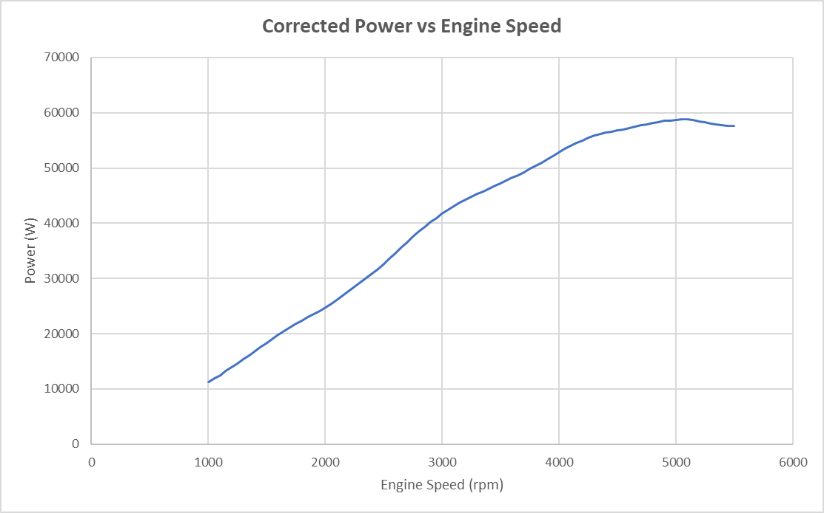

The Corrected Power vs Engine Speed Graph shows an almost proportional increase up to just after 4000rpm where the data begins to plateau. This is the point in the graph where the peak engine power has been reached and the engine can physically not produce any more power however the engine speed continues to increase.

Similarly, to the Torque vs Engine Speed, this is because the engine is designed in such a way that it expects a gear change to be present. As previously explained, the Dyno test uses one gear only. In addition to this, as the engine is approaching 5500 rpm, it would be approaching the red area of the tachometer. This is so that the engine doesn’t over do the power that is capable of and result in damaging itself or even blowing. As the peak power is approached, the engines ECU begins to start protecting it by preventing the power increasing any further.

Further to this, at higher rpm the engine begins to get hot and as a result energy is lost to the surroundings, reducing power output.

6.2 CONCLUSION
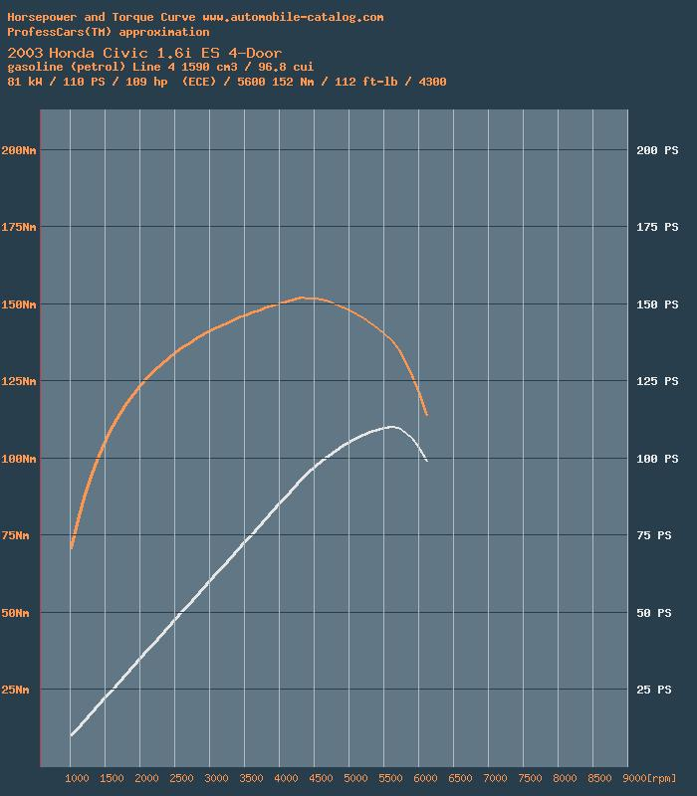
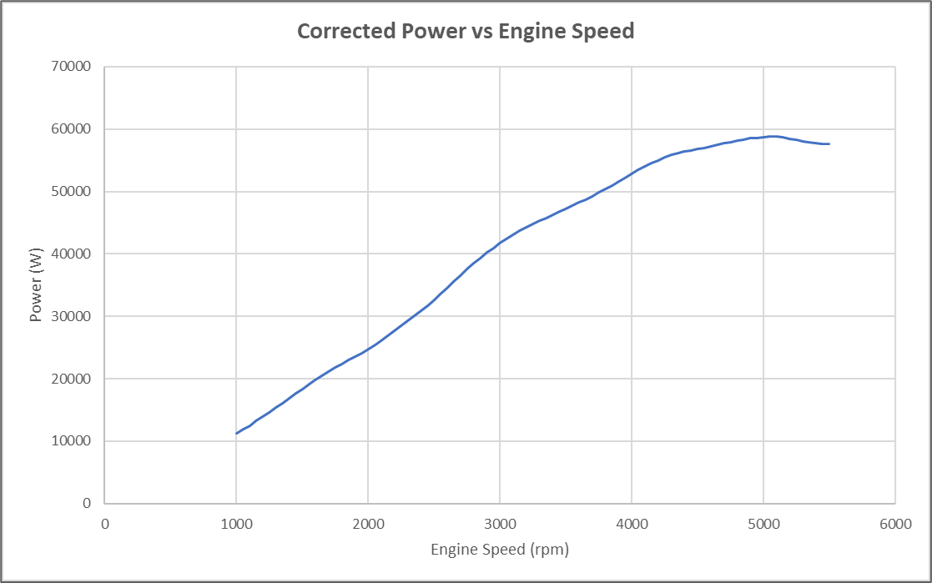
Although the graph from the source is measured in Horsepower instead of Power in Watts and the test was conducted over a marginally larger rpm range, The similarities are still clear to see.

Horsepower is a conversion to power, so the results are still relevant.

The peak power and produced by the test were slightly lower than my results. This could be because of a variety of factors such as our engine being more worn than theirs, their dyno being a different level of accuracy than ours or the conditions in the test being different.

Despite this, the overall shapes of both of my graphs are similar to the results produced by the other test. As a result, I would consider my dyno test to be a success as my results seem valid to other results that have been found.

- Graphical Data produced by me from dyno test

- Torque and Horsepower vs Engine Speed test results produced by https://www.automobile-catalog.com


Overall, the dyno test was a success. We got results that match up with that of other people that have completed the same test. Its important to evaluate how the test was successful, how to improve the accuracy of the test and how to make the test repeatable:

Successfulness of the test: The test would successful due to the engine being kept in good shape and the Dynamometer being maintained sufficiently as well as frequent calibration. In addition to this, the Dyno was operated by a technician who has experience and who has worked with the technology for a long time resulting in a good understanding of the test.

Improving Accuracy: The tests accuracy could be improved with further frequency of calibration, more maintenance and necessary replacing of components. In addition, the engine may need to be serviced and checked more frequently. The conditions of the Dyno test could have been altered to be optimal for the specific engine, to further optimize the performance.

Repeatable Testing: All the tests are completed in the same procedure to optimize result. To make sure the test could be repeated it would have to be done in the same steps again, with the same conditions such as pressure, temperature, and fuel load.

Personal Performance: At the beginning of the test, I had no experience or practice with the test and equipment. I fell as though I quickly learnt about the procedure and would feel semi confident carrying out again. Evidently, the more experienced I became with the test, the better I would work in that environment.

7.0 EVALUATION

8.0 BIBLIOGRAPHY
2003. Honda Civic Coupe CXR: Chassis Maintenance and Repair. 88th ed. Honda Motor co LTD.
2021. Graph to Show Honda Civic HP and Torque vs rpm. [image].
2021. Microsoft Word. Microsoft.
Lish, T., 2021. What is a Dynamometer and How Does it Work?. [online] Setra.com. Available at: <https://www.setra.com/blog/test-and-measurement-dynamometer> [Accessed 16 November 2021].
McFarland, J. and Jenckes, C., 2021. Engine Testing Methods From the Pros - Circle Track Magazine. [online] MotorTrend. Available at: <https://www.motortrend.com/how-to/ctrp-0303-engine-testing-methods-pros/> [Accessed 16 November 2021].
Summerfield, A., n.d. Vehicle Technology ACHA4004 Part 1. 1st ed. pp.21-24.
UWTSD, 2017. University of Wales Trinity Saint David. [Online] Available at: www.uwtsd.ac.uk [Accessed 22 02 2017].

