18/04/2021
Joshua Warren Ede (2023302)
OME apprentice DSTL
Study Skills Assessment
A report on self-learning and evaluation

Abstract
This report details the life history of the author and how this relates to the requirements and outcomes of the study skills course. It begins by considering context and progresses through a series of exercises and self-evaluation. The report also explicitly looks at data management strategies employed by the author. Finally, the document concludes with an evaluation of the study skills course and indeed of the assignment itself, whilst noting the individual context in which it has been written.

Figure 1: First slide for the introduction presentation 5
Figure 2: Places Lived / Previous Jobs slide from introduction presentation. 5
Figure 3: Personality slide from introductory presentation 6
Figure 4: Hobbies and Interests slide from introduction presentation. 7
Figure 5:TED Talks visuals improvements [2] 8
Figure 6: Edited version of the author's work calendar, showing the development of their time management. 11
Figure 7:Honey and Mumford Learning Style (1986) taken from Gareth Jones, University of Wales Trinity St. David. [15] 12
Figure 8: Honey and Mumford Learning Styles (1986) Descriptors taken from Gareth Jones, University of Wales Trinity St. David. [15] 13
Figure 9:Author's Factor I score according to the Five-Factor Mode [15]. 14
Figure 10: Author's Factor II score according to the Five-Factor Mode [14]. 14
Figure 11: Author's Factor III score according to the Five-Factor Mode [14]. 15
Figure 12: Author's Factor IV score according to the Five-Factor Mode [14]. 15
Figure 13: Author's Factor V score according to the Five-Factor Mode [14]. 15
Figure 14: Open Extended Jungian Type indicator test results taken on 25/02/2021 [18] 16
Figure 15: Myers-Briggs taken on 25/02/2021 [19] 17
Figure 16: Myers-Briggs style test completed 05/03/2021 [20] 17
Figure 17: Myers-Briggs test completed 05/03/2021 [21] 18
Figure 18: Holland Career Aptitiude test taken on 25/02/2021 [26] 19
Figure 19: Holland career type suggested professions [26] 20
Figure 20: Self Assessment and goals taken from the lectures provided by Gareth Jones at the University of Wales, Trinity St. David. [31] 22
Figure 21: Reproduction of a typical university week for the author. 24
Figure 22: Typical Gantt chart used for project work by author. 25
Figure 23: Use of google calendar for free time. 27
Figure 24: The E-portfolio structure used by the author one line omitted for work reasons. 28

Contents
Abstract 1
1. Introduction: 4
1.1 About the author 4
2. Presentations in class 4
2.1 Presentation self-evaluation and feedback. 7
3. Skills Evaluation 9
3.1 Skills in higher education & the workplace 9
3.2 The Author’s Evaluation of learning skills 10
4. Application 22
4.1 Data, back up and management 22
4.2 Time management and self-organisation: 24
4.3 Personal development portfolio: 28
5. Evaluations and conclusions: 29
Bibliography: 31
Appendix A: Presentation 34
Appendix B: Ransomware Report 41

Introduction:

About the author

As a report on self-development, learning and professional skills it is important to start with an overview of the author and to discuss as this will provide context for the report. Although some of these details were mentioned in class presentations, which shall be discussed in the subsequent section, there are other salient details that need to be highlighted at the outset.
The author of this report is a thirty-one-year-old male, who has changed jobs and professions on multiple occasions and prior to starting at University of Wales Trinity St. David (UWTSD) had previously studied at several universities both in the United Kingdom and abroad. The reasons these details need to be highlighted are severalfold. Most importantly it should be noted that this is not the first time that the author has engaged in a similar exercises, having taken classes on professional and transferrable skills, at previous academic institutions and having completed institutional courses, at previous workplaces, on dialogue, communication and interpersonal skills. Secondly, the varied personal and professional background of the author means that there have been long periods of previous self-evaluation and analysis, thus this report may at times reflect back to the changes that the author has noted or consistencies that have remained. Indeed, before undertaking the apprenticeship, and ultimately this course at UWTSD, there was a long period of reflection. Finally, and most personally, the author’s familial situation has been a deep influence. The author’s mother is a creative arts psychotherapist and thus the author has been exposed, if not always willingly, to a number of ideas regarding self-awareness, reflection and healing over many years. Being raised in an open household steeped in these ideas meant that discussions regarding mental health and well-being have been part of the author’s life-experience since early adolescence. The author’s father has also been a large influencer in this regard, as although sometimes certain life decisions have been regarded as the foil to the author’s own path, he has also provided much useful advice and began encouraging the use of devices such as the Myers-Briggs test since the author was a teenager.
The necessity of stating the above paragraph at the outset of this report however is not in any way meant to suggest that the author has not engaged with the material of the study skills module. In fact, the author, as already elucidated, has tried to use the module as a marker or waypoint to consider how previous experiences or periods of self-reflection have shaped current perspectives. Therefore, the author entered the class with as open a mind as possible, but felt it was important to reflect on the biases that may be implicit in the report due to previous experience and knowledge.

Presentations in class

The in-class presentations provided students with an opportunity to describe themselves. The expected content was outlined by the lecturer prior to writing and included not just hobbies and interests, but also personality traits and goals [1]. The author has some experience in public speaking, having been a debater at school and university, as well as having given professional presentations in several previous job roles, however the experience of presenting virtually was new. A few of the slides used have been selected below for further discussion. The aim in presenting these slides is to show rationale behind each, in terms of design and layout. The full presentation is included in Appendix A.


In designing a presentation the author wanted to select a background that was interesting, but that could also be easily maintained throughout the presentation. Having previously worked as a teacher and a communications manager, the author was aware that it is important to have a vibrant yet consistent style. The image above shows the background selected as it was thought this would provide an interesting visual for the audience, whilst also being adaptable enough to allow for additional content to be added over the top without too much distraction.
Figure 1: First slide for the introduction presentation
Following the introduction, a contents page was included to guide the viewer through the presentation and to recall the headings given in the presentation brief [1]. The slide below shows the first ‘content’ slide.
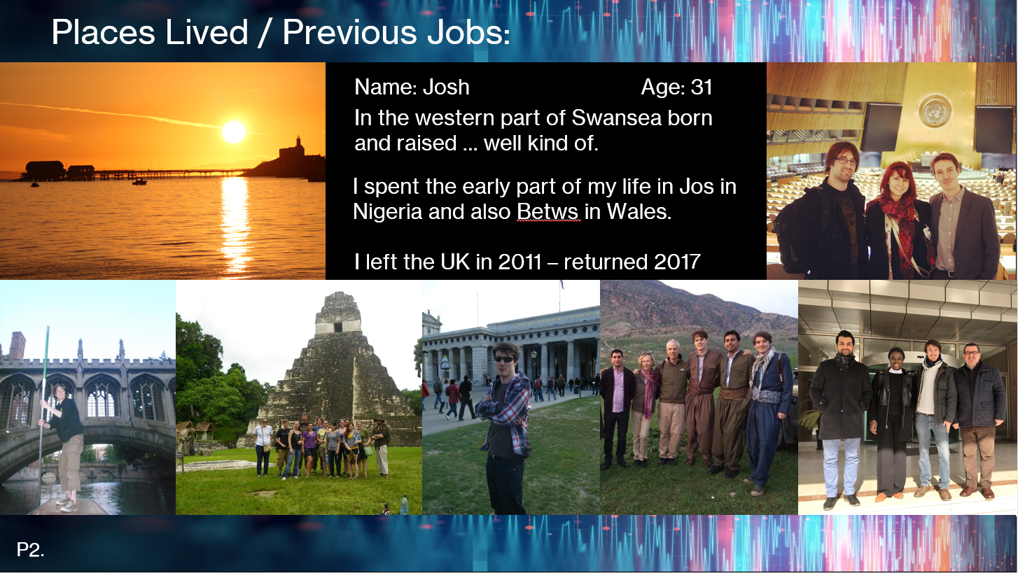
Figure 2: Places Lived / Previous Jobs slide from introduction presentation.
From previous experience presenting and debating the author knew that they speak most effectively with less notes. Therefore, although the author practiced the presentation beforehand, it was important to remove as many temptations to ‘read’ from the slide as possible. The picture selection was purposeful as well, intending to illustrate a myriad of different experiences.
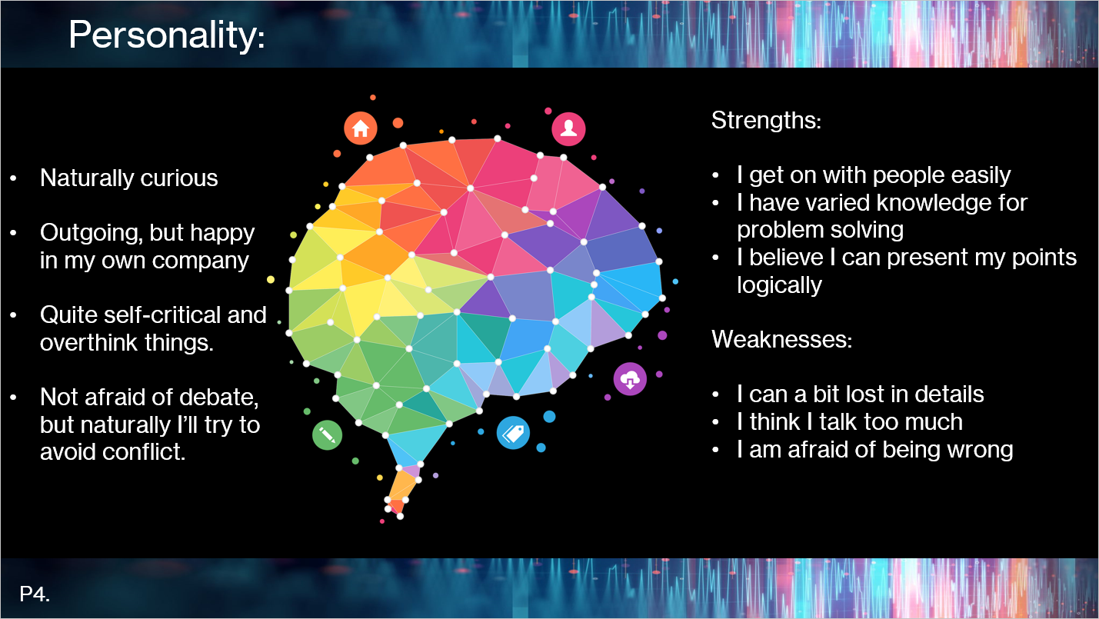
Figure 3: Personality slide from introductory presentation
In almost complete contrast to the previous slide the personality slide focuses more on text and when presenting the author did use the text to guide the speech. This was also intentional, as although a natural flowing style was aimed at overall, it was thought that a balance needed to be struck between personal experience and relating this to broader areas for self-reflection. By listing attributes and then attempting to relate them to strengths and weaknesses the aim was to both to consider personality, but also reflect as to how this can relate to personal and professional development. The use of text therefore makes sense, inviting the viewer to read the sections and draw the links between them, allowing them to check back on previous bits of information as the speech continues.
The final slide to consider is on hobbies and interests. Although this slide was shown in between the ‘Places Lived/Previous Jobs’ and ‘Personality’ slides, it is being considered here afterwards as it also introduces some of the feedback and self-reflection on the presentation overall.
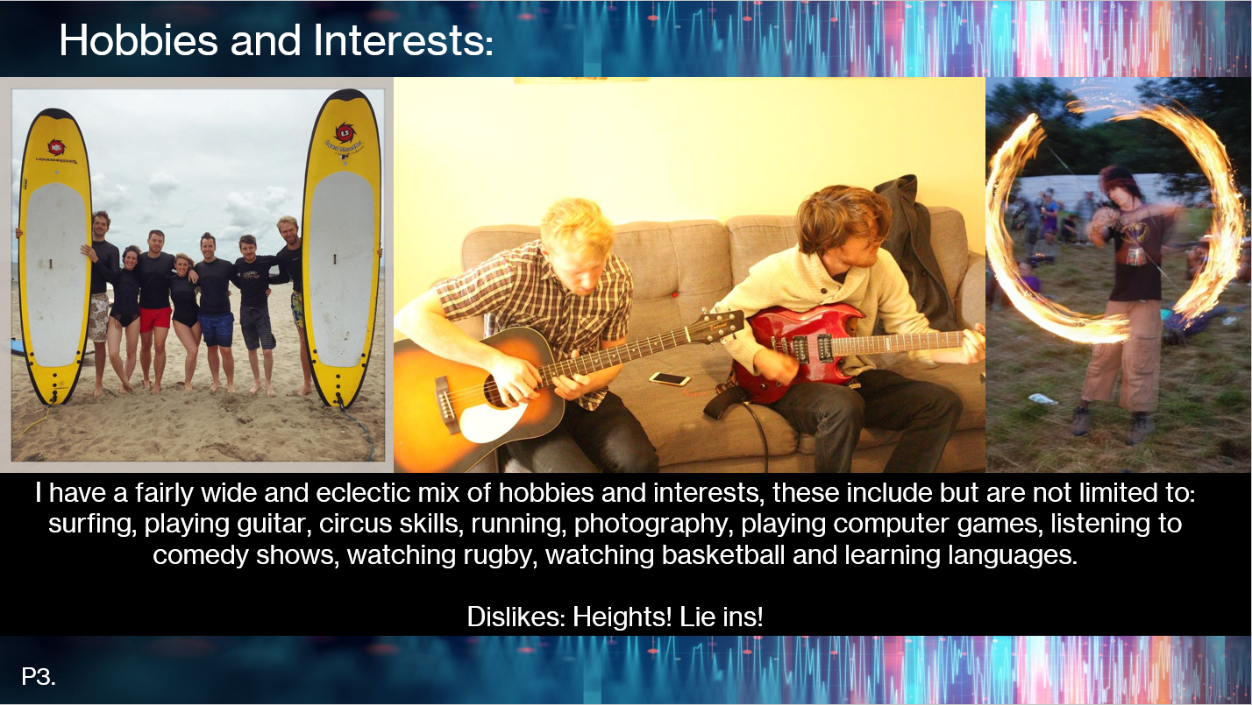
Figure 4: Hobbies and Interests slide from introduction presentation.
The slide was intended to again highlight a wide variety of experiences by combining pictures and text. The text here was not intended to be read fully by the audience, nor was it referenced too heavily in the presentation. It was instead meant to provide a visual joke accentuating the breadth of interests of the author by combining several pictures and a large amount of text.

Presentation self-evaluation and feedback.

Overall, the experience of giving the presentation virtually and the subsequent feedback has highlighted a few points that the author will look to developing in the future. Firstly, one of the criticisms was that the presentation was ‘messy’. The author can certainly appreciate this point. One font and one font colour were used throughout the presentation in order to create cohesion throughout the slides, which was the same rationale between the modified versions of the introductory slide visual. It is possible though that in wanting to select a background that provided a visual identity to the presentation, it was perhaps too vibrant and distracted from the content. In order to remedy this, in the future the author suggests that when creating a presentation it would be beneficial to copy and paste content onto a few different backgrounds and to share these with peers before presenting. Peers could be specifically asked whether they saw the background visuals as too distracting, and whether the relationship between visual impact and content was balanced.
An area that certainly needs development is the picture selection and formatting. An attempt had been made by the author to show a wide expanse of previous experiences and use this as a guide for understanding the personality traits and fulfilling the objectives of the exercise. Another approach may have been to spend more time considering specific moments or experiences of interest and used these to provide the basis of the presentation. In this way the varied experiences could still have been mentioned as part of the speech, but the photographs chosen could have been more carefully selected to highlight certain key moments. In the slides two and three, figures two and four, the deliberate choice to create denser slides and have a visual joke may have instead confused an audience and instead been a little overwhelming. The different formatting of the photos may have accentuated these issues, therefore seriously detracting from the overall goal. The author has subsequently read a brief online guide on how to improve presentations, which focusses on how to improve TED talks [2].
One image in particular from the article that shall shape the author’s future approach to presentation design is shown below:

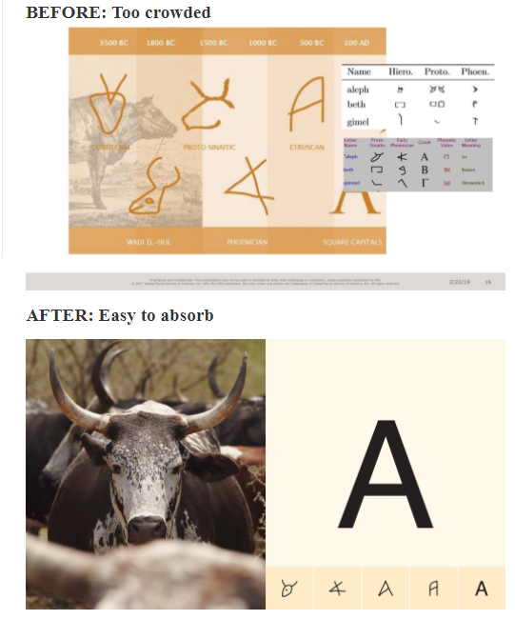
Figure 5:TED Talks visuals improvements [2]
The author particularly likes this example because the ‘before’ image is of a high quality and conveys a lot of information and yet when compared to the second it is clearly shown to be too cluttered. The image illustrates the need to carefully scrutinise image selection and formatting and is something that the author will utilise in their professional development.
Another criticism was that the author needed to be careful with filler words. Interestingly, in the author’s experience this has only ever been an issue on pre-prepared work. Previously in debating the author never wrote a speech, instead relying on one small flashcard with facts or figures. The rest of the speech would then be delivered based on the arguments that the author had considered, but not written down. In university the author experimented with writing longer speeches and giving these in debates, peers at the time observed that the style deteriorated and that the number of filler words increased, which was the criticism given in the feedback to the pre-rehearsed presentation. More research and observation is needed by the author to learn what the optimal amount of preparation and pre-planning for a presentation is. One thought after listening to Nancy Duarte’s TedTalk on presentations [3], was that perhaps considering the speech in terms of storytelling may help. Allowing the author to have a structure to the story in mind, but keeping the details ad-hoc, therefore cultivating a freer flowing style of delivery. It is also possible that given that the presentation was online, many of the non-verbal ways the author has learnt to engage with audiences were not able to be utilised and whether this placed greater emphasis on the content, thus highlighting pauses that had previously been masked by mannerisms, is unclear.
In summary the author still believes that giving presentations is a particular strength. However, it is recognised that careful attention needs to be placed on visuals, as well as speech patterns moving forward. The author has begun to do more research in to this, as shown by the further readings and will continue to develop and hone this skill. Secondly experimentation will continue on the differences between virtual and non-virtual presentations, as well as between planned and unplanned speaking opportunities utilising peers, as has been done previously, for advice and feedback.
This report will now begin to look at wider aspects of personal reflection in both education and professionally.

Skills Evaluation

Skills in higher education & the workplace

In her article ‘What skills do employers want?’ Rachel Swain asserts that companies are looking for staff who have the following abilities, traits or experiences; “resilience”, “good communication”, “effective leadership”, “planning and research skills”, “teamwork and interpersonal skills” and finally “relevant work experience” [4]. She is not alone in outlining these desirable qualities, UCAS the United Kingdom’s University and Colleges Admissions System also outlines a very similar set of skills and indeed places resilience at the top of that list, the same as in Swain’s article [5] [4]. Similarly, the popular job search website, Indeed.com, lists a very similar set of criteria that employers find desirable, although Indeed’s list adds a few extras and starts with “communication skills” [6]. A Guardian article from 2012 shows that these traits have been commonly identified by employers for some time [7]. The question therefore then becomes do these skills overlap with the traits that are required for successful study at university?
As a starting point it is useful to look at the chapter headings for the book “The guide to learning and study skills” [8]. A number of the chapters, in fact over half, are focused on skills that align directly to what employers maybe looking for post university [8]. Chapter 12 for example explicitly focuses on “teamwork” and guides readers through how an individual should consider the skills necessary to work as part of a group including key concepts such as establishing “ground rules” and understanding “responsibilities” [8, pp. 253-274]. The other chapters may not be as explicit, but there is still considerable overlap, see for example “Presenting your Work” and “Handling Time and Pressure” which focus on communication skills and the efficacy of planning [8]. In their advice to students the Oxford Royale Academy and Oxford Learning Centre, both highlight key skills that map onto the traits that are looked for by employers [9] [10]. The Oxford Royale Academy for example explicitly points out the importance of research skills to being successful at university, whereas the Oxford Learning Centre highlights the importance of organisation and planning [9] [10].
In speaking to 10 successful university graduates in a range of industries, George MacGill’s article for the Times Higher Education, also shows the significance of developing good studying habits that benefit life in the workplace. Amongst the references to saving money and eating well, the interviewees gave several tips on avoiding procrastination and being more productive i.e. better time management, as well as developing confidence through putting yourself in new situations which would entail developing communication skills and potentially leadership or resilience traits as well [11]. Whereas Ella Patenell emphatically states that soft skills, including time management, are elements to be focused on as part of a student’s university life [12].
It is therefore clear that good academic practices are related to skills that can be transferred to the job market. The next thing to therefore consider is how one’s individual learning style contributes to the development of these traits.

The Author’s Evaluation of learning skills

As part of the study skills lectures given at the University of Wales, Trinity St. David, the author completed a number of self-evaluations on learning skills, styles and personality traits. It is noted that whilst self-reflection is an important aspect of development some of the tests used have serious issues in terms of their methodological validity [13]. The table below outlines some of the activities associated with learning at university and where the author believes they lie within the grading system.
Table 1: Author's assessment of learning skills, taken from lectures provided by Gareth Jones, University Of Wales Trinity St. David [14]
Skill
 | 5 | 4 | 3 | 2 | 1
I have the confidence to try new things and express my ideas |  | x
I am self motivated and will persevere with difficult tasks |  | x
I am organised and can meet set deadlines |  | x
I am able to find information from different resources easily |  | x
I can read complicated texts and understand the general meaning |  | x
I am able to select what is relevant and what is irrelevant in text |  |  | x
I can compare different opinions and decide what are the best grounds for deciding who is right | x
I can write things in my own words | x
I am able to reflect and evaluate my own work |  | x
I have good strategies for starting a new task/assignment |  |  | x
I have good time management skills and can organise my workload effectively |  |  | x
I am able to make, store and find my notes |  | x
I am able to manage a range of writing skills appropriately |  | x
I am able to think critically and analytically, and evaluate arguments | x
I have good memory strategies |  | x
I know how to use IT to help academic study |  | x
I am confident at preparing and delivering oral presentations |  | x

The author believes that the answers provided are an accurate assessment of their skills as developed through previous higher education and several professional positions and institutions. The three areas where the rating is lower, ‘time management’, ‘starting new work’ and the ability to pick out ‘relevance’ in text relate to the authors understanding of themselves as someone who enjoys a wide range of activities and can therefore be distracted from tasks that do not interest them, including a lack of motivation to start. In understanding this the author had already begun to utilise their calendar more heavily as illustrated below, note the areas redacted are recurring work engagements not attended, but still listed:
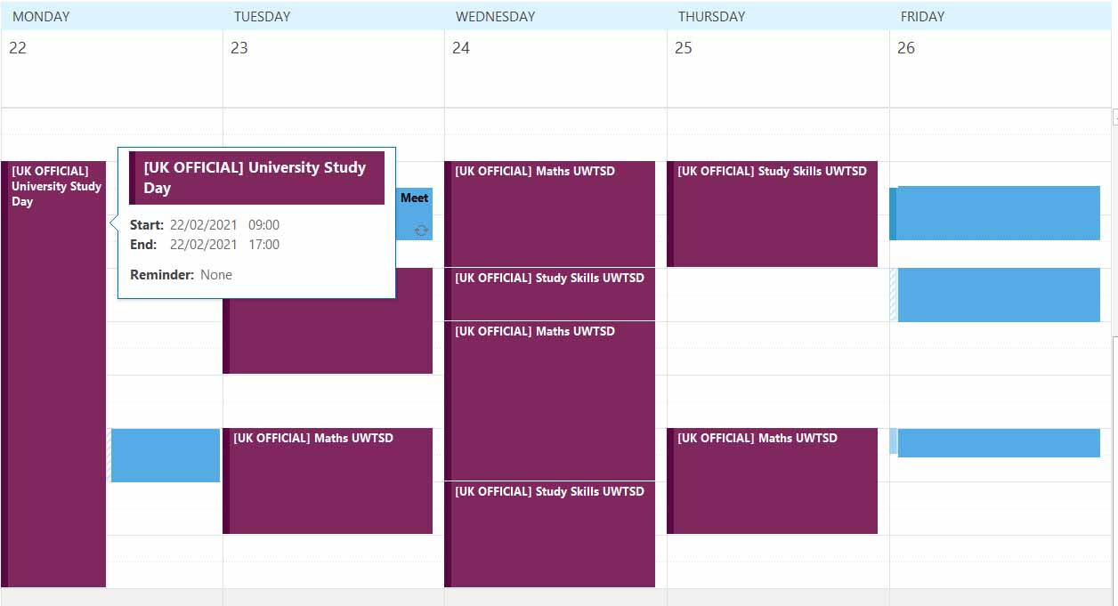
Figure 6: Edited version of the author's work calendar, showing the development of their time management.
The Honey and Mumford learning style results that the author obtained in class were interesting.
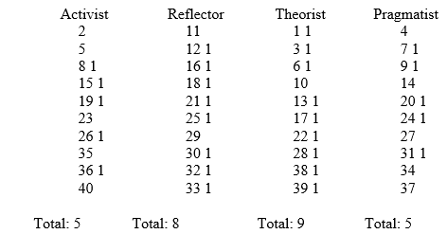
Figure 7:Honey and Mumford Learning Style (1986) taken from Gareth Jones, University of Wales Trinity St. David. [15]
According to the results the author scores most highly in the theorist and reflector categories. The descriptions for the learning styles preferred by each category are shown below.
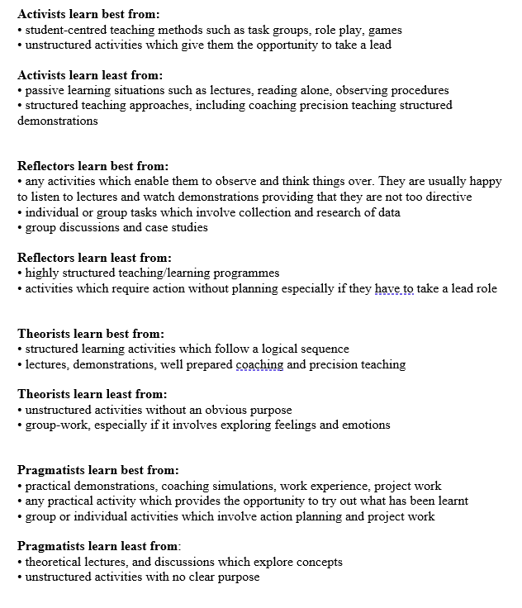
Figure 8: Honey and Mumford Learning Styles (1986) Descriptors taken from Gareth Jones, University of Wales Trinity St. David. [15]
As can be seen the ways in which theorists and reflectors are meant to learn according to the descriptors is somewhat contradictory. As a theorist the author is meant to benefit from structured learning, whereas as a reflector that is when the author learns least. Despite this confusing result it does make sense to the author, as their experience in higher education has demonstrated that their learning style is highly dependent on circumstance. At times structured work has been incredibly beneficial at other times antithetical. Furthermore, though the author scores middling on the pragmatist factor, this was identified as one of their stronger features through previous job placements. Unfortunately, whilst understanding these scores can be useful in a broad sense, it is the author’s experience that they must be taken as evidence of trends and not relied upon too heavily for granular detail.
To try to understand the learning style deeper, the author was encouraged to complete a number of psychological tests. The results of which are contained over the next few pages. The first test is referred to as the Five-Factor Model, which according to one of the original authors should be applied at “a more conceptual level, not to understand individuals, but to clarify issues in disciplines related to personality psychology [14, p. 206]”. Furthermore, they go on to say that the test should be taken as a starting point for a common approach by psychologists and not as a register of the wide gamut of human individuality [14, p. 207] . It is important to state these factors at the start as caution is key in evaluating these results particularly as they have not been derived with the aid of a psychologist as part of a study, but instead as part of an online questionnaire based on interpretations of the study. This is not to say the results are not accurate, but again that they must be contextualised and any conclusions must be drawn carefully.
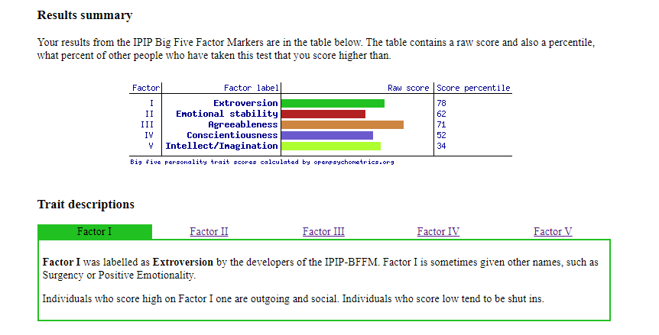
Figure 9:Author's Factor I score according to the Five-Factor Mode [15].
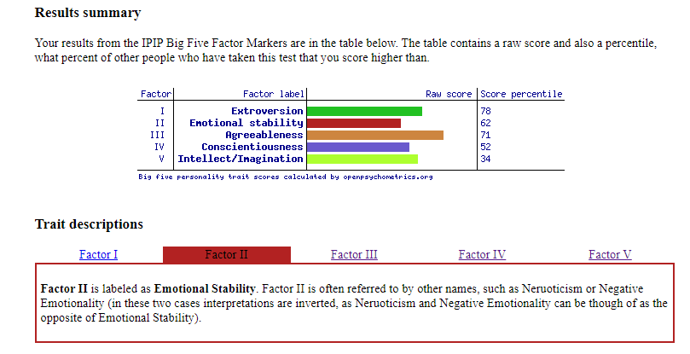
Figure 10: Author's Factor II score according to the Five-Factor Mode [14].
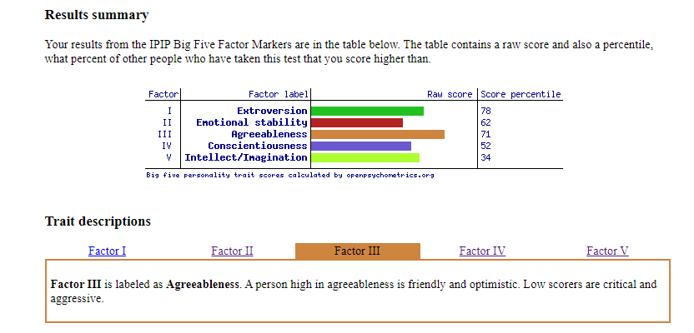
Figure 11: Author's Factor III score according to the Five-Factor Mode [14].
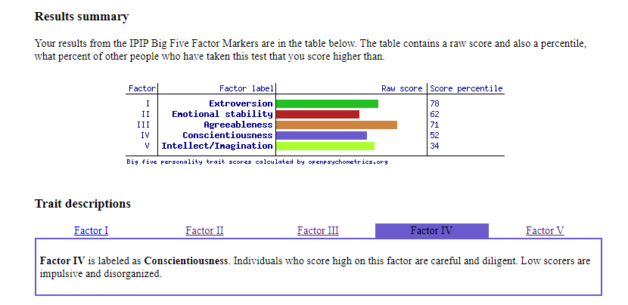
Figure 12: Author's Factor IV score according to the Five-Factor Mode [14].
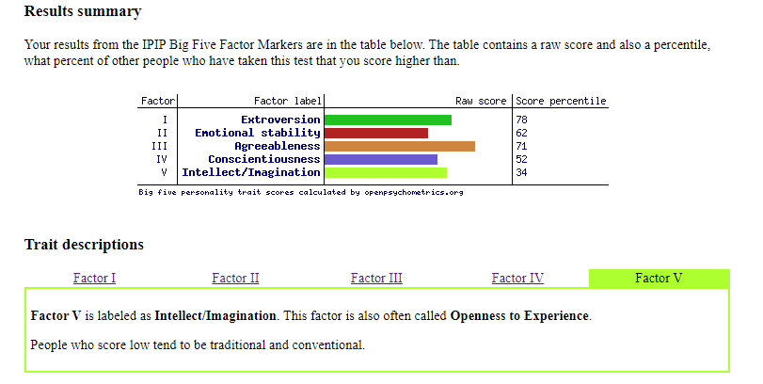
Figure 13: Author's Factor V score according to the Five-Factor Mode [14].
In looking at the results the author appears to score highly in all traits. In trying to understand this it is worth remembering that the test developed out of studies in trying to establish heuristics and commonality across personality so that it might be analysed by different researchers as a coherent discipline [16]. Thus, a high scoring series of traits may simply identify an individual with scores within a normal continuum of behaviours. Recent studies have tried to better aggregate the data across large numbers of individuals so as to be able to create relative groupings that may better described as types, but even this has been problematic [17]. The data seems to highly align with age and gender, perhaps no surprise as aggregates would potentially better capture the lived experience of grouped individuals and therefore show commonality the danger again lies in then extrapolating this back to the individual. As the study suggests, women around forty may display similar traits of “low neuroticism and high openness” [17], but that does not mean that every woman does or that it is unnormal for a woman with a different life experience to display something different [14].
The author has at various points in their life and again for this assessment utilised the Myers-Briggs test to also give an understanding of personality and how this how to search for new opportunities, both in work and personally. In previous tests the author had been identified as an ENFP. The results below are from the most recent round of testing and are taken from a selection of different websites. The first test is based on the Myers-Briggs, but is called the Open Extended Jungian Type indicator test and claims to be more accurate through its use of open source data [18].
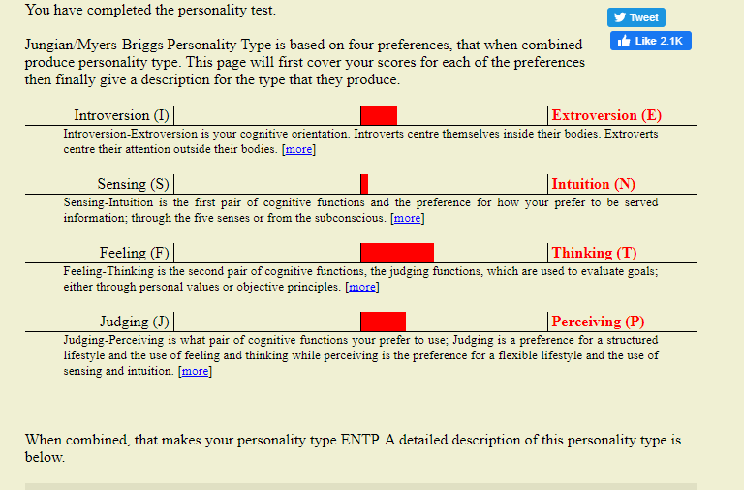
Figure 14: Open Extended Jungian Type indicator test results taken on 25/02/2021 [18]
The result of this test would suggest that the author had changed between previous testing periods and now aligned more closely to the ENTP archetype. To double check the results the author continued to do assessments and document the results. Some of the other tests are listed below.
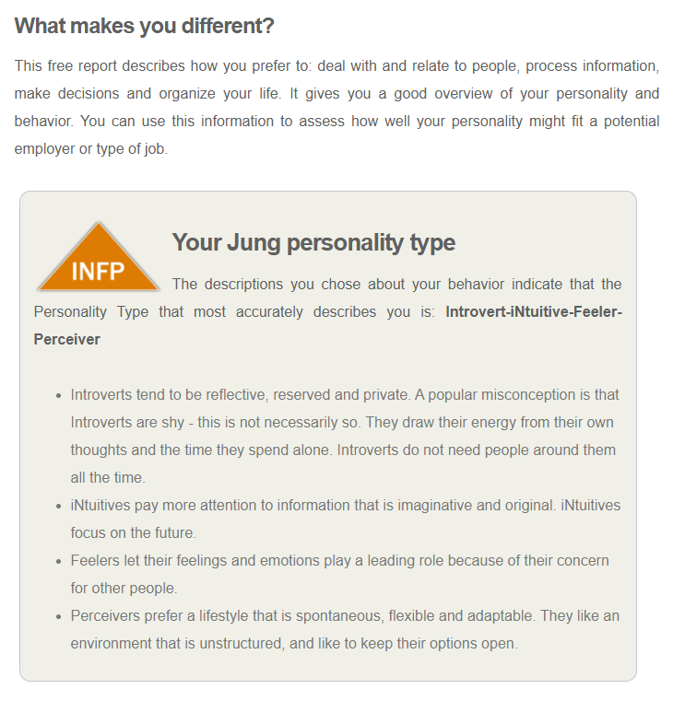
Figure 15: Myers-Briggs taken on 25/02/2021 [19]
Despite showing a propensity towards extroversion in the first test, the second seems to suggest a more introverted personality type. Furthermore, the feeling vs. thinking pairing that gives quite a marked result in favour of thinking is now reversed. Neither test correlate one hundred percent to the author’s previous experience as an ENFP either.
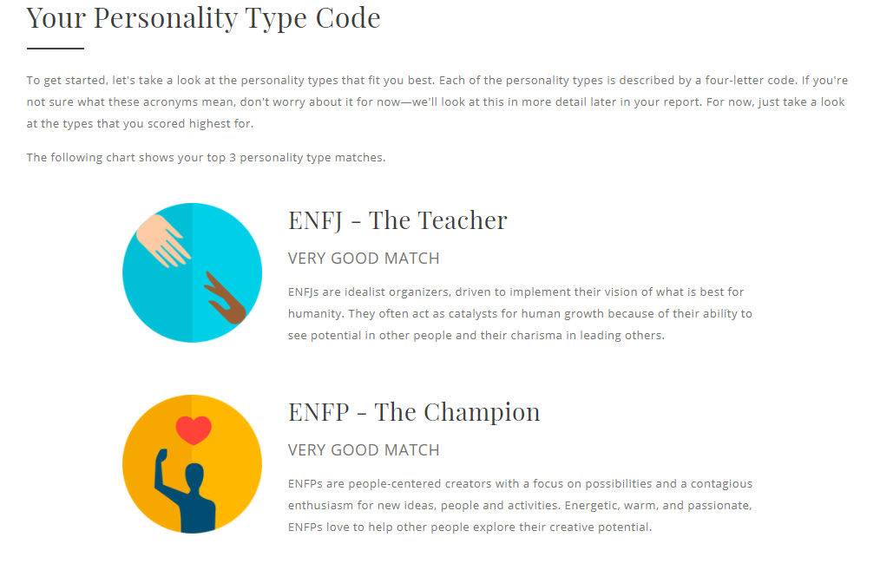
Figure 16: Myers-Briggs style test completed 05/03/2021 [20]
The results of the above test give a somewhat more nuanced approach implying the author is somewhere between two results, with the final pairing being difficult to evaluate, suggesting the author is somewhat in the middle on this continuum. It is interesting to note however that this still contrasts with tests one and two, which both shared a similar result for the final pairing. In the final test conducted below, there was consistency with the first test.
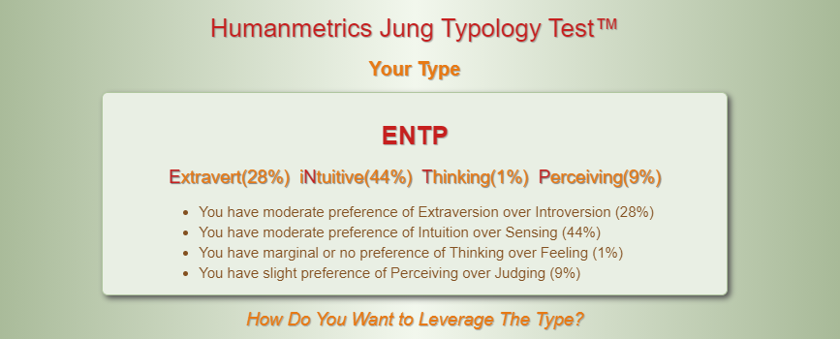
Figure 17: Myers-Briggs test completed 05/03/2021 [21]
Aside from differences in developments over time, there are other reasons to treat the Myers-Briggs with suspicion. In an interview to the Wharton Business school, Merve Emre scholar and author of Personality Brokers: The strange history of Myers-Briggs and the birth of personality testing notes that “I kind of take for granted that its not valid or reliable” [22]. Furthermore, writing in the Washington Post, Emre goes on to explain some of the issues that the author encountered when conducting the test firstly that personality is immutable – it is not [23]. The tests therefore can be a fun introduction into self-reflexion, but one must be careful how to interpret the results and several articles indicate that the use of such tests in formalised processes such as hiring, is highly questionable if not counter-productive [24] [25].
The final part of the tests was to take a Holland career test and examine the results.
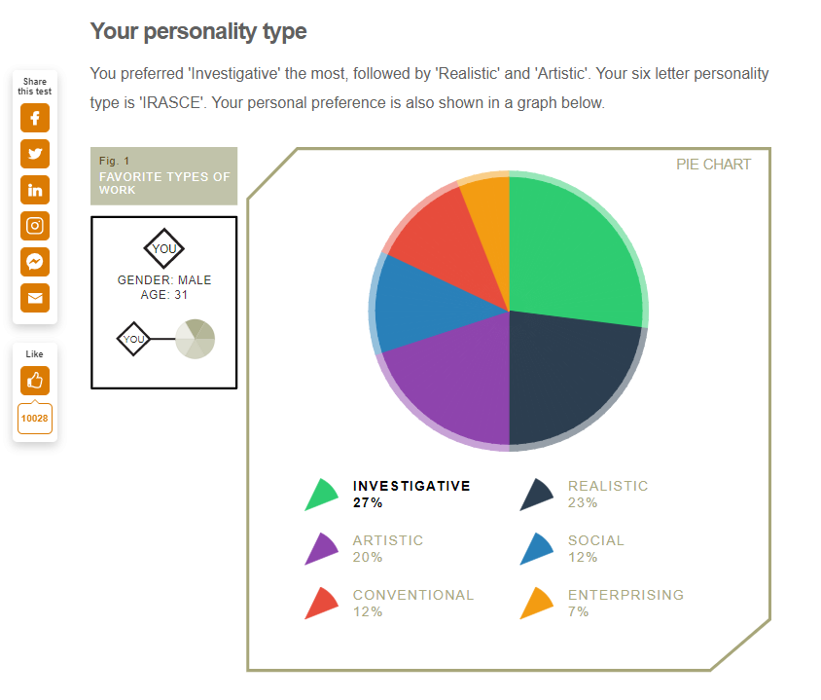
Figure 18: Holland Career Aptitiude test taken on 25/02/2021 [26]
Despite previous criticisms, there does appear to be a high level of correlation between the previous job roles of the author and the findings of the Holland test. Of the suggested occupations, shown below, the author has previously been an archaeologist and archaeology/soil science has been part of the overall life goals and trajectory of the author for a number of years.
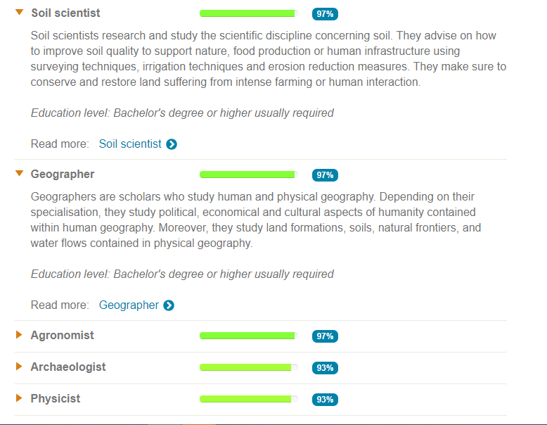
Figure 19: Holland career type suggested professions [26]
Part of the reasons for engaging in the career that the author has now found themselves studying this course is to provide them with skills that if not directly relevant are highly correlated with forensic archaeology, expanding on an MSc previously obtained in the field. Relating this information back to the introduction, it is perhaps unsurprising that given the author’s life experience and familiarity with psychotherapy, and in particular the teachings of Jung, that self-reflection has been a guided previous job and career choices for at least fifteen or sixteen years. This would also correlate with the experience and description from the author and freelance jouranlist Leandra Beabout, who noted that if a user already has a high level of self-reflection then the Holland test is unlikely to reveal anything new but is comforting when it aligns with preconceived notions [27]. Beabout is taken here as an example of another lay-person, but even professionals note that the Holland test should be part of a wider discussion therefore part of a broader sense of self-reflection rather than a prescriptive test [28].
Finally based off the above tests and reflections the author completed the following self-assessment and action plan.
Strengths, skills and qualities
- Outgoing, able to easily get along with others
- Quite self-motivated
- Able to evaluate arguments
- Able to think critically

What I need to work on, develop or improve
- Time management
- Strategies for starting new work
- Strategies for organising previous work, particularly in the longer term
- Confidence to express my ideas without fear of failure

My Priorities: What I am going to do, When and How
What? | When? | How?
- Time management | Start: 08/03/2021  Ongoing (evaluate every month).  Review strategy after 3 months and adjust if necessary. | Utilise online calendars to better manage personal life
- Strategies for starting new work | Start: 05/03/2021  Ongoing (evaluate every month).  Review strategy after 3 months and adjust if necessary. | First research different ways of starting new work. – complete by 12/03/2021  Document results and convert into action plan moving forward.
- Strategies for organising previous work | Already started: 21/01/2021  Review strategy:  21/03/2021  Complete 21/06/2021 | Go back through previous external hard disks and sort data between different drives  Create a personal hard drive area and a professional area.  Organise these areas by year (if possible)
- Confidence to express my ideas without fear of failure | Start: 05/03/2021  Review: 12/03/2021  Set longer term plan once research is completed | Research strategies on how to get over fear of failure and possible confidence issues.  Use this research to come up with a plan, update this space.

How will I measure if I have improved?
- I will keep track of how often I have used calendars and how accurately they reflect my activities.
- Keep a record on how long it has taken me to start an assignment from when it was originally set – see if this reduces.
- If my hard disks are organised by date with the information clearly divided between personal and professional.
- More subjective, but firstly I will need to see what strategies are suggested for building confidence. After this point, I will have to devise a way of tracking when I take risks and express ideas despite my fear.

Figure 20: Self Assessment and goals taken from the lectures provided by Gareth Jones at the University of Wales, Trinity St. David. [31]
It is believed that the self-assessment and action plan gives a realistic estimation of strengths and weaknesses of the author, whilst at the same time providing a roadmap for moving forward. Overall, in this section the author has tried to illustrate that whilst many of the tests developed and put on the internet are problematic that the idea of self-reflexivity is one of use.
Moving forward there will now be an examination of some of the data organisation techniques that have been highlighted during the course and identified as part of the author’s ways of improving.

Application

Data, back up and management

Data is increasingly an important part of life and as part of the course participants were instructed on the “three place rule”. It was demonstrated that until data is backed up effectively in at least three locations that it was prone to being lost, damaged or destroyed. The author has direct experience with this having lost valuable photographic data in the past some of which appears to be lost forever. Following this occurrence, the author began regularly backing up SD memory cards onto external 1 TB harddives. At the time of writing, the author has four such harddives containing mainly personal media – e.g. photographs. The table below details some of the data loss events that the author has experienced or ones that they can envisage and whether or not the proposed backup is effective.
Table 2: Table showing data loss events, back-up methods and their considered effectiveness
Data Event | Back-Up Method | Effective
Loss of portable media storage i.e. loss of camera with SD card | Weekly / Daily / Monthly backup to external hard-drives | Protects from loss of too much data
Loss of external hard drive | Data is copied between drives, copying is less frequently done however due to time constraints | Protects from total loss of material, however significant time periods can still be lost
Computer viruses, trojans, ransomware | No long term personal data is kept on the author’s laptop – it is used as a quick save with all larger material being moved across weekly.  Antivirus software is installed. | Personal laptop only contains files that the author is immediately working on and anything that is going to extend on for more than two/three days is backed up on an external.
Computer physical malfunction | No long term personal data is kept on the author’s laptop – it is used as a quick save with all larger material being moved across weekly. | Personal laptop only contains files that the author is immediately working on and anything that is going to extend on for more than two/three days is backed up on an external.
Fire at current address | As part of the copying of files two external harddrives are kept in a different location to the author and laptop. | Whilst the frequency of the backups is less – making it less effective, the probability of the event is deemed lower therefore this still remains an effective back up method
Theft of laptop / external harddrive | The author has multiple drives, with two serving as copies of the other two. For all data to be lost there would have to be a theft at two addresses and of five items. | The likelihood that the author is to be burgled at both their home address in Swansea and in Salisbury seems unlikely and therefore the current backup strategy is deemed effective.

From the author’s experience the main loss of data has been through “misplacing” portable media devices such as cameras and SD cards. This has resulted in the above media management strategy. Note that the time frame for backing up data from such sources is altered dependent on context. Currently, the author is not using their camera with a great frequency therefore SD cards are either backed up weekly or even monthly, however during periods of high use the SD cards have been backed up as frequently as twice daily with the copying to a second external drive occurring at the earliest possible date. Although this data strategy was primarily designed to cope with loss of significant media files it has proved a robust method for university study as well. The author used a slight variation on the methodology for their MSc and has all their course work and research backed up on two drives and in two locations. The variation was on the timing of the secondary back up, where university material was copied from one hard drive to another. This occurred at the end of every term therefore realistically there was a two or three month gap between copying. The weekly transfer of files from the laptop to the external harddrive occurred as described in the table and formed part of the author’s weekly routine. It is thought that by continuing the above strategy the author may still have an effective back up routine. In the future thought has been given to converting to an automated system utilising NAS cloud storage to better streamline the storage at different locations. The author however is wary of utilising cloud storage due to its vulnerabilities and the sharing of sensitive information over such a system. The author admits this places a large burden on a user to manually back up files and systems, at the moment and considering the frequency of changes in personal data this is deemed acceptable, but is something to be mindful of in the future. The author has included a report on the vulnerabilities of a small business to ransomware attacks and where there will be networked computers with multiple users. This has been included in appendix B to illustrate the differences in the risks associated with personal use and business needs.

Time management and self-organisation:

As part of section 3.1 the author explicitly identified time management as an issue that could be described as a weakness and therefore steps have been taken to try to address this. The image below shows the work calendar of the author, illustrating their adoption of a method of better managing their time professionally. The image shown is of a university week however during a normal work week ten to fifteen minutes per day are devoted to updating the calendar and defining periods of work for the following days.

Figure 21: Reproduction of a typical university week for the author.

Figure 22: Typical Gantt chart used for project work by author.
During the author’s MSc writing a Gantt chart was developed for their final thesis, this is reproduced here to show the familiarity and usefulness of the concept when applied to project work and to show familiarity with varying ways of managing time dependent on the situation.

Outside of work the author subscribes to the belief that “rough scheduling” is important, but over management of time can in itself become a stress [29] [30]. To this end the author keeps track of their exercise regime, which involves three runs a week, two at the same distance and then a third at a slightly longer distance and therefore involving more time. Aside from these scheduled exercises, other activities are kept fairly ad-hoc. One of the most important aspects of the authors free time is that this can be both used to connect and disconnect with other people. This requires a certain level of fluidity to allow for scheduling of contact with others, particularly during Covid-19, but even previously it was common for the author due to the location of their various connections. However, this can at times run contrary to the desire to completely disconnect from others and indeed to an extent the world. Therefore, the author tries to be aware of their self and uses this judgement as part of their assessment of how their time should be structured in any given period. The author has never found it difficult to occupy their free-time either, as noted in the presentation section of this assessment the author has numerous hobbies, which allow for lots of variation in ones freetime.
It is recognised that the ad-hoc approach does not satisfy everyone, nor does it work for all activities, with practice periods or studying time needing to be blocked out to help with learning. Moving forward, this is something that the author is planning for, particularly regarding activities such as surfing and saxophone playing which both require a larger time investment. In an attempt to try to capture some of these longer-term activities the author has begun using google calendar and the below shows a holiday that is currently planned
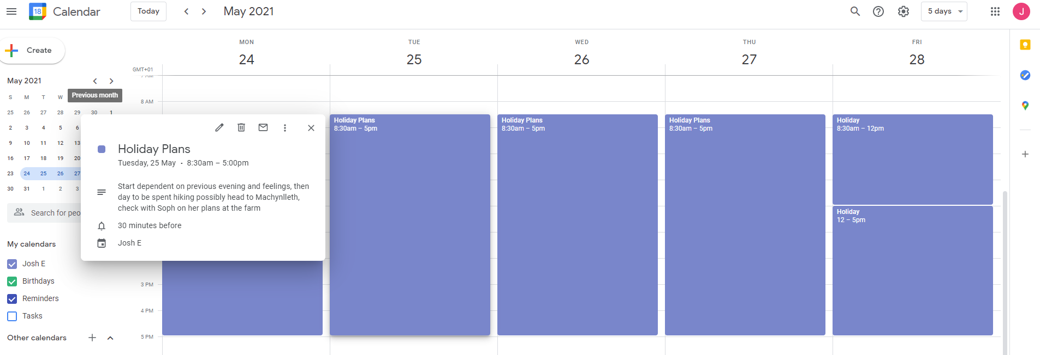
Figure 23: Use of google calendar for free time.
Still some fluidity is in built with activities for each day left in large chunks, detailing options such as hiking along with some locations, but the fact that the time has been blocked and logged as a holiday is an important step in building in free time to the author’s life, which did not use to occur regularly.

Personal development portfolio:

As part of the course participants were encouraged to develop an e-portfolio, this was a very useful concept. Based on requirements the author decided on the following file structure.
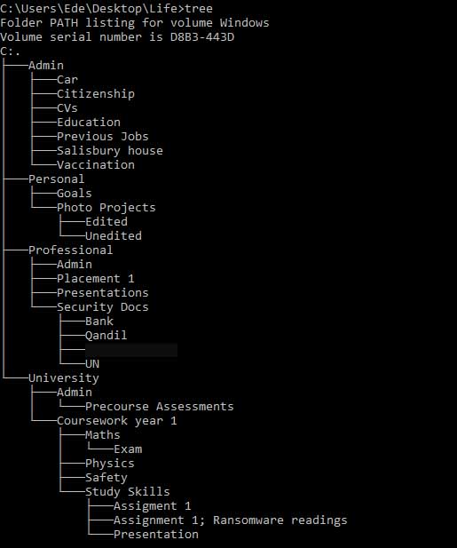
Figure 24: The E-portfolio structure used by the author one line omitted for work reasons.
The structure was chosen to best capture the range of activities in which the author’s personal computer will be used. The life directory provides the overall structure that is adopted throughout the author’s laptop and external hard disks, however there is some variation where external drives are utilised more for photographic media and projects.
The structure has been chosen as it allows for quick searching for everyday admin documents, with folders clearly detailing the common areas of certain information car contains information pertaining to; insurance, registration, digital MOT certificates and parking permits for example.
The Personal folder on the laptop only contains two sub-folders, goals and photo projects. Initially the author had a separate sub-folder for music within goals to detail learning progress of certain instruments. This however proved too granular and meant that the author stopped checking the goals documents collected within that level. Therefore, the conscious decision was made to leave goals as a catch all folder relating to music progression, life goals and other hobbies, with the only separation in personal being for larger more media intensive files such as photographs. Note for documents related to how to take photographs or different techniques the author includes those as part of the goals folder and not photo project. The project folder holds the resources to be worked on not the methodology which is seen as part of continuous development of the skill and therefore a goal orientated document. There is possibility in the future that the personal folder may be sub-divided into a music projects folder emulating the photo projects heading and in fact this already exists on the external hard drives, but given that these are not currently being worked on and in line with the author’s policy of keeping their laptop free of clutter, the folder is not required at the moment.
The professional folder on the personal laptop does not contain work documents for projects as this is by and large not permitted within the author’s work. The folders therefore contain information that may be pertinent to the work environment but might be accessed more frequently outside of work. For example the security documents folder contains contracts from previous jobs that have to be kept as a record for the author’s current employer. Furthermore, the ‘placement 1’ folder, is for articles or research related to the author’s placement within work but that are discovered outside of normal working hours. The idea being to build a small repository of potentially interesting articles or papers and if any of these are particularly useful accessing them again from work.
Organising the laptop in this way the author hopes to be effective in going forward both professionally and academically. The following section will look at evaluating the assignment and things learnt during the exercise.

Evaluations and conclusions:

The study skills module has proved to be useful as a stock take exercise for the author. A number of the activities, particularly on self-reflexivity are things that the author has been doing, either consciously of unconsciously for a number of years therefore whilst they were not new it was good to see that they were not alone in their thinking. There are several key areas following this exercise that the author will try to develop further, which shall be discussed now.
The first is the presentation skills, which the author has always felt was a strength therefore some of the feedback was good to hear and will inform how the author presents in the future. In particular, the better design of visual aids will be explored. As previously stated it will be interesting to see how the effect of in person presentations is different to those given online, however given that the world appears to be moving more and more to virtual space it is good to pause at this point in time and develop these online presentation skills in particular. A second area where the author notes they need to develop better strategies is with time management. The author has a dislike of rigid calendars during their personal life, however it is recognised that this is probably an issue and if they want to better utilise free time a better balance should be found between unstructured and structured leisure activities. As elucidated in a previous section, steps are being taken in this regard with the utilisation of google calendar for personal activities something that was not occurring at all prior to taking the course. The author intends to continue this trend and monitor its effects, whether it leads to more positive outcomes, greater feelings of relaxation or better learning times for musical instruments and hobbies, or whether the production and scheduling of life leads to greater anxiety. The third and final area which has been illustrated as a potential area for work is the digital strategy used by the author. The backup strategy, in particular, is very user intensive involving a lot of copying of data and manual remembering of timings. The adoption of a NAS backup system and the author’s learning of coding in their spare time as another hobby, is possibly seen as an answer to this shortcoming, however more research is required in both before the widescale adoption.
In conclusion the author believes that they have routinely throughout their life adopted a number of the strategies explicitly taught in this course. They have however still found the course useful in highlighting a number of factors and the areas listed above are things that the author shall continue to develop in the future.

Bibliography:

[1] | G. Jones, “University of Wales Trinity St. David, study skills, presentation,” 14 January 2021. [Online]. Available: https://moodle.uwtsd.ac.uk/mod/page/view.php?id=203067. [Accessed 15 01 2021].
[2] | A. Miller, “6 dos and don’ts for next-level slides, from a TED presentation expert,” TED, 13 June 2019. [Online]. Available: https://ideas.ted.com/6-dos-and-donts-for-next-level-slides-from-a-ted-presentation-expert/. [Accessed 05 03 2021].
[3] | N. Duarte, Writer, The secret structure of great talks. [Performance]. TEDxEAST, 2011.
[4] | R. Swain, “What Skills do Employers Want?,” Prospects, May 2019. [Online]. Available: https://www.prospects.ac.uk/careers-advice/applying-for-jobs/what-skills-do-employers-want. [Accessed 02 4 2021].
[5] | UCAS, “What Skills do employers Look For,” UCAS, [Online]. Available: https://www.ucas.com/careers/getting-job/what-are-employers-looking#:~:text=A%20positive%20attitude%20to%20work,to%20recruit%20a%20young%20person.. [Accessed 01 04 2021].
[6] | Indeed Editorial Team, “14 Common Qualities Employers Are Looking For,” Indeed, 1 December 2020. [Online]. Available: https://www.indeed.com/career-advice/finding-a-job/qualities-employers-want. [Accessed 29 03 2021].
[7] | S. Schwartz, “Employability skills – where is wisdom?,” The Guardian, 02 May 2012. [Online]. Available: https://www.theguardian.com/higher-education-network/blog/2012/may/02/wisdom-as-an-employability-skill. [Accessed 04 04 2021].
[8] | R. Bingham, The Guide to Learning and study skills: for higher education, Surrey: Gower, 2012.
[9] | Oxford Royale Academy, “Essential Skills for Undergraduate Life: the 13 Things You Should Know How to Do Before You Go to University,” Oxford Royale Academy, [Online]. Available: https://www.oxford-royale.com/articles/13-skills-university/. [Accessed 12 04 2021].
[10] | Oxford Learning Centre, “How to study effectively: 12 secrets of success,” Oxford Learning Centre, 19 April 2017. [Online]. Available: https://www.oxfordlearning.com/how-to-study-effectively/. [Accessed 11 04 2021].
[11] | G. Macgill, “Top 10 university hacks from some of the UK’s most successful students and graduates,” Times Higher Education, 12 September 2017. [Online]. Available: https://www.timeshighereducation.com/student/advice/top-10-university-hacks-some-uks-most-successful-students-and-graduates. [Accessed 11 04 2021].
[12] | E. Patenall, “Five Soft Skills You Develop At University,” QS Top Universities, 08 April 2021. [Online]. Available: https://www.topuniversities.com/student-info/careers-advice/five-soft-skills-you-develop-university. [Accessed 08 April 2021].
[13] | A. Chen, “How Accurate Are Personality Tests?,” The Scientific American, 10 October 2018. [Online]. Available: https://www.scientificamerican.com/article/how-accurate-are-personality-tests/. [Accessed 29 03 2021].
[14] | G. Jones, “Self Evaluation of Academic Skills,” 2021. [Online]. Available: https://moodle.uwtsd.ac.uk/mod/resource/view.php?id=203171. [Accessed 25 02 2021].
[15] | G. Jones, “Honey and Mumford Learning Styles,” 1986, reproduced 2021. [Online]. Available: https://moodle.uwtsd.ac.uk/mod/resource/view.php?id=337396. [Accessed 25 02 2021].
[16] | R. R. McCrae and O. P. John, “An Introduction to the Five-Factor Model And Its Applications,” Journal of Personality, vol. 60, no. 2, pp. 175-215, 1992.
[17] | Open-Source Psychometrics Project, “The Big Five Personality Test,” Open-Source Psychometrics Project, 02 August 2019. [Online]. Available: https://openpsychometrics.org/tests/IPIP-BFFM/. [Accessed 25 02 2021].
[18] | L. R. Goldberg, “The Structure of Phenotypic Personality Traits,” American Psychologist, vol. 48, pp. 26-34, 1993.
[19] | D. G. Smith, “Big Data Gives the “Big 5” Personality Traits a Makeover,” Scientific American , 18 09 2018. [Online]. Available: https://www.scientificamerican.com/article/big-data-gives-the-big-5-personality-traits-a-makeover/. [Accessed 02 04 2021].
[20] | “Open Extended Jungian Type,” OpenPsychoMetrics, [Online]. Available: https://openpsychometrics.org/tests/OEJTS/. [Accessed 25 02 2021].
[21] | 123Test, “Your Jung Personality report,” [Online]. Available: https://www.123test.com/report/M5APSOSWDYUXC9BUCF/. [Accessed 25 02 2021].
[22] | Truity, “The Type Finder Personality Test,” Truity, [Online]. Available: https://www.truity.com/test/type-finder-personality-test-new. [Accessed 05 03 2021].
[23] | HumanMetrics, “ENTP: Extraverted iNtuitive Thinking Perceiving,” HumanMetrics, [Online]. Available: http://www.humanmetrics.com/personality/entp. [Accessed 05 03 2021].
[24] | Knowledge@Wharton, “Personality Puzzler: Is There Any Science Behind Myers-Briggs?,” 08 November 2018. [Online]. Available: https://knowledge.wharton.upenn.edu/article/does-the-myers-briggs-test-really-work/. [Accessed 05 03 2021].
[25] | M. Emre, “Five Myths About Personality Tests,” The Washington Post, 20 September 2018. [Online]. Available: https://www.washingtonpost.com/outlook/five-myths/five-myths-about-personality-tests/2018/09/20/3a57a8ee-b78a-11e8-a2c5-3187f427e253_story.html. [Accessed 06 03 2021].
[26] | R. Hosie, “Why the Myers-Briggs Test Should Never Be Used in Recruitment,” The Independent, 11 August 2017. [Online]. Available: https://www.independent.co.uk/life-style/myers-briggs-test-recruitment-why-never-use-occupation-psychologists-a7888076.html. [Accessed 07 03 2021].
[27] | W. Martin, “The Problem with Using Personality Tests for Hiring,” The Harvard Business Review, 27 August 2014. [Online]. Available: https://hbr.org/2014/08/the-problem-with-using-personality-tests-for-hiring. [Accessed 07 03 2021].
[28] | 123Test, “Career aptitude test,” [Online]. Available: https://www.123test.com/career-test/. [Accessed 05 02 2021].
[29] | L. Beabout, “Do Career Tests Actually Work? I Tried 5 of Them to Find Out,” Reader's Digest, 05 04 2020. [Online]. Available: https://www.rd.com/article/career-tests/. [Accessed 05 03 2021].
[30] | J. Staunton, “John Holland’s Theory Of Career Choice – Theories Every Careers Adviser Should Know,” 14 January 2015. [Online]. Available: https://runninginaforest.wordpress.com/2015/01/14/john-hollands-theory-of-career-choice-theories-every-careers-adviser-should-know/. [Accessed 07 03 2021].
[31] | G. Jones, “Self-Assessment Action Plan,” 2021. [Online]. Available: https://moodle.uwtsd.ac.uk/mod/resource/view.php?id=203172. [Accessed 25 02 2021].
[32] | J. Rampton, “Science Says Healthy Scheduling Habits Make People Happier,” Entrepeneur Europe, 03 May 2019. [Online]. Available: https://www.entrepreneur.com/article/333169. [Accessed 2021 03 11].
[33] | M. Weinberg, “The Perils (and blessings) of Unstructured Time,” 11 July 2019. [Online]. Available: https://www.openlinescounseling.com/blog/2019/7/11/the-perils-of-unstructured-time. [Accessed 11 03 2021].


Appendix A: Presentation
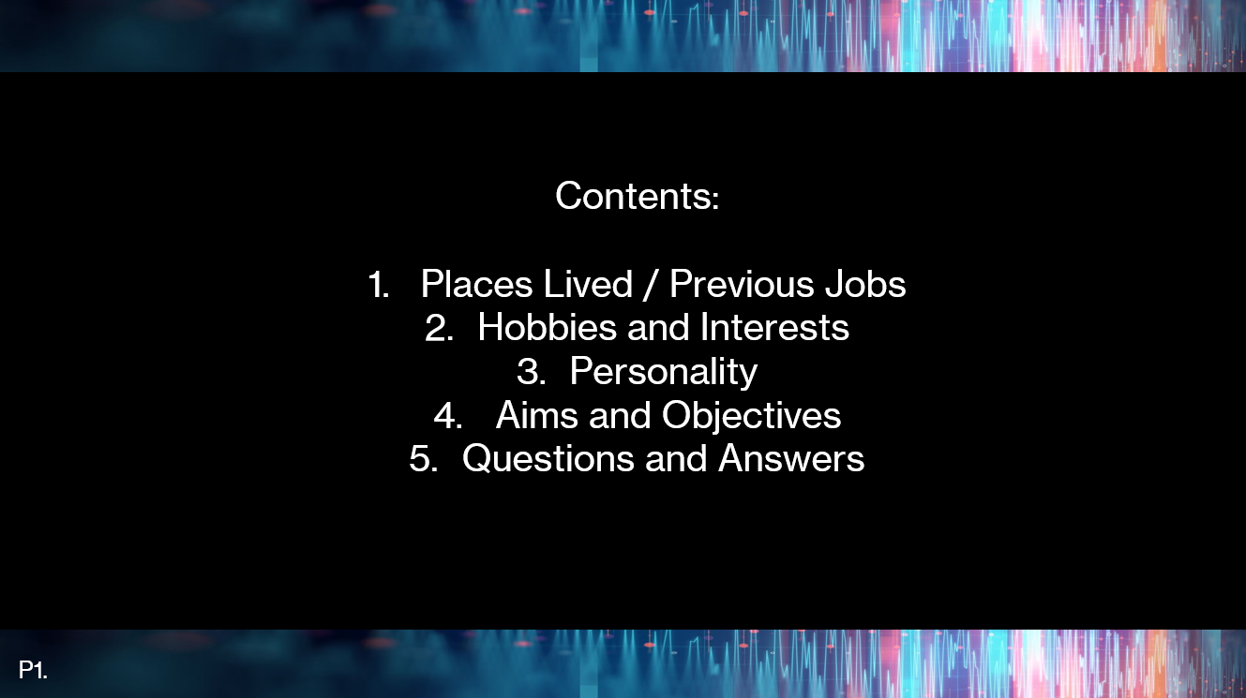

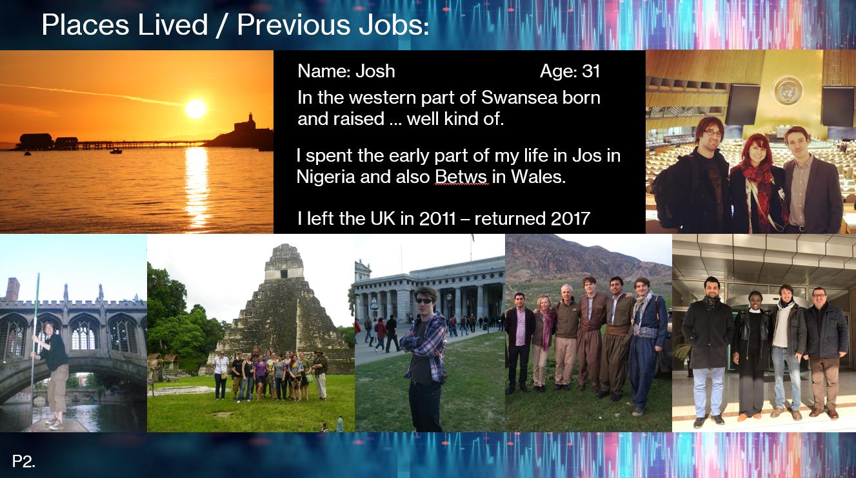

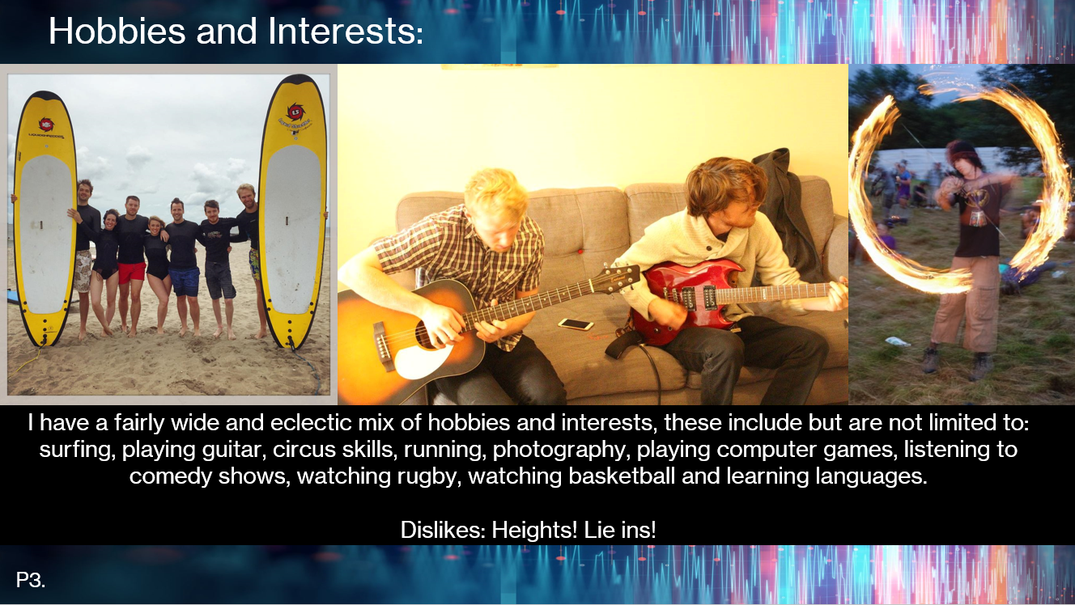

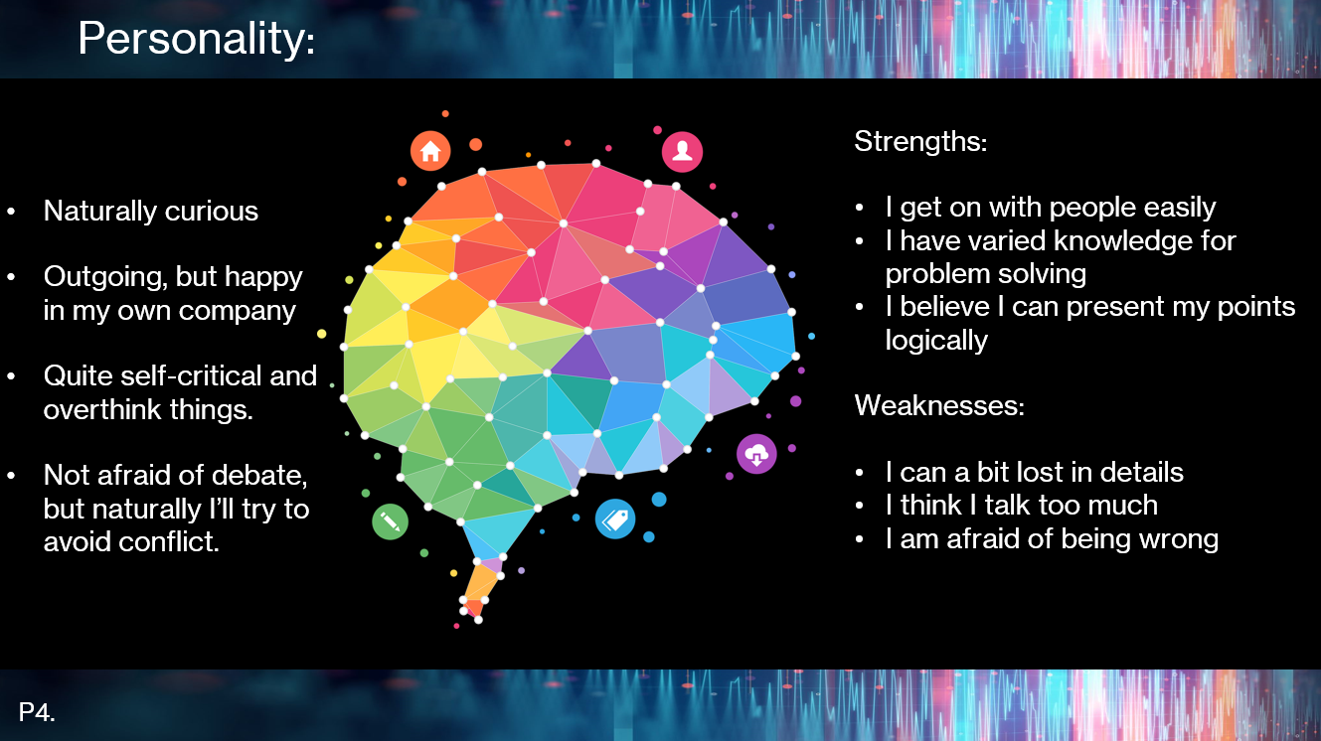

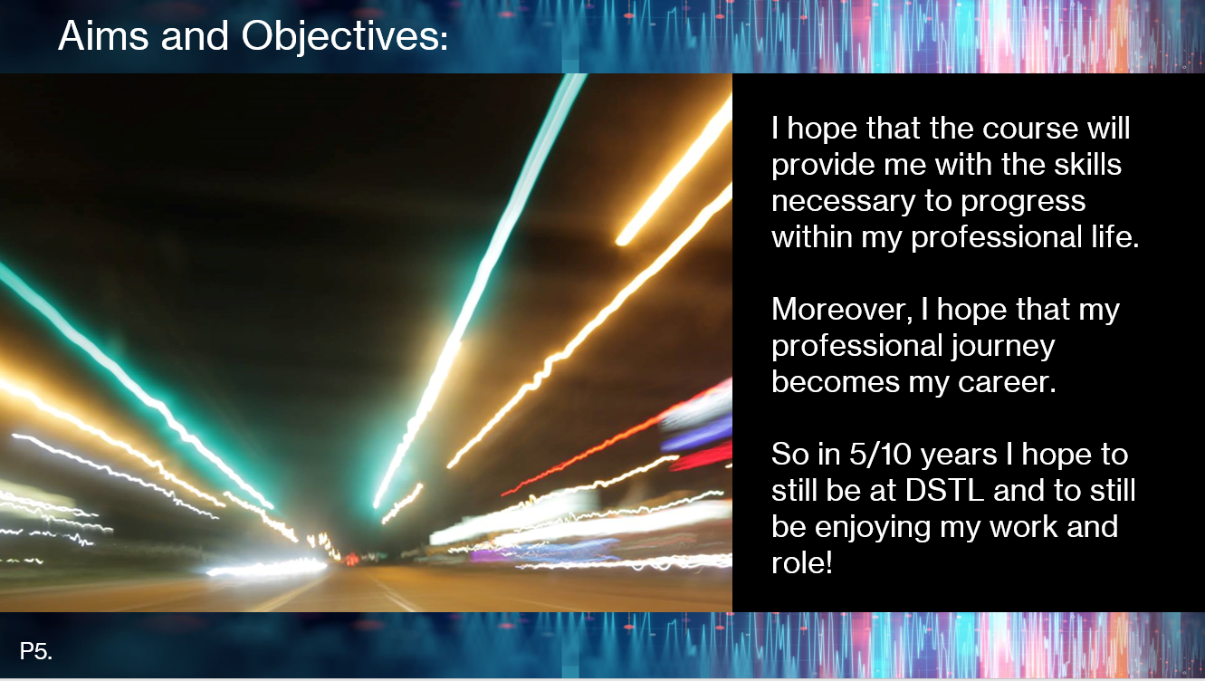

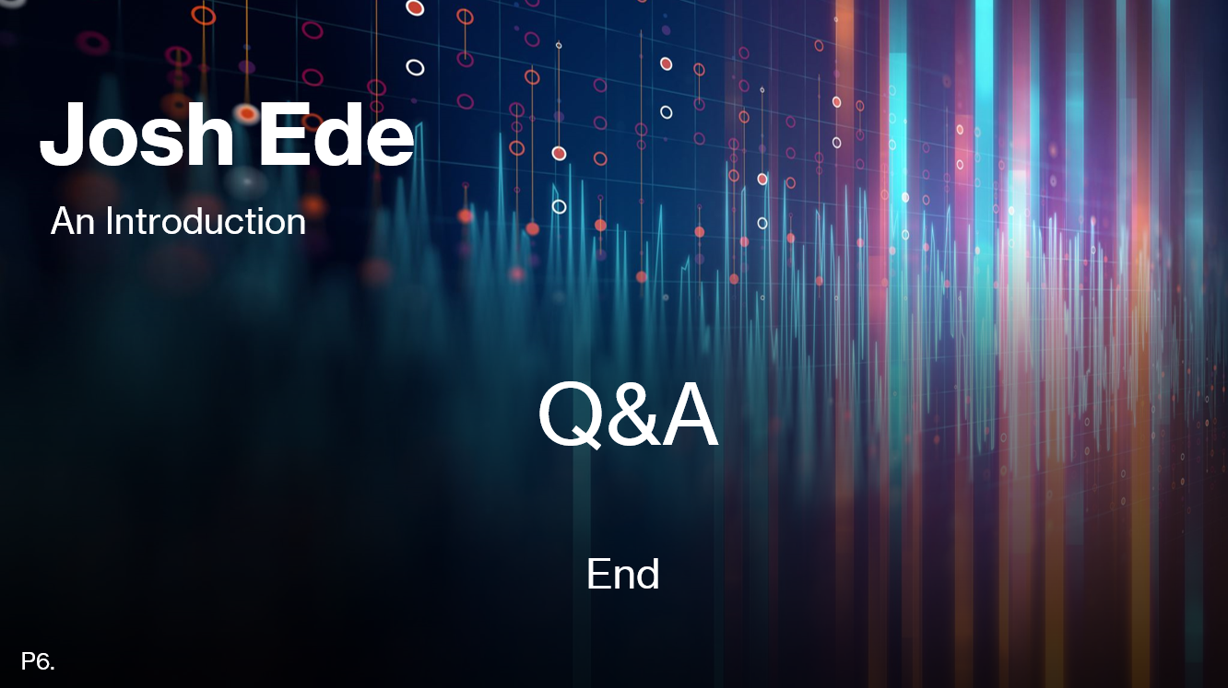

Appendix B: Ransomware Report

13/02/2021
Joshua Warren Ede (2023302)
OME apprentice DSTL
A
The threat, the effects and proposed mitigation actions

Abstract:

This report is a brief overview of ransomware and its effects on business. The report outlines the differences between the terms, malware, trojans, viruses and ransomware before providing a detailed explanation of ransomware and in particular CryptoWall. The report then proceeds to highlight the particular threat of CryptoWall to businesses and lists recommendations for preventing infection along with recommendations for the business to prevent future infections from occurring.

Contents

Abstract: 1
1. Introduction: 3
2. Overview: A description of common terms. 3
2.1. Malware 3
2.2. Virus 3
2.3. Trojan 3
2.4. Worm 3
2.5. Ransomware 3
3. Ransomware 4
3.1. History and types: 4
3.1.1 ScareWare: 4
3.1.2 Screen Lockers: 4
3.1.3 Encrypting ransomware: 4
3.2. Transmission: How do users become infected? 4
3.2.1 Phishing Emails: 4
3.2.2 Exploit Kits: 5
3.2.3 Malvertising: 5
4. CryptoWall 5
4.1. Description 5
4.2. How to protect against CryptoWall 6
4.2.1 Least Privilege Model: 6
4.2.2 Regular System Backups: 6
4.2.3 Firewall Software: 6
4.2.4 Regular System and Software Updates: 6
4.2.5 Personal responsibilities, safe browsing and not clicking links: 6
5. Business recommendations 7
6. Conclusion 7
References 8

Introduction:

This report is intended to be used as a starting point for the company’s response and management of cyber threats. Specifically, this report addresses the recent concerns raised around ransomware. Due to the scale of the issue of cybersecurity this report is not an exhaustive document and will require broadening and updating in the future. It is however hoped that this document will present enough information on the specific threat of ransomware to illustrate what ransomware is, how it targets systems, what this means to businesses and what can be done both to prevent and to recover from it.

Overview: A description of common terms.

Malware

Malware is a portmanteau of malicious software. It is an umbrella term that includes many different types of cyber security threat including but not limited to: viruses, trojans and worms [1].

Virus

A virus is a particular kind of malware that utilises another computer programme to propagate, replicating itself within a host machine. A virus requires human activation and this is where it differs from a worm which can spread without such interaction [2].

Trojan

A Trojan or Trojan Horse, is aptly named, as it a program that looks like a legitimate application, but instead provides illegitimate users access to infected machines. This can then lead to personal information being stolen [2]. Trojans are a common vector by which ransomware may infect a user’s computer [3].

Worm

Worms are considered a sub-species of virus in that they use other programs to replicate [2]. Unlike a Virus however, it is capable of accessing information within a user’s computer in order to travel to other users without the original host knowing [2].

Ransomware

Ransomware combines the words, software and ransom, which provides readers with a clue as to how it operates. Essentially, ransomware is a type of malware that holds the user’s machine or information for ransom, generating messages demanding payment in exchange for the recovery of the system or files [4]. Ransomware therefore is a type of malware, but is not a virus or worm, as it does not attack the user in the same way. Ransomware can be just as devastating however and is estimated to be causing £346 million to UK companies per year [5].
Now that some of terms commonly used to name different threats in cyber security have been outlined and defined this report will continue to examine the specific case of ransomware and offer an even more in-depth look at one such piece of ransomware, CryptoWall. Ransomware is highlighted as a particular threat and warrants particular discussion as the number of attacks using ransomware increased by 20% globally in 2020, even when malware attacks overall were falling [6].

Ransomware

History and types:

Ransomware is not a new phenomenon and early ransomware existed in computing as early as the late 1980s [4]. However, it was not until the 2000s that broader, more pervasive ransomwares appeared [4]. Ransomware can broadly be classified into three different types based on the severity of the attack to the user.

3.1.1 ScareWare:
Scareware relies on scaring users by generating a number of pop-ups informing them that their machine has become infected and instructing them to purchase fake anti-malware software [7]. Users then not only give out credit or debit card details in order to make the purchase, but then in fact download malware onto the already infected computer [7].

3.1.2 Screen Lockers:
The second type of ransomware are screen lockers, whilst not encrypting files or folders, screen lockers effectively freeze a user out of their computer so that they cannot access basic system functions – such as running windows desktop [8] [4]. Similar to scareware, there is a certain psychological component to the attack. Infected computers will often display messages on their screens saying that illegal activities have been traced to the device and unless a fine is paid to an official law enforcement body, such as the FBI or the US Department of Justice, the computer will remain locked [4].

3.1.3 Encrypting ransomware:
The third type of ransomware is particularly harmful to networks and individuals [4]. The software performs “cryptoviral extortion”, whereby the ransomware seeks out sensitive files and folders within the computer and encrypts them [9]. The user then receives a message requesting payment, commonly now in Bitcoin, for the return of their files [3] [10]. In recent years the messages requesting payment have become more threatening and again there is a psychological element to the attack on the user [10].

Transmission: How do users become infected?

3.2.1 Phishing Emails:
Phishing emails, or malspam (malicious spam) are similar phenomena and both are common ways that computer users are vulnerable to ransomware attacks [4] [3]. In both cases users receive emails containing the ransomware disguised as another type of file, such a pdf or zip [3]. Perhaps most perniciously the supposed pdf or zip files are often labelled as invoices, purchase orders or bills and the emails themselves can look like real business communications [3] [4]. During coronavirus the use of words relating to the pandemic has increased, showing the adaptability of criminals to exploit the news media [6] [8].

3.2.2 Exploit Kits:
These work by utilising known weaknesses within existing software. The malware is deployed as part of existing software and infects the hosts computer [10]. Unfortunately, this ransomware can be hidden in operating systems, applications and even websites [10].

3.2.3 Malvertising:
Malvertising (malicious advertising) is another common method for ransomware to infect a computer [4]. The malvertising is within a particular webpage visited by the user, the user may click on a banner or an advertisement, or it might come straight from a particular landing page [4]. The user’s computer then downloads the malware without the user’s knowledge [10] [4].
In order to better understand the dangers of ransomware and how to combat it this report shall proceed to look at the example of one particular family of ransomware known as CryptoWall, which is one of the most successful ransomwares [11].

CryptoWall

Description

CryptoWall emerged around 2014 and has the capability of locking users files with an RSA encryption, this is an incredibly high level of encryption and currently there is not a reliable method for breaking the encryption key [3]. CryptoWall incurred an estimated US 325 million dollars of damages in 2015 [11]. The usual vectors of ransomware have been utilised by CryptoWall, but it has been particularly prevalent as part of email phishing with 67.3% of all attacks originating from this source [11]. Following that trend emails have tended to look like business correspondence and attachments have utilised keywords such as invoice or bill [11] [3]. The rest of the attacks have tended to come from exploit kits within other pieces of software [11].
Focusing on the email phishing attacks, once a user has accessed the infected attachment the CryptoWall infects their computer embedding itself in their %AppData% or %Temp% folders [3]. Once there unless it is completely removed it can still access files, it cannot be bypassed by a simple restart [10]. Following its embedding it will try to make contact with a “Command and Control Server” [10], which will provide it with an encryption key. It will then search all drives mapped as letters, including Dropbox mapping [3]. Once CryptoWall detects a file or folder it detects as ‘sensitive’ it will encrypt it and to make matters worse once it completes the scan and encryptions it will delete all of the shadow volume copies of those files and folders in the computer [3]. This is particularly pernicious as the shadow volume copies can sometimes be used to recover the infected files [3]. The types of files that the programme targets are very broad, from powerpoint presentations .ppt to music files .mp3 [10].
Once CryptoWall has finished searching encrypting files the user will receive a notification of the attack and a request for payment commonly in the form of Bitcoin. The details of the payment vary from user to user but are often around $1000 USD [10]. According to Jeff Petters even after payment files were only returning in 19% of cases and payment is now not recommended at all [10] [4].
CryptoWall is only one such ransomware program, thankfully it is fairly typical of ransomware more generally and therefore methods taken to prevent CryptoWall can help protect against ransomware overall.

How to protect against CryptoWall

The steps outlined here are specifically in reference to CryptoWall and as such there may be some variation between the best practice for staving off CrytoWall and other ransomware. Nevertheless, there are enough commonalities between CryptoWall and other ransomware programs that these steps maybe utilised as a guide for defending against ransomware more generally.
Authors appear agreed that prevention is better than cure [3] [4] [10] and as such measures to prevent CryptoWall start with good computer practice overall, some of which are down to the user and some of which are broader. The following types of good practice will start with ways in which a business can be made more secure, before moving on to the role of individual employees.

4.2.1 Least Privilege Model:
Across a network it may be necessary to adopt a least privilege model [10]. CryptoWall infects an individual’s computer and as such if an individual does not have access to certain files, folders or even drives, then this will limit the extent to which the ransomware penetrate the business’ system overall [10]. Furthermore, if only a single user is compromised it saves time on being able to recover lost files [10].

4.2.2 Regular System Backups:
The entirety of the businesses’ files should be backed-up on a regular basis and preferably in different locations including USB hard-drives and or a local Storage Area Network [10]. By ensuring that files are backed-up and in different locations, should files fall victim to CryptoWall then the company can refer to an earlier version of the file to ensure business continuity. The more frequent the back-ups the less data lost in the event of a successful attack.

4.2.3 Firewall Software:
As CryptoWall relies on a connection to a command and control server in order to be able to receive its encryption key and lock users files, if this can be prevented it effectively nullifies the attack. Local firewalls have some success in being able to do this [10].

4.2.4 Regular System and Software Updates:
Although, CryptoWall relied mainly on phishing attacks there is still a significant threat from the exploit kits that make use of weaknesses in existing software in order to target users [11]. It is therefore recommended that software and systems within the business are regularly updated, as known issues within software are often resolved by the manufacturers in later versions [4].

4.2.5 Personal responsibilities, safe browsing and not clicking links:
There is also an element of personal responsibility on employees for keeping the system safe. Therefore, it is also necessary that staff should practice safe browsing, not click on links within suspicious emails [10] and make sure any personal devices connected to business computers are suitably defended against CryptoWall.
It should be stressed that there can be methods of recovering data, but that these are difficult, costly and time consuming one UK based cyber security company estimates that around 30% of businesses go 5 days or longer without their files once they have been infected [5]. Therefore, in agreement with other authors [3] [4] [10] this report recommends steps for prevention as opposed to cures for recovery.

Business recommendations

In the previous section 4.2., a list of recommendations were given for how to avoid future attacks by CryptoWall and by extension other ransomware programs. However, at this point it is not clear from what standpoint the business is operating. Thus, this section will outline some specific business recommendations that will encompass the steps outlined in 4.2.1 – 4.2.5.
- Baseline: An assessment of the current state of the business computing system needs to be undertaken with appropriate antivirus software. The software must be researched, sourced and procured, before being run on the company system. A number of the references used to compile this report link to software companies that provide antivirus or antimalware and scanning programs, it is suggested that these may form the basis of further research. Once completed a firewall should also be setup in line with 4.2.3 and systems should be checked for their update requirements as per 4.2.4.
- Storage options: Various storage options need to be researched and aligned with the company needs. These options need to take into account the recommendations suggested in 4.2.2. However, the migration of business files onto specific storage options should only occur after the system has been had any existing threats uncovered and removed.
- Restrictions: As files and folders are moved across to storage solutions, their access should be restricted. This is in line with 4.2.1.
- Training: Current staff should be made to attend a training session on safe computing habits. The training should be created by someone familiar with the IT requirements of the company, with input from staff with experience in running educational sessions. Documentation pertaining to this training should be made available to all following its completion and it might also be beneficial to have users sign an agreement on safe computer usage underscoring their responsibilities as well as the company’s. This is in line with 4.2.5.
- Training: New staff should also be made to attend training sessions on safe computing habits as soon as possible and potentially as part of their induction to the company. They would also be expected to sign any agreements about safe browsing habits and computer usage while in the employ of the company.
By completing the above actions it is believed that the company will be in the best possible position to fend off ransomware attacks and to limit the damage of data loss should a breach occur.

Conclusion

In conclusion this report has detailed several different threats that exist in the Cyber ecosystem. Furthermore, the report has outlined one of the most common types of malware that of ransomware. To provide more specific information the report has discussion the CrytoWall example, using it to outline the losses incurred by business due to ransomware. The report has also tried to show that although variations exist within ransomware, CryptoWall can be considered typical and therefore by outlining the possible ways of responding to CryptoWall a list of recommendations has been given.

References

[1] | J. Fruhlinger, “Malware explained: How to prevent, detect and recover from it,” CSO, 17 May 2019. [Online]. Available: https://www.csoonline.com/article/3295877/what-is-malware-viruses-worms-trojans-and-beyond.html. [Accessed 13 02 2021].
[2] | DigiCert, “Security Topics The Difference Between a Virus, Worm and Trojan Horse,” Digicert, [Online]. Available: https://www.websecurity.digicert.com/security-topics/difference-between-virus-worm-and-trojan-horse#:~:text=A%20Trojan%20horse%20is%20not%20a%20virus.&text=Unlike%20viruses%2C%20Trojan%20horses%20do,personal%20information%20to%20be%20theft.. [Accessed 13 02 2021].
[3] | BleepingComputer.com, “CryptoWall and HELP_DECRYPT Ransomware Information Guide and FAQ,” BleepingComputer.com, 10 July 2014. [Online]. Available: https://www.bleepingcomputer.com/virus-removal/cryptowall-ransomware-information. [Accessed 13 02 2021].
[4] | MalwareBytes, “Ransomware,” MalwareBytes, [Online]. Available: https://www.malwarebytes.com/ransomware/. [Accessed 13 02 2021].
[5] | Acronis International, “The top 5 ransomware attacks in the UK and their hidden costs on business,” Acronis International, [Online]. Available: https://www.acronis.com/en-gb/articles/ransomware-attacks/. [Accessed 13 02 2021].
[6] | SonicWall, “Mid-year update July 2020: 2020 Sonic Wall Cyber Threat Report,” SonicWall Inc., Milpitas, California, 2020.
[7] | D. Rafter, “What is scareware? And how to spot online scareware scams,” NortonLifeLock, 22 03 2019. [Online]. Available: https://us.norton.com/internetsecurity-online-scams-how-to-spot-online-scareware-scams.html. [Accessed 13 02 2021].
[8] | L. Abrams, “New Coronavirus screenlocker malware is extremely annoying,” BleepingComputer, 21 04 2019. [Online]. Available: https://www.bleepingcomputer.com/news/security/new-coronavirus-screenlocker-malware-is-extremely-annoying/. [Accessed 13 02 2021].
[9] | Cisco, “What Is the Difference: Viruses, Worms, Trojans, and Bots?,” Cisco, [Online]. Available: https://tools.cisco.com/security/center/resources/virus_differences#:~:text=A%20Trojan%20is%20another%20type,Greeks%20used%20to%20infiltrate%20Troy.&text=Trojans%20are%20also%20known%20to,nor%20do%20they%20self%2Dreplicate.. [Accessed 13 02 2021].
[10] | J. Petters, “Inside Out Security Blog » Data Security » The State of CryptoWall in 2018,” Varonis, 17 06 2020. [Online]. Available: https://www.varonis.com/blog/cryptowall/. [Accessed 2021 02 13].
[11] | CyberThreatAlliance, “Lucrative Ransomware Attacks: Analysis of the CryptoWall Version 3 Threat,” CyberThreatAlliance., 2015.

