

Investigating the Impact of AI-Based Customer Service Tools on Customer Satisfaction in UK Fashion E-commerce Retailers

Module Code and Title: | LCMB7035 Master of Business Administration
Assignment Title: | Dissertation
Word Count  Student Name | 15116 (Excluding Cover page, References and Appendix)  Hari Singh Nenavath
Student ID  Submitted by  Submitted to | 2414104  Hari Singh Nenavath  Rexon Nting
Submission Date | 04/06/2026

Declaration
I declare that this dissertation is my original work and has been prepared with academic honesty and integrity. Every idea, information, argument and source utilised by other writers has been credited properly by appropriate referencing. None of the sections in this work has been imitated, pre-empted or claimed as the work of another individual. I attest that the research was carried out in an ethically acceptable manner, that the data in the survey were handled in a responsible manner, and that I did not plagiarise by doing a thorough paraphrasing and citing of the entire dissertation.

Acknowledgement
I would like to state my humble thanks to my supervisor, who provided me with valuable guidance, support and positive feedback during this dissertation. I also appreciate my lecturers for providing academic support and the people who participated in the survey and gave their time and true answers. I would like to thank my family and friends who showed patience, motivation, and emotionally supported me throughout this research process. They assisted me in following this dissertation with passion and commitment, even when faced with practical and academic difficulties.

Abstract
Purpose: The study aimed to investigate how AI-based customer service tools influenced customer satisfaction in UK fashion e-commerce retailers. It examined customer experience of chatbots and virtual assistants, recommendation systems and AI size or fit recommendations, and examined whether the tools enhanced the usefulness of the service, ease, responsiveness, trust, empathy and overall satisfaction.
Method: The primary quantitative methodology was followed by positivism research philosophy and deductive research approach. The use of an online questionnaire obtained primary data based on 120 respondents who had used AI-based customer service tools in English e-commerce in the fashion industry in the UK. SPSS was used to analyse the responses based on demographic analysis, descriptive statistics, reliability testing, validity testing, correlation and regression analysis.
Findings: The results revealed that AI-based customer service technologies affected customer satisfaction as a whole in a positive way when they were practical in their assistance, easy to navigate, fast and responsive, and trustworthy in their data and provided some assurance. The most identified tool was chatbots, next is virtual assistant, and lastly suggestions of AI size or fit. The most significant factor of satisfaction was perceived usefulness as customers appreciated AI in terms of product search, sizing, delivery and returns. Satisfaction was also enhanced by ease of use, and lack of waiting and effort. Reliable and compassionate attitudes were significant, yet AI was found to be less effective in managing intricate emotional issues.
Recommendations: The research suggested that the UK fashion e-commerce retailers need to enhance AI technologies by making them more helpful, precise, easy, responsive and open. Retailers are advised to feed AI systems with trusted product and sizing, delivery and returns data. Routine queries should be assisted by AI, but human intervention is necessary in complaints, refunds, orders and sensitive customer issues that need to be judged.
Keywords: Artificial Intelligence, AI-based customer service, customer satisfaction, UK fashion e-commerce, chatbots, virtual assistants, AI recommendations, perceived usefulness, ease of use, responsiveness.

Table of Contents
Chapter 1: Introduction 10
1.1 Research Background 10
1.2 Research Rationale 10
1.3 Research Aim and Objectives 11
1.4 Research Questions 12
1.5 Research Significance 12
1.6 Identification of literature gap(s) within the research topic 13
1.7 Research Structure 13
Chapter 2: Literature Review 15
2.1 Introduction 15
2.2 Conceptual Understanding of AI-Based Customer Service Tools 15
2.3 Overview of UK Fashion E-commerce 16
2.4 Application of AI-Based Customer Service Solutions in Fashion E-Commerce 18
2.5 Impact of AI-Based Customer Service Solutions on Customer Satisfaction 19
2.6 Challenges and Customer Concerns in AI-Based Customer Service in UK Fashion E-commerce 20
2.7 Theoretical Framework 22
2.8 Literature Gap 23
2.9 Conceptual Framework 24
2.10 Summary 25
Chapter 3: Methodology 26
3.1 Introduction 26
3.2 Research Philosophy 26
3.3 Research Approach 26
3.4 Research Strategy 26
3.5 Data Collection Process 27
3.6 Sampling Strategy 27
3.7 Data Analysis Process 28
3.8 Ethical Considerations 28
3.9 Summary 28
Chapter 4: Findings and Analysis 30
4.1 Introduction 30
4.2 Demographic Analysis 30
4.2.1 Age 30
4.2.2 Gender 31
4.2.3 Employment Status 32
4.2.4 Shopping Frequency 33
4.2.5 Variation of Using an AI-based customer service tool 34
4.3 Descriptive Statistics 35
4.4 Reliability Statistics 36
4.5 Validity Statistics 37
4.6 Hypothesis Testing Using Correlation and Regression Analysis 37
4.6.1 Hypothesis Test 1 37
4.6.2 Hypothesis Test 2 40
4.6.3 Hypothesis Test 3 42
4.6.4 Hypothesis Test 4 44
4.7 Summary 46
Chapter 5: Discussion 47
5.1 Introduction 47
5.2 Discussion 47
5.3 Summary 55
Chapter 6: Conclusion & Recommendation 56
6.1 Summary of Key Findings 56
6.2 Linking with Objectives 58
6.3 Recommendations 59
6.4 Research Limitations 61
6.5 Future Scope 61
References 62
Appendices 75
Appendix 1: Ethics Form 75
Appendix 2: Survey Questionnaire 85
Appendix 3: Survey Link 92
Appendix 4: Survey Dataset Excel Sheet 93

List of Figures
Figure 1: AI Interaction Engine Workflow 16
Figure 2: UK e-commerce apparel market growth 17
Figure 3: Challenges and Customer Concerns 21
Figure 4: “Technology Acceptance Model (TAM)” 22
Figure 5: Conceptual Framework 24
Figure 6: Age 31
Figure 7: Gender 32
Figure 8: Employment Status 33
Figure 9: Shopping Frequency 34
Figure 10: Variation of Using an AI-based customer service tool 35

List of Tables
Table 1: Age 30
Table 2: Gender 31
Table 3: Employment Status 32
Table 4: Shopping Frequency 33
Table 5: Variation of Using an AI-based customer service tool 34
Table 6: Descriptive Analysis 35
Table 7: Reliability Analysis 36
Table 8: Validity Analysis 37
Table 9: Correlation Analysis 1 38
Table 10: Regression Analysis 1 39
Table 11: Correlation Analysis 2 40
Table 13: Correlation Analysis 3 42
Table 14: Regression Analysis 3 43
Table 15: Correlation Analysis 4 44
Table 16: Regression Analysis 4 45

Chapter 1: Introduction

1.1 Research Background
AI is now one of the most significant service interfaces in fashion e-commerce since online customers are increasingly demanding quick, personalised, and convenient service over slow human service. Zeng et al. (2023) claim that when used in the fashion industry, chatbots transform the interaction between the brand and the customer and the level of personalisation in customer experience. They, however, caution that the technology of chatbots is still in its infancy and that there is a disparity between potential use and reality in retail. Landim et al. (2022) consider chatbots as a novel approach that can be used to provide individual assistance in fashion e-commerce. Nevertheless, they provide a more design-oriented warning by emphasising that the ability of chatbots to work can be reduced due to the complexity of human language. It implies that only technically capable and customer-centred AI service tools are helpful.
Kang and Choi (2024) further this debate by demonstrating that instant responding, navigation, advice, customer experience, brand loyalty and purchase loyalty are supported with AI-based customer services in the fashion industry. The results also indicate that there is scant academic evidence concerning the outcomes of behaviour. Hassan et al. (2025) expand the argument that the application of AI at personalisation enhances trust, satisfaction and loyalty in e-commerce, by showing that AI-driven personalisation can enhance e-commerce. Thus, the research background indicates that use of AI customer service can increase the level of satisfaction, although the effect of this practice is contingent on the trust, empathy, usefulness and quality of services.

1.2 Research Rationale
UK fashion e-commerce is in the process of moving customer service towards being supported by humans alone or AI chatbots, virtual assistants and recommendation systems. It poses a problem as it has impacted the level of satisfaction as it does not depend on the quality of products or speed of delivery alone, but the sense of responsiveness, utility and reliability in the automated service. Manzo et al. (2025) discuss that fashion chatbots have a chance to personalise assistance, whereas Ai-Shafei et al. (2026) warn that the capacity is still exceeded by the implementation. Ozuem et al. (2025) include the fact that instant response and empathy affect experience. Thus, weakly automated markets cannot and may harm satisfaction instead of enhancing it in competitive fashion markets today, in general.
The reason it is a problem is due to online retailing of fashion, which is high-volume, price-sensitive and is comparison-driven. The online retail of UK surpassed 125 billion in 2024 and online sales increased particularly among clothing retailers as wet weather caused a decrease in store traffic (Mintel, 2025). It implies that online service experiences now have a commercial push that used to be undertaken in the store. Hassan et al. 2025 demonstrated that trust has a remarkable effect on satisfaction and loyalty, and personalisation has an enhanced explanatory power by 5%. Thus, inconvenience can be turned into customer dissatisfaction with poor responses of the AI, privacy concerns or lack of empathy relatively easily overall: baskets will be dropped, and loyalty will be diminished.
This matter is significant today as the use of AI in UK retail is gaining momentum, whereas consumers continue to evaluate the service on an emotional and pragmatic level. The market of AI-in-retail in the UK was estimated at USD 310.71 million in 2023 and is set to grow to USD 3.55 billion by 2032, indicating a high rate of investment (Credence Research, 2025). For example, M&S has recorded 450,000 users who have gone through the completion of an AI-style quiz, which shows that even regular fashion customers are exposed to AI-driven personalisation (Halliday, 2024). However, Rahaman et al. (2023) emphasise that experience is informed by empathy and automated responsiveness. Thus, retailers should not view AI as a cost-saving tool, as it has a direct impact on trust and satisfaction level with significant consequences.
The research sheds light on how AI-based customer service tools shape customer satisfaction in UK fashion e-commerce by examining the customer-side experience rather than only the retailer’s technology adoption. It assists in understanding whether chatbots, virtual assistants and customised suggestions are actually making people more satisfied by making the process faster, convenient and offering helpful advice or if they cause frustration due to the lack of empathy, the inability to effectively solve any problem or the issues of privacy. This emphasis is significant since fashion customers usually require prompt assistance in areas like sizing, refunds, delivery and product selection. The research can consequently inform retailers to strike a balance between automation and human services and enhance the quality of digital services.

1.3 Research Aim and Objectives
Aim
The study aims to examine how AI-based customer service applications influence customer satisfaction in the fashion online stores in the UK.
Objectives
- To explore the application of AI-based customer service solutions among UK fashion e-commerce retailers
- To examine how customer service tools that are based on AI influence customer satisfaction in fashion e-commerce retailing in the UK
- To identify the issues associated with the use of AI-based customer service tools in online retailers of the UK fashion market
- To offer suggestions to increase the performance of AI-based customer service tools to increase customer satisfaction among UK fashion e-commerce retailers

1.4 Research Questions
- What is the use of AI-based customer service tools among e-commerce retailers of fashion in UK?
- What is the effect of using AI-based customer service tools on the customer satisfaction of UK fashion e-commerce retailers?
- What are the problems associated with implementation of AI-based customer service tools in UK fashion e-commerce retailers?
- What recommendations can improve AI-based customer service tools and customer satisfaction in UK fashion e-commerce retailers?

1.5 Research Significance
The practical importance of AI-based customer service lies in the fact that the competition of fashion e-commerce is currently turning into a service-driven channel, rather than a product-driven channel. According to the report prepared by Gov.uk (2026), 77% of UK retail businesses apply AI in e-commerce in the form of chatbots, demonstrating that automation is no longer a matter of experiments. Nevertheless, the satisfaction rates with high adoption do not necessarily imply the high customer satisfaction of the fashion customer that requires a guarantee of fit, style, delivery, returns, and complaints. The research of 423 online shoppers conducted by Kang and Choi (2024) indicates that positive experience is formed by using instant response and real-time information, as well as by empathy and automated responsiveness, which is valued by 33.4% of online shoppers. It implies that AI can shorten the waiting time and lead to loyalty or reveal poor service delivery when reactions seem to be robotic.
It is more urgent as the AI personalisation has become a determinant of trust, satisfaction and loyalty. Abdullah (2025) indicates that personalised recommendations enhance the relationship among trust, satisfaction and loyalty in AI-based e-commerce. It implies that customer satisfaction will not be based on the speed of the automation process only, but also on whether AI replies are relevant, clear and helpful. It implies that the quality of the recommendations can make significant changes to the customer relationships, even in the case of minor improvements. Graham et al. (2025) state that chatbot technology is in the initial phase of implementation, and as such, retailers will be taking a risk to invest in technology without knowing its effects on customers. Hence, the study is significant as it determines the effectiveness of AI in enhancing or causing dissatisfaction in the e-commerce of fashion in UK.

1.6 Identification of literature gap(s) within the research topic
Current literature describes that AI chatbots, virtual assistants and personalised suggestions can enhance speed, convenience, trust and customer experience in online shopping. Nevertheless, the vast majority of literature addresses AI in relation to online stores, high-end fashion or general e-commerce, instead of those related to UK fashion e-commerce. The gap is significant as fashion shoppers usually need the service support of sizing, product suitability, returns and delivery, which can necessitate empathy, problem-solving, instead of an automated response.

1.7 Research Structure
- Introduction: The introduction section of the research has identified the background of AI-based customer service tools in e-commerce of fashion in the UK, the purpose of the research, research objectives and goals, research questions and research value. It provides a foundation for the significance of researching customer satisfaction regarding chatbots, virtual assistants and personalised recommendations.
- Literature Review: The literature review will critically review existing academic studies on AI-based customer service tools, customer satisfaction, e-commerce in fashion, service quality, trust, empathy, responsiveness and personalisation. It will discuss the related theoretical frameworks to describe the way customers will accept and judge AI-enabled service experiences.
- Research Methodology: Research philosophy, research approach, research design, sampling strategy, questionnaire design, method of data collection, data analysis technique and ethical considerations will be discussed. It will support employing the primary quantitative survey and SPSS analysis.
- Findings and Analysis: The results and analysis chapter will show the results of the survey in the form of descriptive statistics, correlation and regression analysis to answer the research questions. The discussion chapter will put the findings into perspective concerning literature, theory, objectives and research questions.
- Conclusion and Recommendations: The key findings will be summarised, practical recommendations will be provided, limitations will be explained and future direction of research will be suggested.

Chapter 2: Literature Review

2.1 Introduction
The chapter is a critical review of the literature connected to the AI-based customer service tools and customer satisfaction in the context of e-commerce in UK fashion. It clarifies major concepts, the situation in UK fashion e-commerce, and how AI tools are used, influencing customer satisfaction, and the problems they encounter. The chapter explains appropriate theoretical frameworks used in supporting research objectives, such as TAM and SERVQUAL. It determines the gap in the literature, displays the conceptual framework and sums up the key arguments that have led to the methodology chapter.

2.2 Conceptual Understanding of AI-Based Customer Service Tools
AI-driven customer service software plays a significant role in the transformation of online support to an automated, 24/7 customer service interface. According to Nicolescu and Tudorache (2022), virtual agents are computer-generated representatives which engage in communication with customers via AI. In contrast, Adam et al. (2021) underline their position that self-service technologies reconcile efficiency and the quality of services. It implies that chatbots and virtual assistants will not be only communication features but will alter the method of customer service, where employees are initiators of service interactions, and technology takes over service interactions. Therefore, they can process product, delivery and returns requests in e-commerce in the fashion industry, although they need to maintain quality in the service.
Customer satisfaction is aided by AI tools where less effort is made and value can be created personally. Hollebeek et al. (2024) contend that usefulness, convenience and personalisation create AI value, whereas Oyeniyi et al. (2024) demonstrate that AI-based personalisation fits services to the needs of the customers and helps to achieve satisfaction and loyalty. This analogy implies that the most effective AI recommendation systems are those that produce an appropriate support out of customer data in the form of automated FAQs and fit advice systems. Therefore, fashion retailers need to consider AI personalisation as value co-creation, rather than as automated selling or generic product recommendation.
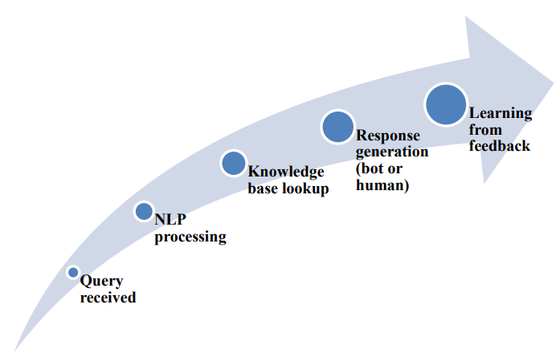

Figure 1: AI Interaction Engine Workflow
(Source: Gopinathan et al. 2024)
Customer service tools based on AI work on data processing, knowledge retrieval and response generation. According to Gopinathan (2024), an interaction engine based on AI takes queries, uses NLP, searches knowledge bases, creates responses by bots or humans, and learns, as depicted in Figure 1. Similarly, Andrade and Tumelero (2022) demonstrate that chatbot maturity enhances agility, availability, accessibility and service resolution. Nonetheless, it is not completely mechanistic, and sophisticated or emotive questions might need human upgrading. Therefore, AI customer service can be thought of as a digital workflow, which is assisted, but not substituted by, human judgment using automation.

2.3 Overview of UK Fashion E-commerce
UK fashion e-commerce is now a significant component of the retail sector since customers now compare prices, styles and delivery methods online before making a decision to purchase. In 2024, UK online retail market increased by over 3% and to over £125 billion, indicating that online shopping has ceased to be a transient post-pandemic trend and has become an established retail channel (Mintel, 2025). Nevertheless, the same growth is a burden to fashion retailers since it requires them to provide more fast information digitally, since customers can easily move through the websites, when the customer service is slow and vague.
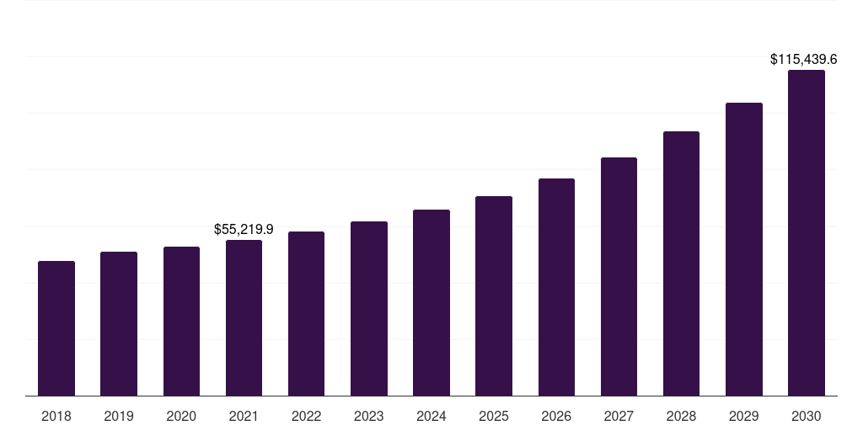

Figure 2: UK e-commerce apparel market growth
(Source: Grand View Research, 2026)
The significance of fashion in this online transformation is that clothes buying entails uncertainties regarding size, fit, quality, and returns. Figure 2 indicates that UK e-commerce currency market attained USD 55.2 billion in 2021 and can attain USD 115.4 billion by 2030, which implies that it has a substantial entrepreneurial potential in the long term (Grand View Research, 2026). However, it does not come without growing the complexity of services as online consumers cannot possibly touch garments before purchase, and thus, rely more on online instructions, product details, and prompt customer service.
The industry is also very competitive and volatile. UK online clothing was not doing well in 2024, and footwear was recovering better since August 2024 (Davies, 2025). It shows that the demand in fashion e-commerce is not only among categories and retailers should not count solely on website traffic but they need to enhance customer experience to secure conversion and loyalty.
Customer service is also expected to be effective due to returns. Online returns are approximated at 30% against 8.89% in-store, and returns of fashion products can go up to approximately 40% (Taylor, 2026). It is important since the cost to retailers and frustration to customers of sizing errors, ambiguous information and poor support is high. Thus, UK fashion e-commerce offers a good environment to analyse AI-based customer service, since chatbots, virtual assistants and recommendation systems can decrease uncertainty but can also negatively affect satisfaction when they perform generic, inaccurate or slow service.
The major players in UK fashion e-commerce have been NEXT, ASOS, M&S, Boohoo, Shein, Zara, H&M, New Look and Vinted, but competition is moving with online fashion retailers towards ultra-fast, social and resale. Shein has become the fourth most popular in the UK to buy fashion online since H&M, ASOS, Zara and New Look and is the most popular among young women between the ages of 16 and 24 (Mintel, 2026). In 2024, Hein boosted its sales in UK to over 2bn, surpassing Boohoo and trailing only ASOS (Butler, 2025). It demonstrates that competition has become price-based, time-sensitive, personalised and socially-media-visible.

2.4 Application of AI-Based Customer Service Solutions in Fashion E-Commerce
Customer service AI-based solutions will be used to enhance real-time communication between fashion retailers and customers. According to Zeng et al. (2023), luxury brands like Burberry, Chanel and Louis Vuitton implement chatbots in online stores or social media, where they inform customers about products, offer sales assistance and 24/7 communication. Similarly, Baloska et al. (2022) mention that chatbots assist in instant replies, personalised suggestions, CRM integration, payment processing and inventory control. Therefore, Fashion e-commerce applies AI not only to question answering, but also to the establishment of end-to-end digital connectivity throughout the shopping process.
Artificial intelligence is used as virtual stylists and recommendation systems, which inform fashion product discovery and decision-making. Ranjan and Upadhyay (2025) discovered that chatbots are being used by users to get fashion insights, trend advice, product discovery, order tracking and personalised suggestions. Alharthi (2025) builds upon this, stating that AI systems impact consumer journey by filtering, predicting fits, customer experience and purchase choices. Consequently, the customer service that is based on AI moves beyond being an operational support as it is a decision-support tool capable of minimising advertising uncertainty regarding style, size, and suitability.
Service solutions based on AI are more regularly implemented as part of an e-commerce infrastructure instead of standalone chatbots. According to Thatavarthi (2023), AI chatbots may be adopted into full-stack platforms to support customers in real-time, recommend and order management. Similarly, Mimani et al. (2024) mention the use of AI in the development of e-commerce stores, such as customer experience, search optimisation, product recommendations, inventory management and payment systems. Therefore, the value of AI services hinges on the integration of back-end, since customers evaluate the entire process of the service, rather than the chatbot dialogue that is visible.
The trend in AI use in e-commerce fashion is towards collaboration with humans and consumer-focused studies. Deng et al. (2026) demonstrate that secondhand fashion sites employ AI suggestions, intelligent customer support and human-AI cooperation to enhance the levels of transparency, trust, and intention to use continuously. Zhang and Liu (2026) note that AI-determined chatbots and general AI services emerge as the dominant in recent fashion consumer research, yet consumer-oriented synthesis is not developed. Therefore, the use of AI should be efficient and yet human-friendly, transparent and context-relevant for customer satisfaction.

2.5 Impact of AI-Based Customer Service Solutions on Customer Satisfaction
Customer service AI enhances customer satisfaction through better perceived efficiency and less effort in service. Singh and Singh (2024) discovered that AI-powered customer service had a substantial influence on customer satisfaction, whereas customer satisfaction mediated the relationship between AI-powered customer service and customer loyalty and the model explained 83.7% of the customer satisfaction variance. Arinze (2024) further asserts that AI enhances satisfaction due to prompt responses, reducing repetitive processes and proactive, timely, and personalised assistance. Thus, the satisfaction rises when AI simplifies the service journey and makes it more relevant, in particular in fashion e-commerce, where customers require assistance in fashion, fit and product selection.
Customer service based on AI enhances satisfaction when customers place trust in system efficiency and reliability. Al-Oraini (2025) discovered that the competence perception was strong and significant in influencing chatbot satisfaction, and trust is to be considered as an essential component of the hypothetical model of AI interaction. Zubair et al. (2026) further this argument by demonstrating that AI-based voice recommendation influences customer satisfaction since credibility, expertise and delivery capability influence customer rating of AI recommendation. Therefore, customers will not be satisfied simply because AI is quick, but customers will be satisfied when they think that the AI response is precise, competent and credible.
Personalisation, convenience and ease of use represent some of the ways through which AI-based customer service can affect satisfaction. According to Alqasa (2023), AI-based service quality, AI-based interaction and AI-based customisation have positive correlations with brand image and customer satisfaction, whereas the ease of use enhances the customer response to AI-based services. Similarly, Zungu et al. (2025) discovered that personalisation and convenience were key predictors of customer experience of the AI-based self-service, and time-saving features were significant to service users. Thus, the satisfaction rises when AI simplifies the service journey and makes it more relevant in fashion e-commerce, where customers require assistance in fashion, fit and product selection.
The chatbots empowered by AI enhance satisfaction by enhancing the response speed, accuracy and perceived quality of service. Onohuean and Nyagadza (2026) discovered that AI-driven chatbots had a considerable influence on response time, accuracy and efficiency in information and enhanced satisfaction based on trust and perceived quality of service. Similar findings were made by Rasheed et al. (2025) who observed that e-commerce chatbots enhanced customer satisfaction due to fast, relevant and personalised replies, and increased retention and business operations. Responsiveness should therefore not be narrowed to quick responses. Customers will be pleased when the fast AI support can give accurate responses, relevant advice and reliable solutions to problems as well.
Artificial intelligence customer service affects satisfaction positively but minimally when human judgment is still needed. According to Shaikh et al. (2024), AI is time-saving and more efficient, although human functions cannot be replaced by AI due to the importance of relationships, strategy and personalised services as an essential prerequisite, AI is a technical assistant rather than a complete replacement. Tabaku et al. (2025) saw that a banking virtual assistant had an 80% first-contact solution rate, but the remaining complex and unresolved cases needed a redirection to other channels. Thus, AI enhances satisfaction with regular assistance, yet fashion e-commerce retailers still require human assistance with emotional reviews, complicated refunds and service failures.

2.6 Challenges and Customer Concerns in AI-Based Customer Service in UK Fashion E-commerce
Privacy and legal risk are huge challenges since AI customer service relies on personal data, browsing behaviour and automated content generation. Israfilzade (2025) claims that generative AI in e-commerce poses risks to the privacy of data, biased results, copyright concerns and potential loss of customer trust. Tambuskar (2025) emphasises that AI systems need to be managed responsibly in relation to customer-related data, ability to comply with GDPRs, transparency and minimisation of bias. Therefore, fashion retailers in the UK should not believe that AI personalisation is a safe endeavour since inappropriate use of customer data can destroy customer satisfaction, trust and brand credibility.
Weak explainability and algorithmic bias may decrease customer trust in AI-based support. According to Nkomo and Mupa (2024), one of the main constraints is presence of black-box AI models, since they reduce the level of transparency and trust in predictive e-commerce analytics. Madanchian (2024) states that AI marketing is a subject of moral concern, particularly algorithmic prejudice, privacy and transparency. It is paramount in e-commerce in fashion as prejudiced suggestions can be misinterpreted in terms of body type, style, gender or cost sensitivity.
The issues of UI/UX and the lack of consistency in the maturity of AI may occur in the case of platforms that are either over-personalised or lack a clear way of communicating with the audience. Eboseremen et al. (2024) suggest that AI-powered UI/UX creates issues related to privacy, data security, user confidence and favouritism in decisions of algorithms made by AI. Papastamoulou and Antonopoulos (2025) further contribute that AI adoption varies among firms due to organisational capabilities, risk perceived and size of firms. Therefore, UK fashion retailers that are less AI-mature might provide customers with uneven chatbot, recommendation and support services, which are a source of frustration instead of credibility.
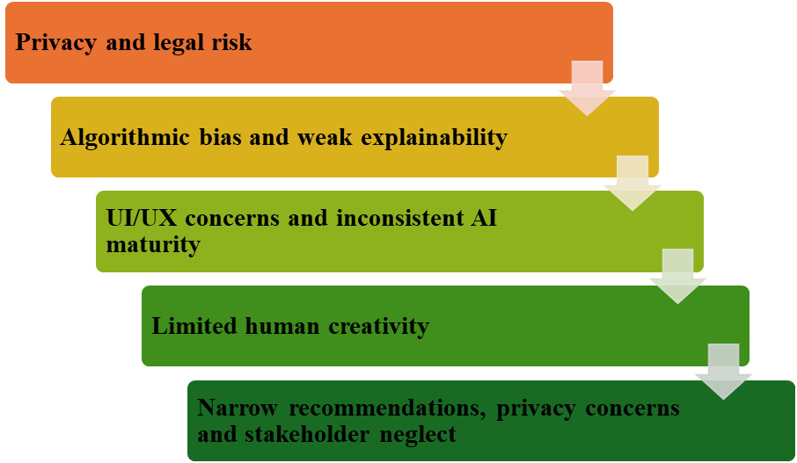

Figure 3: Challenges and Customer Concerns
The lack of human ingenuity, taste, and situational knowledge is an area of concern since fashion-specific AI tools cannot replace human insights. As Zhang and Liu (2024) discovered, Midjourney primarily aids in the initial steps in fashion design and still demands the knowledge and involvement of designers. Siddhu and Mohibi (2024) emphasise an opportunity but challenges of fashion AI in emerging economies in unorganised markets and technology adoption. Hence, AI customer service in the UK fashion e-commerce could be challenged by such subjective problems as styling, fit confidence, sensitivity and sensitivity of complaints and emotional reassurance.
Precise advice, confidentiality issues and oversight of the stakeholders may be a headache when the advice systems minimise customer decision or do not represent broader stakeholder interests. According to Necula and Păvăloaia (2023), the performance of the recommender system can be good or bad based on the precision, and user privacy and trust are hard to control. Raza et al. (2025) note that the e-commerce studies tend to concentrate on consumers and AI recommendation systems without mentioning suppliers, regulators, and indirect stakeholders. Therefore, the fashion e-commerce AI needs to strike a balance between sales conversion and equity, customer autonomy and responsible service design.

2.7 Theoretical Framework
Technology Acceptance Model (TAM)
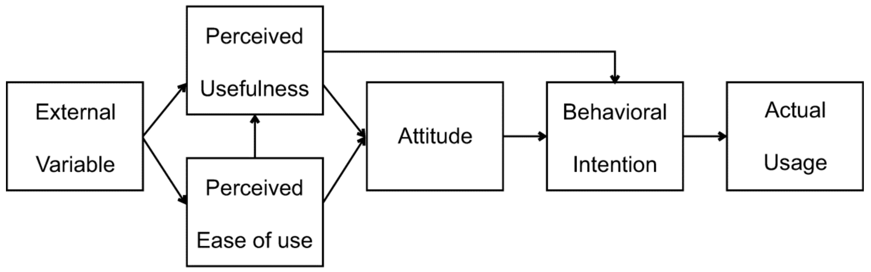

Figure 4: “Technology Acceptance Model (TAM)”
(Source: Park and Park, 2020)
TAM can be used in this research since customer satisfaction with AI-based customer service will be subject to whether customers consider chatbots to be useful and easy to use. Chen et al. (2021) discuss that usability and responsiveness are the parameters by which the adoption of chatbots in e-retailing can be studied since they determine the online customer experience and satisfaction. Rana et al. (2024) utilise TAM by demonstrating that the attitude towards chatbot-assisted online shopping is dependent on the perceived usefulness and ease of use. Therefore, TAM justifies this dissertation by connecting customer satisfaction with perceived usefulness and perception of ease of use in e-commerce on fashion in UK.
Moreover, TAM will be applicable since AI tools will need to promote sustained usage and not a one-time trial. According to Dantsoho et al. (2021), the quality of AI chatbots has an impact on customer satisfaction and intent to keep on using it, which demonstrates that perceptions of the quality of the technologies affect technology acceptance. Wahbi et al. (2023) further note that usefulness, ease of use, responsiveness, personalisation and transparency are contributing factors to chatbot satisfaction. Thus, TAM will assist in explaining the acceptance of AI tools by fashion shoppers due to their ease of use, speed and added value to shopping.
SERVQUAL Model
The application of SERVQUAL is that customer satisfaction with AI-based customer service is based on the perceived quality of the service, and not on technological acceptance. Conversely, Mittameedi et al. (2025) state that the initial version of SERVQUAL is used to assess tangibles, reliability, responsiveness, assurance and empathy, but digital commerce necessitates a more extensive understanding of these aspects. Similarly, Zakaria et al. (2024) use the service quality as an approach to AI chatbots by connecting the notions of reliability, responsiveness, interactivity and usability to customer satisfaction. Therefore, SERVQUAL assists in evaluating the accuracy of AI tools, providing timely and reliable assistance in e-commerce in UK fashion.
Moreover, SERVQUAL is applicable since the fashion customer needs empathy, assurance and human-like reassurance whenever they must handle issues with sizing, delivery, returns and complaints. As Gul et al. (2025) claim, digital SERVQUAL has virtual reliability, digital responsiveness and perceived digital empathy in chatbot communication. Uzan et al. (2025) go a step further by demonstrating that chatbot responses that are personal and empathetic go a long way in improving satisfaction. Therefore, SERVQUAL helps by describing how responsiveness, trust and empathy work to determine satisfaction rate with AI-based customer service tools.

2.8 Literature Gap
According to Chen et al. (2021), AI-based chatbots' usability and responsiveness are the determinants of online customer experience and satisfaction in e-retailing, and this aspect suggests that quality of AI services is important in affecting customer satisfaction. Nevertheless, their research fails to directly concern UK fashion e-commerce, in which customers struggle with product uncertainty regarding size, fit, returns and styling. Likewise, Mittameedi et al. (2025) opined that trust, personalisation, autonomy and engagement determine e-commerce customer experience, yet such a general review does not single out AI-based customer service technologies in UK fashion-retailing. Therefore, this research fulfils this gap by integrating TAM and SERVQUAL to discuss effect of perceived usefulness, ease of use, responsiveness, trust and empathy on customer satisfaction in fashion e-commerce in the UK.

2.9 Conceptual Framework
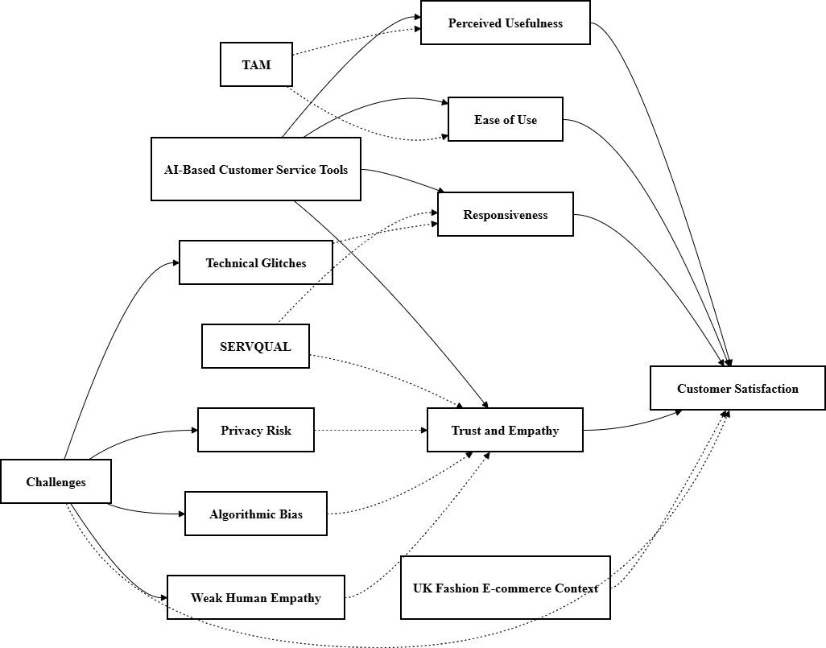

Figure 5: Conceptual Framework
According to Figure 5, the conceptual framework is logically structured, as it connects AI-based customer service tools to four sources of satisfaction, namely, perceived usefulness, ease of use, responsiveness, and trust and empathy. TAM is rightly related to usefulness and ease of use, whereas SERVQUAL is rightly related to responsiveness, trust, and empathy. The framework is aware that issues do not work individually in the sense that technical glitches cause responses to be slow, whereas the risk of privacy issues, algorithmic bias and lack of human empathy respond to trust and empathy. UK fashion e-commerce environment is favourable as a contextual factor since the sizing, returns, delivery and competition influence customer satisfaction. I

2.10 Summary
The chapter discussed the impact of AI-based tools of customer service on customer satisfaction within UK fashion e-commerce. The literature demonstrates that chatbots, virtual assistants and recommendation systems have the ability to enhance service by being fast, useful, personalised, responsive and less exhaustive to customers. The usefulness of them, however, is dependent on accuracy, trust, empathy, user-friendliness and user-friendly human support of complex problems. The context in fashion in UK is pertinent as the customers are not certain about the fit, sizing, delivery and returns. The gap identified brings about the methodology chapter.

Chapter 3: Methodology

3.1 Introduction
The chapter described methodological choices that were applied to explore the effect of AI-based customer service tools in UK fashion e-commerce on customer satisfaction. It talked about the philosophy of the research, the research strategy, survey strategy, data collection, sampling, process of SPSS analysis, ethical considerations and chapter summary.

3.2 Research Philosophy
The research philosophy adopted a positivist study since the research measured the customer perceptions using numerical data in the form of surveys. Positivism was appropriate as it assumes research reality to be measurable in case variables are known and tested in a systematic way (Ikram and Kenayathulla, 2022). The customer satisfaction, perceived usefulness, ease of use, responsiveness, trust and empathy in this study were transformed into Likert-scale responses. Nevertheless, Heinonen and Lipkin (2023) claimed that customer experience has emotional and subjective connotations as well that cannot be completely described in numbers. This criticism was applicable as the process of shopping for fashion entails confidence in fit, assurance and preference. However, positivism was appropriate since the research was not focused on the examination of intimate individual narratives, but on quantifying the associations among AI service variables and satisfaction.

3.3 Research Approach
The current research was based on a deductive research methodology since it began with existing theories and used primary survey data to test them. A deductive research approach was suitable since theoretical frameworks like TAM and SERVQUAL had established variables that were related to technology acceptance and service quality (AlHussainan et al. 2022). TAM assisted in perceived usefulness and ease of use and SERVQUAL assisted in responsiveness, trust and empathy. Padamsee et al. (2021) claimed that an inductive method could be more effective in the case of an underexplored topic since the themes can appear directly to the participants. However, deduction was more suitable since it enabled the researcher to examine the possibility of selected AI service factors affecting customer satisfaction in fashion e-commerce in UK.

3.4 Research Strategy
The research employed a survey method as it enabled the collection of standardised responses of customers who have had experience with AI-based service tools in UK fashion e-commerce. Surveys made sense, as they quantified the attitudes, opinions and behavioural patterns of a broader group of participants (Henn et al. 2022). This approach also facilitated comparison since all the respondents responded to the same questions. Nonetheless, Ahmed (2022) noted that surveys might be constraining due to the fact that respondents are not allowed to elaborate why they respond as they do (Stantcheva, 2023). This shortcoming was acceptable, and the survey approach was still appropriate to fit the research due to the fact that the study was to test quantifiable relationships as opposed to individual stories. The choice of the survey strategy was also suitable as the research incorporated many variables which could be measured, such as usefulness, ease of use, responsiveness, trust, empathy and satisfaction. It assisted in gathering uniform data among the various respondents and contrasting the impact of each AI service factor on satisfaction. Thus, the online questionnaire offered an efficient, systematic and inexpensive method to gather data on customer satisfaction.

3.5 Data Collection Process
The primary data was obtained with the help of the self-administered online questionnaire developed using Google Forms. The use of online collection, in turn, was appropriate due to the fact that the customers of the fashion e-commerce were digital and, therefore, could access the questionnaire in the comfort of their home (Demyen, 2024). This questionnaire contained screening questions, demographic questions and Likert-scale questions that were tied to perceived usefulness, ease of use, responsiveness, trust and empathy as well as customer satisfaction. Semyonov-Tal and Lewin-Epstein (2021) reasoned that closed-ended questions enhance uniformity as the answers can be statistically compared. Nevertheless, Hancock and Cheatham (2024) observed that closed-ended questions might hinder the expression of participants since they select pre-determined choices. The use of closed-ended questions was appropriate in this research project since the SPSS analysis needed to be conducted with measurable and comparable data. The questionnaire linkage was distributed via social media platforms, which reduced the expenditure of the research. Participants were then provided with a consent statement that said the purpose of the research, the voluntary nature of their participation, and the anonymity and academic use of data before answering.

3.6 Sampling Strategy
The participants were selected via purposive sampling as the study sample had to be related to experience with AI-based tools in customer service in UK fashion e-commerce. The purposive sampling was suitable since the researcher could sample respondents who could be useful to the research problem (Obilor, 2023). The study sample needed to be at least 18 years old and had to have used any chatbot, virtual assistant or AI recommendation tool during the process of making purchases at UK fashion websites. A total of 120 participants’ responses were collected to conduct the research. Andrade (2021) believed that purposive sampling might limit generalisability. However, this sampling method proved appropriate, as random participants may not have interacted with AI customer service tools.

3.7 Data Analysis Process
The responses to the survey were saved on Google Forms, coded in MS Excel and decoded into SPSS to do the statistical analysis. Demographic analysis was conducted to verify the accuracy of surveys based on their age, gender, frequency, and experience with AI tools (Chen et al. 2021). Descriptive statistics were subsequently used to determine trends and patterns, including whether or not respondents generally perceived AI tools to be useful, easy to use, responsive and trustworthy (Amini et al. 2021). To test reliability, Cronbach's Alpha method was used to determine whether the questions on each variable were internally consistent. Pearson correlation was applied to investigate the relationship between the factors of AI services and customer satisfaction. Regression analysis was then used to determine the factors that have greater predictive power. It can be stated that statistical analysis could not be appropriate to explain human feelings, but it was appropriate in testing quantifiable patterns of satisfaction.

3.8 Ethical Considerations
Informed consent, voluntary participation, anonymity, and confidentiality were used as ethical practices. Participants had early knowledge of the purpose of the research when they were to fill out the questionnaire and they were allowed to withdraw before filling out the questionnaire. No names, email addresses, or sensitive personal information were gathered in the survey. The data were stored in files which were password-protected and were not used in any way other than academically. By following the instructions of the Data Protection Act 2018, the research maintained a fair and lawful data collection process (Legislatiion.gov.uk, 2026). Thus, the research adhered to the principles of GDPR by gathering the required data solely and ensuring the protection of the responses of the participants during the research process.

3.9 Summary
The application of positivism, deduction and survey strategy to investigate AI-based customer service and customer satisfaction was justified by this chapter. It described how primary data were obtained using an online questionnaire among the customers of UK fashion e-commerce companies and that data was analysed by using SPSS. Consent was supported by ethical safeguards, anonymity, confidentiality and data security.

Chapter 4: Findings and Analysis

4.1 Introduction
The chapter outlines the study's findings and analysis, which were carried out using SPSS, as it facilitated the organisation, testing, and interpretation of the survey data effectively. A total of 120 responses were collected and analysed. Participants were analysed demographically to gain insights into their features like age, gender, employment and shopping behaviour. Descriptive statistics were used to determine the response trends and patterns. To ensure consistency and accuracy of data, reliability and validity tests were carried out. Correlation and regression analyses were further used to test the hypotheses and examine relationships between the study variables.

4.2 Demographic Analysis

4.2.1 Age
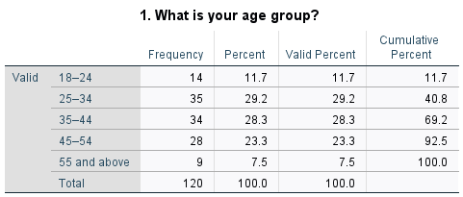

Table 1: Age
Table 1 shows that the respondents were in various age groups, with the highest age group at 55 years and above, and the lowest being 18-24 years. The cumulative percentages are gradually increasing in categories, which depicts the involvement of various age groups. The range of the highest frequency was between 25 and 34 years old, with 35 respondents, and the lowest frequency was the 55 and above category with 9 respondents.
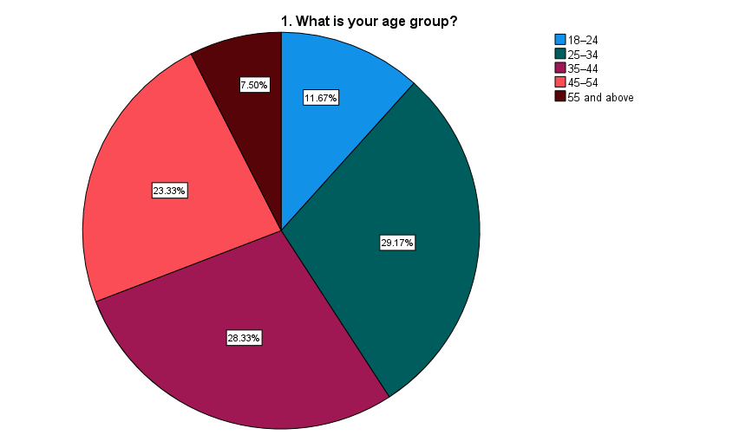

Figure 6: Age
Figure 6 shows that largest percentage of participants was found in 25-34 years age group, accounting for 29.2% of total sample size. The second highest was the 35-44 years category, accounting for 28.3% of total population. Comparatively, the least level of participation was recorded in the 55 years and above category, with the number of respondents being 9 and comprising 7.5% of total sample.

4.2.2 Gender


Table 2: Gender
Table 2 shows the gender distribution of the respondents who participated in this study. Out of 120 respondents, 65 were females and 55 were males. It shows that there is an equal rate of participation of both groups and no missing values.
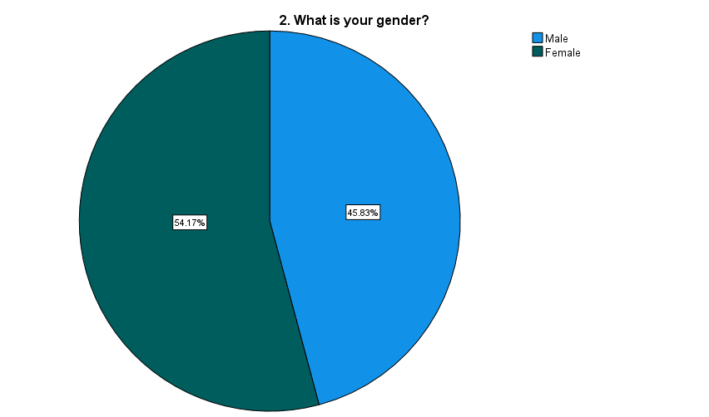

Figure 7: Gender
Figure 7 demonstrated that female respondents comprised the majority at 54.17%, with males at 45.83% in the sample. Thus, there was a little more female participation in this survey.

4.2.3 Employment Status
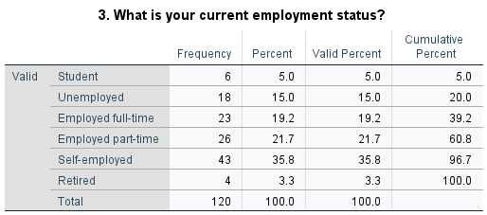

Table 3: Employment Status
Table 3 shows that there are 6 students, 18 unemployed respondents, 23 full-time workers, 26 part-time workers, 43 self-employed participants and 4 retired. It shows that nobody skipped responding in the research survey. The distribution is indicative of the involvement of various occupational groups.
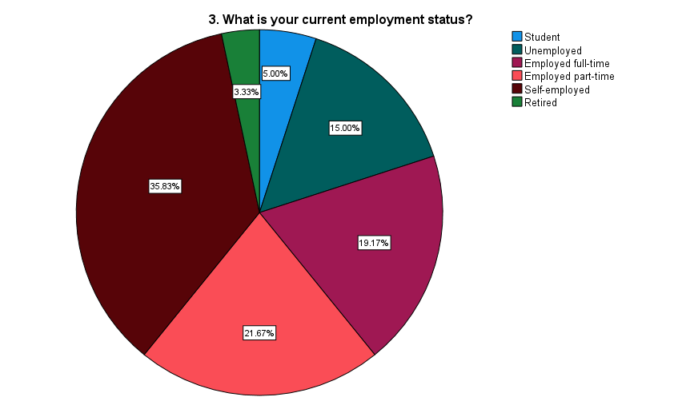

Figure 8: Employment Status
The greatest proportion was found among the respondents of self-employed at 35.8% and the least proportion was among the respondents of retired at 3.3%, as referred to Figure 8.

4.2.4 Shopping Frequency
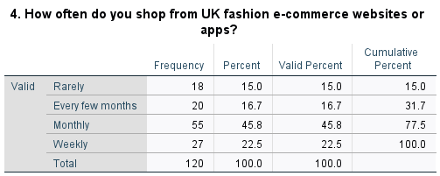

Table 4: Shopping Frequency
Table 4 indicates that the most frequent behaviour was monthly shopping, with largest frequency of 55 respondents. Weekly shopping was second-highest category, with 27 respondents. It implies that a significant number of participants frequent UK fashion e-commerce websites or apps. The least frequency was captured among the rare shoppers, where 18 respondents were found.
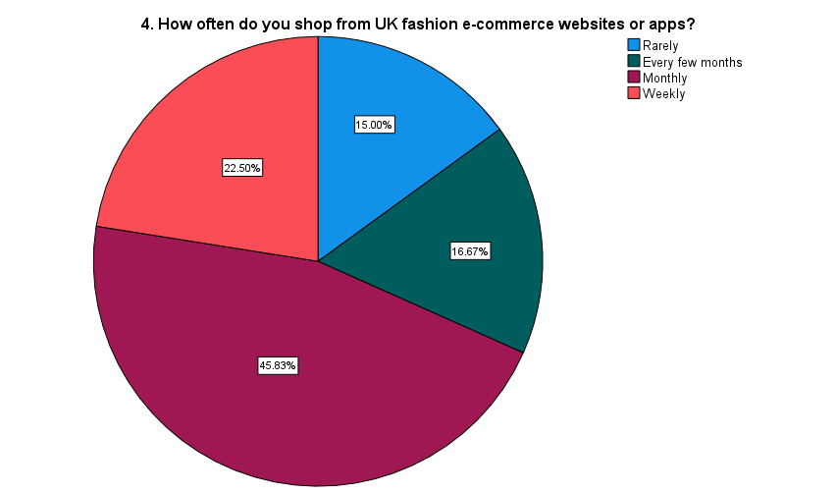

Figure 9: Shopping Frequency
According to Figure 9, the majority of the sample was made up of monthly shoppers at 45.83%, and then 22.50%, which comprises weekly shoppers. The lowest 15% of the sample were rare shoppers, indicating that the sample was largely active online fashion shoppers.

4.2.5 Variation of Using an AI-based customer service tool
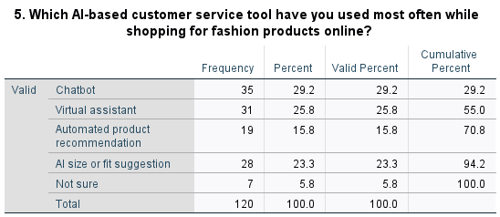

Table 5: Variation of Using an AI-based customer service tool
According to Table 5, chatbots were the most frequent AI-based customer service technology, where 35 respondents were the most frequent. Virtual assistants came with 31 respondents and 28 respondents followed AI size/fit suggestions. The minimum frequency was obtained in the case of not sure, and the number of respondents was 7.
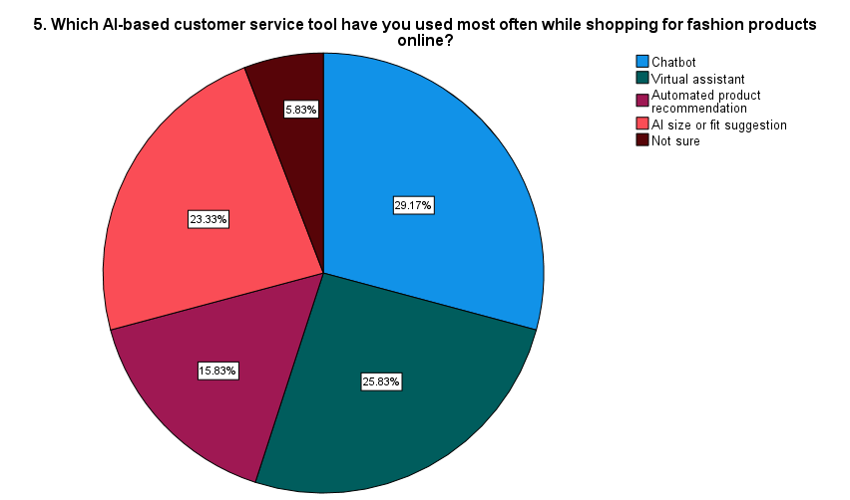

Figure 10: Variation of Using an AI-based customer service tool
Figure 10 indicates that chatbots occupied highest position with 29.17%, following virtual assistants with 25.83%, and lastly AI size or fit suggestions with 23.33%. The least was the not sure percentage at 5.83, indicating that the majority of respondents were able to recognise the AI tool that they had used.

4.3 Descriptive Statistics
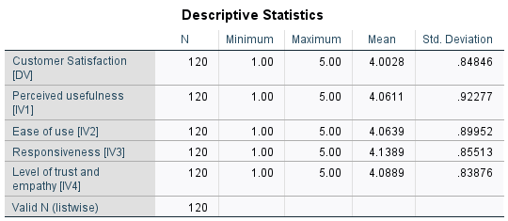

Table 6: Descriptive Analysis
The central tendency and the spread of the responses obtained in the survey are summarised using descriptive statistics (Rana et al. 2023). All variables were measured on a five-point Likert scale as per Table 6, and the higher the mean value, the stronger the agreement or the more positive perceptions (Schober et al. 2021). The findings indicate that the overall mean scores were 4.00 or higher, implying that the respondents were rather positive about AI-based customer service tools in UK-fashion online stores (Wong and Chapman, 2023).
The highest “mean” score was 4.1389 and “standard deviation” was 85513, which was the highest value in responsiveness. It means that the capacity of AI tools to support people and save their waiting time was the most important to respondents. It is reasonable in an e-commerce setting within fashion industry as customers usually require a rapid response regarding delivery, returns, refunds, and sizes or products that they intend to buy (Zennaro et al. 2022). Thus, it seems to be a service characteristic, such as fast response, which can decrease the level of uncertainty and enhance the shopping experience.
Ease of use had an average of 4.0639, where respondents found AI tools easy to learn and use. Despite being useful, technology can go to waste when customers have trouble navigating it and are confused by it. Ease of use in fashion shopping online might facilitate an enhanced service experience, allowing a customer to navigate swiftly from a query to a solution without requiring complicated procedures (Stecuła et al. 2024). The average perceived usefulness was 4.0611, meaning that respondents have deemed AI-based tools to be helpful in searching products, getting information and answering shopping-related questions. It reinforces that AI tools are appreciated when they offer some practical help instead of merely being automated features (Alowais et al. 2023).
The mean of trust and empathy was 4.0889, and respondents were found to mostly consider AI tools to be trustworthy and reasonably helpful. Nonetheless, the fact that this aspect is slightly emotional implies that AI can continue to be limited in responding to more complex complaints or sensitive issues of returns/refunds (Pinar, 2025). The mean of customer satisfaction was 4.0028, which proves that respondents were generally content. However, satisfaction level varies depending on usefulness, ease, responsiveness and trustworthiness of AI tools.

4.4 Reliability Statistics
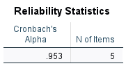

Table 7: Reliability Analysis
Reliability statistics assess internally consistent items in a questionnaire and whether they measure the same overall concept with consistency (Krieglstein et al. 2022). The five variables used have a “Cronbach's Alpha” value of .953 as illustrated in Table 7. “Cronbach's Alpha” value typically lies within the 0-1 range, where the higher the value, the greater the internal consistency (Izah et al. 2023). Hence, a value of.953 indicates that the variables applied to this study are very dependable. It implies that customer satisfaction and perceived usefulness, ease of use, responsiveness, trust and empathy have statistical consistency and can be analysed further. Therefore, the data can be subjected to correlation and regression analysis.

4.5 Validity Statistics
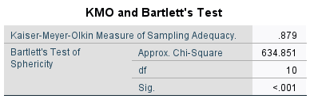

Table 8: Validity Analysis
The validity statistics are applied to determine whether the chosen variables can be further tested statistically and whether the data set contains enough connections between variables (Shrestha, 2021). “Kaiser-Meyer-Olkin Measure of Sampling Adequacy” of Table 8 is .879, which reflects a large sampling adequacy (Fener and Kiroglu, 2026). It indicates that the sample was appropriate in the context of testing correlation between customer service tools based on AI and customer satisfaction. The Test of Sphericity by Bartlett also resulted in a significant value of less than.001, which falls short of the recognised significance level of.05 (Baistaman et al. 2022). Hence, the variables are correlated well and can be used to test a hypothesis.

4.6 Hypothesis Testing Using Correlation and Regression Analysis

4.6.1 Hypothesis Test 1
H0: “Perceived usefulness of AI-based customer service tools does not significantly influence customer satisfaction among UK fashion e-commerce customers.”
H1: “Perceived usefulness of AI-based customer service tools significantly influences customer satisfaction among UK fashion e-commerce customers.”
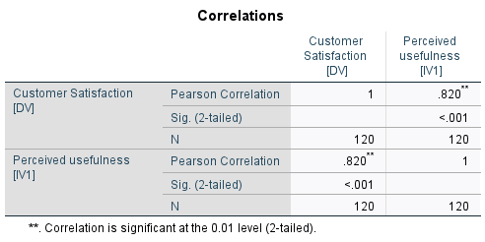

Table 9: Correlation Analysis 1
Correlation analysis is used to measure the strength and direction of the relationship between two variables (Alfadda and Mahdi, 2021). Pearson correlation value between customer satisfaction and perceived usefulness is as shown in Table 9 is 0.820 which is close to 1. The Pearson correlation has a normal value of 0 to 1, and the greater the correlation value, the more positive the relationship (Chen et al. 2021). Hence, the outcome indicates the existence of a close positive correlation between perceptions of usefulness and customer satisfaction. The significant value is < .001, which is lower than 0.05 (Palmas et al. 2021). It implies that handy AI tools will be able to enhance satisfaction, allowing customers to find product, size, delivery, and return and refund data more efficiently.
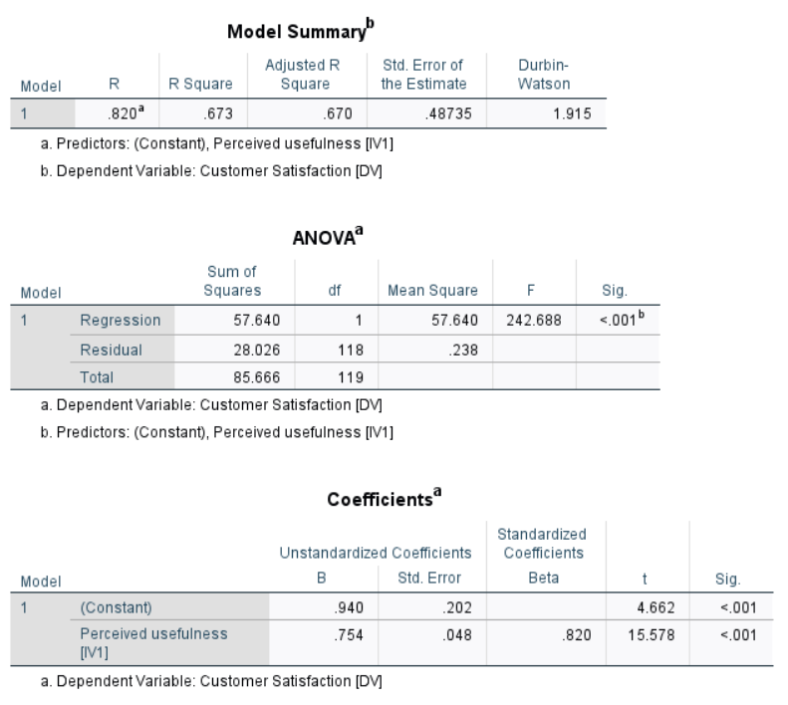

Table 10: Regression Analysis 1
Regression analysis helps determine the strength of an independent variable in explaining change in a dependent variable (Siska, 2022). As per Table 10, R value is 0.820, which shows a strong relationship between perceived usefulness and customer satisfaction. R-square value is .673, meaning that 67.3% changes in customer satisfaction can be explained by perceived usefulness of AI-based customer service tools. This great explanatory power means that customers have a higher probability of being satisfied when AI tools deliver helpful, relevant and problem-solving assistance when performing online fashion shopping. ANOVA outcome also indicates that the significance value is below 0.05, meaning that the regression model is significant (Veza et al. 2022). This result is also supported by the coefficient value since the beta of perceived usefulness is positive and significant with a value of 0.820, which is significant with a value of less than.001. Thus, “Perceived usefulness of AI-based customer service tools significantly influences customer satisfaction among UK fashion e-commerce customers.”

4.6.2 Hypothesis Test 2
H0: “There is no significant relationship between ease of use of AI-based customer service tools and customer satisfaction in UK fashion e-commerce.”
H1: “There is a significant relationship between ease of use of AI-based customer service tools and customer satisfaction in UK fashion e-commerce.”
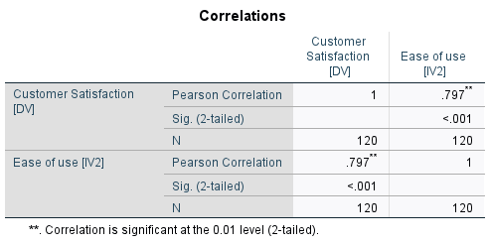

Table 11: Correlation Analysis 2
Table 11 shows the association between customer satisfaction and ease of use. The Pearson correlation value is 0.797, which implies a strong and positive relationship between the two variables. It implies that the higher the level of customer satisfaction, the easier it becomes to comprehend, access and use AI-based customer service tools (Tulcanaza-Prieto et al. 2023). The significance value is less than the standard value of 0.05, which is =.001 and therefore null hypothesis is rejected. This finding indicates that ease of use is not a frivolous technical element, but it has a direct impact on the experience of service to customers. Since correlation analysis is not adequate to establish dependency between variables, another regression analysis is done below.
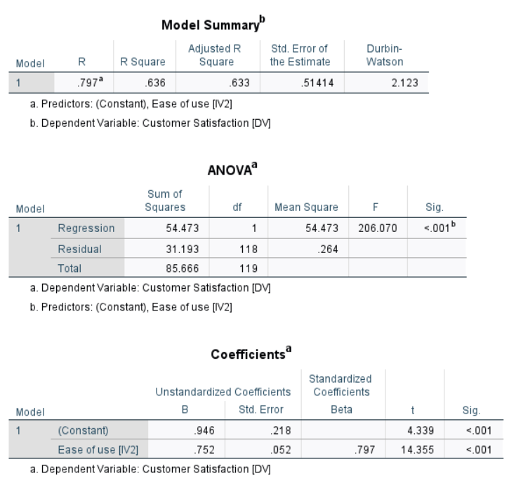
Table 12: Regression Analysis 2
According to Table 12, R-Sq value of 0.636 indicates that the ease of use explains 63.6% of variance in customer satisfaction. It demonstrates that customers are more satisfied when AI tools do not require additional effort to use. In real-life aspects, a chatbot or virtual assistant can come in handy. Nevertheless, when the customer has to work hard to get the appropriate solution or comprehend the answer, levels of satisfaction can go down (Hardcastle et al. 2025). ANOVA significance value is less than 0.001, which proves that the null hypothesis is rejected (Grigoryan, 2024). There is also a positive Beta value of 0.797 at a Sig. of <.001. Therefore, the alternative hypothesis is accepted, confirming “There is a significant relationship between ease of use of AI-based customer service tools and customer satisfaction in UK fashion e-commerce.”

4.6.3 Hypothesis Test 3
H0: “Responsiveness of AI-based customer service tools has no significant impact on customer satisfaction in UK fashion e-commerce.”
H1: “Responsiveness of AI-based customer service tools has a significant impact on customer satisfaction in UK fashion e-commerce.”
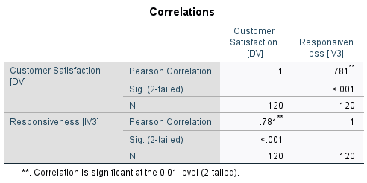

Table 13: Correlation Analysis 3
Table 13 shows the correlation between responsiveness and customer satisfaction. The value of Pearson correlation is 0.781, which is a strong positive relationship. The relationship is statistically significant as the significance value of less than 0.05 is less than that of 0.05. The outcome is reasonable in the context of fashion e-commerce, where delays in services might influence instant buying choices (Sutinen et al. 2022). This fact demonstrates that the correlation analysis is not in some way biased. Customers usually require a quick response to answer questions concerning size, delivery, payment, returns or refund policies before placing an order (Camilleri, 2022). Therefore, AI assistance with quick response can enhance trust and minimise shopping disruptions.
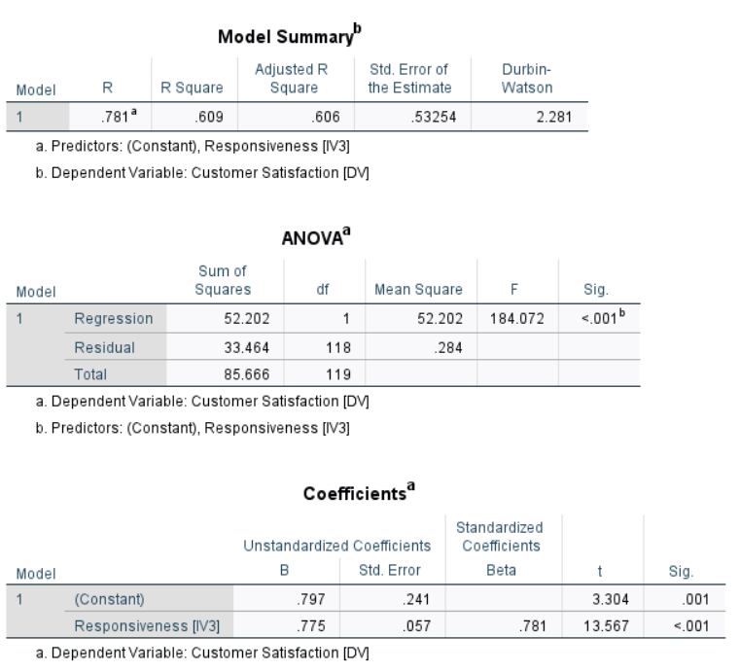

Table 14: Regression Analysis 3
Table 14 shows the extent to which responsiveness can explain customer satisfaction. The value of R-square is 0.609, which implies that 60.9 of the customer satisfaction change can be defined by responsiveness. It suggests that timely support is a key component of AI-based service quality (Noor et al. 2022). A customer can leave the online fashion shop in case the system is responding slowly or unresponsive to a query at an inappropriate time (Orzoł and Szopik-Depczyńska, 2023). ANOVA analysis indicates that Sig. < .001, which proves the statistical significance of the model (Moradi et al. 2021). The coefficient table indicates that the Beta is positive (0.781) with Sig. <.001. Thus, the alternative hypothesis is accepted, and it is possible to conclude that “Responsiveness of AI-based customer service tools has a significant impact on customer satisfaction in UK fashion e-commerce.”

4.6.4 Hypothesis Test 4
H0: “Trust and empathy provided through AI-based customer service tools do not significantly contribute to customer satisfaction in UK fashion e-commerce.”
H1: “Trust and empathy provided through AI-based customer service tools significantly contributed to customer satisfaction in UK fashion e-commerce.”
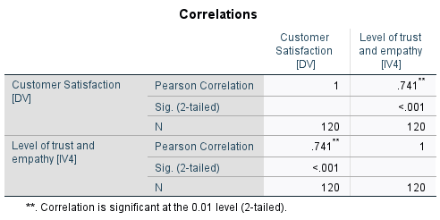

Table 15: Correlation Analysis 4
Table 15 finds the correlation between trust and empathy, and customer satisfaction. The value of Pearson correlation is 0.741 that signifies a strong positive relationship. It implies that customers would be more satisfied after the service tools based on AI respond reliably and accurately, and with support (Mariani and Borghi, 2024). The value of significance is less than 0.05, which is less than 0.001, and therefore it proves that the relationship is statistically significant. It is significant as fashion e-commerce customers could rely upon AI tools to address ambiguous or delicate problems, like refunds, fit, complaint management, or appropriateness. Confidence in automated service interactions is, therefore, assisted by trust and empathy (Ma et al. 2025).
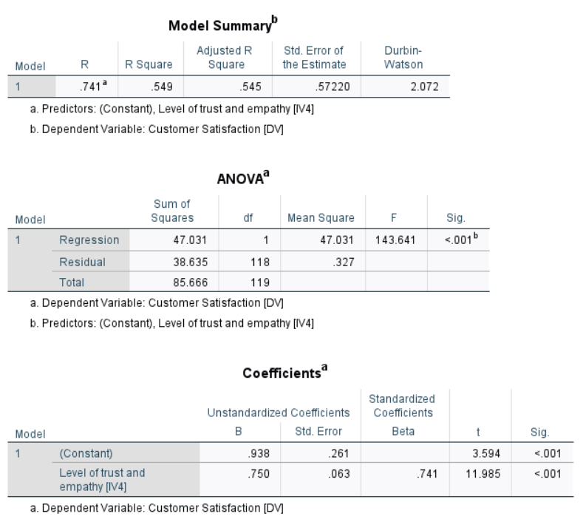

Table 16: Regression Analysis 4
As revealed in Table 16, trust and empathy can be clearly predicted to impact on customer satisfaction. The value of R-squared is 0.549, which implies that trust and empathy explain 54.9% of the change in customer satisfaction. This finding indicates that customers are not solely using speed or usefulness as a criterion to rate AI tools, but they also require confident, reliable and reassuring assistance (Branley-Bell et al. 2023). The value of R-square is, however, a little less than that of the other variables, which can mean that AI tools are more functional than emotional comprehension. The result of ANOVA is significant at =0.001 and the coefficient result also depicts a positive Beta of = 0.741 with =.001 significance. Therefore, the alternative hypothesis is accepted, confirming that “Trust and empathy provided through AI-based customer service tools significantly contributed to customer satisfaction in UK fashion e-commerce.”

4.7 Summary
The chapter discovered that customer service tools that are based on AI in fashion e-commerce in UK had generally positive experiences with the respondents. The majority of the participants were actively shopping online, and chatbots were the most popular AI tool. The descriptive results established that responsiveness was the highest mean score and it demonstrates that quick support is the most valued variable. The tests of reliability and validity proved that the data were reliable and acceptable to test the hypothesis. Correlation and regression findings revealed that perceived usefulness impacted customer satisfaction the most and then ease of use, responsiveness, trust and empathy.

Chapter 5: Discussion

5.1 Introduction
The chapter presents the major findings of the research as applied to the research objectives, research questions, and the literature in the field. It explains the impact of AI-powered customer service technology on customer satisfaction in UK fashion e-commerce. The topic of implementing AI tools, their impact on satisfaction, challenges and practical solutions related to the implementation are discussed.

5.2 Discussion
Discussion on Objective 1
The initial objective was to investigate the use of AI-based customer service solutions in the context of UK fashion e-commerce retailers. The results indicate that use of AI was not abstract and unfamiliar to participants, as majority of participants were able to recognise the single tool that they used. The most common tool mentioned was chatbots and the next one was virtual assistants and suggestions based on size or fit of AI. This observation confirms Nicolescu and Tudorache (2022) that a virtual agent is a computer-generated interlocutor when communicating with customers. However, it advances their argument by demonstrating that in e-commerce, environmentally friendly fashion, customers experience AI not only when they communicate through a chatbot, but through a combination of service points. Adam et al. (2021) state that efficiency and service quality are even in self-service technologies, and the current results partially confirm this assumption, as respondents seemed to be comfortable with a service based on AI-assistance. Nonetheless, such a balance must not be taken for granted, as fashion clients evaluate AI not only based on the availability but also on whether the solution to such issues as size, delivery, returns and product suitability is available.
The popularity of chatbots in the findings is in line with Zeng et al. (2023), who note that fashion brands utilise chatbots to offer product information, sales support and 24/7 communication. Similar arguments in support of chatbots are made by Baloska et al. (2022), who claim that chatbots assist in providing instant responses, personalisation, CRM, and functions related to orders. The current research proves the conspicuousness of such a use among customers of fashion e-commerce in UK. However, it indicates that chatbots are the most familiar tool, not always the most developed or the most contentful tool. It is important since the awareness of the customers towards chatbots might indicate the level of exposure rather than quality of service. That is, chatbots are spread by retailers, but the success of an AI strategy lies in the ability of customers to perceive them as helpful, easy, attentive and reliable.
The results also complement the literature, which states that AI-enhanced customer service is getting integrated into a broader shopping experience. Ranjan and Upadhyay (2025) believe in product discovery, trend suggestions, order tracking and suggestions, and Alharthi (2025) states that AI determines the product filtering, predicting of fits, customer experience, and purchase choices. The AI size suggestions in the findings are significant since they indicate that customers are not necessarily using AI after a problem has happened, but before making purchase decisions. It applies when doing fashion e-commerce, as customers are not able to physically see the clothes and then purchase them. Thus, AI applications can minimise the uncertainty, yet they will also lead to dissatisfaction in case of inaccurate or excessively general advice.
The results also relate to those of Thatavarthi (2023) and Mimani et al. (2024), who indicate that AI tools are becoming part of full-stack e-commerce websites, instead of isolated customer service applications. The survey findings indicate that customers have seen chatbots, virtual assistants, recommendations and fit-related artificial intelligence devices, which suggests that AI is integrated at the communication, product search and decision support. Nonetheless, this integration brings a superior level of retailer. When a single AI feature is good, and another provides bad advice, leading to vague answers, customers might consider the entire retailer to be ineffective. Thus, the use of AI in UK fashion e-commerce is to be perceived as a network of relevant services, rather than an individual technological attribute.
The demographic findings also reinforce the topicality of this purpose. The majority of the respondents were active online fashion shoppers, with a significant percentage of them being monthly and weekly shoppers. It proves the points put forward by Mintel (2025) that UK online retail has become an established channel and the long-term growth of the UK e-commerce clothing proposed by Grand View Research (2026). Davies (2025), however, cautions that the demand for fashion on the internet is unstable, and this implies that retailers cannot rely on the growth in the market alone. The business application is that AI tools should not be used merely to automate the service charges, but it needs to help retain customers and build customer confidence.
The primary objective indicates that AI-powered customer support technologies are becoming apparent and diversified in the UK fashion e-commerce, in the form of chatbots, virtual assistants and AI fit recommendations. It corroborates the literature on AI expansion in retail service, but the results suggest that application is not sufficient. This result has a close connection to TAM in that the perceived usefulness and ease of use influence the acceptance of AI since customers recognise and use chatbots, virtual assistants and AI fit tools. It is related to SERVQUAL in that AI devices are evaluated based on responsiveness, reliability and assurance instead of being evaluated based on their presence alone. Retailers have to make certain that AI tools are incorporated, precise and pertinent to fashion requirements. AI is thus an opportunity and a duty as well, as AI can be used to optimise service and personalise it, but poor adoption can cause loss of trust and satisfaction.
Discussion on Objective 2
The second objective was to investigate the effect of AI-based tools of customer service on customer satisfaction in fashion e-commerce in UK. The results indicate that AI tools have a positive impact on satisfaction as long as they are useful, easy to use, responsive, trustworthy and reasonably empathetic. Perceived usefulness had the strongest statistical outcome, having a Pearson correlation of 0.820 and an R-squared of 0.673, indicating that 67.3% of the customer satisfaction change was attributed to perceived usefulness. It agrees with Singh and Singh (2024), who discovered that AI-based customer service has a significant impact on satisfaction and with Arinze (2024) who says that AI enhances satisfaction by providing timely, anticipative and customised service. Nevertheless, usefulness is important as customers require functional assistance in searching products, sizing, delivery and returns, not necessarily because AI is a concept of high technology.
It also endorses TAM, where perceived usefulness is the core of acceptance of technology. Chen et al. (2021) posit that usability and responsiveness determine customer experience based on chatbots in e-retailing, whereas Rana et al. (2024) claim that usefulness and ease of use determine the attitude towards chatbot-assisted shopping. The current results support this theoretical stance since shoppers were more pleased when AI applications assisted them in accomplishing shopping missions more efficiently. However, usefulness has strength, implying a constraint on retailer comprehension of AI implementation. The presence of AI does not satisfy customers, but they are satisfied when AI delivers service functionality more effectively than a slow search process or human response. Thus, AI needs to demonstrate its worth.
Satisfaction was highly correlated with ease of use and the correlation was 0.797 with an R-SQ of 0.636. It is consistent with Alqasa (2023), who established that ease of use affects customer reaction to AI-based services in a positive way and Zungu et al. (2025), who determined the convenience and time-saving factors to be critical predictors of AI self-service experience. The general agreement among respondents was that AI tools were simple to learn and use, and therefore, simplicity was not a factor of satisfaction. The convenience can soon turn into frustration if a chatbot interface can be opened with ease, and provides repetitive or irrelevant answers. Therefore, usability should be related to the quality of resolutions.
The descriptive mean of responsiveness was greatest and it was a strong predictor with an R-squared of 0.609. This result can be attributed to Onohuean and Nyagadza (2026), who assert that AI chatbots enhance satisfaction by adding value in terms of promptness, accuracy and efficiency. Rasheed et al. (2025), who attribute satisfaction and retention to fast, relevant and personalised responses. The discovery is particularly critical to UK fashion e-commerce since the decisions to make a purchase can be instant and easily influenced. Failure to provide the customers with fast information on fit, delivery or money-back policy can lead to abandonment of the basket or shift to a new retailer. Responsiveness must not, however, be confined to speed. Speedy yet inaccurate responses may have a negative effect on satisfaction compared to a slower yet dependable response and that is, responsiveness requires timeliness, relevancy and solution to the problem.
The satisfaction was also affected greatly by trust and empathy, with a correlation of 0.741 with R-square of 0.549. It is in line with the arguments presented by Al-Oraini (2025), postulating that chatbot satisfaction depends on competence and trust. Zubair et al. (2026) note the importance of credibility, expertise and delivery capacity of AI guidelines. Nevertheless, the fact that the explanatory power of trust and empathy is lower than the power of usefulness is an indication that customers still might think about AI, that it is more functional than emotional. It is indicative of Shaikh et al. (2024), who claim that AI is productive, yet it will not be able to substitute the relations between people and the personalised judgement. Hence, AI will help to enhance satisfaction with routine work, but sensitive issues such as complaints, money back, delivery issues and disappointment with the fit should be supported by humans.
The results are clearly indicating in favor of TAM since perceptions of usefulness and ease of use were most influential in customer satisfaction, proving that the customers are willing to embrace AI in case it will allow them to shop more productively. The SERVQUAL is also applicable since responsiveness, trust and empathy indicate that satisfaction is based on the quality of service and not technology acceptance only. The results indicate that AI-based customer service positively affects customer satisfaction, although it does not do this automatically. AI enhances satisfaction when it makes things easier, offers practical assistance, is fast and generates sufficient trust. The most significant effect of usefulness demonstrates that the customers of fashion consider AI based on the results of the usefulness of service provided. The lesser, but not yet insignificant, impact of trust and empathy demonstrates that AI is yet unable to substitute human reassurance. Thus, AI should be viewed by UK fashion retailers as an enhancing satisfaction support system and not as an ultimate replacement of human service.
Discussion on Objective 3
The third objective was to determine the problems which are related to the utilisation of AI-based customer service technologies in the online fashion stores of UK. The results indicate that there are mostly positive perceptions, though satisfaction was based on usefulness, ease of use, responsiveness, trust and empathy. Thus, whether AI can be found in fashion e-commerce or not is not the biggest problem, but whether AI is of sufficient quality to satisfy customers. It is in line with Israfilzade (2025), who identifies risks related to privacy and lost trust, bias and prejudice, as well as Tambuskar (2025), who emphasises transparency and bias minimisation as per GDPR compliance. Though legal adherence was not explicitly put into examination, the importance of trust and empathy is so large that the appeal of the customers might turn into a negative response when AI does not seem to be dependable, intrusive or sensitive.
Among the key problems, AI tools might be practical but fail to be emotional and complex in their work. Trust and empathy described 54.9% of the customer satisfaction as compared to perceived usefulness, ease of use and responsiveness. It means that customers consider reassurance, yet they might still consider AI to be poor in terms of emotional insights. It confirms Shaikh et al. (2024), who believe that AI saves time and enhances efficiency but cannot substitute relationship-based, strategic and personalised service. Tabaku et al. (2025) also demonstrate that virtual assistants are able to address most cases during the first contact, but those that cannot be resolved must be redirected. It is a grave limitation in fashion e-commerce as refund requests, delays, disappointing sizes and complaints sometimes need both an empathic touch and information.
Accuracy and explainability are yet another concern. According to Necula and Păvăloaia (2023), only precision can influence the work of a recommender system, whereas privacy and trust are issues that are hard to manage. Nkomo and Mupa (2024) also caution that black-box AI makes things less transparent and trustworthy. These results corroborate this since usefulness and trust were strongly associated with satisfaction. The wrongful or ambiguous AI recommendations can cause customers to dismiss the tool as well as the trustworthiness of the retailer. It plays a role in fashion where a suggestion might be based on body shape/size, gender expression, budget and style identity. Wrong suggestions are not simply technical and they may lead to customers being misunderstood.
The problem of over-standardised service also arises. The highest mean score was of responsiveness, which indicated that the customers value fast services, though speed is not a sufficient condition to be satisfied. Both Onohuean and Nyagadza (2026) and Rasheed et al. (2025) agree that AI chatbots are more effective at enhancing satisfaction when the response is quick, accurate, relevant and personal. The results substantiate this, although they point to responsiveness needing to be addressed seriously. When retailers prioritise AI towards rapid responses, they can end up designing a service experience that is perceived to work, yet does not answer the query. In online fashion, it can lead to infinite chatbot conversations, ambiguous return instructions or even inappropriate suggestions of sizes, as well as growing frustration.
Privacy and customer data usage are focal as the principle of personalisation requires information about the customers. Personalisation is proposed as an AI value and satisfaction source by Hollebeek et al. (2024) and Oyeniyi et al. (2024). However, Israfilzade (2025) and Madanchian (2024) warn against the potential emergence of ethical concerns, such as privacy, transparency and algorithmic bias in AI marketing. It is important since the very data used to customise service by AI can also lead to uncomfortable situations for the customers. An appropriate size recommendation can also be useful in cases where it is accurate, but it can be intrusive where the customers lack knowledge of how the data will be used. Thus, the level of satisfaction hinges on the sense of personalisation as supportive as opposed to exploitative.
The results indicate an imbalanced AI maturity of retailers as well. According to Eboseremen et al. (2024), AI-driven UI/UX might present risks of privacy, security, user confidence and favouritism of algorithms, whereas Papastamoulou and Antonopoulos (2025) posit that adoption of AI varies based on organisational ability, perceived risk and size of the firm. The respondents identified various tools of AI, yet this does not mean that they are equally good. The bigger the retailer, the greater the potential of having built-in AI, and the smaller the retailer, the less advanced the chatbots, which cannot cope with the more complicated problems. This brings about inconsistent UK fashion experiences.
The third objective presents difficulties in terms of trust, empathy, accuracy, privacy, bias, transparency, and consistency of the provided services. These concerns are interconnected with TAM since low usability, low usefulness and ambiguous AI reactions may decrease the degree of customer acceptance toward AI tools. They also relate to SERVQUAL since issues to privacy, insensitivity, wrongful responses and low reliability undermine assurance, responsiveness and trust in the service experience. Customers will generally be pleased when AI works well, whereas it will be subject to loss when it has no human judgment and sound problem-solving. Thus, the problems of implementation are not only technical; they influence the confidence of the customers in the product, emotional comfort, willingness to purchase, and loyalty. It implies that improper distribution of AI can turn what may be a convenient service into an element of doubt when customers are in need of assurance before they commit to shop or even send back inappropriate fashion goods safely and with ample confidence online, round-the-clock.
Discussion on Objective 4
The fourth aim was to provide recommendations to enhance the functioning of AI-based customer service tools to enhance customer satisfaction in UK e-commerce retailers of fashion products. The results imply that perceived usefulness was most related to satisfaction with the importance of the improvement, and the practical usefulness of AI tools needs to be improved the most, as it explained 67.3% of the variance. It corroborates Singh and Singh (2024), who demonstrate that AI-powered service has a significant impact on satisfaction, and Arinze (2024), who associates AI value with prompt and personalised service. Nevertheless, it is also in the findings that retailers are being challenged to go beyond simple automation. AI must not just be able to answer some general questions; it must be able to offer correct assistance regarding the sizing, delivery, and refunding, as well as comparing and tracking products and orders. Thus, the AI that UK fashion retailers should model should not be focused on cost reduction aims but on customer issues.
The second suggestion is to enhance the ease of use, as ease of use is described as 63.6% of customer satisfaction. It corroborates Chen et al. (2021) and Rana et al. (2024), who mention that perception of usefulness and ease of use have an impact on acceptance of chatbot-assisted shopping. Easy access is not enough, though. Alqasa (2023) points out that ease of use enhances responses to AI services, whereas Zungu et al. (2025) associate convenience and time-saving with positive AI self-service experiences. The results indicate that effective AI interfaces should be made user-friendly, transparent and goal-oriented by fashion retailers. The way customers should be able to ask a question in a natural way is to be answered with a corresponding answer and they should be transferred to a human adviser in case of necessity. It would lessen the effort of customers and help AI not to become another obstacle in a service journey.
The third recommendation is to improve the flexibility without compromising accuracy. The descriptive mean of responsiveness was the greatest and it explained 60.9% of satisfaction, which indicates that customers were very keen on quick response. It confirms Onohuean and Nyagadza (2026), who relate chatbot satisfaction with response time, accuracy and efficiency, and Rasheed et al. (2025), who highlight quick, relevant and personalised responses. Speed should, however, be taken seriously. With fashion e-commerce, the faster one makes a mistake in answering a question regarding delivery, returns or sizing, the more dissatisfaction an individual may have than when making a mistake that is slower. Thus, AI systems need to be taught the latest product, stock, delivery and returns information and chatbot responses must be verified by retailers regularly. Responsiveness must imply quick resolution, rather than quick response.
Customer satisfaction was attributed to trust and empathy; 54.9% of the customer satisfaction was accounted for by the two factors, implying that the two variables are not as strong as the functional variables. This is in line with Al-Oraini (2025), who highlights trust and competence as the main factors associated with the satisfaction of chatbots, and Zubair et al. (2026), who reveal that credibility and expertise influence customer ratings of AI recommendations. However, Shaikh et al. (2024) believe that AI will never substitute a human relationship-based service, whereas Tabaku et al. (2025) indicate that a case that is not solved yet should still be redirected. Thus, retailers must not pretend to have AI capable of resolving all issues. An easy way up to human agents must exist in complaints, money back, late orders and emotional dissatisfaction.
Responsible personalisation should also be enhanced by retailers. Hollebeek et al. (2024) and Oyeniyi et al. (2024) claim that personalisation builds AI value, facilitates the satisfaction process, and Alharthi (2025) relates AI to product filtering, fit prediction, and purchase choices. However, Israfilzade (2025), Tambuskar (2025) and Madanchian (2024) caution that AI has the potential of producing privacy, transparency and bias issues. This opposition implies that personalisation must be useful, clarifiable and consensual. Customers must have reasons as to why they get recommended and must have the ability to manage the way their data is used. It is particularly the case with fashion since size, style and body-related advice might be sensitive when not administered properly.
AI is supposed to be implemented as a human-aided service ecosystem. According to Thatavarthi (2023) and Mimani et al. (2024), AI performs optimally when integrated with e-commerce systems, recommendations, order management and customer experience systems. It is substantiated by the findings since customers did not just use chatbots, but a variety of AI tools. Nonetheless, according to Deng et al. (2026) and Zhang and Liu (2026), AI in fashion must be created to be human-friendly, transparent and consumer-centred. TAM supports the recommendations since the willingness to accept and continue using AI service tools can be enhanced by enhancing usefulness and ease of use. SERVQUAL also supports them since improved responsiveness, reliability, empathy and assurance have the potential to enhance service quality and increase customer satisfaction in fashion e-commerce in UK. Thus, retailers are supposed to use automated efficiency coupled with human judgment, constant testing and customer response. The most pertinent suggestion is not to upgrade AI usage, but to enhance AI usefulness, simplicity, accuracy, empathy, transparency and responsible human-AI interaction at all times.

5.3 Summary
This chapter discussed the research findings in relation to the four objectives, existing literature, TAM and SERVQUAL. The discussion revealed that AI-based customer service services are prevalent in fashion e-commerce in the UK by chatbots, virtual assistants, and AI fit recommendations. The results affirmed that the perceived usefulness, ease of use, responsiveness, empathy and trust have a positive impact on customer satisfaction. Nevertheless, it was also revealed in the discussion that AI technologies may result in difficulties when the responses are false, unbiased, biased, or vague. Thus, AI may be enhanced by accuracy, transparency, responsible personalisation and functionality of human support.

Chapter 6: Conclusion & Recommendation

6.1 Summary of Key Findings
The study concludes that AI-based customer service tools have a positive impact on customer satisfaction in fashion e-commerce in UK, although it relies on how customers interact with the tools in the context of actual shopping. The results were not that AI brings about satisfaction only when it has been automated or is widely used. Rather, customer satisfaction increased when AI assisted them in doing achievable actions, reducing uncertainty and navigating online fashion experience with a lesser amount of effort. It is necessary since fashion shopping is more about individual choices in terms of size, fit, delivery, returns and product suitability, where customers have a tendency to require reassurance to finalise a purchase.
The most important discovery was that AI-based customer service solutions are apparent in UK e-commerce in fashion. The majority of respondents were able to recognise AI tools that they had used, proving that AI is no longer an unknown or concealed retail feature. The most widely recognised tool was chatbots, virtual assistants and suggestions of size or fit of AI. AI is experienced when customers are in various stages of the service experience, including querying, product-searching, getting recommendations and addressing issues. Thus, AI is a component of the broader service ecosystem, and not an individual technology.
The importance of this finding is that customers’ experience of fashion e-commerce is determined by many interconnected service moments. An example of how a customer can utilise AI is searching for a product, and afterwards seeking size advice to feel more secure and a chatbot to inquire about delivery or refund. Nevertheless, in cases where an aspect of the system provides low-quality or inappropriate information, customers can consider entire retailer unreliable. Thus, AI values are generated when one is connected, correct and pertinent to the customer's urgent shopping issue.
The study was reinforced with the findings of the demographics and the shopping behaviours. The sample consisted of various age groups, sex and occupation, and the majority of the respondents were online fashion shoppers. It implies that the results were based on individuals with a real-life experience of online fashion retailing and were able to compare AI-based service with the real one. Their feedback was helpful since they not only portray the way the average digital consumers interact with AI support during the shopping process, but also how they think the technology could operate. It renders the results applicable to retailers where they require customer responses in practical service scenarios.
The descriptive data exhibited that the respondents perceived AI-based customer service tools positively. The participants were more likely to consent that the tools were beneficial, convenient to use, responsive, reliable and conducive to satisfaction. Speed in responding to the requests also seemed to be a significant factor, with customers appreciating fast service in online fashion purchases. It makes sense since indecisiveness is able to disrupt a purchase. Customers who are not sure about size, delivery time, payment, returns or refund terms and conditions are assisted by fast customer care to get on with more assurance. Hence, responsiveness is appealing as it minimises waiting, eliminates uncertainty which can develop and makes the customer remain focused on the purchasing process.
Nonetheless, the research results indicated that speed is not sufficient. Responsiveness enhances customer satisfaction by providing them with responsive access to valuable support. A quick solution without solving the issue might seem to be effective at first, yet it can turn out to be frustrating as the customer will need to rephrase the query or seek an answer elsewhere. AI responsiveness provides a customer with an immediate point of direction, but only if it is correct, relevant and helpful. That is why an AI-based service should be fast and offer a high quality of solving problems, but with the specificity of fashion, where the choice is personal and connected to confidence.
The most significant result of the hypothesis testing was the significance of the perceived usefulness. It led to customers being more satisfied as AI assisted them in attaining something valuable in shopping process. When assisting customers in locating right products, comprehending sizing, checking the delivery details, comparing the products or addressing the issues with returns, an AI tool becomes appealing. AI is not easily valued by customers because it exists, but because it can ease their lives and enhance their decision-making process. As such, usefulness is the primary factor that transforms AI from a technical characteristic to a valuable customer service tool.
Another significant result was the ease of use. Whenever the AI tools were easy to retrieve, comprehend and use, customers felt more content. Internet consumers do not desire intricate menus, vague chatbot routes and tech speak when they want fast assistance. An easy-to-use tool makes the customer concentrate on the shopping as opposed to acquiring knowledge of how the system operates. Consequently, usability will enhance satisfaction as friction will be eliminated, and customers will be free to go through the questions to answer smoothly. When AI finds it hard, there is an increased weight load to the service journey instead of lightness.
Sensibility also had a significant impact on satisfaction since timely support would impact customers' confidence. Those who shop via fashion have a habit of rapidly shopping around and slow responses can prompt them to quit the site or app. When AI can reduce waiting time and maintain the customer's attention until they are convinced that they are being served and not ignored, it becomes useful. However, the responsiveness should be backed by the accuracy since the customers require accurate answers and not speedy responses. Answering hastily and incorrectly can ruin the experience, as it causes false confidence and can lead to bad purchases.
Satisfaction was also influenced by trust and empathy, but they seem to be of a lesser strength compared to more practical service factors. It implies that AI will more likely be useful than verbal comfort. Still, customers require assurance that the automated systems are trustworthy, considerate and capable of addressing delicate areas like complaints, money back, delayed deliveries and issues with fits. Human support is required when AI is not able to give an assurance. The research finds that AI would enhance customer satisfaction when it is helpful, easy, receptive, reliable and human intervention where necessary.

6.2 Linking with Objectives
Linking with Objective 1
The first objective was to find out what UK fashion e-commerce retailers think about the use of AI-based customer service solutions. The research found that AI tools are currently being implemented and are known to customers in this industry. The most noticeable tool was chatbots, then virtual assistants and suggestions of AI size and fit. It demonstrates that, besides providing answers to simple questions, AI is also used to help find products, make purchases and service requests. The conclusion, which can be attributed to this goal, is that customer service with AI has become a part of the overall experience in fashion e-commerce. Nevertheless, it worth hinges on the effectiveness of the incorporation of these tools in the customer journey. By providing support that is relevant and accurate, AI tools can decrease the amount of uncertainty and enhance trust. Unless well executed, they can ruin the service experience in their entirety.
Linking with Objective 2
The second objective was to test the effect of AI-based customer service technology on customer satisfaction during UK fashion e-commerce. AI has a positive impact on customer satisfaction when it aids customers in functional and significant ways. The strongest factor was perceived usefulness since customers were more satisfied when AI assisted them in locating products, grasped sizing, were informed about delivery details and established the solutions to shopping-related questions. Satisfaction was enhanced by ease of use and responsiveness since customers appreciated easy tools and rapid customer support. Confidence and compassion were desirable when a customer had to be comforted in instances of customer complaint, refunds or other issues related to fitting. Thus, the conclusion associated with this task is that AI enhances satisfaction as it helps to decrease conflict, save time and offer valid solutions. Nevertheless, AI will not be sufficient to achieve satisfaction unless it is accurate, comprehensible and assisted by humans as needed.
Linking with Objective 3
The third objective was to discover the problems related to utilisation of AI-based customer service tools in UK e-commerce in fashion industry. The research concluded that it is not the presence of AI, but rather its performance, which is the central problem. The customers can be unhappy with the inaccurate, repetitive, unclear, or unhelpful answers when using the AI. The issues of privacy, transparency and bias are also persisting since AI tools frequently rely on customer data to make personalised suggestions. The conclusion that could be made in connection with this goal is that AI may cause frustration when it cannot resolve the actual problem of the customer. Hence, retailers need to make sure that AI tools can be trusted, are transparent and can redirect customers to human support in case of a complicated or sensitive situation.
Linking with Objective 4
The fourth objective was to provide recommendations on how AI-based customer service tools could be enhanced to make UK fashion e-commerce retailers more satisfied with their customers. AI tools used by retailers need to be enhanced by taking into consideration usefulness, simplicity, accuracy, responsiveness, transparency and human support. The real needs of customers should be made AI-wise to include search for products, sizing, updated delivery, information returned and feedback. The tools must be user-friendly as customers should not be perplexed. Quick reactions should also be truthful and pertinent as opposed to being general and misinformed. The responsible personalisation, transparent data use and reasonable recommendations can help to improve trust. The conclusion associated with this aim is that AI need not be used in full place of human service. Rather, a hybrid model involving AI responding to simple queries and human personnel assisting with complicated issues affecting the person will be the most effective solution.

6.3 Recommendations
Recommendation 1: Improving the practical usefulness of AI tools
To enhance AI tools, UK fashion e-commerce retailers must target concrete issues of the customer, instead of applying AI in the form of an automation feature. The results revealed that usefulness was the most significant aspect that influences satisfaction, that is, customers appreciate AI when they are assisted in performing a real task. It involves identification of the appropriate product, size and fit checks, knowledge of delivery and returns issues in fashion shopping. If AI provides general answers, it might seem sophisticated, but not assist the customer in deciding on the matter. It may bring frustration as the customer will have to do a manual search or call a human agent. Thus, AI must be trained using updated product and stock, sizing, delivery and returns data to ensure that it offers specific and trusted advice (Rahmani et al. 2023). It would turn AI into a problem-solving tool as opposed to an adorned digital service feature.
Recommendation 2: Making the AI service simple and customer-friendly
The development of AI-based customer service tools should have a simple navigation system, natural language responses and well-defined paths to services by retailers. The analysis discovered that the ease of use was a significant contributor to the level of satisfaction, and it indicates that users do not desire to experience the difficulty of using a complicated chatbot menu or do not understand the meaning of the automatic response. This is significant since online shopping for fashion is normally quick and comparative in nature. The low-technology AI interface will decrease friction and assist customers in rapidly navigating their way through query-solution (Campa et al. 2024). Retailers must consequently put AI tools to the test as their customers see them and do away with redundant processes, redundant questions and bewildering terminology. It can ensure that AI becomes supportive rather than overbearing.
Recommendation 3: Balancing fast responses with accuracy and reliability
Responsiveness is not just the speed of the reply that should be adopted by UK fashion e-commerce retailers. Responsiveness was greatly appreciated, although a prompt response is beneficial when it is used to resolve the issue of the customer in the right way. The misinformation during the process of fashion e-commerce, like sizing, delivery, refunds or availability, can hurt satisfaction as customers can make bad purchasing decisions due to bad advice from AI. It implies that AI applications should be updated and tracked on a regular basis to have responses that are aligned with the latest information on products and services (Spring et al. 2022). Another option is having the retailers go through failed chatbot interactions in order to detect recurrent mistakes. The success can be huge since a proper responsiveness level can minimise uncertainty of customers, avoid the situation of basket abandonment and enhance trust in the retailer. It must thus aim at a quick resolution, but not necessarily quick automated communication.
Recommendation 4: Keeping human support for complex and sensitive issues
AI should be employed by retailers with simple queries, but with easy access to human service assistance on more complex, emotional or sensitive service issues. The results demonstrated that trust and empathy affected satisfaction, whereas AI did not seem to be as strong in emotional reassurance as in functional reassurance. It is important since fashion clients might require the human touch in case of delayed orders, refund-related issues, complaints or dissatisfaction with fit. When AI continues to keep the customers in the loop of an automatic mechanism in such cases, the service will seem impersonal and annoying (Xu and Greiffenhagen, 2024). Human dial can also be used to assure the customer that their trust is not compromised, by demonstrating that the retailer is not naive about the constraints of automation (Pappas et al. 2023). Retailers should instead create a hybrid that has AI to deal with quick and simple queries and have human advisers deal with those scenarios where judgment, empathy and reassurance are needed.

6.4 Research Limitations
The research relied on 120 responses to surveys, which gave valuable results, but they might not count all the customers of the fashion e-commerce in UK. Purposive sampling was used to select the sample, therefore, making the results more applicable to the customers already using AI-based service tools. The research adopted a quantitative questionnaire, which aided in quantifying the relationships between variables but did not allow for attaining in-depth personal experiences, frustrations or emotional responses. The research concentrated on customer perceptions as opposed to data related to the retailers. Therefore, it did not look into the design, management, or updating of AI systems by companies. Lastly, the results were only generalised to UK fashion e-commerce and might not be the same for other retail industries.

6.5 Future Scope
The study could be furthered in future research by adopting a larger and more diversified sample of customers of fashion e-commerce in UK. It would enhance generalisability and make better comparisons between age groups, frequency and level of customer experience of shopping. As part of future research, interviews may be utilised to investigate the reasons behind customer satisfaction or dissatisfaction with AI-based service tools in further detail. It would come in handy since some of the areas like trust, empathy, privacy and frustration might require more qualitative insight. Another potential research topic is comparing the various categories of AI tools like chatbots, virtual assistants, and recommendation systems and AI size or fit tools. As well, further research can be conducted to study retailer-side viewpoints, to learn how AI systems are created, tracked and enhanced.

References
Abdullah, M.S. (2025). Examining The Effect Of AI-Powered Personalisation On Customer Loyalty: A Meta-Analysis Of E-Commerce Studies. Review of Applied Science and Technology, 4(02), pp.309-338. https://rast-journal.org/index.php/RAST/article/download/33/33
Adam, M., Wessel, M. and Benlian, A. (2021). AI-based chatbots in customer service and their effects on user compliance: M. Adam et al. Electronic markets, 31(2), pp.427-445. https://doi.org/10.1007/s12525-020-00414-7
Ai-Shafei, M., Gupta, S., Shin, M.M., Yan, Y. and Liu, R. (2026). Integrated Learning with AI Enabled Interactions with Customers by Fashion Retailers. Corporate Reputation Review, 29(1), pp.61-78. https://ualresearchonline.arts.ac.uk/id/eprint/26106/1/CRRR-D-23-00041_R1.pdf
Alfadda, H.A. and Mahdi, H.S. (2021). Measuring students’ use of zoom application in language course based on the technology acceptance model (TAM). Journal of psycholinguistic research, 50(4), pp.883-900. https://doi.org/10.1007/s10936-020-09752-1
Alharthi, S. (2025). From Browsing to Decision: How Artificial Intelligence Systems Influence the Modern Fashion Consumer Journey. Systems, 14(1), p.31. https://doi.org/10.3390/systems14010031
AlHussainan, O.N., AlFayyadh, M.A., Al-Saber, A. and Alkandari, A.M. (2022). The factors of E-Government service quality in Kuwait during the coronavirus disease 2019 pandemic. International Journal of Electronic Government Research (IJEGR), 18(1), pp.1-19. https://www.igi-global.com/viewtitle.aspx?titleid=311417
Al-Oraini, B.S. (2025). Chatbot dynamics: trust, social presence and customer satisfaction in AI-driven services. Journal of Innovative Digital Transformation, 2(2), pp.109-130. https://doi.org/10.1108/JIDT-08-2024-0022
Alowais, S.A., Alghamdi, S.S., Alsuhebany, N., Alqahtani, T., Alshaya, A.I., Almohareb, S.N., Aldairem, A., Alrashed, M., Bin Saleh, K., Badreldin, H.A. and Al Yami, M.S. (2023). Revolutionizing healthcare: the role of artificial intelligence in clinical practice. BMC medical education, 23(1), p.689. https://doi.org/10.1186/s12909-023-04698-z
Alqasa, K.M.A. (2023). Impact of artificial intelligence-based marketing on banking customer satisfaction: examining moderating role of ease of use and mediating role of brand image. Transnational Marketing Journal, 11(1), pp.167-180. https://doi.org/10.58262/tmj.v11i1.1012
Amini, M., Zayeri, F. and Salehi, M. (2021). Trend analysis of cardiovascular disease mortality, incidence, and mortality-to-incidence ratio: results from global burden of disease study 2017. BMC public health, 21(1), p.401. https://doi.org/10.1186/s12889-021-10429-0
Andrade, C. (2021). The inconvenient truth about convenience and purposive samples. Indian journal of psychological medicine, 43(1), pp.86-88. https://doi.org/10.1177/0253717620977000
Andrade, I.M.D. and Tumelero, C. (2022). Increasing customer service efficiency through an artificial intelligence chatbot. Revista de Gestão, 29(3), pp.238-251. https://doi.org/10.1108/REGE-07-2021-0120
Arinze, E.D. (2024). Artificial intelligence (AI) in customer service: Revolutionising support and engagement. IAA Journal of Scientific Research, 11(2), pp.33-39. https://doi.org/10.59298/IAAJSR/2024/112.3339
Baistaman, J., Nawi, F.A.M., Mustapha, W.M.W. and Mamat, M. (2022), September. Exploratory factor analysis of financial literacy in the Malaysian context. In Proceedings (Vol. 82, No. 1, p. 24). MDPI. https://doi.org/10.3390/proceedings2022082024
Baloska, S., Mechkaroska, D. and Domazet, E. (2022). AI-driven Chatbot in E-Commerce. Journal of UIST, 3(1), pp.30-40. https://www.researchgate.net/profile/Daniela-Mechkaroska-2/publication/390348505_AI-driven_Chatbot_in_E-Commerce/links/67eb001e03b8d7280e163186/AI-driven-Chatbot-in-E-Commerce.pdf
Branley-Bell, D., Brown, R., Coventry, L. and Sillence, E. (2023). Chatbots for embarrassing and stigmatizing conditions: could chatbots encourage users to seek medical advice?. Frontiers in Communication, 8, p.1275127. https://www.frontiersin.org/journals/communication/articles/10.3389/fcomm.2023.1275127/pdf
Butler, S. (2025). 'Online fashion retailer Shein’s UK sales leap by a third to more than £2bn,' The Guardian, 15 August. https://www.theguardian.com/business/2025/aug/15/online-fashion-retailer-shein-uk-sales-leap-by-a-third-to-more-than-2bn
Camilleri, M.A. (2022). E-commerce websites, consumer order fulfillment and after-sales service satisfaction: the customer is always right, even after the shopping cart check-out. Journal of Strategy and Management, 15(3), pp.377-396. https://doi.org/10.1108/JSMA-02-2021-0045
Campa, M.F., Brown, C.M., Byrley, P., Delborne, J., Glavin, N., Green, C., Griep, M., Kaarsberg, T., Linkov, I., Miller, J.B. and Porterfield, J.E. (2024). Nanotechnology solutions for the climate crisis. Nature nanotechnology, 19(10), pp.1422-1426. https://pmc.ncbi.nlm.nih.gov/articles/PMC11555653/
Chen, J.S., Le, T.T.Y. and Florence, D. (2021). Usability and responsiveness of artificial intelligence chatbot on online customer experience in e-retailing. International Journal of Retail & Distribution Management, 49(11), pp.1512-1531. https://doi.org/10.1108/IJRDM-08-2020-0312
Chen, P., Li, F. and Wu, C. (2021), January. Research on intrusion detection method based on Pearson correlation coefficient feature selection algorithm. In Journal of Physics: Conference Series (Vol. 1757, No. 1, p. 012054). IOP Publishing. https://doi.org/10.1088/1742-6596/1757/1/012054
Chen, R., Sun, C., Chen, J.J., Jen, H.J., Kang, X.L., Kao, C.C. and Chou, K.R. (2021). A large‐scale survey on trauma, burnout, and posttraumatic growth among nurses during the COVID‐19 pandemic. International journal of mental health nursing, 30(1), pp.102-116. https://onlinelibrary.wiley.com/doi/pdfdirect/10.1111/inm.12796
Credence Research (2025). UK artificial intelligence in retail market. https://www.credenceresearch.com/report/united-kingdom-artificial-intelligence-in-retail-market
Dantsoho, M.A., Ringim, K.J. and Kura, K.M. (2021). The relationship between artificial intelligence (AI) quality, customer preference, satisfaction and continuous usage intention of e-banking services. Indonesian Business Review, 4(1), pp.24-43. https://www.researchgate.net/profile/Mohammed-Dantsoho/publication/353230750_The_Relationship_between_Artificial_Intelligence_AI_Quality_Customer_Preference_Satisfaction_and_Continuous_Usage_Intention_of_e-Banking_Services/links/60f0be750859317dbde5fe49/The-Relationship-between-Artificial-Intelligence-AI-Quality-Customer-Preference-Satisfaction-and-Continuous-Usage-Intention-of-e-Banking-Services.pdf
Davies, E.-R. (2025). Trends within fashion and beauty eCommerce. https://www.imrg.org/blog/trends-within-fashion-and-beauty-ecommerce
Demyen, S. (2024). The online shopping experience during the pandemic and after—a turning point for sustainable fashion business management?. Journal of Theoretical and Applied Electronic Commerce Research, 19(4), pp.3632-3658. https://www.mdpi.com/0718-1876/19/4/176
Deng, K., Zhang, C., Song, M. and Hu, X. (2026). Exploring key factors influencing generation z users’ continuous use intention on human-ai collaboration in secondhand fashion e-commerce platforms. Sustainability, 18(2), p.964. https://doi.org/10.3390/su18020964
Eboseremen, B.O., Moyo, T.M., Oladimeji, O., Ajayi, J.O., Tafirenyika, S., Erigha, E.D., Akindemowo, A.O., Afuwape, A.A. and Oladega, F. (2024). Comparative analysis of AI-enhanced UI/UX design practices in e-commerce websites: A case study of the USA and the UK. International Journal of Future Engineering Innovations, 1(2), pp.48-57. https://doi.org/10.54660/IJFEI.2024.1.2.48-57
Fener, İ. and Kıroğlu, K. (2026). Development of the Environmental Awareness Scale for Primary School Students. International Journal of Educational Studies and Policy, (Advanced Online Publication), pp.120-146. https://doi.org/10.5281/ijesp.1825894
Gopinathan, V.R. (2024). AI-Driven Customer Support Automation: A Hybrid Human–Machine Collaboration Model for Real-Time Service Delivery. International Journal of Technology, Management and Humanities, 10(01), pp.67-83. https://doi.org/10.21590/ijtmh.10.01.10
Gov.uk (2026). AI Adoption Research. https://www.gov.uk/government/publications/ai-adoption-research/ai-adoption-research
Graham, G., Nisar, T.M., Prabhakar, G., Meriton, R. and Malik, S. (2025). Chatbots in customer service within banking and finance: Do chatbots herald the start of an AI revolution in the corporate world?. Computers in Human Behaviour, 165, p.108570. https://doi.org/10.1016/j.chb.2025.108570
Grand View Research (2026). UK E-commerce Apparel Market Size & Outlook (2021)-2030. https://www.grandviewresearch.com/horizon/outlook/e-commerce-apparel-market/uk
Grigoryan, K. (2024). Labor shortages in the hospitality industry: The effects of work-life balance, employee compensation, government issued unemployment benefits and job insecurity on employees’ turnover intentions. Westcliff International Journal of Applied Research, 8(1), pp.59-73. https://pdfs.semanticscholar.org/daab/8a375d4c6756f1bbe49a367432e770c2157e.pdf
Gul, S., Zulfiqar, B., Khan, F., Jabeen, N. and Fareed, G. (2025). Impact of AI-powered chatbots on customer retention: Moderating role of service quality perception. Journal of Management Science Research Review, 4(1), pp.100-117. https://www.jmsrr.com/index.php/Journal/article/download/43/31
Halliday, S. (2024). 'M&S now using AI to advise shoppers on fashion choices,' FashionNetwork.com, 6 September. https://ww.fashionnetwork.com/news/M-s-now-using-ai-to-advise-shoppers-on-fashion-choices,1661375.html
Hancock, C.L. and Cheatham, G.A. (2024). How Early Head Start home visitors foster or impede shared decision-making with families. Journal of Research in Childhood Education, 38(1), pp.80-103. https://www.tandfonline.com/doi/pdf/10.1080/02568543.2023.2195460
Hardcastle, K., Vorster, L. and Brown, D.M. (2025). Understanding customer responses to AI-driven personalized journeys: Impacts on the customer experience. Journal of Advertising, 54(2), pp.176-195. https://doi.org/10.1080/00913367.2025.2460985
Hassan, N., Abdelraouf, M. and El-Shihy, D. (2025). The moderating role of personalized recommendations in the trust–satisfaction–loyalty relationship: an empirical study of AI-driven e-commerce. Future Business Journal, 11(1), p.66. https://doi.org/10.1186/s43093-025-00476-z
Heinonen, K. and Lipkin, M. (2023). Ordinary customer experience: Conceptualization, characterization, and implications. Psychology & Marketing, 40(9), pp.1720-1736. https://onlinelibrary.wiley.com/doi/pdf/10.1002/mar.21830
Henn, K., Goddyn, H., Olsen, S.B. and Bredie, W.L. (2022). Identifying behavioral and attitudinal barriers and drivers to promote consumption of pulses: A quantitative survey across five European countries. Food Quality and Preference, 98, p.104455. https://doi.org/10.1016/j.foodqual.2021.104455
Hollebeek, L.D., Menidjel, C., Sarstedt, M., Jansson, J. and Urbonavicius, S. (2024). Engaging consumers through artificially intelligent technologies: Systematic review, conceptual model, and further research. Psychology & Marketing, 41(4), pp.880-898. https://doi.org/10.1002/mar.21957
Ikram, M. and Kenayathulla, H.B. (2022). Out of touch: comparing and contrasting positivism and interpretivism in social science. Asian Journal of Research in Education and Social Sciences, 4(2), pp.39-49. https://www.researchgate.net/profile/Maryam-Ikram/publication/366810045_Out_of_Touch_Comparing_and_Contrasting_Positivism_and_Interpretivism_in_Social_Science/links/63b30f54097c7832ca84ccd3/Out-of-Touch-Comparing-and-Contrasting-Positivism-and-Interpretivism-in-Social-Science.pdf
Israfilzade, K. (2025). The role of Generative Artificial intelligence in E-Commerce: Trends, challenges and opportunities. The Eurasia Proceedings of Educational and Social Sciences, 42, pp.1-20. https://www.epess.net/index.php/epess/article/download/906/929
Izah, S.C., Sylva, L. and Hait, M. (2023). Cronbach's alpha: A cornerstone in ensuring reliability and validity in environmental health assessment. ES Energy and Environment, 23, p.1057. https://www.espublisher.com/uploads/article_pdf/esee1057.pdf
Kang, J.Y.M. and Choi, D. (2024). Artificial intelligence-powered digital solutions in the fashion industry: a mixed-methods study on AI-based customer services. International Journal of Fashion Design, Technology and Education, 17(2), pp.162-176. https://doi.org/10.1080/17543266.2023.2261019
Krieglstein, F., Beege, M., Rey, G.D., Ginns, P., Krell, M. and Schneider, S. (2022). A systematic meta-analysis of the reliability and validity of subjective cognitive load questionnaires in experimental multimedia learning research. Educational Psychology Review, 34(4), pp.2485-2541. https://doi.org/10.1007/s10648-022-09683-4
Landim, A.R.D.B., Pereira, A.M., Vieira, T., de B. Costa, E., Moura, J.A.B., Wanick, V. and Bazaki, E. (2022). Chatbot design approaches for fashion E-commerce: an interdisciplinary review. International Journal of Fashion Design, Technology and Education, 15(2), pp.200-210. https://doi.org/10.1080/17543266.2021.1990417
Legislatiion.gov.uk (2026). Data Protection Act 2018. https://www.legislation.gov.uk/ukpga/2018/12/contents
Ma, N., Khynevych, R., Hao, Y. and Wang, Y. (2025). Effect of anthropomorphism and perceived intelligence in chatbot avatars of visual design on user experience: accounting for perceived empathy and trust. Frontiers in Computer Science, 7, p.1531976. https://www.frontiersin.org/journals/computer-science/articles/10.3389/fcomp.2025.1531976/pdf
Madanchian, M. (2024). The impact of artificial intelligence marketing on e-commerce sales. Systems, 12(10), p.429. https://doi.org/10.3390/systems12100429
Manzo, D.S.H., Jiang, Y., Elyan, E. and Isaacs, J. (2025). Artificial intelligence-based conversational agents used for sustainable fashion: Systematic literature review. International Journal of Human–Computer Interaction, 41(8), pp.4640-4652. https://doi.org/10.1080/10447318.2024.2352920
Mariani, M.M. and Borghi, M. (2024). Artificial intelligence in service industries: customers’ assessment of service production and resilient service operations. International Journal of Production Research, 62(15), pp.5400-5416. https://doi.org/10.1080/00207543.2022.2160027
Mimani, S., Ramakrishnan, R., Rohella, P., Jiwani, N. and Logeshwaran, J. (2024), March. The Utilization of AI Extends Beyond Payment Systems to E-Commerce Store Development. In 2024 2nd International Conference on Disruptive Technologies (ICDT) (pp. 555-560). IEEE. https://www.researchgate.net/profile/Sushant-Mimani-2/publication/379762696_The_Utilization_of_AI_Extends_Beyond_Payment_Systems_to_E-Commerce_Store_Development/links/663a9e9608aa54017ae41f2e/The-Utilization-of-AI-Extends-Beyond-Payment-Systems-to-E-Commerce-Store-Development.pdf
Mintel (2025). UK Online Retailing Market Report 2025 | Mintel, Mintel Store. https://store.mintel.com/report/uk-online-retailing-market-report
Mintel (2025). UK Online Retailing Market Report 2025. https://store.mintel.com/report/uk-online-retailing-market-report
Mintel (2026). UK Fashion Online Market Report 2024 | Mintel Store, Mintel Store. https://store.mintel.com/report/uk-fashion-online-market-report
Mittameedi, S.K., Dogra, V. and Sayal, A. (2025). Customer experience in e-commerce: A systematic review of metrics, models, and the role of AI. IEEE Access. https://ieeexplore.ieee.org/iel8/6287639/6514899/11131174.pdf
Moradi, M., Aminzadeh, A., Rahmatabadi, D. and Rasouli, S.A. (2021). Statistical and experimental analysis of process parameters of 3D nylon printed parts by fused deposition modeling: response surface modeling and optimization. Journal of Materials Engineering and Performance, 30(7), pp.5441-5454. https://pureportal.coventry.ac.uk/files/43531941/Binder4.pdf
Necula, S.C. and Păvăloaia, V.D. (2023). AI-driven recommendations: A systematic review of the state of the art in e-commerce. Applied Sciences, 13(9), p.5531. https://doi.org/10.3390/app13095531
Nicolescu, L. and Tudorache, M.T. (2022). Human-computer interaction in customer service: the experience with AI chatbots—a systematic literature review. Electronics, 11(10), p.1579. https://doi.org/10.3390/electronics11101579
Nkomo, N.I.G.E.L. and Mupa, M.N. (2024). The impact of artificial intelligence on predictive customer behaviour analytics in e-commerce: A comparative study of traditional and AI-driven models. Iconic Research and Engineering Journal, 8(5), pp.432-451. https://www.researchgate.net/profile/Munashe-Naphtali-Mupa/publication/386135078_The_Impact_of_Artificial_Intelligence_on_Predictive_Customer_Behaviour_Analytics_in_E-commerce_A_Comparative_Study_of_Traditional_and_AI-driven_Models/links/6745acaff309a268c00ddb9d/The-Impact-of-Artificial-Intelligence-on-Predictive-Customer-Behaviour-Analytics-in-E-commerce-A-Comparative-Study-of-Traditional-and-AI-driven-Models.pdf
Noor, N., Rao Hill, S. and Troshani, I. (2022). Recasting service quality for AI-based service. Australasian Marketing Journal, 30(4), pp.297-312. https://researchonline.jcu.edu.au/79177/1/JCU_Recasting_Service_Quality_for_AI_Based_S.pdf
Obilor, E.I. (2023). Convenience and purposive sampling techniques: Are they the same. International Journal of Innovative Social & Science Education Research, 11(1), pp.1-7. https://www.researchgate.net/profile/Esezi-Obilor/publication/398681103_Convenience_and_Purposive_Sampling_Techniques_Are_they_the_Same/links/693fe9e8a1fd01798907e406/Convenience-and-Purposive-Sampling-Techniques-Are-they-the-Same.pdf
Onohuean, E. and Nyagadza, B. (2026). Evaluating the impact of AI-Powered chatbots adoption on customer satisfaction and service management: Perspectives from an emerging market multinational retail corporation. Strategic Business Research, p.100071. https://doi.org/10.1016/j.sbr.2026.100071
Orzoł, M. and Szopik-Depczyńska, K. (2023). Development trends in e-commerce sector. Procedia Computer Science, 225, pp.4157-4166. https://doi.org/10.1016/j.procs.2023.10.412
Oyeniyi, L.D., Ugochukwu, C.E. and Mhlongo, N.Z. (2024). Implementing AI in banking customer service: A review of current trends and future applications. International Journal of Science and Research Archive, 11(2), pp.1492-1509. https://doi.org/10.30574/ijsra.2024.11.2.0639
Ozuem, W., Ranfagni, S., Willis, M., Salvietti, G. and Howell, K. (2025). Chatbots, service failure recovery, and online customer experience through lenses of frustration–aggression theory and signaling theory. Journal of Services Marketing, 39(5), pp.493-512. https://research.uca.ac.uk/6734/1/Ozuem_Ranfagni%20et%20al_Journal%20of%20Services%20Marketing_April%202025.pdf
Padamsee, T.J., Hils, M. and Muraveva, A. (2021). Understanding low chemoprevention uptake by women at high risk of breast cancer: findings from a qualitative inductive study of women’s risk-reduction experiences. BMC Women's Health, 21(1), p.157. https://doi.org/10.1186/s12905-021-01279-4
Palmas, V., Pisanu, S., Madau, V., Casula, E., Deledda, A., Cusano, R., Uva, P., Vascellari, S., Loviselli, A., Manzin, A. and Velluzzi, F. (2021). Gut microbiota markers associated with obesity and overweight in Italian adults. Scientific reports, 11(1), p.5532. https://doi.org/10.1038/s41598-021-84928-w
Papastamoulou, P. and Antonopoulos, N. (2025). Artificial Intelligence in E-Commerce: A Comparative Analysis of Best Practices Across Leading Platforms. Systems, 13(9), p.746. https://doi.org/10.3390/systems13090746
Pappas, A., Fumagalli, E., Rouziou, M. and Bolander, W. (2023). More than machines: The role of the future retail salesperson in enhancing the customer experience. Journal of Retailing, 99(4), pp.518-531. https://www.academia.edu/download/108207708/2023_xx_JR_More_than_Machines.pdf
Park, E.S. and Park, M.S. (2020). 'Factors of the Technology Acceptance Model for Construction IT,' Applied Sciences, 10(22), p. 8299. https://doi.org/10.3390/app10228299
Pinar, A. (2025). A Hybrid AI and Fuzzy MCDM Approach for Retailer Evaluation: Leveraging Sentiment Analysis and Expert Insights. Applied AI Letters, 6(3), p.e70006. https://doi.org/10.1002/ail2.70006
Rahaman, S.U., Abdul, M.J. and Patchipulusu, S. (2023). AI-driven empathy in UX design: Enhancing personalisation and user experience through predictive analytics. Technology (IJCET), 14(2), pp.255-268. https://www.researchgate.net/profile/Shafeeq-Ur-Rahaman/publication/384730424_AI-Driven_Empathy_in_UX_Design_Enhancing_Personalization_and_User_Experience_Through_Predictive_Analytics/links/6705612733ab504c04f54069/AI-Driven-Empathy-in-UX-Design-Enhancing-Personalization-and-User-Experience-Through-Predictive-Analytics.pdf
Rahmani, A.M., Rezazadeh, B., Haghparast, M., Chang, W.C. and Ting, S.G. (2023). Applications of artificial intelligence in the economy including applications in stock trading, market analysis, and risk management. IEEE Access, 11, pp.80769-80793. https://ieeexplore.ieee.org/iel7/6287639/6514899/10197415.pdf
Rana, J., Gutierrez, P.L. and Oldroyd, J.C. (2023). Quantitative methods. In Global encyclopedia of public administration, public policy, and governance (pp. 11202-11207). Cham: Springer International Publishing. https://doi.org/10.1007/978-3-319-31816-5_460-1
Rana, J., Jain, R. and Nehra, V. (2024). Utility and acceptability of AI-enabled Chatbots on the online customer journey. International Journal of Computing and Digital Systems, 15(1), pp.323-335. http://dx.doi.org/10.12785/ijcds/150125
Ranjan, A. and Upadhyay, A.K. (2025). Value co-creation by interactive AI in fashion E-commerce. Cogent Business & Management, 12(1), p.2440127. https://doi.org/10.1080/23311975.2024.2440127
Rasheed, M., Sami, I. and Tabassam, A. (2025). The Impact of AI-Powered Chatbots on Customer Satisfaction and Business Performance in E-Commerce. Social Science Review Archives, 3(1), pp.2390-2401. https://doi.org/10.70670/sra.v3i1.547
Raza, A., Salahuddin, G.A., Soomro, M.H. and Batool, S. (2025). Analyzing the Impact of Artificial Intelligence on Shaping Consumer Demand in E-Commerce: A Critical Review. International Journal of Information Engineering and Electronic Business (IJIEEB), 17(5), pp.42-61. https://doi.org/10.5815/ijieeb.2025.05.04
Schober, P., Mascha, E.J. and Vetter, T.R. (2021). Statistics from A (agreement) to Z (z score): a guide to interpreting common measures of association, agreement, diagnostic accuracy, effect size, heterogeneity, and reliability in medical research. Anesthesia & Analgesia, 133(6), pp.1633-1641. https://doi.org/10.1213/ANE.0000000000005773
Semyonov-Tal, K. and Lewin-Epstein, N. (2021). The importance of combining open-ended and closed-ended questions when conducting patient satisfaction surveys in hospitals. Health Policy OPEN, 2, p.100033. https://www.sciencedirect.com/science/article/pii/S2590229621000046
Shaikh, A.A., Kumar, A., Mishra, A. and Elahi, Y.A. (2024). A study of customer satisfaction in using banking services through Artificial Intelligence (AI) in India. Public Administration and Policy, 27(2), pp.167-181. https://doi.org/10.1108/PAP-05-2023-0060
Shrestha, N. (2021). Factor analysis as a tool for survey analysis. American journal of Applied Mathematics and statistics, 9(1), pp.4-11. https://doi.org/10.12691/ajams-9-1-2
Siddhu, M. and Mohibi, S. (2024). AI application and fashion industry: A case study of emerging economies. In Illustrating Digital Innovations Towards Intelligent Fashion: Leveraging Information System Engineering and Digital Twins for Efficient Design of Next-Generation Fashion (pp. 537-552). Cham: Springer Nature Switzerland. https://doi.org/10.1007/978-3-031-71052-0_22
Singh, P. and Singh, V. (2024). The power of AI: enhancing customer loyalty through satisfaction and efficiency. Cogent Business & Management, 11(1), p.2326107. https://doi.org/10.1080/23311975.2024.2326107
Siska, E. (2022). Financial Technology (FinTech) and its impact on financial performance of Islamic banking. ARBITRASE: Journal of Economics and Accounting, 2(3), pp.102-108. https://pdfs.semanticscholar.org/546b/d99dff142a29fe0ff7d9a5e6c6853423d4fe.pdf
Spring, M., Faulconbridge, J. and Sarwar, A. (2022). How information technology automates and augments processes: Insights from Artificial‐Intelligence‐based systems in professional service operations. Journal of Operations Management, 68(6-7), pp.592-618. https://onlinelibrary.wiley.com/doi/pdfdirect/10.1002/joom.1215
Stantcheva, S. (2023). How to run surveys: A guide to creating your own identifying variation and revealing the invisible. Annual Review of Economics, 15(1), pp.205-234. https://www.annualreviews.org/content/journals/10.1146/annurev-economics-091622-010157?crawler=true&mimetype=application/pdf
Stecuła, K., Wolniak, R. and Aydın, B. (2024). Technology development in online grocery shopping—From shopping services to virtual reality, metaverse, and smart devices: A review. Foods, 13(23), p.3959. https://doi.org/10.3390/foods13233959
Sutinen, U.M., Saarijärvi, H. and Yrjölä, M. (2022). Shop at your own risk? Consumer activities in fashion e‐commerce. International Journal of Consumer Studies, 46(4), pp.1299-1318. https://doi.org/10.1111/ijcs.12759
Tabaku, E., Duçi, E., Kapçiu, R. and Kosova, A.M. (2025). Exploring the impact of artificial intelligence in banking: A case study on the integration of virtual assistants in customer service. International Research Journal of Modernisation in Engineering Technology and Science, 7(1), pp.4177-4183. https://www.doi.org/10.56726/IRJMETS66700
Tambuskar, S. (2025). AI Use for E-Commerce and Online Retail: Transforming the Future. PromptAI Academy Journal, 4, pp.e080-e080. https://doi.org/10.37497/PromptAI.4.2025.80
Taylor, S. (2026). E-Commerce fashion Returns: What customers want and how you can provide it. https://www.international-logistics-group.com/uk-en/insights/e-commerce-fashion-returns-161371
Thatavarthi, N.L.S. (2023). Integrating AI-driven Chatbots with full stack E-commerce platforms to enhance customer experience. Journal of Artificial Intelligence & Cloud Computing, 2(4), pp.1-5. https://www.researchgate.net/profile/Naga-Lalitha-Sree-Thatavarthi/publication/383442352_Integrating_AI-Driven_Chatbots_with_Full_Stack_E-commerce_Platforms_to_Enhance_Customer_Experience/links/67a03d1952b58d39f2671354/Integrating-AI-Driven-Chatbots-with-Full-Stack-E-commerce-Platforms-to-Enhance-Customer-Experience.pdf
Tulcanaza-Prieto, A.B., Cortez-Ordoñez, A. and Lee, C.W. (2023). Influence of customer perception factors on AI-enabled customer experience in the Ecuadorian banking environment. Sustainability, 15(16), p.12441. https://doi.org/10.3390/su151612441
Uzan, S., Freud, D. and Elalouf, A. (2025). Optimizing Chatbots to Improve Customer Experience and Satisfaction: Research on Personalization, Empathy, and Feedback Analysis. Applied Sciences, 15(17), p.9439. https://doi.org/10.3390/app15179439
Veza, I., Karaoglan, A.D., Ileri, E., Kaulani, S.A., Tamaldin, N., Latiff, Z.A., Said, M.F.M., Hoang, A.T., Yatish, K.V. and Idris, M. (2022). Grasshopper optimization algorithm for diesel engine fuelled with ethanol-biodiesel-diesel blends. Case Studies in Thermal Engineering, 31, p.101817. https://doi.org/10.1016/j.csite.2022.101817
Wahbi, A., Khaddouj, K. and Lahlimi, N. (2023). Study of the relationship between chatbot technology and customer experience and satisfaction. International Journal of Accounting, Finance, Auditing, Management and Economics, 4(6-1 (2023)), pp.758-771. https://doi.org/10.5281/zenodo.10442472
Wong, W.H. and Chapman, E. (2023). Student satisfaction and interaction in higher education. Higher education, 85(5), pp.957-978. https://doi.org/10.1007/s10734-022-00874-0
Xu, X. and Greiffenhagen, C. (2024). The disciplined customer: A video-based study of automated self-service hotels. new media & society, 26(9), pp.5013-5038. https://journals.sagepub.com/doi/pdf/10.1177/14614448241251793
Zakaria, M.M.A., Doheir, M., Akmaliah, N. and Yaacob, N.B.M. (2024). Infinite potential of AI chatbots: Enhancing user experiences and driving business transformation in e-commerce: Case of Palestinian e-commerce. Journal of Ecohumanism, 3(5), pp.216-229. https://doi.org/10.62754/joe.v3i5.3896
Zeng, N., Jiang, L., Vignali, G. and Ryding, D. (2023). Customer interactive experience in luxury retailing: the application of AI-enabled Chatbots in the interactive marketing. In The Palgrave Handbook of Interactive Marketing (pp. 785-805). Cham: Springer International Publishing. https://doi.org/10.1007/978-3-031-14961-0_34
Zeng, N., Vignali, G. and Ryding, D. (2023). Understanding the application of AI-enabled chatbots in luxury fashion retailing. In The garment economy: Understanding history, developing business models, and leveraging digital technologies (pp. 369-388). Cham: Springer International Publishing. https://doi.org/10.1007/978-3-031-33302-6_19#DOI
Zennaro, I., Finco, S., Calzavara, M. and Persona, A. (2022). Implementing E-commerce from logistic perspective: Literature review and methodological framework. Sustainability, 14(2), p.911. https://doi.org/10.3390/su14020911
Zhang, Y. and Liu, C. (2024). Unlocking the potential of artificial intelligence in fashion design and e-commerce applications: The case of Midjourney. Journal of Theoretical and Applied Electronic Commerce Research, 19(1), pp.654-670. https://doi.org/10.3390/jtaer19010035
Zhang, Y. and Liu, C. (2026). AI-Driven Consumer Research in Fashion: A Systematic and Bibliometric Review (2022–2025) and Future Research Agenda. Journal of Theoretical and Applied Electronic Commerce Research, 21(3), p.74. https://doi.org/10.3390/jtaer21030074
Zubair, M., Iqbal, S., Kashif, M., Kosonogov, V. and Shestakova, A. (2026). AI credibility and customer satisfaction: a neuroscience-based approach. Journal of Consumer Marketing, 43(4), pp.445-458. http://dx.doi.org/10.1108/JCM-10-2024-7280
Zungu, N.P., Amegbe, H., Hanu, C. and Asamoah, E.S. (2025). AI-driven self-service for enhanced customer experience outcomes in the banking sector. Cogent Business & Management, 12(1), p.2450295. https://doi.org/10.1080/23311975.2025.2450295

Appendices

Appendix 1: Ethics Form
APPLICATION FOR ETHICAL APPROVAL

In order for research to result in benefit and minimise risk of harm, it must be conducted ethically.

The University follows the OECD Frascati manual definition of research activity: “creative work undertaken on a systematic basis in order to increase the stock of knowledge, including knowledge of man, culture and society, and the use of this stock of knowledge to devise new applications”. As such this covers activities undertaken by members of staff, postgraduate research students, and both taught postgraduate and undergraduate students working on dissertations/projects.

The individual undertaking the research activity is known as the “principal researcher”.

This form must be completed and approved prior to undertaking any research activity.

SECTION A: About You (Principal Researcher)
1 | Full Name: | Hari Singh Nenavath
2 | Student Number: | 2414104
3 | Email address: | 2414104@student.uwtsd.ac.uk
4 | Programme of Study: | MBA International
5 | Supervisor: | Rexon Nting

SECTION B: Internal and External Ethical Guidance Materials
 | Please list the core ethical guidance documents that have been referred to during the completion of this form (including any discipline-specific codes of research ethics, location-specific codes of research ethics, and also any specific ethical guidance relating to the proposed methodology). Please tick to confirm that your research proposal adheres to these codes and guidelines. You may add rows to this table if needed.
1 | UWTSD Research Ethics & Integrity Code of Practice | ☐
2 | UWTSD Research Data Management Policy | ☐
3 |  | ☐
4 |  | ☐

SECTION C: Details of Research Activity
1 | Indicative title: | Investigating the Impact of AI-Based Customer Service Tools on Customer Satisfaction in UK Fashion E-commerce Retailers
2 | Proposed start date: |  | Proposed end date:
Introduction to the Research (maximum 300 words in each section)
Ensure that you write for a Non-Specialist Audience when outlining your response to the three points below:
- Purpose of Research Activity
- Proposed Research Question
- Aims of Research Activity
- Objectives of Research Activity
Demonstrate, briefly, how Existing Research has informed the proposed activity and explain
- What the research activity will add to the body of knowledge
- How it addresses an area of importance.
3 | Purpose of Research Activity  AI-powered customer service applications, including chatbots and virtual assistants, are becoming more popular in the sphere of e-commerce due to their ability to enhance responsiveness, availability, and cost-effectiveness. Nonetheless, the customer satisfaction level is not determined by speed only, but also by accuracy, empathy, and the skills of handling a complicated issue. Although AI in online shopping has been studied more and more extensively, less research has been directed towards UK fashion online shopping, where customer service is of particular concern due to returns, size-fitting problems, delivery questions, and product-related inquiries. The study will contribute to the current knowledge since it will offer firsthand customer data on the role of AI-based service tools in their satisfaction within this particular industry. It discusses a relevant field since the perceptions of customers can be used to understand customer perceptions, which can benefit retailers in raising the quality of customer service, enhancing customer relationships, and making decisions related to the implementation of AI in customer care.
4 | Research Question  What is the impact of AI-based customer service tools on customer satisfaction with UK fashion e-commerce retailers?
5 | Aims of Research Activity  The study aims to examine how AI-based customer service applications influence customer satisfaction in the fashion online stores in the UK.
6 | Objectives of Research Activity  - To explore the application of AI-based customer service solutions among UK fashion e-commerce retailers  - To examine how customer service tools that are based on AI influence customer satisfaction in fashion e-commerce retailing in the UK  - To identify the issues associated with the use of AI-based customer service tools in online retailers of the UK fashion market  - To offer suggestions to increase the performance of AI-based customer service tools to increase customer satisfaction among UK fashion e-commerce retailers
Proposed data collection methods (maximum 600 words)
Provide a brief summary of all the methods that may be used in the research activity to collect data, making it clear what specific techniques may be used. If methods other than those listed in this section are deemed appropriate later, additional ethical approval for those methods will be needed. You do not need to justify the methods here but should instead describe how you intend to collect the data necessary for you to complete your project.
7 | A primary quantitative survey will be the primary data collection method of this research. The data will be gathered through direct surveying of the customers who have experience of utilising AI-based customer service tools (chatbots, virtual assistants, or automated messaging systems) when they are shopping with e-commerce retailers in the United Kingdom. The survey will be structured in a way that it will be used to collect systematic answers regarding customer experiences, perception, as well as level of satisfaction regarding these digital customer service tools.  The specific data collection method will be the self-administered online questionnaire. The questionnaire will be developed using Google Forms. It will have a total of 20 questions, and all the questions will be closed-ended because it must be structured to elicit answers in a form that can be quantified and measured. The response options will be primarily based on a Likert scale in which the respondents will be requested to provide their degree of agreement, satisfaction or experience on a fixed scale, like very dissatisfied to very satisfied, strongly disagree to strongly agree. This format will assist in the generation of unified data, which can be easily tabulated and analysed.  It is that the questionnaire will start with a brief introduction that explains why this study was conducted, why the study is voluntary and how much time will be required to complete the survey. They will be introduced to an information section and a consent section, after which they will be allowed to pass on to the survey questions. The questionnaire will be filled out by those who voluntarily agree to take part.  There will be 120 participants who will fill out the survey. The participants will be chosen among adults who have placed their orders with the e-commerce vendors of fashion in the UK and have interacted with AI-based customer service software during their shopping process or after-sales inquiries. The participants will be recruited over the online platform, including the social media platform.  The 20 close-ended items will be aimed at the frequency of the utilisation of AI-based customer service tools, convenience of use, the speed of the response, usefulness of the information provided, the capacity to solve problems, the degree of trust, and general customer satisfaction. To describe the sample, a few closed-ended background questions could be included, such as age group and frequency of online shopping.  The questionnaire will be open-ended, with a specific duration to collect the answers. All the responses will be electronically submitted and kept safely in the survey system, and then transferred to an encrypted file to be analysed. In this project, no interviews, focus groups, observations, experiments, or other methods of data collection will be employed. The responsibility of the study is restricted to data collection in the form of a survey that includes questionnaires.

SECTION D: Scope of Research Activity
 | Will the research activity include: | YES | NO
1 | Use of a questionnaire or similar research instrument? | ☒ | ☐
2 | Use of interviews? | ☐ | ☒
3 | Use of focus groups? | ☐ | ☒
4 | Use of participant diaries? | ☐ | ☒
5 | Use of video or audio recording? | ☐ | ☒
6 | Use of computer-generated log files? | ☐ | ☒
7 | Participant observation with their knowledge? | ☐ | ☒
8 | Participant observation without their knowledge? | ☐ | ☒
9 | Access to personal or confidential information without the participants’ specific consent? | ☐ | ☒
10 | Administration of any questions, test stimuli, presentation that may be experienced as physically, mentally or emotionally harmful / offensive? | ☐ | ☒
11 | Performance of any acts which may cause embarrassment or affect self-esteem? | ☐ | ☒
12 | Investigation of participants involved in illegal activities? | ☐ | ☒
13 | Use of procedures that involve deception? | ☐ | ☒
14 | Administration of any substance, agent or placebo? | ☐ | ☒
15 | Working with live vertebrate animals? | ☐ | ☒
16 | Procedures that may have a negative impact on the environment? | ☐ | ☒
17 | Other primary data collection methods. Please indicate the type of data collection method(s) below. | ☐ | ☒
 | Details of any other primary data collection method:  (this box should expand as you type) | ☐ | ☒

If you have ticked NO to every question then the research activity is (ethically) low risk and you may skip section E and continue to section F.

If YES to any question, then no research activity should be undertaken until full ethical approval has been obtained.

SECTION E: Intended Participants
 | Who are the intended participants: | YES | NO
1 | Students or staff at the University? | ☐ | ☒
2 | Adults (over the age of 18 and competent to give consent)? | ☒ | ☐
3 | Vulnerable adults? | ☐ | ☒
4 | Children and Young People under the age of 18? (Consent from Parent, Carer or Guardian will be required) | ☐ | ☒
5 | Prisoners? | ☐ | ☒
6 | Young offenders? | ☐ | ☒
7 | Those who could be considered to have a particularly dependent relationship with the investigator or a gatekeeper? | ☐ | ☒
8 | People engaged in illegal activities? | ☐ | ☒
9 | Others. Please indicate the participants below, and specifically any group who may be unable to give consent. | ☐ | ☒
 | Details of any other participant groups:  NA | ☐ | ☒

Participant numbers and source
Provide an estimate of the expected number of participants. How will you identify participants and how will they be recruited?
10 | How many participants are expected? | The number of respondents involved in the research is around 120 who will be recruited by distributing the survey through the social media by way of social media tools like Facebook and Twitter and through student networks, online communities and personal connections.
11 | Who will the participants be? | The participants will be adults aged over 18 and have experience in using the AI-based customer service tools in UK fashion e-commerce retailers, as well as could provide informed consent.
12 | How will you identify the participants? | The participants will be established by screening questions in the first stage of the online questionnaire to ensure that they are of age over 18 and have used AI-based tools of customer service in e-commerce in the UK fashion.

 | Information for participants: | YES | NO | N/A
13 | Will you describe the main research procedures to participants in advance, so that they are informed about what to expect? | ☒ | ☐ | ☐
14 | Will you tell participants that their participation is voluntary? | ☒ | ☐ | ☐
15 | Will you obtain written consent for participation? | ☒ | ☐ | ☐
16 | Will you explain to participants that refusal to participate in the research will not affect their treatment or education (if relevant)? | ☒ | ☐ | ☐
17 | If the research is observational, will you ask participants for their consent to being observed? | ☐ | ☐ | ☒
18 | Will you tell participants that they may withdraw from the research at any time and for any reason? | ☒ | ☐ | ☐
19 | With questionnaires, will you give participants the option of omitting questions they do not want to answer? | ☐ | ☒ | ☒
20 | Will you tell participants that their data will be treated with full confidentiality and that, if published, it will not be identifiable as theirs? | ☒ | ☐ | ☐
21 | Will you debrief participants at the end of their participation, in a way appropriate to the type of research undertaken? | ☒ | ☐ | ☐
22 | If NO to any of above questions, please give an explanation
 | Question 17 is insignificant as the research is not a case of a observational study, and question 19 is marked no since the 20 questions in the survey are close-ended Likert scale questions to be filled in, although the survey process itself is voluntary.

 | Information for participants: | YES | NO | N/A
24 | Will participants be paid? | ☐ | ☒ | ☐
25 | Is specialist electrical or other equipment to be used with participants? | ☐ | ☒ | ☐
26 | Are there any financial or other interests to the investigator or University arising from this study? | ☐ | ☒ | ☐
27 | Will the research activity involve deliberately misleading participants in any way, or the partial or full concealment of the specific study aims? | ☐ | ☒ | ☐
28 | If YES to any question, please provide full details

SECTION F: Anticipated Risks

 | Outline any anticipated risks that may adversely affect any of the participants, the researchers and/or the University, and the steps that will be taken to address them.
1 | Risks to participants  For example: sector-specific health & safety, emotional distress, financial disclosure, physical harm, transfer of personal data, sensitive organisational information. If you have identified in section D that there are no participants, then enter N/A and go skip to question 3.
 | Risk to participants:  Participants may face slight discomfort, loss of time, or minor privacy risks. | Participation will be voluntary, questions will be non-sensitive, and responses will be kept confidential and stored securely.
2 | If research activity may include sensitive, embarrassing or upsetting topics (e.g. sexual activity, drug use) or issues likely to disclose information requiring further action (e.g. criminal activity), give details of the procedures to deal with these issues, including any support/advice (e.g. helpline numbers) to be offered to participants. Note that where applicable, consent procedures should make it clear that if something potentially or actually illegal is discovered in the course of a project, it may need to be disclosed to the proper authorities
 | This study does not involve sensitive or upsetting topics, and participants can stop the survey at any time if they feel uncomfortable.
3 | Risks to the investigator  For example: personal health & safety, physical harm, emotional distress, risk of accusation of harm/impropriety, conflict of interest
 | Risk to the investigator:  The investigator may face minor stress and responsibility for secure data handling. | The investigator will follow the research plan, manage time carefully, and store data securely.
4 | University/institutional risks  For example: adverse publicity, financial loss, data protection
 | Risk to the University:  There may be a small risk of reputational or data protection issues if the research is not handled properly. | The research will follow ethical guidelines and all data will be handled confidentially and securely.
5 | Environmental risks  For example: accidental spillage of pollutants, damage to local ecosystems
 | Risk to the environment:  The study has no environmental risk because it is conducted online. | The research will use an online survey to reduce paper use and physical waste.

SECTION G: Feedback, Consent and Confidentiality

If you have identified in section D that there are no participants, then enter skip this section and continue to section H.

1 | Feedback  What de-briefing and feedback will be provided to participants, how will this be done and when?
 | At the conclusion of the survey, the participants will receive a short debrief statement and will have an email address to address in case they require additional information regarding the study.
2 | Informed consent  Describe the arrangements to inform potential participants, before providing consent, of what is involved in participating. Describe the arrangements for participants to provide full consent before data collection begins. If gaining consent in this way is inappropriate, explain how consent will be obtained and recorded in accordance with prevailing data protection legislation.
 | In the online questionnaire, there will be an information and consent section before the survey commences, which the participants will give through the next button and completion of the survey, which will constitute informed consent.
3 | Confidentiality / Anonymity  Set out how anonymity of participants and confidentiality will be ensured in any outputs. If anonymity is not being offered, explain why this is the case.
 | The responses to the participants will remain anonymous and confidential, no names will be gathered and the data will be stored safely and reported in summary format.

SECTION H: Data Protection and Storage

 | Does the research activity involve personal data (as defined by the General Data Protection Regulation 2016 “GDPR” and the Data Protection Act 2018 “DPA”)? | YES | NO
1 | “Personal data” means any information relating to an identified or identifiable natural person (‘data subject’). An identifiable natural person is one who can be identified, directly or indirectly, in particular by reference to an identifier such as a name, an identification number, location data, an online identifier or to one or more factors specific to the physical, physiological, genetic, mental, economic, cultural or social identity of that natural person. Any video or audio recordings of participants is considered to be personal data. | ☐ | ☒
 | If YES, provide a description of the data and explain why this data needs to be collected:
2 | This includes audio/video data of participants but can also include IP addresses and usernames. Names, addresses and emails also count, as do consent forms.  (this box should expand as you type)
 | Does it involve special category data (as defined by the GDPR)? | YES | NO
3 | “Special category data” means sensitive personal data consisting of information as to the data subjects’ –  (a) racial or ethnic origin,  (b) political opinions,  (c) religious beliefs or other beliefs of a similar nature,  (d) membership of a trade union (within the meaning of the Trade Union and Labour Relations (Consolidation) Act 1992),  (e) physical or mental health or condition,  (f) sexual life,  (g) genetics,  (h) biometric data (as used for ID purposes), | ☐ | ☒
 | If YES, provide a description of the special category data and explain why this data needs to be collected:
4 | What counts as ‘sensitive’ will differ between cultures. Any information on behaviour that is not in accordance with cultural norms would count as sensitive personal data.  (this box should expand as you type)

 | Will data from the research activity (collected data, drafts of the thesis, or materials for publication) be stored in any of the following ways? | YES | NO
5 | Manual files (i.e. in paper form)? | ☐ | ☒
6 | University computers? | ☒ | ☐
7 | Private company computers? | ☐ | ☒
8 | Home or other personal computers? | ☐ | ☒
9 | Laptop computers/ CDs/ Portable disk-drives/ memory sticks? | ☒ | ☐
10 | “Cloud” storage or websites? | ☒ | ☐
11 | Other – specify: | ☐ | ☐
12 | For all stored data, explain the measures in place to ensure the security of the data collected, data confidentiality, including details of backup procedures, password protection, encryption, anonymisation and pseudonymisation:
 | All data will be stored securely in password-protected files on the researcher’s university-approved storage and personal password-protected computer, with access limited to the researcher only. Survey responses will be anonymised as far as possible, no names will be collected, and all findings will be reported in summary form only. Any downloaded files will be kept securely and backed up in protected cloud storage where available. If portable devices are used, they will also be password-protected. Data will be handled confidentially and in line with GDPR, the Data Protection Act 2018, and university data management requirements.

 | Data Protection
 | Will the research activity involve any of the following activities: | YES | NO
13 | Electronic transfer of data in any form? | ☐ | ☒
14 | Sharing of data with others at the University outside of the immediate research team? | ☐ | ☒
15 | Sharing of data with other organisations? | ☐ | ☒
16 | Export of data outside the UK or importing of data from outside the UK? | ☐ | ☒
17 | Use of personal addresses, postcodes, faxes, emails or telephone numbers? | ☐ | ☒
18 | Publication of data that might allow identification of individuals? | ☐ | ☒
19 | If YES to any question, please provide full details, explaining how this will be conducted in accordance with the GDPR and Data Protection Act (2018) (and/or any international equivalent):
20 | List all who will have access to the data generated by the research activity:
 | The principal researcher and the research supervisor will have access to the data if required.
21 | List who will have control of, and act as custodian(s) for, data generated by the research activity:
 | The principal researcher will act as the custodian of the data generated by the research activity.
22 | Give details of data storage arrangements, including security measures in place to protect the data, where data will be stored, how long for, and in what form.
 | All data will be digitized and stored in password-protected devices and secure cloud storage available to the researcher and the data will be safely stored until the research project is done and then deleted according to the university requirements.
22 | Confirm that you have read the UWTSD guidance on data management (see https://www.uwtsd.ac.uk/library/research-data-management/) | ☒
23 | Confirm that you are aware that you need to keep all data until after your research has completed or the end of your funding | ☒

SECTION I: Use of AI tools
Use of generative AI and other AI-based tools  There are a number of ethical issues relating to the use of generative AI and other AI-based tools, including data security, output bias, and output errors. In general you should assume that any generative AI or other AI-based tool that you pay to use is more secure and accurate than one which is free to use.  Will the research use AI tools to do any of the following: |  | YES | NO | N/A
1 | Capture data? | ☐ | ☒ | ☐
2 | Generate and/or edit text? | ☐ | ☒ | ☐
3 | Generate graphics? | ☐ | ☒ | ☐
4 | Generate video? | ☐ | ☒ | ☐
5 | Generate sound/music? | ☐ | ☒ | ☐
6 | Generate code? | ☐ | ☒ | ☐
7 | Generate synthetic data? | ☐ | ☒ | ☐
8 | Analyse data? | ☐ | ☒ | ☐
9 | Analyse personal or sensitive data? | ☐ | ☒ | ☐
10 | Classify data? | ☐ | ☒ | ☐
11 | Do you intend to use the free version of any AI tools? | ☐ | ☒ | ☐
If you have answered YES to any of questions O1-O11, please provide justification detailing why this is necessary for the research.
12

SECTION J: Declaration
The information which I have provided is correct and complete to the best of my knowledge. I have attempted to identify any risks and issues related to the research activity and acknowledge my obligations and the rights of the participants.

In submitting this application I hereby confirm that I undertake to ensure that the above named research activity will meet the University’s Research Ethics and Integrity Code of Practice which is published on the website: https://www.uwtsd.ac.uk/research/research-ethics/
 | 1 | Signature of applicant: |  | Date:
2 |  | Supervisor: |  |  | Date:
3 |  | Signature: |  |  | Date:

Appendix 2: Survey Questionnaire
Demographic Questions
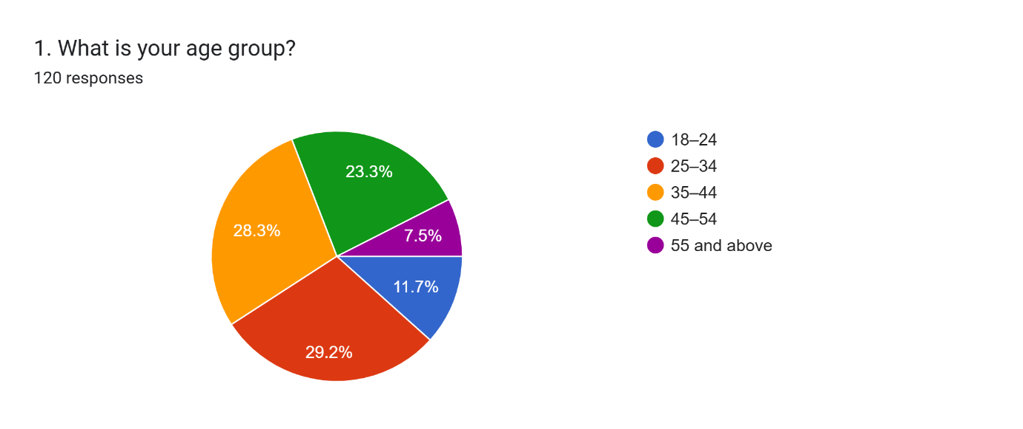
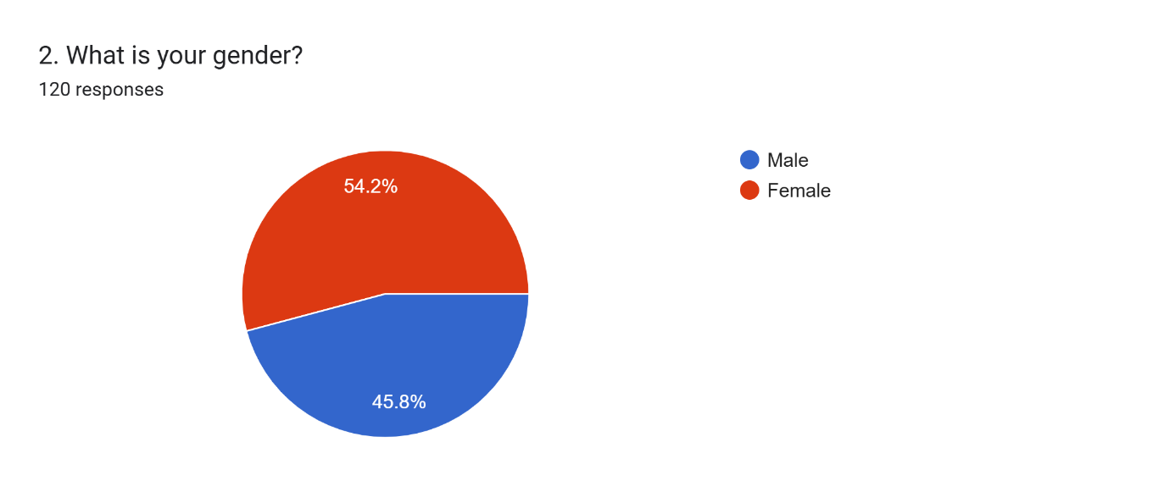
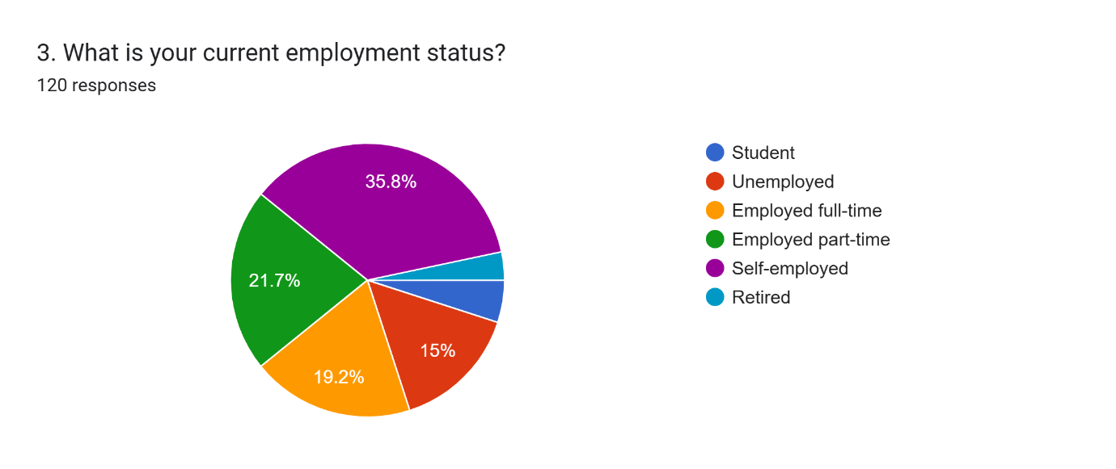
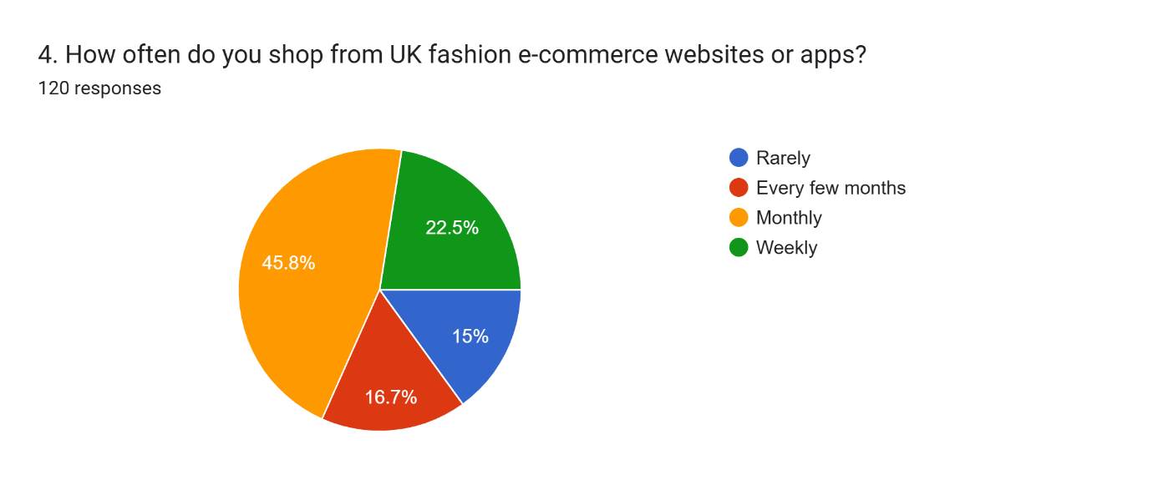
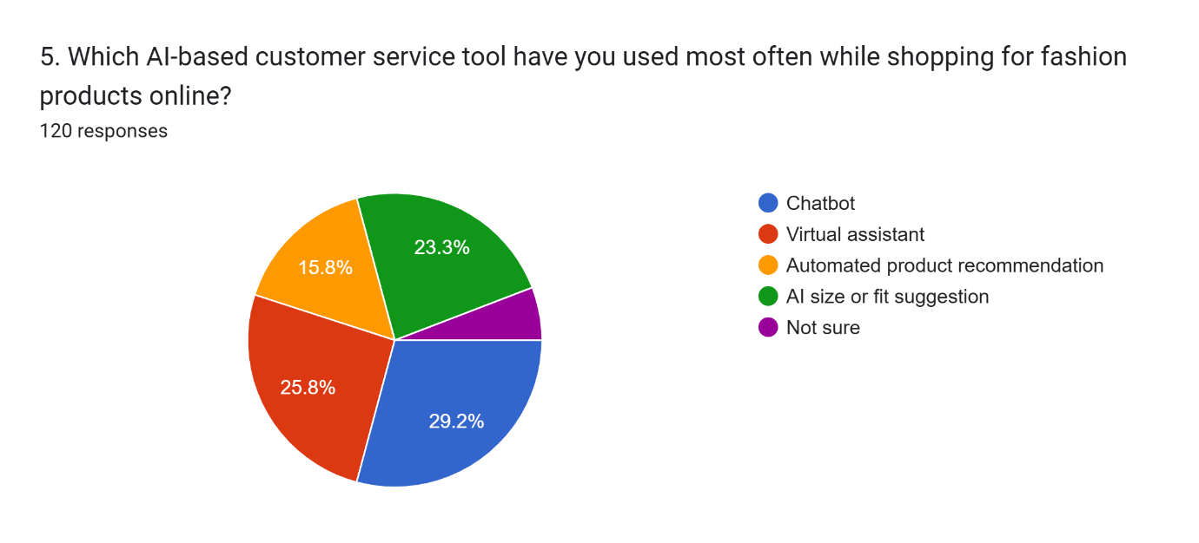
Descriptive Questions
DV: Customer Satisfaction
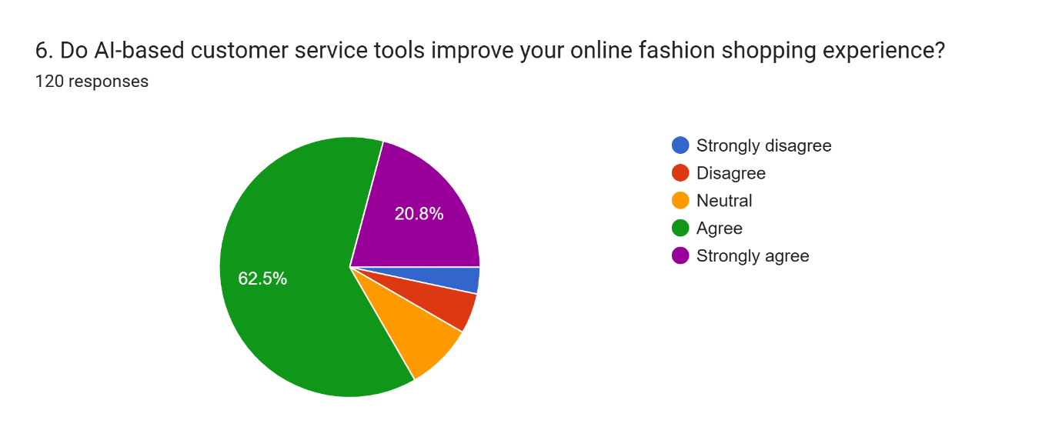
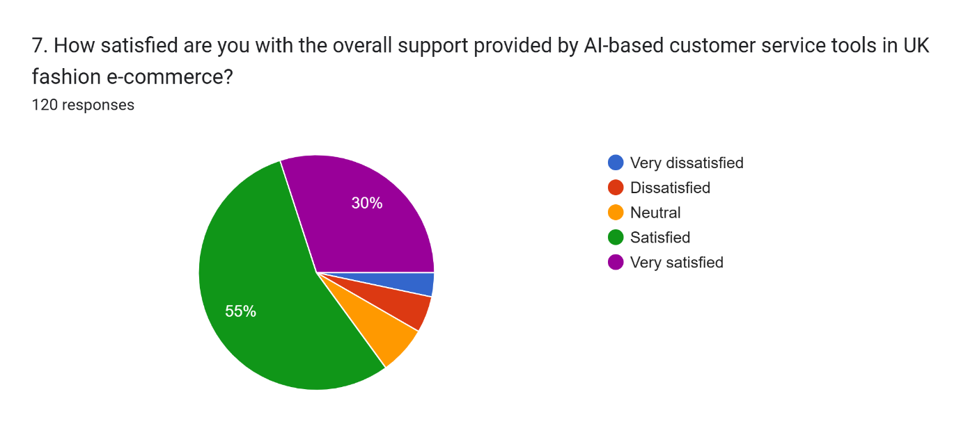
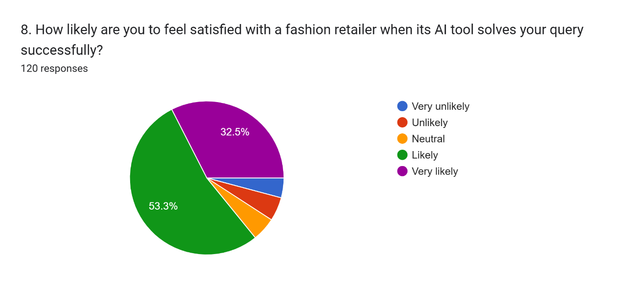
IV1: Perceived usefulness
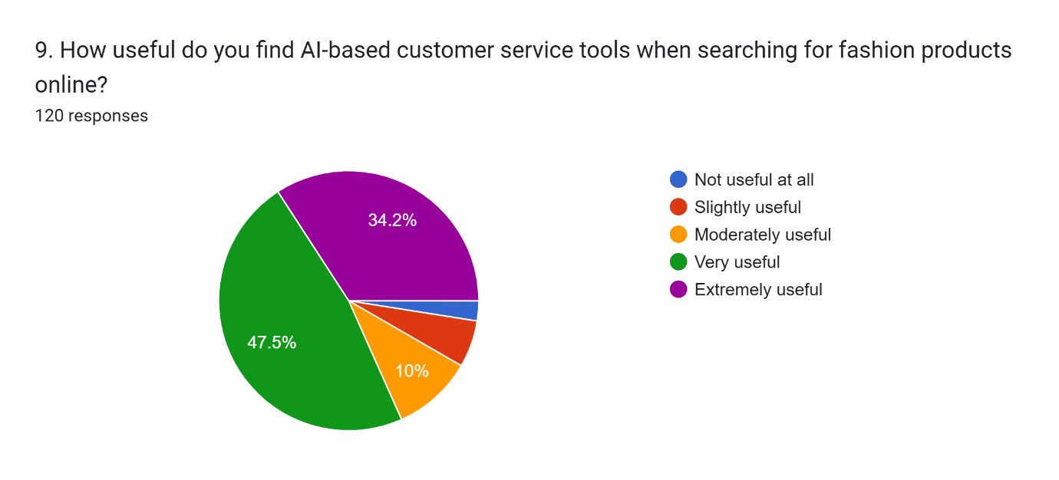
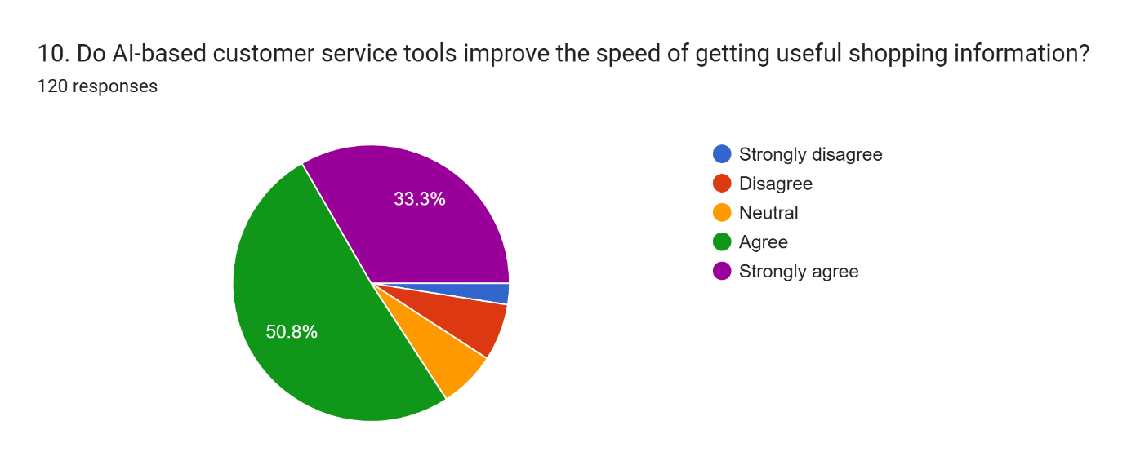
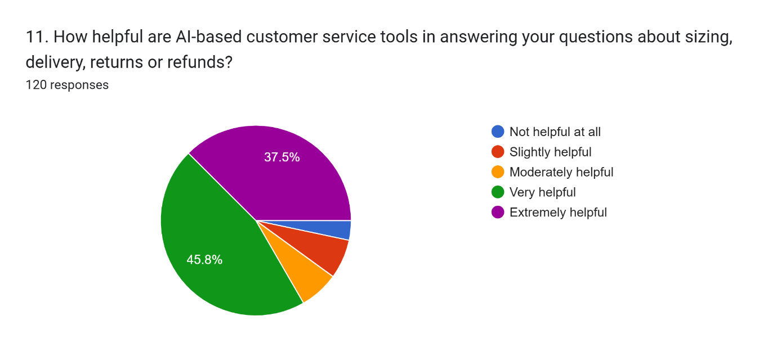
IV2: Ease of use
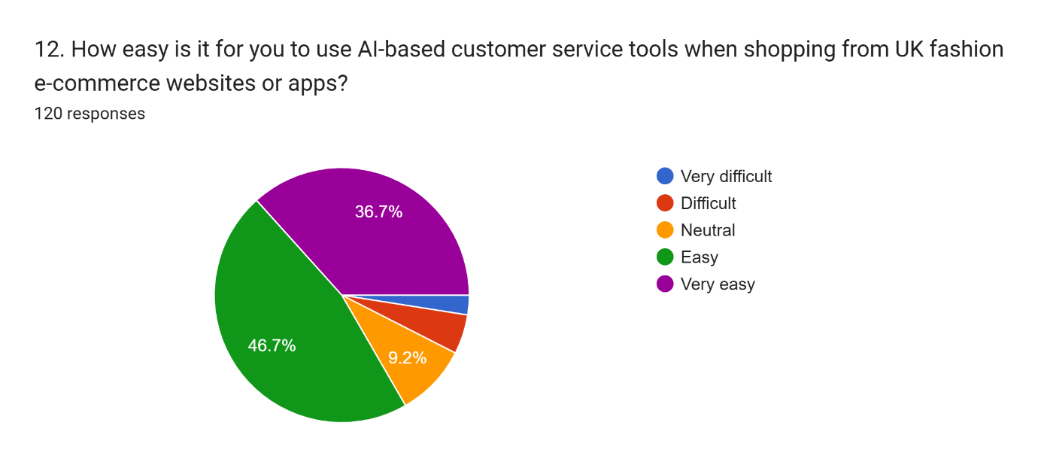
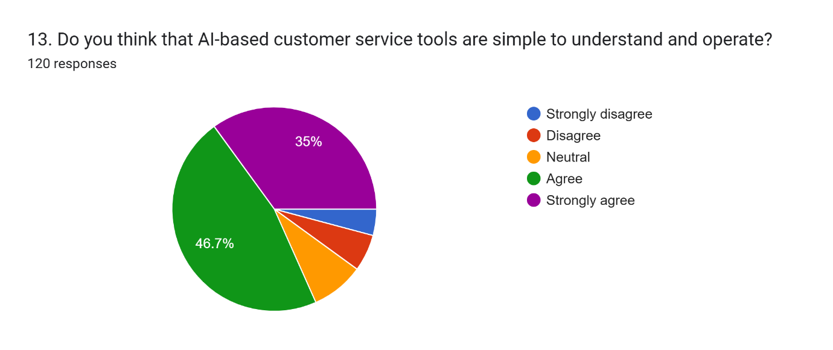
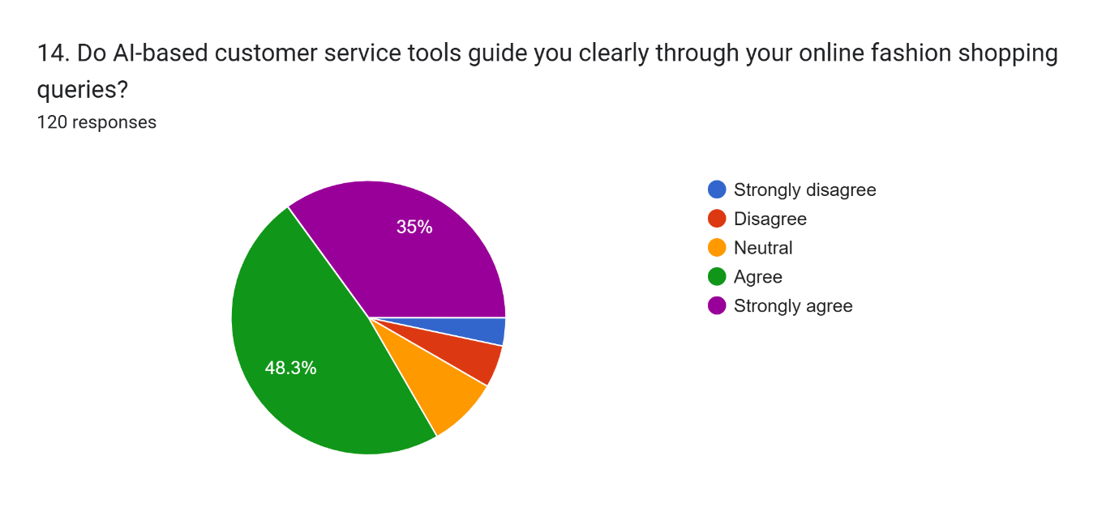
IV3: Responsiveness
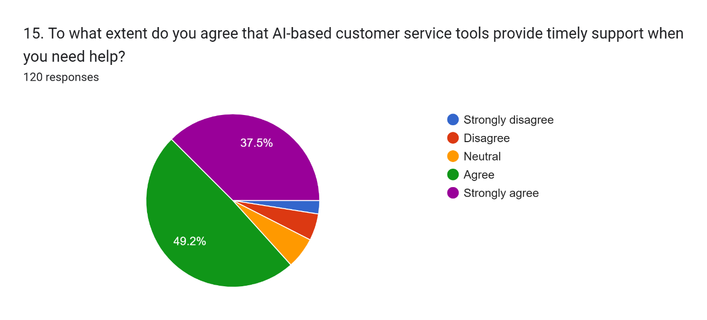
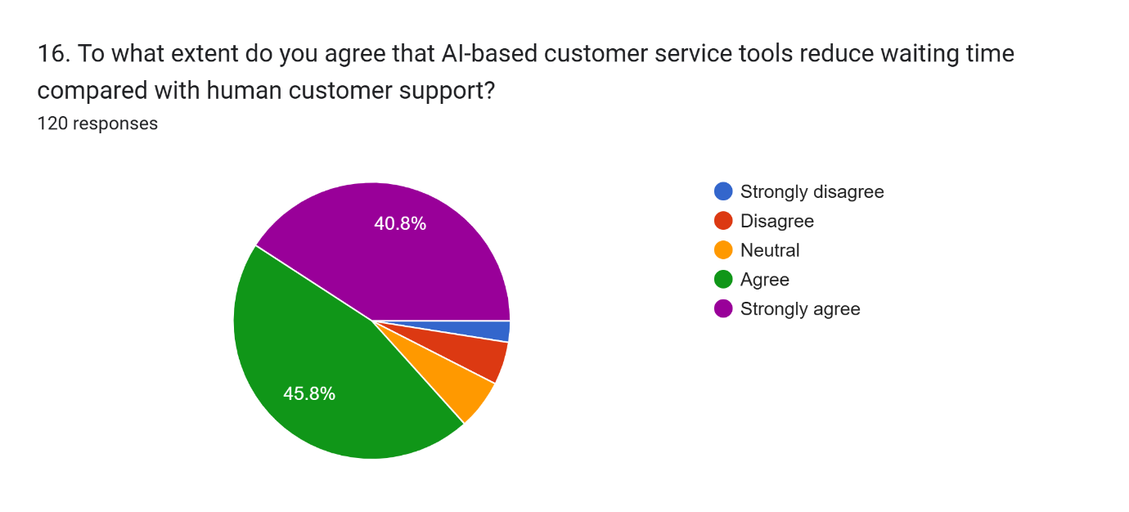
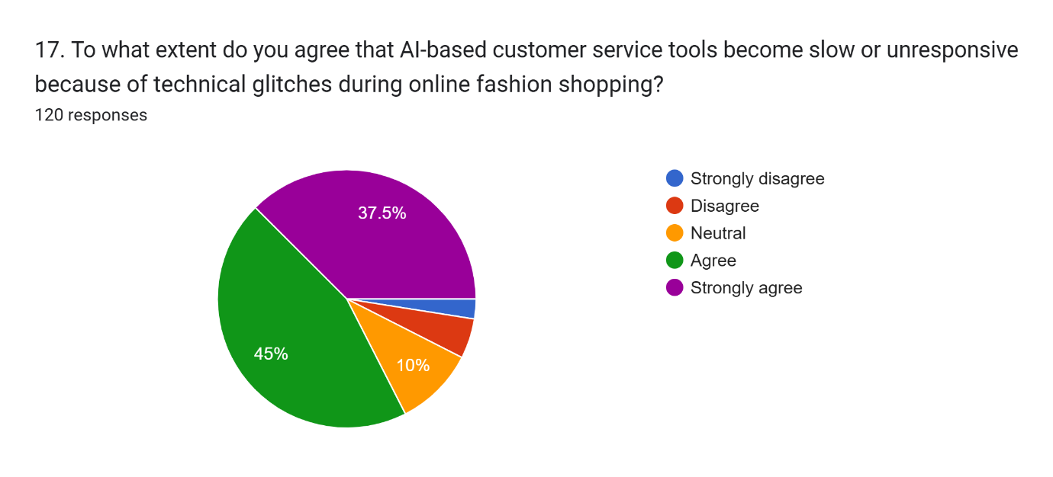
IV4: Level of trust and empathy
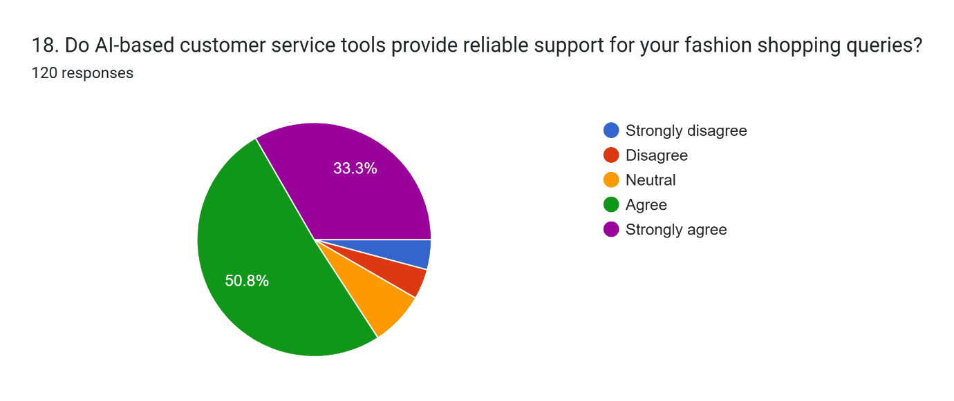
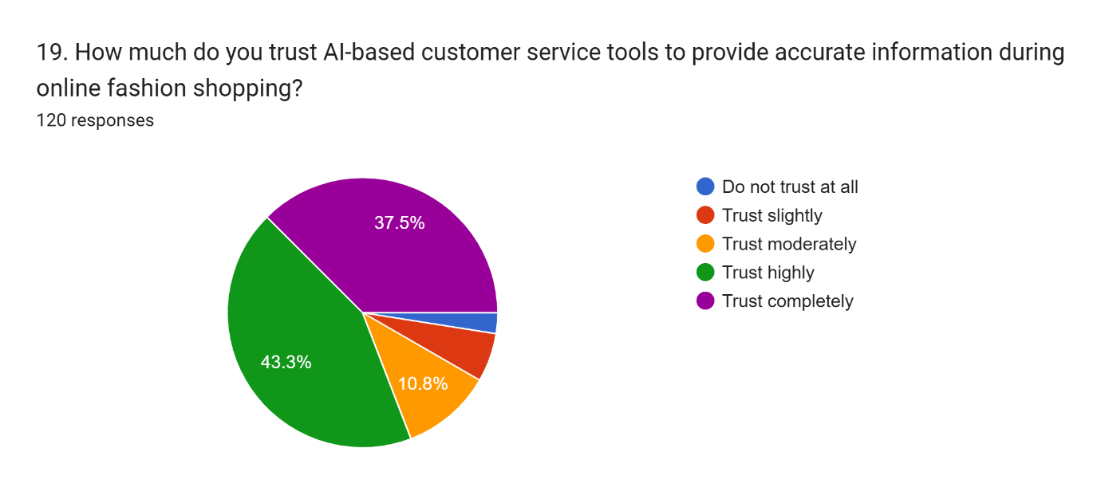
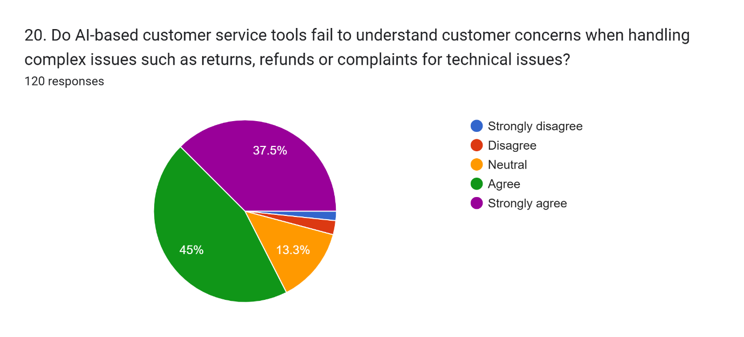

Appendix 3: Survey Link
https://forms.gle/Y2vAPCWAtfuZQsoE9

Appendix 4: Survey Dataset Excel Sheet
(Double click to open)

