

Power Train & sustainability: Drive cycle study
Thomas Sykes
School of Engineering
University of wales Trinity Saint David
P147408


March 23, 2020

Contents
1. Introduction 2
2. Trask 1 & 2 3
Channels for distance Validation/calculation 3
2.1. Road slope 7
2.2. Rolling Resistance 8
2.2.1. Coefficient of rolling resistance 8
2.2. Aerodynamic Drag Force 9
2.3. Inertial force 11
2.4. Power 12
2.5. Task 1 & 2 Conclusion 14
3. Task 3 14
3.1. KERS 14
3.2. Alternative fuel 16
4. Task 4 18
References 20

Introduction

For this assignment the author was tasked with the analysis of 3 data sets provided from various sensors such as aux and OBD2 sensor over a daily 30km drive cycle of 3 different vehicles of different configurations.
These vehicles include a 2016 Toyota 1.0L petrol, 2016 Volvo V40 D2 diesel and a 2011 800cc petrol Tiger XC, these vehicles vary censurably in size and driveability, but all demonstrate the same fuel economy of 50.MGP across the 30km recorded distance.
This study will aim to analyse and normalise the data on its typical drive to work ‘drive cycle’ to determine the validity of the data channels through comparison with the aim of determining benefits and draw backs of each vehicle compared to the other vehicle configurations.

vehicle specifications
Table 1 Aygo vehicle specifications

(Handbook, 2011)

The basic specifications for each vehicle were given such as well as researched for further specifications (see Table 1 Aygo vehicle specifications & ………… in appendix) , these crucial specifications needed for the validation of data and calculation of further data include mass, fuel economy, frontal areas for drag and tire pressure for the calculations of rolling resistance.

Trask 1 & 2

Task 1 asks that the author process the raw data from its given format (CSV) into a usable Excel format and determine the unreliable data and the useable data for example the use of the time channel cannot be used as that it starts as soon as the ignition starts and therefore will not a constant for each data set as there is a different amount of time taken between engine start and actual start of journey
The author determined that channels generated per timeframe had to much questionability as to normalising with other data channels and there for unwanted. Other channels such as unrecorded columns with no data were also removed, calculated channels for power and toque were discounted due to the incorrect fuel density values set for the Volvo as well as the displacement channels also no being accurate for tiger and therefore had no viable comparison channels.
The final channels saved for further calculation and validation of calculated data include:
Channels for distance Validation/calculation:
- Delta Frame time
- Calc. Distance Km
Channels for positional/ rout analysis and validation:
- GPS Altitude (AUX)
- GPS Latitude (AUX)
- GPS Longitude (AUX)
- GPS Roll (AUX)
- GPS Pitch (AUX)
Channels for Velocity
- SAE Speed Km/h
- SAE RPM Engine Speed
With these channels the author was able to validate and calculated channels for speed and acceleration per meter as well as being able to Map the location and angle of slop the vehicle in question travels along using the Longitude and latitude inputs along with pitch and roll for road slope.
The SAE. Km/h channel was gathered by the OBD2 (internal sensors) and was used to calculate the speed of the vehicle in Meters per second, with this data and the time per frame the distance can be calculated per meter via:
$$Distance=V*t$$
With the calculated distance in Km plotted against the CALC. Distance since last refuel channel to determine similarity as seen in Figure 1 Distance per frame comparison.

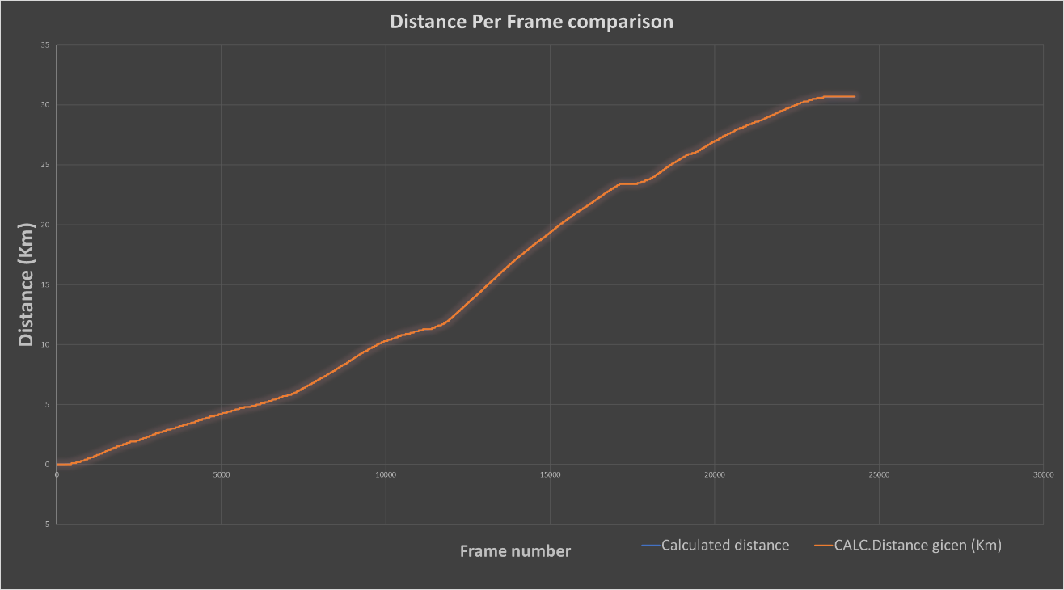
Figure 1 Distance per frame comparison
As the maximum distance for each vehicle falls within a minimum of 2.3% inaccuracy of googles prediction of the distance of the route travelled, as seen in Figure 2 Google maps Route distance prediction & Table 2 accuracy of distance Travelled compared to google maps predictions.
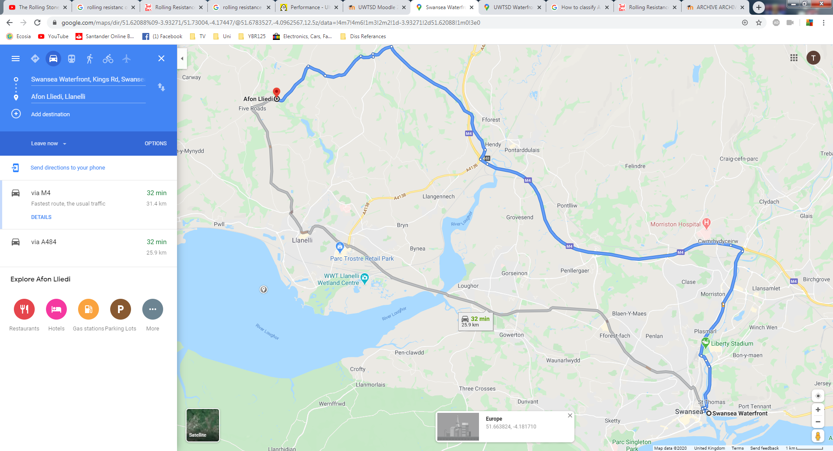
Figure 2 Google maps Route distance prediction
Table 2 accuracy of distance Travelled compared to google maps predictions
The rout taken was predicted by using the initial and final longitude and Latitude values provided which determined the most likely route on google.
With the validity of the start point and end point being Dr Williams’s home near Llanelli to the Technium facility at Swansea waterfront and UWTSD waterfront campus for the Triumph the, author plotted the latitude against longitude and overlaid the plotted data onto the google maps image of the rout taken as seen in Figure 3 Mapping of the journey.

It is worth noting that the Triumph’s distance travelled is increase due to it being kept at the rear of the probity.

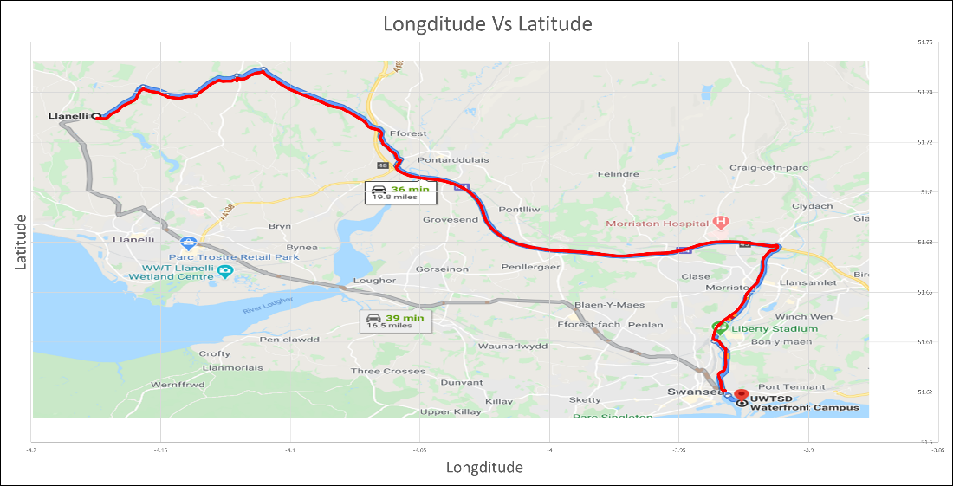
Figure 3 Mapping of the journey

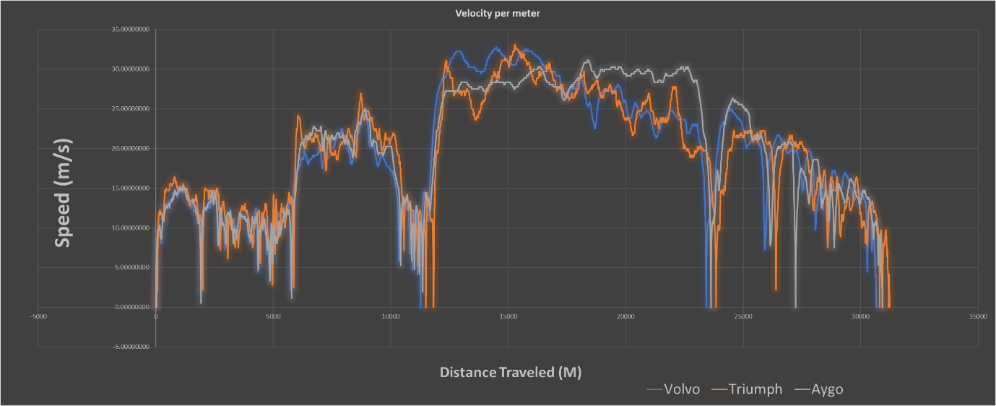
Figure 4 Velocity of each vehicle comparison

Figure 4 Velocity of each vehicle comparison shows the comparative speeds in meters per second across the journey which demonstrates a similar pattern at the same scale therefore the author determined this data can be used for further analysis.

With the distance, speed, longitude and latitude validated the author was then able to go on and calculate the forces acting on the vehicle during its drive cycle such as:
Calculated Channels
- Acceleration (m/s²) = $(V2-V1)$
- Road slope
- Kinetic Energy
- Rolling resistance
- Aerodynamic Drag
- Inertia of vehicle
- Resistive forces
- Power used (Kw)

2.1. Road slope

The author researched a method of using pitch and Roll to determine the angle at which the vehicle sits can be determined (road slope) a paper from the university of Tennessee demonstrated a formula to achieve this where pits is Represented by (Alpha) and roll by (Betta) expressed via:
$Cos θ=\sqrt{\frac{1}{(1+\tan^{2}α+\tan^{2}β}}$ (R.N Barbosa, 2012)
Due to the lack of lean angle data for the triumph the author was unable to use this formula to determine the Road slope angle however an average of the Aygo and Volvo results were used as a reasonable value.
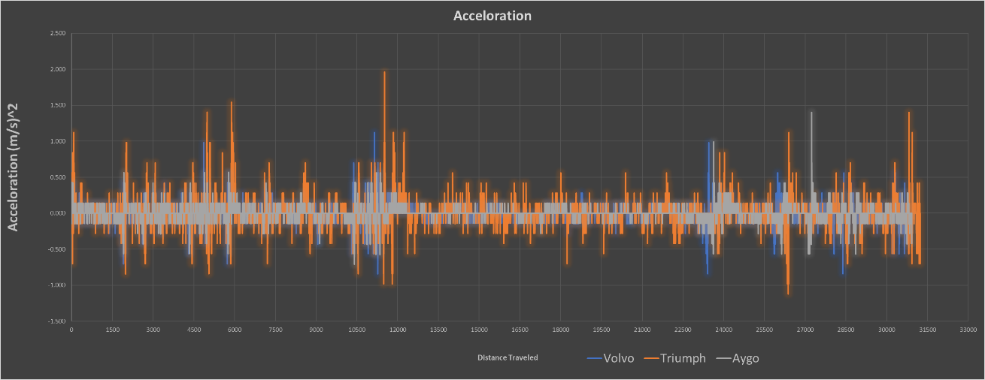
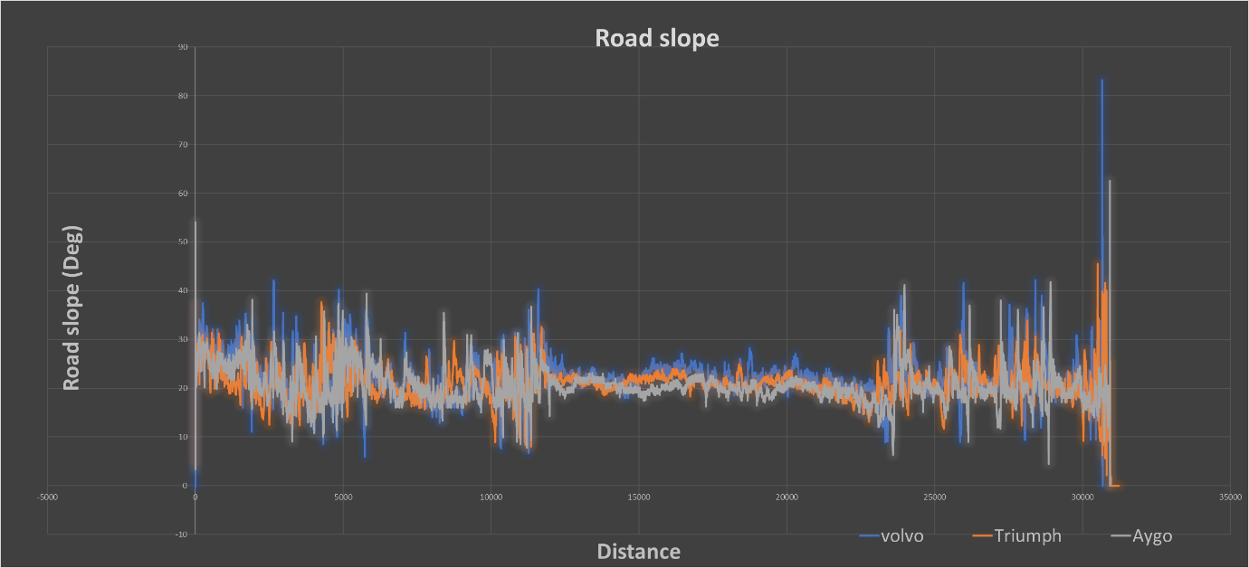
It is worth noting that the large oscillations in the longitude and latitude data is due to the aux input being a mobile app on the driver’s person therefore the movement of the device will not be perfect and therefore the slope angles are unreliable however assumed to be accurate enough to provide comparable results see Figure 5 Road slope comparison.
Figure 5 Acceleration per meter Comparison
Figure 6 Road slope comparison

Rolling Resistance

To determine the accumulative resistive forces acting on the vehicle the author aimed to determine the roiling resistance of the vehicle due to its mass.

Coefficient of rolling resistance

To determine the rolling resistance based on the mass of the vehicle a formula was Researched for rolling resistance coefficient using tire pressure the formula is expressed via:
$C=0.005++\left(\frac{1}{tire pressure}\right)*(0.01+0.0095*(\frac{V}{1000})^2$ (The Engineering toolbox, 2008)

Where:
C = Rolling resistance coefficient
Fr = Rolling Friction
G = Gravity (9.81 M/s^2)
W = Vehicle Weight

with the rolling resistance coefficient calculated the author was able to use a further calculation Expressed as:
$$Fr=C*W*G*cos⁡(θ)$$
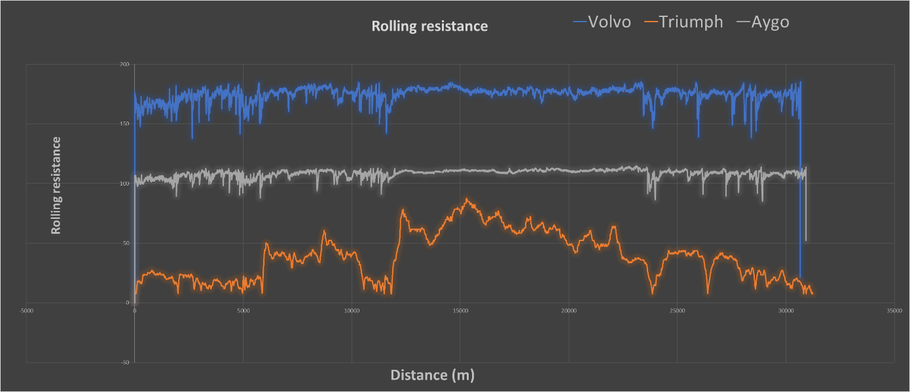
With this formula the author was able to generate comparable results for the rolling resistance of the vehicle as seen in Figure 7 Rolling resistance comparison it can be seen that
Figure 7 Rolling resistance comparison

Table 3 Tire pressures
Table 4 Similarity of weight & Rolling resistance comparison
Table 4 , Table 3 & Figure 7 Rolling resistance comparison demonstrate the effects of varying tire pressures on rolling resistance, as can be seen the tiger has the lowest rolling resistance this is to be expected due to less wheels contacting the road, however the trend demonstrates with increased mass the rolling resistance also increases.
It can also be seen that with increased tire pressure the rolling resistance is decreased (see this leads the author to assume that this formula accounts for defamation of the tire under a weight which increases the surface area contacting the road increasing the rolling resistance.
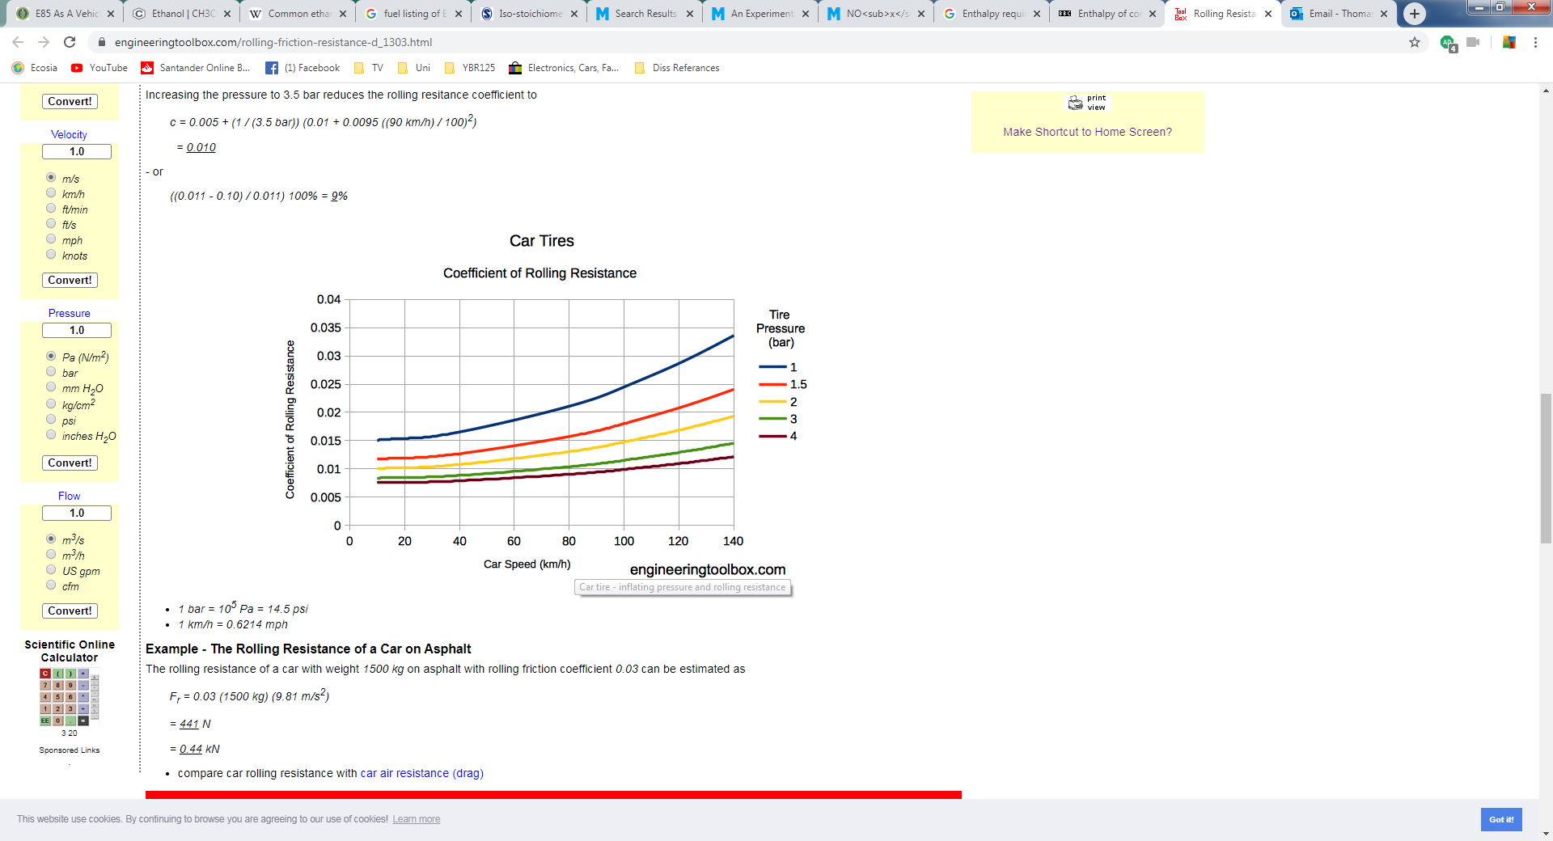
Figure 8 Increase of coefficient of friction with tire pressure
(The Engineering toolbox, 2008)

Aerodynamic Drag Force

Further resisting forces calculated included aerodynamic drag which can be calculated as a product of frontal area (85% of which is effective) of the vehicle and velocity.
This was calculated via:
$$Drag force=0.5*CdA*ρ*V^2$$

Where:
- CdA $= Coefficient of Drag *(Height*Width*Effectice Area)$
- $ρ$ = air density

- The values of which can be seen in Table 1, Figure 16 Triumph specifications & Figure 17 Volvo specifications In the appendix

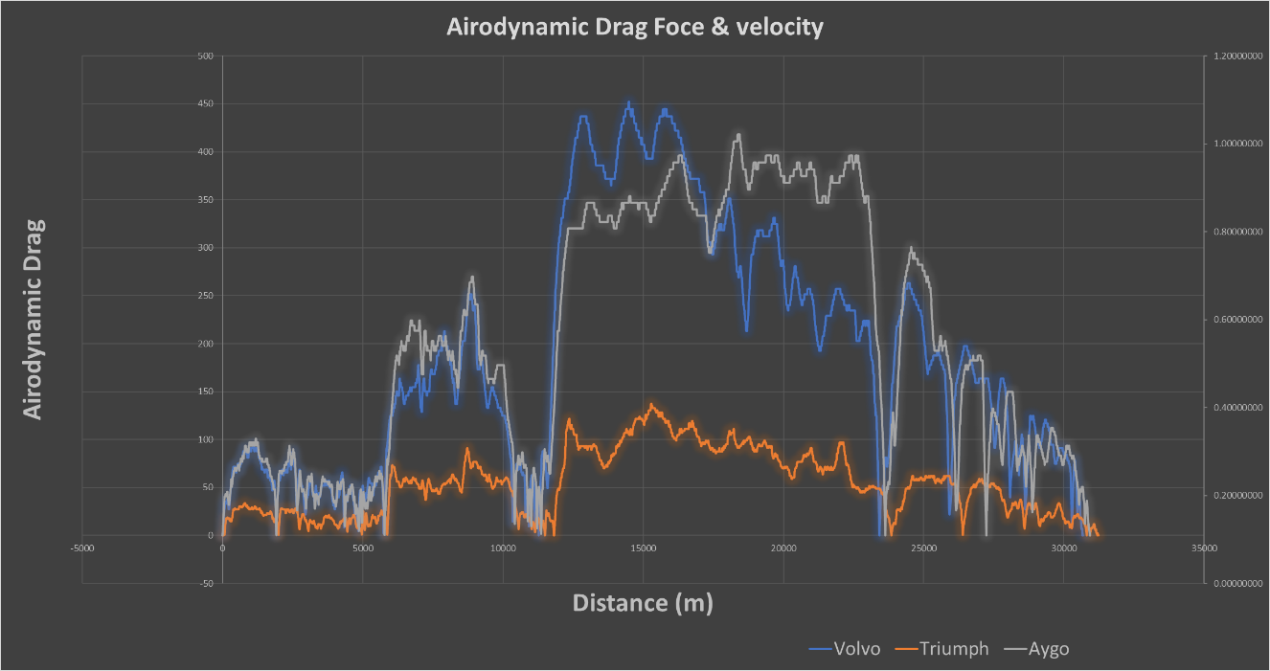
Figure 9 Aerodynamic Drag force comparison shows the resistive forces from air on each vehicle as the author would expect the trend shown where the two card demonstrate similar values for resistance where as the triumph has considerably less drag force from frontal area due the considerably smaller size compared to the Volvo and Aygo.
Figure 9 Aerodynamic Drag force comparison
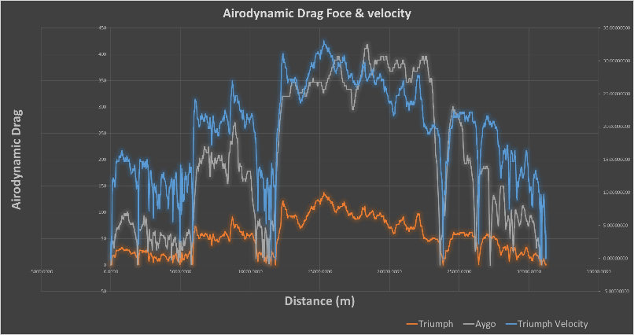
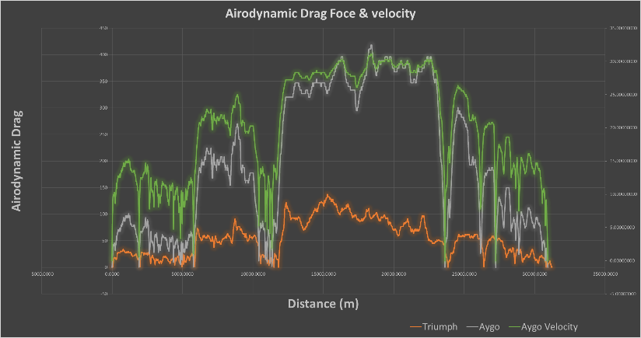
It is worth noting that the drag force is also directly effected by velocity as well as frontal area and as can be seen in Figure 4 Velocity of each vehicle comparison the velocity of the Volvo is on average slightly higher than the Aygo which accounts for the slightly higher drag forces on the Volvo as well as the larger frontal area see Figure 10 Relationship between Velocity and Aerodynamic Drag.
Figure 10 Relationship between Velocity and Aerodynamic Drag

It is worth noting that these calculations don’t account for wind speed acting against the vehicle due to weather conditions for example the author doubts the Triumph will be used is weather of high winds whereas the other vehicle likely would be however the author lacks this information, this throw some doubt into the accuracy of the drag force, however the data is assumed to be accurate enough for comparison between vehicles.

Inertial force

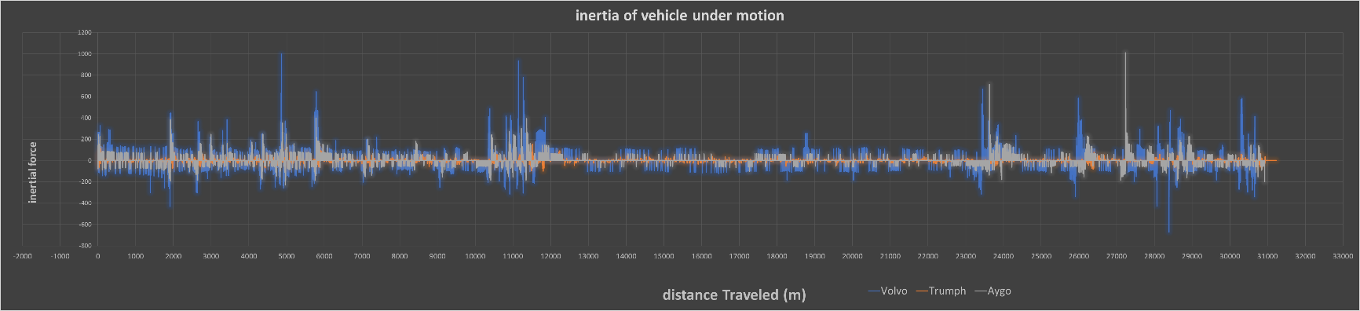
The final force determined to find a reasonable value of resistive force for each vehicle was the inertia of the vehicle from motion, calculated from:
Figure 11 Inertial force Comparison
$Inertia from motion=M*α*\cos{θ}$

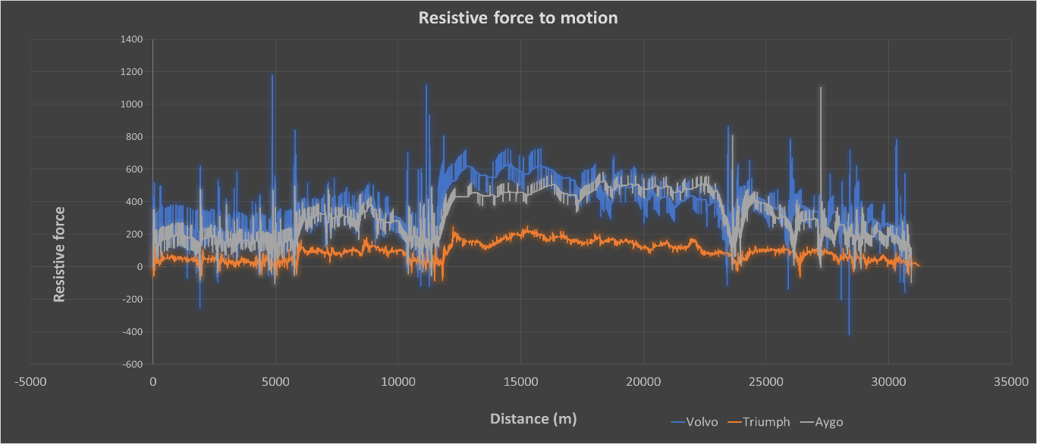
With the inertial force calculated the total resistive forces to motion of each vehicle can be determined by accumulating the forces of rolling resistance, Drag and inertial force as seen in Figure 12 Total resistive force to motion.
Figure 12 Total resistive force to motion
Figure 12 shows the difference in resistive force form each vehicle across its journey as can be seen the Volvo has the largest resistance to motion which is to be expected due to the increased size compared to the other vehicle configurations as well as increased mass, followed by the Aygo hatchback which is over a smaller size and mass.
The engine size is proportional to the design of the vehicle for example the Volvo is an estate luxury car deigned for comfort and therefore would require a larger design and therefore has greater resistance which requires more force to move prompting the need for larger, whereas the Aygo is designed for commuting and efficiency representing a smaller more compact design leading to the need for smaller engine sixes due to decreased mass and drag.
Table 5 Resistive forces comparison

Power

One of the main comparisons was for the power used throughout the journey as seen in Figure 13 Power used across the drive cycle as can be seen the power by the Volvo is considerably more than the triumph and the Aygo which is expected due to the additional resisting force, the Triumph however produces marginally less power across the journey compared to the Aygo which is surprising due to the reduced resisting forces and reduced mass of the vehicle it would be expected that in would take considerably less power to move the Triumph the same distance.
With this it can been seen as that considering the velocity of the Triumph no exceeding that of the other vehicles in most areas (see Figure 4 ) the power must be used in the more aggressive acceleration seen in Figure 5 Acceleration per meter Comparison which shows that the oscillation of acceleration is much greater and this must be a contributary factor, this however wouldn’t account for the entire power usage.
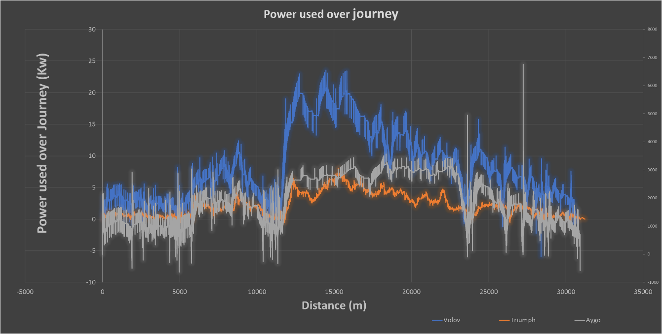
Figure 13 Power used across the drive cycle
The power results were calculated through two methods to determine the validity of the results one of which calculates the Angular power (at the wheel) and linear power needed to overcome resistive forces.
$$Power needed to overcome Resistance=\frac{Resistive force*Velocity}{1000}$$

$Angular Power=\frac{((\frac{Velocity}{Rolling Radius})*Wheel Torque)}{1000}$

where wheel torque us a product of resistive forces multiplied by Rolling radius of the wheel which is determined via:
$$Rolling Radius=\frac{\left(\frac{Wheel diamiter}{2}\right)+\left(tire width*aspect ratio\right)0.8}{1000}$$

with this the torque at the wheel can be calculated via:
$$Angular power=Resistive forces*(\frac{Rolling radius}{1000})$$
With these comparable results were able to be calculated for accuracy due to the separate power values being calculated from different methods but should produce identical results.
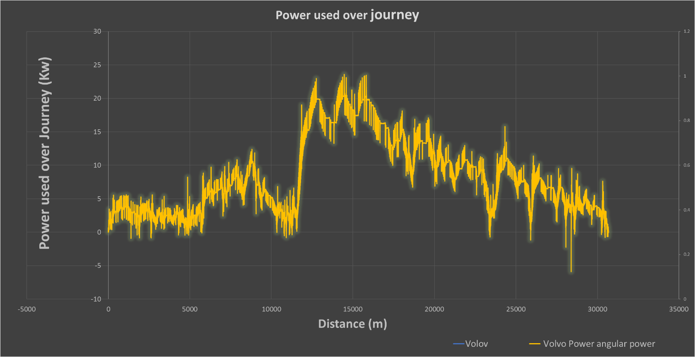
Figure 14 Power Validation

Figure 14 Power Validation demonstrates the power channels plotted against each other to demonstrate accuracy of results. Table 14 shows the % of accuracy between linear and angular power where the values for the Aygo are inaccurate believed to be an error in data.

Task 1 & 2 Conclusion

The author determined that at 50MPg the lest efficient out of the 3 vehicles due to the fact that although it has less of a weight its use it produced a minimum of 71% less power than the other vehicle

Task 3

Task 3 asks that the author use The AUX.GPS Data as the basis of the 60Km and the results of task 1 & 2 to model and ‘ideal’ Vehicle for the journey in both directions using one of the studied vehicles as a start point. The author was then tasked with looking at a range of Technologies that would improve the drive cycle with respect to rang extending, economy and efficiency.
The author decided to study the Volvo due to it having the most reliable and consistent data, the author also decided to use the same specifications of vehicle size and mass for the purpose of this task as the author would be unable to approximate the space requirements and additional mass of some additional components

3.1. KERS

Kinetic Energy Recovery systems is described as range extending technologies where kinetic energy from braking with the ability to convert the energy into propulsion power. According to a paper found by the author KERS is based on storing recovered energy in various forms such as the chosen method of using the Energy regained to spin up a flywheel to up to 60,000Rpm which allows for an energy recovery of up to 70% of the vehicles Kinetic energy. Due to the laws of perpetual motion this energy cannot be stored permanently due to frictional losses, to reduce these losses the flywheel is put in a vacuum as well as on Magnetic Bearings to reduce drag from air and friction form contacting forces. (Italian National Research Council (CNR), 2019) (Magnus Hedlund *, 1996)

The author was able to research the Volvo specifications for their Hybrid Drive system for the Flywheel KERS system as seen in Table 6 Vacuumed Flywheel KERS system specifications
Table 6 Vacuumed Flywheel KERS system specifications, (Howard, 2013)
R1
R2

From Research documents found on Regenerative Braking the author was able to determine the calculations needed to determine the moment of inertia of the fly wheel using formula ……..
$$Moment of inertia \left(J\right)= \frac{1}{2}*M*({r1}^{2}-{r2}^{2})$$
With moment of inertia of the fly wheel that author was able to determine the Maximum capacity of energy the Fly wheel can store.
$$KE able to be stored=0.5*Moment of inertia*radians per second^2$$
Table 7 Maximum storable energy by the Fly wheel

As the name suggests Regenerative braking can store up to 70% of kinetic energy when braking therefor the author determined the Kinetic energy generated by the vehicle via:
$$KE of Vehicle= \frac{1}{2}*M*V^{2}$$
(Boretti, 2010)
with the analysis of KERS systems Energy is only stored during braking therefore the author determined that a deceleration of 0.3 M/s² due to this being the most reoccurring value in the data it is assumed this is the deceleration rate when coasting.
With this assumption 70% of the kinetic energy under deceleration of more than 0.3 m/s2 was calculated to determine the recoverable energy across the journey
Table 8 Energy used and Energy Recovered

From calculation specified in 3.1. KERS the author was able to determine that with the claims of 70% efficiency of their system made by Volvo the KERS system of a Vacuumed Fly wheel recovers enough energy that only 2.6% of the energy recovered is equal to the energy required used across the cycle see .

Alternative fuel

The author decided to look at the viability of using alternative fuels by using the fuel calculator from the previous power train and sustainability Assignment to determine the CO2 produced Per Kg of fuel. The chosen fuel was a 15% iso-octane and 85% ethanol.
To determine the additional mass of fuel and CO2 output per Kg of the Ethanol Blend compared to that of the Volvos diesel engine a ratio between the calorific value of the fuel was generated to determine the additional molar density per kg required to produce the same calorific value as diesel, this can be achieved through turbo charging the cylinders which increases the density or air which will in turn increase the calorific value as desired.
$$Ratio of calorific value=\frac{Calorific value of Diesel}{Calorific value of Ethanol blend}$$

$$New calorifica value=Ratio of calorific values*Origional LHV$$

$Mass of fuel Per kmol to achieve the same calorific value=\frac{New LHV}{Net enthalpy of Methanol Blend}$
See
Table 9 Calculated Required Mass of Fuel and LHV to meet same energy output of diesel
The results found from this study determined that ethanol blend study produced 0.014% more CO2 molecules per Kg of fuel.
Table 10 % of change in pollution output

As can be seen in Table 10, % of change in pollution output with marginally more CO2 output the N2 molecules produced is decreased by 68.7% this is a significant improvement on the emotions of the vehicle across the journey as long as the flame temperatures can be maintained to current standards there is less N2 to dissociate in Nox emotions however study’s into high ethanol fuels demonstrate that temperatures are increased particularly if turbo charging occurs which increases pressure and therefore temperature, therefor the amount of Nox produced is uncertain however indications lead to the suggestion it is more economical when considering N2 emissions.
Figure 15 Emissions Results for diesel and ethanol blend

Task 4

Task 4 asks that the author assume the position of a technical director of a company and to determine the specifications of vehicle the company should pursue with consideration of economical and politically viable solutions with regards to 2028 vehicle specifications.
The author determined in the position of a technical director considering the guidelines for 2028 to attempt to reduce emissions and make current ICE engines obsolete, whether this means that all fuels currently used will no longer be able to be used or just petrol and diesel, with this in consideration the author advised that the company would be best suited to developing would be an electrical hybrid using the studied ethanol fuel in Task 3, as well as the application of KERS systems.
With the data gathered in section 3.1. KERS the energy recovered over the journey the vehicle can be fully powered once the journey is underway therefore a hybrid system would be ideal due to the fact that if a downsized engine was developed using the ethanol & iso-octane the N2 emissions would be decreased 68.9%, bearing in mind that with the amount of Energy recovered used in 2.6% therefor the amount of energy should be well within the ranges of charging an EV vehicle with the ICE engine providing support if necessary and for initial power generation.
Benefits found for adaptation of an iso-octane & ethanol Blend is that the mass of the fuel is reduces by 71% assuming the same quantity of fuel is stored on the vehicle however with the Electrical motors of the KERS system doing the majority of work through the use of recovered energy.

With the KERS system return motors being the main drive system the fuel capacity could be reduced further for weight conservation, with all this reduced mass resistive forces can be significantly decreased increasing Power to weight ratios increasing performance as well as efficiency
Table 11 CO2 & H2 emissions

Table 11 CO2 & H2 emissions demonstrates the 68% reduction of N2 output which with further validation of combustion characteristics to determine flame temperatures for dissociation of NOx emissions could yield a great step toward meeting 2028 Euro Emissions regulations as well as possibly UK Recent Uk emotion regulation announcement Depending on the determination of ‘Current’ ICE engines and hybrids.
Table 12 % of increase in CO2 per Kg of fuel used

The increase in CO2 seen in Table 12 is so negligible that it would still fall within emotions regulations with the use of engine technology’s such as EGR these values are in consideration of the additional fuel needed to produce the same amount of energy from the reaction the fore with the use of significantly more fuel the Co2 output remains near identical.
With the use of the blended fuel, modifications to existing ICE engines needed would be minimal reducing the cost for redevelopment of design.
Other Research suggests that other % of ethanol blends can if used on mass or in fleet vehicles:
- reduce Carbon monoxide by 25%
- show 35-46% reduction in greenhouse Gas emissions and 50-60% reduction in fossil fuel usage
- Rentable fuel source produced from mainly bio waste such as starchy food products by-products reducing Carbon footprint of fuel
(AFV Institute, n.d.)
Negatives of High-ethanol fuels:
- Cold climate worsens cold start however the addition of higher iso-octane content to aid cold start

References
AFV Institute. (n.d.). E85 as a Vehicle Fuel Vehicle Fuel. Retrieved from https://afdc.energy.gov/files/pdfs/e85_driver_training.pdf
Bonde, J. (2014-2020). volovo V40 2016 . Retrieved from car.info: https://www.car.info/en-se/volvo/v40/v40-cross-country-d2-m6-2016-6583115/specs
Boretti, A. (2010). Improvements of Vehicle Fuel Economy Using Mechanical Regenerative Braking. Ballarat: SAE international.
Car.info. (2014-2020). toyota Aygo 2016. Retrieved from https://www.car.info/en-se/toyota/aygo/aygo-5-door-10-vvt-i-m5-2016-6418500/specs
Handbook, T. T. (2011). Retrieved from file:///C:/Users/user/Downloads/Tiger%20800%20Series%20Owners%20Handbook%20%20English.pdf
Howard, B. (2013, April 29th). Volvo hybrid drive: 60,000 rpm flywheel, 25% boost to mpg. ExtremeTech, p. 1.
Italian National Research Council (CNR). (2019). A Feasibility Analysis of an Electric KERS for Internal Combustion Engine Vehicles. SAE international.
Magnus Hedlund *, J. L. (1996). SAE mobulus. Retrieved from file:///C:/Users/user/Downloads/energies-08-10636%20(1).pdf
PubChem. (n.d.). Retrieved from https://pubchem.ncbi.nlm.nih.gov/compound/Ethanol
R.N Barbosa, J. W. (2012). Slope Gradient and Vehicle Attitude Definition Based on Pitch and Roll. 36-37.
sheet, T. u. (2001, october 19th). online document. Retrieved from https://old.moto4.ru/manuals/triumph_tiger800_cheatsheet.pdf
The Engineering toolbox. (2008). The Engineering toolbox - Resources, Tools and Basic Information for Engineering and Design of Technical Applications. Retrieved from The Engineering toolbox: https://www.engineeringtoolbox.com/rolling-friction-resistance-d_1303.html?fbclid=IwAR1YSvpRNZolatYgPRcJq9-EdTOgE7Cl3LaUHYWrGXLCCNP4mamIJfPpysw

Appendix
Figure 16 Triumph specifications

Figure 17 Volvo specifications

