
project manaement and planning in WORKPLACE
Nazrin Karim - 1710333

December 20, 2019
University of Wales Trinity Saint David

Table of Contents
Introduction 2
Main Findings 3
Initiating Phase……………………………………………………………………………………………………………………..3
Planning Phase……….…………………………………………………………………………………………………………….4
Executing Phase…………………………………………………………………………………………………………………….5
Monitoring and Controlling Phase……………….……………………………………………………………..…………7
Closing Phase……………………………………………………………………………………………………………..…………9
Conclusion… 10
Bibliography 11

Introduction

Project management is the practice of five phases to accomplish a project goal according to the criteria within agreed boundaries and timescale (APM, 2019). Putting these phases together signifies the direction a project takes from the beginning to the end, commonly referred to the project ‘’life cycle’’. The project life cycle delivers essential substance of actions that must be accomplished, regardless of the specific work involved (Invensis, 2019). This tool is important to pursue as it gives a transparent understanding of the various phases allowing managers and executives to sustain control of the project more effectively (20/20 Project Management, 2019).
These phases have been utilized by a project team to manage a project for Cardiff Muslim School (CMS), who is a self-funded primary school offering balanced education along with Islamic studies (Khan, 2019). The main aims for this project are to create a school profile and involved a variety of events like fundraising and marketing the school in the local community as a SWOT analysis identified one of the schools’ weaknesses is that people in the community are unaware of CMS which can be a threat as this could mean not enough children leading to closure of the school. Also, a PESTEL analysis, schools must fulfil to Ofsted. According to a recent report, the school is complying to most regulations, but still has areas of development, which is required to meet the education needs of all children (Estyn, 2018). Several tools have been used during the life cycle phases to help in making the CMS project successful.

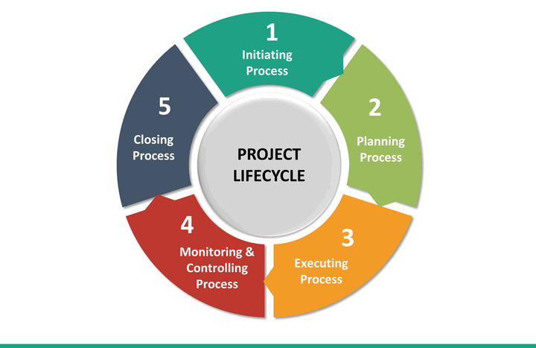

Main Findings

Initiating Phase
This is the starting point where the projects value is measured, the purpose or need is identified and suitable responses to the need is documented with proposed results. Some organisations use this stage to make decisions on whether the project is profitable or beneficial and if not, then this would be the best phase to abandon the project (Villanova University, 2019). There are many tools that can help begin a project.
A quad chart is one of the many tools and is extremely useful as it gives a simple and clear visual outline of a project as well as informative therefore can be useful for a more successful outcome (NC State University, 2013). Divided into parts it defines the main aspects of a project which are the purpose, stakeholders, desired results, secondary benefits and measures of success. Quad charts are applied for a range of planning and communication purposes explain what the project is all about (US Department of Veterans Affairs, 2016). However, according to MindTools (2019), a Project Initiation Document (PID) is more appropriate for projects where you have the resources to write a more comprehensive document as Quad chart is normally simple and may have less detail.
The project team for CMS created a quad chart (below), as this project had many elements and may benefit in a more successful outcome. The quad chart helped the team members clearly identify the aims and objectives giving them clear understanding on what needs to be done to reach the goal. This gave them the opportunity to plan accordingly which is important as good planning is the key to success (Naybour, 2018).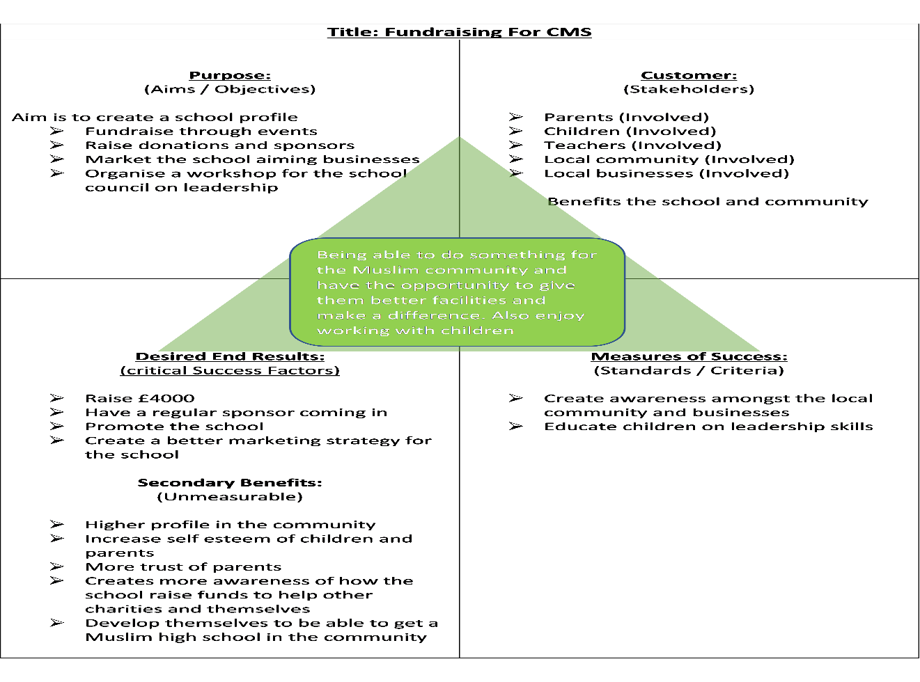
The first box outlines the project purpose which for CMS was to create a school profile. This was to be done through sponsors and donations and different fundraising events during their charity week, such as games or henna tattoos. Another aim was also to organise a workshop for the school council members on leadership. The customers and stakeholders who are involved are the parents, children, teachers and the local community and businesses. The stakeholders who will benefit from this project is the school as more people will be aware of their existence, and the Muslim community, as they benefit from improved facilities at the school for their children going to the school or looking to go to the school in the future. The desired results from this project is to raise £4000 along with a better marketing strategy for the school. The secondary benefits are to raise the school profile and increase the self-esteem of both the children and parents, gaining more trust from them. Also, to develop the school enough to hopefully be able to get a Muslim high school in the community in the future. The measures of success will be when awareness has been created amongst the local community and businesses and to have educated the children on leadership.

Planning Phase
After the project has been approved it moves onto the second phase known as the planning phase. Throughout this phase, with more formal set of plans, the project is broken into smaller tasks with smaller goals ensuring each goal is achievable within the time frame (Lucidchart Team, 2017). Resources required need to be identified and strategies need to be made in an organised manner to deliver them. To ensure the project is successful it is vital to identify the stakeholders who are actively involved and whose involvement and support is essential. They can be individuals and organisations whose interests may be influenced as a result of the project execution (Project Management.com, 2018). To do this project managers use a stakeholder analysis which is an important technique to identify, analyse and prioritise key stakeholders and their needs and interest. A stakeholder analysis also outlines any potential issues, strategies, actions to take and helps review the status. (Thompson, 2019). Although the stakeholder analysis is widely used, some have said that it has a lack of awareness on particular cases of double or even multiple belongings as most individuals are likely to belong in more than one stakeholder group at the same time (Jansson, 2005). For example, a manager is also an employee but can also be a shareholder and an employee are also a member of the community so, even though a stakeholder may be part of an organisational group, they may still be part of other action committees. It has been argued that the breakdown of stakeholder places should be organised in terms of the certain stakeholder role being played at any given time.
The CMS project team used the stakeholder analysis as they felt that it would help them analyse their stakeholders. From this they found that local businesses had a low priority in their project and the level of the local Muslim community was high as they are the ones who are most likely to invest in the school and would be able to spread awareness of the school more easily. It is vital to keep stakeholders updated on the progress regularly, (Bowen, 2019), which is why the team updated their stakeholders in different ways. For example, the school and children had updates through regular meetings and a WhatsApp group, Businesses were visited a few times by the team and other stakeholders such as parents and community were updated through leaflets and letters from the school. Below is the full stakeholder analysis for CMS: -

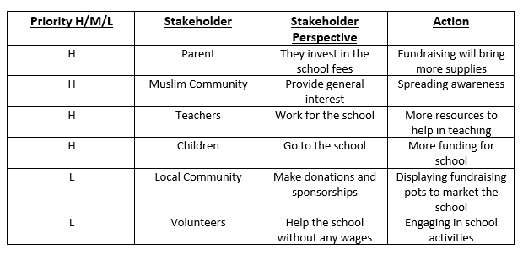

Executing Phase
Once the planning phase is completed it is then time to implement the plans to satisfy the project specification (Watt, 2019). This is normally the longest phase in a project and requires the most energy and resources. In this phase its all about the deliverables and outputs. It is important to have regular meetings to report progress information which is used by the project manager to maintain control over the path of the project by comparing project plans to measure the performance of activities (Method. 2019). Plans should be regularly updated keeping stakeholder updated of status. To ensure that the project is organised into manageable sections, it is important to use a Work Breakdown Structure (WBS). This gives a visual structure of project activities and deliverables (Cohen, 2018). This is done by breaking down the project into smaller manageable groups. WBS is a perfect tool for projects that involve several steps and stakeholders (Lynn, 2019). Benefits of using a WBS include a project schedule and budget by allocating time and cost to specific sections, identify potential risks and if a project is falling behind, referring to the WBS will help detect the main deliverables impacted (Workbreakdownstructure.com, 2019).
There are two ways to create a WBS, bottoms – up which involves team members brainstorming all lower level tasks that need to be completed. All the tasks are then logically grouped into categories to make up work packages. Although it gives a more detailed schedule, this approach is more time consuming (Maker, 2018). This approach is good to use for unfamiliar projects where team members are new techniques and approaches but Project-management.com (2018), do not recommend this approach unless it is being created by a team of experts who have knowledge on the project and its tasks as nearly always more than a few tasks are carelessly lost because team members are not knowledgeable all parts of the project.
The second way is the top -down approach which is better suited for projects who the team are more familiar with is known to be more precise as its starts with the project goal or final deliverable at the top which is then broken down into lower level tasks. This continues to move down until the tasks have touched a level where they can be accurately identified and estimated and split between team members. According to Project-management.com (2018) this approach is more common than the bottom-up approach as it identifies major tasks quickly and is more logical. However, Maker (2018), argues that in this approach although the tasks are quickly identified they are later refined by the project team, details maybe missed without a proper review by the project team.
The project management team of CMS decided to use the bottoms -up approach WBS. The team felt that this approach helped through the project as the method to breakdown the tasks made it easier for the team to assign tasks and focus on the deliverables. WBS provides a high level of visibility, (Lynn, 2019), and this helped have better communication with stakeholders and team members and track progress during the project. The CMS Project has outlined five lower level deliverables to reach the project goal. The full WBS is as below: -

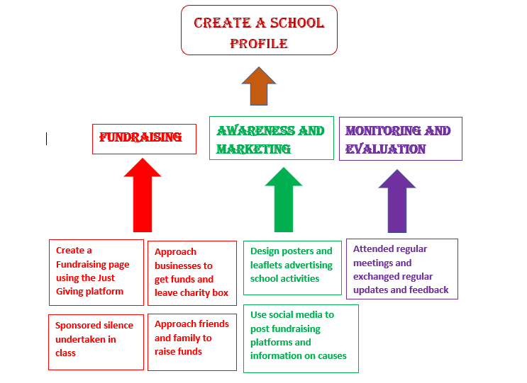
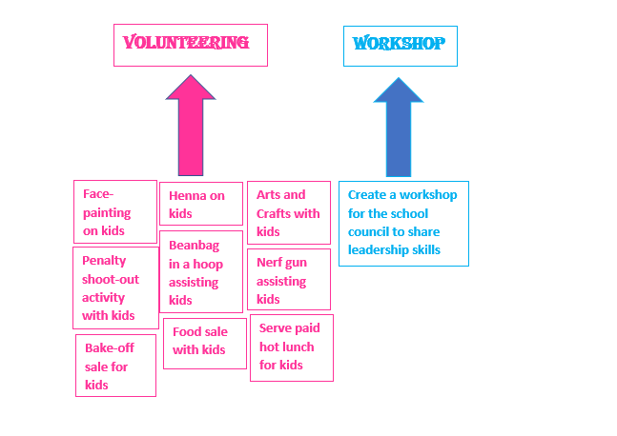

Monitoring and controlling
The fourth phase of the project life cycle where most of the responsibility falls on the project manager. This stage involves tracking the performance of the project with planned project management activities (Grey Campus, 2019). The monitoring phase tends to be applied throughout the execution phase. During the execution the project should be regularly monitored. This ensures the project is progressing. It is vital to manage the triple constraint. Meaning tasks are completing in accordance to the set time scale. (Office Timeline, 2017), to ensure the project is undertaken inside cost approved and quality is always maintained (Office Timeline, 2017). This process can also be known as the Iron Triangle, a model which expresses the time, cost and quality of the project. Each constraint is attached and changing one point will affect the other two. Using the iron triangle can help in decision making and identify and modify concerns before they develop into complications leading to a successful completion (Westland, 2018).
The CMS project came across some impacts on the three Constraints. One of their tasks involved a henna tattoo for the children. Several designs were printed in order to ensure quality designs which occurred costs for paper and ink. However, this caused time delays as the children were taking too long to choose designs and queues started building.

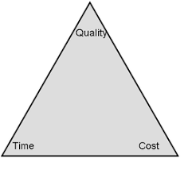

This monitoring and controlling phase also require comparing actual accomplishments with anticipated performances and taking corrective action to produce the desired result (Coventry University, 2019). It is important to make sure that the project progresses with minimum risks and risks that are identified should be handled accordingly. However, without a proper structure of a framework on risk management, this will be unsuccessful (Lavanya & Malarvizhi, 2008). Applying the risk analysis framework which can managing a project by analysing, identifying, and controlling any potential risks. However according to Brady, (2019), not all risks are identified and when a fault is found it is not always possible to identify all the causes therefore complete mitigation not always possible. A risk analysis should include a list of possible risks, the impact it may have, an action plan to resolve the risk, frequent review throughout the project and prioritising the high rated risks (Lavanya & Malarvizhi, 2018). The risk analysis should be used regularly throughout all the phases on the life cycle.
The CMS project team created a risk analysis which they used to identify the possible risks in their project keeping the most impactful risks on high priority. This proved very important as one possible risk was closure of their funding page which could lead to no donations. Unfortunately, even though the team used a well-known funding page, the page was closed, however, the team manged to prevent the outcome of no donations as they identified the issue and took appropriate action on time avoiding any impact on the project. Below is the risk analysis created for CMS: -

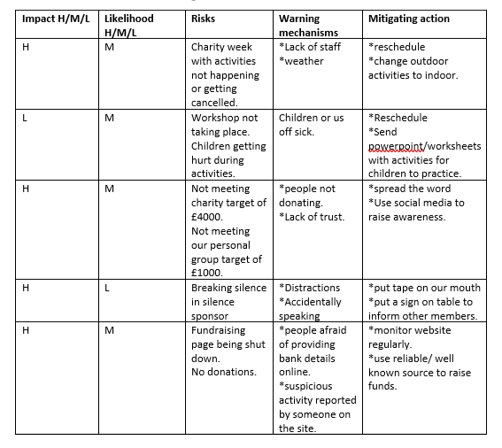

Closing Phase
This is the final stage were the team completes the work, provides final deliverable and defines the project success. This phase involves reflecting to what worked and what didn’t, identifying weaknesses and strengths and what could be done better next time (Watt, 2019).
The project team of CMS used the Gibbs reflective cycle to reflect on their project. This tool has five stages of reflection (Mind Tools, 2019). The team felt they worked well together bringing in a variety of ideas leading to a successful project.
As there were a lot of various tasks it required a lot of planning and preparation and to do this successfully, they created a Gantt chart which is a visible view of tasks organised over time (Project Manager, 2019). Gantt charts can be used for any project planning showing how long a task is scheduled for, the specific days, beginning and end any overlapping tasks and the final project end date. Using a Gantt chart is beneficial as it helps monitor the progress. It is important to compare anticipated progress to actual progress and update regularly. However, having a perfect chart does not guarantee a successful project (Gantt.com, 2019).

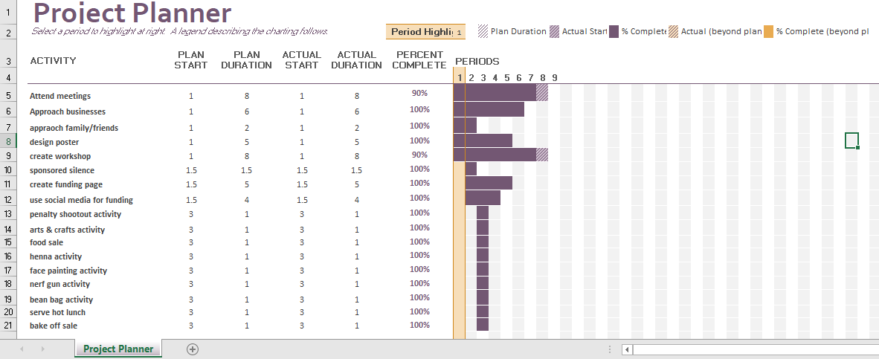

Conclusion

CMS project team have concluded that following the project life cycle phases helps manage a project in an organised manner. Using tools and techniques in a project is vital as they help in preparing a successful outcome (APM, 2019). They helped planning and identifying all tasks and resources along with any risks giving the opportunity to rectify any issues before it becomes a major problem. Using these tools alongside each life cycle phase has a higher chance of success. However, due to various tasks they found that it was difficult to keep to time schedule on some tasks. For example, during their leadership workshop they were unable to complete all tasks planned due to lack of time, so it is recommended that any future projects require more time management planning. Through this project the team gained soft skills such as better communication and excellent teamwork whether this was with the teachers or the children. they also gained hard skills such as better use of PowerPoint. All members of the team created their own slides for the workshop which was sent to the deputy head for approval who was very pleased. Feedback from the deputy head teacher was frequently received from which the team were able to evaluate their progress and skills as the project went on.

Bibliography

20/20 Project Management. (2019), ‘What is the Project Life Cycle?’, [Online]. Available: https://2020projectmanagement.com/resources/project-lifecycle-and-methodology/what-is-the-project-life-cycle. [Accessed: 17th November 2019].
APM. (2019), ‘What is Project Management?’, [Online]. Available: https://www.apm.org.uk/resources/what-is-project-management/. [Accessed: 9th December 2019].
Bowen, R. (2019), ‘Ways to Keep Project Stakeholder Informed’, [Online]. Available: https://www.brighthubpm.com/monitoring-projects/52884-keeping-project-stakeholders-in-the-loop/. [Accessed: 18th December 2019].
Brady, J. (2019), ‘Risk Assessment: Issues and Challenges’, [Online]. Available: https://www.ispe.gr.jp/ISPE/07_public/pdf/201506_en.pdf. [Accessed: 13th December 2019].
Cohen, E. (2018), ‘A Beginner – Friendly Guide to Work Breakdown Structure (WBS)’, [Online]. Available: https://www.workamajig.com/blog/guide-to-work-breakdown-structures-wbs. [Accessed: 12th December 2019].
Coventry University. (2019), ‘The Five Stages of the Project Life Cycle’, [Online]. Available: https://www.futurelearn.com/courses/importance-of-project-management-in-global-construction/0/steps/46418. [Accessed: 12 December 2019].
Estyn. (2018), ‘Cardiff Muslim School’, [Online] Available: https://www.estyn.gov.wales/sites/www.estyn.gov.wales/files/documents/Inspection%20report%20Cardiff%20Muslim%20Primary%20School%202014%20%28English%20only%29_0.pdf [Accessed: 13th December 2019].
Gantt.com. (2019), ‘What is a Gantt Chart?’, [Online]. Available: https://www.gantt.com/. [Accessed: 13th December 2019].
Grey Campus. (2019), ‘Project Management Professional’, [Online]. Available: https://www.greycampus.com/opencampus/project-management-professional/monitor-and-control-project-work. [Accessed: 12th December 2019].
Invensis. (2019), ‘What is Project Life Cycle and its Main Characteristics?’, [Online]. Available: https://www.invensislearning.com/resources/pmp/what-is-project-life-cycle-and-its-main-characteristics. [Accessed: 9th December 2019].
James. J. (2016), ‘What are the Benefits of Planning a Project’, [Online]. Available: https://www.activia.co.uk/blog/what-are-the-benefits-of-planning-a-project. Accessed: [11th December 2019].
Jansson, E. (2005),’ The Stakeholder Model: The Influence of Ownership and Governance Structure’, [Online]. Available: https://www.jstor.org/stable/25123408?seq=1. [Accessed: 11th December 2019].
Khan, Z. (2019), ‘Head Teacher’s Message’, [Online]. Available: https://cmpswales.org/About-Us/Head-Teacher-s-Message/. [Accessed: 9th December].
Lucidchart Team. (2017), ‘The 4 Phases of the Project Management Life Cycle’, [Online]. Available: https://www.lucidchart.com/blog/the-4-phases-of-the-project-management-life-cycle. [Accessed: 11th December 2019].
Lynn, R. (2019), ‘What is Work Breakdown Structure?’, [Online]. Available: https://www.planview.com/resources/articles/work-breakdown-structure/. [Accessed: 12th December 2019].
Maker, A. (2018), ‘Top-Down Vs Bottom-Up Project Management Strategies’, [Online]. Available: https://www.liquidplanner.com/blog/how-long-is-that-going-to-take-top-down-vs-bottom-up-strategies/. [Accessed: 12th December 2019].
Method. (20169), ‘Project Execution Phase’, [Online]. Available: https://www.method123.com/project-execution-phase.php. [Accessed: 12th December 2019].
Mind Tools. (2019), ‘Gibbs’ Reflective Cycle’, [Online] Available: https://www.mindtools.com/pages/article/reflective-cycle.htm. [Accessed: 13th December 2019].
Mind Tools. (2019), ‘Project Initiation Document’, [Online]. Available: https://www.mindtools.com/pages/article/newPPM_85.htm. [Accessed: 10th December 2019].
Naybour, P. (2018), ‘The Importance of Project Planning for Successful Outcomes’, [Online]. Available: https://www.parallelprojecttraining.com/blog/importance-project-planning-project-success/. [Accessed: 10th December 2019].
NC State University. (2013), ‘Assignment: Quad Chart’, [Online]. Available: https://pwresources.wordpress.ncsu.edu/2013/08/26/quad-chart-assignment/. [Accessed: 10th December 2019].
Office Timeline. (2017), ‘Conquer the 5 Phases of the PM Life Cycle’, [Online] Available: https://www.officetimeline.com/blog/conquer-the-5-phases-of-the-project-management-life-cycle, [Accessed: 12th December 2019].
Project Manager. (2019), ‘The Ultimate Guide to…Gantt Chart’, [Online]. Available: https://www.projectmanager.com/gantt-chart. [Accessed: 13th December 2019].
Project-Management.com. (2018), ‘What is Stakeholder Analysis?’, [Online]. Available: https://project-management.com/what-is-stakeholder-analysis/. [Accessed: 11th December 2019].
Project-management.com. (2018), ‘Work Breakdown Structure (WBS): Top-Down or Bottom-Up?)’, [Online]. Available: https://project-management.com/work-breakdown-structure-wbs-top-down-or-bottom-up/. [Accessed: 12th December 2019].
Thompson, R. (2019), ‘Stakeholder Analysis’, [Online]. Available: https://www.mindtools.com/pages/article/newPPM_07.htm. [Accessed: 11th December 2019].
US Department of Veterans Affairs. (2016), ‘Project and Award Quad Chart Guidelines’, [Online]. Available: https://www.hsrd.research.va.gov/funding/quad_charts.cfm. [Accessed: 17th November 2019].
Villanova University. (2019), ‘Five Phases of Project Management Life Cycle, [Online]. Available: https://www.villanovau.com/resources/project-management/5-phases-project-management-lifecycle/. [Accessed: 10th December 2019].
Watt, A. (2019), ‘The Project Life Cycle’ Phases, [Online]. Available: https://opentextbc.ca/projectmanagement/chapter/chapter-3-the-project-life-cycle-phases-project-management/. [Accessed: 11th December 2019].
Westland, J. (2018), ‘The Triple Constraint in Project Management: Time, Scope and Cost’, [Online]. Available: https://www.projectmanager.com/blog/triple-constraint-project-management-time-scope-cost. [Accessed: 13th December 2019].
Workbreakdownstructure.com. (2019), ‘Work Breakdown Structure (WBS)’, [Online]. Available: https://www.workbreakdownstructure.com/. [Accessed: 12th December 2019].

