

LOCATION: Swansea | LLEOLIAD: abertawe
LEVEL 4 | LEFEL 4
EXAMINATION PERIOD | CYFNOD ARHOLIADAU
January 2021 | IONAWR 2021

MODULE CODE: ACMA4000
Materials and introduction to processing – DUMMY EXAM

TIME: 10 Minutes !!! (Use 1 ½ NOt 1.5 for time)
answer all questions

Equipment or materials required – Open book
Adnoddau neu ddefnyddiau sydd eu hangen – Llyfrau agor

ANSWER ALL QUESTIONS

- First Exam Question (30 marks).

Draw a picture of a dog (or panda or cat) ! (30 marks)

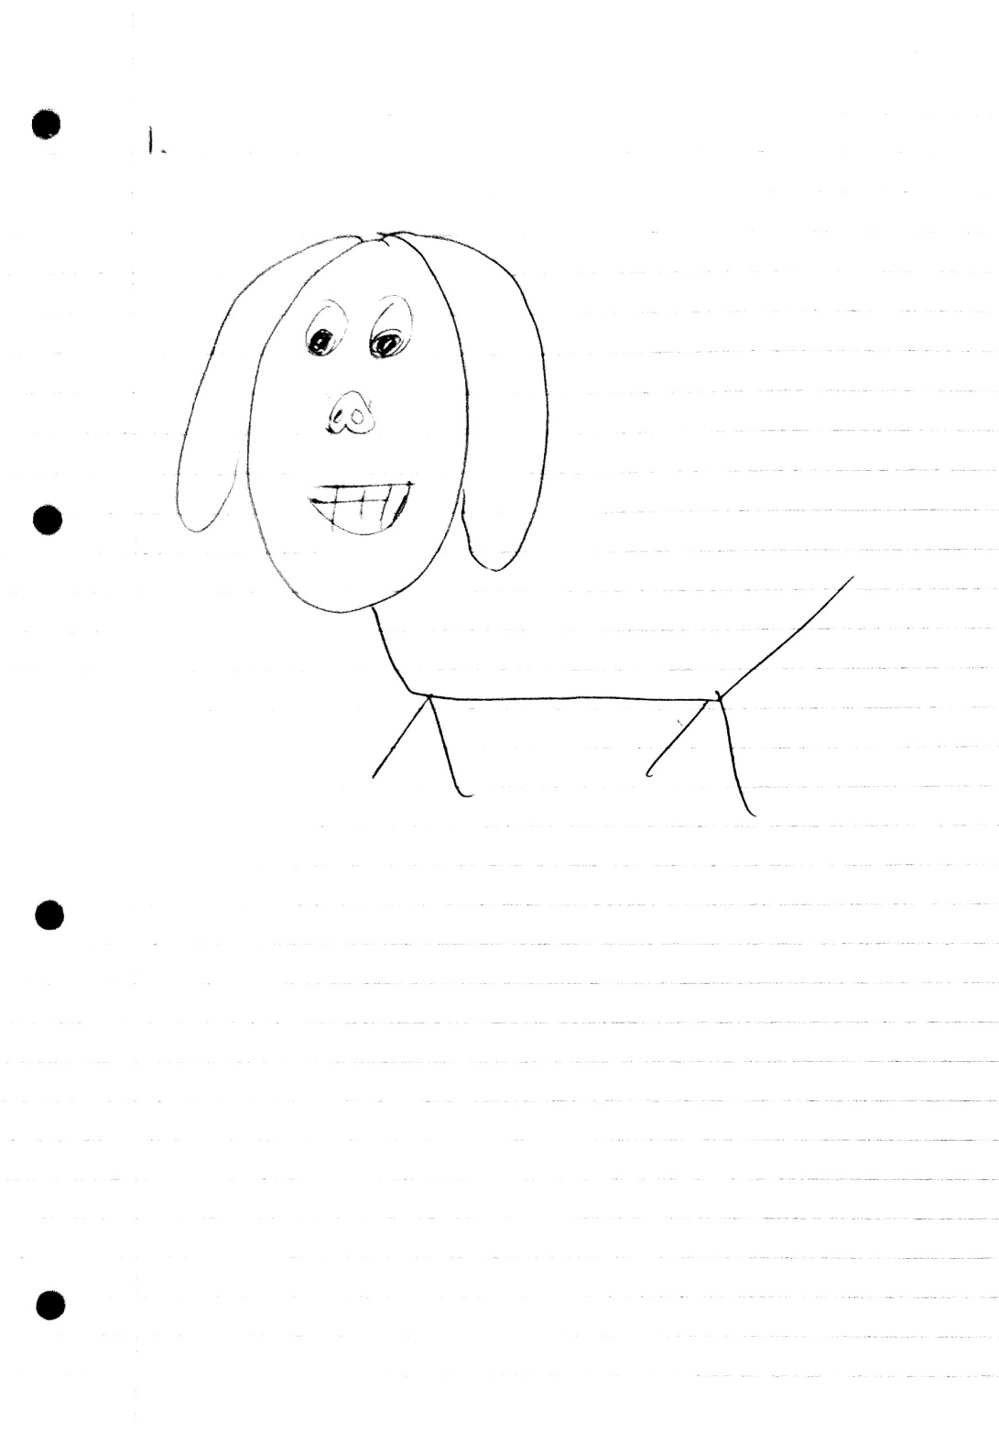

- Second Exam Question (20 marks)

Write a 300 word story : My favourite place is XXXX because YYY

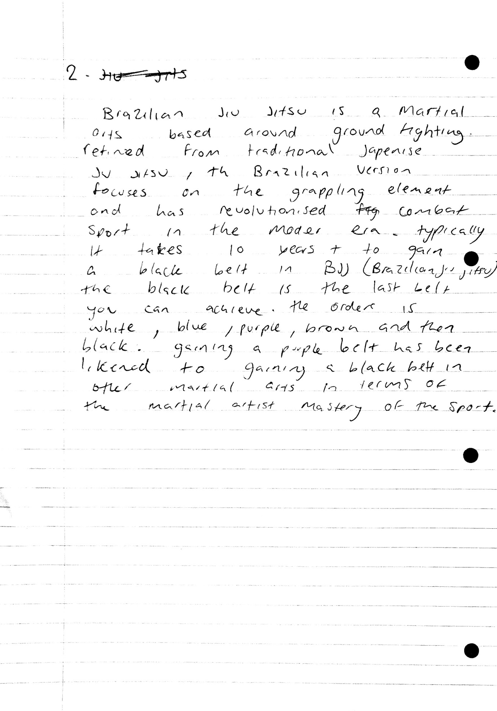
/End

