

UNIVERSITY OF WALES TRINITY SAINT DAVID

ACADEMIC SKILLS (LCBB4006)

LECTURER - DR. LIZETA DEMETRIOU

ASSINGMENT 2

IMPORTANCE AND EVALUATION OF ACADEMIC SKILLS

(GROUP REPORT)
STUDENT’S NAMES AND ID
TSONYO TODOROV - 2021609
LINDA ROZE - 2219027
VALENTIN BORISOV - 2219028
IVAYLO MADZHAROV - 2210990
YANISLAV GEORGIEV - 2219323
Table of content

Introduction pp.3-4
Motivation pp.4-7
Teamwork pp.7-10
Analytical and Critical thinking pp.11-13
Reflection pp.13-17
Conclusion pp.17-18
References pp.19-22

Table of Figures and Tables
Figure 1: Figure 1: Kurt, S. (2020) ‘Maslow’s Hierarchy Of Needs In Education’………………………………………………………………………………………………………...p.5
Figure 2: Tarricone, P. & Luca, J. (2002) Successful teamwork……...…p.10
Figure3:'Gibbsreflectivecycle',https://expertprogrammanagement.com/2019/05/gibbs-reflective-cycle/………………………………………...……….…p.15

Table 1: ‘Inside the team Factors and Dimensions’…………………………p.9

INTRODUCTION

Academic skills are skill sets that assist students in successfully navigating their academic lives and accomplishing their academic goals (Indeed,2022). Students who have strong academic skills are more likely to be successful overall. Students who have great academic skills are better able to retain their academic discipline and achieve higher levels of success in their studies (Indeed,2022). This is because strong academic skills are directly correlated to higher levels of academic achievement. It is impossible to emphasize the value of having academic talents that may be applied in other areas of life. People discover that they are better able to achieve in both their personal and professional lives after obtaining these qualities, and this is true for both areas of their lives (Malthouse & Roffey-Barentsen,2013). Academic talents are something that, depending on the school, may or may not be taught in the classroom. In order for students to acquire these abilities, they are expected to put in a significant amount of effort, which comes in the form of practices and tactics, and they should always be attempting to enhance them over time (Indeed,2022). Academic abilities such as motivation, teamwork, critical thinking, and reflection are all necessary (Malthouse & Roffey-Barentsen,2013). The acquisition of these abilities provides students with a number of benefits, including improved preparedness for their future occupations, higher capacity to sustain attention and motivation, and enhanced understanding of alternate ways of thinking. Having said that, there is more to these abilities than just an innate talent to do the thing. The environment has a role in helping youngsters broaden their perspective, and this includes factors like parent’s motivation and the habit of asking them challenging questions. (Trent University,2021). In this study, the relevant academic skills are detailed, and the relative usefulness of those skills in both academic and future professional life is discussed.

MOTIVATION

The word by itself refers to the reasons behind someone’s actions. It is what motivates people to behave in the manner they do. The mechanism that starts, leads, and promotes goal-oriented acts is known as motivation. Additionally, motivation contains aspects that guide and sustain the main objective activity. Even so, these motivations are rarely clearly visible. As a result, it is frequently necessary to interpret the intentions behind people’s actions from their observable behaviors (Cherry,2020). Everyone has a unique character that manifests itself via motivation, allowing us to accomplish vital objectives like higher performance, better health, personal development, or a feeling of purpose. Motivation enables us to have some control over our feelings, ideas, and actions. One can engage learners and motivate staff and customers by applying motivational theory in practical settings. Motivation is an essential tool that enables people to adapt, perform well, and maintain wellbeing in the face of a constant flow of possibilities and difficulties. Improve morale has numerous positive effects on health. Physiology and motivation as a mental state are related. Functioning and well-being decrease when our motivation is low (Souders,2019).

Source: https://staffskillstraining.co.uk/course/motivation-skills-certification/
There are numerous motivational ideas. The most significant steps of the pyramid, constructed by a person's needs and expectations, are specifically discussed in Maslow’s Hierarchy theory:
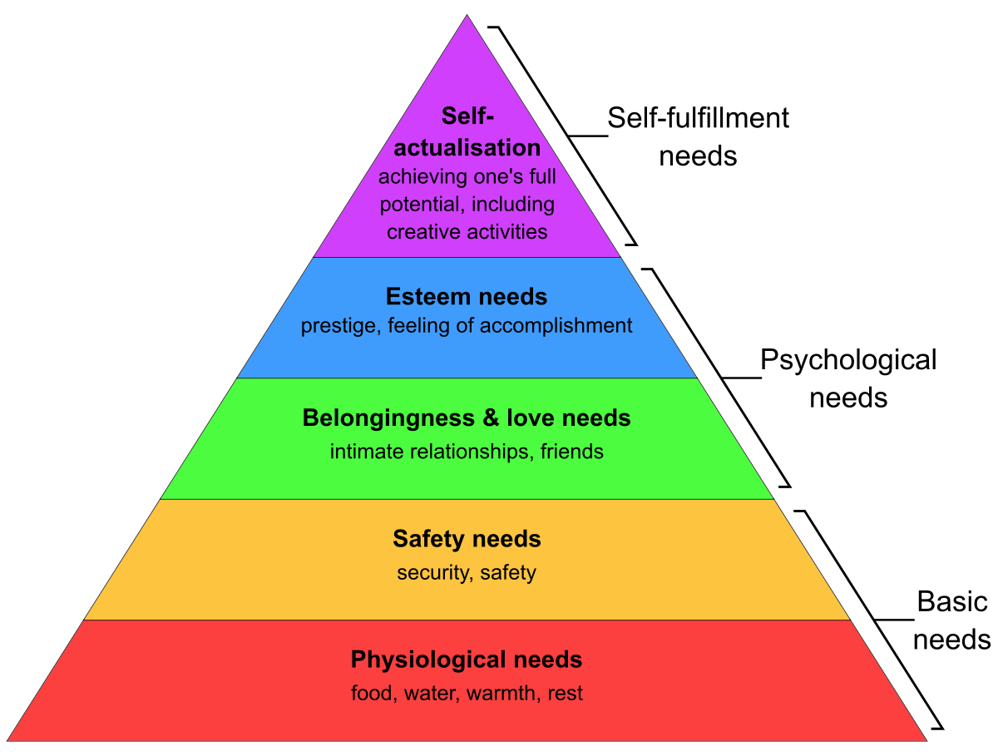
Figure 1: Kurt, S., (2020) ‘Maslow’s Hierarchy Of Needs In Education’

- Physical criteria come first and must be satisfied. Food, rest, clothes, and a place to live are all necessities. If these basic needs are not met, people cannot focus on anything else. They will only engage in actions if they meet these physiological needs. They are the first priority, which makes them the most powerful source of inspiration for individuals. A person would prioritize hunger while it is present above all other wants (Kurt,2020).
- Safety comes next in importance. Environmental demands for safety often encompass a person’s home, school, and any other environment they may be a part of. A person will find it challenging to work or study if he is experiencing personal problems at home or reside in an unsafe place because his fundamental safety needs have not been satisfied. Like how one would find it difficult to do daily duties if he’s bullied or don’t feel like people accept and like him. Security would be his top priority.
- Following the satisfaction of physiological and safety demands, the significance of love and a feeling of community becomes apparent. A person can grow his feeling of community by participating in clubs, volunteering, or other group-focused activities. Belonging and love can be equally important to a person's physiological demands, despite the fact that this may go unrecognized.
- Self-esteem is influenced by individuality, respect for others, achievement, and self-assurance. Most individuals are so hard on themselves because they criticize their own potential and ability. Two different kinds of self-esteem exist. People will look for success, certainty, talent, and fortitude in that order. They will also crave for status, respect, reputation, and fame.
- According to Maslow, at the top of the pyramid is self-actualization. This is an aim to fulfil one's potential. Instead of being driven by a feeling of inadequacy, this urge is driven by a desire to better oneself. Maslow thinks that few people ever achieve this level. Impulsive, independent, analytical, and practical traits of self-actualized people (Kurt,2020).
All these factors are essential for success in both personal and academic development.

TEAMWORK

The term “teamwork skills” refers to a collection of related skill set that enable a person to participate with people in an organized and empathic manner in various settings, discussions, and tasks. Study shows that collaborative problem-solving provides excellent performance. The probability of people taking calculated risks that lead to creativity increases when they are supported by a team. The growth of the person, increased employee satisfaction, and reduced stress are all benefits of teamwork. (Middleton,2022). Teams, an essential component of many businesses, should be included in delivering results in extra. Successful cooperation relies on the synergy between all team members to build an atmosphere where they are all driven to collaborate and participate in order to construct and cultivate a healthy, productive team environment. Team members need to be fully aware of their roles and understand what is required of them in terms of their contributions to the team (Tarricone,2002). For a group to be successful, a variety of qualities are required, including diverse individuals, a common aim, a sense of community, information exchange, and concentrated effort (Sohmen,2013). These great goals must be achieved with effective management and leadership. In today’s knowledge-intensive environment, effective leaders who influence and inspire teams create strong groups of people who work together to achieve a shared goal. Intelligent and thoughtful leaders change their manner to meet any circumstance and create an environment where the team develops. Strengths, weaknesses, and opportunities in teams must be known. Influential leaders balance out the advantages and disadvantages of their team. Indeed, teamwork involves collaborative decision-making to accomplish project objectives. Therefore, the leader seeks to understand the heritage of each section and find opportunities to boost their team and its members. A dynamic concept needs to be taken to drive the corporate strategic vision of the organization through effective leadership (Sohmen,2013).
Created in 1995, The T7 Model, by Michael Lombardo and Robert Eichinger, identifies the elements that influence team effectiveness. They discovered seven factors, five internal and two externals (De Meuse,2009).
Internal elements

- A shared vision of what must be done
- Having faith in one another as teammates
- The team's ability to complete the task
- Working together effectively and productively
- Carrying out an assignment successfully

External elements

- the level of needs-satisfaction the team leader provides
- how well the organization’s leadership supports the team’s performance
The five internal features include 18 dimensions of team efficiency in total.
Table 1 shows the dimensions and their connection with the main factors (De Meuse, 2009).
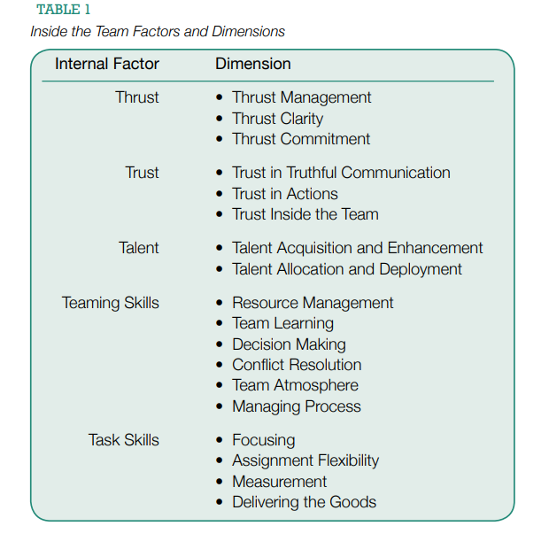
De Meuse, K., P., (2009) ‘Driving team effectiveness’
A great example of the importance of successful teamwork and the possible threats the team can face is the case study by Tarricone and Luca, (2002). They evaluate all the obstacles via the Interactive Multimedia course at Edith Cowan University between students, divided into teams. Within this context, two groups were chosen for the study. The first team collaborated really well and produced a high-quality product. The second team experienced a problematic situation, which caused it to become unreliable and had to be split. Data was gathered through focus groups, interviews, and surveys that were recorded and transcribed for analysis (Tariccone, Luca, 2002). The main characteristics are used to assess a team’s success rate and how the groups react to essential attributes, are shown in Figure below.
Figure 2: Tarricone, P. & Luca, J. (2002) Successful teamwork

ANALYTICAL AND CRITICAL THINKING

A life skill that prevents one from being dull or stagnant is analytical and critical thinking. Instead, one may adopt a proactive attitude to improve any circumstances and foster personal development. When all these elements are taken into account, a person’s level of fulfilment and pleasure in all facets of his life will be greatly increased (Team CircleDNA,2021). Studies show that those who think critically are happier and more satisfied with their life. This fulfilment stems from a better understanding of oneself. Self-reflection is a skill that critical thinkers excel in, and they are conscious of their own goals and desires. Additionally, critical thinkers are better at processing information and analysing everything that happens, which enables them to understand the most crucial lessons and apply them to their daily life (Team CircleDNA,2021). It can be difficult to define critical thinking because many people associate the word “critical” with negative meanings. After all, no one enjoys being criticised, and most people dislike finding fault. However, critical thinking is anything but that, even though the concept itself is rather complex when applied to everyday life (Team CircleDNA,2021). Some define critical thinking as the process of analysing information to form sound judgement. Before concluding, one’s must investigate all possible paths and angles (Team CircleDNA,2021). Because it is a universal skill that can be used by anybody, regardless of ethnicity, culture, financial class, or religion, critical thinking is crucial in our society. Additionally, in order for society and businesses to handle issues effectively and efficiently, critical thinking is necessary. The ability to think clearly and methodically about the problem at hand makes critical thinkers typically good communicators. They interpret the messages they perceive and completely comprehend what is said, eliminating misconceptions and misinterpretation (Team CircleDNA,2021).
Furthermore, this gives people the tools they need to self-reflect and evaluate what they need to do. When you have peace of mind in your life, you can:
- Reduce your daily stress.
- Reduce conflict in your relationships.
- Be more relaxed.
- Have a happier life.
However, following belongings you can easily success by practicing critical thinking:
- Examine data
- Solve problems creatively.
- Make methodical plans.
- Consider thinking outside of the box.
Critical thinkers do more than just solve problems efficiently. Instead, they analyse ideas and come up with novel approaches and solutions. They can always adjust to any situation. As a result, they will be able to make better decisions for them and their family’s (Slideshare,2012).



Non-Critical Thinking: Critical Thinking:
#1
Collects information

#2
Evaluates information
#1
Collects information

#2
Draws concluison
(without logic)
#4
Evaluates logical conclusions

#3
Draw Conclusion
(using logic)

REFLECTION

Reflection is a constant, conscious, and active study of each idea or claim made considering the evidence supporting it and the logical conclusion it tends to reach. Reflection assists students in finding relevance and purpose in a lecture and connecting the academic experience to real-life circumstances. Innovative research highlighted the significant role that reflection could play in promoting learner’s critical thinking, self-reflection, and evident growth of professional skills and values. There has been a rise in interest between researchers and educators in the contribution of reflection in learning. Reflection has acquired multiple meanings in the literature from various sources.
Problem-based learning is distinguished by learners working cooperatively in small class groups, with training focused on challenges related to the field of study of the learners and a significant amount of time used for self-directed studying. Students study by contemplating their own experiences and by solving problems in problem-based learning. Reflecting on the connection between learning and solving problems is an essential element of PBL and is required to facilitate the development of flexible and broad knowledge (Da Silva et al.,2018).Self-reflection assists learners in reviewing the processes in a group and their own functioning personally in the class group, comprehending how the student’s knowledge and problem-solving skills may be reimplemented, and relating new information to previous understanding (Alsaleh,2020). During the process of learning and when solving a problem, PBL integrates reflection at various points. Students can reflect on the information they have studied, how students interacted with the group successfully, and how efficiently they guided their learning after completing a problem. As a result, learners develop self-reflection as they become skilled in judging their advancement in knowledge. The reflective practice fosters ownership of learning by allowing students to absorb a topic after a lesson. This improves learner’s ability to develop and adapt from their experiences and gain insight, among the most crucial life skills to achieve. When students are involved in ongoing reflection courses and programs in the school, they can remember and apply acquired knowledge to other application areas and promote their preparedness to be more reflective and introspective students in the long run. This type of contemplative capacity assists students in recognizing their talents.
Graham Gibbs developed his model “Gibbs reflective cycle” to aid in experience studying. It was intended to be utilized as a continual cycle of development for a recurrent experience. It gives one a framework for understanding events, and because it’s cyclical, it fits itself incredibly well to repetitive encounters, allowing one to comprehend and plan from either scenarios that went good or bad. It is divided in six stages: Description of your experience, Feelings, Evaluation, Analysis, Conclusion and Action plan. Several people discover that they can learn best from experience. However, it is difficult for individuals to acquire something when they do not reflect on their studies. This is where “Gibbs Reflective Cycle” comes in handy.

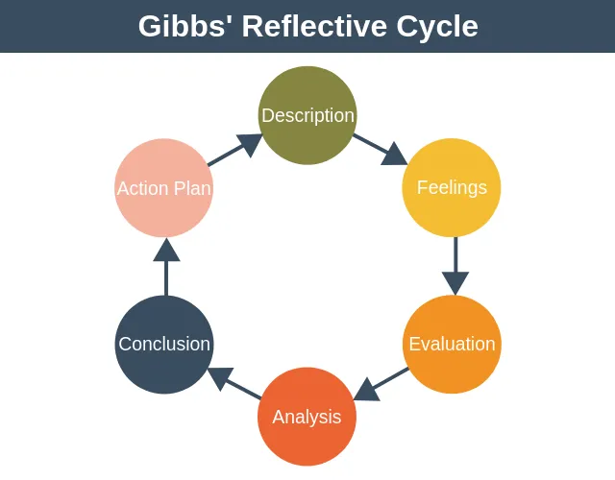

Figure 3: https://expertprogrammanagement.com/2019/05/gibbs-reflective-cycle/

- Description - In this phase, one thoroughly explains the circumstance, occurrence, or action without making any immediate judgments.

- Feelings - This stage is all about the emotions the experience provoked and the thoughts someone had while it was happening. The goal is not to dive into the emotion in-depth or make direct remarks about it. There’s no need to assess or condemn emotions. The main objective of this stage is awareness.

- Evaluation - In this stage, one decides if his first encounter with the event was favorable or bad. Which tactic, specifically, was effective? Which tactic didn’t work as well?

- Analysis - This stage focuses on what a person have discovered from the event, experience, or action. One now understands what to do in such circumstances in the future because of this experience. This implies that every event he had, whether good or bad, will be recorded and carefully examined.

- Conclusion - Now is the time to stand back, assess actions objectively, and consider other options one could have made. In this phase, the information one’s obtained before is quite helpful and might motivate him to reach a wise and fruitful decision.

- Action Plan - Actions are planned for upcoming scenarios, events, or activities in this last phase. Individuals create specific pledges to themselves in this stage based on the “Conclusions” section. These commitments will be kept. One might establish an agreement with himself that won’t repeat any mistakes in areas where things didn’t go so well. What strategy will be more successful, and which adjustment will result in improvement? It is advisable to have both an action plan and a strategy for motivating oneself to keep him committed.

CONCLUSION

The value of academic skills can be seen in both the academic world and the professional sphere, as the paper demonstrates. A student’s life is comparable to the infantile stage of human development. In the future, every skill and piece of knowledge learned during this period will be helpful in several circumstances of human life. It is vital for one to improve these qualities to the best of their abilities to be successful. This time is ideal for developing these abilities to their full potential because there are so many opportunities to improve them while one is a student. This time frame is optimal for developing these abilities to their full potential because there are so many possibilities to do so. As people get older, there is a possibility that they will no longer have that opportunity. Possessing academic and transferable talents such as teamworking, organization, the ability to interact with others, the capacity to motivate oneself, analytical ability, and introspection can be beneficial to a person in his personal life (Trent University,2021). These capabilities not only make the work less complicated, but they also make it far less difficult and more effective to learn new things. Because these are academic abilities, it goes without saying that if a student possesses them, they will have an easier time getting higher marks. Someone with superior grades has a better chance of being accepted to a better institution or university, as well as landing a better career. All these factors contribute to a person’s ability to live a respectable life. Because acquiring these abilities has a positive impact on a person’s academic life, there is little question that it will also have a positive impact on their professional life. Consequently, if one wishes to live a satisfying and secure life, it is necessary to acquire these talents.

REFERENCES

- Ahmadova, T. (2020) ‘The Role of Motivation in Teaching and Learning Process’, Интернаука, pp.41-42.

- Alsaleh, N. J. (2020) ‘Teaching Critical Thinking Skills: Literature Review’, TOJET: The Turkish Online Journal of Educational Technology, 19(1), pp.21-39.

- Cherry, K. (2022) What Is Motivation? The Driving Force Behind Human Actions. Available at: https://www.verywellmind.com/what-is-motivation-2795378/ (Accessed: 15th December 2022).

- De Meuse, K., P., (2009) ‘A Comparative Analysis of the Korn/Ferry T7 Model With Other Popular Team Models’, Driving Team Effectiveness.

- Howard, J. L., Bureau, J., Guay, F., Chong, J.X.Y and Ryan, R.M. (2021) ‘Student Motivation and Associated Outcomes: A Meta-Analysis From Self-Determination Theory’, Perspectives on Psychological Science, 16(6), pp.1300-1323. DOI: https://doi.org/10.1177/1745691620966789

- Indeed (2022) 12 Examples of Academic Skills (Plus Tips To Improve Them). Available at: https://www.indeed.com/career-advice/career-development/academic-skills/ (Accessed: 12th December 2022).

- Kurt, S. (2020) Maslow’s Hierarchy Of Needs In Education. Available at: https://educationlibrary.org/maslows-hierarchy-of-needs-in-education/ (Accessed: 18th December 2022)

- Malthouse, R. and Roffey-Barentsen, J. (2013) Academic Skills. Contemporary Education Series. London: Thalassa.

- Middleton, T. (2022) The importance of teamwork (as proven by science). Available at: https://atlassianblog.wpengine.com/teamwork/the-importance-of-teamwork/ (Accessed: 16th December 2022).

- Silva, A.B.D., Bispo, A.C.K.d.A., Rodriguez, D.G. and Vasquez, F.I.F. (2018), ‘A proposal for structuring PBL and its implications for learning among students in an undergraduate management degree program’, Problem-based learning , 25(2), pp.160-177. DOI: https://doi.org/10.1108/REGE-03-2018-030

- Slideshare (2012) Conclusions in Critical Thinking. Available at: https://www.slideshare.net/lbrook/conclusions-in-critical-thinking/ (Accessed: 12th December 2022).

- Sohmen, V. (2013) ‘Leadership and Teamwork: Two Sides of the Same Coin’, Journal of IT and Economic Development 4(2).

- Souders, B. (2019) The Vital Importance and Benefits of Motivation. Available at: https://positivepsychology.com/benefits-motivation/ (Accessed: 19th December 2022).

- Tarricone, P. & Luca, J. (2002) ‘Successful teamwork: A case study’, Quality Conversations, Proceedings of the 25th HERDSA Annual Conference, Perth, Western Australia, p. 640.

- Team CircleDNA (2021) What Is Critical Thinking And Why Is It Important. Available at: https://magazine.circledna.com/what-is-critical-thinking-and-why-is-it-important/ (Accessed: 18th December 2022).

- Toolshero (2018) Gibbs Reflective Cycle by Graham Gibbs. Available at: https://www.toolshero.com/management/gibbs-reflective-cycle-graham-gibbs/ (Accessed: December 17th 2022).

- Trent University (2021) Academic Skills. Available at: https://www.trentu.ca/academicskills/ (Accessed: December 12th 2022).

- Tyata, R. K., Dahal, N., Pant, B. P., & Luitel, B. C. (2021) ‘Exploring Project-Based Teaching for Engaging Students Mathematical Learning’, Mathematics Education Forum Chitwan, 6(6), pp.30–49. DOI: https://doi.org/10.3126/mefc.v6i6.42398

- Woodbridge, C. (2020) The importance of motivation in the workplace. Available at: https://www.penguins.co.uk/incentive-travel-blog/the-importance-of-motivation-in-the-workplace/ (Accessed: 15th December 2022).

